Content

Subnetwork Connection States 1
Call States 6
Revision History 9
Acknowledgements 9
How to comment on the document 9

Subnetwork Connection States

The possible subnetwork connection states and transitions as a result of NMS requests to create, activate, create and activate, deactivate, delete and deactivate delete subnetwork connections are illustrated in the following state transition diagrams:

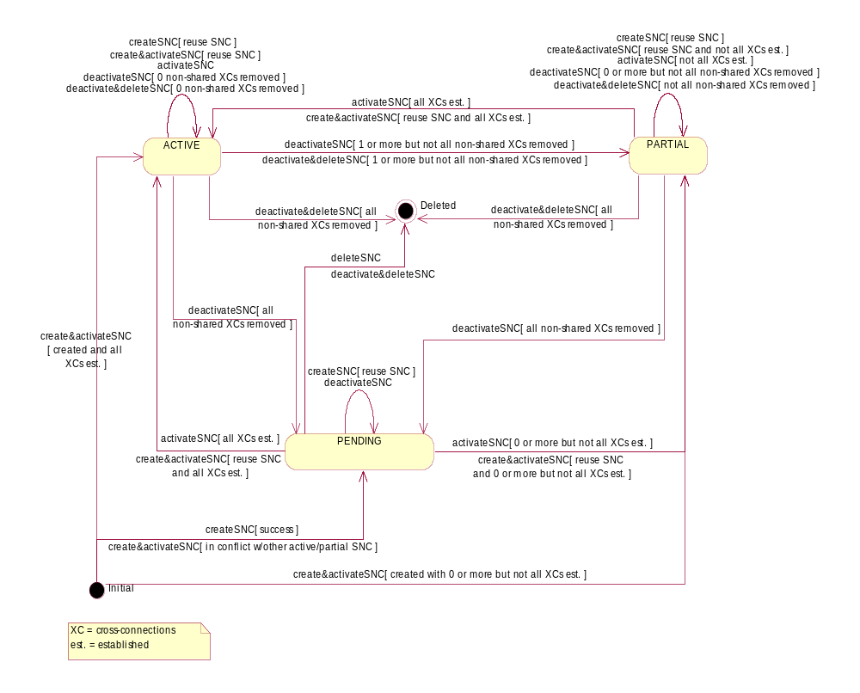

Figure 1: Statechart Diagram - SubnetworkConnection.sncState [Pending Supported]

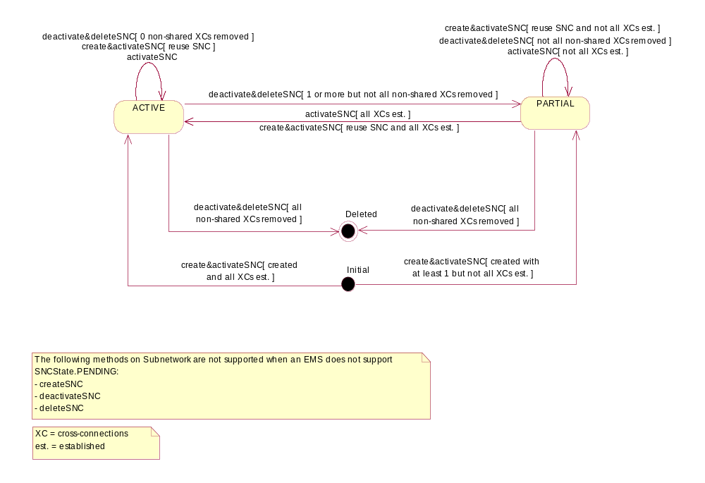

Figure 2: Statechart Diagram - SubnetworkConnection.sncState [Pending Not Supported]

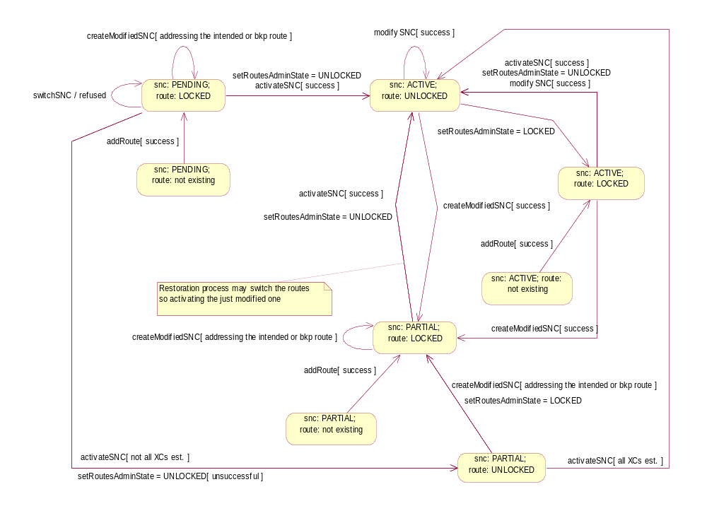
Figure 3:
Statechart Diagram - Modification of a SNC with multiple routes and SNC name preserved

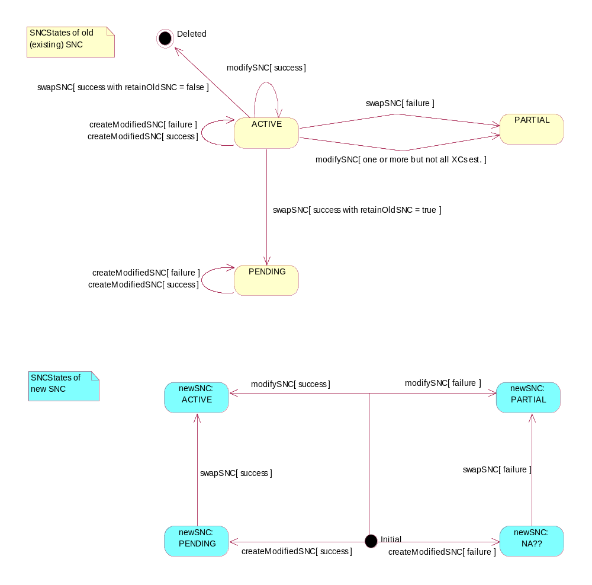
Figure 4: Statechart Diagram - Modification of a SNC with SNC name not preserved

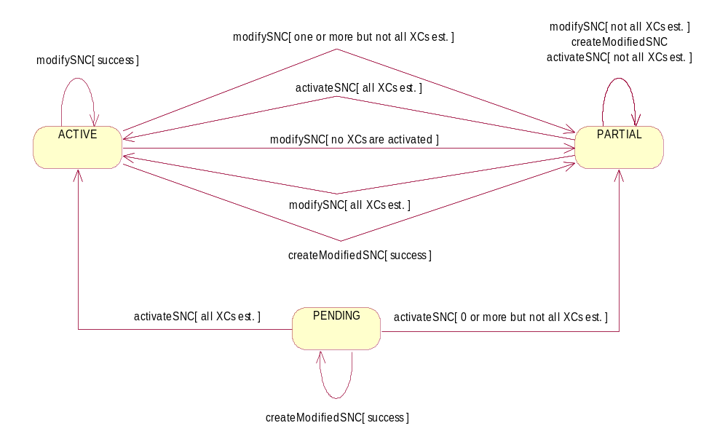
Figure 5: Statechart Diagram - Modification of a SNC with SNC name preserved

Call States

The possible Call states and transitions as a result of NMS requests to establish, modify and restore Calls are illustrated in the following state transition diagrams:

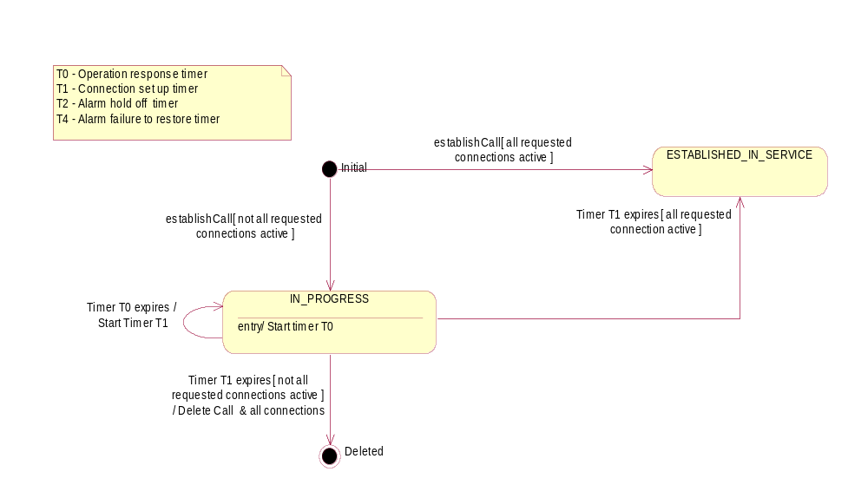

Figure 6: Statechart Diagram - Establish Call

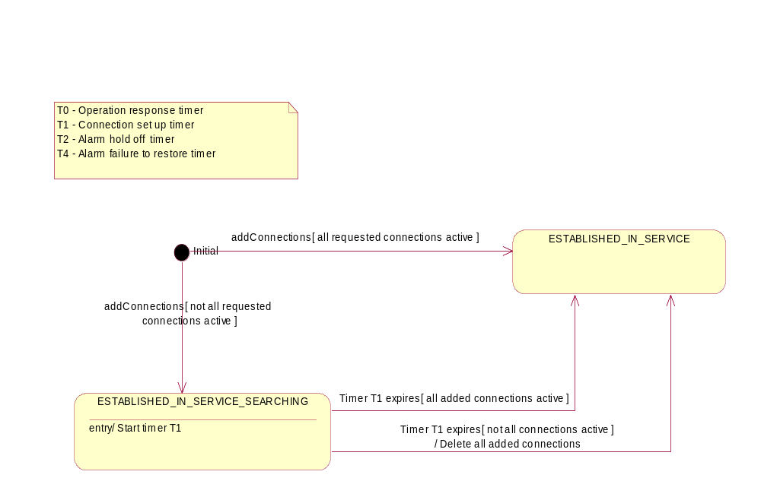

Figure 7: Statechart Diagram - Modify a Call - Add Connections

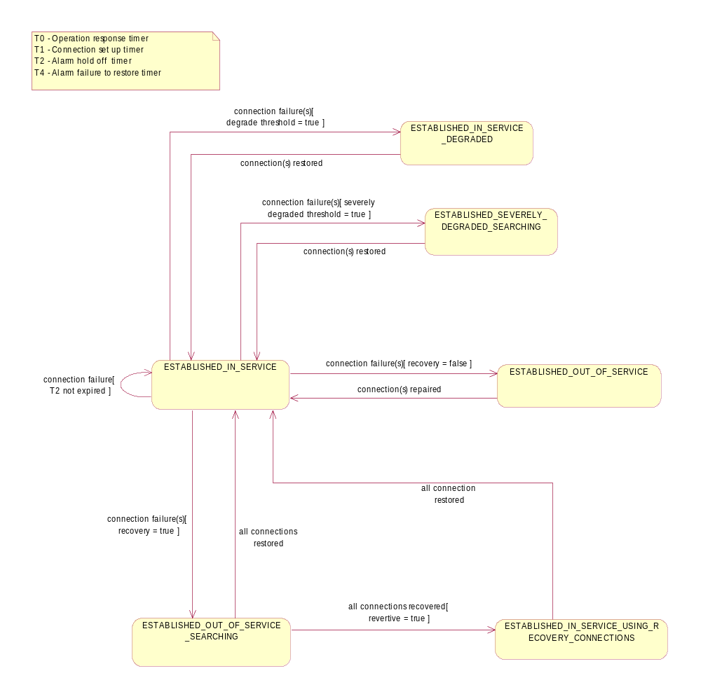

Figure 8: Statechart Diagram - Call Restoration

Revision History
Version | Date | Description of Change
3.0 | April 2005 | Initial version.
3.1 | March 2007 | Call state diagrams added.  File name changed from "SD1-35_SNCStateDiagram" to "SD1-35_StateDiagrams"

Acknowledgements
<FirstName> | <LastName> | <Company>

How to comment on the document
Comments and requests for information must be in written form and addressed to the contact identified below:

Keith | Dorking | CIENA
Phone: | +1 678 867 5007
Fax: | +1 678 867 5010
e-mail: | Kdorking@ciena.com

Please be specific, since your comments will be dealt with by the team evaluating numerous inputs and trying to produce a single text. Thus we appreciate significant specific input. We are looking for more input than wordsmith” items, however editing and structural help are greatly appreciated where better clarity is the result.

