PM Threshold Types

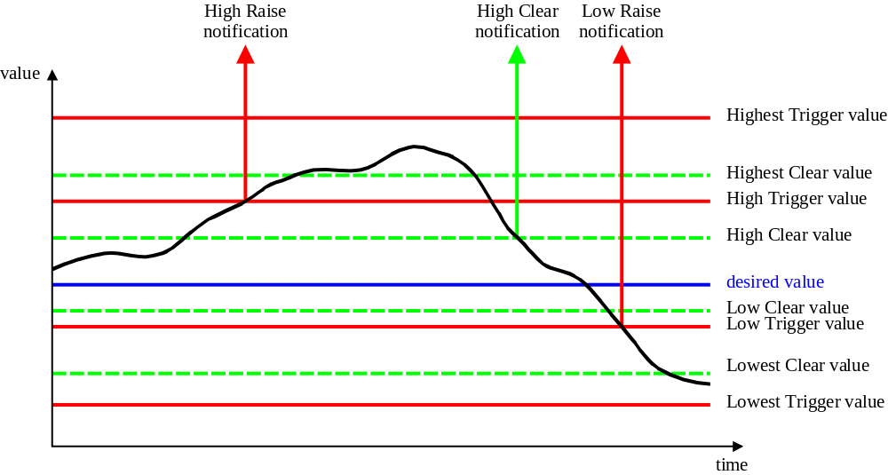
Note: Identification of Trigger/Clear for each threshold type is modelled by the attribute triggerFlag

Revision History
Version | Date | Description of Change
3.0 | June 2005 | Conversion into new template.

Acknowledgements
<FirstName> | <LastName> | <Company>

How to comment on the document
Comments and requests for information must be in written form and addressed to the contact identified below:

Keith | Dorking | CIENA
Phone: | +1 678 867 5007
Fax: | +1 678 867 5010
e-mail: | Kdorking@ciena.com

Please be specific, since your comments will be dealt with by the team evaluating numerous inputs and trying to produce a single text. Thus we appreciate significant specific input. We are looking for more input than wordsmith” items, however editing and structural help are greatly appreciated where better clarity is the result.

