MTOSI 2.1 Release Notes

RN306
Version 1.0


September 2011

©TM Forum 2011
Notice
No recipient of this document shall in any way interpret this document as representing a position or agreement of the TeleManagement Forum (TM Forum) or its members. This document is a draft working document of TM Forum and is provided solely for comments and evaluation. It is not a Forum Approved Document and is solely circulated for the purposes of assisting TM Forum in the preparation of a final document in furtherance of the aims and mission of TM Forum.
Although it is a copyrighted document of TM Forum:
- Members of TM Forum are only granted the limited copyright waiver to distribute this document within their companies and may not make paper or electronic copies for distribution outside of their companies.
- Non-members of the TM Forum are not permitted to make copies (paper or electronic) of this draft document other than for their internal use for the sole purpose of making comments thereon directly to TM Forum.
- If this document forms part of a supply of information in support of an Industry Group Liaison relationship, the document may only be used as part of the work identified in the Liaison and may not be used or further distributed for any other purposes
Any use of this document by the recipient, other than as set forth specifically herein, is at its own risk, and under no circumstances will TM Forum be liable for direct or indirect damages or any costs or losses resulting from the use of this document by the recipient.
This document is governed by all of the terms and conditions of the Agreement on Intellectual Property Rights between TM Forum and its members, and may involve a claim of patent rights by one or more TM Forum members or by non-members of TM Forum.
Direct inquiries to the TM Forum office:
240 Headquarters Plaza,
East Tower – 10th Floor,
Morristown, NJ 07960 USA
Tel No. +1 973 944 5100
Fax No. +1 973 944 5110
TM Forum Web Page: www.tmforum.org
Table of Contents

Notice 2
Table of Contents 3
1 Overview of MTOSI Release 2.1 7
1.1 DDP Structure (reminder) 7
2 Feature added: Ethernet Service Specification 10
3 Bugs Fixed and Modifications 11
3.1 Bugs reported as CRs 11
3.2 Bugs fixed not reported as CRs and modifications introduced 13
3.2.1 BAs and SDs 13
3.2.1.1 All BAs 13
3.2.1.2 Framework 13
3.2.1.3 MRI 13
3.2.1.4 Service Basic 13
3.2.1.5 Service Activation 14
3.2.2 IAs 14
3.2.2.1 General 14
3.2.2.2 Framework 14
3.2.2.3 ManageResourceInventory 15
3.2.2.4 NetworkResourceAssurance 17
3.2.2.5 NetworkResourceBasic 17
3.2.2.6 NetworkResourceFulfillment 19
3.2.2.7 ResourceProvisioning 20
3.2.2.8 ResourceTroubleManagement 21
3.2.2.9 UML Profile 21
3.2.3 IISs 21
3.2.3.1 Framework 21
3.2.3.2 NRB 22
3.2.3.3 NRA 23
3.2.3.4 NRF 23
3.2.3.5 RP 24
3.2.3.6 MRI 26
3.2.3.7 RTM 27
3.2.3.8 RPM 27
3.2.3.9 Service Basic 29
3.2.3.10 Service Activation 29
4 Release Definition 30
4.1 Document Release Description 30
4.1.1 Major BA Deliverables 35
4.1.1.1 TMF518_FMW, Framework - DDP BA 35
4.1.1.2 TMF518_NRB, Network Resource Basic - DDP BA 35
4.1.1.3 TMF518_NRF, Network Resource Fulfillment - DDP BA 35
4.1.1.4 TMF518_NRA, Network Resource Assurance - DDP BA 35
4.1.1.5 TMF518_MRI, Manage Resource Inventory - DDP BA 35
4.1.1.6 TMF518_RP, Resource Provisioning - DDP BA 36
4.1.1.7 TMF518_RTM, Resource Trouble Management (RTM) - DDP BA 36
4.1.1.8 TMF518_RPM, Resource Performance Management - DDP BA 36
4.1.1.9 TMF518_SB, Service Basic - DDP BA 36
4.1.1.10 TMF518_SA_1, Service Activation - DDP BA - Part 1: Overview 36
4.1.1.11 TMF518_SA_2, Service Activation - DDP BA - Part 2: Service Activation Interface (SAI) 37
4.1.1.12 TMF518_SA_3, Service Activation - DDP BA - Part 3: Service Component Activation 37
4.1.1.13 TMF518_MSI, Manage Service Inventory - DDP BA 37
4.1.2 Major IA Deliverables 37
4.1.3 Major IIS Deliverables 37
4.1.4 Joint MTOSI / MTNM Supporting Documents 39
4.1.4.1 SD0-1, mTOP Dictionary 39
4.1.4.2 SD0-2_mTOPGuidelines_BA, SD0-3_mTOPTemplate_BA.dot 39
4.1.4.3 SD0-4_mTOPGuidelines_IA 39
4.1.4.4 SD0-5_mTOPGuidelines_WebServices 39
4.1.4.5 SD0-6_mTOPTemplate_SD.dot 39
4.1.5 MTOSI Supporting Documents 39
4.1.5.1 SD2-2_XML_ImplementationUserGuide.doc 40
4.1.5.2 SD2-4_TransportIndependentExampleOfMTOSI.zip 40
4.1.5.3 SD2-5_Communication_Styles 40
4.1.5.4 SD2-6_VersioningAndExtensibility 40
4.1.5.5 SD2-7_ObjectNaming 40
4.1.5.6 SD2-9_UsingJMSAsMTOSITransport 40
4.1.5.7 SD2-10_ExampleUsingJMS 40
4.1.5.8 SD2-12_MTOSI_Inventory_Layout 41
4.1.5.9 SD2-14, Attribute Value Change & State Change Notifications 41
4.1.5.10 SD2-16_UsingHTTPAsMTOSITransport 41
4.1.5.11 SD2-17_MTOSI_EnhancedResourceStates 41
4.1.5.12 SD2-18_VPNServiceModel.xls 41
4.1.5.13 SD2-19_VoIPServiceDefinition 41
4.1.5.14 SD2-20_EquipmentModel 41
4.1.6 MTNM Supporting Documents 41
4.1.6.1 SD1-3_BundledSNC 41
4.1.6.2 SD1-5_ATMConformanceDefinitions 42
4.1.6.3 SD1-6, Examples for contained TPs different states of usage 42
4.1.6.4 SD1-7_DSLOverview 42
4.1.6.5 SD1-8, Coding of X.731 and M.3100 State and Status Information 42
4.1.6.6 SD1-13_guiCutThrough 42
4.1.6.7 SD1-14, Inverse Multiplexing (IM) Overview 42
4.1.6.8 SD1-16, Layered Parameters 42
4.1.6.9 SD1-17, Layer Rates 42
4.1.6.10 SD1-18, Functional Modeling Concepts 42
4.1.6.11 SD1-19, Location Identification 42
4.1.6.12 SD1-20, Maintenance Commands 42
4.1.6.13 SD1-22, Modeling Components 43
4.1.6.14 SD1-23_ModesOfOperation 43
4.1.6.15 SD1-28, Performance Parameters 43
4.1.6.16 SD1-29_PGPParameters 43
4.1.6.17 SD1-30, PM File Format 43
4.1.6.18 SD1-31, PM File Format 43
4.1.6.19 SD1-32 PM File Format 43
4.1.6.20 SD1-33, Specification of probableCause strings 43
4.1.6.21 SD1-34_protectionSwitch 43
4.1.6.22 SD1-36, SNC and Protection 43
4.1.6.23 SD1-37, PM Threshold Types 43
4.1.6.24 SD1-41_TPPoolRelationship 43
4.1.6.25 SD1-44, Connectionless Technology Management 44
5 Administrative Appendix 45
5.1 Document History 45
5.2 Company Contact Details 46
5.3 Acknowledgments 47
5.4 About TM Forum 47

??? not to forget:
introduce TR164
new files
files removed

Overview of MTOSI Release 2.1
Release 2.1 of the MTOSI product is a minor release. It means that it does not contain any new feature.

??? exception of the Ethernet Service Specifications

The modifications introduced in this release all relate to bug fixes at different levels: from simple editorial modifications to more important changes in the information model or in the WSDL or XML Interface specification.
Those different modifications have had an impact on many files from the BA, the IA and the IIS. Also several Supporting Documents have been updated to reflect the changes.

DDP Structure (reminder)
The overall structure has not changed. We simply highlight the most important aspects to help the reader.
The MTOSI artifacts are structured into self-contained (though not independent) units called Document Delivery Packages (DDPs).
This is similar to the 3GPP concept of Integration Reference Point (IRP). The basic idea is that the Interface, which is specified by the entire document set (of a release), is partitioned into DDPs where each DDP specifies “a certain aspect” of the Interface, which needs to be very clearly scoped.
There are three kinds of DDPs:
  - the FrameWork DDP (FMW) – this DDP contains the generic artifacts that are applicable to all the other DDPs.
  - Data Model DDP (DM-DDP) – a DDP that concerns a data model (entities, data structures, attributes, state, but no operations)
  - Operation Model DDP (OM-DDP) – a DDP that concerns a computational model (operations, notifications, transactions) for a given functional area (such as resource inventory management)
The unified deliverables structure for each DDP is as follows:
  - Business Agreements (BAs): a business view specification
  - Information Agreements (IAs): a system view specification
  - Interface Implementation Specifications (ISSs): implementation and deployment view specification for XML (WSDL, XSD, bindings…)
  - Supporting Documentation: normative and informative supporting documents.
The MTOSI 2.1 Release is constituted of several DDPs which names are presented in the table below (no change compared to MTOSI 2.0).

 | DDP long name | DDP short name
General
 | Framework | FMW
RM related
 | DM-DDPs
 | NetworkResourceBasic | NRB
 | NetworkResourceFulfilment | NRF
 | NetworkResourceAssurance | NRA
 | OM-DDPs
 | ManageResourceInventory | MRI
 | ResourceProvisioning | RP
 | ResourceTroubleManagement | RTM
 | ResourcePerformanceManagement | RPM
SM related
 | DM-DDPs
 | ServiceBasic | SB
 | OM-DDPs
 | ServiceActivation | SA
 | ManageServiceInventory | MSI

The OM-DDPs reflect business scenarios as highlighted in the next sub section.

It may happen that artifacts defined in one DDP may use artifacts defined in one or several other DDPs.
The figure below shows the DDP dependency graph:

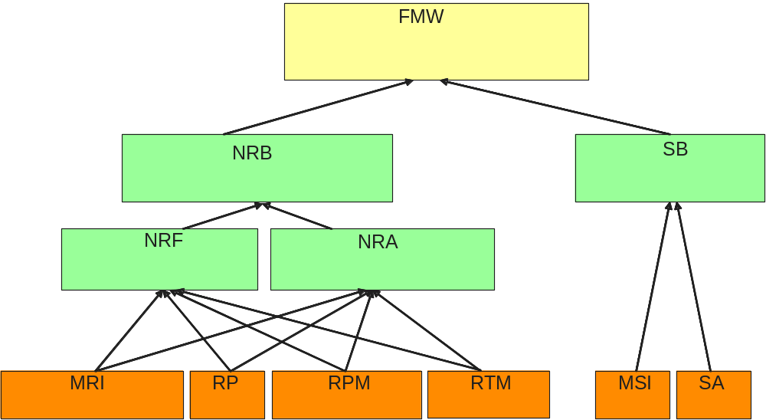

Feature added: Ethernet Service Specification

SD2-21_Ethernet_Service_Specification.doc
This document provides a recommendation on how to use MTOSI Service Management activation interfaces for the provisioning of broadband Ethernet services.

Bugs Fixed and Modifications

Bugs reported as CRs
The table below references the bugs documented in the gforge tracker (???) which have been fixed in this Release 2.1.

No | Problem description | Solution
artf1440 | File: FMW/SD/SD1-18 (top of p 10)  typo: bullet: ITU-T members + "(see… G.805)" | fix the typo and create a new version of the file
artf1440 | File: FMW/BA/TMF518_NRF (section 3.1.13)  error reference;  the file under "Product/trunk" is correct; it seems that the file in "main" is not the correct one. | No need to change the file under "Product/trunk";  instead reuse this file in main and when packaging release 2.1
artf1440 | FMW/BA/TMF518_NRF  navigation does not work in PDF (works in Word) | need to re-generate the PDF  (using the correct Word file)
artf1440 | FMW/SD/SD0-1_mTOPDictionary.pdf (section 1.2)  “TBD” left | fix the typo and create a new version of the file
artf1440 | FMW/SD/SD0-4_mTOPGuidelines_IA.pdf  "to be defined", highlighted in blue at different places | The Word file in "main" is correct (the pdf was generated from a previous version); need to regenerate the pdf in "main"and repackage.
artf1440 | FMW/SD/SD0-5_mTOPGuidelines_WebServices.pdf  section 1.1: reference to wiki on Gforge | reformulate the satement
artf1440 | FMW/SD/SD0-5_mTOPGuidelines_WebServices.pdf  section 7.2: some references are not navigable | fix the hyperlinks to relative reference
artf1440 | NetworkResourceFulfillment/SD/SD2-20_EquipmentModel.pdf  hyperlinks are not navigable | The Word file in "main" is correct; need to regenerate the pdf and check, then repackage.
artf1440 | NetworkResourceFulfillment/SD/SD1-7_DSLOverview.pdf  references should not have the "pdf" suffix | Remove the ".pdf" extension in the textToDisplay of the hyperlinks
artf1440 | ServiceBasic\BA  file "SD2-19_VoIPServiceDefinition.pdf" should not be here | "Product\trunk\ServiceBasic\BA" is correct; remove this file from "main\DDPs\ServiceBasic\BA"
artf1670 | FMW/SD/SD1-16_LayeredParameters.doc
artf1951 | TMF518_NRF
artf1965 | FMW/SD1/SD1-33_ProbableCauses
artf1997 | The operation getManagedElementsIterator is missing in ManagedElementRetrievalJms.wsdl description.  Define the operation as done in ManagedElementRetrievalHttp.wsdl file
artf1998 | The structure getManagedElementsIteratorRequest to be used as input is of type GetAllDataIteratorRequestType (in  MessageDefinitions.xsd in Framework pacakage) is empty.  Define a type for getManagedElementsIteratorRequest.
artf1999 | SD1-44 gives some example how it is possible to name the member of a LAG.  The string used is lag_fragment=XXX and it seems related to LR_LAG_FRAGMENT (30) layer.  But SD1-17 states that this layer is NOT used for naming, but just to highlight the aggreagation/fragmentation at LAG.  In addition it seems client of the LR_Ethernet. So it conflicts the general rule to use the more server LR for naming.  Define clear rules in LAG member naming. | Nigel:  SD1-18 provides patterns for naming of each of the "types" of CTP in Section 3.1 of SD1-18, Figure 38 "CTP connection layers, naming and terminationMode".  Reading the figure I think the rule applied would ideally be stated as "The naming layer is the lowest G.805 TCP/CP layer.". So a CTPs with (roughly) an AP (e.g. L) where the layer X is just a hint of the layer terminated in the server CTP (e.g. a CTP of type K - clearly in this example Layer K.Y = layer L.X) is named from the next CP up (in the case of type L in the figure this is layer Y). In the short hand form of the MTNM figures the TCP in CTP type N in layer Y is not shown (just to make the rule especially hard to state for the figures). So for the MTNM figure style the naming layer is the layer of the lowest G.805 Trail Termination, G.805 Connection Point or G.805 Termination Connection Point (labels as per Figure 2 in SD1-18). So the rule is "The naming layer is the lowest G.805 TCP/CP/Trail Termination layer.". This is not explicitly stated in SD1-18, it is only implicit from the diagram.  Bernd:  Object Name String added for 305 LR_LAG_Fragment to SD1-17, version 3.4
artf2005 | In the example table of SD1-44 v1.1 paragraph 9.2.10 page 39, the Traffic Mapping Table is reported with additional  columns "Inner VLAN ID" and "Inner Priority" and it is stated "..In order to accommodate this  situation, two more columns would be used: InnerVID and InnerPriority..".  So it needs to add in SD1-16 the following layered paramters (missing in v3.3) valid for CPTP and FP:  TrafficMappingFrom_Table_InnerVID  TrafficMappingFrom_Table_InnerPriority | TrafficMappingFrom_Table_InnerVID and  TrafficMappingFrom_Table_InnerPriority added to SD1-16, version 3.4
art2520 | The createAndActivateSubnetworkConnection() operation does not allow to provide an SNC as a resource.  It is possible to provide CCs via ccInclusionList:CrossConnect [*] = empty list.  It is possible to provide TPs, MEs, TLs and GTPs via inclusionResourceRefList:ObjectName [*] = empty list.  The requested change would allow having the ability to provide also server SNCs as a required resource for creating/  modifying an SNC.  Note Figure 123 from SD1-18 showing that SNCs can serve SNCs. | Proposal:  Enhance the description of the inclusionResourceRefList attribute as follows:  "This attribute specifies a list of Termination Points, Managed Elements, Topological Links, Subnetwork Connections and  Group Termination Points that must be used by the Subnetwork Connection. ..."
art2521 | The PM data defined in the PM File Format (SD1-30) does not provide the userLabel of the SNC associated to the PM Data. | The SNCUserLabel should be added to the PM File Format as defined in the attached document
art2352 |  | Add this operation
  The operation getActiveAlarmsIterator is missing.

Bugs fixed not reported as CRs and modifications introduced

BAs and SDs

All BAs
    - Updated sections 1.1 and 2.
    - Replaced mTOP by MTNM / MTOSI everywhere in the document

Framework
  - File: DDPs\Framework\SD\SD2-7_ObjectNaming
    - Accepted changes that appear to have been left there for some time in the past.
  - File: DDPs\Framework\SD\ SD1-17_LayerRates
    - Added new requested layer rates
  - File: DDPs\Framework\SD\ SD0-1, SD0-2, SD0-3, SD0-4, SD0-5, SD0-6
    - Removed “mTOP” from the title and the name of the documents.
  - File: DDPs\Framework\SD\ SD0-1_Dictionary
    - Added section 3.1 (terms which were previously defined in the FMW BA)
  - File: DDPs\Framework\SD\ SD1-16_LayeredParameters
    - Added TrafficMappingFrom_Table_InnerVID and TrafficMappingFrom_Table_InnerPriority to traffic mapping table

      - MRI
  - File: DDPs\ManageResourceInventory\BA\TMF518_MRI
    - Section 3.3.1.4: Remove some inaccurate text and adding further explanation concerning the Merge with Overwrite case.

Resource Performance Management
  - File: DDPs\ResourcePerformanceManagement\SD1-30_PMFileFormat
    - Added ConnectionUserLabel

Service Basic
  - File: DDPs\ServiceBasic\BA\TMF518_SB
    - For CFS and RFS: change sapReferenceList into sapList
    - For SAP and SAP Specification: add describedByList
    - For Service Definition and Service Template:
      - change characterizedByList into describedByList,
      - add containedByServiceSpecRef and containsServiceSpecRefList
    - For SSC: add id, unique, extensible
    - For SCV: add rangeInterval, validFor, containsSSCVList

Service Activation
  - File DDPs\ServiceActivation\BA\Part2\TMF518_SA_2
    - In order to synchronize the BA with the IIS:
      - removed feasibilityFlag and offeredActivationTime from the cfsCreationEvent and the list of response parameters in Table 3-3 of TMF518_SA_2
      - updated description for “list of Cfs”
      - removed “feasible” from the list of response parameters as it does not appear in the operation signatures in Table 3-3 of TMF518_SA_2 or in the associated XSD
      - removed productName from all the responses in TMF518_SA_2
      - made a note (in two places) that serviceRequestRef is handled in the message header in the IIS.
      - updated the first sentence of the Behavior statement in Table 3-4

    - Added a note in Section 3.4.1 that says the various failure events are not exceptions but rather partial failures.
      - Also, removed the reasonForException parameter in the four failure events since these are being treated as replies not exceptions (and it is the exceptions that have a “reason” field).
    - Removed serviceRequestRef and productName in both TMF518_SA_1 and SaExceptions.xsd since these are unnecessary. The correction is done via the message header as noted.

IAs

General
- HTML tags deleted from all documentations in all Resource related DDPs.

Framework
- Interfaces::CommonObjectProvisioning::setUserLabel
Duplicate return parameter deleted.
- Type Definitions::State
attribute1 deleted.
- Operation Exceptions: INVALID_FILTER_DEFINITION, INVALID_TOPIC, NOTIFICATION_SERVICE_PROBLEM, UNSUPPORTED_COMPRESSION_FORMAT and UNSUPPORTED_PACKING_FORMAT added.
- Interfaces::NotificationBrokerService::subscribe: Exceptions added.
- Interfaces::NotificationBrokerService::unsubscribe: Exceptions added.
- Interfaces::NotificationProducerService::subscribe: Exceptions added.
- Interfaces::NotificationProducerService::unsubscribe: Exceptions added.
- Interfaces::NotificationProducerService::unsubscribe: Exceptions added.
- Operation Exceptions: Names converted into upper camel case.
- Operation Exceptions: InvalidInputObjectDoesNotExist added.
- Operation Exceptions: InvalidInputUnsupportAttributesOrValues added.
- Operation Exceptions: InvalidInputUnsupportedObjectTypes added.
- Operation Exceptions: PolicyViolation added.
- Interfaces::NotificationBrokerService: Parameters completed.
- Interfaces::NotificationConsumerService: Parameters completed.
- Interfaces::NotificationProducerService: Parameters completed.
- FMW Notification Handling Class Diagram added.
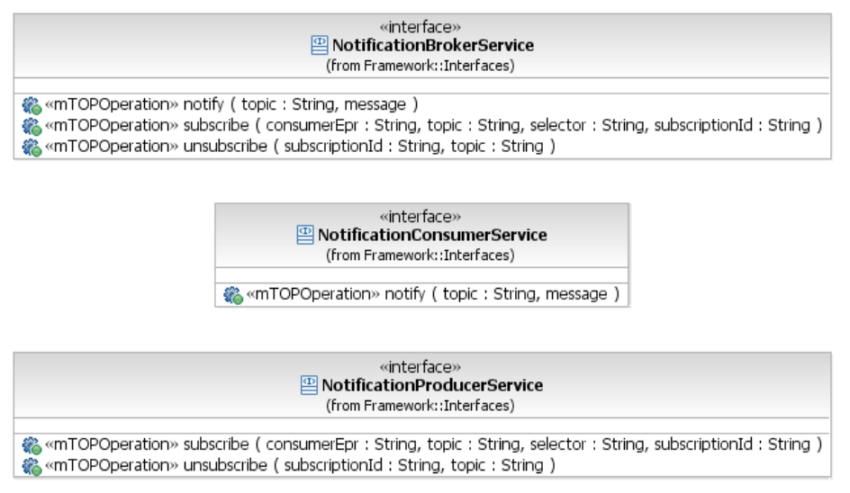
- Type Definitions::MultiEventInventoryAttributes: added.
- Data Object Classes::CommonObjectInfo::additionalInfo: Note "In the IIS this attribute is defined as vendorExtensions." added.
- Type Definitions::CommonObjectSetData::additionalInfo: Note "In the IIS this attribute is defined as vendorExtensions." added.
- Notifications::ObjectCreationNotification: Attribute object added.

ManageResourceInventory
- Type Definitions::ManagedElementFilter::resourceState
Default value UNKNOWN re-set.
- Interfaces::FlowDomainRetrievalService::getConnectivityAwareness::Documentation
"R_TMF518_MRI_II_0154" replaced by "R_TMF518_MRI_V_0154"
- Interfaces::TerminationPointRetrievalService::getTerminationPointGroupingRelationships
"and GTPs" added to the documentation in "- the names of all TP Pools << and GTPs>> associated to a provided TP".
- Interfaces::ConnectionRetrievalService::getIntendedRoute: New input parameter isHigherOrderCcListIncluded added.
- Interfaces::ConnectionRetrievalService::getIntendedRoute: Output parameter intendedRoute replaced by route to harmonise with IIS.
- Interfaces::FlowDomainRetrievalService::getAllFlowDomains: Exceptions INVALID_INPUT and ENTITY_NOT_FOUND added.
- Interfaces::ResourceInventoryRetrievalService::getInventory::whereAndHowToReply: Reference to SD2-5_Communication_Styles supporting document added.
- Interfaces::ResourceInventoryRetrievalService::getInventory: Exceptions UNSUPPORTED_COMPRESSION_FORMAT and UNSUPPORTED_PACKING_FORMAT added.
- Interfaces::FlowDomainRetrievalService::getAllFlowDomains: mdRef added as input parameter.
- Interfaces::OperationsSystemRetrievalService::getSubordinateOperationsSystem: subordinateOs replaced by os. subordinateOsRef replaced by osRef.
- Interfaces::TerminationPointRetrievalService::getAllEdgePoints: edgeTpList replaced by tpList.
- Interfaces::TerminationPointRetrievalService::getAllFloatingTerminationPoints: ftpList replaced by tpList.
- Interfaces::TerminationPointRetrievalService::getAllPhysicalTerminationPoints: ptpList replaced by tpList.
- Interfaces::TerminationPointRetrievalService::getAllPhysicalTerminationPointsWithoutFtps: ptpList replaced by tpList.
- Interfaces::TerminationPointRetrievalService::getAllSupportedPhysicalTerminationPoints: ptpList replaced by tpList.
- Interfaces::TerminationPointRetrievalService::getContainedCurrentConnectionTerminationPoints: ctpList replaced by tpList.
- Interfaces::TerminationPointRetrievalService::getContainedInUseConnectionTerminationPoints: ctpList replaced by tpList.
- Interfaces::TerminationPointRetrievalService::getContainedPotentialConnectionTerminationPoints: ctpList replaced by tpList.
- Interfaces::TrafficConditioningProfileRetrievalService::getAllTrafficConditioningProfiles: mdRef added as input parameter.
- Interfaces::ResourceInventoryUpdateService::updateInventory: Exception InvalidInput replaced by InvalidInputObjectDoesNotExist, InvalidInputUnsupportedObjectTypes and InvalidInputUnsupportAttributesOrValues.
- Interfaces::ResourceInventoryUpdateService::updateInventory: Exception PolicyViolation added.
- Interfaces::TopologicalLinkRetrievalService::getAllTopologicalLinksOfFd: Documentation updated.
- Type Definitions::InventoryData: moved to NRF DDP.

NetworkResourceAssurance
- Type Definitions::PerformanceMonitoringParameter::pmThresholdList
Attribute pmThresholdList re-created.
- Type Definitions::correlatedNotifications
"correlatedNotifications" replaced by "CorrelatedNotifications".
- NetworkResourceFulfillment model imported.
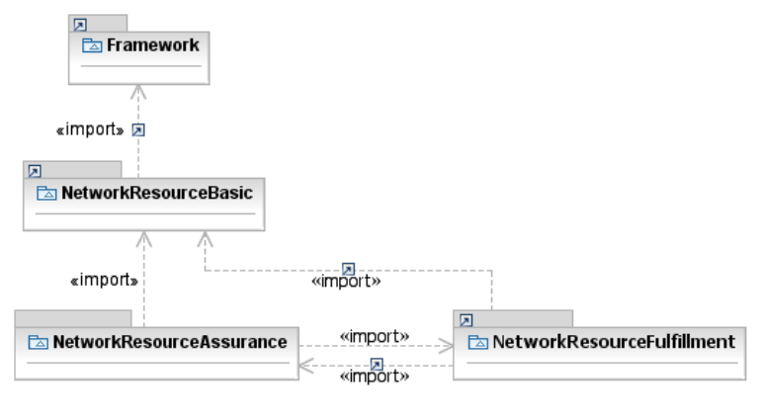
- The "illustrative" association TpContainsPmps has been marked as abstract.
- Type Definitions::ItuArcStateOrStatus: Enumeration converted into a Data Type; name replaced by "ItuArcStateAndStatusList"; multiplicity of all attributes defined as [0..1]; type of attributes NalmQIInterval and NalmTIInterval changed to Integer.
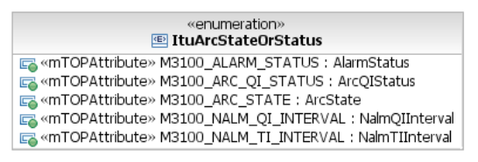 → 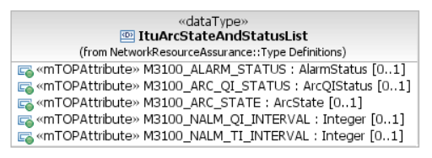
- Type Definitions::NalmQIInterval and Type Definitions::NalmTIInterval: deleted.
- Data Object Classes::EquipmentProtectionGroup::ituArcStateAndStatusList,
Data Object Classes::ProtectionGroup::ituArcStateAndStatusList:
multiplicity changed from [*] to [0..1]; default value deleted.
- Type Definitions::ItuArcStateAndStatusList: M3100_STATE added.
- Type Definitions: M3100ArcState added with M3100_ALARM_STATUS, M3100_ARC_QI_STATUS, M3100_ARC_STATE moved from State data type in NRB.
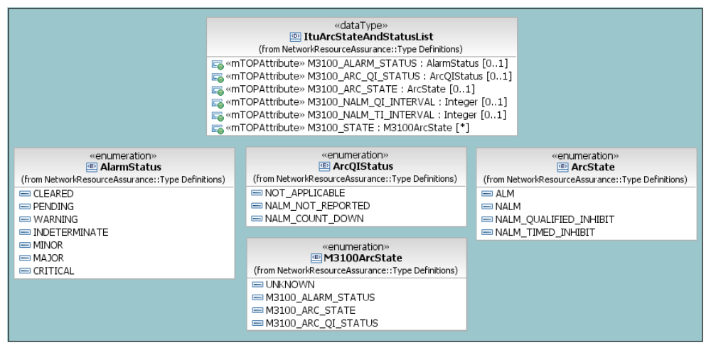

NetworkResourceBasic
- Enumeration Type Definitions::ResourceState
All resource state sub states copied directly into ResourceState enumeration; all sub states deleted.
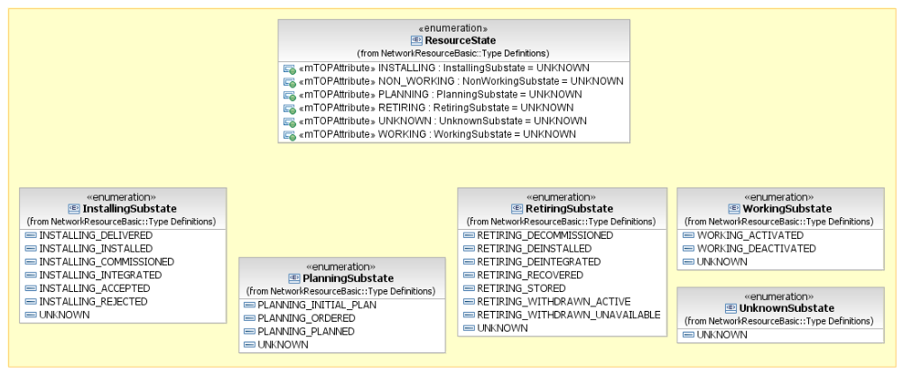→
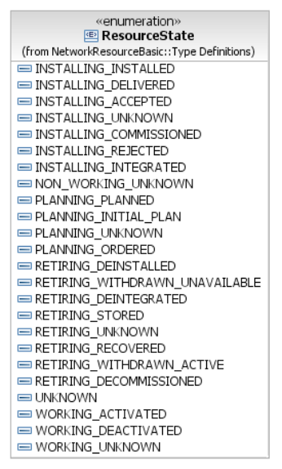
- Type Definitions::ItuStateOrStatus
Enumeration converted into a Data Type; name replaced by "ItuStateAndStatusList"; multiplicity of all non list attributes changed to [0..1].
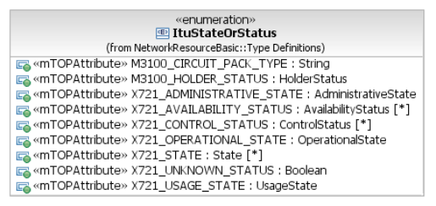 → 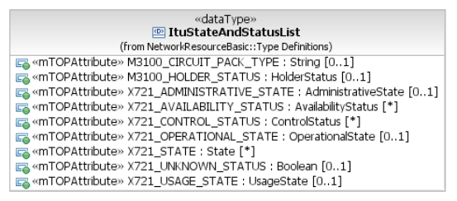
- Data Object Classes::CommonResourceInfo::ituStateAndStatusList
Multiplicity changed from [*] to [0..1]; default value deleted.
- Type Definitions::ItuStateOrStatusNameValuePair
Deleted; since was never used.
- Type Definitions::ItuStateOrStatusName
Deleted; since was never used.
- Data Object Classes::CommonResourceInfo::meiAttributes: added.
- Type Definitions::State: M3100_ALARM_STATUS, M3100_ARC_QI_STATUS, M3100_ARC_STATE moved to a new data type M3100ArcState in NRA.
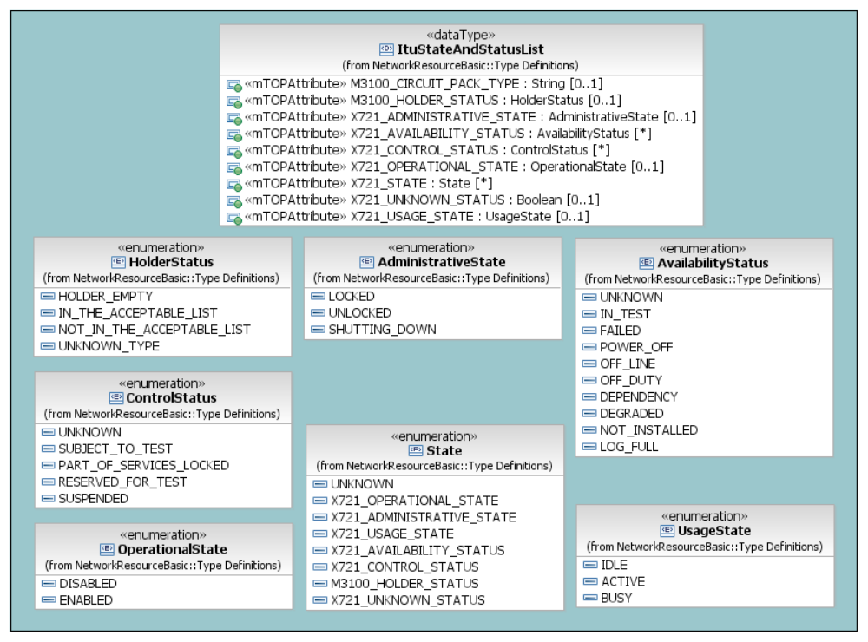

NetworkResourceFulfillment
- Data Object Classes::Associations::HasSubordinate
Made the subordinateOS side of the relationship navigable.
- Data Object Classes::Associations::SncHasZEndGtps
Made the GroupTerminationPoint (zEndTpList) side of the relationship navigable.
- Associations::RouteChangeNotificationHasRoute
Relationship moved to Notifications::Associations and missing Route object class added.
- Data Object Classes::Equipment::ituArcStateAndStatusList,
Data Object Classes::EquipmentHolder::ituArcStateAndStatusList,
Data Object Classes::FlowDomain::ituArcStateAndStatusList;
Data Object Classes::FlowDomainFragment::ituArcStateAndStatusList,
Data Object Classes::GroupTerminationPoint::ituArcStateAndStatusList,
Data Object Classes::OperationsSystem::ituArcStateAndStatusList,
Data Object Classes::ManagedElement::ituArcStateAndStatusList,
Data Object Classes::MatrixFlowDomain::ituArcStateAndStatusList,
Data Object Classes::MultiLayerSubNetwork::ituArcStateAndStatusList,
Data Object Classes::SubNetworkConnection::ituArcStateAndStatusList,
Data Object Classes::TerminationPoint::ituArcStateAndStatusList,
Data Object Classes::TopologicalLink::ituArcStateAndStatusList:
multiplicity changed from [*] to [0..1]; default value deleted.
- Associations::CcHasZEndGtps
Relationship added.
- Data Object Classes::SubNetworkConnection::correlationIdentifier
Text "Changes in the value of this attribute lead to an AVC notification." deleted from documentation.
- Data Object Classes::Associations::GtpContainsCtps
Made listOfTps public.
Renamed listOfTps to "containedTpRefList".
Made relationship non-abstract.
- Data Object Classes::Associations::GtpIsMemberOfTpPool
Made relationship name compliant to upper camel case.
Made tpPoolRef non-navigable and removed the role name.
- Data Object Classes::TrafficConditioningProfile
Inheritance relationship added between TrafficConditioningProfile and CommonResourceInfo.
- Type Definitions::CrossConnect::connectionId::Documentation
Current documentation "This attribute represents the identifier of the associated Connection." replaced by "This attribute represents the control plane identifier. It corresponds to the Connection Name attribute in G.7713. Note that also the Cross Connection points to its superior Connection." To align it with the IIS description.
- Data Object Classes::FlowDomainFragment::a/zEndTpDataList
TerminationPointData associated as type to aEndTpDataList and zEndTpDataList.
- Data Object Classes::SubNetworkConnection::a/zEndTpDataList
TerminationPointData associated as type to aEndTpDataList and zEndTpDataList.
- Data Object Classes::FlowDomainFragment: Traceability added to the description.
- Data Object Classes::FlowDomainFragment: asapRef attribute added.
- Data Object Classes::SncIsCharacterisedByRoutes: Association made non-navigable; i.e., route attribute removed from SubNetworkConnection.
- Data Object Classes::TopologicalLink: Naming relationship to FlowDomain added.
- Data Object Classes::OperationsSystem: "Manages" and "Offers" relationships added. Corresponding class diagram (NRF OS Relationships Class Diagram) created.
- Data Object Classes::Equipment::SupportedBy relationship: made non-navigable.
- Data Object Classes::Equipment::Supports relationship: made non-navigable.
- Data Object Classes::OperationsSystem::HasSubordinate relationship: made non-navigable.
- Data Object Classes::TerminationPoint::AssociatedWith relationship: made non-navigable.
- Data Object Classes::TransmissionDescriptor::serviceCategory: added with profile=corba.
- Data Object Classes::TransmissionDescriptor::conformanceDefinition: added with profile=corba.
- Type Definitions::InventoryData: moved from MRI DDP.
- Type Definitions::InventoryData: defined and corresponding "Resource Inventory Layout Class Diagram" added.
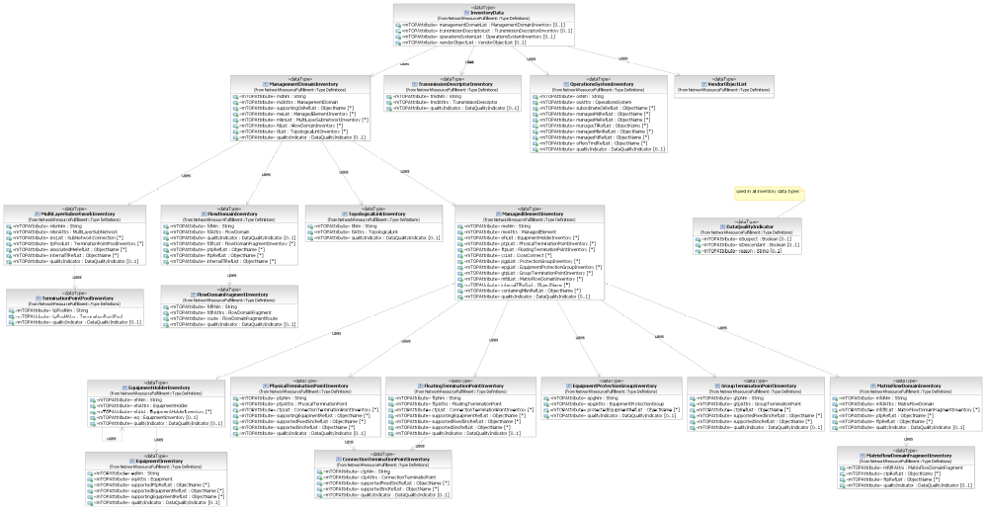
- Data Object Classes::SncHasAEndGtps: Made aEndTpList non navigable.
- Data Object Classes::SncHasZEndGtps: Made zEndTpList non navigable.
- Notifications::SoftwareBackupStatusNotification::meName: Deleted.
- Notifications::SoftwareBackupStatusNotification::neTime: Deleted.
- Notifications::SoftwareBackupStatusNotification::emsTime: Deleted.
- Notifications::SoftwareBackupStatusNotification: Inherits from EventInformation instead of CommonEventInformation.
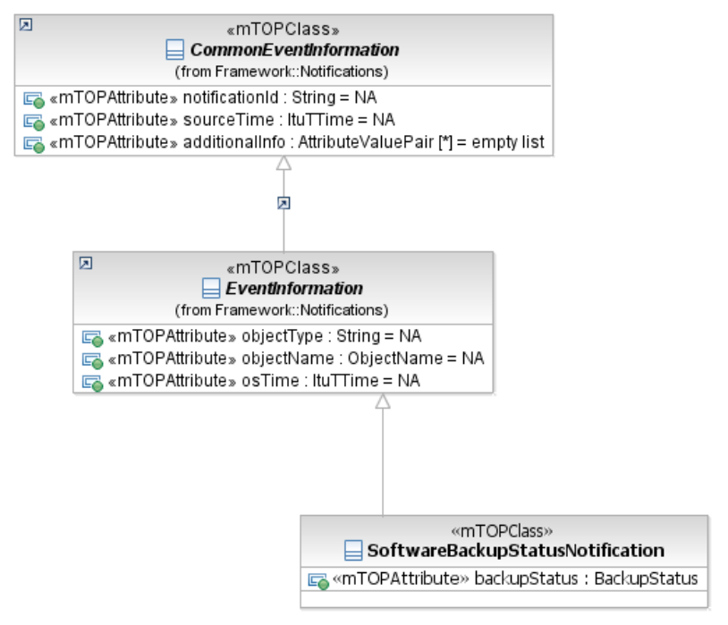

ResourcePerformanceManagement
- Interfaces::PerformanceManagementRetrievalService::getHistoryPerformanceMonitoringData: String added as data type to destination, password and userName parameters.

ResourceProvisioning
- Documentation deleted from DDP.

ResourceTroubleManagement
- Documentation deleted from DDP.
- Interfaces::AlarmControlService::setResourceAlarmReportingOff
Deleted the exceptions from the documentation.
- Interfaces::AlarmControlService::setAlarmReporting: Input parameter layerRate added and specification completed.
- Interfaces::ProtectionRetrievalService: Operation getContainingProtectionGroupNames() added.
- Interfaces::AlarmRetrievalService::getActiveAlarms: Exceptions UNSUPPORTED_COMPRESSION_FORMAT and UNSUPPORTED_PACKING_FORMAT added.
- Interfaces::TransmissionDescriptorControlService::verifyTransmissionDescriptorAssignment: "profile=corba" removed from operation. Exception NE_COMM_LOSS replaced by COMM_LOSS.
- Interfaces::MaintenanceControlService::getActiveMaintenanceOperations: Exception NOT_IN_VALID_STATE added.
- Interfaces::MaintenanceControlService::performMaintenanceOperation: Exception NOT_IN_VALID_STATE added.
- Interfaces::AlarmSeverityAssignmentProfileControlService::createAlarmSeverityAssignmentProfile::newAsap: "newASAP" renamed by "newAsap".
- Interfaces::AlarmSeverityAssignmentProfileControlService::modifyAlarmSeverityAssignmentProfile::modifiedAsap: "modifiedASAP" renamed by "modifiedAsap".
- Interfaces::AlarmHandlingService::acknowledgeAlarms: parameter notepad added.
- Interfaces::AlarmHandlingService::acknowledgeAlarms: parameter username added.
- Interfaces::AlarmHandlingService::unacknowledgeAlarms: parameter notepad added.
- Interfaces::AlarmHandlingService::unacknowledgeAlarms: parameter username added.
- Interfaces::AlarmRetrievalService::getActiveAlarms::whereAndHowToReply: Reference to supporting document SD2-5_Communication_Styles added.
- Type Definitions::ActiveAlarmFilter::scope: Addressing of managed elements in case of remote units clarified in the documentation.
- Interfaces::AlarmSeverityAssignmentProfileControlService::createAlarmSeverityAssignmentProfile: Parameter targetOperationsSystem deleted.

UML Profile
- Added a note to the UML Profile documentation to explain the ongoing usage of the term "mTOP" here.

IISs

Framework
  - File: DDPs\Framework\IIS\xsd\MartMessages.xsd
    - Added entityNotFound as exception for operations "getProcessState"and "terminateProcess"
  - File: DDPs\NetworkResourceBasic\IIS\xsd\CommonResourceInfo.xsd
File: DDPs\Framework\IIS\xsd\GeneralDefinitions.xsd
    - Moved type “ObjectEnumType” from the second file to the first file above.

NRB
  - File: DDPs\NetworkResourceBasic\IIS\xsd\ITU-T-Definitions.xsd
    - Removed all the artefacts related to ituArcStateAndStatusList.
These artefacts have been moved to a new file in the NRA DDP (“ITU-T-ArcDefinitions.xsd”):
m3100.AlarmStatus
m3100.ArcState
m3100.NALMTIInterval
m3100.NALMQIInterval
m3100.ArcQIStatus
    - Created a type “ituStateAndStatusList” replacing the “ituParameters” element.
This “ituStateAndStatusList” is used in type “CommonResourceInfoType” (see the modified “CommonResourceInfo.xsd” file)
    - Modified “X721.OperationalStateType” type from Boolean to enumeration (DISBALED, ENABLED)
  - File: DDPs\NetworkResourceBasic\IIS\CommonResourceInfo.xsd
    - Created element
<xsd:element name="ituStateAndStatusList" type="itu:ItuStateAndStatusList" />
in the “CommonResourceInfoType” type.
  - File: DDPs\NetworkResourceBasic\IIS\xsd\LayerRates.xsd
    - Added the following late rates:
LR_LAG_Fragment.
LR_DSR_10Megabit_Ethernet
LR_DSR_100Megabit_Ethernet
LR_DSR_2Gigabit_Ethernet
LR_DSR_2.5Gigabit_Ethernet
LR_DSR_10.7Gigabit_Ethernet
LR_DSR_11.1Gigabit_Ethernet
LR_DSR_10Gigabit_Ethernet_LAN
LR_DSR_10Gigabit_Ethernet_WAN
LR_DSR_40Gigabit_Ethernet
LR_DSR_100Gigabit_Ethernet
LR_DSR_OTU2e
LR_DSR_OTU3e1
LR_DSR_OTU3e2
LR_DSR_OTU4
LR_OCH_Data_Unit_0
LR_OCH_Data_Unit_2e
LR_OCH_Data_Unit_3e1
LR_OCH_Data_Unit_3e2
LR_OCH_Data_Unit_4
LR_OCH_Data_Unit_Flexible
LR_OCH_Transport_Unit_2e
LR_OCH_Transport_Unit_3e1
LR_OCH_Transport_Unit_3e2
LR_OCH_Transport_Unit_4
LR_Optical_Physical_Section
LR_Optical_Physical_Section_Multilane
LR_Section_OC3072_STS3072_and_RS_STM1024
LR_Line_OC3072_STS3072_and_MS_STM1024
LR_DSR_OC3072_and_STM1024

NRA
  - New file: DDPs\NetworkResourceAssurance\IIS\xsd\ITU-T-ArcDefinitions.xsd
    - This module contains the XML Schema type definitions of all the supported Alarm ITU-T parameters.
Previously there were in the NRB file ITU-T-Definitions.xsd:
m3100.AlarmStatus
m3100.ArcState
m3100.NALMTIInterval
m3100.NALMQIInterval
m3100.ArcQIStatus
  - File: DDPs\ NetworkResourceAssurance\IIS\xsd\Epg.xsd
    - Added “ituArcStateAndStatusList”
  - File: DDPs\ NetworkResourceAssurance\IIS\xsd\Pg.xsd
    - Added “ituArcStateAndStatusList”

NRF
  - File: DDPs\ NetworkResourceFulfillment\IIS\xsd\Eh.xsd
    - Added “ituArcStateAndStatusList”
  - File: DDPs\ NetworkResourceFulfillment\IIS\xsd\Eq.xsd
    - Added “ituArcStateAndStatusList”
  - File: DDPs\ NetworkResourceFulfillment\IIS\xsd\Fd.xsd
    - Added “ituArcStateAndStatusList”
    - Added “ConnectivityAwarenessType”
  - File: DDPs\ NetworkResourceFulfillment\IIS\xsd\Fdfr.xsd
    - Added “ituArcStateAndStatusList”
  - File: DDPs\ NetworkResourceFulfillment\IIS\xsd\Gtp.xsd
    - Added “ituArcStateAndStatusList”
  - File: DDPs\ NetworkResourceFulfillment\IIS\xsd\Me.xsd
    - Added “ituArcStateAndStatusList”
  - File: DDPs\ NetworkResourceFulfillment\IIS\xsd\Mlsn.xsd
    - Added “ituArcStateAndStatusList”
  - File: DDPs\ NetworkResourceFulfillment\IIS\xsd\Os.xsd
    - Added “ituArcStateAndStatusList”
  - File: DDPs\ NetworkResourceFulfillment\IIS\xsd\Snc.xsd
    - Added “ituArcStateAndStatusList”
    - Added “SubnetworkConnectionModeOfOperationType”
    - Added “mustRetainOldSnc”
  - File: DDPs\ NetworkResourceFulfillment\IIS\xsd\Tl.xsd
    - Added “ituArcStateAndStatusList”
  - File: DDPs\ NetworkResourceFulfillment\IIS\xsd\Ptp.xsd
    - Added “ituArcStateAndStatusList”
Added “asapRef”
  - File: DDPs\ NetworkResourceFulfillment\IIS\xsd\Ftp.xsd
    - Added “ituArcStateAndStatusList”
Added “asapRef”
  - File: DDPs\ NetworkResourceFulfillment\IIS\xsd\Ctp.xsd
    - Added “ituArcStateAndStatusList”
Added “asapRef”
  - File: DDPs\NetworkResourceFulfillment\IIS\xsd\FdfrRoute.xsd
    - Added actualState,
Added vendorExtensions
  - File: DDPs\NetworkResourceFulfillment\IIS\xsd\Mfd.xsd
    - Added tmdState
Added “ituArcStateAndStatusList”
  - File: DDPs\NetworkResourceFulfillment\IIS\xsd\ResourceInventoryLayout.xsd
    - Added managesFdRefList in OperationsSystemInventoryType

RP
  - File: DDPs\ResourceProvisioning\IIS\xsd\EquipmentProvisioningMessages.xsd
    - Added “isReportingAlarm” to “EquipmentCreateDataType”
    - Replaced:

<xsd:element name="manufacturer"
type="gen:ManufacturerType" minOccurs="0"/>
by
<xsd:element name="manufacturer"
type="xsd:string" minOccurs="0"/>

  - File: DDPs\ResourceProvisioning\IIS\xsd\EventBackupStatus.xsd
    - Added emsTime
Added neTime
Added osTime

- File: DDPs\ResourceProvisioning\IIS\xsd\TransmissionDescriptorControlMessages.xsd
    - Delete operation « validateTransmissionDescriptorAssignmentToObject” (request, response, exception)
- File: DDPs\ResourceProvisioning\IIS\wsdl\TransmissionDescriptorControlHttp.wsdl
    - Delete operation « validateTransmissionDescriptorAssignmentToObject”
- File: DDPs\ResourceProvisioning\IIS\wsdl\TransmissionDescriptorControlJms.wsdl
    - Delete operation « validateTransmissionDescriptorAssignmentToObject”
- File: DDPs\ResourceProvisioning\IIS\wsdl\TransmissionDescriptorControlMessages.wsdl
    - Delete operation « validateTransmissionDescriptorAssignmentToObject”

  - File: DDPs\ResourceProvisioning\IIS\xsd\CommonResourceProvisioningMessages.xsd
    - Added “modifiedVendorExtensions” as parameter of the setCommonAttributesRequest request

  - File: DDPs\ResourceProvisioning\IIS\xsd\ConnectionControlMessages.xsd
    - Added “containingMlsnRef” to “createAndActivateSubnetworkConnection”
    - Added “containingMlsnRef“ to “createSubnetworkConnection”
    - Added “errorReason” to “deleteSubnetworkConnection”
    - Replaced “com:TerminationPointRoleInSubnetworkConnectionType” by “com:EndPointRoleListType”
    - Added “objectInUse” to “checkValidSubnetworkConnectionException”
    - Added “timeSlotInUse”, “notInValidState” to “createAndActivateSubnetworkConnectionException”
    - Added “unableToComply” to deleteSubnetworkConnectionException”
    - Added “SNCs” to the annotation associated to the “inclusionResourceRefList” parameter in the “SubnetworkConnectionCreateDataType” and “SubnetworkConnectionModifyDataType” data structures.

  - File: DDPs\ResourceProvisioning\IIS\xsd\FlowDomainControlMessages.xsd
    - Added “containingFdRef” to “createAndActivateFlowDomainFragment”
    - Added “containingMeRef” to “createMatrixFlowDomain”
    - Added “tpInvalidEndPoint” to “createAndActivateFlowDomainFragmentException”
    - Added “accessDenied” to “deactivateAndDeleteFlowDomainFragmentException”
    - Added “objectInUse” to “deAssociateConnectionlessPortTerminationPointsFromFdException”

  - File: DDPs\ResourceProvisioning\IIS\xsd\GuiCutThroughControlMessages.xsd
    - Added “commLoss”, “unableToComply” to “destroyGuiCutThroughException”
    - Added “commLoss”, “unableToComply”, “notImplemented” to “getGuiCutThroughProfileInfoException”
    - Added “commLoss” to “launchGuiCutThroughException”

  - File: DDPs\ResourceProvisioning\IIS\xsd\SoftwareAndDataControlMessages.xsd
    - Added “unableToComply” to “abortManagedElementBackupException”
    - Added “unableToComply” to “backupManagedElementException”
    - Added “unableToComply” to “getBackupListException”
    - Added “unableToComply” to “getManagedElementBackupStatusException”

  - File: DDPs\ResourceProvisioning\IIS\xsd\TerminationPointControlMessages.xsd
    - Added “commLoss” to “deleteGroupTerminationPointException”
    - Added “commLoss”, “unableToComply” to “deleteTerminationPointPoolException”
    - Added “commLoss”, “notImplemented” to “setTerminationPointDataException”
    - Added “GroupTerminationPointCreateDataType” and “TerminationPointPoolCreateDataType”

  - File: DDPs\ResourceProvisioning\IIS\xsd\TopologicalLinkControlMessages.xsd
    - Added “commLoss” to “deleteTopologicalLinkException”
    - Added “containingResourceRef” to “TopologicalLinkCreateDataType”

  - File: DDPs\ResourceProvisioning\IIS\xsd\TrafficConditioningProfileControlMessages.xsd
    - Added “unableToComply” to “createTrafficConditioningProfileException”
    - Added “unableToComply” to “deleteTrafficConditioningProfileException”
    - Added “unableToComply” to “modifyTrafficConditioningProfileException”

  - File: DDPs\ResourceProvisioning\IIS\xsd\TransmissionDescriptorControlMessages.xsd
    - Added “unableToComply” to “createTransmissionDescriptorException”
    - Added “unableToComply” to “deleteTransmissionDescriptorException”
    - Added “unableToComply” to “modifyTransmissionDescriptorException”

MRI
  - File: DDPs\ManageResourceInventory\IIS\xsd\TransmissionDescriptorRetrievalMessages.xsd
    - Removed:
<xsd:element ref="msg:entityNotFound"/>
<xsd:element ref="msg:invalidInput"/>
from getAllTransmissionDescriptorsException
    - Removed:
<xsd:element ref="msg:tooManyOpenIterators"/>
from getTransmissionDescriptorException
- File: DDPs\ManageResourceInventory\IIS\xsd\ConnectionRetrievalMessages.xsd
    - Added operation « getSubnetworkConnectionModeOfOperation” (request, response, exception)
- File: DDPs\ManageResourceInventory\IIS\wsdl\ConnectionRetrievalHttp.wsdl
    - Added operation « getSubnetworkConnectionModeOfOperation”
- File: DDPs\ManageResourceInventory\IIS\wsdl\ConnectionRetrievalJms.wsdl
    - Added operation « getSubnetworkConnectionModeOfOperation”
- File: DDPs\ManageResourceInventory\IIS\wsdl\ConnectionRetrievalMessages.wsdl
    - Added operation « getSubnetworkConnectionModeOfOperation”

- File: DDPs\ManageResourceInventory\IIS\xsd\ EquipmentInventoryRetrievalMessages.xsd
    - Changed “equipmentName” into “equipmentRef” in “GetSupportEquipmentRequestType”
    - Changed “ei:EquipmentOrEquipmentHolderListType” into a list of “equipment” for:
      - “getAllSupportingEquipmentResponse”
      - “getSupportingEquipmentResponse”
      - “getSupportedEquipmentResponse”

- File: DDPs\ManageResourceInventory\IIS\xsd\FlowDomainRetrievalMessages.xsd
    - Added operation « getConnectivityAwareness” (request, response, exception)
- File: DDPs\ManageResourceInventory\IIS\wsdl\FlowDomainRetrievalHttp.wsdl
    - Added operation « getConnectivityAwareness”
- File: DDPs\ManageResourceInventory\IIS\wsdl\FlowDomainRetrievalJms.wsdl
    - Added operation « getConnectivityAwareness”
- File: DDPs\ManageResourceInventory\IIS\wsdl\FlowDomainRetrievalMessages.wsdl
    - Added operation « getConnectivityAwareness”

  - File: DDPs\ManageResourceInventory\IIS\xsd\FlowDomainRetrievalMessages.xsd
    - Added “notImplemented” to getAllManagedElementsException
  - File: DDPs\ManageResourceInventory\IIS\xsd\TerminationPointRetrievalMessages.xsd
    - Corrected “getAssociatedTerminationPointsWrtTmdException”

RTM
  - File: DDPs\ ResourceTroubleManagement\IIS\xsd\ AlarmSeverityAssignmentProfileControlMessages.xsd
    - Added “objectInUse” to deleteAlarmSeverityAssignmentProfileException
  - File: DDPs\ ResourceTroubleManagement\IIS\xsd\ MaintenanceControlMessages.xsd
    - Added “resourceRef” to performMaintenanceOperation
  - File: DDPs\ ResourceTroubleManagement\IIS\xsd\ AlarmControlMessages.xsd
File: DDPs\ ResourceTroubleManagement\IIS\ wsdl\AlarmControl\ AlarmControlPortType.wsdl
File: DDPs\ ResourceTroubleManagement\IIS\ wsdl\AlarmControl\ AlarmControlMessages.wsdl
File: DDPs\ ResourceTroubleManagement\IIS\ wsdl\AlarmControl\ AlarmControlJms.wsdl
File: DDPs\ ResourceTroubleManagement\IIS\ wsdl\AlarmControl\ AlarmControlHttp.wsdl
    - Replaced “setAlarmReportingOff”, “setAlarmReportingOn”, “setGtpAlarmReportingOff”, “setGtpAlarmReportingOn”
By a single operation : “setAlarmReporting”
  - File: DDPs\ ResourceTroubleManagement\IIS\ wsdl\ AlarmRetrieval\ AlarmRetrievalPortType.wsdl
File: DDPs\ ResourceTroubleManagement\IIS\ wsdl\ AlarmRetrieval\ AlarmRetrievalMessages.wsdl
File: DDPs\ ResourceTroubleManagement\IIS\ wsdl\ AlarmRetrieval\ AlarmRetrievalJms.wsdl
File: DDPs\ ResourceTroubleManagement\IIS\ wsdl\ AlarmRetrieval\ AlarmRetrievalHttp.wsdl
    - Added “getActiveAlarmsIterator” operation

RPM
  - File: DDPs\ResourcePerformanceManagement\IIS\xsd\ThresholdCrossingAlertControlMessages.xsd
    - Removed operation « getAllTcaParameterProfileNames” (request, response, exception)
    - Removed operation « getTcaParameterProfileNamesIterator” (request, response, exception)
    - Removed operation « setTcaParameterProfilePointer” (request, response, exception)
    - Added « tcaParameterProfile” as output parameter to the “setTcaParameterProfile” operation
- File: DDPs\ ResourcePerformanceManagement \IIS\wsdl\ ThresholdCrossingAlertControl\ ThresholdCrossingAlertControlPortType.wsdl
    - Removed operation « getAllTcaParameterProfileNames”
    - Removed operation « getTcaParameterProfileNamesIterator”
    - Removed operation « setTcaParameterProfilePointer”
- File: DDPs\ ResourcePerformanceManagement \IIS\wsdl\ ThresholdCrossingAlertControl \ ThresholdCrossingAlertControlMessages.wsdl
    - Removed operation « getAllTcaParameterProfileNames”
    - Removed operation « getTcaParameterProfileNamesIterator”
    - Removed operation « setTcaParameterProfilePointer”
- File: DDPs\ ResourcePerformanceManagement \IIS\wsdl\ ThresholdCrossingAlertControl \ ThresholdCrossingAlertControlJms.wsdl
    - Removed operation « getAllTcaParameterProfileNames”
    - Removed operation « getTcaParameterProfileNamesIterator”
    - Removed operation « setTcaParameterProfilePointer”
- File: DDPs\ ResourcePerformanceManagement \IIS\wsdl\ ThresholdCrossingAlertControl \ ThresholdCrossingAlertControlHttp.wsdl
    - Removed operation « getAllTcaParameterProfileNames”
    - Removed operation « getTcaParameterProfileNamesIterator”
    - Removed operation « setTcaParameterProfilePointer”

  - File: DDPs\ResourcePerformanceManagement\IIS\xsd\ PerformanceManagementRetrievalMessages.xsd
    - Removed operation « getAllPerformanceMonitoringPointNames” (request, response, exception)
    - Removed operation « getPerformanceMonitoringPointNamesIterator” (request, response, exception)
    - Added “userName", “password” and “destination” as input parameters to the “getHistoryPerformanceMonitoringData”operation
- File: DDPs\ ResourcePerformanceManagement \IIS\wsdl\ PerformanceManagementRetrieval\ PerformanceManagementRetrievalPortType.wsdl
    - Removed operation « getAllPerformanceMonitoringPointNames”
    - Removed operation « getPerformanceMonitoringPointNamesIterator”
- File: DDPs\ ResourcePerformanceManagement \IIS\wsdl\ PerformanceManagementRetrieval\ PerformanceManagementRetrievalMessages.wsdl
    - Removed operation « getAllPerformanceMonitoringPointNames”
    - Removed operation « getPerformanceMonitoringPointNamesIterator”
- File: DDPs\ ResourcePerformanceManagement \IIS\wsdl\ PerformanceManagementRetrieval\ PerformanceManagementRetrievalJms.wsdl
    - Removed operation « getAllPerformanceMonitoringPointNames”
    - Removed operation « getPerformanceMonitoringPointNamesIterator”
- File: DDPs\ ResourcePerformanceManagement \IIS\wsdl\ PerformanceManagementRetrieval\ PerformanceManagementRetrievalHttp.wsdl
    - Removed operation « getAllPerformanceMonitoringPointNames”
    - Removed operation « getPerformanceMonitoringPointNamesIterator”

Service Basic
  - File: DDPs\ServiceBasic\IIS\xsd\Service.xsd
    - For CFS and RFS: change sapReferenceList into sapList
    - For SAP and SAP Specification: add describedByList
    - For Service Definition and Service Template:
      - change characterizedByList into describedByList,
      - add containedByServiceSpecRef and containsServiceSpecRefList
    - For SSC: add id, unique, extensible
    - For SCV: add rangeInterval, validFor, containsSSCVList

Service Activation
  - File DDPs\ServiceActivation\IIS\SaExceptions.xsd
    - corrected “documentation” which said something about an ftp exception (seems to have been a cut and paste error)
    - corrected comment concerning ServiceDeletionFailureEven
    - Added entityNotFound and objectInUse to the list of BasicFailureEventType
  - File DDPs\ServiceActivation\IIS\xsd\ServiceComponentActivationInterfaceMessages.xsd
    - Update the sapList element of the ModifyServiceDataType complexType to reflect the service modify data pointing to SAP objects, and not referencing them directly
    - For each operation, replaced the list of specific exceptions by reference to BasicFailureEventType as defined in SaExceptions.xsd

Release Definition
This section describes the documents included in MTOSI Release 2.0.

Document Release Description
The following table lists the documents that constitute the full MTOSI 2.0 Release, organized per DDP.

Table 1. Documents in the MTOSI 2.0 Release
DDP | Document | Title | New Doc | Rel 2.0  version | Doc Status | Latest Date
FMW | TMF518_FMW | Framework - DDP BA | Yes | 1.1 | Submitted for  TMFoum Approval | May 2008
FMW | TMF612_FMW | Framework - DDP IA | Yes | 1.0 | Ditto | May 2008
FMW | TMF864_FMW_XML | Framework - DDP IIS | Yes | 1.0 | Ditto | May 2008
FMW | SD0-1_mTOPDictionary | mTOP Dictionary | Yes | 1.0 | Ditto | Oct 2007
FMW | SD0-2_mTOPGuidelines_BA | mTOP BA Guideliness | Yes | 1.0 | Ditto | May 2008
FMW | SD0-3_mTOPTemplate_BA.dot | mTOP Word template for BA documents | Yes | 1.0 | Ditto | May 2008
FMW | SD0-4_mTOPGuidelines_IA | mTOP IA Guidelines | Yes | 1.0 | Ditto | May 2008
FMW | SD0-5_mTOPGuidelines_WebServices | mTOP Web Services Design Guidelines | Yes | 1.0 | Ditto | May 2008
FMW | SD0-6_mTOPTemplate_SD.dot | mTOP Word template for SD documents | Yes | 1.0 | Ditto | May 2008
FMW | SD1-6_ContainedTPs | Examples for contained TPs in different states of usage |  | 3.3 | Ditto | Nov 2007
FMW | SD1-8_encodingX731M3100 | Coding of X.731 and M.3100 State and Status Information |  | 3.2 | Ditto | Nov 2007
FMW | SD1-14_IMOverview | Inverse Multiplexing Overview |  | 3.2 | Ditto | Oct 2007
FMW | SD1-16_LayeredParameters | Layered Parameters |  | 3.3 | Ditto | Oct 2007
FMW | SD1-17_LayerRates | Layer Rates |  | 3.3 | Ditto | Oct 2007
FMW | SD1-18_layers | Functional Modeling Concepts |  | 3.3 | Ditto | Nov 2007
FMW | SD1-19_LocationIdentification | Location Identification |  | 3.0 | Ditto | Apr 2005
FMW | SD1-20_MaintenanceCommands | Maintenance Commands |  | 3.2 | Ditto | Nov 2007
FMW | SD1-22_modelDiagramComponents.ppt | Modeling Components |  | 3.1 | Ditto
FMW | SD1-25_objectNaming.doc | MTNM support for a Naming convention |  | 3.4 | Ditto | Dec 2007
FMW | SD1-28_PerformanceParameters | Performance Parameters |  | 3.1 | Ditto | Oct 2006
FMW | SD1-33_ProbableCauses | Specification of probableCause strings |  | 4.1 | Ditto | Oct 2006
FMW | SD1-36_SNCTypes | SNC And Protection |  | 3.1 | Ditto | Dec 2006
FMW | SD1-44_  ConnectionlessTechnologyManagement | Connectionless Technology Management |  | 1.1 | Ditto | Nov 2007
FMW | SD2-1_MTOSI_IS_Main.doc | MTOSI Implementation Statement |  | 1.5 | Ditto | May 2008
FMW | SD2-2_XML_ImplementationUserGuide.doc | MTOSI XML Implementation User Guide |  | 2.0 | Ditto | May 2008
FMW | SD2-4_TransportIndependentExampleOfMTOSI.zip | Transport Independent Example of MTOSI |  | 1.2 | Ditto | May 2008
FMW | SD2-5_Communication_Styles | Communication Styles |  | 1.3 | Ditto | May 2008
FMW | SD2-6_VersioningAndExtensibility | Versioning and Extensibility |  | 2.0 | Ditto | May 2008
FMW | SD2-7_ObjectNaming | Object Naming |  | 2.0 | Ditto | May 2008
FMW | SD2-9_UsingJMSAsMTOSITransport | Using JMS as an MTOSI Transport |  | 1.2 | Ditto | May 2008
FMW | SD2-10_ExampleUsingJMS | Example using JMS |  | 1.1 | Ditto | May 2008
FMW | SD2-16_UsingHTTPAsMTOSITransport | Using HTTP as an MTOSI Transport |  | 1.1 | Ditto | May 2008
NRB | TMF518_NRB | Network Resource Basic  - DDP BA | Yes | 1.1 | Ditto | May 2008
NRB | TMF612_NRB | Network Resource Basic - DDP IA | Yes | 1.0 | Ditto | May 2008
NRB | TMF864_NRB_XML | Network Resource Basic - DDP IIS | Yes | 1.0 | Ditto | May 2008
NRB | SD2-17_  MTOSI_EnhancedResourceStates | MTOSI Enhanced Resource States |  | 1.0 | Ditto | Oct 2007
NRF | TMF518_NRF | Network Resource Fulfillment  - DDP BA | Yes | 1.1 | Ditto | May 2008
NRF | TMF612_NRF | Network Resource Fulfillment - DDP IA | Yes | 1.0 | Ditto | May 2008
NRF | TMF864_NRF_XML | Network Resource Fulfillment - DDP IIS | Yes | 1.0 | Ditto | May 2008
NRF | SD1-3_BundledSNC | Bundled SNC |  | 3.0 | Ditto | June 2005
NRF | SD1-5_ATMConformanceDefinitions | ATM Conformance Definitions |  | 3.0 | Ditto | Nov 2006
NRF | SD1-7_DSLOverview | DSL Overview |  | 3.1 | Ditto | Nov 2005
NRF | SD2-12_MTOSI_Inventory_Layout | Inventory Layout |  | 2.0 | Ditto | Nov 2007
NRF | SD2-20_EquipmentModel | Equipment Model | Yes | 1.0 | Ditto | May 2008
NRA | TMF518_NRA | Network Resource Assurance  - DDP BA | Yes | 1.1 | Ditto | May 2008
NRA | TMF612_NRA | Network Resource Assurance - DDP IA | Yes | 1.0 | Ditto | May 2008
NRA | TMF864_NRA_XML | Network Resource Assurance - DDP IIS | Yes | 1.0 | Ditto | May 2008
NRA | SD1-29_PGPParameters | PGP Parameters |  | 3.0 | Ditto | April 2005
NRA | SD1-34_protectionSwitch | Protection Switching |  | 3.0 | Ditto | April 2005
NRA | SD1-37_TCAs | PM Threshold Types |  | 3.0 | Ditto | Jun 2005
MRI | TMF518_MRI | Manage Resource Inventory  - DDP BA | Yes | 1.0 | Ditto | Sep 2007
MRI | TMF612_MRI | Manage Resource Inventory - DDP IA | Yes | 1.0 | Ditto | May 2008
MRI | TMF864_MRI_XML | Manage Resource Inventory - DDP IIS | Yes | 1.0 | Ditto | May 2008
MRI | SD1-41_TPPoolRelationship | Relationship between a TPPool and its TerminationPoints |  | 3.0 | Ditto | April 2005
MRI | SD2-14_AVC_SC_Notifications | Attribute Value Change & State Change Notifications |  | 2.0 | Ditto | Nov 2007
RP | TMF518_RP | Resource Provisioning  - DDP BA | Yes | 1.0 | Ditto | Sep 2007
RP | TMF612_RP | Resource Provisioning - DDP IA | Yes | 1.0 | Ditto | May 2008
RP | TMF864_RP_XML | Resource Provisioning  - DDP IIS | Yes | 1.0 | Ditto | May 2008
RP | SD1-13_guiCutThrough | GUI Cut Through |  | 3.0 | Ditto | Nov 2006
RP | SD1-23_ModesOfOperation | Modes of Operation |  | 3.0 | Ditto | June 2005
RTM | TMF518_RTM | Resource Trouble Management  - DDP BA | Yes | 1.1 | Ditto | May 2008
RTM | TMF612_RTM | Resource Trouble Management  - DDP IA | Yes | 1.0 | Ditto | May 2008
RTM | TMF864_RTM_XML | Resource Trouble Management  - DDP IIS | Yes | 1.0 | Ditto | May 2008
RPM | TMF518_RPM | Resource Performance Management  - DDP BA | Yes | 1.1 | Ditto | May 2008
RPM | TMF612_RPM | Resource Performance Management  - DDP IA | Yes | 1.0 | Ditto | May 2008
RPM | TMF864_RPM_XML | Resource Performance Management  - DDP IIS | Yes | 1.0 | Ditto | May 2008
RPM | SD1-30_PMFileFormat | PM File Format Definition |  | 3.3 | Ditto | Oct 2007
RPM | SD1-31_PMExample | An example of a PM File format in plain text
RPM | SD1-32_PMExample | An example of a PM File format in xls
SB | TMF518_SB | Service Basic  - DDP BA | Yes | 1.1 | Ditto | May 2008
SB | TMF612_SB | Service Basic  - DDP IA | Yes | 1.0 | Ditto | May 2008
SB | TMF864_SB_XML | Service Basic  - DDP IIS | Yes | 1.0 | Ditto | May 2008
SB | SD2-18_VPNServiceModel.xls | VPN Service Model | Yes | 1.0 | Ditto | Nov 2007
SB | SD2-19_VoIPServiceDefinition |  | Yes | 1.0 | Ditto | May 2008
MSI | TMF518_MSI | Manage Service Inventory – DDP BA | Yes | 1.0 | Ditto | May 2008
MSI | TMF864_MSI_XML | Manage Service Inventory - DDP IIS | Yes | 1.0 | Ditto | May 2008
SA | TMF518_SA_1 | Service Activation  - DDP BA - Part 1: Overview | Yes | 1.1 | Ditto | May 2008
SA | TMF518_SA_2 | Service Activation  - DDP BA - Part 2: Service Activation Interface (SAI) | Yes | 1.1 | Ditto | May 2008
SA | TMF518_SA_3 | Service Activation  - DDP BA - Part 3: Service Component Activation | Yes | 1.1 | Ditto | May 2008
SA | TMF612_SA | Service Activation - DDP IA | Yes | 1.0 | Ditto | May 2008
SA | TMF864_SA_XML | Service Activation - DDP IIS | Yes | 1.0 | Ditto | May 2008

Major BA Deliverables

TMF518_FMW, Framework - DDP BA
This Framework BA covers requirements and use cases concerning both the interface communication mechanisms and the general network resources aspects.
The following items are covered:
  - Resource identification
  - Functional modeling
  - Resources data retrieval mechanisms
  - Notification mechanisms

TMF518_NRB, Network Resource Basic - DDP BA
The Network Resource Basic BA covers the static requirements for the general aspects of the network resources (Data Model).

TMF518_NRF, Network Resource Fulfillment - DDP BA
The Network Resource Fulfillment BA addresses the Data Model (DM) aspects of resource fulfillment and as such it defines all resource related managed entities visible across the Interface that are used in support of resource fulfillment.

TMF518_NRA, Network Resource Assurance - DDP BA
The Network Resource Assurance BA addresses the Data Model (DM) aspects of resource assurance and as such it defines all resource related managed entities visible across the Interface that are used in support of resource assurance.

TMF518_MRI, Manage Resource Inventory - DDP BA
The Manage Resource Inventory BA covers requirements and use cases concerning the management of resource inventory.
The following management capabilities are covered:
  - General Management such as (among others):
    - Bulk inventory retrieval (retrieving selected information in a single operation)
    - Multi-Object Inventory Update
  - Inventory Management of Connection Oriented Technologies
  - Inventory Management of Connectionless Technologies
  - Inventory Notifications

TMF518_RP, Resource Provisioning - DDP BA
The Resource Provisioning BA covers requirements and use cases concerning the provisioning of network resources.
The following management capabilities are covered:
- Connection Control
- Equipment Provisioning
- Flow Domain Control
- GUI Cut-Through Control
- Software and Data Control
- Termination Point Control
- Transmission Descriptor Control
- Assignment of Transmission Descriptors
- Topological Link Control

TMF518_RTM, Resource Trouble Management (RTM) - DDP BA
The Resource Trouble Management BA covers requirements and use cases for the following aspects of RTM: resource fault management, protection management, and maintenance and diagnostics control.

TMF518_RPM, Resource Performance Management - DDP BA
The Resource Performance Management BA covers requirements and use cases concerning resource performance management.
The following management capabilities are covered:
  - Monitor Performance Management
    - PM Retrieval – this includes the retrieval of both current and historical PM data
    - Threshold Crossing Alert (TCA) Notifications
  - Control Performance Management
    - PM Control – this includes, for example, the enabling and disabling of PM collection
    - TCA Control – this includes, for example, the enabling and disabling of TCA generation

TMF518_SB, Service Basic - DDP BA
The Service Management BA presents the service Management technology neutral data model. It initiates from the SID service management information model with several extensions and adaptations introduced to fit the business needs for service activation and inventory (those modifications will be proposed to the SID team as suggestion for improvement).
It defines the static and structural requirements of the managed objects that are visible across the Service Activation Interface(s) and the Service Component Activation Interface.

TMF518_SA_1, Service Activation - DDP BA - Part 1: Overview
The Service Activation BA Overview specifies common definitions, architecture aspects and functional requirements for the MTOSI Service Activation feature.
It introduces two interfaces:
  - The Service Activation interface between the CRM and SM&O layers
  - The Service Component Activation interface is an internal SM&O layer interface.
The primary focus of both interfaces is service activation exclusively.

TMF518_SA_2, Service Activation - DDP BA - Part 2: Service Activation Interface (SAI)
The Service Activation BA Service Activation Interface covers requirements and use cases for a service activation interface where it is assumed that one side of the interface supports and understands the eTOM’s Customer Relationship Management (CRM) concepts, e.g., product and customer, and the other side of the interface supports and understands the eTOM Service Management & Operations (SM&O) concepts, e.g., customer facing service and service order. This interface also allows for the management of service orders that are created as a result of a service activation request.

TMF518_SA_3, Service Activation - DDP BA - Part 3: Service Component Activation
The Service Activation BA Service Component Activation covers requirements and use cases for a service component activation interface (SCAI). This interface is entirely within the eTOM SM&O layer. As such, it receives activation requests from another SM&O application that is normally responsible for the orchestration of end-to-end service activation.
The interfaces exposed by the SCAI hide the complexity of the underlying resource activation process through the use of service templates and references to service access points.

TMF518_MSI, Manage Service Inventory - DDP BA
This Manage Service Inventory BA covers the requirements for a Service Inventory interface.
Only bulk inventory retrieval, retrieving selected information in a single operation, is required. The information of interest is selected by a filter mechanism using a white page of a yellow page style (driven by names or by properties).
As opposed to the Inventory for Network Resources, the objects in the Service Inventory OS are not organized in a hierarchical way and there is no containment tree. Service Inventory Objects do not have a superior and do not have subordinates. However, objects relate together through associations represented by specific reference attributes which values contain the name of the associated object.

Major IA Deliverables
All IA deliverables, for all DDPs, are structured in the same way:
  - a “xxx.emx” file containing the UML2 specification of the information model or of the interface operations; those files have been created using the RSM tool
  - a “xxx_HTML.zip” file containing the equivalent information in HTML format.
There are two exceptions to this principle:
  - the IA for the Framework DDP (TMF612_FMW) contains in addition a RSM file specifying UML Profile specifications.
  - the MSI DDP does not contain an specific information model since the entities used are those from the SID (extended version containing ServiceTemplate and ServiceDefinition).

Major IIS Deliverables
The IIS deliverables are structured in the following way:
  - a “wsdl” directory containing the wsdl specification of each operation interface, with one wsdl file per interface (relevant only for the OM-DDP)
  - a “xsd” directory containing the schema specifications of the entities and data structures specified in the DM or OM DDPs
  - a “xml” directory giving concrete examples illustrating the usage of the MTOSI specifications both on the data or the operations aspects.
  - a “xxxHtml.zip” file containing a HTML description of the associated specifications of the DDP.
The table below presents the list of interfaces for the FMW-DDP and for each OM-DDP :

DDP name | Functional Interfaces
TMF864_FMW_XML | Mart,  NotificationBroker,  NotificationConsumer,  NotificationProducer
TMF864_MRI_XML | ResourceInventoryRetrieval,  ResourceInventoryUpdate  ConnectionRetrieval,  EquipmentInventoryRetrieval,  FlowDomainRetrieval,  ManagedElementRetrieval,  ManagementDomainRetrieval,  MultiLayerSubnetworkRetrieval,  OperationsSystemRetrieval,  TerminationPointRetrieval,  TopologicalLinkRetrieval,  TrafficConditioningProfileRetrieval,  TransmissionDescriptorRetrieval
TMF864_RP_XML | CommonResourceProvisioning,  ConnectionControl,  EquipmentProvisioning,  FlowDomainControl,  GuiCutThroughControl,  SoftwareAndDataControl,  TerminationPointControl,  TopologicalLinkControl,  TrafficConditioningProfileControl,  TransmissionDescriptorControl
TMF864_RTM_XML | AlarmControl,  AlarmHandling,  AlarmRetrieval,  AsapControl,  AsapRetrieval,  MaintenanceControl,  ProtectionControl,  ProtectionRetrieval
TMF864_RPM_XML | PerformanceManagementControl,  PerformanceManagementRetrieval,  ThresholdCrossingAlertControl
TMF864_MSI_XML | ServiceInventoryRetrieval
TMF864_SA_XML | ServiceActivationInterface,  ServiceComponentActivationInterface

Joint MTOSI / MTNM Supporting Documents
Few supporting documents present general guidelines, tools or set of terms and as such they are applicable to both MTOSI and MTNM.

SD0-1, mTOP Dictionary
The document presents the acronyms and the definitions of the essential terms used throughout the different MTOSI documents.

SD0-2_mTOPGuidelines_BA, SD0-3_mTOPTemplate_BA.dot
The BAs are edited as Word documents, following some guidelines for the editorial presentation of the requirements and use cases and the control of their numbering.
A Word template file (“.dot”) is available to automate some editorial tasks using Word macros.

SD0-4_mTOPGuidelines_IA
The purpose of this document is to be the unique design reference for the development of all mTOP Information Agreements (IA).
The Unified Modelling Language (UML) Version 2.1 is used as the notation for the IA. These guidelines shall ensure that different people can create individual parts of the Information Agreement with the same "look and feel" which can then be combined into an mTOP Release.

SD0-5_mTOPGuidelines_WebServices
This mTOP supporting document captures all the design guidelines applied to the development of the mTOP DDP Web Services Interface Implementation Specifications (IIS). The intent of this document is to be an mTOP contributor helper’s guide for the generation of the MTOSI R2.0 WS IIS for any given DDP.

SD0-6_mTOPTemplate_SD.dot
This Word template document helps the edition of SDs documents

MTOSI Supporting Documents
In cases where the main MTOSI deliverables need to supply the same information, it was decided to move the common information into the set of supporting documents listed below. This allows for updates to the common information in a single place without needing to coordinate updates in several of the main deliverables.
.

SD2-2_XML_ImplementationUserGuide.doc
This document provides an overview of the MTOSI data and service interface models and their associated XML definitions, which are described and captured in the various MTOSI Delivery Document Packages (DDPs).
This document provides behavior descriptions and usage guidelines that:
- require a rather long description
- require supporting diagrams
- appear repeatedly throughout the XML.

SD2-4_TransportIndependentExampleOfMTOSI.zip
This zip file contains a Word document and an XML file.
The Word document presents a concrete example of a very small network and shows how inventory information is handled by the MTOSI XML. The XML inventory information is available in the appendix file “getInventoryResponse.xml”.

SD2-5_Communication_Styles
This document outlines the top down approach followed by MTOSI to define the technology neutral abstract interfaces and the various technology specific concrete solutions set.

SD2-6_VersioningAndExtensibility
This supporting document addresses versioning and extendibility mechanisms adopted by MTOSI.
Through the versioning mechanism it is possible to evolve the interfaces in a controlled manner maintaining backward and forward compatibility for a class of changes considered minor.
The extendibility mechanism allows a vendor (and\or an MTOSI architect) to tailor the specification to deal with future or specific concerns not addressed in the most current MTOSI release (latest version of the service interfaces).

SD2-7_ObjectNaming
This MTOSI Supporting Document provides a normative and informative description of the MTOSI Object Naming. It should be read in conjunction with:
  - The MTNM Supporting document SD1-25 ObjectNaming
  - The Framework BA, IA and IIS.

SD2-9_UsingJMSAsMTOSITransport
This document illustrates how the JMS API can be used as transport mechanism supporting the MTOSI application level requirements in terms of communication and operation exchange.
It gives an introduction to the JMS concepts and then it gives the bindings rules and recommendations to use JMS to support MTOSI operations.

SD2-10_ExampleUsingJMS
This document illustrates how the rules and recommendations on how to use JMS as MTOSI transport can be exercised, using the support of a concrete example.
The usage of the JMS API will be demonstrated using code snippets.

SD2-12_MTOSI_Inventory_Layout
The document includes a diagram and associated explanation for the MTOSI inventory layout structure. This layout structure is used to transport inventory data via the various bulk inventory operations.

SD2-14, Attribute Value Change & State Change Notifications
The document lists the minimum set of attributes for which the OS is expected to provide Attribute Value Change (AVC) and State Change (SC) notifications.

SD2-16_UsingHTTPAsMTOSITransport
This document illustrates how MTOSI messages can be encapsulated in SOAP and transported over HTTP in support of the MTOSI application level requirements for communication and operation exchange.
It gives an introduction to the HTTP SOAP concepts and then it gives the bindings rules and recommendations to use SOAP encapsulated message over HTTP to support MTOSI operations.

SD2-17_MTOSI_EnhancedResourceStates
The document presents how the static states Planned, Installed Retired are replaced by complex dynamic super-states 'Planning' 'Installing' 'Retiring' each refined into a number of substates.

SD2-18_VPNServiceModel.xls
The document presents a simple example illustrating the key concepts of the Service Activation interface.

SD2-19_VoIPServiceDefinition
This document contains a Service Definition example for Voice over IP to be used in the context of the overall TM Forum framework for Service Activation. The VoIP Service Definition description in this document will be used for the creation of a formal VoIP Service Definition expressed in XMLSchema. This document also includes an example of a Service Template and shows how it fits into the overall product/service context.

SD2-20_EquipmentModel
This document presents some technical aspects related to the equipment model through its various manageable physical components of the Network Element (circuit packs or field replaceable units or also, fan, fuse panel, power supply, etc.).
The document presents the class definitions, the naming structure, the protection aspects and also supplies different illustrative examples.

MTNM Supporting Documents
For the resource management aspects, MTOSI is based on the MTNM model and, as such, MTOSI relies on much of the background information in the MTNM supporting documents. This section describes how each of the MTNM supporting documents is to be used for MTOSI Release 2.0.

SD1-3_BundledSNC
This document illustrates how the concept of bundled SNC service involves the establishment of a bundle of connections (i.e., not necessarily of the same layerRate) from one point in a subnetwork to another. The bundled SNC service is treated as a single SNC.

SD1-5_ATMConformanceDefinitions
This document shows different tables representing the mapping Service Category and Conformance Definition values against Supported Traffic Descriptor Combinations for ATM: UNI 4.1, UNI 4.0, UNI 3.1

SD1-6, Examples for contained TPs different states of usage
The document provides examples of configurations explaining the expected output of the operations getContainedPotentialTP(Name)s, getContainedInUseTP(Name)s and getContainedCurrentTP(Name)s. MTOSI reuses the MTNM behavior as-is.

SD1-7_DSLOverview
This very comprehensive document provides an overview of standard DSL technology and the support of DSL lines by the interface model.

SD1-8, Coding of X.731 and M.3100 State and Status Information
The document specifies how X.731 and M.3100 state and status information MUST be mapped to the Interface information model if supported by an OS

SD1-13_guiCutThrough

SD1-14, Inverse Multiplexing (IM) Overview
The document describes inverse multiplexing and how it is supported in the MTNM model. MTOSI reuses this document “as-is”.

SD1-16, Layered Parameters
The document lists all the general and technology-specific transmission parameters for MTNM. MTOSI reuses this document “as-is”.

SD1-17, Layer Rates
The document lists all the layer rates for MTNM. MTOSI reuses this document “as-is”.

SD1-18, Functional Modeling Concepts
The document extends the layered concepts of ITU-T Recommendation G.805 using encapsulations identified from real network element behavior to provide modeling and performance advantages for information transfer between the management systems. This document provides an explanation of the layering and encapsulation and then builds a view of the use of the layered components in a large number of network scenarios. MTOSI reuses this document “as-is”, with the exception that references to “NMS” should be replaced “Requesting OS” and references to “EMS” should be replaced by “Target OS”, i.e., an OS that fulfills the request of another OS.

SD1-19, Location Identification
The document defines and provides examples for terms related to the location of alarms and performance monitoring. Since MTOSI Release 1.1 does not cover performance management, only the sections entitled Probable Causes and Layered Parameters pertain to MTOSI.

SD1-20, Maintenance Commands
The document presents figures showing the maintenance operation signal flow for some of the maintenance commands supported by the NML-EML interface.

SD1-22, Modeling Components
The document includes diagram components from SD1-18, Functional Modeling Concepts. The components are to be used in proposals to update SD1-18, with the goal of using a single consistent convent for all the diagrams in SD1-18. MTOSI reuses this document “as-is”.

SD1-23_ModesOfOperation
This document illustrates how, in the context of the Interface, the target OS can manage the SNCs using different rules that best suit the particular application or architecture of the target OS. The target OS’ 48ehavior regarding SNCs is called an “SNC management mode of operation”.
Four different SNC management modes of operation can be used by an target OS. Each target OS operates in any one (but only one) of these four modes.

SD1-28, Performance Parameters
The document lists various performance measurement parameters.

SD1-29_PGPParameters
This document lists in tabular format all the PGP parameters, giving for each of them its name, its valid values, the PG types to which it is applicable and a description.

SD1-30, PM File Format
The document describes the PM file format. Also, text and Excel examples are provided.

SD1-31, PM File Format
Shows an example of a PM File format in plain text.

SD1-32 PM File Format
Shows an example of a PM File format in xls.

SD1-33, Specification of probableCause strings
The document describes the probable causes to be used in MTOSI alarms. This version of the document (i.e., Version 4.0) includes all the probable causes from the Version 3.0 of SD1-33 with a few additions for MTOSI.

SD1-34_protectionSwitch
This document illustrates through figures and examples different aspects related to protection switching.

SD1-36, SNC and Protection
The document describes the various SNC types and protection schemes. MTOSI reuses this document “as-is”.

SD1-37, PM Threshold Types
The document presents a figure illustrating the identification of Trigger/Clear for each threshold type.

SD1-41_TPPoolRelationship
This short document illustrates that the relationship between a TPPool and its associated TPs (not GTPs) is an “asymmetric” relationship.

SD1-44, Connectionless Technology Management
The document aims at specifying a framework for supporting connectionless technologies from the Interface. While seeking compliance with the generic modelling concepts recommended in ITU-T (G.809, G.8010) this work is initially intended to address the management of Ethernet and related technologies as defined in ITU-T G.8011 and MEF 10. The term “Ethernet” refers to the Ethernet MAC layer (ETH). This model is designed to complement and integrates seamlessly with the existing ITU-T G.805 based MTNM release 3.0 interface aimed at connection oriented technologies. Similar modelling activities from ITU-T (Q.840.1) and MEF Phase 1 (MEF 7) have been considered for consistency.

Administrative Appendix

Document History
Version History (This document)

Version Number | Date Modified | Modified by: | Description of changes
0.1 | June 2005 | MTOSI Team | Initial version
0.2 | 27-July 2005 | Tina O’Sullivan | Updated version numbers, and other items prior to Member Evaluation.
0.3 | Dec. 2005 | Stephen Fratini | Updated the version number of the various SD after the Member Evaluation.
1.0 | Oct. 2006 | Michel Besson | MTOSI Release 1.1 Notes
1.1 | Dec 2006 | Michel Besson | Aligned document versions
1.2 | Dec 2006 | Tina O’Sullivan | Final modifications prior to ME web posting.
1.3 | Mar 2007 | Tina O’Sullivan | Updated document status, to reflect end of Member Evaluation.
2.0 | November 2007 | Michel Besson | Initial new version
2.1 | May 2008 | Michel Besson | Added:  - the IA for each DDP,  - the IIS for each DDP,  - the MSI DDP  - and several SDs  for the full MTOSI 2.0 release.
2.2 | March 2009 | Michel Besson | Corrections from ME comments

Release History (MTOSI Release)

Release Number | Date Modified | Modified by: | Description of changes
1.0 | June 2005 | MTOSI Team | Initial version
1.1 | October 2006 | MTOSI Team | - Bug fixes  - Support for HTTP  - MEPs for synchronous communication  - Reorganisation of the SS
2.0 BA | November 2007 | mTOP Team | - Service activation management  - Resource provisioning and activation  - Management of connectionless networks  - Performance management and maintenance commands  - Inventory updates, multi-event inventory notifications and enhanced inventory retrieval (attribute value matching)  - Enhanced model for resource states  - Multi-action and request transactions  - Division of deliverables into Document Delivery Packages (DDPs) as shown in the next subsection.
2.0ME | May 2008 | mTOP Team | - Added the  Service Inventory DDP  - For all DDPs, added the IA and the XML IIS  - Added several SDs
2.0 final | March 2009 | mTOP Team | - Corrections from ME comments

Company Contact Details
For requests of information or comments concerning this document please contact:

Stephen Fratini (mTOP Team Leader)  Telcordia Technologies  One Telcordia Drive  Piscataway, NJ 08854  Phone: +1 732 699 2226  Email: sfratini@telcordia.com | Michel Besson  (MTOSI Product Manager)  Cramer > Amdocs OSS Division  Phone: +44 7717 692 178  Email: Michel.Besson@Amdocs.com

Acknowledgments
The MTOSI 2.0 release was prepared by the following contributors:
- Michel Besson, Amdocs
- Shlomo Cwang, Amdocs
- Keith Dorking, Ciena Corporation
- Marc Flauw, HP
- Steve Fratini, Telcordia Technologies
- Elisabetta Gardelli, NSN
- Jessie Jewitt, Alcatel-Lucent
- Jérôme Magnet, Nortel
- Gary Munson, AT&T
- John Reilly, TMForum
- Giuseppe Riccuci, Telecom Italia
- Gerard Vila, Alcatel-Lucent
- Wudy Wu, Chunghwa Telecom Lab
- Bernd Zeuner, T-Systems

About TM Forum
TM Forum is an international consortium of communications service providers and their suppliers. Its mission is to help service providers and network operators automate their business processes in a cost- and time-effective way. Specifically, the work of the TM Forum includes:
- Establishing operational guidance on the shape of business processes.
- Agreeing on information that needs to flow from one process activity to another.
- Identifying a realistic systems environment to support the interconnection of operational support systems.
- Enabling the development of a market and real products for integrating and automating telecom operations processes.
The members of TM Forum include service providers, network operators and suppliers of equipment and software to the communications industry. With that combination of buyers and suppliers of operational support systems, TM Forum is able to achieve results in a pragmatic way that leads to product offerings (from member companies) as well as paper specifications.

