Inventory Layout
Abstract
This document describes the inventory layout structure used in conjunction with the getInventory operation.

Inventory Layout Structure
The MTOSI getInventory operation allows an OS to request part or all of the inventory maintained by another OS. The response result set (Inventory snapshot) is logically organized according to the MTOSI naming convention and forms a collection of four trees data structures (Figure 1). Note, Figure 1 is not listing the entire set of inventory elements but just the structure notion of it.The inventory layout is used to organize, package, and carry the requested inventory information in the response to the getInventory operation regardless of the Message Exchange Pattern (MEP) used.
The first release of MTOSI will only include two MEPs: Asynchronous Batch Response and Asynchronous (File) Bulk. Refer to the Communication Style supporting document and the IA-SS mapping for a detailed description of the Communication Style and MEPs and supported in MTOSI.
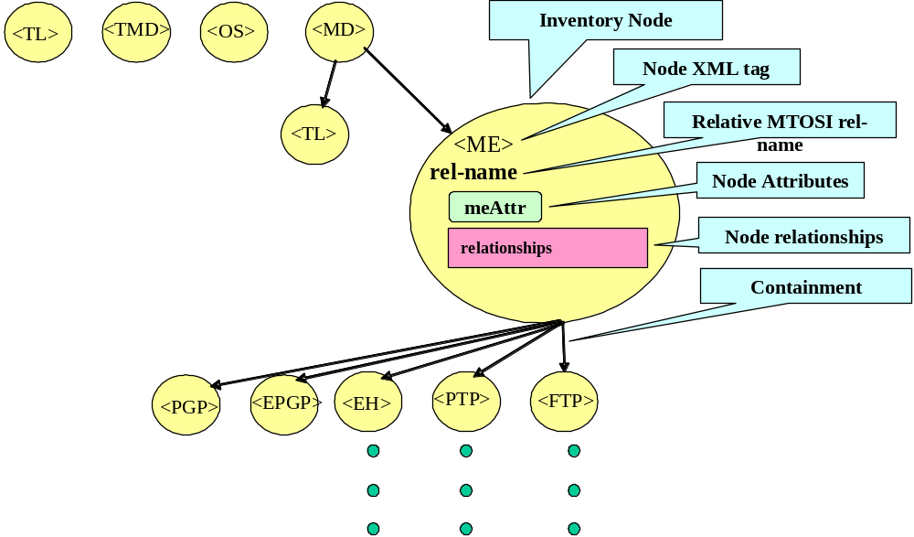
Figure 1 - Inventory hierarchical structure notion
Each node in the layout is called and “Inventory Name” because it contains an inventory of the components of a generic network element object. The Inventory Node contains the following optional components:
- node XML tag –the XML tag name for the network element object
- relative MTOSI name – the MTOSI name of the network element pruned of the name components of the ancestor node in the hierarchy.
- Node Attributes – the list of all the attributes proper of the NE as specified in the TMF 608 UML.
- Node Relationships – List of pointers (MTOSI names) characterizing relationships other than containment.

The following picture (Figure 2) illustrates an example of XML content of an Attribute component of an Inventory Node. This picture does not contain the entire inventory elements but just a sample to illustrate the concept.
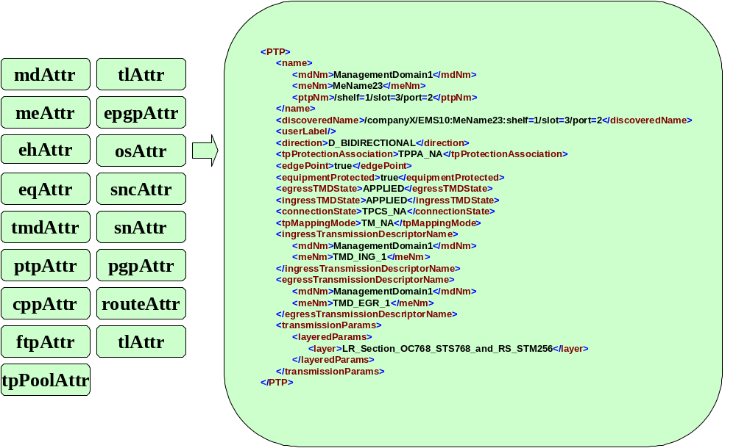
Figure 2 – Sample of NE attributes rendered to XML.
In the layout diagram (Figure 3), the containment of one box within another is used to represent the naming hierarchy. For example, Equipment Holders (EHs) are named under Managed Elements (MEs) and are thus represented as a box within ME. Further, and perhaps most important to the discussion here, the containment in the layout diagram is reflected in the associated XML for the inventoryData structure (this is used to carry the requested inventory data). Relationships (other than naming) are represented via the pointers, indicated in the pink boxes.

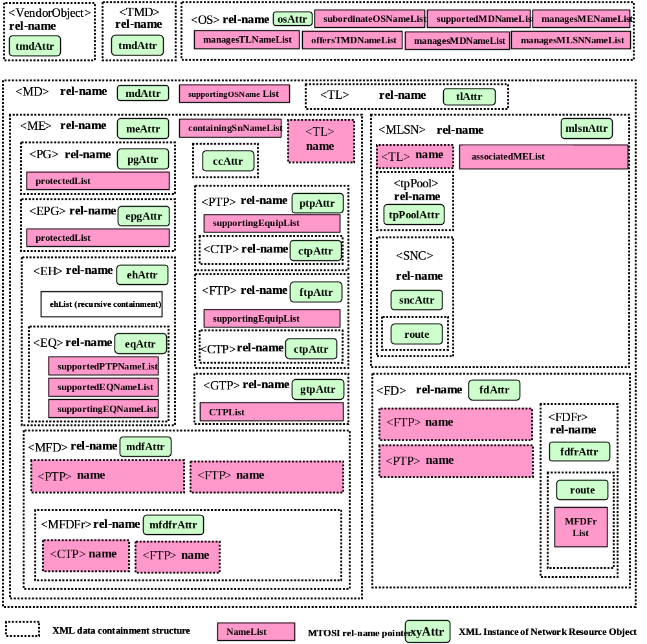
Figure 3 - Inventory XML layout
Starting from the top of the diagram, we have the following:
- The TLs at the top-left represent TLs between Management Domains (MDs), if any. Remember that there is not necessarily any connectivity between MDs.
- The TMDs are also at the top of the naming tree, although this may change in MTOSI Phase 2.
- At the top right are the OSs. This includes the top-level OS on the CCV (indicated by the value TRUE in its topLevel attribute) and all the other (subordinate) OSs known to the top-level OS (these OSs have their topLevel attribute set to FALSE). MTOSI defines additional relationships between the subordinate OS and the portion of the network that they manage but these relationships are not currently available via the inventory layout (for simplicity). The relationship can, however, be retrieved via the various TMF 814 style operations:
  - OSMgr::getAllTLsWrtOS
  - OSMgr::getAllTLNamesWrtOS
  - OSMgr::getAllTMDsWrtOS
  - OSMgr::getAllTMDNamesWrtOS
  - OSMgr::getAllMEsWrtOS
  - OSMgr::getAllMENamesWrtOS
  - OSMgr::getAllSNsWrtOS
  - OSMgr::getAllSNNamesWrtOS
- Also at the top-level of the naming hierarchy are the ever popular Management Domains (MDs). The MDs are used only for naming purposes to group portions of a network. Unlike subnetworks, there is no assumption that the objects within an MD are necessarily connectable.
- Each MD typically contains a collection of MEs, subnetworks, TrafficConditioningProfile and FlowDomains.
- FlowDomain conatins CPTP (== PTP|FTP) and Flow Domain Fragment
- FlowDomainFragment contains Route
- The TLs directly under an MD are between (not within) the subnetworks under the MD. These are called top-level TLs in MTNM, but in MTOSI these are not really at the top level (it is the TLs between MDs that are at the highest level in the naming hierarchy).
- The TLs under a Subnetwork are between the various MEs within the Subnetwork.
- The naming under ME is fairly mostly straightforward.
  - MEs contain EHs which, in turn, contain EQ instances.
  - The EHs under an ME are returned in flat list. An EH can contain other EHs, and this is reflect via the name of the EH. This follows the MTNM convention.
  - In keeping with the MTNM convention, PTPs are named directly under MEs.
  - MEs also contain MatrixFlowDomains
- MatrixFlowDomain contains CPTP (== PTP|FTP) and MFDFr
- MFDFR contains FlowPoint ( == TP)
- FDFr conatains FlowPoint (== TP)
- The naming under Subnetwork needs a little further explanation for those not familiar with TMF 608. MEs are named directly under MD, but a subnetwork is defined as a collection of MEs connected by TLs. The relationship between a subnetwork and its MEs is via a non-naming association. Only the names of the MEs appear under the Subnetwork (not the complete structure). The TLs between the MEs of a subnetwork are, however, named under the Subnetwork.

Partitioning of Inventory Segments
The amount of information requested in a given invocation of getInventory can be quite large, and so the multiple responses or retrieval (in the case of iterators) will likely be needed. In such cases, the requested inventory needs to be broken (partitioned) into pieces that can easily be reassembled by the requesting OS. In particular, we have the following statement from TMF 517:
“The partitioning of the Inventory document is constrained based on the following atomic (non divisible) XML object structures including their full containment hierarchy; ME, TL, OS, TMD, and SN. The inventory document is divided in such a way that the receiver can reconstruct the document as the various segments are received.”

Absolute and Relative MTOSI Names
MTOSI follows, very closely, the MTNM naming conventions. In particular, each managed object is given a fully distinguished name that allows one to completely determine the object’s position in the naming hierarchy. In general, object names are always characterized as the full hierarchical name described in the “SD2-7_v1.0_Object_Naming”
Where it is clear and not ambiguous from the message context that an object belongs in the full hierarchical name structure, a Relative Distinguished Name (RDN) is used.
The RDN holds only the name component for that object, and not its superior name components.
Note that this notation will not affect the way a network resource is addressed by its MTOSI name, but rather simply shorten the notation of an MTOSI name in a context of a message structure.
In the inventory layout, the data is organized according to the naming hierarchy and MTOSI relative Distinguished Names are used in the names of the network objects within an “inventory node”. Note the name in the pointers as well as the name in the object attributes is still absolute.

CTPs in the Inventory Layout
The MTNM model defines three types of CTPs, i.e.,
- An In Use CTP is defined as a CTP that is used by an SNC in any state (including pending) or a CTP that is terminated and mapped (either with or without assigned bandwidth).
- A Current CTP is a CTP that is either cross-connectable or cross-connected, in the current mapping configuration. The set of current CTPs with respect to a containing TP contains the set of In Use CTPs.
- A Potential CTP with respect to a given containing TP is a CTP than can possibly be created for a given channelization of the containing TP. The set of Potential CTPs with respect to a containing TP contains the set of In Use and Current CTPs.


Figure 4 - Potential, Current and In Use CTPs with respect to a Containing TP
The MTOSI getInventory operation only returns Current CTPs which as noted, includes the set of In Use CTPs. In order to get the full set of potential CTPs, a requesting OS needs to use either the getContainedPotentialTPs or the getPotentialTPNames operation.
The structure returned in response to the getInventory operation does not mark the CTPs as being In Use or Current but the requesting OS can make the determination as follows:
- A CTP is In Use if either
  - its connection state is TPCS_SOURCE_CONNECTED, TPCS_SINK_CONNECTED or TPCS_BI_CONNECTED, or
  - its termination mode is TM_TERMINATED_AND_AVAILABLE_FOR_MAPPING.
- In addition to the In Use CTPs (as determined in the previous step), any other CTPs returned in response to the getInventory operation can be assume to be Current.

Considerations on Future changes to the Inventory Layout
The inventory layout has the same versioning properties of the rest of the XSDs. Adding optional structures on the tree will be a minor change. Removing branches will be a major change. Adding optional attributes in the node will be a backward compatible minor change.

XML Example
An updated XML example will be provided as a standalone file in the next issue of this document (Jan 08).

Revision History
Version | Date | Description of Change
1.0 | May 2005 | This is the first version and as such, there are no changes to report.
1.1 | Dec 2005 | Added member evaluation feedback
2.0 | Oct 2007 | Incorporated change requests for MTOSI 2.0  - Added GTP in ME  - Removed TL from toplevel  - Changed TL to be a reference in MSLN  - Added TL reference in ME  - Added How to use MTOSI names for SubNetworks in appendix.  - Added Connectionless elements

How to comment on the document
Comments and requests for information must be in written form and addressed to the contact identified below:

Francesco | Caruso | Telcordia Technologies
Phone: | +1 732 699 3072
e-mail: | fcaruso@research.telcordia.com
Please be specific, since your comments will be dealt with by the team evaluating numerous inputs and trying to produce a single text. Thus we appreciate significant specific input. We are looking for more input than wordsmith” items, however editing and structural help are greatly appreciated where better clarity is the result.

Appendix I – How to use MTOSI names for SubNetworks
This appendix shows the flexibility of the MTOSI naming schema by giving examples for the naming of SubNetworks.

A central point in the discussion is the following statement extracted from the TMF518_FMW BA document:
“The Management Domain object is introduced solely for the purpose of guaranteeing unique names.”

It clearly means that there is no implicit notion of geography associated with a MD object: in no case the objects named as subordinates (immediate or several levels below) of a given MD object must be located in the same physical network. The way objects are organized as subordinates of different MD objects is under the entire responsibility of the Service Provider when deploying MTOSI MTOSI.

The only constraint is that any object in a MTOSI deployed system must have a unique name.

Considerations for Subnetwork Naming
Consider the following example where the 35 green ellipses represent MEs. The SP may want to organize his inventory by grouping those MEs by vendor: he will then use 5 independent MD objects, each representing a specific vendor, and he will position each ME as subordinate of the appropriate vendor.

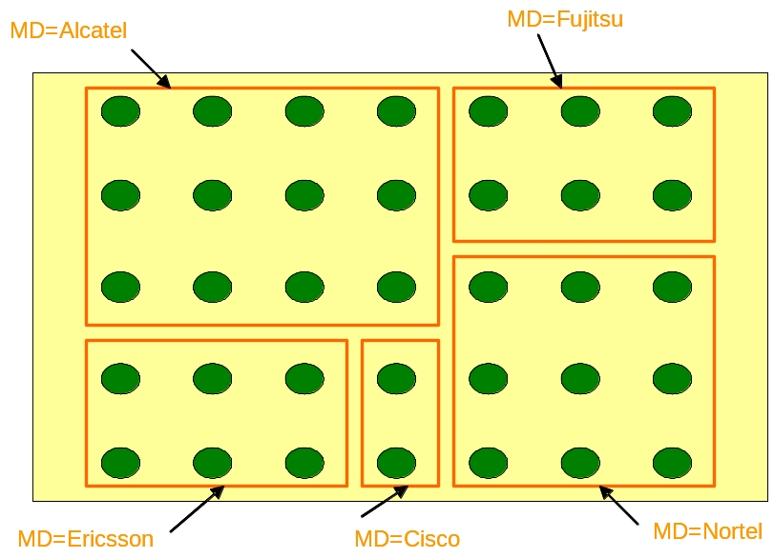

In each of the 5 MDs, the names used for the ME objects must be unique, but indeed the same relative name may be used for different MEs belonging to different MDs. For instance, as shown below, the two ME objects at the upper left corner of the MD=Alcatel and MD=Fujitsu MD objects have the same relative name ME=me1, which does not create any problem because their full name differs by the MD part.
.

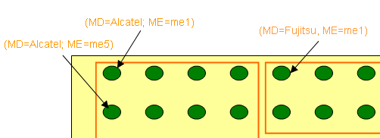

This being said, lets assume that the same SP has installed those different MEs in 5 networks located in 5 different cities in 2 different countries.
It is indeed understandable that he may want to organize the Subnetwork objects into 2 different MDs to reflect the distributed nature of his global network. The mTOP naming scheme offers him this possibility; for this purpose, he can create the additional MDs and Subnetwork objects as illustrated on the picture below:

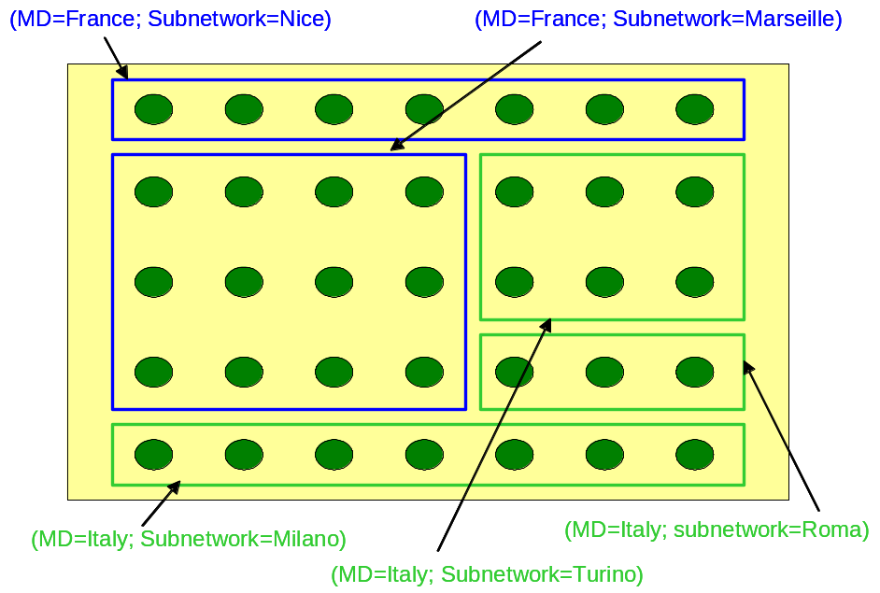

The combination of the two sets of MDs would lead to the following topology tree, where the MEs are named under the “equipment supplier” MDs and not under the “country” MD.

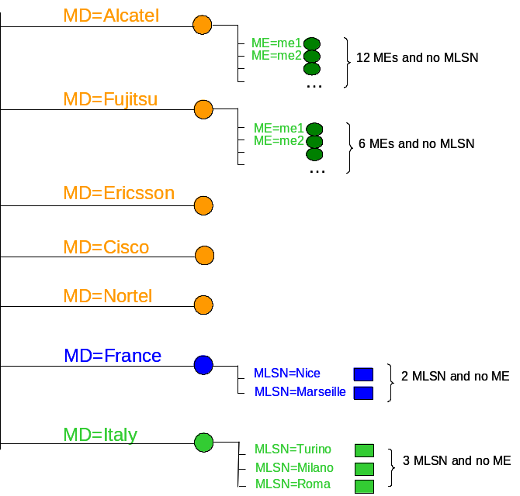

Indeed, our SP may want to “document” in his inventory that some MEs from Alcatel are located in France while some others are located in Italy.
He certainly cannot do this by giving another name to the corresponding MEs, for instance by naming them as subordinates of the MD=France of the MD=Italy Management Domain objects, since any object can have only one single name.
Actually, he may probably want to do more, by “documenting” in his inventory that:
the (MD=Alcatel; ME=me1) “belongs” to the Subnetwork in Nice
and that:
the (MD=Alcatel; ME=me5) “belongs” to the Subnetwork in Milano.

The way to “capture” this information is not by using naming relationships but by using the following reference relationships implemented in the ME MTOSI objects:by the following attributes:
associatedMEList available in the MLSN class
containingSnNameList available in the ME class

as available in the Inventory Layout.

