mTOP Information Agreement Guidelines
Abstract
This document contains the unique design reference for the development of all mTOP Information Agreements (IA).
Table of Contents

1 Introduction 4
1.1 Status 4
1.2 Context 4
1.3 Future 4
2 General Guidelines 4
2.1 IA Architecture 4
2.1.1 Overview 4
2.1.2 Logical View 5
2.1.3 Development View 6
2.1.4 Deployment View 10
2.2 Naming Conventions 10
2.3 Versioning 11
2.4 Documentation 11
3 IA Modelling Guidelines 11
3.1 Introduction 11
3.2 General IA Requirements 11
3.3 New General IA Requirements 12
3.4 General UML Guidelines 12
3.4.1 mTOP Profile 14
3.4.2 Data Type Guidelines 21
3.4.3 Object Class Guidelines 26
3.4.4 Object Class Attribute Guidelines 27
3.4.5 UML Diagram Guidelines 30
3.4.6 Use Case Guidelines 31
3.4.7 Reference Guidelines 31
3.4.8 Relationship Guidelines 31
3.4.9 Traceability Guidelines 33
3.4.10 Product Identification Guidelines 33
3.5 Data Model (DM) DDP Guidelines 34
3.5.1 Overview 34
3.5.2 Location 34
3.5.3 Object Class Guidelines 34
3.5.4 Relationship Guidelines 34
3.5.4.1 Naming relationship 34
3.5.4.2 Instance Reference relationship 35
3.5.5 Dependencies 37
3.6 Service Interface Guidelines 37
3.6.1 Overview 37
3.6.2 Location 37
3.6.3 Interface Guidelines 37
3.6.4 Operation Guidelines 38
3.6.5 Operation Parameter Guidelines 43
3.6.6 Relationship Guidelines 46
3.6.7 Dependencies 46
3.7 Notification Guidelines 47
3.7.1 Overview 47
3.7.2 Location 47
3.7.3 Guidelines 47
3.7.4 Dependencies 50
4 Changes History 51
4.1 IA v3.4 (used in MTNM R3.5) to IA v3.5 (used in MTOSI R2.0) 51
5 References 51
5.1 External References 51
5.2 Internal References 51
Appendix A: mTOP Parameters Supporting Documents 52
Appendix B: mTOP Layered Parameters Domains 53
Appendix C: Requirements for additional properties in the mTOP IA UML model 54
Appendix D: known issues with RSM/RSA 59
Appendix E: known issues with the IA Guidelines 60
6 Administrative Appendix 63
6.1 Document History 63
6.2 Acknowledgments 64
6.3 How to comment on this document 65

Introduction
The purpose of this document is to be the unique design reference for the development of all mTOP Information Agreements (IA).
The Unified Modelling Language (UML) Version 2.1 [Ref 1] will be used as the notation for the IA. The IA will be created with the "Rational Software Modeler" (RSM) tool [Ref 2] provided by IBM. However, in the future, it is possible that other tools may be used.
These guidelines shall ensure that different people can create individual parts of the Information Agreement with the same "look and feel" which can then be combined into an mTOP Release.

Status
This document is an mTOP Guideline document.
Refer to the mTOP_Guidelines_GForgeUsage document [Ref 4] for access and usage procedures of all the mTOP data available through the TMF GForge Subversion (SVN) repository.

Context
The definition of these mTOP IA guidelines is driven by the development of the MTOSI Release 2.0 mTOP product. The writing of these IA guidelines has been made possible based on the experience the mTOP team gained from the previous MTOSI and MTNM releases.

Future
These IA guidelines are not a static document. The following factors will certainly influence the evolution of these guidelines sometime in the future:
- During the creation of the individual IA DDPs the editors become more and more familiar with the RSM tool which may lead to improvements.
- mTOP Methodology: The idea of generating a protocol specific UML which then allows one to automatically (tool supported) create the IIS (XML, IDL) is still the targeted goal. The guidelines will therefore have to be adapted to the process/tooling chosen.
- Harmonization/Convergence with the UML models from other standards (SID, OSS/J, 3GPP, etc) will also lead to an evolution of these guidelines.

General Guidelines

IA Architecture

Overview
The purpose of the mTOP IA is to provide a description of the protocol neutral mTOP Information Model based on UML.
The overall mTOP IA is structured along the mTOP DDP partitioning which is based on the eTOM level2/3 processes. All IA definitions must relate to the scope of the mTOP DDP that it is part of. Refer to the mTOP Guidelines DDP Definitions documents [Ref 5] for a rational description of the mTOP DDPs.

Logical View
The complete definition of the mTOP Information Model is based on the use of individual UML Models containing the mTOP DDPs.
The DDPs are grouped into two basic types:
- Data Model DDPs (DM-DDPs) containing the static data entities.
- Operations Model DDPs (OM-DDPs) containing the dynamic (service) interfaces where each service interface consists of several operations.
The following DDPs will be created for MTOSI Release 2.0:
- Framework (FMW)
- RM&O + RD&M
  - Data Model DDPs
    - Network Resource Basic (NRB)
    - Network Resource Fulfillment (NRF)
    - Network Resource Assurance (NRA)
  - Operations Model DDPs
    - Manage Resource Inventory (MRI)
    - Resource Provisioning (RP)
    - Resource Trouble Management (RTM)
    - Resource Performance Management (RPM)
- SM&O + SD&M
  - Data Model DDPs
    - Service Basic (SB)
  - Operations Model DDPs
    - Manage Service Inventory (MSI)
    - Service Activation (SA)

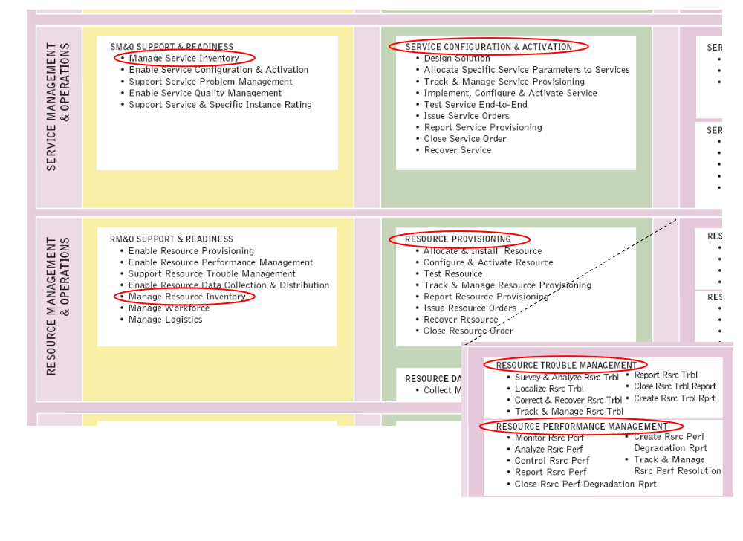
Figure 1: "Location" of the MTOSI Release 2.0 DDPs within eTOM
Note: The development of the Framework DDP will have the highest priority because this DDP is used in all other DDPs.

Development View
The development view of the mTOP IA is maintained and managed through the TMF GForge Subversion repository. Refer to the mTOP_Guidelines_GForgeUsage [Ref 4].
The following steps describe how to add the IA (in fact it adds the complete specification) from the GForge Subversion repository as a new project into RSM.
- A prerequisite is that you have installed the "Subclipse" (an Eclipse Plug-in) Subversion tool into RSM. Section 2.4.3 in the mTOP_Guidelines_GForgeUsage [Ref 4] document describes how to install and configure "Subclipse".
- Creating a new Repository Location (customised based on the "Subclipse" help documentation):
You create and work with your repository locations from the SVN Repository View, which is part of the SVN Repository Exploring Perspective. To create a new repository location, click the Add SVN Repository button or right clicking inside the view and selecting New > Repository Location...
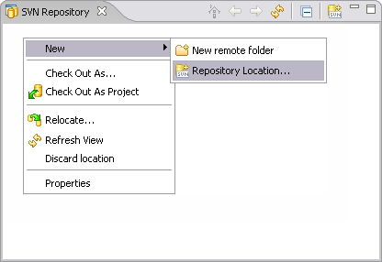
The Add SVN Repository dialog will prompt you for a repository location URL. Enter the URL of the mTOP repository
- svn+ssh://<username>@svn.gforge.tmforum.org/svn/mtop (<username> is your TMF GForge registered username) or
- https://gforge.tmforum.org/svn/mtop/ (Note: https should only be used if svn+ssh is blocked by the firewall).
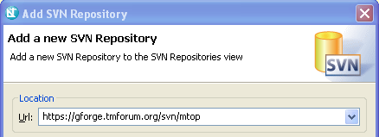
Once you click finish, the wizard will create the location:
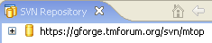
Expand the location to see the contents for the given URL.
Note: If your PC is connected to the Internet via a firewall you have to provide the firewall as a proxy. This is done by updating the “servers” file located at ~/.subversion on Linux and OS X and at C:\Documents and Settings\userName\Application Data\Subversion on Windows:
[groups]
group1 = gforge.tmforum.org
### Information for the first group:
[group1]
http-proxy-host = <yourProxy.some-domain-name.com>
http-proxy-port = <yourProxyPort>
http-proxy-username = blah
http-proxy-password = doubleblah
http-timeout = 60
neon-debug-mask = 130
- Checking out the draft MTOSI Release 2.0 specification from the GForge repository:
Excerpt from "Subclipse" help documentation: Check out is the term used to describe the process of making a copy of a project from a repository into your local workspace. In SVN, the check out process creates a working copy. A working copy is a specially formatted folder structure which contains additional .svn folders that store SVN information, as well as a pristine copy of each item that is checked out.
In the SVN Repository window, select the Product / trunk repository directory and choose Checkout from the context menu:
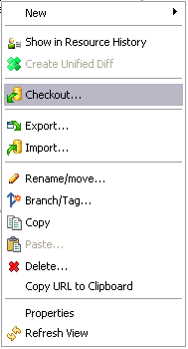
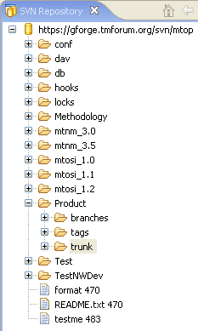

Choose Check out as a project in the workspace and click Finish:
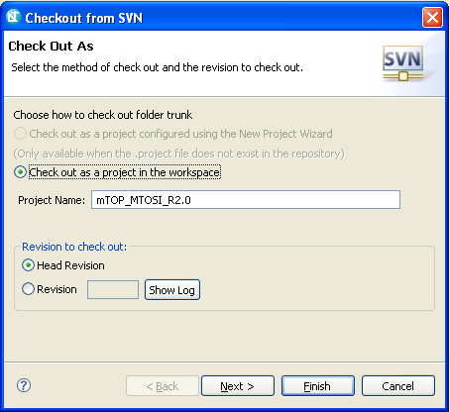

Finally, move to the Modeling view in RSM and you will find the new project mTOP_MTOSI_R2.0 in the Project Explorer:
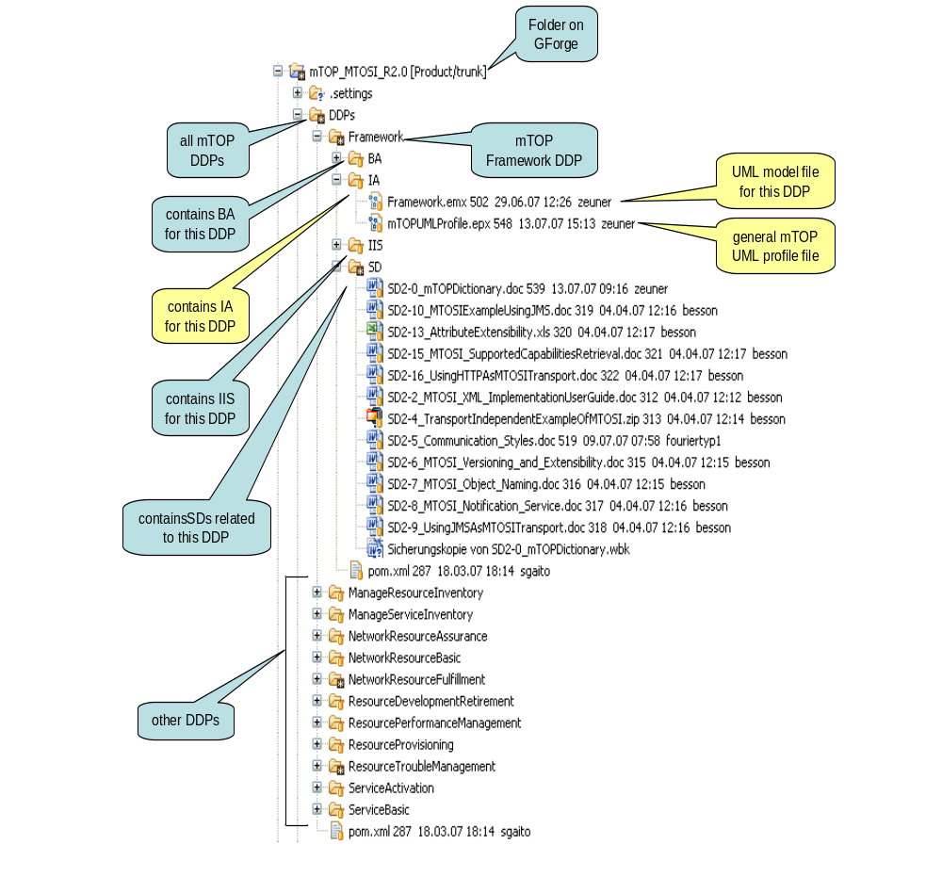
Figure 2: Structure of the IA Model files on GForge during development

Deployment View
to be defined

Naming Conventions
Refer to the mTOP Naming Convention Guidelines in SD0-1_mTOPDictionary [Ref 6].
mTOP artifacts are the Business Agreement (BA), the Information Agreement (IA) and the Interface Implementation Specification (IIS).
UML artifacts are classes, attributes, operations, notifications, parameters and relationships.
In this document the following tags are used as variables:
- <DDP_Full> for the full DDP name
- <DDP> for the short DDP name (acronym)

Versioning
The IA is a protocol neutral specification. Backward compatibility with previous IA versions is therefore not required.
- It is allowed to add new attributes to classes and new operations to interfaces.
- IA artefacts (e.g., classes, interfaces, attributes, operations) which become obsolete in a new version must not be deleted. They shall be identified as "obsolete" using the <<stereotype>> field; i.e., <<obsolete>>.
- IA artefacts which have been enhanced in a new version shall be identified as "enhanced" using the <<stereotype>> field; i.e., <<enhanced>>.

Documentation
The documentation of the mTOP UML IA will be done with the tool "Rational Software Modeler" from IBM. This application can also generate HTML-based documentation of the UML models.
The location for the generated HTML documentation is: to be defined.

IA Modelling Guidelines

Introduction
The information modeling comprises the "analysis" part of the specification. The requirements and use cases defined in the BA are the basis for the analysis.

The purpose of this section is to provide a set of UML design recommendations to promote all mTOP IA editors to specify the IA in a standardized mTOP UML style. The benefits are:
- Readability of the UML specifications as they all have the same style.
- Providing the necessary information to distribute the workload between many editors.

General IA Requirements
- The UML 2.1 (Unified Modeling Language) is used as a notation for the model.
- The IA shall be protocol-neutral, i.e., not reflect any middleware protocol-specific characteristics (like CORBA, HTTP, JMS).
- The IA shall be map-able to various protocol-specific interfaces.
Until this mapping is automated, it will be necessary to (manually) create an IA to IIS mapping document.
- The requirements and use cases from the BA are converted into the model as object classes (containing attributes or operations), relationships between the objects and notifications.
- For attributes with defined value transitions, state transition diagrams shall be created.
- For operations with high complexity, activity diagrams shall be created.
- Traceability from each modeling construct back to the requirements and use cases has to be provided.
- The information agreement has to provide guidelines on how the UML notation (e.g., relationship stereotypes) is used to model specific requirements.

New General IA Requirements
This section provides the requirements which are new wrt. the last mTOP IA version (i.e., TMF608 v3.4).
- The IA shall be documented in UML 2.1 using the “Eclipse dialect”.
- The IA shall be divided into:
  - Data entities – represent managed entities specified in the DM-DDPs.
These entities only have attributes and associations.
Notifications are also treated as data entities.
  - Service interfaces – specified in the OM-DDPs.
These interfaces only have operations.
- The IA shall be sectionalized based on the DDP separations.
- This will allow for:
  - Multiple editors of the IA
  - Release of portions of the IA.
- Overlap of information between the BA and IA is allowed, but is strongly recommended that the BA be considered the source and the other document be populated automatically with the redundant information.
- Eventually, the intent is to have UML models for the various protocol-specific interfaces (IDL, XML, WSDL). These UML models will be considered part of the IIS and not the IA.

General UML Guidelines
This section provides the general guidelines (i.e., which are not specific to the Data Model or the Service Interfaces Model).
Each DDP shall be stored in a separate Model file (xxx.emx file). Each Model shall be structured in the following way:
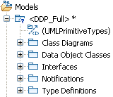
Figure 3: UML Model structure
The Data Model DDPs only have "Data Object Classes" and the Service Interface Model DDPs only have "Interfaces". The only exception which has both types of classes is the Framework DDP.
Note: RSM creates automatically an additional "Diagrams" folder that contains all the diagrams which are created in the specific Model.
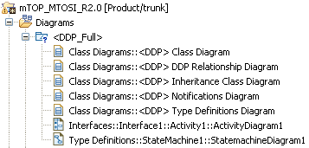
Figure 4: UML Model diagrams structure
The following figure shows the location of the UML artifacts:
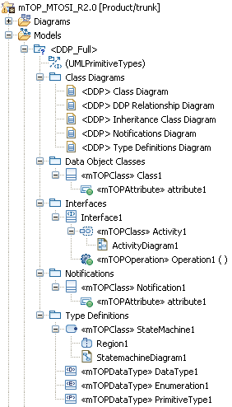
Figure 5: UML artifact structure

mTOP Profile
The RSM tool allows extending the UML core metamodel (see Figure 32) by using profiles. An mTOP UML Profile has been defined to extend the "class", "structuralFeature" and "operation" metaclasses of the core metamodel.
The "class" metaclass has been extended with the capability to specify:
- the creation notifications of the resource/service object class (NO | YES | NOT_APPLICABLE), default value = NOT_APPLICABLE
- the deletion notifications of the resource/service object class (NO | YES | NOT_APPLICABLE), default value = NOT_APPLICABLE
- the discovery notifications of the resource/service object class (NO | YES | NOT_APPLICABLE), default value = NOT_APPLICABLE.
The "structuralFeature" metaclass (i.e., the superclass of the attributes) has been extended with the capability to specify:
- the kind of notification that has to be send when an attribute changes its value (ATTRIBUTE_VALUE_CHANGE | STATE_CHANGE | NO_NOTIFICATION | NOT_APPLICABLE), default value = NOT_APPLICABLE
- if the attribute is invariant after it is created (Boolean), default value = false
- if the attribute can be set/changed by an OS (NONE_OS | TARGET_OS_ONLY | REQUESTING_OS_ONLY | TARGET_AND_REQUESTING_OS), default value = REQUESTING_OS_ONLY

is invariant  (after attribute creation) | send notification | writeable by target OS | writeable by requesting OS | read only (is dependent on writeable by requesting OS) | meaning
X | X | - | - | - | not allowed; because if invariant it will never send a notification
X |  | X | X |  | can be set by target OS only during creation when requesting OS does not provide a value;  can be set by requesting OS only during creation
X |  | X |  | X | can be set by target OS only during creation;  can not be set by requesting OS
X |  |  | X |  | can not be set by target OS;  can be set by requesting OS only during creation
X |  |  |  | X | can not be set by target OS;  can not be set by requesting OS;  value is set by the network only during creation
 | - |  |  | X | can not be set by target OS;  can not be set by requesting OS;  value can be set by the network at anytime
 | - | X | X |  | can be set by target OS at anytime;  can be set by requesting OS at anytime
 | - | X |  | X | can be set by target OS at anytime;  can not be set by requesting OS
 | - |  | X |  | can not be set by target OS;  can be set by requesting OS at anytime
- → don't care

The "operation" metaclass has been extended with the capability to specify:
- Message Exchange Patterns (MEP) for the operations (SRR | ARR | SIT | ABR | SFB | AFB | SN | AN), default = empty list, see SD2-5 Communication Styles [Ref 7].
- if the operation is idempotent (Boolean), default value = false
All extensions have been defined as mandatory. For the cases where an additional property makes no sense, the value "NOT_APPLICABLE" has been defined.
A description of the defined stereotypes is contained in Appendix C: Requirements for additional properties in the mTOP IA UML model.
Figure 31 explains how the Ecore metamodel is enhanced with the Profile by showing the relationships between the Ecore metamodel, the mTOP UML Profile and the enhanced mTOP model.
Figure 6 shows how the mTOP Profile is defined in the RSM tool.
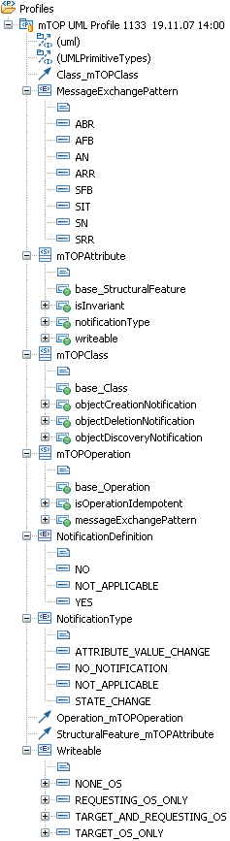
Figure 6: mTOP Profile structure
The mTOP UML Profile has to be added to all UML model files where these additional properties are necessary.
Left click the UML model file that you would like to add the profile to in the Project Explorer (in our example the NetworkResourceBasic model. Go to the Profiles tab within the Properties and click on Add Profile …
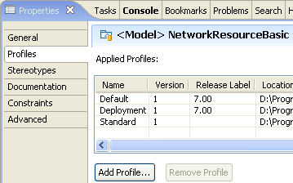

Choose the mTOPUMLProfile.epx file from your RSM workspace in folder: \mTOP_MTOSI_R2.0\DDPs\Framework\IA\.

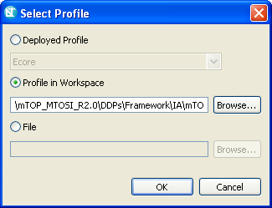

The current Profile has not been released so far because it is not mature enough. Therefore click OK on the next window:
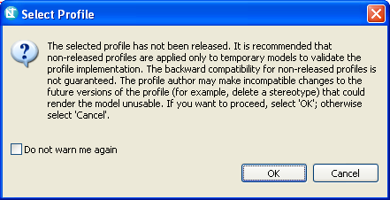

The mTOP UML Profile is now added to the list of profiles:
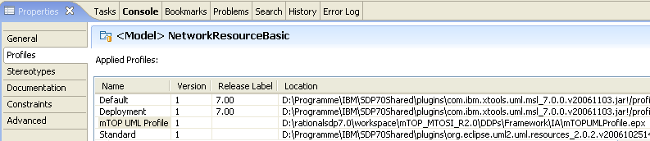

All object classes, attributes, operations and associations contain now the additional properties. This is identified by the stereotypes <<mTOPClass>> for the object classes, <<mTOPAttribute>> for the attributes and <<mTOPOperation>> for the operations:
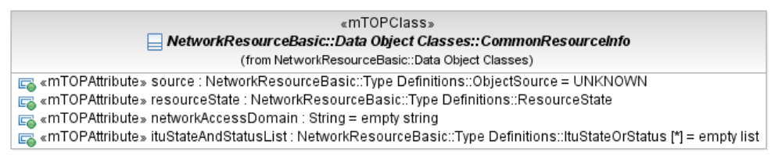

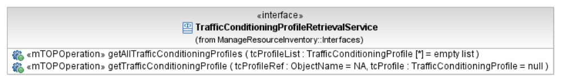

The additional properties are defined as stereotypes as depicted in the following figures:
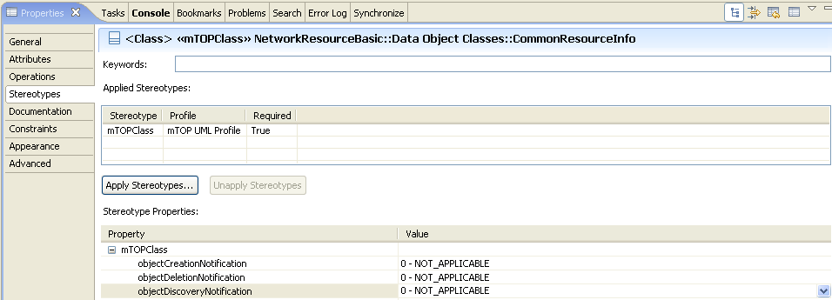

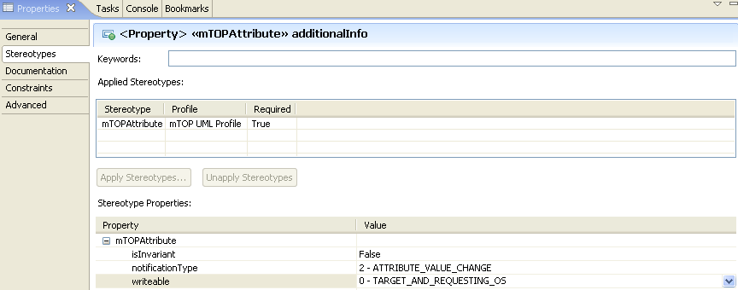

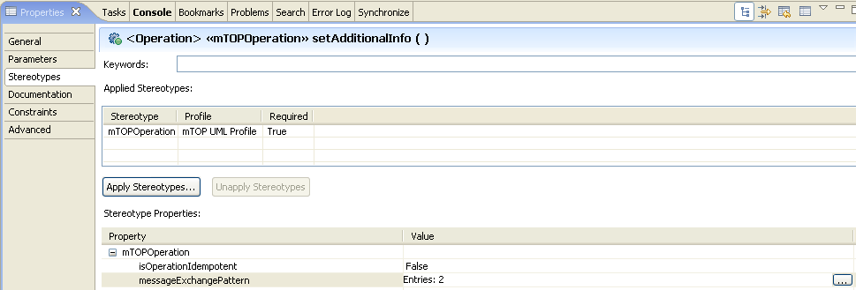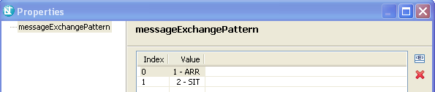

Data Type Guidelines
We distinguish between "basic" and "complex" data types.
The basic data types do not need additional specification. They are provided by the RSM tool as .
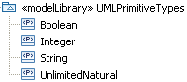
Figure 7: Basic data types
In addition four more basic data types are defined:
.
Basic data types are Boolean, Integer, ItuTTime, ObjectName; Real, String, UnsignedInteger.
The ItuTTime is defined as:
"yyyyMMddhhmmss.s[Z|{+|-}HHMm]" where:
yyyy "0000".."9999" year
MM "01".."12" month
dd "01".."31" day
hh "00".."23" hour
mm "00".."59" minute
ss "00".."59" second
s ".0"..".9" tenth of second (set to ".0" if EMS or ME cannot support this granularity)
Z "Z" indicates UTC (rather than local time)
{+|-} "+" or "-" delta from UTC
HH "00".."23" time zone difference in hours
Mm "00".."59" time zone difference in minutes.
The ObjectName has to be used for the unique, read-only name of an object. The exact type is defined in the protocol specific IIS.

Complex data types are specified for attribute and parameter types when basic data types cannot be used. They are defined as object classes with attributes and are contained in the Type Definitions folder within each UML Model. Complex data types use basic and/or other complex data types for their Type definitions.
General data type Guidelines:
- The category of the data type is identified by a little icon in front of the type name. The RSM meta-model already provides the dataType = , enumeration = and primitive data types.
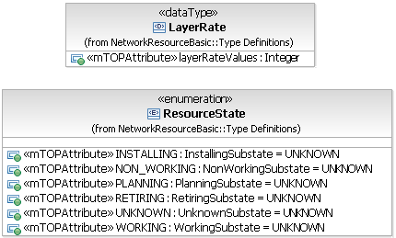
Figure 8: Complex data types (example)
- Parameter lists for creation and modification of resources shall be specified as (dataTypes) in the Type Definitions folder.
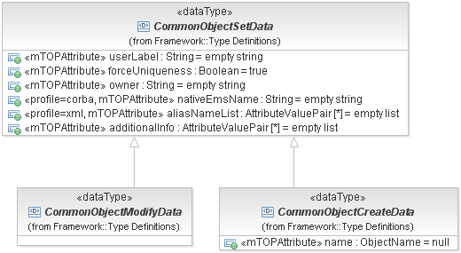
Figure 9: Common Object Creation/Modification parameter data types
- Groups of attributes which can be used in object classes shall be specified as (dataTypes).
Example:
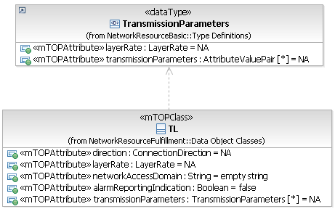
- Data types containing a group of attributes where only one of which can be active at a time shall be specified as  (dataTypes with choice stereotype).
Example:
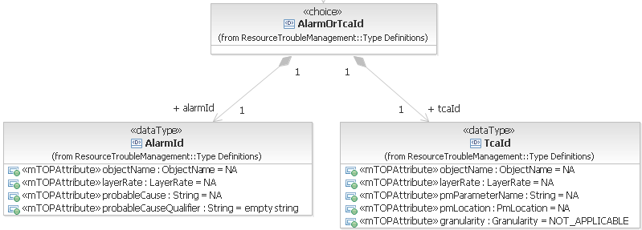
Note: These data types can be implemented in IDL via a "union" construct or in XML via an "<xsd:choice>".
- Data type names
  - follow Upper CamelCase (UCC)
  - must be unique across all data type names defined in the whole mTOP IA
  - special definitions are in the mTOP Naming Convention Guidelines in SD0-1_mTOPDictionary [Ref 6].
- Attributes within data types
  - Name
    - follow Lower CamelCase (LCC)
    - must be unique across all attribute names defined in the whole mTOP IA
    - special definitions are in the mTOP Naming Convention Guidelines in SD0-1_mTOPDictionary [Ref 6].
  - Visibility
    - this property can be ignored
    - fixed to "Public".
  - Qualifiers
    - this property can be ignored
    - fixed to "Unique".
  - Type
    - refers to a basic or complex data type.
  - Default Value
    - provides the value that the attribute has to start with in case the value is not provided.
In the case of a single-value property, the default value shall be specified as an <Opaque Expression>, except for the case in which the type of the property is an Enumeration type, in which case it shall be an Enumeration Literal selected from the Enumeration. (Note that an Enumeration Literal must be selected from the appropriate browser in RSM and must not simply be typed as a string.)
In the case of a multiple-valued property, the default shall be specified as a comma-separated list of <Opaque Expression> enclosed in braces. (Note that it is not possible to have a multiple-value property of an Enumeration type.)
If a default value makes no sense (e.g., if representing state of the system) = "<Opaque Expression> NA".
No default value for object name = "<Literal Null>".
No default value for String = "<Opaque Expression> empty string".
No default value for Sequence = "<Opaque Expression> empty list".this property can be ignored
  - Multiplicity
    - defines the number of values the attribute can simultaneously have
  - Aggregation
    - this property can be ignored
    - fixed to "None".
  - Invariant (contained in mTOPAttribute stereotype)
    - this property can be ignored
    - fixed to "True"; see also section 3.4.1.
  - Notification Type (contained in mTOPAttribute stereotype)
    - this property can be ignored
    - fixed to "NOT_APPLICABLE"; see also section 3.4.1.
  - Writeable (contained in mTOPAttribute stereotype)
    - this property can be ignored
    - fixed to "TARGET_AND_REQUESTING_OS"; see also section 3.4.1.

- Enumeration "value" names of data types
  - have only upper case characters
  - words are separated by "_"
  - examples are in the mTOP Naming Convention Guidelines in SD0-1_mTOPDictionary [Ref 6].
- Enumeration "values" are specified as Enumeration Literals in the enumeration object classes.

Importing Data Types from other DDPs (e.g., Framework DDP)
DDPs can use the general Data Types defined in other DDPs by importing the DDP package which contains the common Data Types defined:
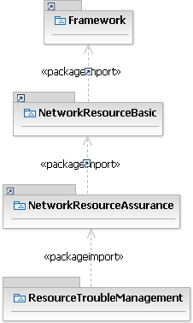
Figure 10: Data type import using "DDP inheritance" (example)

Object Class Guidelines
Object classes are used to model data entities in the DM model or (service) interfaces in the OM model.
Each object class comprises:
- Object Class Name
  - follow Upper CamelCase (UCC)
  - must be unique across all class names defined in the whole mTOP IA
  - special definitions are in the mTOP Naming Convention Guidelines in SD0-1_mTOPDictionary [Ref 6].
- Object Class Documentation
  - contains a short summary of usage
  - refers to the appropriate BA requirement.
- Superclass(es)
  - inheritance and multiple inheritance may be used.
- Abstract Object Class
  - indicates if the object class can be instantiated or is just used for inheritance.

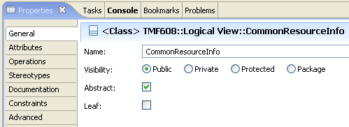
Figure 11: Defining an object class as "abstract" (example)
- Object Notifications (contained in mTOPClass stereotype)
  - identifies if creation/deletion notifications have to be send
"objectCreationNotification" <NO | YES | NOT_APPLICABLE>
"objectDeletionNotification" <NO | YES | NOT_APPLICABLE>
"objectDiscoveryNotification" <NO | YES | NOT_APPLICABLE>; see also section 3.4.1.

Object Class Attribute Guidelines
Each attribute in an object class comprises:
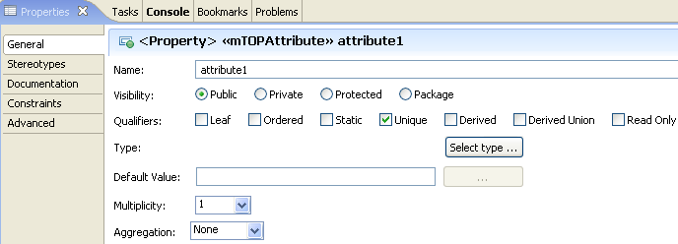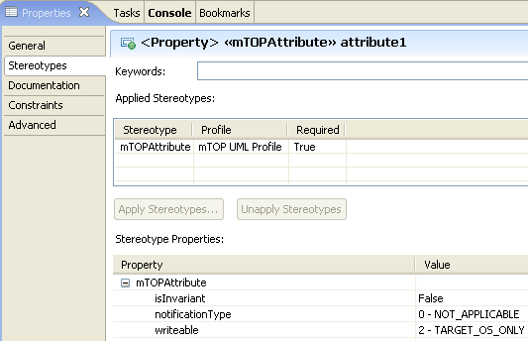
Figure 12: Defining attribute properties (example)
- Attribute Name
  - follow Lower CamelCase (LCC)
  - must be unique across all attribute names defined in the whole mTOP IA
  - special definitions are in the mTOP Naming Convention Guidelines in SD0-1_mTOPDictionary [Ref 6]
  - Boolean typed attribute names always start with a verb like ‘is’, 'must', etc. (e.g., ‘isAbstract’) and the whole attribute name must be composed in a way that it is possible to answer it by "true" or "false".
  - Enumeration typed attributes always end with “Kind” (e.g., ‘aggregationKind’).
- Attribute Documentation
  - contains a short summary of usage
  - refers to the specific BA requirement if defined.
- Visibility
  - Public: if the attribute shall be inherited to subclasses; this should be used in general within the IA.
  - Private: if the attribute shall not be inherited to subclasses.
- Qualifiers
  - Leaf: defines if it is allowed to specialize or redefine the attribute in a subclass; default value is false.
  - Ordered: for a multi-valued multiplicity; this specifies whether the values in an instantiation of this attribute are sequentially ordered; default is false
  - Static: specifies whether this feature characterizes individual instances classified by the classifier (false) or the classifier itself (true); default value is false
  - Unique: for a multi-valued multiplicity, this specifies whether the values in an instantiation of this attribute are unique (i.e., no duplicate attribute values are allowed); default is true.
Excerpt from UML Superstructure Specification, v2.1.1: When isUnique is true (the default) the collection of values may not contain duplicates. When isOrdered is true (false being the default) the collection of values is ordered. In combination these two allow the type of a property to represent a collection in the following way:
Ordered | Unique | Collection type
false | true | Set
true | true | OrderedSet
false | false | Bag
true | false | Sequence
Table 1: Table 7.1 - Collection types for properties
from UML Superstructure Specification, v2.1.1
  - Derived: defines whether the attributes value or values can be computed from other information; default value is false
  - Derived Union: defines whether the attributes value or values are derived as the union of all of the values that are constrained to subset it; default value is false
  - Read Only: if true, the attribute may only be read, and not written by the Requesting OS. The default value is false. This state is dependent on the additional mTOP UML attribute property writeable. I.e., if the attribute can not be set/changed by the Requesting OS, it is read only.
- Type
  - refers to a basic or complex data type.
- Default Value
provides the value that the attribute has to start with in case the value is not provided during creation or already defined because of a system state.
In the case of a single-value property, the default value shall be specified as an <Opaque Expression>, except for the case in which the type of the property is an Enumeration type, in which case it shall be an Enumeration Literal selected from the Enumeration. (Note that an Enumeration Literal must be selected from the appropriate browser in RSM and must not simply be typed as a string.)
In the case of a multiple-valued property, the default shall be specified as a comma-separated list of <Opaque Expression> enclosed in braces. (Note that it is not possible to have a multiple-value property of an Enumeration type.)
If a default value makes no sense (e.g., if representing state of the system) = "<Opaque Expression> NA".
No default value for object name = "<Literal Null>".
No default value for String = "<Opaque Expression> empty string".
No default value for Sequence = "<Opaque Expression> empty list".
- Multiplicity
  - defines the number of values the attribute can simultaneously have.
- Aggregation
An association may represent a composite aggregation (i.e., a whole/part relationship). Only binary associations can be aggregations. Composite aggregation is a strong form of aggregation that requires a part instance be included in at most one composite at a time. If a composite is deleted, all of its parts are normally deleted with it. Note that a part can (where allowed) be removed from a composite before the composite is deleted, and thus not be deleted as part of the composite. Compositions may be linked in a directed acyclic graph with transitive deletion characteristics; that is, deleting an element in one part of the graph will also result in the deletion of all elements of the subgraph below that element. Composition is represented by the isComposite attribute on the part end of the association being set to true.
  - None: the affect on the attribute is unspecified when the parent is deleted
  - Shared: the attribute is not deleted when its parent is deleted
  - Composite: the attribute is deleted when its parent is deleted.
- Invariant (contained in mTOPAttribute stereotype)
  - identifies if the value of the attribute can be changed after it has been created
  - default value "False"; see also section 3.4.1.
- Attribute Notifications (contained in mTOPAttribute stereotype)
  - identifies which kind of notification has to be sent in case of a value change:
"Changes in the value of the attribute lead to an <AVC | SC> notification." or
"Changes in the value of the attribute will not be notified automatically."
See also section 3.4.1.
- Writeable (contained in mTOPAttribute stereotype)
  - identifies who can set/change the value of the attribute: either none OS, or the target OS only, or the requesting OS only or both, the target and requesting OSs.
  - default value "requesting OS only"; see also section 3.4.1.
  - note that the Read Only qualifier has to be true if the requesting OS is not allowed to set/change the value of the attribute.

UML Diagram Guidelines
Objects and their relationships are added to class diagrams. It is recommended to create
- an overview class diagram containing all object classes from the DDP (<DDP> Class Diagram)
- an overview interface diagram containing all interfaces defined in the DDP (<DDP> Interface Diagram)
- a relationship class diagram showing the associated DDPs (<DDP> DDP Relationship Diagram)
- a separate inheritance class diagram in case the overview diagram would be overloaded when showing the inheritance structure (<DDP> Inheritance Class Diagram)
- a class diagram containing the defined notifications (<DDP> Notifications Diagram)
- a class diagram containing the defined types (<DDP> Type Definitions Diagram).
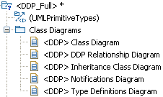
Figure 13: Recommended Class Diagrams
- Additional class diagrams may be established to show specific parts of the DDP in detail.
- State diagrams shall be created for complex state attributes.
- Activity diagrams\Sequence Diagrams (possibly use cases) shall be created for complex operations.
- The class name compartment shall contain the "Qualified Name"
- The class attributes and operation shall show the "Signature".

Use Case Guidelines
Use Cases are only specified in the BA. The use case specification template is contained in section "Specifications for Use Cases" of supporting guideline document SD0-2_mTOPGuidelines_BA.

Reference Guidelines
Where appropriate, a UML artifact should reference external (wrt. UML) documentations (e.g., supporting documents) by a URL .
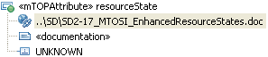
Figure 14: URL example

Relationship Guidelines
Relationships between the object classes are derived from the dynamic and static requirements in the BA. Each relationship comprises:
- Relationship Name
  - follow Upper CamelCase (UCC)
  - format: "<ClassName><VerbPhrase><ClassName>" where the verb phrase creates a sequence that is readable and meaningful
  - must be unique across all relationship names defined in the whole mTOP IA.
- Stereotype
  - e.g., <<naming>> shall be used if the relationship defines the object naming tree; see 3.5.4.1.
- Relationship Type
  - e.g., inheritance, association (composition, aggregation, association class), dependency, realisation.
- Role Names
  - identifies the role that the object plays at this end of the relationship
  - follow Lower CamelCase (LCC)
  - the plural form shall be "<name>List"
  - special definitions are in the mTOP Naming Convention Guidelines in SD0-1_mTOPDictionary [Ref 6]
  - only navigable relationships have role names.
- Cardinality
  - identifies the number of objects that can have this relationship.
- Constraint(s)
  - list the constraint(s) under which the relationship can exist.
- Abstract
  - It is recommended to create relationships which are just for explanation to the reader of the model. These relationships should be defined as "abstract", they are not navigable and have no role names. They will therefore not be taken into account in the protocol specific specification. This can for example be used to show the relationship to the object which is retrieved by a get-operation in another DDP.
Example:
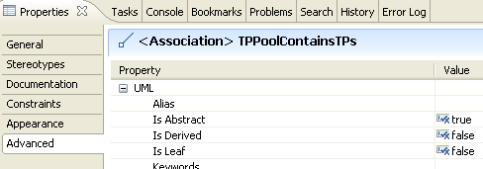

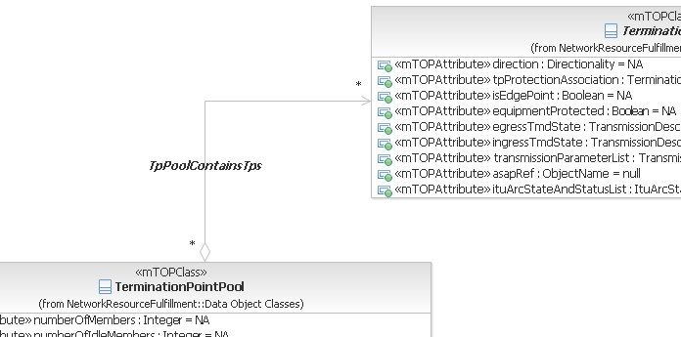
Figure 15: "Abstract" relationship (example)

Traceability Guidelines
Traceability from IA back to BA shall be provided in 2 ways:
- Where appropriate, a UML artifact should reference the corresponding requirement and/or use case identifier in the documentation field.
- Traceability matrices have to be provided as defined in 2. Traceability Guidelines in section Appendix E: known issues with the IA Guidelines.

Product Identification Guidelines
As a general guideline, the UML artifacts are not product specific. If, in an exceptional case, it is necessary to define product specific artefacts, the product shall be identified in the stereotype of the artefact.
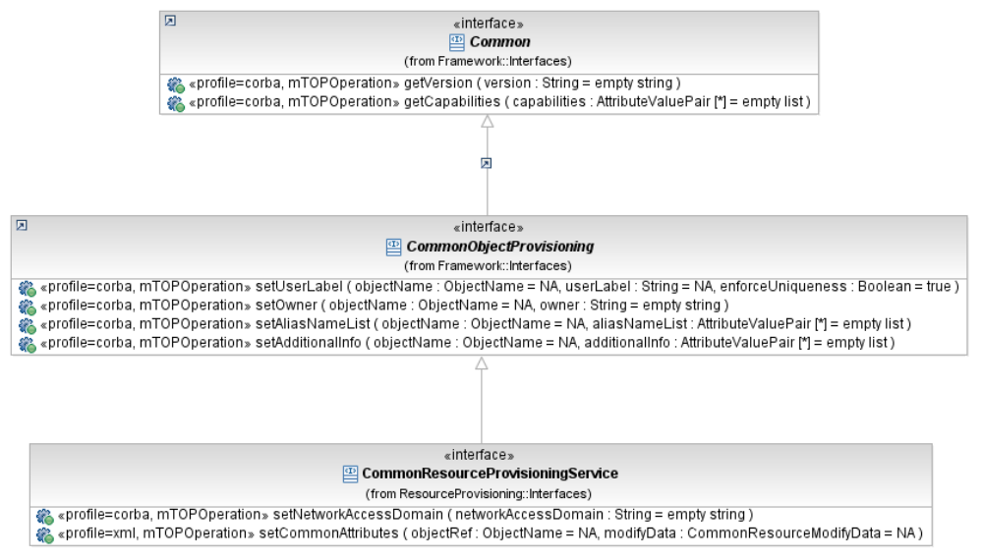
Figure 16: Product specific artefacts (example)

Data Model (DM) DDP Guidelines

Overview
There is an mTOP UML Model for each mTOP DM DDP; see section 2.1.2.

Location
An mTOP IA UML data model file corresponds to an mTOP DM DDP and is contained in the IA folder of this DDP; see section 2.1.3.

Object Class Guidelines
DM Model object classes are derived from the static requirements (i.e., category I requirements) in the BA.

Relationship Guidelines

Naming relationship
Naming relationships are defined using the composition association with:
- a private role name at the subordinate class
- stereotype = <<naming>>
- abstract = true
- no relationship name.
The attribute which is used for naming is identified by an additional stereotype <<objectRefKey>>.
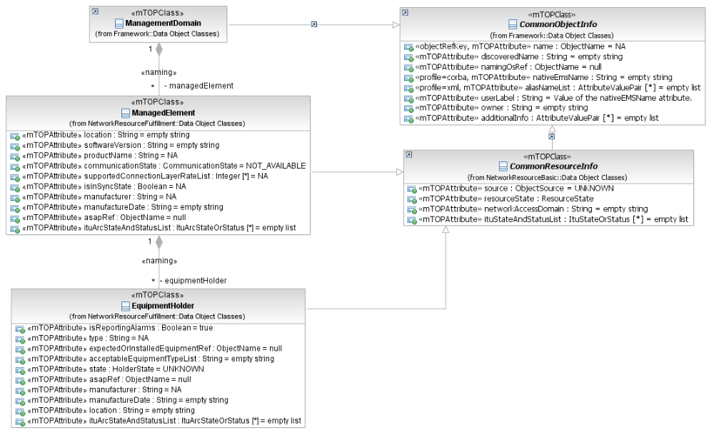
Figure 17: Naming relationship (example)

Instance Reference relationship
An object instance (name) is referenced in another object by either using the aggregation association or the simple association with:
- a relationship name
  - format: "<ClassName><VerbPhrase><ClassName>" or "<ClassName><VerbPhrase>" where the verb phrase creates a sequence that is readable and meaningful
  - must be unique across all relationship names defined in the whole mTOP IA
- a public role name at the referenced class side
- default value = NA
- notificationType = ATTRIBUTE_VALUE_CHANGE or NO_NOTIFICATION.
Example:
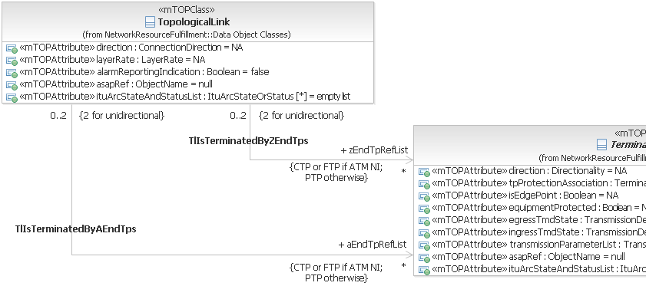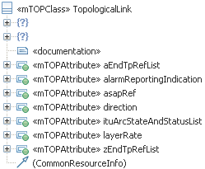
Figure 18: Instance Reference relationship using simple association (example)

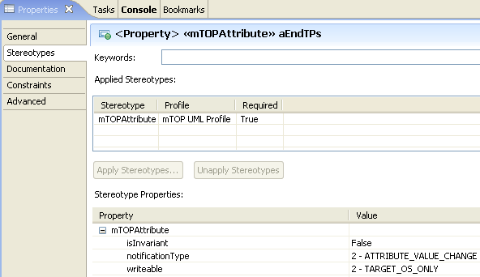
Figure 19: Additional properties of role attribute in example
In the example (Figure 18 and Figure 19), the names of the A-End Termination Points (TP) shall be part of the information that is provided when the Topological Link (TL) is retrieved via the interface using the role name as the identifier (e.g., aEndTPs shall be implemented as an attribute of TL).

Dependencies
to be added

Service Interface Guidelines
Service Interfaces are specified in the OM-DDPs.

Overview
There is an mTOP UML Model for each mTOP OM DDP; see section 2.1.2.

Location
An mTOP IA UML operations model file corresponds to an mTOP OM DDP and is contained in the IA folder of this DDP; see section 2.1.3.

Interface Guidelines
OM Model Interfaces are derived from the dynamic requirements (i.e., category II requirements) in the BA. The Interfaces are modelled as object classes (i.e., the service interfaces).

Operation Guidelines
Operations (within the Interfaces) are derived from the dynamic requirements and use cases in the BA. Each operation comprises:

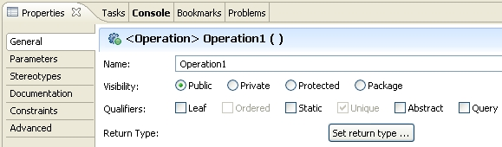
Figure 20: Defining operation properties (example)
- Operation Name
  - follow Lower CamelCase (LCC)
  - must be unique across all operation names defined in the whole mTOP IA
  - special definitions are in the mTOP Naming Convention Guidelines in SD0-1_mTOPDictionary [Ref 6].
- Visibility
  - Public: if the operation shall be inherited to subclasses
  - Private: if the operation shall not be inherited to subclasses = default value.
- Qualifiers
  - Leaf: defines if it is allowed to specialize or redefine the operation in a subclass; default value is false.
  - Static: specifies whether the operation has class or instance scope.
  - Abstract: if true, then the behavioral feature does not have an implementation, and one must be supplied by a more specific element. If false, the behavioral feature must have an implementation in the classifier or one must be inherited from a more general element. Default value is false.
  - Query: defines whether an execution of the BehavioralFeature leaves the state of the system unchanged (= true) or whether side effects may occur (= false); default value is false.
  - Return Type : always "void".
- Operation Documentation
  - contains a short summary of usage.
- Pre-condition(s)
Pre-condition(s) are modeled as Constraints. They list the conditions that have to be true before the operation can be started (i.e., if not true, the operation will not start at all).

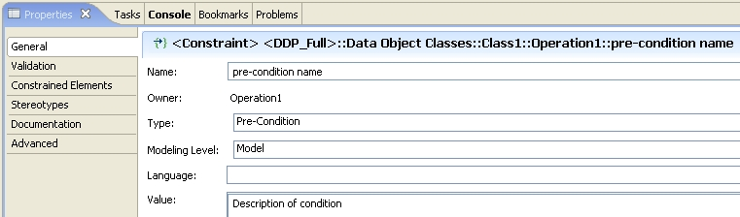

Note: It is also possible to define the pre-condition in OCL.
Figure 21: Defining operation pre-conditions
- Parameter(s)
see below.
- Post-condition(s)
Post-condition(s) are modeled as Constraints. They describe the state of the system after the operation has been successfully executed.
- Idempotency (contained in mTOPOperation stereotype)
  - this additional property defines if the operation is idempotent or not; see also section 3.4.1.
- Message Exchange Pattern (MEP) (contained in mTOPOperation stereotype)
  - the MEP fully identifies the messages and the choreography (sequencing and cardinality) of the messages independently from a business activity (SRR | ARR | SIT | ABR | SFB | AFB | SN | AN) ; see also section 3.4.1 and SD2-5 Communication Styles [Ref 7].
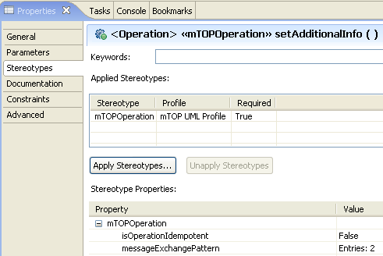
Figure 22: mTOPOperation additional properties (example)
- Operation Exceptions
List the allowed exceptions (together with a failure reason) for the operation.
  - ACCESS_DENIED - Raised when the requesting OS is not permitted to perform the operation.
  - CAPACITY_EXCEEDED - Raised when the request will result in resources being created or activated beyond the capacity supported by the NE or target OS.
  - COMM_LOSS - Raised when the target OS (which is a top-level OS) is unable to communicate with the subordinate OS and communication is required to complete the request.
  - ENTITY_NOT_FOUND - Raised when the specified object instance does not exist.
  - INTERNAL_ERROR - Raised when the request has resulted in an OS internal error.
  - INVALID_INPUT - Raised when the operation contains an input parameter that is syntactically incorrect or identifies an object of the wrong type or is out of range.
  - NE_COMM_LOSS - Raised when communication to the managed element is lost.
  - NOT_IMPLEMENTED - Raised when the target OS does not support this operation.
  - NOT_IN_VALID_STATE - Raised when the state of the specified object is such that the target OS cannot perform the operation.
  - OBJECT_IN_USE - Raised when the object identified in the request is currently in use.
  - PROTECTION_EFFORT_NOT_MET - Raised when the level of protection effort in the request cannot be met by the target OS.
  - TIMESLOT_IN_USE - Raised when a requested timeslot is already in use.
  - TP_INVALID_ENDPOINT - Raised when the specified TP does not exist or cannot be created.
  - UNABLE_TO_COMPLY - Raised when the target OS cannot respond to the request.
  - UNSUPPORTED_ROUTING_CONSTRAINTS - Raised when the target OS is unable to satisfy the requested routing constraints.
  - USERLABEL_IN_USE - Raised when the user label uniqueness constraint is not met; the specified user label is currently being used.

The exceptions are contained in the folder "Operation Exceptions" in the Framework DDP.
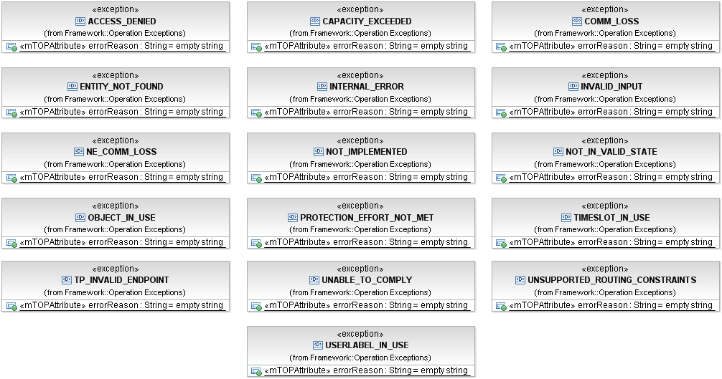
Figure 23: Operation Exceptions Class Diagram
The relevant exceptions can be added to an operation by right click on the operation, choose UML Properties …, choose RaisedException and browse to the exception class via the "…" button on the right:

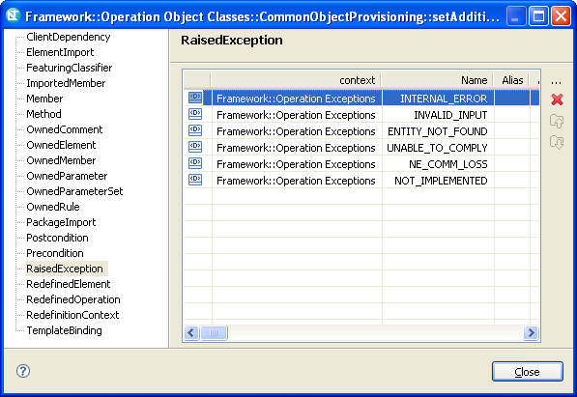
Figure 24: Raised exception window

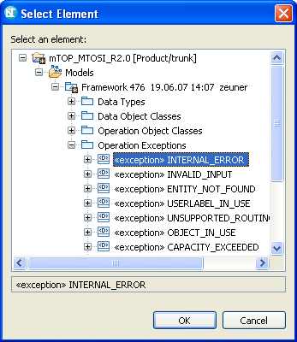
Figure 25: Select exception window

Operation Parameter Guidelines
Each parameter in an operation comprises:
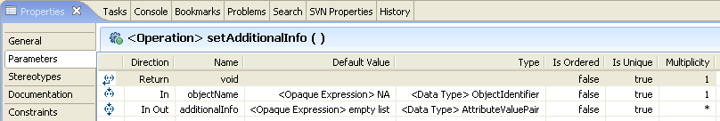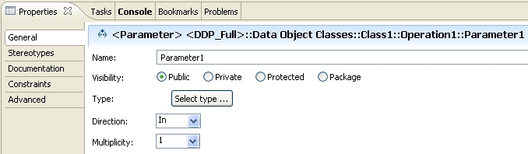
Figure 26: Defining operation parameters
- Name
  - follow Lower CamelCase (LCC)
  - special definitions are in the mTOP Naming Convention Guidelines in SD0-1_mTOPDictionary [Ref 6].
- Visibility
  - Public: if the attribute shall be inherited to subclasses
  - Private: if the attribute shall not be inherited to subclasses = default value.
- Type
  - refers to a basic or complex data type
  - a list of input (in a few cases also output) parameters could also be combined in a data type
  - if possible, the following common set of resource create and modify input parameters shall be used:
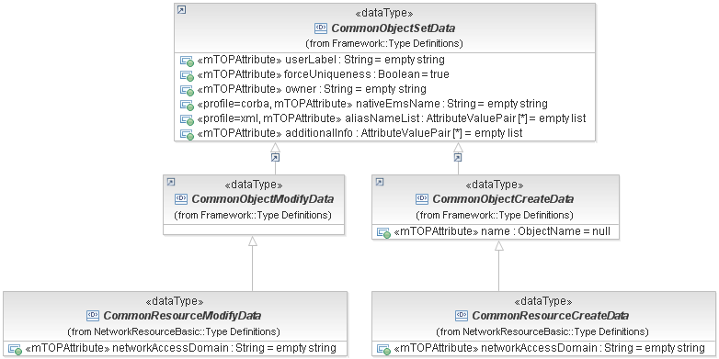
Figure 27: Common Resource Create and Modify parameters
- Direction
  - In | In Out | Out | Return .
- Default Value
provides the value that the parameter has to start with in case the value is not provided.
In the case of a single-value property, the default value shall be specified as an <Opaque Expression>, except for the case in which the type of the property is an Enumeration type, in which case it shall be an Enumeration Literal selected from the Enumeration. (Note that an Enumeration Literal must be selected from the appropriate browser in RSM and must not simply be typed as a string.)
In the case of a multiple-valued property, the default shall be specified as a comma-separated list of <Opaque Expression> enclosed in braces. (Note that it is not possible to have a multiple-value property of an Enumeration type.)
If a default value makes no sense (e.g., the requesting OS has to provide a value for this parameter) = "<Opaque Expression> NA".
No default value for object identifier = "<Literal Null>".
No default value for String = "<Opaque Expression> empty string".
No default value for Sequence = "<Opaque Expression> empty list".
- Is Ordered
for a multivalued parameter; the order of the values is important.
- Is Unique
for a multivalued parameter, no duplicate values are allowed.
- Multiplicity
defines the number of values the parameter can simultaneously have.
- parameter Documentation
contains a short summary of usage.
For attributes in Data Types which are used as a parameter list (e.g., CommonResourceCreateModifyData; see Figure 27), the additional properties contained in the mTOPAttribute stereotype are not meaningful. The properties shall be fixed to:
- isInvariant fixed to "True"
- notificationType fixed to "NOT_APPLICABLE"
- writeable fixed to "REQUESTING_OS_ONLY"

Relationship Guidelines
It is recommended to use the dependency relationship to associate input or output parameter lists to the operations in an object. These relationships are just for explanation to the reader of the model. No special care has to be taken in the protocol specific part; they are usually modelled in operations of the dependent class.

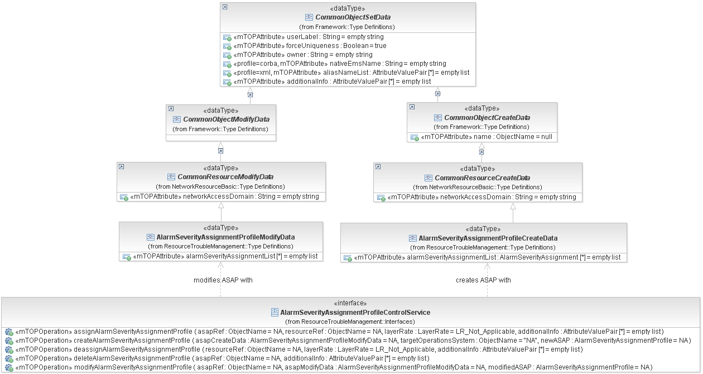
Figure 28: Depiction of operation parameter classes (example)

Dependencies
to be added

Notification Guidelines

Overview
The IA specifies the information which has to be provided by a notification; i.e., the notification parameters.
This section explains how to model this information. The trigger events for the notifications are described in other sections; i.e., at the place where the artifact which causes the notification is defined (e.g., object creation notification in section 3.4.3, attribute value change notification in section 3.4.4.

Location
Notifications are contained in a separate "Notifications" package within the Data Model DDPs.
A notification class diagram is added in the "Class Diagrams" package.

Guidelines
Object classes are used to model the notifications in the DM model.
Each notification comprises:
- Notification Name
  - follow Upper CamelCase (UCC)
  - ends with the word "Notification" (e.g., EquipmentProtectionSwitchNotification)
  - must be unique across all notification names defined in the whole mTOP IA
  - special definitions are in the mTOP Naming Convention Guidelines in SD0-1_mTOPDictionary [Ref 6].
- Notification Documentation
  - contains a short summary of usage
refers to the appropriate BA requirement.
- Superclass(es)
  - inheritance and multiple inheritance may be used
  - two common lists of notification parameters are defined in the Framework DDP which shall be used whenever possible:
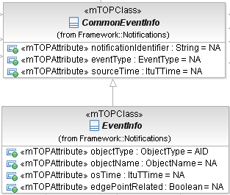
Figure 29: Common Notification parameters
- Abstract Object Class
  - indicates if the notification can be instantiated or is just used for inheritance (like the previous common parameter lists).
- Object Notifications (contained in mTOPClass stereotype)
  - this property can be ignored for Notifications
  - "objectCreationNotification" fixed to "NOT_APPLICABLE"
"objectDeletionNotification" fixed to "NOT_APPLICABLE"
"objectDiscoveryNotification" fixed to "NOT_APPLICABLE"; see also section 3.4.1.

Notification Parameter Guidelines
Attributes are used to model the parameters in the Notifications.
Each parameter (attribute) in a Notification comprises:
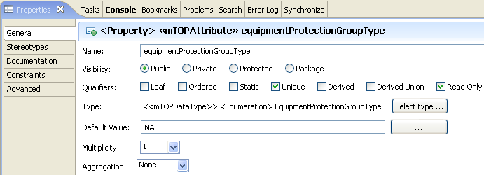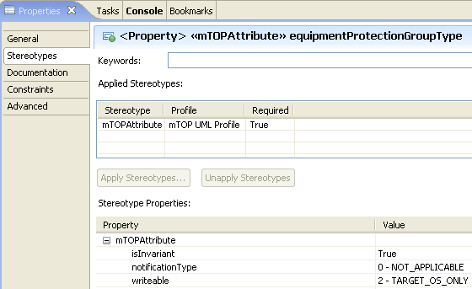
Figure 30: Notification Parameter properties (example)
- Parameter Name
  - follow Lower CamelCase (LCC)
  - must be unique across all notification parameter names defined in the whole mTOP IA
  - special definitions are in the mTOP Naming Convention Guidelines in SD0-1_mTOPDictionary [Ref 6]
  - Boolean typed parameters always start with ‘is’ (e.g., ‘isClearable’)
  - Enumeration typed attributes always end with “Kind” (e.g., ‘aggregationKind’).
- Parameter Documentation
  - contains a short summary of usage
  - refers to the specific BA requirement if defined.
- Visibility
  - this property can be ignored for Notification parameters
  - fixed to "Public".
- Qualifiers
  - this property can be ignored for Notification parameters
  - fixed to "Unique" and "Read Only".
- Type
  - refers to a basic or complex data type.
- Default Value
  - this property can be ignored for Notification parameters
  - fixed to "NA" because it has to reflect the current situation.
- Multiplicity
  - this property can be ignored for Notification parameters
  - fixed to "1".
- Aggregation
  - this property can be ignored for Notification parameters
  - fixed to "None".
- Invariant (contained in mTOPAttribute stereotype)
  - this property can be ignored for Notification parameters
  - fixed to "True"; see also section 3.4.1.
- Notification Type (contained in mTOPAttribute stereotype)
  - this property can be ignored for Notification parameters
  - fixed to "NOT_APPLICABLE"; see also section 3.4.1.
- Writeable (contained in mTOPAttribute stereotype)
  - this property can be ignored for Notification parameters
  - fixed to "TARGET_OS_ONLY"; see also section 3.4.1.

Dependencies
to be added

Changes History
The purpose of this section is to summarize the evolution/changes of mTOP IA guidelines / best-practices between product releases.

IA v3.4 (used in MTNM R3.5) to IA v3.5 (used in MTOSI R2.0)
The following list includes all the important new or updated features introduced into the development of MTOSI R2.0 IA:
- IA for MTOSI R2.0 is based on the new mTOP DDPs.
- Tool change from "Rational Rose" to "Rational Software Modeler".

References

External References
Ref 1 OMG Unified Modeling Language (UML) – http://www.uml.org/
Ref 2 IBM Rational Software Modeler (RSM) –
http://www-306.ibm.com/software/awdtools/modeler/swmodeler/index.html

Internal References
Ref 3 mTOP Wiki (GForge) – http://gforge.tmforum.org/plugins/wiki/index.php?id=12&type=g
Ref 4 mTOP GForge (Subversion) Usage Guidelines – mTOP_Guidelines_GForgeUsage
Ref 5 mTOP DDP Guidelines – mTOP_Guidelines_DDP_Definitions, mTOP_Guidelines_DDP_Maps
Ref 6 mTOP Naming Convention Guidelines – SD0-1_mTOPDictionary
Ref 7 SD2-5 Communication Styles – SD2-5_Communication_Styles
Ref 8 SD2-6 MTOSI Versioning and Extensibility supporting document – SD2-6_VersioningAndExtensibility

Appendix A: mTOP Parameters Supporting Documents
The latest versions of these SDs are available on GForge.

Supporting Document | Version | Comments
SD1-8_encodingX731M3100
SD1-16_Layered Parameters |  | See Appendix B for all layered parameters applicable domains
SD1-17_LayerRates
SD1-28_PerformanceParameters
SD1-29_PGPParameters
SD1-33_ProbableCauses
Table 2: Supporting Documents containing Parameters

Appendix B: mTOP Layered Parameters Domains
Generally Applicable Parameters

Connection-oriented Technology Parameters

General parameters for Inverse Multiplexing
SDH/SONET/PDH specific parameters
ATM specific parameters
ATM parameters relevant only to ATM Network Interfaces supporting PNNI
IMA (Inverse Multiplexing for ATM) specific parameters
ATM specific Traffic Descriptor parameters
WDM specific parameters
Protection specific parameters
TCM related parameters for SDH/SONET
TCM related parameters for DWDM/OTN
Radio specific parameters
Frame Relay specific parameters
DSL (Digital Subscriber Line/Loop) specific parameters

Connectionless Technology Parameters

Ethernet specific Parameters
Spanning Tree Protocol (STP) related parameters
VLAN related parameters
Traffic conditioning parameters
Resilient Packed Ring (RPR) related parameters
Class of Service parameters
Ethernet MAU parameters
Link Aggregation Parameters

Appendix C: Requirements for additional properties in the mTOP IA UML model
This section contains the requirements for the additional properties grouped by Stereotypes.
The following tables contain the stereotypes that have already been defined for mTOP:
Stereotype: mTOPClass

name of property | type | allowed values | default value | associated to metaclass | mandatory/optional | comments
objectCreationNotification | enumeration | NO,  YES,  NOT_APPLICABLE | NOT_APPLICABLE | EClass | mandatory
objectDeletionNotification | enumeration | NO,  YES,  NOT_APPLICABLE | NOT_APPLICABLE | EClass | mandatory
objectDiscoveryNotification | enumeration | NO,  YES,  NOT_APPLICABLE | NOT_APPLICABLE | EClass | mandatory
Table 3: Stereotype: mTOPClass
Stereotype: mTOPAttribute

name of property | type | allowed values | default value | associated to metaclass | mandatory/optional | comments
notificationType | enumeration | ATTRIBUTE_VALUE_CHANGE,  STATE_CHANGE,  NO_NOTIFICATION,  NOT_APPLICABLE | NOT_APPLICABLE | EStructuralFeature | mandatory
writeable | enumeration | NONE_OS  REQUESTING_OS_ONLY,  TARGET_OS_ONLY,  TARGET_AND_REQUESTING_OS | REQUESTING_OS_ONLY | EStructuralFeature | mandatory | An indication of which OS can set the attribute.
isInvariant | boolean | true/false | false | EStructuralFeature | mandatory
Table 4: Stereotype: mTOPAttribute
Stereotype: mTOPOperation

name of property | type | allowed values | default value | associated to metaclass | mandatory/optional | comments
messageExchangePattern | enumeration list | SRR,  ARR,  SIT,  ABR,  SFB,  AFB,  SN,  AN | empty list | EOperation | mandatory | A description of the values can be found in SD2-5_Communication_Styles.pdf.
isOperationIdempotent | boolean | True/False | false | EOperation | mandatory
Table 5: Stereotype: mTOPOperation
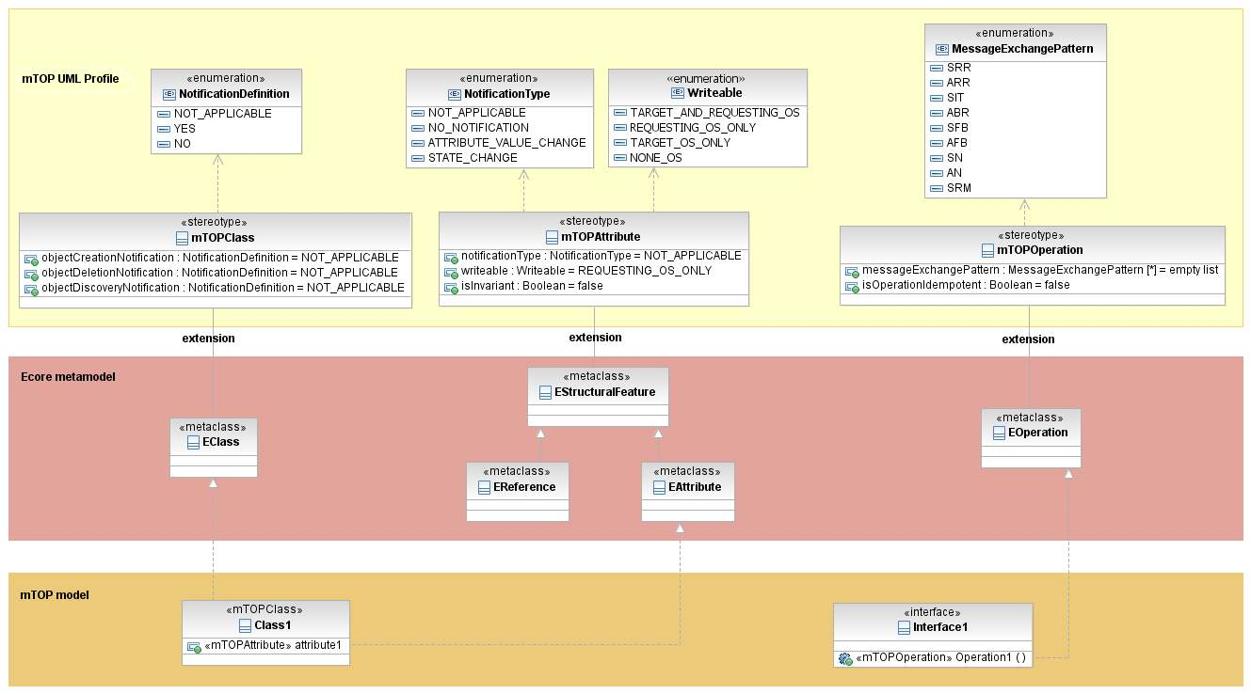
Figure 31: RSM model structure
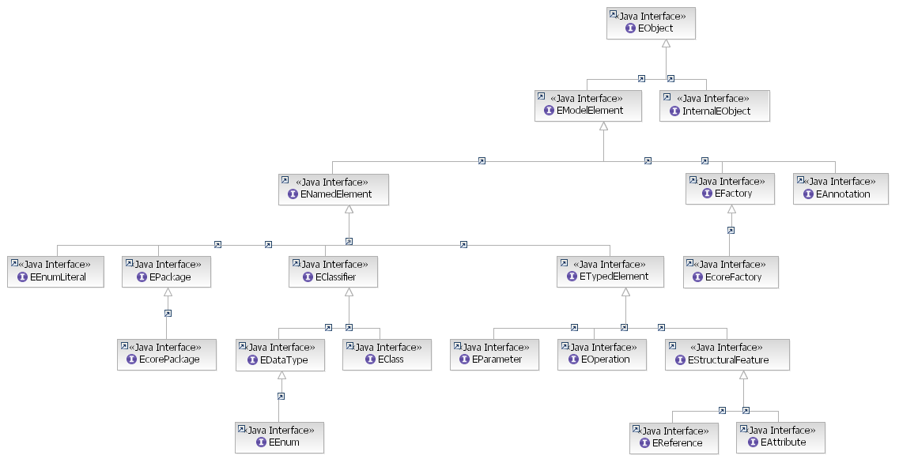
Figure 32: The RSM Ecore metamodel

Appendix D: known issues with RSM/RSA
This section contains all known open issues with regard to the RSM/RSA tool.
Note: Finally this section will be (hopefully) deleted.

- HTML Export is incomplete.

Appendix E: known issues with the IA Guidelines
This section contains all known open/postponed IA Guideline issues. This list has to be revisited after completion of MTOSI Rel. 2.0.

- It may be necessary to enhance the list of agreed protocol neutral basic data types to accommodate harmonization with other models.
Copy from Chameleon (Cisco’s internal information model for management) section 9.2:
Most of the datatypes in Chameleon are taken from the XML XSD specification [XSD] and have the same semantics. The differences are:
- anyURI : Can also be used to encode a reference, that could be an Entity Class reference. Use the <<TypeOfUri>> stereotype to specify a specific Entity Type.
- objectid : An opaque identity.
- octetstring : ASN Octetstring presentation.
- void : Used on Operation return to specify that there is no return parameter.
These primitive types are defined in the MODEL-TYPES model library.
Name | Description
anyURI | Used to encode a reference, that could be an Entity Class reference. Use TypeOfUri to specify a specific type.
boolean | As XSD
byte | As XSD
datetime | As XSD
double | As XSD
duration | As XSD
float | As XSD
hexBinary | As XSD
int | As XSD
long | As XSD
objectId | An opaque identity.
octetstring | As XSD
short | As XSD
string | As XSD
unsignedByte | As XSD
unsignedInt | As XSD
unsignedLong | As XSD
unsignedShort | As XSD
void | Used on Operation return to specify that there is no return parameter.
blob | Used to encode a loosely typed object. Typically in java this will be mapped to java.lang.Object

- Traceability Guidelines
Not required for MTOSI 2.0; will be added once they can be generated automatically.
The following traceability matrices shall be provided:
  - mapping from object classes to requirements
  - mapping from object class attributes to requirements
  - mapping from object class operations to requirements
  - mapping from object classes to use cases.

- OM Service description structure
An OM Service description structure has to be defined. The "SOA Reference Model" developed in OASIS (http://wiki.oasis-open.org/soa-rm/TheArchitecture/ServiceView/ServiceDescription) shall be used as a basis.
However we should start with a simplified version.
Key attributes are:
  - Business activities (operations)
  - Message Exchange Patterns

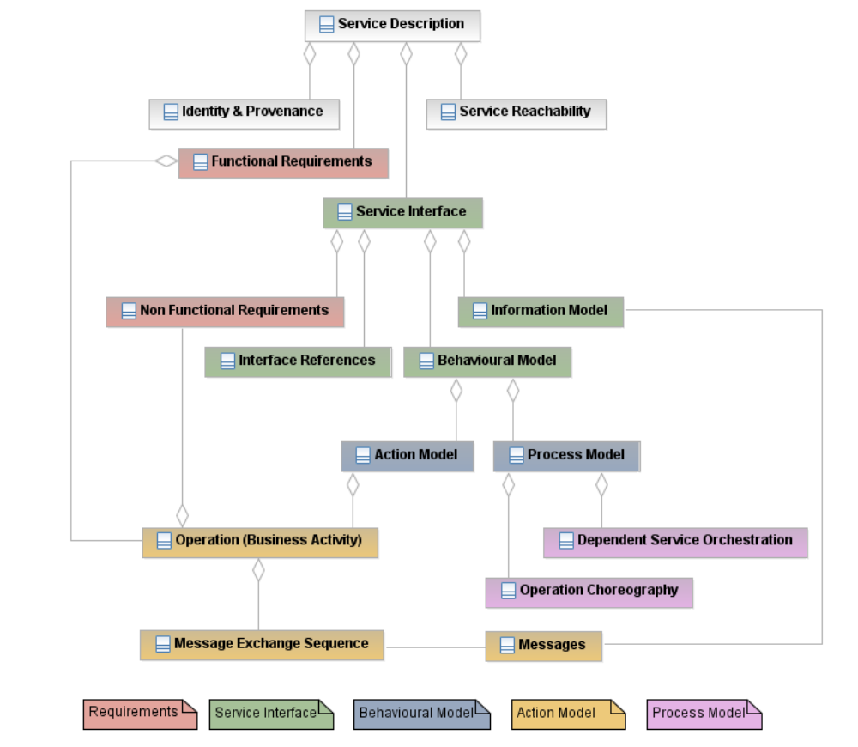
Figure 33 - OM Service description structure

Administrative Appendix

Document History

Version Number | Date Modified | Modified by: | Description of changes
0.1 | 20 July 2007 | Bernd Zeuner | Initial version based on mTOP_Guidelines_IA.doc in Methodology folder (20 July 2007; revision 585).
0.2 | 24 July 2007 | Bernd Zeuner | Updated based on discussion during TAW Boston.
0.3 | 16 August 2007 | Bernd Zeuner | Comments from Chris Hartley, Steve Jerman and Hector Trevino added and partly answered.
0.4 | 27 August 2007 | Bernd Zeuner | Comments from Steve Fratini added and partly answered.  Guidelines for Notifications added.
0.5 | 07 Sept. 2007 | Bernd Zeuner | Comments from Cisco (Chris, Steve, Hector) added and partly answered.  Appendix C: "Requirements for additional properties in the mTOP IA UML model" added.
0.6 | 14 Sept. 2007 | Bernd Zeuner | Definitions from Chameleon (Cisco) added.  Stereotype <<objectRefKey>> added.  mTOP UML Profile updated:  - Property "Idempotent" added to <<mTOPOperation>>  - Properties "Invariant" and "WriteableByRequestingOS" added to <<mTOPAttribute>>  - Property "AttributeOrderSignificant" removed from <<mTOPClass>>.
0.7  Revision 876 | 05 Oct. 2007 | Bernd Zeuner | Converted to new SD template (Revision 850).  Data Type extensibility deleted.
0.8 | 12 Nov. 2007 | Bernd Zeuner | mTOPAttribute stereotype updated:  - writeable defined,  - passedBy deleted.  UnsignedInteger added as basic type.  COMM_LOSS exception added.  Attribute List relationship deleted.
0.9 | 20 Nov. 2007 | Bernd Zeuner | ObjectName added as basic data type.  Literal NONE_OS added to writeable attribute property.  Postponed functions are summarized in the new Appendix E: known issues with the IA Guidelines.
0.10 | 11 Dez. 2007 | Bernd Zeuner | BA reference requirements added.  Remaining comments deleted as accepted during conference call on 29 November.  Firewall/proxy configuration added for Subclipse.  Common Object Provisioning interface added.
0.11 | 30 April. 2008 | Bernd Zeuner | Guidelines for data type attributes added.  "Choice" data type added.  Product Identification Guidelines added.
0.12 | 08 May. 2008 | Bernd Zeuner | Reference to SD0-1_mTOPGuidelines_NamingConventions.doc replaced by reference to  SD0-1_mTOPDictionary.doc.

Acknowledgments

First Name | Last Name | Company

How to comment on this document
Comments and requests for information must be in written form and addressed to the contact identified below:

<FirstName> | <LastName> | <Company>
Phone:
Fax:
e-mail:

Please be specific, since your comments will be dealt with by the team evaluating numerous inputs and trying to produce a single text. Thus we appreciate significant specific input. We are looking for more input than wordsmith” items, however editing and structural help are greatly appreciated where better clarity is the result.

The term Service Interface comes from ETSI TS 188 001. “NGN OSS Service Interface (NGN OSS SI): A well defined grouping of related NGN OSS Operations and constant data which are necessary to deliver coherent business or system functionality.”

