mTOP Information Agreement Guidelines
Contributors:
- Steve Fratini, Telcordia, sfratini@telcordia.com
- Jérôme Magnet, Nortel, jeromem@nortel.com
- Bernd Zeuner, T-Systems, bernd.zeuner@t-systems.com
Storage Location: Methodology folder of the TMF GForge mTOP project
Publication History:
Issue | Status / Change Summary | Author(s) | Date
0.01 | Initial creation  Using the XML guidelines document from Jerome as a basis. | Bernd Zeuner | March 15, 2007
0.02 | Changes made during 29 March Call included.  Rational Rose examples replaced by RSM examples.  Mapping table from UML 1.4 to UML 2.0 added. | Bernd Zeuner | April 19, 2007
0.03 | All changes from version 0.0.2 accepted.  Proposal on Naming Conventions added.  CamelCase definitions inserted.  Mapping (MTNM R3.5 → MTOSI R2.0) rule for Attribute access inserted. | Bernd Zeuner | May 14, 2007
0.04 | All changes from version 0.0.3 accepted.  DDP structure added.  mTOP Profile structure added.  Figures updated based on GForge structure.  Known issues with RSM added in Appendix C. | Bernd Zeuner | June 20, 2007
0.05 | Description on how to add the IA from the GForge Subversion repository as a new project into RSM added.  Definition for operation exceptions added.  References to Naming Convention Guideline document added. | Bernd Zeuner | June 28, 2007
0.06 | Comments provided by Michel (July 12) added.  General IA Requirements enhanced. | Bernd Zeuner | July 12, 2007

Table of Contents
1 Overview 3
1.1 Introduction 3
1.2 Status 3
1.3 Context 3
1.4 Future 3
2 General Guidelines 3
2.1 IA Architecture 3
2.1.1 Overview 3
2.1.2 Logical View 3
2.1.3 Development View 4
2.1.4 Deployment View 5
2.2 Naming Conventions 5
2.3 Versioning 5
2.3.1 Overview 5
2.4 Documentation 5
3 IA Modelling Guidelines 6
3.1 Introduction 6
3.2 General IA Requirements (provided by Steve Fratini) 6
3.3 New General IA Requirements (provided by Steve Fratini) 6
3.4 General UML Guidelines 7
3.4.1 mTOP Profile 8
3.4.2 Data Type Guidelines 9
3.4.3 Object Class Guidelines 10
3.4.4 UML Diagram Guidelines 12
3.4.5 Use Case Guidelines 12
3.4.6 Relationship Guidelines 12
3.4.7 Traceability Guidelines 13
3.5 Data Model (DM) DDP Guidelines 13
3.5.1 Overview 13
3.5.2 Location 13
3.5.3 Object Class Guidelines 13
3.5.4 Relationship Guidelines 13
3.5.5 Dependencies 14
3.6 Operation Model (OM) Guidelines 14
3.6.1 Overview 14
3.6.2 Location 14
3.6.3 Object Class Guidelines 14
3.6.4 Operation Guidelines 14
3.6.5 Relationship Guidelines 17
3.6.6 Dependencies 17
3.7 Notification Guidelines 17
3.7.1 Overview 17
3.7.2 Location 17
3.7.3 File/Information Structur 17
3.7.4 Dependencies 18
4 Changes History 18
4.1 IA v3.4 (used in MTNM R3.5) to IA v3.5 (used in MTOSI R2.0) 18
5 References 18
5.1 External References 18
5.2 Internal References 18
Appendix A: mTOP Parameters Supporting Documents 19
Appendix B: mTOP Layered Parameters Domains 20
Appendix C: known issues with RSM 21

Overview

Introduction
The purpose of this document is to be the unique design reference for the development of all mTOP Information Agreements (IA).
The Unified Modelling Language (UML) Version 2.1 [Ref 1]will be used as the notation for the IA. The IA will be created with the "Rational Software Modeler" (RSM) tool [Ref 2] provided by IBM.
These guidelines shall ensure that different people can create individual parts of the Information Agreement with the same "look and feel" which can then be combined into an mTOP Release.

Status
This document is an mTOP Guideline document.
Refer to the mTOP Guidelines GForge Usage document [Ref 4]for access and usage procedures of all the mTOP data available through the TMF GForge Subversion (SVN) repository.

Context
The definition of these mTOP IA guidelines is driven by the development of the MTOSI Release 2.0 mTOP product. The writing of these IA guidelines has been made possible based on the experience the mTOP team gained from the previous MTOSI and MTNM releases.

Future
These IA guidelines are not a static document. The following factors will certainly influence the evolution of these guidelines sometime in the future:
- During the creation of the individual IA DDPs the editors become more and more familiar with the RSM tool which may lead to improvements.
- mTOP Methodology: The idea of generating a protocol specific UML which then allows to automatically (tool supported) create the IIS (XML, IDL) is still the targeted goal. The guidelines will therefore have to be adapted to the process/tooling chosen.
- Harmonization/Convergence with the UML models from other standards (SID, OSS/J, 3GPP, etc) will also lead to an evolution of these guidelines.

General Guidelines

IA Architecture

Overview
The purpose of the mTOP IA is to provide a description of the protocol neutral mTOP Information Model based on UML.
The overall mTOP IA is structured along the mTOP DDP partitioning which is based on the eTOM level2/3 processes. All IA definitions must relate to the scope of the mTOP DDP that it is part of. Refer to the mTOP Guidelines DDP Definitions documents [Ref 5] for a rational description of the mTOP DDPs.

Logical View
The complete definition of the mTOP Information Model is based on the use of individual UML Models containing the mTOP DDPs.
The DDPs are grouped into two basic types:
- Data Model DDPs (DM-DDPs) containing the static data model.
- Operation Model DDPs (OM-DDPs) containing the dynamic computational model.
The following DDPs will be created for MTOSI Release 2.0:
- Framework (FMW)
- RM&O + RD&M
  - Data Model DDPs
    - Network Resource Basic (NRB)
    - Network Resource Fulfillment (NRF)
    - Network Resource Assurance (NRA)
  - Operation Model DDPs
    - Manage Resource Inventory (MRI)
    - Resource Provisioning (RP)
    - Resource Trouble Management (RTM)
    - Resource Performance Management (RPM)
- SM&O + SD&M
  - Data Model DDPs
    - Service Basic (SB)
  - Operation Model DDPs
    - Manage Service Inventory (MSI)
    - Service Activation (SA)
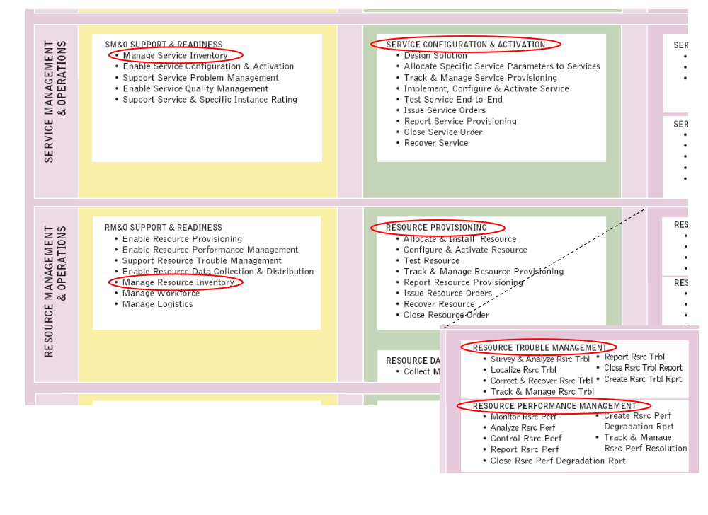
Figure 1: "Location" of the MTOSI Release 2.0 DDPs within eTOM
Note: The development of the Framework DDP will have the highest priority because this DDP is used in all other DDPs.

Development View
The development view of the mTOP IA is maintained and managed through the TMF GForge Subversion repository. Refer to the mTOP Guidelines GForge Usage [Ref 4].
The following steps describe how to add the IA (in fact it adds the complete specification) from the GForge Subversion repository as a new project into RSM.
- A prerequisite is that you have installed the "Subclipse" (an Eclipse Plug-in) Subversion tool into RSM. Section 2.4.3 in the mTOP Guidelines GForge Usage [Ref 4] document describes how to install and configure "Subclipse".
- Creating a new Repository Location (customised based on the "Subclipse" help documentation)
You create and work with your repository locations from the SVN Repository View, which is part of the SVN Repository Exploring Perspective. To create a new repository location, click the Add SVN Repository button or right clicking inside the view and selecting New > Repository Location...
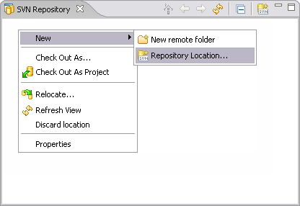
The Add SVN Repository dialog will prompt you for a repository location URL. Enter the URL of the mTOP repository
- svn+ssh://<username>@svn.gforge.tmforum.org/svn/mtop (<username> is your TMF GForge
registered username) or
- http://gforge.tmforum.org/svn/mtop/ (Note: http should only be used if svn+ssh is blocked by the
firewall).
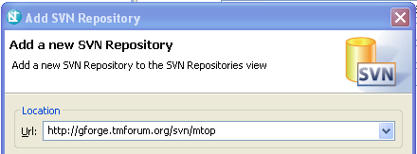
Once you click finish, the wizard will create the location:
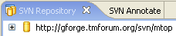
Expand the location to see the contents for the given URL.
- Checking out the draft MTOSI Release 2.0 specification from the GForge repository
Excerpt from "Subclipse" help documentation: Check out is the term used to describe the process of making a copy of a project from a repository into your local workspace. In SVN, the check out process creates a working copy. A working copy is a specially formatted folder structure which contains additional .svn folders that store SVN information, as well as a pristine copy of each item that is checked out.
In the SVN Repository window, select the Product / trunk repository directory and choose Checkout from the context menu:
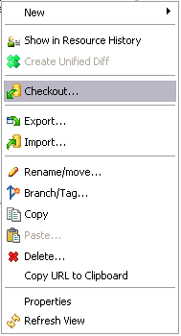
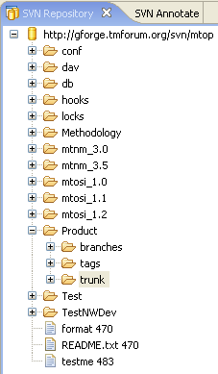
Choose Check out as a project configured using the New Project Wizard and click Next:
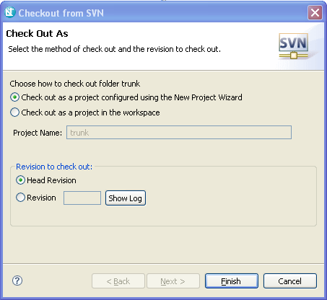
Choose General / Project and click Next:
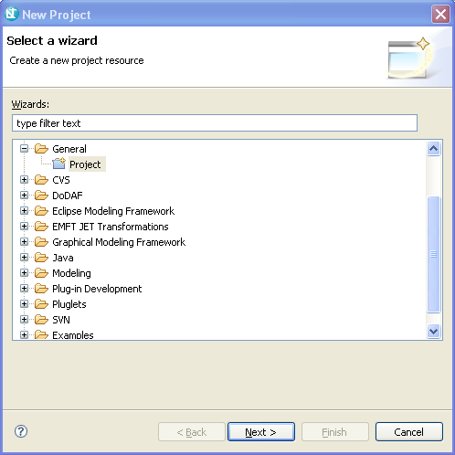
Choose a new project name (e.g., "mTOP_MTOSI_R2.0") and the location for the files and click Next:
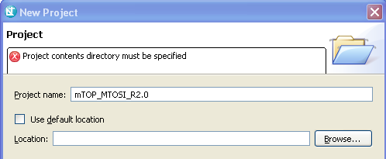
Do not reference a project and click Finish.
Finally, move to the Modeling view in RSM and you will find the new project mTOP_MTOSI_R2.0 in the Project Explorer:
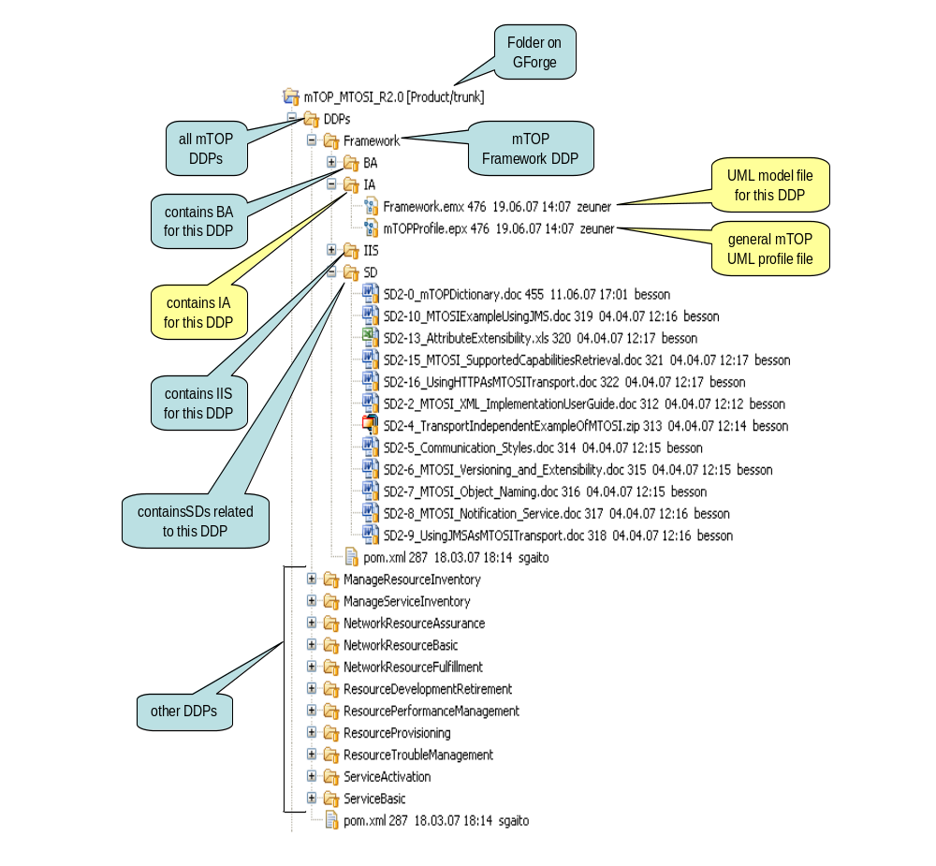
Figure 2: Structure of the IA Model files on GForge during development

Deployment View
To be defined.

Naming Conventions
Refer to the mTOP Guidelines NamingConventions document [Ref 6].
mTOP artifacts are the Business Agreement (BA), the Information Agreement (IA) and the Interface Implementation Specification (IIS).
UML artifacts are classes, attributes, operations, parameters and relationships.
In this document the following tags are used as variables:
- <DDP_Full> for the full DDP name
- <DDP> for the short DDP name (acronym)

Versioning

Overview
Editor's note: Should not be a problem because backward compatibility is not required for the IA.

Documentation
The documentation of the mTOP UML IA will be done with the tool "Rational Software Modeler" from IBM. This application can also generate HTML-based documentation of the UML models.
The location for the generated HTML documentation is: to be defined.

IA Modelling Guidelines

Introduction
The information modeling comprises the "analysis" part of the specification. The requirements and use cases defined in the BA are the basis for the analysis.
The purpose of this section is to provide a set of UML design recommendations to promote all mTOP IA editors to specify the IA in a standardized mTOP UML style. The benefits are:
- Readability of the UML specification as they all have the same style.
- Providing the necessary information to distribute the workload between many editors.
- …

General IA Requirements (provided by Steve Fratini)

- The UML 2.1 (Unified Modeling Language) is used as a notation for the model.
- The IA shall be protocol-neutral, i.e., not reflect any middleware protocol-specific characteristics (like CORBA, HTTP, JMS).
- The IA shall be map-able to various protocol-specific interfaces.
Until this mapping is automated, it will be necessary to (manually) create an IA to IIS mapping document.
- The requirements and use cases from the BA are converted into the model as object classes (containing attributes or operations) and relationships between the objects.
- For complex attributes state transition diagrams shall be created.
- For complex operations activity diagrams shall be created.
- Traceability from each modeling construct back to the requirements and use cases has to be provided.
- The information model has to provide guidelines on how the UML notation (e.g., relationship stereotypes) is used to model specific requirements.

New General IA Requirements (provided by Steve Fratini)
This section provides the requirements which are new wrt. the last mTOP IA version (i.e., TMF608 v3.4).
- The IA shall be documented in UML 2.1 using the “Eclipse dialect.”
- The IA shall be divided into:
  - Data objects – objects that represent managed entities.
These objects only have attributes and associations.
Notifications are also treated as data objects.
  - Computational objects – objects that represent service interfaces (contracts).
These objects only have operations.
- The IA shall be sectionalized based on the DDP separations.
This will allow for:
  - Multiple editors of the IA
  - Release of portions of the IA.
- Overlap of information between the BA and IA is allowed, but is strongly recommended that one document be considered the source and the other document be populated automatically with the redundant information.
- Eventually, the intent is to have UML models for the various protocol-specific interfaces. These UML models will be considered part of the IIS and not the IA.

General UML Guidelines
This section provides the general guidelines (i.e., which are not specific to the Data Model or Operation Model).
Each DDP shall be stored in a separate Model file (xxx.emx file). Each Model shall be structured in the following way:
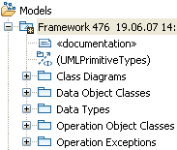
Figure 3: UML Model structure (example)
The Data Model DDPs only have "Data Object Classes" and the Operation Model DDPs only have "Operation Object Classes". The only exception which has both types of classes is the Framework DDP.
Note: RSM creates automatically an additional "Diagrams" folder that contains all the diagrams which are created in the specific Model.
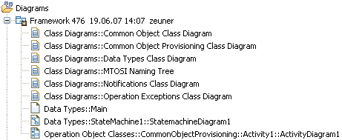
Figure 4: UML Model diagrams structure (example)
The following figure shows the location of the UML artifacts:
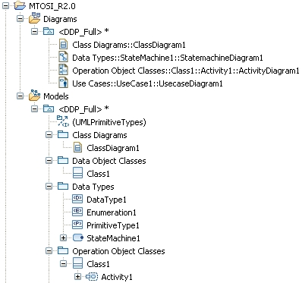
Figure 5: UML artefact structure

mTOP Profile
The RSM tool allows customizing the object and attribute templates in the UML model by using profiles. The mTOP UML Models use profiles for specifying
- the creation notifications of the resource objects (NO | YES | NOT_APPLICABLE)
- the deletion notifications of the resource objects (NO | YES | NOT_APPLICABLE)
- the discovery notifications of the resource objects (NO | YES | NOT_APPLICABLE)
- the lifecycle of the resource objects (String)
- the kind of notification that has to be send when an attribute changes its value (ATTRIBUTE_VALUE_CHANGE | STATE_CHANGE | NO_NOTIFICATION | NOT_APPLICABLE).
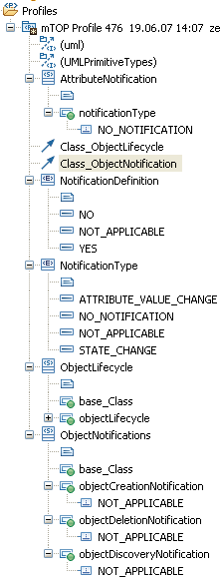
Figure 6: mTOP Profile structure
Editor's note: While it was possible to assign the additional properties to the object class template, it was not possible to assign the notification property to the attributes template so far.
The additional properties are defined as stereotypes as depicted in the following figure:
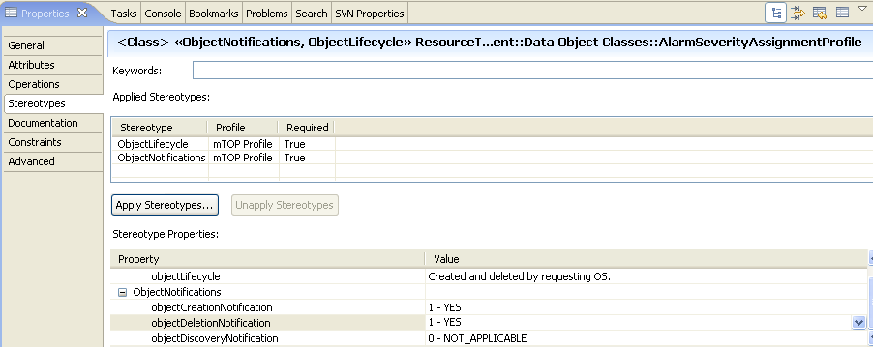
Figure 7: Additional object class properties (example)

Data Type Guidelines
We distinguish between "basic" and "complex" data types.
The basic data types do not need additional specification. They are provided by the RSM tool as "UMLPrimitiveTypes".
Basic data types are Boolean, String, Integer.
Add list of agreed protocol neutral data types here. Contact Steve O.
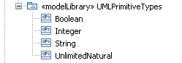
Figure 8: Basic data types
Complex data types are specified for attribute and parameter types when basic data types cannot be used. They are defined as object classes with attributes and are contained in the Data Types folder within each UML Model. Complex data types use basic and/or other complex data types for their Type definitions. Two categories of data types are defined: Enumerations and Structures.
Guidelines:
- The category of the data type is contained in the "Stereotype" field of the object class which defines the data type. The RSM meta-model already provides the "dataType" and "enumeration" data types.
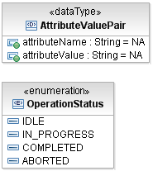
Figure 9: Complex data types (example)
- Parameter lists for creation and modification of resources shall be specified as "dataTypes" in the Data Type folder.
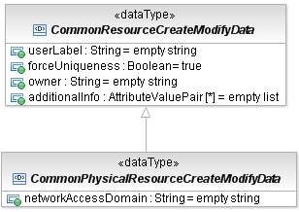
Figure 10: Creation/Modification parameter data types (example)
- Data type names
- follow Upper CamelCase (UCC)
- special definitions are in the mTOP Guidelines NamingConventions document [Ref 6].
- Attribute names within data types
- follow Lower CamelCase (LCC)
- special definitions are in the mTOP Guidelines NamingConventions document [Ref 6].
- Enumeration "value" names of data types
- have only upper case characters
- words are separated by "_"
- examples are in the mTOP Guidelines NamingConventions document [Ref 6].
- Enumeration "values" are specified as literals in the enumeration object classes.

Importing Data Types from Framework DDP
DDPs can use the general Data Types defined in the Framework DDP by importing the "Data Types" package which contains all the common Data Types defined:
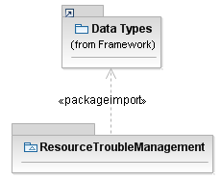
Figure 11: package import (example)

Object Class Guidelines
Object classes are used to model resources in the DM model or managers in the OM model.
Each object class comprises:
- Object Name
- follow Upper CamelCase (UCC)
- special definitions are in the mTOP Guidelines NamingConventions document [Ref 6].
- Object Documentation
- contains a short summary of usage.
- Superclass(es)
- inheritance and multiple inheritance may be used.
- Abstract Object
- indicates if the object can be created or is just used for inheritance.
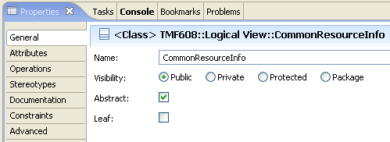
Figure 12: Defining an object class as "abstract" (example)
- Object Lifecycle
- provides information on who and when the object is created and deleted (e.g., Created and
deleted by requesting OS); see also section 3.4.1.
- Object Notifications
- identifies if creation/deletion notifications have to be send
"objectCreationNotification" <NO | YES | NOT_APPLICABLE>
"objectDeletionNotification" <NO | YES | NOT_APPLICABLE>; see also section 3.4.1.

Object Class Attribute Guidelines
Each attribute in an object class comprises:
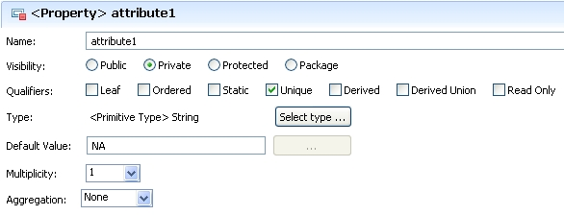
Figure 13: Defining attribute properties (example)
- Attribute Name
- follow Lower CamelCase (LCC)
- special definitions are in the mTOP Guidelines NamingConventions document [Ref 6].
- Attribute Documentation
- contains a short summary of usage.
- Attribute Notifications
- identifies which kind of notification has to be send in case of a value change:
"Changes in the value of the attribute lead to an <AVC | SC> notification." or
"Changes in the value of the attribute will not be notified automatically."
See also section 3.4.1.
- Visibility
- Public: if the attribute shall be inherited to subclasses
- Private: if the attribute shall not be inherited to subclasses = default value.
- Qualifiers
- Leaf: defines if it is allowed to specialize or redefine the attribute in a subclass; default value is
false.
- Ordered: for a multivalued multiplicity; the order of the values is important
- Static: means invariant
- Unique: for a multivalued multiplicity, no duplicate attribute values are allowed
- Derived: defines whether the attributes value or values can be computed from other information;
default value is false
- Derived Union: defines whether the attributes value or values are derived as the union of all of
the values that are constrained to subset it; default value is false
- Read Only: not writeable by Requesting OS.
MTNM R3.5 | MTOSI R2.0
Readable by NMS? Yes  Writeable by NMS? No  Invariant? No | Static = False  Read Only = True
Readable by NMS? Yes  Writeable by NMS? No  Invariant? Yes | Static = True  Read Only = True
Readable by NMS? Yes  Writeable by NMS? Yes  Invariant? No | Static = False  Read Only = False
Table 1: Attribute access mapping
- Type
- refers to a basic or complex data type.
- Default Value
provides the value that the attribute has to start with in case the value is not provided during creation or already defined because of a system state.
If a default value makes no sense (e.g., if representing state of the system) = "na".
No default value for object identifier = "null".
No default value for String = "empty string".
No default value for Sequence = "empty list".
- Multiplicity
- defines the number of values the attribute can simultaneously have.
- Aggregation
- None: the affect on the attribute is unspecified when the parent is deleted
- Shared: the attribute is not deleted when its parent is deleted
- Composite: the attribute is deleted when its parent is deleted.

UML Diagram Guidelines
Objects and their relationships are added to class diagrams. It is recommended to create an overview class diagram containing all object classes from the DDP. Additional class diagrams may be established to show specific parts of the DDP in detail.
State diagrams shall be created for complex attributes.
Activity diagrams shall be created for complex operations.
The class name compartment shall contain the "Qualified Name"
The class attributes and operation shall show the "Signature".

Use Case Guidelines
Use Cases are only specified in the BA.

Reference Guidelines
Where appropriate, a UML artifacts should reference external (wrt. UML) documentations (e.g., supporting documents) by a URL .

Relationship Guidelines
Relationships between the object classes are derived from the dynamic and static requirements in the BA. Each relationship comprises:
- Relationship Name
- each word starts with an upper case character (e.g., AssociatedWith)
- Relationship Type
e.g., inheritance, composition, association, dependency, aggregation.
- Role Names
identifies the role that the object plays at this end of the relationship.
- Granularity
identifies the number of objects that can have this relationship.
- Constraint(s)
list the constraint(s) under which the relationship can exist.
It is recommended to create relationships which are just for explanation to the reader of the model. These relationships have no role names and will therefore not be taken into account in the protocol specific specification. This can for example be used to show the relationship to the object which is retrieved by a get-operation.
Example:
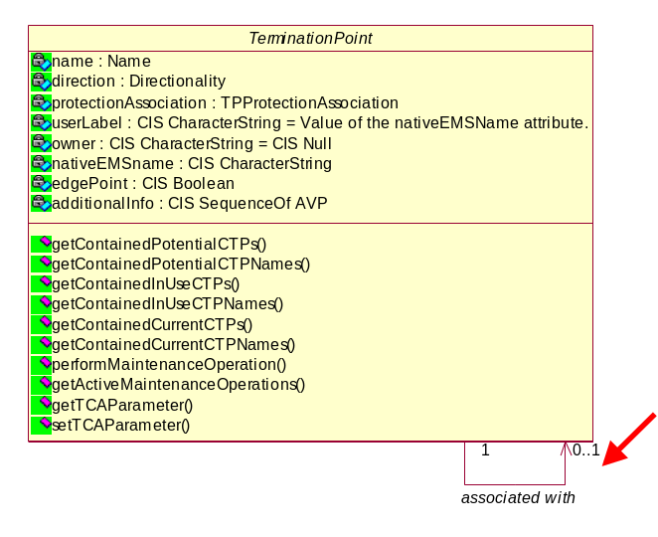

Traceability Guidelines
Not required for MTOSI 2.0; we will add it once it can be automated.
The following traceability matrices shall be provided:
- mapping from object classes to requirements
- mapping from object class attributes to requirements
- mapping from object class operations to requirements
- mapping from object classes to use cases.

Data Model (DM) DDP Guidelines

Overview
There is an mTOP UML Model for each mTOP DM DDP; see section 2.1.2.

Location
An mTOP IA UML data model file corresponds to an mTOP DM DDP and is contained in the IA folder of this DDP; see section 2.1.3.

Object Class Guidelines
DM Model object classes are derived from the static requirements (i.e., category I requirements) in the BA.

Relationship Guidelines
An object instance name is used in another object by creating the following relationship between the two object classes:
Class A (TopologicalLink) has an association with class B (TerminationPoint) and class B plays a public (+) role in this association, then the name of the class B instance shall be part of the information that is provided when class A is retrieved via the interface using the role name as the identifier (e.g., name of class B instance shall be implemented as an attribute of class A).
Example:
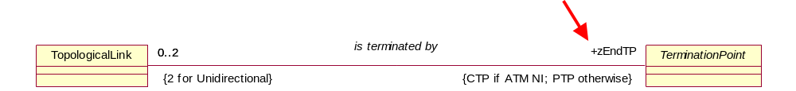
IDL: zEndTP will become an attribute of the TopologicalLink struct and contains the name of the TP.

The complete information of an object instance can be used in another object by creating the following relationship between the two object classes:
Class A (TerminationPoint) has a Containment or Composition relationship with class B (transmissionParameters) and class B plays a private (-) role in this relationship, then the contained information of class B shall be part of the information when class A is retrieved via the interface (e.g., attributes of class B shall be retrieved together with attributes of class A).
Example:
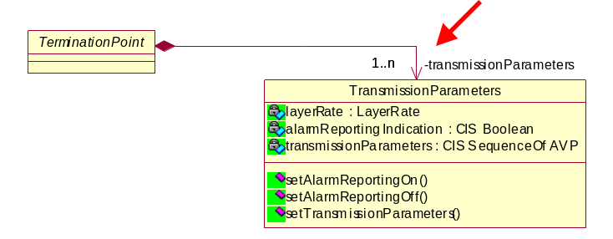

Dependencies
TBD

Operation Model (OM) Guidelines

Overview
There is an mTOP UML Model for each mTOP OM DDP; see section 2.1.2.

Location
An mTOP IA UML operation model file corresponds to an mTOP OM DDP and is contained in the IA folder of this DDP; see section 2.1.3.

Object Class Guidelines
OM Model object classes are derived from the dynamic requirements (i.e., category II requirements) in the BA. The object classes are modelled as Interfaces (i.e., the service interfaces).

Operation Guidelines
Operations (within the Interfaces) are derived from the dynamic requirements and use cases in the BA. Each operation comprises:
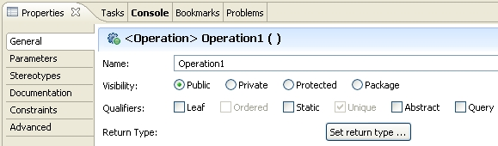
Figure 14: Defining operation properties (example)
- Operation Name
- follow Lower CamelCase (LCC)
- special definitions are in the mTOP Guidelines NamingConventions document [Ref 6].
- Visibility
- Public: if the operation shall be inherited to subclasses
- Private: if the operation shall not be inherited to subclasses = default value.
- Qualifiers
- Leaf: defines if it is allowed to specialize or redefine the operation in a subclass; default value is
false.
- Static: ??
- Abstract: If true, then the behavioral feature does not have an implementation, and one must be supplied by a more specific element. If false, the behavioral feature must have an implementation in the classifier or one must be inherited from a more general element. Default value is false.
- Query: defines whether an execution of the BehavioralFeature leaves the state of the system
unchanged (= true) or whether side effects may occur (= false); default value is false.
- Return Type : always "void".
- Operation Documentation
- contains a short summary of usage.
- Pre-condition(s)
Pre-condition(s) are modeled as Constraints. They list the conditions that have to be true before the operation can be started (i.e., if not true, the operation will not start at all).
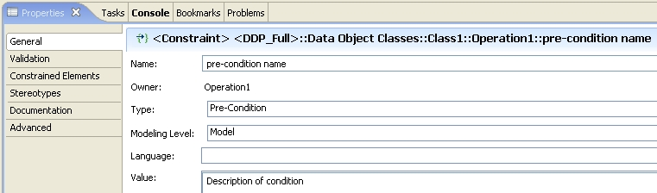
Note: It is also possible to define the pre-condition in OCL.
Figure 15: Defining operation pre-conditions
- Parameter(s)
see below.
- Post-condition(s)
Post-condition(s) are modeled as Constraints. They describe the state of the system after the operation has been successfully executed.
- Operation Exceptions
List the allowed exceptions (together with a failure reason) for the operation.
- ACCESS_DENIED - Raised when the requesting OS is not permitted to perform the operation.
- CAPACITY_EXCEEDED - Raised when the request will result in resources being created or
activated beyond the capacity supported by the NE or target OS.
- ENTITY_NOT_FOUND - Raised when the specified object instance does not exist.
- INTERNAL_ERROR - Raised in case of non-specific target OS internal failure.
- INVALID_INPUT - Raised when the operation contains an input parameter that is syntactically
incorrect or identifies an object of the wrong type or is out of range.
- NE_COMM_LOSS - Raised when communication to the managed element is lost.
- NOT_IMPLEMENTED - Raised when the target OS does not support this operation.
- NOT_IN_VALID_STATE - Raised when the state of the specified object is such that the target OS cannot perform the operation.
- OBJECT_IN_USE - Raised when the object identified in the request is currently in use.
- PROTECTION_EFFORT_NOT_MET - Raised when the level of protection effort in the request cannot be met by the target OS.
- TIMESLOT_IN_USE - Raised when a requested timeslot is already in use.
- TP_INVALID_ENDPOINT - Raised when the specified TP does not exist or cannot be created.
- UNABLE_TO_COMPLY - Raised when the target OS cannot respond to the request.
- UNSUPPORTED_ROUTING_CONSTRAINTS - Raised when the target OS is unable to satisfy
the requested routing constraints.
- USERLABEL_IN_USE - Raised when the user label uniqueness constraint is not met; the
specified user label is currently being used.
The exceptions are contained in the folder "Operation Exceptions" in the Framework DDP.
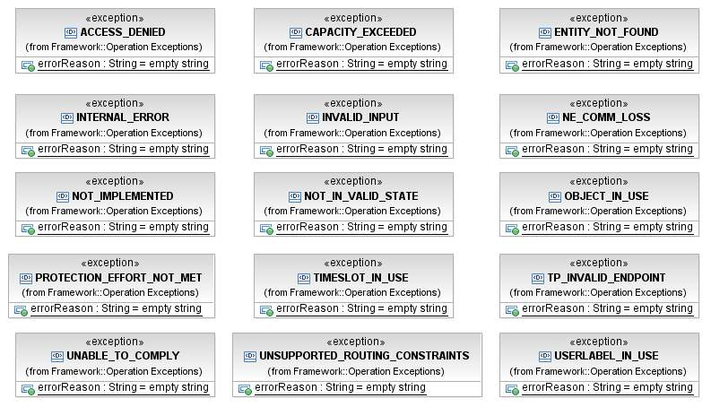
Figure 16: Operation Exceptions Class Diagram
The relevant exceptions can be added to an operation by right click on the operation, choose "UML Properties …", choose "RaisedException" and browse to the exception class via the "…" button on the right:

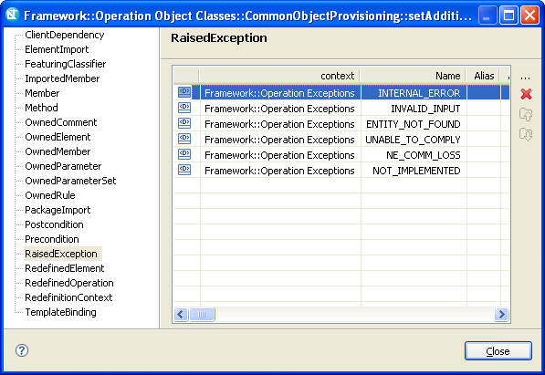
Figure 17: Raised exception window
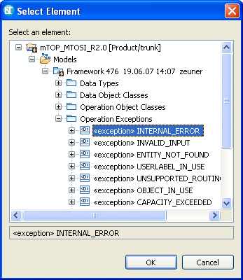
Figure 18: Select exception window
Each parameter in an operation comprises:
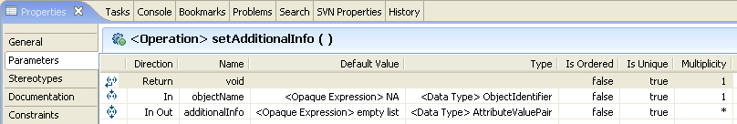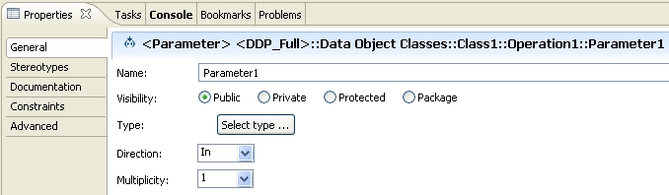
Figure 19: Defining operation parameters
- Name
- follow Lower CamelCase (LCC)
- special definitions are in the mTOP Guidelines NamingConventions document [Ref 6].
- Visibility
- Public: if the attribute shall be inherited to subclasses
- Private: if the attribute shall not be inherited to subclasses = default value.
- Type
refers to a basic or complex data type.
- Direction
In | In Out | Out | Return .
- Default Value
provides the value that the parameter has to start with in case the value is not provided.
- Is Ordered
for a multivalued parameter; the order of the values is important.
- Is Unique
for a multivalued parameter, no duplicate values are allowed.
- Multiplicity
defines the number of values the parameter can simultaneously have.
- parameter Documentation
contains a short summary of usage.

Relationship Guidelines
It is recommended to use dependency relationships to associate input or output parameter lists to the operations in an object. These relationships are just for explanation to the reader of the model. No special care has to be taken in the protocol specific part; they are usually modelled in operations of the dependent class.
Example:
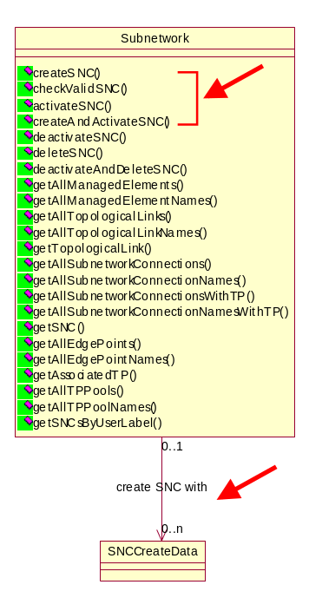

Dependencies
TBD

Notification Guidelines

Overview
TBD

Location
TBD

File/Information Structur
The content of the mTOP IA package typically consists of the following subfolders:
TBD

Dependencies
TBD

Changes History
The purpose of this section is to summarize the evolution/changes of mTOP IA guidelines / best-practices between product releases.

IA v3.4 (used in MTNM R3.5) to IA v3.5 (used in MTOSI R2.0)
The following list includes all the important new or updated features introduced into the development of MTOSI R2.0 IA:
- IA for MTOSI R2.0 is based on the new mTOP DDPs.
- Tool change from "Rational Rose" to "Rational Software Modeler".

References

External References
Ref 1 OMG Unified Modeling Language (UML) – http://www.uml.org/
Ref 2 IBM Rational Software Modeler (RSM) –
http://www-306.ibm.com/software/awdtools/modeler/swmodeler/index.html

Internal References
Ref 3 mTOP Wiki (GForge) – http://gforge.tmforum.org/plugins/wiki/index.php?id=12&type=g
Ref 4 mTOP GForge (Subversion) Usage Guidelines – [mTOP_Guidelines_GForgeUsage.doc]
Ref 5 mTOP DDP Guidelines – [mTOP_Guidelines_DDP_Definitions.doc], [mTOP_Guidelines_DDP_Maps.xls]
Ref 6 mTOP Naming Convention Guidelines – [mTOP_Guidelines_NamingConventions.doc]

Appendix A: mTOP Parameters Supporting Documents
The latest versions of these SDs are available on the CWS
Location: Multi-Technology OSS Program / Supporting Documents / SD1 Series

Supporting Document | Version | Comments
SD 1-8 encodingX731M3100 | 3.1.1
SD1-16 Layered Parameters | 3.2.3 (*)
SD 1-17 Layer Rates | 3.2.3
SD1-28 Performance Parameters | 3.1.2
SD 1-29 PGP Parameters | 3.0.1
SD 1-33 Probable Causes | 4.1.2
Table 2: Supporting Documents containing Parameters

(*) See Appendix B for all layered parameters applicable domains

Appendix B: mTOP Layered Parameters Domains

Generally Applicable Parameters
Connection-oriented Technology Parameters
General parameters for Inverse Multiplexing
SDH/SONET/PDH specific parameters
ATM specific parameters
ATM parameters relevant only to ATM Network Interfaces supporting PNNI
IMA (Inverse Multiplexing for ATM) specific parameters
ATM specific Traffic Descriptor parameters
WDM specific parameters
Protection specific parameters
TCM related parameters for SDH/SONET
TCM related parameters for DWDM/OTN
Radio specific parameters
Frame Relay specific parameters
DSL (Digital Subscriber Line/Loop) specific parameters
Connectionless Technology Parameters
Ethernet specific Parameters
Spanning Tree Protocol (STP) related parameters
VLAN related parameters
Traffic conditioning parameters
Resilient Packed Ring (RPR) related parameters
Class of Service parameters
Ethernet MAU parameters
Link Aggregation Parameters

Note: Model elements referenced in this table have a different name between version 1.4 and version 2.0 of UML; if a model element is not listed, assume it has the same name as in UML 1.4.
Table extracted from RSM help documentation:
UML 1.4 model element name | UML 2.0 model element name
Association end | Member end and Property
Object (when used in activity diagrams) | Object node
Object (when used in sequence diagrams) | Lifeline
Collaboration diagrams | Communication diagrams
Swimlane (or partition) | ActivityPartition
Activity | Structured activity node
Decision | Decision node or merge node
Final State or end state | Final Activity Node
Initial state or start state | Initial node
Object Instance (in activity diagrams) | Central buffer node
State | Structured activity node
State machine | Structured activity node
Synchronization bar (synch bar) | Fork node or Join node
Transition (on an activity diagram) | Control flow
Transition condition (guard condition) | Control flow guard
Formal Arguments (collection of Formal Arguments) | Template Binding
Three-tiered diagrams | Class diagrams
Class Instance | Lifeline
Self-link | Message pathway
Connection relationship | Communication Path
Process (in a deployment diagram) | Artifact
Processor | Execution environment
Destruction marker | Stop node
Focus of Control | Execution Occurrence
Action | UML activity
State diagram | Statechart diagram
Table 3: UML 1.4 - UML 2.0 mapping

Appendix C: known issues with RSM
This section contains all known open issues with regard to the RSM tool.
Note: Finally this section will be (hopefully) deleted.
- Don't know how to show relationship constraints in class diagrams.
In TMF608 the TopologicalLink (TL) has a containment relationship with either MultiLayerSubnetwork or EMS; depending whether it is a top-level or intra-subnetwork TL. This is defined by constraints in Rose:
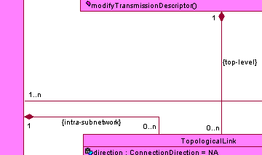
The imported model in RSM does not show these constraints:
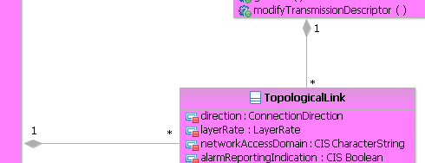
Where are these kinds of constraints defined in RSM?
- On the other side, a constraint defined in Rose:
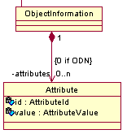 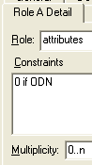
is shown in RSM:
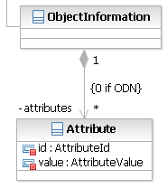
but I cannot find the place where the constraint is defined in RSM.
- In Rose, a lot of definitions are defined in the description only; i.e., not machine readable:
- Object Lifecycle: Created and deleted by EMS or NMS.
- Object Creation Notification Issued? Yes
- Object Deletion Notification Issued? Yes
- Object Discovery Notification Issued? Yes
- Changes in the value of this attribute lead to an AVC notification.
I have started to create a Profile in RSM that defines these kinds of definitions as Stereotypes which (I hope) make them machine readable.
I was able to associate the Stereotypes to object classes:
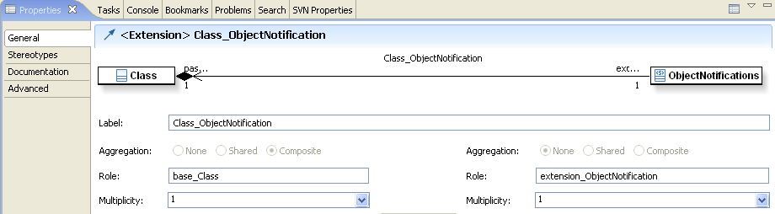
But I'm not able to associate them to attributes:
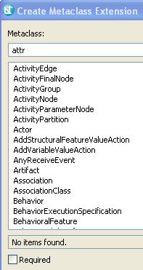
Why is it not possible to associate Stereotypes to attributes?
Is this the right way defining such statements to become machine readable?
There is a "known issue" on the profiles tutorial at http://www-128.ibm.com/developerworks/rational/library/05/0906_dusko/:
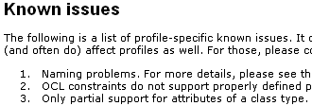
which may mention this.

