mTOP Business Agreement Guidelines

Abstract
This document presents the unique reference for the writing of Business Agreement documents.
A Word template (“SD0-3_mTOPTemplate_BA.dot”) file has been elaborated to facilitate the editing task by automating some requirements specified in those guidelines. This template makes use of different macros and specific menus bars. All the details how to make the best use of this template are also presented below.
Table of Contents

mTOP Business Agreement Guidelines 1
Abstract 1
Table of Contents 1
1 General Aspects 2
2 Specifications for Requirements 2
3 Specifications for Use Cases 4
3.1 General Considerations 4
3.2 About Exceptions 5
3.3 Example 7
4 How to use the “SD0-3_mTOPTemplate_BA.dot ” Word Template 9
4.1 Creating a New BA Document 9
4.2 Formatting Paragraphs 11
4.3 How to Create Requirements Automatically Numbered 11
4.4 How to Create Use Cases automatically Numbered 14
4.5 How to Create Traceability Matrices Automatically 15
4.6 How to Re-Sequence the Requirements or Use Cases 16
4.7 Caveats 16
5 Administrative Appendix 17
5.1 Document History 17
5.2 Acknowledgments 17
5.3 How to comment on this document 17

General Aspects
In general, the DDPs BA documents should NOT make use of the mTOP product names, such as MTOSI or MTNM. The reason is that DDP BA features stay at the mTOP level and may be applicable to both MTOSI and MTNM.
When necessary, a product neutral term like “mTOP” may be used.

Specifications for Requirements
- There are five categories (TMF labeled) of requirements in addition to the business requirements.
- In each DDP, requirements identifiers must be unique within each category.
- Requirements are defined using the following tabular template:

R_TMFXXX_DDD_C_N | Description of the requirement
Source | Source of the requirement

where:
    - “C” designates the category of the requirement and is one of:
“BR”, I, II, III, IV, V and
    - “N” is a 4 digits integer (e.g. 0012)
    - XXX denotes the type of DDP document e.g., 518 (BA), 612 (IA) or 864 (SS)
    - DDD denotes the feature area of the DDP document e.g. NRA (NetworkResourceAssurance).
- A requirement is referred to by its identifier “R_TMFXXX_DDD_C_N”
- It must be possible to display the definition of a requirement by a simple mouse click from any of its references.
- When a new BA document is generated, the “N” part of the requirement identifier must be generated in sequence (no “hole” in the requirements definitions) within each category, until the document is made available to the team (editors’ decision). From this stage the identifier of a given requirement will never change.
Any modification introduced after this stage may break this sequence:
    - when a requirement is rejected, its definition is simply removed
    - it must be possible to move a requirement within the BA document;
further, the requirement identifier must remain the same when the requirement is moved.
    - it must be possible to introduce a new requirement definition at any place in the BA document (indeed a new requirement definition takes the next available “N” in the corresponding category).
- [nice to have] For each DDP, it must be possible to automatically generate or access to the list of requirement identifiers without accessing the BA document itself, with the following status attributes:
- created in version X.Y of the DDP
- rejected during the review process (was then never published)
- modified in version X.Y of the DDP
- removed in version X.Y of the DDP
- [nice to have] list of documents where it is referred and corresponding page number
- Do NOT use the DDP version number as part of the requirement identifier
(e.g. Requirement (1.1)I. 5 )
- Traceability matrices should be generated automatically.

Specifications for Use Cases

General Considerations
- In each DDP, use case identifiers must be unique.
- Use cases are defined using the following tabular template

where “N” is a 4 digits integer

Use Case Id | <UC_TMFXXX_DDD_N>
Use Case Name
Summary
Actor(s)
Pre-Conditions
Begins When
Description
Ends When
Post-Conditions
Exceptions | Put a reference here to a document or a separate table which lists all the exceptions.  Specific exceptions will be explicitly listed in the Description clause.
Traceability | Hyperlinks to the associated requirements

- A use case is referred to by its identifier “UC_TMFXXX_DDD_N”
- It must be possible to display the definition of a use case by a simple mouse click from any of its references.
- It must be easy to “navigate” from a requirement to the Use Cases where this requirement applies and vice versa (within the same document or across BA documents belonging to different DDPs).
- When a new BA document is generated, the “N” part of the Use Case identifier must be generated in sequence (no “hole” in the Use Case definitions), until the document is released for official approval. From this stage the identifier of a given Use Case will never change.
Any modification introduced after this stage may break this sequence:
    - when a Use Case is rejected, its definition is simply removed
    - it must be possible to move the definition of a Use Case without changing its identifier
    - it must be possible to introduce a new Use Case definition at any place in the BA document (indeed a new Use Case definition takes the next available “N” in the DDP).
- [nice to have] For each DDP, it must be possible to automatically generate or access to the list of use case identifiers without accessing the BA document itself, with the following status attributes:
- created in version X.Y of the DDP
- rejected during the review process (was then never published)
- modified in version X.Y of the DDP
- removed in version X.Y of the DDP
- [nice to have] list of documents where it is referred and corresponding page number
- Traceability matrices should be generated automatically

About Exceptions
This subsection provides guidelines for writing Use Cases with regard to how they should make reference to the supported exceptions. The same information is also incorporated in section 4.1.1 of the TMF518_FMW BA document.
The Table 3-1 identifies the complete list of exceptions that may be raised by a target OS in response to a requesting OS. In the “Description” section of each Use Case the specific exceptions that may be raised are identified. The target OS can qualify each exception by indicating further details about the exception in a free format string attached to the exception. This is specifically necessary if more than one step in the description leads to the same exception. The following exceptions from Table 3-1 are considered to be “general” exceptions, in that an OS may raise these exceptions at any time:
  - Internal Error
  - Not Implemented
  - Unable To Comply
  - Comm Loss

The Unable To Comply exception may be raised whenever the OS cannot respond to a request, some Use Cases may identify specific conditions that will result in this exception.
The Comm Losss exception may be raised for two different reasons:
  - When communication between a top-level OS and a subordinate OS is necessary to fulfill the requests in the Use Case and communication to the subordinate OS(s) is lost;
  - When communication with at least one NE is necessary to fulfill the requests in a Use Case and communication to the NE(s) is lost. This also applies to the case where communication to a “Control Plane” entity is required to fulfill a request. A specific step for this exception will not be specified in the description of the use cases.

The “error reason” parameter may be used to supply more information.

Table 3-1 Use Case Exceptions
ID | Name | General Description
1 | Internal Error | The request has resulted in an OS internal error.
2 | Not Implemented | The entire request is not supported by the target OS or the request with the specified input parameters is not supported.
3 | Invalid Input | The request contains an input parameter that is syntactically incorrect or identifies an object of the wrong type or is out of range.
4 | Entity Not Found | The specified object instance does not exist.
5 | Object In Use | The object identified in the request is currently in use.
6 | User Label In Use | The user label uniqueness constraint can not be met; the specified user label is currently being used.
7 | Unable To Comply | The target OS cannot respond to the request.
8 | Unsupported Routing Constraints | The target OS is unable to satisfy the requested routing constraints.
9 | Access Denied | The requesting OS is not permitted to perform the request.
10 | Capacity Exceeded | The request will result in resources being created or activated beyond the capacity supported by the NE or target OS.
11 | Not In Valid State | The state of the specified object is such that the target OS cannot perform the request.
12 | Protection Effort Not Met | The level of protection effort in the request cannot be met by the target OS.
13 | Timeslot In Use | A timeslot is already in use.
14 | TP Invalid Endpoint | The specified TP does not exist or cannot be created.
15 | Comm Loss | The target OS (which is a top-level OS) is unable to communicate:  - either with the subordinate OS,  - or with the NE  and communication is required to complete the request.  The “error reason” parameter may be used to supply more information.
16 | Policy Violation | A policy of the target OS has been violated;  it may happen when requesting to create or delete a given object or to modify specific attributes.  The target OS should indicate the specific policy that has been violated.

Example
The table below shows a complete example of a Use Case taken from the Resource Provisioning BA document - TMF518_RP – (in the RP BA document, the items in blue are hyperlinks; those hyperlinks have been removed in the table below).

Use Case Id | UC_TMF518_RP_0030
Use Case Name | The requesting OS configures Traffic Mapping Table
Summary | This operation allows A requesting OS to configure the Traffic Mapping Table in an CPTP or FP.  The requesting OS provides a complete (except default) new set of mappings which will overwrite all (except default) existing mappings.
Actor(s) | The requesting OS
Pre-Conditions | The requesting OS and target OS have successfully executed the Use Case The requesting OS and target OS have successfully executed the Use Case 0001 OS (Re) Starts as defined in the TMF518_FMW BA document.
Begins When | The requesting OS sends a request to target OS to configure the Traffic Mapping Table of an FD Edge CPTP or FP.
Description | - The requesting OS sends a request to target OS to configure the Traffic Mapping Table of an FD Edge CPTP or FP.  - The requesting OS provides a complete (except default) new set of mappings.  - The target OS validates the request:  - If the syntax is in error, an Invalid Input exception is raised.  - If at least one referenced TC Profile objects is not known to the target OS, an Entity Not Found exception is raised.  - If the request is valid:  - If the provided set of mappings contains no mapping at all (i.e., is empty), all mappings, except the default one, are removed; i.e., the traffic units flowing through the TP are only conditioned by the default configuration.  Note: The traffic units may still be conditioned specifically by another TP on this port. If the mappings cannot be removed, an Unable To Comply exception is raised.  - If the provided set of mappings contains mappings, all existing mappings (except default) are overwritten by the new set of mappings; i.e., the traffic units are conditioned by the new configuration. If the mappings cannot be overwritten, an Unable To Comply exception is raised.  - The target OS replies with a success indication.  - The target OS sends an attribute value change notification to the notification service.
Ends When | In case of success:  The target OS has set the new mappings in the Traffic Mapping Table.  In case of failure:  The requesting OS receives an exception as an indication of the failure of the request.
Post-Conditions | In case of success:  The TP conditions the traffic units according to the modified Traffic Mapping Table.  In case of failure:  Nothing has changed in the System, i.e., the Traffic Mapping Tables have not been changed.
Exceptions | Refer to Category III: Abnormal or Exception Conditions, Dynamic Requirements.
Traceability | R_TMF518_RP_II_0059  This use case is a generalization of Use Case 9.5.4 from TMF 513 v3.1

How to use the “SD0-3_mTOPTemplate_BA.dot ” Word Template
The “SD0-3_mTOPTemplate_BA.dot” Word template (distributed separately) tries to implement most of the specifications presented in the previous sections.

Copy the SD0-3_mTOPTemplate_BA.dot under
HomeDir\Application Data\Microsoft\Templates
where HomeDir is your home directory on Windows.
It is the directory where the Normal.dot file is already.

To create a new BA file, you can either:
- double click on this SD0-3_mTOPTemplate_BA.dot
- or enter Word and then enter the menu File / New and then select
the SD0-3_mTOPTemplate_BA.dot template on your computer.

Two new menu bars (called mTOP Formatting and mTOP main commands) will appear looking as follows:

mTOP Formatting:

mTOP main commands:

In addition the main menu bar has been modified to show the following additional buttons:

Creating a New BA Document
When you create a new BA Document, the first thing you must do is to set the value of one standard property and 3 custom properties:
- Setting the Document Title
Go to File / Properties / Summary
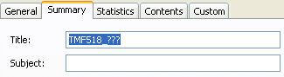
By default the template set the Title to “TMF518_???”.
Change it to the proper name (e.g. “TMF518_NRB” but you may choose any name here).
Then go back to the beginning of the document, click left anywhere in the title and hit the F9 key. It will automatically update the title. The title is also used in the top left header of the BA document. You may do the same thing to update its value as well.
(to update all the fields in one go, select all the document and hit F9).
- Setting 2 custom properties (out of 6)
Go to File / Properties / Custom
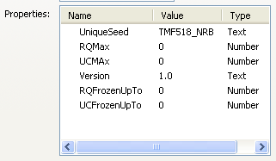

You will see 6 custom properties that have been created by the template.
Before starting working on the BA document you must set 2 of them: UniqueSeed and Version.
      - UniqueSeed must be unique for each DDP and it corresponds to the TMFXXX_DDD part of the requirement and use case Ids (see previous sections). Its value must then be something like TMF518_DDD. By default the template proposes TMF518_NRB as an example.
This value will be displayed on the front page and in the footer of each page.
      - Version is the version number of the BA document in preparation.
Its value will be displayed on the front page and in the footer of each page.
By default it is set to 1.0.
Here are some explanations about the remaining 4 custom properties:
      - RQMax and UCMax are set to 0 by default. You do not need to change their values. Those two properties are used to keep trace of the maximum number of requirements and use cases created in the document. They will be automatically updated when you add requirements or use cases using the appropriate buttons from the mTOP main commands menu bar. Since those properties are associated to the document, their associated value will be kept between two Word sessions (closing and re-opening the document, those values will be kept).
      - RQFrozenUpTo and UCFrozenUpTo are set to 0 by default.
Those properties are never updated automatically.
They are used to avoid re-sequencing the requirements and use case identifiers below certain values.
The typical use is when a BA document has been released for review, the identifiers of the existing requirements and use case should not change any more. If, as a result of the review process, some requirements or use cases are removed, it should not influence the numbering of the other requirements of use cases.
The corresponding values of those two properties should be set manually by the editor just before releasing the BA document.
Once this is done, new requirements and use cases may be created in a future iteration of the BA document and they can be re-sequenced without any modifications on the ones from the already agreed version.
The example below shows the custom properties of the MRI BA document; requirement 149 was created in a second iteration of the document.
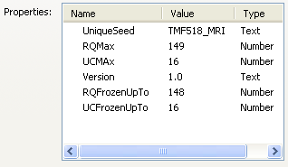

Formatting Paragraphs
There are many ways in Word to handle paragraph formatting most of them may create trouble at some point in time.
Using the different buttons of the mTOP Formatting menu EXCLUSIVELY to handle paragraph formatting will make your life much easier.
.
PLEASE USE THE BUTTONS FROM THE mTOP Formatting MENU BAR TO HANDLE THE FORMATTING OF PARAGRAPHS AND AVOID USING ANY OTHER METHOD.

How to Create Requirements Automatically Numbered
Use the mTOP main commands menu bar.
When you want to create a new requirement, move the cursor where you want to insert the new requirement definition within any of the sections in chapter 3 of the BA document.
Then click on the createRQ button.
A requirement definition table is automatically created.
If you move the cursor and click again on the createRQ button a second requirement definition appears; if you do it again you will get three requirement definition tables as shown on the screen dump below:

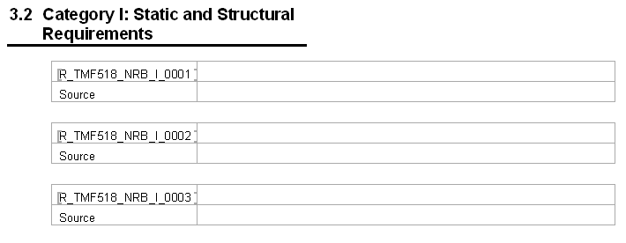

The requirement number is automatically incremented and for each requirement a bookmark is created at the beginning of the requirement number in the first cell of each table.
You can now enter the definition of the requirement and the source fields manually.
The requirement number will always increase (and the RQMax property will be incremented accordingly).

If you want to remove or move a requirement definition you can do it manually. Since the requirement numbers are simple numbers, this will not change the numbering of the other requirements. Indeed, when a requirement definition table is removed its associated bookmark is removed as well.
For instance, if you remove the requirement 0002 and then move the requirement 0003 in first position this will result in the following view:

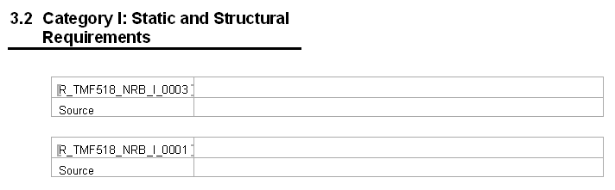

In principle, the bookmarks brackets ([ ]) may not be displayed, except if you have selected the bookmark toggle in Tools / Options / View as follows (Not really very useful; I use it more for debugging the macros):
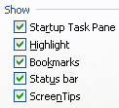

You should never change the identifier of a requirement by manual editing (for instance when you enter a wrong category when you create the requirement): you will break the repository of bookmarks. You can always delete the table (2 lines) associated to the specific requirement and create a new one, but a better way is to use the macro to fix one bookmark only. You will be invited enter the new bookmark name interactively

Once you have entered new requirements, the list of bookmarks in the appropriate Bookmarks(I,II,III,IV) popup menu (in the main menu bar) is automatically updated. Then you do NOT need to explicitly select the Bookmarks button and click on the Refresh list item.
This is NOT true when you delete a requirement table (which will delete the associated bookmark as well). In this case you need to update the list of available bookmarks by clicking on the Refresh list item:

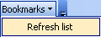

The list updates automatically by the addition of the newly created bookmarks:

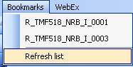

How to Create Use Cases automatically Numbered

To create a use case, move the cursor at the point of insertion and then click on the createUC button.
A use case definition table is automatically created.
A new bookmark is created at the beginning of the use case number in the first cell, as shown in the example below:
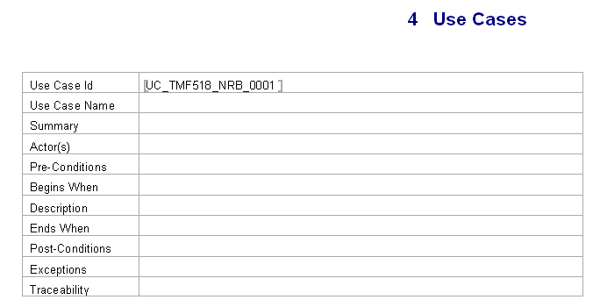
To enter hyperlinks to one or several requirements in the Traceability value field, move the cursor where the hyperlink must be inserted and then click the appropriate Bookmarks(I,II,III,IV) popup menu (in the main menu bar). Select the chosen requirement item in this menu. Repeat the operation for each requirement to add:

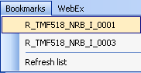

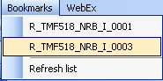

The corresponding hyperlinks are created automatically:

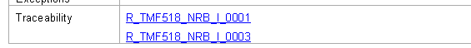

How to Create Traceability Matrices Automatically
Two macros are available through two corresponding buttons of the mTOP main commands bar menu. createRqsMatrix and createUCsMatrix can be used to automatically create the cross reference tables (from use case to requirements and vice versa).
Just move the cursor to the place you want to create those tables and click on the appropriate button.
The tables will be generated automatically. Here are two examples below:

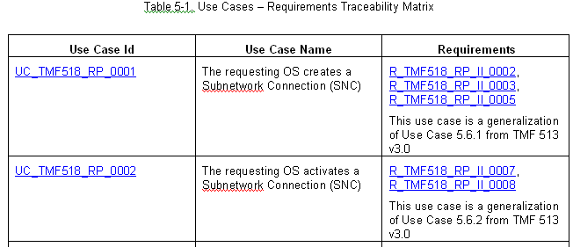

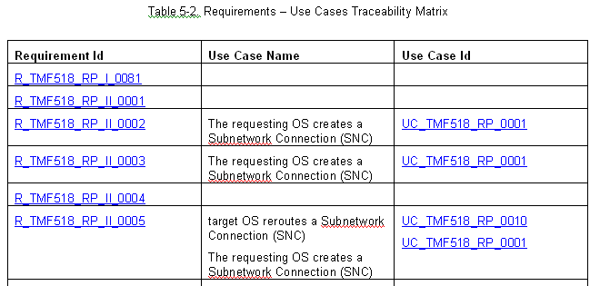

How to Re-Sequence the Requirements or Use Cases
When you are editing a “draft” version, you may often create new requirements tables which you will delete later or move to a different place in the document (same for use case tables). After a while, you will end up with a BA draft document where the requirements (use cases) are randomly sequenced, with possible “holes” as well.
Before releasing the document for review (leaving the draft mode) you may want to re-sequence those requirements (or use case) tables. The two following macros are for this purpose.
When you use those macros, indeed, not only the bookmarks are renumbered but also the hyperlinks pointing to them are updated as well.
Only the requirements or use cases which identifiers are superior to the values of the RQFrozenUpTo and UCFrozenUpTo custom properties are renumbered.

Caveats
  - When you create a new requirement table or a new use case table the corresponding bookmark is automatically generated, associated with the new identifier. The template automatically updates the list of bookmarks in the Bookmarks popup menus. Then you do NOT need to explicitly select the Bookmarks button and click on the Refresh list item. This is NOT true when you delete a requirement table or a use case table (and then delete the associated bookmark as well). In this case you need to update the list of available bookmarks by clicking on the Refresh list item.
  - When you delete a requirement table or use case table, the hyperlinks which may point to the corresponding bookmarks are NOT modified. You need to remove them manually.

Administrative Appendix

Document History
Version Number | Date Modified | Modified by: | Description of changes
1.0 | May 2008 |  | This is the first version of this document

Acknowledgments
First Name | Last Name | Company
Bernd | Zeuner | T-Systems
Keith | Dorking | Ciena
Steve | Fratini | Telcordia

How to comment on this document
Comments and requests for information must be in written form and addressed to the contact identified below:

Michel | Besson | Cramer > Amdocs OSS Division
Phone: | +44 7717 692 178
Fax:
e-mail: | Michel.Besson@Amdocs.com

Please be specific, since your comments will be dealt with by the team evaluating numerous inputs and trying to produce a single text. Thus we appreciate significant specific input. We are looking for more input than wordsmith” items, however editing and structural help are greatly appreciated where better clarity is the result.

