DSL Overview
The TMF MTNM NML-EML interface model supports DSL as a layer 1 transmission technology. This document provides an overview of standard DSL technology and the support of DSL lines by the interface model. Refer to Section 3.10 "Remote Unit Encapsulations" and Section 4.7 "DSL ports utilizing the Remote Unit capability" of the supporting document SD1-18_layers.pdf for supplementary modelling considerations for DSL lines.
The MTNM interface includes six models for DSL lines, transmission layer rates for DSL technology, probable cause identifiers for alarms raised by these layers, use cases for DSL line provisioning, transmission parameters for ADSL, SHDSL, and VDSL (i.e., the current/read-only and desired/configurable characteristics of these basic DSL types), DSL states and statuses, DSL maintenance operations, and DSL performance parameters. All parts of the model are extensible: further DSL types (e.g., HDSL4, ADSL2, ADSL2plus, SHDSL2) are for further study in a further step and can then easily be added on demand. The models and parameters comply with the applicable DSLF, FSAN, IETF, ETSI, and ITU-T reference models and TMN parameter specifications.

Introduction
Over the past years the local loop has become one of the most important media for transmission of multiple high-speed converged services to and from a residential or business customer premises, in particular when combined with optical fibre to the neighbourhood. These services include high-speed Internet access, voice services, and high-quality digital video streams, known in the industry as the "triple play".
In simplified terms the local loop is an unshielded twisted pair (UTP) of copper wires connecting customer premises equipment (CPE) to service provider equipment, and the technologies that facilitate the required high-bit-rate duplex transmission across one or more UTPs are known as Digital Subscriber Line/Loop (DSL) technologies. They enable traditional telecom operators to compete cost-effectively with cable and satellite operators who use coaxial cables and wireless media to deliver comparable services.
A DSL is a point-to-point transmission system consisting of two DSL transceivers and a UTP connecting them. Legacy DSL systems may need two or more UTPs to enable duplex operation at the desired rates and distances. The transceiver unit (TU) at the central office (CO) or digital loop carrier (DLC) or optical network unit (ONU) is a downstream transmitter and an upstream receiver and the TU of the CPE is an upstream transmitter and a downstream receiver. DSL reference models introduce the terms TU-C (TU at the CO) or TU-O (TU at the ONU) for the end of the DSL line at the side of the provider and TU-R (TU at the remote side) for the DSL line end at the subscriber side.
There exist many DSL types for historical reasons, and the forefather is basic rate access DSL at 160 kbps which can be used for 2 * 64 kbps digitized voice services known as ISDN-BA. Nowadays the most important DSL types are ADSL (asymmetric DSL), SHDSL (single-pair high-speed DSL), and VDSL (very high-speed DSL). ADSL typically provides between 1 and 3 Mbps downstream and approximately 700 kbps upstream while SHDSL allows for symmetric transmission rates up to 2.3 Mbps. The emerging VDSL technology facilitates symmetric rates up to 26 Mbps over distances up to 1500 metres, and even higher asymmetric and short-haul rates. Telecom services such as voice, data, and video (VDV) that require transport across a DSL physical layer are usually first adapted to ATM or Ethernet and then to DSL but TDM over DSL is also possible.
DSL technology achieves the high digital transmission rates through the utilization of high-frequency signals, with agreed duplexing method and according to standardized frequency plans, beyond the 4 kHz upper bound of the classic voiceband. While ADSL and SHDSL use approximately 1 MHz of the copper wire spectrum, VDSL can use up to 12 MHz depending on its deployment from central offices or from fibre-fed cabinets located near the customer premises.
MTNM includes means to configure and monitor DSL lines across the NML-EML interface. It reveals of the respective DSL technologies only as much as needed for network management purposes. Since ADSL, SHDSL, and VDSL are subject to multiple ongoing standardization efforts the current findings of these efforts regarding management parameters are taken over thereby guaranteeing standards compliance.
Regarding ADSL this approach amounts to an enhancement of the MTNM information model by the ADSL facilities that were modelled by the DSL Forum and the ITU-T in GDMO/CMIP (TR-005, WT-039, TR-028, Q.833.1) and by the DSL Forum in CORBA IDL (TR-050, TR-041, TR-035), based on G.992.x, G.997.1 (1999), RFC 2662, and RFC 3440. The basic ADSL facility is the ADSL line that is a physical link between an ADSL port of the ADSL TU-C (ATU-C) and an ADSL port of the ADSL TU-R (ATU-R). It is characterized by a metallic transmission medium, the copper pair, utilizing an analogue line coding algorithm, which provides both analogue and digital performance monitoring at the line entity;
at either end point the analogue coding algorithm is terminated (i.e., demodulated) and the subsequent digital signal is monitored for integrity. An ADSL line may be structured into ADSL channels with specified latency (i.e., throughput delay) according to G.992.x and depending on the respective equipment capabilities.
SHDSL/HDSL2/HDSL4 lines and ports can be modelled similarly but with technology-specific attributes according to G.991.2 and RFC 3276. Despite of its name, an SHDSL TU (STU) may optionally operate in a four-wire or two-UTP mode thereby doubling the configurable digital payload data rates and increments. To achieve data transmission over greater distances than are achievable over a single SHDSL segment, one or more signal regenerator units (SRUs) may optionally be employed between the STU-C and STU-R, and then the resulting multi-segment line is called a span.
VDSL lines and ports can be modelled similar to ADSL but with technology-specific attributes according to DSL Forum's TR-057 and IETF's draft-ietf-adslmib-vdsl.
Chapter 2 "DSL Line Models" introduces DSL line models covering types of TU-Rs that are different from the management point of view and taking into consideration that the configuration data of the TU-R is usually stored at the TU-C/O. The modelling of DSL channels and their end points as well as SHDSL spans is for further study.
Chapter 3 "Transmission Layer Rates for DSL" introduces a transmission layer rate that universally represents DSL technology (LR_DSL), PTPs which have this layer rate on top (DSL PTPs), and topological links that are bound by a pair of DSL PTPs and represent a downstream/upstream association between a TU-C/O PTP and a TU-R PTP.
DSL technology uses metallic access cables for signal transport, typically one UTP per DSL line and multiple UTPs in binder cables, and so LR_ELECTRICAL_PHYSICAL will be the lowest transmission media layer of any DSL PTP. Since MTNM requires a digital signal rate (DSR) layer to represent the adaptation of the analogue electrical signal to binary form, the raw binary signal rate layer LR_DIGITAL_SIGNAL_RATE is used to represent likewise a digital electrical signal that is adapted from/to the respectively applicable DSL framing format (e.g., ADSL superframe in one of four framing modes). This allows for defining DSL-specific DSR transmission parameters as required (e.g., line code and duplexing method). Basic signal-related alarms (e.g., LOS, LOF, LPR) are raised against this layer.
Chapter 4 "Provisioning of DSL Lines" uses the DSL layer rate to represent in detail the various DSL line models and to specify use cases for DSL line provisioning.
Chapter 5 "Transmission Parameters" introduces transmission parameters for LR_DSL, according to mainly G.997.1 (1999), TR-057, and IETF MIBs. A mandatory transmission parameter specifies the DSL type which currently is ADSL or SHDSL or VDSL. Further DSL types can easily be added as required (e.g., UDSL/ADSL.lite, HDSL, ADSL2, SHDSL2, proprietary DSLs such as SDSL, even ISDN BRI lines). Further transmission parameters specify the current and the desired downstream/upstream characteristics of DSL lines according to the DSL type. While the current characteristics is read-only, the desired characteristics is configurable by the NMS. Transmission descriptors (TMDs) can be used to predefine DSL PTP and line configurations, i.e. transmission descriptors can serve as DSL configuration profiles.
Chapter 6 "States and Statuses" introduces X.731 and G.997.1 (1999) resp. IETF states and statuses for DSL facilities.
Chapter 7 "Maintenance Operations" enhances the MTNM maintenance model by maintenance operations for DSL PTPs and (indirectly) DSL lines.
Chapter 8 "Performance Parameters" introduces performance management (PM) parameter names for DSL PTPs. Since PM parameters with associated thresholds identify the subjects of MTNM performance monitoring and threshold supervision activities at TPs, relatively to a transmission layer rate, a location qualifying the traffic, and a granularity, the full range of MTNM's PM capabilities becomes available for DSL technology.

DSL Line Models
In MTNM terms the most natural way to model DSL lines would be to introduce DSL PTPs and consider a DSL line to be a TL between a TU-C/O PTP and a TU-R PTP. Then the TUs would be contained in different MEs that are connected by the TL. The local or central ME would be a DSLAM, the remote ME would be a DSL modem, and the DSL line would be contained in the EMS.
However, quite often the DSL modem containing the TU-R PTP is integrated, from the TMN interface (e.g., SNMP MIB) point of view and hence from the EMS point of view, into the DSLAM containing the TU-C/O and is remotely managed by the DSLAM. Or the TU-R is not modelled at all but the configuration data and some current data of the TU-R (upstream characteristics) is stored at the TU-C/O (unmanaged TU-R). Then the DSL line is contained in the DSLAM and is either an "internal" TL or not a TL at all. Therefore this chapter proposes additional models for DSL lines besides "ordinary" TLs that comply with the applicable TU-R types. The "natural" way to consider a DSL line as a TL between a TU-C/O PTP and a TU-R PTP is referred to as MTNM DSL reference model.
In the following it is generally assumed that the TU-C/O is managed by an EMS that offers an MTNM NML-EML interface. The proposed DSL line models differ mainly in the way this EMS manages or manages not the TU-R. For the different DSL lines of a DSLAM or a TU-C/O different DSL models may be applicable at the same time.

DSL Facilities, Reference Model
The TU-C/O is a plug-in unit (PIU) resp. a circuit-pack of a DSL access multiplexer (DSLAM), or of a multi-service access platform (MSAP), and the TU-R usually is a DSL modem or a broadband network termination (NT) or an integrated access device (IAD) or a customer premises gateway (CPG). Both TUs have ports that are physically interconnected by usually just one UTP. Each connection is called a DSL line and represents the subscriber of the corresponding DSL service. A DSL line resp. DSL subscriber is therefore represented by a physical link between the TU-R and TU-C/O.
Nowadays DSLAMs and MSAPs mostly use state-of-the-art ATM technology with sophisticated quality of service (QoS) characteristics to multiplex/demultiplex the DSL traffic to/from a broadband backbone network; then the TU-Rs need to be ATM-capable as well. The corresponding ATM cell stream above the DSL transmission layer is represented by an ATM link contained in the physical link.
In MTNM terms a DSL line would usually be modelled as a bidirectional TL bound by DSL PTPs and an ATM link is in fact modelled as a TL bound by ATM NI CTPs. As a consequence the ATM-capability of a DSL PTP is represented by client layer containment of an ATM NI CTP. This is shown in Figure 1 below. Refer to Chapter 3 for the semantics of LR_DIGITAL_SIGNAL_RATE and the universal DSL layer rate LR_DSL.
The aEndTP of an MTNM DSL line is referred to as local TP while the zEndTP is termed remote TP. Therefore the downstream, controlled by the local TP, flows from the aEndTP to the zEndTP and the upstream, controlled by the remote TP, flows from the zEndTP to the aEndTP. The name of the remote TP is the Q.833.1 downstream connectivity pointer (DCP) as seen from the TU-C/O and the name of the local TP is the corresponding upstream connectivity pointer (UCP) as seen from the TU-R.
However, as mentioned above, quite often the TU-R is integrated into the DSLAM or is even unmanaged, and then the DSL line is not an ordinary TL. Therefore Figure 1 is considered to be a reference model rather than a general MTNM model of DSL lines. Refer to Figure 79 "Two models of DSL ports carrying ATM" of the supporting document SD1-18_layers.pdf for a modification of Figure 1 that takes advantage of MTNM's Remote Unit capability.
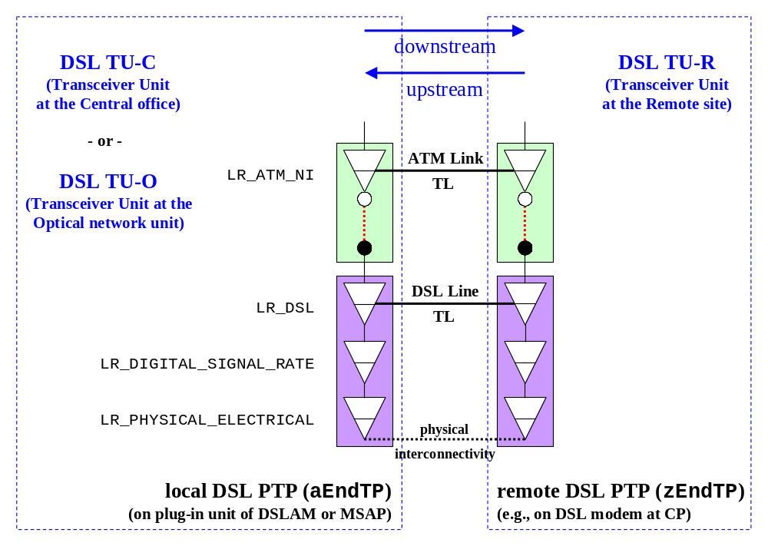
Figure 1: DSL Reference Model with ATM Support in MTNM Terms
DSL standards and discriminating DSL equipment allow to channelize DSL lines into multiple bearer channels that can be configured separately with different DSL QoS characteristics. For example, they can be allocated to different latency paths of the DSL line and assigned different downstream respectively upstream desired rate intervals. You then can allocate delay-insensitive services (e.g., Internet access, video) that usually require very low bit error rates (i.e., are error-sensitive) to interleaved/slow DSL paths and delay-sensitive services (e.g., voice, audio) with higher acceptable bit error rates (i.e., error-insensitivity) to fast DSL paths. A low-latency path exhibits no greater than 1 ms delay (average of upstream and downstream). A high-latency path has a configurable delay (e.g., up to 20 ms in 1 ms steps) where the maximum delay is capable of sustaining burst error free performance when the path is subject to a specified noise burst. The allocation of capacity between latency paths should be configurable.
When bearer channels are configured, the transmission convergence (TC) from the TDM/DWDM or ATM or packet transfer mode (PTM) technology that requires transport over DSL is executed per active channel by the DSL transceiver. For example, each configured ATM-capable DSL channel will contain an ATM link and so the same VPIs/VCIs can be used on different channels.
In MTNM terms a DSL bearer channel could be modelled as a link connection (LC) that is bound by DSL CTPs (at a new layer rate LR_DSL_Channel) and contained in the TL representing the DSL line, and its ATM-capability could then be modelled as an ATM link contained in that LC. But currently LCs are not supported by the MTNM model. Therefore, and also because of the integrated and unmanaged TU-Rs, the modelling of DSL channels is for further study.
The usefulness of DSL channels arises from the fact that they represent different services being allocated to the same DSL subscriber. They can be added to the MTNM model, for example, when the packet transfer mode of DSL (according to G.992.3 and G.993.x) is studied (e.g., for the provisioning of Ethernet-over-VDSL services).

Autonomous TU-R
A DSL TU-R is called autonomous (or stand-alone) when it is an ME. It can then be managed either by the same EMS as the DSLAM/MSAP hosting the TU-C/O or by a different EMS. In both cases the DSL reference model can be used as DSL line model.
When the TUs are managed by the same EMS
- either the DSL line is a top-level TL
and the DSLAM/MSAP and TU-R belong to different MLSNs

- or the DSL line is an inner TL
and the DSLAM/MSAP and TU-R belong to the same MLSN
Which case applies is entirely at the discretion of the EMS. Since provisioning of DSL lines always proceeds by provisioning of their end points (see Chapter 4), in case 1) edge PTPs are provisioned while in case 2) inner PTPs are provisioned. Regarding connection management on top of DSL PTPs, in case 1) separate XCs are provisioned in the DSLAM/MSAP and TU-R while in case 2) SNCs can be provisioned between the network side of the DSLAM/MSAP and the subscriber side of the TU-R.
When the TUs are managed by different EMSes (e.g., the TU-R is an IAD)
- the DSL line is an off-network top-level TL of each EMS
In this case the configuration data of the TU-R can (and should) nevertheless be managed by the DSLAM/MSAP EMS. To represent the DSL line properly as a single Topological Link, an NMS on top of the EMSes would be required that converts the two off-network TLs into a TL.
Note that off-network TLs are already known in MTNM v2. Sections 7.3 and 7.4 of MTNM's layering document SD1-18_layers.pdf show single-ended TLs (at RS layer) that are (but need not be) supported by the EMS. Such a TL is single-ended since only one end point belongs to the EMS managing the TL the other being off-network and being reported as a remote address. According to MTNM's object naming document SD1-25_objectNaming.pdf the name value of an off-network TP is "/remoteaddress=<remote address>" with a globally unique, EMS-independent <remote address> and empty name values for EMS and ME, and also for PTP or FTP in case of an off-network CTP.
An important special case of an autonomous TU-R (besides IADs and CPGs) is a "remote" DSLAM that is connected to the "local" DSLAM via one or more DSL links. A more and more frequently used example is IMA over SHDSL which requires proper configuration and set-up of SHDSL lines before the IMA configuration can take place.

Integrated TU-R
A DSL TU-R is called integrated when it is not an ME, from the TMN point of view, but is nevertheless managed, namely remotely by the same EMS as the DSLAM/MSAP hosting the corresponding TU-C/O. It can then be integrated in the DSLAM/MSAP network element (ME) or in the TU-C/O plug-in unit (EQP) as a managed object.
In both cases the TU-R shall be modelled as a virtual plug-in unit (PIU) of the DSLAM/MSAP that hosts all PTPs of the TU-R (DSL PTP and tributary PTPs):
- either the DSLAM contains a virtual equipment holder (TU-R shelf) that contains virtual equipment holders (slots) each containing a TU-R as virtual equipment; then "internal" TLs are used to represent the DSL lines between the TU-C/O PTPs on PIUs of the main shelf and the TU-R PTPs on PIUs of the TU-R shelf

- or each equipment holder (slot) of the DSLAM that contains a TU-C/O (motherboard) also contains, for each DSL PTP of the TU-C/O, a virtual equipment holder (sub-slot) that contains a TU-R as virtual equipment (daughterboard); then "internal" TLs are used to represent the DSL lines between the TU-C/O PTPs on DSL PIUs of the main shelf and the TU-R PTPs on plug-in sub-units of the DSL PIUs
So in both cases, for each TU-R DSL PTP an internal TL represents the DSL line and relates the TU-R DSL PTP to the corresponding TU-C/O DSL PTP. Thus an internal TL is a TL that exists within the same ME (i.e., an inner TL of a singleton MLSN). It is furthermore recommended to use a numbering scheme for the virtual equipment, if applicable, that allows to identify directly the corresponding end points of internal TLs. Refer to Chapter 4 for details how the integrated TU-R models should be implemented.
If the DSL line is ATM-capable, the models can be used for management support of the remote end of the ATM link according to ATM Forum's integrated local management interface (ILMI) specification AF-ILMI-0065. Instead of applying it to the local DSL PTP it is then applied to the local ATM NI CTP.
Similarly the models could be applied to a local ATM NI CTP to remotely configure AAL link connections and, depending on the AAL type, associated service characteristics that arise from terminated ATM VC CTPs at the remote side. This is for further study.

Unmanaged TU-R
A DSL TU-R is called unmanaged when it is not itself a managed object but its DSL port(s) can be managed remotely by the same EMS as the DSLAM/MSAP hosting the corresponding DSL TU-C/O, in particular regarding configuration and monitoring. Then the configurable data and some current data (e.g., states) of its DSL port(s) can be integrated in the DSLAM/MSAP and related to the corresponding DSL port(s) of the TU-C/O. This allows for remote management of the upstream characteristics of the DSL line(s). The remote TU-R configuration data is utilized particularly by the handshake procedures according to G.994.1 during start-up and reconfiguration of the DSL line(s).
Remotely managing a TU-R PTP from the TU-C/O amounts to an extension of the corresponding TU-C/O PTP with attributes of the TU-R PTP:
- the supported configurable and current data of the TU-R PTP are added as
new distinguishing information to the TU-C/O PTP; then the enhanced TU-C/O PTP represents the whole DSL line
Refer to Chapter 4 for details how this model could be implemented. It is based on transmission parameters for DSL PTPs and naming conventions to distinguish remote/upstream data from local/downstream data.
Note that this "DSL line model for beginners" is the only one that does not require a TL to represent the DSL line (which would be a loop). It rather depends on one or more states and statuses of the TU-C/O PTP whether a TU-R PTP is actually connected to the local site and the DSL line is operational (see Chapter 6).
As in the cases of integrated TU-Rs the model can be used for remote management of higher layers (e.g., ATM and AAL, Ethernet and IP) that are transported across DSL or other layer 1 technology. But despite of clear naming conventions one could lose track of things when many remote information is stirred in local information. A design according to some extension mechanism would improve the flat model 6) considerably.

Summary
Figure 2 below summarizes MTNM's DSL line models, namely
1) autonomous TU-R which is an ME that is managed by the DSLAM EMS
where TU-R and TU-C/O belong to different MLSNs

2) autonomous TU-R which is an ME that is managed by the DSLAM EMS
where TU-R and TU-C/O belong to the same MLSN

3) autonomous TU-R which is an ME that is managed but not by the DSLAM EMS;
the shown off-network TL TL-1 resp. TL-2 is managed by EMS-1 resp. EMS-2

4) integrated TU-R which is an equipment that is contained in a dedicated TU-R shelf

5) integrated TU-R which is an equipment that is contained in a sub-slot of the corresponding DSL PIU

6) unmanaged TU-R whose DSL PTPs are represented by additional distinguishing information of the corresponding DSL PTPs of the TU-C/O
As not shown in the figure, an individual TU-C/O, i.e. DSL PIU of a DSLAM/MSAP, can (but need not) support different types of DSL lines at the same time.
In case of SHDSL the proposed models include only single-segment SHDSL lines. Multi-segment SHDSL lines, so-called spans, with inserted SHDSL regenerator units (SRUs), each consisting of an SRU-C and SRU-R, are for further study.
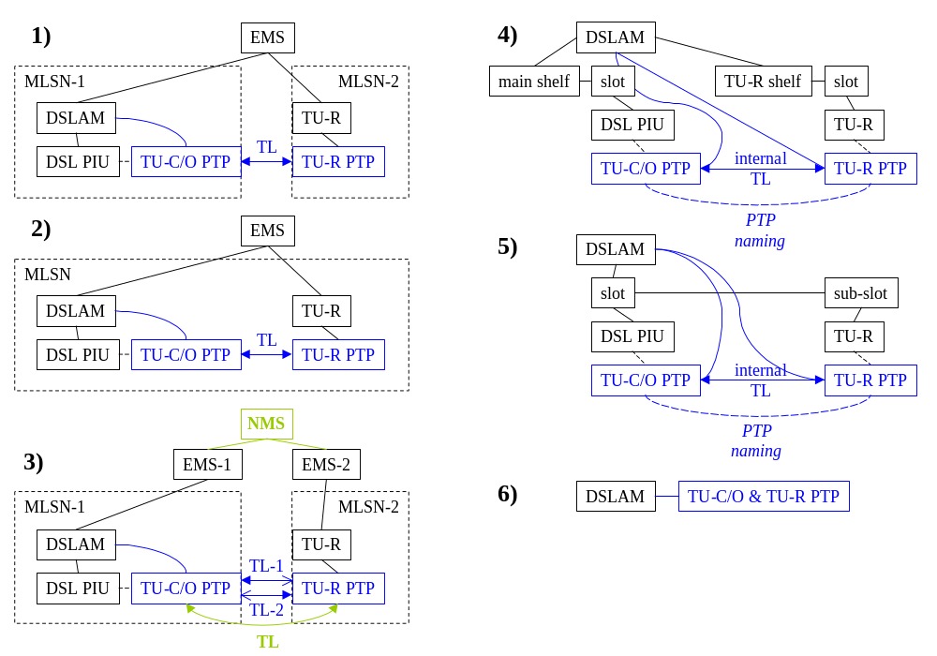
Figure 2: Six DSL Line Models

Transmission Layer Rates for DSL
The DSL functional and protocol reference models according to G.995.1 split the DSL physical layer into a physical media dependent (PMD) sublayer and a transmission convergence (TC) sublayer. The PMD sublayer provides bidirectional bit transmission capability across the underlying electrical medium (i.e., one or more UTPs), based on a DSL type-specific line coding and duplexing mechanism. The term TC refers to all functions required to transform a transport protocol specific flow (e.g., ATM cells, Ethernet frames) into and from a flow of DSL protocol data units (i.e., DSL transmission frames) which can be transmitted and received over the physical medium.
Since the DSL framing and frame synchronization functions became quite sophisticated in the course of time, mainly due to the support of multiple latency paths, the DSL TC sublayer (as used, e.g., for HDSL) has been renamed to Transport Protocol Specific TC (TPS-TC) sublayer (e.g., ATM-TC), and an optional Physical Media Specific TC (PMS-TC) sublayer has been split off the PMD sublayer (e.g., SHDSL PMS-TC, ADSL2 PMS-TC, VDSL PMS-TC). The TPS-TC sublayer is application-specific and consists largely of the packaging of user data within DSL frames, including multiplexing capabilities if no PMS-TC is present (e.g., for ADSL). The primary purpose of the PMS-TC sublayer is to provide for the multiplexing and transport of several channels of information, which are received from and transmitted to the TPS-TC sublayer (e.g., downstream and upstream frame bearers, a reference clock signal, a management channel).
This document is not concerned with the TPS-TC sublayer since the most important examples, adaptation of ATM cells resp. Ethernet frames for DSL transport, are modelled already in MTNM as layer rate LR_ATM_NI respectively LR_Encapsulation for any physical layer. Presently no need has been identified to enhance the transmission parameters of these layers but G.997.1 (1999) specifies quite some ATM data path related alarms and performance parameters that have to be assigned to LR_ATM_NI in the MTNM model. See below for alarms and refer to the supporting document SD1-28_PerformanceParameters.pdf regarding ATM performance parameters.
Though DSL channels are not modelled for the time being the TPS-TC sublayer is responsible for the structuring of user payload into frame bearer channels (of particular latencies) which can then be multiplexed by the PMS-TC sublayer (or the TPS-TC itself, if the PMS-TC is not present). So if DSL channels would be modelled through a new layer rate, LR_DSL_Channel say, in order to facilitate application-independent DSL line capacity and latency management, that layer rate would be split off the TPS-TC sublayer and the PMS-TC sublayer must then be present.
The PMD sublayer (with optionally split off PMS-TC sublayer) obviously must have LR_PHYSICAL_ELECTRICAL as physical media layer, and the layer rates LR_DIGITAL_SIGNAL_RATE and LR_DSL are added on top of it as a further transmission media layer and the universal DSL technology layer. While LR_DSL is responsible for the DSL type-specific framing format (e.g., ADSL superframe in one of four framing modes) and, if the PMS-TC is present, multiplexing of framed TPS-TC payloads, LR_DIGITAL_SIGNAL_RATE provides the desired respectively configured bit transmission capability for various framing formats through dedicated line codings, modulation types, and duplexing methods.
The following table shows how the sublayers of the functional and protocol reference models for the DSL physical layer map to the MTNM layers:
DSL Reference Layer | MTNM Layer
Transport Protocol Specific TC sublayer (TPS-TC) (e.g., ATM-TC, PTM-TC) | e.g., LR_ATM_NI, LR_Encapsulation
 | LR_DSL_Channel (optional)
Physical Media Specific TC sublayer (PMS-TC) (optional) | LR_DSL
Physical Media Dependent sublayer (PMD) | LR_DSL
Physical Media Dependent sublayer (PMD) | LR_DIGITAL_SIGNAL_RATE
Physical Media Dependent sublayer (PMD) | LR_PHYSICAL_ELECTRICAL
Table 1: DSL Reference Layers and Corresponding MTNM Layers
This mapping is not an encapsulation of ITU-T layers into MTNM layers but rather a dismantlement. G.995.1 defines a layered protocol architecture of DSL but not a layered transmission architecture according to G.805, so that there are no transmission sublayers that could be encapsulated into MTNM layers. Instead the PMD layer is split into DSL layer, DSR layer, and analogue physical transmission layer. Consequently there is no sublayer encapsulations for DSL technology as described in Section 3.2 of SD1-18_layers.pdf for SDH/SONET and OTN/WDM
For example, in case of HDSL with E1 transmission capacity LR_DSL corresponds to LR_E1_2M but while for E1 there is a dedicated framing format and digital signal rate this is not the case for DSL.
Seen bottom-up the transmission media layers of MTNM for DSL technology consist of the physical media layer LR_PHYSICAL_ELECTRICAL, which is responsible for the bidirectional transport of the analogue DSL signal, and the universal digital section layer LR_DIGITAL_SIGNAL_RATE, which modulates respectively demodulates the digital respectively analogue DSL signal of the respective DSL type. Currently there are, at least regarding DSL technology, neither transmission parameters nor alarms associated with LR_PHYSICAL_ELECTRICAL. This layer is in fact configured and monitored indirectly via LR_DIGITAL_SIGNAL_RATE.
With LR_DIGITAL_SIGNAL_RATE, however, some transmission parameters (refer to the supporting document SD1-16_LayeredParameters.pdf) and probable causes of alarms (see supporting document SD1-33_ProbableCauses.pdf) are associated.
Note. The probable cause "LPR" does not refer to an egress or ingress transmission characteristic but to the electrical supply (mains) power of the TU-C/O. An LPR failure is declared after 2.5 + 0.5 s of contiguous near-end LPR primitive presence, and is cleared after 10 + 0.5 s of no near-end LPR primitive presence. An LPR primitive occurs when the TU-C/O electrical supply power drops to a level equal to or below the manufacturer-determined minimum power level required to ensure proper operation of the TU-C/O, and terminates when the power level exceeds the manufacturer-determined minimum power level. An RU-LPR failure is declared after the occurrence of a far-end LPR primitive followed by 2.5 + 0.5 s of contiguous near-end LOS defect, and is cleared after 10 + 0.5 s of no near-end LOS defect. An RU-LPR primitive is an LPR primitive detected at the far-end and is reported by the LPR indicator. A far-end LPR primitive occurs when an LPR indicator is present, and terminates if for a period of 0.5 s no LPR indicator and no near-end LOS defect is present.
With LR_DSL and LR_ATM_NI some DSL signal-related respectively DSL-related probable causes of alarms are associated (see supporting document SD1-33_ProbableCauses.pdf). Depending on the DSL line model a DSL PTP can be physically located in two distinct located NEs. Such a PTP may detect the same probable cause in the local and in the remote NE. In order to distinguish the two probable causes, an additional prefix "RU_" (RU for Remote Unit) has to be used in the name of one probable cause. These prefixed probable causes are not explicitly listed in SD1-33_ProbableCauses.pdf.

Provisioning of DSL Lines
This chapter uses the transmission layer rates for DSL to define DSL PTPs as well as DSL Topological Links and to specify DSL line configuration procedures based on DSL PTPs and the DSL line models of Chapter 2. A DSL PTP is defined, as shown in Figure 1, by three transmission media layers: LR_PHYSICAL_ELECTRICAL as the physical media layer, LR_DIGITAL_SIGNAL_RATE as the digital section layer, and LR_DSL as the transmission frame layer. A DSL Topological Link (TL) is a TL at layer rate LR_DSL that is bound by two DSL PTPs (one of which may be off-network, and both of which may belong to the same ME).
The individual steps for DSL line configuration depend on the DSL line model and use or non-use of Transmission Descriptors. According to these models a DSL line is either a DSL TL or a single DSL PTP. As a consequence the provisioning of DSL lines will be done via PTP configuration. Depending on the model two or just one DSL PTP, hosted by one or two EMSes, has to be configured. Since the configuration data (but not all current data) of a TU-R PTP is generally stored at the corresponding TU-C/O PTP, the provisioning of TU-C/O PTPs by the DSLAM EMS is the main focus of DSL provisioning.
Two ways are frequently used:
  - direct configuration of a single DSL PTP
  - "mass" configuration of multiple DSL PTPs (possibly a very large number of PTPs scattered across multiple MEs that are managed by the same EMS) by using a single, predefined DSL profile
Both configuration methods can easily be done at MTNM's NML-EML interface by means of the use cases (see TMF513) "NMS provisions the TP transmission parameters" (namely the applicable DSL parameters listed in the supporting document SD1-16_LayeredParameters.pdf, or vendor-specific DSL parameters for standard or vendor-specific DSL types), "NMS sets additional info parameters", and "NMS modifies a Transmission Descriptor (TMD) on a TP".
The use cases "NMS provisions or re-provisions a single DSL line" and "NMS provisions multiple DSL lines by using TMDs" (see TMF513) formalize these considerations.

Transmission Parameters
MTNM's transmission parameters for all layers (according to SD1-17_LayerRates.pdf) are specified in the supporting document SD1-16_LayeredParameters.pdf in tabular form. The parameters for the DSL layer rate LR_DSL (and also some parameters for LR_DIGITAL_SIGNAL_RATE) are listed in Section "DSL (Digital Subscriber Line/Loop) specific parameters".
The applicability of an individual transmission parameter (i.e., a row of the parameter table) to one or more DSL types, is specified in the "Layers" column by adding to the layer rate the applicable DSL types in brackets, e.g. "LR_DSL (ADSL, VDSL)", and by additionally commenting the "Legal values" and/or "Comment / Example" columns if required. If no brackets and/or comments are added the parameter and/or its values apply to all DSL types.
The xTU-R (xDSL Transceiver Unit at the Remote side) is considered to be an MTNM remote unit (RU) and therefore parameters referring to the xTU-R end point of the xDSL line are prefixed with "RU_". So parameters with "RU_" prefix refer to upstream data while parameters without "RU_" prefix refer to downstream data.
Configuration parameters, i.e. transmission parameters that are writeable by the NMS, are generally suffixed by "Cfg".
Parameters, which are indicated as optional in the source standard(s) or require implementation considerations, are marked as conditional.
Note that it is generally optional for the EMS to implement an individual MTNM transmission parameter. For example, in case of read-only parameters the NMS is frequently asked to get the information via GUI cut through (GCT). The main purpose of transmission parameter specifications (and specifications of other name/value pair parameters) in MTNM is therefore not the prescription of implementation issues but to guarantee conditional multi-vendor compatibility: if an individual feature is implemented by several vendors it MUST be exposed in the same way by all of them.
Regarding type-specific DSL parameters no naming agreement has been achieved by the various bodies involved in DSL standardization, and most names are a bit awkward. MTNM introduce much simpler, intuitive names. Table 1 "Examples of ITU-T/IETF/DSLF Parameter Names and Simple MTNM Names" of SD1-16_LayeredParameters.pdf shows some examples of configuration and diagnostic ADSL and VDSL parameters together with the names used in standards specifications, and the much simpler names defined by MTNM.
The following rules were applied to obtain the simple MTNM names:
- drop any prefix relating to the DSL type
This rule is possible since the DSL type is a separate, mandatory parameter.
- delete substrings referring to xTU-C/O respectively downstream
This rule is a shorter and more intuitive naming that covers all DSL line models. It introduces xTU-C/O as default xTU and downstream/egress-from-xTU as default orientation.
- replace substrings referring to xTU-R respectively upstream by the prefix "RU_"
(i.e., add the prefix "RU_" and delete the original substring)
This rule is a shorter and more intuitive naming that covers all DSL line models.
- distinguish configuration parameters, i.e. writeable ones, by the final suffix "Cfg"
This rule allows to relate directly desired/configurable values to current/diagnostic values by concatenating the name of the current value with "Cfg".
The rules apply to xTU-C/O PTPs only and do not make sense for xTU-R PTPs. In particular, the xTU-C/O will not be considered as an RU of the xTU-R. This is due to the fact that the DSL standards development organizations (SDOs) either consider the TU-R being managed by the TU-C/O or consider at least the TU-R PTP being managed by the TU-C/O or model TU-C/O PTP and TU-R PTP jointly as a DSL line.

ADSL
The determination of details of TR-005 / G.997.1 (1999) and the SNMP ADSL-LINE-MIB (RFC 2665, supplemented by ADSL-LINE-EXT-MIB of RFC 3440) that are designated for transfer, as transmission parameters at layer rate LR_DSL, between the EMS and NMSes across the open NML-EML interface was achieved by full alignment with DSL Forum's CORBA MIB, Version 2, for ADSL EMS-NMS Interface (TR-050, based on TR-041) and implementation considerations such as rate adaptation or trellis coding or used subcarriers or bandwidth usage.
For historical and technical reasons many ADSL MIBs are around that use vendor-specific configuration and diagnostic data, even if the equipment is G.992.x or T1.413 or TS 101 388 compliant. This data shall be put in a vendor-specific TMD that is referenced by the dedicated conditional ADSL transmission parameter "VendorTMDpointer". The transmission parameters that can be used within this TMD are specified by vendor-specific documentation.
Line code specific (LCS) ADSL MIBs (e.g., DSLF's TR-024 for DMT and WT-023 for CAP) are considered not relevant from the NMS point of view. If nevertheless required they could be modelled as vendor-specific transmission descriptors. Similarly missing parameters of G.997.1 resp. RFC 3440 can be added on demand through an MTNM contribution or a vendor documentation, e.g. fast retrain parameters for G.lite operation.
SD1-16_LayeredParameters.pdf offers a long list of ADSL transmission parameters. The amount of support by the EMS depends on the particular DSLAMs or MSAPs to be managed across the MTNM interface. But the list can remain long even when restricted to a specific DSLAM model and equipping without dual latency mode (e.g., a DSLAM in G.992.2/G.lite operation). A convenient way to package the offered configuration complexity is the use of TMDs for layer rate DSL (and layer rate DSR, if required) with "DSLtype" = "ADSL", i.e. the use of ADSL configuration profiles.
SD1-16_LayeredParameters.pdf further specifies, for ADSL's diagnostic and configured bit rate parameters of the ATU-C (DataRate, DataRateFast, PrevDataRateFast, DataRateSlow, PrevDataRateSlow, AttainableRate, MinRateCfg, MaxRateCfg, MinRateFastCfg, MaxRateFastCfg, MinRateSlowCfg, MaxRateSlowCfg), the range 0..256*32 kbps in steps of 32 kbps. Similarly for the bit rate parameters of the RU ATU-R the range 0..32*32 kbps in steps of 32 kbps is specified. This is in accordance with G.992.1, which requires 6144 kbps downstream and 640 kbps upstream only. In case of G.992.2/G.lite operation the 32 kbps stepping complies with G.992.2 but the upper range boundary is 1536 kbps for the ATU-C and 512 kbps for the ATU-R. ADSL2 (G.992.3) requires 8 Mbps downstream and 800 kbps upstream. However, G.997.1 and RFC 2662 make no assumptions about the possible range of these parameters and even allow steps of 1 bps. Also, any combination of an integer multiple of 32 kbps as downstream data rate with an integer multiple of 32 kbps as upstream data rate is legal, provided the mentioned upper bounds are kept.

SHDSL
SHDSL (Symmetric High-Bitrate Digital Subscriber Loop) is the first standardized multi-rate symmetric DSL and is designed to transport rate-adaptive symmetrical data across a single copper pair at data rates from 192 kbps to 2.3 Mbps respectively 384 kbps to 4.6 Mbps over two pairs. Data rates are defined in increments of 64 kbps resp. 128 kbps but smaller increments down to 8 kbps resp. 16 kbps are possible as well. In dual-pair operation the data rate on both pairs must be equal. SHDSL covers applications traditionally served by HDSL, SDSL, T1, E1, and services beyond E1. SHDSL adheres to the following standards: ITU-T G.991.2 SHDSL, ETSI TS 101 524 SDSL, ANSI T1.418 HDSL2 (which will cover four-wire mode in Issue 2), and IETF RFC 3276.
SHDSL provides excellent reach capabilities. Symmetric rates of 2.3 Mbps can be achieved out to >= 10 kft (3 km) scaling down to 192 kbps at >= 20 kft (6 km) on a single 26 AWG cable pair. The optional four-wire mode can be used to extend the reach for specific target rates such as 2.3 Mbps at >= 16 kft (5 km). Optional repeaters are defined for both single-pair and dual-pair operation. The ITU-T standard supports up to eight repeaters allowing for extremely long reach scenarios. Such a repeater is called a signal regenerator unit (SRU). When SRUs are employed between the STU-C and STU-R, the resulting multi-segment DSL line is called a span, and each segment end point is either at network side (towards STU-C) or customer side (towards STU-R).
The resulting topology of an SHDSL line can be depicted as follows:
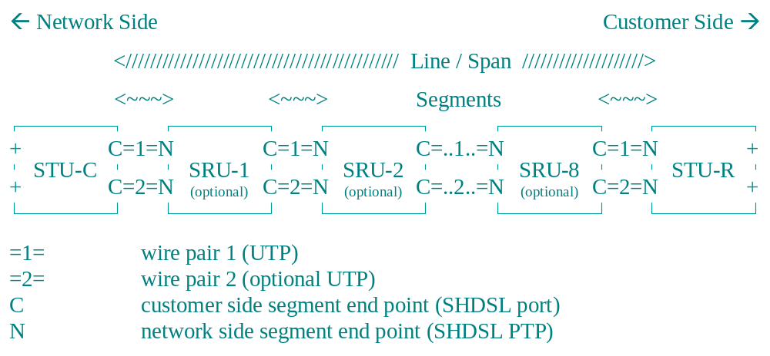
Figure 3: SHDSL Line as a Span with up to Nine Segments
Since SHDSL does not define latency paths and all its diagnostic and configured rates are eventually symmetric, the provisioning of SHDSL/HDSL2/HDSL4 requires much less parameters than ADSL, at least when no SRUs are involved.
In the past multi-rate symmetric DSL has typically been deployed using a proprietary technology called Symmetric Digital Subscriber Loop (SDSL) utilizing 2B1Q line coding as HDSL does. SHDSL uses a more advanced coding technology called TCPAM (Trellis Coded Pulse Amplitude Modulation). This leads to higher loop reach together with better spectral compatibility with other DSL technologies. In case of SDSL the admissible downstream and upstream rates can be "160", "192", "208", "256", "288", "320", "352", "384", "400", "768", "784", "1152", "1168", "1536", "1552", "1744", and "2320" but can also vary depending to the used equipment and chip sets in particular. The DSL transmission modes (framing, PSD masks, etc) are proprietary and depend on the used equipment as well.

VDSL
VDSL is seen as a technology to be developed for the long term, giving very large bandwidths to customers. Two classes of payload are considered, symmetric classes and asymmetric classes. According to ETSI TS 101 270 symmetric VDSL ranges from 6.400 Mbps up to 28.288 Mbps, and asymmetric VDSL ranges from 6.400 Mbps up to 23.168 Mbps payload bit rates. ANSI T1.424 defines symmetric classes from 6.48 Mbps up to 25.92 Mbps (for medium and short-haul service ranges), and asymmetric classes from 6.48 Mbps up to 51.84 Mbps. ANSI's ranges, namely 6.48 - 12.96 Mbps for 4.5 kft, 12.96 - 25.92 Mbps for 3 kft, and 25.92 - 51.84 for 1 kft reachability, are defined as integer submultiples of the basic canonical STM-1 speed (155.52 Mbps) and allow for specified overhead to the transmitted payload that ensures QoS and performance requirements can be met.
VDSL has the most challenging operational environment of all DSL modems to date with severe EMC design constraints because the operational bandwidth of the system has been moved up to in excess of 10 MHz and as far as 30 Mhz. In this region, the twisted pair acts as an inefficient, but not insignificant radiator, and care must be taken to avoid excessive levels of unwanted emissions in the high-frequency band. The reverse is also true; the twisted wire pairs are more susceptible to the ingress of interference which is outside the control of the network operator.
VDSL includes goodies from ADSL such as low latency/ fast channel and high latency/ slow channel but, for the advantage of extremely high configurable payloads, it lacks the reach capabilities of SHDSL and is less rate-adaptive. Instead it utilizes a much larger spectral range and therefore provides improved spectral management features including the definition of PSD template masks and configuration of notches for spectral bands.
VDSL's basic provisioning capabilities are similar to ADSL and SHDSL but there are new features as well. In MTNM terms all capabilities can be mapped to transmission parameters for layer rate LR_DSL. This is done in the supporting document SD1-16_LayeredParameters.pdf using DSL Forum's protocol-neutral management framework TR-057 for the management of VDSL lines at the NE-EMS interface, and IETF's draft SNMP VDSL-LINE-MIB (draft-ietf-adslmib-vdsl). TR-057 stresses the relevance of ADSL parameters, according to TR-005 / G.997.1 and RFC 2662, for VDSL.
Unlike ADSL and SHDSL there are no standardized legal values for downstream and upstream data rates and increments. But ANSI and ETSI defined payload bit rate classes that shall be configurable at long, medium, and short distances using vendor-specific line rates as needed to ensure the required transmission performance and QoS. For example, ETSI defines the following asymmetric and symmetric service classes:
VDSL Class Downstream (kbps) Upstream (kbps)
---------- ----------------- ---------------
A4 23168 4096
A3 14464 3072
A2 8576 2048
A1 6400 2048
S5 28288 28288
S4 23168 23168
S3 14464 14464
S2 8576 8576
S1 6400 6400
Figure 4: ETSI Payload Bit Rates (TS 101 270)
From the point of view of telecom services that require transport over VDSL (such as, for example, LR_ATM_NI and LR_Encapsulation as client layers of LR_DSL for ATM and PTM technology) the configurable downstream and upstream payload data rates and their guaranteed quality characteristics (including EMC issues) are of main interest. But there are many factors of influence. As mentioned above ANSI and ETSI have defined service classes as guidelines of what should be achieved by VDSL equipment but there is also ongoing work in VDSL standards development organizations and joint industry consortia, e.g. ITU-T SG 15 and SG 16 (including former FSAN VDSL work), VDSL Coalition (aiming towards optimizing SCM based on CAP or QAM), VDSL Alliance (working for MCM optimization with DMT), DAVIC (Digital Audio Video Council). This work presumably will lead to considerable enhancements of MTNM transmission parameters for VDSL in the future.

Further DSL Types
Along the same lines as specifying transmission parameters for ADSL, SHDSL, and VDSL further standardized or vendor-specific DSL types can be integrated in the MTNM DSL model when required by new or legacy DSL equipment. Two legacy examples are HDSL (high-bit-rate DSL), with E1 or DS1 capacity using two UTPs, and IDSL (ISDN DSL) with the BRI of 160 kbps. However, when data rate and latency of a DSL line are fixed there is not much to configure except possibly the target SNR margin and the DSL line is mainly monitored regarding states and performance.
Two recently standardized examples are ADSL2 (see ITU-T Recs. G.992.3 and G.992.4) and ADSL2plus (see ITU-T Rec. G.992.5) which are part of the ongoing ADSL evolution towards higher data rates, multiple latency paths, and improved PTM as well as inverse multiplexing support. The DSL types "ADSL2" and "ADSL2plus" can be introduced to a future MTNM version by means of the transmission parameter "DSLtype". The protocol-neutral management details of ADSL2 and ADSL2plus are specified by the Revised ITU-T Rec. G.997.1 (May 2003), and the IETF is about to charter work on corresponding SNMP MIBs. Based on this work transmission parameters tables for ADSL2 and ADSL2plus can be compiled. This is for further study in a further step.

Transmission Descriptors and ASAPs
In order to ease and accelerate the management of very large numbers of DSL lines, a DSL line may reference a (dynamic) DSL configuration profile that stores values of the configurable line (and channel) parameters (identified by the suffix "Cfg" in the MTNM parameter name), and a DSL port may reference an alarm severity assignment profile (ASAP) that relates the alarm types of the port, identified by Probable cause values, to perceived alarm severities, identified by Alarm status values. Since DSL line (and channel) parameters are modelled as MTNM transmission parameters, MTNM's Transmission Descriptors (TMDs) can be used to model DSL configuration profiles.
An alarm severity assignment profile is not an alarm configuration profile as specified by DSL standards for alarm (e.g., SNMP trap) generation. DSL alarm configuration profiles correspond to MTNM's TCA parameter profiles rather.

States and Statuses
The ability of a DSL line to offer its services depends on its states, and on statuses that further qualify states. Since DSL lines are determined by their end points their states and statuses are determined by the states and statuses of DSL PTPs. This chapter summarizes the states and statuses of the MTNM interface that apply to DSL. The definitions are given with respect to the DSL layer LR_DSL and are not restricted to the DSL PTP. They can therefore be applied directly to the DSL line when it is modelled as a TL (see Chapter 2).
The supporting document SD1-8_encodingX731M3100.pdf specifies X.731 and M.3100 states and statuses for managed objects that can be encoded either as additional info parameters, and then apply to all layers of the object, or as transmission parameters for individual layers. For DSL PTPs and DSL lines the EMS may optionally support the following X.731 and M.3100 states and statuses: "X.721::OperationalState", "X.721::AvailabilityStatus", "X.721::AdministrativeState", "X.721::ControlStatus", "X.721::UsageState", "M.3100::AlarmStatus", "M.3100::ArcState".
The ITU-T states and statuses can give only a general picture of the current operability of DSL lines. To communicate more detailed line conditions from the EML to the NML DSL-specific states and statuses must be implemented by the EMS. These DSL-specific states and statuses are specified by the supporting document SD1-16_LayeredParameters.pdf for the layer rate LR_DSL: "LineStatus", "RU_LineStatus", "InitStatus", "LinkState". Note that all the possible values are listed but the occurrence of a value may depend on the DSL type. In case of SHDSL/HDSL2 further values of "LineStatus" are defined in G.991.2 and RFC 3276 (e.g., SRU-related ones) whose support by MTNM is for further study.
In case of ATM-over-DSL the state of the DSL line may have some impact on the contained ATM link. Some of this impact is configurable through the so-called ATM alarm generation states "AISonLOS" and "AISonACT" which are transmission parameters of the ATM NI layer (see SD1-16_LayeredParameters.pdf).

Maintenance Operations
Since DSLs require high-frequency signal transmission over a copper plant that was optimized initially for low-frequency signals, service providers use local loop qualification tools that allow them to analyze remotely line suitability for high-frequency signals and determine whether and what type of DSL service may be supported. The main limitation that makes loop qualification necessary is the attenuation experienced by DSL signals flowing through the loop and the originating signal-to-noise ratio (SNR), i.e. the ratio of the power in the signal to the power in the noise, that results from the usually inevitable presence of interference and noise.
Remote local loop qualification can save the cost and supply delay caused by sending a technician to the subscriber's site. It can be regarded a maintenance operation.
Thus in MTNM terms "Local_Loop_Qualification" is a maintenance operation applied from the service provider site to a remote DSL PTP. MTNM v3 adds this operation to the straightforward maintenance model of MTNM v2 that allows to apply to and release from a TP, and all or just one of its layers, some predefined maintenance operations with additional infos (subject to bilateral agreement between NMS and EMS not further specified by MTNM).
Performing loop qualification will then consist of the preprovisioning of the desired DSL line with unknown DSL type thereby creating the remote DSL PTP and associating it to a dummy local DSL PTP. When loop qualification succeeds the right remote xDSL transceiver can be purchased and installed. After installation of the xTU-R the dummy local DSL PTP is replaced by a free local DSL PTP of the appropriate xDSL type, hosted by some xDSL-capable ME (DSLAM/MSAP), and the xDSL line proper can be provisioned.
The provisioned DSL line can then be supervised by the "DSL_Line_Supervision" maintenance operation. Depending on the EMS implementation this operation can determine, for example, the bit-loading allocation of an ADSL line, i.e. the number of bits currently transported by each DMT subcarrier.

Performance Parameters
MTNM includes performance management (PM) parameter names for DSL PTPs that represent counters of errored seconds or anomalies during the accumulation period. Since PM parameters with associated thresholds identify the subjects of MTNM performance monitoring and threshold supervision activities at TPs, relatively to a transmission layer rate, a location qualifying the traffic, and a granularity, the full range of MTNM's PM capabilities becomes available for DSL technology. The applicable layer rates are LR_DSL and LR_DIGITAL_SIGNAL_RATE.
Refer to the supporting document SD1-28_PerformanceParameters.pdf for the specification of DSL performance parameters where DSL-specific parameters can be identified by looking to the "Layer rate" column. Additionally there are applicable parameters that apply to other layers as well; these are "PMP_CRC", "PMP_FEC_EC", "PMP_UAS" for LR_DSL and "PMP_CV", "PMP_ES", "PMP_LSS", "PMP_SES" for LR_DIGITAL_SIGNAL_RATE.

Administrative Appendix

Document History
Version | Date | Description of Change
3.0 | April 2004
3.0 | June 2005 | References updated
3.1 | November 2005 | Version in names of referenced supporting documents deleted.

Acknowledgments

First Name | Last Name | Company

How to comment on this document
Comments and requests for information must be in written form and addressed to the contact identified below:

Keith | Dorking | CIENA
Phone: | +1 678 867 5007
Fax: | +1 678 867 5010
e-mail: | Kdorking@ciena.com

Please be specific, since your comments will be dealt with by the team evaluating numerous inputs and trying to produce a single text. Thus we appreciate significant specific input. We are looking for more input than wordsmith” items, however editing and structural help are greatly appreciated where better clarity is the result.

In the DSL object model introduced by the DSL Forum in TR-035 a DSL line is always contained in the DSLAM. This overall point of view is adopted by DSL Forum's CORBA MIB definition (TR-050, TR-041) where dslf_adsl_v2::ADSLLine is contained by itut_m3120::ManagedElement (see the containment diagram, UML diagram, and name bindings of TR-050).
DSLAMs with IMA boards can be cascaded in a star configuration. Due to the advantages of the IMA protocol the ATM cell streams can be load-balanced across all of the physical links of an IMA virtual link at the same time in a dynamical fashion, which can be even non-disruptive if IMA's LASR procedure is supported. This allows to connect remote locations very efficiently using already existing transport infrastructure. The cascading DSLAM collects the remote DSLAMs via the IMA links and provides DSL interfaces for local subscribers. For large central office applications the DSLAMs can be connected locally to a cascading DSLAM to provide a high degree of traffic concentration onto one backbone feeder interface. Each DSLAM, cascaded or cascading, is seen as a separate ME.
In MTNM two ILMI parameters (and the ILMI VPI and VCI) are specified (using model 6), however) as can be seen from the description of the transmission parameters for LR_ATM_NI (see the supporting document SD1-16_LayeredParameters.pdf).
Refer to Annex D of G.991.2 and RFC 3276.
ITU-T recommendations define further TC sublayers, namely MPS-TC for management protocols (e.g., SNMP over HDLC) and HSS-TC for handshake protocols. These need not be considered from the NML-EML interface perspective. Note that management across a DSL line can take place through the TPS-TC sublayer as well, e.g. via a dedicated ATM VCC.

