MTOSI 2.0 editorial buck fixes list
The following buck fixes have been executed on the MTOSI model contained in https://collab.tmforum.org/svn/repos/mtop/Product/trunk

Framework
- Interfaces::CommonObjectProvisioning::setUserLabel
Duplicate return parameter deleted.
- Type Definitions::State
attribute1 deleted.

ManageResourceInventory
- Type Definitions::ManagedElementFilter::resourceState
Default value UNKNOWN re-set.

NetworkResourceAssurance
- Type Definitions::PerformanceMonitoringParameter::pmThresholdList
Attribute pmThresholdList re-created.
- Type Definitions::correlatedNotifications
"correlatedNotifications" replaced by "CorrelatedNotifications".
- NetworkResourceFulfillment model imported.
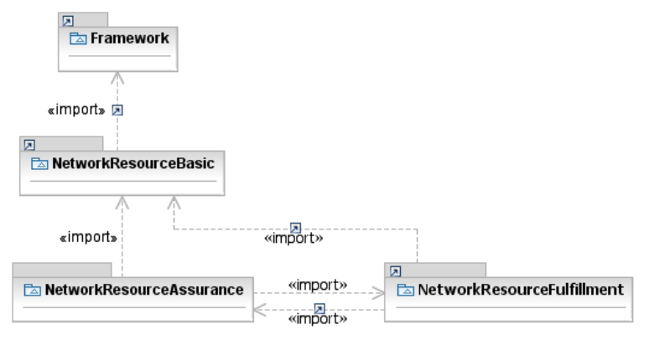
- The "illustrative" association TpContainsPmps has been marked as abstract.

NetworkResourceBasic
- Data Object Classes::CommonResourceInfo::resourceState
Default value UNKNOWN re-set

NetworkResourceFulfillment
- Data Object Classes::Associations::HasSubordinate
Made the subordinateOS side of the relationship navigable.
- Data Object Classes::Associations::SncHasZEndGtps
Made the GroupTerminationPoint (zEndTpList) side of the relationship navigable.
- Associations::RouteChangeNotificationHasRoute
Relationship moved to Notifications::Associations and missing Route object class added.

