The mTOP Simulator Documentation

Abstract
This document presents the mTOP Simulator which has been developed to demonstrate the key features of the MTOSI Resource Inventory interface. The simulator brings benefits to both end users and developers:
- end users will take advantage from its GUI client interfaces and its database populated with a small but realistic network information;
- developers will take profit of its open source code which can be used to understand how to build, deploy and run the different elements of the architecture using the Sun Glassfish J2EE environment.

Table of Contents

The mTOP Simulator Documentation 1
Abstract 1
Table of Contents 1
1 Introduction 3
1.1 Where to Find the mTOPSimulator package? 4
1.2 Prerequisite 5
1.3 The J2EE / JEE5 Platform 6
2 Architecture and Design 8
2.1 The mTOP-Simulator 8
2.1.1 Overview 8
2.1.2 Some Essential Classes 9
2.2 The PopulateDatabase 10
3 Start the Environment Servers 11
4 Build and Deploy the Simulator Servers 14
4.1 Build and Deploy the PopulateDatabase Server 15
4.2 Build and Deploy the mTOP-Simulator Server 15
5 Populate the database 17
6 Use the mTOP-Simulator 18
6.1 With the Java Client 18
6.2 With the Web Client 23
7 Overview of the Development Chain 29
7.1 Generate the Classes from a WSDL File 29
7.2 Add Persistence to Generated Classes 30
7.3 Implement the Service Endpoint Interface 31
7.4 Consume the Web Service from the Java Client Application 32
7.5 Add New Operation and Managed Entities 32
8 Caveats and Limitations 33
9 Technical Appendix 1: Class Diagrams 34
9.1 mTOP-Simulator ejb module class diagram 34
9.2 PopulateDatabase class diagram 35
10 Technical Appendix 2: How to install the Sun JEE5 Environment 36
10.1 On Windows 36
10.2 On Linux 37
10.2.1 Get the Java EE 5 SDK 37
10.2.2 Install the Application Server Software 37
10.2.3 Start and Verify the Server 38
10.2.4 Confirm that the Server Is Running 38
10.2.5 Test with the Hello-JAXWS Sample Application 39
11 Administrative Appendix 41
11.1 Document History 41
11.2 Acknowledgments 41
11.3 How to comment on this document 41

Introduction
MTOSI is one of the two products of the mTOP program.
MTOSI Release 1.1 was approved by the TMF in January 2007. The different related documents and specifications are available at the TMForum site http://www.tmforum.org/browse.aspx?catID=2320.
The MTOSI Release 1.1 supports two essential services:
  - The Configuration Service
  - The Fault Service
The Configuration Service is constituted of several interfaces specified in WSDL:
  - InventoryRetrieval
  - EquipmentInventoryMgr
  - ManagedElementMgr
  - MultiLayerSubnetworkMgr
  - OSMgr
  - ProtectionMgr
  - TransmissionDescriptorMgr

The InventoryRetrieval interface exposes a single “business activity” called getInventory. As opposed to the business activities of all the other interfaces which are very “fine grain” (many specific operations), this one allows a Client OS (e.g. an Inventory OS) to retrieve all the relevant information from a Supplier OS (e.g. an NMS) by a single invocation: by using the appropriate input filter parameters, the Client OS can control the information to collect from the Supplier OS. It is then very powerful.

This document presents the technical aspects of a simulator which has been developed as part of a reference implementation package for mTOP-MTOSI.

This simulator is constituted of the following components:
  - The Server which simulates a NMS system handling a collection of network resources in a data base. It implements the InventoryRetrieval interface presented above and, as such, it replies to getInventory queries.
This Server has been developed in Java using a WSDL framework.
It is expected that the TMF will run such a Server hosted in one of the TMF Lab computers, in such a way that interested users can send requests using the Web Client pages. The TMF Server database cannot be modified remotely by end users but only by the TMF admin.
Alternatively end users can download the entire Server package and deploy it in their own local J2EE environment.
  - A Web Client (Web pages) through which a human user is able to create getInventory requests by specifying the appropriate input filter parameters. The XML response generated by the Server is displayed in return; the inventory structure returned can also be visualized in a graphical way (using a XSLT transform).
The actual generation of a XML getInventory request is handled on the Server side (between the receiving servlet and the session bean exposing the InventoryRetrieval interface).
This kind of Web Client will typically be used by new comers to the MTOSI standard when they want to get an idea how the InventoryRetrieval interface works in just one click.

The Web Client has been validated for Internet Explorer and Firefox.
  - A Java Client: it is a Java based application exposing a simple GUI, similar to the one of the Web Client and Java classes representing the entities of the mTOP RM model.
The parameters entered by the user are collected by this Java Client application to create a getInventory XML request which is then sent in a SOAP message to the remote server. Upon reception of this message, the Server queries its database to collect the requested information and returns a getInventoryResponse XML response to the Java Client application. When the Java Client receives this response message it builds local instance objects corresponding to the collected inventory information and displays them to the user in either XML form or graphical form (this time the XSLT transformation takes place at the Client side).
The transport stack used between the Java Client and the Server is HTTP, meaning that only the synchronous MEP (Message Exchange Pattern) has been implemented.
This kind of Client will typically be used by users who are interested in implementing the MTOSI standard. They will be able to download the Client package and run it on their own environment and be able to exchange SOAP messages with a local or remote Server.
  - Actually there is another component which allows for uploading an information model to the Server. The Server data base can be modified from a Web Client interface by simply sending to the Server a XML representation of the Inventory information, following the getInventoryData XML structure (the same as the one used in a getInventoryResponse XML response).

This tool is called the “PopulateDatabase” tool.
You will have to use it to populate the database of your local Server (you cannot modify the database of the TMForum Server).

Where to Find the mTOPSimulator package?
The mTOPSimulator is available, as an open source package, on GForge at the following location:
svn.gforge.tmforum.org/svn/mtop/mtosi_1.2/simulator

It is configured to run on Windows NT. Adapting it to run on a Linux platform is straightforward.
The distributed package is structured has follows:

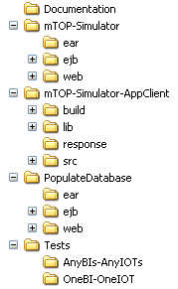

  - Documentation
contains this document
  - mTOP-Simulator
contains the Server (mTOP-Simulator) which have been packaged to be deployed easily using the maven tool;
  - mTOP-Simulator-AppClient
contains the Java Client
  - PopulateDatabase
contains the tool used to populate the database using an input XML file;
  - Tests
contains inputs and outputs of different tests which have been run using a database populated with the data from the example network supplied in the
”SD2-4_TransportIndependentExampleOfMTOSI.zip” supporting document.

??? (SG) should we say anything about restricted usage, license, condition of utilisation,… liabilities, … copyrights

Prerequisite
Indeed, if you read this document, it means that you have some interest in the MTOSI standard.
This simulator has been developed based on the MTOSI 1.1 specifications available at http://www.tmforum.org/browse.aspx?catID=2320.
and also on GForge at:
svn.gforge.tmforum.org/svn/mtop/mtosi_1.1
More precisely, the important files to look at (among others) are:
    - BA document:
mtosi_1.1/BA/TMF517.doc
    - IIS documents:
mtosi_1.1/IIS\wsdl/services/ConfigurationService.wsdl
mtosi_1.1/IIS\wsdl/common/InventoryRetrieval.wsdl
mtosi_1.1/IIS/xsd
    - Supporting documents:
mtosi_1.1/SD2 Series/SD2-12_MTOSI_Inventory_Layout.doc
mtosi_1.1/SD2 Series/SD2-4_TransportIndependentExampleOfMTOSI.zip
containing:
SD2-4_TransportIndependentExampleOfMTOSI.doc
getInventoryResponse.xml

To take the best profit of this document and be able to understand the architecture of the Simulator and use it, we make the assumption you are familiar with Java, J2EE, XML, WSDL, SOAP and database essentials.
To build and deploy the complete package as is, you will need to be familiar with the Sun Glassfish JEE5 Environment, which contains the Sun Application PE 9 (refer to the appendix at the end of this document) and with the maven tool (http://maven.apache.org).
Other important references:
  - tutorial jee5: http://java.sun.com/javaee/5/docs/tutorial/doc/
  - ejb3: http://java.sun.com/products/ejb/
  - jax-ws: https://jax-ws.dev.java.net/
  - jaxb: https://jaxb.dev.java.net/

The J2EE / JEE5 Platform
One the key criteria to select the platform was that it would be available at no licence cost.
The following J2EE / Web Services development platforms have been considered and evaluated before starting the implementation:
  - Axis1.4 Axis 2/ Tomcat ,
  - JBoss,
  - Sun Application Server 9 (a.k.a Glassfish)
The first two ones showed different limitations. In particular, the Sun Application Server 9 was the only environment processing the complete set of XSD files without any warning or exceptions (note that the “union” XSD type is translated into Strings; with this approach, the generated Java files need to be modified, which slightly complicates the implementor’s task but does not change the XML representation exchanged).
As a consequence, the decision was taken to adopt the platform from Sun (the technology used for the generation of the Java stubs is JAX-WS).

JavaDB (default DB coming with the Glassfish installation) has been used for the implementation of the database (considering that no performance aspects are required for the simulator).

The architecture of the Server tier use Session beans for the WSDL interface (in our case there be just one Service exposed) and Entity Beans for the XSD data types. The use of EJB 3.0 facilitates the persistency of the information. This modular approach will allow easy enhancement of the simulator in the future, to introduce new services or new data types.

The development has been done using the Netbeans IDE delivered with the Sun platform.

However, to make things easier for the installation and the deployment of the Server, the final packaging has been done in conformance with the maven tool. As a consequence, the delivered package must be installed using maven.

Architecture and Design

The mTOP-Simulator

Overview

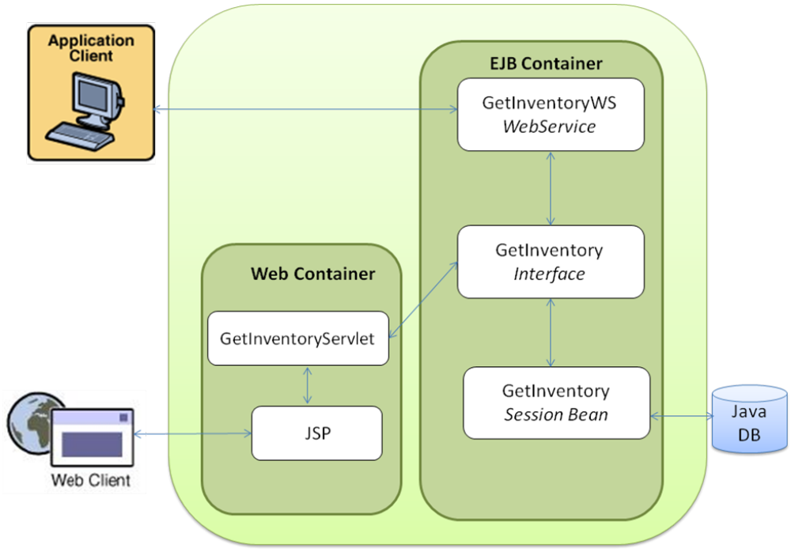
Figure 1 Architecture of the mTOP-Simulator

The mTOP-Simulator application is a standard 3-tier application.
It has two clients: a Java Application Client and a Web Client. They both allow the user to enter the values of the parameters of getInventory and getInventoryIterator operations, to submit requests and to display the responses.
The Web Client is a servlet which accesses the database through enterprise session beans.
The application client is built using the Swing Java API and accesses the database through the MTOSI InventoryRetrieval web service over a soap/http protocol stack.
The mTOP-Simulator application has three session beans: InventoryRetrievalWS, InventoryRetrieval and InventoryRetrievalImpl:
  - InventoryRetrievalWS is the Stateless Session Bean Web Service which exposes the two operations getInventory and getInventoryIterator defined in the InventoryRetrieval.wsdl of the MTOSI Solution Set.
  - InventoryRetrievalImpl is the Stateful Session Bean which provides a client's view of the application's business logic

Some Essential Classes
The ApplicationClient class creates the getInventory or getInventoryIterator requests from the values entered in the GUI. One of the two methods of the web service GetInventoryWS is then consumed through a soap/http protocol.

The getInventory session bean implements the semantic of the getInventory and getInventoryIterator operations in the two functions with the same name.
For each different couples BaseInstance/IncludedObjectType the Util class checks that the values are correct and, if so, creates a ejbql request to query the database. Depending on the type of the managed entities to retrieve a CreateManagedEntityResponse is instantiated.
All the CreateManagedEntityResponse classes implement the createResponse() function from CreateGetInventoryReponse. This function takes as input the list of the managed entities retrieved from the database and creates or updates the getInventoryResponse inventorydata which will be returned to the Client.
The ids of the managed Entities retrieved are then put into a list. If the getInventory requestedBatchSize parameter is positive and if there are still some managed entities to be retrieved in future partial responses (not all the filtered managed entities could be retrieved in one response because of the value of the BachSize parameter), the Client will have to send getInventoryIterator requests and the ejbql request in the database will only select the managed entities whose ids are not in the list. Indeed, this list is updated by each new getInventoryIterator request.

The two methods getInventory and getInventoryIterator are exposed to the remote Client using the JAX-WS annotations @WebMethod and the class is defined as a web service using the @WebService annotation. The ejb3 annotation @EJB defines the link the InventoryRetrieval Session Bean.

InventoryRetrievalImpl is the Stateful Session Bean which provides a client's view of the application's business logic. Hidden from the clients are the server-side routines that implement the business logic, access databases, manage relationships, and perform error checking.
It defines the two MTOSI operations getInventory and getInventoryIterator, the select database request and it contructs the response.

The PopulateDatabase

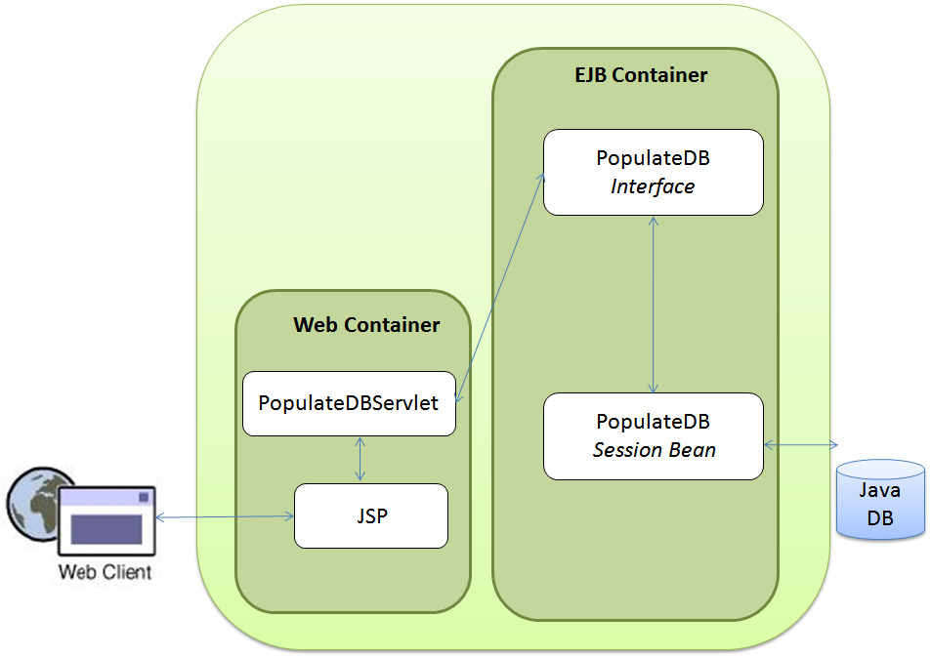

Figure 2 Architecture of the PopulateDatabase Tool

The PopulateDabase application allows the user to populate the database with the data of an XML file. The input XML file must conform to the InventoryRetrieval.xsd schema (getInventoryResponse).
The design is similar to the one of the mTOP-Simulator Web Client part.
The user enters the path of the XML file in the Web browser page. The PopulateDBServlet then invokes the ejbModule which will unmarshalls the XML file into Java instances.

Start the Environment Servers
This section describes how to start the JavaDB database and the Sun Application Server, essential steps before deploying and run the Simulator system.

- Start the Sun Application Server

In a console window enter:
asadmin start-domain domain1

and wait until the Sun Application Server has started.

- Configure the Java DB database
  - Go to the Web page of the administration console of the Sun Application Server using the following URL: http://localhost:4848/asadmin/
  - Under Resources –> JDBC –> Connection Pools
- Create a new connection pool with the following properties:
      - DataSource = org.apache.derby.jdbc.ClientConnectionPoolDataSource.
      - Datasource Classname = org.apache.derby.jdbc.ClientDataSource
      - Resource Type = javax.sql.DataSource

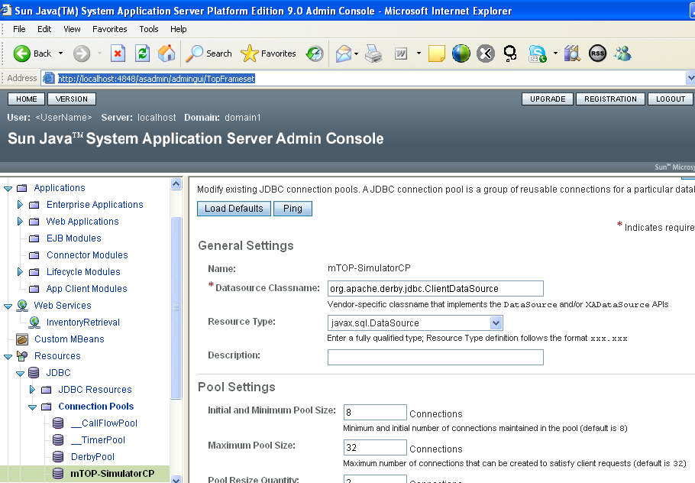

- Create a new JNDI name jdbc/mTOP-Simulator and set it to point at the connection pool mTOP-SimulatorCP you just created:

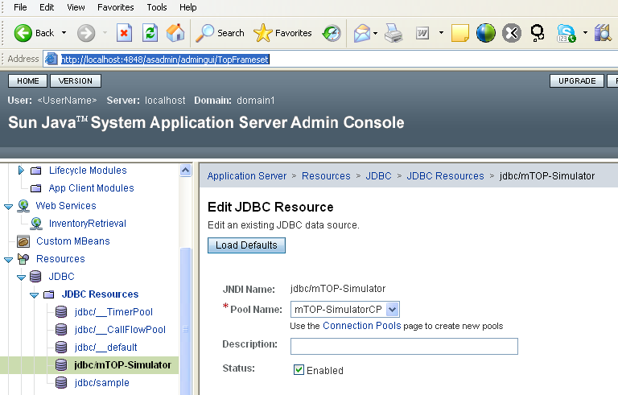

The database and Application Server are now configured.

- Start the Java DB database

In a console window enter:

asadmin start-database

Build and Deploy the Simulator Servers
The two applications PopulateDatabase and mTOP-Simulator have been developed and packaged to run with maven 2.0 and jdk 1.6.
The JNDI name given when the database was created must be the same as the name which appears under the <jta-data-source> tag the in persistence.xml files of the applications:
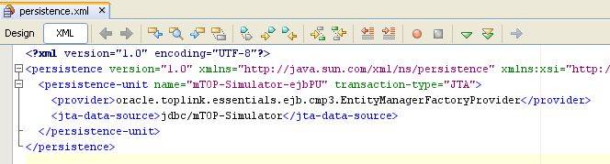

If you didn’t give the same name as the one given on screenshots (jdbc/mTOP-Simulator) you need to update the two files:
PopulateDatabase\ejb\src\main\resources\META-INF\persistence.xml
mTOP-Simulator\ejb\src\main\resources\META-INF\persistence.xml

Build and Deploy the PopulateDatabase Server
- Build

In a console window go to the PopulateDatabase directory of the project and enter the following command in the three subdirectories (in that order due to dependencies) ejb, web, ear:
mvn install
- Deploy
  - Go to the Web page of the administration console of the Sun Application Server using the following URL: http://localhost:4848/asadmin/
  - Under Applications -> Enterprise Applications
- Click on the deploy button
- Select the PopulateDatabase-ear-1.0.ear file which has been created during the Build step available under PopulateDatabase\ear\target directory
- Click Next
- Click Finish
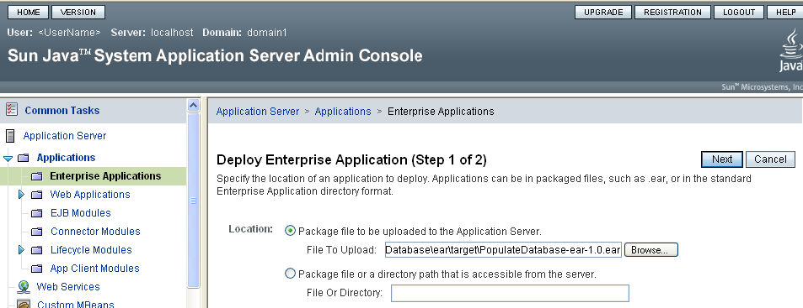

Build and Deploy the
mTOP-Simulator Server
- Build

In a console window go to the mTOP-Simulator directory of the project and enter the following command in the three subdirectories (in that order due to dependencies) ejb, web, ear:
mvn install
- Deploy
  - Go to the Web page of the administration console of the Sun Application Server using the following URL: http://localhost:4848/asadmin/
  - Under Applications -> Enterprise Applications
- Click on the deploy button
- Select the mTOP-Simulator-ear-1.0.ear file which has been created during the Build step available under mTOP-Simulator\ear\target directory
- Click Next
- Click Finish
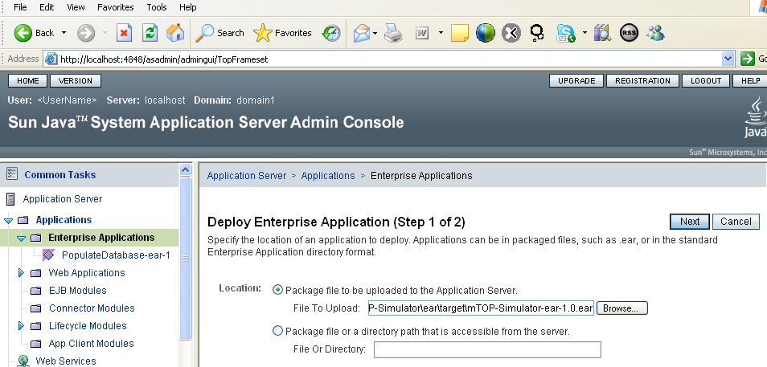

After completion, the window displays as shown below:
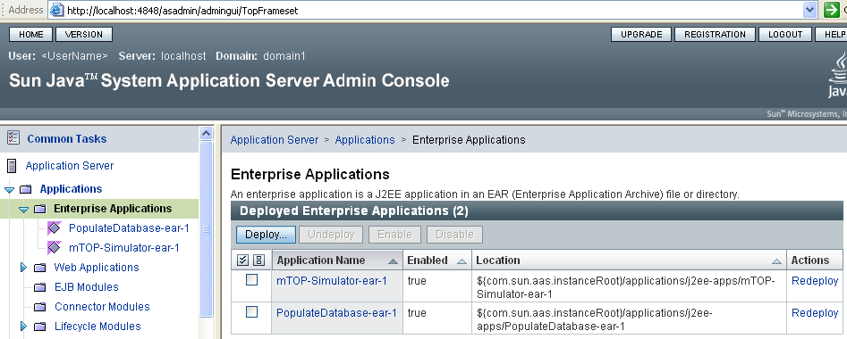

Populate the database
To populate the database use the PopulateDatabase Web Client at:
http://localhost:8080/PopulateDatabase/
and select the getInventoryResponse.xml input file available under the Tests directory:

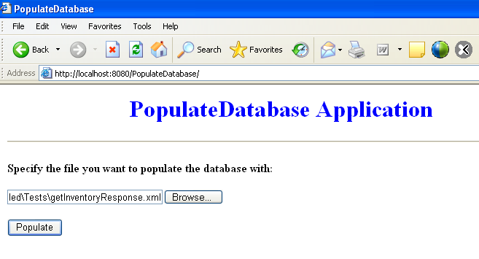
After successful completion (will take about 30 secs) you should see the following page:
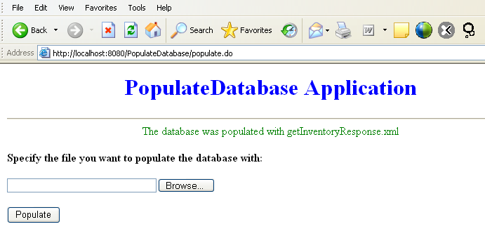

Use the mTOP-Simulator

With the Java Client
In a console window go to the mTOP-Simulator-AppClient directory of the project and enter the following command:
ant run

After completion the GUI displays as follows:
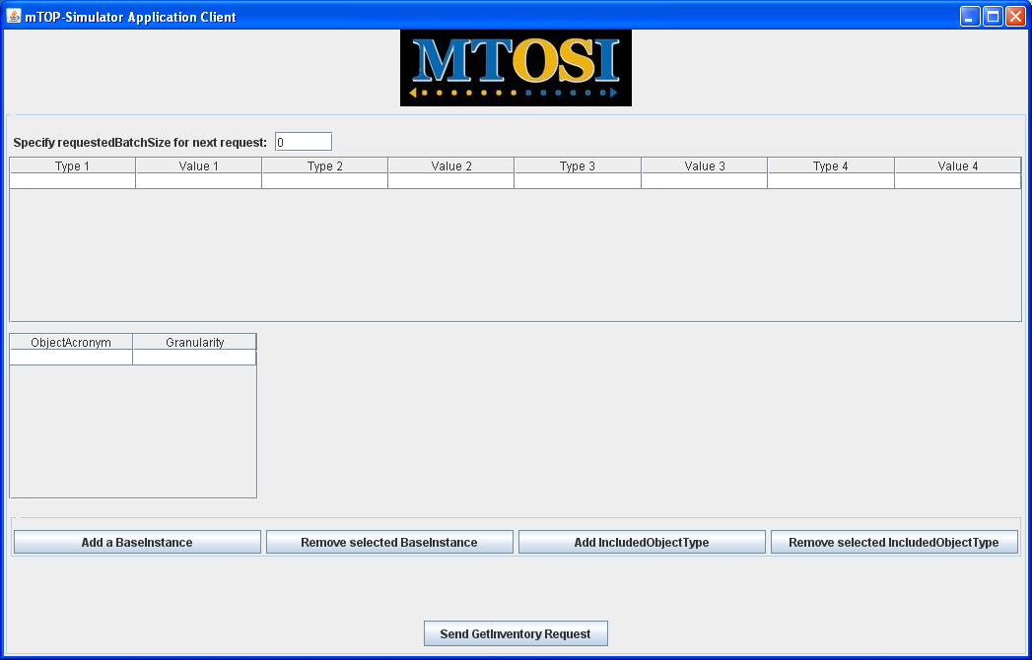

Figure 3 Initial GUI screen

- Sending a getInventory request

(The very first request may take few seconds to execute, even it is a simple one)
The user interface enables the user to enter the parameters of the getInventory and getInventoryIterator operations:
  - requestedBatchSize: header parameter of the getInventory and getInventoryIterator operations. The value specifies the number of unit to be returned for each batch. Zero or any wrong values returns all the units in one batch. A positive value N returns N units for each response. If the requestedBatchSize is N with N > 0, depending on the filter parameters and the managed entities in the database two cases can occurs after the getInventory request:
- All units are returned in first batch, that is there are less or equals units than the requestedBatchSize to be returned. The user can then send another getInventoryRequest request
- N units are returned after the getInventory request. The user can see the resulting xml file and html table. The next requests will be getInventoryIterator requests and the user can only modify the requestedBatchSize parameters for these request. Once all the units are retrieved a message is sent to user which can then send another getInventory request.
  - baseInstance: body parameter of the getInventory operation. If a baseInstance type BITypeX (with X in {1,2,3,4}) is provided the next cell in the table BIValueX must also be given.
  - includedObjectType:. body parameter of the getInventory operation.For each objectAcronym the corresponding granularity (NAME, ATTRS, FULL) must be provided.

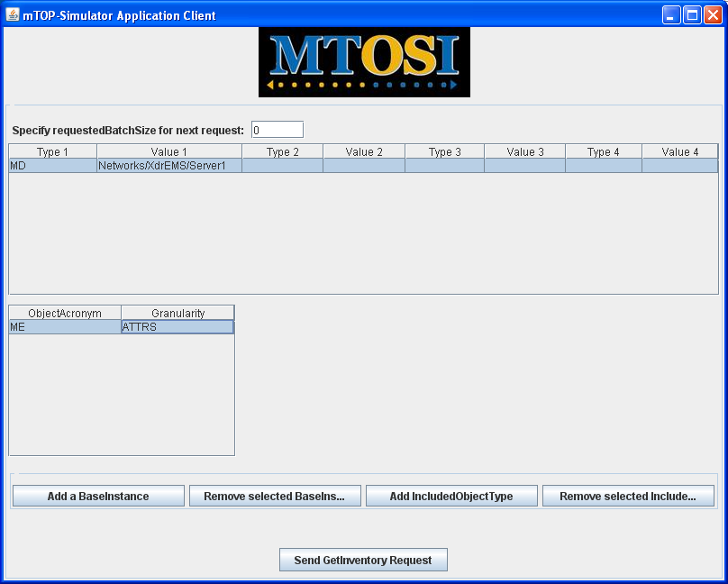
Figure 4 A First getInventory Request

- Visualizing the response

The response can be visualized in two ways by clicking on new View Response button at the bottom of the window:
- getInventory-response.xml file:
displays the XML representation of the getInventoryResponse body in a Web browser page
- table.html:
displays an HTML equivalent table resulting from an XSLT transformation of the same getInventoryResponse body.

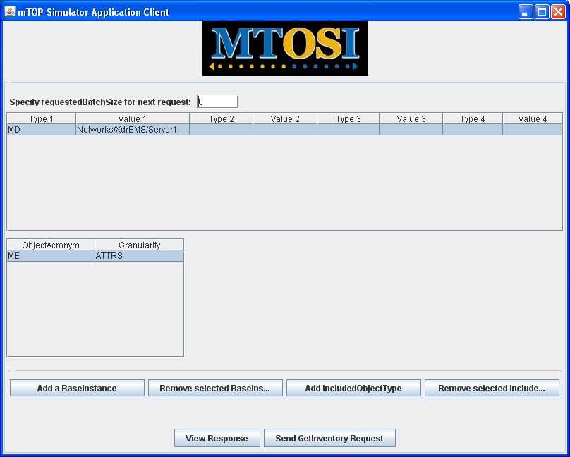
Figure 5 Response Page of the getInventory Request

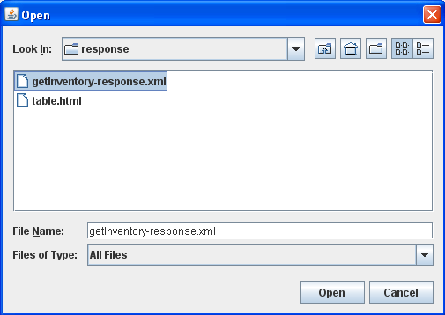
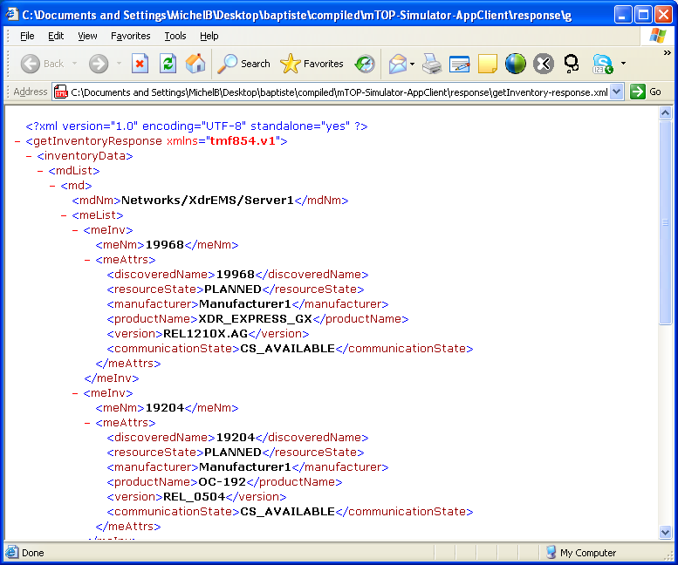

Figure 6 Opening the XML File Response

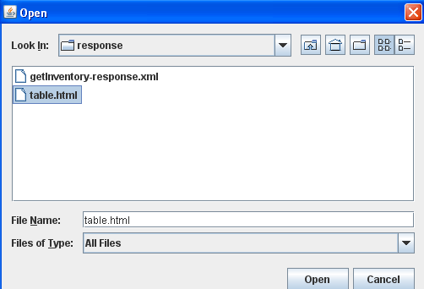
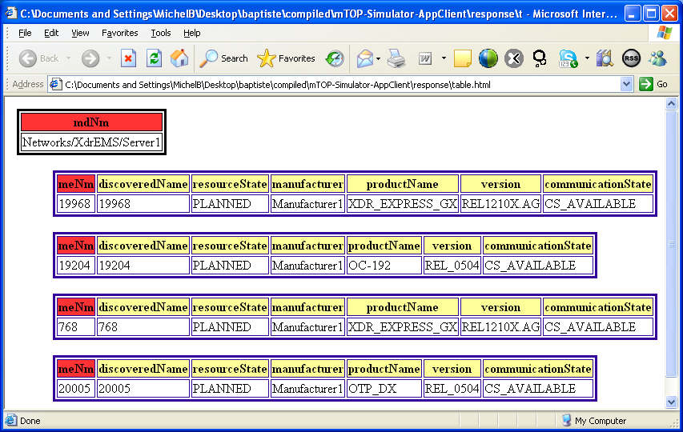

Figure 7 Opening the HTML Table Response

- Sending a getInventoryIterator request

The screen below shows a request querying the first 100 set of PTPs our of the 430 ones subordinates of the {MD= Networks/XdrEMS/Server1, ME=19968} managed element.
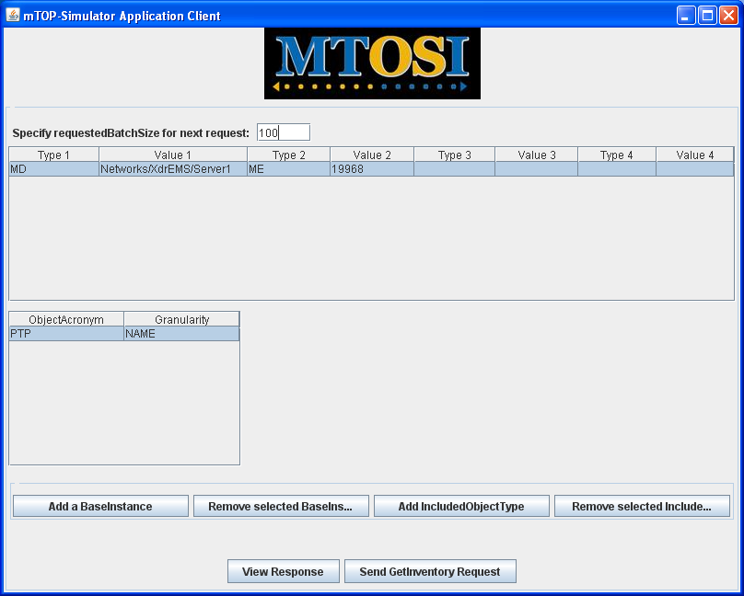

Figure 8 Requesting the first 100 PTPs out of 430 (requestedBatchSize set to 100)

Upon completion the response screen will show a different button at the bottom:


After having visualized the partial response (click on the View Response button) you can continue querying the Server by sending a getInventoryIterator request (click on the Send GetInventoryIterator Request button).
Proceeding this way 4 times you will get the following response screens:
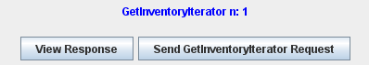
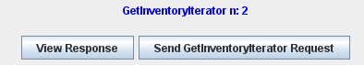
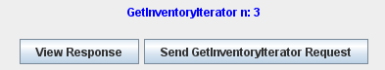
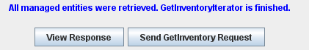
The last response contains 30 PTPs in this example, and you can sent a new request.

When iterating on getInventoryIterator requests, the input parameters rows are frozen preventing any modification of the filter to the exception of the requestedBatchSize parameter which can be modified from one getInventoryIterator request to another.

With the Web Client
Open the following URL in your Web browser (IE or Firefox)
http://localhost:8080/mTOP-Simulator

Then the screens are very similar to the ones of the Java Client

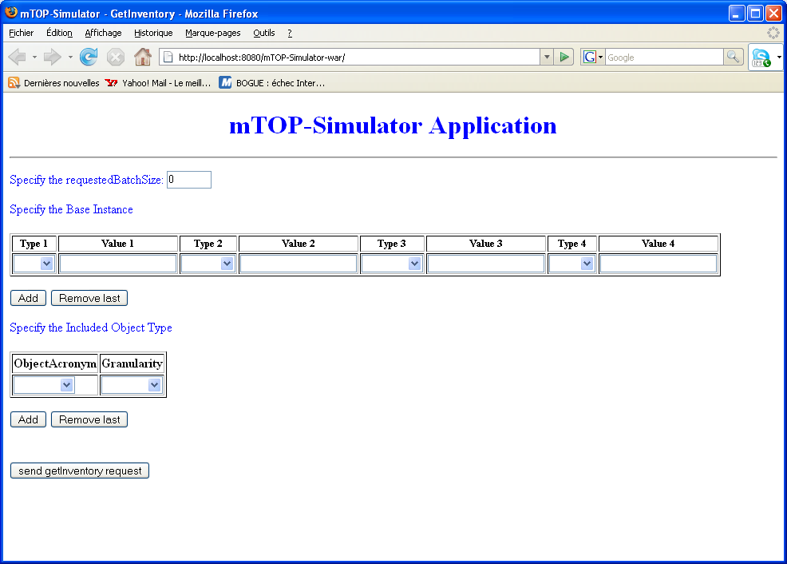
Figure 9 GetInventoryRequest at the begining

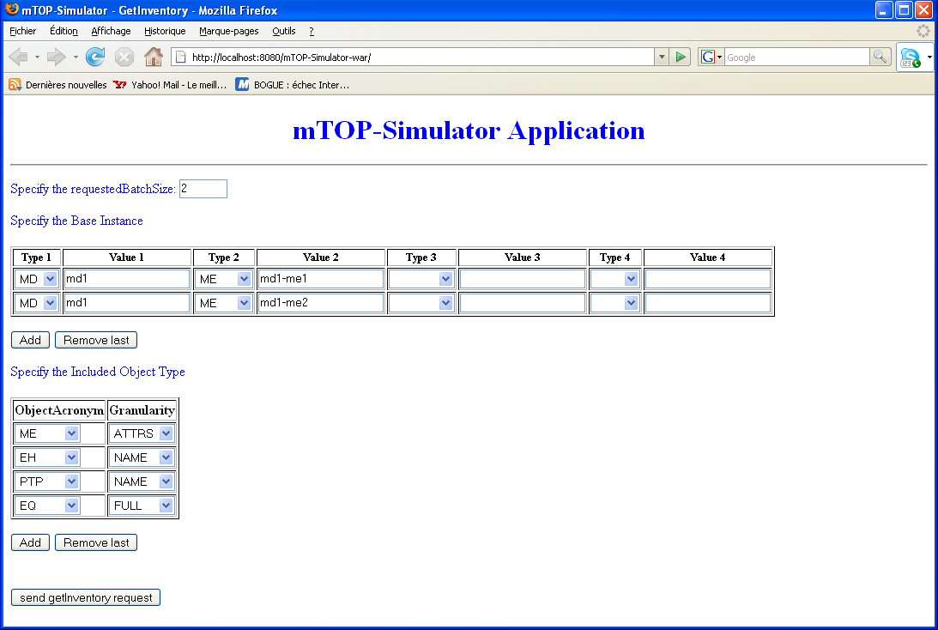
Figure 11 first getInventory request

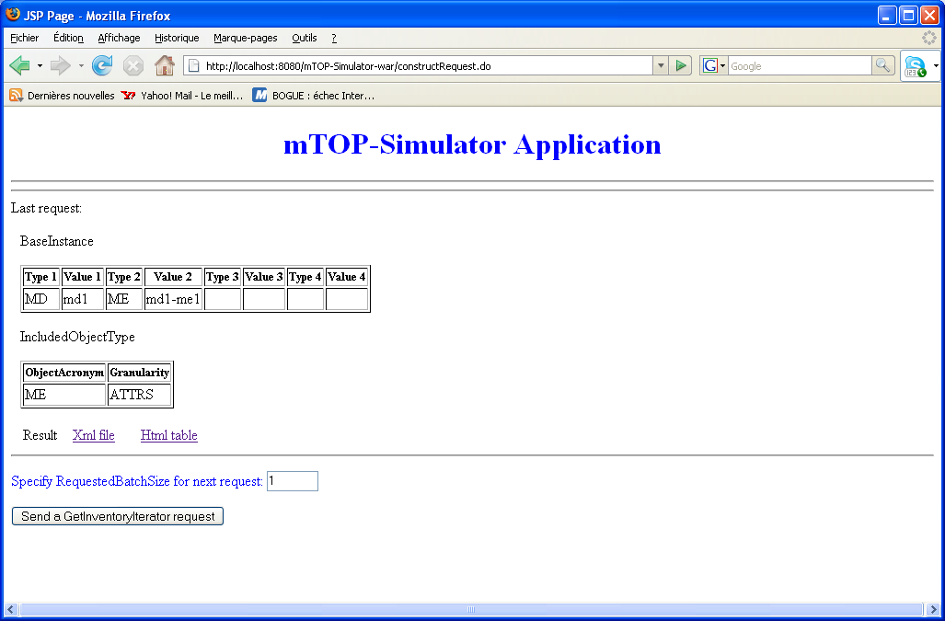
Figure 12 response of the getInventory request and set requestedBatchSize to 1 for next request

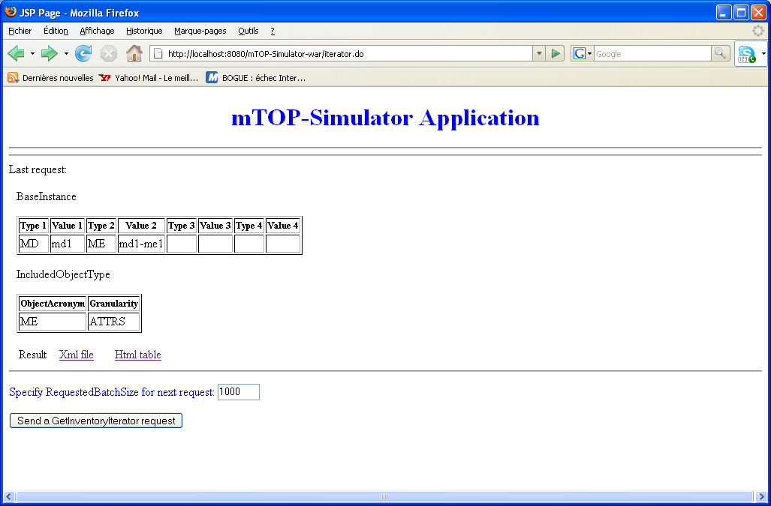
Figure 13 response of getInventoryIterator request and set requestedBatchSize to 1000 for next request

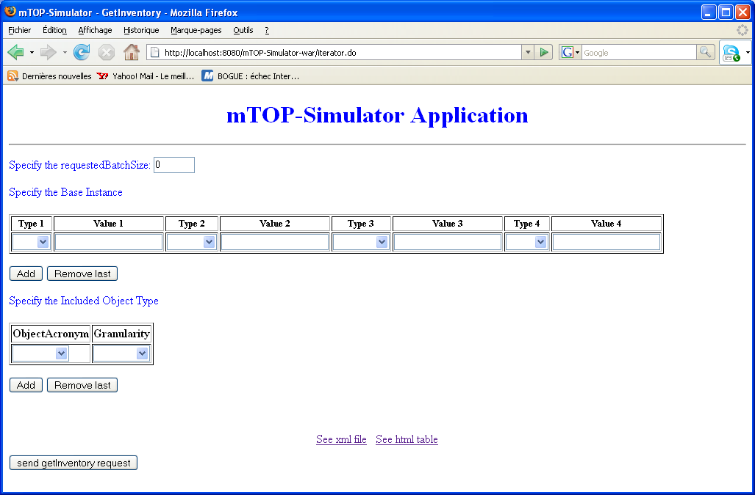
Figure 14 response of the last getInventoryIterator request

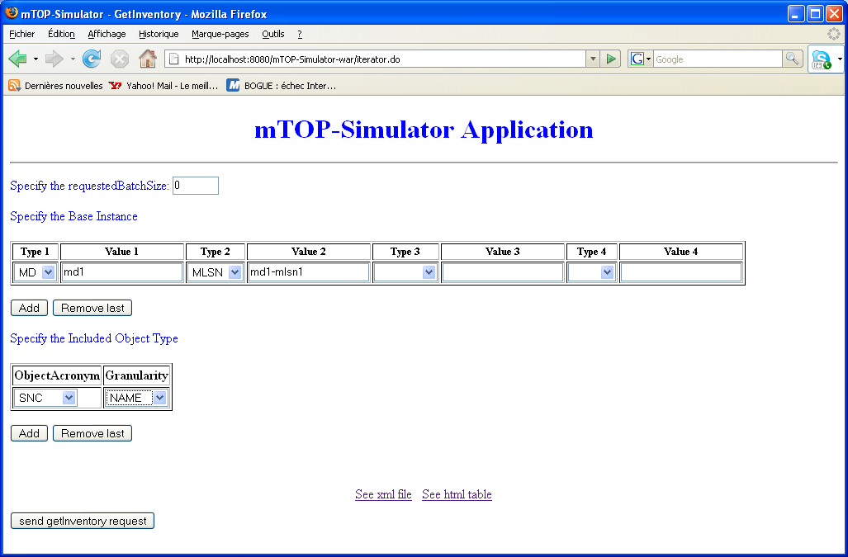

Figure 14 new getInventory request

Overview of the Development Chain

Generate the Classes from a WSDL File
In order to implement the semantics of the operations defined in a WSDL file, all the artifacts needed by those operations (as defined in the XSD files) must be generated in Java classes. This generation can be automated by using the wsimport tool provided by the Sun Application Server.
As the mTOP-Simulator application implements the getInventory and getInventoryIterator operations, the WSDL file used for the generation process is InventoryRetrieval.wsdl.
Before running wsimport on this file some changes must first be made to the original InventoryRetrieval.wsdl file available in the MTOSI 1.1 delivery. Here is the modified file:
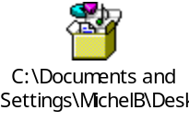
Once these changes have been made, the following command will generate all the artifacts and the service endpoint interface:

wsimport –s srcGeneratedFromWsdl –d classesGeneratedFromWsdl pathSolutionSet/wsdl/common/InventoryRetrieval.wsdl –b jaxbcustom.xml

Note: The jaxbcustom.xml file avoids the creation of JAXBElement in generated classes:


Add Persistence to Generated Classes
All the classes generated from the Solution Set schema appear in v1.tmf854 package.
The EJB 3.0 persistence annotations allow to persist any plain old java object (POJO) in a database.
For example the generated ManagedElementT class looks like :

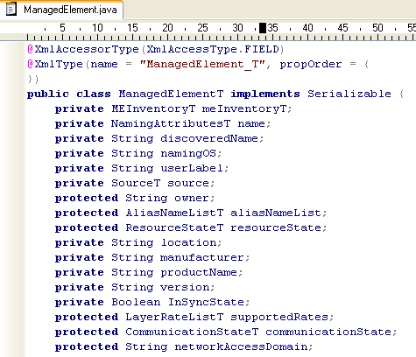

After adding persistent annotations:

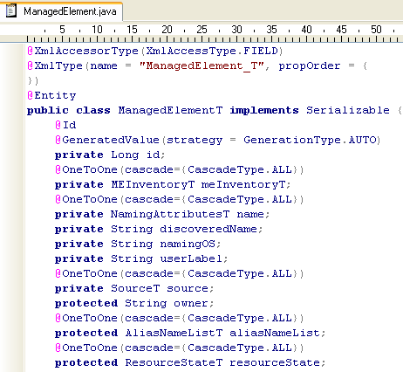

The annotations define the mapping and the relationship between entity beans and database tables.

Implement the Service Endpoint Interface
The generated service endpoint interface looks as follows. ???

The JAX-WS annotations expose this class as a Web Service endpoint.

The semantic of the initial operations getInventory and getInventoryIterator is implemented
in GetInventoryBean (see Figure 1).

Consume the Web Service from the Java Client Application
To consume the InventoryRetrievalService, a client application must use the proxy classes generated by wsimport:

wsimport –s srcClientFromWsdlDeployed –d classesClientFromWsdlDeployed http://address:port/InventoryRetrieval/Inventory?WSDL

As it is assumed that some client might not have the wsimport tool, a jar is provided which already contains the required class to consume the web service.

Add New Operation and Managed Entities
The portability and maintainability of the mTOP-Simulator was an important criteria when designing the application.
Adding a new operation to the original application is very simple. For example, if you need to implement two new operations getInventory2 and getInventoryIterator2, you just have to define the three classes GetInventoryWS2, GetInventoryBean2 and GetInventoryImpl2 exactly the same way as for getInventory and getInventoryIterator operations.
If a new managed entity is added to the naming hierarchy of the MTOSI Solution Set it can be easily embedded in the mTOP-Simulator application by deriving a new class from CreateGetInventoryResponse.

Caveats and Limitations
Known limitations / bugs:
  - To change the content of the database, you must reinstall the PopulateDataBase application
  - Header parameters are not displayed in the response
  - All the entities and attributes of the inventory layout have been implemented to the exception of the “assocME” attribute (MLSN) and some top level entities (e.g. TMD)
  - In some cases, CTPs subordinates of FTPs are not processed correctly
(hint: CTPs can be subordinate of PTPs and FTPs, and there is a single class CreateConnectTerminationPointResponse in the implementation which is used for the PTP case only)
  - vendorExtensions are displayed with the Web Client but not with the Java Application
(limitation due to SOAP)
  - vendorExtensions shown in the Web Client are not displayed as an XML element but the displayed string is correct
  - The date and time parameters of the filter has not been implemented (diff feature)
  - Sometimes, modifying an IncludedObjectType generates an exception in the Java Client (displayed in the Java Client console), but the Java application catches the exception without any damage. The way to work around this problem is to add or remove IncludedObjectTypes.
  - The XSLT transforms generating the table representation is not complete and sometimes not all the data available in the XML representation are shown in the tabular representation.

Technical Appendix 1: Class Diagrams

mTOP-Simulator ejb module class diagram

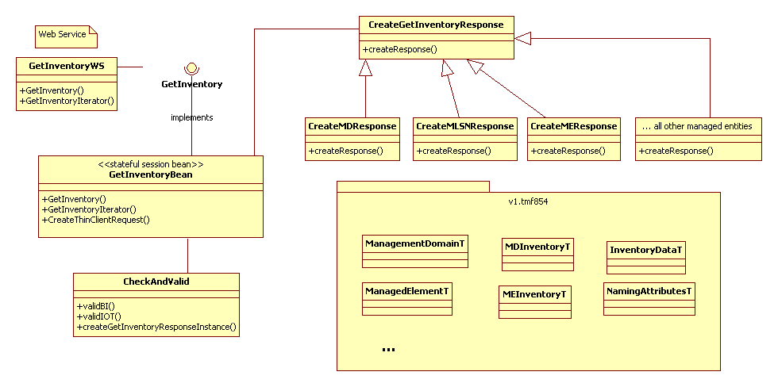

PopulateDatabase class diagram

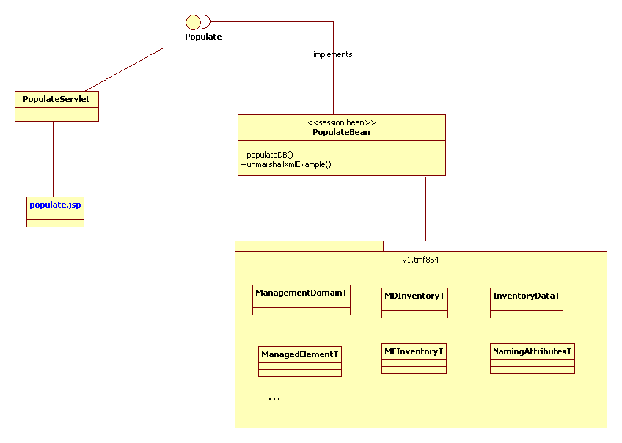

Technical Appendix 2:
How to install the Sun JEE5 Environment

On Windows
We assume that the jdk 1.6 environment is already installed.

- Download the Java EE 5 SDK

Go to http://java.sun.com/javaee
Download the Java EE 5 SDK Update 3 or more recent package:
java_ee_sdk-5_03-windows-nojdk.exe
or the full bundle (including the Netbeans IDE 6.0):

Download also the following tutorial:
The Java EE 5 Tutorial
(for Sun Java System Application Server Platform Edition 9)
February 18, 2006
from http://java.sun.com/javaee/5/docs/tutorial/doc

- Install
  - install the Sun Application Server
(double click on the executable file you have loaded).
When prompted enter a User Name and a Password.

We will assume you have installed the Application Server under the default directory C:\Sun\SDK.
  - Install the tutorial.

We will assume you have installed the tutorial under C:\Sun\javaeetutorial5.
(If you use a different location, remember that you should not install the tutorial to a location with spaces in the path).

- Configure
You will find the instructions to configure your environment in the tutorial document,
chapter “About This Tutorial”,
section “Building the Examples”,
subsection “Building the examples on the Command-Line Using Ant”.

The configuration steps are:
    - Add the following to your CLASSPATH system environment variable:
C:\Sun\SDK\lib\javaee.jar
    - Add the following to your PATH system environment variable:
C:\Sun\SDK\bin
    - Go to C:\Sun\javaeetutorial5\examples\bp-project
      - rename the file build.properties.sample into build.properties
      - edit this renamed file and adapt it to your environment by setting the three following variables (note the use of “/” instead of “\”):
javaee.home=C:/Sun/AppServer
javaee.tutorial.home=C:/Sun/javaeetutorial5

javaee.server.username= user name you entered during the installation
      - verify that the variables in the file app-server.properties are also set properly
    - Edit the file C:\Sun\javaeetutorial5\examples\common\admin-password.txt
and type in the password you entered during the installation.

On Linux
We assume that the jdk 1.6 environment is already installed.

Get the Java EE 5 SDK
To get the Java EE 5 SDK, go to: http://java.sun.com/javaee/downloads/index.jsp and download java_app_platform_sdk-5_03-preview-linux-nojdk.bin

Install the Application Server Software
The Application Server product distribution includes the following components:
  - Application Server software, including administrative tools and utilities
  - Sun Java System Message Queue
  - Java DB

To install the Software on Linux, you must have read/write access to the following directories:
  - The installation directory you select
  - The home directory of the installation user
  - The /var/tmp directory
  - The /tmp directory

Proceed as follows:
- Navigate to the directory where you downloaded the distribution file.
- Change the permission of the distribution file so that you have execute access:
chmod +x distribution_filename
- Run the installation program:
    - To run the installation program that uses a graphical interface, at the command prompt, type the name of the distribution file:
./distribution_filename
    - To run the installation program that uses the command-line interface, at the command prompt, type the name of the distribution file followed by the -console option:
./distribution_filename -console
- In the Administration Configuration page (or at the command line), enter the following:
    - Admin User Name – Name of the user who administers the server.
    - Password – Admin user’s password to access the Admin Server (8-character minimum).
    - Prompt or Don't Prompt for Administrator User Name – The user name can be stored in a preferences file so that you do not have to provide it to perform administrative tasks.
    - Admin Port – Administration port number for initial server instance.
    - HTTP Port – Port number to access the default server instance.
    - HTTPS Port – Secure port number to access the default server instance.
- Enter the directory where you want to install the software
- On the Ready to Install page click Install Now.
- After the installation completes, set the PATH environment variable to include the Application Server install-dir/bin directory.

Start and Verify the Server
To Start the Application Server on Linux:
- Add the install-dir/bin/ directory to the PATH environment variable.
- Start the server by entering this command:
asadmin start-domain domain1.
When the server has started, this message appears:
Domain domain1 is ready to receive client requests. Additional services are being started in the background.

Confirm that the Server Is Running
To verify that the server is running on your system, click this URL: http://localhost:8080.
You should see the Server Welcome page as shown below.
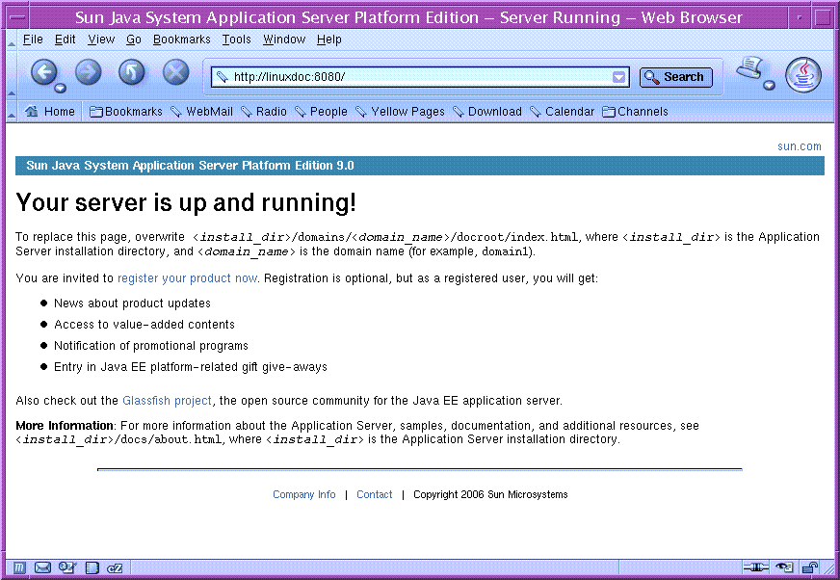
This page might take a few seconds to appear.
When you see this page, you know that the server is running. If the server is not running, but your system is operating normally, you get a server not found error (In some browsers, that error automatically launches a search engine).

Test with the Hello-JAXWS Sample Application
Use the hello-jaxws application available under:
<INSTALL> /javaee5_samples/javaee5/webservices/hello-jaxws

- Deploy

Compile the Webservice class directly into the autodeploy directory:
javac -cp <INSTALL>/SDK/lib/javaee.jar -d <INSTALL>/domains/domain1/autodeploy endpoint/Hello.java

You can verify the Webservice is active from your browser (example server host and port):
http://localhost:8080/Hello/HelloService?WSDL

- Get Artifact files
${javaee.home}/bin/wsimport -d ./build dsfdf http://localhost:8080/Hello/HelloService?WSDL

- Compile Client

javac -cp ./build:${javaee.home}/lib/javaee.jar -d ./build client/Client.java

- Run the client

cd ./build
${javaee.home}/bin/appclient.bat client.Client

Administrative Appendix

Document History

Version Number | Date Modified | Modified by: | Description of changes
1.0 |  |  | This is the first version of this document

Acknowledgments

First Name | Last Name | Company
Baptiste |  | Student at the University of Nice
Stephen | Gaito | TMForum

How to comment on this document
Comments and requests for information must be in written form and addressed to the contact identified below:

Michel | Besson | Cramer > Amdocs OSS Division
Phone: | +44 7717 692 178
Fax:
e-mail: | Michel.Besson@Amdocs.com

Please be specific, since your comments will be dealt with by the team evaluating numerous inputs and trying to produce a single text. Thus we appreciate significant specific input. We are looking for more input than wordsmith” items, however editing and structural help are greatly appreciated where better clarity is the result.

