TM Forum Interface Program

Service Management Team

Broadband Ethernet Service Specifications

Version 1.1


April 2013

Notice
No recipient of this document shall in any way interpret this document as representing a position or agreement of the TeleManagement Forum (TM Forum) or its members. This document is a draft working document of TM Forum and is provided solely for comments and evaluation. It is not a Forum Approved Document and is solely circulated for the purposes of assisting TM Forum in the preparation of a final document in furtherance of the aims and mission of TM Forum.
Although it is a copyrighted document of TM Forum:
- Members of TM Forum are only granted the limited copyright waiver to distribute this document within their companies and may not make paper or electronic copies for distribution outside of their companies.
- Non-members of the TM Forum are not permitted to make copies (paper or electronic) of this draft document other than for their internal use for the sole purpose of making comments thereon directly to TM Forum.
- If this document forms part of a supply of information in support of an Industry Group Liaison relationship, the document may only be used as part of the work identified in the Liaison and may not be used or further distributed for any other purposes
Any use of this document by the recipient, other than as set forth specifically herein, is at its own risk, and under no circumstances will TM Forum be liable for direct or indirect damages or any costs or losses resulting from the use of this document by the recipient.
This document is governed by all of the terms and conditions of the Agreement on Intellectual Property Rights between TM Forum and its members, and may involve a claim of patent rights by one or more TM Forum members or by non-members of TM Forum.
Direct inquiries to the TM Forum office:
240 Headquarters Plaza,
East Tower – 10th Floor,
Morristown, NJ 07960 USA
Tel No. +1 973 944 5100
Fax No. +1 973 944 5110
TM Forum Web Page: www.tmforum.org

Table of Contents
Notice 2
Table of Contents 3
List of Figures 5
List of Tables 6
1 Overview 7
1.1 Network Architecture 7
1.2 VLAN Schemes 7
1.2.1 VLAN Per Service Connectivity Scenario 8
1.2.2 VLAN Per Subscriber Connectivity Scenario 8
1.2.3 VLAN Per Subscriber / VLAN Per Service Connectivity Scenario 9
1.3 Broadband Ethernet Services 10
2 Scope 11
3 MTOSI R2.0 Service Management 13
3.1 General Concepts – CFS/RFS 13
3.2 Service Activation Interfaces 15
3.3 Mapping MEF Concepts to TM FORUM 16
3.4 MTOSI-SM Information Model 17
3.4.1 General Overview 17
3.4.2 Service Definitions / Service Templates 17
3.4.3 SAP Specification - SAP Definition / Sap Template 18
3.4.4 Service and Service Access Points 19
3.4.5 ServiceSpecCharacteristics and Values 20
4 Broadband Ethernet Services 22
4.1 Overview 22
4.2 Operator Virtual Connections 23
4.3 Broadband Resource Perspective 24
4.4 Managing Broadband Services 25
5 Broadband Ethernet Access Service Specification 27
5.1 Broadband Ethernet – ServiceSpecCharacteristics(SSC) 27
5.2 Broadband Ethernet Access Line - Service Definition (SD) and SAP Definitions(SAP) 30
5.3 Broadband Ethernet Access Line– Service Template 34
5.4 Broadband Ethernet Access Line - Sap Templates 34
5.5 Broadband Ethernet Access Line - General Service Activation 37
6 Appendix 42
6.1 MEF Services – Overview 42
6.1.1 E-LINE Service Type 42
6.1.2 E-LAN Service Type 42
6.1.3 E-TREE Service Type 43
6.2 Ethernet OAM Overview 44
6.2.1 802.3ah Link OAM 44
6.2.2 802.1ag Connectivity Fault Monitoring 45
6.2.3 ITU-T Y.1731 OAM Functions for Ethernet Based Networks 47
6.2.4 Ethernet Link Management Interface (E-LMI) 47
7 Document Administration 48
7.1 Document History 48
7.2 Company Contact Details 48
7.3 Acknowledgments 48
7.4 References 49
8 Terminology 51
9 Abbreviations and Mnemonics 55

List of Figures
Figure 1 – Network Architecture for Ethernet-based GPON Aggregation 7
Figure 2 - VLAN Per Service 8
Figure 3 - VLAN Per Subscriber 9
Figure 4 - VLAN Per Service / VLAN Per Subscriber 9
Figure 5 – Communications Alliance – NBN Reference Architecture 10
Figure 6 – Example of Ethernet Service CFS/RFS 13
Figure 7 – Ethernet Service Provider Perspectives 14
Figure 8 - MTOSI R2.0 Service Activation Interfaces 15
Figure 9 – Comparison of MEF / TM FORUM Perspectives 16
Figure 10 Service Definitions and Service Templates 18
Figure 11 – Service and Service Access Points 19
Figure 12 SID Service Spec Characteristics and Values 21
Figure 13 – Broadband Ethernet Services – VLAN per Subscriber 22
Figure 14 – Broadband Ethernet Services – OVC’s 24
Figure 15 – GPON Access Example 25
Figure 16 – Access Network Model 26
Figure 18 – General OSS/BSS Process Flow Broadband Ethernet Access Services 37
Figure 19 – Metro Ethernet Forum E-LINE Service Type 42
Figure 20 – Metro Ethernet Forum E-LAN Service Type 43
Figure 21 – Metro Ethernet Forum E-TREE Service Type 43
Figure 22 – MEF Ethernet OAM Defined 44
Figure 23 – 802.3ah EFM OAM 45
Figure 24 – 802.1ag CFM 45
Figure 25 – 802.1ag Maintenance Associations 46
Figure 26 – Scope of Y.1731 and 802.1ag 47

List of Tables
Table 1- Ethernet Service Spec Characteristics 28
Table 2 Ethernet SAP Characteristics 29
Table 3 – Broadband Ethernet Access Line - Service Definition (SD) 31
Table 4 UNI SAP Definitions 32
Table 5 ENNI SAP Definition 33
Table 6 – Broadband Ethernet Access Line– Example Service Template 34
Table 7 – Broadband Ethernet Access Line – UNI SAP (aEnd) Template 35
Table 8 Broadband Ethernet Access Line – ENNI (zEnd) Template 36
Table 9 – Broadband Ethernet Access Line – RFS Create Data 41

Overview
  - Network Architecture

Ethernet has proven itself in the LAN Enterprise market over the last few decades, with now more than 90% of terminations being on Ethernet ports. [Nortel-1].Ethernet is simple, cost effective, and provides flexible and scalable bandwidth options. With recent Carrier Grade enhancements, including Ethernet OAM and Protection Switching, Ethernet is viewed as the logical and acclaimed choice for the replacement of TDM and other legacy services in the Metro market; it provides the capability to support bandwidth-intensive voice, video, and data applications while offering incremental migration options.

In the consumer triple-play market, service providers are migrating their more traditional ATM networks to Ethernet; broadband access is being delivered over Ethernet enabled DSLAM/xPON networks, with Ethernet switches performing the aggregation and backhaul function. The Broadband Forum has defined specifications for migration to Ethernet based DSL networks [TR-101] and GPON networks [TR-156], taking into account network architectures and deployment considerations. The diagram below depicts a GPON access and aggregation network.

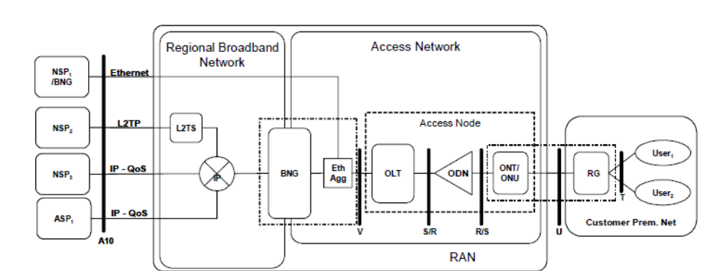

Figure 1 – Network Architecture for Ethernet-based GPON Aggregation

  - VLAN Schemes

For both DSL and GPON access networks, the Broadband Forum defines different approaches for connecting users via the access network to core, based upon VLAN definitions. The approach taken by the service provider may depend on their existing network architecture, their migration path to Ethernet, and the services being offered. No particular VLAN scheme is preferred over another, and all of the following scenarios are covered in this specification.

VLAN Per Service Connectivity Scenario

The following diagram [NSN-1] depicts a typical “VLAN Per Service” scenario:

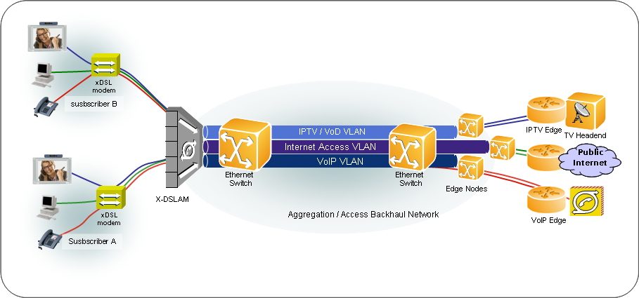
Figure 2 - VLAN Per Service

In the VLAN per service model, commonly known as N:1, there is a separate VLAN for each service: High-Speed Internet access (HSI), Voice over IP (VoIP), IP-based broadcast television (IPTV) and Video on Demand (VoD). In this mode, all subscriber traffic for a given service travels on an individual service VLAN. The subscriber services get mapped to individual IPoE / PPPoE sessions. A shared multi-cast VLAN is used for IPTV.

The residential services are aggregated by an Ethernet aggregation switch (EAS) that then backhauls the traffic to a broadband network gateway (BNG). The BNG may be a service router (BSR), or broadband remote access server (BRAS). This approach requires that all subscriber and service provisioning be carried out on the access node.

VLAN Per Subscriber Connectivity Scenario

In the VLAN per subscriber model, commonly known as 1:1, the subscriber is given connectivity to the IP network over a single VLAN for all of his/her services. Each subscriber is identified by a C-VLAN tag, which usually identifies the subscriber’s port on the DSLAM, or an ONT. For scalability purposes, the traffic of each DSLAM could be further encapsulated using a second VLAN, or S-VLAN. The S-VLAN may identify the DSLAM/OLT. It can be added either by the DSLAM/OLT itself, or the broadband service aggregation switch. In this scenario all traffic of the customer is terminated at the same Edge node.

This approach differs from the “multi-edge” VLAN per service approach in that there is usually only a single edge. This scenario is often referred to as a “consolidated architecture”. Only PPPoE sessions are supported. Like the VLAN per Service approach, there is still only one MC-VLAN that is shared for IPTV.

The Ethernet Access Line Scenario in this document is based upon VLAN 1:1.

The following diagram [NSN-1] depicts a typical “VLAN Per Subscriber” scenario:

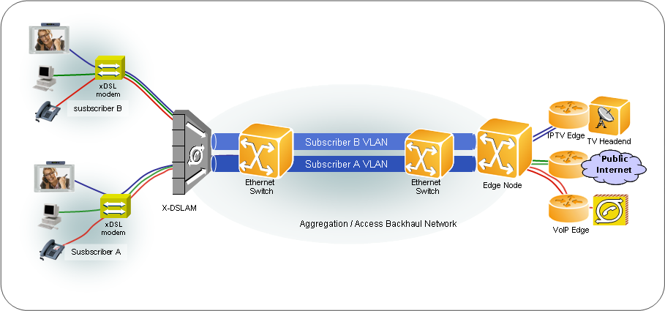
Figure 3 - VLAN Per Subscriber

VLAN Per Subscriber / VLAN Per Service Connectivity Scenario
In the hybrid VLAN per service / VLAN per subscriber model, there is a combination of S-VLAN based services, and C-VLAN tagged subscriber based services. The tagging options are those that are described separately above. Both IPoE and PPPoE sessions are supported. Essentially, those services destined for the BRAS continue to use the VLAN per subscriber approach. IPTV continues to be supported via a unique MC-VLAN id.

The following diagram [NSN-1] depicts a “VLAN Per Service / VLAN Per Subscriber” Hybrid scenario:

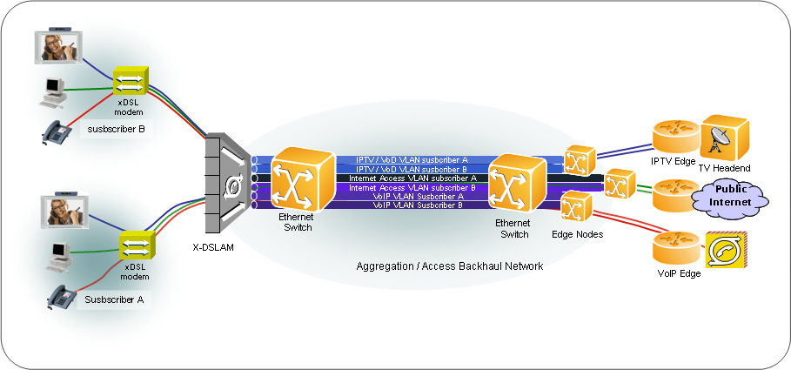
Figure 4 - VLAN Per Service / VLAN Per Subscriber

  - Broadband Ethernet Services
In addition to the changing network architectures and protocols, new business models are emerging that support wholesale Ethernet services in both the access and aggregation & backhaul networks. These Ethernet services are not directly “sold” to the residential customer, but are in support of the triple-play services, and may be sold either directly, or indirectly, to the network service provider providing connectivity to the IP network and application service providers.

The following reference architecture, provided by the Communications Alliance [NBN-1], serves as a framework for the services defined in this document.

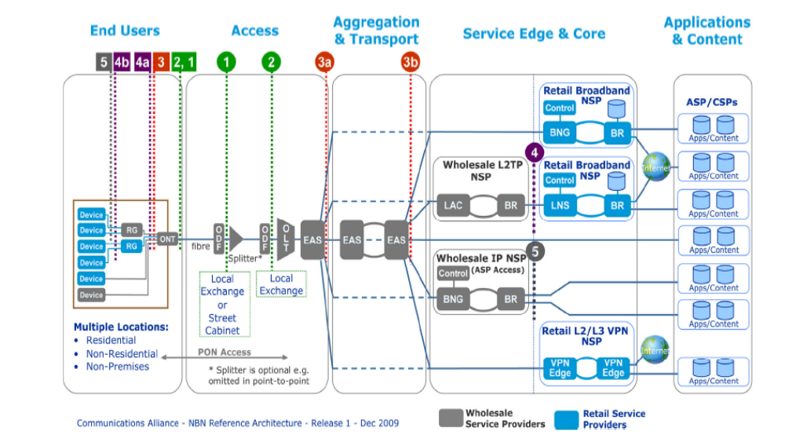
Figure 5 – Communications Alliance – NBN Reference Architecture

This document defines 3 general categories of services supported based upon the above architecture:
- Broadband Ethernet Access Line (BEAL)
A point-to-point Ethernet service between service point boundaries “3” and “3a”. Similar to a Metro Ethernet Forum (MEF) EVPL, but between a UNI located at the customer premise and an ENNI between the access and transport providers. The BEAL service supports the delivery of HSI, VoIP, and VoD services to residential customers.
- Broadband Aggregation & Backhaul Service (BABS)
A point-to-point tunnel that aggregates Ethernet access lines and transports them between service point boundaries “3a” and “3b” - i.e., from the access network to the service edge network.
- Broadband Ethernet Multicast Service (BEMS)
A rooted multipoint Ethernet service between service point boundaries “3” and “3a”. Similar to the MEF EVPTREE, but between a UNI and ENNI. The BEMS supports the delivery of video broadcast services to residential customers.

Scope

This document is the result of an analysis done by the TIP Service Management team on supporting Ethernet service provisioning over MTOSI 2.x service management interfaces. The focus is on the following types of Ethernet services: 1) Broadband Ethernet Access Line, 2) Broadband Aggregation & Backhaul, and 3) Broadband Ethernet Multicast Services.

The Metro Ethernet Forum (MEF) has to date only defined Ethernet services in the context of the Enterprise and Wireless Backhaul markets. These services are based on Ethernet Virtual Connections (EVCs) that are an association of two or more User Network Interfaces (UNI). See the Appendix for more information on MEF services, and specifications MEF-10.2, MEF-6.1.

The BEA, BAB, and BEM Ethernet services have been defined using MEF constructs; however, they are based on constructs defined in completed and ongoing projects within MEF as well as extensions that are not yet defined in MEF:
  - Operator Virtual Connections (OVCs) [MEF-26] for UNI to ENNI (External Network-to-Network Interface), or ENNI-to-ENNI services
  - Virtual UNI (VUNI) at the ENNI [letter ballot to complete in Jan 2011]
  - Endpoint type within a VUNI [letter ballot in Jan 2011]. Future work in MEF might include extending the type of endpoints within a VUNI.
  - SNI [MEF 4, MEF-11]. The SNI as an interface is identified but not specified within MEF specifications. Also, future work in MEF might include VUNI in an SNI

It is to be noted that MEF is currently working on defining OVC based services with initial focus on Point-to-Point UNI to ENNI OVCs. Future work in MEF might include other types and also ENNI to ENNI OVCs.

This TM FORUM Ethernet Services Specifications document has been executed jointly with members of the TM FORUM and colleagues from the MEF. The resulting services described in this document are not currently defined by the MEF, and we anticipate evolving this document as work continues to progress between the MEF and TM FORUM.

The following assumptions and constraints have been made:
- Business roles:
  - Ethernet access, aggregation, and backhaul providers
    - Broadband Ethernet Access provider (BEA) provides Ethernet access lines
    - Broadband Ethernet Aggregation & Backhaul provider (BAB) provides aggregation and backhaul services
    - If Ethernet access and Ethernet backhaul is provided by the same provider, then this is considered to be a Broadband Ethernet Network provider (BEN)
  - IP network service provider (NSP)
    - Provides IP connectivity from the subscriber’s terminal to an IP network
    - May also provide application services as part of “triple-play” bundle
    - Typically will procure Ethernet Access and/or Backhaul services from wholesale provider, or internal transport organizational entity
  - Application Service Provider (ASP)
    - Provides consumer applications such as internet mail, messaging, IPTV, VoIP (e.g., Yahoo, U-Verse, Skype)
    - NSP may also provide application services

- Technologies & solutions deployed
  - Home network
    - Residential Gateway (RG)
    - DSL Modem
  - Access networks
    - GPON
    - IPDSLAM
  - Residential Gateway
    - Trusted -> managed by the service provider
    - Untrusted -> not managed
  - Session control protocol
    - PPPoE
    - IPoE
  - Connectivity Strategies
    - VLAN per subscriber

Note: The use of the term subscriber is primarily used in this document to refer to the entity that is a customer of the triple-play IP services offered by the Network Service Provider (NSP). However, in relation to the Ethernet Services described in the document, the subscriber is the NSP who has procured these services from the BEA and/or BAB.

MTOSI R2.0 Service Management

  - General Concepts – CFS/RFS
The TMF SID categorizes services as being of two different types. A Customer Facing Service (CFS) is bound to a “product”, and is “visible” to the customer in that it is directly purchasable. A Resource Facing Service (RFS) is linked to “resources”, supports Customer Facing Services, and is “invisible” to the customer.

Ethernet Services may be viewed as both CFS and RFS, depending on the scenario and the service provider perspective and associated OSS/BSS. The BEA and BAB service providers may sell “wholesale” Ethernet access, aggregation and backhaul services to the Network Service Provider. From the BEA/BAB perspectives, these are customer facing services, to which an SLA is associated. However, the NSP is selling triple-play services to his end customer, and thus the Ethernet Connectivity, from his perspective, is a resource facing service. Note: The Ethernet Connectivity Service is represented differently in the respective service provider OSS/BSS; thus it would be incorrect to say that the Ethernet connectivity is BOTH a CFS and an RFS.

The following diagram illustrates this concept (simplified). The NSP offers triple-play IP services to his residential customers, represented by an IP CFS. Assume the NSP purchases both Ethernet Access and Aggregation & Backhaul from the BEA and BAB respectively; these are represented in the BEA/BAB domains as “products”, which eventually get instantiated as Ethernet Access Line CFS and Ethernet Backhaul CFS. Each service provider (BEA/BAB) must then activate component RFS in order to provide their Ethernet services to the NSP. This is done in their separate, respective OSS/BSS domains.

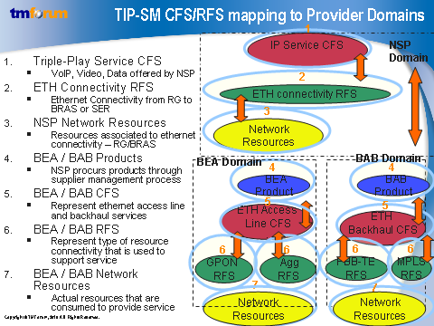
Figure 6 – Example of Ethernet Service CFS/RFS
It is important to understand the relationships between CFS, RFS, Logical Resources, and Physical Resources from each provider’s perspective (NSP, BEA, and BAB) in order to fully understand the services being specified in this document.

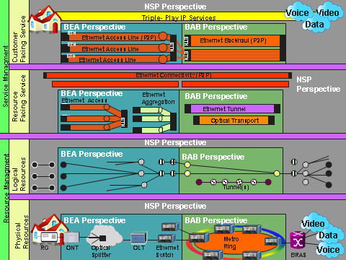

Figure 7 – Ethernet Service Provider Perspectives
  - Network Service Provider
- Offers Triple-Play Services which are represented as CFS
- Has an RFS to represent each Broadband Ethernet Access Line purchased from the BEA provider, and one for per Backhaul Service provided by the BAB, if applicable.
- Sees any “logical” resources associated with the Residential Gateway (if managed), and the BNG, i.e. VLANs, logical ports, ACLs, etc.
- Manages residential gateway and BNG, including all physical resources.
  - Broadband Aggregation & Backhaul Provider
- Offers Ethernet Backhaul Service which is represented as CFS; depending on business relationships, could be sold to either the BEA, or the NSP
- Has various RFS to represent decomposition of Ethernet Backhaul CFS, i.e., Ethernet Tunnel, Optical Transport, MPLS Tunnel, etc.
- From a logical “resource” perspective, the BAB provider manages flow domain fragments (FDFr) and subnetwork connections (SNC), including their termination points
- The BAB manages a physical Ethernet/Optical metro network
  - Broadband Ethernet Access Line Provider
- Offers Ethernet Access Lines which are represented as CFS
- Has various RFS to represent decomposition of Ethernet Access Line CFS, i.e., GPON and DSLAM RFS, and Ethernet Aggregation RFS.
- From a logical “resource” perspective, the BEA provider manages flow domain fragments (FDFr) and subnetwork connections (SNC), including their termination points
- The BEA manages the physical GPON/DSL access network & 1st level aggregation

  - Service Activation Interfaces
Service management capabilities were introduced in MTOSI R2.0, and are available in the MTOSI Service Activation DDP. There are two different “service activation” interfaces described:

  - Service Activation Interface (SAI)
Allows a CRM (OS), such as an Order Entry system, to request via a service request the activation of a given service, or set of services, that instantiate a given product based upon product related information. This interface links the product related information, such as the product specification, to the service domain via the service request. The SAI is used for the instantiation of customer facing services (CFS).
  - Service Component Activation Interface (SCAI)
Is internal within the SM&O layer and allows for the activation of service components, or resource facing service (RFSs) instances given specific service related information defined in a service template. The SCAI, contrary to the SAI, has no knowledge of the product domain. The server OS in this case provides RFS service templates to the client that describe the invariant service characteristics of the services support by the SCAI. These templates are referenced by the client OS when activating a given service over the SCAI.

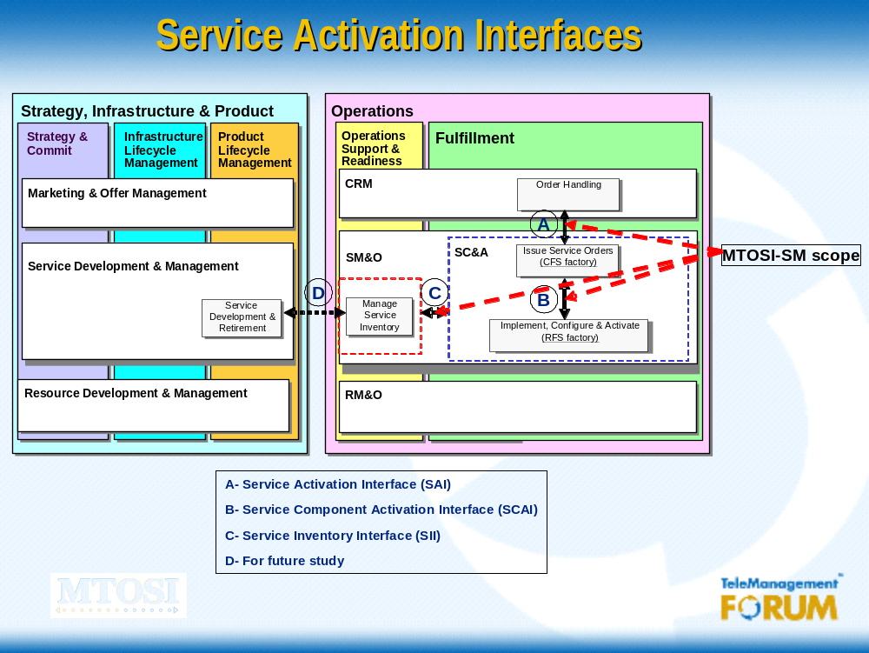

Figure 8 - MTOSI R2.0 Service Activation Interfaces

  - Mapping MEF Concepts to TM FORUM
The MEF does not make the distinction between “services” and “resources” as does the TM FORUM with the eTOM, SID, and interface solution sets. Some of the MEF “service” characteristics are perhaps more appropriately implemented as “resource” characteristics, and some could potentially be implemented as both service and resource characteristics. The level at which they are placed may depend on the information received in the service order, the differing levels of responsibilities of service provider OSS, and the level to which equipment vendors supply service management solutions. This document only recommends the usage of MEF defined characteristics, and does not attempt to enforce usage one way or another.
The MEF introduced the notion of an “Ethernet Layer Connection” [See Error: Reference source not found] which represents a transport entity used to convey ETH Layer PDUs among endpoints.The EVC and OVC are intended to be service constructs, with associated UNI/ENNI interfaces as service demarcation points.
The diagram below illustrates the various network domains (NSP, BAB, BEA, and Customer). The top half of the diagram shows the relationship between TMF Services (CFS/SAP) and MEF Services (OVC/UNI/ENNI). The bottom half of the diagram illustrates the relationship between TMF Resources (CPTP/FP/TL/FDFr) and constructs that the MEF uses that are similar (FP/EC). The EC gets represented in the TM FORUM resource model as a sequence of topological links and flow domain fragments.

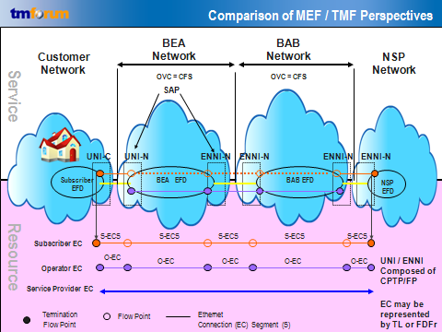
Figure 9 – Comparison of MEF / TM FORUM Perspectives

  - MTOSI-SM Information Model

General Overview
The MTOSI 2.0 Service Management Model can be found in the “Service Basic” DDP in the IA folder [MTOSI_SM]. There are 5 major concepts that will be used in this document for the purpose of describing Ethernet services. See terminology section for definitions [Terminology]
- Service Specifications – Service Definitions/Service Templates
- Service Access Point Specifications – SAP Definitions/SAP Templates
- Service Access Point
- Service Spec Characteristic
- Service Spec Characteristic Value

Service Definitions / Service Templates

The abstract class Service Specification in the TM FORUM Shared Information & Data (SID) has been extended to support two new concepts introduced in the TIP Service Management interfaces:

- Service Definition Used during service design time to define the ServiceSpecCharacteristics (SSCs) of a service, their associated data types, and default values. SSCs are able to be globally set, which implies they may be defined in a service template; if not, the characteristics are passed in real-time over an activation interface

- Service Template Defines specific ServiceSpecCharacteristicsValues (SSCV) for the globally set ServiceSpecCharacteristics (SSC) that were defined in the Service Definition. The Service Template is checked against its associated Service Definition by verifying the presence of the ServiceSpecCharacteristics and the validity of the corresponding assigned ServiceSpecCharacteristicsValues. Only Service Templates that contain SSCs/SSCVs that are in conformance with their specification in the Service Definition are considered valid.

Both Service Activation interfaces make use of the Service Definition and Service Template concepts in the activation of CFS and RFS. The Service Definition and Service Template further define the Service Specification through their respective associations, with the versions being identified through the Service Spec Version. The association class Service Spec Relationship allows for Service Specifications to contain other Service Specifications, which thus holds true for Service Definitions and Service Templates. The nesting of the Service Specification type, identified by the label Involved Service Spec Types allows for the grouping of Service Definition and Service Template types. For example, there may be a type of Service Definition for Ethernet Services, and contained within that type are E-LINE, E-LAN, and E-TREE Service Definition.

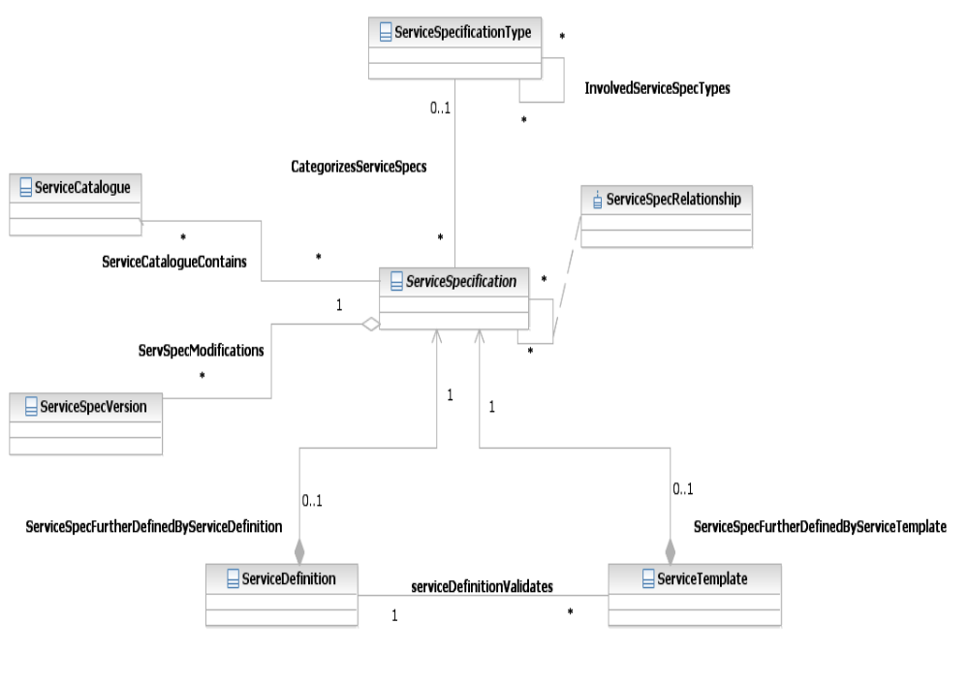

Figure 10 Service Definitions and Service Templates

SAP Specification - SAP Definition / Sap Template
A SAP Definition represents a type of SAP specification introduced for the purposes of Service Fulfillment. It defines all the SAP characteristics used to create corresponding SAP instances when activating Service instances.

The SAP Definition defines a set of attributes and (optionally) associated values. A SAP Definition may be applied to one or more SAPs. It defines the characteristics of the SAPs used for a given type of Service as defined by a Service Definition. It is referenced by the Service Definition at Service Design time, and the SAPs created at activation time are verified against the SAP definition.

The SAP Template provides “fixed” values associated to those characteristics that can be referenced at service activation time. The SAP template is defined at Service Deployment time.
The service spec characteristics must be identified in the SAP definition as being candidates to be defined in a SAP template. Having a service spec characteristic and associated value defined in the SAP Template does not prohibit the client OS in “overriding” the value in real-time when activating the service; however it must be identified as capable of being “overriden” when defined.

Service and Service Access Points
The service configuration and activation process involves the instantiation of both customer facing services, and associated resource facing services. The CFS and RFS are constructed based upon their respective Service Definitions, ServiceTemplates, and real-time Service Characteristic values passed over the activation interface, as well as the Service Access Points (SAPs).
The Service Access Point (SAP) represents a unique (logical and/or physical) resource where the Service can be accessed. A SAP is characterized by a SAP Specification. The SAP Spec defines a set of attributes and associated values that may be applied to one or more SAPs. The relationship between the Service Specification and the Sap Specification illustrates that for every Service Specification, there may be associated multiple Sap Specifications.
For example, given an Ethernet E-LINE Service Specification, there may be multiple SAP Specifications that correspond to various Bandwidth Profiles that can be applied to the SAP – one for GOLD, one for SILVER, and one for BRONZE. Likewise, there may be a single SAP Specification that is used for multiple Ethernet Service Specifications – E-LINE and E-LAN.
The following diagram illustrates the classes and relationships as required for Service Activation:
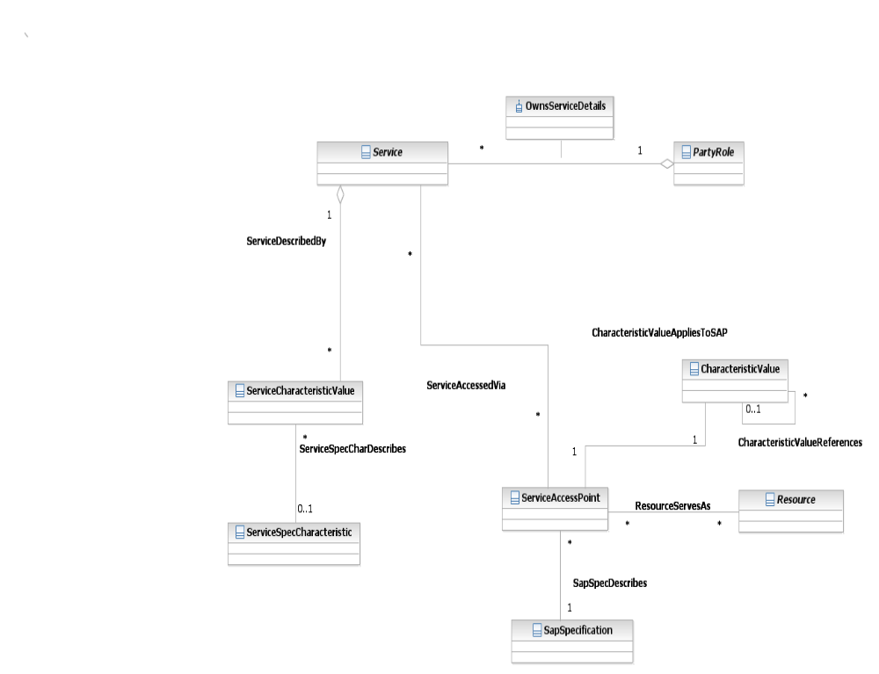

Figure 11 – Service and Service Access Points

ServiceSpecCharacteristics and Values
ServiceSpecCharacteristic (SSC) is a concrete class type of entity. The same SSC can be associated with more than one Service Definition. The “name” attribute provides a label for any particular SSC. An SSC can be either an ‘atomic’ SSC or a ‘composite’ SSC, which is described through the ServiceSpecCharRelationship: An atomic SSC may be stand-alone, i.e., not contained in any composite SSC; or it may be contained in one or more composite SSCs. A composite SSC may contain a mixture of atomic and other composite SSCs.

The “valueType” attribute is used in an atomic SSC to indicate the type of data that SSC represents (e.g., String, Boolean, Integer, or Complex).
The “minCardinality” and “maxCardinality” optional attributes within the SSC indicate the number of occurrences that an SSC could have. For example, a minCardinality value of 0 would mean that it need not occur at all. A maxCardinality of 10 would mean that the SSC could occur up to 10 times. Within the Service Definition, each occurrence of that SSC may possibly have different associated values.

Service Spec Characteristics will be used to model MEF service characteristics when used over MTOSI service management interfaces. Note: some of the MEF characteristics will be defined as resource characteristics and mapped to the appropriate layered parameters.

ServiceSpecCharacteristicValue (SSCV) is used to assign specific values to atomic SSCs.
As pertains to use with a Service Definition, an atomic SSC may contain one or more SSCVs that a priori constrain (but may not completely determine) the values associated with that SSC for use with any Service Definition. The 1 to 0..n SSC-SSCV relationship indicates that more than one SSC value may be associated with an SSC. So, for example, for an SSC named “color” one may choose to have three values associated with it: {red, green, blue}.

The “valueType” attribute is used to indicate the type of data that SSC represents (e.g., StringBoolean, Integer, or Complex). The “value” attribute can be used to assign a value. This may be used to define default values. The “unitOfMeasure” attribute can be used to describe units of measure, such as Mbps. The “valueFrom” and “valueTo” attributes can be used to describe lower and upper bounds on a range of values, if desired and appropriate. The “rangeInterval” attribute can also be used to express a range of values.

Service Spec Characteristic Values will be used in conjunction with Service Spec Characteristics to define all MEF service characteristic values. For example: SSC = CIR, SSCV= 1000.

The following diagram from the TM FORUM Shared Information and Data (SID) model illustrates the ServiceSpecCharacteristic and the relationship to ServiceSpecCharacteristicValues.

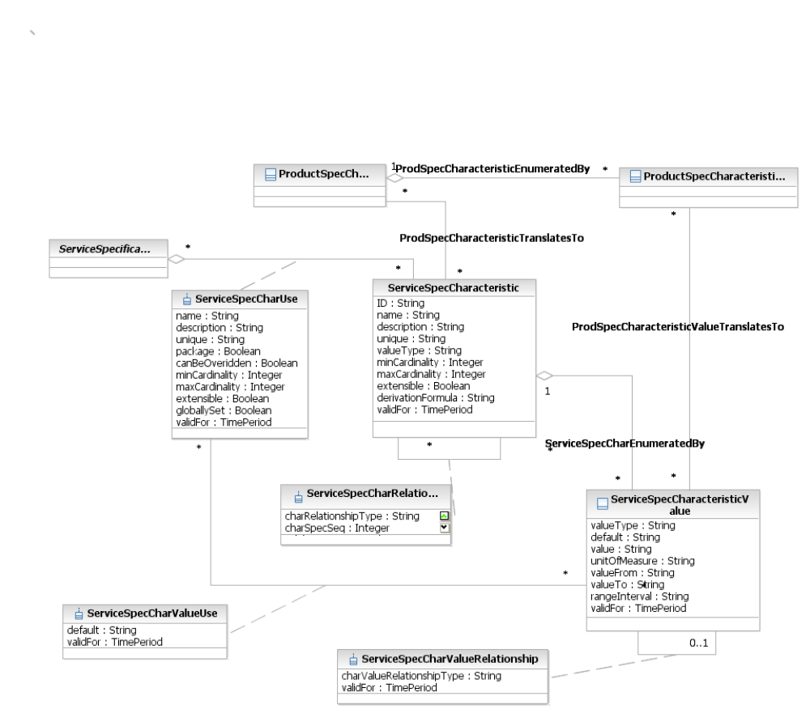
Figure 12 SID Service Spec Characteristics and Values

Broadband Ethernet Services
  - Overview
In this scenario, the BEA provider is assumed to be selling Broadband Ethernet Access Lines based upon a VLAN per subscriber model. It is assumed that the BEA provider has also implemented Q-in-Q, with one SVLAN per Access Node, in order to achieve scalability within the network. The BAB is selling an Ethernet Aggregation & Backhaul Service that bundles multiple S-TAGGED flows into a single tunnel. The “tunnel” technology used is not considered relevant to the use scenario.
From a “cloud” (CFS) perspective, the diagram looks something like this:

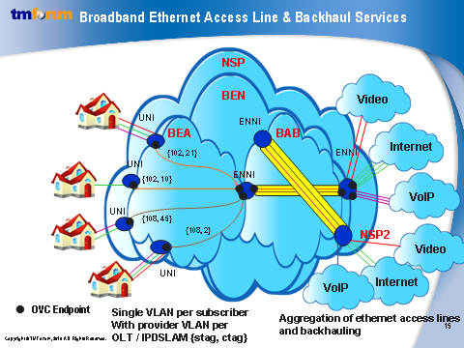
Figure 13 – Broadband Ethernet Services – VLAN per Subscriber
Contrary to traditional MEF Enterprise services, the services defined here are not represented by EVCs; an EVC is defined to be an association of UNIs. In the case of BEA, the Ethernet Access Lines are represented by Operator Virtual Connections (OVC)s that associate the subscriber UNI with an ENNI [MEF26] between the BEA and BAB providers. In this example, each Ethernet Access Line is identified by the combination {stag, ctag}, where S-VIDS = [102, 108] and C-VIDS = [21, 10, 45, 2].

The BAB provider may be providing backhaul services to multiple NSPs, carrying traffic that potentially may come from multiple BEA providers. The “tunnels” are represented in yellow and represent single service instances. This service is ENNI-to-ENNI, where the interface is to the BEA on the left-hand side, and to the NSP on the right, connecting to the BNG. Even though the BAB service is aggregating individual Ethernet Access Lines, it has its own distinct SLA and service definition.
  - Operator Virtual Connections
With a closer look into the “clouds”, we can see the BEA and BAB services as operator virtual connections (OVCs) with OVC endpoints. To understand the logic of the figure below, let’s start with the customer who has the residential gateway on the left side of the diagram. The traffic “mappings” to OVC endpoints will be as follows:

- In the VLAN 1:1, all of this specific customer’s triple-play traffic will either arrive untagged, priority tagged, or tagged. In the case of untagged and priority tagged frames, the access node will add a C-VID (i.e., C-VID = 5 in this case). In the case of tagged traffic, the incoming tag will be translated to the C-VID provisioned on the access node. In the case where the incoming tag is the same as the provisioned tag, the RG is considered to be “trusted”.
- Assume there is an OVC with endpoints “1” and “b” that represent the access line {111,5}
- Traffic with C-VID = 5 gets mapped to endpoint “1”. On the other end of the OVC, C-VID = 5 gets mapped to “b”.
- The endpoint “b” gets mapped to the VUNI endpoint “V1” that is on the ENNI-N in the BEA domain. It is assumed that there is 1 VUNI per S-VLAN, and that in this case there is one S-VLAN per access node. In this case V1 is for S-VLAN 111. (VUNI’s V2 and V3 will also get associated to the same ENNI-N).
- On the Ethernet aggregation switch, S-VID = 111 gets mapped to the OVC endpoint S3, as well as the S-VIDs 112, and 113. This is the ENNI-N in the BAB domain.
- On the other end of the BAB OVC, the S-VIDS are mapped to S4 at the ENNI with the NSP.
- On the BNG there is one VUNI per S-VLAN, similar to the VUNI in the BEA network, with C-VLANS mapping to the individual S-VLANS.

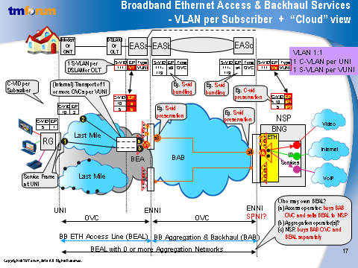
Figure 14 – Broadband Ethernet Services – OVC’s
  - Broadband Resource Perspective
In order to better understand the service perspective and the association to the resource view, the following diagram gives a more detailed example of a GPON Access Network and an Ethernet Aggregation and Backhaul network. Each OLT is provisioned with a Provider S-VLAN tag, and all the ONTs connected to the OLT are given a unique subscriber C-VLAN tag. The subscriber services are provisioned on the BRAS by the NSP. The BEA sells Ethernet access lines with a unique {S-VID, C-VID} identifier. The backhaul service provided by the BAB may be identified by a “tunnel” id, which may correspond to a PBT tunnel; MPLS label switched path, or other technology specific identifier. However, this is optional as there may not be a “tunnel id”. For example, if BAB has an E-o-SONET/SDH then there is no tunnel id in the encap and the S-VIDs are bundled in to a timeslot

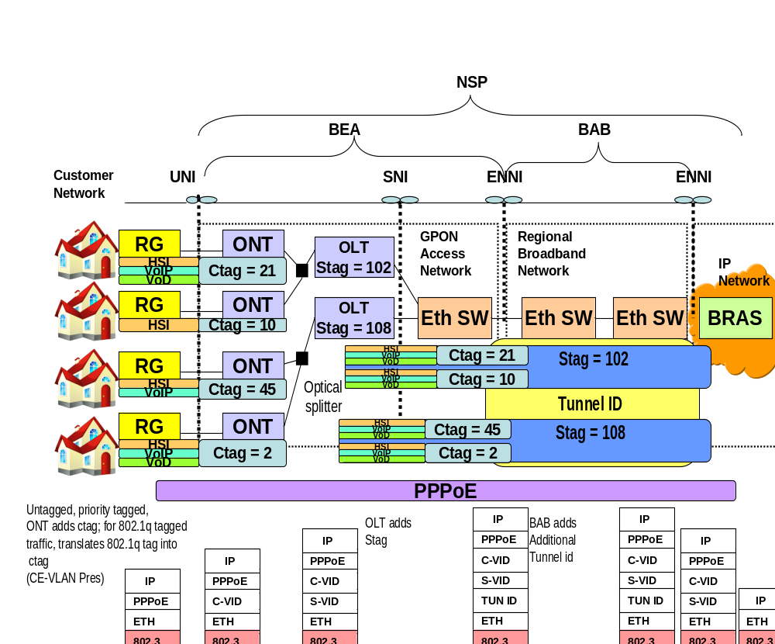
Figure 15 – GPON Access Example
  - Managing Broadband Services
In the context of the use case described in this document, it is assumed that each service provider (NSP, BEA, and BAB) has his own OSS/BSS systems. As the BEA and BAB are providing wholesale services, there is clearly a B2B exchange and purchase of product that occurs. This B2B interface is currently outside the scope of this project.
The management of the broadband services starts from the moment an order is received in either a BEA or BAB BSS system. The specifications defined in this document would allow the service provider’s CRM to make product requests over the MTOSI Service Activation Interface that would be decomposed into CFSs. The service management OSS would then decompose the CFSs into service components; SM applications exposing SCAI would process requests for the instantiation of RFSs – for example an RFS for the access node and a separate RFS for the Ethernet aggregation node(s).
Although the MEF doesn’t make the distinction between an OVC being in a “customer facing” perspective, or a “resource facing” perspective, it appears that one can map it according to the diagram below. Only the OVC as an RFS maps down to the “resource” layer, to a flow domain fragment, with flow points that correspond to OVC endpoints.
Given that the UNI and the ENNI have more port- based characteristics, they may or may not be provisioned as part of the service. For example, the customer port on the DSLAM most likely will be provisioned as part of the service, but the ENNI port, which will support multiple endpoints, will usually be provisioned as part of the infrastructure provisioning. Thus, even though the SAP will include the UNI/ENNI in its’ naming structure, the actual provisioning may not include UNI/ENNI characteristics.
The service definition for the BEA service and the associated SAPs should contain all the service characteristics and their constraints, defaults, etc. in order to be able to fully map the service from the highest level CFS to the lowest level resources. The mapping logic will reside in the service management and resource management applications that must know how to retrieve the necessary information from inventory and other databases to perform the mappings and provision the associated resources in order to correctly provision the BEA / BAB services.

-
UNI
N
UNI
-
N
111/10
111/5
111/10
111/5
ENNI-N
-
CPTP
FP
Bridge
TL
to BAB
Access Node
Ethernet Aggregation Switch
from
RG
-
-
113
112
111
111
112
113
ENNI
-
N
to BAB
UNI
VUNI
/ENNI
ENNI
ENNI
OVC EP
OVC EP
OVC
TM FORUM
Resource
Layer
MEF
Service
SAP
RFS
SAP
SAP
RFS
SAP
TM FORUM
Service
SAP
SAP
CFS
OVC EP
OVC EP
OVC
OVC EP
OVC EP
OVC
ENNI-N
ENNI-N
ENNI-N

Figure 16 – Access Network Model

Broadband Ethernet Access Service Specification
The following sections describe in detail how to create Ethernet Specifications for the Broadband Ethernet Access Line Service. It serves as an example from which one could derive the Broadband Aggregation & Backhaul Service Specifications. The set of ServiceSpecCharacteristics will be quite similar between the two services. What will vary for the most part are the values applied to the characteristics, and where the characteristics actually get applied (i.e. applying BW profile characteristics to a SAP vs. the Service itself representing an OVC. Note: The characteristics below are NOT intended to be a mapping of all MEF characteristics for UNIs, ENNIs, OVCs, and OVC endpoints. They map only those that are relevant to this scenario.
  - Broadband Ethernet – ServiceSpecCharacteristics(SSC)

The table below represents all the MEF characteristics required to define the BEA specifications, and BEA SAPs and hence to provision the associated services. For a full explanation of all the characteristics described below, see MEF 6.1 and MEF 10.2. The columns in the table represent the attributes in the serviceSpecCharacteristic, and are as follows:

- SSC name (from Common Service Info) Name of the characteristic
- SSC description (from Common Service Info) Description of the characteristic
- SSC valueType Providers the “type” for the characteristic – integer, string, boolean
- containedBySSCRefList Gives the list of names of composite SSCs containing this atomic SSC
- containsSSCRefList Gives the list of names of atomic SSCs contained within this composite SSC
- derivationFormula
Other SSC attributes that aren’t in the table, but may be implemented include: minCardinality, maxCardinality, extensible, and validFor.
The rows of the table that are shaded may be implemented as resource characteristics that are part of infrastructure provisioning (i.e. UNI and ENNI port parameters) and not passed over the MTOSI Service Management interfaces. This provisioning may happen using MTOSI resource management interfaces, proprietary interfaces, or directly via a management system. The provisioning of resource characteristics is outside of the scope of this document. The choice is up to the user.

Name | MEF Equivalent | Description | valueType
ServiceType | OVC Type | For this scenario, the only valid type is Point-to-Point | String
UniCeVlanIdPreservation | C-VLAN CoS Preservation | Maintain CE-VLAN id preservation throughout network | Boolean
UniCeVlanCoSPreservation | CE-VLAN CoS Preservation | Maintain CE-VLAN CoS preservation throughout network | Boolean
UniPeVlanIdPreservation | S-VLAN-ID  Preservation | Maintain S-VLAN id preservation throughout network | Boolean
UniPeVlanCoSPreservation | S-VLAN CoS Preservation | Maintain S-VLAN CoS preservation throughout network | Boolean
ColorForwarding | Color Forwarding | This implies provisioning same two-rate three color markers on both AN and EAS | Boolean
MaximumTransmissionUnit | OVC Maximum Transmission Unit Size | The maximum length in bytes allowed in a frame mapped to the an OVC End Point that is associated by the OVC | Integer
UnicastFrameDelivery | Unicast Service Frame Delivery | This attribute describes how ingress frames mapped to an OVC End Point with a unicast destination MAC address are delivered to the other External Interfaces with OVC End Points associated by the OVC | String
MulticastFrameDelivery | Multicast Service Frame Delivery | Similar description as for unicast, except multicast destination MAC address | String
BroadcastFrameDelivery | Broadcast Service Frame Delivery | Similar description as for unicast, except broadcast destination MAC address | String
Table 1- Ethernet Service Spec Characteristics

Name | MEF Equivalent | Description | valueType
AdministrativeSpeedRate | Speed | Port speed. For UNI most likely 10/100 | String
DuplexMode | Mode | Port mode – Half duplex or Full duplex | String
ServiceMuxIndicator | Service Multiplexing | Indicates whether there is service multiplexing on the UNI | Boolean
BundlingIndicator | Bundling | Indicates whether more than one  CE-VLAN can be associated to an OVC | Boolean
AllToOneIndicator | All To One Bundling | Indicates that all CE-VLANs are bundled to the same OVC | Boolean
MaximumFrameSize | Maximum Transmission Unit Size | Maximum Frame Unit | Integer
PVID | CE-VLAN-ID | CE-VLAN Id for untagged or priority tagged traffic | Integer
Layer2ControlProtocolProcessingList | L2 Control Processing | String containing comma separated list of: “<controlProtocolName>”, “<destMAC>”, “discard | peer | pass-”, [“<RFS name>” - if set to pass] | String
FrameFormat | Frame Format | Standard Ethernet Frame format with Stags/Ctags defined in accordance with 8021.ad | String
NumPhyLinks | Number of Links | Number of physical links if interface supports LAG | Integer
ProtectionMechanism | Protection Mechanism | Identifies the type of protection mechanism, i.e. LAG, EPSRing | String
MaxNumOVCs | Maximum Number of OVCs | The maximum number of OVCs that the Operator can support at the ENNI | Integer
TrafficMapping_Table_Count | Traffic Mapping | This parameter indicates the number of traffic mappings in the table.  This table groups ingress Ethernet frames (classification of traffic) and maps them to conditioning parameters (e.g., class of service, bandwidth).  The table is composed of two sets of parameters, each representing a column of the table.  The parameters with names of the form TrafficMappingTableFrom_<column header name> define the traffic classification. The parameters with name of the form TrafficMappingTableTo_<column header name> define the traffic conditioning.  All these parameters have a value part of the same form “<value #1>,<value #2>,<value #3>…”, that is, a list of elementary values separated by commas, which are the values in a column of the table. Just as all columns in a table have the same number of rows, so each value part in the same table must have the same number of elementary values. | String
TrafficMappingFrom_Table_VID |  | This parameter identifies the traffic groupings based on VID. | Integer
TrafficMappingFrom_Table_InnerVID |  | This parameter identifies the traffic groupings based on inner VID. | Integer
TrafficMappingFrom_Table_Priority |  | This parameter identifies the traffic groupings based on priority. | Integer
TrafficMappingFrom_Table_InnerPriority |  | This parameter identifies the traffic groupings based on inner priority. | Integer
TrafficMappingTo_Table_TrafficClass |  | This parameter identifies the traffic classes to which the traffic groupings are assigned . | Integer
TrafficMappingTo_Table_TcProfile |  | This parameter identifies the TC Profiles to whichthe traffic groupings are assigned | String
TCProfile | Bandwidth Profile | Traffic Conditioning Profile | Complex value identified by name
Name
IngressCIR |  | Committed Information Rate | Integer
IngressCBS |  | Committed Burst Size | Integer
IngressEIR |  | Excess Information Rate | Integer
IngressEBS |  | Excess Burst Size | Integer
IngressColorMode |  | Color Mode | String
IngressCouplingFlag |  | Coupling Flag | Boolean
Table 2 Ethernet SAP Characteristics

  - Broadband Ethernet Access Line - Service Definition (SD) and SAP Definitions(SAP)
The following tables describe the Service and SAP definitions for the Broadband Ethernet Access Line Service. These value lists define the constraints on the values, possible default values, units of measure, etc. The Service Definition also provides lists of product specifications and service catalogue references for which the SD is valid. The SD is also the place where the references to the SAP specs are provided.
The following example represents a Service Definition: [Note: not all attributes included, and some complex types are simplified]

- Name Identifier of the SD
- Type Identifies type of SD
- Version Indicates the SD version number
- Product Spec Reference List The list of product spec references for which this SD is valid
- Service Catalog Ref List The list of service catalog references for which this SD is valid
- describedByList The list of service characteristics describing the service*
- activationMode Indicates whether the service is provisioned or signaled. In this case it is provisioned
- sdStatus Service Definition status. This attribute can take on one of the values: DRAFT, STANDARD, or PROPRIETARY
- sapSpecificationRefList A list of SAP specifications that define the types of SAPs allowed when accessing this service.

- dependencies This would be for any pre- required for this service (if required).

The describedByList* is a list of serviceSpecCharInUse which is composed of:
- sscRef
- sscUse
- valueList
- sscUse globallySet (not used for ServiceTemplates, only required for Service Definitions and indicates whether the characteristic may be set in the template or must be set over the interface)
- sscUse minCardinality (valid for both; the minimum number of times the attributes must occur)
- sscUse maxCardinality (valid for both; the maximum number of times the attributes may occur)
- sscUse extensible
- sscUse validFor (Indicates how long the value is valid).

The valueList is further decomposed as follows:
- valueType, default, allowed values, unitOfMeasure, valueFrom, valueTo, rangeInterval, validFor. Value contains all value in the table, including the ones that should be in range.

The following table represents an example of a Service Definition for a Broadband Ethernet Access Line Service as described in this document. Using the Service Definition, the Service Designer could then create Broadband Ethernet Access Service Specifications and Associated Service Templates that would then allow the Service Provisioner to Provision Ethernet Access Services in the BEA Network.

Service Definition | Broadband Ethernet AccessLine service
GENERAL Section
Name | BEA Service Definition
Type | ELINE
Version | V1.0
Product Spec Ref | EAL Product Offering
Service Catalog Ref | EAL Service
DescribedbyList

sscRef | sscUse | valueList
 | globallySet | default | allowedvalues | measure
ServiceType | no | “Point-to-Point” |  | [Not applicable]
UniCeVlanIdPreservation | no | “true” | “true” | “false” | [Not applicable]
UniCeVlanCoSPreservation | no | “true” | “true” | “false” | [Not applicable]
ColorForwarding | yes | “true” | “true” | “false” | [Not applicable]
MaximumFrameSize | yes | “9216” | rangeFrom=”0” rangeTo=”10218” | [Not applicable]
UnicastFrameDelivery | yes | “deliver | “discard”, “deliverUnconditionally”, “deliverConditionally [<condition>]” | [Not applicable]
MulticastFrameDelivery | yes | “deliver | “discard”, “deliverUnconditionally”, “deliverConditionally [<condition>]” | [Not applicable]
BroadcastFrameDelivery | yes | “deliver | “discard”, “deliverUnconditionally”, “deliverConditionally [<condition>]” | [Not applicable]
Table 3 – Broadband Ethernet Access Line - Service Definition (SD)

SAP Definition | Broadband Ethernet AccessLine UNI SAP
GENERAL Section
Name | BEA UNI SAP Definition
Type | UNI
Version | V1.0
Service Catalog Ref | EAL Service
DescribedbyList
sscRef |  | sscUse |  | valueList
 |  | globallySet |  | default |  | allowedvalues | measure
AdministrativeSpeedRate |  | yes |  | “100” |  | “10” ,”100” , “1000” | Mbps
DuplexMode |  | yes |  | “Full” |  | “half”,“full”
ServiceMultiplexingIndicator |  | no |  | “true” |  | “true” , “false”
BundlingIndicator |  | no |  | “true” |  | “true” , “false”
AllToOneIndicator |  | no |  | “false” |  | “true” , “false”
MaximumTransmissionUnit |  | yes |  | “1522” |  | “0-10,218”
PVID |  | no |  | “1” |  | “0-4094”
L2ControlProtocolProcessingList |  | yes |  | “pass” |  | “all”, “all” ,“pass”
TrafficMapping_Table_Count |  | yes | “1”
TrafficMappingFrom_Table_VID |  | yes | “all” |  | “all”, “allOthers”  rangeFrom=”0”, rangeTo=”4094”  rangeInterval=”Closed”
TrafficMappingFrom_Table_Priority |  | yes | “all” |  | rangeFrom=”0”, rangeTo=”7”
TrafficMappingTo_Table_TrafficClass |  | yes | “0” |  | “0-7”
TrafficMappingTo_Table_TcProfile |  | yes | “DefaultUNIProfile”
TCProfile |  | yes
Name |  | yes | “DefaultUNIProfile”
IngressCIR |  | yes | 1024 |  |  |  | Bps
IngressCBS |  | yes | 128 |  |  |  | Bytes
IngressEIR |  | yes | 0 |  |  |  | Bps
IngressEBS |  | yes | 0 |  |  |  | Bytes
IngressColorMode |  | yes | “true” |  | “true” | “false”
IngressCouplingFlag |  | yes | “0” |  | “0” , “1”
Table 4 UNI SAP Definitions

SAP Definition | Broadband Ethernet AccessLine ENNI SAP
GENERAL Section
Name | BEA ENNI SAP Definition
Type | ENNI
Version | V1.0
Service Catalog Ref | EAL Service
DescribedbyList
sscRef |  | sscUse | valueList
 |  | globallySet | default | allowedvalues | measure
FrameFormat |  | yes |  | “vidBasedDoubleTag” “portBasedDoubleTag”
  vidBasedDoubleTag
NumPhyLinks |  | yes | 0
ProtectionMechanism |  | yes | “None” | “LAG”, “None”, “Other”
MaxNumOVCs |  | no | “4000”
PVID |  | no | “1”
L2ControlProtocolProcessingList |  | yes
TrafficMapping_Table_Count |  | yes | “1”
TrafficMappingFrom_Table_VID |  | yes | “all” | “all”, “allothers”,  rangeFrom=”0”, rangeTo=”4094”
TrafficMappingFrom_Table_InnerVID |  | yes | “all” | “all”, “allothers”,  rangeFrom=”0”, rangeTo=”4094”
TrafficMappingFrom_Table_Priority |  | yes | “all” | rangeFrom=”0”, rangeTo=”7”
TrafficMappingFrom_Table_InnerPriority |  |  |  | rangeFrom=”0” ”, rangeTo=”7”
TrafficMappingTo_Table_TrafficClass |  | yes | “0” | rangeFrom=”0” ”, rangeTo=”7”
TrafficMappingTo_Table_TcProfile |  | yes | “DefaultENNIProfile”
TCProfile |  | yes
Name |  | yes | “DefaultENNIProfile”
IngressCIR |  | yes | 1024
IngressCBS |  | yes | 128
IngressEIR |  | yes | 0
IngressEBS |  | yes | 0
IngressColorMode |  | yes | “true”
IngressCouplingFlag |  | yes | “0”
Table 5 ENNI SAP Definition

Note: This table includes the MEF ENNI + VUNI characteristics

  - Broadband Ethernet Access Line– Service Template
The following service template is based upon the characteristics as defined in the Broadband Ethernet Access Line Definition.

Service Definition | Broadband Ethernet AccessLine service
GENERAL Section
Name | BEA ELINE
Type | ELINE
Version | V1.0
Product Spec Ref | EAL Product Offering
Service Catalog Ref | EAL Service
DescribedbyList

sscRef | sscUse | sccUse
 | canBeOverridden | value | containsSSCVs | comments
MaximumTransmissionUnit | yes | “1522”
UnicastFrameDelivery | yes | “deliverUnconditionally”
MulticastFrameDelivery | yes | “deliverUnconditionally”
BroadcastFrameDelivery | yes | “deliverUnconditionally”

Table 6 – Broadband Ethernet Access Line– Example Service Template

  - Broadband Ethernet Access Line - Sap Templates

SAP Definition | Broadband Ethernet AccessLine SAP Template
GENERAL Section
Name | BEA UNI SAP
Type | UNI
Version | V1.0
Product Spec Ref | EAL Product Offering
Service Catalog Ref | EAL Service
DescribedbyList
sscRef |  | sscUsess sscUse | sscValues
 |  | canBeOverriden | Value(s) | containsSSCVs | Comment
AdministrativeSpeedRate |  | yes | “100” |  | Single value
MaximumTransmissionUnit |  | yes | “1522” |  | Single value
PVID |  | no | “10” |  | Single value
TrafficMapping_Table_Count |  | yes | “2” |  | Single value
TrafficMappingFrom_Table_VID |  | yes | “1-100,allOthers” |  | These are CVID values
TrafficMappingFrom_Table_Priority |  | yes | “0,all” |  | These are CVID priorities
TrafficMappingTo_Table_TrafficClass |  | yes | “0,1” |  | One string value that is comma separated
TrafficMappingTo_Table_TcProfile |  | yes | “EALProfile1, EALProfile2” |  | One string value that is comma separated
TCProfile |  | yes |  | IngressCIR, IngressCBS, IngressEIR, IngressEBS, IngressColorMode, IngressCouplingFlag | These are references to the SSCs contained within the SAP template
Name |  | yes | “EALUniProfile1”,  “EALUniProfil2” |  | One value for profile #1, and one for profile #2
IngressCIR |  | yes | “2048”, “1024” |  | One value for profile #1, and one for profile #2
IngressCBS |  | yes | “128”,”56” |  | One value for profile #1, and one for profile #2
IngressEIR |  | yes | “1024”,”526” |  | One value for profile #1, and one for profile #2
IngressEBS |  | yes | “56”,”0” |  | One value for profile #1, and one for profile #2
Table 7 – Broadband Ethernet Access Line – UNI SAP (aEnd) Template

SAP Definition | Broadband Ethernet AccessLine ENNI SAP
GENERAL Section
Name | BEA ENNI SAP
Type | ENNI
Version | V1.0
Product Spec Ref | EAL Product Offering
Service Catalog Ref | EAL Service
DescribedbyList
sscRef |  | sscUse | valueList
 |  | canBeOverridden | value | ContainsSSCVs | Comments
AdministrativeSpeedRate |  | no | “1000” |  | Single value
MaximumTransmissionUnit |  | no | “9056” |  | Single value
TrafficMapping_Table_Count |  | yes | “2”
TrafficMappingFrom_Table_VID |  | yes | “1-100,allOthers” |  | One string value that is comma separated
TrafficMappingFrom_Table_Priority |  | yes | “0,all” |  | One string value that is comma separated
TrafficMappingTo_Table_TrafficClass |  | yes | “0,1” |  | One string value that is comma separated
TrafficMappingTo_Table_TcProfile |  | yes | “EALVuniProfile1, EALVuniProfile2” |  | One string value that is comma separated
IngressCIR |  | yes | “2048”, “1024” |  | One value for profile #1, and one for profile #2
IngressCBS |  | yes | “128”,”56” |  | One value for profile #1, and one for profile #2
IngressEIR |  | yes | “1024”,”526” |  | One value for profile #1, and one for profile #2
IngressEBS |  | yes | “56”,”0” |  | One value for profile #1, and one for profile #2

Table 8 Broadband Ethernet Access Line – ENNI (zEnd) Template

  - Broadband Ethernet Access Line - General Service Activation

Once the Service / SAP Definitions and Service /SAP Templates are defined, Service Activation over the MTOSI-SM Interfaces can be used. There are two possible activation methods which in essence result in either “pass by value” or “pass by reference”. In the first method, the activation OS has knowledge of all the service characteristics / values and passes them directly over the interface to the target OS. In the second model, it is the target OS who has knowledge of all the service characteristics / values (as defined in the templates), and the activation OS is simply referencing them over the activation interface. In this example, we are showing the “pass by reference” method, which assumes there are service templates (as defined above) that exist and may be referenced.

Also, the activation method may depend on the state of the network and the types of services being provisioned. For example, the first time activation is occurring on the ENNI/VUNI, certain characteristics ( numPhyLinks, protectionMechanism) may be required for provisioning, but not for subsequent activation requests. However, on the other side (in the GPON case), it may be required to provision the UNI and the OVC for every subscriber as we have a single VLAN per subscriber model. The provisioning model needs to be flexible to handle all different possibilities and configurations.

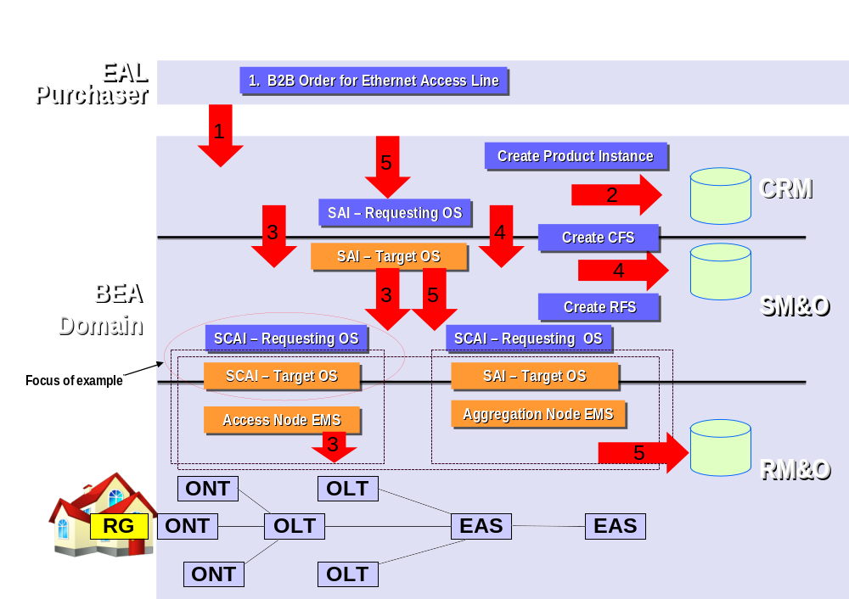
Figure 17 – General OSS/BSS Process Flow
Broadband Ethernet Access Services

The provisioning process is as follows:
- NSP, or other provider, places an order for a broadband Ethernet Access Line from the BEA provider
- The BEA, handles the order, and amongst other activities at the CRM layer creates a Product instance
- The BEA CRM application sends an MTOSI SAI “feasibilityCheck” request to the SM&O service management application to determine the feasibility of being able to support the product instance – internally at the SM&O layer, there is also a “feasbilityCheck” to both the “Access Node” and “Ethernet Access Service” management systems [if implemented] to see if the resources are available, or can support the product instance. For example, DSL may not be available in the area requested.
- At the point the CFS object has been created, and it is known whether the service request can be fulfilled or not. It is possible to perhaps “reserve” resources for future provisioning, but for the sake of this example, we will go straight to the provisioning request.
- By this time the ONT/DSL modem has been installed on the customer site, and the resource inventory data base has been updated. [Note: It is also possible to even “pre-provision”, and most likely that the service provider will “pre-provision” the Ethernet access line service before the access node is installed such that once it is installed the service will be up and running.]
- The “provisionRequest” operation will be issued over the SAI, presenting the customer’s ONT/DSLAM port as the UNI, the customer CVLAN and the provider SVLAN, the combination of which will give the unique identifier {stag, ctag} of the Ethernet access line. Note: input into the SAI operation is: Product Info, Subscriber List, User List – so the info stated must be passed as product info.
- In turn, the service management application issues the SCAI “provisionService” operations to provision the RFS. These will result in the creation of the RFS and the provisioning of the associated OLT/ONT (or DSLAM) resources on the access network, and the Ethernet access switches in the EAN.
Note, it is the responsibility of NSP to ensure the provisioning of the residential modems and gateways.

The following example is based upon the Service Component Activation Interface (SCAI) for the Access Node. If we refer back to the “Internal View of the BEA” in Broadband Ethernet Services, there is an OVC between the ONT / Customer port on DSLAM [with the SAP being the GPON ONT Ethernet port + OVC Endpoint] and the OLT / DSLAM Network port [with the SAP being the ENNI/VUNI +OVC Endpoint]. As the MEF has not defined this scenario, or the SNI, we will use the ENNI as defined for the sake of our example.

The MTOSI-SM SCAI “provisionService” operation takes as input:
- rfsCreateData this is a structure that is based on the ResourceFacingServiceType and contains all the required elements to create the service. See below

The rfsCreateData has the following format:
[The following fields are taken from commonServiceInfo ]
- name Name of the RFS. For the sake of the example, the service will be named by the {Stag, Ctag} combination.
- userLabel An alternative service identifier (optional)
- owner A service owner (optional)
- aliasNameList Other names for the service (optional)
[The following fields are taken from Service]
- serviceTemplateRef This will be the MTOSI name of the BEA Service Template
- subscriberRef This is normally for the SAI, and refers to a Subscriber known at the CRM layer. However, it may be passed down, if required, and associated to the actual Ethernet Access Line. (optional)
- userRefList This is normally for the SAI, and refers to a List of Users of the Service known at the CRM layer. However, they may be passed down, if required, and associated to the actual Ethernet Access Line. (optional)
- cfsRef A reference to the Customer Facing Service
- sapRefList In MTOSI 2.0 this is a list SAP names. We changed this in 2.1 to be the actual SAP objects which would contain the references to the Upstream/Downstream SAP specs and in the case of the UNI, a describedByList of characteristics for that particular SAP that would indicated a CE-VLAN-ID
- describedByList A set of serviceSpecCharacteristics passed over the interface that characterize the service. The values for these SSC either override those specified in templates, or specify values for SSC that were defined as “globally defined = no”.

The describedByList* is a list of serviceCharacteristicValueType which is composed of:

- Value The value to be associated to the service characteristic
- validFor This is optional and will not be used in the example.
- sscRef The serviceSpecCharacteristic to which the value refers

A SAP (Service Access Point) represents a set of parameters associated (directly or indirectly) with a unique (logical and/or physical) resource where the single Service can be accessed. In the case of the Broadband Ethernet Services under considerations, the SAPs correspond to the OVC endpoints, which are the connection endpoints of the virtual connection relative to the UNI/VUNIs which contain them.

The SAP includes the commonServiceInfo of which at least the name below should appear:
- Name Identifier of the SAP
- Type Identifies type – UNI, VUNI
- AdminState [optional – depends on capabilities of equipment]
- ServiceState [optional – depends on capabilities of equipment]
- OperState [optional – depends on capabilities of equipment]
- subscriberRef Reference to subscriber – optional
- userRef Reference to user – optional
- sapSpecRef Reference to the BW Specification.
- describedByList Set of SSCs/SSCVs. For the UNI, the CVLAN-Id would be provided here
For the GPON ONT / DSLAM Customer UNI, this will be the “Upstream” Template, and for the OLT / DSLAM Network UNI, this will be the “Downstream” Template.

Thus, to summarize the RFS Create Data would have the following format for the activation of the Broadband Ethernet Access Line over the SCAI:

 | Broadband Ethernet AccessLine – RFS Create Data
GENERAL Section
name | BEA – Network Service {110,5}
owner | BEA Service Provider
serviceTemplateRef | Reference to BEA ELINE
subscriberRef | John K. Smith
cfsRef | BEA – Customer Service {110,5}
sapRefList | A SAP object for each OVC endpoint containing the following:
SAP-> | Aend SAP
Name | UNI_SAP_{110,5}
resourceRef | UNI PTP
Type | UNI
SapSpecRef | BEA UNI SAP
DescribedByList | [ any SAP level SSC that can be overridden]
SAP-> | Zend SAP
Name | SAP_{110,5}
resourceRef | ENNI PTP
Type | UNI
SapSpecRef | BEA ENNI SAP
DescribedByList | [ any SAP level SSC that can be overridden]
DescribedbyList
value | sscRef
OVC related chars
[values] | [ any Service level SSC that can be overridden]

Table 9 – Broadband Ethernet Access Line – RFS Create Data

Note: The OVC endpoints, from a resource management perspective are the underlying CTPs that are created as a result of the SAP references. The MEF ENNI (PTP) has the notion of referenced VUNI endpoints, which are essentially the connection endpoints, or CTPs contained within the PTP. Since this containment relationship is managed as the resource layer, it is not captured at the service layer.

Appendix
  - MEF Services – Overview

Three different service types are defined in MEF 6.1 for Metro Ethernet Services.

E-LINE Service Type
- Provides a point-to-point Ethernet Virtual Connection (EVC) between two User Network Interfaces (UNIs).
- MEF defines two E-Line type services: Ethernet Private Line (EPL) and Ethernet Virtual Private Line (EVPL). These are analogous to frame relay, ATM or Private Line Services. These services may be created for instance to provide internet access connectivity between a customer location and an internet access provider PoP.

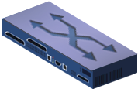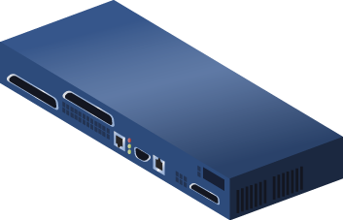
Point-to-Point EVC
Carrier Ethernet Network
CE
UNI
UNI
CE
Figure 18 – Metro Ethernet Forum E-LINE Service Type

E-LAN Service Type
- Provides a multi-point connectivity between sites, i.e. between two or more UNIs which are connected via a multi-point EVC.
- MEF defines two E-LAN type services: Ethernet Private LAN and Ethernet Virtual Private LAN. These services may be used to create Transparent Ethernet LAN services or Multi-point Layer 2 Private Networks.


Multipoint-to-Multipoint EVC
Carrier Ethernet Network
CE
UNI
CE
UNI
Figure 19 – Metro Ethernet Forum E-LAN Service Type

E-TREE Service Type
- Provides a rooted multi-point Ethernet Virtual Connection. This service only supports communication between the leaves and the root of the tree. Direct communication between the leaves is not supported.
- MEF defines two E-TREE type services: Ethernet Private Tree (EP-Tree) and Ethernet Virtual Private Tree (EVP-Tree).


Root
CE
UNI
UNI
UNI
CE
CE
Leaf
Leaf
UNI
CE
Leaf
Rooted Multi-Point EVC
Carrier Ethernet Network

Figure 20 – Metro Ethernet Forum E-TREE Service Type

  - Ethernet OAM Overview

The 4 major Ethernet OAM protocols required for Ethernet service assurance as defined by the MEF are: IEEE 802.1ag, IEEE 802.3ah, ITU Y.1731, and E-LMI.

The following sections provide brief overviews of these protocols.

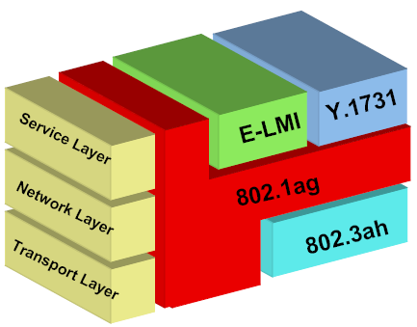

Figure 21 – MEF Ethernet OAM Defined

802.3ah Link OAM

IEEE 802.3ah OAM, also called link OAM, encompasses a simple protocol that operates across a single link. 802.3ah OAM is applicable to all of the emerging EFM technologies.

Link OAM addresses three key operational issues when deploying Ethernet across geographically disparate locations: link monitoring, fault signaling, and remote loopback.

- Link monitoring introduces some basic error definitions for Ethernet so entities can detect failed and degraded connections.
- Fault signaling provides mechanisms for one entity to signal another that it has detected an error.
- Remote loopback, which is often used to troubleshoot networks, allows one station to put the other station into a state whereby all inbound traffic is immediately reflected back onto the link.

Prior to placing a link in service, EFM OAM may be used to test the performance of the link. Once verified to be operational and error-free, the link is taken out of remote loopback and placed in service. Thresholds are configured to monitor signal degradation (i.e., frame errors). Messages are passed across the link to communicate statistics regarding link health. When a failing link is detected, SNMP communicates this to management stations. The management stations may then forward a notification to an OS to indicate that a link failure has been detected. In addition, the link may be taken out of service and placed in remote loopback mode for fault isolation.

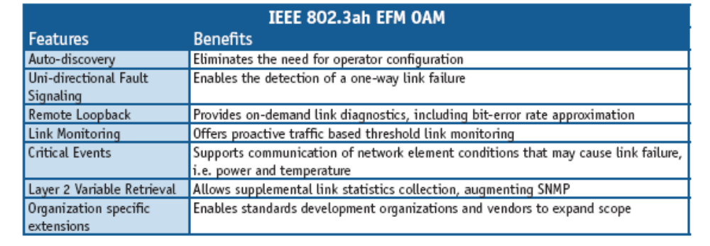
Figure 22 – 802.3ah EFM OAM

802.1ag Connectivity Fault Monitoring

The purpose of Connectivity Fault Monitoring (CFM) is to detect, isolate, and verify connectivity faults in a network providing data transport services to multiple customers. Each service monitored by CFM is identified by a collection of Service Access Points (SAPs), and is called a Service Instance. CFM continually verifies that a Service Instance’s SAPs are fully connected, and issues fault alarms upon detecting a loss of connectivity in one or more links.

A Service Instance may utilize a physical network that is logically partitioned into multiple parts, each of which is potentially under the authority of a separate administrative organization. For CFM purposes, a portion of a network that is under the control of a common administrative entity is called a Maintenance Domain (MD). An MD is assigned a name that is unique within the CFM network, called a Maintenance Domain Name.

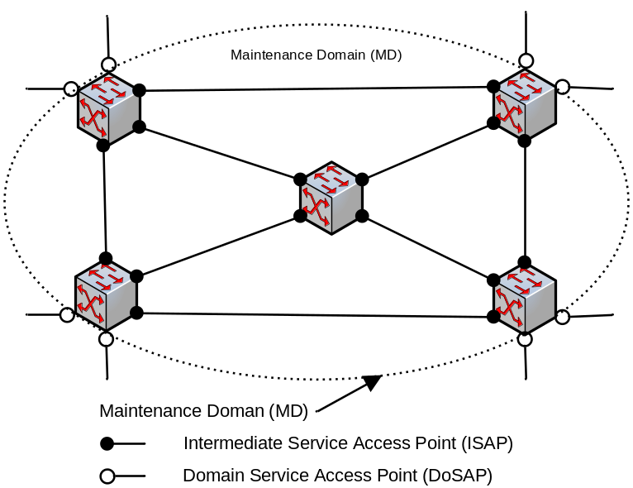
Figure 23 – 802.1ag CFM

A Maintenance Domain designates a subset of its Service Access Points, called Domain Service Access Points (DoSAP), as connection points for external systems desiring to use its connectivity services. The Service Access Points that connects SAPs internal to the MD are called Intermediate Service Access Points (ISAP).

Since a surrounding MD may in turn offer connectivity services through its own DoSAPs, it can be enclosed by other MDs. As a result, the MDs in a CFM network have a nested relationship.

Each individual MD conceptually resides at a specific level in the nested MD hierarchy, called a Maintenance Domain Level. The CFM standard defines eight distinct MD Levels, divided into three functional roles:

- Operator: Levels 0 – 2
- Provider: Levels 3 – 4
- Customer: Levels 5 – 7

Every CFM Service must be associated with a specific Service Instance and Maintenance Domain. A Maintenance Association (MA) is the CFM construct that relates these two components, and designates which SAP belongs to the Service Instance.

CFM requires the instantiation of a unique entity associated with an MA at each of its Saps. This entity, called a Maintenance Association End Point (MEP), is logically associated with a sub-port or tunnel, and provides the context for generating and processing CFM messages.

While MEPs alone can verify MD connectivity at its edges, fault isolation requires the existence of additional Maintenance Points at interior devices, called Maintenance Intermediate Points (MIPs).

The example below shows Maintenance Associations (MAs) between Maintenance Association End Points (MEPs) at three levels within a Maintenance Domain (MD). Maintenance Domain Intermediate Points (MIPs) can be associated per MD or per MA, depending on the visibility configured by the administrator.

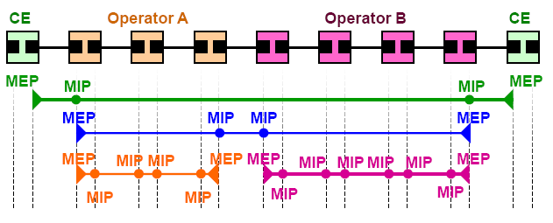
Figure 24 – 802.1ag Maintenance Associations

ITU-T Y.1731 OAM Functions for Ethernet Based Networks

Y.1731 consists of Fault Management and Performance Monitoring.
For performance monitoring, Y.1731 defines the following performance measurements:
- Frame Loss Measurement (frame loss ratio)
- Frame Delay Measurement (delay and delay variation)
- Throughput Measurement

The ITU distinguishes between pro-active and on-demand OAM:
- Pro-active OAM
  - Pro-active OAM refers to OAM actions which are carried out continuously to permit proactive reporting of fault and/or performance results.
- On-demand OAM
  - On-demand OAM refers to OAM actions which are initiated via manual intervention for a limited time to carry out diagnostics. On-demand OAM can result in singular or periodic OAM actions during the diagnostics time interval.

Technically, measuring is different from performance monitoring. For example, getting a measurement of a frame delay between two MEG Endpoints (MEPs) doesn’t provide performance of the Ethernet Service between the two MEPs. It would require a certain amount of sampling (measurements) to give a measurement of the performance.

The Fault Management portion of Y.1731 includes 802.1ag. In other words, CFM is a subset of Y.1731 Fault Management.

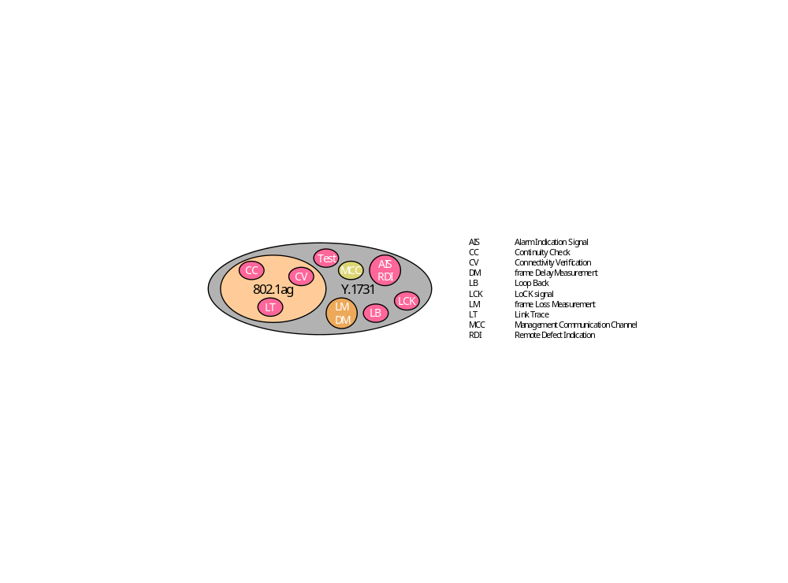
Figure 25 – Scope of Y.1731 and 802.1ag

Ethernet Link Management Interface (E-LMI)

The E-LMI protocol is based on ITU-T Q.933, X.36 and other relevant Recommendations as well as Frame Relay Local Management Interface (FR-LMI) Implementation Agreement document defined by the Frame Relay Forum and related ITU-T recommendations.

The E-LMI procedures and protocol are used for enabling auto configuration of the CE to support Metro Ethernet services. The E-LMI protocol also provides UNI and EVC status information to the CE. The UNI and EVC information enables automatic configuration of CE operation based upon the Metro Ethernet Network configuration [MEF-16].

Document Administration
  - Document History

Version | Date | Description of changes
1.0 | May 2010 | This is the first version of the document and as such, there are no changes to report.
1.1 | April 2013 | The Ethernet service specification model definitions and examples were changed to reflect the addition of SAP Definitions and SAP Templates (as inherited from the SAP Specification), and the associated change of defining SAP characteristics in a SAP definition rather than in the Service Definition. This allows for decoupling of the SAP characteristics from the Service characteristics, providing more flexibility in implementing a solution supporting MEF services

  - Company Contact Details

Company | Team Member Representative
Ciena | Name: Jessie Jewitt  Email: JJewitt@Ciena.com  Phone: +1 650 714-2593

  - Acknowledgments

This document was prepared by the members of the TM Forum TIP Service Management team. The following people have contributed to the realization of this document:
Name | Email | Company | Role
Jessie Jewitt | jjewitt@ciena.com | Ciena | Team Leader
Steve Fratini | sfratini@telcordia.com | Telcordia | TMF TIP Lead
Olga Havel | olga.havel@amartus.com | Amartus | Contributor
Brian Hedstrom | B.Hedstrom@CableLabs.com | Cable Labs | Reviewer
Francois LeRoux | francois.leroux@us.fujitsu.com | Fujitsu | Contributor
Menachem Malkosh | Menachem.Malkosh@ecitele.com | Ecitele | Reviewer
Andrew Mayer | amayer@telcordia.com | Telcordia | MEF Liaison
Pedro Nunes | pedro.nunes@nsn.com | Nokia Siemens Networks | Contributor
Raghu Ranganathan | rraghu@ciena.com | Ciena | MEF Reviewer
Ana Robnik | robnik@iskratel.si | Iskratel | Contributor
Ralph Santitoro | ralph.santitoro@us.fujitsu.com | Fujitsu | MEF Reviewer
Camilo Tiago | tiago.camilo@nsn.com | Nokia Siemens Networks | Contributor
Bernd Zeuner | b.zeuner@telekom.de | Deutsche Telekom | Contributor

  - References

Reference | Description | Publication Date
Nortel-1 | Carrier Ethernet Solutions for Residential Services
NSN-1 | High-Quality and Resilient IPTV Multicast Architecture
MEF-2 | Requirements and Framework for Ethernet Service Protection | February 2004
MEF-4 | Metro Ethernet Network Architecture Framework - Part 1: Generic Framework | May 2004
MEF-6.1 | Metro Ethernet Services Definitions Phase 2 | April 2008
MEF-7.1 | Phase 2 EMS-NMS Information Model | October 2009
MEF-10.2 | Metro Ethernet Services Attributes Phase 2 | October 2009
MEF-11 | User Network Interface (UNI) Requirements and Framework | November 2004
MEF-12 | Metro Ethernet Network Architecture Framework  Part 2: Ethernet Services Layer | April 2005
MEF-13 | User Network Interface (UNI) Type 1  Implementation Agreement | November 2005
MEF-15 | Requirements for Management of Metro Ethernet Phase 1 Network Elements | November 2005
MEF-16 | Ethernet Local Management Interface (E-LMI) | January 2006
MEF-17 | Service OAM Framework and Requirements | April 2007
MEF-19 | Abstract Test Suite for UNI Type 1 | April 2007
MEF-21 | Abstract Test Suite for UNI Type 2  Part 1 Link OAM | July 2008
JUNIPER-1 | sanog8-iptv-tripleplay-ayman.pdf
ETH-1 | Ethernet Services – Service Definition and Market Definition Author: Peter P. Komisarczuk
SIEMENS-1 | Siemens_Carrier_Ethernet_2006_03_13_Kuhn_.pdf
CIENA-1 | Ethernet and MPLS OAM
MEF | Mapping of ITU-T Q.840.1 Objects to TMF MTNM 3.5
MEF | EFM_OAM_Tutorial_v2.pdf
TR-101 | Migration to Ethernet-based DSL Aggregation
TR-156 | Using GPON Access in the Context of TR-101
NBN-1 | NBN-Wholesale-Service-Definition-Framework-Ethernet-Release1-Dec-2009.pdf
MEF-26 | External Network Network Interface (ENNI) – Phase 1 | January 2010
MEF_D00077 | D00077_003_Eth Service Layer Architecture - Phase 2_Hernandez-Valencia.doc
Draft D00079_002 | External Network to Network Interface (ENNI) Support for UNI Tunnel Access and Virtual UNI
TMF-SM-1 | mTOP_MTOSI_R2.0\DDPs\ServiceBasic\IA | March 2009
TMF-RM-1 | SD1-44_ConnectionlessTechnologyManagement.pdf | March 2009
SID Phase 9 | TM Forum Shared Information/Data model | April 2010

Terminology
The following definitions are taken from the MTOSI 2.0 Service Management “Service Basic” Business Agreement.

Term | Definition
CFS  Customer Facing Service | A CustomerFacingService is an abstraction that defines the characteristics and behavior of a particular Service as seen by the Customer.  A CustomerFacingService represents the realization of a Product within a provider’s infrastructure. For example, a Hi Speed Internet Access, bundled in a Product instance, is realized by an internet connectivity Service.
Product | A Product is an instance of a ProductOffering as procured by a Customer, or other interested Party playing a PartyRole, appearing as a BusinessInteractionItem, which could take the form of an Agreement. ProductSpecificationCharacteristic(s) in part define the Product. A Product is realized as one or more Service(s) and/or Resource(s).
RFS  Resource Facing Service | ResourceFacingServices are “internal” Services that are required to support a CustomerFacingService. The Customer purchases a Product which is always realized within a provider’s infrastructure by CustomerFacingServices, in turn decomposed into one or more component services facing the supported resources that is ResourceFacingServices, and directly by Resources (in case no associated strictly related-services, for example maintenance service of the resources).  The Customer is not aware of the ResourceFacingServices.
Service | All Services are characterized as either being a realization of a Product (CustomerFacingService) facing the Customer or how a Service is provisioned within a provider’s infrastructure (ResourceFacingService) facing the resources. Services are defined by a ServiceSpecification. The purpose of the specification is twofold. First, it is used to define attributes, methods, and relationships that are common to all Services. Second, it provides a convenient point to define how Services interact with other parts business entities.
SAP  Service Access Point | A point of entry where the service can be accessed.  This point of entry is always associated (directly or indirectly) with a resource (such as a PTP, a CTP). However, sometimes the SAP is an object or a logical resource that contains or identifies the support of the physical resource. (Customer Premise Equipment, a Mobile Terminal, a Set-top Box, an internet address).
Sap Specification | The SAP Specification defines a set of attributes and (optionally) associated values. A SAP Spec may be applied to one or more SAPs
ServiceCatalog | A grouping of Service Specifications that share common characteristics. For example one catalog could group all internet related Service Specifications.
ServiceSpecCharacteristic | A characteristic quality or distinctive feature of a Service as represented in a ServiceSpecification (specialized as ServiceDefinition or ServiceTemplate). In particular it contains typing information which can be arbitrarily complex.  A Service Spec Characteristic can be atomic or composite (also called “packages”). The components of a composite Service Spec Characteristic can in turn be atomic or composite.
ServiceSpecCharacteristicValue | A value that can be associated with a ServiceSpecCharacteristic in conformance with the specified typing information.  When associated with a Service Spec Characteristic in a Service Definition, it is used to restrict the “type” information. SSC Values may be to specify additional information (e.g. default values).  When associated with an SSCin a Service Template, it will apply globally to all the Service instances conformant to this ServiceTemplate. In this case, the ServiceSpecCharacteristicValue is set at the design stage when the ServiceTemplate is created, and it cannot be modified afterwards.  A ServiceSpecCharacteristic present in a ServiceTemplate is sometimes qualified as being “invariant”, since it cannot be modified after the creation of the ServiceTemplate (the term “globally set” can also be used”)  A ServiceSpecCharacteristic which value is passed over the Activation Interface is sometimes qualified as being “variant”, since the value must be given for each Service instance created (the term “individually set” can also be used).
ServiceCharacteristicValue | A ServiceCharacteristicValue is a value passed over the Activation Interface to convey an individually set service characteristic (i.e. not reference in a ServiceTemplate) or to override a globally set characteristic value (present in a ServiceTemplate).  A ServiceCharacteristicValue will apply only to the specific Service instance created.
ServiceDefinition | A type of Service Specification (from the SID) introduced for the purposes of Service Fulfillment.  It defines ALL the ServiceSpecCharacteristics that must be used to create corresponding Service instances:  - the ones which are set globally (the corresponding values are defined only in ServiceTemplates and are sometimes designated as “invariant”)  - and the ones which are set individually (the corresponding values can be defined only over the Activation Interface and are sometimes designated as “variant”).  A ServiceSpecCharacteristic specified in a ServiceDefinition may be associated with ServiceSpecCharacteristicValues to restrict the typing information or to specify a default value.
ServiceSpecification | Changeable as well as invariant attributes, methods, relationships and constraints which define a Service.  It can be conceptually thought of as a template that different Service instances can be instantiated from. Each of these Service instances will have the same invariant characteristics. However, the other characteristics of the instantiated Service will be specific to each instance.
ServiceSpecificationType | The ServiceSpecificationType class defines a generic category of ServiceSpecifications. Each ServiceSpecificationType serves to group a set of particular ServiceSpecifications that share the same behavior and other semantics. One result of this is to be able to more efficiently define a set of related Services that can be grouped together to form a higher-level Service. For example, a given higher-level Service might include VPN and QoS Services. If these Services are always used together, then they can be categorized using a common type.
ServiceTemplate | A type of Service Specification (from the SID) introduced for the purposes of Service Fulfillment.  It defines specific ServiceSpecCharacteristicsValues for the globally set ServiceSpecCharacteristics that can be dynamically referenced by multiple Service instances during their lifecycle span.  A ServiceTemplate is checked against its associated ServiceDefinition by verifying the presence of the ServiceSpecCharacteristics and the validity of the corresponding assigned ServiceSpecCharacteristicsValues.  Each of the associated Service instances will have the same invariant characteristics which values are taken from the ServiceTemplate.  However, when activating a Service, it may be possible to specify over the Activation Interface a ServiceCharacteristicsValue which overrides the corresponding ServiceSpecCharacteristicValue available in the associated ServiceTemplate. In this case the new proposed value applies only to the Service instance created, and the ServiceSpecCharacteristicValue in the ServiceTemplate is not modified.  In order not to descend into sub-classing, the ServiceTemplate is considered to be generic such that it serves as a framework for defining technology or service specific templates. Other TMForum groups, or service providers, may use the service template as a foundation for building or populating service templates.

Abbreviations and Mnemonics
ACL
API Application Programming Interface
ATM Asynchronous Transfer Mode
ASP Application Service Provider
BAB Broadband ethernet Aggregation & Backhaul provider
BABS Broadband Aggregation & Backhaul Service
BB
BEA Broadband Ethernet Access provider
BEAL
BEMS Broadband Ethernet Multicast Service
BEN Broadband Ethernet Network provider
BNG Broadband Network Gateway
BRAS Broadband Remote Access Server
BSS Business Support System
BW BandWidth
C-xx C-Tag-xx
CCM Continuity Check Message
CE
CES Circuit Emulation Services
CFM Connectivity Fault Monitoring
CFS Customer Facing Service
CIR Committed Information Rate
CoS Class of Service
CPTP Connectionless Port Termination Point
CRM Customer Relationship Management
CTP Connection Termination Point
DDP Document Delivery Package
DM (Frame) Delay Measurement
DoSAP Domain Service Access Point
DSCP Differential Service Code Point
DSL Digital Subscriber Line
DSLAM Digital Subscriber Line Access Multiplexer
E-LAN
E-LINE
E-LMI Ethernet - Link Management Interface
ELMI Ethernet Link Management Interface
E-TREE
EAS
EC Ethernet Connection
ECS Ethernet Connection Segment
EFD
EFM Ethernet in the First Mile
EMS Element Management System
EP
EP-Tree Ethernet Private Tree
EPL Ethernet Private Line
EPLAN Ethernet Private LAN
EPTREE Ethernet Private Tree
ENNI………External Network-to-Network Interface
ENNI-N
ES Errored Seconds
ETH ETHernet
EVC Ethernet Virtual Connection
EVP-Tree Ethernet Virtual Private Tree
EVPL Ethernet Virtual Private Line
EVPLAN Ethernet Virtual Private LAN
EVPTREE Ethernet Virtual Private Tree
FD Frame Delay
FDFr Flow Domain Fragment
FDV Frame Delay Variation
FLR Frame Loss Ratio
FP Flow Point
FR-LMI Frame Relay - Local Management Interface
FTP Floating Termination Point
GARP Generic Attribute Registration Protocol
GBPS Giga bit per second
GPON Gigabit Passive Optical Network
HSI
IA Information Agreement
IP Internet Protocol
IPoE Internet Protocol over Ethernet
IPTV Internet Protocol TeleVision
ISAP Intermediate Service Access Point
ITU-T International Telecommunication Union - Telecommunication Standardization Sector
LACP Link Aggregation Control Protocol
LAMP
LAN Local Area Network
LLCP
LM (Frame) Loss Measurement
LMI Local Management Interface
LMM Loss Measurement Message
LMR Loss Measurement Reply
MA Maintenance Association
Mbps Mega bit per second
MC-VLAN
MD Maintenance Domain
ME Maintenance Entity
MEF Metro Ethernet Forum
MEG Maintenance Entity Group
MEN Metro Ethernet Network
MEP IEEE: Maintenance association End Point
ITU-T: MEG End Point
MIP IEEE: Maintenance domain Intermediate Point
ITU-T: MEG Intermediate Point
MPLS Multi-Protocol Label Switching
MTNM Multi-Technology Network Management
MTOSI Multi-Technology Operations System Interface
MTU Maximum Transfer Unit
NBN
NID
NMS Network Management System
NNI Network-Network-Interface
NSP ip Network Service Provider
OAM Operation, Administration and Maintenance
OLT Optical Line Terminal
ONT Optical Network Terminal
OVC Operator Virtual Connection
OS Operations System
OSS Operations Support System
PBB-TE Provider Backbone Bridging - Traffic Engineering
PCP Priority Code Point
PoP Point of Presence
PPPoE Point to Point Protocol over Ethernet
PTP Physical Termination Point
RFS Resource Facing Service
RG Residential Gateway
RM Resource Management
Resource Manager
RUNI Remote User Network Interface
S-xx S-Tag-xx
SAI Service Activation Interface
SAP Service Access Point
SC&A Service Configuration and Activation
SCAI Service Component Activation Interface
SES Severely Errored Seconds
SFTP SSH File Transfer Protocol or Secure File Transfer Protocol
SID Shared Information and Data model
SLA Service Level Agreement
SM Service Management
Service Manager
SNC SubNetwork Connection
SNI Service Node Interface
SNMP Simple Network Management Protocol
SPNI
SSC Service Specification Characteristic
SSCV Service Specification Characteristic Value
STP Spanning Tree Protocol
TIP TMForum Interface Program
TL Topological Link
UAS UnAvailable Seconds
UML Unified Modelling Language
UNI User-Network-Interface
UNI-C User Network Interface – Customer side
UNI-N User Network Interface – Network side
VID Vlan IDentifier
VUNI Virtual User Network Interface
VLAN Virtual LAN
VoD Video on Demand
VoIP Voice over IP
XML eXtensible Markup Language

