Examples for contained TPs in different states of usage
Abstract
This supporting document provides examples of configurations explaining the expected output of the operations getContainedPotentialTP(Name)s, getContainedInUseTP(Name)s and getContainedCurrentTP(Name)s.
There are two different examples of connection-oriented transmission (STM-4 ports), the first one is described in sections 1 to 3, the second one is described in section 4, and one example of connectionless transmission (Ethernet port assigned to a matrix flow domain) described in section 5.
Table of Contents

Examples for contained TPs in different states of usage 1
Abstract 1
Table of Contents 1
1 Example 1: Initial Situation 3
1.1 Overview 3
1.2 Potential TPs 4
1.3 In Use TPs 6
1.4 Current TPs 6
2 Example 1: Effect of Termination and Mapping 8
2.1 Overview 9
2.2 Potential TPs 9
2.3 In Use TPs 9
2.4 Current TPs 10
3 Example 1: Effect of Cross Connections (Both Pending and Active SNCs) 13
3.1 Overview 14
3.2 Potential TPs 14
3.3 In Use TPs 15
3.4 Current TPs 16
4 Example 2: Bidirectional & Unidirectional CTPs 20
4.1 Initial Situation: No Connections Nor Mapped CTPs 20
4.2 With Connections And Mapped CTPs 21
5 Example 3: Connectionless Transmission 23
5.1 Principles of connectionless transmission modelling 23
5.2 Effect of inventory operations 23
5.3 Overview 23
5.4 Potential Flow Points 24
5.5 In Use (“Active”, “Existing”) / “Current” Flow Points 25
6 Administrative Appendix 26
6.1 Document History 26
6.2 Acknowledgments 26
6.3 How to comment on this document 26

Example 1: Initial Situation
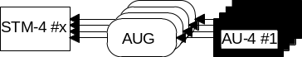
Figure 1: non-terminated STM-4 Port
Figure 1 shows the current situation in the network element before the following operations are applied. The setTPData operation can potentially be applied as follows (see Figure 2):
  - au4CTP #1 can be "SDH-terminated", i.e., terminated and mapped to SDH lower order CTPs. (Several configurations of SDH lower order CTPs are possible, but which configuration is chosen is determined only which CTPs are actually cross-connected.) It cannot be terminated and mapped in any other way.
  - au4CTP #4 can be "ATM-terminated", i.,e, terminated and mapped to ATM CTPs. It cannot be terminated and mapped in any other way.
  - au4CTP#2 and au4CTP#3 cannot be terminated nor mapped at all.

Overview
Table 1 gives an overview of the situation. The lines of the table detail the various types of CTP. The columns detail the counts of CTPs in various situations, as follows:
- The "Potential" column shows us the total potential number of CTPs of each type, that are returned by getContainedPotentialTPs and getPotentialTPNames operations. These numbers do not depend on the current configuration.
- The "Terminated and Mapped" column shows how many CTPs of each type are currently terminated and mapped.
- The "Cross-connected (Pending)" column shows how many CTPs of each type are currently used in a cross-connection by a SNC in Pending state. These CTPs are not in reality cross-connected.
- The "Cross-connected (Active)" column shows how many CTPs of each type are currently used in a cross-connection by a SNC in Active state (or in Partial state, which has succeeded in executing the cross-connection on this particular NE). These CTPs are in reality cross-connected.
- The "In Use" column shows us how many CTPs of each type are returned by the getContainedInUseTPs and getContainedInUseNames operations. By definition, an "in use" CTP is "a CTP that is used by an SNC in any state (including pending) or a CTP that is terminated and mapped." - i.e., the sum of columns b), c) and d).
- The "Current" column shows us how many CTPs of each type are returned by getContainedCurrentTPs and getContainedCurrentTPNames operations. By definition, a "Current" CTP is "a CTP that is either cross-connectable or cross-connected, in the current mapping configuration".
Table 1: Behaviour of "Get Contained" operations on non-terminated STM-4 port
CTP Type | Potential | Terminated and Mapped | Cross-connected (Pending) | Cross-connected (Active) | In Use | Current
AU-4 | 4 | 0 | 0 | 0 | 0 | 4
TU-3 | 3 | 0 | 0 | 0 | 0 | 0
TU-2 | 21 | 0 | 0 | 0 | 0 | 0
TU-12 | 63 | 0 | 0 | 0 | 0 | 0
Total SDH | 91 | 0 | 0 | 0 | 0 | 4
ATMNI | 1 | 0 | 0 | 0 | 0 | 0
VP | 4095 | 0 | 0 | 0 | 0 | 0
VC | 268 238 880 | 0 | 0 | 0 | 0 | 0
Total ATM | 268 242 976 | 0 | 0 | 0 | 0 | 0

Potential TPs
The getContainedPotentialTPNames operation returns the names of all the CTPs in Figure 2.
- getContainedPotentialTPNames
in tpName: PTP #x,
in layerRateList: 15 = LR_STS3c_and_AU4_VC4
13 = LR_Low_Order_TU3_VC3
12 = LR_VT6_and_TU2_VC2
11 = LR_VT2_and_TU12_VC12
43 = LR_ATM_NI
44 = LR_ATM_VP
45 = LR_ATM_VC
out (91 SDH CTPs, 268 242 976 ATM CTPs)
- AU-4 CTPs:
EMS="...", ManagedElement="...", PTP= "#4", CTP="/sts3c_au4-j=1"
EMS="...", ManagedElement="...", PTP= "#4", CTP="/sts3c_au4-j=2"
EMS="...", ManagedElement="...", PTP= "#4", CTP="/sts3c_au4-j=3"
EMS="...", ManagedElement="...", PTP= "#4", CTP="/sts3c_au4-j=4"
- TU-3 CTPs:
EMS="...", ManagedElement="...", PTP= "#4", CTP="/sts3c_au4-j=1/tu3_vc3-k=1"
EMS="...", ManagedElement="...", PTP= "#4", CTP="/sts3c_au4-j=1/tu3_vc3-k=2"
EMS="...", ManagedElement="...", PTP= "#4", CTP="/sts3c_au4-j=1/tu3_vc3-k=3"
- TU-2 CTPs:
EMS="...", ManagedElement="...", PTP= "#4", CTP="/sts3c_au4-j=1/vt6_tu2-k=1-l=1"
EMS="...", ManagedElement="...", PTP= "#4", CTP="/sts3c_au4-j=1/vt6_tu2-k=1-l=2"
..............
EMS="...", ManagedElement="...", PTP= "#4", CTP="/sts3c_au4-j=1/vt6_tu2-k=1-l=7"
EMS="...", ManagedElement="...", PTP= "#4", CTP="/sts3c_au4-j=1/vt6_tu2-k=2-l=1"
EMS="...", ManagedElement="...", PTP= "#4", CTP="/sts3c_au4-j=1/vt6_tu2-k=2-l=2"
..............
EMS="...", ManagedElement="...", PTP= "#4", CTP="/sts3c_au4-j=1/vt6_tu2-k=2-l=7"
EMS="...", ManagedElement="...", PTP= "#4", CTP="/sts3c_au4-j=1/vt6_tu2-k=3-l=1"
EMS="...", ManagedElement="...", PTP= "#4", CTP="/sts3c_au4-j=1/vt6_tu2-k=3-l=2"
..............
EMS="...", ManagedElement="...", PTP= "#4", CTP="/sts3c_au4-j=1/vt6_tu2-k=3-l=7"
- TU-12 CTPs:
EMS="...", ManagedElement="...", PTP= "#4", CTP="/sts3c_au4-j=1/vt2_tu12-k=1-l=1-m=1"
EMS="...", ManagedElement="...", PTP= "#4", CTP="/sts3c_au4-j=1/vt2_tu12-k=1-l=1-m=2"
EMS="...", ManagedElement="...", PTP= "#4", CTP="/sts3c_au4-j=1/vt2_tu12-k=1-l=1-m=3"
EMS="...", ManagedElement="...", PTP= "#4", CTP="/sts3c_au4-j=1/vt2_tu12-k=1-l=2-m=1"
EMS="...", ManagedElement="...", PTP= "#4", CTP="/sts3c_au4-j=1/vt2_tu12-k=1-l=2-m=2"
EMS="...", ManagedElement="...", PTP= "#4", CTP="/sts3c_au4-j=1/vt2_tu12-k=1-l=2-m=3"
..............
EMS="...", ManagedElement="...", PTP= "#4", CTP="/sts3c_au4-j=1/vt2_tu12-k=1-l=7-m=1"
EMS="...", ManagedElement="...", PTP= "#4", CTP="/sts3c_au4-j=1/vt2_tu12-k=1-l=7-m=2"
EMS="...", ManagedElement="...", PTP= "#4", CTP="/sts3c_au4-j=1/vt2_tu12-k=1-l=7-m=3"
EMS="...", ManagedElement="...", PTP= "#4", CTP="/sts3c_au4-j=1/vt2_tu12-k=2-l=1-m=1"
EMS="...", ManagedElement="...", PTP= "#4", CTP="/sts3c_au4-j=1/vt2_tu12-k=2-l=1-m=2"
EMS="...", ManagedElement="...", PTP= "#4", CTP="/sts3c_au4-j=1/vt2_tu12-k=2-l=1-m=3"
EMS="...", ManagedElement="...", PTP= "#4", CTP="/sts3c_au4-j=1/vt2_tu12-k=2-l=2-m=1"
EMS="...", ManagedElement="...", PTP= "#4", CTP="/sts3c_au4-j=1/vt2_tu12-k=2-l=2-m=2"
EMS="...", ManagedElement="...", PTP= "#4", CTP="/sts3c_au4-j=1/vt2_tu12-k=2-l=2-m=3"
..............
EMS="...", ManagedElement="...", PTP= "#4", CTP="/sts3c_au4-j=1/vt2_tu12-k=2-l=7-m=1"
EMS="...", ManagedElement="...", PTP= "#4", CTP="/sts3c_au4-j=1/vt2_tu12-k=2-l=7-m=2"
EMS="...", ManagedElement="...", PTP= "#4", CTP="/sts3c_au4-j=1/vt2_tu12-k=2-l=7-m=3"
EMS="...", ManagedElement="...", PTP= "#4", CTP="/sts3c_au4-j=1/vt2_tu12-k=3-l=1-m=1"
EMS="...", ManagedElement="...", PTP= "#4", CTP="/sts3c_au4-j=1/vt2_tu12-k=3-l=1-m=2"
EMS="...", ManagedElement="...", PTP= "#4", CTP="/sts3c_au4-j=1/vt2_tu12-k=3-l=1-m=3"
EMS="...", ManagedElement="...", PTP= "#4", CTP="/sts3c_au4-j=1/vt2_tu12-k=3-l=2-m=1"
EMS="...", ManagedElement="...", PTP= "#4", CTP="/sts3c_au4-j=1/vt2_tu12-k=3-l=2-m=2"
EMS="...", ManagedElement="...", PTP= "#4", CTP="/sts3c_au4-j=1/vt2_tu12-k=3-l=2-m=3"
..............
EMS="...", ManagedElement="...", PTP= "#4", CTP="/sts3c_au4-j=1/vt2_tu12-k=3-l=7-m=1"
EMS="...", ManagedElement="...", PTP= "#4", CTP="/sts3c_au4-j=1/vt2_tu12-k=3-l=7-m=2"
EMS="...", ManagedElement="...", PTP= "#4", CTP="/sts3c_au4-j=1/vt2_tu12-k=3-l=7-m=3"
- ATMNI CTPs:
EMS="...", ManagedElement="...", PTP= "#4", CTP="/sts3c_au4-j=4/atmnetworkinterface=45
- VP CTPs:
EMS="...", ManagedElement="...", PTP= "#4", CTP="/sts3c_au4-j=4/atmnetworkinterface=45/vpi=1
EMS="...", ManagedElement="...", PTP= "#4", CTP="/sts3c_au4-j=4/atmnetworkinterface=45/vpi=2
..............
EMS="...", ManagedElement="...", PTP= "#4", CTP="/sts3c_au4-j=4/atmnetworkinterface=45/vpi=4095
- VC CTPs:
EMS="...", ManagedElement="...", PTP= "#4", CTP="/sts3c_au4-j=4/atmnetworkinterface=45/vpi=1/vci=32
EMS="...", ManagedElement="...", PTP= "#4", CTP="/sts3c_au4-j=4/atmnetworkinterface=45/vpi=1/vci=33
..............
EMS="...", ManagedElement="...", PTP= "#4", CTP="/sts3c_au4-j=4/atmnetworkinterface=45/vpi=1/vci=65535
EMS="...", ManagedElement="...", PTP= "#4", CTP="/sts3c_au4-j=4/atmnetworkinterface=45/vpi=2/vci=32
EMS="...", ManagedElement="...", PTP= "#4", CTP="/sts3c_au4-j=4/atmnetworkinterface=45/vpi=2/vci=33
..............
EMS="...", ManagedElement="...", PTP= "#4", CTP="/sts3c_au4-j=4/atmnetworkinterface=45/vpi=2/vci=65535
..............
EMS="...", ManagedElement="...", PTP= "#4", CTP="/sts3c_au4-j=4/atmnetworkinterface=45/vpi=4095/vci=32
EMS="...", ManagedElement="...", PTP= "#4", CTP="/sts3c_au4-j=4/atmnetworkinterface=45/vpi=4095/vci=33
..............
EMS="...", ManagedElement="...", PTP= "#4", CTP="/sts3c_au4-j=4/atmnetworkinterface=45/vpi=4095/vci=65535

In Use TPs
The getContainedInUseTPNames operation returns no CTPs.
- getContainedInUseTPNames
in tpName: PTP #x,
in layerRateList: 15 = LR_STS3c_and_AU4_VC4
13 = LR_Low_Order_TU3_VC3
12 = LR_VT6_and_TU2_VC2
11 = LR_VT2_and_TU12_VC12
43 = LR_ATM_NI
44 = LR_ATM_VP
45 = LR_ATM_VC
out "empty list"

Current TPs

The getContainedCurrentTPNames operation returns the names of the CTPs that are "there" in Figure 1.

- getContainedCurrentTPNames
in tpName: PTP #x,
in layerRateList: 15 = LR_STS3c_and_AU4_VC4
13 = LR_Low_Order_TU3_VC3
12 = LR_VT6_and_TU2_VC2
11 = LR_VT2_and_TU12_VC12
43 = LR_ATM_NI
44 = LR_ATM_VP
45 = LR_ATM_VC
out (4 SDH CTPs, 0 ATM CTPs)
- AU-4 CTPs:
EMS="...", ManagedElement="...", PTP= "#4", CTP="/sts3c_au4-j=1"
EMS="...", ManagedElement="...", PTP= "#4", CTP="/sts3c_au4-j=2"
EMS="...", ManagedElement="...", PTP= "#4", CTP="/sts3c_au4-j=3"
EMS="...", ManagedElement="...", PTP= "#4", CTP="/sts3c_au4-j=4"

Example 1: Effect of Termination and Mapping
Then the au4CTP #1 and au4CTP #4 are set to "TERMINATED_AND_AVAILABLE_FOR_MAPPING" using the setTPData operation.
The au4CTP #1 is "SDH-terminated" and the au4CTP #4 is "ATM-terminated" (see Figure 2).
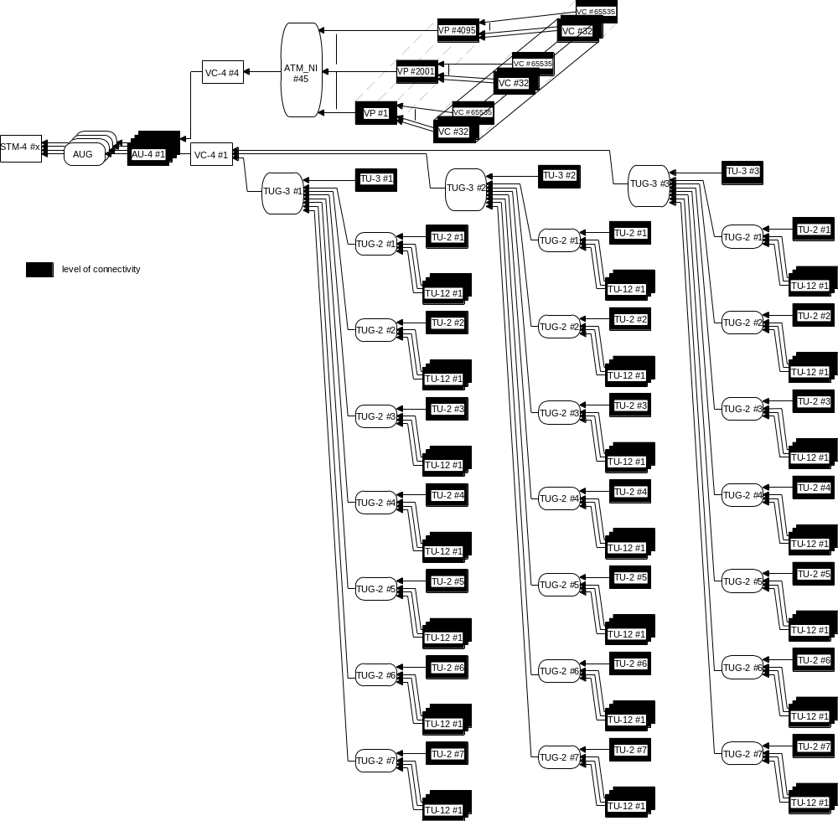
k
l
m
m
m
m
m
m
m
l
m
m
m
m
m
m
m
l
m
m
m
m
m
m
m
Figure 2: partly terminated STM-4 Port
Figure 2 shows the current situation in the network element before the following operations are applied.

Overview
Table 2 is constructed in the same way as Table 1, but the following changes can be seen:
- 2 of the AU-4 CTPs are now terminated and mapped. Therefore, they are no longer "current" (they cannot be cross-connected), but they are now "in use".
- The ATMNI CTP is terminated and mapped, but the VP CTPs are not. Therefore the VP CTPs are "current", but the VC CTPs are not. The ATMNI CTP is "in use".
Table 2: Behaviour of "Get Contained" operations on terminated STM-4 port
CTP Type | Potential | Terminated and Mapped | Cross-connected (Pending) | Cross-connected (Active) | In Use | Current
AU-4 | 4 | 2 | 0 | 0 | 2 | 2
TU-3 | 3 | 0 | 0 | 0 | 0 | 3
TU-2 | 21 | 0 | 0 | 0 | 0 | 21
TU-12 | 63 | 0 | 0 | 0 | 0 | 63
Total SDH | 91 | 2 | 0 | 0 | 2 | 89
ATMNI | 1 | 1 | 0 | 0 | 1 | 0
VP | 4095 | 0 | 0 | 0 | 0 | 4095
VC | 268 238 880 | 0 | 0 | 0 | 0 | 0
Total ATM | 268 242 976 | 1 | 0 | 0 | 1 | 4095

Potential TPs
- getContainedPotentialTPNames
in tpName: PTP #x,
in layerRateList: 15 = LR_STS3c_and_AU4_VC4
13 = LR_Low_Order_TU3_VC3
12 = LR_VT6_and_TU2_VC2
11 = LR_VT2_and_TU12_VC12
43 = LR_ATM_NI
44 = LR_ATM_VP
45 = LR_ATM_VC
out (91 SDH CTPs, 268 242 976 ATM CTPs) same as before

In Use TPs
- getContainedInUseTPNames
in tpName: PTP #x,
in layerRateList: 15 = LR_STS3c_and_AU4_VC4
13 = LR_Low_Order_TU3_VC3
12 = LR_VT6_and_TU2_VC2
11 = LR_VT2_and_TU12_VC12
43 = LR_ATM_NI
44 = LR_ATM_VP
45 = LR_ATM_VC
out (2 SDH CTPs, 1 ATM CTP)
- AU-4 CTPs:
EMS="...", ManagedElement="...", PTP= "#4", CTP="/sts3c_au4-j=1"
EMS="...", ManagedElement="...", PTP= "#4", CTP="/sts3c_au4-j=4"
- ATMNI CTPs:
EMS="...", ManagedElement="...", PTP= "#4", CTP="/sts3c_au4-j=4/atmnetworkinterface=45

Current TPs
For getContainedCurrentTPNames, the result is the same as the previous getContainedPotentialTPNames, except that:
- The following TPs are left out since they are terminated and mapped: au4CTP #1, au4CTP #4, ATMNI #45. (These are the CTPs returned by getContainedInUseTPs.)
- The VC CTPs are left out since their containing VP CTPs are not terminated and mapped.
- All the other potential CTPs are now "current", i.e. a cross connection that includes any of them can be activated.
- getContainedCurrentTPNames
in tpName: PTP #x,
in layerRateList: 15 = LR_STS3c_and_AU4_VC4
13 = LR_Low_Order_TU3_VC3
12 = LR_VT6_and_TU2_VC2
11 = LR_VT2_and_TU12_VC12
43 = LR_ATM_NI
44 = LR_ATM_VP
45 = LR_ATM_VC
out (89 SDH CTPs, 4095 ATM CTPs)
- AU-4 CTPs:
(mapping ⇒ no AU-4#1)
EMS="...", ManagedElement="...", PTP= "#4", CTP="/sts3c_au4-j=2"
EMS="...", ManagedElement="...", PTP= "#4", CTP="/sts3c_au4-j=3"
(mapping ⇒ no AU-4#4)
- TU-3 CTPs:
EMS="...", ManagedElement="...", PTP= "#4", CTP="/sts3c_au4-j=1/tu3_vc3-k=1"
EMS="...", ManagedElement="...", PTP= "#4", CTP="/sts3c_au4-j=1/tu3_vc3-k=2"
EMS="...", ManagedElement="...", PTP= "#4", CTP="/sts3c_au4-j=1/tu3_vc3-k=3"
- TU-2 CTPs:
EMS="...", ManagedElement="...", PTP= "#4", CTP="/sts3c_au4-j=1/vt6_tu2-k=1-l=1"
EMS="...", ManagedElement="...", PTP= "#4", CTP="/sts3c_au4-j=1/vt6_tu2-k=1-l=2"
..............
EMS="...", ManagedElement="...", PTP= "#4", CTP="/sts3c_au4-j=1/vt6_tu2-k=1-l=7"
EMS="...", ManagedElement="...", PTP= "#4", CTP="/sts3c_au4-j=1/vt6_tu2-k=2-l=1"
EMS="...", ManagedElement="...", PTP= "#4", CTP="/sts3c_au4-j=1/vt6_tu2-k=2-l=2"
..............
EMS="...", ManagedElement="...", PTP= "#4", CTP="/sts3c_au4-j=1/vt6_tu2-k=2-l=7"
EMS="...", ManagedElement="...", PTP= "#4", CTP="/sts3c_au4-j=1/vt6_tu2-k=3-l=1"
EMS="...", ManagedElement="...", PTP= "#4", CTP="/sts3c_au4-j=1/vt6_tu2-k=3-l=2"
..............
EMS="...", ManagedElement="...", PTP= "#4", CTP="/sts3c_au4-j=1/vt6_tu2-k=3-l=7"
- TU-12 CTPs:
EMS="...", ManagedElement="...", PTP= "#4", CTP="/sts3c_au4-j=1/vt2_tu12-k=1-l=1-m=1"
EMS="...", ManagedElement="...", PTP= "#4", CTP="/sts3c_au4-j=1/vt2_tu12-k=1-l=1-m=2"
EMS="...", ManagedElement="...", PTP= "#4", CTP="/sts3c_au4-j=1/vt2_tu12-k=1-l=1-m=3"
EMS="...", ManagedElement="...", PTP= "#4", CTP="/sts3c_au4-j=1/vt2_tu12-k=1-l=2-m=1"
EMS="...", ManagedElement="...", PTP= "#4", CTP="/sts3c_au4-j=1/vt2_tu12-k=1-l=2-m=2"
EMS="...", ManagedElement="...", PTP= "#4", CTP="/sts3c_au4-j=1/vt2_tu12-k=1-l=2-m=3"
..............
EMS="...", ManagedElement="...", PTP= "#4", CTP="/sts3c_au4-j=1/vt2_tu12-k=1-l=7-m=1"
EMS="...", ManagedElement="...", PTP= "#4", CTP="/sts3c_au4-j=1/vt2_tu12-k=1-l=7-m=2"
EMS="...", ManagedElement="...", PTP= "#4", CTP="/sts3c_au4-j=1/vt2_tu12-k=1-l=7-m=3"
EMS="...", ManagedElement="...", PTP= "#4", CTP="/sts3c_au4-j=1/vt2_tu12-k=2-l=1-m=1"
EMS="...", ManagedElement="...", PTP= "#4", CTP="/sts3c_au4-j=1/vt2_tu12-k=2-l=1-m=2"
EMS="...", ManagedElement="...", PTP= "#4", CTP="/sts3c_au4-j=1/vt2_tu12-k=2-l=1-m=3"
EMS="...", ManagedElement="...", PTP= "#4", CTP="/sts3c_au4-j=1/vt2_tu12-k=2-l=2-m=1"
EMS="...", ManagedElement="...", PTP= "#4", CTP="/sts3c_au4-j=1/vt2_tu12-k=2-l=2-m=2"
EMS="...", ManagedElement="...", PTP= "#4", CTP="/sts3c_au4-j=1/vt2_tu12-k=2-l=2-m=3"
..............
EMS="...", ManagedElement="...", PTP= "#4", CTP="/sts3c_au4-j=1/vt2_tu12-k=2-l=7-m=1"
EMS="...", ManagedElement="...", PTP= "#4", CTP="/sts3c_au4-j=1/vt2_tu12-k=2-l=7-m=2"
EMS="...", ManagedElement="...", PTP= "#4", CTP="/sts3c_au4-j=1/vt2_tu12-k=2-l=7-m=3"
EMS="...", ManagedElement="...", PTP= "#4", CTP="/sts3c_au4-j=1/vt2_tu12-k=3-l=1-m=1"
EMS="...", ManagedElement="...", PTP= "#4", CTP="/sts3c_au4-j=1/vt2_tu12-k=3-l=1-m=2"
EMS="...", ManagedElement="...", PTP= "#4", CTP="/sts3c_au4-j=1/vt2_tu12-k=3-l=1-m=3"
EMS="...", ManagedElement="...", PTP= "#4", CTP="/sts3c_au4-j=1/vt2_tu12-k=3-l=2-m=1"
EMS="...", ManagedElement="...", PTP= "#4", CTP="/sts3c_au4-j=1/vt2_tu12-k=3-l=2-m=2"
EMS="...", ManagedElement="...", PTP= "#4", CTP="/sts3c_au4-j=1/vt2_tu12-k=3-l=2-m=3"
..............
EMS="...", ManagedElement="...", PTP= "#4", CTP="/sts3c_au4-j=1/vt2_tu12-k=3-l=7-m=1"
EMS="...", ManagedElement="...", PTP= "#4", CTP="/sts3c_au4-j=1/vt2_tu12-k=3-l=7-m=2"
EMS="...", ManagedElement="...", PTP= "#4", CTP="/sts3c_au4-j=1/vt2_tu12-k=3-l=7-m=3"
- ATMNI CTPs:
(mapping ⇒ no ATMNI)

- VP CTPs:
EMS="...", ManagedElement="...", PTP= "#4", CTP="/sts3c_au4-j=4/atmnetworkinterface=45/vpi=1
EMS="...", ManagedElement="...", PTP= "#4", CTP="/sts3c_au4-j=4/atmnetworkinterface=45/vpi=2
..............
EMS="...", ManagedElement="...", PTP= "#4", CTP="/sts3c_au4-j=4/atmnetworkinterface=45/vpi=4095
- VC CTPs:
(none, since the VP CTPs are neither terminated nor mapped)

Example 1: Effect of Cross Connections (Both Pending and Active SNCs)
Then after several createSNC and createAndActivateSNC operations some of the potential CTPs are participating in active SNCs and some CTPs are participating in pending SNCs (see Figure 3). To execute cross-connections 10, 12 and 13 it is necessary to terminate and map VP#1 and VP#4095.
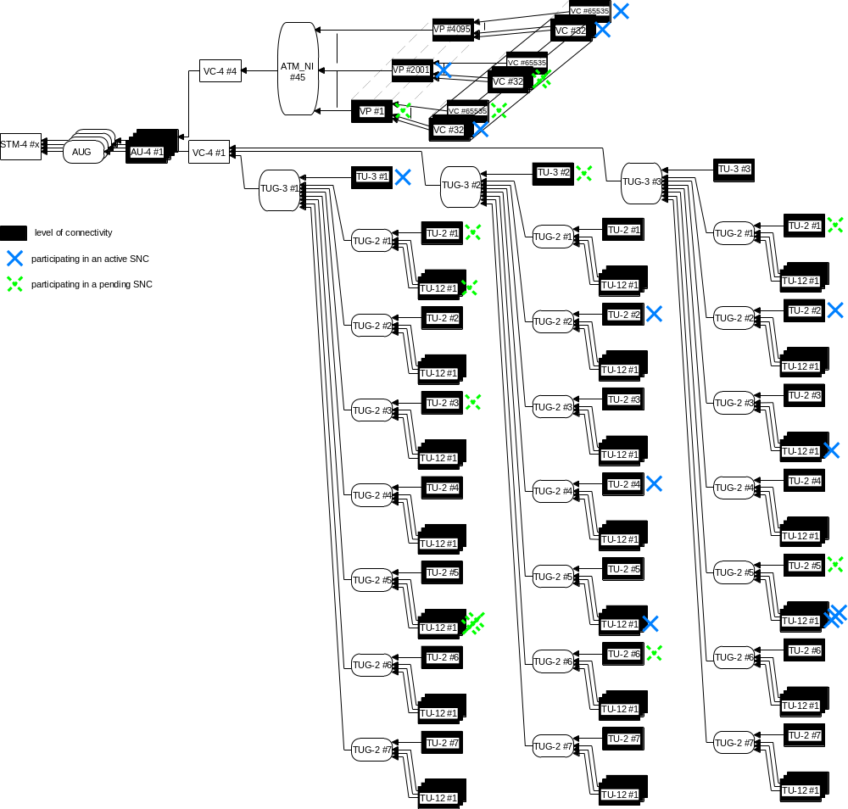
1
2

3

4

5

6

7, 8, 9

10

11

12

13

Figure 3: partly terminated STM-4 Port with CTPs that participate in SNCs
Figure 3 shows the current situation in the network element before the following operations are applied.

Overview
Table 3 is constructed in the same way as Table 1 and Table 2. The following changes can be seen:
- Two of the ATM VP CTPs have been terminated and mapped. In consequence there are
2 x 65 504 = 131 008 new "current" (i.e., cross-connectable) ATM CTPs.
- The "current" SDH CTPs are determined by the presence or absence of cross-connections. Any potential CTP is only "current" if its containing CTP is terminated and mapped, and if it is not prevented from existing by another, incompatible CTP that is part of a cross connection. For details, see Figure 4, where the "current" CTPs are in coloured boxes.
Table 3: Behaviour of "Get Contained" operations with cross connections
CTP Type | Potential | Terminated and Mapped | Cross-connected (Pending) | Cross-connected (Active) | In Use | Current
AU-4 | 4 | 2 | 0 | 0 | 2 | 2
TU-3 | 3 | 0 | 1 | 1 | 2 | 1
TU-2 | 21 | 0 | 5 | 3 | 8 | 11
TU-12 | 63 | 0 | 4 | 5 | 9 | 33
Total SDH | 91 | 2 | 10 | 8 | 21 | 47
ATMNI | 1 | 1 | 0 | 0 | 1 | 0
VP | 4095 | 2 | 1 | 1 | 2 | 4093
VC | 268 238 880 | 0 | 3 | 3 | 6 | 131 008
Total ATM | 268 242 976 | 1 | 3 | 4 | 9 | 135 101

Potential TPs
The getContainedPotentialTPNames operation returns the same result as before.
- getContainedPotentialTPNames
in tpName: PTP #x,
in layerRateList: 15 = LR_STS3c_and_AU4_VC4
13 = LR_Low_Order_TU3_VC3
12 = LR_VT6_and_TU2_VC2
11 = LR_VT2_and_TU12_VC12
43 = LR_ATM_NI
44 = LR_ATM_VP
45 = LR_ATM_VC
out (91 SDH CTPs, 268 242 976 ATM CTPs) same as before

In Use TPs
The getContainedInUseTPNames operation returns the terminated and mapped CTPs, plus the CTPs that are involved in an SNC (either pending, or active).
- getContainedInUseTPNames
in tpName: PTP #x,
in layerRateList: 15 = LR_STS3c_and_AU4_VC4
13 = LR_Low_Order_TU3_VC3
12 = LR_VT6_and_TU2_VC2
11 = LR_VT2_and_TU12_VC12
43 = LR_ATM_NI
44 = LR_ATM_VP
45 = LR_ATM_VC
out (21 SDH CTPs, 9 ATM CTPs)
EMS="...", ManagedElement="...", PTP= "#4", CTP="/sts3c_au4-j=1"
EMS="...", ManagedElement="...", PTP= "#4", CTP="/sts3c_au4-j=4"
EMS="...", ManagedElement="...", PTP= "#4", CTP="/sts3c_au4-j=1/tu3_vc3-k=1"
EMS="...", ManagedElement="...", PTP= "#4", CTP="/sts3c_au4-j=1/tu3_vc3-k=2"
EMS="...", ManagedElement="...", PTP= "#4", CTP="/sts3c_au4-j=1/vt6_tu2-k=1-l=1"
EMS="...", ManagedElement="...", PTP= "#4", CTP="/sts3c_au4-j=1/vt6_tu2-k=1-l=3"
EMS="...", ManagedElement="...", PTP= "#4", CTP="/sts3c_au4-j=1/vt6_tu2-k=2-l=2"
EMS="...", ManagedElement="...", PTP= "#4", CTP="/sts3c_au4-j=1/vt6_tu2-k=2-l=4"
EMS="...", ManagedElement="...", PTP= "#4", CTP="/sts3c_au4-j=1/vt6_tu2-k=2-l=6"
EMS="...", ManagedElement="...", PTP= "#4", CTP="/sts3c_au4-j=1/vt6_tu2-k=3-l=1"
EMS="...", ManagedElement="...", PTP= "#4", CTP="/sts3c_au4-j=1/vt6_tu2-k=3-l=2"
EMS="...", ManagedElement="...", PTP= "#4", CTP="/sts3c_au4-j=1/vt6_tu2-k=3-l=5"
EMS="...", ManagedElement="...", PTP= "#4", CTP="/sts3c_au4-j=1/vt2_tu12-k=1-l=1-m=1"
EMS="...", ManagedElement="...", PTP= "#4", CTP="/sts3c_au4-j=1/vt2_tu12-k=1-l=5-m=1"
EMS="...", ManagedElement="...", PTP= "#4", CTP="/sts3c_au4-j=1/vt2_tu12-k=1-l=5-m=2"
EMS="...", ManagedElement="...", PTP= "#4", CTP="/sts3c_au4-j=1/vt2_tu12-k=1-l=5-m=3"
EMS="...", ManagedElement="...", PTP= "#4", CTP="/sts3c_au4-j=1/vt2_tu12-k=2-l=5-m=1"
EMS="...", ManagedElement="...", PTP= "#4", CTP="/sts3c_au4-j=1/vt2_tu12-k=3-l=3-m=1"
EMS="...", ManagedElement="...", PTP= "#4", CTP="/sts3c_au4-j=1/vt2_tu12-k=3-l=5-m=1"
EMS="...", ManagedElement="...", PTP= "#4", CTP="/sts3c_au4-j=1/vt2_tu12-k=3-l=5-m=2"
EMS="...", ManagedElement="...", PTP= "#4", CTP="/sts3c_au4-j=1/vt2_tu12-k=3-l=5-m=3"
EMS="...", ManagedElement="...", PTP= "#4", CTP="/sts3c_au4-j=4/atmnetworkinterface=45
EMS="...", ManagedElement="...", PTP= "#4", CTP="/sts3c_au4-j=4/atmnetworkinterface=45/vpi=1
EMS="...", ManagedElement="...", PTP= "#4", CTP="/sts3c_au4-j=4/atmnetworkinterface=45/vpi=2001
EMS="...", ManagedElement="...", PTP= "#4", CTP="/sts3c_au4-j=4/atmnetworkinterface=45/vpi=1/vci=32
EMS="...", ManagedElement="...", PTP= "#4", CTP="/sts3c_au4-j=4/atmnetworkinterface=45/vpi=1/vci=65535
EMS="...", ManagedElement="...", PTP= "#4", CTP="/sts3c_au4-j=4/atmnetworkinterface=45/vpi=2001/vci=32
EMS="...", ManagedElement="...", PTP= "#4", CTP="/sts3c_au4-j=4/atmnetworkinterface=45/vpi=2001/vci=33
EMS="...", ManagedElement="...", PTP= "#4", CTP="/sts3c_au4-j=4/atmnetworkinterface=45/vpi=4095/vci=32
EMS="...", ManagedElement="...", PTP= "#4", CTP="/sts3c_au4-j=4/atmnetworkinterface=45/vpi=4095/vci=65535

Current TPs
The getContainedCurrentTPNames operation returns the CTPs that are currently cross-connected or cross-connectable. See the coloured TPs in Figure 4 .
- getContainedCurrentTPNames
in tpName: PTP #x,
in layerRateList: 15 = LR_STS3c_and_AU4_VC4
13 = LR_Low_Order_TU3_VC3
12 = LR_VT6_and_TU2_VC2
11 = LR_VT2_and_TU12_VC12
43 = LR_ATM_NI
44 = LR_ATM_VP
45 = LR_ATM_VC
out (47 SDH CTPs, 135 101 ATM CTPs)
- AU-4 CTPs:
(mapping ⇒ no AU-4#1)
EMS="...", ManagedElement="...", PTP= "#4", CTP="/sts3c_au4-j=2"
EMS="...", ManagedElement="...", PTP= "#4", CTP="/sts3c_au4-j=3"
(mapping ⇒ no AU-4#4)
- TU-3 CTPs:
EMS="...", ManagedElement="...", PTP= "#4", CTP="/sts3c_au4-j=1/tu3_vc3-k=1" (XC#1)
(XC#2 ⇒ no TU-3#2)
(XC#5 ⇒ no TU-3#3)
- TU-2 CTPs:
(XC#1 ⇒ no TU-2 with k=1)
EMS="...", ManagedElement="...", PTP= "#4", CTP="/sts3c_au4-j=1/vt6_tu2-k=2-l=1"
EMS="...", ManagedElement="...", PTP= "#4", CTP="/sts3c_au4-j=1/vt6_tu2-k=2-l=2" (XC#2)
EMS="...", ManagedElement="...", PTP= "#4", CTP="/sts3c_au4-j=1/vt6_tu2-k=2-l=3"
EMS="...", ManagedElement="...", PTP= "#4", CTP="/sts3c_au4-j=1/vt6_tu2-k=2-l=4" (XC#3)
(XC#4 ⇒ no TU-2#5)
EMS="...", ManagedElement="...", PTP= "#4", CTP="/sts3c_au4-j=1/vt6_tu2-k=2-l=6"
EMS="...", ManagedElement="...", PTP= "#4", CTP="/sts3c_au4-j=1/vt6_tu2-k=2-l=7"
EMS="...", ManagedElement="...", PTP= "#4", CTP="/sts3c_au4-j=1/vt6_tu2-k=3-l=1"
EMS="...", ManagedElement="...", PTP= "#4", CTP="/sts3c_au4-j=1/vt6_tu2-k=3-l=2" (XC#5)
(XC# ⇒ no TU-2#3)
EMS="...", ManagedElement="...", PTP= "#4", CTP="/sts3c_au4-j=1/vt6_tu2-k=3-l=4"
(XC#7, 8, 9 ⇒ no TU-2#5)
EMS="...", ManagedElement="...", PTP= "#4", CTP="/sts3c_au4-j=1/vt6_tu2-k=3-l=6"
EMS="...", ManagedElement="...", PTP= "#4", CTP="/sts3c_au4-j=1/vt6_tu2-k=3-l=7"
- TU-12 CTPs:
(XC#1 ⇒ no TU-2 with k=1)
EMS="...", ManagedElement="...", PTP= "#4", CTP="/sts3c_au4-j=1/vt2_tu12-k=2-l=1-m=1"
EMS="...", ManagedElement="...", PTP= "#4", CTP="/sts3c_au4-j=1/vt2_tu12-k=2-l=1-m=2"
EMS="...", ManagedElement="...", PTP= "#4", CTP="/sts3c_au4-j=1/vt2_tu12-k=2-l=1-m=3"
(XC#2 ⇒ no TU-12 k=2, l=2)
EMS="...", ManagedElement="...", PTP= "#4", CTP="/sts3c_au4-j=1/vt2_tu12-k=2-l=3-m=1"
EMS="...", ManagedElement="...", PTP= "#4", CTP="/sts3c_au4-j=1/vt2_tu12-k=2-l=3-m=2"
EMS="...", ManagedElement="...", PTP= "#4", CTP="/sts3c_au4-j=1/vt2_tu12-k=2-l=3-m=3"
(XC#3 ⇒ no TU-12 with k=2, l=4)
EMS="...", ManagedElement="...", PTP= "#4", CTP="/sts3c_au4-j=1/vt2_tu12-k=2-l=5-m=1" (XC#4)
EMS="...", ManagedElement="...", PTP= "#4", CTP="/sts3c_au4-j=1/vt2_tu12-k=2-l=5-m=2"
EMS="...", ManagedElement="...", PTP= "#4", CTP="/sts3c_au4-j=1/vt2_tu12-k=2-l=5-m=3"
EMS="...", ManagedElement="...", PTP= "#4", CTP="/sts3c_au4-j=1/vt2_tu12-k=2-l=6-m=1"
EMS="...", ManagedElement="...", PTP= "#4", CTP="/sts3c_au4-j=1/vt2_tu12-k=2-l=6-m=2"
EMS="...", ManagedElement="...", PTP= "#4", CTP="/sts3c_au4-j=1/vt2_tu12-k=2-l=6-m=3"
EMS="...", ManagedElement="...", PTP= "#4", CTP="/sts3c_au4-j=1/vt2_tu12-k=2-l=7-m=1"
EMS="...", ManagedElement="...", PTP= "#4", CTP="/sts3c_au4-j=1/vt2_tu12-k=2-l=7-m=2"
EMS="...", ManagedElement="...", PTP= "#4", CTP="/sts3c_au4-j=1/vt2_tu12-k=2-l=7-m=3"
EMS="...", ManagedElement="...", PTP= "#4", CTP="/sts3c_au4-j=1/vt2_tu12-k=3-l=1-m=1"
EMS="...", ManagedElement="...", PTP= "#4", CTP="/sts3c_au4-j=1/vt2_tu12-k=3-l=1-m=2"
EMS="...", ManagedElement="...", PTP= "#4", CTP="/sts3c_au4-j=1/vt2_tu12-k=3-l=1-m=3"
(XC#5 ⇒ no TU-12 with k=3, l=2)
EMS="...", ManagedElement="...", PTP= "#4", CTP="/sts3c_au4-j=1/vt2_tu12-k=3-l=3-m=1" (XC#6)
EMS="...", ManagedElement="...", PTP= "#4", CTP="/sts3c_au4-j=1/vt2_tu12-k=3-l=3-m=2"
EMS="...", ManagedElement="...", PTP= "#4", CTP="/sts3c_au4-j=1/vt2_tu12-k=3-l=3-m=3"
EMS="...", ManagedElement="...", PTP= "#4", CTP="/sts3c_au4-j=1/vt2_tu12-k=3-l=4-m=1"
EMS="...", ManagedElement="...", PTP= "#4", CTP="/sts3c_au4-j=1/vt2_tu12-k=3-l=4-m=2"
EMS="...", ManagedElement="...", PTP= "#4", CTP="/sts3c_au4-j=1/vt2_tu12-k=3-l=4-m=3"
EMS="...", ManagedElement="...", PTP= "#4", CTP="/sts3c_au4-j=1/vt2_tu12-k=3-l=5-m=1" (XC#7)
EMS="...", ManagedElement="...", PTP= "#4", CTP="/sts3c_au4-j=1/vt2_tu12-k=3-l=5-m=2" (XC#8)
EMS="...", ManagedElement="...", PTP= "#4", CTP="/sts3c_au4-j=1/vt2_tu12-k=3-l=5-m=3" (XC#9)
EMS="...", ManagedElement="...", PTP= "#4", CTP="/sts3c_au4-j=1/vt2_tu12-k=3-l=6-m=1"
EMS="...", ManagedElement="...", PTP= "#4", CTP="/sts3c_au4-j=1/vt2_tu12-k=3-l=6-m=2"
EMS="...", ManagedElement="...", PTP= "#4", CTP="/sts3c_au4-j=1/vt2_tu12-k=3-l=6-m=3"
EMS="...", ManagedElement="...", PTP= "#4", CTP="/sts3c_au4-j=1/vt2_tu12-k=3-l=7-m=1"
EMS="...", ManagedElement="...", PTP= "#4", CTP="/sts3c_au4-j=1/vt2_tu12-k=3-l=7-m=2"
EMS="...", ManagedElement="...", PTP= "#4", CTP="/sts3c_au4-j=1/vt2_tu12-k=3-l=7-m=3"
- ATMNI CTPs:
(mapping ⇒ no ATMNI)
- VP CTPs:
(XC#10 ⇒ no VP with vpi=1)
EMS="...", ManagedElement="...", PTP= "#4", CTP="/sts3c_au4-j=4/atmnetworkinterface=45/vpi=2
..............
EMS="...", ManagedElement="...", PTP= "#4", CTP="/sts3c_au4-j=4/atmnetworkinterface=45/vpi=2001 (XC#11)
..............
EMS="...", ManagedElement="...", PTP= "#4", CTP="/sts3c_au4-j=4/atmnetworkinterface=45/vpi=4094
(XC#10 ⇒ no VP with vpi=4095)
- VC CTPs:
EMS="...", ManagedElement="...", PTP= "#4", CTP="/sts3c_au4-j=4/atmnetworkinterface=45/vpi=1/vci=32 (XC#10)
EMS="...", ManagedElement="...", PTP= "#4", CTP="/sts3c_au4-j=4/atmnetworkinterface=45/vpi=1/vci=33
..............
EMS="...", ManagedElement="...", PTP= "#4", CTP="/sts3c_au4-j=4/atmnetworkinterface=45/vpi=1/vci=65535
EMS="...", ManagedElement="...", PTP= "#4", CTP="/sts3c_au4-j=4/atmnetworkinterface=45/vpi=2/vci=32
EMS="...", ManagedElement="...", PTP= "#4", CTP="/sts3c_au4-j=4/atmnetworkinterface=45/vpi=2/vci=33
..............
EMS="...", ManagedElement="...", PTP= "#4", CTP="/sts3c_au4-j=4/atmnetworkinterface=45/vpi=2/vci=65535
..............
(XC#11 ⇒ no VC with vpi=2001)
..............
EMS="...", ManagedElement="...", PTP= "#4", CTP="/sts3c_au4-j=4/atmnetworkinterface=45/vpi=4095/vci=32 (XC#12)
EMS="...", ManagedElement="...", PTP= "#4", CTP="/sts3c_au4-j=4/atmnetworkinterface=45/vpi=4095/vci=33
..............
EMS="...", ManagedElement="...", PTP= "#4", CTP="/sts3c_au4-j=4/atmnetworkinterface=45/vpi=4095/vci=65535 (#XC#13)
1

2

3

4

5

6

7, 8, 9

10

11

12

13

Figure 4: Illustration of getContainedCurrentTPs

Example 2: Bidirectional & Unidirectional CTPs
This examples shows how to model ports that support both bidirectional and unidirectional CTPs, and the behavior of the get*TPs methods on such a case.
The example is an STM-4 port, that provides AU-4 CTPs, which can be connected or mapped to TU-3 CTPs. However, this port can provide, independently for each AU-4, either 1 bidirectional CTP or 2 unidirectional CTPs. When mapped, bidirectional AU-4 CTPs provide bidirectional TU-3 CTPs, while unidirectional AU-4 CTPs provide unidirectional TU-3 CTPs. Obviously, the bidirectional AU-4 CTP for a given AUG can not be used at the same time as the unidirectional AU-4 CTPs for the same AUG.

Initial Situation: No Connections Nor Mapped CTPs
The getContainedPotentialTPNames operation returns the names of all the potential CTPs.
- getContainedPotentialTPNames
in tpName: PTP #5,
in layerRateList: 15 = LR_STS3c_and_AU4_VC4
13 = LR_Low_Order_TU3_VC3
out (48 CTPs)
- AU-4 CTPs:
EMS="...", ManagedElement="...", PTP= "#5", CTP="/sts3c_au4-j=1"
EMS="...", ManagedElement="...", PTP= "#5", CTP="/sts3c_au4-j=2"
EMS="...", ManagedElement="...", PTP= "#5", CTP="/sts3c_au4-j=3"
EMS="...", ManagedElement="...", PTP= "#5", CTP="/sts3c_au4-j=4"
EMS="...", ManagedElement="...", PTP= "#5", CTP="/direction=src/sts3c_au4-j=1"
EMS="...", ManagedElement="...", PTP= "#5", CTP="/direction=src/sts3c_au4-j=2"
EMS="...", ManagedElement="...", PTP= "#5", CTP="/direction=src/sts3c_au4-j=3"
EMS="...", ManagedElement="...", PTP= "#5", CTP="/direction=src/sts3c_au4-j=4"
EMS="...", ManagedElement="...", PTP= "#5", CTP="/direction=sink/sts3c_au4-j=1"
EMS="...", ManagedElement="...", PTP= "#5", CTP="/direction=sink/sts3c_au4-j=2"
EMS="...", ManagedElement="...", PTP= "#5", CTP="/direction=sink/sts3c_au4-j=3"
EMS="...", ManagedElement="...", PTP= "#5", CTP="/direction=sink/sts3c_au4-j=4"
- TU-3 CTPs:
EMS="...", ManagedElement="...", PTP= "#5", CTP="[/direction={src|sink}]/sts3c_au4-j={1-4}/tu3_vc3-k=1"
EMS="...", ManagedElement="...", PTP= "#5", CTP="[/direction={src|sink}]/sts3c_au4-j={1-4}/tu3_vc3-k=2"
EMS="...", ManagedElement="...", PTP= "#5", CTP="[/direction={src|sink}]/sts3c_au4-j={1-4}/tu3_vc3-k=3"

The getContainedInUseTPNames operation returns no CTPs, since none are currently connected or mapped.
- getContainedInUseTPNames
in tpName: PTP #5,
in layerRateList: 15 = LR_STS3c_and_AU4_VC4
13 = LR_Low_Order_TU3_VC3
out (0 CTPs)

The getContainedCurrentTPNames operation returns 12 CTPs, since all 12 potential AU-4 CTPs are currently connectable.
- getContainedCurrentTPNames
in tpName: PTP #5,
in layerRateList: 15 = LR_STS3c_and_AU4_VC4
13 = LR_Low_Order_TU3_VC3
out (12 CTPs)
- AU-4 CTPs:
EMS="...", ManagedElement="...", PTP= "#5", CTP="/sts3c_au4-j=1"
EMS="...", ManagedElement="...", PTP= "#5", CTP="/sts3c_au4-j=2"
EMS="...", ManagedElement="...", PTP= "#5", CTP="/sts3c_au4-j=3"
EMS="...", ManagedElement="...", PTP= "#5", CTP="/sts3c_au4-j=4"
EMS="...", ManagedElement="...", PTP= "#5", CTP="/direction=src/sts3c_au4-j=1"
EMS="...", ManagedElement="...", PTP= "#5", CTP="/direction=src/sts3c_au4-j=2"
EMS="...", ManagedElement="...", PTP= "#5", CTP="/direction=src/sts3c_au4-j=3"
EMS="...", ManagedElement="...", PTP= "#5", CTP="/direction=src/sts3c_au4-j=4"
EMS="...", ManagedElement="...", PTP= "#5", CTP="/direction=sink/sts3c_au4-j=1"
EMS="...", ManagedElement="...", PTP= "#5", CTP="/direction=sink/sts3c_au4-j=2"
EMS="...", ManagedElement="...", PTP= "#5", CTP="/direction=sink/sts3c_au4-j=3"
EMS="...", ManagedElement="...", PTP= "#5", CTP="/direction=sink/sts3c_au4-j=4"

With Connections And Mapped CTPs
Now, assume that the following is changed starting from the initial situation:
- /sts3c_au4-j=1 is terminated and mapped,
- /direction=src/sts3c_au4-j=2 is connected,
- /direction=sink/sts3c_au4-j=2 is terminated and mapped,
- /direction=sink/sts3c_au4-j=2/tu3_vc3-k=2 is connected.

The getContainedPotentialTPNames operation still returns the names of all the potential CTPs, which gives the same result as in 4.1.
- getContainedPotentialTPNames
in tpName: PTP #5,
in layerRateList: 15 = LR_STS3c_and_AU4_VC4
13 = LR_Low_Order_TU3_VC3
out (48 CTPs)

The getContainedInUseTPNames operation now returns the 4 CTPs that are currently connected or mapped.
- getContainedInUseTPNames
in tpName: PTP #5,
in layerRateList: 15 = LR_STS3c_and_AU4_VC4
13 = LR_Low_Order_TU3_VC3
out (4 CTPs)
- AU-4 CTPs:
EMS="...", ManagedElement="...", PTP= "#5", CTP="/sts3c_au4-j=1"
EMS="...", ManagedElement="...", PTP= "#5", CTP="/direction=src/sts3c_au4-j=2"
EMS="...", ManagedElement="...", PTP= "#5", CTP="/direction=sink/sts3c_au4-j=2"
- TU-3 CTPs:
EMS="...", ManagedElement="...", PTP= "#5", CTP="/direction=sink/sts3c_au4-j=2/tu3_vc3-k=2"

The getContainedCurrentTPNames operation returns 13 CTPs. Not all potential AU-4 CTPs are now currently connected or connectable, since for example, /sts3c_au4-j=1 is connected, which makes /direction=src/sts3c_au4-j=1 and /direction=sink/sts3c_au4-j=1 unavailable. Some potential TU-3 CTPs are now currently connected or connectable since some AU-4 CTPs are now mapped.
- getContainedCurrentTPNames
in tpName: PTP #5,
in layerRateList: 15 = LR_STS3c_and_AU4_VC4
13 = LR_Low_Order_TU3_VC3
out (13 CTPs)
- AU-4 CTPs:
EMS="...", ManagedElement="...", PTP= "#5", CTP="/sts3c_au4-j=3"
EMS="...", ManagedElement="...", PTP= "#5", CTP="/sts3c_au4-j=4"
EMS="...", ManagedElement="...", PTP= "#5", CTP="/direction=src/sts3c_au4-j=2"
EMS="...", ManagedElement="...", PTP= "#5", CTP="/direction=src/sts3c_au4-j=3"
EMS="...", ManagedElement="...", PTP= "#5", CTP="/direction=src/sts3c_au4-j=4"
EMS="...", ManagedElement="...", PTP= "#5", CTP="/direction=sink/sts3c_au4-j=3"
EMS="...", ManagedElement="...", PTP= "#5", CTP="/direction=sink/sts3c_au4-j=4"
- TU-3 CTPs:
EMS="...", ManagedElement="...", PTP= "#5", CTP="/sts3c_au4-j=1/tu3_vc3-k=1"
EMS="...", ManagedElement="...", PTP= "#5", CTP="/sts3c_au4-j=1/tu3_vc3-k=2"
EMS="...", ManagedElement="...", PTP= "#5", CTP="/sts3c_au4-j=1/tu3_vc3-k=3"
EMS="...", ManagedElement="...", PTP= "#5", CTP="/direction=sink/sts3c_au4-j=2/tu3_vc3-k=1"
EMS="...", ManagedElement="...", PTP= "#5", CTP="/direction=sink/sts3c_au4-j=2/tu3_vc3-k=2"
EMS="...", ManagedElement="...", PTP= "#5", CTP="/direction=sink/sts3c_au4-j=2/tu3_vc3-k=3"

Example 3: Connectionless Transmission

Principles of connectionless transmission modelling

The following principles were adopted for representing connectionless termination points:
- Flow points are represented by CTPs. An Ethernet flow point has layer rate Ethernet.
- Connectionless Port Termination Points (CPTPs) can be PTPs, or FTPs, or CTPs, according to circumstances. An Ethernet CPTP also has a layer rate Ethernet (it generally has other layer rates as well).
- Naming and instantiation of flow points in a MFD (a matrix flow domain) should correspond to the routing capabilities of the MFD. For instance, a MFD that routes frames to different ports according to the value of the S-VLAN ID may name its flow points according to the S-VID value. Likewise, a MFD that can route frames according to both S-VID and C-VID values may name its flow points according to both values.

Effect of inventory operations
For connectionless (CL) transmssion, the concepts that were introduced for connection-oriented (CO) transmission are hereby redefined as follows:
- The concept of "Potential" CTPs does not apply to connection-oriented transmission. (These are the TPs that are returned by getContainedPotentialTPs and getPotentialTPNames operations.Only “in use” flow points can be inventoried.
- The "Termination and Mapping" concept, used in CO transmission, does not apply to CL transmission.
- The "Cross-connected (Pending)" concept, used in CO transmission, does not apply to CL transmission. This is because flow domain fragments (the connectionless equivalent of SNCs) cannot be in the “pending” state.
- The "Cross-connected (Active)" concept, defined in CO transmission, corresponds in CL transmission to the flow points that are currently part of a flow domain fragment. These CTPs are said to “Exist” in the CL model. The "In Use" and “Current” concepts are equivalent, .

Overview
Figure 5 shows a Matrix Flow Domain (MFD) in simple Ethernet “provider bridge” configuration.
- There are 3 PTPs assigned to the bridge.
- Each PTP contains Ethernet layer CTPs (known as Flow Points or FPs). These FPs are characterised (and named) by a particular S-VLAN ID value. (The figure also shows that this S-VID value is used in the Traffic Mapping Table in the layered parameters of each FP).
- There are 4 Matrix Flow Domain Fragments (MFDFrs) connecting FPs of different PTPs.

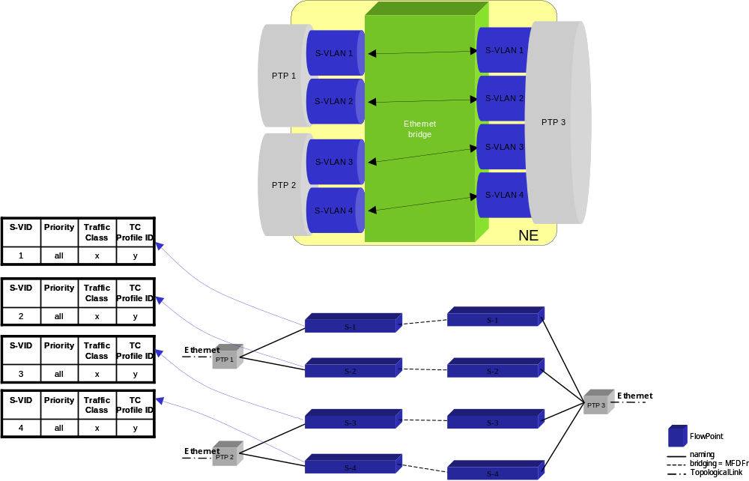
Figure 5: Example of Provider Bridge
Table 4 shows the effect of “Get contained” operations on PTP_3.
Table 4: Behaviour of "Get Contained" operations on an Ethernet “CPTP” port
CTP Type | Potential | Terminated and Mapped | Cross-connected (Pending) | Cross-connected (Active) | In Use | Current
Ethernet FPs | 0 | 0 | 0 | 4 | 4 | 4
Total CTPs | 0 | 0 | 0 | 4 | 4 | 4

Potential Flow Points
The getContainedPotentialTPNames operation returns an empty list of flow point names.
- getContainedPotentialTPNames
in tpName: PTP #x,
in layerRateList: 96 = LR_Ethernet
out (0 FPs):
(empty list)

In Use (“Active”, “Existing”) / “Current” Flow Points
The getContainedInUseTPNames and the getContainedCurrentTPNames operations both return the names of all FPs that are currently involved in a flow domain fragment.
- getContainedInUseTPNames
in tpName: PTP #x,
in layerRateList: 96 = LR_Ethernet
out (4 FPs):
EMS="...", ManagedElement="...", PTP= "PTP_3", CTP="/ethsvid=1"
EMS="...", ManagedElement="...", PTP= "PTP_3", CTP="/ethsvid=2"
EMS="...", ManagedElement="...", PTP= "PTP_3", CTP="/ethsvid=3"
EMS="...", ManagedElement="...", PTP= "PTP_3", CTP="/ethsvid=4"

Administrative Appendix

Document History
Version | Date | Description of Change
3.0 | April 2004
3.1 | August 2006 | Added section 5 on connectionless CTPs (flow points).
3.2 | October 2006 | Corrections.
3.3 | November 2007 | Removed reference to MTNM.

Acknowledgments

First Name | Last Name | Company

How to comment on this document
Comments and requests for information must be in written form and addressed to the contact identified below:

Keith | Dorking | CIENA
Phone: | +1 678 867 5007
Fax: | +1 678 867 5010
e-mail: | Kdorking@ciena.com

Please be specific, since your comments will be dealt with by the team evaluating numerous inputs and trying to produce a single text. Thus we appreciate significant specific input. We are looking for more input than wordsmith” items, however editing and structural help are greatly appreciated where better clarity is the result.

For the sake of legibility, the TP names in these lists are interleaved with bullet paragraphs giving the type of TP. Colour is used for easier recognition. In the real interface, an uninterrupted stream of TP names is returned.

