This document compares BA, IA and IIS of the Network Resource Assurance DDP

References:
BA: TMF518_NRA.doc 484 19.06.07 20:39 kdorking
IA:
IIS: Asap.xsd 658 13.08.07 11:39 driss
CommonTypes.xsd 658 13.08.07 11:39 driss
Pmp.xsd 658 13.08.07 11:39 driss
Tcapp.xsd 658 13.08.07 11:39 driss
Epgp.xsd 590 23.07.07 16:07 jeromem (Epgp.xsd is located in the NRF DDP not in NRA DDP.)
Pgp.xsd 487 20.06.07 16:31 jeromem (Pgp.xsd is located in the NRF DDP not in NRA DDP.)
SDs:

Conventions:
yellow marked items are to be corrected (often discussion necessary)
turquoise marked items are to be added/changed

Content:
1 High level UML diagrams 3
1.1 NRA DDP Relationship Diagram 3
1.2 NRA Class Diagram 4
1.3 NRA ASAP Class Diagram 5
1.4 NRA Notifications Diagram 6
2 Objects 7
2.1 Alarm Severity Assignment Profile 7
2.2 Performance Monitoring Point (PMP) 11
2.3 Equipment Protection Group (EPG) 16
2.4 Protection Group (PG) 18
2.5 Threshold Crossing Alert (TCA) Parameter Profile 20
3 Notifications 22
3.1 AID 22
3.2 Threshold Crossing Alert (TCA) Notification 22
3.3 Alarm Notification 24
3.4 Performance Monitoring Point (PMP) State Change Notification 30
4 new section 32

Figures:
Figure 1: NRA DDP Relationship Diagram 3
Figure 2: NRA Class Diagram 4
Figure 3: NRA ASAP Class Diagram 5
Figure 4: NRA Notifications Diagram 6

History:
Version | Date | Description of Change
 | 30.08.2007 | Initial version.

High level UML diagrams

NRA DDP Relationship Diagram
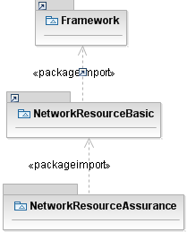
Figure 1: NRA DDP Relationship Diagram

NRA Class Diagram
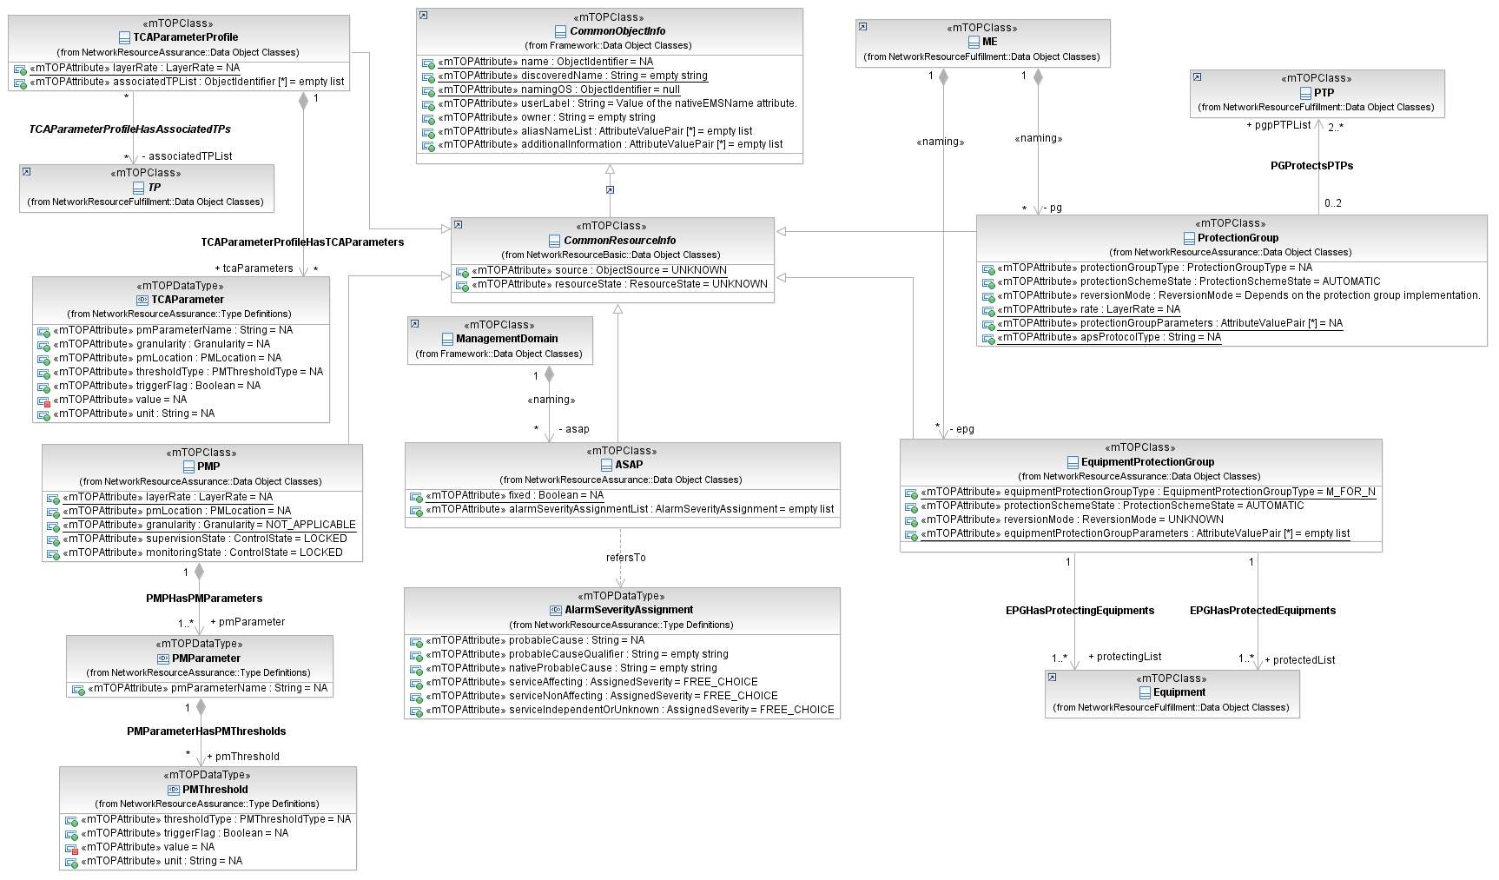
Figure 2: NRA Class Diagram

NRA ASAP Class Diagram
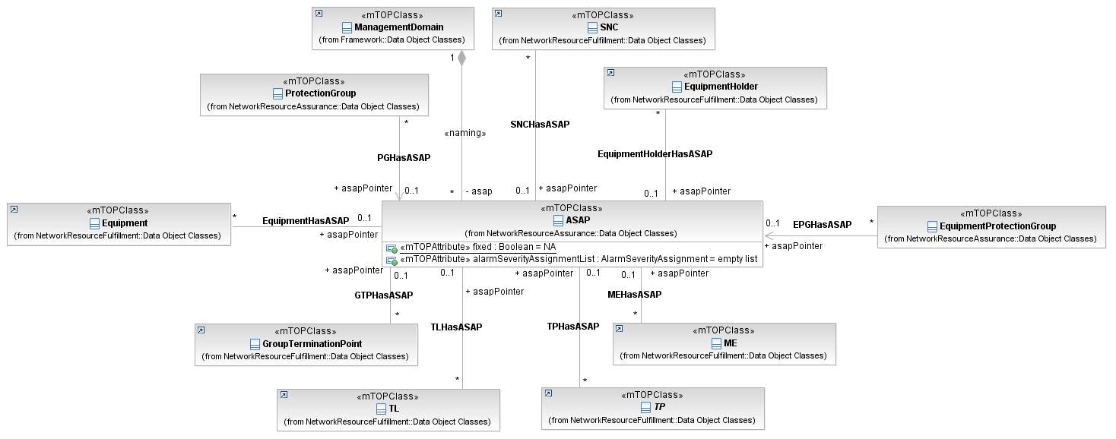
Figure 3: NRA ASAP Class Diagram

NRA Notifications Diagram
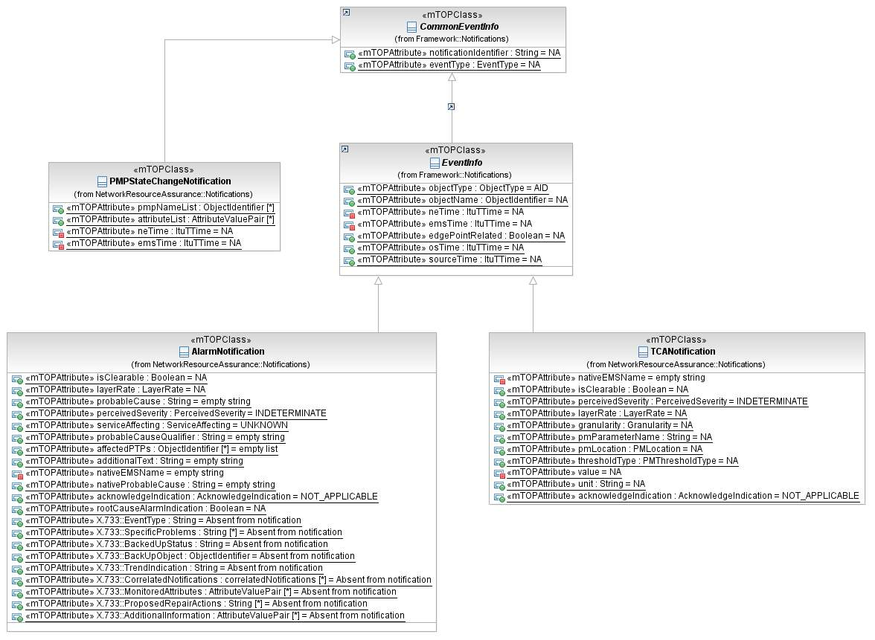
Figure 4: NRA Notifications Diagram

Objects

Alarm Severity Assignment Profile

BA (AlarmSeverityAssignmentProfile) | IA | IIS | Comments
R_TMF518_NRA_I_0001  The Alarm Severity Assignment Profile (ASAP) object shall represent a set of severities that can be assigned to specific alarm probable causes.  An ASAP is contained within an OS. | The object class AlarmSeverityAssignmentProfile (ASAP) models the (flexible) severity assignment to specified probable causes. So the ASAP object includes a table, with each row specifying the probable cause (plus optionally the probableCauseQualifier and / or the nativeProbableCause) and the assigned severity for "service affecting", "non service affecting" and "service independent or unknown" alarms.  Probable cause, probableCauseQualifier and nativeProbableCause are the coordinates of the ASAP entries, so there must not be two ASAP entries with the same coordinates. It is the responsibility of the EMS to enforce this.  Alarms against entities that are not modeled by the interface are reported using the "AID" objectType. For these "AID" alarms the ASAP mechanism is not applicable.  Typically the ASAP function is implemented in the OS or NE where the alarm is originated. I. e. the severity will usually be assigned directly by the NE, so it is up to the EMS to download the defined ASAP to the NE. Other alarms, e.g. on arcs like SNCs, may be generated by the EMS.  An alarm becomes reportable by NE/EMS:  - when for PTP, CTP, FTP: AlarmReporting changes from "off" to "on"  - when for SNC, TopologicalLink, Equipment, EquipmentHolder, GTP: alarmReportingIndicator changes from false to true.  Alarms are always reportable for all other objects as they do not have any alarm reporting attribute.  When an alarm becomes reportable the ASAPs are applied (accessed via the asapPointer). The severity of the alarm is adopted from the ASAP entry that matches for all of the following:  - same probableCause  - same probableCauseQualifier (an empty string is a match)  - same nativeProbableCause (an empty string is a match).  For example, if the reportable alarm has LOS probableCause and an ASAP entry is found with LOS probableCause and both probableCauseQualifier and nativeProbableCause are empty strings, then the search is successful.  If there is a matching ASAP, then the severities are adopted on the following basis:  - the alarm is service affecting: the severity specified in the serviceAffecting field is assigned  - the alarm is service non affecting: the severity specified in the serviceNonAffecting field is assigned  - the alarm is service independent or NE/EMS is not equipped to determine if the alarm affects service or not:  the severity specified in the serviceIndependentOrUnknown field is assigned.  If the assigned severity specified in the ASAP is:  - "FREE_CHOICE" then the NE/EMS are free to determine the severity. If there is no local mechanism on  the ME/EMS to determine severity then the severity "INDETERMINATE" should be assigned.  - "NOTALARMED" then the EMS should not emit an alarm over the EML-NML interface.  If there is no ASAP that matches, then the NE/EMS is free to determine the severity. If there is no local mechanism on the NE/EMS to determine severity then the severity "INDETERMINATE" should be assigned.  Once a severity has been assigned, the alarm notification is emitted (other than for "NOTALARMED").  Note: Any operation of alarm retrieval will not include "NOTALARMED" alarms.  Object Lifecycle: Created and deleted by EMS and NMS.  Object Creation Notification Issued? Yes  Object Deletion Notification Issued? Yes | AlarmSeverityAssignmentProfile_T  This aggregate defines all the AlarmSeverityAssignmentProfile mTOP network resource object attributes.
R_TMF518_NRA_I_0002  An ASAP object shall have, in addition to the attributes identified in requirement R_TMF518_NRB_I_0001, the following attributes:  - fixed - this attribute shall indicate whether the ASAP is modifiable by an OS. If not, the ASAP can be neither modified nor deleted by an OS, but only assigned/de-assigned.  - alarmSeverityAssignmentList - this attribute shall represent a list of Alarm Severity Assignments (ASA). Refer to requirement R_TMF518_NRA_I_0003 for the details of an ASA. | 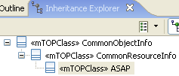  fixed (Boolean = NA; static, readOnly)  This attribute defines if the Alarm Severity Assignment Profile (ASAP) is fixed or not.  If true, then this ASAP instance is fixed, i.e. is an ASAP which is defined at NE or EMS level and can be neither modified nor deleted through MTNM interface, but only assigned/de-assigned.  If false, otherwise.  alarmSeverityAssignmentList (AlarmSeverityAssignment = empty list)  This attribute identifies a list of Alarm Severity Assignments. Each record of this sequence specifies the probable cause (plus optionally the probableCauseQualifier and / or the nativeProbableCause) and the severities to be assigned.  Changes in the value of this attribute lead to an AVC notification. | AlarmSeverityAssignmentProfile_T  xsd:extension base="cri:CommonResourceInfo_T  This element entails the attributes common to all mTOP network resource objects.  fixed (boolean)  This attribute indicates whether the ASAP is modifiable by an OS. If not, the ASAP can be neither modified nor deleted by an OS, but only assigned/de-assigned.  alarmSeverityAssignmentList (tns:AlarmSeverityAssignmentList_T)  This attribute represents a list of Alarm Severity Assignments (ASA). Refer to requirement R_TMF518_NRA_I_0003 for the details of an ASA.
R_TMF518_NRA_I_0003  The Alarm Severity Assignment (ASA) object shall represent the specific severities for the various service affecting conditions that are to be assigned to a specific alarm probable cause. The attributes of an ASA are:  - probableCause - this attribute shall represent the name of a specific probable cause to which the severities are to be assigned. Refer to supporting document for  - probableCauseQualifier - this attribute shall represent the probable cause qualifier and shall be present if the probable cause attribute is not sufficient to uniquely identify an alarm. OPTIONAL  - nativeProbableCause - this attribute shall represent the native probable cause. OPTIONAL  - serviceAffectingSeverity - this attribute shall represent the value to be assigned in the case where the reportable alarm is service affecting.  - non-ServiceAffectingSeverity - this attribute shall represent the severity value to be assigned in the case where the reportable alarm is non-service affecting.  - serviceIndependentSeverity - this attribute shall represent the severity value to be assigned in the case where the reportable alarm is service independent. This severity value may also be assigned in the case where the reporting OS is unable to determine whether the alarm is service affecting or not. | Alarm Severity Assignment  This data type structure provides three values for severity to cover the three cases of service affecting conditions, non- service affecting conditions and conditions where the service impact is unknown. The structure identifies the specific case of alarm that it applies to using three probable cause identifiers in combination.  See also attached supporting document for further details on the values of the strings probableCause, probableCauseQualifier and nativeProbableCause.  Object Lifecycle: NA  Object Creation Notification Issued? No  Object Deletion Notification Issued? No  probableCause (String = NA)  This attribute identifies the probable cause of the alarm to which the severities should be applied to.  See attached supporting document.  probableCauseQualifier (String = empty string)  This attribute identifies a qualifier of the probable cause that is used to achieve uniqueness in some cases where the probable cause is not sufficient.  nativeProbableCause (String = empty string)  This attribute identifies the probable cause used on the NE/EMS. This may also be used to qualify the probable cause to achieve uniqueness in some cases where the probable cause is not sufficient.  serviceAffectingSeverity (AssignedSeverity = FREE_CHOICE)  This attribute identifies the severity assigned to the probable cause when service affecting.  serviceNonAffectingSeverity (AssignedSeverity = FREE_CHOICE)  This attribute identifies the severity assigned to the probable cause when not service affecting.  serviceIndependentOrUnknown (AssignedSeverity = FREE_CHOICE)  This attribute identifies the severity assigned to the probable cause when the service impact is not known. | AlarmSeverityAssignment_T  The Alarm Severity Assignment (ASA) object represents the specific severities for the various service affecting conditions that are to be assigned to a specific alarm probable cause.  xsd:extension base="cri:CommonResourceInfo_T"  This element entails the attributes common to all mTOP network resource objects.  probableCause (prc:ProbableCause_T)  The name of a specific probable cause to which the severities are to be assigned.  probableCauseQualifier (tns:ProbableCauseQualifier_T)  tThe probable cause qualifier and shall be present if the probable cause attribute is not sufficient to uniquely identify an alarm.  nativeProbableCause (tns:NativeProbableCause_T)  The native probable cause.  serviceAffecting (com:AssignedSeverity_T)  The value to be assigned in the case where the reportable alarm is service affecting.  nonServiceAffectingSeverity (com:AssignedSeverity_T)  The severity value to be assigned in the case where the reportable alarm is non-service affecting.  serviceIndependentSeverity (com:AssignedSeverity_T)  tThe severity value to be assigned in the case where the reportable alarm is service independent. This severity value may also be assigned in the case where the reporting OS is unable to determine whether the alarm is service affecting or not.  <!-- ================ -->  ProbableCauseQualifier_T (?)  Represents the probable cause qualifier and shall be present if the probable cause attribute is not sufficient to uniquely identify an alarm.  NativeProbableCause_T (?)  Represents the native probable cause.  AssignedSeverity_T (?)  The assigned severity is allocated to a probable cause using the alarm severity assignment profile.  The identified probable cause should be raised with the assigned severity.  The assignment of severities is extended beyond PerceivedSeverity to cover the case where:  - no alarm should be raised: "NOT_ALARMED"  - the EMS/NE is free to make a choice based upon its local criteria: "FREE_CHOICE"  All extensions are permitted (VENDOR_EXT and MINOR_EXT).  xsd:extension base="tns:AssignedSeverityEnum_T"  AssignedSeverityEnum_T  The enum values of a probable cause.  <xsd:restriction base="xsd:string">  <xsd:enumeration value="INDETERMINATE"/>  <xsd:enumeration value="CRITICAL"/>  <xsd:enumeration value="MAJOR"/>  <xsd:enumeration value="MINOR"/>  <xsd:enumeration value="WARNING"/>  <xsd:enumeration value="NOT_ALARMED"/>  <xsd:enumeration value="FREE_CHOICE"/>  </xsd:restriction> | BZ: Which SD is here referenced? (SD1-33_ProbableCauses.pdf)

Performance Monitoring Point (PMP)

BA (Performance Monitoring Point) | IA | IIS | Comments
R_TMF518_NRA_I_0004  The Performance Monitoring Point (PMP) object shall represent an access point at which performance monitoring and threshold supervision are provided for a set of PM parameters.  It is contained in a Termination Point (TP) .  All PMPs contained in a TP constitute the PM capabilities of the containing TP. | PMP  This object class represents one performance monitoring point including performance monitoring and threshold supervision.  There always exists one PMP for every triple of layer rate, PM location and granularity for which the containing TP is capable to monitor performance.  Thus, its existence reflects the TP's PM capabilities.  Object Lifecycle: Created and deleted by EMS.  Object Creation Notification Issued? Yes  Object Deletion Notification Issued? Yes | PerformanceMonitoringPoint_T  This object represents one performance monitoring point (PMP). It is determined by the containing TerminationPoint (TP) and by the layer rate, the PM location and the granularity the monitoring is done for. PMP objects are contained in TPs and represent the PM capabilities of their containing TP(s).  Activation and deactivation of Performance Monitoring respectively Performance Threshold Supervision is achieved by changing the Monitoring State or Supervision State of the related PMP.  The monitoring state of a PMP is set to:  - unlocked using the operation enablePMData, (activate Performance Monitoring)  - locked using the operation disablePMData, (deactivate Performance Monitoring)  The supervision state of a PMP is set to:  - unlocked by using the operation enableTCA, (activate Performance Threshold Supervision),  - locked by using the operation disableTCA, (deactivate Performance Threshold Supervision).
R_TMF518_NRA_I_0005  A PMP object shall have, in addition to the attributes identified in requirement R_TMF518_NRB_I_0001, the following attributes:  - layerRate - this attribute shall represent the layer rate of the PMP. The layer specified must be supported by the containing TP. Refer to requirement R_TMF518_NRB_I_0002.  - location - this attribute shall represent the location of the performance monitoring measurement.  - granularity - this attribute shall represent the time granularity of the PMP, either 15 minutes or 24 hours. This attribute is not applicable for instantaneous measurements (i.e. gauge type measurements).  - supervisionState - this attribute shall represent whether threshold supervision is enabled or disabled.  - monitoringState - this attribute shall represent whether performance monitoring is enabled or disabled.  - pmParameterList - this attribute shall represent a list of the names of the PM parameter associated with the PMP. Refer to supporting document PerformanceParameters.pdf for the list of currently defined performance parameters.  - PM thresholds – this attribute shall represent a list of the names of the thresholds associated with each PM parameter. Refer to R_TMF518_NRA_I_0006 | 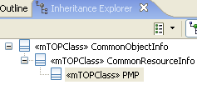  layerRate (LayerRate = NA; static, readOnly)  This attribute defines the layer rate of the PerformanceMonitoringPoint.  The layer specified must be supported by the termination point.  pmLocation (PMLocation = NA; static, readOnly)  This attribute identifies the location of the PM measure.  See attached supporting document SD1-19_LocationIdentification.pdf.  granularity (NetworkResourceAssurance::Type Definitions::Granularity = NOT_APPLICABLE; static, readOnly)  This attribute defined the granularity of the PerformanceMonitoringPoint measurement interval. For counters two values "15_MIN" or "24_H" are supported. For current instantaneous measurements the granularity does not apply which is indicated by the value "NOT_APPLICABLE".  supervisionState (ControlState = LOCKED)  This attribute identifies whether performance threshold supervision is enabled or disabled for the PMP.  Changes in this attribute lead to a State Change notification.  Writeable by NMS? Via operations enableTCA() / disableTCA()  monitoringState (ControlState = LOCKED)  This attribute identifies whether performance monitoring is enabled or disabled for the PMP.  Changes in this attribute lead to a State Change notification.  Writeable by NMS? Via operations enablePMData() / disablePMData()  Relationship PMPHasPMParameters to PMParameter  This attribute represents a list of the names of the PM parameter associated with the PMP.  This attribute holds the name of Performance Measurements. It has been defined as a string to accommodate proprietary extensions.  See attached supporting document SD1-28_PerformanceParameters for the list of defined Performance Measurements.  Relationship PMParameterHasPMThresholds to PMThreshold  This attribute represents a list of the names of the thresholds associated with each PM parameter. | PerformanceMonitoringPoint_T  xsd:extension base="cri:CommonResourceInfo_T  This element entails the attributes common to all mTOP network resource objects.  layerRate (lay:LayerRate_T)  Represents the layer rate of the PMP. The layer specified must be supported by the containing TP.  location (gen:Location_T)  Represents the location of the performance monitoring measurement.  granularity (tns:PMGranularity_T)  Represents the time granularity of the PMP, either 15 minutes or 24 hours. This attribute is not applicable for instantaneous measurements (i.e. gauge type measurements).  supervisionState (itu:X721.AdministrativeState_T)  Represents whether threshold supervision is enabled or disabled.  monitoringState (itu:X721.AdministrativeState_T)  Represents performance monitoring is enabled or disabled.  pmParameterList (tns:PMParameterNameList_T)  Represents a list of the names of the PM parameter associated with the PMP. Refer to supporting document PerformanceParameters.pdf for the list of currently defined performance parameters.  pmParameterWithThresholdsList (tns:PMThresholdList_T)  Represents a list of the names of the thresholds associated with each PM parameter.  <!-- ================ -->  PMParameterWithThresholdsList_T  A list of PMParameterWithThresholds.  pmParameterWithThresholdsList (tns:PMParameterWithThresholds_T)  <!-- ================= -->  PMParameterWithThresholds_T  This structure represents the list of thresholds associated with a particular PM Parameter.  pmParameterName (tns:PMParameterName_T)  Represents the name of the PM Measure.  pmThresholdList (tns:PMThresholdList_T)  Holds the list of PM thresholds associated with the named PM parameter.  <!-- ================ -->  PMParameterNameList_T  A list of PMParameterName.  pmParameterNameList (tns:PMParameterName_T)  <!-- ================= -->  PMParameterName_T  Holds the name of Performance Measurements. It has been defined as a string to accommodate backward compatibility and proprietary extension. For currently standardized values see Performance Parameters.  <!-- ================ -->  PMGranularity_T  Describes threshold types (watermark levels) for TCA parameters. The TWM_HIGH and TWM_HIGHEST types are used for TCAs that are raised when the measured value goes above the threshold. The TWM_LOW and TWM_LOWEST types are used for TCAs that are raised when the measured value goes below the threshold (only apply to gauges).  When there is only one level of TCA trigger, only TWM_HIGH and/or TWM_LOW are used. When there are two levels of TCA triggers, TWM_HIGHEST and/or TWM_LOWEST are used in addition.  See SD1-37 PM Threshold Types for information on how water mark levels are used.  <xsd:restriction base="xsd:string">  <xsd:enumeration value="TWM_HIGHEST "/>  <xsd:enumeration value="TWM_HIGH "/>  <xsd:enumeration value="TWM_LOW "/>  <xsd:enumeration value="TWM_LOWEST "/>  </xsd:restriction>
R_TMF518_NRA_I_0006  The PM Threshold object shall represent the specific severities for the various service affecting conditions that are to be assigned to a specific alarm probable cause.  - thresholdType - this attribute shall represent the type of the PM threshold, (shall indicate the level at which the threshold is triggered or cleared).  - trigger - this attribute shall indicate whether the PM threshold shall trigger a raise or a clear TCA.  - value - this attribute shall represent the value for the PM threshold parameter.  - measurementUnits - this attribute shall represent the unit of measurement for the PM threshold parameter. | PMThreshold data type  This data type lists all configured thresholds of the containing PM parameter. The PMThreshold object covers the ability of the NE to supervise thresholds on a specific PMParameter (i.e. if the NE is able to supervise thresholds on a PM parameter the object PMThreshold has to exist, otherwise will never exist).  thresholdType (PMThresholdType = NA)  This attribute identifies the type of the threshold value.  Valid values are:  "Highest"  "High"  "Low"  "Lowest".  Changes in the attribute lead to an AVC notification.  triggerFlag (Boolean = NA)  This attribute indicates if the threshold is for the trigger (true) or the clear (false).  See attached document for explanation.  Changes in the attribute lead to an AVC notification.  value (float = NA)  This attribute identifies the value for the PM threshold parameter (float used to incorporate gauge PM parameters).  Changes in the attribute lead to an AVC notification.  unit (String = NA)  This attribute identifies the unit for the threshold value in a free format string.  Changes in the attribute lead to an AVC notification. | PMThresholdList_T  A list of PMThresholds.  pmThreshold (tns:PMThreshold_T)  <!-- ================= -->  PMThreshold_T  This structure represents a Performance Monitoring Threshold.  thresholdType (tns:PMThresholdType_T)  Represents the type of threshold value.  trigger (boolean)  Indicates if the threshold is for the trigger (TRUE) or the clear (FALSE).  value (float)  Threshold value (float used to incorporate gauge PM parameters).  measurementUnits (string)  Free format string describing the units for the threshold value.  <!-- ================ -->  PMThresholdType_T  Count period (interval) for which PM data may be collected (and subsequently retrieved). The value is one of:  "15min" (15 minute interval collection)  "24h" (24 hour interval collection)  "NA" (for current instantaneous measurements)  <xsd:restriction base="xsd:string">  <xsd:enumeration value="15min "/>  <xsd:enumeration value="24h "/>  <xsd:enumeration value="NA "/>  </xsd:restriction>

Equipment Protection Group (EPG)

BA (Equipment Protection Group) | IA | IIS | Comments
R_TMF518_NRA_I_0007  The Equipment Protection Group (EPG) object shall represent Equipment protection. | EquipmentProtectionGroup  This object represents the information about the equipment protection group in a managed element which is used to model equipment protection.  MTOSI Specific Documentation  This class is applicable to MTOSI. The specific operations and relationships that apply to MTOSI are listed in SD2-11.  For MTOSI, references to "NMS" can be interpreted as "Requesting OS" and references to "EMS" can be interpreted as "Target OS", i.e., the OS that fulfills requests from another OS.  The statements concerning Object Lifecycle, i.e., whether the object can be created by the NMS or EMS, are not particularly meaningful for MTOSI, since MTOSI does not define management systems with fixed roles such as the NMS and EMS entities in MTNM.  Object Lifecycle: Created and deleted by EMS.  Object Creation Notification Issued? Yes  Object Deletion Notification Issued? Yes  Object Discovery Notification Issued? Yes
R_TMF518_NRA_I_0008  An EPG object shall have, in addition to the attributes identified in requirement R_TMF518_NRB_I_0001, the following attributes:  - type - this attribute shall represent the type of the EPG (e.g. M:N).  - protectionSchemeState -this attribute shall indicate the current state of the protection scheme (i.e. whether it is active or locked).  - reversionMode - this attribute shall indicate whether the protection scheme is revertive or not.  - pgParameterList - this attribute shall represent the EPG specific parameters. For example SwitchMode, SwitchPosition, wait to restore time.  - protectedEquipmentList - these attribute shall represent a list of the protected Equipment instances.  - protectingEquipmentList - this attribute shall represent a list of the protecting Equipment instances.  - alarmSeverityAssignmentProfile - this attribute shall represent the name of the Alarm Severity Assignment Profile (ASAP) that has been assigned to the EPG. | 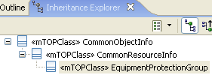  equipmentProtectionGroupType (EquipmentProtectionGroupType = M_FOR_N; static, readOnly)  This attribute defines the type of scheme this group represents (so far, only M:N equipment protection has been identified).  protectionSchemeState (ProtectionSchemeState = AUTOMATIC; readOnly)  This attribute indicates whether the protection scheme is active or frozen locked out because of a forced switch command. This is an indicator whether the protection scheme is free to switch or is in a state where it cannot switch freely, without an explicit clear command applied to the protection scheme. FORCED_OR_LOCKED_OUT indicates that the entire group is locked; partial locking is indicated by AUTOMATIC (partial locking could be done via operation PerformProtectionCommand in CTP).  reversionMode (ReversionMode = UNKNOWN; readOnly)  This attribute defines whether the protection scheme is revertive or not.  equipmentProtectionGroupParameters (AttributeValuePair [*] = empty list; static, readOnly)  This attribute contains a name value list of the associated parameters for the equipment protection group.  No equipment Protection Group parameters have been identified.  Relationship EPGHasProtectedEquipments to Equipment  This attribute provides a list of the protected equipment instances. For M:N equipment protection, this list would have N elements.  Relationship EPGHasProtectingEquipments to Equipment  This attribute provides a list of the protecting equipment instances. For M:N equipment protection, this list would have M elements.  Relationship EPGHasASAP to ASAP  This attribute indicates the assignment of an ASAP to the EquipmentProtectionGroup.  Changes in the value of this attribute (regardless of the initiator) lead to an AVC notification.  Writeable by NMS? Only via assignASAP/deassignASAP operations. | EquipmentProtectionGroup_T  This aggregate defines all the EquipmentProtectionGroup mTOP network resource object attributes.  xsd:extension base="cri:CommonResourceInfo_T  This element entails the attributes common to all mTOP network resource objects.  eProtectionGroupType (EProtectionGroupType_T)  protectionSchemeState (ProtectionSchemeState_T)  reversionMode (ReversionMode_T)  ePgpParameters (?)  The epgpParameters contains a list of the associated parameters for the equipment protection group. It is a readonly attribute.  protectedList (NamingAttributesList_T)  This provides a list of the protected equipment instances. For M:N equipment protection, this list would have N elements.  protectingList (NamingAttributesList_T)  This provides a list of the protecting equipment instances. For M:N equipment protection, this list would have M elements.  G_774_3_APSfunction (G_774_3_APSfunction_T)  ASAPPointer | BZ1: Epgp.xsd is located in the NRF DDP not in NRA DDP.  BZ2: EquipmentProtectionGroupType from NRB.

Protection Group (PG)

BA (Protection Group) | IA | IIS | Comments
R_TMF518_NRA_I_0009  The Protection Group (PG) object shall represent trail protection schemes. | This object represents the information about the protection group in a managed element. This object models a trail protection.  MTOSI Specific Documentation  This class is applicable to MTOSI. The specific operations and relationships that apply to MTOSI are listed in SD2-11.  For MTOSI, references to "NMS" can be interpreted as "Requesting OS" and references to "EMS" can be interpreted as "Target OS", i.e., the OS that fulfills requests from another OS.  The statements concerning Object Lifecycle, i.e., whether the object can be created by the NMS or EMS, are not particularly meaningful for MTOSI, since MTOSI does not define management systems with fixed roles such as the NMS and EMS entities in MTNM.  Object Lifecycle: Created and deleted by EMS.  Object Creation Notification Issued? Yes  Object Deletion Notification Issued? Yes  Object Discovery Notification Issued? Yes
R_TMF518_NRA_I_0010  A PG object shall have, in addition to the attributes identified in requirement R_TMF518_NRB_I_0001, the following attributes:  - type - this attribute shall represent the type of the PG.  - protectionSchemeState - this attribute shall indicate the current state of the protection scheme (i.e. whether it is active or locked).  - reversionMode - this attribute shall indicate whether the protection scheme is revertive or not.  - layerRate - refer to requirement R_TMF518_NRB_I_0002.  - pgParameters - this attribute shall represent the Protection Group specific parameters (e.g. switch mode, switch position, wait to restore time etc.).  - apsProtocolType - this attribute shall indicate the type of APS protocol supported by the PG.  - alarmSeverityAssignmentProfile - this attribute shall represent the name of the Alarm Severity Assignment Profile (ASAP) (refer to R_TMF518_NRA_I_0001) that has been assigned to the PG.  - protectionRelatedPTPList - this attribute shall represent a list of the Physical Termination Point (PTP) (s) related by the PG. | 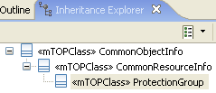  protectionGroupType (ProtectionGroupType = NA; static, readOnly)  This attribute identifies the type of the protection group.  protectionSchemeState (ProtectionSchemeState = AUTOMATIC; readOnly)  This attribute identifies the state in which the protection scheme is in. PSS_FORCED_OR_LOCKED_OUT indicates that the entire group is locked; partial locking is indicated by PSS_AUTOMATIC.  Individual locks can be reported through transmission parameters on the appropriate TPs.  Changes in the value of this attribute lead to a State Change notification.  reversionMode (ReversionMode = Depends on the protection group implementation.; readOnly)  This attribute identifies whether the switch is revertive or not.  Changes in the value of this attribute lead to an AVC notification.  rate (LayerRate = NA; static, readOnly)  This attribute identifies the line rate of the PTPs of the protection group.  protectionGroupParameters (AttributeValuePair [*] = NA; static, readOnly)  This attribute identifies any protection group specific parameters. Non-applicable parameters and parameters for which the value is unknown to the target OS may be left out.  See attached supporting document PGPParameters for values and descriptions.  apsProtocolType (String = NA; static, readOnly)  This attribute defines the APS protocol on which the switching function is based on.  Possible values:  - "G.783" in case of K1/K2 based APS  - "Legacy" in case of proprietary APS protocol, as for radio equipment.  Relationship PGHasASAP to ASAP  This attribute indicates the assignment of an ASAP to the ProtectionGroup.  Changes in the value of this attribute (regardles of the initiator) lead to an AVC notification.  Writeable by NMS? Only via assignASAP/deassignASAP operations.  Relationship PGProtectsPTPs to PTP  This attribute contains the list of TPs that belong in the protection group. The list of TPs is partially ordered. The protecting TP always trails its worker TPs. The East TPs are always contiguous in the list, as well as West TPs. | ProtectionGroup_T  This aggregate defines all the ProtectionGroup mTOP network resource object attributes.  xsd:extension base="cri:CommonResourceInfo_T  This element entails the attributes common to all mTOP network resource objects.  protectionGroupType (ProtectionGroupType_T)  protectionSchemeState (ProtectionSchemeState_T)  reversionMode (ReversionMode_T)  rate (LayerRate_T)  Line rate of the PTPs of the protection group. It is a readonly attribute.  pgpParameters (PgpParameters_T)  The pgpParameters contains a list for the known parameters of the protection group. Non-applicable parameters and parameters for which the value is unknown to the EMS may be left out.  apsProtocolType  ASAPPointer  pgpTpList (NamingAttributesList_T)  This is the list of TPs that belong in the protection group. The list of TPs is partially ordered. The protecting TP always trails its worker TPs. The East TPs are always contiguous in the list, as well as West TPs.  G_774_3_APSfunction (G_774_3_APSfunction_T) | BZ1: Pgp.xsd is located in the NRF DDP not in NRA DDP.

Threshold Crossing Alert (TCA) Parameter Profile

BA (TCA Parameter Profile) | IA | IIS | Comments
R_TMF518_NRA_I_0011  A Threshold Crossing Alert (TCA) Parameter Profile object shall represent for a specific layer rate a set of Threshold Crossing Alert (TCA) Parameters associated with a set of Termination Point (TP)s. | The TCAParameterProfile (threshold crossing alert) object class contains per layer rate a set of PM parameter/threshold value pairs per granularity (e.g. VC12: ES / 50; 15min).  Instances of this class could be associated to TPs. A list of all associated TPs will be maintained in the profile.  Object Lifecycle: Created and deleted by EMS or NMS.  Object Creation Notification Issued? Yes; regardless of the initiator.  Object Deletion Notification Issued? Yes; regardless of the initiator. | TCAParameterProfile_T  This object represents one performance monitoring point (PMP). It is determined by the containing TerminationPoint (TP) and by the layer rate, the PM
R_TMF518_NRA_I_0012  A TCA Parameter Profile object shall have, in addition to the attributes identified in requirement R_TMF518_NRB_I_0001 , the following attributes:  - layerRate - this attribute shall represent the layer to which the PM threshold values apply. (Refer to requirement R_TMF518_NRB_I_0002).  - associatedTPList - this attribute shall represent a list of the Termination Point (TP) that are associated with the TCA Parameter Profile.  - tcaParameterList - | 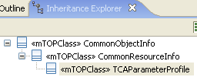  layerRate (LayerRate = NA; static, readOnly)  This attribute identifies the layer rate of the Profile to which the thresholds apply.  associatedTPs (ObjectIdentifier [*] = empty list)  This attribute contains the list of TPs that have been associated to this Profile.  Writeable by NMS? Yes (Via operation "setTCAParameterProfilePointer" defined in the "TerminationPoint" object.)  Relationship TCAParameterProfileHasTCAParameters to TCAParameter  This attribute represents a list of Threshold Crossing Alert (TCA) Parameters. | TCAParameterProfile_T  xsd:extension base="cri:CommonResourceInfo_T  layerRate (lay:LayerRate_T)  Represents the layer rate of the PMP. The layer specified must be supported by the containing TP.  associatedTPList (nam:NamingAttributesList_T)  Represents list of the Termination Point (TP) that are associated with the TCA Parameter Profile.  tcaParameterList (tns:TCAParameterList_T)  Represents a list of Threshold Crossing Alert (TCA) Parameters.
missing? | TCAParameter  This data type contains the TCA parameters assigned to the TCAParameterProfile.  pmParameterName (String = NA)  This attribute identifies the name of the Performance Measurements.  It has been defined as a string to accommodate proprietary extensions.  granularity (Granularity = NA)  This attribute defines the granularity of the TCAParameter.  For counters two values "15_MIN" or "24_H" are supported. For current instantaneous measurements the granularity does not apply which is indicated by the value "NOT_APPLICABLE".  pmLocation (PMLocation = NA)  This attribute identifies the location of the PM measure.  thresholdType (PMThresholdType = NA)  This attribute identifies the type of the threshold value.  Valid values are:  "Highest"  "High"  "Low"  "Lowest".  Changes in the attribute lead to an AVC notification.  triggerFlag (Boolean = NA)  This attribute identifies if the threshold is for the trigger (true) or the clear (false).  See attached document for explanation.  Changes in the attribute lead to an AVC notification.  value (float = NA)  This attribute identifies the value for the PM threshold parameter (float used to incorporate gauge PM parameters).  Changes in the attribute lead to an AVC notification.  unit (String = NA)  This attribute identifies the unit for the threshold value in a free format string.  Changes in the attribute lead to an AVC notification. | TCAParameterList_T  A list of TCAParameter_T.  tcaParameterList (tns:TCAParameter_T)  <!-- ================= -->  TCAParameter_T  This structure represents the list of thresholds associated with a particular PM Parameter.  pmParameterName (pmp:PMParameterName_T)  Holds the name of the SD1-28 Performance Parameters. It has been defined as a string to accomodate proprietary extension.  granularity (pmp:PMGranularity_T)  This attribute defines the granularity of the TCA Parameter. For counters two values "15min" or "24h" are supported. For current instantaneous measurements the granularity does not apply which is indicated by the value "N/A".  pmLocation (gen:Location_T)  Represents the location of the PM measure.  thresholdFlag (pmp:PMThresholdType_T)  Represents the type of threshold value.  triggerFlag (boolean)  Represents the type of threshold value.  value (float)  Threshold for parameter (float used to incorporate gauge PM parameters).  unit (string)  Free format string describing the units for the threshold value.

Notifications

AID

BA (AID) | IA | IIS | Comments
R_TMF518_NRA_I_0013
The Interface shall allow an OS to generate alarms against objects that are not explicitly modeled in the Interface by using the “AID” objectType.
The OS that generates the alarm shall ensure that all such entities have a unique value for the AID within the containing Network Element (NE).

Threshold Crossing Alert (TCA) Notification

BA (TCA Notification) | IA | IIS | Comments
R_TMF518_NRA_I_0014  A Threshold Crossing Alert (TCA) Notification is an event used across the Interface to indicate that a performance monitoring parameter threshold has been crossed.  A Threshold Crossing Alert (TCA) Notification shall have in addition to the attributes identified in R_TMF518_FMW_I_0016 and R_TMF518_FMW_I_0017 the following attributes:  - Alias name(s) – this attribute represents an alias (or set of aliases) for the object whose threshold has been crossed. The native EMS name is an example alias.  - Clearable – see R_TMF518_NRA_I_0017Wording in TMF513 is ambiguous concerning this attribute.  - Perceived severity – this attribute shall indicate (when the TCA is reported as an alarm) whether it is a raise (value shall be INDETERMINATE) or a clear (value shall be CLEARED) alarm.  - Layer rate – this attribute shall indicate the layer at which the threshold was crossed.  - Granularity – this attribute shall represent the time granularity of the TCA, either 15 minutes or 24 hours. This attribute is not applicable for instantaneous measurements (i.e. gauge type measurements).  - Parameter name, Parameter location, Threshold type, Value and Measurement units – need to reference the requirement concerning the Threshold Crossing Alert (TCA) Parameter object in the DM-DDP on assurance (once this document is created). This was Requirement I.035 in TMF513 Version 3.0.  Acknowledgement – see R_TMF518_NRA_I_0023 | TCANotification  This object class holds details of a Threshold Crossing Alert.  Object Lifecycle: Created and deleted by EMS.  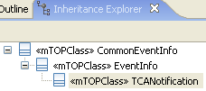  nativeEMSName = empty string  This attribute is owned by the EMS. It represents how an EMS user addresses an object on the EMS GUI.  isClearable (Boolean = NA; static, readOnly)  This attribute is True if the alarm/event represents a condition that will not be cleared at a later time (or is itself a clear); False otherwise.  perceivedSeverity (PerceivedSeverity = INDETERMINATE; static, readOnly)  This attribute identifies the severity of the threshold crossing alert.  layerRate (LayerRate = NA; static, readOnly)  This attribute identifies the layer rate to which the TCA applies.  granularity (Granularity = NA; static, readOnly)  This attribute defines the granularity of the TCA Alert.  For counters two values "15_MIN" or "24_H" are supported. For current instantaneous measurements the granularity does not apply which is indicated by the value "NOT_APPLICABLE".  pmParameterName (String = NA; static, readOnly)  This attribute identifies the name of the Performance Measurements.  It has been defined as a string to accommodate proprietary extensions.  pmLocation (PMLocation = NA; static, readOnly)  This attribute identifies the location of the PM measurement.  thresholdType (PMThresholdType = NA; static, readOnly)  This attribute identifies the type of the threshold which has been crossed.  value (Real = NA; static, readOnly)  This attribute identifies the details of the threshold that has been crossed, if known. It is optional.  unit (String = NA; static, readOnly)  This attribute identifies the unit of the measurement of the threshold that has been crossed, if known. It is optional.  acknowledgeIndication (AcknowledgeIndication = NOT_APPLICABLE; static, readOnly)  This attribute identifies if the alarm has been acknowledged or not.  In case the EMS does not support acknowledgement for this event or does not support acknowledgement at all NOT_APPLICABLE shall be used. | missing?

Alarm Notification

BA (Alarm Notification) | IA | IIS | Comments
R_TMF518_NRA_I_0015  An Alarm Notification is an event used across the Interface to indicate that a fault condition has occurred.  An Alarm Notification shall have in addition to the attributes identified in R_TMF518_FMW_I_0016 and R_TMF518_FMW_I_0017 the following attributes:  - Clearable – see R_TMF518_NRA_I_0017  - Layer rate – this is the layer rate at which the alarm occurred.  - Probable Cause – see R_TMF518_NRA_I_0018.  - Perceived severity – see R_TMF518_NRA_I_0019.  - Service affecting – see R_TMF518_NRA_I_0020.  - Probable Cause Qualifier – see R_TMF518_NRA_I_0016. OPTIONAL  - Affected PTPs – this attribute shall in the case of equipment related alarms represent the names of the affected Physical Termination Point (PTP) implemented by the alarmed equipment. OPTIONAL.  - Additional text – see R_TMF518_NRA_I_0022. OPTIONAL.  - Alias name(s) – this attribute represents an alias (or set of aliases) for the object whose threshold has been crossed. The native EMS name is an example alias. OPTIONAL.  - Native Probable Cause – this attribute shall represent the value of the probable cause shown on the user interface of the OS sending the alarm. OPTIONAL.  - Acknowledgement – see R_TMF518_NRA_I_0023.  - Root Cause Alarm indication – this attribute shall indicate whether the alarm is a raw (un-correlated) alarm or a root cause alarm indication.  - X.733 Event Type – this attribute shall represent the classification of the alarm in terms of the categories specified in ITU-T X.733. This is consistent with the ITU-T X.733 definition. OPTIONAL.  - X.733 Specific problems – this attribute shall represent a clarification of the Probable Cause of the alarm. This is similar to Probable Cause Qualifier, but this attribute is designed to be human readable and compatible with ITU usage. This is consistent with the ITU-T X.733 definition. OPTIONAL  - X.733 Backed-up status – this attribute shall represent whether or not the object emitting the alarm has been backed-up, and services provided to the user have, therefore, not been disrupted. This is consistent with the ITU-T X.733 definition OPTIONAL  - X.733 Back-up object – this attribute shall represent the object that is providing back-up services for the object to which the alarm notification pertains. This parameter shall be present when the X.733 Backed-up status attribute is present and indicates that the object has been backed up. This is consistent with the ITU-T X.733 definition. OPTIONAL.  - X.733 Trend indication – this attribute shall represent the current severity trend of the object it indicates that there are one or more alarms (“outstanding alarms”) which have not been cleared, and pertain to the same object as that to which this alarm (“current alarm”) pertains. This is consistent with the ITU-T X.733 definition. OPTIONAL  - X.733 Correlated notifications – this attribute shall represent the a set of Notification identifiers and, if necessary, their associated object names. This set is defined to be the set of all notifications to which this notification is considered to be correlated. The source object name shall be present if the correlated event report is from an object other than the one in which the Correlated Notifications parameter appears. Otherwise it shall be empty. This is consistent with the ITU-T X.733 definition. OPTIONAL.  - X.733 Monitored attributes – this attribute shall represent the one or more attributes of the managed object and their corresponding values at the time of the alarm. This is consistent with the ITU-T X.733 definition. OPTIONAL.  - X.733 Proposed repair actions – this attribute shall represent one or more possible solutions (such as switch in standby equipment, retry, replace media). This is consistent with the ITU-T X.733 definition. OPTIONAL.  - X.733 Additional Information – this attribute shall represent a set of additional information in an alarm notification. The same information can be directly encoded as separate parameters of the notification. However, this parameter is retained for consistency with ITU-T X.733. OPTIONAL. | This object class represents the information in an alarm notification.  MTOSI Specific Documentation  This class is applicable to MTOSI. The specific operations and relationships that apply to MTOSI are listed in SD2-11.  For MTOSI, references to "NMS" can be interpreted as "Requesting OS" and references to "EMS" can be interpreted as "Target OS", i.e., the OS that fulfills requests from another OS.  The statements concerning Object Lifecycle, i.e., whether the object can be created by the NMS or EMS, are not particularly meaningful for MTOSI, since MTOSI does not define management systems with fixed roles such as the NMS and EMS entities in MTNM.  Object Lifecycle: Created and deleted by EMS.  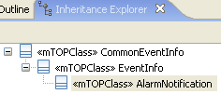  isClearable (Boolean = NA; static, readOnly)  This attribute is True if the alarm/event represents a condition that will not be cleared at a later time (or is itself a clear); False otherwise.  layerRate (NetworkResourceBasic::Type Definitions::LayerRate = NA; static, readOnly)  This attribute identifies the layer rate to which the alarm is relevant to.  probableCause (String = empty string; static, readOnly)  This attribute identifies further qualification as to the probable cause of the alarm.  No other string than the ones defined in the ProbableCause class shall be used for this field.  perceivedSeverity (PerceivedSeverity = INDETERMINATE; static, readOnly)  This attribute identifies the severity of the alarm.  serviceAffecting (ServiceAffecting = UNKNOWN; static, readOnly)  This attribute identifies whether the alarm has affected service.  probableCauseQualifier (String = empty string; static, readOnly)  This attribute, when present, may further qualify the source of the alarm.  Refer to supporting document SD1-33_ProbableCauses.pdf for the currently specified probable cause names.  affectedPTPs (ObjectIdentifier [*] = empty list; static, readOnly)  This attribute identifies all affected associated PTP names.  additionalText (String = empty string; static, readOnly)  This attribute contains a free form text description to be reported. The requested OS is not required to understand the semantics of this field for interpretation of the notification.  nativeEMSName = empty string; static, readOnly)  nativeProbableCause (String = empty string; static, readOnly)  This attribute identifies the probableCause as portrayed on the EMS user interface.  acknowledgeIndication (AcknowledgeIndication = NOT_APPLICABLE; static, readOnly)  This attribute identifies if the alarm has been acknowledged or not.  In case the EMS does not support acknowledgement for this event or does not support acknowledgement at all NOT_APPLICABLE shall be used.  rootCauseAlarmIndication (Boolean = NA; static, readOnly)  This attribute indicates whether an alarm is a raw (uncorrelated) alarm or a root cause alarm indication.  The attribute can have two values:  - True (meaning that the alarm is a Root Cause Alarm Indication)  - False (meaning the alarm is a raw alarm).  X.733::EventType (String = Absent from notification; static, readOnly)  This attribute, when present in an alarm notification, classifies the alarm into one of the five basic categories specified in ITU-T X.733.  This is consistent with the ITU-T X.733 definition.  Value is one of the following:  - "communicationsAlarm",  - "environmentalAlarm",  - "equipmentAlarm",  - "processingErrorAlarm",  - "qualityOfServiceAlarm".  X.733::SpecificProblems (String [*] = Absent from notification; static, readOnly)  This attribute, when present in an alarm notification, identifies further refinements to the Probable Cause of the alarm.  Note: It is similar to ProbableCauseQualifier, but this parameter is designed to be human readable and compatible with ITU usage.  This is consistent with the ITU-T X.733 definition.  X.733::BackedUpStatus (String = Absent from notification; static, readOnly)  This attribute, when present in an alarm notification, specifies whether or not the object emitting the alarm has been backed-up, and services provided to the user have, therefore, not been disrupted.  This is consistent with the ITU-T X.733 definition.  Value is one of the following:  - "BACKED_UP"  - "NOT_BACKED_UP".  X.733::BackUpObject (ObjectIdentifier = Absent from notification; static, readOnly)  This attribute, when present in an alarm notification, specifies the object that is providing back-up services for the object about which the notification pertains.  This parameter shall be present when the Backed-up status parameter is present and has the value "BACKED_UP".  This is consistent with the ITU-T X.733 definition.  X.733::TrendIndication (String = Absent from notification; static, readOnly)  This attribute, when present in an alarm notification, specifies the current severity trend of the object. If present it indicates that there are one or more alarms ("outstanding alarms") which have not been cleared, and pertain to the same object as that to which this alarm ("current alarm") pertains.  This is consistent with the ITU-T X.733 definition.  Value is one of the following:  - "MORE_SEVERE",  - "NO_CHANGE",  - "LESS_SEVERE".  X.733::CorrelatedNotifications (correlatedNotifications [*] = Absent from notification; static, readOnly)  This attribute, when present in an alarm notification, contains a set of Notification identifiers and, if necessary, their associated object names.  This set is defined to be the set of all notifications to which this notification is considered to be correlated.  The source object name shall be present if the correlated event report is from an object other than the one in which the Correlated Notifications parameter appears. Otherwise, it is Null (empty list).  This is consistent with the ITU-T X.733 definition.  X.733::MonitoredAttributes (AttributeValuePair [*] = Absent from notification; static, readOnly)  This attribute, when present in an alarm notification, defines one or more attributes of the managed object and their corresponding values at the time of the alarm.  This is consistent with the ITU-T X.733 definition.  X.733::ProposedRepairActions (String [*] = Absent from notification; static, readOnly)  This attribute, when present in an alarm notification, is used if the cause is known and the system being managed can suggest one or more solutions (such as switch in standby equipment, retry, replace media).  This is consistent with the ITU-T X.733 definition.  X.733::AdditionalInformation (AttributeValuePair [*] = Absent from notification; static, readOnly)  This attribute, when present in an alarm notification, allows the inclusion of a set of additional information in an alarm notification.  This is consistent with the ITU-T X.733 definition.  Note: The same information can be directly encoded as separate parameters of the notification. However, this parameter is retained for consistency with ITU-T X.733. | missing?
R_TMF518_NRA_I_0016
The Probable Cause Qualifier parameter, when present, identifies further refinements to the Probable cause of the alarm, so as to correlate the “raise” and “clear” notifications of the same fault condition in case of ambiguity (i.e., when several different fault conditions give rise to the same values). This parameter gives more detail about the alarm, e.g., it may further qualify the source. Refer to R_TMF518_NRA_I_0021.

R_TMF518_NRA_I_0017
An indication is required as to whether an alarm raise event will have an associated alarm clear event. If an alarm clear event is generated then the alarm is defined to be Clearable.
The same distinction is used in the Threshold Crossing Alert (TCA) Notification.

R_TMF518_NRA_I_0018  The Probable Cause will allow the EMS to indicate the likely cause of the alarm. Refer to supporting document [need to add reference to probable cause SD] for the currently specified probable cause names. | See description of probableCause attribute.
R_TMF518_NRA_I_0019
Perceived Severity is defined as:
- Critical
- Major
- Minor
- Warning
- Cleared or
- Indeterminate

R_TMF518_NRA_I_0020
The Service Affecting indication is defined as the alarm generating OS’ determination of whether or not the condition affects service. The OS shall indicate if the condition is service affecting, is not service affecting, or is unknown as to whether it is service affecting.

R_TMF518_NRA_I_0021
An instance of an alarm shall be uniquely identifiable if:
- The Source Name, Layer and Probable Cause can uniquely correlate clears with alarms. In this case, the Probable Cause Qualifier is left empty (default value).
- The Source Name, Layer and Probable Cause are not sufficient to uniquely correlate clears with raises. In this case, the Probable Cause Qualifier field needs to be populated. It contains information such that any clear of that alarm can be correlated to the alarm.
This means that if the alarm is raised, cleared, raised again, and cleared again, if the original clear and second alarm were missed, the second clear would clear the first alarm.

R_TMF518_NRA_I_0022
The optional Additional Text attribute allows a free form text description to be reported.

R_TMF518_NRA_I_0023
The Acknowledgement attribute shall have the following possible values:
- Not applicable – this indicates that the reporting OS (i.e., the OS that generated the alarm or TCA) does not support acknowledgement for this event or does not support acknowledgement at all
- Acknowledged – this indicates that the alarm has been acknowledged in the reporting OS. All alarm fields other than osTime and acknowledge indication shall remain similar to the original alarm notification. (The osTime is always provided as the time that the alarm acknowledgement notification has been reported by the reporting OS.)
- Unacknowledged – this indicates that the alarm has not been acknowledged but the reporting OS, or in the event that the alarm has been previously acknowledged and then unacknowledged. All alarm fields other than osTime shall remain in that case similar to the original alarm notification. (The osTime is always provided as the time that the alarm acknowledgement notification has been reported by the reporting OS.)

Performance Monitoring Point (PMP) State Change Notification

BA (PMP State Change Notification) | IA | IIS | Comments
R_TMF518_NRA_I_0024  A Performance Monitoring Point (PMP) State Change Notification is a special type of State Change Notification event used across the Interface to indicate the following:  - PM data has been cleared  - PM data collection has been disabled or enabled  - TCA generation has been enabled or disabled.  This notification is used to report only one type of change at a time. The reporting OS shall not use both this notification and individual PMP state change notifications to report the same event.  This notification and an attribute value change notification on a PMP may be used interchangeably by the reporting OS on individual PMPs and at other times on a list of PMPs.  A PMP State Change Notification shall have in addition to the attributes identified in R_TMF518_FMW_I_0016 the following attributes:  - PMP name(s) – this attribute shall represent a list of the PMP name(s) for which a state attribute has changed its value.  - Attribute value(s) – this attribute shall represent a list of the state attribute name(s) that have changed their value along with their new values.  - OS time – this attribute shall represent the time at which the event occurred at the reporting OS.  - Source time – this attribute shall represent the time at which the event occurred at the source (typically the NE). Issues: See issue noted in R_TMF518_FMW_I_0017. | PMPStateChangeNotification  This notification has to be sent when PM data is cleared, PM data collection is disabled or enabled, and when TCA generation is enabled or disabled.  This notification is used to report only one type of change at a time, e.g., PM data collection is set to disable for a collection of PMPs, or TCA generation is enabled for a set of PMPs.  The EMS should not use both this notification and individual state change notifications on PMPs to report the same event. This is not to say that an EMS could not sometimes issue state change notifications on individual PMPs and other times on a list of PMPs.  Object Lifecycle: Created and deleted by EMS.  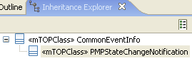  pmpNameList (ObjectIdentifier [*]; static, readOnly)  This attribute identifies the PMP objects for which the AVC applies.  attributeList (AttributeValuePair [*]; static, readOnly)  This attribute lists the state attribute name(s) that have changed their value along with their new values.  Three attribute names have been identified:  - clearPMData (an indication that PM registers have been cleared for a PM select list). This parameter has only one possible value, i.e., TRUE.  - monitoringState (an indication that PM data collection has been enabled or disabled for a PM select list). This attribute is either AS_Unlocked (PM data collection enabled), or AS_Locked (PM data collection disabled).  - supervisionState (an indication that TCA generation has been enabled or disabled for a PM select list). This attribute is either AS_Unlocked (TCA generation enabled) or AS_Locked (TCA generation disabled).  neTime (ItuTTime = NA; static, readOnly)  This attribute identifies the time of generation of the event provided by the NE. In a case where the NE does not report time, zero time shall be reported.  emsTime (ItuTTime = NA; static, readOnly)  This attribute identifies the time of realization of the event by the EMS.  The time at which the event was reported by the EMS system. | missing?

new section

BA (?) | IA | IIS | Comments

