Maintenance Commands
The following Figure shows the maintenance operation signal flow for some of the maintenance commands supported by TMF NML-EML interface.

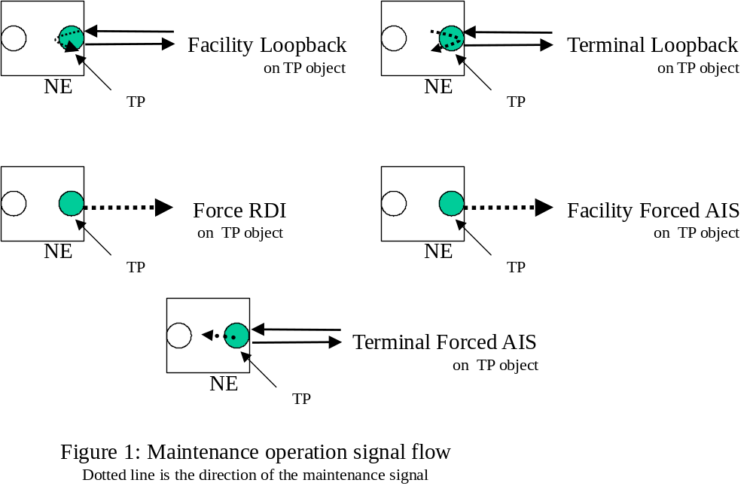

The following is a list of maintenance of operations that shall be supported:

- Facility Loopback
- Terminal Loopback
- Facility Forced AIS
- Terminal Forced AIS
- Force RDI
- Set As Segment End Point (ATM)
- End To End Loopback OAM Cell (ATM)
- Segment Loopback OAM Cell (ATM)
- Local Loop Qualification (DSL)
- DSL Line Supervision (DSL)
- Single Ended Line Test (DSL)
- Dual Ended Line Test (DSL)
- Payload Loopback (PDH)
- Dual Loopback (PDH)

It will be possible to add additional commands, as required for other technologies or to support more robust maintenance needs.

When specifying the operation it will be possible to indicate a specific object that is encapsulated by the MTNM Object. This may be done by specifying the layer rate. For example, for a PTP that encapsulates the RS and MS objects into a single PTP the command will indicate the layer rate of the object on which to apply the operation. If no specification (layer rate) is provided then the EMS may reject the operation or apply the operation to a default object (i.e. the EMS will always use the MS object in the previous example.).

Revision History
Version | Date | Description of Change
3.0 | June 2005 | Conversion of maintenanceCommands into new template.
3.1 | March 2007 | Added support for the following new commands:  - Set As Segment End Point (ATM)  - End To End Loopback OAM Cell (ATM)  - Segment Loopback OAM Cell (ATM)  - Local Loop Qualification (DSL)  - DSL Line Supervision (DSL)
3.2 | November 2007 | Added the following missing commands:  - Single Ended Line Test (DSL)  - Dual Ended Line Test (DSL)  - Payload Loopback (PDH)  - Dual Loopback (PDH)

Acknowledgements
<FirstName> | <LastName> | <Company>

How to comment on the document
Comments and requests for information must be in written form and addressed to the contact identified below:

Keith | Dorking | CIENA
Phone: | +1 678 867 5007
Fax: | +1 678 867 5010
e-mail: | Kdorking@ciena.com

Please be specific, since your comments will be dealt with by the team evaluating numerous inputs and trying to produce a single text. Thus we appreciate significant specific input. We are looking for more input than wordsmith” items, however editing and structural help are greatly appreciated where better clarity is the result.

