ASON Control Plane Management – Scenarios

Table of contents
1. Introduction 3
2. Architecture of Subnetworks 4
2.1. Network architectures not supported by current version 8
2.2. Network views which can be supplied by NMS 9
3. Multi-Layer Routing Area scenarios 11
4. Topological model across routing hierarchy 19
4.1. The hierarchy of SNPP and SNPP Links 21
4.2. The possible scenarios for the inventory of network resources managed by CP 24
4.2.1. Scenarios of the local inventory of network resources managed by CP 29
4.2.2. Scenarios of the Remote inventory of network resources managed by CP 35
5. The hierarchical routing process 42
6. SNPP types and modeling 53
7. SNPP Link data structure 58
8. Connection Route 60
9. Call and Connections, Protection, Restoration, VCAT 70
10. Diversity Management 79
A Revision History 84
B Acknowledgements 84
C How to comment on the document 84

Table of figures

Figure 2.1 – MTNM 3.0 view of more MLSNs 4
Figure 2.2 – MTNM 3.5 view of more MLSNs 5
Figure 2.3 – MTNM 3.5 view of more MLSNs, SNCs/Connection highlighted 6
Figure 2.4 – more isolated MLRAs per EMS Domain 7
Figure 2.5 – MTNM does not support any MLSN partitioning 8
Figure 2.6 – NMS “white box” view of routing area island 9
Figure 2.7 – NMS “opaque” view of routing area island 10
Figure 3.1 – EMS Domain = MLSN, Routing Area is not seen at NMS-EMS i/f 12
Figure 3.2 – EMS Domain = MLSN of Routing Area type, centralized CC 13
Figure 3.3 – EMS Domain = MLSN of Routing Area type, distributed CC 14
Figure 3.4 – 3 levels hierarchy, EMS Domain = top level MLRA, centralized CC per RA 15
Figure 3.5 – 3 levels hierarchy, one EMS per Routing Area of intermediate level 16
Figure 3.6 – 3 levels hierarchy, all MLRAs are wider than EMS Domain, distributed CC 17
Figure 3.7 – 3 levels, all MLRAs are wider than EMS Domain, distributed CC, distinct NMSs 18
Figure 4.1 – Multi-Layered View of Routing Areas 19
Figure 4.2 – Example of the hierarchy of Multi-Layer Routing Areas 20
Figure 4.3 – SNPP Links in the Hierarchy of Multi-Layer Routing Areas (from level 0) 21
Figure 4.4 – SNPP Links in the Hierarchy of Multi-Layer Routing Areas (from level 1) 22
Figure 4.5 – SNPP Links in the Hierarchy of Multi-Layer Routing Areas (just level 2) 23
Figure 4.6 – Single NMS managing the whole Top Level Routing Area 26
Figure 4.7 – More NMSs managing the Top Level Routing Area 27
Figure 4.8 – Reference scenario for SNPP Link inventory 28
Figure 4.9 – Local SNPP Link Inventory, internal links of RA 1.1 29
Figure 4.10 – Local SNPP Link Inventory, external links of RA 1.1 30
Figure 4.11 – Local SNPP Link Inventory, internal links of RA 1 – full view 31
Figure 4.12 – Local SNPP Link Inventory, internal links of RA 1 – reduced view 32
Figure 4.13 – Local SNPP Link Inventory, external links of RA 1 33
Figure 4.14 – Local SNPP Link Inventory, Routing Node links 34
Figure 4.15 – Remote SNPP Link Inventory, transparent view, internal links 36
Figure 4.16 – Remote SNPP Link Inventory, transparent view, external links 37
Figure 4.17 – Remote SNPP Link Inventory, opaque view 38
Figure 4.18 – Remote SNPP Link Inventory, opaque view (2) 39
Figure 4.19 – Remote SNPP Link Inventory, limited view, internal links (1) 40
Figure 4.20 – Remote SNPP Link Inventory, limited view, internal links (2) 41
Figure 5.1 – Hierarchical Routing, SNPP view at level 1 42
Figure 5.2 – Hierarchical Routing, SNPP view at level 2 43
Figure 5.3 – Hierarchical Routing, view of SNPP Links at level 1 44
Figure 5.4 – Hierarchical Routing, view of SNPP Link hierarchy 45
Figure 5.5 – Hierarchical Routing, view of SNPP Link at level 2 46
Figure 5.6 – view of SNPP Link at level 2, partitioning within same ME 47
Figure 5.7 – Multi-Layer SNPP Link example of structure 48
Figure 5.8 – SNPP Link Inventory, external links of RA 1.1 49
Figure 5.9 – SNPP Link Inventory, Routing Node links 50
Figure 5.10 – SNPP Link Inventory, external links of RA 1.1 51
Figure 5.11 – SNPP Link Inventory, Routing Node links 52
Figure 6.1 – SNPP of Connection Point type 53
Figure 6.2 – SNPP of Termination Connection Point type, VCAT 55
Figure 6.3 – SNPP of Termination Connection Point type, modifiable VC4 57
Figure 8.1 – Top Level Connection 60
Figure 8.2 – Route of top level connection in terms of connection segments (EMS1) 62
Figure 8.3 – Detailed route of top level connection (EMS1) 63
Figure 8.4 – Route of top level connection in terms of connection segments (EMS2) 64
Figure 8.5 – Detailed route of top level connection (EMS2) 65
Figure 8.6 – Detailed view of SNPP Link and its SNPs 66
Figure 8.7 – SNCP protection scheme and replied connections 67
Figure 8.8 – End to end restoration scheme and replied connections 68
Figure 8.9 – Routing Areas involved in the route of top level connection 69
Figure 9.1 – Protection scheme 70
Figure 9.2 – Detailed view of Protection Scheme 71
Figure 9.3 – Protection scheme across four RAs 72
Figure 9.4 – Restoration scheme, local restoration 73
Figure 9.5 – Restoration scheme, end to end restoration 74
Figure 9.6 – Protection scheme combined with local restoration 75
Figure 9.7 – Protection scheme combined with end to end restoration 76
Figure 9.8 – Virtual Concatenation / inverse multiplexing 77
Figure 9.9 – Protection Scheme terminated outside the top level MLRA 78
Figure 10.1 – Route Groups, co-routing and diversity constraints specified 80
Figure 10.2 – Route Groups, co-routing constraint not specified, diversity constraint specified 81
Figure 10.3 – Route Groups, co-routing constraint specified, diversity constraint not specified 82
Figure 10.4 – Examples of Shared Risk Groups 83

Introduction
This document has been written to assist in the understanding of the scope of application and features of MTNM version 3.5 interface from a Control Plane management perspective.

It is assumed that the reader has an understanding of the MTNM 3.0 interface plus general knowledge of Control Plane architecture (e.g. according to ITU-T G.8080).

The inherent complexity of ASON/ASTN enhanced networks is reflected on network management as well. The purpose of this document is to describe, through a set of figures, a number of possible scenarios that can be applicable when ASON/ASTN subnetwork is managed. Along the paragraphs the figures will focus on different aspects of the modelling, trying to supply more point of views of the overall architecture.

Architecture of Subnetworks
This chapter identifies the possible ways to organize Multi-Layer Subnetworks, considering the introduction of ASON/ASTN enhanced subnetworks. In other words, the subnetworks are considered from external point of view.

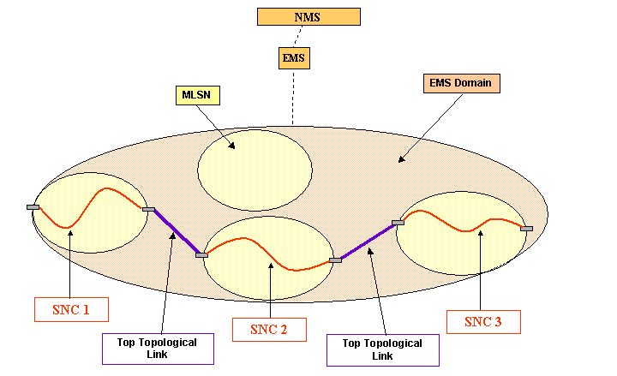

Figure 2.1 – MTNM 3.0 view of more MLSNs

In Figure 2.1 it is shown the only possible scenario where more than one Multi-Layer Subnetworks are managed by a given EMS domain. As MTNM 3.0 does not foresee any partitioning feature, then the view is flat, which implies that the only space of Subnetwork Connections is defined by a Multi-Layer Subnetwork, hence end to end SNCs, spanning more MLSNs cannot be represented through the interface. Same limitation applies to MTNM 3.5, as far as MLSNs (i.e. which are not Control Plane driven) are concerned.

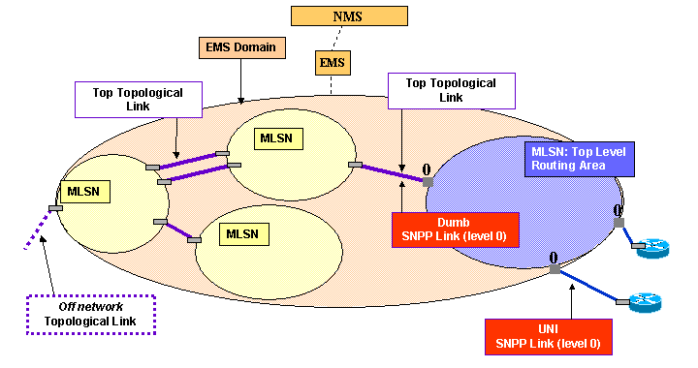

Figure 2.2 – MTNM 3.5 view of more MLSNs

In Figure 2.2 it is shown a possible scenario of MTNM 3.5 where more than one Multi-Layer Subnetwork is managed by a given EMS domain. Usually there is one instance of Multi-Layer Routing Area (MLRA), because it has been recognized that Control Plane introduction is mainly useful to gather, assemble the managed network in a unique mesh, where connectivity can be managed fully end-to-end. Anyway it is allowed to manage more isolated control plane subnetworks from the same EMS, see Figure 2.4.

The MLRA can possibly be connected to other MLSNs via top topological links. Control plane side, (some of) the resources composing such topological links may be part of external SNPP Links of top level MLRA. In other words, some link connections linking CTPs of MLSN to SNPs of MLRA may form an SNPP Link. Note that there could be some CTPs of MLSN which are linked to some CTPs of MLRA, being such CTPs not assigned to Control Plane engine.

Note that the top level MLSN/RA is marked as “level 0”, it is the convention followed in this document to identify the levels of routing hierarchy.
Same concept applies to the SNPP Links, in fact the SNPP Link connecting top level subnetworks is marked as “level 0”, indicating that it is a “top level SNPP Link”.

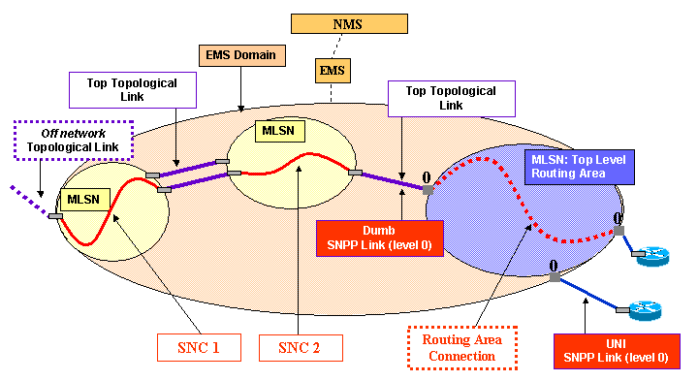

Figure 2.3 – MTNM 3.5 view of more MLSNs, SNCs/Connection highlighted

The model of ASON/ASTN enhanced subnetworks, i.e. MLSNs of Routing Area type (also referred as MLSN/RA or MLRA), allows the introduction of subnetwork partitioning, with the capabilities and limitations shown in subsequent paragraphs.

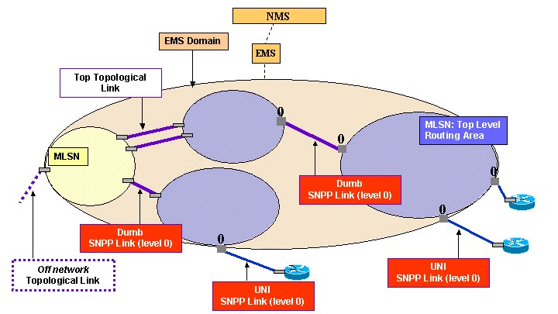

Figure 2.4 – more isolated MLRAs per EMS Domain

  - Network architectures not supported by current version
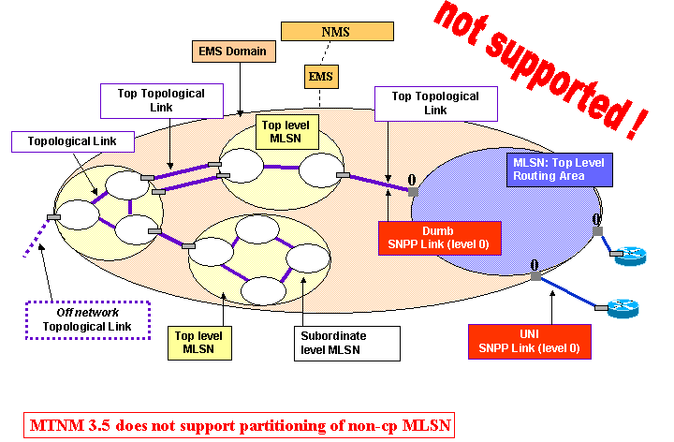

Figure 2.5 – MTNM does not support any MLSN partitioning

  - Network views which can be supplied by NMS

Following figures show scenarios which can be supplied by NMS, i.e. they are NOT supported through MTNM interface. The purpose is to present a couple of examples of possible views the NMS can supply to its clients (OS or operator) thanks to the integration of information available at NMS southbound interface.

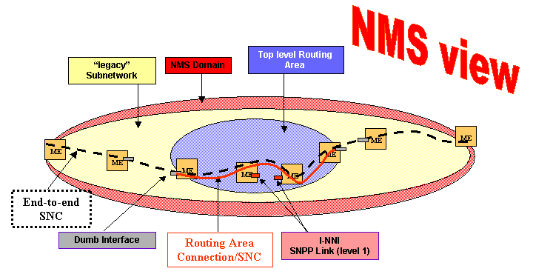

Figure 2.6 – NMS “white box” view of routing area island

Figure 2.6 shows a possible view supplied by NMS, where an island of managed subnetwork has been migrated under Control Plane management. In this case, the NMS is still capable to directly manage (some aspects of) Data Plane features.

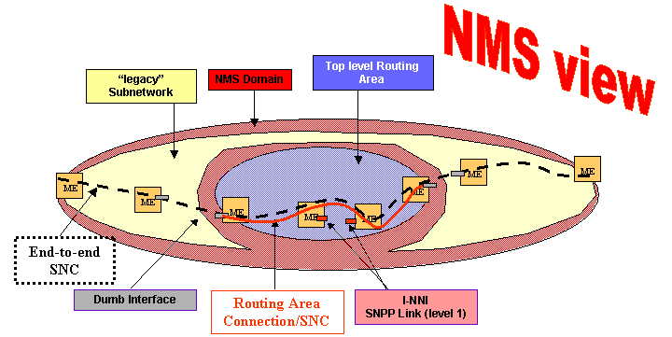

Figure 2.7 – NMS “opaque” view of routing area island

Figure 2.7 differs from Figure 2.6 concerning the Data Plane visibility. In this case, the portion of managed subnetwork which is now under Control Plane management, is no longer seen by NMS, i.e. Control Plane is the only mediation towards Data Plane.

Multi-Layer Routing Area scenarios
This chapter describes more detailed scenarios concerning the ASON/ASTN subnetwork management.
The following constraints, assumptions and simplifications are valid along this document:
- MTNM 3.5 constraints:
  - there is always an 1:1 relationship between a Managed Element and a Routing Node, hence along the figures the MLSN/Routing Node managed object is implicitly represented by the ME.
  - the Routing Node boundary coincides with the boundary of the NE fabric (the Routing Node could also represent a subset of the capacity of the fabric). As a consequence the Routing Node Connection coincides with the ME Cross Connection.

- Simplifications of representation:
  - the UNI, I-NNI, E-NNI interfaces are shown as PTPs, for simplicity. An UNI/NNI is actually represented by an SNPP Link object. Hence, unless otherwise specified, along the figures there is 1:1 relationship between a PTP and an SNPP (i.e. the end point of the SNPP Link). As a consequence, the SNPP Link is composed by all the bandwidth supported by a Topological Link.
  - A single layer network is considered, if not otherwise specified.
  - All the shown resources are assigned to Control Plane Management, if not otherwise specified.
  - “MLSN/RA” is short for a MLSN of type “Multi-Layer Routing Area”.
  - EMS domain includes just the unique instance of top level MLRA, other possible MLSNs are not shown.
  - Signalling Communication Channels are not shown.

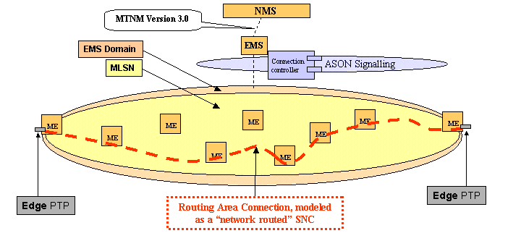

Figure 3.8 – EMS Domain = MLSN, Routing Area is not seen at NMS-EMS i/f

shows centralized EMS and Connection Controller Component. This scenario can be supported by MTNM 3.0, as NMS may ask EMS for the creation of a “network routed” SNC. No further Control Plane knowledge is needed at MTNM i/f, the EMS is delegated to manage Connection Controller(s) in order to implement the “network routed” SNC. If UNIs are available on edge PTPs, then the NMS may be notified by EMS that a SNC has been created by the network, but such behavior is not supported by 3.0 version.

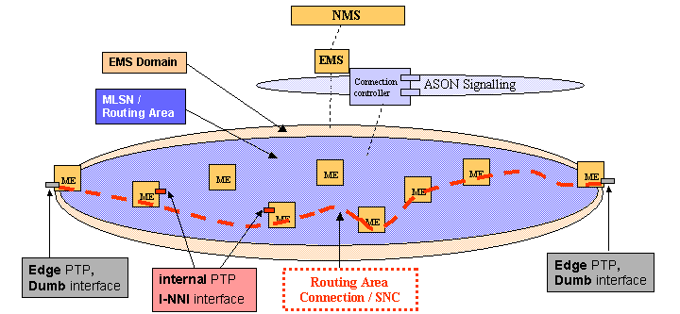

Figure 3.9 – EMS Domain = MLSN of Routing Area type, centralized CC

Figure 3.9 shows centralized EMS and Connection Controller Components. NMS may ask EMS for the Call establishment, which causes the creation of a Call object plus one or more Routing Area Connections, modelled as SNC objects SS side. In case UNI is available, signalling may establish a Call, hence EMS notifies NMS of such Call and its SNCs object creation.
Within a Routing Area, modelled by MLSN object, the ASON signalling can provide the complete view of transport resources, but represented through the Control Plane Name Space (SNP, SNPP, SNPP Link). In this case the Routing Area coincides with the EMS domain, which may allow the EMS to have full direct visibility of Transport Plane (also referred as Data Plane).

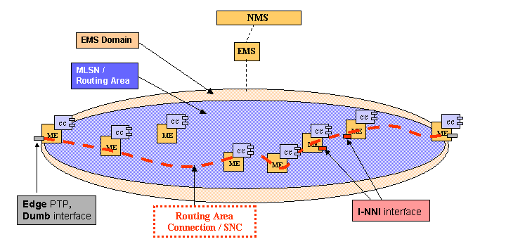

Figure 3.10 – EMS Domain = MLSN of Routing Area type, distributed CC

Figure 3.10 shows centralized EMS and distributed Connection Controller Components, e.g. Connection Controller is integrated directly in the ME.
As far as the MTNM i/f is concerned, this scenario is equivalent to the scenario of centralized CC (Figure 3.9), because the centralized EMS hides the CP distributed architecture. Also in this case the EMS may have full direct visibility of Transport Plane.

In other words, it is shown that the interface is defined to keep separate the
- the view of Transport Plane, as it is shown by the Control Plane, with respect to
- the view of Control Plane itself, i.e. the Operating Systems implementing the Control Plane functions.

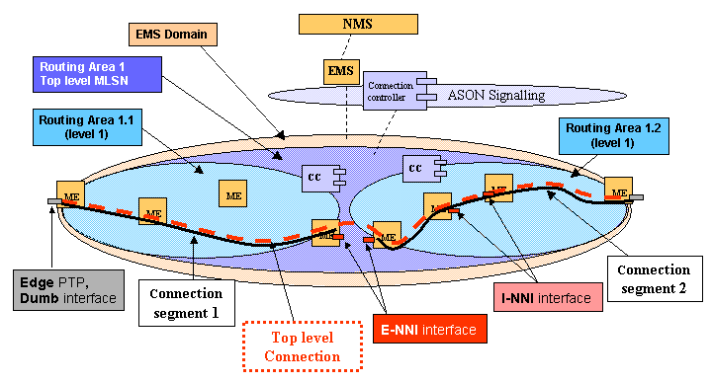

Figure 3.11 – 3 levels hierarchy, EMS Domain = top level MLRA, centralized CC per RA

In Figure 3.11 one EMS domain fully contains a three levels routing hierarchy, hence may also have full direct visibility of all transport plane resources.

MTNM 3.5 foresees the management of a control plane network with at most three levels of routing hierarchy, which are

- bottom level, the connectivity within the Routing Node (level 2, being the numbering just for illustration purposes),

- intermediate level, the connectivity within the intermediate level MLRA (level 1),

- top level, the connectivity within the top level MLRA (level 0).

In this release an intermediate level routing area is wholly managed by a single EMS. Hence, in many figures the EMS domain is no longer represented, as it considered coincident with a Routing Area of level 1.

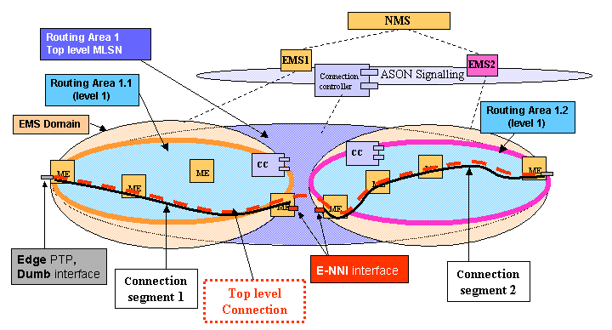

Figure 3.12 – 3 levels hierarchy, one EMS per Routing Area of intermediate level

Figure 3.12 shows a Routing Area wider than EMS Domain.
The top level Routing Area is presented as a unique bubble, as it is from functional point of view, but of course at NMS-EMS interface there is a top level MLSN/RA instance per each EMS domain, i.e. per each interface instance. Through the interface, it is possible to address the top level MLSN/RA to get resources even external to the local EMS domain.
This is allowed by the signalling implemented in the top level Routing Area, across E-NNIs.
Concerning Transport Plane resources, the EMS domain seen at NMS-EMS1 interface has potential visibility only within local EMS domain, e.g. it is surely not possible to get PTPs of an ME within EMS domain 2.
The “top level connection” is the connection in the scope of top level MLSN/RA, Solution Set side it is represented by the SNC 2nd class object.

Of course, EMS1 and EMS2 can be provided by different vendors.

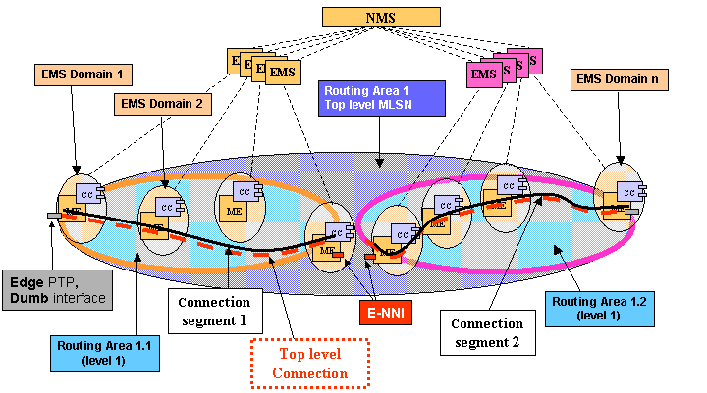

Figure 3.13 – 3 levels hierarchy, all MLRAs are wider than EMS Domain, distributed CC

Figure 3.13 shows a Routing Area wider than EMS Domain and fully distributed Connection Controller Components, e.g. the EMS scope is just one ME, and the Connection Controller is integrated directly in the ME.
Note that to establish a Call, in this scenario the NMS has to address a border EMS domain, i.e. an EMS domain where UNI or Dumb interfaces are available.
Note that a “middle” EMS, i.e. a EMS which does not directly manage any boundary point of any MLRA, can reply very reduced routing information, e.g. just the busy time slots / SNPs.

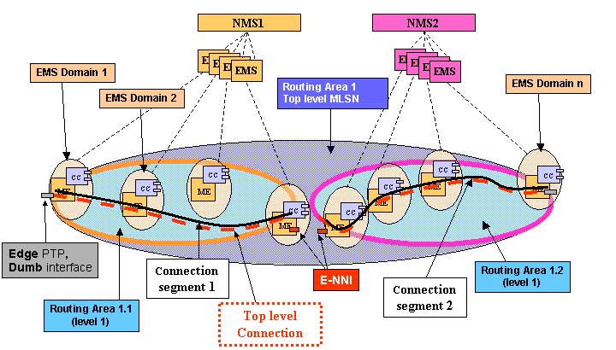

Figure 3.14 – 3 levels, all MLRAs are wider than EMS Domain, distributed CC, distinct NMSs

Figure 3.14 differs from Figure 3.13 with respect to TMN architecture, i.e. two distinct NMS, NMS1 and NMS2 are shown, highlighting that possible multi-vendor scenario may include NMS level besides EMS level.

Topological model across routing hierarchy
This chapter describes the network topology as it is shown by Control Plane, considering that subnetworks are partitioned according to routing hierarchy features.

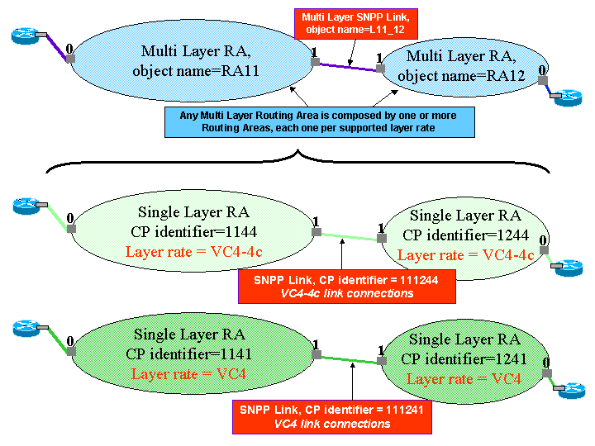

Figure 4.15 – Multi-Layered View of Routing Areas

With reference to Figure 4.15, it is shown how a MLSN/RA is actually composed by one or more Routing Areas, each one per supported layer rate. The example proposes a MLSN/RA which supports SDH VC4 and VC4-4c (contiguously concatenated signal four times a VC4). Hence the two corresponding Routing Areas are foreseen.
Note that Solution Set foresees the MLRA 2nd class object, which includes the information concerning the layered Routing Areas. In other words, there is not a 2nd class object representing the (single-layer) Routing Area, rather the list of control plane identifiers of included routing areas is present.
For simplification, along the following figures only “single layer” MLSN/RA are considered, unless explicitly specified (hence MLRA and RA, MLSNPP and SNPP are synonyms).

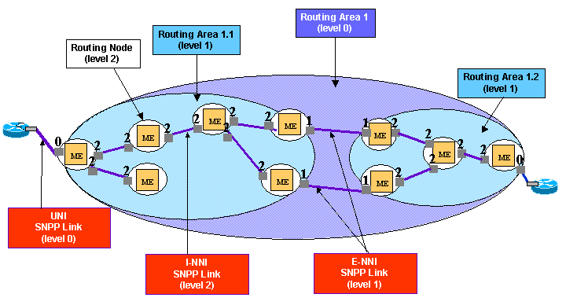

Figure 4.16 – Example of the hierarchy of Multi-Layer Routing Areas

In Figure 4.16 it is shown an example of Routing Area hierarchy, there is the top level RA 1, which is partitioned into two Routing Areas, RA1.1 and RA1.2.
Recursively, RA1.1 and RA1.2 are partitioned into a number of Routing Nodes, which represent the bottom level of routing hierarchy.
The topology is described in terms of SNPP Links, which link Routing Areas. The SNPP Links are hierarchically organized according to the routing hierarchy. In Figure 4.16, only the SNPP Links at uppermost level are shown.
  - The hierarchy of SNPP and SNPP Links
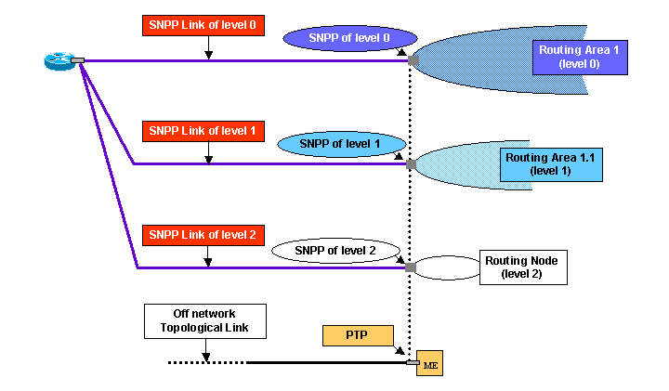

Figure 4.17 – SNPP Links in the Hierarchy of Multi-Layer Routing Areas (from level 0)

In Figure 4.17 it is shown an UNI interface, represented by an SNPP Link of level 0 (top level). Such SNPP Link is an external SNPP Link for top level Routing Area RA 1. Furthermore, at the lower level, it is defined another SNPP Link, which is an external SNPP Link for Routing Area R1.1, and same applies for Routing Node, i.e. there is an SNPP Link at level 2.
It is also shown the PTP at Data or Transport Plane side, as possible elementary mapping to SNPP of level 2. The mapping allowed granularity is 1:1 between SNP and TP.

The model of the hierarchy of SNPP Links is necessary because at each routing level, Routing Areas (or Nodes at bottom level) have their external SNPP Links.
From bottom to top, it may happen that an external SNPP Link of a Routing Node is also an external SNPP Link of superior Routing Area, and so on. On the reverse direction, from top to bottom, an external SNPP Link of a Routing Area is always mapped to one (or more) SNPP Links at subordinate level.

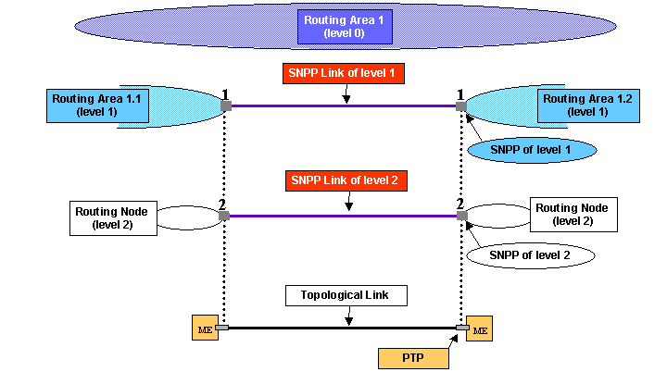

Figure 4.18 – SNPP Links in the Hierarchy of Multi-Layer Routing Areas (from level 1)

In Figure 4.18 is shown an I-NNI interface of top level Routing Area RA 1, which is also an E-NNI interface of subordinate RA1.1.
In fact, such SNPP Link of level 1 is an internal SNPP Link for top level Routing Area RA 1, and an external SNPP Link for Routing Area R1.1 (see also E-NNI SNPP Links in Figure 4.16, connecting RA1.1 to RA1.2).
Furthermore, at the lower level (bottom level), it is defined another SNPP Link, which is an external SNPP Link for Routing Node, i.e. at level 2.

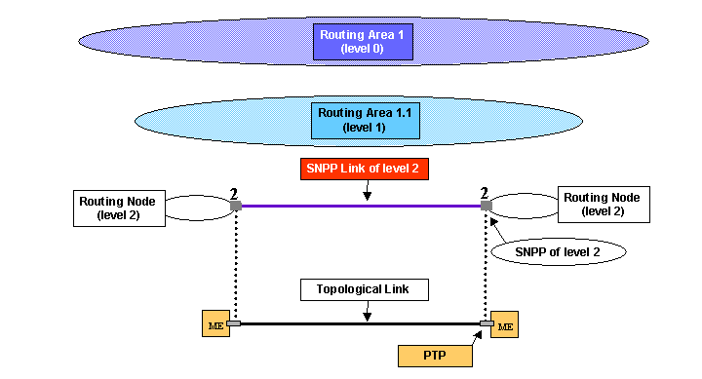

Figure 4.19 – SNPP Links in the Hierarchy of Multi-Layer Routing Areas (just level 2)

In Figure 4.19 is shown an I-NNI interface of Routing Area RA 1.1, which is also an external SNPP Link of subordinate Routing Node (see also I-NNI SNPP Link in Figure 4.16, internal to RA1.1).

  - The possible scenarios for the inventory of network resources managed by CP

A “local” MLSN/RA is an MLSN/RA which is completely contained by the EMS Domain.

In the following are defined the different possible scenarios concerning the visibility a given EMS may have concerning MLRA Data Plane aspects in both Data Plane and Control Plane name spaces.

Consider the NMS-EMS interface managing the EMS domain coincident with Routing Area 1.1 (see e.g. Figure 4.22).
- By definition, an EMS which “completely manages” a given MLRA, is allowed to read and provision all Data or Transport Plane aspects (e.g. Equipment, PTPs, CTPs, XCs, Protection Groups etc.) defined within such MLRA. Obviously, the EMS is also allowed to manage all Control Plane features on such MLRA, e.g. upload of SNPP Link, Call and Connection inventory and provisioning, across all levels of routing hierarchy.
For the sake of completeness, it is defined also the case of
- an EMS which “directly manages through Control Plane” a given MLRA. This case defines the scenario of an EMS which does not see any Data or Transport Plane aspect of such MLRA, but relies on Control Plane full view. In other words, this EMS is supplied by Control Plane of all details of MLRA in the Control Plane name space. Hence the EMS is allowed to manage all Control Plane features on such MLRA, e.g. upload of SNPP Link, Call and Connection inventory and provisioning, across all levels of routing hierarchy.
Now we consider the following cases, which are complementary of the above ones:
- an EMS which “remotely manages” a given MLRA defines the scenario of an EMS which does not see any Data or Transport Plane aspects of such MLRA, but relies on Control Plane view. In other words, this EMS is supplied by Control Plane of MLRA details in the Control Plane name space (e.g. SNPP Links, Multi-Layer Routing Nodes, Call and Connections, etc.) but depending on signalling features:
  - in case signalling distributes the full picture of Routing Area internal topology (as depicted in Figure 4.22), then the EMS is supplied with all remote MLRA aspects, with same level of details as case where EMS “directly manages through Control Plane” such MLRA (transparent view).
  - In case signalling does not distribute any detail of Routing Area internal topology (as depicted in Figure 4.31), then the EMS is supplied with a minimum set of information concerning remote MLRA aspects, i.e. just the reachability points (opaque view).
With respect to routing hierarchy, the reachability points stand at top level.
  - Last, signalling may distribute summarized topological information of remote MLRA aspects, that is to say an intermediate picture with respect to the two “extreme” cases above (limited view).

In the case EMS is remotely managing a given MLRA, as a general assumption only the inventory features may be supplied (but not in Version 3.5, see below), with more or less details depending on signalling capabilities.
As far as Call and Connection provisioning is concerned, from a given EMS it is possible to modify a Call only if its originating point belongs to a MLRA which is completely or directly managed by such EMS. Furthermore, it is possible to release a Call only if its originating or end point belongs to a MLRA which is completely or directly managed by such EMS.

As far as routing and diversity constraints are concerned, depending on signalling features, it may be possible to supply routing / diversity constraints at Call establishment and modification time, even addressing resources which belongs to remotely managed MLRAs.
Note that the capability to provision routing / diversity constraints does not necessarily depend from the visibility (supplied by CP signalling) a given EMS may have concerning remote MLRA. For example, it may occur that the EMS is supplied by signalling with just the reachability points (opaque view) of a given remote MLRA, but it is allowed to provision routing / diversity constraints over such remote MLRA, because its inner resources are known by other means (e.g. see Figure 4.20, where the unique NMS collects all information from the different EMSs - while in Figure 4.21 it is less likely an NMS knows about other NMSs).
Of course, signalling has to support the provisioning of routing constraints.

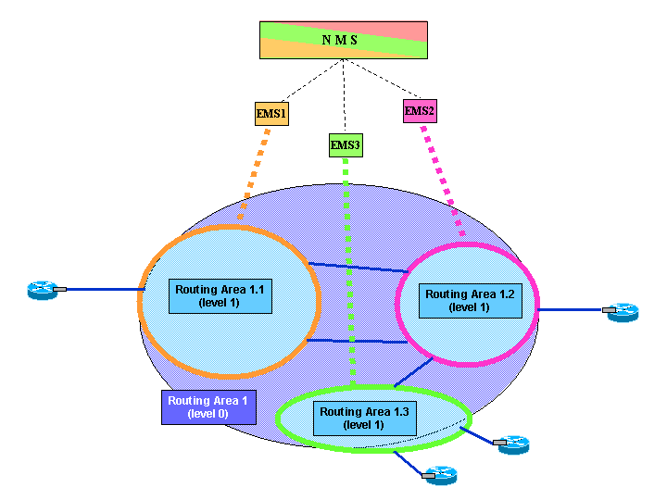

Figure 4.20 – Single NMS managing the whole Top Level Routing Area

The Figure 4.20 proposes a reference scenario concerning NMS and EMS architecture, where the unique NMS allows to restrict at a minimum the amount of needed information from E-NNI signalling. For example, internal topology of each Routing Area is uploaded by NMS from the EMS which completely manages (or directly manages through Control Plane) the requested Routing Area. Hence the main help supplied by Control Plane (signalling at E-NNI) regards which Routing Areas (and hence which EMS managing each of them) are involved e.g. in a top level connection. Once NMS knows the proper EMSs, it is allowed to directly address the operations over corresponding NMS-EMS interface instances.

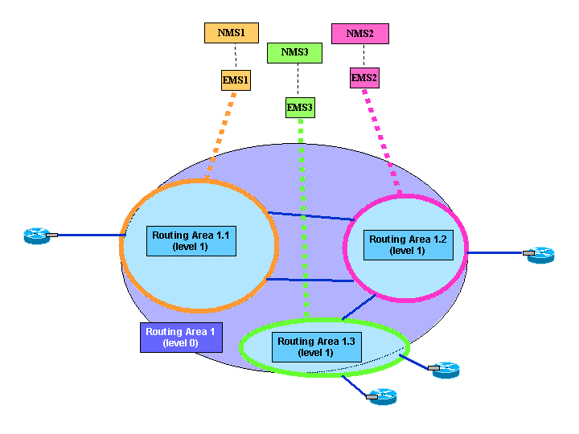

Figure 4.21 – More NMSs managing the Top Level Routing Area

The Figure 4.21 proposes a reference scenario concerning NMS and EMS architecture, where the multiple NMS may imply more requests addressing information which is available only thanks to E-NNI signalling. Anyway due to the fact that each NMS actually manages a single Routing Area, there should be little or no requirements concerning the visibility of topology and connectivity along remote domains. For this reason the requests addressing Routing Areas which are remotely managed are not supported by Version 3.5 of the interface, see also below.

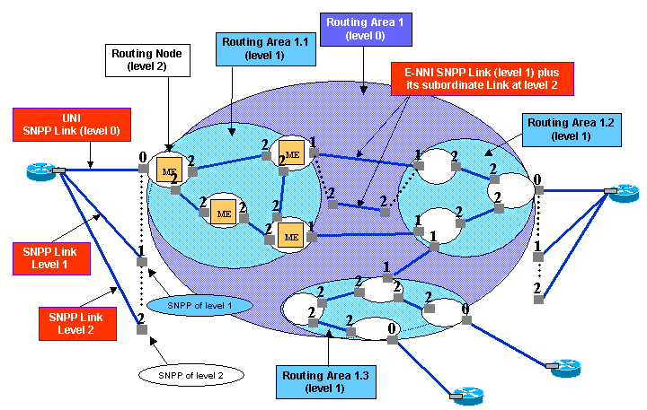

Figure 4.22 – Reference scenario for SNPP Link inventory

The Figure 4.22 proposes a scenario which will be used as reference to explain the various cases of SNPP Link inventory operations.

Scenarios of the local inventory of network resources managed by CP

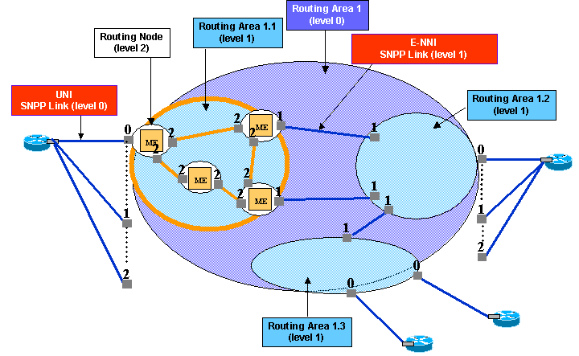

Figure 4.23 – Local SNPP Link Inventory, internal links of RA 1.1

Considering Figure 4.23, the following operation can be addressed to the EMS which completely manages (or directly manages through Control Plane) RA 1.1:

- “Get All Internal SNPP Links of RA1.1” replies all the highlighted I-NNI SNPP Links, i.e. all the level 2 links.
Note that the SNPP Links of level 2 that are subordinates of upper level SNPP Links are not replied, because they are external SNPP Link for the Routing Node (and for RA1.1 as well).

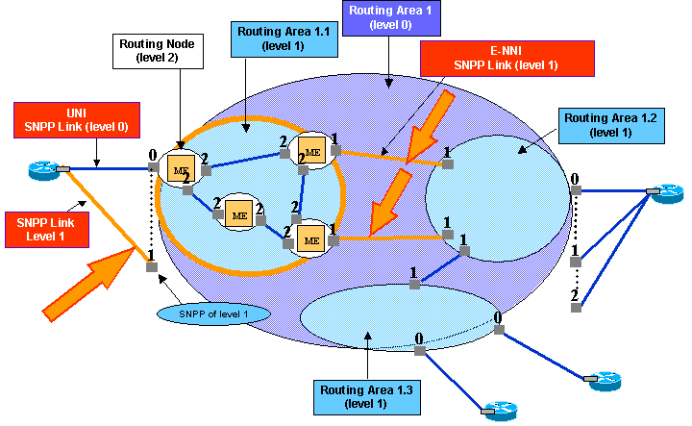

Figure 4.24 – Local SNPP Link Inventory, external links of RA 1.1

Considering Figure 4.24, the following operation can be addressed to the EMS which completely manages (or directly manages through Control Plane) RA 1.1:

- “Get All Edge SNPP Links of RA1.1” replies all the highlighted level 1 links which interconnects RA1.1 to the other MLRAs at same level of routing hierarchy.
Note that the level 1 link which is subordinate of level 0 link (UNI on the left) is included in the reply.

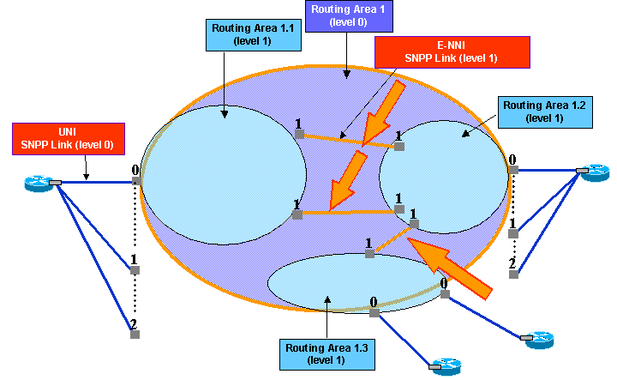

Figure 4.25 – Local SNPP Link Inventory, internal links of RA 1 – full view

Considering Figure 4.25, the following operation can be addressed to any EMS, but only in case signalling actually distributes such information over all E-NNIs:

- “Get All Internal SNPP Links of RA 1” replies all the highlighted E-NNI SNPP Links, i.e. all the level 1 links (or the I-NNI SNPP Links, from RA 1 level point of view).

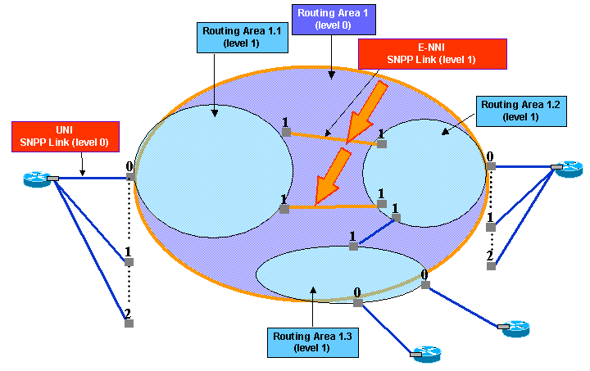

Figure 4.26 – Local SNPP Link Inventory, internal links of RA 1 – reduced view

Note that if EMS1 completely manages (or directly manages through Control Plane) RA1.1 only, then the SNPP Link between RA 1.2 and RA 1.3 could be not available to the Routing Controller of RA1.1. In fact, as far as routing is concerned, RC 1.1 must just know that to reach a TNA address of RA 1.3, then routing has to select one of the SNPP Links connecting RA 1.1 to RA 1.2. It will be a task of RC 1.2 to select the proper SNPP Link connecting RA 1.2 to RA 1.3, and so on.
Hence, considering Figure 4.26, the following operation can be addressed to the EMS which completely manages (or directly manages through Control Plane) RA 1.1:

- “Get All Internal SNPP Links of RA 1” replies all the highlighted E-NNI SNPP Links, i.e. all and only the level 1 links which ends on RA 1.1 – being such links the only view of RA 1 internal links it is provided by CP controlling RA 1.1.

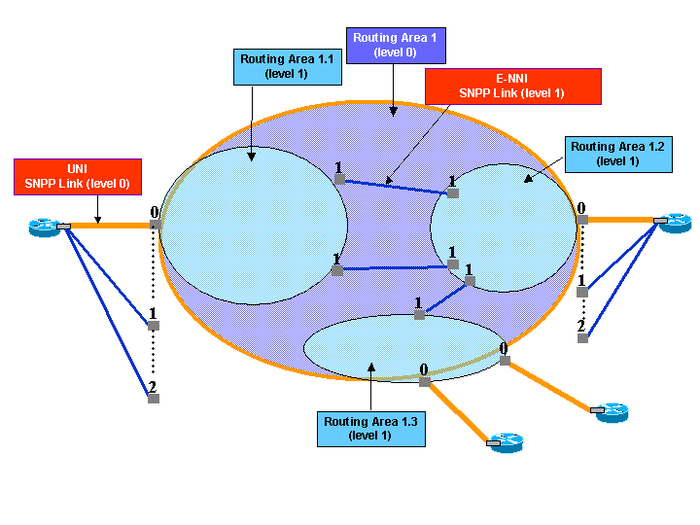

Figure 4.27 – Local SNPP Link Inventory, external links of RA 1

Considering Figure 4.27, the following operation can be addressed to any EMS:

- “Get All Edge SNPP Links of RA 1” replies all the highlighted UNI and Dumb SNPP Links, i.e. all the level 0 links.

In this case the request concerns the overall reachability info of the whole Control Plane controlled network. Signalling has to distribute this information to the Routing Controllers of all subordinate Routing Areas. Hence any EMS can upload all external SNPP Links of the Top Level Routing Area.

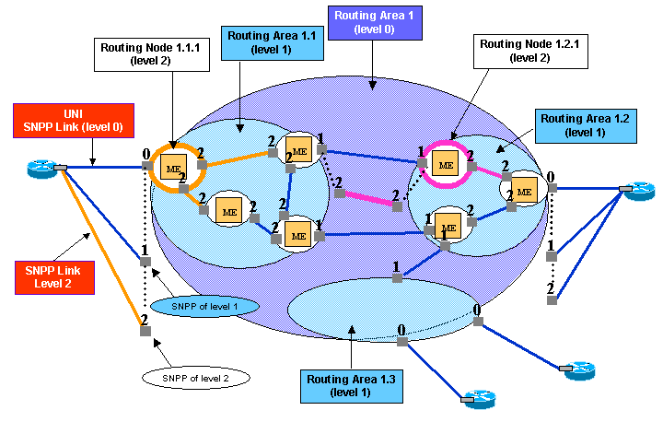

Figure 4.28 – Local SNPP Link Inventory, Routing Node links

Considering Figure 4.28, the following operations can be addressed to the EMS which completely manages (or directly manages through Control Plane) RA 1.1:

- “Get All Internal SNPP Links of Routing Node 1.1.1” is not applicable,

- “Get All Edge SNPP Links of Routing Node 1.1.1” replies all the level 2 links which interconnects the addressed Routing Node to other Routing Nodes. Note that the level 2 link which is subordinate of level 0 link (UNI on the left) is included in the reply.
The following operation can be addressed to the EMS which completely manages (or directly manages through Control Plane) RA 1.2:

- “Get All Edge SNPP Links of Routing Node 1.2.1“ replies all the level 2 links which interconnects the addressed Routing Node to other Routing Nodes. Note that the level 2 link which is subordinate of level 1 link (E-NNI in the centre) is included in the reply.

Scenarios of the Remote inventory of network resources managed by CP

MTNM Version 3.5 does not support the following scenarios, as they have been recognized as unlikely to occur. In fact, even considering multiple NMS scenario (see Figure 4.21), due to the fact that each NMS actually manages a single Routing Area, there should be little or no requirements concerning the visibility of topology and connectivity along remote domains using information available at E-NNI side.

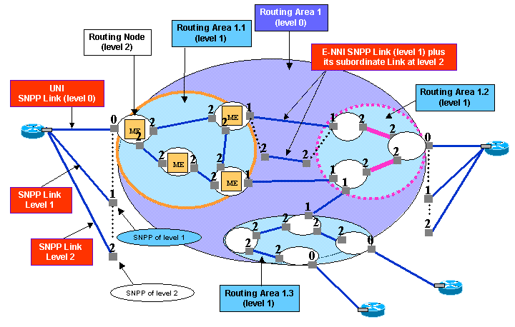

Figure 4.29 – Remote SNPP Link Inventory, transparent view, internal links

Considering Figure 4.29, the following operation can be addressed to the EMS which completely manages (or directly manages through Control Plane) RA 1.1, but does not manage the other RAs, RA 1.2, 1.3 etc.:

- “Get All Internal SNPP Links of remote RA 1.2” replies all the highlighted I-NNI SNPP Links, i.e. all the level 2 links.
This is possible because the information describing all the I-NNI SNPP Links of RA 1.2 is exported by Control Plane through the E-NNI towards RA 1.1

It is shown that from RA1.1 it is not possible to see the ME of external Routing Areas (RA 1.2, RA 1.3, etc.), because as previously assumed, the EMS domain scope is coincident with the Routing Areas of level 1. Hence the NMS-EMS interface managing the EMS domain coincident with RA 1.1 cannot upload e.g. the MEs of RA 1.2, but at most the Routing Nodes.

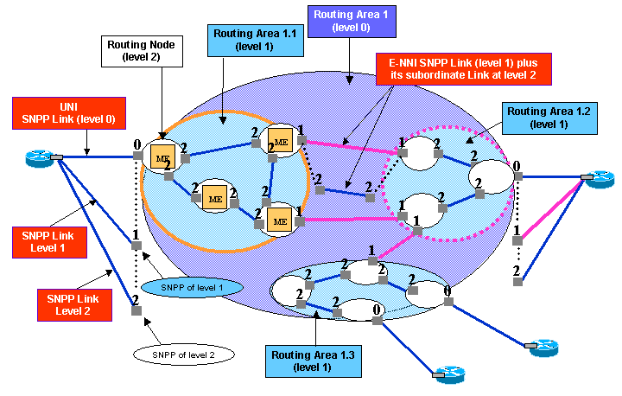

Figure 4.30 – Remote SNPP Link Inventory, transparent view, external links

Considering Figure 4.30, the following operation can be addressed to the EMS which completely manages (or directly manages through Control Plane) RA 1.1, but does not manage the other RAs, RA 1.2, 1.3 etc.:

- “Get All Edge SNPP Links of remoteError: Reference source not found RA 1.2” replies all the highlighted level 1 SNPP Links to another MLSN/RA of same level.
Note that the level 1 link which is subordinate of level 0 link (UNI on the right) is included in the reply.

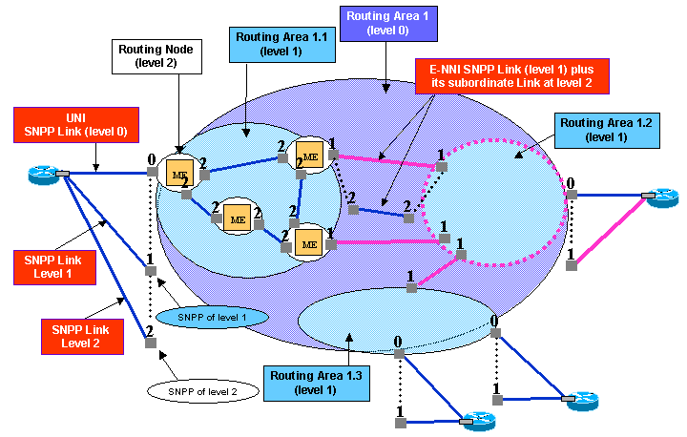

Figure 4.31 – Remote SNPP Link Inventory, opaque view

Considering Figure 4.31, the following operations can be addressed to the EMS which completely manages (or directly manages through Control Plane) RA 1.1, but does not manage the other RAs, RA 1.2, 1.3 etc.:

- “Get All Internal SNPP Links of remoteError: Reference source not found RA 1.2” replies empty list, because the information describing the I-NNI SNPP Links is not exported by Control Plane through the E-NNI.

- “Get All Edge SNPP Links of remoteError: Reference source not found RA 1.2” replies all the highlighted level 1 SNPP Links to another MLSN/RA of same level.
Note that the level 1 link which is subordinate of level 0 link (UNI on the right) is included in the reply.
In fact, the “opaque view” scenario foresees the exchange, through E-NNI, of all and only the edge points of a given routing area of level 1, or more in general, first level of subordinate routing areas of top level routing area.

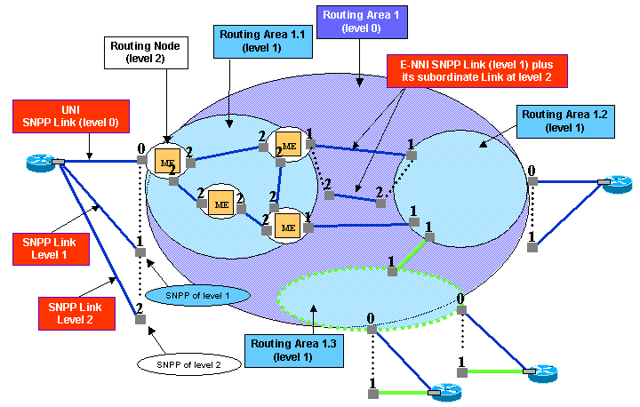

Figure 4.32 – Remote SNPP Link Inventory, opaque view (2)

Considering Figure 4.32, the following operation can be addressed to the EMS which completely manages (or directly manages through Control Plane) RA 1.1, but does not manage the other RAs, RA 1.2, 1.3 etc.:

- “Get All Internal SNPP Links of remoteError: Reference source not found RA 1.3” replies empty list, because the information describing the I-NNI SNPP Links is not exported by Control Plane through the E-NNI.

- “Get All Edge SNPP Links of remoteError: Reference source not found RA 1.3” replies all the highlighted level 1 SNPP Links to another MLSN/RA of same level.
Note that the level 1 links which are subordinate of level 0 links (UNIs on the bottom) are included in the reply.

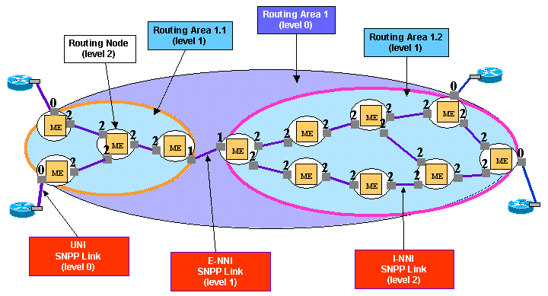

Figure 4.33 – Remote SNPP Link Inventory, limited view, internal links (1)

Figure 4.33 shows all details of both RA1.1 and RA1.2, to introduce an example of limited view, see Figure 4.34.

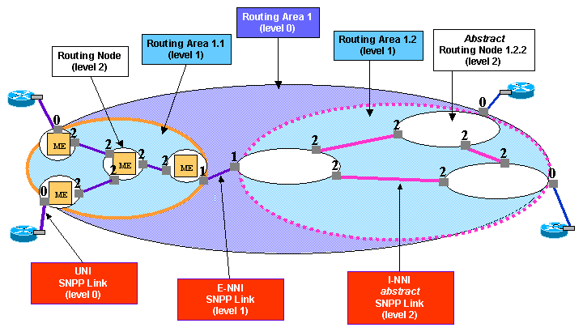

Figure 4.34 – Remote SNPP Link Inventory, limited view, internal links (2)

Considering Figure 4.34 the following operation can be addressed to the EMS which completely manages (or directly manages through Control Plane) RA 1.1, but does not manage the other RAs, RA 1.2, 1.3 etc.:

- “Get All Internal SNPP Links of remoteError: Reference source not found RA 1.2” replies all the highlighted I-NNI SNPP Links, i.e. all the level 2 abstract links.
In fact, the internal detailed topology of RA1.2 is depicted in figure Figure 4.33, but due to the limited view signalling is providing at E-NNI side, only a summary / abstraction of internal topology of RA1.2 is supplied.

The hierarchical routing process
This section describes the main steps of the routing process across the hierarchy of routing areas.

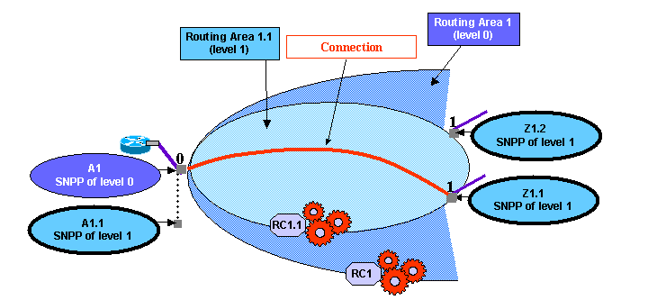

Figure 5.35 – Hierarchical Routing, SNPP view at level 1

With reference to Figure 5.35, the Routing Controller managing RA1, called RC1, asks the RC managing RA1.1 (RC1.1) to set up a connection between A1.1 and Z1.1, which are the SNPP instances known by RC1.1 - in fact they represent the boundary points of RA1.1 (including Z1.2).

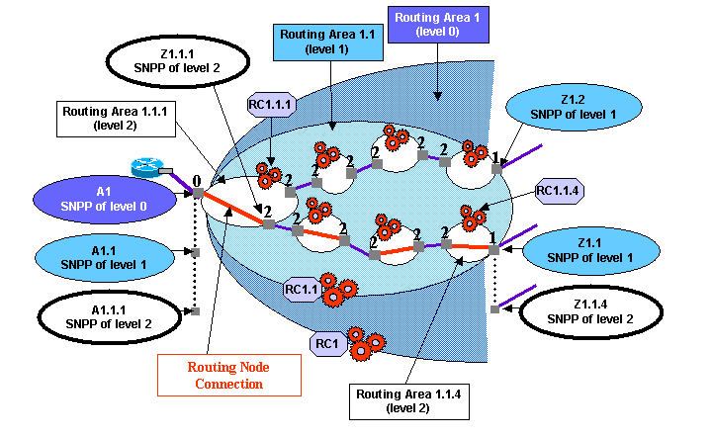

Figure 5.36 – Hierarchical Routing, SNPP view at level 2

With reference to Figure 5.36, the Routing Controller managing RA1.1, called RC1.1, will ask RC1.1.1 to set up a connection between A1.1.1 and Z1.1.1, then will ask RC1.1.2, and so on till the RC1.1.4, with the connection between A.1.1.4 and Z1.1.4

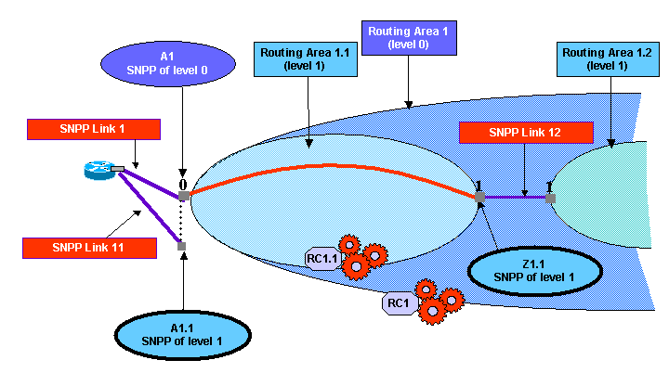

Figure 5.37 – Hierarchical Routing, view of SNPP Links at level 1

With reference to Figure 5.37, the Routing Controller managing RA1, called RC1, asks the RC managing RA1.1 (RC1.1) to set up a connection between A1.1 and Z1.1, which are the SNPP instances known by RC1.1
Note that such boundary points are the end points of external SNPP Links of RA1.1
On left side, SNPP Link 11 is also an external SNPP Link of top level RA1 (named SNPP Link1)
Hence a hierarchy of SNPP Links is shown.

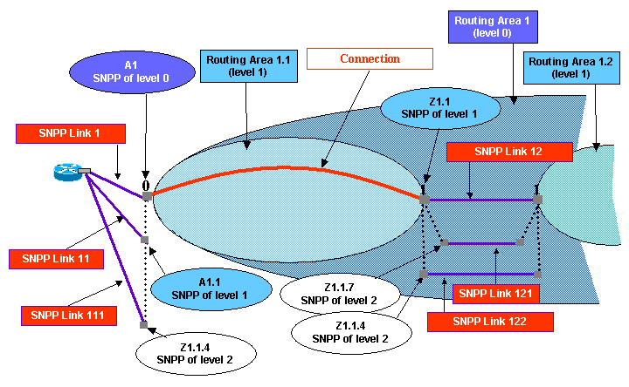

Figure 5.38 – Hierarchical Routing, view of SNPP Link hierarchy

With reference to Figure 5.38, it is shown that SNPP Link 12 is composed, at lower routing level, by two distinct SNPP Links, 121 and 122.
This partitioning of SNPP Links is necessary in case from RA1.1 routing perspective, it is known that there are different e.g. link costs to reach RA1.2

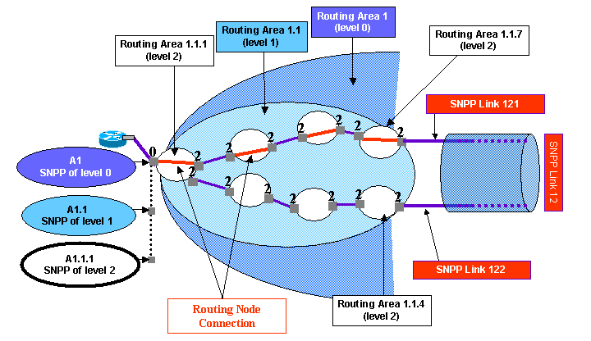

Figure 5.39 – Hierarchical Routing, view of SNPP Link at level 2

With reference to Figure 5.39, RC1.1 will ask RC1.1.1 to set up a connection between A1.1.1 and Z1.1.1, then will ask RC1.1.5, and so on till the RC1.1.7, with the connection between A.1.1.7 and Z1.1.7
From top level Routing Area, on right side it is visible the SNPP Link 12, moving down to RA1.1 the internal Routing Nodes appear, including the SNPP Links 121 and 122. This further partitioning of SNPP Links becomes necessary when e.g. routing costs are different exiting RA1.1 through RA1.1.4 or RA1.1.7, and this detail of information is irrelevant at superior routing level (where just SNPP Link 12 is described).
The routing engine (Control Plane Routing Controller) working in the scope of RA1.1 is called to create a connection exiting from SNPP Link 12 (i.e. towards RA1.2).
Given that such Routing Controller knows that SNPP Link 12 is hierarchically mapped to SNPP Links 121 and 122, it is able to perform connection routing at the level of detail of its competence, i.e. the Routing Nodes.

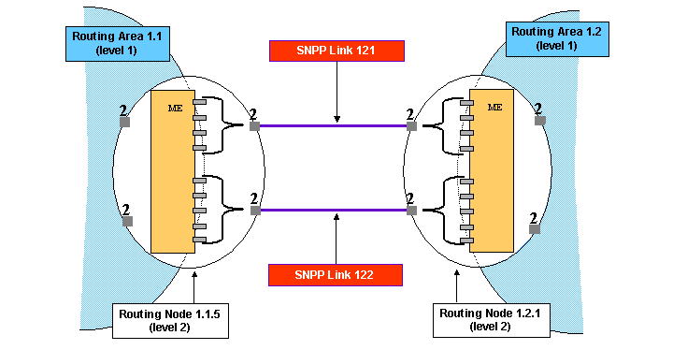

Figure 5.40 – view of SNPP Link at level 2, partitioning within same ME

With reference to Figure 5.40, it is shown an alternative scenario with respect to Figure 5.39, which is allowed by SNPP Link modeling. In this case, instead to have separate Routing Nodes, the set of Transport Plane links between two Managed Elements is partitioned into two separate SNPP Links at level 2. This may be necessary e.g. for different routing costs, or any other relevant network parameter (different shared risks, ducts, transmission media, etc.).
E.g. behind SNPP Link 121 there is a radio span, while SNPP Link 122 is supported by cables.
Last, such partitioning may be useful for pure administrative purposes, to assign “colours” to network resources for the management of filling factors, etc.

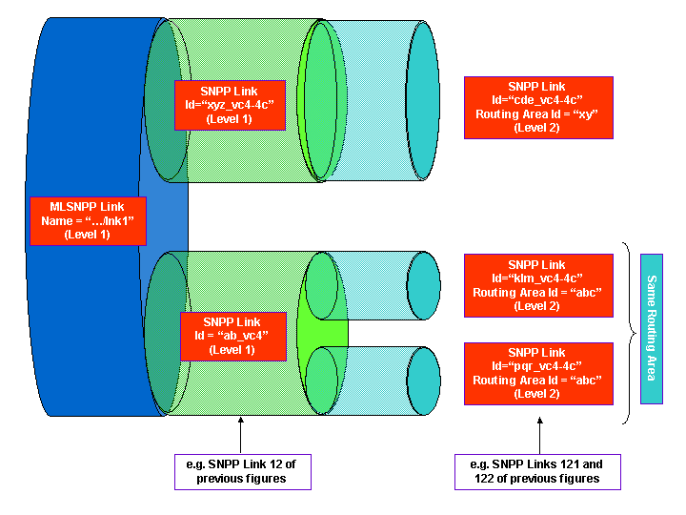

Figure 5.41 – Multi-Layer SNPP Link example of structure

With reference to Figure 5.41, it is shown how can be structured an MLSNPP Link at level 1 of routing hierarchy. If two layer rates are supported, then two SNPP Links are defined (“ab_vc4” and “xyz_vc4-4c”). Recursively, lower level SNPP Links are described. Note that SNPP Link “ab_vc4” is structured into two SNPP Links at lower routing level, both belonging to same routing area. This is another view of the scenario described along figures Figure 5.38, Figure 5.39 and Figure 5.40.

Figure 5.42 – SNPP Link Inventory, external links of RA 1.1

Figure 5.42 highlights level 1 links which interconnects RA1.1 to the other MLRAs at same level of routing hierarchy, i.e. the reply of “Get All Edge SNPP Links of RA1.1” operation.

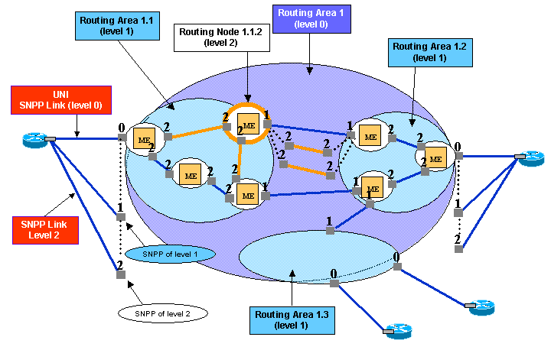

Figure 5.43 – SNPP Link Inventory, Routing Node links

Figure 5.43 highlights level 2 links which interconnects Routing Node 1.1.2 to the other Routing Nodes, i.e. the reply of “Get All Edge SNPP Links of Routing Node 1.1.2” operation. Note that two SNPP Links at level two are replied, while at level 1 there is only one SNPP Link, as shown by Figure 5.42. In this case the two SNPP Links (at level 2) end on the same Routing Node, like the example of Figure 5.40.

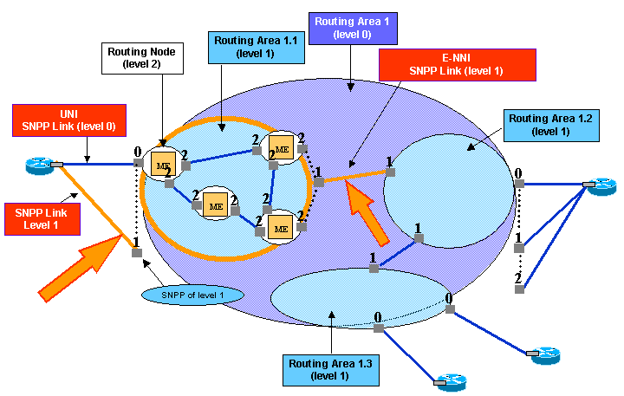

Figure 5.44 – SNPP Link Inventory, external links of RA 1.1

Figure 5.44 highlights level 1 links which interconnects RA1.1 to the other MLRAs at same level of routing hierarchy, i.e. the reply of “Get All Edge SNPP Links of RA1.1” operation.

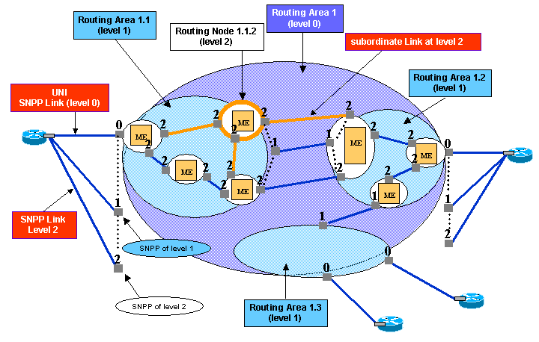

Figure 5.45 – SNPP Link Inventory, Routing Node links

Figure 5.45 highlights level 2 links which interconnects Routing Node 1.1.2 to the other Routing Nodes, i.e. the reply of “Get All Edge SNPP Links of Routing Node 1.1.2” operation. Note that one SNPP Links at level two is replied, as the other SNPP Link at level 2 actually ends on a different Routing Node, like example of Figure 5.39.

SNPP types and modeling
This section describes the model of SNPPs, according to the different scenarios.

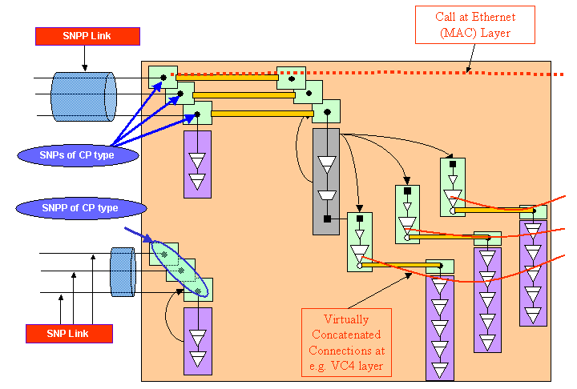

Figure 6.46 – SNPP of Connection Point type

In Figure 6.46 is shown an example of SNPP of CP (Connection Point, according to G.805) type. This SNPP groups a set of SNPs of CP type. Each one of these SNPs is associated to one CTP (1:1 relationship), in this example CTPs of Ethernet type are shown.

Following the reverse direction, a given CTP of Data or Transport Plane is assigned a Control Plane identifier, i.e. is 1:1 associated to a SNP. This actually allows Control Plane to manage the Data Plane resource (the CTP), typically for routing purposes.
Given a set of SNPs which e.g. are equivalent with respect to forwarding, such set can be explicitly defined through the SNP Pool (SNPP) concept. As far as Solution Set is concerned, the SNPP description is embedded into attributes and structures of the SNPP Link 2nd class object.
This because SNPPs of CP type always end an SNPP Link.
Each SNPP Link shown in the figure can support an UNI, so the Ethernet Call could have been requested at such UNI.

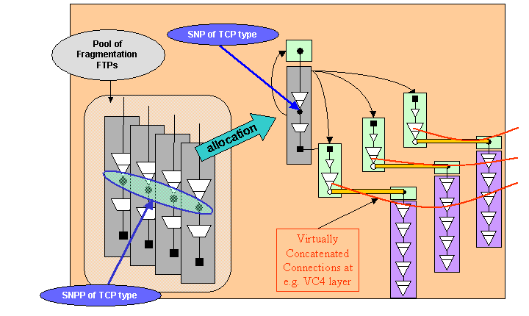

Figure 6.47 – SNPP of Termination Connection Point type, VCAT

In Figure 6.47 is shown an example of SNPP of TCP (Termination Connection Point, according to G.805) type. This SNPP groups a set of SNPs of TCP type. Each one of these SNPs is associated to one FTP (1:1 relationship), in this example FTPs of fragment type are shown.

Following the reverse direction, a given FTP of Data or Transport Plane is assigned a Control Plane identifier, i.e. is 1:1 associated to a SNP. This actually allows Control Plane to manage the Data Plane resource (the FTP), typically for routing purposes. Given a set of SNPs which e.g. are equivalent with respect to forwarding, such set can be explicitly defined through the SNP Pool (SNPP) concept. Note that this pool is not necessarily linked to any port/PTP of the ME, rather it represents a pool of internal resources. At Call/Connection establishment time one of these resources is allocated to support VCAT connectivity, similarly to the case an SNC is created specifying a generic end point within a ME, where the EMS will choose the appropriate FTP instance.

As far as Solution Set is concerned, the SNPP of TCP type is explicitly modelled by a 2nd class object. This because SNPPs of TCP type never end an SNPP Link.

A given ME may support just one instance of SNPP of TCP type, if any SNP of this SNPP can support a connectivity towards any direction (in other words, if any SNP can potentially terminate a trail routed over any SNPP Link of the Routing Node). If e.g. hardware restrictions are described (e.g. the SNPP describes a set of resources which can route signal only to/from ports of the same board), then more SNPP instances can be foreseen, each instance identifying a forwarding equivalence class.

Last, an SNPP of TCP type can support a “vertical” UNI, e.g. a Call may be established specifying such SNPP as end point. Control Plane will then allocate one or more SNPs to actually support the required connectivity. For instance, considering Figure 6.48, it is possible to establish a VC4 Call, supported by just one VC4 connection, specifying as end point the SNPP which groups all the SNPs mapped to FTPs representing modifiable VC4 trail terminations.

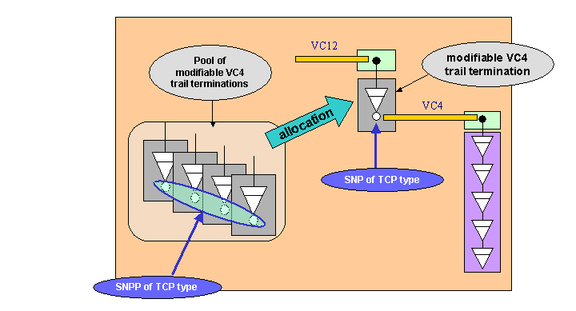

Figure 6.48 – SNPP of Termination Connection Point type, modifiable VC4

With reference to ITU-T G.852.2 definitions:
- an access group represents a group of co-located trail termination points that are bound to one subnetwork or link
For example, an access group may contain a number of trail termination points that are equivalent for routing purposes, i.e. from this access group originates a unique link towards a unique subnetwork in the same layer network.
The application of this example is shown in Figure 6.46, the horizontal UNI.

Another example foresees that the group is made according to the client layer network: all trail termination points of this access group serve connection termination points at the boundary of an unique subnetwork in the client layer.
The application of this example is shown in Figure 6.47 and Figure 6.48, the vertical UNI.

SNPP Link data structure
With reference to IDL Solution Set, MultiLayerSNPPLink_T is the structure of MLSNPP Link 2nd class object. It contains a complex type to describe the hierarchy of routing levels plus the supported layer rates, LayeredSNPPLinkList_T, which is a list of the SNPPLinks at a particular layer. Note that a given layerRate value can appear only once in this list.

typedef sequence<LayeredSNPPLink_T> LayeredSNPPLinkList_T;

struct LayeredSNPPLink_T
{
transmissionParameters::LayerRate_T layerRate;
SNPPLinkList_T sNPPLinkList;
};

The SNPPLinkList_T is the list of SNPPLink_T, i.e. a list of the SNPP Links along the levels of routing hierarchy. This shall always include the details for the SNPP Links in the relevant layer directly represented by the MLSNPPLink object and may also include details for the subordinate SNPP Links if the information is available to the EMS. The routing level is identified via the Routing Area IDs of end SNPPs.

typedef sequence<SNPPLink_T> SNPPLinkList_T

struct SNPPLink_T
{
string SNPPLinkId;
mLSNPP:: SNPP_T aEnd;
mLSNPP:: SNPP_T zEnd;
};

Where SNPP_T describes the list of SNPs and corresponding TPs in the data/transport plane.

struct SNPP_T
{
string sNPPId;
SNPList_T sNPList;
TNAName_T tNAName; The TNA name assigned to an SNPP
TNAName_T groupTNAName; The TNA group name associated to an SNPP
string rAId; Routing Area of the SNPP
};

typedef sequence<SNP_T> SNPList_T;

struct SNP_T
{
string sNPId;
globaldefs::NamingAttributes_T tPName;
TNAName_T tNAName;
};

The naming space of Transport and Control Plane topologies shall be separated, as much as possible. The minimum necessary point of contact is the 1:1 relationship between a CTP and an SNP instance. In fact, the SNPP is described as a set of CTPs. From the CTP name, the Transport Plane topology can be inferred.

As far as Call and Connection provisioning is concerned, the connection end points (and any other point to be referenced, e.g. for routing constraint purposes) may be coded as a
- CTP/FTP if the information is available to EMS (e.g. in case this point is “completely managed” by EMS)
- MLSNPP / MLSNPP Link names, if the information is available to EMS (e.g. in case this point is “directly managed through Control Plane” by EMS)
- SNPP / SNP identifier if no further information is available to EMS (e.g. in case this point is “remotely managed” by EMS)
- TNA if no further information is available to EMS. Note that TNA may be defined at MLSNPP (Link) level, or at SNPP Link, or even at SNP level.

Concerning SNPP and SNP, their reference shall include the following information:
- Routing Area Identifier, plus
- SNPP Identifier, plus (for SNP)
- SNP Identifier

In fact, the Routing Area Id is necessary to identify the scope and routing level of the SNPP.

Connection Route
This section describes how the route of a (top level) connection can be provisioned and retrieved along Routing Areas.
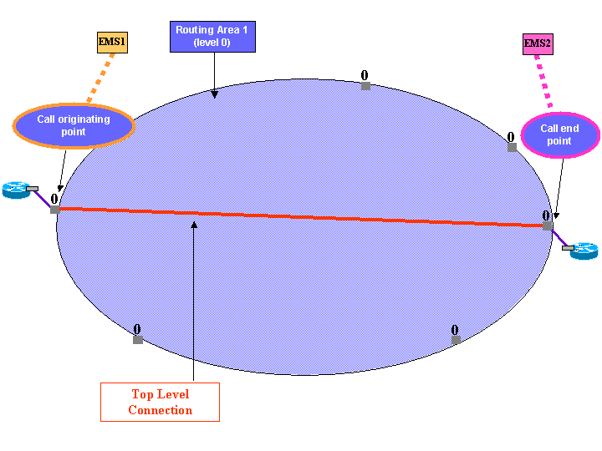

Figure 8.49 – Top Level Connection

Figure 8.49 shows an example of a Top Level connection, in terms of its end points and without further routing details.
The following operation can be addressed to EMS1 and EMS2, to discover which EMS controls the originating point of the Call which is supported by the top level connection shown in Figure 8.49.

- “Get All Calls And Top Level Connections of top level RA 1”, replies the whole information (i.e. the 2nd class object) about Calls plus all top level connection(s) supporting each call. In the case shown by Figure 8.49, result of the operation will be empty for EMS2 and will reply the Call plus shown top level connection when addressed to EMS1.
The following operation

- “Get Connections And Route Detail (Call Identifier)”

replies the route details across the Routing Areas that EMS1 completely manages (or directly manages through Control Plane).
The reply includes both connection segments (see Figure 8.50) and routing nodes connections (see Figure 8.51) of the input Call.

The operation can be filtered on MLRA:
- If the reference MLRA is the top level MLRA then the response will only include a list of all of the top level connections supporting the call, e.g. see Figure 8.49.
- If the reference MLRA is at intermediate level, e.g. RA 1.4 of Figure 8.50, then the EMS should return the routes for all connections within the referenced MLRA that support any top level connection of the referenced call (there could be more than one top level connection for the same call passing through an MLRA).
- If the reference MLRA is at bottom level (Routing Node), the answer is empty.
Alternatively, can be filtered on SNP or SNPP, hence EMS should return:
- if the SNP or SNPP is at the top level then the response will only include a list of all of the top level connections, that originate from the specified SNP(P), e.g. see Figure 8.49.
- If the SNP or SNPP is at intermediate level, e.g. RA 1.4 of Figure 8.50, then the EMS should return the routes for the connection(s) that originate from the referenced SNP or SNPP. See Figure 8.55 for the example with more connections for same Call.
- If the SNP or SNPP is at the hierarchical level of a routing node, then response is empty.

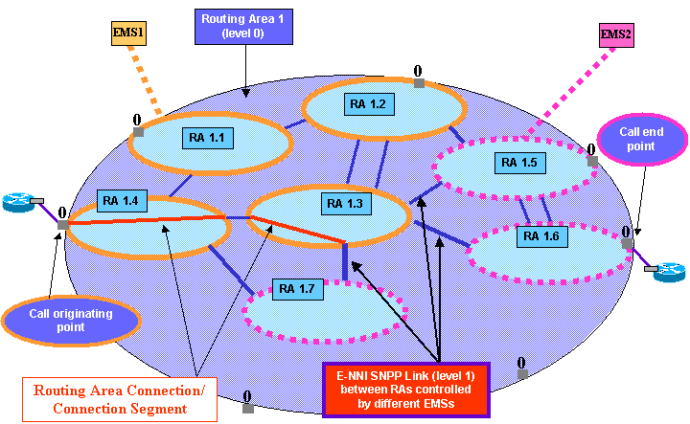

Figure 8.50 – Route of top level connection in terms of connection segments (EMS1)

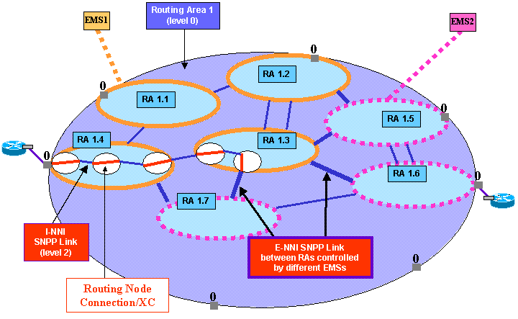

Figure 8.51 – Detailed route of top level connection (EMS1)

Note that the replied route ends at the highlighted SNPP Link between RA 1.3 and 1.7, which implies that last Routing Node connection includes the border SNP, allowing NMS to know which is the Control Plane identifier of remote neighbour Routing Area (see chapter 7, the SNPP_T structure). The EMS managing such Routing Area (RA 1.7 of Figure 8.51) is the EMS2.

With this information, NMS can perform same operation (Get Connections And Route Detail) addressing EMS2, to get the detailed routes of the subordinate connections of top level connections as shown in Figure 8.52 and Figure 8.53.

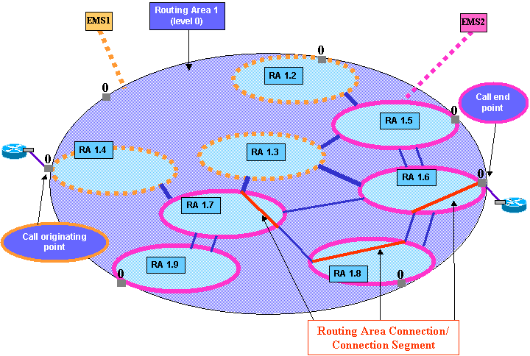

Figure 8.52 – Route of top level connection in terms of connection segments (EMS2)

Figure 8.53 shows the possible result of the “Get Connections And Route Detail” operation, addressed to EMS2, specifying as input parameter the control plane identifier of SNP, see detailed view at Figure 8.54.

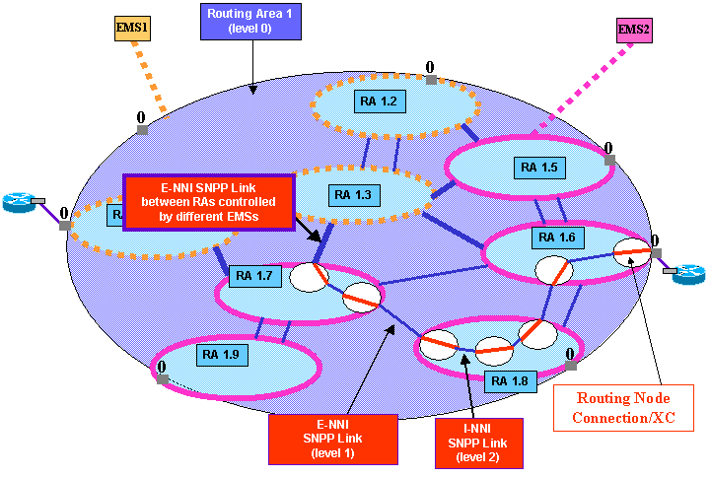

Figure 8.53 – Detailed route of top level connection (EMS2)

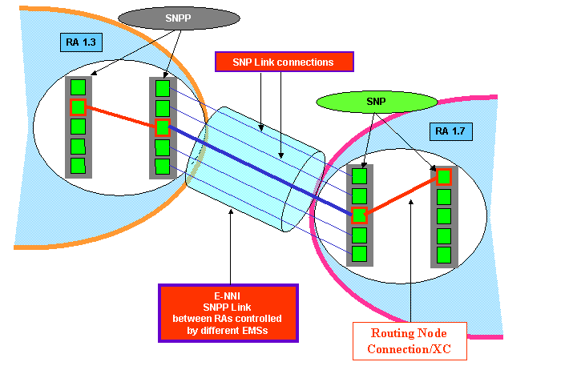

Figure 8.54 – Detailed view of SNPP Link and its SNPs

With reference to chapter 7, the SNPP Link structure includes the control plane identifiers of the SNPPs which end the link, and for each SNPP, the control plane identifier of all its SNPs.

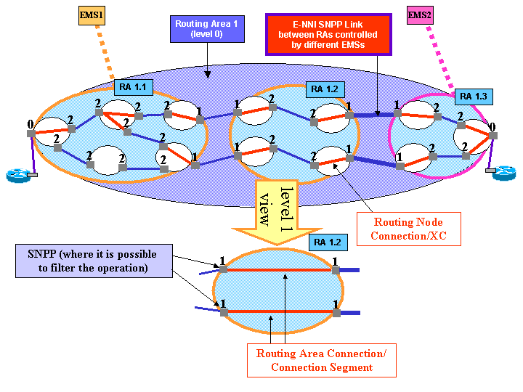

Figure 8.55 – SNCP protection scheme and replied connections

In Figure 8.55 it is shown the case of a Call which is supported by a top level connection, which is SNCP protected. Within RA 1.2, there are two separate connection segments, respectively supporting the main and spare legs of top level connection. The Get Connections And Route Detail operation will reply both Connection Segments, plus their detailed routes, i.e. their Routing Node Connections/XCs.
Note that the Get Connections And Route Detail operation can be filtered e.g. on one SNPP of level 1, hence only the connection segment ending on such SNPP will be replied (plus its XCs).

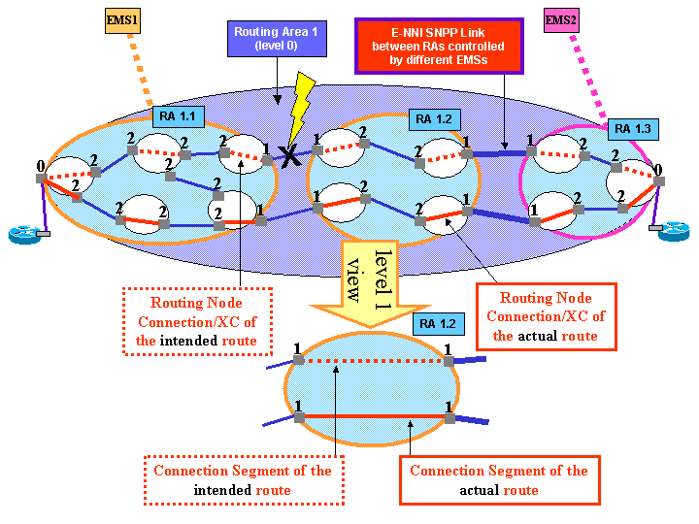

Figure 8.56 – End to end restoration scheme and replied connections

In Figure 8.56 it is shown the case of a Call which is supported by a top level connection, which is currently being restored, due to a failure affecting its home or intended route.
Within RA 1.2, there are two separate connection segments, respectively supporting the intended and actual routes of top level connection. The Get Connections And Route Detail operation will reply both Connection Segments, plus their detailed routes, i.e. their Routing Node Connections/XCs.
Note that the Get Connections And Route Detail operation can be filtered also on route type, hence only the connection segment of e.g. the actual route will be replied (plus its XCs).

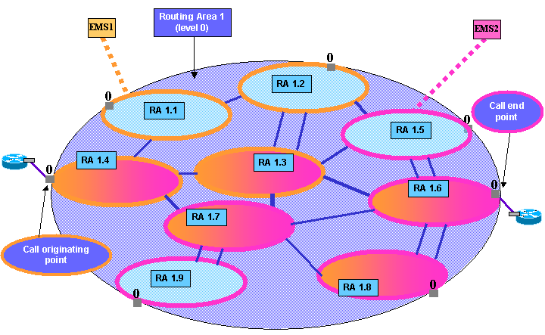

Figure 8.57 – Routing Areas involved in the route of top level connection

The following operation can be addressed to EMS1:

- “Get All Subordinate MLSN With Connection” with input parameters the Connection name just discovered and the top level RA 1, replies the Control Plane identifier of all Routing Areas which are known to be involved in the route of input top level connection, e.g. the RAs highlighted in Figure 8.57 are replied.

The operation cannot be addressed to EMS2, as it does not control the originating point of the call.

Call and Connections, Protection, Restoration, VCAT
This section describes the model of Call and Connections, considering Protection, Restoration and Virtual Concatenation features.

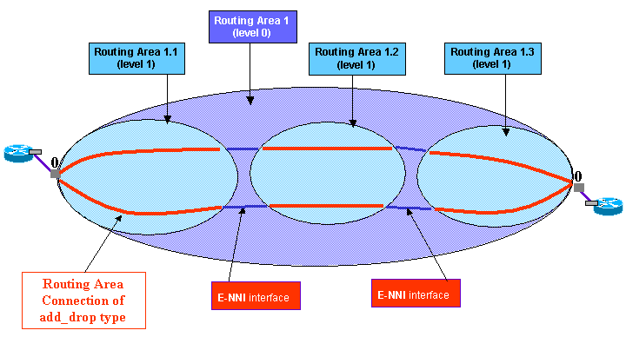

Figure 9.58 – Protection scheme

In Figure 9.58 it is shown an end-to-end protection scheme, e.g. an SNCP scheme in SDH Transport Plane.
By definition of protection scheme, primary and secondary branches are both active in the network. There is one Call, supported by:
- Top level RA 1 (level 0): one top level Connection of “simple” type, “partial protected” protection level (see also Figure 9.59)
- Subordinate RA 1.1 and 1.3 (level 1): per each RA, there is one Connection (representing a Connection Segment), of “add drop” type, “unprotected” protection level.
- Subordinate RA 1.2 (level 1): there are two Connections (each one representing a Connection Segment), of “simple” type, “unprotected” protection level.

Note that within RA 1.2 the two Connections are distinct, the only shared property is the Control Plane identifier of the Call.

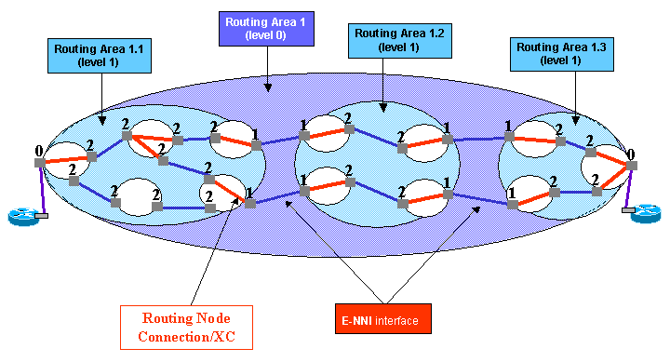

Figure 9.59 – Detailed view of Protection Scheme

Figure 9.59 shows the information concerning the route of end to end protected top level connection in terms of Routing Node connections. Within RA 1.1 the route is not fully disjoint, hence the resulting protection level should be “partial”.

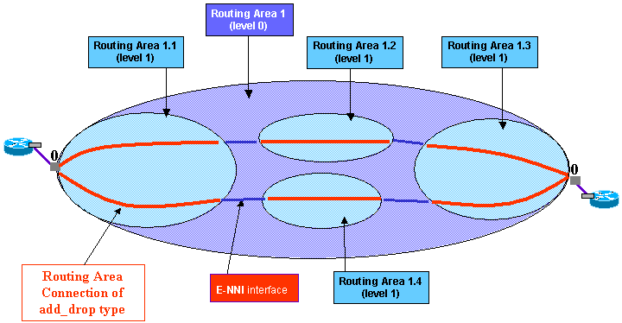

Figure 9.60 – Protection scheme across four RAs

In Figure 9.60 is shown the end-to-end protection scheme, this time spanning four subordinate Routing Areas. There is one Call, supported by:
- Top level RA 1 (level 0): one top level Connection of “simple” type, “partial protected” protection level (see also Figure 9.59 concerning RA 1.1)
- Subordinate RA 1.1 and 1.3 (level 1): per each RA, there is one Connection (representing a Connection Segment), of “add drop” type, “unprotected” protection level.
- Subordinate RA 1.2 and 1.4 (level 1): per each RA, there is one Connection (representing a Connection Segment), of “simple” type, “unprotected” protection level.

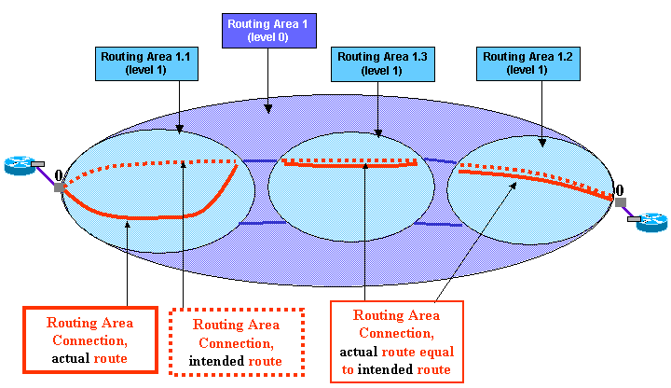

Figure 9.61 – Restoration scheme, local restoration

In Figure 9.61 there is one Call, supported by

- Top level RA1 (level 0): one Connection of “simple” type, “unprotected” protection level, and “rerouteAllowed” equal to “no” .
- Subordinate RA 1.1, 1.2 and 1.3 (level 1): per each RA, there is one Connection (representing a Connection Segment), of “simple” type, “unprotected” protection level and “rerouteAllowed” equal to “yes”.

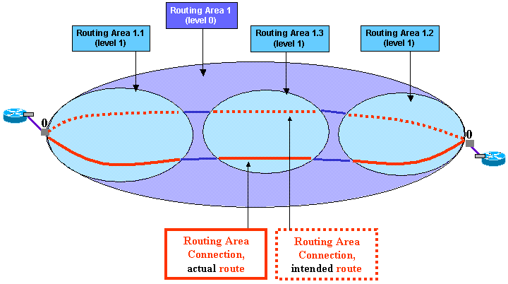

Figure 9.62 – Restoration scheme, end to end restoration

In Figure 9.62 there is one Call, supported by

- Top level RA1 (level 0): one Connection of “simple” type, “unprotected” protection level, and “rerouteAllowed” equal to “yes”.
- Subordinate RA 1.1, 1.2 and 1.3 (level 1): per each RA, there is one Connection (representing a Connection Segment), of “simple” type, “unprotected” protection level and “rerouteAllowed” equal to “no” .

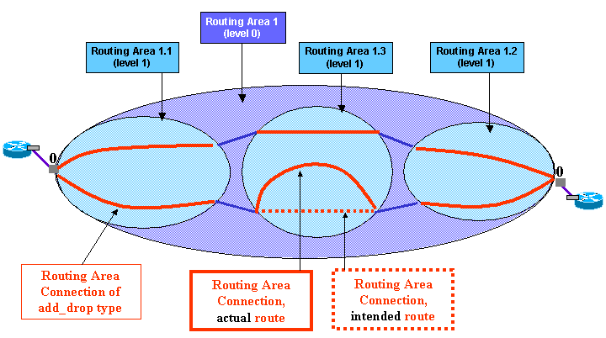

Figure 9.63 – Protection scheme combined with local restoration

In Figure 9.63 there is one Call, supported by

- Top level RA1 (level 0): one Connection of “simple” type, “partial protected” protection level.
- Subordinate RA 1.1, 1.2 (level 1): per each RA, there is one Connection (representing a Connection Segment), of “add drop” type, “unprotected” protection level.
- Subordinate RA 1.3 (level 1): there are two Connections (each one representing a Connection Segment), of “simple” type, “unprotected” protection level and “rerouteAllowed” equal to “yes”.

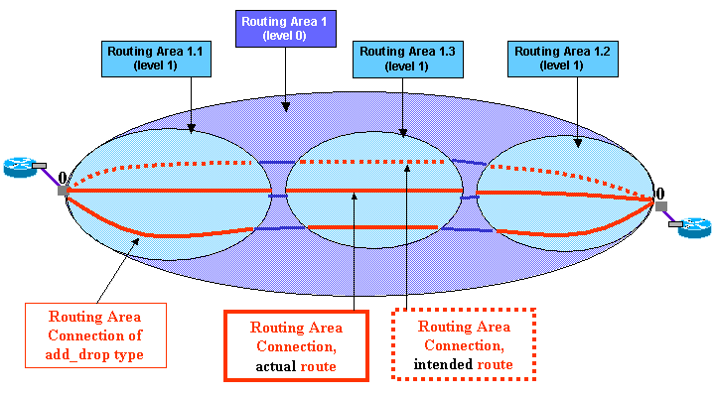

Figure 9.64 – Protection scheme combined with end to end restoration

In Figure 9.64 there is one Call, supported by

- Top level RA1 (level 0): one Connection of “simple” type, “partial protected” protection level and “rerouteAllowed” equal to “yes”.
- Subordinate RA 1.1, 1.2 (level 1): per each RA, there is one Connection (representing a Connection Segment), of “add drop” type, “unprotected” protection level and “rerouteAllowed” equal to “no” .
- Subordinate RA 1.3 (level 1): there are two Connections (each one representing a Connection Segment), of “simple” type, “unprotected” protection level and “rerouteAllowed” equal to “no” .

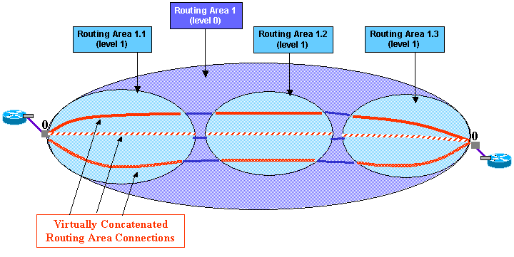

Figure 9.65 – Virtual Concatenation / inverse multiplexing

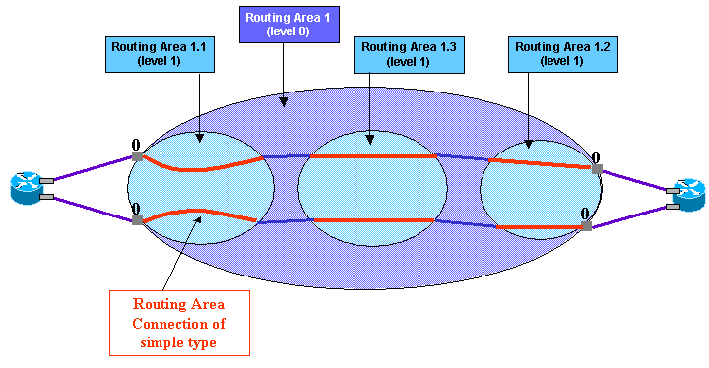

Figure 9.66 – Protection Scheme terminated outside the top level MLRA

In Figure 9.66 it is shown a protection scheme where the SNCP bridge&switch is implemented outside the top level Multi-Layer Routing Area. It is a possible implementation of Dual Homing Protection.
There is one Call, supported by

- Top level RA1 (level 0): two Connections of “simple” type, “unprotected” protection level.
- Subordinate RA 1.1, 1.2, 1.3 (level 1): per each RA, there are two Connections (each one representing a Connection Segment), of “simple” type, “unprotected” protection level.

The Establish Call operation needs at least the following parameters:
- {a1, a2; z1, z2} end points (the “role” each end point plays in the Call shall be provisioned)
- routing constraints (or diversity of home routes)
- characteristic information, bandwidth

Anyway the chosen solution is to always represent only two call end points, which are the external “reliable” TNAs, while the four end points of the network connectivity are described at (top level) connection side only.

Diversity Management
This section describes how the routing constraints concerning diversity can be provisioned. Each Connection may be assigned a Route Group, identified by a label. A Route Group is the entity to which diversity and/or co-routing constraints apply. More in detail:

- co-routing can be specified within a Route Group, and cannot be specified between different Route Groups,

- diversity can be specified between different Route Groups, and cannot be specified within a Route Group.

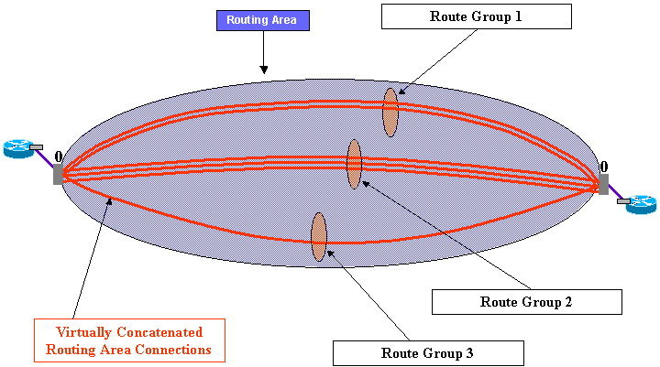

Figure 10.67 – Route Groups, co-routing and diversity constraints specified

Figure 10.67 shows an example of Call supported by six top level Connections. Three Route Groups have been defined at Call establishment time, Route Group 1 is formed by two Connections (i.e. management model side, these two Connections share same value of Route Group Label attribute), Route Group 2 is formed by three Connections and Route Group 3 contains only one connection. As co-routing constraint has been provisioned, then the Connections belonging to a Route Group follow similar/same route.

Note: Route Group 3 is formed by only one Connection, hence co-routing constraint does not apply, of course until one or more new Connections are added to the Route Group 3.
As diversity constraint has been specified, then the Connections belonging to different Route Groups are routed over different paths.

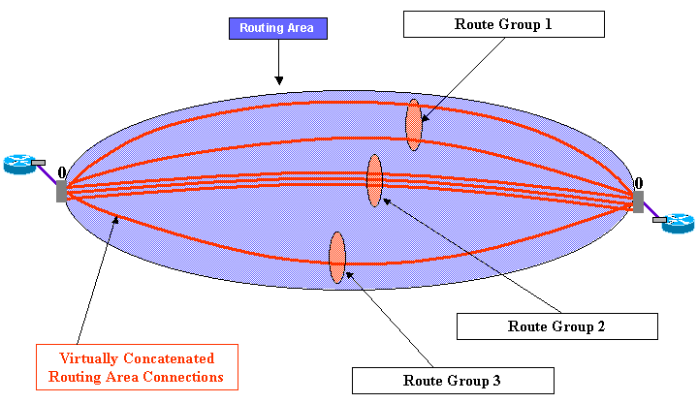

Figure 10.68 – Route Groups, co-routing constraint not specified, diversity constraint specified

Figure 10.68 shows the scenario where the co-routing constraint has not been specified, and diversity constraint has been specified. In fact, the two Connections belonging to Route Group 1 do not follow the same route. Note that the Connections belonging to Route Group 2 follow same route, this result is to be considered correct because when co-routing is not provisioned, this does not imply that any diversity within Route Groups is required.
Like Figure 10.67, as diversity constraint has been specified, then the Connections belonging to different Route Groups are routed over different paths.

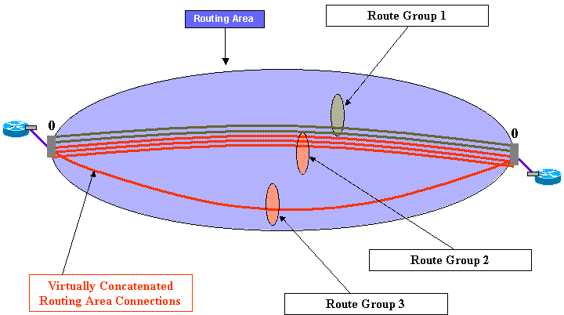

Figure 10.69 – Route Groups, co-routing constraint specified, diversity constraint not specified

Figure 10.69 shows the scenario where the co-routing constraint has been specified, and diversity constraint has not been specified. In fact, the two Connections belonging to Route Group 1 follow same route, furthermore they follow same route as Connections belonging to Route Group 2. The Connection within Route Group 3 does not follow same route as other Connections because the missing specification of diversity constraint does not imply any co-routing requirement between Route Groups.

It is possible to specify different degrees of diversity / co-routing constraint:
- none indicates that no co-routing / diversity constraint are required
- best effort indicates that co-routing / diversity constraint are required with best effort, i.e. the connections are created even in case the calculated routes have one or more violations to co-routing / diversity requirement
- mandatory indicates that co-routing / diversity constraint are mandatory required, which means that connections are created only if their routes strictly fulfil the required constraints.
It is also possible to modify routing constraints of already existing Connections, same rules apply, i.e. the modification is refused if mandatory effort cannot be fulfilled.

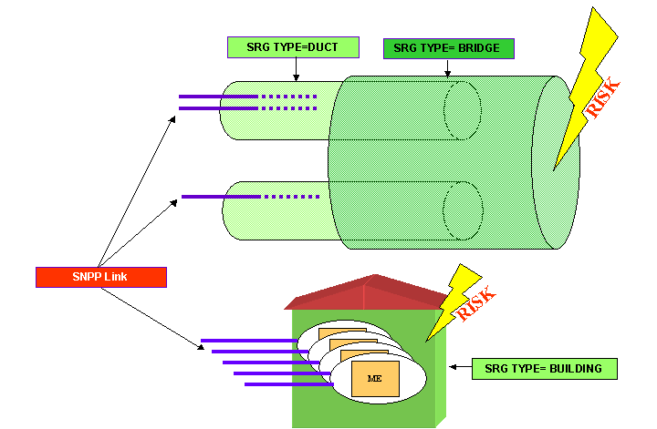
Last, the type of shared risk group (SRG) can be provisioned, respectively for node and link co-routing/diversity. Examples of SRG types are duct, sidewalk and bridge for link constraints, and room, building and block for node constraints.

Figure 10.70 – Examples of Shared Risk Groups

Revision History
Version | Date | Description of Change
0.1 | 2004/11/11 | Initial version
0.2 | 2005/04/17 | Second main version, several changes and simplifications are done
0.3 | 2006/10/12 | Final version to be likely included in the Primer supporting document of TMF814 3.5
0.4 | 2006/12/21 | Further version which remains a distinct supporting document of TMF814 3.5  Added figures concerning SNPP Link modeling – removed the “alias” term. Added figures clarifying the inventory of Control Plane topology, of Calls and Connections, including their routes. Included diversity management.

Acknowledgements
First Name | Last Name | Company
Nigel | Davis | Nortel

How to comment on the document
Comments and requests for information must be in written form and addressed to the contact identified below:

Andrea Maria | Mazzini | Alcatel-Lucent
Phone: | +39 039 686 4961
Fax: | <will be provided if required>
e-mail: | andrea_maria.mazzini@alcatel-lucent.it

Please be specific, since your comments will be dealt with by the team evaluating numerous inputs and trying to
produce a single text. Thus we appreciate significant specific input. We are looking for more input than wordsmith” items, however editing and structural help are greatly appreciated where better clarity is the result.

more precisely, network resources in the Control Plane name space, represented by e.g. SNP, SNPP, SNPP Link managed objects. May include e.g. the remote connection segment 2 as well.
more precisely, network resources in the Transport Plane name space, represented by e.g. ME, PTP, CTP Managed objects.
Note that the transparency does not necessarily recur, e.g. RA of level N exports all of its internal links at N+1 level, but no information is exported concerning links at N+2 routing level, and so on.
Note that the limited view does not necessarily recur, e.g. RA of level N exports some of its internal links at N+1 level, but no information is exported concerning links at N+2 routing level, and so on.
In such case the ME (and all its TPs, etc.) within Routing Node is no longer visible.
Note that E-NNI and I-NNI definitions are related to the hierarchy level considered, following the partitioning concept. E.g. given a MLRA of level N, its edge links have the E-NNI role with respect to level N. Same links have I-NNI role with respect to level N-1 (superior), i.e. are internal links of superior MLRA.
Note that a remote Routing Area can be addressed only through its Control Plane Identifier, rather than the name of 2nd class object – which by definition of remote Routing Area, is not available at the interface.
Note that in some cases the MLSNPP/ MLSNPP Link names can be refined by specifying also SNPP (Link) identifier plus optionally SNP identifier. In fact, the solution set does not supply any 2nd class object representing SNPP (Link) and SNP, hence in case such details (i.e. layer rate and time slot) are known, such addition to MLSNPP (Link) object name is performed.
For further study, it may be possible/necessary to set “yes” also at top level.
For further study, it may be possible/necessary to set “yes” also at level 1.
For further study, it may be possible/necessary to set “yes” also at level 1.
For further study, it may be possible/necessary to set “yes” also at level 1.

