MTOSI 2.0 Release Notes

RN306
Version 2.1


May 2008

©TM Forum 2008
Notice
No recipient of this document shall in any way interpret this document as representing a position or agreement of the TeleManagement Forum (TM Forum) or its members. This document is a draft working document of TM Forum and is provided solely for comments and evaluation. It is not a Forum Approved Document and is solely circulated for the purposes of assisting TM Forum in the preparation of a final document in furtherance of the aims and mission of TM Forum.
Although it is a copyrighted document of TM Forum:
- Members of TM Forum are only granted the limited copyright waiver to distribute this document within their companies and may not make paper or electronic copies for distribution outside of their companies.
- Non-members of the TM Forum are not permitted to make copies (paper or electronic) of this draft document other than for their internal use for the sole purpose of making comments thereon directly to TM Forum.
- If this document forms part of a supply of information in support of an Industry Group Liaison relationship, the document may only be used as part of the work identified in the Liaison and may not be used or further distributed for any other purposes
Any use of this document by the recipient, other than as set forth specifically herein, is at its own risk, and under no circumstances will TM Forum be liable for direct or indirect damages or any costs or losses resulting from the use of this document by the recipient.
This document is governed by all of the terms and conditions of the Agreement on Intellectual Property Rights between TM Forum and its members, and may involve a claim of patent rights by one or more TM Forum members or by non-members of TM Forum.
Direct inquiries to the TM Forum office:
240 Headquarters Plaza,
East Tower – 10th Floor,
Morristown, NJ 07960 USA
Tel No. +1 973 944 5100
Fax No. +1 973 944 5110
TM Forum Web Page: www.tmforum.org
Table of Contents

Notice 2
Table of Contents 3
Executive Summary 6
In memoriam 6
1 Overview of MTOSI Release 2.0 7
1.1 Relationship to NGOSS and SID 7
1.2 DDP Structure 7
1.3 MTOSI 2.0 DDPs 8
1.4 Supported Business scenarios 10
1.4.1 Resource Management & Operations (RM&O) 10
1.4.1.1 Operations Support & Readiness: Support Resource Trouble Management (RTM) 10
1.4.1.2 Operations Support & Readiness: Managed Resource Inventory (MRI) 12
1.4.1.3 Resource Provisioning (RP) 13
1.4.1.4 Resource Performance Management (RPM) 14
1.4.2 Service Management & Operations (RM&O) 14
1.4.2.1 Service Configuration & Activation 14
1.4.2.2 Manage Service Inventory 15
2 Release Definition 16
2.1 Document Release Description 16
2.1.1 Major BA Deliverables 21
2.1.1.1 TMF518_FMW, Framework - DDP BA 21
2.1.1.2 TMF518_NRB, Network Resource Basic - DDP BA 21
2.1.1.3 TMF518_NRF, Network Resource Fulfillment - DDP BA 21
2.1.1.4 TMF518_NRA, Network Resource Assurance - DDP BA 21
2.1.1.5 TMF518_MRI, Manage Resource Inventory - DDP BA 21
2.1.1.6 TMF518_RP, Resource Provisioning - DDP BA 22
2.1.1.7 TMF518_RTM, Resource Trouble Management (RTM) - DDP BA 22
2.1.1.8 TMF518_RPM, Resource Performance Management - DDP BA 22
2.1.1.9 TMF518_SB, Service Basic - DDP BA 22
2.1.1.10 TMF518_SA_1, Service Activation - DDP BA - Part 1: Overview 22
2.1.1.11 TMF518_SA_2, Service Activation - DDP BA - Part 2: Service Activation Interface (SAI) 23
2.1.1.12 TMF518_SA_3, Service Activation - DDP BA - Part 3: Service Component Activation 23
2.1.1.13 TMF518_MSI, Manage Service Inventory - DDP BA 23
2.1.2 Major IA Deliverables 23
2.1.3 Major IIS Deliverables 23
2.1.4 Joint MTOSI / MTNM Supporting Documents 25
2.1.4.1 SD0-1, mTOP Dictionary 25
2.1.4.2 SD0-2_mTOPGuidelines_BA, SD0-3_mTOPTemplate_BA.dot 25
2.1.4.3 SD0-4_mTOPGuidelines_IA 25
2.1.4.4 SD0-5_mTOPGuidelines_WebServices 25
2.1.4.5 SD0-6_mTOPTemplate_SD.dot 25
2.1.5 MTOSI Supporting Documents 25
2.1.5.1 SD2-2_XML_ImplementationUserGuide.doc 26
2.1.5.2 SD2-4_TransportIndependentExampleOfMTOSI.zip 26
2.1.5.3 SD2-5_Communication_Styles 26
2.1.5.4 SD2-6_VersioningAndExtensibility 26
2.1.5.5 SD2-7_ObjectNaming 26
2.1.5.6 SD2-9_UsingJMSAsMTOSITransport 26
2.1.5.7 SD2-10_ExampleUsingJMS 26
2.1.5.8 SD2-12_MTOSI_Inventory_Layout 27
2.1.5.9 SD2-14, Attribute Value Change & State Change Notifications 27
2.1.5.10 SD2-16_UsingHTTPAsMTOSITransport 27
2.1.5.11 SD2-17_MTOSI_EnhancedResourceStates 27
2.1.5.12 SD2-18_VPNServiceModel.xls 27
2.1.5.13 SD2-19_VoIPServiceDefinition 27
2.1.5.14 SD2-20_EquipmentModel 27
2.1.6 MTNM Supporting Documents 27
2.1.6.1 SD1-3_BundledSNC 27
2.1.6.2 SD1-5_ATMConformanceDefinitions 28
2.1.6.3 SD1-6, Examples for contained TPs different states of usage 28
2.1.6.4 SD1-7_DSLOverview 28
2.1.6.5 SD1-8, Coding of X.731 and M.3100 State and Status Information 28
2.1.6.6 SD1-13_guiCutThrough 28
2.1.6.7 SD1-14, Inverse Multiplexing (IM) Overview 28
2.1.6.8 SD1-16, Layered Parameters 28
2.1.6.9 SD1-17, Layer Rates 28
2.1.6.10 SD1-18, Functional Modeling Concepts 28
2.1.6.11 SD1-19, Location Identification 28
2.1.6.12 SD1-20, Maintenance Commands 28
2.1.6.13 SD1-22, Modeling Components 29
2.1.6.14 SD1-23_ModesOfOperation 29
2.1.6.15 SD1-28, Performance Parameters 29
2.1.6.16 SD1-29_PGPParameters 29
2.1.6.17 SD1-30, PM File Format 29
2.1.6.18 SD1-31, PM File Format 29
2.1.6.19 SD1-32 PM File Format 29
2.1.6.20 SD1-33, Specification of probableCause strings 29
2.1.6.21 SD1-34_protectionSwitch 29
2.1.6.22 SD1-36, SNC and Protection 29
2.1.6.23 SD1-37, PM Threshold Types 29
2.1.6.24 SD1-41_TPPoolRelationship 29
2.1.6.25 SD1-44, Connectionless Technology Management 30
3 Administrative Appendix 31
3.1 Document History 31
3.2 Company Contact Details 32
3.3 Acknowledgments 33
3.4 About TM Forum 33

Executive Summary
This document constitutes the Release Note of the full MTOSI 2.0 Release.
It presents an overview of the Release 2.0 of the MTOSI product and it shows the complete list of all the different documents constituting this Release.

In memoriam
This release has been made possible thanks to the expertise and contributions of many experts from many companies and organizations. Among them, Shlomo Cwang of Amdocs was certainly one of the most committed and enthusiastic. Shlomo was the first leader of the mTOP Service Management team and made essential contributions to key deliverables on Service Activation, Service Inventory and other related topics.
Illness did not leave him the opportunity to see the final consolidation of his work—the final product of which he would have been proud
Those who worked with Shlomo will remember how passionate and resolute he was in technical discussions, and how brave he was in continuing his work in the face of severe illness.
Sadly, we have now lost both an essential contributor and a good friend. May he rest in peace.
The TM Forum would like to dedicate this release to him.

Overview of MTOSI Release 2.0
Release 2.0 of the MTOSI product is a major release. It means that it does contain new features compared to the previous MTOSI 1.x releases.
Many modifications have been introduced in this release. They are summarized below:
  - Service activation management
  - Service inventory management
  - Resource provisioning and activation
  - Management of connectionless networks
  - Performance management and maintenance commands
  - Inventory updates, multi-event inventory notifications and enhanced inventory retrieval (attribute value matching)
  - Enhanced model for resource states
  - Multi-action and request transactions
  - Division of deliverables into Document Delivery Packages (DDPs) as shown in the next subsection.

Relationship to NGOSS and SID
MTOSI Release 2.0 covers aspects of both the NGOSS lifecycle business and system views. The various Business Agreement documents in MTOSI Release 2.0 have a combination of first order business requirements and then many second order requirements (derived from the first order requirements) that are best classified as being requirements on the system view. The IA and IIS cover the system view. SD2-1, MTOSI Implementation Statement, and SD2-2, XML Implementation User Guide, cover aspects of the implementation view.
With respect to the SID model, the MTOSI Service Basic DDP has made extensions to the GB922 Service Model addendum. These extensions have been agreed with the SID team and will be incorporated in a future SID release.
Concerning the resource model, there have been a large number of CRs accepted by the CCB concerning alignment between the SID and MTOSI-MTNM resource models in the area of equipment (see CRs 289, 290, and 291), external plant (see CR 272 and note that support for external plant is not previously covered by the SID model or MTOSI), and connectivity and TPs (see CRs 269, 280 and 282) modelling. These changes, however, still need to be made in either the SID resource models (PR and LR) or the MTOSI – MTNM implementation model (TMF 612 and 608, respectively).

DDP Structure
In order to allow for more efficient release delivery, the previous monolithic BA, IA and SS documents have been partitioned into smaller self-contained (though not independent) units called Document Delivery Packages (DDPs).
This is similar to the 3GPP concept of Integration Reference Point (IRP). The basic idea is that the Interface, which is specified by the entire document set (of a release), is partitioned into DDPs where each DDP specifies “a certain aspect” of the Interface, which needs to be very clearly scoped.
There are three kinds of DDPs:
  - the FrameWork DDP (FMW) – this DDP contains the generic artifacts that are applicable to all the other DDPs.
  - Data Model DDP (DM-DDP) – a DDP that concerns a data model (entities, data structures, attributes, state, but no operations)
  - Operation Model DDP (OM-DDP) – a DDP that concerns a computational model (operations, notifications, transactions) for a given functional area (such as resource inventory management)
The unified deliverables structure for each DDP is as follows:
  - Business Agreements (BAs): a business view specification
  - Information Agreements (IAs): a system view specification
  - Interface Implementation Specifications (ISSs): implementation and deployment view specification for XML (WSDL, XSD, bindings…)
  - Supporting Documentation: normative and informative supporting documents.

MTOSI 2.0 DDPs
The MTOSI 2.0 Release is constituted of several DDPs which names are presented in the table below.

 | DDP long name | DDP short name
General
 | Framework | FMW
RM related
 | DM-DDPs
 | NetworkResourceBasic | NRB
 | NetworkResourceFulfilment | NRF
 | NetworkResourceAssurance | NRA
 | OM-DDPs
 | ManageResourceInventory | MRI
 | ResourceProvisioning | RP
 | ResourceTroubleManagement | RTM
 | ResourcePerformanceManagement | RPM
SM related
 | DM-DDPs
 | ServiceBasic | SB
 | OM-DDPs
 | ServiceActivation | SA
 | ManageServiceInventory | MSI

The OM-DDPs reflect business scenarios as highlighted in the next sub section.

It may happen that artifacts defined in one DDP may use artifacts defined in one or several other DDPs.
The figure below shows the DDP dependency graph:

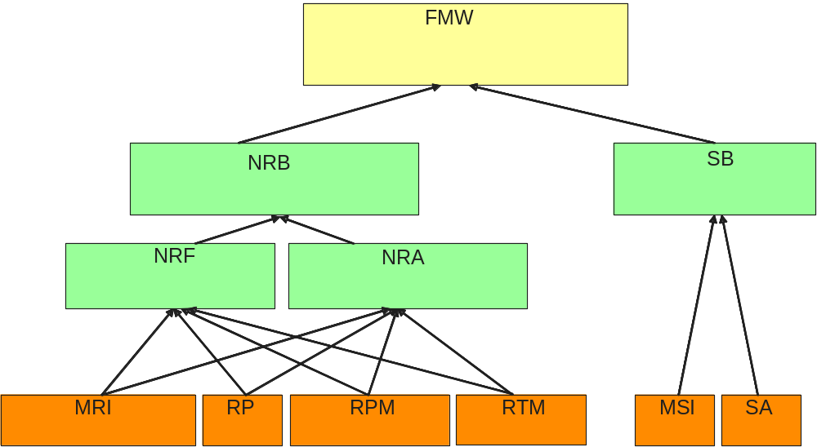

Supported Business scenarios
The MTOSI product is intended to provide a unified set of management interfaces in support of the functions described in this section.
It should be noted that the OS types used in this section are only examples; MTOSI does not define or mandate the use of specific OS types but it provides a management interface that can be used at a variety of OS types.
Examples of interaction between OS are illustrated through different figures. In those figures the OS in red represents the requestor OS.

Resource Management & Operations (RM&O)

Operations Support & Readiness: Support Resource Trouble Management (RTM)
This set of capabilities covers resource fault management, protection management and maintenance and diagnostics.
In terms of fault management, the focus is on alarm subscription, active alarm synchronization, the control of alarm reporting and the predetermined assignment of severities to given alarm types.
The protect management requirements and use cases entail the retrieval of protection related information such as protection groups and subscription to protect switch events.
The maintenance and diagnostics aspect focuses on the sending of maintenance commands and the determination of active (still running) maintenance actions
This capability is supported by means of the interface that both allows an OS to send alarms to a set of interested OSs and allows an OS (alarm requesting OS) to request some or all of the active alarms known to another OS (target OS). In order to receive alarms from a given OS, an alarm consuming OS must first subscribe to receive the alarms of the given OS. A single OS could play both roles.
For more details on the RTM requirements and use cases, see the Resource Trouble Management Business Agreement document. The associated management entities can be found in the Network Resource Assurance Business Agreement document.
For an example of the fault management capability, consider Figure 1-1 which shows three alarm consuming OSs receiving alarms from a single alarm generation OS.
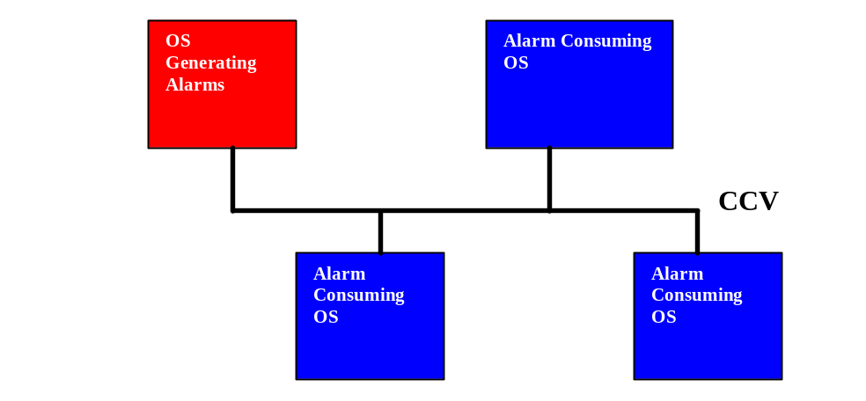
Figure 1-1. Alarm Reporting

Figure 1-2 shows a single OS (in the role of a manager of fault managers) retrieving alarms from several target OSs (perhaps single technology fault management systems).
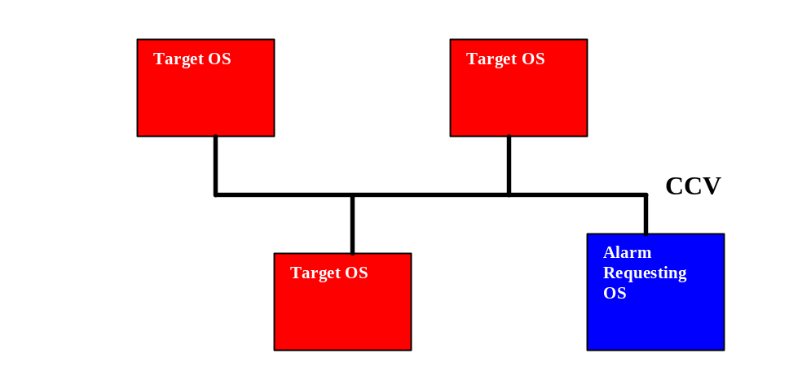
Figure 1-2. Active Alarm Retrieval

Operations Support & Readiness: Managed Resource Inventory (MRI)
This capability is supported by means of the interface that both allows an OS to retrieve all or part of the inventory known to another OS, and also allows an OS to send inventory update notifications to a set of interested OSs.
In Figure 1-3, a Fault Management OS, Inventory OS, and Service Creation OS obtain network inventory from the Inventory OS.

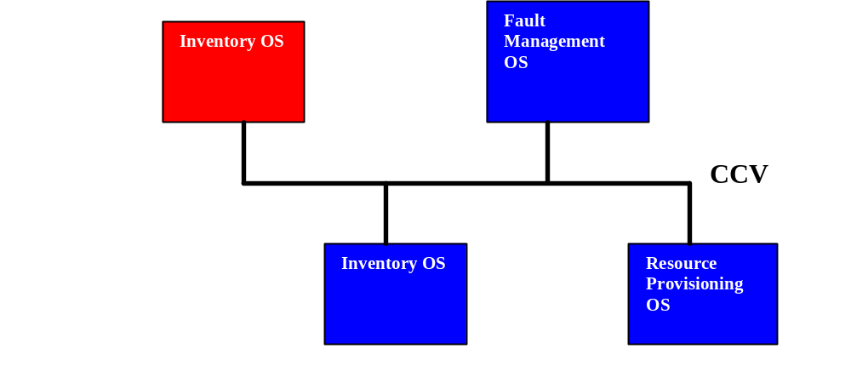
Figure 1-3. Inventory Retrieval

In the above discussion, it should be noted that the OS types are just roles that an OS may take. It is possible for a single OS product to assume several roles, e.g., alarm producer, alarm consumer and Inventory OS.

The inventory updates include entity creation, entity deletion, entities discovery, attribute value change and state change notifications.

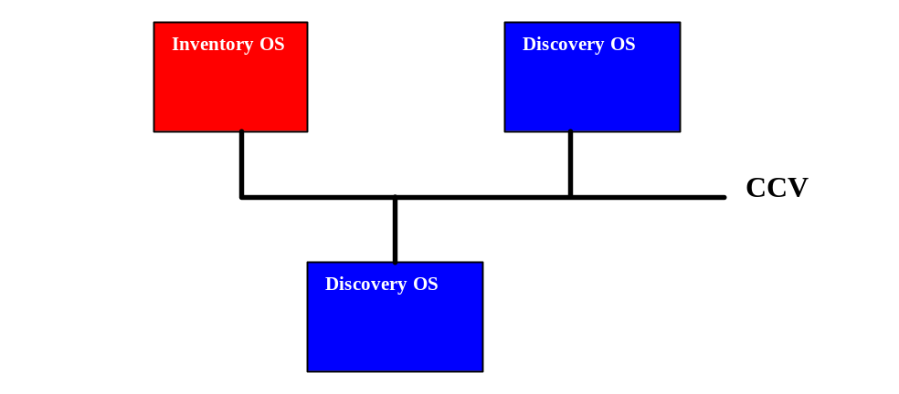
Figure 1-4. Inventory Updates

For more details on the MRI requirements and use cases, see the Managed Resource Inventory Business Agreement document. The associated management entities can be found in the Network Resource Assurance Business Agreement document.

Resource Provisioning (RP)
This capability allows for creating, modifying and deleting network resource entities handling control of connections, flow domains (for connectionless technologies), software, termination points, transmission descriptors, topological links, the provisioning of equipment and the management of traffic conditioning profiles and flow domain fragments.
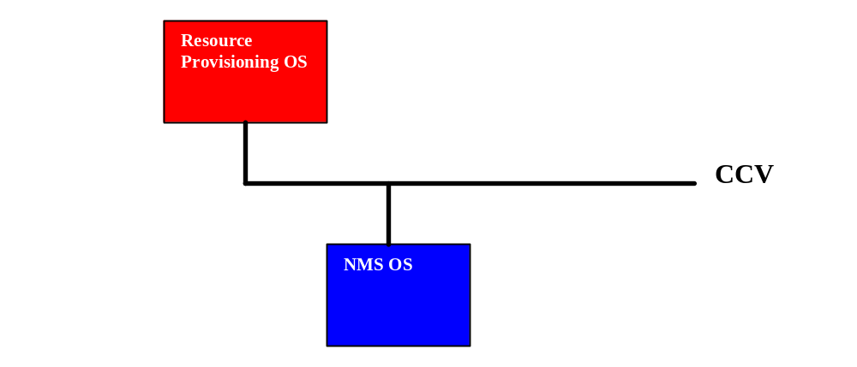
Figure 1-5. Resource Provisioning

More details on this topic can be found in the Resource Provisioning Business Agreement document. The associated management entities can be found in the Network Resource Assurance Business Agreement document.
.

Resource Performance Management (RPM)
This capability covers resource performance monitoring and control:
- Monitor Performance Management
  - PM Retrieval – this includes the retrieval of both current and historical PM data
  - Threshold Crossing Alert (TCA) Notifications
- Control Performance Management
  - PM Control – this includes, for example, the enabling and disabling of PM collection
  - TCA Control – this includes, for example, the enabling and disabling of TCA generation.
More details on this topic can be found in the Resource Performance Management Business Agreement document. The associated management entities can be found in the Network Resource Assurance Business Agreement document.
Figure 1-6 shows an example of performance monitoring. The Resource Performance Management (RPM) OS issues Threshold Crossing Alerts (TCAs) over the CCV which are received by a Service Quality Management (SQM) OS and a Resource Trouble Management (RTM) OS.
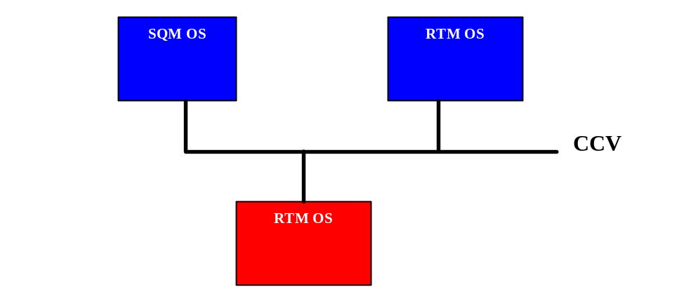
Figure 1-6. TCA Example

Service Management & Operations (RM&O)

Service Configuration & Activation
This capability entails the provisioning, activation and subsequent deactivation and release of services. There are currently to two interfaces defined in this area, i.e.
- Service Activation Interface (SAI) – an activation interface between an OS support the Customer Relationship Management (CRM) capability and another OS supporting the Service Configuration and Activation (SC&A) capability. See Service Activation - DDP BA - Part 2: Service Activation Interface (SAI) for more information on the SAI.
- Service Component Activation Interface (SCA)) an activation interface between two OSs supporting the SC&A capability. See Service Activation - DDP BA - Part 3: Service Component Activation Interface (SCAI) for more information on the SCAI.
Figure 1-7 depicts an example where a CRM OS sends service activation requests to an SC&A OS using the SAI.
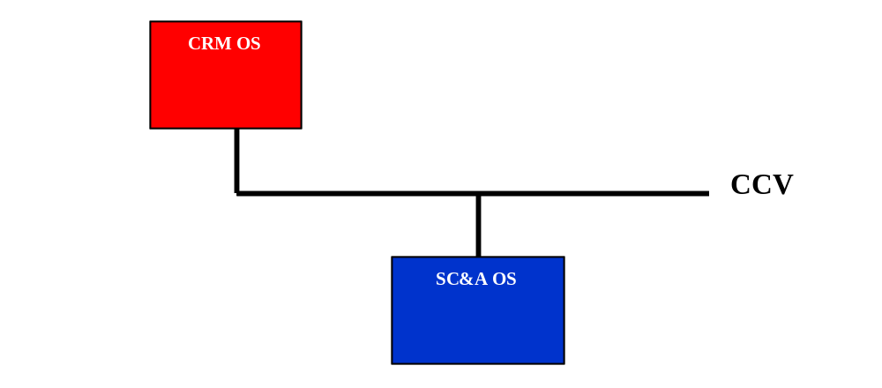
Figure 1-7. SAI Example

Manage Service Inventory
This capability entails the retrieval of Service Inventory related information. The interface supports only bulk inventory retrieval (retrieving selected information in a single operation) where a filter mechanism can be used to drive the information of interest. This filter uses a white page or a yellow page style (filtering by name or properties).
Figure 1-8 depicts an example where a different OS sends service inventory requests to a Service Inventory OS using the MSI:
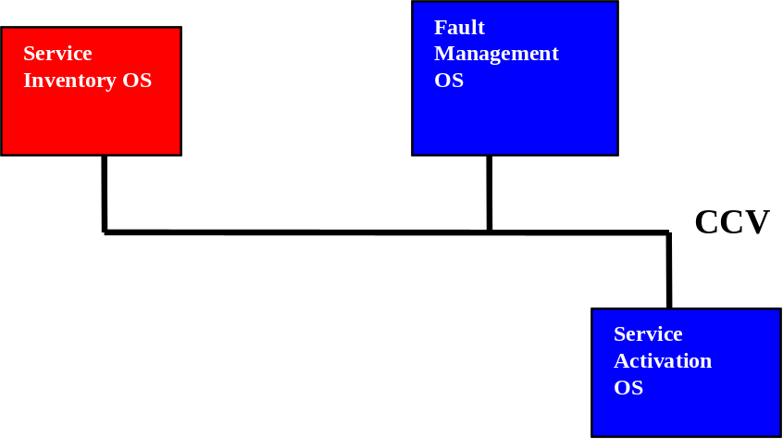
Figure 1-8, MSI Example

Release Definition
This section describes the documents included in MTOSI Release 2.0.

Document Release Description
The following table lists the documents that constitute the full MTOSI 2.0 Release, organized per DDP.

Table 1. Documents in the MTOSI 2.0 Release
DDP | Document | Title | New Doc | Rel 2.0  version | Doc Status | Latest Date
FMW | TMF518_FMW | Framework - DDP BA | Yes | 1.1 | Submitted for  Member Evaluation | May 2008
FMW | TMF612_FMW | Framework - DDP IA | Yes | 1.0 | Ditto | May 2008
FMW | TMF864_FMW_XML | Framework - DDP IIS | Yes | 1.0 | Ditto | May 2008
FMW | SD0-1_mTOPDictionary | mTOP Dictionary | Yes | 1.0 | Ditto | Oct 2007
FMW | SD0-2_mTOPGuidelines_BA | mTOP BA Guideliness | Yes | 1.0 | Ditto | May 2008
FMW | SD0-3_mTOPTemplate_BA.dot | mTOP Word template for BA documents | Yes | 1.0 | Ditto | May 2008
FMW | SD0-4_mTOPGuidelines_IA | mTOP IA Guidelines | Yes | 1.0 | Ditto | May 2008
FMW | SD0-5_mTOPGuidelines_WebServices | mTOP Web Services Design Guidelines | Yes | 1.0 | Ditto | May 2008
FMW | SD0-6_mTOPTemplate_SD.dot | mTOP Word template for SD documents | Yes | 1.0 | Ditto | May 2008
FMW | SD1-6_ContainedTPs | Examples for contained TPs in different states of usage |  | 3.3 | Ditto | Nov 2007
FMW | SD1-8_encodingX731M3100 | Coding of X.731 and M.3100 State and Status Information |  | 3.2 | Ditto | Nov 2007
FMW | SD1-14_IMOverview | Inverse Multiplexing Overview |  | 3.2 | Ditto | Oct 2007
FMW | SD1-16_LayeredParameters | Layered Parameters |  | 3.3 | Ditto | Oct 2007
FMW | SD1-17_LayerRates | Layer Rates |  | 3.3 | Ditto | Oct 2007
FMW | SD1-18_layers | Functional Modeling Concepts |  | 3.3 | Ditto | Nov 2007
FMW | SD1-19_LocationIdentification | Location Identification |  | 3.0 | Ditto | Apr 2005
FMW | SD1-20_MaintenanceCommands | Maintenance Commands |  | 3.2 | Ditto | Nov 2007
FMW | SD1-22_modelDiagramComponents.ppt | Modeling Components |  | 3.1 | Ditto
FMW | SD1-25_objectNaming.doc | MTNM support for a Naming convention |  | 3.4 | Ditto | Dec 2007
FMW | SD1-28_PerformanceParameters | Performance Parameters |  | 3.1 | Ditto | Oct 2006
FMW | SD1-33_ProbableCauses | Specification of probableCause strings |  | 4.1 | Ditto | Oct 2006
FMW | SD1-36_SNCTypes | SNC And Protection |  | 3.1 | Ditto | Dec 2006
FMW | SD1-44_  ConnectionlessTechnologyManagement | Connectionless Technology Management |  | 1.1 | Ditto | Nov 2007
FMW | SD2-1_MTOSI_IS_Main.doc | MTOSI Implementation Statement |  | 1.5 | Ditto | May 2008
FMW | SD2-2_XML_ImplementationUserGuide.doc | MTOSI XML Implementation User Guide |  | 2.0 | Ditto | May 2008
FMW | SD2-4_TransportIndependentExampleOfMTOSI.zip | Transport Independent Example of MTOSI |  | 1.2 | Ditto | May 2008
FMW | SD2-5_Communication_Styles | Communication Styles |  | 1.3 | Ditto | May 2008
FMW | SD2-6_VersioningAndExtensibility | Versioning and Extensibility |  | 2.0 | Ditto | May 2008
FMW | SD2-7_ObjectNaming | Object Naming |  | 2.0 | Ditto | May 2008
FMW | SD2-9_UsingJMSAsMTOSITransport | Using JMS as an MTOSI Transport |  | 1.2 | Ditto | May 2008
FMW | SD2-10_ExampleUsingJMS | Example using JMS |  | 1.1 | Ditto | May 2008
FMW | SD2-16_UsingHTTPAsMTOSITransport | Using HTTP as an MTOSI Transport |  | 1.1 | Ditto | May 2008
NRB | TMF518_NRB | Network Resource Basic  - DDP BA | Yes | 1.1 | Ditto | May 2008
NRB | TMF612_NRB | Network Resource Basic - DDP IA | Yes | 1.0 | Ditto | May 2008
NRB | TMF864_NRB_XML | Network Resource Basic - DDP IIS | Yes | 1.0 | Ditto | May 2008
NRB | SD2-17_  MTOSI_EnhancedResourceStates | MTOSI Enhanced Resource States |  | 1.0 | Ditto | Oct 2007
NRF | TMF518_NRF | Network Resource Fulfillment  - DDP BA | Yes | 1.1 | Ditto | May 2008
NRF | TMF612_NRF | Network Resource Fulfillment - DDP IA | Yes | 1.0 | Ditto | May 2008
NRF | TMF864_NRF_XML | Network Resource Fulfillment - DDP IIS | Yes | 1.0 | Ditto | May 2008
NRF | SD1-3_BundledSNC | Bundled SNC |  | 3.0 | Ditto | June 2005
NRF | SD1-5_ATMConformanceDefinitions | ATM Conformance Definitions |  | 3.0 | Ditto | Nov 2006
NRF | SD1-7_DSLOverview | DSL Overview |  | 3.1 | Ditto | Nov 2005
NRF | SD2-12_MTOSI_Inventory_Layout | Inventory Layout |  | 2.0 | Ditto | Nov 2007
NRF | SD2-20_EquipmentModel | Equipment Model | Yes | 1.0 | Ditto | May 2008
NRA | TMF518_NRA | Network Resource Assurance  - DDP BA | Yes | 1.1 | Ditto | May 2008
NRA | TMF612_NRA | Network Resource Assurance - DDP IA | Yes | 1.0 | Ditto | May 2008
NRA | TMF864_NRA_XML | Network Resource Assurance - DDP IIS | Yes | 1.0 | Ditto | May 2008
NRA | SD1-29_PGPParameters | PGP Parameters |  | 3.0 | Ditto | April 2005
NRA | SD1-34_protectionSwitch | Protection Switching |  | 3.0 | Ditto | April 2005
NRA | SD1-37_TCAs | PM Threshold Types |  | 3.0 | Ditto | Jun 2005
MRI | TMF518_MRI | Manage Resource Inventory  - DDP BA | Yes | 1.0 | Ditto | Sep 2007
MRI | TMF612_MRI | Manage Resource Inventory - DDP IA | Yes | 1.0 | Ditto | May 2008
MRI | TMF864_MRI_XML | Manage Resource Inventory - DDP IIS | Yes | 1.0 | Ditto | May 2008
MRI | SD1-41_TPPoolRelationship | Relationship between a TPPool and its TerminationPoints |  | 3.0 | Ditto | April 2005
MRI | SD2-14_AVC_SC_Notifications | Attribute Value Change & State Change Notifications |  | 2.0 | Ditto | Nov 2007
RP | TMF518_RP | Resource Provisioning  - DDP BA | Yes | 1.0 | Ditto | Sep 2007
RP | TMF612_RP | Resource Provisioning - DDP IA | Yes | 1.0 | Ditto | May 2008
RP | TMF864_RP_XML | Resource Provisioning  - DDP IIS | Yes | 1.0 | Ditto | May 2008
RP | SD1-13_guiCutThrough | GUI Cut Through |  | 3.0 | Ditto | Nov 2006
RP | SD1-23_ModesOfOperation | Modes of Operation |  | 3.0 | Ditto | June 2005
RTM | TMF518_RTM | Resource Trouble Management  - DDP BA | Yes | 1.1 | Ditto | May 2008
RTM | TMF612_RTM | Resource Trouble Management  - DDP IA | Yes | 1.0 | Ditto | May 2008
RTM | TMF864_RTM_XML | Resource Trouble Management  - DDP IIS | Yes | 1.0 | Ditto | May 2008
RPM | TMF518_RPM | Resource Performance Management  - DDP BA | Yes | 1.1 | Ditto | May 2008
RPM | TMF612_RPM | Resource Performance Management  - DDP IA | Yes | 1.0 | Ditto | May 2008
RPM | TMF864_RPM_XML | Resource Performance Management  - DDP IIS | Yes | 1.0 | Ditto | May 2008
RPM | SD1-30_PMFileFormat | PM File Format Definition |  | 3.3 | Ditto | Oct 2007
RPM | SD1-31_PMExample | An example of a PM File format in plain text
RPM | SD1-32_PMExample | An example of a PM File format in xls
SB | TMF518_SB | Service Basic  - DDP BA | Yes | 1.1 | Ditto | May 2008
SB | TMF612_SB | Service Basic  - DDP IA | Yes | 1.0 | Ditto | May 2008
SB | TMF864_SB_XML | Service Basic  - DDP IIS | Yes | 1.0 | Ditto | May 2008
SB | SD2-18_VPNServiceModel.xls | VPN Service Model | Yes | 1.0 | Ditto | Nov 2007
SB | SD2-19_VoIPServiceDefinition |  | Yes | 1.0 | Ditto | May 2008
MSI | TMF518_MSI | Manage Service Inventory – DDP BA | Yes | 1.0 | Ditto | May 2008
MSI | TMF864_MSI_XML | Manage Service Inventory - DDP IIS | Yes | 1.0 | Ditto | May 2008
SA | TMF518_SA_1 | Service Activation  - DDP BA - Part 1: Overview | Yes | 1.1 | Ditto | May 2008
SA | TMF518_SA_2 | Service Activation  - DDP BA - Part 2: Service Activation Interface (SAI) | Yes | 1.1 | Ditto | May 2008
SA | TMF518_SA_3 | Service Activation  - DDP BA - Part 3: Service Component Activation | Yes | 1.1 | Ditto | May 2008
SA | TMF612_SA | Service Activation - DDP IA | Yes | 1.0 | Ditto | May 2008
SA | TMF864_SA_XML | Service Activation - DDP IIS | Yes | 1.0 | Ditto | May 2008

Major BA Deliverables

TMF518_FMW, Framework - DDP BA
This Framework BA covers requirements and use cases concerning both the interface communication mechanisms and the general network resources aspects.
The following items are covered:
  - Resource identification
  - Functional modeling
  - Resources data retrieval mechanisms
  - Notification mechanisms

TMF518_NRB, Network Resource Basic - DDP BA
The Network Resource Basic BA covers the static requirements for the general aspects of the network resources (Data Model).

TMF518_NRF, Network Resource Fulfillment - DDP BA
The Network Resource Fulfillment BA addresses the Data Model (DM) aspects of resource fulfillment and as such it defines all resource related managed entities visible across the Interface that are used in support of resource fulfillment.

TMF518_NRA, Network Resource Assurance - DDP BA
The Network Resource Assurance BA addresses the Data Model (DM) aspects of resource assurance and as such it defines all resource related managed entities visible across the Interface that are used in support of resource assurance.

TMF518_MRI, Manage Resource Inventory - DDP BA
The Manage Resource Inventory BA covers requirements and use cases concerning the management of resource inventory.
The following management capabilities are covered:
  - General Management such as (among others):
    - Bulk inventory retrieval (retrieving selected information in a single operation)
    - Multi-Object Inventory Update
  - Inventory Management of Connection Oriented Technologies
  - Inventory Management of Connectionless Technologies
  - Inventory Notifications

TMF518_RP, Resource Provisioning - DDP BA
The Resource Provisioning BA covers requirements and use cases concerning the provisioning of network resources.
The following management capabilities are covered:
- Connection Control
- Equipment Provisioning
- Flow Domain Control
- Gui Cut-Through Control
- Software and Data Control
- Termination Point Control
- Transmission Descriptor Control
- Assignment of Transmission Descriptors
- Topological Link Control

TMF518_RTM, Resource Trouble Management (RTM) - DDP BA
The Resource Trouble Management BA covers requirements and use cases for the following aspects of RTM: resource fault management, protection management, and maintenance and diagnostics control.

TMF518_RPM, Resource Performance Management - DDP BA
The Resource Performance Management BA covers requirements and use cases concerning resource performance management.
The following management capabilities are covered:
  - Monitor Performance Management
    - PM Retrieval – this includes the retrieval of both current and historical PM data
    - Threshold Crossing Alert (TCA) Notifications
  - Control Performance Management
    - PM Control – this includes, for example, the enabling and disabling of PM collection
    - TCA Control – this includes, for example, the enabling and disabling of TCA generation

TMF518_SB, Service Basic - DDP BA
The Service Management BA presents the service Management technology neutral data model. It initiates from the SID service management information model with several extensions and adaptations introduced to fit the business needs for service activation and inventory (those modifications will be proposed to the SID team as suggestion for improvement).
It defines the static and structural requirements of the managed objects that are visible across the Service Activation Interface(s) and the Service Component Activation Interface.

TMF518_SA_1, Service Activation - DDP BA - Part 1: Overview
The Service Activation BA Overview specifies common definitions, architecture aspects and functional requirements for the MTOSI Service Activation feature.
It introduces two interfaces:
  - The Service Activation interface between the CRM and SM&O layers
  - The Service Component Activation interface is an internal SM&O layer interface.
The primary focus of both interfaces is service activation exclusively.

TMF518_SA_2, Service Activation - DDP BA - Part 2: Service Activation Interface (SAI)
The Service Activation BA Service Activation Interface covers requirements and use cases for a service activation interface where it is assumed that one side of the interface supports and understands the eTOM’s Customer Relationship Management (CRM) concepts, e.g., product and customer, and the other side of the interface supports and understands the eTOM Service Management & Operations (SM&O) concepts, e.g., customer facing service and service order. This interface also allows for the management of service orders that are created as a result of a service activation request.

TMF518_SA_3, Service Activation - DDP BA - Part 3: Service Component Activation
The Service Activation BA Service Component Activation covers requirements and use cases for a service component activation interface (SCAI). This interface is entirely within the eTOM SM&O layer. As such, it receives activation requests from another SM&O application that is normally responsible for the orchestration of end-to-end service activation.
The interfaces exposed by the SCAI hide the complexity of the underlying resource activation process through the use of service templates and references to service access points.

TMF518_MSI, Manage Service Inventory - DDP BA
This Manage Service Inventory BA covers the requirements for a Service Inventory interface.
Only bulk inventory retrieval, retrieving selected information in a single operation, is required. The information of interest is selected by a filter mechanism using a white page of a yellow page style (driven by names or by properties).
As opposed to the Inventory for Network Resources, the objects in the Service Inventory OS are not organized in a hierarchical way and there is no containment tree. Service Inventory Objects do not have a superior and do not have subordinates. However, objects relate together through associations represented by specific reference attributes which values contain the name of the associated object.

Major IA Deliverables
All IA deliverables, for all DDPs, are structured in the same way:
  - a “xxx.emx” file containing the UML2 specification of the information model or of the interface operations; those files have been created using the RSM tool
  - a “xxx_HTML.zip” file containing the equivalent information in HTML format.
There are two exceptions to this principle:
  - the IA for the Framework DDP (TMF612_FMW) contains in addition a RSM file specifying UML Profile specifications.
  - the MSI DDP does not contain an specific information model since the entities used are those from the SID (extended version containing ServiceTemplate and ServiceDefiition).

Major IIS Deliverables
The IIS deliverables are structured in the following way:
  - a “wsdl” directory containing the wsdl specification of each operation interface, with one wsdl file per interface (relevant only for the OM-DDP)
  - a “xsd” directory containing the schema specifications of the entities and data structures specified in the DM or OM DDPs
  - a “xml” directory giving concrete examples illustrating the usage of the MTOSI specifications both on the data or the operations aspects.
  - a “xxxHtml.zip” file containing a HTML description of the associated specifications of the DDP.
The table below presents the list of interfaces for the FMW-DDP and for each OM-DDP :

DDP name | Functional Interfaces
TMF864_FMW_XML | Mart,  NotificationBroker,  NotificationConsumer,  NotificationProducer
TMF864_MRI_XML | ResourceInventoryRetrieval,  ResourceInventoryUpdate  ConnectionRetrieval,  EquipmentInventoryRetrieval,  FlowDomainRetrieval,  ManagedElementRetrieval,  ManagementDomainRetrieval,  MultiLayerSubnetworkRetrieval,  OperationsSystemRetrieval,  TerminationPointRetrieval,  TopologicalLinkRetrieval,  TrafficConditioningProfileRetrieval,  TransmissionDescriptorRetrieval
TMF864_RP_XML | CommonResourceProvisioning,  ConnectionControl,  EquipmentProvisioning,  FlowDomainControl,  GuiCutThroughControl,  SoftwareAndDataControl,  TerminationPointControl,  TopologicalLinkControl,  TrafficConditioningProfileControl,  TransmissionDescriptorControl
TMF864_RTM_XML | AlarmControl,  AlarmHandling,  AlarmRetrieval,  AsapControl,  AsapRetrieval,  MaintenanceControl,  ProtectionControl,  ProtectionRetrieval
TMF864_RPM_XML | PerformanceManagementControl,  PerformanceManagementRetrieval,  ThresholdCrossingAlertControl
TMF864_MSI_XML | ServiceInventoryRetrieval
TMF864_SA_XML | ServiceActivationInterface,  ServiceComponentActivationInterface

Joint MTOSI / MTNM Supporting Documents
Few supporting documents present general guidelines, tools or set of terms and as such they are applicable to both MTOSI and MTNM.

SD0-1, mTOP Dictionary
The document presents the acronyms and the definitions of the essential terms used throughout the different MTOSI documents.

SD0-2_mTOPGuidelines_BA, SD0-3_mTOPTemplate_BA.dot
The BAs are edited as Word documents, following some guidelines for the editorial presentation of the requirements and use cases and the control of their numbering.
A Word template file (“.dot”) is available to automate some editorial tasks using Word macros.

SD0-4_mTOPGuidelines_IA
The purpose of this document is to be the unique design reference for the development of all mTOP Information Agreements (IA).
The Unified Modelling Language (UML) Version 2.1 is used as the notation for the IA. These guidelines shall ensure that different people can create individual parts of the Information Agreement with the same "look and feel" which can then be combined into an mTOP Release.

SD0-5_mTOPGuidelines_WebServices
This mTOP supporting document captures all the design guidelines applied to the development of the mTOP DDP Web Services Interface Implementation Specifications (IIS). The intent of this document is to be an mTOP contributor helper’s guide for the generation of the MTOSI R2.0 WS IIS for any given DDP.

SD0-6_mTOPTemplate_SD.dot
This Word template document helps the edition of SDs documents

MTOSI Supporting Documents
In cases where the main MTOSI deliverables need to supply the same information, it was decided to move the common information into the set of supporting documents listed below. This allows for updates to the common information in a single place without needing to coordinate updates in several of the main deliverables.
.

SD2-2_XML_ImplementationUserGuide.doc
This document provides an overview of the MTOSI data and service interface models and their associated XML definitions, which are described and captured in the various MTOSI Delivery Document Packages (DDPs).
This document provides behavior descriptions and usage guidelines that:
- require a rather long description
- require supporting diagrams
- appear repeatedly throughout the XML.

SD2-4_TransportIndependentExampleOfMTOSI.zip
This zip file contains a Word document and an XML file.
The Word document presents a concrete example of a very small network and shows how inventory information is handled by the MTOSI XML. The XML inventory information is available in the appendix file “getInventoryResponse.xml”.

SD2-5_Communication_Styles
This document outlines the top down approach followed by MTOSI to define the technology neutral abstract interfaces and the various technology specific concrete solutions set.

SD2-6_VersioningAndExtensibility
This supporting document addresses versioning and extendibility mechanisms adopted by MTOSI.
Through the versioning mechanism it is possible to evolve the interfaces in a controlled manner maintaining backward and forward compatibility for a class of changes considered minor.
The extendibility mechanism allows a vendor (and\or an MTOSI architect) to tailor the specification to deal with future or specific concerns not addressed in the most current MTOSI release (latest version of the service interfaces).

SD2-7_ObjectNaming
This MTOSI Supporting Document provides a normative and informative description of the MTOSI Object Naming. It should be read in conjunction with:
  - The MTNM Supporting document SD1-25 ObjectNaming
  - The Framework BA, IA and IIS.

SD2-9_UsingJMSAsMTOSITransport
This document illustrates how the JMS API can be used as transport mechanism supporting the MTOSI application level requirements in terms of communication and operation exchange.
It gives an introduction to the JMS concepts and then it gives the bindings rules and recommendations to use JMS to support MTOSI operations.

SD2-10_ExampleUsingJMS
This document illustrates how the rules and recommendations on how to use JMS as MTOSI transport can be exercised, using the support of a concrete example.
The usage of the JMS API will be demonstrated using code snippets.

SD2-12_MTOSI_Inventory_Layout
The document includes a diagram and associated explanation for the MTOSI inventory layout structure. This layout structure is used to transport inventory data via the various bulk inventory operations.

SD2-14, Attribute Value Change & State Change Notifications
The document lists the minimum set of attributes for which the OS is expected to provide Attribute Value Change (AVC) and State Change (SC) notifications.

SD2-16_UsingHTTPAsMTOSITransport
This document illustrates how MTOSI messages can be encapsulated in SOAP and transported over HTTP in support of the MTOSI application level requirements for communication and operation exchange.
It gives an introduction to the HTTP SOAP concepts and then it gives the bindings rules and recommendations to use SOAP encapsulated message over HTTP to support MTOSI operations.

SD2-17_MTOSI_EnhancedResourceStates
The document presents how the static states Planned, Installed Retired are replaced by complex dynamic super-states 'Planning' 'Installing' 'Retiring' each refined into a number of substates.

SD2-18_VPNServiceModel.xls
The document presents a simple example illustrating the key concepts of the Service Activation interface.

SD2-19_VoIPServiceDefinition
This document contains a Service Definition example for Voice over IP to be used in the context of the overall TM Forum framework for Service Activation. The VoIP Service Definition description in this document will be used for the creation of a formal VoIP Service Definition expressed in XMLSchema. This document also includes an example of a Service Template and shows how it fits into the overall product/service context.

SD2-20_EquipmentModel
This document presents some technical aspects related to the equipment model through its various manageable physical components of the Network Element (circuit packs or field replaceable units or also, fan, fuse panel, power supply, etc.).
The document presents the class definitions, the naming structure, the protection aspects and also supply different illustrative examples.

MTNM Supporting Documents
For the resource management aspects, MTOSI is based on the MTNM model and, as such, MTOSI relies on much of the background information in the MTNM supporting documents. This section describes how each of the MTNM supporting documents is to be used for MTOSI Release 2.0.

SD1-3_BundledSNC
This document illustrates how the concept of bundled SNC service involves the establishment of a bundle of connections (i.e., not necessarily of the same layerRate) from one point in a subnetwork to another. The bundled SNC service is treated as a single SNC.

SD1-5_ATMConformanceDefinitions
This document shows different tables representing the mapping Service Category and Conformance Definition values against Supported Traffic Descriptor Combinations for ATM: UNI 4.1, UNI 4.0, UNI 3.1

SD1-6, Examples for contained TPs different states of usage
The document provides examples of configurations explaining the expected output of the operations getContainedPotentialTP(Name)s, getContainedInUseTP(Name)s and getContainedCurrentTP(Name)s. MTOSI reuses the MTNM behavior as-is.

SD1-7_DSLOverview
This very comprehensive document provides an overview of standard DSL technology and the support of DSL lines by the interface model.

SD1-8, Coding of X.731 and M.3100 State and Status Information
The document specifies how X.731 and M.3100 state and status information MUST be mapped to the Interface information model if supported by an OS

SD1-13_guiCutThrough

SD1-14, Inverse Multiplexing (IM) Overview
The document describes inverse multiplexing and how it is supported in the MTNM model. MTOSI reuses this document “as-is”.

SD1-16, Layered Parameters
The document lists all the general and technology-specific transmission parameters for MTNM. MTOSI reuses this document “as-is”.

SD1-17, Layer Rates
The document lists all the layer rates for MTNM. MTOSI reuses this document “as-is”.

SD1-18, Functional Modeling Concepts
The document extends the layered concepts of ITU-T Recommendation G.805 using encapsulations identified from real network element behavior to provide modeling and performance advantages for information transfer between the management systems. This document provides an explanation of the layering and encapsulation and then builds a view of the use of the layered components in a large number of network scenarios. MTOSI reuses this document “as-is”, with the exception that references to “NMS” should be replaced “Requesting OS” and references to “EMS” should be replaced by “Target OS”, i.e., an OS that fulfills the request of another OS.

SD1-19, Location Identification
The document defines and provides examples for terms related to the location of alarms and performance monitoring. Since MTOSI Release 1.1 does not cover performance management, only the sections entitled Probable Causes and Layered Parameters pertain to MTOSI.

SD1-20, Maintenance Commands
The document presents figures showing the maintenance operation signal flow for some of the maintenance commands supported by the NML-EML interface.

SD1-22, Modeling Components
The document includes diagram components from SD1-18, Functional Modeling Concepts. The components are to be used in proposals to update SD1-18, with the goal of using a single consistent convent for all the diagrams in SD1-18. MTOSI reuses this document “as-is”.

SD1-23_ModesOfOperation
This document illustrates how, in the context of the Interface, the target OS can manage the SNCs using different rules that best suit the particular application or architecture of the target OS. The target OS' behaviour regarding SNCs is called an "SNC management mode of operation".
Four different SNC management modes of operation can be used by an target OS. Each target OS operates in any one (but only one) of these four modes.

SD1-28, Performance Parameters
The document lists various performance measurement parameters.

SD1-29_PGPParameters
This document lists in tabular format all the PGP parameters, giving for each of them its name, its valid values, the PG types to which it is applicable and a description.

SD1-30, PM File Format
The document describes the PM file format. Also, text and Excel examples are provided.

SD1-31, PM File Format
Shows an example of a PM File format in plain text.

SD1-32 PM File Format
Shows an example of a PM File format in xls.

SD1-33, Specification of probableCause strings
The document describes the probable causes to be used in MTOSI alarms. This version of the document (i.e., Version 4.0) includes all the probable causes from the Version 3.0 of SD1-33 with a few additions for MTOSI.

SD1-34_protectionSwitch
This document illustrates through figures and examples different aspects related to protection switching.

SD1-36, SNC and Protection
The document describes the various SNC types and protection schemes. MTOSI reuses this document “as-is”.

SD1-37, PM Threshold Types
The document presents a figure illustrating the identification of Trigger/Clear for each threshold type.

SD1-41_TPPoolRelationship
This short document illustrates that the relationship between a TPPool and its associated TPs (not GTPs) is an "asymmetric" relationship.

SD1-44, Connectionless Technology Management
The document aims at specifying a framework for supporting connectionless technologies from the Interface. While seeking compliance with the generic modelling concepts recommended in ITU-T (G.809, G.8010) this work is initially intended to address the management of Ethernet and related technologies as defined in ITU-T G.8011 and MEF 10. The term “Ethernet” refers to the Ethernet MAC layer (ETH). This model is designed to complement and integrates seamlessly with the existing ITU-T G.805 based MTNM release 3.0 interface aimed at connection oriented technologies. Similar modelling activities from ITU-T (Q.840.1) and MEF Phase 1 (MEF 7) have been considered for consistency.

Administrative Appendix

Document History
Version History (This document)

Version Number | Date Modified | Modified by: | Description of changes
0.1 | June 2005 | MTOSI Team | Initial version
0.2 | 27-July 2005 | Tina O’Sullivan | Updated version numbers, and other items prior to Member Evaluation.
0.3 | Dec. 2005 | Stephen Fratini | Updated the version number of the various SD after the Member Evaluation.
1.0 | Oct. 2006 | Michel Besson | MTOSI Release 1.1 Notes
1.1 | Dec 2006 | Michel Besson | Aligned document versions
1.2 | Dec 2006 | Tina O'Sullivan | Final modifications prior to ME web posting.
1.3 | Mar 2007 | Tina O'Sullivan | Updated document status, to reflect end of Member Evaluation.
2.0 | November 2007 | Michel Besson | Initial new version
2.1 | May 2008 | Michel Besson | Added:  - the IA for each DDP,  - the IIS for each DDP,  - the MSI DDP  - and several SDs  for the full MTOSI 2.0 release.

Release History (MTOSI Release)

Release Number | Date Modified | Modified by: | Description of changes
1.0 | June 2005 | MTOSI Team | Initial version
1.1 | October 2006 | MTOSI Team | - Bug fixes  - Support for HTTP  - MEPs for synchronous communication  - Reorganisation of the SS
2.0 BA | November 2007 | mTOP Team | - Service activation management  - Resource provisioning and activation  - Management of connectionless networks  - Performance management and maintenance commands  - Inventory updates, multi-event inventory notifications and enhanced inventory retrieval (attribute value matching)  - Enhanced model for resource states  - Multi-action and request transactions  - Division of deliverables into Document Delivery Packages (DDPs) as shown in the next subsection.
2.0 | May 2008 | mTOP Team | - Added the  Service Inventory DDP  - For all DDPs, added the IA and the XML IIS  - Added several SDs

Company Contact Details
For requests of information or comments concerning this document please contact:

Stephen Fratini (mTOP Team Leader)  Telcordia Technologies  One Telcordia Drive  Piscataway, NJ 08854  Phone: +1 732 699 2226  Email: sfratini@telcordia.com | Michel Besson  (MTOSI Product Manager)  Cramer > Amdocs OSS Division  Phone: +44 7717 692 178  Email: Michel.Besson@Amdocs.com

Acknowledgments

About TM Forum
TM Forum is an international consortium of communications service providers and their suppliers. Its mission is to help service providers and network operators automate their business processes in a cost- and time-effective way. Specifically, the work of the TM Forum includes:
- Establishing operational guidance on the shape of business processes.
- Agreeing on information that needs to flow from one process activity to another.
- Identifying a realistic systems environment to support the interconnection of operational support systems.
- Enabling the development of a market and real products for integrating and automating telecom operations processes.
The members of TM Forum include service providers, network operators and suppliers of equipment and software to the communications industry. With that combination of buyers and suppliers of operational support systems, TM Forum is able to achieve results in a pragmatic way that leads to product offerings (from member companies) as well as paper specifications.

