Connectionless Technology Management

Table of Contents
Table of Contents 1
Table of Figures 3
Table of Tables 4
1 Scope 5
2 References 7
3 Acronyms and Definitions 9
4 Connectionless technology modelling terms 10
4.1 Connectionless Port TP (CPTP) 10
4.2 Call 14
4.3 Flow Domain (FD) 15
4.4 Flow Domain Fragment (FDFr) 15
4.5 Flow Point (FP) 16
4.6 Flow Point Pool (FPP) 16
4.7 Flow Point Pool Link (FPP Link) 16
4.8 Link Flow 16
4.9 Matrix Flow Domain (MFD) 16
4.10 MFD Port 16
4.11 Topological Component 16
4.12 Traffic Conditioning function 17
4.13 Transport Entity 17
5 Different managers for connection-oriented and connection-less Technologies 18
6 Call 19
6.1 Introduction 19
6.2 Call diversity 23
6.2.1 ELL Creation and ELL Bandwidth-Change parameters 23
6.2.2 ELL Layered Parameters 24
6.2.3 Rules for Diverse ELL Creation 24
6.2.3.1 Route Groups 24
6.2.3.2 Diversity Level 25
6.2.3.3 Remembering Creation Criteria 25
6.2.4 “Modify ELL” operation 25
6.2.5 Changing ELL bandwidth 25
6.2.5.1 Changing ELL bandwidth with diversity request 25
6.2.5.2 Changing ELL bandwidth without diversity request 25
6.2.6 Retrieving the SNC members of Route Groups 26
7 LAG 27
7.1 Introduction 27
7.2 FTP with new Layer Rate 27
7.3 LAG creation by EMS or NMS 27
7.4 Populating LAGs with VCATs 28
7.5 Associating LAG_Fragment CTPs with actual TPs 28
7.6 Naming of LAG TPs 28
7.7 Association by EMS or by NMS 28
7.8 Manual LAG population vs Automatic LAG population by LACP 29
7.9 LAG members cannot be CPTPs 29
7.10 LAG attributes and PM counters 29
7.11 A LAG is a STP port 29
7.12 LAG Alarms 29
7.13 LAG use in Call creation must be explicit 30
7.14 Modeling aggregation of signals for Ethernet CPTPs 30
8 Tag Management 34
8.1 VLAN Tag 34
8.2 General Tag Management 35
8.3 IEEE 802.1Q-compliant Tagging 35
8.4 IEEE 802.1ad-compliant Tagging 36
9 Traffic Mapping Table 37
9.1 Explanations 37
9.2 Table Processing Rules 38
9.2.1 Selection Criteria strings, recognized by compliant systems 38
9.2.1.1 VLAN ID 38
9.2.1.2 Priority field of header 38
9.2.2 Results Actions strings, recognized by compliant systems 39
9.2.2.1 Traffic Class 39
9.2.2.2 Traffic Conditioning Profile 39
9.2.3 Order of selection columns 39
9.2.4 Order of selection rows 39
9.2.5 Default and empty values 40
9.2.6 Unselected frames 40
9.2.7 Invalid values 40
9.2.8 Wrong number of columns 40
9.2.9 Unrecognized selection criterion or results action 41
9.2.10 Selection using two frame headers 41
9.3 Example layered parameters 41
Appendix I Hypothetical Ethernet network examples 43
Appendix II Modelling of Bridges 47
II.1 Rationale 47
II.2 Summary 47
II.3 Representation of VLAN-Unaware bridge (IEEE 802.1D) 47
II.3.1 What happens in the Bridge 47
II.3.2 For each Port not selected as a potential transmission Port, the frame shall be discarded.What happens in the model 48
II.4 Representation of VLAN-aware bridge (IEEE 802.1Q and P802.1ad) 48
II.4.1 What happens in the Bridge 48
II.4.2 What happens in the model 48
II.5 Representation of Customer Bridge (IEEE P802.1ad) 48
II.5.1 What happens in the Bridge 48
II.5.2 What happens in the model 49
II.6 Representation of Provider bridge 49
II.6.1 What happens in the Bridge 49
II.6.2 What happens in the model 49
II.7 Representation of “double VLAN-aware” bridge 49
II.7.1 Usage 49
II.7.2 What happens in the Bridge 50
II.7.3 What happens in the model 50
Appendix III Mapping MEF - MTNMETH 52
Revision History 61
Acknowledgements 61
How to comment on the document 62

Table of Figures
Figure 1: Implementations of CPTPs 10
Figure 2: unassigned CPTP 11
Figure 3: assigned CPTP 11
Figure 4: fdInternal CPTP 12
Figure 5: fdEdge CPTP 13
Figure 6: State diagram for Port TP Role State 14
Figure 7: Example: Separate SDH-EMS and Ethernet-EMS 18
Figure 8: Encapsulation Layer Link usage 19
Figure 9: Example of Encapsulation Layer Link segments with off-network CPTPs 20
Figure 10: Example: Modelling of an RPR-Ring 22
Figure 11: Example: Ethernet LAN port with LAG and VLAN 31
Figure 12: Example: Ethernet WAN port with LAG and VLAN 32
Figure 13: Example: Ethernet WAN port with LAG ,VLAN and VCAT 33
Figure 14: Figure 3-3 / IEEE 802.3 34
Figure 15: Figure 9-1 / IEEE 802.1ad 34
Figure 16: Figure 9-2 / IEEE 802.1ad 35
Figure 17: Hypothetical network example showing singleton FDs 43
Figure 18: Hypothetical network example showing FDs that span several NEs 44
Figure 19: Hypothetical network example showing FDs that span several NEs and internal MFDs 45
Figure 20: G.8010 resources of the Ethernet Layer Network Domain 46
Figure 21: “double VLAN-aware” bridge 50

Table of Tables
Table 1: Major CPTP states 13
Table 2: Objects represented by SDH and ETH EMS (simple example) 18
Table 3: Objects represented by SDH and ETH EMS 21
Table 4: Example Traffic Mapping Table 38
Table 5: Example Traffic Mapping Table for 2-header selection 41
Table 6: MEF - MTNM Ethernet Mapping 60

Scope
This supporting document aims at specifying a framework for supporting connectionless technologies from the MTNM NMS-EMS interface. While seeking compliance with the generic modelling concepts recommended in ITU-T (G.809 [7], G.8010 [8]) this work is initially intended to address the management of Ethernet and related technologies as defined in ITU-T G.8011 [9] and MEF 10 [15]. The term “Ethernet” refers to the Ethernet MAC layer (ETH). This model is designed to complement and integrates seamlessly with the existing ITU-T G.805 [16] based MTNM V3.0 interface aimed at connection oriented technologies. Similar modelling activities from ITU-T (Q.840.1 [33]) and MEF Phase 1 (MEF 7 [11]) have been considered for consistency.
The MTNM Rel 3.5 connectionless solution is primarily targeted at managing Ethernet over traditional or next generation transport network such as SONET/SDH, WDM, ATM or RPR. MTNM Rel 3.5 provides fully integrated support for SONET/SDH, WDM and ATM from MTNM V3.0 while only the access points (Connectionless Port Termination Points (CPTPs)) are supported in case of RPR transport.
Support for point-to-point services (Ethernet Private Line (EPL), Ethernet Virtual Private Line (EVPL)) are provided in compliance with MEF 10 [15] definitions. MEF Phase 2 however has not yet completed its work on multipoint services (Ethernet Private Local Area Network (EPLAN), Ethernet Virtual Private Local Area Network (EVPLAN)) at the time this TMF specification is published. Therefore, future alignment with MEF (Phase 2) will be required in a subsequent MTMN release. With regard to the EPL, MTNM Rel 3.5 provides an alternative to the existing MTNM V3.0 support based on the connection oriented model and TP containment relationships. An EMS may support either or both EPL implementations (though not simultaneously on the same object instances) in order to meet the objectives of the NMS.
The following capabilities are supported with MTNM Rel 3.5:
- Point-to-point services (EPL, EVPL) in compliance with MEF Service Definition Phase 1
- Multipoint services (EPLAN, EVPLAN)
- Link Aggregation (LAG)
- Point-to-point Call (represent connectionless connectivity between NEs) provisioning (including Control Plane option)
- Diverse routes for point-to-point Calls
- Multipoint Topological Links (e.g., for representing RPR transport connectivity)
- CPTP provisioning
- Fixed MFD modelling (e.g., direct mapped EPL services)
- VLAN-unaware routing as per IEEE 802.1D
- C-VLAN based tagging as per IEEE 802.1Q
- S-VLAN based tagging as per 802.1ad
- Port (UNI/NNI), C-VLAN/EVC and/or CoS (802.1p) based classification
- Spanning Tree management
- Ingress traffic conditioning
- C-Tag/S-Tag translation
- Non routed layer 2 networks (using singleton Flow Domains)
- Integrated or separate transport (SONET/SDH, etc.) and Ethernet EMSs
- CORBA Solution Set
To support the abovementioned features the following new terms have been defined:
- Flow Domain (FD)
- Matrix Flow Domain (MFD)
- Connectionless Port Termination Point (CPTP)
- Flow Point (FP)
- Flow Domain Fragment (FDFr)
- TC Profile

The following functionalities have been deferred to future MTNM releases (i.e., not in scope for Rel 3.5):
- Enhancement of connectionless technologies from Ethernet to client layers (e.g., IP)
- Non layer 2 frame based technologies (e.g., RPR)
- Non S-VLAN based tagging (e.g., Pseudo-wire encapsulation)
- Egress and internal Traffic Conditioning
- Handling of mutual influence of bandwidth configurations within one port
- Splitting/merging of MFD and FD
- Multipoint Topological Link provisioning (e.g., RPR transport)
- Point-to-multipoint ELL provisioning (e.g., for WiMAX applications)
- RPR transport layer (beyond multipoint RPR layer Topological Link and RPR layer CPTP)
- Modelling of client side of a UNI (per MEF 10)
- XML Solution Set (integration with MTOSI)

References
- IETF RFC 1493 (July 1993): Definitions of Managed Objects for Bridges.
- IETF RFC 2613 (June 1999): Remote Network Monitoring MIB Extensions for Switched Networks, Version 1.0.
- IETF RFC 2674 (August 1999): Definitions of Managed Objects for Bridges with Traffic Classes, Multicast Filtering and Virtual LAN Extensions.
- IETF RFC 3289: Management Information Base for the Differentiated Services Architecture.
- IEEE Std. 802.1D (2004): IEEE standard for local and metropolitan area networks: Media Access Control (MAC) Bridges. NOTE – 802.1D-2004 incorporates 802.1t and 802.1w.
- IEEE Std. 802.1Q (2003): IEEE standard for local and metropolitan area networks: Virtual Bridged Local Area Networks. NOTE – 802.1Q-2003 incorporates 802.1u, 802.1v, and 802.1s
- ITU-T G.809 (2003): Functional architecture of connectionless layer networks.
- ITU-T G.8010/Y.1306 (2004): Architecture of Ethernet Layer Networks.
- ITU-T G.8011/Y.1307 (2004): Ethernet Services Framework.
- MEF: Draft TS D00011_v5.7 (April 14, 2004) [MEF 6]: Ethernet Services Definitions – Phase I.
- MEF TS MEF 7 (October 2004): EMS-NMS Information Model.
- IEEE Std. 802.3 (2002): IEEE Standard for Information technology - Telecommunications and information exchange between systems - IEEE standard for local and metropolitan area networks - Specific requirements – Part 3: Carrier Sense Multiple Access with Collision Detection (CSMA/CD) Access Method and Physical Layer Specifications.
- IEEE Std. 802.3ae (2002): IEEE Standard for Information technology - Telecommunications and information exchange between systems - IEEE standard for local and metropolitan area networks - Specific requirements – Part 3: Carrier Sense Multiple Access with Collision Detection (CSMA/CD) Access Method and Physical Layer Specifications, Amendment: Media Access Control (MAC) Parameters, Physical Layers, and Management Parameters for 10 Gb/s Operation
- IEEE Draft Std. P802.1ad/D6.0 (August 17, 2005): Virtual Bridged Local Area Networks – Amendment 4: Provider Bridges.
- MEF TS MEF 10 (November 2004): Ethernet Services Attributes Phase 1.
- .ITU-T G.805 (2000): Generic functional architecture of transport networks
- ITU-T Y.1730 (2004): Requirements for OAM functions in Ethernet based networks and Ethernet services.
- TMF 513 (April 2004): MTNM Business Agreement Version 3.0.
- ITU-T G.7041/Y.1303 (2003): Generic Framing Procedure (GFP).
- ITU-T G.7042/Y.1305 (2004): Link Capacity Adjustment Scheme (LCAS) for Virtual Concatenated Signals.
- ITU-T G.808.1 (2003): Generic protection switching - Linear trail and subnetwork protection.
- ITU-T G.8012 (2004): Ethernet UNI and Ethernet NNI.
- ITU-T Q.838.1 (2004): Requirements and Analysis for the Management Interface of Ethernet Passive Optical Networks.
- ITU-T G.8011.1/Y.1307.1 (2004): Ethernet Private Line Service.
- MEF Draft TS 10033_000 (July 23, 2004): Requirements for Management of MetroEthernet Network Elements.
- MEF Draft TS D00021_001 (March 27, 2003): Ethernet Performance Monitoring.
- MEF Draft TS 10035_001 v1.2 (July 23, 2004): MEF Service OAM Requirements & Framework.
- ITU-T Draft Y.17ethoam: OAM Functions and Mechanisms for Ethernet based networks.
- IETF Internet Draft draft-ietf-bridge-bridgemib-smiv2-06 (April 2004): Definitions of Managed Objects for Bridges.
- IETF Internet Draft draft-ietf-bridge-ext-v2-02 (March 2004): Definitions of Managed Objects for Bridges with Traffic Classes, Multicast Filtering and Virtual LAN Extensions.
- IETF Internet Draft draft-ietf-bridge-rstpmib-04 (March 2004): Definitions of Managed Objects for Bridges with Rapid Spanning Tree Protocol.
- MEF TS MEF 4 (May 2004): Metro Ethernet Network Architecture Framework - Part 1: Generic Framework
- ITU-T Draft Q.840.1 (02/2006): Requirements and Analysis for NMS-EMS Management Interface of Ethernet over Transport and Metro Ethernet Network

Acronyms and Definitions
Bridge The 802.1D term used here to represent a matrix FD (i.e., the smallest possible Flow Domain)
CPTP Connectionless Port Termination Point
ELL Encapsulation Layer Link
EPL Ethernet Private Line
EPLAN Ethernet Private LAN
ETH Ethernet MAC layer
Ethernet layer a (non-)continuous of flow of ETH_CI traffic units as specified in G.8010
EVPL Ethernet Virtual Private Line
EVPLAN Ethernet Virtual Private LAN
FD Flow Domain
FDEdgeTP Flow Domain Edge Termination Point
FDFr Flow Domain Fragment
FP Flow Point
FPP Flow Point Pool
LAG Link Aggregation or Link Aggregation Group
LAN Local Area Network
MAC Media Access Control
MEF Metro Ethernet Forum
MEN Metro Ethernet Network
MFD Matrix Flow Domain
MFDFr Matrix Flow Domain Fragment (not modelled in version 3.5)
NNI Network Node Interface
NVP Name/Value Pair
RMON Remote Network Monitoring
SMON Switched Network Monitoring (RMON for switched networks)
SNI Service Node Interface
STP Spanning Tree Protocol
TPP TPPool object as specified in MTNM v3.0
UNI User Network Interface
VLAN Virtual LAN

Connectionless technology modelling terms

Connectionless Port TP (CPTP)
A Connectionless Port TP is a logical entity which represents a port capability of an equipment. It can be any kind of port capable of supporting a connectionless client layer (e.g., external port, internal encapsulation port).
The term "Connectionless Port TP" is a general term used in this specification for defining the characteristics of a port at a connectionless matrix (note: the clients of a CPTP, i.e. Flow Points (FPs), are connected via the matrix). It is modelled as a Physical Termination Point (PTP) if the port does not support encapsulation or link aggregation. It is modelled as a Floating Termination Point (FTP) if the port does provide encapsulation or link aggregation. It is modelled as a Connection Termination Point (CTP) if the port does provide encapsulation but not link aggregation. A Boolean layered parameter for PTPs, FTPs and CTPs at connectionless layers (e.g. Ethernet) identifies the TP as a CPTP.
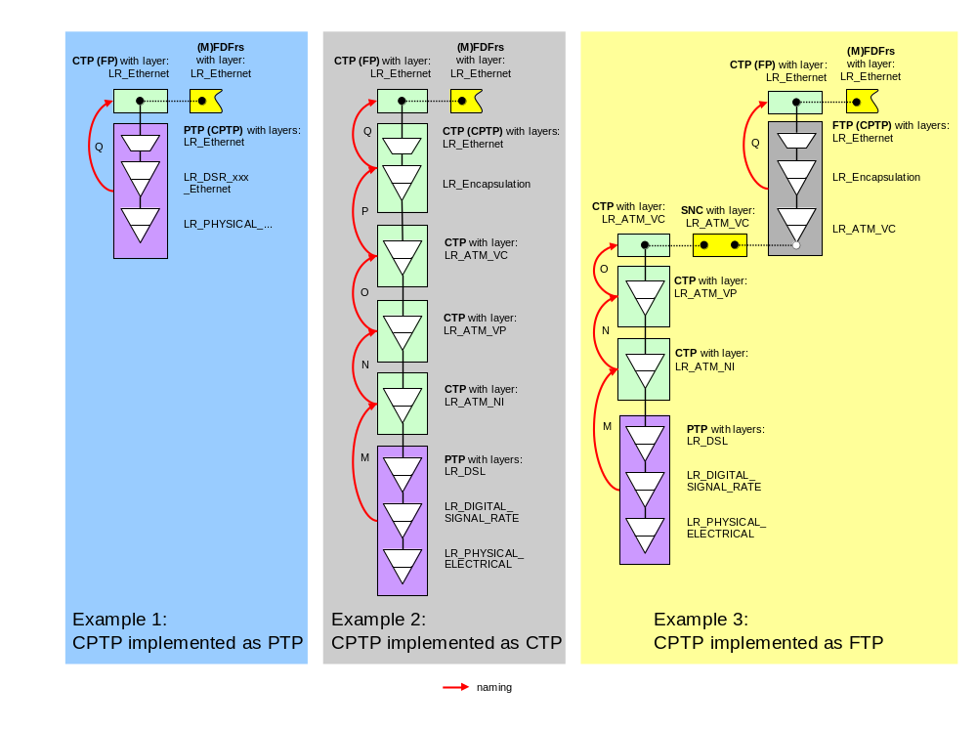
Figure 1: Implementations of CPTPs
In the context of a Flow Domain (FD), a CPTP can be an edge port or an internal port. The fdEdge port is identified by the value "fdEdge" in the layered parameter "PortTPRoleState" (see following definition) and the fdInternal port is a CPTP that is assigned to one of the Matrix Flow Domains (MFDs) which are associated to the FD but not acting as an edge (i.e. have the value "assigned" in the layered parameter "PortTPRoleState").

A CPTP can "play" several roles depending on its usage in the network:
- unassigned CPTP
This is the usual initial role of a CPTP. CPTPs (if automatically created) will be created as "unassigned" CPTPs when the equipment (which supports the port) is plugged into the NE. In this role, the CPTP cannot carry any traffic.
In case the NE allows traffic to flow automatically when the equipment is plugged in, the EMS has to
- create a default MFD,
- create a default FD to which the MFD is associated to,
- assign all relevant CPTPs to the MFD (either as fdEdge or assigned),
- create all default Flow Domain Fragments (FDFrs) and corresponding FPs. An "unassigned" CPTP has a relationship to its supporting equipment and naming relationship to its containing NE.
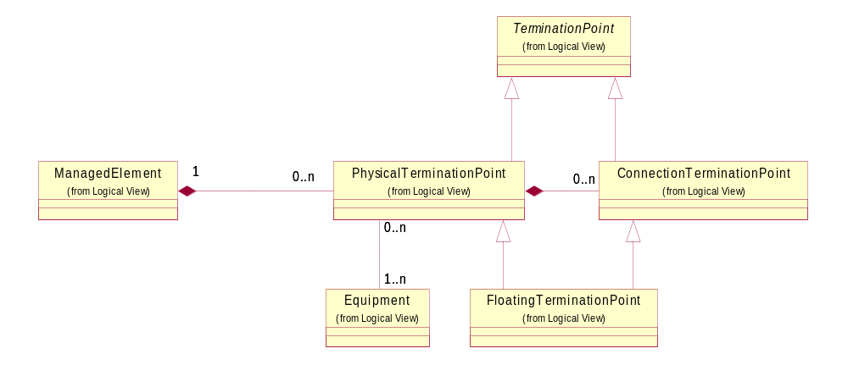
Figure 2: unassigned CPTP
Note: The naming relationship between ManagedElement and Equipment (via EquipmentHolder) is not shown in the UML diagram.
- assigned CPTP
An "unassigned" CPTP becomes an "assigned" CPTP when it is associated to a Matrix Flow Domain (MFD) via a management operation.
In this role, the CPTP cannot carry any traffic because the MFD is not associated to a Flow Domain (FD).
An "assigned" CPTP has, in addition to the relationships of an "unassigned" CPTP, a relationship to its associated MFD.
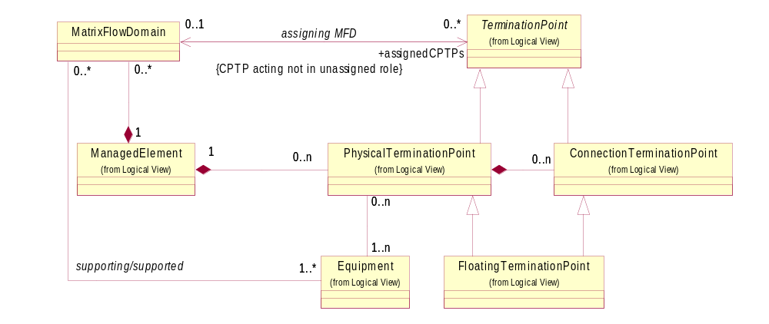
Figure 3: assigned CPTP
- fdInternal CPTP (FD Internal CPTP)
An "assigned" CPTP becomes an "fdInternal" CPTP when its MFD is associated to a Flow Domain.
An "unassigned" CPTP becomes an "fdInternal" CPTP when it is assigned to an MFD that is already associated to a Flow Domain.
In the fdInternal role, the "potential" client Flow Points of the CPTP can be used as internal points of the route (in case auto-routing is not supported, e.g., in case of Ethernet automatic VLAN-ID registration is not supported) of a Flow Domain Fragment; i.e., can carry traffic.
An "fdInternal" CPTP has, in addition to the relationships of an "assigned" CPTP, a relationship to its associated Flow Domain.
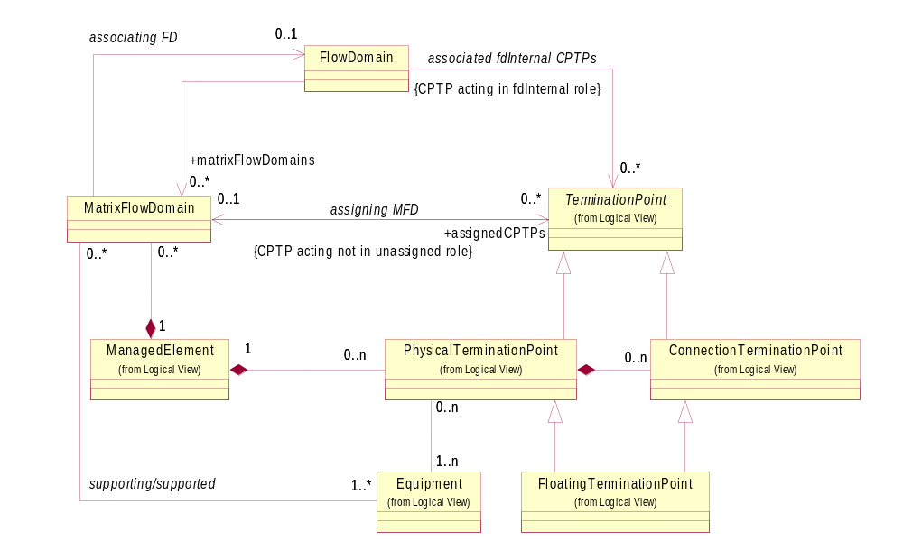
Figure 4: fdInternal CPTP
- fdEdge CPTP (FD Edge CPTP)
An "assigned" CPTP becomes an "fdEdge" CPTP via a management operation (Note: Precondition is, that the MFD is already associated to the FD). In this role, the "potential" client Flow Points of the CPTP can be used as edge points of a Flow Domain Fragment; i.e., can carry traffic.
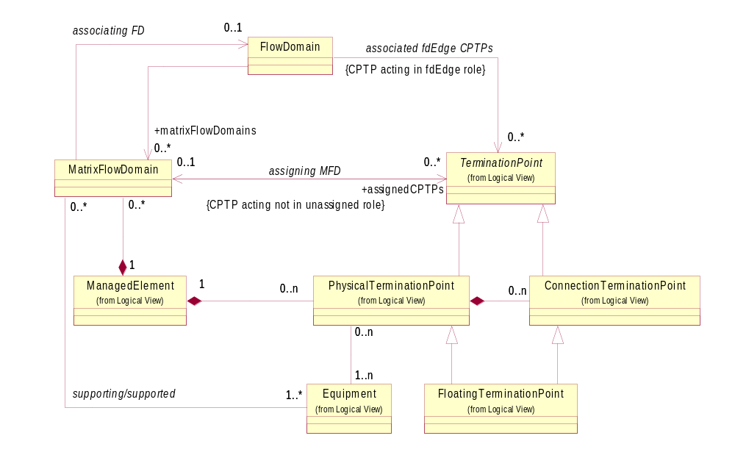
Figure 5: fdEdge CPTP

A CPTP can exist in four major states:
CPTP state examples | CPTP assigned to MFD | MFD associated to FD | CPTP configured to fdEdge | PortTPRoleState | CPTP can carry traffic?
1 | no | not applicable | not possible | unassigned | no
2 | yes | no | not possible | assigned | no
3 | yes | yes | no | fdInternal | yes
4 | yes | yes | yes | fdEdge | yes
Table 1: Major CPTP states

The kind of role that a CPTP is "playing" for its connectionless client layer is stored in a new layered parameter "port TP Role State" associated to the PTP/FTP/CTP object.
The retrieval of the CPTPs over the interface is possible with the following operations:
- The operations "ManagedElement:getAllPTP(Name)s" will return all (assuming layer rate filter is set properly) CPTPs (playing any role) within the NE.
- The operations "ManagedElement: getAllPTP(Name)sWithoutFTPs" will return all (assuming layer rate filter is set properly) "PTP" CPTPs (playing any role) not supporting encapsulation or link aggregation within the NE.
- The operations "ManagedElement: getAllFTP(Name)s" will return all (assuming layer rate filter is set properly) "FTP" CPTPs (playing any role) supporting encapsulation or link aggregation within the NE.
- The operations "MatrixFlowDomain:getAllAssignedCPTPs" will return all CPTPs assigned to this MFD (i.e., playing "assigned", "fdInternal" or "fdEdge" role).
- The operations "MatrixFlowDomain:getAllAssignableCPTPs" will return all CPTPs that are potentially able to be assigned to this MFD. Potentially means: The CPTPs are on the same Equipment or same Rack with backplane connectivity as the MFD. It is irrelevant whether the CPTPs are already assigned to an MFD or not.
- The operations "FlowDomain:getAllCPTPs" will return all CPTPs associated to this FD (i.e., playing "fdInternal" or "fdEdge" role). It is possible to filter the request to retrieve only fdEdge, only fdInternal or all CPTPs.

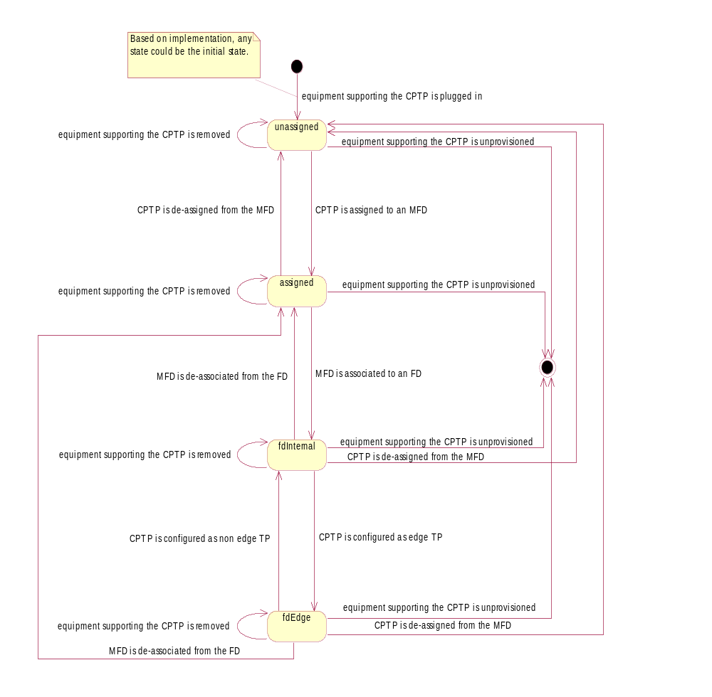
Figure 6: State diagram for Port TP Role State

Call
Refer to chapter 6

Flow Domain (FD)
G.809: "A topological component used to effect forwarding of a specific characteristic information."
This entity groups Matrix Flow Domains (MFDs) and obliquely the CPTPs (i.e., server layer TPs of Flow Points) assigned to the MFDs. Traffic cannot flow between points that are related solely by an FD. Traffic can only flow if there exist a Flow Domain Fragment (FDFr) within the FD. An FD is used to indicate the potential for flow of traffic between a set of points (and in this sense it is directly analogous with the connection oriented Subnetwork). The lowest level of decomposition of an FD is a single (non-decomposable) Matrix Flow Domain (e.g., a Bridge in case of Ethernet).
The Flow Domain represents an administrative partitioning of the connectionless network domain. Similarly with connection oriented Subnetworks, the Flow Domain primary role is to identify within each subordinate EMS the portion of connectionless networks that participate into the same higher level Flow Domain known and managed by the NMS (i.e., two-level hierarchy). Flow Domains differ from MTNM Subnetworks as they provide the NMS for defining them and requesting explicit implementation by the EMS across the management interface (MTNM Subnetworks can only be discovered). Unlike connection oriented Subnetworks which often constitute the widespread transport layer (DWDM, SONET/SDH) shared by many network applications, connectionless Subnetworks such as Metro Ethernet are likely to be deployed as smaller “islands” dedicated to a single network application (e.g., multiple sites of a corporate customer). Flow Domain provisioning capability allows an NMS to instantiate and to change a Flow Domain so it can meet the infrastructure requirement (CPTPs, MFDs) needed to fulfil requests (FDFrs set up, tear down and modify) received from a service order system.
An additional difference between FD and Subnetwork is that an ME can participate in more than one FD at the same layer rate but in only one subnetwork.
Note: Appendix I show some hypothetical Ethernet network examples.

Flow Domain Fragment (FDFr)
This entity represents a Virtual Private Network (VPN) for a single customer in the provider’s network and enables the flow of traffic between Flow Points (FPs). The server layer CPTPs of the FPs that are connected via an FDFr have to be assigned to the MFDs that are associated to the FD containing the FDFr. If traffic that is correctly structured (i.e., not damaged by previous transport) arrives at a point that is a member of an FDFr, it will (barring a fault or frame dropping) emerge at one or more of the other edge Flow Points that are members of the same FDFr (and in this sense it is directly analogous with the connection oriented subnetwork connection). An FDFr may relate two or more edge Flow Points activating traffic connectivity between those points. The FDFr within an FD that is not the MFD/Bridge will potentially have a route that would be described by internal FPs and smaller Matrix Flow Domain Fragments (MFDFrs). The edge Flow Points that act as endpoints of the FDFr may be associated with CPTPs connected to customer domains or they may be associated with CPTPs connected to other provider domains (of the same or different providers) or they may be a mixture of both.
An FDFr may be associated with a certain VLAN ID on one Flow Point, and with a different VLAN ID on another Flow Point when VLAN swapping is supported within the FDFr. When VLAN swapping is not supported, VLAN Ids of the FPs must equal the VLAN Id of the FDFr. The only VLAN ID seen by an FDFr is the VLAN ID of the outermost frame. An FDFr may also support untagged frames, or may be unaware of frame tags.
A Flow Domain Flow (as defined in G.809 [7]) is not modelled as it describes the instantaneous transfer of a single MAC frame and it is therefore transient and highly variable.
A Flow Domain Fragment may be considered as the aggregation of all potential Flow Domain Flow (FDFs) within its containing Flow Domain and hence as the connectionless analogue of the connection-oriented Subnetwork Connection (SNC). Individual FDFs are generally not modelled at the NML-EML Interface.
Note: An FDFr is similar to an "EVC" defined in MEF.

Flow Point (FP)
A point in a connectionless layer (e.g., Ethernet layer) which represents an association between a CPTP and an FDFr. It is either an endpoint of an FDFr, where traffic enters or exits an FDFr or an internal point of an FDFr, used to define the route of an FDFr. It is modelled as a CTP. Operations on frames, which occur on entry to or exit from an FDFr, are defined on the CTP object.
Note: The Flow Point will not be used for the modelling of a single MAC frame (as defined in ITU-T).
Note: In the case of Ethernet, Flow Points are always bidirectional.

Flow Point Pool (FPP)
G.809 [7]: "A group of co-located flow points that have a common routing." The ITU-T FPP will not be used in the model. The CPTP represents the grouping of Flow Points on the server layer.

Flow Point Pool Link (FPP Link)
G.809 [7]: "A “topological component” which describes a fixed relationship between Flow Domains." The ITU-T FPP Link will not be used in the model. The Call represents an FPP Link on the server layer.

Link Flow
G.809 [7]: "A “transport entity” that transfers information between “ports” across a Flow Point Pool Link." The ITU-T Link Flow will not be used in the model.

Matrix Flow Domain (MFD)
An MFD is a Flow Domain at the lowest level of decomposition that represents the actual minimum decomposition of the hardware. It is a logical entity that is contained within one single Managed Element (ME). One ME may contain many MFDs. An MFD is characterised by a set of (possible empty) MFD Ports (i.e. CPTPs).
For the Ethernet technology, the Matrix Flow Domain corresponds to an IEEE (virtual) bridge.
Point to Point connectionless services without an explicitly created MFD are modelled with a "fixed" MFD.

MFD Port
An MFD Port is a Connectionless Port Termination Point (CPTP) which is associated to an MFD (i.e., is an assigned CPTP). It represents a port attached to an MFD at the server layer of the connectionless layer (e.g., Ethernet). An MFD Port can be associated as an FD Edge or an FD Internal CPTP to a Flow Domain. This is only possible when the MFD (to which the MFD Port is associated to) is associated to the FD.
For the Ethernet technology, the MFD Port is a Bridge Port whose uppermost layer can adapt to Ethernet (Ethernet server TP).

Topological Component
G.809 [7]: "An architectural component, used to describe the transport network in terms of the topological relationships between sets of points within the same layer network."

Traffic Conditioning function
G.8010 [8]: "A "transport processing function" which accepts the characteristic information of the layer network at its input, classifies the traffic units according to configured rules, meters each traffic unit to determine its eligibility, polices non-conformant traffic units and presents the remaining traffic units at its output as characteristic information of the layer network."
The Traffic Conditioning function is modelled by a Traffic Conditioning (TC) Profile that contains the (bandwidth) parameters (according to MEF 10 [15]) that policies the traffic at the ingress and or egress (in this version only ingress is supported) of a connectionless layer (e.g., Ethernet) network. The policies can be applied to
- a whole port (CPTP)
(e.g., for Ethernet per VLAN-Id, Priority and CoS)
- a point of an FDFr (FP)
(e.g., for Ethernet per VLAN-Id, Priority and CoS).
The TC Profiles are associated to CPTPs and FPs via the "Traffic Mapping Table". Refer to chapter 9 for details of the "Traffic Mapping Table".
The association of a TC Profile to an FP or CPTP is defined in a "cascaded" manner; i.e., parameters associated to traffic units at a CPTP can be overwritten by parameters associated to the same traffic units at an FP.

Transport Entity
G.809 [7]: "An architectural component which transfers information between its inputs and outputs within a layer network."

Different managers for connection-oriented and connection-less Technologies
In case the connectionless technology and the connection oriented technology are managed by two different EMSes, the CPTPs (which are FTP objects) are known in both Managers and the attributes and operations might have restricted write access. The Call might be known to the SDH EMS, or it might not.
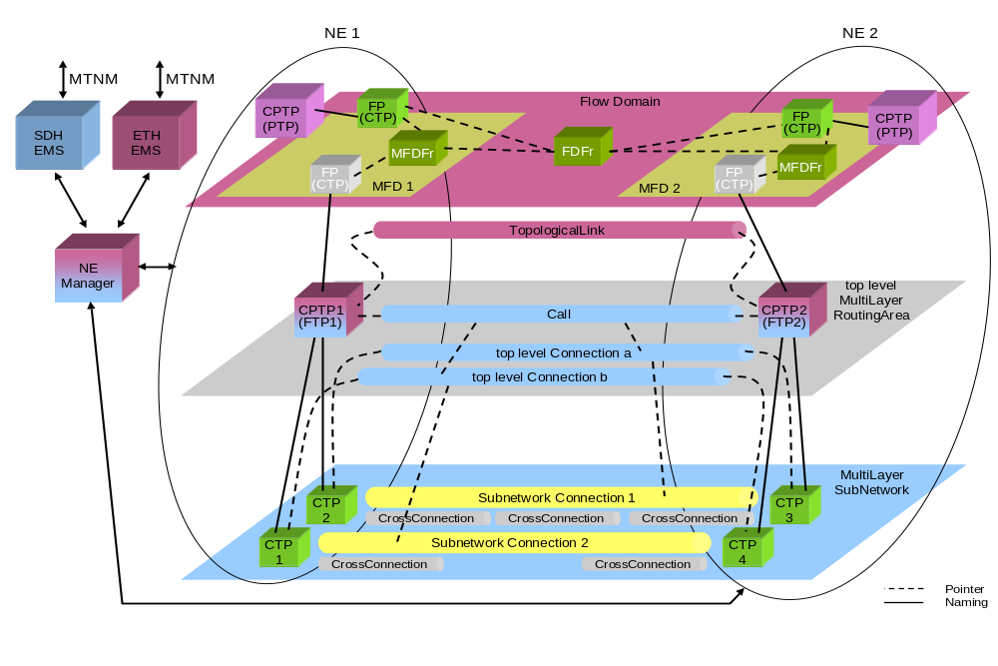
Figure 7: Example: Separate SDH-EMS and Ethernet-EMS
The following table identifies which objects in Figure 7 are represented by which EMS:
EMS | managed objects
SDH EMS | MLSN  top level MLRA  CTPs in MLSN  SNCs in MLSN  FTP in NE 1, FTP in NE 2  Call  top level Connections
ETH EMS | FD, MFD and MFDFr in NE 1, MFD and MFDFr in NE 2  FPs in FD, PTPs in MFDs  FDFr in FD  FTP in NE 1, FTP in NE 2 (like ATM-NI the FTPs could also be represented as PTPs)  TolplogicalLink
Table 2: Objects represented by SDH and ETH EMS (simple example)

Call

Introduction
The Call is a link between two Matrix Flow Domains at the Encapsulation layer rate, i.e., it connects two CPTPs. The Call represents the bandwidth available to its client connectionless layer (e.g., Ethernet). It is used to "manage" the server layer (e.g., SDH VC12, SDH VC12-5v) capacity.
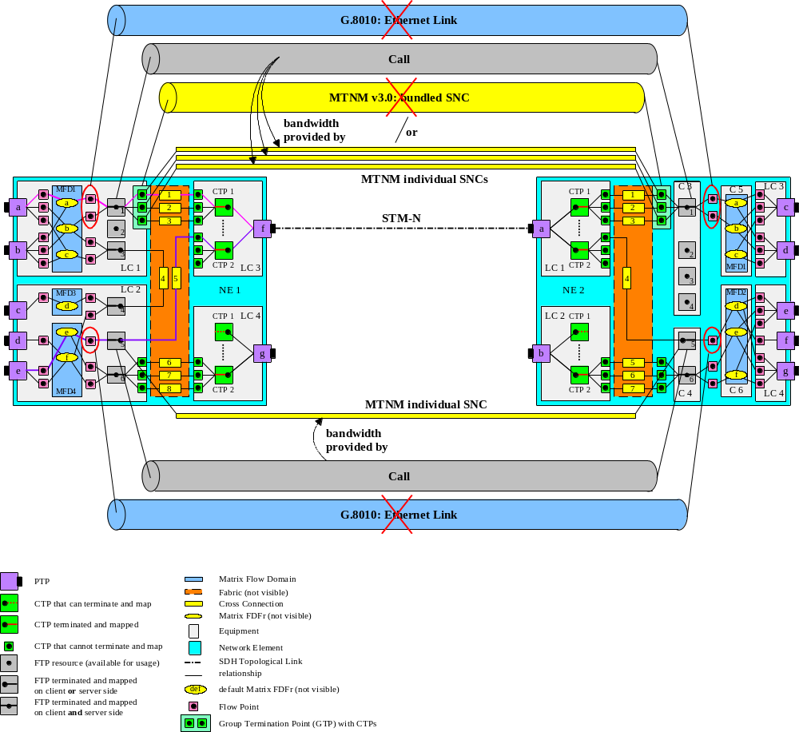
Figure 8: Encapsulation Layer Link usage
Note:
The bundledSNC defined in MTNM Version 3.0 can not be used (without modification) because it requires, that the ordering of the CTPs within the Group Termination Point (GTP) has to be preserved (which is not necessary when LCAS (Link Capacity Adjustment Scheme) is used) and because all "contained" SNC use the same route (which is not necessary for VCAT (Virtual Concatenation) or LAG (Link Aggregation Group)).
The Ethernet Link (G.8010) can not be used because it does not allow configuring the GFP (Generic Framing Procedure) and LCAS parameters.

In case the connectionless technology and the connection oriented technology are managed by two different EMS, the Call object is known in the connection oriented technology EMS and a corresponding Topological Link object is known in the connectionless technology EMS.
Refer to Figure 7.

In the case where the EMS only has visibility of one CPTP, the other CPTP (that is managed by another EMS) is an off-network CPTP which will be referenced by a remote address. Refer to Figure 9.
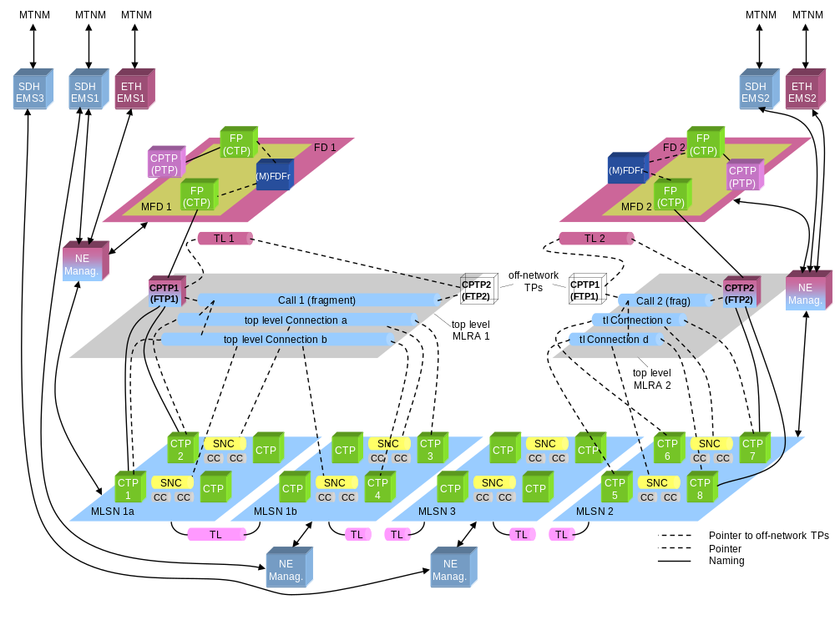
Notes:
Resources are shown as they are represented at the MTNM interfaces.
Only one NE is shown in each MLSN. There may be many NEs within each MLSN.
FD1 and FD2 may contain many MFDs.
Figure 9: Example of Encapsulation Layer Link segments with off-network CPTPs

The following table identifies which objects in Figure 9 are represented by which EMS:
EMS | managed objects
SDH EMS 1 | MLSN 1a, MLSN 1b  CTPs in MLSN 1a, CTPs in MLSN 1b  SNCs in MLSN 1a, SNCs in MLSN 1b  TL between MLSN 1a and MLSN 1b, TL segment in MLSN 1b  FTP 1  Call 1 fragment, top level Connection a, top level Connection b
ETH EMS 1 | FD 1, MFD 1  CTPs in FD 1, PTP in MFD 1  FDFr in FD 1  FTP 1  TL 1
SDH EMS 2 | MLSN 2  CTPs in MLSN 2  SNCs in MLSN 2  TL segment in MLSN 2  FTP 2  Call 2 fragment, top level Connection c, top level Connection d
ETH EMS 2 | FD 2, MFD 2  CTPs in FD 2, PTP in MFD 2  FDFr in FD 2  FTP 2  TL 2
SDH EMS 3 | MLSN 3  CTPs in MLSN 3  SNCs in MLSN 3  two TL segments in MLSN 3
Table 3: Objects represented by SDH and ETH EMS

Two types of Topological Links are modelled:
- Point to Point and
- Multipoint.
Point to Point connectivity is provided by the Topological Links described so far.
Multipoint (any-to-any) connectivity exists between MFDs in case the transport network consists of a broadcast medium such as a traditional physical Ethernet bus or a Resilient Packet Ring (RPR). The same amount of bandwidth has to be associated between each pair of nodes within an RPR.
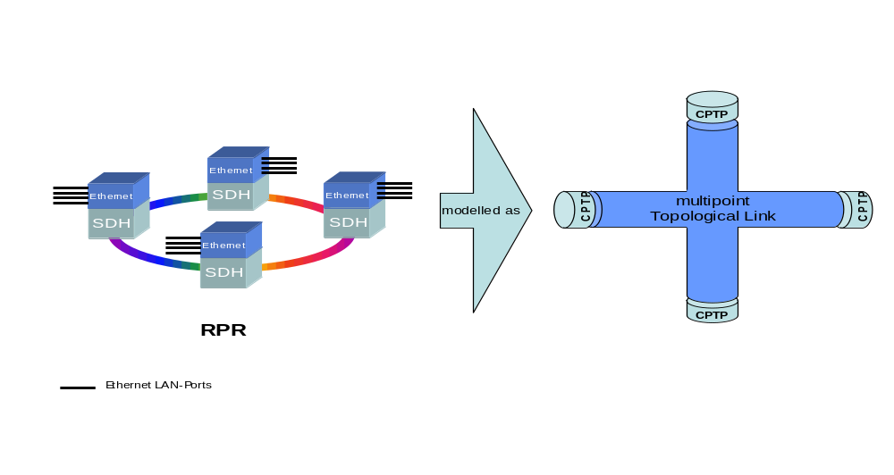
Figure 10: Example: Modelling of an RPR-Ring

A Call can be supported in its server layer by one of two varieties:
- with Inverse Multiplexing, using Virtual Concatenation (VCAT) or Link Aggregation (LAG)
- without Inverse Multiplexing, directly using SONET/SDH or other technologies
If VCAT is used, additional parameters are needed to indicate how many server layer SNCs should support the link and the single server layer rate (STS-1, VC-3, VC-4, etc.). Also, the NMS can direct the EMS to automatically create the server layer SNCs based on the EMS’s routing method(s). LCAS and VCAT-related parameters are specified in the transmission parameters. The interface allows the NMS also to require diverse routed SNCs. This is described in the section below.
If LAG is used, additional parameters are needed to indicate how many server layer SNCs should support the link and the server layer rate (STS-1, VC-3, VC-4, Fragment, etc.). A Fragment server layer rate means that the LAG members are VCAT groups.
The operations will be:
- NMS creates a Call
VCAT or non-VCAT bandwidth at the server layer can also be created by this operation. The server layer SNC (in case of non-VCAT) or the server layer SNCs (in the case of VCAT or LAG), that are already created between the terminating CPTPs via other operations are automatically associated to the new Call. (Bandwidth using LAG cannot be created by this operation.)
- NMS deletes a Call
The Call (and all supporting server layer SNCs) is deleted.
- NMS modifies a Call
The attributes and the capacity of a Call are modified. Note that Routing constraints for each of the new server layer SNCs may be supplied by the NMS.
The typical life cycle for a non-VCAT supported Call would be to create the Call, modify the parameters as needed later, and then finally delete the Call.
The typical life cycle for a VCAT or LAG supported Call with automatic server layer SNC creation would be to create the Call (specify automatic server layer SNC creation, number of server layer SNCs and server layer rate); modify the Call later on, adding/removing automatically created server layer SNCs as needed; and then finally delete the Call.
The typical life cycle for a VCAT supported Call with manual server layer SNC creation would be to create the Call (specify manual server layer SNC creation and server layer rate); create explicitly the SNCs, routed as desired; modify the Call later on, creating/deleting the SNC’s; and then finally delete the Call.

Call diversity
It is possible to increase the resilience of a Call by using diverse routed Connections. This is described in Appendix E "Diversity and Co-routing" of SD1-45.

LAG

Introduction
Ethernet Link Aggregation (LAG) is supported, both for the LAN side and the WAN side, in MTNM Rel 3.5.
Ethernet Link Aggregation is specified in IEEE 802.3ad and will be covered also in ITU-T G.8010.
Supporting LAG is very similar to supporting VCAT. It is a particular variation of Inverse Multiplexing (see SD1-14). Inverse Multiplexing is also called Fragmentation in MTNM language. The specific characteristics of LAG Fragmentation, which differentiate it from Fragmentation generally, are:
a) its application specifically to Ethernet, and
b) the fact that the signal in any member of the Link Aggregation Group is a valid Ethernet signal.
Link Aggregation is supported by a protocol, called LACP (Link Aggregation Control Protocol) whose task is to guarantee the compatibility of both sides of the aggregated link. This protocol, which is specified in IEEE 802.3ad, has many attributes and configuration parameters. However, these attributes and configuration parameters can be considered to be “low level”, in the sense that they can be handled at the EMS level. The first phase of LAG support in Release 3.5 does not deal with these attributes and parameters at the NMS level.
Similarly, the criteria for distributing Ethernet frames among the LAG members can vary, and some implementations may allow configuring different LAGs with different criteria. It might be desirable to be able to do this from the NMS (implying support in the interface), but the specification would be too complex to work out for Release 3.5, and is therefore not included. Where needed, this configuration can be done at the EMS level, or below.

FTP with new Layer Rate
A LAG is represented by an FTP, whether on the LAN side or on the WAN side. A new layer rate is defined for this FTP, called LR_LAG_Fragment. It is similar to the LR_Fragment layer rate, but in addition to the layer attributes belonging to LR_Fragment, it also has Ethernet attributes, as explained below, and LAG attributes and notifications.

LAG creation by EMS or NMS
A LAG FTP may either be created by the EMS and discovered by the NMS (like most TPs), or it may be created by the NMS using the createFTP() operation.
Whether created by EMS or NMS, LAG FTPs act like other Fragment TPs, in that the maximum number of allowed members is in the read-only attribute “AllocationMaximum”, and the number of members desired by the NMS is configured using the “AllocatedNumber” attribute.
When created by the EMS, without possibility of creation by the NMS, the EMS creates all the potential LAG FTPs that it can handle, each with its “FragmentServerLayer” set to a layer rate for which LAG can be supported, and with “AllocationMaximum” set to the maximum number of members which can be supported for that layer rate. It is understood that populating a LAG FTP for some layer rate may block the possibility of populating other LAG FTPs at a different layer rate or even at the same layer rate. For example: If the bandwidth capacity is 16xVC4, and the possible layer rates are VC4 and VC4-4c, and a LAG can use all of the bandwidth, then the EMS will create 20 LAG FTPs. It will create 16 LAG FTPs with layer rate VC4 and AllocationMaximum=16, and it will create 4 LAG FTPs with layer rate VC4-4c and AllocationMaximum=4. If an operator populates a LAG FTP with 6 VC4s, then only 10 LAG FTPs with layer rate VC4, and 2 LAG FTPs with layer rate VC4-4c, remain as candidates for population. Even though the value of AllocationMaximum does not change, an attempt to populate a LAG FTP with more members than there is remaining available bandwidth will be rejected.

Populating LAGs with VCATs
Since a LAG can also have members which are VCATs, where this is supported by the equipment, an EMS or NMS may create LAG FTPs which have FragmentServerLayer = LR_Fragment.

Associating LAG_Fragment CTPs with actual TPs
Once the AllocatedNumber attribute of a LAG FTP has been set to n, the NMS can assume, or it can discover by uploading the FTP, that there are n server side CTPs, numbered 1 through n. These CTPs will have layer rate LR_LAG_Fragment.
LAG_Fragment CTPs will have an attribute called LagMember which points to an actual TP, which is the actual member of the LAG. It is an error for the layer rate of the actual TP to be different from the layer rate specified in the FragmentServerLayer attribute of the LAG FTP.
Alternatively, there may be a cross-connect between the LAG_Fragment CTP and the actual TP to which it is associated. Here, too, it is an error for the layer rate of the actual TP to be different from the layer rate specified in the FragmentServerLayer attribute of the LAG FTP.
The value of a LagMember pointer is the DN (Distinguished Name) of the actual TP to which the LAG_Fragment CTP points.
When the LAG is aggregating VCATs, the LagMember pointer (or cross-connect) will point to an FTP which represents a VCAT. The EMS may reject an attempt to populate a LAG with VCATs which don’t all have the same FragmentServerLayer and AllocatedNumber.
It is an error to have an actual TP being a member of more than one LAG.
On the LAN side, a LAG_Fragment CTP will point to an Ethernet PTP. All member PTPs of a LAG must be of the same Ethernet rate.

Naming of LAG TPs
LAG naming rules are the same as VCAT naming rules. A LAG FTP is identified in a similar way as a PTP, either with reference to the host equipment, with the specific FTP given some number by the EMS, or by some other identification scheme used by the EMS for PTPs. When the FTP is told to configure n member, they will become CTPs, under the FTP, with layer rate LR_LAG_Fragment, and numbered 1 to n.
For example, a LAG which aggregates 3 VC4s would look like this (in a "shorthand" version):
EMS=xxx/NE=yyy/FTP=ftpIDi, layer= the number for LR_LAG_Fragment, FragmentServerLayer= the number for VC4, AllocatedNumber=3
CTP=/lag_fragment=1, LagMember=<DN of the real VC4 associated with 1st member CTP>
CTP=/lag_fragment=2, LagMember=<DN of the real VC4 associated with 2nd member CTP>
CTP=/lag_fragment=3, LagMember=<DN of the real VC4 associated with 3rd member CTP>
For another example, a LAG which aggregates 2 VCATs of VC4s might look like this:
EMS=xxx/NE=yyy/FTP=ftpIDj, layer= the number for LR_LAG_Fragment, FragmentServerLayer= the number for LR_Fragment, AllocatedNumber=2
CTP=/lag_fragment=1, LagMember=<DN of the real VCAT FTP associated with 1st member CTP>
CTP=/lag_fragment=2, LagMember=<DN of the real VCAT FTP associated with 2nd member CTP>

Association by EMS or by NMS
In some implementations, setting the AllocatedNumber attribute of a LAG FTP causes the EMS to select the real TPs which will be associated with the LAG member CTPs. In this case, the EMS will set the LagMember pointers with the DNs of the selected TPs. In other implementations, setting the AllocatedNumber attribute of a LAG FTP causes the EMS to create the member CTPs, whose LagMember pointers remain empty until set by the NMS. An NMS can see if the EMS selected TPs for association by checking the value of LagMember pointer.

Manual LAG population vs Automatic LAG population by LACP
Some LACP implementations determine by themselves the number of members in a particular LAG and who those members are. In order to allow this, there will be a LAG attribute called AutoLAG, with values Enabled and Disabled. When Enabled, the EMS will set the AllocatedNumber attribute of the LAG FTP and LagMember attributes of the LAG_Fragment CTPs, according to the determination of the LACP. When the equipment does not support automatic LAG configuration, or if the EMS does not want to allow it, the EMS will reject an attempt to set AutoLAG to Enabled. If the NMS wants to impose LAG configuration, it will set AutoLAG to Disabled.

LAG members cannot be CPTPs
A LAN port, which usually can be an edge CPTP, cannot be an edge CPTP if it is a member of a LAG. The LAG FTP is the edge CPTP.
Similarly, an FTP on the WAN side, which usually can be a CPTP which is an endpoint of a Call, cannot be a Call endpoint if it is a member of a LAG. The LAG FTP is the Call endpoint.

LAG attributes and PM counters
The LAG FTP, in addition to being a Fragment, with Fragment attributes, and in addition to having the AutoLAG attribute which is special to the LAG FTP, also acts like an Ethernet port, with all of the attributes which Ethernet ports have.
Similarly, PM counters normally associated with an Ethernet port are also associated with a LAG FTP. LAN side counters will be maintained on LAN side LAG FTPs, and WAN side counters will be maintained on WAN side FTPs. This is in addition to the counters associated with each of the LAG members.
LAG FTPs will report TCAs, in addition to the TCAs which will be reported by the LAG members.

A LAG is a STP port
A LAG is an STP port, and therefore has all of the attributes needed for STP management. A port which is a member of a LAG cannot be a STP port. The EMS will reject an attempt to treat a LAG member like a STP port.

LAG Alarms
A LAG FTP will report the Ethernet alarms (and TCAs) and STP alarms (and TCAs) that can be reported by an Ethernet port. In addition, when all LAG members are down, a LinkDown alarm will be reported by the LAG FTP. When some members are functioning, but at least one member is down, a PartialLinkDown alarm will be reported. The individual LAG members will report their own alarms.

LAG use in Call creation must be explicit
The EMS will not create a LAG when a establishCall operation requests automatic creation of server SNCs. In order for a Call to use a LAG endpoint, the LAG must already exist and the Call created explicitly using that LAG.

Modeling aggregation of signals for Ethernet CPTPs
The following diagrams show that a CPTP on the Ethernet side (LAN side) of an MFD (the yellow connector on top) can either be a port (the purple PTP) or an aggregation of several ports (the striped FTP). On the transport side (WAN side), a CPTP is either a VCAT (striped FTP labeled VCAT), an aggregation of VCATs or VCx (striped FTP labeled LAG), or a single VCx. (VCx is used generically, and can also be a TUx or a SONET equivalent of these. VCx sometimes is used in the plural sense, to avoid writing VCxs.) A VCx can either be a floating one (see the striped FTP labeled VCx), which needs to be connected to a PTP, or it can be a CTP already belonging to a PTP. The first diagram (Figure 11) shows a floating VCx and the second diagram (Figure 12) shows a VCx belong to a PTP. The diagrams also show that a LAG on the WAN side can aggregate either VCATs or non-concatenated VCx.
A new layer rate LR_LAG_Fragment.has been introduced.
LAG Fragmentation differs from Fragmentation in that is doesn’t change the nature of the signal, it just distributes it. Each LAG member carries a valid Ethernet signal. The regular Fragmentation is assumed to change the signal. VCAT Fragmentation, for example, takes Encapsulated Ethernet and distributes it among the VCx such that the VCx are not carrying valid Ethernet signals. In addition to this difference, a LAG Fragment FTP has specific characteristics of an Ethernet port, as opposed to the usual Fragment, which is a general TP. The LAG Fragment FTP has many more attributes than a Fragment TP.
Usually VCAT FTPs are created by the EMS (or below). The number of existing VCATs is the maximum number that the equipment can use at a given time. However, when the EMS allows CPTP creation, a CPTP can be created as a VCAT. Whether created by EMS or NMS, they are born unpopulated (without member CTPs). They become populated with member CTPs by configuration, when the NMS tells the EMS how many members are required. After that, the NMS associates the VCAT member CTPs with actual TPs.
LAG FTPs are very similar in this regard to VCAT FTPs. They can be created either by the EMS (or below) or by the NMS. LAG FTPs are populated in the same way as VCAT FTPs. A LAG member CTP is associated with an actual TP (port on the LAN side, VCAT or VCx on the WAN side) either by pointer or connection. Note that associating a VCAT FTP with a LAG member CTP means creating two levels of inverse multiplexing. A LAG FTP contains members which associate to FTPs which themselves contain members which associate to TPs.

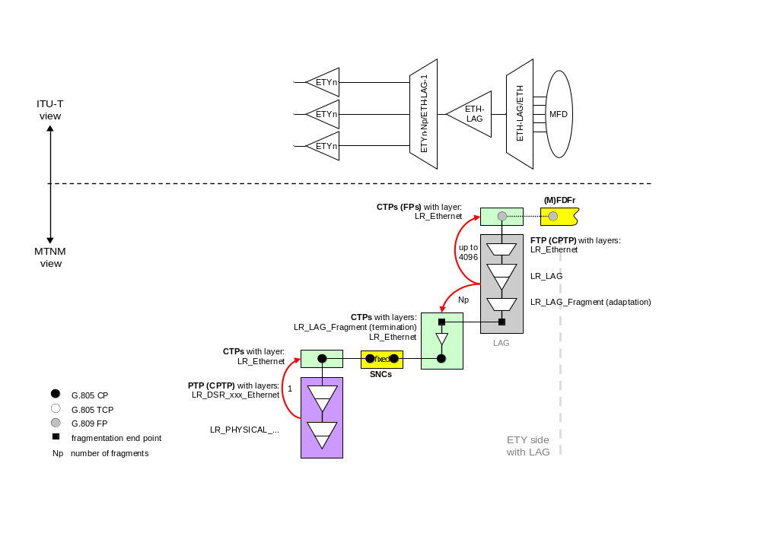
Figure 11: Example: Ethernet LAN port with LAG and VLAN

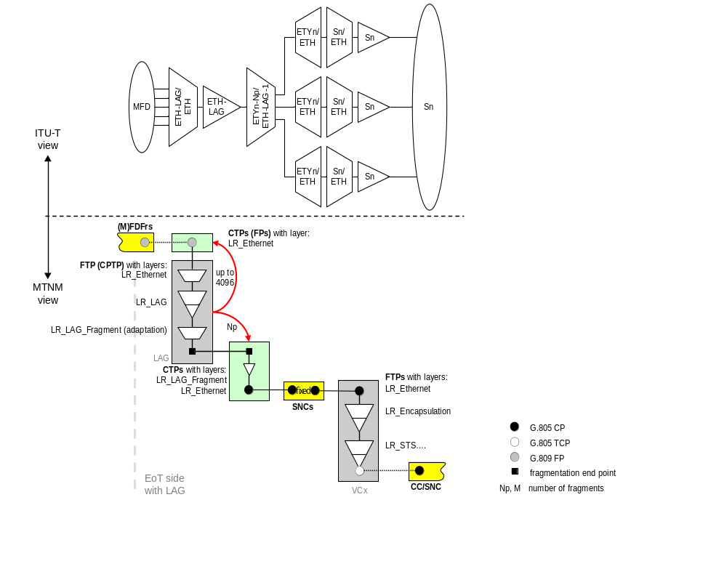
Figure 12: Example: Ethernet WAN port with LAG and VLAN

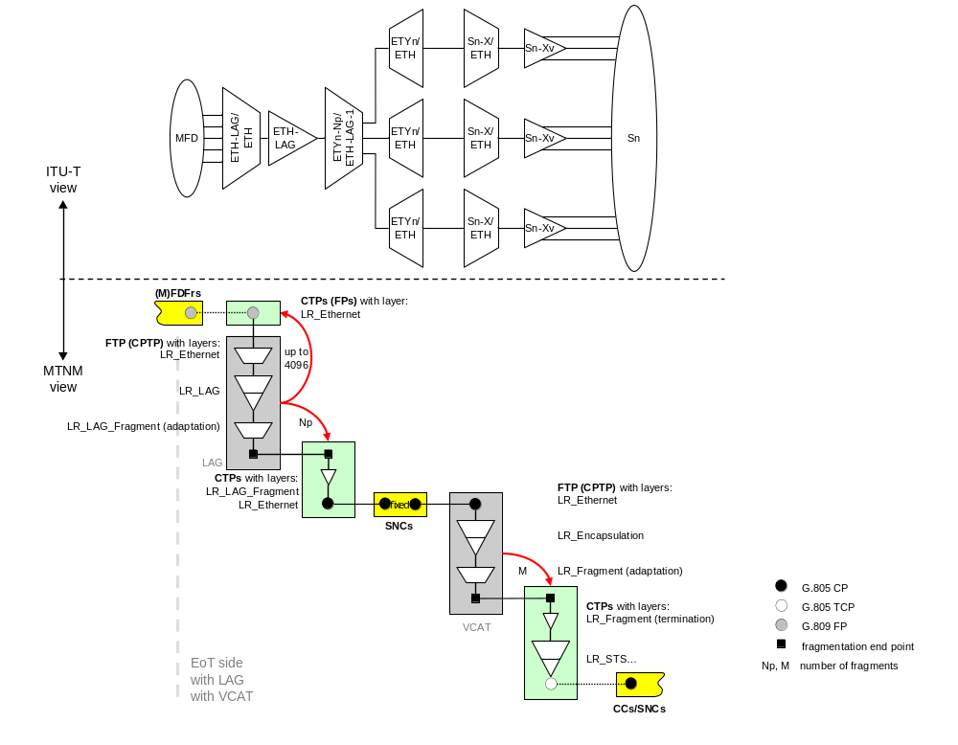
Figure 13: Example: Ethernet WAN port with LAG ,VLAN and VCAT

Tag Management

VLAN Tag
Figure 14 shows the position of the VLAN tag within the Ethernet MAC frame.

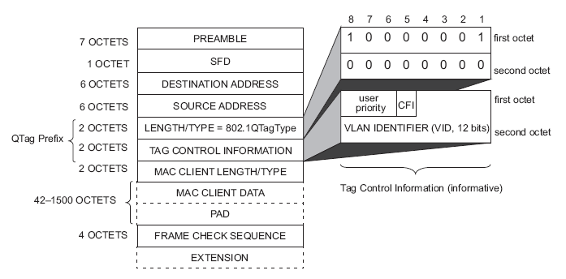
Figure 14/IEEE 802.3-2005 Figure 3-3: Tagged MAC Frame Format

Per IEEE 802.1ad [14], a VLAN tag consists of the following parts:
- A Tag Protocol Identifier (TPID) (802.1QTagType) – 16 bits. This will identify the tag as either being a “C-Tag” or an “S-Tag”. The TPID of “81-00” is reserved for a “C-Tag”, and the TPID of an “S-Tag” is ”88-a8” (however, some vendors use “FF-FF” and some use “91-00”).
- Tag Control Information (TCI):
  - If the Tag is a “C-Tag”, the fields are:
    - Priority Code Point (PCP) – 3 bits
    - Canonical Format Indicator (CFI) – 1 bit
    - VLAN ID – 12 bits

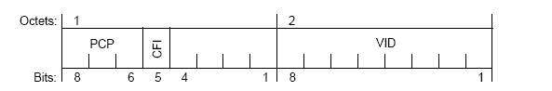
Figure 15/ IEEE 802.1ad-2005 Figure 9-1: C-TAG TCI format

  - If the Tag is an “S-Tag”, the fields are:
    - Priority Code Point (PCP) – 3 bits
    - Drop Eligibility Indicator (DEI) – 1 bit
    - VLAN ID – 12 bits

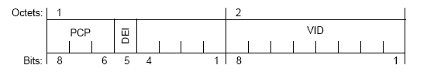
Figure 16/IEEE 802.1ad-2005 Figure 9-2: S-TAG TCI format
- Additional information, as needed by the tag type and Tag Control Information

General Tag Management
In order to enforce that incoming frames have a VLAN Tag (or not), the PortAcceptableFrameTypes parameter should be set accordingly. In addition, if PortAcceptableFrameTypes is “All” or “VlanTaggedOnly”, in order to enforce that those incoming frames have a VLAN Tag matching the provisioned VLANs on the port, the EnableIngressFiltering parameter should be set to “Enabled”.

To strip the outermost VLAN Tag from the frame on egress, the VLANsForUntaggingOnEgress would have the set of VLAN IDs that this should be performed on.

IEEE 802.1Q-compliant Tagging
As per IEEE 802.1Q, the incoming tag is a “C-Tag” and it is not translated.

The following parameters would be set on the CPTP:
- PVID = "0"
- TPID = “8100”
And the following parameters would be set on the Flow Point:
- AddSTag = “false”

If the port were to allow untagged frames and to tag them on ingress, the parameters would be set on the CPTP as follows instead:
- PVID = the C-Tag VLAN ID
- PVIDFrameTypes = “UntaggedOnly”
- TPID = “8100”
- PortDefaultUserPriority = default user priority for the added tag

The IEEE 802.1Q standard forbids tag translation, but if the hardware supported it anyway, the following parameters would be set on the CPTP:
- CTagTranslationEnable = “enabled”
- CTagTranslation_Table_* = structure of pairs of external VLAN IDs and internal VLAN IDs.
For example, a mapping of
CTagTranslation_Table_Count = “3”
CTagTranslation_Table_External = “1,2,3”
CTagTranslation_Table_Internal = “2,3,1”
means on ingress, a VLAN ID of 1 will be re-mapped to 2 and on egress, a VLAN ID of 1 will be re-mapped to 3, etc.

In a color-aware network, it may be desired to encode the drop eligibility in the CFI bit (as is done for the DEI bit in the S-Tag).

IEEE 802.1ad-compliant Tagging
As per IEEE 802.1ad [14], the incoming tag is a “C-Tag” and it may be translated. The Service Provider adds an additional tag, called an “S-Tag”.

The following parameters would be set on the CPTP:
- PVID = "0"
- PVIDFrameTypes = “AllFrames”
- TPID = any value from “0601 to FFFF”, except “8100”
- PortDefaultUserPriority = default user priority for the S-Tag
And the following parameters would be set on the Flow Point:
- IVID = VLAN ID for the FDFr
- AddSTag = “true”

If C-Tag (inner tag) translation were needed, the following parameters would be set on the CPTP:
- CTagTranslationEnable = “enabled”
- CTagTranslation_Table_* = structure of pairs of external VLAN IDs and internal VLAN IDs.
For example, a mapping of
CTagTranslation_Table_Count = “3”
CTagTranslation_Table_External = “1,2,3”
CTagTranslation_Table_Internal = “2,3,1”
means on ingress, a C-Tag VLAN ID of 1 will be re-mapped to 2 and on egress, a VLAN ID of 1 will be re-mapped to 3, etc. The S-Tag will remain the same.
If S-Tag (outer tag) translation were needed, the following parameters would be set on the CPTP:
- STagTranslationEnable = “enabled”
- STagTranslation_Table_* = structure of pairs of external VLAN IDs and internal VLAN IDs.
For example, a mapping of
STagTranslation_Table_Count = “3”
STagTranslation_Table_External = “1,2,3”
STagTranslation_Table_Internal = “2,3,1”
means on ingress, an S-Tag VLAN ID of 1 will be re-mapped to 2 and on egress, a VLAN ID of 1 will be re-mapped to 3, etc.
Both the C-Tag and S-Tag translation may be specified at the same time and will operate independently of each other.

Traffic Mapping Table

Explanations
The Traffic Mapping Table is used to select frames coming in to a CPTP, or an FP, and to specify some decisions about what to do with the selected frames. There is no limit, other than those imposed by practical processing considerations, to the number of selection criteria or to the number of resulting actions.
A Traffic Mapping Table at a CPTP applies to all frames entering the CPTP. A Traffic Mapping Table at an FP selects the frames, from among the frames entering at the CPTP, which are to be directed to the FDFr for whom this FP is an endpoint. An attempt to create an FP, with a Traffic Mapping Table which would select some frames which are already selected by some other FP of the same CPTP, is rejected with INVALID_INPUT. Any frame coming into a CPTP, which is not selected by some FP of the CPTP, is dropped.

Some columns of the table represent selection criteria (these are called “From” columns), and the other columns represent resulting actions to be performed on selected frames (these are called “To” columns). A row of the table contains the values by which frames are selected. In each cell of a row, in the “From” columns of the table, there must be values which belong to the set of values which are compatible with the selection criteria which the column represents. Similarly, in each cell of a row, in the “To” columns of the table, there must be values which belong to the set of values which are compatible with the results actions which the column represents. The result actions specified in the “To” columns of a row of the table are applied to the frames which were selected by the “From” columns of the same row of the table. In order for a frame to be selected, it must fulfill the criteria in all of the “From” columns for some row. The actions specified in all of the “To” columns, in a particular row, will be applied to all of the frames selected by the “From” columns in the same row. It is not acceptable for a frame to be able to be selected by more than one row.
There is a layered parameter, "TrafficMappingTable_Count", which contains the number of rows in the table. There is a layered parameter for each column. The “From” columns are represented by layered parameters named "TrafficMappingFrom_Table_xxxx", where xxxx is the name of the selection criterion. See example. The “To” columns are represented by layered parameters named "TrafficMappingTo_Table_xxxx", where xxxx is the name of the action to be applied. Each parameter representing a column has a value which is a string of cell values separated by commas. The number of comma-separated values in each parameter must be equal to the value of "TrafficMappingTable_Count".
The names of certain parameters, representing selection criteria (“From” columns) and results actions (“To” columns), are to be recognized and understood by all complying systems (even if not used). These are listed in the Layered Parameters list. Other parameter names may be used as agreed by cooperating systems.
Example:
The following table specifies selection criteria VLAN ID and Priority field, and result actions Traffic Class assignment and Traffic Conditioning Profile assignment.

VLAN ID | Priority | Traffic Class | TC Profile ID
1-1000 | 0-1 | 0 | 52
1-1000 | 2-3 | 1 | 64
1-1000 | 4-5 | 2 | 17
1-1000 | 6-7 | 3 | 99
1001-2000 | 0-2 | 0 | 52
1001-2000 | 3-7 | 1 | 127
2001-3600 | 0 | 0 | 100
2001-3600 | 1-6 | 2 | 102
2001-3600 | 7 | 3 | 103
4000, 4010, 4020 | all | 1 | 101
allOthers | all | 0 | 100
Table 4: Example Traffic Mapping Table

All frames whose VID (in the outermost header) has a value between 1 and 1000, and whose priority field (in the outermost header) is 0 or 1, will be assigned to Traffic Class 0 and will be assigned the TC Profile whose ID is 52. All frames whose VID (in the outermost header) has a value between 2001 and 3600, will be assigned Traffic Classes and Profiles according to their Priority Fields. All frames with VID 4000 or 4010 or 4020 will be assigned to Traffic Class 1 and will be assigned the TC Profile whose ID is 101. Etc. All frames which are not covered by the selection criteria specified in the first ten rows of the table (the row of titles is not counted) will be assigned to Traffic Class 0 and will be assigned the TC Profile whose ID is 100.

Table Processing Rules

Selection Criteria strings, recognized by compliant systems

VLAN ID
Layered parameter: "TrafficMappingFrom_Table_VID"
meaning: select according to VLAN ID of outermost frame header
values: single integer between 1 and 4095 (inclusive), or
parenthesized list of single integers (1-4095), separated by commas, or
range in the form a-b, where 1 ≤ a, b ≤ 4095 and a < b, or
“all”, or
“untagged”, or
“allOthers”

Priority field of header
Layered parameter: "TrafficMappingFrom_Table_Priority"
meaning: select according to the priority field of outermost frame header
values: 1-digit number in the range 0-7, or
parenthesized list of 1-digit numbers in the range 0-7, separated by commas, or
range in the form a-b, where a and b are 1-digit numbers (0-7) and a < b, or
“all”, or
“allOthers”

Results Actions strings, recognized by compliant systems

Traffic Class
Layered parameter: "TrafficMappingTo_Table_TrafficClass"
meaning: assign selected frames to the specified traffic class
values: integer between 0 and 7 (inclusive), or “default” or empty (same as “default”)

Traffic Conditioning Profile
Layered parameter: "TrafficMappingTo_Table_TcProfile"
meaning: assign specified traffic conditioning profile to the selected frames
values: existing profile ID, or “default” or empty (same as “default”)

Order of selection columns
When only VID and Priority are used as selection criteria, the order of applying them should not make any difference in the selection results. If other selection criteria are used, by agreement, and if the order of applying the criteria is significant, the agreement should specify the ordering rules.

Order of selection rows
Since it is an error for a frame to be able to be selected by more than one row, the order of rows is not significant.
☹
VLAN ID | Priority | Traffic Class | TC Profile ID
1-250 | all | 0 | 52
200-1000 | 2-3 | 1 | 64
Note that “allOthers” can appear in a row which is before rows with specific values. It still means that the values used are the ones left after the specific values have been used. “allOthers” cannot appear in a column more than once, unless they are mutually exclusive due to other selection columns. “all” cannot appear with any other rows, unless they are mutually exclusive due to other selection columns.
VLAN ID | Priority | Traffic Class | TC Profile ID
1-1000 | 0-1 | 0 | 52  ☺
1-1000 | allOthers | 1 | 64
1-1000 | 4-5 | 2 | 17
1-1000 | 6-7 | 3 | 99
1001-2000 | AllOthers | 0 | 52
1001-2000 | 3-7 | 1 | 127

VLAN ID | Priority | Traffic Class | TC Profile ID  ☹
1-250 | All | 0 | 52
1-250 | 2-3 | 1 | 64
Furthermore, since a frame cannot be selected by more than one FP, “allOthers” cannot appear in a column more than once among all of the Traffic Mapping Tables of all the FPs of a CPTP, unless they are mutually exclusive due to other selection columns. Similarly, “all” cannot appear with any other rows among all of the Traffic Mapping Tables of all the FPs of a CPTP, unless they are mutually exclusive due to other selection columns.
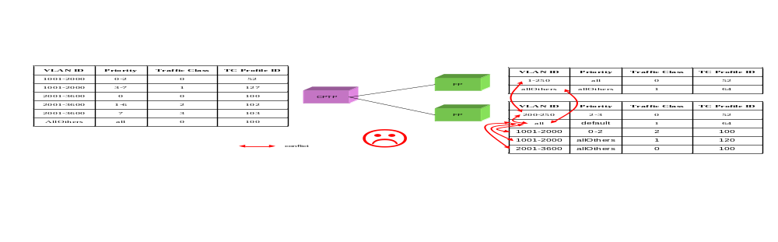
“allOthers” can be used to select all remaining frames which are not selected by any other FP of the CPTP. Note that “allOthers” might not select any frames, if every frame is selected by some row from among all of the Traffic Mapping Tables of all the FPs of the CPTP. Therefore, it is legal for both “all” and “allOthers” to appear, in which case the “allOthers” will not select any frames.

Default and empty values
Where the value “default”, or an empty value (which means “default”), is acceptable, and is used, the result is that the EMS chooses the value which is to be used.

Unselected frames
The frames entering a CPTP which has no Traffic Mapping Table can still be selected by a Traffic Mapping Table at one of the FPs of the CPTP. When a CPTP has a Traffic Mapping Table, a frame which is not selected by any of the rows of the CPTP’s Traffic Mapping Table can still be selected by a Traffic Mapping Table at one of the FPs of the CPTP. A frame which is not selected by a Traffic Mapping Table, at one of the FPs of a CPTP, is dropped.

Invalid values
An invalid value in a column representing a recognized selection criterion or results action (i.e., that appears in the Layered Parameters list) is considered an error.

Wrong number of columns
It is an error (INVALID_INPUT) for any "TrafficMappingFrom_Table_xxxx" or "TrafficMappingTo_Table_xxxx" parameter to contain a number of members which is different from "TrafficMappingTable_Count". Empty members can be designated by consecutive commas or a comma with nothing after it (if the last member is empty).

Unrecognized selection criterion or results action
If a "TrafficMappingFrom_Table_xxxx" or "TrafficMappingTo_Table_xxxx" parameter is not in the Layered Parameters list or in an implementation agreement, the request which introduces the unrecognized parameter is rejected with exception EXCPT_NOT_IMPLEMENTED, with the name(s) of all unrecognized parameters (separated by commas) in the Error Reason field of the exception.

Selection using two frame headers
There are systems which need to select frames according to both the outermost header and the header directly “under” the outermost header. Typically they would be the S-Tag and the C-Tag. In order to accommodate this situation, two more columns would be used: InnerVID and InnerPriority. In order for a frame to be selected by a particular row, it would need to fulfill the criteria expressed by all four “From” columns: VID, Priority, IVID, and IPriority.
Example:
VLAN ID | Priority | Inner  VLAN ID | Inner  Priority | Traffic Class | TC Profile ID
1000 | 0-1 | 10 | 0-3 | 0 | 52
1000 | 0-1 | 10 | allOthers | 1 | 64
1000 | allOthers | 10 | 2-3 | 1 | 64
1000 | 0-1 | 20 | 0 | 2 | 17
1000 | allOthers | 20 | allOthers | 3 | 99
1000 | all | allOthers | all | 0 | 90
2000 | (0,7) | all | all | 2 | 30
2000 | allOthers | all | all | 3 | 33
2001-4000 | all | all | all | 0 | 52
Table 5: Example Traffic Mapping Table for 2-header selection
In order for a frame to be selected by the first row, the outer header must have VID =1000 and Priority either 0 or 1 AND the next inner header must have VID=10 and Priority in the 0 to 3 range.

Example layered parameters
The tables described in Table 4 could be represented as layered parameters, as follows:
"TrafficMappingTable_Count" = "11"
"TrafficMappingFrom_Table_VID” =
“1-1000,1-1000,1-1000,1-1000,1001-2000,1001-2000,2001-3600,2001-3600,2001-3600,(4000,4010,4020),allOthers”
"TrafficMappingFrom_Table_Priority” = “0-1,2-3,4-5,6-7,0-2,3-7,0,1-6,7,all,all”
"TrafficMappingTo_Table_TrafficClass” = “0,1,2,3,0,1,0,2,3,1,0”
"TrafficMappingTo_Table_TcProfile” = “52,64,17,99,52,127,100,102,103,101,100”

The table described in Table 5 would be represented as layered parameters, as follows:
"TrafficMappingTable_Count" = "9"
"TrafficMappingFrom_Table_VID” = “1000,1000,1000,1000,1000,1000,2000,2000,2001-4000”
"TrafficMappingFrom_Table_Priority” = “0-1,0-1,allOthers,0-1,allOthers,all,(0,7),allOthers,all”
"TrafficMappingFrom_Table_InnerVID” = “10,10,10,20,20,allOthers,all,all,all”
"TrafficMappingFrom_Table_InnerPriority” = “0-3,allOthers,2-3,0,allOthers,all,all,all,all”
"TrafficMappingTo_Table_TrafficClass” = “0,1,1,2,3,0,2,3,0”
"TrafficMappingTo_Table_TcProfile” = “52,64,64,17,99,90,30,33,52”

- Hypothetical Ethernet network examples
Figure 17and Figure 18 depict an Ethernet WAN application deployed over a single SONET/SDH transport ring. Some transport NEs participate in bridging and VLAN activities while some other NEs are only operated at the SONET/SDH layer. An NMS may manage this application by means of one or several EMS depending on the NE vendors involved (most likely only one in this particular example). Each EMS may itself support a different level of abstraction of the Ethernet network, for example:
Each individual matrix (a.k.a., bridge) within the ME is presented as a flow domain, hence providing the NMS for managing flow domain fragments (FDFr, a.k.a. VLANs) within the boundaries of a single matrix. SONET/SDH sub-network connections provisioned to interconnect flow domains/matrices (inter-FD) are top-level topological links (at Ethernet layer rate) similar to those interconnecting Multi Layer Subnetworks (MLSNs) in a connection-oriented network. This mode of operation is equivalent to the singleton MLSN view with the exception that the level of granularity is no longer the ME but its matrix sub-component. A vendor EMS may need to use this solution if it does not support a network view within its own management domain. In this case a flow domain does not usually reflect the resources involved for delivering Ethernet services to customers but rather an implementation constraint. Figure 17 illustrates this scenario.

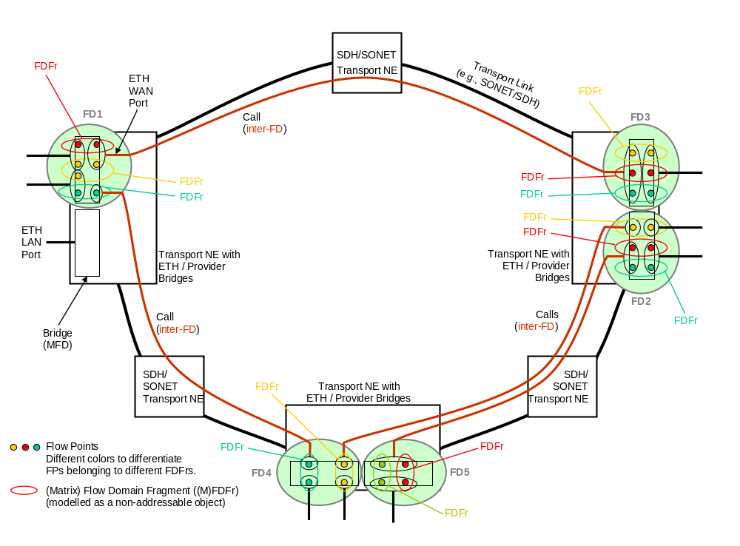
Figure 17: Hypothetical network example showing singleton FDs
Note: Not all entities shown are modelled as managed objects.
- Matrices, usually (but not necessarily) located on separate MEs, are logically associated and presented by the EMS as the flow domains within which the NMS can establish flow domain fragments. A flow domain is likely to represent the resources involved within the EMS domain for delivering Ethernet services to a group of customers. Some level of details internal to the flow domain may not need to be presented to the NMS which would then assume that proper instrumentation (matrices) and connectivity (intra-FD Ethernet links) are in place for Ethernet services (FDFr) to be managed. Those flow domains would usually have administrative significance (customer segregation), so the need for topological links between flow domains managed by the same EMS is less likely than for singleton case. Figure 18 illustrates this scenario.
Note that in order to manage flow domain fragments across the entire network the NMS needs to define the topological links established between flow domains managed by different EMS (in the same way that it needs to know the topological links existing between MLSNs in order to manage network connections made of multiple SNCs).

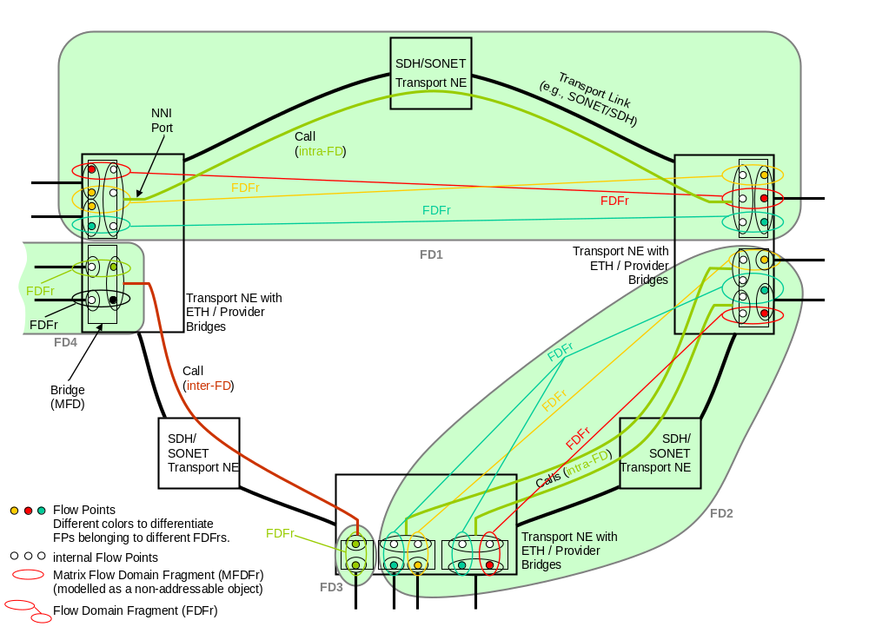
Figure 18: Hypothetical network example showing FDs that span several NEs
Note: Not all entities shown are modelled as managed objects.

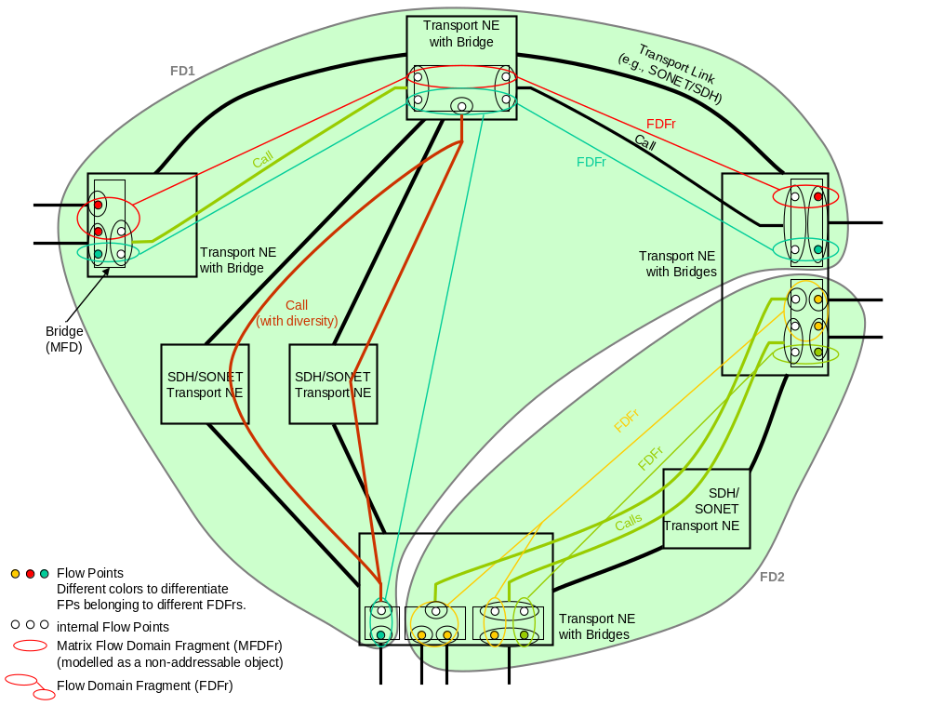
Figure 19: Hypothetical network example showing FDs that span several NEs and internal MFDs
Note: Not all entities shown are modelled as managed objects.

Mapping of G.8010 Entities
The intention of Figure 20 is to list the network entities within the Ethernet Layer Network Domain identified in G.8010 and to explain their mapping and relations to MTNM objects.

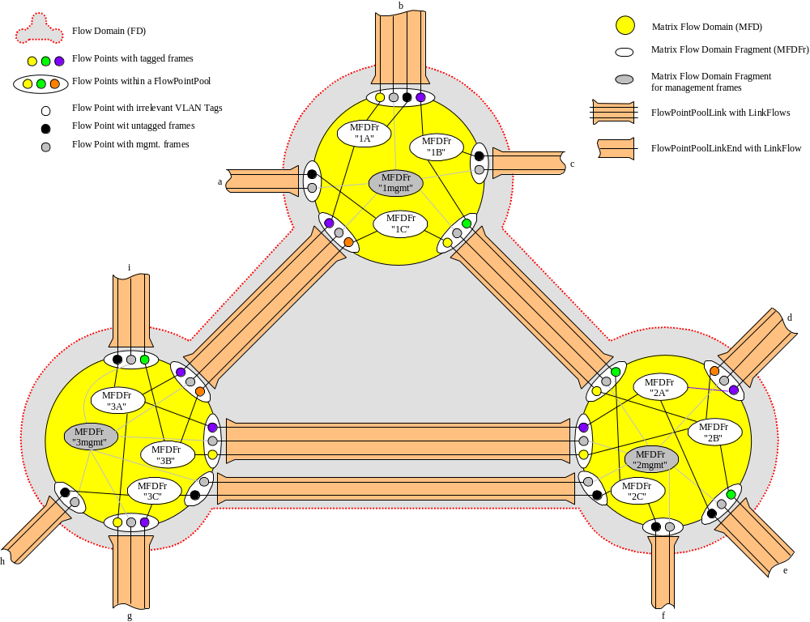
Figure 20: G.8010 resources of the Ethernet Layer Network Domain

- Modelling of Bridges
This appendix clarifies how the model works out in practice to represent the various types of Ethernet bridges that have been standardised by the IEEE (and that are also analysed in ITU-T G.8010): VLAN-unaware bridges (IEEE 802.1D), …. (.1Q), (.1ad).
  - Rationale
The existing MTNM/Ethernet document set explains in general how Ethernet bridges are modelled, using the terminology of ITU-T connectionless networks (e.g., flow domains). But it does not specify how exactly this representation applies to the various types of bridges described in IEEE standards. This appendix aims to clarify these questions.
  - Summary
Frame mapping and tag translation are represented by tables both in CPTP and FP.
Frame mapping consists in filtering input frames, and performing various operations on them according to their content.
The main inputs are:
- The contents of the incoming tag (if applicable): VLAN ID and priority.
- The port of entry (however, this does not appear as such in the model since the tables are themselves properties of CPTPs and FPs; objects themselves correspond to IEEE ports.).
- Other parameters may be used.
The main outputs are:
- the traffic class and TC profile.
Tag translation consists in replacing an existing tag VID by another one.
  - Representation of VLAN-Unaware bridge (IEEE 802.1D)
    - What happens in the Bridge
The bridge collaborates with other bridges in the network (via spanning tree protocol, or by other means such as fixed provisioning) to form a spanning tree, so that frames do not go round and round in loops. (This is implemented by “switching off” some of the ports in the bridges; Spanning Tree Protocol maintains the port states dynamically so as to preserve connectivity in spite of network evolution and faults).
No processing of VLAN tags is performed.
Routing of frames does not depend on their user priority. However, the bridge performs classification according to priority and may regenerate priority.
In IEEE 802.1D, section 7.7.1 describes the selection of transmission (egress) ports, i.e, routing. The following is an integral quote of the section; note that priority does not feature in the selection criteria:
Each Port is selected as a potential transmission Port if, and only if
  - The Port on which the frame was received was in a forwarding state (8.4), and
  - The Port considered for transmission is in a forwarding state, and
  - The Port considered for transmission is not the same as the Port on which the frame was received, and
  - The size of the mac-service-data-unit conveyed by the frame does not exceed the maximum size of mac-service-data-unit supported by the LAN to which the Port considered for transmission is attached.
    - For each Port not selected as a potential transmission Port, the frame shall be discarded. What happens in the model
- Tag translation: not applicable.
- Frame mapping: Yes. Priority is an input.
- Flow Point identification: by default. There is only 1 FP per CPTP for user traffic. An additional FP may be instantiated to represent management frames.
- Salient feature: port state (for Spanning Tree Protocol).
  - Representation of VLAN-aware bridge (IEEE 802.1Q and P802.1ad)
    - What happens in the Bridge
The idea of the Virtual LAN is to separate out the traffic flows belonging to different users, without the expense of maintaining multiple physical infrastructures. This is implemented by an additional field called the “VLAN tag” in the user frames (the bridge may add or remove tags, or it may merely make use of tags that are already present in the frames). Conceptually, the VLAN aware bridge is envisaged as a superposition of VLAN-unaware bridges, in which each separate “virtual” bridge has its own behaviour (e.g., its own instance of spanning tree protocol => its own port states).
There are two particular kinds of VLAN-aware bridges (described in IEEE P802.1ad [14]): Customer Bridge and Provider Bridge. See section II.5 and section II.6 respectively.
    - What happens in the model
This is the generic case – the bridge may be either C-TAG aware or S-TAG aware.
- Tag translation in CPTP: Optional
- Frame mapping in CPTP: no
- Tag translation in FP: no
  - See remarks for Provider Bridge
- Frame mapping in FP: yes
- Flow Point identification: The flow point is identified by the C-VID or S-VID value that it recognises (C-VID for a customer bridge, S-VID for a provider bridge). This value is also present in the Frame Mapping Table.
Comments:
- In the case of a singleton representation, or when there is no VID swapping in the Flow Domain, the VID can be used to identify both the FDFr itself and its connected FPs.
  - Representation of Customer Bridge
    - What happens in the Bridge
Customer bridges are characterised by the following properties:
- They recognise only C-TAG format, not S-TAG format (the two differ by their Ethertype; that is the value of the TPID field in the tag.)
- They do not perform tag translation (on the VID part of the tag).
    - What happens in the model
- Tag translation in CPTP: No (by definition)
- Frame mapping in CPTP: no
- Tag translation in FP: No (by definition)
- Frame mapping in FP: yes
- Note: Customer bridges can route according to C-TAG, and we model this by tables at the FP
  - Representation of Provider bridge (IEEE 802.1ad)
    - What happens in the Bridge
Provider bridges are characterised by the following properties:
- They recognise only S-TAG format, not C-TAG (see above Customer Bridge)
- They can perform tag translation (on the VID part of the tag) through a VLAN translation table on each port.
    - What happens in the model
The following combinations of tables are used:
Case 1: Translation followed by mapping:
- Tag translation in CPTP: yes
- Frame mapping in CPTP: no
- Tag translation in FP:no
- Frame mapping in FP: yes
Case 2: No translation, just mapping:
- Tag translation in CPTP: no
- Frame mapping in CPTP: no
- Tag translation in FP: no
- Frame mapping in FP: yes
- Note: The frame mapping table may be trivial (same treatment for all frames).
  - Representation of “double VLAN-aware” bridge
    - Usage
This case may arise either because there is a bridge that behaves in exactly this way (which is not described in IEEE 802.1Q or P802.1ad), or because for practical reasons the EMS provider chooses to concatenate the representation of several bridges into a single bridge.
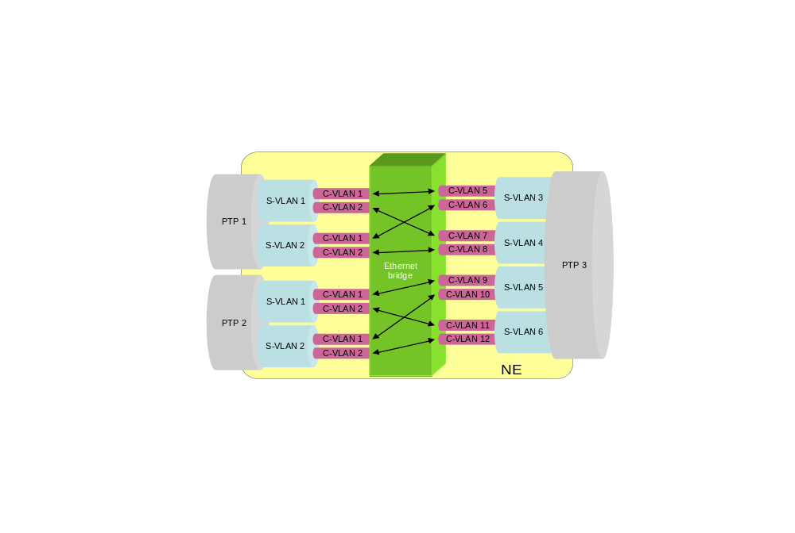
Figure 21: “double VLAN-aware” bridge
    - What happens in the Bridge
Whereas bridges conformant to IEEE 802.1Q or P802.1ad process only a single VLAN tag – either the C-VLAN or the S-VLAN tag – this new kind of bridge processes BOTH tags simultaneously.
This is modelled in the Frame Mapping Table by including input parameters from both kinds of VLAN tag:
- C-VID
- S-VID
- Priority
Note: The Traffic Mapping Table may be some 4000 times larger!
Note: It is theoretically possible for the bridge to discriminate between the priority field in the C-VLAN tag, and the same field in the S-VLAN tag. However, this does not seem to be required in practice.
    - What happens in the model
- Tag translation in CPTP: Optional
- Frame mapping in CPTP: no
- Tag translation in FP: no
  - See remarks for Provider Bridge
- Frame mapping in FP: yes
  - The mapping table uses multiple VLAN Ids (see above).
- Flow Point identification: The flow point is identified by the combination of S-VID and C-VID.
Comments:
- This is the same model as the previous VLAN aware bridges: the only difference is in the greater complexity of the Traffic Mapping Table and the difference in flow point naming.

- Mapping MEF - MTNMETH
The table in this appendix provides a mapping between the information model presented in MEF 7 [11], the Metro Ethernet Forum’s EMS-NMS Information Model, and the MTNM Rel 3.5 Connectionless Network Model.

MEF 7 Object | Type | MEF 7 Item | MTNM Object | MTNM Item | Note
ETH_Flow_Domain |  |  | FlowDomain
ETH_Flow_Domain | attribute | userLabel | FlowDomain | userLabel
ETH_Flow_Domain | operation | setupPtToPtETH_FDFr_EVCWithFPPs | FlowDomain | createFDFr
ETH_Flow_Domain | operation | setupMultiToMultiETH_FDFr_EVCwithFPPs | FlowDomain | createFDFr
ETH_Flow_Domain | operation | releaseETH_FDFr_EVC | FlowDomain | deleteFDFr
ETH_FPP |  |  | CPTP, PTP, FTP
ETH_FPP | attribute | fPP_FPPType | CPTP (TP) PTP, FTP | InterfaceType
ETH_FPP | attribute | availableCapacity | CPTP (TP) | Layered Parameters: AvailableCapacity
ETH_FPP | attribute | userLabel | CPTP (TP) | userLabel
ETH_FPP | attribute | physAddress | CPTP (TP) | Layered Parameters:  PhysAddress
ETH_FPP | attribute | operState | CPTP (TP) | Layered Parameters:  ServiceState
ETH_FPP | attribute | availabilityStatus | CPTP (TP) | additionalInfo: "X.721::AvailabilityStatus"
ETH_FPP | attribute | adminState | CPTP (TP) | Layered Parameters:  ServiceState
ETH_FPP | attribute | ingressMaxAssignableBW | CPTP (TP) | Layered Parameters: IngressMaxAssignableBW
ETH_FPP | attribute | egressMaxAssignableBW | CPTP (TP) | Layered Parameters: EgressMaxAssignableBW
ETH_FPP | attribute | maxNumEVCs | CPTP | Layered Parameters:  MaxNumFDFrs
ETH_FPP | attribute | numConfiguredEVCs |  | Layered Parameters: NumConfiguredFDFrs
ETH_FPP_UNI |  |  | CPTP
ETH_FPP_UNI | attribute | uniIdentifier | CPTP (TP) | CPTP Name
ETH_FPP_UNI | attribute | layer2ControlProtocolProcessingList | CPTP (TP) | Layered Parameters: Layer2ControlProtocolProcessingList
ETH_FPP_UNI | attribute | serviceMuxingIndicator | CPTP (TP) | Layered Parameters: ServiceMuxingIndicator
ETH_FPP_UNI | attribute | bundlingIndicator | CPTP (TP) | Layered Parameters: BundlingIndicator
ETH_FPP_UNI | attribute | allToOneIndicator | CPTP (TP) | Layered Parameters: AllToOneIndicator
ETH_FPP_UNI | attribute | untaggedVLANAssignment | CPTP (TP) | Layered Parameters:  PVID
ETH_FPP_UNI | attribute | unassignedCeVlanIDList | CPTP (TP) |  | This optional attribute is not mapped
ETH_Link |  |  | EncapsulationLayerLink
ETH_Link | attribute | availableCapacity | CPTP | Layered Parameters:  AvailableCapacity | Reflected on FPP (CPTP)
ETH_Link | attribute | userLabel | EncapsulationLayerLink | userLabel
ETH_Link | attribute | usageCost | CPTP | Layered Parameters:  LinkUsageCost | Reflected on FPP (CPTP)
ETH_FDFr_EVC |  |  | FlowDomainFragment
ETH_FDFr_EVC | attribute | adminState | FlowDomainFragment | Layered Parameters:  ServiceState
ETH_FDFr_EVC | attribute | operState | FlowDomainFragment | Layered Parameters:  ServiceState
ETH_FDFr_EVC | attribute | availabilityStatus | FlowDomainFragment | additionalInfo: "X.721::AvailabilityStatus
ETH_FDFr_EVC | attribute | eVCProtected | FlowDomainFragment | staticProtectionLevel
ETH_FDFr_EVC | attribute | userLabel | FlowDomainFragment | userLabel
ETH_FDFr_EVC | attribute | eVCType | FlowDomainFragment | fDFrType | New attribute (e.g., Point-to-Point; E-Tree; Multi-Point)
ETH_FDFr_EVC | attribute | ethEVCID | FlowDomainFragment | userLabel | EVC ID may be included in the userLabel
ETH_FDFr_EVC | attribute | uniCeVlanIdPreservation | FlowDomainFragment | Layered Parameters: VLANIdPreservation
ETH_FDFr_EVC | attribute | uniCeVlanCosPreservation | FlowDomainFragment | Layered Parameters: VLANPriorityPreservation
ETH_FDFr_EVC | operation | performEVCTrace |  |  | Perform EVC Trace operation not mapped
ETH_FDFr_EVC | operation | addTPsToMultiETH_FDFr_EVCwithFPPs | FlowDomain | addFPsToFDFr
ETH_FDFr_EVC | operation | removeTPsFromMultiETH_FDFr_EVC | FlowDomain | removeFPsFromFDFr
ETH_Flow_Point |  |  | FP / CTP
ETH_Flow_Point | attribute | operState | CTP (TP) | Layered Parameters:  ServiceState
ETH_Flow_Point | attribute | alarmStatus | CTP (TP) | additionalInfo: "M.3100::AlarmStatus"
ETH_Flow_Point | attribute | currentProblemList | CTP (TP) | Get Active Alarms | OPEN ISSUE
ETH_Flow_Point | attribute | ethCeVlanIDList | CTP (TP) | Layered Parameters:  TrafficMappingFrom_Table_VID | The Traffic Mapping Table maps CE VLAN IDs to FDFrs.
ETH_Flow_Point | attribute | ethUNIEVCID | CTP (TP) | userLabel
ETH_Flow_Point | attribute | layer2ControlProtocolDispositionList | CTP (TP) | Layered Parameters: Layer2ControlProtocolDispositionList
ETH_Flow_Point | attribute | unicastServiceFrameDelivery | CTP (TP) | Layered Parameters: UnicastServiceFrameDelivery
ETH_Flow_Point | attribute | multicastServiceFrameDelivery | CTP (TP) | Layered Parameters: MulticastServiceFrameDelivery
ETH_Flow_Point | attribute | broadcastServiceFrameDelivery | CTP (TP) | Layered Parameters: BroadcastServiceFrameDelivery
ETH_Flow_Point | attribute | trailTerminating | CTP (TP) | tpMappingMode
ETH_Flow_Point | attribute | adminState | CTP (TP) | Layered Parameters:  ServiceState
ETHBandwidthProfile (TrafficConditioner) |  |  | TC Profile
ETHBandwidthProfile | attribute | bwCategoryIdentifier | CPTP FP | userLabel
ETHBandwidthProfile | attribute | cir | CPTP FP | Layered Parameters:  IngressCIR | May be per COS
ETHBandwidthProfile | attribute | cbs | CPTP FP | Layered Parameters:  IngressCBS | May be per COS
ETHBandwidthProfile | attribute | eir | CPTP FP | Layered Parameters:  IngressEIR | May be per COS
ETHBandwidthProfile | attribute | ebs | CPTP FP | Layered Parameters:  IngressEBS | May be per COS
ETHBandwidthProfile | attribute | colorMode | CPTP FP | Layered Parameters:  IngressColorMode | May be per COS
ETHBandwidthProfile | attribute | couplingFlag | CPTP FP | Layered Parameters:  IngressCouplingFlag | May be per COS
ETHCosProfile |  |  | CPTP FP | ingressCoSMapping
ETHCosProfile | attribute | cosIdentifier |  |  | Indicated on the individual parameters
ETHCosProfile | attribute | cosDelay | CPTP FP | Layered Parameters:  Delay | Per COS
ETHCosProfile | attribute | cosJitter | CPTP FP | Layered Parameters:  Jitter | Per COS
ETHCosProfile | attribute | cosLoss | CPTP FP | Layered Parameters:  Loss | Per COS
TransportPort |  |  | PhysicalTerminationPoint
TransportPort | attribute | characteristicInformationType | TP | Layer Rate
TransportPort | attribute | operState | PTP | Layered Parameters:  ServiceState
TransportPort | attribute | alarmStatus | PTP | additionalInfo: "M.3100::AlarmStatus"
TransportPort | attribute | currentProblemList | PTP | Get Active Alarms | OPEN ISSUE
TransportPort | attribute | portID | PTP | Layered Parameters:  Location
TransportPort | attribute | potentialCapacity | PTP | Layered Parameters:  PotentialCapacity
MAUTransportPTP
MAUTransportPTP | attribute-INH | characteristicInformationType | TP | Layer Rate
MAUTransportPTP | attribute-INH | operState | PTP | Layered Parameters:  ServiceState
MAUTransportPTP | attribute-INH | alarmStatus | PTP | additionalInfo: "M.3100::AlarmStatus"
MAUTransportPTP | attribute-INH | currentProblemList | PTP | Get Active Alarms | OPEN ISSUE
MAUTransportPTP | attribute-INH | portID | PTP | Location
MAUTransportPTP | attribute-INH | potentialCapacity | PTP | Layered Parameters:  PotentialCapacity
MAUTransportPTP | attribute | mauType | PTP | Layered Parameters:  MauType
MAUTransportPTP | attribute | mauStatus | PTP | Layered Parameters:  MauStatus
MAUTransportPTP | attribute | mauMediaAvailable | PTP | Layered Parameters:  MauMediaAvailable
MAUTransportPTP | attribute | mauJabberState | PTP | Layered Parameters:  MauJabberState
MAUTransportPTP | attribute | mauDefaultType | PTP | Layered Parameters:  MauDefaultType
MAUTransportPTP | attribute | mode | PTP | Layered Parameters:  DuplexMode
MAUTransportPTP | attribute | mauAutoNegSupported | PTP | Layered Parameters:  AutoNegotiation
MAUTransportPTP | attribute | mauTypeList | PTP | Layered Parameters:  MauTypeList
MAUTransportPTP | attribute | mauJackTypeList | PTP | Layered Parameters:  MauJackTypeList
MAUTransportPTP | attribute | mauAutoNegAdminState | PTP | Layered Parameters:  MauAutoNegAdminState
MAUTransportPTP | attribute | mauAutoNegRemoteSignaling | PTP | Layered Parameters:  MauAutoNegRemoteSignaling
MAUTransportPTP | attribute | mauAutoNegConfig | PTP | Layered Parameters:  MauAutoNegConfig
MAUTransportPTP | attribute | mauAutoNegCapability | PTP | Layered Parameters:  MauAutoNegCapability
MAUTransportPTP | attribute | mauAutoNegCapAdvertised | PTP | Layered Parameters:  MauAutoNegCapAdvertised
MAUTransportPTP | attribute | mauAutoNegCapReceived | PTP | Layered Parameters:  MauAutoNegCapReceived
MAUTransportPTP | attribute | mauAutoNegRemoteFaultAdvertised | PTP | Layered Parameters:  MauAutoNegRemoteFaultAdvertised
MAUTransportPTP | attribute | mauAutoNegRemoteFaultReceived | PTP | Layered Parameters:  MauAutoNegRemoteFaultReceived
MAUTransportPTP | operation | mauAutoNegRestart |  |  | MAU Auto Negotiation Restart operation not mapped

Color Key
Not Mapped (gap)

Table 6: MEF - MTNM Ethernet Mapping

Revision History
Version | Date | Description of Change
0.0.1 | 03.11.05 | Initial version extracted from FlowDomains051031.doc working document and various contributions as described in "Skeleton" section above.
0.0.2 | 05.12.05 | MEF - MTNMETH mapping table provided by Andy added to Appendix V.
0.0.3 | 19.12.05 | Updated ELL Diversity from Menachem included.  Tag management from Floyd added.  Table of tables added.
0.0.4 | 18.01.06 | Updated Tag management (19 Dec.) from Floyd added.  ELL diversity updated.  Updated MEF - MTNM Ethernet Mapping (09 Jan.) from Andy added.
0.0.5 | 30.03.06 | Scope section replaced by Francois' update (including comments).  References section updated.  Chapter 9 Traffic Mapping Table updated.  "Ethernet Frame Management" figure in chapter 8 updated.  Figure 3: "Example: Separate SDH-EMS and Ethernet-EMS" updated.  Figure 5: "Example of Encapsulation Layer Link segments with off-network CPTPs" updated.  Figures in chapter 7 "LAG" updated.  "Noam diagrams" updated by Menachem.
0.0.6 | 28.09.06 | Comments from Steve Fratini (11. August) added and taking into account.  Section on ELL updated with Call.  Appendix I: Hypothetical Ethernet network examples updated as proposed by Steve.  Appendix II, III and VI deleted.  Appendix IV (Modelling of Bridges) replaced by update from Gerard (22. August).  Editorial corrections.
0.1.1 | 16.11.06 | Comments from Gerard (12. October) taking into account.
0.1.2 | 13.12.06 | LR_Ethernet_VLAN deleted from section 7.14 "Modeling aggregation of signals for Ethernet CPTPs".  LR_Ethernet_Flow deleted from Figure 11: Example: Ethernet LAN port with LAG and VLAN.  Text in section 6.2 on Call diversity replaced by a reference to Appendix E in SD1-45 CP-Primer.
1.1 | June 2008 | Minor editorial changes.

Acknowledgements
<FirstName> | <LastName> | <Company>

How to comment on the document
Comments and requests for information must be in written form and addressed to the contact identified below:

Keith | Dorking | Ciena
Phone: | +1 678 867 5007
Fax: | +1 678 867 5010
e-mail: | kdorking@ciena.com

Please be specific, since your comments will be dealt with by the team evaluating numerous inputs and trying to produce a single text. Thus we appreciate significant specific input. We are looking for more input than wordsmith” items, however editing and structural help are greatly appreciated where better clarity is the result.

Note: C-Tag translation is not defined in IEEE 802.1ad (only S-Tag translation).
Typically, this will be done so as to have only one bridge per managed element, just as in MTNM 3 there is only one connection-oriented “fabric” or connection matrix per managed element (which is not represented in the model by a separate object).

