Service Activation - DDP BA - Part 1: Overview

TMF518_SA_1
Version 1.0


September 2007

©TM Forum 2007
Notice
No recipient of this document shall in any way interpret this document as representing a position or agreement of the TeleManagement Forum (TM Forum) or its members. This document is a draft working document of TM Forum and is provided solely for comments and evaluation. It is not a Forum Approved Document and is solely circulated for the purposes of assisting TM Forum in the preparation of a final document in furtherance of the aims and mission of TM Forum.
Although it is a copyrighted document of TM Forum:
- Members of TM Forum are only granted the limited copyright waiver to distribute this document within their companies and may not make paper or electronic copies for distribution outside of their companies.
- Non-members of the TM Forum are not permitted to make copies (paper or electronic) of this draft document other than for their internal use for the sole purpose of making comments thereon directly to TM Forum.
- If this document forms part of a supply of information in support of an Industry Group Liaison relationship, the document may only be used as part of the work identified in the Liaison and may not be used or further distributed for any other purposes
Any use of this document by the recipient, other than as set forth specifically herein, is at its own risk, and under no circumstances will TM Forum be liable for direct or indirect damages or any costs or losses resulting from the use of this document by the recipient.
This document is governed by all of the terms and conditions of the Agreement on Intellectual Property Rights between TM Forum and its members, and may involve a claim of patent rights by one or more TM Forum members or by non-members of TM Forum.
Direct inquiries to the TM Forum office:
240 Headquarters Plaza,
East Tower – 10th Floor,
Morristown, NJ 07960 USA
Tel No. +1 973 944 5100
Fax No. +1 973 944 5110
TM Forum Web Page: www.tmforum.org
Table of Contents

Notice 2
Table of Contents 3
List of Requirements 5
List of Use Cases 6
List of Figures 7
List of Tables 8
Executive Summary 9
1 Introduction 10
1.1 mTOP DDP Structure 10
1.2 Document Structure 10
1.3 Terminology Used In This Document 11
2 Business Problem Description, Project Scope 12
2.1 Project Scope 12
2.2 Supported Business scenarios 14
2.2.1 Service Activation Interface 14
2.2.2 Service Component Activation Interface 15
2.3 Benefits 16
3 Business Processes 17
3.1 Process Definition and Issues 17
3.2 Mapping of Processes to eTOM Business Framework 17
3.2.1 The SM&O Layer 17
3.2.2 Issues with the eTOM Decomposition 18
3.3 Business Requirements 19
3.4 Category I: Static and Structural Requirements 21
3.5 Category II: Normal Sequences, Dynamic Requirements 21
3.5.1 Service States 21
3.5.2 Service State Requirement 21
3.6 Category III: Abnormal or Exception Conditions, Dynamic Requirements 21
3.7 Category IV: Expectations and Non-Functional Requirements 22
3.8 Category V: System Administration Requirements 22
4 Use Cases 23
5 Traceability Matrices 24
6 Future Directions 25
7 Appendix: IPTV Activation Use Case using SAI and SCAI 26
7.1 Definitions 26
7.2 Assumptions 27
7.3 Decomposition of IPTV 27
7.4 IPTV Service Activation Use Case 28
8 References 31
8.1 References 31
8.2 IPR Releases and Patent Disclosure 31
9 Administrative Appendix 32
9.1 About this document 32
9.2 Use and Extension of a TM Forum Business Agreement 32
9.3 Document History 32
9.4 Company Contact Details 33
9.5 Acknowledgments 33
9.6 About TM Forum 33
List of Requirements
R_TMF518_SA_1_BR_0001 19
R_TMF518_SA_1_BR_0002 19
R_TMF518_SA_1_BR_0003 20
R_TMF518_SA_1_BR_0004 20
R_TMF518_SA_1_BR_0005 20
R_TMF518_SA_1_BR_0006 20
R_TMF518_SA_1_BR_0007 20
R_TMF518_SA_1_BR_0008 20
R_TMF518_SA_1_II_0009 21

List of Use Cases

List of Figures
Figure 2-1. mTOP program 12
Figure 2-2 MTOSI Service Activation Interface 14
Figure 2-3 Service Activation Interface 15
Figure 2-4 Service Activation Interface - [Order aware] 15
Figure 2-5 Service Component Activation 16
Figure 3-1 eTOM Layer 3 Decomposition 18
Figure 3-2 MTOSI-SA Service Interfaces and th eTOM 19
Figure 7-1. Various OS Configurations for SCAMing 29
Figure 7-2. PAM-SPAM-SCAM Activation Flow 30

List of Tables

Executive Summary
The TM Forum’s Multi-Technology Operations System Interface (MTOSI) Service Management team has been tasked with defining a set of unified open interfaces to be used between Operations Systems (OS) whereby the functionality implemented supports a subset of the eTOM Service Management and Operations (SM&O) processes. These interfaces include:
  - The Service Activation interface between the CRM and SM&O layers
  - Interactive Service Activation - The following modes are supported :
    - Best-effort Transaction interface – Service requests entail multi-task transaction execution. In this type of interface, the entire transaction execution is completed despite single task failures. We assume failed tasks are reported and later resolved by any external means, either manually or automatically. This is a best-effort type of interface, i.e., the service request will be executed as soon as possible but no delivery time is guaranteed, nor is there any roll-back capability.
    - Atomic Transaction interface - This interface has the same operations as the previous one; however, the failure of any single task will incur the termination of the transaction execution and will invoke a roll-back of the preceding task.
    - Service Order Management interface - Add-on interface to both the Best-effort Transaction or Atomic Transaction interfaces. Provides full exposure and control of the service order associated with the service request over the interface. It depends on the functions provided by the previous interfaces.
  - The Service Component Activation interface is an internal SM&O layer interface.

This document specifies common definitions, architecture aspects and functional requirements for the MTOSI Service Activation feature. The primary focus of both interfaces is service activation exclusively. Although there are dependencies between service activation and other processes described in the SM&O layer, they are considered to be outside the scope of this document.
The MTOSI Service Activation sub-team has worked extensively with key contributors to the TMF SID with the goal of being closely aligned with SID service object definitions as described in GB922_Addendum_4SO_V2-1. The resulting service object model is an extension of the model defined in the SID, and is included in TMF608. The corresponding XML-based specification is part of MTOSI Release 2.0 that can be found in the TMF854 solution set.
* Note: It should be emphasized that NGOSS contracts are defined in terms of functional and non-functional aspects (see TMF 053B). Non-functional part of the contract contains “obligations (required behavior), prohibitions (disallowed behavior), restrictions (limits on behavior) and permissions (allowed behavior) on the capabilities defined in the functional part of the contract.”

Introduction

mTOP DDP Structure
In order to allow for more efficient release delivery, the previous monolithic BA, IA and SS documents have been partitioned into smaller self-contained (though not independent) units called Document Delivery Packages (DDPs).
This is similar to the 3GPP concept of Integration Reference Point (IRP). The basic idea is that the Interface, which is specified by the entire document set (of a release), is partitioned into DDPs where each DDP specifies “a certain aspect” of the Interface, which needs to be very clearly scoped.
There are three kinds of DDPs:
  - Data Model DDP (DM-DDP) – a DDP that concerns a data model (entities, data structures, attributes, state, but no operations)
  - Operation Model DDP (OM-DDP) – a DDP that concerns a computational model (operations, notifications, transactions) for a given functional area (such as resource inventory management)
  - the FrameWork DDP (FMW) – this DDP contains the generic artifacts that are applicable to all the other DDPs.
The unified deliverables structure for any given mTOP product release is as follows:
  - Product Release Notes:
    - a scope specification for the type and extent of the delivered product,
    - the partitioning of the release into DDPs (i.e., definitions of various aspects of the release),
    - and an overview of the release’s (delta) deliverables;
  - For each DDP:
    - Business Agreements (BAs): a business view specification
    - Information Agreements (IAs): a system view specification
    - Interface Implementation Specifications (ISSs): implementation and deployment view specification per supported enabling technology (mapping of the IA to either CORBA (IDL, services usage) or XML (WSDL, XSD, bindings…)
    - Supporting Documentation: normative and informative supporting documents.
  - Reference Implementation (optional) of core IIS fragments for selected interfaces and enabling technologies

Document Structure
The document has been structured in the following way:
- Section 1 is the introduction.
- Section 2 defines the business problem and scope.
- Section 3 contains the requirements.
- Section 4 has the use cases.
- Section 5 provides a traceability matrix between use cases and requirements, and vice versa.
- Section 6 provides a list of open points for future study.
- Section 7 is an appendix presenting a use case using SAI and SCAI using IPTV Activation
- Section 8 lists the references used in this document and notes any IPR claims.
- Section 9 notes the contact for this document and has administrative information such as the document version history and list of acknowledgements.

Terminology Used In This Document
The terminology used in this document is covered in the Service Basic DDP BA and SD2-0_mTOPDictionary.
Additional acronyms are presented in the table below:
Acronym | Definition
CCV | Common Communication Vehicle
HTTP | Hyper Text Transfer Protocol
JMS | Java Message Service
MEP | Message Exchange Pattern
SOAP | Simple Object Access Protocol
XML | eXtended Markup Language
XSD | XML Schema Document
WSDL | Web Service Description Language
SID | Shared Information Data
eTOM | Enhanced Telecommunications Operation Map
SE | Service
SET | Service Template
SD | Service Definition
SAP | Service Access Point
MTOSI | Multi-technology Operations System Interface
OS | Operations System
RFS | Resource Facing Service
CFS | Customer Facing Service
OCN | Object Creation Notification
ODN | Object Deletion Notification
AVC | Attribute Value Change Notification
EXCPT | Exception
SCAI | Service Component Activation Interface
SAI | Service Activation Interface

Business Problem Description, Project Scope

Project Scope
The TM Forum’s mTOP program consists of two projects, i.e., resource management and service management, and four coordination teams, i.e., product planning council (the mTOP PPC), architecture, methodology and implementation.

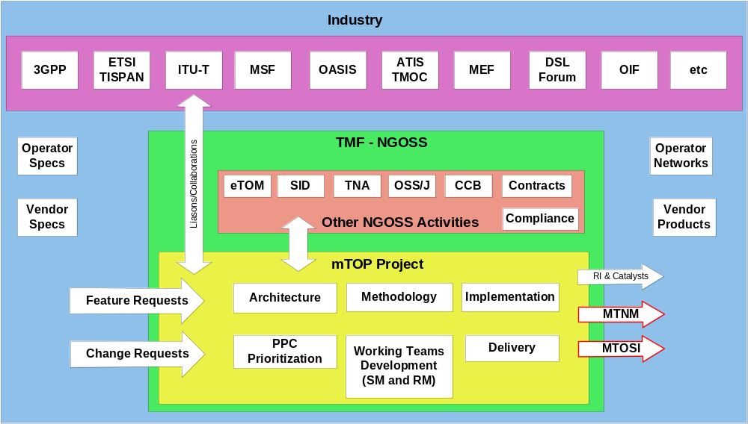
Figure 2-1. mTOP program

The scope of mTOP (with respect to the eTOM) is within Service Management and Operations (SM&O) and Resource Management and Operations (RM&O) with respect to Fulfillment, Assurance and some limited aspects of Operations Support and Readiness (OS&R). It should be emphasized that mTOP does not cover every aspect within these areas.
The goal of this program is to provide a unified set of specifications for both an OS-OS interface and an NML-EML interface covering assurance and fulfillment for all transmission/network technologies via G.805/G.809 while using enabling technologies such as JMS, HTTP, and CORBA to transport the management messages themselves.
The projects within this program are intended to provide rigorous specifications for the implementation of interfaces concerning the management of connection oriented and connectionless based networks. Both service and resource level management are within scope.

The Multi-Technology Operations Systems Interface (MTOSI) Service Activation project (SA) is focused on end-to-end service activation. The objective is to define standardized, service-oriented interfaces that are involved in the activation process at various places within the eTOM map. Note:
The first interface is an SM&O northbound Service Activation interface (SAI) that allows a CRM (OS), such as an Order Entry system, to request via a service request the activation of a given service, or set of services, that instantiate a given product based upon product related information. This interface links the product related information, such as the product specification, to the service domain via the service request.
In this current release, the Service Activation Interface supports only an interactive or on-line service requests. Batch mode service requests are not currently supported. The interactive mode is specified further decomposed into three different types:
  - Best-effort Transaction Interface
    - Supports single service request
    - Best-effort transaction server implementation, no rollback support
    - Coarse-grained operations, only internal Service Order state is exposed over the interface
    - Priorities supported
    - No troubleshooting support, failed tasks areproblems are automatically escalated to other SM&O processes
    - The CRM application submits a Service Request and monitors the Customer Facing Service (CFS) states associated with the requested Product instance
  - Atomic TransactionEnhanced Interface
    - Same operations as in previous interface
    - A failed task in the associated Service Order incurs in transaction execution termination and the inititation of a roll-back or cancellation of preceding tasks
    - Adds roll-back capabilities to the Best-effort Interface
    - The CRM application submits a Service Request and monitors the CFS states associated with the requested Product instance
  - Service Order Management Interface
    - Add-on interface to either the Best-effort or the Atomic Transaction interface
    - Provides full control and exposure of Service Order over the interface

The Service Activation batch mode is not supported in the current release.
The following figure depicts the Service Activation interfaces. In this diagram, the Service Order Management interface is implicitly bundled in the SAI interface. It may be made visible or not by the specific implementation. For clients that support the asynchronous notification capability, they may receive reports containing status about the service request and its associated information.
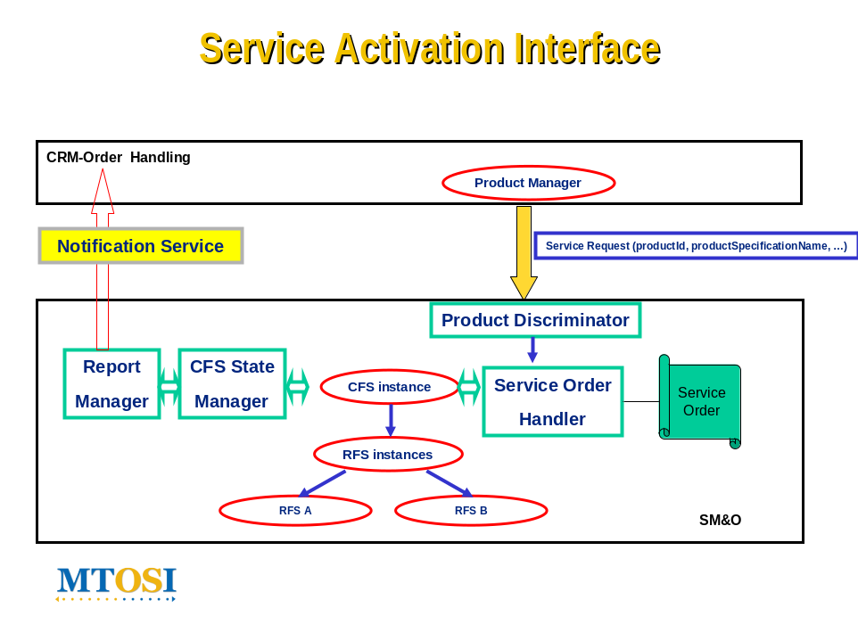
Figure 2-2 MTOSI Service Activation Interface

The second interface, the Service Component Activation Interface (SCAI) is internal in the SM&O layer and allows for the activation of service component (RFSs) instances given specific service related information defined in a service template.
The SCAI, contrary to the SAI, has no knowledge of the product domain. The server OS in this case provides RFS service templates to the client that describe the invariant service characteristics of the services support by the SCAI. These templates are referenced by the client OS when activating a given service over the SCAI. The client OS is responsible for the mapping of the product from the CRM domain to the service.

Supported Business scenarios
The MTOSI Release 2.0 service activation interfaces support the functions as described in this section. Although MTOSI in general does not define or mandate the usage of specific OS types, it is assumed that SM&O layer functionality offered by an interface is implemented by an OS capable of performing such functions. For example, while an EML OS may be capable of offering a Service Component Activation interface, it is highly unlikely that it would expose a Service Activation interface to a BML layer OS. Likewise, an SML OS would not expose a Service Activation interface to another SML or EML OS.

Service Activation Interface
The SAI interfaces allow a CRM application to place a service request to a Service Activation OS to perform an action (create, activate, modify, retire, etc.) on one or more services, given product and subscriber related information from the business management layer. The service upon which this interface is making service requests is viewed as a “customer facing service”. The interface also allows, for clients with an asynchronous notification detection capability the option of receiving notifications when service requests have completed, as well as monitoring service request progress via a corresponding CFS lifecycle state transitions.

Service ActivationOS

Notification Service (ASYNCH)

CCV
CRM Order Handling OS

Figure 2-3 Service Activation Interface

Figure 2-3 above shows an example of one Order Entry OS sending requests to a Service Activation OS. In the case of clients with asynchronous notification mechanisms, a Notification Service sends notifications back to the Order Entry OS to inform the OS about the status of Service Requests.
The Service Order Management interface allows an OS to perform operations on service orders (SO) such as stop, suspend, resume, cancel, and suspend. It also has the ability to retrieve a list of service orders from a service order processing OS.
Service Order OS

CCV
CRM Order Handling SOS
Figure 2-4 Service Activation Interface - [Order aware]

Service Component Activation Interface
This capability allows an OS to request to another OS that a service component be activated based upon service specific information found in a service template. A service component, or resource facing service, may be viewed as a discrete entity involved in the end-to-end delivery of a customer facing service.
The interface exists solely within the SM&O layer, and has no knowledge of associated products. Although a service component activation request may reference a resource for activation purposes, it is assumed that all resource configuration and activation occurs at the network activation interface, or within the OS exposing the service component activation interface.

Element ManagementOS

Network ManagementOS

CCV
Service Activation OS
Content ManagementOS

Figure 2-5 Service Component Activation

Figure 2-5 shows an example of one Service Activation OS sending requests to multiple Network and Element Management OS’s to complete end-to-end activation for a given service.

Benefits
The MTOSI-SA is intended to provide the following benefits to customers, service providers and suppliers:
  - Open OS-OS interface allowing service providers to more easily “mix-and-match” OSs from different suppliers;
  - Ability to perform end-to-end service activation using a standardized framework, technologies and operations;
  - Abstracted service interfaces keep the knowledge “where it needs to be”. Service management layer can focus on service related functions without having to have in-depth knowledge of resource layer details.
  - Reduced integration times between OSs from different suppliers and thus quicker time to market for new services and increased REVENUE;
  - Reduced integration costs between OSs from different suppliers results in reduction of OPEX.
  - Reduced integration risk between OSSs from different suppliers.

Business Processes

Process Definition and Issues
This section defines the business process issues to be addressed in this document. It provides a business process view of the requirements to be satisfied through the implementation of the MTOSI Service Activation interfaces. Given the focus on “Service Activation”, the processes addressed will be primarily those in the eTOM SM&O layer and how they interact with the upper CRM layer and the lower RM&O layer.

Mapping of Processes to eTOM Business Framework

The SM&O Layer
The eTOM is a business process framework, or model, that provides the enterprise processes required for a service provider. There are various levels of granularity, or decomposition, of processes that have been defined. The MTOSI-SM work has considered a Level 3 decomposition of the eTOM SM&O layer in order to fully evaluate the process flow for service configuration and activation.
The eTOM Level 3 decomposition takes the process called “Service Configuration & Activation” found at Level 2 and breaks it down into the following sub-processes (see also the tables mapping operations and notifications to eTOM processes in TMF518_SA_2 and TMF518_SA_3.

- Design Solution | Develop an end-end specific service design which complies with a particular customer's requirement
- Allocate Service Specific Parameters | Issue service identifiers for new services.
- Track & Manage Service Provisioning | Launch all the operational tasks needed to fix each solution requirement.
- Implement, Configure & Activate | Service Ensure service provisioning activities are assigned, managed and tracked efficiently.
- Test Service End-to-End | Test specific services to ensure all components are operating within normal parameters, and that the service is working to agreed performance levels
- Issue Service Orders | Issue correct and complete service orders
- Report Service Provisioning | Monitor the status of service orders, provide notifications of any changes and provide management reports.
- Close Service Order | Close a service order when the service provisioning activities have been completed
- Recover Service | Recover specific services that are no longer required by customers.
These processes are illustrated below in the context of their relationship with the CRM and the RM&O layers. The identified interfaces include: A) Service Activation interface, B) Resource Activation interface, C) Service Inventory interface, and D) Resource Inventory Interface
Note: Not all Layer 3 processes are shown, in particular those that would not be part of the MTOSI-SM interfaces.
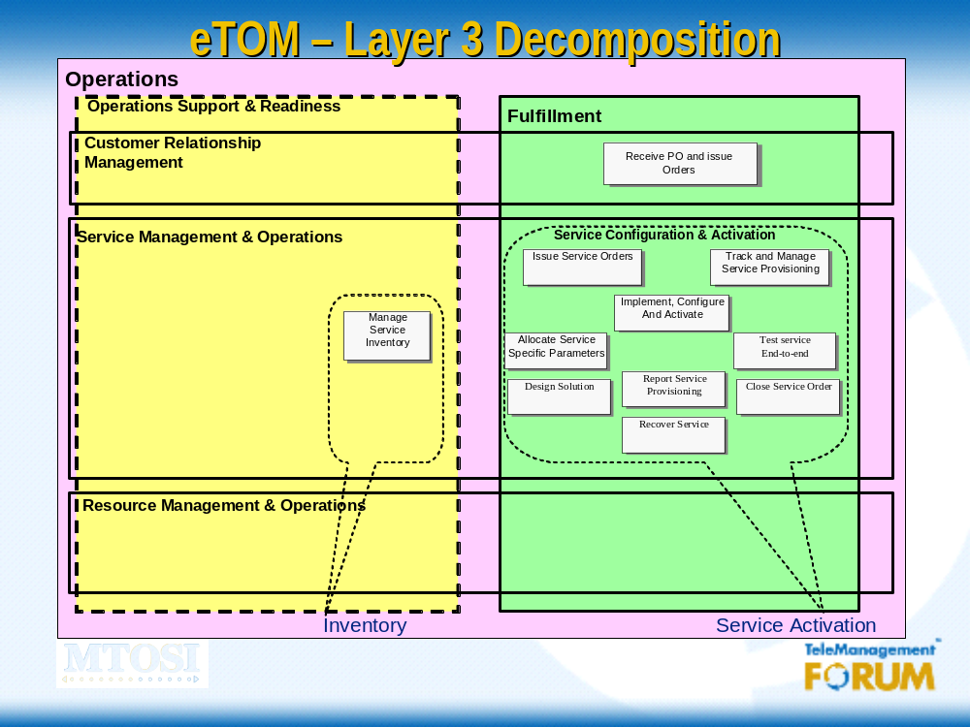

Figure 3-6 eTOM Layer 3 Decomposition

Issues with the eTOM Decomposition
The MTOSI-SM team has identified a number of issues with the eTOM in regards to specifying service interfaces:
  - The eTOM’s current specification does not define an interface that supports the network resource-oriented operations (e.g., MTNM NMS-EMS interface). The eTOM considers the EMS as a specific implementation of the RM&O processes.
  - The eTOM also does not support a split at the SM&O layer that has been identified as being necessary to implement “Service Configuration Activation”. Only the top layer interface between the CRM & the SM&O layer and the lower layer interface towards RM&O are defined.
The team has had numerous discussions with the eTOM team in an effort to ensure that the two groups are aligned. In regards to the first issue, the general response from the eTOM representative was:
“This is a long standing issue, and one that was intended for consideration several times. I don't believe there has ever been any real detail on the mapping to NMS/EMS in the eTOM - it was visible in the old TOM, but eTOM abstracted the network handling to the more general resource management, and it has always been anticipated that any specific concerns relative to network resources would emerge below the current level of detail...”
The MTOSI-SM team has defined the following “service interfaces” and will continue to work with the eTOM and SID members to further align the models: Service Activation, Service Component Activation, Resource Activation, and Network Activation. Only the first two Service Interfaces are within the scope of the MTOSI-SM business agreement.
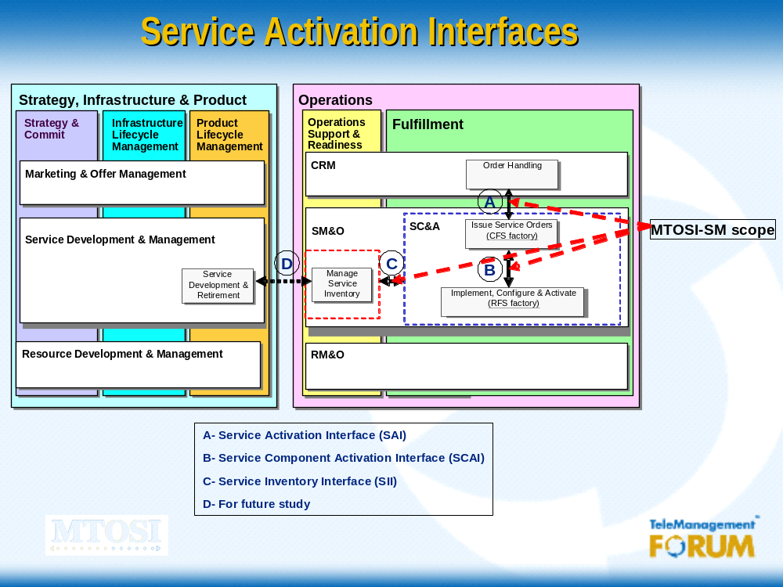
Figure 3-7 MTOSI-SA Service Interfaces and the eTOM

Business Requirements
R_TMF518_SA_1_BR_0001 | The MTOSI-SM interfaces shall be used between Operations Systems (OSs) for service activation within the same administration (i.e., service provider).
Source | TMF518_SA_1, Version 1.0

R_TMF518_SA_1_BR_0002 | MTOSI-SM interfaces shall be technology and service agnostic and thus allow for implementation by any type of service provider.  Example of such services include (amongst others):  - Network Transport Services: DSL, VPN, E-Line, E-LAN, FR, ATM, etc.  - Signaled Services: VoIP, Voice (Mobile and Fixed), VoD  - Application Services : Email, SMS, Voice Mail, etc.  - Triple Play Services: VoIP, IPTV, and HSI
Source | TMF518_SA_1, Version 1.0

R_TMF518_SA_1_BR_0003 | MTOSI-SM interfaces shall support end-to-end template based service activation across the CRM, SMO and RMO layers.
Source | TMF518_SA_1, Version 1.0

R_TMF518_SA_1_BR_0004 | The MTOSI-SM interfaces shall support the activation of atomic services, composite services, and in the future bundled services (cf SID).
Source | TMF518_SA_1, Version 1.0

R_TMF518_SA_1_BR_0005 | The MTOSI-SM object model shall keep traceability with the TMF SID, to the extent possible, without compromising the functionality, efficiency, and flexibility, and performance required.
Source | TMF518_SA_1, Version 1.0

R_TMF518_SA_1_BR_0006 | MTOSI-SM interfaces shall allow for service definition and service template versioning.
Source | TMF518_SA_1, Version 1.0

R_TMF518_SA_1_BR_0007 | Service Activation interfaces shall allow for the interruption of traffic for a given service, or component service, and the resumption of traffic at a later date/time.
Source | TMF518_SA_1, Version 1.0

R_TMF518_SA_1_BR_0008 | All MTOSI-SA operations shall be secure, whereby a requesting OS must be authorized and authenticated before performing any activation operations on a given service. This implies that security is implemented on a per service basis, and that a client OS may have the authority to activate one, some, or all services provided by a target.
Source | TMF518_SA_1, Version 1.0

Category I: Static and Structural Requirements
Not Applicable.

Category II: Normal Sequences, Dynamic Requirements

Service States
The MTOSI-SM interfaces introduce the notion of “service activation states” associated with either the global service, or individual component services that make up the end-to-end service. This “service activation state” is not to be confused with the existing MTNM service state that may take on such values as “in service” (IS), “out of service”, (OOS) “out of service for maintenance” (OOS-M), and “not available”. The MTNM service states are associated with resources, whereas the MTOSI-SM service states are associated with services.
The service activation state describes its lifecycle span as it goes through several stages of processing within the Service Configuration and Activation process until it becomes fully activated and eventually retired in the end. Some of these states depend on the states of their supporting resources.
The global service state for an end-to-end service depends on the service states of the individual components. These service states in turn depend on the underlying states of the resources supporting the component services. Hence, there is a strict dependency between the resource layer and the service layer “service states”.
A Global Service’s state value may change due to some composing service’s state value change, or due to some interface explicit request such as a deactivation request. Likewise, a composing service’s state value may change due to some supporting Resource’s state value change or due to an interface explicit request.

Service State Requirement

R_TMF518_SA_1_II_0009 | The MTOSI-SA service objects shall be named in accordance with the general MTOSI naming conventions and shall reside under the MD (Management Domain). These include: Service Definition, Service Template, Customer Facing Service, and Resource Facing Service.
Source | TMF518_SA_1, Version 1.0

Category III: Abnormal or Exception Conditions, Dynamic Requirements
Not Applicable.

Category IV: Expectations and Non-Functional Requirements
Not Applicable.

Category V: System Administration Requirements
Not Applicable.

Use Cases

Traceability Matrices

Future Directions
The following areas have been identified as requiring future study for possible inclusion in later releases of MTOSI:
  - Associated to any given subscriber there may be a user profile, or set of profiles, that describe service usage specific parameters. This concept is defined in the 3GPP “Generic User Profile”, and needs to be aligned the the user profile defined as a “service access profile” in MTOSI-SA. This concept is also being elaborated in the SID, under the security management context.
  - The role of Policy based Management in MTOSI service activation.
  - MTOSI currently doesn’t define “Profile Configuration” capabilities which are required in order to build Service Templates. This may be the object of a resource configuration interface, but is tightly coupled to the service template operations in MTOSI-SA.
  - Communication between peer-to-peer SM&O applications.
  - Alignment with the TAM and NGOSS contracts.
  - Migration / modification of service Templates.

Appendix: IPTV Activation Use Case using SAI and SCAI
This appendix provides IPTV activation use cases. There are multiple components involved in the activation of an end-to-end IPTV service, depending on the type of infrastructure used for delivering the service. These components include, but are not limited to: terminal device (TV, Laptop…), Access network (wireless, fixed), IMS (if applicable), Aggregation & Core network, Video servers, etc.
The request starts from a CRM application which is sent (via the SAI) to an SC&A application. The SC&A application decomposes the request into RFSs and sends a series of requests to another SC&A application via the SCAI. It is responsible for the orchestration of the activation of the various components, and error handling in the event of failure of any given component. In the example below, each component OS (RG, Access, Transport, IPTV) would expose a service component activation interface to the service activation OS. As such, these component OS have “service management” capabilities. They may also have EMS/NMS capabilities, or may translate the incoming activation request to a request that an EMS/NMS may then process (not shown in diagram).
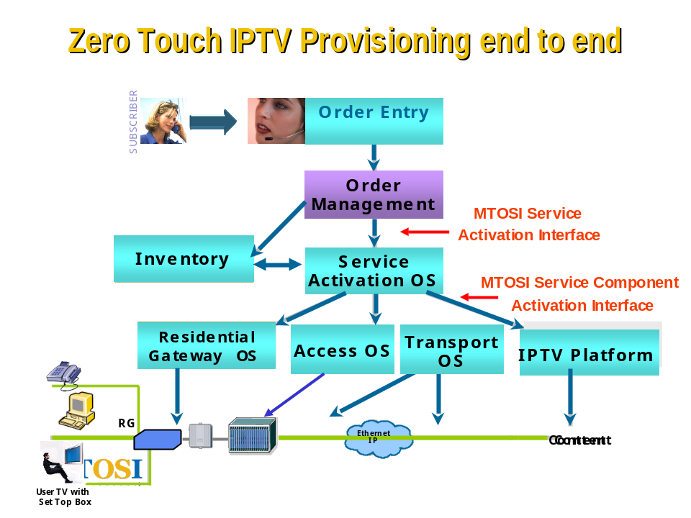

Definitions
The following systems are used in the use case that follows. It should be emphasized that these are only example systems and are in no way normative
  - PAM – Product Activation Manager
  - SCAM – Service Component Activation Manager
  - SPAM – Service-Product Activation Manager

Assumptions
The SPAM needs to decompose the CFSs into RFSs that are understood by the SCAM. So, the SPAM and SCAM designers need to have a common understanding of the CFSs and associated decomposition. However, since the SPAM does the product decomposition into CFSs, the PAM and SPAM do not need to share of common understanding of how the product instances are decomposed. In fact, the PAM doesn’t need to know about product decomposition into CFSs at all.

Decomposition of IPTV
The IPTV product that is sold to a customer in Triple Play today is normally accessed via fixed line technology, either xDSL, xPON, or cable. For the purposes of this document, this scenario is assumed.
The user may, or may not, already have connectivity for other services, such as internet access. In either case, there are at least two CFSs that are involved in the delivery of the IPTV service:
  - Connectivity CFS Represents a fixed connectivity service , e.g., xDSL, xPON, or cable
  - IPTV CFS Represents the IPTV service
These services are “customer facing” in that they are directly associated to “product offerings”.
Each CFS is then decomposed into the resource facings services (RFS) that are required to deliver the service.
In the case of the “Connectivity CFS”, and let’s assume it is xPON connectivity, this is decomposed into at least the following:
  - xPON RFS
This RFS will be specific to various types of access offered, for example indicating the upstream/downstream bandwidth, etc.
  - RG RFS
This RFS will indicate a set of residential gateway options available, which may differ depending on the type of RG’s offered
There may be other RFSs necessary to deliver the connectivity service, but they are outside of the scope of this document

The IPTV CFS is decomposed into the RFS required to deliver that service. This may include:
  - IGMP RFS
To deliver the IPTV service, one will need to activate the IGMP signaling on the xPON access for a particular subscriber
  - RG RFS
The residential gateway may require further configuration to deliver the IPTV service
  - SetTop RFS
This RFS is required for the configuration of the TV set top box, and will depend on the options available
  - Content RFS
This RFS describes the IPTV channels that will be made available based upon subscription options

IPTV Service Activation Use Case
The general flow to be described in this scenario is depicted in Figure 7-9. The high-level steps are as follows:
- Loading Product and Service Catalogue The SPAM loads all the product and service definitions and templates from the product and service inventory database(s) when it starts up. Thus, it has knowledge of the products and services that are available, their characteristics and invariant values; and how various products can be decomposed into CFSs and how the associated CFSs can be decomposed into RFSs. These relationships are designed at product and service creation time. [Part of product offer & development and service offer & development in the eTOM]
- Activation Request The PAM (supporting CRM processes) sends a request to the SPAM to activate the services (CFSs to be exact) supporting a given product instance. The request is made in the language of the product level and includes parameters such as productName, productSpecificationName, productBundleName (optional) and List Of (productSpecCharacteristicID, productCharacteristicValue). The list refers to the variant product characteristics. If some work has been done on some or all of the associated CFSs (i.e., some CFSs have been checked for feasibility, designed, reserved, provisioned or even activated), then this needs to be discernable by SPAM.
- Message Validation and Queuing The SPAM analyzes and validates the request message, checks its priority, and puts it in a corresponding queue for processing.
    - If the message validation process fails, an appropriate exception will be returned to the requesting OS.
    - If the message validation succeeds, the SPAM will return a response with the request status parameter value “waiting_in_queue”.
- Initiate Fulfillment of Request At some point, the SPAM takes the service request message from the queue and proceeds to process it.
- Decomposing Product Assuming the SPAM has access to the most current catalogue information, it decomposes the product instance associated with the activation request into to a set of CFS instances
- Re-check Product Catalog If the previous step is unsuccessful (i.e., the SPAM does not have sufficient information to decompose the given product instance), it queries the product inventory to see if a product type definition exists for the given product instance (i.e., it has been added since the last time the SPAM checked). If one does exist, the SPAM uses the product definition and associated information to decompose the product instance into CFS instances. If not, it sends an error back to the requesting OS (CRM) that the CFS associated with the given product instance could not be activated. The suggest error reason is “Product type not recognized or no longer supported”.
- (SPAMing) Upon successful creation of each CFS, the SPAM begins the orchestration process of creating and activating each component RFS. There are 3 possibilities:
- There is one SCAM that handles all the RFS components. Thus a sequence of “activate” requests are sent by SPAM to a single SCAM, and error checking is handled sequentially.
- Multiple SCAMs are needed to activate the RFSs for a given CFS (this case is depicted in Figure 7-9. PAM-SPAM-SCAM Activation FlowFigure 7-9). In this case, the SPAM divides the requests for each SPAM and may (in parallel) send a serial list of RFS “activate” requests to each SCAM.
It is important to note that each SCAM responds to the SPAM using the language and concepts of the service level and not the resource level.
(SCAMing) Each SCAM either passes the request down to the resource level (e.g., EMS/NMS or NE) in a series of resource create, configure and activate requests, or if it contains resource activation capabilities itself, the SCAM will begin the activation process. The interaction between a SCAM and the underlying resource activation entities is outside of the scope of this use case.
However, some possible scenarios are illustrated in Figure 7-9.

SCAI
Requesting
OS
NE

NE

Target OS

Requesting
OS
Target & Requesting OS
SCAI
Target OS

NE

NE

TMF814
Requesting
OS
Target & Requesting OS
SCAI
Target OS

Proprietary
NE

NE

SM&O
RM&O
Figure 7-8. Various OS Configurations for SCAMing

Note: As part of the request to activate an RFS, subscriber (optional), a SAP, and a reference to a service template are passed. The service template being referenced would reside on the SCAM or an underlying system that would use the information found in the service template for the actual activation of the resources.
- (RFS Activation) If all the resources are successfully activated for a given component RFS, the SCAM creates the RFS service level object and returns successful to the SPAM. If the activation is not successful, the RFS is not created, and an error is returned. The SCAM, depending on its capabilities and those of the underlying activation systems, may request that resources be rolled back in the event of failure.
- (CFS Activation) Once the SPAM has received successful responses for all the RFSs associated with a given CFS, it will send a state transition event to the PAM (indicating that the CFS is now in the Provisioned_Active state). If any RFC (component) activation is unsuccessful, the SPAM will indicate that a given CFS activation has failed and may attempt to roll back the other RFS activation requests associated with the given CFS (via terminate and retire requests to the appropriate SCAM).
- (Looping for each CFS) The previous steps are repeated for each CFS regardless of whether some of the CFS requests have failed. Even if all the CFSs are successfully moved to the Provisioned_Active state and the PAM is so informed, it is still the decision of the PAM as to whether or when to move the product instance to an active state (note that TMF518_SA does not cover definition of product states).
- (Finish) The final response from the SPAM to the PAM will indicate that the request has been successfully completely; otherwise, the SPAM will send an exception. When this request is successfully completed, each CFS (associated with the product instance) shall be in the Provisioned_Active state and made available for use by the customer.

Product Activation Manager (PAM)
Service-Product Activation Manager (SPAM)
Request to activate CFSs associated with a given product (using SAI)
SPAM decomposes the request into the required CFSs. Then, decomposes the CFSs into RFSs and sends multiple RFS activate requests to one or more SCAMS.
A series of RFS activate requests (using SCAI)
The SCAMs will decompose each RFS into the required resources and ensures that all the identified resources are configured and activated.
Service Component Activation Manager (SCAM)
Service Component Activation Manager (SCAM)
Service Component Activation Manager (SCAM)
Figure 7-9. PAM-SPAM-SCAM Activation Flow

References

References
- TMF518_FMW, Framework DDP-BA, Version 1.0
- TMF518_SB, Service Basic DDP-BA, Version 1.0
- TMF518_SA_2, Service Activation DDP-BA, Service Activation Interface, Version 1.0
- TMF518_SA_3 Service Activation DDP-BA, Service Component Activation Interface, Version 1.0

IPR Releases and Patent Disclosure
There are no known IPR claims on the material in this document. As per the TM Forum bylaws, any TM Forum member company that has IPR claims on this or any TM Forum specification needs to make the claims known to the TM Forum membership immediately.

Administrative Appendix
This Appendix provides additional background material about the TM Forum and this document.

About this document
This document has been generated from the SD0-3_mTOPTemplate_BA.dot Word template,
which itself is based on Version 5.10 of the TMF 402, BA Template.

Use and Extension of a TM Forum Business Agreement
This document defines the business problem and requirement model for <<problem area>>. The Business Agreement is used to gain consensus on the business requirements for exchanging information among processes and systems in order to solve a specific business problem. The Business Agreement should feed the development of Information Agreement(s), which is a technology-neutral model of one or more interfaces. While the Business Agreement contains sufficient information to be a “stand alone” document, it is better read together with the Information Agreement document <<(TMF <<number>> if available)>> when the Information Agreement is available. Reviewing the two documents together helps in gaining a full understanding of how the technology neutral information model solution is defined for this requirement model. An initial Business Agreement may only deal with a subset of the requirements. It is acceptable for subsequent issues of the document to add additional requirements not addressed by earlier releases of the BA. Business Agreements are the basis for requirement traceability for information models.
It is expected that this document will be used:
- As the foundation for a TM Forum Information Agreement(s)
- To facilitate requirement agreement between Service Providers and vendors
- As input to a service Provider’s Request for Information / Request for Proposal (RFI/RFP—RFX)
- As input for vendors developing COTS products
- As a source of requirements for other bodies working in this area

Document History
Version | Date Modified | Description of changes
1.0 | October 2007 | This is the first version of the document and as such, there are no changes to report.

Company Contact Details

Company | Team Member Representative
Alcatel Lucent | Name: Jessie Jewitt  Email: Jessie.Jewitt@alcatel-lucent.com  Phone: +1 707 480-6418

Acknowledgments
This document was prepared by the members of the TM Forum <<team name>> team…
- Name, Company, Editor
- Name, Company, position if appropriate (e.g. team leader)
Additional input was provided by the following people:
- Name, Company

About TM Forum
TM Forum is an international consortium of communications service providers and their suppliers. Its mission is to help service providers and network operators automate their business processes in a cost- and time-effective way. Specifically, the work of the TM Forum includes:
- Establishing operational guidance on the shape of business processes.
- Agreeing on information that needs to flow from one process activity to another.
- Identifying a realistic systems environment to support the interconnection of operational support systems.
- Enabling the development of a market and real products for integrating and automating telecom operations processes.
The members of TM Forum include service providers, network operators and suppliers of equipment and software to the communications industry. With that combination of buyers and suppliers of operational support systems, TM Forum is able to achieve results in a pragmatic way that leads to product offerings (from member companies) as well as paper specifications.

