MTOSI 2.0 BA Release Notes

RN306
Version 2.0


November 2007

©TM Forum 2007
Notice
No recipient of this document shall in any way interpret this document as representing a position or agreement of the TeleManagement Forum (TM Forum) or its members. This document is a draft working document of TM Forum and is provided solely for comments and evaluation. It is not a Forum Approved Document and is solely circulated for the purposes of assisting TM Forum in the preparation of a final document in furtherance of the aims and mission of TM Forum.
Although it is a copyrighted document of TM Forum:
- Members of TM Forum are only granted the limited copyright waiver to distribute this document within their companies and may not make paper or electronic copies for distribution outside of their companies.
- Non-members of the TM Forum are not permitted to make copies (paper or electronic) of this draft document other than for their internal use for the sole purpose of making comments thereon directly to TM Forum.
- If this document forms part of a supply of information in support of an Industry Group Liaison relationship, the document may only be used as part of the work identified in the Liaison and may not be used or further distributed for any other purposes
Any use of this document by the recipient, other than as set forth specifically herein, is at its own risk, and under no circumstances will TM Forum be liable for direct or indirect damages or any costs or losses resulting from the use of this document by the recipient.
This document is governed by all of the terms and conditions of the Agreement on Intellectual Property Rights between TM Forum and its members, and may involve a claim of patent rights by one or more TM Forum members or by non-members of TM Forum.
Direct inquiries to the TM Forum office:
240 Headquarters Plaza,
East Tower – 10th Floor,
Morristown, NJ 07960 USA
Tel No. +1 973 944 5100
Fax No. +1 973 944 5110
TM Forum Web Page: www.tmforum.org
Table of Contents

Notice 2
Table of Contents 3
Executive Summary 5
1 Overview of MTOSI Release 2.0 BA 6
1.1 DDP Structure 6
1.2 MTOSI 2.0 DDPs 7
1.3 Supported Business scenarios 8
1.3.1 Resource Management & Operations (RM&O) 8
1.3.1.1 Operations Support & Readiness: Support Resource Trouble Management (RTM) 8
1.3.1.2 Operations Support & Readiness: Managed Resource Inventory (MRI) 10
1.3.1.3 Resource Provisioning (RP) 11
1.3.1.4 Resource Performance Management (RPM) 12
1.3.2 Service Management & Operations (RM&O) 12
1.3.2.1 Service Configuration & Activation 12
2 Release Definition 14
2.1 Document Release Description 14
2.1.1 Major Deliverables 16
2.1.1.1 TMF518_FMW, Framework - DDP BA 16
2.1.1.2 TMF518_NRB, Network Resource Basic - DDP BA 16
2.1.1.3 TMF518_NRF, Network Resource Fulfillment - DDP BA 16
2.1.1.4 TMF518_NRA, Network Resource Assurance - DDP BA 16
2.1.1.5 TMF518_MRI, Manage Resource Inventory - DDP BA 17
2.1.1.6 TMF518_RP, Resource Provisioning - DDP BA 17
2.1.1.7 TMF518_RTM, Resource Trouble Management (RTM) - DDP BA 17
2.1.1.8 TMF518_RPM, Resource Performance Management - DDP BA 17
2.1.1.9 TMF518_SB, Service Basic - DDP BA 18
2.1.1.10 TMF518_SA_1, Service Activation - DDP BA - Part 1: Overview 18
2.1.1.11 TMF518_SA_2, Service Activation - DDP BA - Part 2: Service Activation Interface (SAI) 18
2.1.1.12 TMF518_SA_3, Service Activation - DDP BA - Part 3: Service Component Activation 18
2.1.2 MTOSI Supporting Documents 18
2.1.2.1 SD2-0, mTOP Dictionary 18
2.1.2.2 SD2-12, Inventory Layout 19
2.1.2.3 SD2-14, Attribute Value Change & State Change Notifications 19
2.1.2.4 SD2-17, MTOSI Enhanced Resource States 19
2.1.2.5 SD2-18_VPNServiceModel.xls 19
2.1.3 MTNM Supporting Documents 19
2.1.3.1 SD1-6, Examples for contained TPs different states of usage 19
2.1.3.2 SD1-8, Coding of X.731 and M.3100 State and Status Information 19
2.1.3.3 SD1-14, Inverse Multiplexing (IM) Overview 19
2.1.3.4 SD1-16, Layered Parameters 19
2.1.3.5 SD1-17, Layer Rates 19
2.1.3.6 SD1-18, Functional Modeling Concepts 19
2.1.3.7 SD1-19, Location Identification 20
2.1.3.8 SD1-20, Maintenance Commands 20
2.1.3.9 SD1-22, Modeling Components 20
2.1.3.10 SD1-28, Performance Parameters 20
2.1.3.11 SD1-30, PM File Format 20
2.1.3.12 SD1-31, PM File Format 20
2.1.3.13 SD1-32 PM File Format 20
2.1.3.14 SD1-33, Specification of probableCause strings 20
2.1.3.15 SD1-36, SNC and Protection 20
2.1.3.16 SD1-37, PM Threshold Types 20
2.1.3.17 SD1-44, Connectionless Technology Management 20
3 Administrative Appendix 22
3.1 Document History 22
3.2 Company Contact Details 23
3.3 Acknowledgments 23
3.4 About TM Forum 23

Executive Summary
This document constitutes the Release Note of the MTOSI 2.0 Release.
It presents an overview of the Release 2.0 of the MTOSI product and it shows the complete list of all the different documents constituting this Release.

Overview of MTOSI Release 2.0 BA
Release 2.0 of the MTOSI product is a major release. It means that it does contain new features compared to the previous MTOSI 1.x releases.
Many modifications have been introduced in this release. They are summarized below:
  - Service activation management
  - Resource provisioning and activation
  - Management of connectionless networks
  - Performance management and maintenance commands
  - Inventory updates, multi-event inventory notifications and enhanced inventory retrieval (attribute value matching)
  - Enhanced model for resource states
  - Multi-action and request transactions
  - Division of deliverables into Document Delivery Packages (DDPs) as shown in the next subsection.

DDP Structure
In order to allow for more efficient release delivery, the previous monolithic BA, IA and SS documents have been partitioned into smaller self-contained (though not independent) units called Document Delivery Packages (DDPs).
This is similar to the 3GPP concept of Integration Reference Point (IRP). The basic idea is that the Interface, which is specified by the entire document set (of a release), is partitioned into DDPs where each DDP specifies “a certain aspect” of the Interface, which needs to be very clearly scoped.
There are three kinds of DDPs:
  - the FrameWork DDP (FMW) – this DDP contains the generic artifacts that are applicable to all the other DDPs.
  - Data Model DDP (DM-DDP) – a DDP that concerns a data model (entities, data structures, attributes, state, but no operations)
  - Operation Model DDP (OM-DDP) – a DDP that concerns a computational model (operations, notifications, transactions) for a given functional area (such as resource inventory management)
The unified deliverables structure for each DDP is as follows:
  - Business Agreements (BAs): a business view specification
  - Information Agreements (IAs): a system view specification
  - Interface Implementation Specifications (ISSs): implementation and deployment view specification for XML (WSDL, XSD, bindings…)
  - Supporting Documentation: normative and informative supporting documents.

MTOSI 2.0 DDPs
The MTOSI 2.0 Release is constituted of several DDPs which names are presented in the table below. For The MTOSI 2.0 BA release (this release), only the documents relating to the BA aspects are delivered.

 | DDP long name | DDP short name
General
 | Framework | FMW
RM related
 | DM-DDPs
 | NetworkResourceBasic | NRB
 | NetworkResourceFulfilment | NRF
 | NetworkResourceAssurance | NRA
 | OM-DDPs
 | ManageResourceInventory | MRI
 | ResourceProvisioning | RP
 | ResourceTroubleManagement | RTM
 | ResourcePerformanceManagement | RPM
SM related
 | DM-DDPs
 | ServiceBasic | SB
 | OM-DDPs
 | ServiceActivation | SA

The OM-DDPs reflect business scenarios as highlighted in the next sub section.

It may happen that artifacts defined in one DDP may use artifacts defined in one or several other DDPs.
The figure below shows the DDP dependency graph:
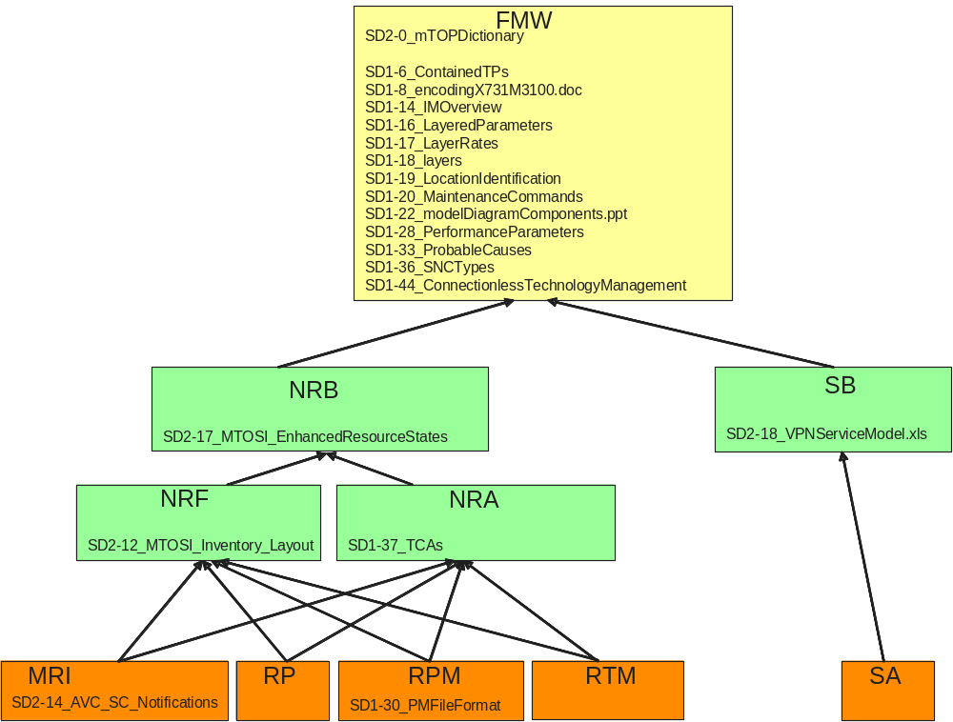

Supported Business scenarios
The MTOSI product is intended to provide a unified set of management interfaces in support of the functions described in this section.
It should be noted that the OS types used in this section are only examples; MTOSI does not define or mandate the use of specific OS types but it provides a management interface that can be used at a variety of OS types.
Examples of interaction between OS are illustrated through different figures. In those figures the OS in red represents the requestor OS.

Resource Management & Operations (RM&O)

Operations Support & Readiness: Support Resource Trouble Management (RTM)
This set of capabilities covers resource fault management, protection management and maintenance and diagnostics.
In terms of fault management, the focus is on alarm subscription, active alarm synchronization, the control of alarm reporting and the predetermined assignment of severities to given alarm types.
The protect management requirements and use cases entail the retrieval of protection related information such as protection groups and subscription to protect switch events.
The maintenance and diagnostics aspect focuses on the sending of maintenance commands and the determination of active (still running) maintenance actions
This capability is supported by means of the interface that both allows an OS to send alarms to a set of interested OSs and allows an OS (alarm requesting OS) to request some or all of the active alarms known to another OS (target OS). In order to receive alarms from a given OS, an alarm consuming OS must first subscribe to receive the alarms of the given OS. A single OS could play both roles.
For more details on the RTM requirements and use cases, see the Resource Trouble Management Business Agreement document. The associated management entities can be found in the Network Resource Assurance Business Agreement document.
For an example of the fault management capability, consider Figure 1-1 which shows three alarm consuming OSs receiving alarms from a single alarm generation OS.
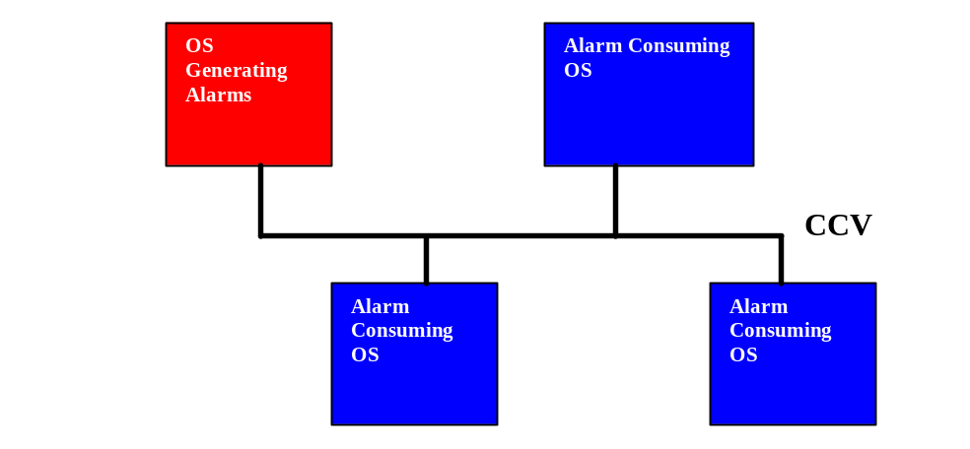
Figure 1-1. Alarm Reporting

Figure 1-2 shows a single OS (in the role of a manager of fault managers) retrieving alarms from several target OSs (perhaps single technology fault management systems).
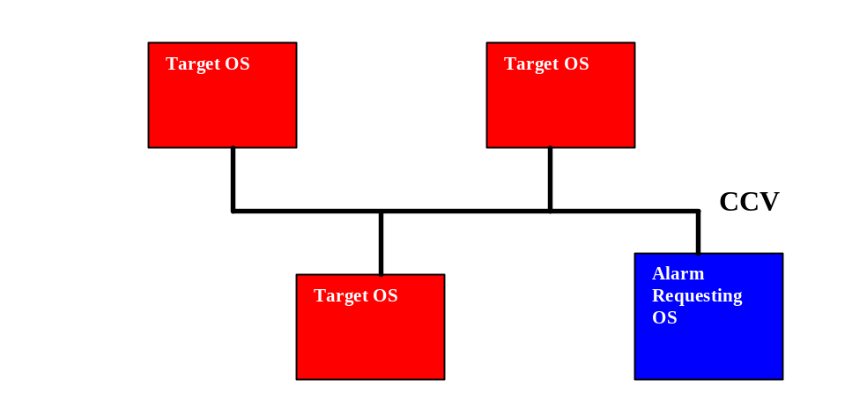
Figure 1-2. Active Alarm Retrieval

Operations Support & Readiness: Managed Resource Inventory (MRI)
This capability is supported by means of the interface that both allows an OS to retrieve all or part of the inventory known to another OS, and also allows an OS to send inventory update notifications to a set of interested OSs.
In Figure 1-3, a Fault Management OS, Inventory OS, and Service Creation OS obtain network inventory from the Inventory OS.

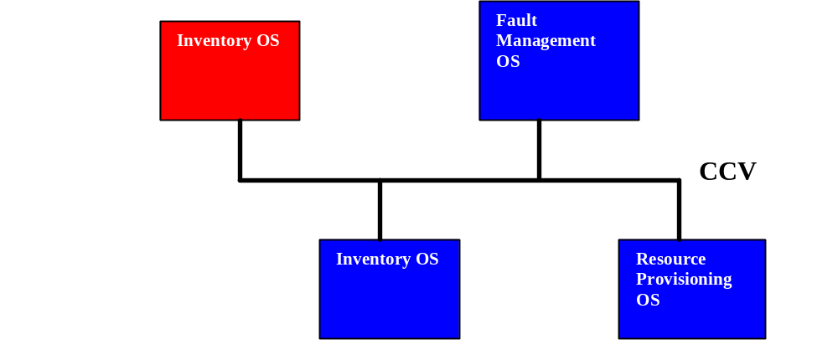
Figure 1-3. Inventory Retrieval

In the above discussion, it should be noted that the OS types are just roles that an OS may take. It is possible for a single OS product to assume several roles, e.g., alarm producer, alarm consumer and Inventory OS.

The inventory updates include entity creation, entity deletion, entities discovery, attribute value change and state change notifications.

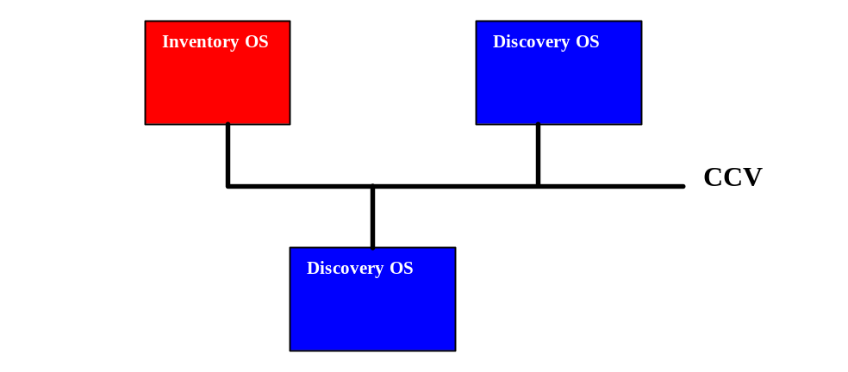
Figure 1-4. Inventory Updates

For more details on the MRI requirements and use cases, see the Managed Resource Inventory Business Agreement document. The associated management entities can be found in the Network Resource Assurance Business Agreement document.

Resource Provisioning (RP)
This capability allows for creating, modifying and deleting network resource entities handling control of connections, flow domains (for connectionless technologies), software, termination points, transmission descriptors, topological links, the provisioning of equipment and the management of traffic conditioning profiles and flow domain fragments.
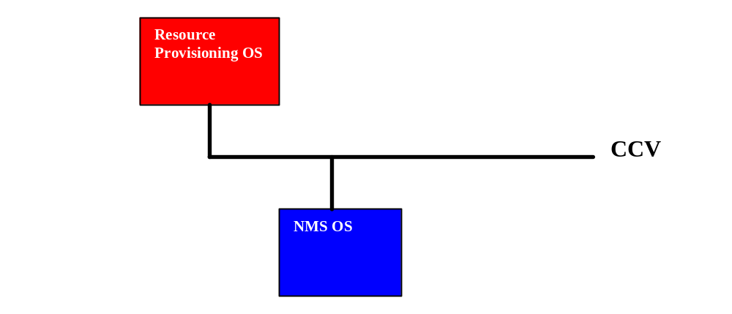
Figure 1-5. Resource Provisioning

More details on this topic can be found in the Resource Provisioning Business Agreement document. The associated management entities can be found in the Network Resource Assurance Business Agreement document.
.

Resource Performance Management (RPM)
This capability covers resource performance monitoring and control:
- Monitor Performance Management
  - PM Retrieval – this includes the retrieval of both current and historical PM data
  - Threshold Crossing Alert (TCA) Notifications
- Control Performance Management
  - PM Control – this includes, for example, the enabling and disabling of PM collection
  - TCA Control – this includes, for example, the enabling and disabling of TCA generation.
More details on this topic can be found in the Resource Performance Management Business Agreement document. The associated management entities can be found in the Network Resource Assurance Business Agreement document.
Figure 1-6 shows an example of performance monitoring. The Resource Performance Management (RPM) OS issues Threshold Crossing Alerts (TCAs) over the CCV which are received by a Service Quality Management (SQM) OS and a Resource Trouble Management (RTM) OS.
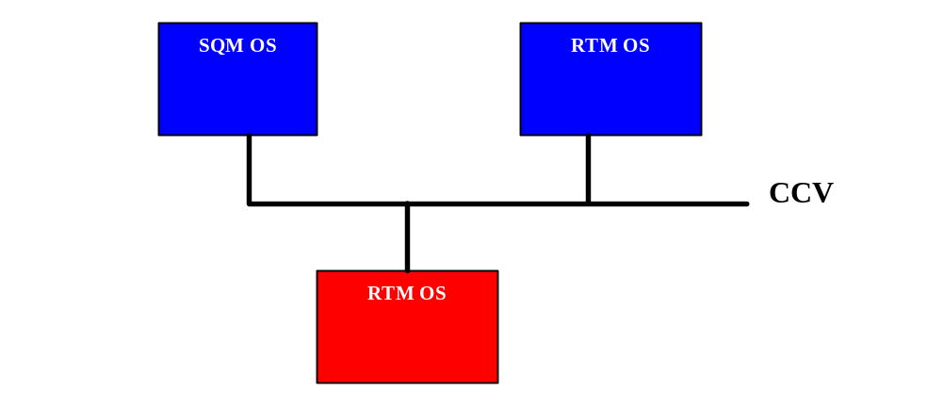
Figure 1-6. TCA Example

Service Management & Operations (RM&O)

Service Configuration & Activation
This capability entails the provisioning, activation and subsequent deactivation and release of services. There are currently to two interfaces defined in this area, i.e.
- Service Activation Interface (SAI) – an activation interface between an OS support the Customer Relationship Management (CRM) capability and another OS supporting the Service Configuration and Activation (SC&A) capability. See Service Activation - DDP BA - Part 2: Service Activation Interface (SAI) for more information on the SAI.
- Service Component Activation Interface (SCA)) an activation interface between two OSs supporting the SC&A capability. See Service Activation - DDP BA - Part 3: Service Component Activation Interface (SCAI) for more information on the SCAI.
Figure 1-7 depicts an example where a CRM OS sends service activation requests to an SC&A OS using the SAI.
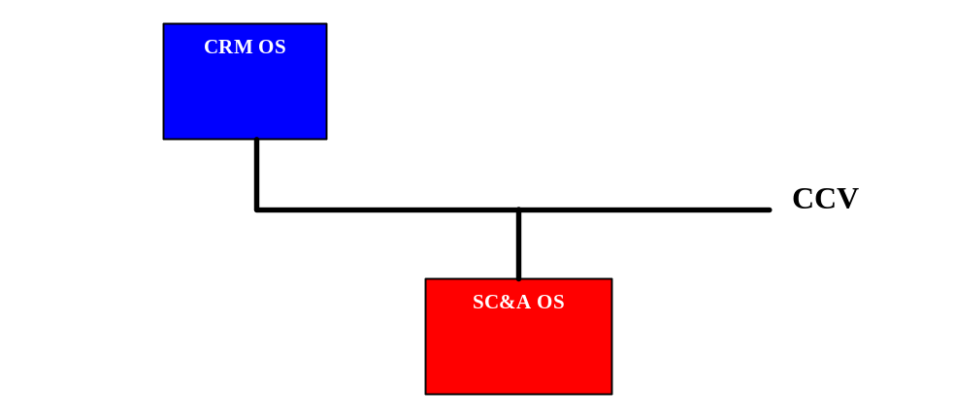
Figure 1-7. SAI Example

Release Definition
This section describes the documents included in MTOSI Release 2.0.

Document Release Description
The following table lists the documents that constitute the MTOSI 2.0 BA Release, organized per DDP.

Table 1. Documents in the MTOSI 2.0 BA Release
DDP | Document | Title | New Doc | Rel 2.0  version | Doc Status | Latest Date
FMW | TMF518_FMW | Framework - DDP BA | Yes | 1.0 | Submitted for  Member Evaluation | Nov 2007
FMW | SD2-0_mTOPDictionary | mTOP Dictionary | Yes | 1.0 | Ditto | Oct 2007
FMW | SD1-6_ContainedTPs | Examples for contained TPs in different states of usage |  | 3.3 | Ditto | Nov 2007
FMW | SD1-8_encodingX731M3100.doc | Coding of X.731 and M.3100 State and Status Information |  | 3.2 | Ditto | Nov 2007
FMW | SD1-14_IMOverview | Inverse Multiplexing Overview |  | 3.2 | Ditto | Oct 2007
FMW | SD1-16_LayeredParameters | Layered Parameters |  | 3.3 | Ditto | Oct 2007
FMW | SD1-17_LayerRates | Layer Rates |  | 3.3 | Ditto | Oct 2007
FMW | SD1-18_layers | Functional Modeling Concepts |  | 3.3 | Ditto | Nov 2007
FMW | SD1-19_LocationIdentification | Location Identification |  | 3.0 | Ditto | Apr 2005
FMW | SD1-20_MaintenanceCommands | Maintenance Commands |  | 3.2 | Ditto | Nov 2007
FMW | SD1-22_modelDiagramComponents.ppt | Modeling Components |  | 3.1 | Ditto
FMW | SD1-28_PerformanceParameters | Performance Parameters |  | 3.1 | Ditto | Oct 2006
FMW | SD1-33_ProbableCauses | Specification of probableCause strings |  | 4.1 | Ditto | Oct 2006
FMW | SD1-36_SNCTypes | SNC And Protection |  | 3.1 | Ditto | Dec 2006
FMW | SD1-44_  ConnectionlessTechnologyManagement | Connectionless Technology Management |  | 1.1 | Ditto | Nov 2007
NRB | TMF518_NRB | Network Resource Basic  - DDP BA | Yes | 1.0 | Ditto | Sep 2007
NRB | SD2-17_  MTOSI_EnhancedResourceStates | MTOSI Enhanced Resource States |  | 1.0 | Ditto | Oct 2007
NRF | TMF518_NRF | NetworkResourceFulfillment  - DDP BA | Yes | 1.0 | Ditto | Sep 2007
NRF | SD2-12_MTOSI_Inventory_Layout | Inventory Layout |  | 2.0 | Ditto | Nov 2007
NRA | TMF518_NRA | Network Resource Assurance  - DDP BA | Yes | 1.0 | Ditto | Sep 2007
NRA | SD1-37_TCAs.doc | PM Threshold Types |  | 3.0 | Ditto | Jun 2005
MRI | TMF518_MRI | Manage Resource Inventory  - DDP BA | Yes | 1.0 | Ditto | Sep 2007
MRI | SD2-14_AVC_SC_Notifications | Attribute Value Change & State Change Notifications |  | 2.0 | Ditto | Nov 2007
RP | TMF518_RP | Resource Provisioning  - DDP BA | Yes | 1.0 | Ditto | Sep 2007
RTM | TMF518_RTM | Resource Trouble Management (RTM)  - DDP BA | Yes | 1.0 | Ditto | Oct 2007
RPM | TMF518_RPM | Resource Performance Management  - DDP BA | Yes | 1.0 | Ditto | Oct 2007
RPM | SD1-30_PMFileFormat | PM File Format Definition |  | 3.3 | Ditto | Oct 2007
 | SD1-31_PMExample | An example of a PM File format in plain text
 | SD1-32_PMExample | An example of a PM File format in xls
SB | TMF518_SB | Service Basic  - DDP BA | Yes | 1.0 | Ditto | Sep 2007
SB | SD2-18_VPNServiceModel.xls |  | Yes | 1.0 | Ditto | Nov 2007
SA | TMF518_SA_1 | Service Activation  - DDP BA - Part 1: Overview | Yes | 1.0 | Ditto | Oct 2007
SA | TMF518_SA_2 | Service Activation  - DDP BA - Part 2: Service Activation Interface (SAI) | Yes | 1.0 | Ditto | Oct 2007
SA | TMF518_SA_3 | Service Activation  - DDP BA - Part 3: Service Component Activation | Yes | 1.0 | Ditto | Oct 2007

Major Deliverables

TMF518_FMW, Framework - DDP BA
This Framework BA covers requirements and use cases concerning both the interface communication mechanisms and the general network resources aspects.
The following items are covered:
  - Resource identification
  - Functional modeling
  - Resources data retrieval mechanisms
  - Notification mechanisms

TMF518_NRB, Network Resource Basic - DDP BA
The Network Resource Basic BA covers the static requirements for the general aspects of the network resources (Data Model).

TMF518_NRF, Network Resource Fulfillment - DDP BA
The Network Resource Fulfillment BA addresses the Data Model (DM) aspects of resource fulfillment and as such it defines all resource related managed entities visible across the Interface that are used in support of resource fulfillment.

TMF518_NRA, Network Resource Assurance - DDP BA
The Network Resource Assurance BA addresses the Data Model (DM) aspects of resource assurance and as such it defines all resource related managed entities visible across the Interface that are used in support of resource assurance.

TMF518_MRI, Manage Resource Inventory - DDP BA
The Manage Resource Inventory BA covers requirements and use cases concerning the management of resource inventory.
The following management capabilities are covered:
  - General Management such as (among others):
    - Bulk inventory retrieval (retrieving selected information in a single operation)
    - Multi-Object Inventory Update
  - Inventory Management of Connection Oriented Technologies
  - Inventory Management of Connectionless Technologies
  - Inventory Notifications

TMF518_RP, Resource Provisioning - DDP BA
The Resource Provisioning BA covers requirements and use cases concerning the provisioning of network resources.
The following management capabilities are covered:
- Connection Control
- Equipment Provisioning
- Flow Domain Control
- Gui Cut-Through Control
- Software and Data Control
- Termination Point Control
- Transmission Descriptor Control
- Assignment of Transmission Descriptors
- Topological Link Control

TMF518_RTM, Resource Trouble Management (RTM) - DDP BA
The Resource Trouble Management BA covers requirements and use cases for the following aspects of RTM: resource fault management, protection management, and maintenance and diagnostics control.

TMF518_RPM, Resource Performance Management - DDP BA
The Resource Performance Management BA covers requirements and use cases concerning resource performance management.
The following management capabilities are covered:
  - Monitor Performance Management
    - PM Retrieval – this includes the retrieval of both current and historical PM data
    - Threshold Crossing Alert (TCA) Notifications
  - Control Performance Management
    - PM Control – this includes, for example, the enabling and disabling of PM collection
    - TCA Control – this includes, for example, the enabling and disabling of TCA generation

TMF518_SB, Service Basic - DDP BA
The Service Management BA presents the service Management technology neutral data model. It initiates from the SID service management information model with several extensions and adaptations introduced to fit the business needs for service activation and inventory (those modifications will be proposed to the SID team as suggestion for improvement).
It defines the static and structural requirements of the managed objects that are visible across the Service Activation Interface(s) and the Service Component Activation Interface.

TMF518_SA_1, Service Activation - DDP BA - Part 1: Overview
The Service Activation BA Overview specifies common definitions, architecture aspects and functional requirements for the MTOSI Service Activation feature.
It introduces two interfaces:
  - The Service Activation interface between the CRM and SM&O layers
  - The Service Component Activation interface is an internal SM&O layer interface.
The primary focus of both interfaces is service activation exclusively.

TMF518_SA_2, Service Activation - DDP BA - Part 2: Service Activation Interface (SAI)
The Service Activation BA Service Activation Interface covers requirements and use cases for a service activation interface where it is assumed that one side of the interface supports and understands the eTOM’s Customer Relationship Management (CRM) concepts, e.g., product and customer, and the other side of the interface supports and understands the eTOM Service Management & Operations (SM&O) concepts, e.g., customer facing service and service order. This interface also allows for the management of service orders that are created as a result of a service activation request.

TMF518_SA_3, Service Activation - DDP BA - Part 3: Service Component Activation
The Service Activation BA Service Component Activation covers requirements and use cases for a service component activation interface (SCAI). This interface is entirely within the eTOM SM&O layer. As such, it receives activation requests from another SM&O application that is normally responsible for the orchestration of end-to-end service activation.
The interfaces exposed by the SCAI hide the complexity of the underlying resource activation process through the use of service templates and references to service access points.

MTOSI Supporting Documents
In cases where the main MTOSI deliverables need to supply the same information, it was decided to move the common information into the set of supporting documents listed below. This allows for updates to the common information in a single place without needing to coordinate updates in several of the main deliverables.

SD2-0, mTOP Dictionary
The document presents the acronyms and the definitions of the essential terms used throughout the different MTOSI documents.

SD2-12, Inventory Layout
The document includes a diagram and associated explanation for the MTOSI inventory layout structure. This layout structure is used to transport inventory data via the various bulk inventory operations.

SD2-14, Attribute Value Change & State Change Notifications
The document lists the minimum set of attributes for which the OS is expected to provide Attribute Value Change (AVC) and State Change (SC) notifications.

SD2-17, MTOSI Enhanced Resource States
The document presents how the static states Planned, Installed Retired are replaced by complex dynamic super-states 'Planning' 'Installing' 'Retiring' each refined into a number of substates.

SD2-18_VPNServiceModel.xls
The document presents a simple example illustrating the key concepts of the Service Activation interface.

MTNM Supporting Documents
For the resource management aspects, MTOSI is based on the MTNM model and, as such, MTOSI relies on much of the background information in the MTNM supporting documents. This section describes how each of the MTNM supporting documents is to be used for MTOSI Release 2.0.

SD1-6, Examples for contained TPs different states of usage
The document provides examples of configurations explaining the expected output of the operations getContainedPotentialTP(Name)s, getContainedInUseTP(Name)s and getContainedCurrentTP(Name)s. MTOSI reuses the MTNM behavior as-is.

SD1-8, Coding of X.731 and M.3100 State and Status Information
The document specifies how X.731 and M.3100 state and status information MUST be mapped to the Interface information model if supported by an OS

SD1-14, Inverse Multiplexing (IM) Overview
The document describes inverse multiplexing and how it is supported in the MTNM model. MTOSI reuses this document “as-is”.

SD1-16, Layered Parameters
The document lists all the general and technology-specific transmission parameters for MTNM. MTOSI reuses this document “as-is”.

SD1-17, Layer Rates
The document lists all the layer rates for MTNM. MTOSI reuses this document “as-is”.

SD1-18, Functional Modeling Concepts
The document extends the layered concepts of ITU-T Recommendation G.805 using encapsulations identified from real network element behavior to provide modeling and performance advantages for information transfer between the management systems. This document provides an explanation of the layering and encapsulation and then builds a view of the use of the layered components in a large number of network scenarios. MTOSI reuses this document “as-is”, with the exception that references to “NMS” should be replaced “Requesting OS” and references to “EMS” should be replaced by “Target OS”, i.e., an OS that fulfills the request of another OS.

SD1-19, Location Identification
The document defines and provides examples for terms related to the location of alarms and performance monitoring. Since MTOSI Release 1.1 does not cover performance management, only the sections entitled Probable Causes and Layered Parameters pertain to MTOSI.

SD1-20, Maintenance Commands
The document presents figures showing the maintenance operation signal flow for some of the maintenance commands supported by the NML-EML interface.

SD1-22, Modeling Components
The document includes diagram components from SD1-18, Functional Modeling Concepts. The components are to be used in proposals to update SD1-18, with the goal of using a single consistent convent for all the diagrams in SD1-18. MTOSI reuses this document “as-is”.

SD1-28, Performance Parameters
The document lists various performance measurement parameters.

SD1-30, PM File Format
The document describes the PM file format. Also, text and Excel examples are provided.

SD1-31, PM File Format
Shows an example of a PM File format in plain text.

SD1-32 PM File Format
Shows an example of a PM File format in xls.

SD1-33, Specification of probableCause strings
The document describes the probable causes to be used in MTOSI alarms. This version of the document (i.e., Version 4.0) includes all the probable causes from the Version 3.0 of SD1-33 with a few additions for MTOSI.

SD1-36, SNC and Protection
The document describes the various SNC types and protection schemes. MTOSI reuses this document “as-is”.

SD1-37, PM Threshold Types
The document presents a figure illustrating the identification of Trigger/Clear for each threshold type.

SD1-44, Connectionless Technology Management
The document aims at specifying a framework for supporting connectionless technologies from the Interface. While seeking compliance with the generic modelling concepts recommended in ITU-T (G.809 Error: Reference source not found, G.8010 Error: Reference source not found) this work is initially intended to address the management of Ethernet and related technologies as defined in ITU-T G.8011 Error: Reference source not found and MEF 10 Error: Reference source not found. The term “Ethernet” refers to the Ethernet MAC layer (ETH). This model is designed to complement and integrates seamlessly with the existing ITU-T G.805 Error: Reference source not found based MTNM release 3.0 interface aimed at connection oriented technologies. Similar modelling activities from ITU-T (Q.840.1 Error: Reference source not found) and MEF Phase 1 (MEF 7 Error: Reference source not found) have been considered for consistency.

Administrative Appendix

Document History
Version History (This document)

Version Number | Date Modified | Modified by: | Description of changes
0.1 | June 2005 | MTOSI Team | Initial version
0.2 | 27-July 2005 | Tina O’Sullivan | Updated version numbers, and other items prior to Member Evaluation.
0.3 | Dec. 2005 | Stephen Fratini | Updated the version number of the various SD after the Member Evaluation.
1.0 | Oct. 2006 | Michel Besson | MTOSI Release 1.1 Notes
1.1 | Dec 2006 | Michel Besson | Aligned document versions
1.2 | Dec 2006 | Tina O'Sullivan | Final modifications prior to ME web posting.
1.3 | Mar 2007 | Tina O'Sullivan | Updated document status, to reflect end of Member Evaluation.
2.0 | November 2007 | Michel Besson | Initial new version

Release History (MTOSI Release)

Release Number | Date Modified | Modified by: | Description of changes
1.0 | June 2005 | MTOSI Team | Initial version
1.1 | October 2006 | MTOSI Team | - Bug fixes  - Support for HTTP  - MEPs for synchronous communication  - Reorganisation of the SS
2.0 BA | November 2007 | mTOP Team | - Service activation management  - Resource provisioning and activation  - Management of connectionless networks  - Performance management and maintenance commands  - Inventory updates, multi-event inventory notifications and enhanced inventory retrieval (attribute value matching)  - Enhanced model for resource states  - Multi-action and request transactions  - Division of deliverables into Document Delivery Packages (DDPs) as shown in the next subsection.

Company Contact Details
For requests of information or comments concerning this document please contact:

Stephen Fratini (mTOP Team Leader)  Telcordia Technologies  One Telcordia Drive  Piscataway, NJ 08854  Phone: +1 732 699 2226  Email: sfratini@telcordia.com | Michel Besson  (MTOSI Product Manager)  Cramer > Amdocs OSS Division  Phone: +44 7717 692 178  Email: Michel.Besson@Amdocs.com

Acknowledgments

About TM Forum
TM Forum is an international consortium of communications service providers and their suppliers. Its mission is to help service providers and network operators automate their business processes in a cost- and time-effective way. Specifically, the work of the TM Forum includes:
- Establishing operational guidance on the shape of business processes.
- Agreeing on information that needs to flow from one process activity to another.
- Identifying a realistic systems environment to support the interconnection of operational support systems.
- Enabling the development of a market and real products for integrating and automating telecom operations processes.
The members of TM Forum include service providers, network operators and suppliers of equipment and software to the communications industry. With that combination of buyers and suppliers of operational support systems, TM Forum is able to achieve results in a pragmatic way that leads to product offerings (from member companies) as well as paper specifications.

