Summary of the MTNM Version 3.0 Features

This supporting document provides a short summary of each of the new features added to Version 3.0 of the MTNM interface.
Table of Contents
1 Support for New Transport Technologies 4
1.1 Digital Subscriber Line (DSL) 4
1.2 Microwave Radio 4
1.3 Ethernet Transport 4
1.4 Frame Relay 4
2 Enhanced Support for Existing Technologies 4
2.1 Inverse Multiplexing for ATM (IMA) 4
2.2 Virtual Concatenation 5
2.3 ATM Performance Parameters 5
2.4 BLSR Squelch Tables 5
2.5 DWDM Enhancements 5
2.6 Generalization of Multiplex Section Protection (MSP) 5
3 Enhancements Not Specific to a Transport Technology 5
3.1 Connection Management 5
3.1.1 Bundled SNCs 5
3.1.2 SNC Modification 6
3.1.3 Management of SNCs with Multiple Routes 6
3.1.4 Dynamic Connection Management 7
3.1.5 Group TPs (GTPs) 7
3.1.6 Clarification and Enhancement of TP Pools 7
3.1.7 Opaque View 7
3.1.8 Additional Method for SNC Route Retrieval 8
3.1.9 Fixed Cross Connections 8
3.1.10 Clarification of Agent Management Attributes 8
3.2 Configuration Management 8
3.2.1 Reverse Layers 8
3.2.2 Floating TPs (FTPs) 9
3.2.3 Provisioning of Trails 9
3.2.4 Management of Topological Links 9
3.2.5 Topology Management – Administrative Domains 10
3.2.6 Transmission Descriptors 10
3.2.7 Sliding Concatenation 10
3.3 Equipment Management 11
3.3.1 Equipment Protection 11
3.3.2 Addition of Equipment Manufacturer to Equipment Object and Managed Element Object 11
3.3.3 Supported and Supporting Equipment Relationships 11
3.3.4 Modeling of Shared Racks 11
3.4 Performance Management 12
3.4.1 Non-Intrusive Monitoring 12
3.4.2 On demand retrieval of history PM data 13
3.4.3 Notifications Concerning Changes in PM parameters 13
3.4.4 Definition of Performance Monitoring Points (PMP) 13
3.4.5 Setting TCA Parameters with a Profile Mechanism 14
3.4.6 TCM Modeling 14
3.5 Fault Management 15
3.5.1 Arc-oriented Fault Management 15
3.5.2 Alarm Acknowledgement 15
3.5.3 Support for Root Cause Alarm Indications 15
3.5.4 Alarm Severity Assignment Profile 15
3.6 General 16
3.6.1 Addition of getContainingPGNames Operation 16
3.6.2 Setting Additional Info 16
3.6.3 Backward & Forward Compatibility 16
3.6.4 OMG Telecom Log Service 17
3.6.5 Software Backup 17
3.6.6 Proprietary Layer Rates 17
3.6.7 Iterator Behavior 17
3.6.8 Naming Service Delimiters 18

Support for New Transport Technologies

Digital Subscriber Line (DSL)
This feature supports configuration, fault management and performance management for DSL lines. The MTNM DSL model complies with the applicable DSLF, FSAN, IETF, ETSI, and ITU-T reference models and TMN parameter specifications. It covers ADSL and SHDSL as well as VDSL, and models the current/read-only and desired/configurable characteristics of these basic DSL types by a comprehensive set of transmission parameters. Extension characteristics for further DSL types (e.g., HDSL4, ADSL2, ADSL2plus, and SHDSL2) may be added in a future MTNM version.
The provisioning of DSL lines can be done via PTP configuration in two ways: direct configuration of a single DSL PTP or configuration of multiple DSL PTPs (possibly scattered across multiple MEs that are managed by the same EMS) by using a single, pre-defined DSL profile. DSL profiles are modeled as transmission descriptors (see Section 3.2.6).

Microwave Radio
This feature entails the management of microwave radio transport. By means of an alteration to the MTNM Version 2.1 protection model radio protection aspects are properly managed. The feature also allows for the management of two multiplexed SDH signals at physical level.

Ethernet Transport
This feature entails the management of Ethernet tributary interfaces. The main focus of this feature is on the management of an Ethernet flow that is transported via Virtual Concatenation. This feature also includes support for fault and performance management.
Ethernet bridging and Ethernet-based layer 2 VLANs are not covered in Version 3.0 of the MTNM interface.

Frame Relay
This feature supports configuration management for Frame Relay service. New layer rates and transmission parameters have been added for Version 3.0. The transmission parameters are introduced as being generic, and can be used for other packet switched technologies.

Enhanced Support for Existing Technologies

Inverse Multiplexing for ATM (IMA)
Inverse Multiplexing for ATM (IMA) is specified in ITU-T Rec. I.761 and ATM Forum Spec. AF-PHY-0086 including the SNMP IMA-MIB. IMA speeds up data transmission by dividing an ATM cell stream into multiple concurrent streams that are transmitted at the same time across separate channels and then reconstructed at the other end back into the original data stream. In the MTNM IMA model, the IMA Group is a Floating TP (see Section 3.2.2) that is an ATM Network Interface to its clients and can be terminated and mapped at the server side to generate a list of server CTPs which represent (respectively can be cross connected to) the IMA Links.
This feature supports configuration, fault and performance management of IMA. The provisioning and monitoring of IMA configurations can be done via FTP and CTP configuration and monitoring. To this end, a comprehensive set of transmission parameters is defined according to the IMA-MIB. The IMA Virtual Link between two peer IMA groups is managed as a topological link (see Section 3.2.4).

Virtual Concatenation
This feature supports the configuration of virtual concatenation in SONET, SDH and DWDM networks.

ATM Performance Parameters
A set of standard ATM performance parameters has been added to the MTNM model for Version 3.0. The same (Version 2.1) retrieval mechanism, and optionally the Version 3.0 PMP concept (see Section 3.4.4) and Version 3.0 TCAPP concept (see Section 3.4.5), is used for ATM, SONET/SDH, DWDM and any other technology supported by the MTNM interface.

BLSR Squelch Tables
This feature provides support for BLSR squelch tables in cases where an EMS is not capable of calculating them (i.e., the squelch tables) by itself.

DWDM Enhancements
The feature includes management support for transmission functions defined in ITU-T Recommendations G.709 and G.798 (concerning the Optical Transport Network).
Management of the following functions is covered:
- transmission (ODUk, OTUk layers, including ODUk TDM):
  - provisioning of trace identifiers, POM, TCT/TCM
  - fault management
  - OTUk trail protection
- connection (multiplexing at the ODUk layer):
  - management of ODUk-SNCP
- performance management

Generalization of Multiplex Section Protection (MSP)
The MSP functionality has been generalized to cover trail protection mechanisms.

Enhancements Not Specific to a Transport Technology

Connection Management

Bundled SNCs
Bundled SNC service involves the establishment of a bundle of connections (i.e., not necessarily of the same layerRate) from one point in a subnetwork to another. The bundled SNC is treated as a single SNC.
Version 2.1 of the MTNM interface does not support an efficient way to establish a bundle of SNCs. Using the capabilities available in MTNM Version 2.1, the NMS would need to make individual SNC requests for each SNC in the bundle, and might also need to provide routing constraints to request that the component SNCs follow the same route. This becomes impractical for large bundles, e.g., a bundle of 48 STS-1s carried in the form of an STS-48 (unconcatenated).

SNC Modification
This feature allows for modification (with little or null traffic impact) of an SNC’s shape as well as modification of an SNC’s attributes. Some example SNC modifications are shown below:
- The NMS may request a change to the static protection level from unprotected to fully protected, and vice versa (see the following figure). This configuration is not applicable for singleton subnetworks. The NMS may specify the full route, a partial route, some routing constraints or nothing.
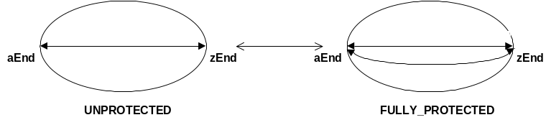

- The NMS may request a change in the shape of an SNC from ST_SIMPLE to ST_ADD_DROP and vice-versa, with aEnd (or zEnd) as the reliable TP (see the following figure). The NMS may specify either the full route, or only the switch port.

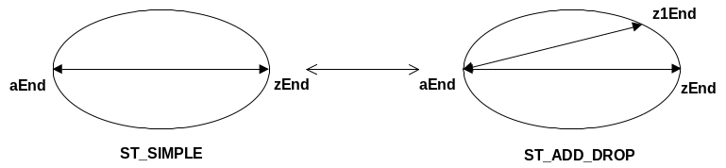

Management of SNCs with Multiple Routes
This feature allows for the management of SNCs with more than one route, i.e., an intended route and one or more backup routes. The following figure shows 2 SNCs (SNC 1 and SNC 2). Each SNC has an intended route and a backup route. The NMS can request traffic to follow on either the intended or backup route. Also, the model support partial or full route sharing among SNCs (as suggested in the figure).

Intended route of SNC 1 (current)
Backup route of SNC 1 (pending)
Intended route of SNC 2 (current)
Backup route of SNC 2 (pending)

Dynamic Connection Management
This feature supports the discovery of UNI-initiated connections (possibly consisting of several SNCs). In support of this feature a "correlationID" attribute has been added to the SNC object. It can be used to correlate several SNCs to comprise an end-to-end (UNI-initiated) connection.

Group TPs (GTPs)
A GTP is a sequence of CTPs (with a specific order) in the same ME. GTPs can be cross connected. As an example application, GTPs can be used to model cross connections that comprise a bundled SNC service. Other applications are possible. GTPs can be created, deleted, and modified by both the EMS and the NMS. The concept of a GTP was based on a similar concept in ITU-T Rec. M.3100.

Clarification and Enhancement of TP Pools
A TP pool represents, according to ITU-T Rec. M.3100, a grouping (without a specific order) of TPs or GTPs (see above), taken from the same Subnetwork, for some administrative management purpose such as bandwidth reservation or common routing. Version 3.0 aligns the TP pool definition with M.3100 and allows the NMS to provision TP pools (creation, deletion, modification) similar to GTP provisioning. It also clarifies the possible relationships between TPs and TP pools which are not constrained to the containment of the TP in the TP pool. For example, a TP could be related to a TP pool that does not contain the considered TP itself but groups client CTPs of the related TP. Such relationships are created, e.g., when an ATM NI CTP is partitioned (by the EMS or NMS) into ATM VP TPPools.

Opaque View
The intent of an opaque view (sometimes referred to as a cloud, edge or subnetwork view) is to provide an abstraction of the network and its subnetworks to the NMS. The idea is to provide the NMS with a minimum set of a subnetwork's resources that it needs to see in order to manage the subnetwork (e.g., edge TPs and "needed" inner TPs together with enhanced SNCs between these TPs).
MTNM v2.1 already provides some means to support this feature in the case where only cross connections at the SNC's layer are required. Trails can be created by the NMS through terminating and mapping CTPs that are adjacent to the CTPs at the end of subnetwork connections. However, if edge points can only be connected by using cross connections at different layers this requires knowledge of some internal details of a subnetwork. In order to minimize the amount of these details, this feature defines some enhanced concepts.
In particular, the SNC concept is enhanced to allow the creation of an SNC to the G.805 TCP encapsulated in an MTNM TP in order to "include the trail termination function". In Version 2.1 it was only possible to create an SNC between the G.805 CP of a CTP or a G.805 TCP of a CTP that possessed no G.805 CP at the layer of connectivity. It was not possible to create an SNC terminating on a PTP, which now is possible.
The enhanced SNC concept of Version 3.0 allows the NMS to provision G.805 network connections that support end-to-end trails (see also Section 3.2.3), when the end points are terminated and mapped.

Additional Method for SNC Route Retrieval
This feature provides an operation on the MultiLayerSubnetworkMgr interface, which allows NMS to retrieve the list of topological links along with cross connections that comprise an SNC’s route. Note that the MTNM v2.1 method for retrieving an SNC’s route returns a list of cross connections – the topological links are not included.

Fixed Cross Connections
Cross connections within NEs are sometimes fixed. This is important information to know from an NMS point of view for routing, restoration and resource planning purposes. This feature is to provide a means to discover fixed cross connections and SNCs, where a fixed SNC is defined as an SNC all of whose cross connects are fixed.

Clarification of Agent Management Attributes
In general, the MTNM interface does not distinguish between a requirement that is fulfilled at the EMS level or at the network level. In most cases, the distinction is not needed. In some cases, however, it is important to know and to specify whether an object is created or an operation is implemented in an NMS or in the network element itself.
The interface already makes the distinction for an SNC to exist at the EMS level only or at the network level as well.
This feature extends the EMS/network distinction to the route of the SNC. When the route of an SNC is not fully specified by the NMS, the feature allows the NMS to specific whether the route should be computed at the EMS level or at the network level.

Configuration Management

Reverse Layers
This is a technical feature that is needed to support other features such as SONET/SDH virtual concatenation and ATM IMA. In particular, this feature makes the following extensions to the MTNM layer model as explained in detail in the supporting document layers.pdf:
- Generalize the current MTNM 2.1 concept that allows a TP to be contained in another without being its client,
- Allow "special" layering, i.e., force the use of a CTP when layer order changes,
- Force the layers of a TP to be reported in a specific order,
- Generalize the definition of tpMappingMode to cover mapping to server layers,
- Generalize TP naming to cover TPs that can be mapped to server layers.
It should be noted that this feature provides a clearer (if not completely backward/forward compatible) definition of tpMappingMode for Version 3.0:
For PTPs (and TPPools), the value of tpMappingMode is always TM_NA. (Note that for PTPs this means they always have client CTPs while for TPPools it means they never have client CTPs.)
For CTPs, the tpMappingMode can be one of three values, defined as follows:
- TM_NA: The CTP can not be mapped (i.e., it has no contained potential CTPs).
- TM_NEITHER_TERMINATED_NOR_AVAILABLE_FOR_MAPPING: The CTP can be mapped but currently is not (i.e., it does have contained potential CTPs, but currently has no contained actual CTPs).
- TM_TERMINATED_AND_AVAILABLE_FOR_MAPPING: The CTP can be mapped and currently is (i.e., it has contained actual CTPs).

Floating TPs (FTPs)
In order to model various internal aspects of a Managed Element, the concept of a Floating TP (FTP) was added to Version 3.0 of the MTNM interface. This is a very important concept and is used in support of several Version 3.0 features, e.g., termination points not directly supported by a physical port (but receiving and transmitting signals at non-physical layer rates), Provisioning of Trails, termination points that can not be associated with a single physical port (inverse multiplexing) and trail protection.
FTPs inherit properties from PTPs and CTPs and will be used as PTPs or CTPs where the definitions of these TPs (i.e., PTPs and CTPs) are too constraining.

Provisioning of Trails
The MTNM 2.1 states that "Trails can be created by the NMS by using setTPData to terminate and map CTPs that are adjacent to the CTPs at the end of subnetwork connections created by means of createSNC." This approach does not work for Floating Termination Points (FTPs). This feature describes an extension of the trail creation procedure in support of FTPs. A further extension of the Version 2.1 trail concept is given by the introduction of the Opaque View (see Section 3.1.7).

Management of Topological Links
Topological link auto-discovery is a complex feature, which is often not supported by NEs or EMSs. The topological link capabilities in MTNM Version 2.1, if they were to be fully implemented in an EMS, would in most cases be based on a mixture of:
- Topological link auto-discovery at the NE level, and
- Manually entered Topological link information at the EMS level.
As a consequence, the installation or decommissioning of a physical link, which requires manual intervention from field technicians, also requires manual enter of data into the EMS after the installation is completed, unless the NEs involved in the link support its auto-discovery.
However, in most EMS/NMS architectures, the overall process of installing physical links is managed at the NMS level. Therefore, when the installation is completed, the topological link is known at the NMS level, but not at the EMS level. Allowing the NMS to inform the EMS of those new/deleted topological links through the MTNM interface eliminates the need for manual datafill at the EMS level. Such a capability (NMS creation and deletion of Topological Links) has been added to MTNM V3.0.

Topology Management – Administrative Domains
This feature entails the definition of a new attribute (i.e., the Network Access Domain or NAD) for MTNM managed objects, in particular PTPs, CTPs and SNCs. A given NAD represents a domain to which some transmission network resources (i.e., MTNM objects) have been assigned and a given Functional Access Domain (FAD) or set of FADs determines the functions which can be applied to the NAD. A network resource should be assigned to only one NAD, or be unassigned (or free). Using this feature it is possible to define Virtual Private Networks (VPNs), in which also the routing resources can be reserved to a specific set of users (sharing a given NAD) for SNC management.

Transmission Descriptors
This feature involves the use of Transmission Descriptors (TMDs). A TMD is a new MTNM managed object class that represents a collection of attributes, which are used to define multi-layer transmission parameters and additional info parameters on a TP. The state and behavior of a TMD are modeled similar to a Traffic Descriptor (TD) but allow for more general semantics. TMDs contain parameters that specify the transmission characteristics of (the end points of) a subnetwork connection or a topological link. From a customer's point of view a TMD represents a service profile, or service level specification (SLS), i.e., a set of parameters and their values which together define the service type offered by the service provider to one or more customers (e.g., DSL or ATM transmission characteristics).
An SLS is used as the technical basis for one or more service level agreements (SLAs). An SLA is a contract between a service provider and one or more customers (i.e., a user organization or another provider domain) defining provider responsibilities in terms of an SLS (classified in terms of grades of service), times of availability, methods of measurement, consequences if service levels are not met by the provider (service degradation or failure) or granted traffic levels are exceeded by the customer, and all the costs involved.
The special case where the TP is an ATM VP or VC CTP and the transmission parameters are ATM traffic parameters, as specified by MTNM v2, amounts to an alternate modeling of ATM traffic descriptors with the option to pre-define additional TP parameters as well. Therefore ATM TDs are deprecated in MTNM v3 and the use of TMDs instead is recommended.
TMDs are contained by the EMS. A TMD can be assigned to a TP by writing the TMD's name to the TP's ingressTrafficDescriptorName or egressTrafficDescriptorName attribute, explicitly with setTPData () or implicitly when creating an SNC. TMDs can be created, deleted, and retrieved (with full value or name only), and all TPs to which a particular TMD has been assigned can be retrieved as well. A TMD may reference another TMD from which it inherits the configuration parameters (modular definition of TMDs), and the consistency of TMD assignments to TPs can be verified on demand.

Sliding Concatenation
This feature allows various VC4-nc payloads to start at boundaries other than those specified in ITU-T Recommendation G.707. The payloads may slide in increments of either VC4 or VC3.

Equipment Management

Equipment Protection
The feature allows the NMS to discover protection relationships between equipment. The concept of an MTNM protection group has been enhanced to support equipment protection relationships. In Version 2.1, protection groups were only used to model protection relationships among PTPs.

Addition of Equipment Manufacturer to Equipment Object and Managed Element Object
This feature entails the addition of an extra data attribute (to the Equipment and ManagedElement objects) that holds the manufacturer name. This extra attribute is useful for NMSs performing equipment auto-discovery.

Supported and Supporting Equipment Relationships
This feature allows the NMS to discover support relationships among equipment. Each equipment object instance may optionally have a list of object instances that support it. Likewise, each equipment object instance may optionally have a list of object instances that it supports. Examples include power-supply cards that support several other cards in a shelf, timing cards that support a shelf.”

Modeling of Shared Racks
Racks in MTNM v2.1 are named as follows:
- name="EMS", value="<CompanyName>/<EMSName>"
- name="ManagedElement", value="<ManagedElementName>"
- name="EquipmentHolder", value="/rack=<r>"
Racks are therefore named under a managed element object. This implies that a rack is contained in a managed element, and does not allow managed elements to be contained in racks.
This limitation does not correspond to the reality for several small MEs. Indeed, many small MEs have a single shelf, which is mounted in a rack that can be shared by other MEs. The problem is also made more complex by the fact that MEs with a small number of shelves can be spread across multiple shared racks. This is illustrated in the following figure, which has 2 single shelf MEs and 3 dual-shelf MEs located in 2 shared racks.
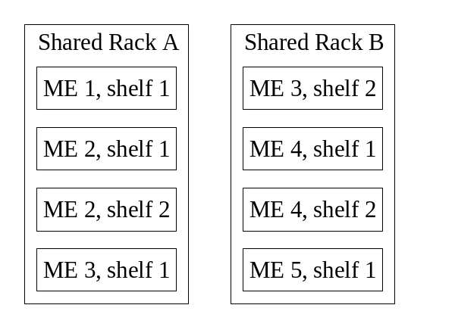
Note that, in this example, none of the two racks are contained by a single ME, and that ME 3 is not contained by any single rack. This shows that ME/rack containment (in either direction) is not always possible.
With MTNM v2.1, at least one rack has to be reported for every ME. This is mandatory according to the naming model, since the "/rack=<r>" part of equipment and equipment holder names is mandatory. It is not possible to report a shelf that is not contained in any rack.
In order to address the problem described above, the following changes to MTNM v2.1 are made for v3.0:
- make optional the "/rack=<r>" part of the name, and
- make optional the containment of shelves inside racks.
Naming of equipment holders would change to:
/rack=<r>[/shelf=<sh>[/sub_shelf=<ssh>][/slot=<sl>[/sub_slot=<ssl>]]]
when a rack can be reliably reported, or
/shelf=<sh>[/sub_shelf=<ssh>][/slot=<sl>[/sub_slot=<ssl>]]
when a rack can not be reliably reported.

Performance Management

Non-Intrusive Monitoring
The feature (the name is perhaps misleading) provides support for 3 monitoring situations not covered in MTNM v2.1:
- Situations where a layer is present in a PTP or CTP for monitoring purposes only (i.e., connectivity is not possible)
- Monitoring of unmapped layers, e.g. monitoring of the client PDH 2 Mb/s signal within a pure SDH NE or monitoring of the client SDH STM-N signal in a pure optical NE
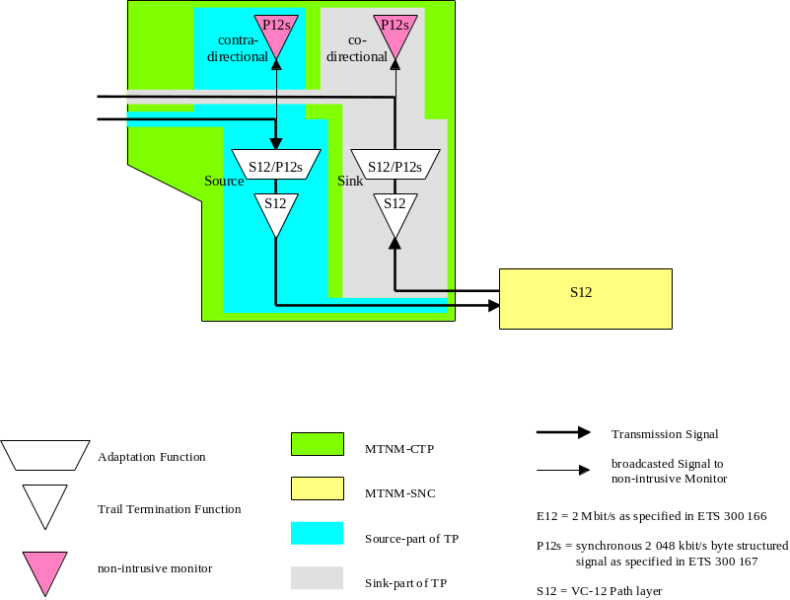
- Monitoring on both sides of a TP and on both sides of a matrix.
In general, all possible locations of PM and Alarm measurements have been defined.
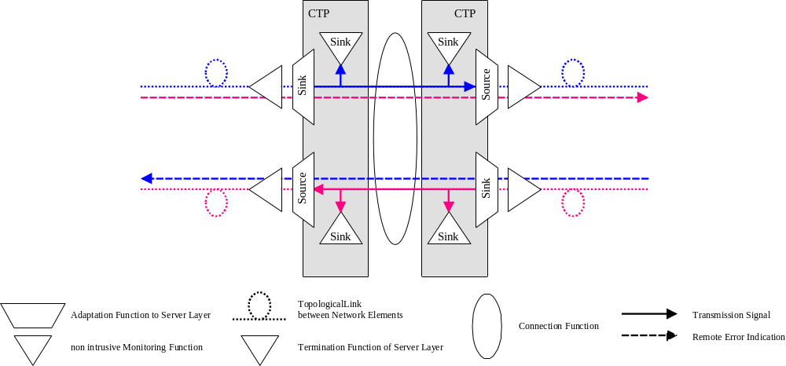

On demand retrieval of history PM data
The MTNM v2.1 operation of the PerformanceManagementMgr does not allow the NMS to retrieve history PM values on demand. To retrieve historical PM values, the NMS has to invoke the getHistoryPMData operation on the PerformanceManagementMgr. Since this is an asynchronous operation, NMS has to wait to receive a file transfer notification. No matter how small the file there is going to be some fixed delay in ftp.
However, when a customer reports that the quality of their service was bad during a particular interval, NMS user may need to know the history PM parameter of a CTP immediately. To address this need a new operation is being defined for the PerformanceManagementMgr interface. This operation allows for on demand retrieval of historical PM data.

Notifications Concerning Changes in PM parameters
It is quite possible for a user to clear PM data, disable/enable PM data collection, or enable/disable TCA generation without any notification to the NMS (at least in MTNM Version 2.1). This could leave the NMS user with the predicament of not receiving expected PM data or TCAs. This problem is corrected by a new Version 3.0 feature. In particular, this new feature involves the generation notifications (by the EMS) when PM data is cleared, PM data collection is disabled or enabled, and when TCA generation is enabled or disabled.

Definition of Performance Monitoring Points (PMP)
In MTNM v2.1, PM data was not represented as a separate object. In v2.1, it was not possible to determine whether performance monitoring was enabled or disabled for a TP, or whether threshold supervision was enabled or disabled for a TP. In order to address this issue and, in general, to allow for additional management of the PM characteristics of a TP, the Performance Monitoring Point (PMP) object was introduced into MTNM v3.0.
A PMP represents an access point identified by the triple of layer rate, PM location and granularity at which performance monitoring and threshold supervision are provided for a set of PM parameters. It is contained in a Termination Point. The set of Performance Monitoring Points contained in a Termination Point constitute the PM capabilities of the Termination Point.

Setting TCA Parameters with a Profile Mechanism
Most services are offered to the customers with a predefined level of availability (e.g., standard service, premium service). For each service, a set of TCA threshold values will be defined to supervise the fulfillment of the availability. This set of TCA thresholds is common for all TPs that carry traffic of the same service.
Changes in the quality of the service offered to the customer lead to a change in the associated threshold value set in every termination point carrying this kind of service. It is required to do this "bulk change" using a profiling mechanism. Such a mechanism has been added to v3.0 of the MTNM interface.
With this mechanism it is possible to change the TCA supervision in all termination points carrying a specific kind of service by only changing the (one) profile for that service.

TCM Modeling
Some Tandem Connection Monitoring (TCM) related transmission architectures cannot be mapped to the Version 2.1 MTNM model. This feature describes enhancements in support of additional TCM configurations. In particular, in Version 2.1 it was not possible to define both the ending and starting point of a TCM trail within one TP. Moreover, in Version 2.1, it was not possible to model Tandem Connection Monitoring, but only Tandem Connection Termination.
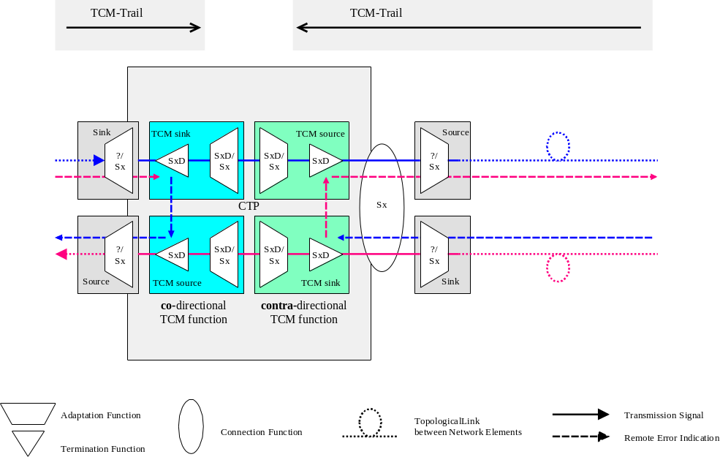

Fault Management

Arc-oriented Fault Management
NMS systems which control the subnetwork via an "opaque view" primarily manage "arcs" (topological links and subnetwork connections) instead of termination points. To provide such a view to the NMS, the EMS has to correlate TP information into "arc" information. The method to provide this correlation is EMS internal behavior, and is therefore outside the scope of the MTNM interface.
This feature, however, provides probable causes, attributes and operations for topological links and subnetwork connections which are necessary to notify arc-oriented alarms and to activate and de-activate Fault Management (FM) supervision.

Alarm Acknowledgement
This feature allows for the management of alarm acknowledgements. The following requirements are supported in Version 3.0 of the MTNM interface:
- The EMS shall be able to acknowledge an alarm (i.e., designate an alarm of being acknowledged) through a request over the NML-EML interface.
- The NMS shall be notified in the event that an alarm is acknowledged by any source (i.e. the EMS, the same NMS, or another NMS).
- The NML-EML interface shall support NMS requests to retrieve active unacknowledged Managed Element and EMS related alarms from the EMS for a given filter criteria (filtering may be performed using the probable cause and/or severity).
- The EMS shall be able to unacknowledge previously acknowledged alarms based on a request by the NMS.
- The NMS shall be notified in the event that an alarm is unacknowledged by any source (i.e. the EMS, the same NMS, or another NMS).

Support for Root Cause Alarm Indications
The Root Cause Alarm Indication (RCAI) feature allows the EMS to indicate a distinction between raw (i.e., un-correlated) alarms, and root cause alarm indications. This feature is supported by the new field "rootCauseAlarmIndication" (in TMF608) and "rcaiIndicator" (in TMF814 and OMGServicesUsage.pdf) in the alarm notification to indicate whether it is a root cause alarm indication or not.
The filtering capability of the Notification Service can be used by the NMS to
- receive only raw alarms, i.e., alarms with the root cause alarm field set to FALSE,
- receive only RCAIs, i.e., alarms with the root cause alarm field set to TRUE, or
- receive both raw alarms and RCAIs.

Alarm Severity Assignment Profile
Some Managed Elements are capable of flexibly assigning a severity to an alarm by using the Alarm Severity Assignment Profile (ASAP) mechanism, defined in ITU Recommendation M.3100. The ASAP is a table, with each row specifying a probable cause and the assigned severity for "service affecting", "non service affecting" and "service independent" alarms. For MTNM Version 3.0, an ASAP can be associated to the following objects:
- EMS
- ManagedElement
- TerminationPoint
- GroupTerminationPoint
- SubnetworkConnection
- TopologicalLink
- Equipment
- EquipmentHolder
- ProtectionGroup
- EquipmentProtectionGroup
In case of termination points, there could be more encapsulated layer rates, and so it may be necessary to assign multiple ASAPs to a TP (at most one per each encapsulated layer rate).

General

Addition of getContainingPGNames Operation
This new operation allows the NMS to retrieve (from the EMS) all the protection groups containing a given TP.

Setting Additional Info
The additionalInfo attribute of the various second-level objects (e.g., TPs, SNCs) will be used to carry (store) the Version 3.0 extensions. In some cases, the fields within additionalInfo may need to be set by the NMS. This feature allows for the setting of additionalInfo.

Backward & Forward Compatibility
The MTNM has defined rules for backward and forward compatibility. Backward and forward compatibility can be defined as follows:
- Backward compatibility is a characteristic that allows an upgrade of a client (NMS) to be made while still being able to interact with the current servers (EMSs).
- Forward compatibility is a characteristic that allows an upgrade of a server (EMS) to be made while still being able to interact with the current clients (NMSs).
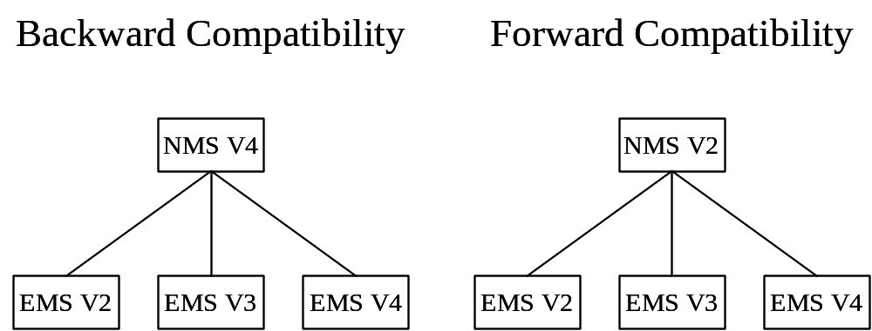

With very few exceptions, the team has preserved both backward and forward compatibility.

OMG Telecom Log Service
The feature allows for the use a log service. The feature requirements are fulfilled by the OMG Telecom Log Service. Note that the OMG Telecom Log Service incorporates all the capabilities of the OMG Notification Service.

Software Backup
This feature allows the NMS request the backup of a list of Managed Elements. The storage of these backups is a local matter of the EMS and is not transferred across this interface to the NMS. This is an asynchronous operation. The EMS will send the results of the backup operation for each Managed Element via the Notification Service. The NMS can get the status of any backup operation on-demand.
This feature will also allow the NMS to view all database backups of Managed Elements that are available on the EMS (only the date of the backup is provided – not the backup itself). The NMS can also view the database backups for a specified list of Managed Elements.

Proprietary Layer Rates
This feature provides a mechanism for the addition of "proprietary" layerRates. This is considered as necessary to allow a vendor to add support in their implementation of the interface for layerRates that are not supported in the active version of the MTNM interface definition.

Iterator Behavior
The TMF 814 iterators contain a getLength () method that is to return the total number of elements contained in the iterator. In some cases, it may not be feasible for the EML to obtain the total number of elements that will be returned by the iterator, e.g.,
- The EMS may have to first fetch all of the data that has been requested (making a local copy) and then count the number of elements being iterated over. This could prove to be particularly inefficient.
- The EML may be able to obtain a count of the number of elements, but due to concurrent modifications, the actual number may vary over the time of the iteration.
It should be noted that a client of the MTNM interface can always determine when all data has been collected by repeatedly fetching chunks of data until the iterator indicates that no further data remains.
To account for the cases where the EMS may not be able to efficiently determine the length it is therefore proposed that the usage of the getLength() method in the iterator is adjusted such that:
- An EMS is permitted to throw a not supported exception in cases where calculation of an absolute length of data to be returned would lead to significant implementation inefficiencies.

Naming Service Delimiters
The MTNM currently defines usage of ‘/’ and ‘.’ in the OMG Naming Service in the Versioning and Object Naming supporting documentation. These characters have a reserved usage in the OMG Naming Service. Using the ‘/’ and ‘.’ requires usage of escape characters which that does not work well with many Naming Service implementations.
The following characters shall be considered as syntactically equivalent when registering an EMS in the Naming Service:
A ‘:’ may replace ‘/’ so that an EMS can register as “VendorA:EMSA”
‘_’ may replace ‘.’ so that an EMS can register under a directory named “2_0” instead of 2.0.

Revision History
Version | Date | Description of Change
3.0 | December 2005 | Conversion into new template.

Acknowledgements
<FirstName> | <LastName> | <Company>

How to comment on the document
Comments and requests for information must be in written form and addressed to the contact identified below:

Keith | Dorking | CIENA
Phone: | +1 678 867 5007
Fax: | +1 678 867 5010
e-mail: | Kdorking@ciena.com

Please be specific, since your comments will be dealt with by the team evaluating numerous inputs and trying to produce a single text. Thus we appreciate significant specific input. We are looking for more input than wordsmith” items, however editing and structural help are greatly appreciated where better clarity is the result.

