Protection Switching

In the CORBA implementation, the object model represented here is captured in attributes. The switchData Object is implemented as a data structure and not as a first class or second class object.

The protection groups are created on the managedElement via the EMS or the craft interface and not via this interface. The interface however will notify the NMS of such a creation (or deletion) of the protection group.

The 1+1 APS and 1:N APS groups provide the basic line layer protection. The examples that follow refer to SDH/SONET usage, but the principles and approaches explained here could be applied to any Trail protection scheme.

The 2- fiber ring protection group contains the east and the west TPs. The implementation of the 4-fiber rings is that there are three component groups. One for each span as these TPs provide protection to each other within a span first and then the third group encompasses these two groups. By convention for 2-Fiber the first TP is for East and second is for West (mandated) , for 4-fiber, the first 2 are East and the last two TPs are for West. The list of TPs within a group is an ordered list, with the protecting TP at the end of the list (except in a non-revertive 1+1 MSP systems, where there is no notion of worker and protection TPs).

In this document and the related IDL, the terms «worker TP» and «protection TP» are used to identify the role of a TP in a protection group. A «worker TP» is sometimes referred to as a «working TP», «protected TP», «primary TP», or «main TP». A «protection TP» is sometimes referred to as a «protecting TP», «secondary TP», or «backup TP».

Pictorial Depiction of the MS (Line) Layer Protection groups

Application of the Protection groups

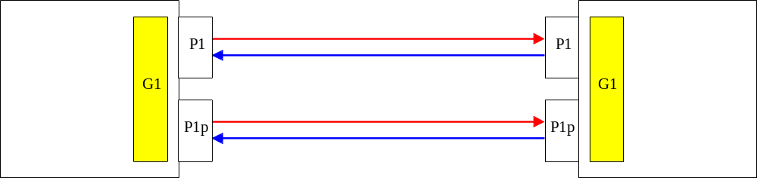

Figure : 1+1 MSP

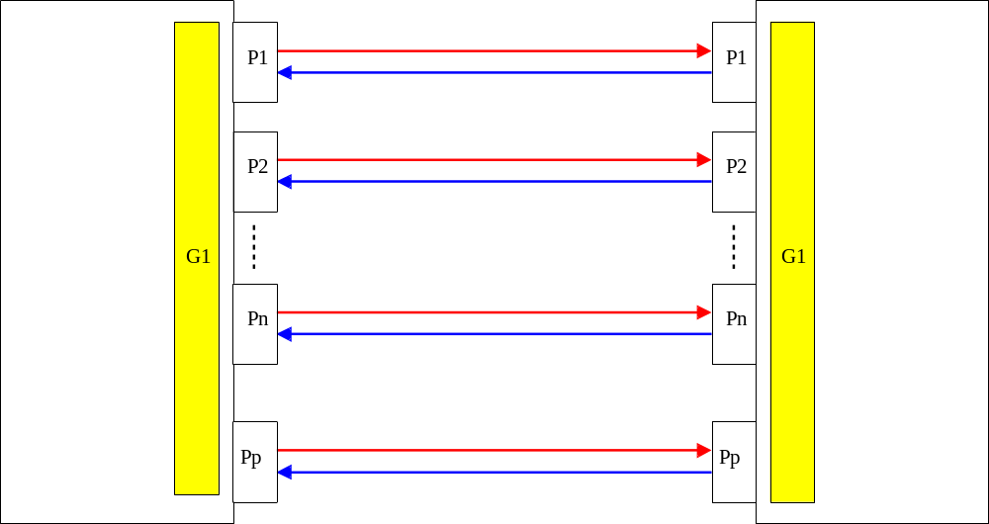

Figure: 1:N MSP Groups.

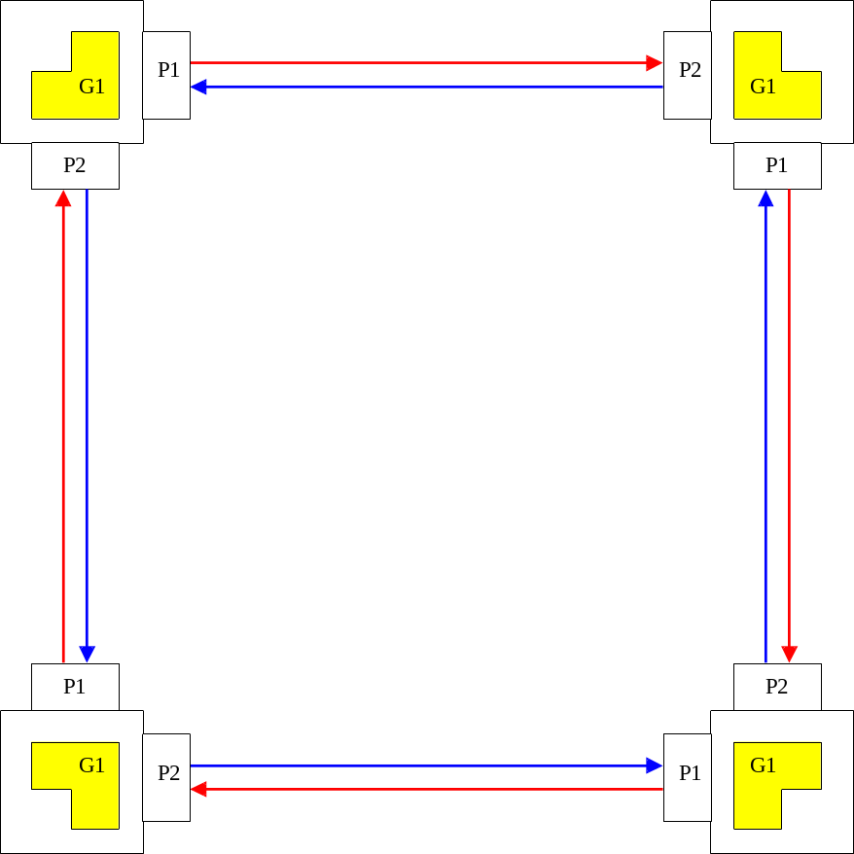

Figure: 2 Fiber MSSPRING

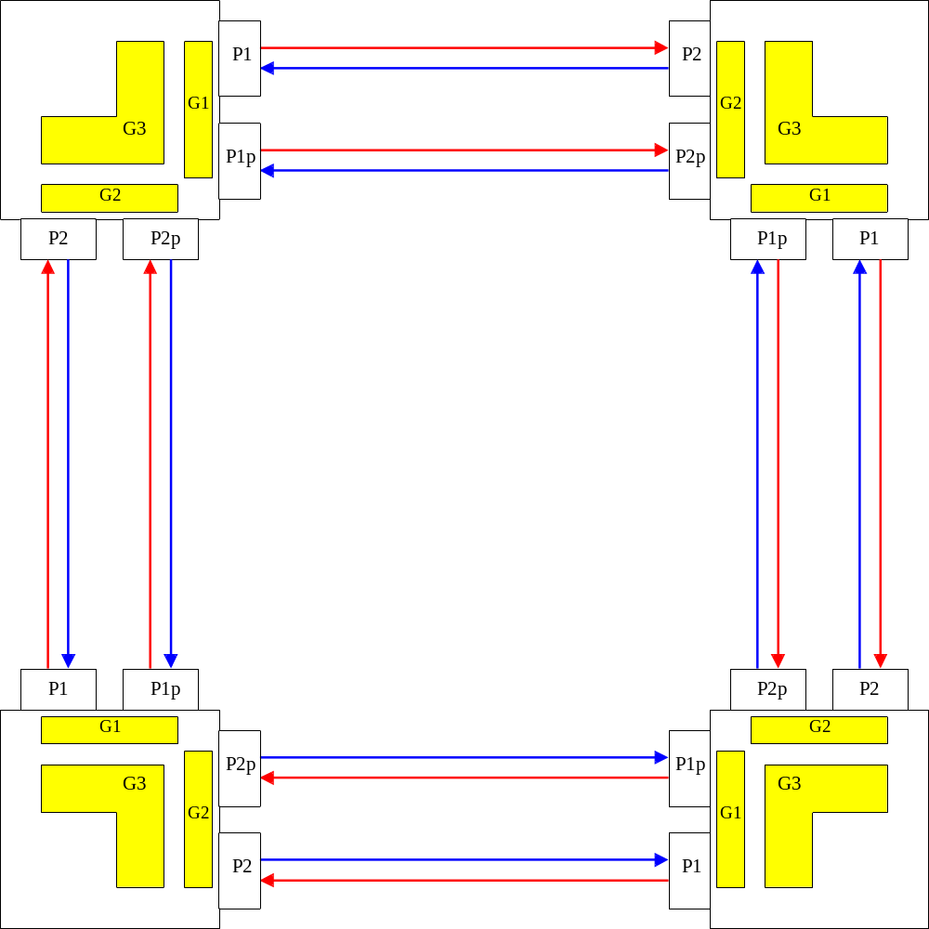

Figure: Protection Groups in a 4-Fiber MSSPRING.

In the figures, the shaded portions represents the different protection groups and their component TPs at one end.

PGP Config | Number of groups | Ordered List of TPs.
1+1 MSP | 1 | G1 = { P1, P1p} (PGP_TYPE=1+1)
1:N MSP | 1 | G1 = { P1........Pn, Pp} (PGP_TYPE=1:N)
2F BLSR | 1 | G1 = {P1,P2} (PGP_TYPE=2FBLSR)
4FBLSR | 3 | G1= {P1,P1p}, G2 = {P2,P2p}, (PGP_TYPE= 1:N groups)  G3 = {P1,P1p,P2,P2p} (PGP_TYPE=4FBLSR)

Examples of Protection Switch Notifications
In the following examples, the following apply:
- 1+1 MSP consists of
- TP_{w} and TP_{p}
- 1:N consists of
- TP_{w1}…..TP_{wi}….. TP_{wn} and TP_{p}
- When used in the context of a 4-Fiber ring groups these are 1:1 groups {EW, EP} and {WW, WP} denoting the direction East and West and the worker/protection relationship.
- 2F Ring consists of
- E and W
- 4F Ring consists of
- EW, EP, WW, and WP.

Scenario Description | protectedTP | switchAwayFromTP | switchToTP | Comments
1+1 MSP, switch from worker to protection. | TPw | TPw | TPp
1+1 MSP, switch from protection to worker. | TPw | TPp | TPw | When the lockout occurs and the traffic position is changed, no notification is raised.
1:N MSP, switch from one of the workers to Protection. | TPwi | TPwi | TPp
1:N MSP, switch from protection back to one of the workers. | TPwi | TPp | TPwi
1:N MSP, priority switch: (1) the lower priority traffic switches from protection back to its failed worker; (2) the higher priority traffic switches from its failed worker to the protection. | (1) TPwi  (2) TPwj | TPp  TPwj | TPwi  TPp | Low priority traffic  High priority traffic  Two notifications are generated in this case.
2 Fiber Ring, fault detected on the east and redirect the traffic to west. | E | E | W | Similar examples apply for the other direction.
2 Fiber Ring, traffic reverts to East | E | W | E | Similar examples apply for the other direction.
4-Fiber Ring, Span Switch in the East span. | EW | EW | EP | Similar examples apply for the other direction.
4-Fiber Ring, Span Switch in the East span., reversion. | EW | EP | EW | Similar examples apply for the other direction.
4 Fiber Ring, Ring Switch from the East to the West | EW | EW | WP | Similar examples apply for the other direction.
4 Fiber Ring, reversion of the ring switch, in the previous case. | EW | WP | EW | Similar examples apply for the other direction.

Examples Of Protection Switch Data Retrieval

Scenario Description | protectedTP | switchToTP | Comments
1+1 MSP,after a switch from worker to protection. | TPw | TPp
1+1 MSP, after switch back from protection to worker or when no switch. | TPw | TPw
1:N MSP, after a switch from one of the workers to Protection. | TPwi {i=1..n} | TPp | Retrieve Switch data returns data structure, one per worker TP.
1:N MSP, after a switch from protection back to one of the workers or in a steady state. | TPwi {i=1..n} | TPwi | Retrieve Switch data returns data structure, one per worker TP
2 Fiber Ring after redirection of the traffic to west. | E | W | .
2 Fiber Ring after redirection of the traffic to west. | W | W
2 Fiber Ring, after traffic reverts to East or in steady state | E | E | .
 | W | W
4-Fiber Ring, after a Span Switch in the East span. | EW | EP | .This examples assumes that the span switch has not occurred in the West direction.
4-Fiber Ring, after a Span Switch in the East span. | WW | WW
4-Fiber Ring, after a Span Switch in the East span., reversion or in steady state | EW | EW
 | WW | WW
4 Fiber Ring, after a Ring Switch from the East to the West | EW | WP
4 Fiber Ring, after a Ring Switch from the East to the West | WW | WW
4 Fiber Ring, after reversion of the ring switch, in the previous case or in steady state | EW | EW | .
 | WW | WW | .

Revision History
Version | Date | Description of Change
3.0 | April 2005

Acknowledgements
<FirstName> | <LastName> | <Company>

How to comment on the document
Comments and requests for information must be in written form and addressed to the contact identified below:

Keith | Dorking | CIENA
Phone: | +1 678 867 5007
Fax: | +1 678 867 5010
e-mail: | Kdorking@ciena.com

Please be specific, since your comments will be dealt with by the team evaluating numerous inputs and trying to produce a single text. Thus we appreciate significant specific input. We are looking for more input than wordsmith” items, however editing and structural help are greatly appreciated where better clarity is the result.

