ASON Control Plane Management – Primer

Table of contents
1. Introduction 3
2. Guidelines for simple Control Plane interface operation 5
2.1. Simple network 6
2.2. Management system architecture 7
2.3. Initial conditions 8
2.4. Initial alignment 9
2.4.1. Retrieve a list of all Multi-Layer Routing Areas from all EMSs 9
2.4.2. Retrieve a list of all MLSNPPLinks from all EMSs 12
2.4.3. Retrieve a list of all MLSNPPs from all EMSs 16
2.4.4. Retrieve calls and connections 17
2.4.5. Gathering TP information related to the control plane 24
2.5. Call and Connection management 25
2.5.1. Establishing a call 25
2.5.2. Add connection to call 27
2.6. Preparing for SC Call establishment – UNI signalling setup 28
2.6.1. General Considerations 28
2.6.2. Assign, configuring and activating signalling 28
2.6.3. Adjustment of Signalling properties 29
2.6.4. Removal of UNI signalling 29
2.7. Assigning and deassigning a TNA 29
2.8. Detecting the establishment of a UNI Call 30
2.9. Infrastructure build – Maintaining alignment with the network 30
2.9.1. General Considerations 30
2.9.2. Basic Notifications of change 31
2.9.3. Link Capacity change 31
2.9.4. MLSNPPLink Lifecycle 31
2.9.5. Key aspects of the MLSNPP Lifecycle 33
2.10. Problem analysis – Discovering the route of a connection 34
2.11. Network Operations – Planned Engineering works 34
2.12. Alternative architectures – client OS does not retain a database 35
A Limitations of this release 36
A.1 Introduction 36
A.2 Support for active build of control plane infrastructure 36
A.3 Management of control plane controllers 36
A.4 Billing 36
A.5 Modelling of SNPPLinks 36
A.6 Modelling of Calls 36
A.7 Modelling of Routing Areas 37
A.7.1 Levels of Routing Area Hierarchy 37
A.7.2 EMS to Routing Area Relationship 37
A.7.3 Routing Area demarcation 37
A.7.4 Routing Node 37
A.8 Call and Connection Segments 38
A.9 TP data setting 39
A.10 TP Naming and Identification 40
A.11 Mixed networks of ASON Control Plane and traditional OSS based routing 40
B What is the Control Plane? 41
B.1 Control Plane purpose and overview 41
B.2 The mechanism of service setup and recovery in a Control Plane environment 41
C MTNM interface in the context of overall control plan operation 43
C.1 Overview of the MTNM interface capability to support control plane 43
C.2 Communication infrastructure 44
C.3 Controllers, Control Plane Communications and Routing Areas 44
C.4 SNPP Links and SNPPs 44
C.5 Setup achieved by configuration outside the scope of the MTNM interface 46
D TCP Termination – concept 47
E Diversity and Co-routing 48
E.1 Background 48
E.2 Specific application to the call and connections/SNCs 49
E.3 Shared Risk in more detail 49
E.4 A specific case 51
E.5 Some specific capabilities available through the interface 51
E.6 Rules for Modification 53
F TNA 54
G Mapping from external standards to Information Agreement and Solution Set 55
H Migration Considerations 56
I Naming Considerations 58
I.1 Dealing with changes in the name source 59
I.2 ASON Administration cost v algorithmic approach 59
I.3 Multilayer consideration 59
I.4 Specific Naming 60
J References and Related Documents 61
K Revision History 62
L Acknowledgements 62
M How to comment on the document 62

Table of figures

Figure 1 Basic view of managed control plane 6
Figure 2 NMS with rich stored model 7
Figure 3 NMS with basic cache containing a sparse network model 8
Figure 4 View of Routing Areas and SNPP Links 13
Figure 5 Following the route 20
Figure 6 Call and Connections 25
Figure 7 Discovery of SNPPLinks – network preconditions 32
Figure 8 Call and Call Segment 38
Figure 9 Connection and Connection Segments 39
Figure 10 Three Level Routing Area Hierarchy 45
Figure 11 MTNM and G.805 Layered Model 47

Introduction
This document has been written to assist in the understanding of the scope of application and features of release 3.5 of the MTNM interface from a Control Plane management perspective.

The document is targeted for first time readers who are:

- Specifying the use of release 3.5 of the MTNM interface.
- Developing applications using release 3.5 of the MTNM interface.
- Integrating systems that have implementations of release 3.5 of the MTNM interface.

This document has been written with the assumption that the reader will have an understanding of release 3.0 of the MTNM interface.

This document provides a network operations scenario based walk-through of the use of release 3.5 of the MTNM interface. It provides references to the IDL, UML and cases, for each step to assist the user of the interface in their understanding. The document does not walk-through all aspects of the interface and also does not deal with all possible styles of usage.

The steps taken through the document cover network infrastructure discovery/modification as well as call/connection establishment/adjustment/tear-down. This “guided tour” should assist the reader to become familiar with the interface operations and the documentation so that the full extent of the interface can be taken advantage of.

The scenarios in the main body of the document (section 2 Guidelines for simple Control Plane interface operation on page 5) start at the point where the control plane infrastructure has been set up and resources allocated. The set up of the control plane infrastructure resources is outside the scope of release 3.5 of the MTNM interface but some text is provided in the Appendix to further support the walk-thorough:
- Appendix C on page 43 provides a brief walk through the aspects of infrastructure setup that are required to be carried out using tools separate from the MTNM interface
  - This section identifies the areas of control plane setup that are outside the scope of release 3.5 of the MTNM interface
  - This section identifies when components of the MTNM model are created
- For those unfamiliar with the details of control plane some background is provided in Appendix B on page 41.
  - A very brief introduction to the Control Plane along with some references
    - The intention of this section is to provide a brief refresher overview.
  - The section will help lead to further reading.
- Appendix A on page 36 provides exclusions from this release.
- Appendix C.1 on page 43 provides a high level summary of feature of release 3.5 of the MTNM interface

There are a number of other sections in the Appendix that have been added to aid the understanding of other aspects of the interface implementation to support management of the ASON Control Plane.

Guidelines for simple Control Plane interface operation
In this section it is assumed that the infrastructure of the Control Plane has been set up (as identified in Appendix C MTNM interface in the context of overall control plan operation on page 43) and that the Control Plane is operational.

This section uses a number of relatively simple Control Plane network examples to highlight the steps required for an NMS to:
- Align its data base with the information in the network
  - See 2.4 Initial alignment on page 9
- Establish and tear down calls
  - 2.5 on page 25
- Add a connection to a call
  - See 2.5.2 Add connection to call on page 27
- Set up the UNI and its addressing
  - See 2.6 Preparing for SC Call establishment – UNI signalling setup on page 28
  - See 2.7 Assigning and deassigning a TNA on page 29
- Discover Calls and Connections created via a UNI or other management system
  - See 2.8 Detecting the establishment of a UNI Call on page 30
- Discover changes in network infrastructure
  - See 2.9 Infrastructure build – Maintaining alignment with the network on page 30
- Analyse network faults (considering key extensions due to addition of control plane)
  - See 2.10 Problem analysis – Discovering the route of a connection on page 34
- Coordinate engineering works (considering key extensions due to addition of control plane)
  - See 2.11 Network Operations – Planned Engineering works on page 34

For each aspect the section references the Use Cases from the TMF 513, the objects from the TMF608 and the IDL operations from TMF 814,.

This section also briefly explores some of the potential complexity in the network and references to the SD1-46_ASONControlPlaneManagement-Scenarios for more examples.

The section references a number of assumed management solution architectures to emphasise usage of the operations (the management architectures are described in section 2.2 Management system architecture on page 7).

It is advised that the reader refers to SD1-25_objectNaming and SD1-46_ASONControlPlaneManagement-Scenarios whilst studying this document.

  - Simple network
To remove complexity from the description of the operation of the interface a simple network has been chosen (see also see limitation identified in section C on page 43):

- Within the top level routing area which represents the entire control plane network there are only four routing areas at the next level
- Each of the four intermediate level routing areas only contain routing nodes (i.e. there is a 3 level hierarchy of routing areas in the network)
- Each intermediate level routing areas is fully managed by a dedicated EMS
  - As a consequence all the MEs in a specific routing area are managed by a single EMS
  - All the control plane components associated with the MEs managed by a single EMS are also managed by the same EMS
- Each routing area is also a rerouting domain
- Naming has been simplified (and follows the naming guidelines)

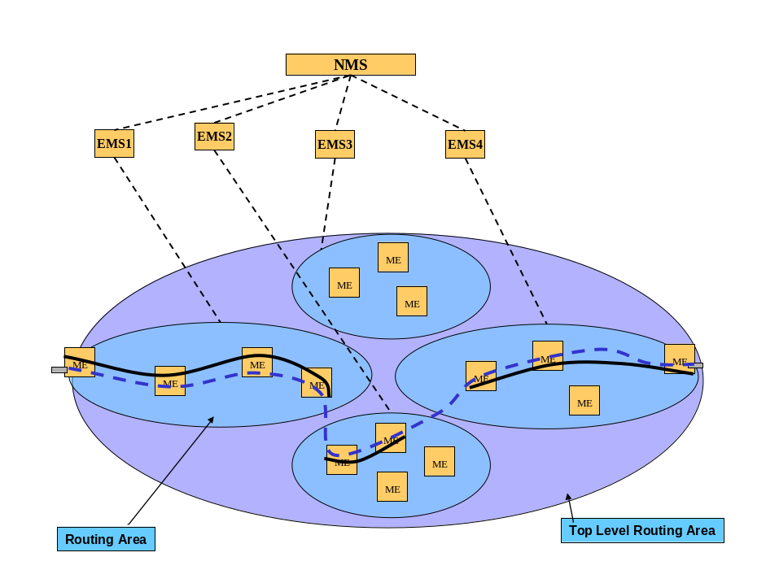
Figure 1 Basic view of managed control plane

The diagram above set out the network being considered (the diagrams used throughout this document relate to those set out in SD1-46_ASONControlPlaneManagement-Scenarios description). It shows the flow of a connection across the top level Routing Area and also the connections that support it in the subordinate Routing Areas. It should be noted here that some key aspects of the mapping from external standards to the IDL Solution set is summarised in Appendix G Mapping from external standards to Information Agreement and Solution Set on page55 and it is important to read this section to understand the terminology used throughout this document. The document will focus on the terminology used in the IDL Solution Set for the remainder of this section.

  - Management system architecture
It is assumed that in a majority of the cases of use of the interface the client of the NML-EML interface (the NML or OSS) will have a database in which it stores an image of the relatively static aspects of the network (SNPPLinks, Routing Areas etc). The primary style of operation here is “align and notify of change”. This style of operation is considered through a majority of the following section. The client application maintains a database or network cache that provides a view of all “static” network resources. The client application will align with full retrieval and will maintain alignment via notification

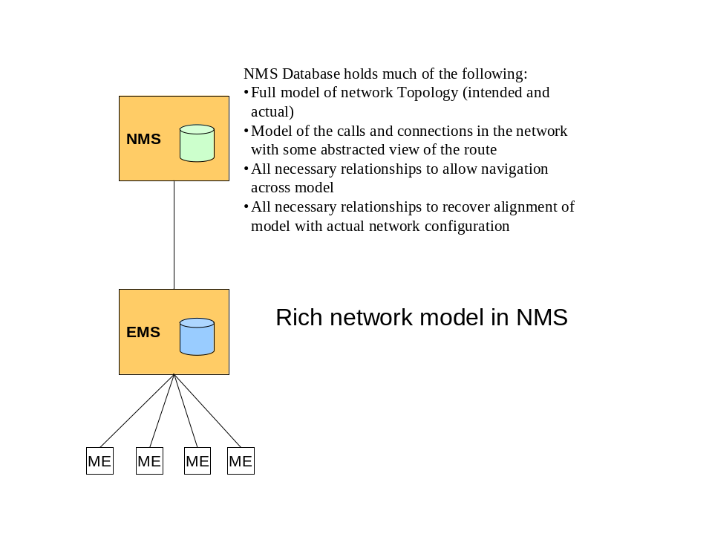
Figure 2 NMS with rich stored model

An alternative style where the client has little to no data stored is considered in brief at the end of the section. The client application does not maintain and extensive database/cache and effectively uses the network as the database. The client application will make specific enquiries for information on a per use operation basis.
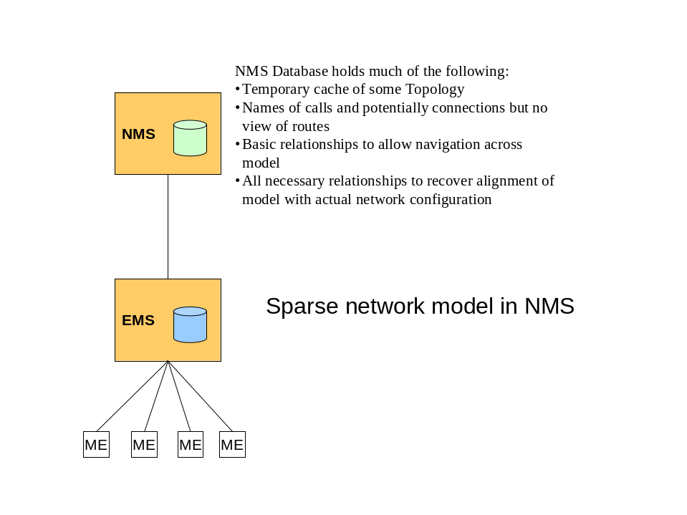
Figure 3 NMS with basic cache containing a sparse network model

  - Initial conditions
For the purposes of this description it is assumed that:
- Communications between the NMS and EMS were not active during the initial configuration of the control plane.
- The NMS has no information related to the control plane.
- A number of control plane components have been configured and resources have been allocated to the control plane from the transport plane
  - This allocation has been carried out using local EMS tools
- A number of calls have been set up, some as a result of UNI signalling (SC) and some as a result of direct operator action on the control plane (SPC)
- The NMS gains full knowledge of the transport infrastructure during an alignment phase outside the scope of this description using normal features available in release 3.0 of the MTNM interface.
  - This would include the retrieval of traditional MLSNs, PTPs and SNCs in the MLSNs.

  - Initial alignment
The NMS uses a retrieval operations to align with the current state of the control plane. The operations support retrieval of all control plane entity types supported by release 3.5 of the MTNM interface.

The enquiries that are to be performed allow the NMS to:
- Retrieve a list of all Multi-Layer Routing Areas from all EMSs
- Retrieve a list of all MLSNPPLinks from all EMSs
- Retrieve a list of all MLSNPPs from all EMSs
- Retrieve a list of all calls and top level connections from all EMSs
- Retrieve the home route of each top level connection
- Retrieve TPs to determine the control plane allocation state

The entities noted above are described in more detail in SD1-46_ASONControlPlaneManagement-Scenarios supporting document..

As a result of the sequence of enquiries above the NMS is aligned with the control plane for a majority of the Control Plane data.

Depending upon its role the NMS may require:
- The actual route of all connections (although this is not likely to be required other than for a very limited number of connections at any particular time (see section 2.10 Problem analysis – Discovering the route of a connection on page 34).
- The PTPs to determine the allocation and operational states (this uses standard release 3.5 operations to retrieve the PTP). The states are available via additional info.

The NMS should require no further information than that retrieved above to align its representation of the control plane network.

The operations identified above are described in detail in the following subsections.

Retrieve a list of all Multi-Layer Routing Areas from all EMSs
The section describes the way that the NMS will take to gather the MLRA (see Figure 1 Basic view of managed control plane).

The section is broken into two parts.
- The “Expected Approach” sequence described lends itself well to a management architecture where the NMS stores a full representation of the network and maintains alignment of the information in this store with the network (see Figure 2 NMS with rich stored model).

- If the NMS does not cache a network view then fragments of the sequence will be run depending upon the specific requirement as noted in the “Alternative Approach” (this fits with the management architecture where the NMS stores minimal information (see Figure 3 NMS with basic cache containing a sparse network model).

Expected approach
The operation sequence described in this section supports Use Case “NMS discovers Multi-Layer Routing Area (MLRA)s”. The aspects of this case described below are supported by the operations:
- ControlPlaneMgr::getAllMLRAs() from TMF 608
- EMSMgr_I::getAllMLRAs () from TMF814

The NMS retrieves a list of all Multi-layer Routing areas from the EMSs.
  - The NMS address each EMS in turn to retrieve the MLRAs for the entire network.
    - The operations identified provide the full set of MLSNs that represent MLRAs
    - For each MLSN that represent a Routing Node the NMS now knows the NE that support it
    - It is assumed that the NMS will already have a view of the MEs supported by each EMS using standard operations available in release 3.0 of the MTNM interface.
  - The MLSN representing the Top-Level MLRA will be returned by all EMSs that support the control plane. Each EMS should return the same named object.
  - Each EMS will also return the MLSNs representing the subordinate MLRAs that it manages. Each MLRA other than the Top-Level MLRA will be returned by only one EMS.
    - Note that in more complex network configurations than that considered here, some MLRAs would be returned by more than one EMS, however in the simple configuration where each MLRA (other than the Top-Level MLRA) is managed by one and only one EMS each MLRA (other than the Top-Level MLRA) would be returned only once.
  - The presence of the additional info attribute “RoutingAreaLevel” indicates the whether this MLSN is a MLRA. The relevance of MLRA can be identified by the value of the attribute:
    - “TopLevelRA” indicates that this is a Top-Level MLRA
    - “IntermediateRA” indicates that this is a routing area but is not the top level and is not a routing node
    - “MLRN” indicates that this is a Routing Node

Note that the following additional info attributes are supported:
  - “supportingMEName” which provides the name of the ME supporting a Routing Node
  - “SRG” which provides the routing node shared risk group information
  - "LayeredRoutingAreaList_T” which provides the control plane ids for the routing areas as the MLRA potentially represents many control plane routing areas (one per layer).
  - “superiorMLRA” which provides the name of the superior MLRA information to assist in determining the hierarchy of MLRAs.

As a result of this operation the NMS has a full view of the MLRA hierarchy (with each MLRA being represented by an MLSN) and of the ME that supports each Routing Node and as a consequence all MEs that support the control plane. The NMS also knows which EMS can provide information about any particular routing areas.

Alternative approach
The operation sequence described in this section supports the Use Case “NMS discovers Multi-Layer Routing Area (MLRA)s”. The sequence uses the Use Case “NMS discovers subordinate MultiLayer Routing Area (MLRA)s”. The aspects of this case described below are supported by the operations:
- ControlPlaneMgr::getAllTopLevelMLRA() from TMF 608
- MultiLayerRoutingArea::getAllSubordinateMLRAs() from TMF 608
- EMSMgr_I::getAllTopLevelSubnetworks() from TMF814
- MultiLayerSubnetworkMgr_I:: getAllSubordinateMLSNs() from TMF814

The NMS retrieves a list of all Multi-layer Routing areas from the EMSs.
  - The NMS address each EMS in turn to retrieve the necessary MLRAs for the entire network.
    - The operations identified can provide the full set of MLSNs that represent MLRAs or a subset as necessary
    - For each MLSN that represent a Routing Node the NMS now knows the NE that support it
    - It is assumed that the NMS will already have a view of the MEs supported by each EMS using standard operations available in release 3.0 of the MTNM interface.
  - The MLSN representing the Top-Level MLRA will be returned by all EMSs that support the control plane in response to the getAllTopLevelSubnetworks request. Each EMS should return the same named object so only one need be asked (see SD1-25_objectNaming).
  - Once the name of the MLSN representing the Top-Level MLRA is known the NMS can request each relevant EMS in turn to return the MLSNs representing the subordinate MLRAs that it manages using getAllSubordinateMLSNs. Each MLRA other than the Top-Level MLRA will be returned by only one EMS.
    - Note that in more complex network configurations than that considered here, some MLRAs would be returned by more than one EMS, however in the simple configuration where each MLRA (other than the Top-Level MLRA) is managed by one and only one EMS each MLRA (other than the Top-Level MLRA) would be returned only once.
  - The presence of the additional info attribute “RoutingAreaLevel” indicates the whether this MLSN is a MLRA. The relevance of MLRA can be identified by the value of the attribute:
    - “TopLevelRA” indicates that this is a Top-Level MLRA
    - “IntermediateRA” indicates that this is a routing area but is not the top level and is not a routing node
    - “MLRN” indicates that this is a Routing Node
  - The NMS repeats the operation getAllSubordinateMLSNs for each returned MLSN other than those that represent Routing Nodes until there are no more non-routing node MLSNs to query or until the necessary set of MLSNs have been temporarily cached.

Note that additional info is described in the previous section.

Note that to speed realignment in particular cases fragments of the above sequence may be of use. However it is likely that the operation getAllSubordinateMLSNs will not be of use to an NMS that maintains a full representation of the network where the approach described in 2.4.1.1 Expected approach on page 10 would be sufficient.

As a result of these operations the NMS can gain the necessary view (up to full view) of the MLRA hierarchy (with each MLRA being represented by an MLSN) and of the ME that supports each Routing Node and as a consequence all MEs that support the control plane. The NMS also knows which EMS can provide information about any particular routing areas.

Retrieve a list of all MLSNPPLinks from all EMSs
The section describes the approach that the NMS will take to gather the MLSNPPLinks (see Figure 4 View of Routing Areas and SNPP Links and further details in SD1-46_ASONControlPlaneManagement-Scenarios).

There are two potential approaches that the NMS can take. The first is the expected approach and the second an alternative.

The first approach lends itself well to a management architecture where the NMS stores a representation of the network and maintains alignment of the information in this store with the network (see Figure 2 NMS with rich stored model). The second approach (probably run in fragments) fits with the management architecture where the NMS stores minimal information (see Figure 3 NMS with basic cache containing a sparse network model).
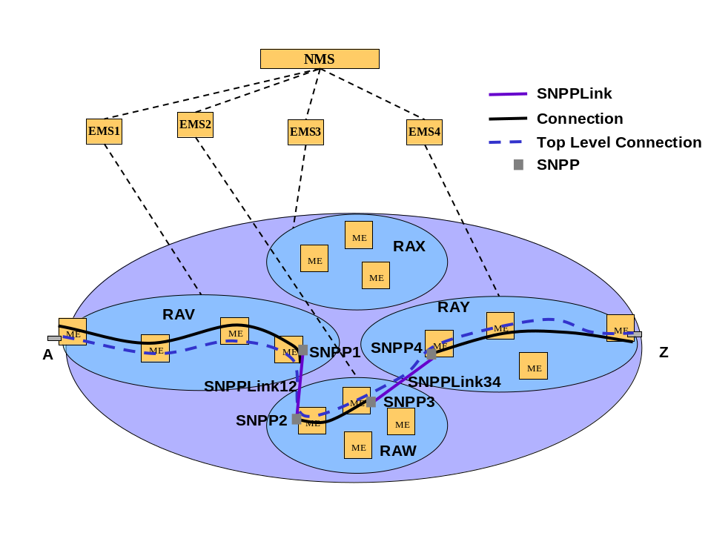
Figure 4 View of Routing Areas and SNPP Links

Expected approach
This operation is covered by the Use Case “NMS discovers MLSNPP Links” with the filter set to “all”. The aspects of this case described below are supported by the operations:
- MultiLayerRoutingArea::getAllMLSNPPLinks() from TMF 608
- EMSMgr_I::getAllMLSNPPLinks() from TMF814

The NMS targets all EMSs that support the control plane (i.e. those that provided MLSNs representing MLRAs in 2.4.1 Retrieve a list of all Multi-Layer Routing Areas from all EMSs on page 9) and gathers a list of all MLSNPP Links. This will provide the NMS with a view of the SNPP alias and the relationship between the SNPPs and the transport entities (PTP/CTP). The operation returns Links that are UNIs as well as ENNI/NNI (refer to Appendix C.4 SNPP Links and SNPPs on page 44 for an explanation of the SNPP).

An EMS can only provide full information for an SNPP Link if it also manages the associated physical resources.

The NMS uses an operation on each EMS to retrieve all MLSNPP Links in the Network. It is assumed that the NMS would request all the known SNP to CTP mappings at this stage by setting “sNPListRequested” to True. Note that when the TP is allocated to the control plane (“allocatedToControlPlane” = “True”) the TP attribute ”TPConnectionState_T” should take the state “TPCS_NA” as it does not reflect the connection state of the control plane.

The single operation returns:
- All edge MLSNPP Links for the Top-Level MLRA from an EMS that exposed the Top-Level MLRA.
- The EMS only provides edge MLSNPP Links for which it knows the relationship to the transport entities (PTP/CTP) to remove excessive duplication of partial information.
- The MLSNPPLinks can be one of the following interfaceTypes:
  - “UNI”,
  - “external E-NNI”
  - “UNSPECIFIED” (where there is no signalling – the link is “dumb”)
- Each MLSNPPLink will provide, as appropriate:
  - UNI signalling information including signalling controller reference and signalling protocol parameters for UNI MLSNPP Links
  - SNPP Alias list for all levels of the routing area hierarchy and SNP to CTP mappings via the structure “LayeredSNPPLinkList_T”
  - TNA references where applicable for both the SNPP and SNP aliases (see Appendix F TNA on page 54)
  - A pointer to each Routing Area for each SNPP
  - All internal MLSNPP Links for the Top-Level MLRA from each EMS that exposed the Top-Level MLRA
- The EMS only provides internal MLSNPP Links for which it knows the relationship to the transport entities (PTP/CTP) at least at one end of the Link.
  - Where the MLSNPP link connects MLSNPPs of two routing areas that are not each managed by the same EMS, i.e. one EMS knows one end and another EMS the other, the sequence of operations on all EMSs will return the link to the NMS twice. In this case the NMS will need to merge the information from the two instances of the link as one will contain mappings to the transport naming for one end and the other for the other. The aliases will also only be partially filled out in each case.
  - The merge can be carried out by utilising the control plane identifiers such as raID as these are communicated across the control plane network.
- The MLSNPPLinks can be one of the following interfaceTypes:
  - “Internal E-NNI”
  - “I-NNI”
- Each MLSNPPLink will provide:
  - SNPP Alias list for all levels of the routing area hierarchy and SNP to CTP mappings via the structure “LayeredSNPPLinkList_T”
  - TNA references where applicable for both the SNPP and SNP aliases
  - All internal MLSNPP Links for each intermediate level MLRA from the EMS that exposed it.
- In the example network used for this scenario all MLSNPPLinks will be fully defined because:
  - each MLRA directly subordinate to the Top-Level MLRA is managed by only one EMS (i.e. both ends of any MLSNPP Link internal to a particular MLRA will be known to a single EMS).
  - the EMS manages all MEs that support a particular MLRA (i.e. all SNP to CTP resource mappings can be provided).
- In the example network used for this scenario all MLSNPPLinks will be of interfaceType “I-NNI” because the next subordinate level of MLRAs are Routing Nodes (as the example is a three level hierarchy).
- Each MLSNPPLink will provide:
  - SNPP Alias list for all levels of the routing area hierarchy and SNP to CTP mappings via the structure “LayeredSNPPLinkList_T”.
    - In the example (see Figure 1 Basic view of managed control plane) the MLSNPPLink ends will have only one level as the subordinate MLRAs are all Routing Nodes.
  - TNA references where applicable for both the SNPP and SNP aliases

Note that the following additional info attributes are supported:
- “SRG” which provides the shared risk group information for the link

As a result of this operation the NMS has a full view of all MLSNPPLinks and for each the SNPP aliases and CTP mappings for both ends. The NMS also knows which EMS can provide information about any particular MLSNPPLinks.

Alternative approach
If the management architecture is one where the NMS stores minimal information (see Figure 3 NMS with basic cache containing a sparse network model) it is likely that in most cases only fragments of the network topology are required to be retrieved at any one time. The interface offers the following capabilities.

This operation sequence sketched in this section covers the Use Case “NMS discovers MLSNPP Links” for various filter settings other than “all”. The aspects of this case described below are supported by the operations:
- MultiLayerRoutingArea::getAllMLSNPPLinks() from TMF 608
- MultiLayerRoutingArea::getAllInternalMLSNPPLinks() from TMF 608
- MultiLayerRoutingArea::getAllEdgeMLSNPPLinks() from TMF 608
- MultiLayerSubnetworkMgr_I::getAllMLSNPPLinks() from TMF814
- MultiLayerSubnetworkMgr_I::getAllInternalMLSNPPLinks() from TMF814
- MultiLayerSubnetworkMgr_I::getAllEdgeMLSNPPLinks() from TMF814

As this is not the preferred sequence and as there is a great deal of variety as to the sequence followed this section only provides a sketch.

It would be possible for the NMS to gather all MLSNPPLink information in a stepwise fashion:
- By commencing with the MLSN representing the top level MLRA and gathering first the Edge MLSNPPLinks (from all EMSs that report the MLSN representing the top level MLRA)
- Then proceeding for each the Internal MLSNPPLinks:
  - Where the MLSNPP link connects MLSNPPs of two routing areas that are not each managed by the same EMS, i.e. one EMS knows one end and another EMS the other, the sequence of operations on all EMSs will return the link to the NMS twice. In this case the NMS will need to merge the information from the two instances of the link as one will contain mappings to the transport naming for one end and the other for the other. The aliases will also only be partially filled out in each case.
- Then proceeding for each MLSN representing a subordinate MLRA (other than Routing Nodes) to gather the Internal MLSNPPLinks.

Note that additional info is described in the previous section.

Retrieve a list of all MLSNPPs from all EMSs
This operation is covered by the Use Case “NMS request EMS for the list of MLSNPPs”. The aspects of this case described below are supported by the operations:
- MultiLayerRoutingArea::getAllMLSNPPs() from TMF 608
- EMSMgr_I::getAllMLSNPPs() from TMF 814

The NMS retrieves a list of all MLSNPPs (that represent G.805 TCPs – see Appendix D TCP Termination – concept on page 47) from each EMS that reported MLRAs. This provides the NMS with a view of the MLSNPP aliases and the relationship between the transport entities (PTP/CTP). It is assumed that the NMS would request all the known SNP to CTP mappings at this stage by setting “sNPListRequested” to True.

The NMS uses an operation on each EMS to retrieve all MLSNPPs in the Network. The single operation returns:
- All MLSNPPs from an EMS.
- The EMS only provides MLSNPPs for which it knows the relationship to the transport entities (PTP/CTP) to remove excessive duplication of partial information.
- Each MLSNPP will provide:
  - SNPP Alias list for all levels of the routing area hierarchy and SNP to CTP mappings via the structure “LayeredSNPPList_T”
  - TNA references where applicable for both the SNPP and SNP aliases
  - A pointer to each Routing Area for each SNPP
  - The name of the highest level MLRA in which it appears (via naming)

As a result of this operation the NMS has a full view of all MLSNPPs and for each the SNPP aliases and CTP mappings for both ends. The NMS also knows which EMS can provide information about any particular MLSNPPs.

Retrieve calls and connections
The retrieval of calls and connections for alignment of an NMS with the view of the network held by an EMS is best described in two parts:
- The retrieval of calls and top level connections
- The retrieval of the route of the connections

The following two subsections set out this process.

Retrieve a list of all calls and top level connections from all EMSs
This operation is covered by the Use Case “NMS discovers Calls and top level Connections”. The aspects of this case described below are supported by the operations:
- MultiLayerRoutingArea::getAllCallsAndTopLevelConnections() from TMF 608
- MultiLayerSubnetworkMgr_I:: getAllCallsAndTopLevelConnections () from TMF814

The NMS retrieves a list of all calls and top level connections from each EMS that reported MLRAs.
- All Calls are assumed to be present in the Top-Level routing area (the MLRA name is provided as a reference to the operation).

The EMS will respond with a list of calls where each call that is in the response:
- Is supported by at least one connection that originates from (has an A end that is part of) an SNPP of which the EMS has full visibility (i.e. can provide the transport mapping between the SNP and CTP).
- This reduces the level of duplication of call/connection information in general and in the scenario used here means that each call and its top level connections are reported from only one EMS.
  - The A end of a call is assumed to align with the A ends of all of the connections supporting it
  - It is assumed that for all connections of a call, the A end MLSNPPLink/MLSNPP of each connection supporting a specific call has an alias SNPP that is in an MLRA managed by a single EMS so that the A end of all connections are visible to that single EMS
- Is supported by zero connections
- A call with no connections is not signalled in the control plane. It is assumed that if a call with no connections is to be set up in preparation for the instantiation of a service it will be set up in the EMS that is expected to manage that service. It is assumed here that the EMS managing the service will manage the resources at the A end of the connections that are to be created to support the call that provides the service.
- For each Call the EMS will respond with an SNC for each of the Top-Level connections that support that call.
- For a connection the Z end is likely to be not managed by the EMS returning the connection of the connection, the returned name in the Z end will be whatever the control plane provided. It will be at least the TNA Name (as this is signalled). The remote point may Include the SNPP+SNP Name, PTP+CTP Name if the EMS has the necessary view.

Note that the following additional info attributes are supported for a connection:
- “aEndTPList” and “zEndTPList” which provide the TP aliases of the A and Z end SNP
- “aEndTNANameOrGroupTNAName” and “zEndTNANameOrGroupTNAName” which provide the TNA name for the A and Z end of the connection respectively.
- “routeGroupLabel” indicates which route group the connection belongs to
- “connectionSetUpType” indicates whether the connection is a PC, SC or SPC
- “CallId” provides the control plane signalled id (name) of the call
- “ConnectionId” provides the control plane signalled id for the connection
- “ConnectionState” indicates whether the connection has a route or not (and will therefore influence the next stage of the process)
- “UsingHomeRoute” indicates whether the connection is on the home route or not

As a result of this operation the NMS has a full view of all Calls and for each call the Top-Level connections (each in the form of an SNC) that support the call. The NMS also knows which EMS can provide information about any particular Call and any particular Top-Level connection.

Retrieve a list of the home route of each top level
This scenario assumes that the NMS is required to align its database with the home routes of each connection supporting all calls and as a consequence it will cycle through the route retrieval operations for each connection in turn to completion.

There are two methods for deriving the route from the control plane depending upon the signalling used in the specific case of the control plane.

The first and second approaches below both lend themselves well to a management architecture where the NMS stores a representation of the network and maintains alignment of the information in this store with the network (see Figure 2 NMS with rich stored model). If the NMS does not retain the topology (i.e. the NMS stores minimal information, see Figure 3 NMS with basic cache containing a sparse network model), then this can be accommodated requesting that the EMS provide MLSNPPLinks as well as the SNCs.

Expected approach - Follow the route
This operation is covered by 9.3.10 “NMS requests EMS for the route details of the connection(s) supporting a specified Call within a specified routing area”. The aspects of this case described below are supported by the operations:
- MultiLayerRoutingArea::getConnectionsAndRouteDetails() from TMF 608
- MultiLayerSubnetworkMgr_I::getConnectionsAndRouteDetails() from TMF814

The following figure has been used to help illustrate the sequence of operations.
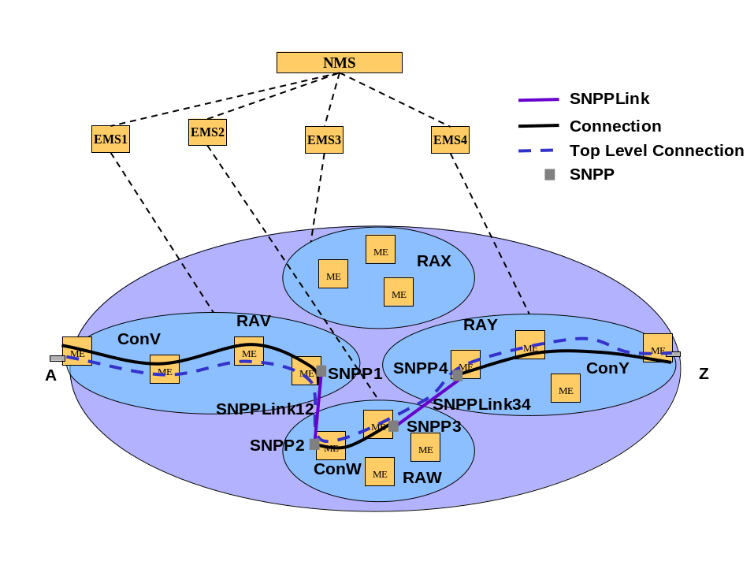
Figure 5 Following the route

The NMS works across each Top-Level connection that supports a call navigating the connections and MLSNPPLinks that support it.

- For a specific Top-Level connection of a specific call the NMS identifies the SNP/CTP name at the A end from the connection object:
  - The MLSNPPLink/MLSNPP that references this SNP/CTP can be found in the set of MLSNPPLinks/MLSNPPs that were obtained in 2.4.2 Retrieve a list of all MLSNPPLinks from all EMSs on page 12 and 2.4.3 Retrieve a list of all MLSNPPs from all EMSs on page 16
  - The connection may provide the CTP name in some cases. Where it is not provided it can be derived from the SNP name using the MLSNPPLink SNP-CTP mapping information.
- The NMS identifies the name of the MLRA one level subordinate to the Top-Level MLRA (in the figure this is RAV) from the MLSNPPLink/MLSNPP information and other previous operations
  - The set of MLRAs one level subordinate to the Top-Level MLRA are known from previous operations 2.4.1 Retrieve a list of all Multi-Layer Routing Areas from all EMSs on page 9)
  - From each MLRA the list of Routing Areas that it represents can be derived
  - Each SNPP referenced in the MLSNPPLink/MLSNPP references a Routing Area
  - One of the SNPPs in the MLSNPPLink/MLSNPP at the end of the connection will reference a Routing Area that is represented by a MLRA one level subordinate to the Top-Level MLRA. This MLRA is the one to chose.
  - Alternatively CTP Name information can be used as follows:
    - The CTP name provides an ME name
    - The ME is related to a Routing Node (reverse of reference derived earlier)
    - The Routing Node provides a pointer to the superior MLRA (which is the target MLRA as this scenario is a 3 Level scenarios, i.e. one up from Routing Node is one down from Top-Level).
- The NMS identifies the target EMS (in the figure example this is EMS1) using the MLRA/CTP name derived in the previous alignment step 2.4.1”Retrieve a list of all Multi-Layer Routing Areas from all EMSs” on page 9
  - In this simplified scenario the target EMS for the first connection in a chain of connections supporting a Top-Level connection will be the same one from which that Top-Level connection and the supported call were derived.
- The NMS request the target EMS to provide the SNC that represents the connection across the referenced MLRA (in the example figure this is ConV), supporting the referenced Call ID and originating from the referenced SNP (or SNPP)
  - The SNP (or SNPP) alias used is the one corresponding to the Routing Area represented by the referenced MLRA
  - It is assumed that the MLSNPPLinks connecting the Routing Areas are already known to the NMS and will not need to be derived again so the parameter “MLSNPPLinkRequested” will be set to FALSE.
  - It is assumed that the operation will only request the RouteType ““HOME/INTENDED” as the NMS does not require to track actual route
  - The response from the EMS will include:
    - the connection across the referenced MLRA
    - the route details in terms of crossconnects (representing Routing Node Connections) and MLSNPP Links (assuming a 3 level routing area hierarchy)
    - It is assumed here that the A end of this SNC corresponds to the A end of the Top-Level SNC
  - Note that the NMS need not reference the MLRA in which case the EMS should return all SNCs that represent connections supporting the referenced call in any MLRAs that EMS manages.
  - This will potentially return the route more efficiently as in a normal situation an EMS will manage several MLRAs.
  - In some cases the entire route may be returned as a result of this single enquiry
- The NMS uses the newly identified SNC to determine the next target EMS etc
  - Assuming that the SNP used to find the SNC was at the A-end the SNP name provided in the SNC Z-end is used to identify the next MLSNPPLink as covered by step (1) above (the SNPP1 and the MLSNPPLink corresponding to SNPPLink12 are identified)
    - It should be noted that if there is SNCP under the control of the control plane this will give rise to two Z-ends and hence a more complex connection navigation algorithm. This scenario assumes an unprotected connection.
  - The MLSNPPLink is used to identify the next EMS to interrogate and the MLRA reference
    - The SNP will be referenced as an alias in the appropriate MLSNPPLink
    - The SNP at the other end of the SNPPLink (the remote end) can be determined from the MLSNPPLink information
      - This can be determined by examining the contents of LayeredSNPPLinkList_T. of the MLSNPPLink.
    - The remote end MLSNPPLink information is then used to identify the next MLRA reference and the corresponding EMS to interrogate (using the approach described in steps (2) and (3) above)
  - The identified EMS is interrogated for the next SNC (using step 4 of this approach above)
- The method set out in step (5) above is repeated for all of the connections supporting the Top-Level connection (i.e. until the Z end of the Top-Level connection is reached)
- The above approach is used for all Top-Level connections supporting the call
- The above approach is used to identify the routes for all of the calls

As a result of this operation sequence the NMS has a full view of the home route of each Top-Level connection across the network.

Alternative approach - Gather the route
This operation is covered by the Use Case “NMS requests EMS for the list of subordinate Multi-Layer Routing Areas involved in the route of a Connection” and the Use Case “NMS requests EMS for the route details of the connection(s) supporting a specified Call within a specified routing area”. The aspects of the Use Case “NMS requests EMS for the list of subordinate Multi-Layer Routing Areas involved in the route of a Connection” described below are supported by the operations:
- MultiLayerRoutingArea::getAllSubordinateRAidsWithConnection() from TMF 608
- MultiLayerSubnetworkMgr_I::getAllSubordinateRAidsWithConnection() from TMF814
The aspects of the Use Case “NMS requests EMS for the route details of the connection(s) supporting a specified Call within a specified routing area” described below are supported by the operations:
- MultiLayerRoutingArea::getConnectionsAndRouteDetails() from TMF 608
- MultiLayerSubnetworkMgr_I::getConnectionsAndRouteDetails() from TMF814

The NMS takes each Top-Level connection that supports a call and gathers a list of the MLRAs that support the connection. The NMS then collects the connections from each of the listed MLRAs and assembles a picture of the connection route as approriate (in the example figure this would result in ConV, ConW and ConY having been retrieved).

Note that this approach will only provide the route in the case when the Use Case “NMS requests EMS for the list of subordinate Multi-Layer Routing Areas involved in the route of a Connection” provides all MLRAs involved in the connection (“Full case”) and not for the use case “Sparce case”

- For a specific call the NMS identifies the EMS that controls the call
- For a specific Top-Level connection of a specific call the NMS requests the identified EMS to provide a list of ids of the Routing Areas that the connection passes through
- For each RAid in turn (no relevant order) the NMS identifies the target EMS using the information provide by the previous alignment step 2.4.1”Retrieve a list of all Multi-Layer Routing Areas from all EMSs” on page 9
- The NMS request the target EMS to provide the SNC that represents the connection across the referenced MLRA, supporting the referenced Call ID
  - It is assumed that the MLSNPPLinks connecting the Routing Areas are already known to the NMS and will not need to be derived again so the parameter “MLSNPPLinkRequested” will be set to FALSE.
  - It is assumed that the operation will only request the RouteType “Home” as the NMS does not require to track actual route
  - The response from the EMS will include:
    - the connection across the referenced MLRA
    - the route details in terms of crossconnects (representing Routing Node Connections) and MLSNPP Links (assuming a 3 level routing area hierarchy)
    - It is assumed here that the A end of this SNC corresponds to the A end of the Top-Level SNC
  - The connection may provide the CTP name in some cases. Where it is not provided it can be derived from the SNP name using the MLSNPPLink SNP-CTP mapping information.
- This method set out in step (4) of this approach above is repeated for all of the listed MLRAs that support connections supporting the Top-Level connection
  - It is expected that the NMS will then use the MLRA and MLSNPPLink information that it derived earlier to arrange the connections in a logical order accounting for any SNCP configurations under the control of the control plane
- The above method is used for all Top-Level connections supporting the call
- The above method is used to identify the routes for all of the calls
The NMS would retrieve the home route of the top level connections by following the route from the A end in a sequence of operations working across the network for each call in turn.

As a result of this operation the NMS has a full view of the home route of each Top-Level connection across the network.

Gathering TP information related to the control plane
This operation is covered by the existing Use Case “NMS discovers the EMS network inventory”. The aspects of this case described below are supported by the operations:
- ManagedElement::getAllPTPs() from TMF 608
- TerminationPoint::getContainedPotentialCTPs() from TMF 608
- ManagedElementMgr_I::getAllPTPs() from TMF 814
- ManagedElementMgr_I::getContainedPotentialTPs() from TMF 814 (where the control plane allocation is resolved to CTP level)

The operations on the TP noted above return all PTPs, FTPs and CTPs. Those related to the Control Plane include an additional info attribute related to the control plane indicating that the resources are allocated to the control plane
- “allocatedToControlPlane” with value “True”

As a result of running these operation the NMS has a full view of the TPs that are used to support the Control Plane and the state of those TPs.

  - Call and Connection management
This section provides a brief overview of the key call and connection management cases in the context of a call and connection lifecycle. The scenario assumes that the network is running and the OSS is aligned with the network as per the operations identified in the previous sections.

The network operator wishes to Establish a call to support a service where the service is supported by a single connections via RAV, RAX, RAY in Figure 6 Call and Connections below.

The service is then modified to add a second connection that is diverse from the first via RAV, RAW and RAY in Figure 6 Call and Connections below (for diversity specification considerations see Appendix E Diversity on page 48). Then after some time the service is ceased.
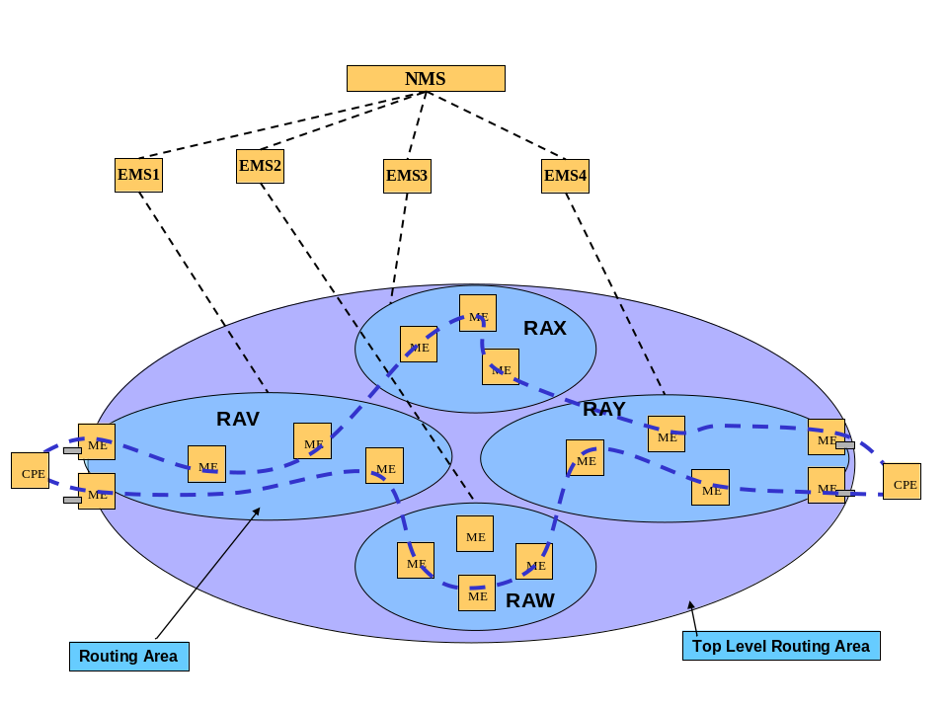
Figure 6 Call and Connections

Establishing a call
This operation is covered by the Use Case “NMS establishes a Call”. The aspects of this case described below are supported by the operations:
- MultiLayerRoutingArea::establishCall() from TMF 608
- MultiLayerSubnetworkMgr_I::establishCall() from TMF 814
Note that the operations applies to both traditional and control plane networks but is considered here only in the context of control plane.

The call may be established prior to the message response being sent or there may be a significant delay in finding the route or activating the connection. This will result in a response indication a stage of completion and then this will be followed by notifications (Use Case “EMS notifies NMS of inventory change” and existing IDL/UML etc). This is covered in full in the Use Case and further in the UML.

Note that:
- The following additional info attributes may be supplied via the “SNCCreateDataList_T” structure in “additionalCreationInfo” (refer to the Use Case for more details on end names and use of null identifiers):
  - “aEndTNANameOrGroupTNAName” and “zEndTNANameOrGroupTNAName” which provide the TNA name for the A and Z end of the connection respectively (see Appendix F TNA on page 54 for information on “GroupTNAName”)
  - “aEndTPList” and “zEndTPList” which provide the TP aliases of the A and Z end SNP.
    - Only TPs that have been allocated to the control plane may be used as references in the establish call
  - “routeGroupLabel” indicates which route group the connection belongs if any
- If an SNPP name was used in the “SNCCreateData” then the returned connection should provide the SNP details, plus optionally the PTP/CTP details.
  - It is within specification to provide null TP names in additional info of the connection
- If the call ends on a point with TNA Name defined, then the connection should return the TNA Name for the SNP regardless of the naming scheme used to specify the end of the connection (as this will remove the need for another lookup of SNP to TNA Index).
  - Optionally the PTP/CTP name is listed as well.
- For the remote end point, the returned name will be whatever the control plane provided.
  - This may be the TNA Name (as this is potentially signalled).
  - The remote point may Include the SNPP+SNP Name, PTP+CTP Name if the EMS has the necessary view.
- The returned connections will be as described in 2.4.4 Retrieve calls and connections on page 17.
  - The additional info attribute “connectionState” indicates whether the connection has a route (“COMPLETE”) or not (“SEARCHING”). If the connection indicates “Searching” then there will be further notifications as defined in the Use Case “NMS establishes a Call”.
  - The “connectionSetUpType” in the returned connections will indicate that the connection is an SPC

All PTP/CTP/FTPs will be visible to the management plane independent of the allocation to the control plane. An additional info attribute is provided to indicate that a TP is no longer available to the management plane for connectivity (“allocatedToControlPlane”). If the NMS attempts to use a CTPs for traditional connections whilst it is allocated to the control plane there are two potential behaviours:
- The operation is rejected by the NE/EMS - expected behaviour for release 3.5
- The operation is accepted and activated in the network
If the connection is activated in the network it is possible that the control plane may:
- Immediately remove the connection
- Operate inconsistently
- See the bandwidth used by the connection as not available
Specifying behaviour other than rejection is outside the scope of this release.

Note also related operations to release a call:
- Use Case “NMS releases a Call”
- MultiLayerRoutingArea::releaseCall() from TMF 608
- MultiLayerSubnetworkMgr_I::releaseCall() from TMF 814

Note also related cases:
- Use Case “EMS notifies NMS of new Call and its Connection(s)”
- Use Case “EMS notifies NMS of deleted Call and its top level Connection(s)”

Add connection to call
This operation is covered by the Use Case “NMS adds one or more Connections to a Call”. The aspects of this case described below are supported by the operations:
- Call::addConnections() from TMF 608
- MultiLayerSubnetworkMgr_I::addConnections() from TMF 814

If the connection to be added to a call is to be diverse from an existing call and the call has only one connection prior to the addition and has no diversity/co-routing settings, because the route group information will need to set on the existing connection (via the additional info attribute routeGroupLabel“ it will be necessary to prepare the existing call and connection as described:
- Use Case “NMS requests EMS to set/modify diversity and co-routing parameters of a Call”
- Call::modifyDiversityAndCorouting() from TMF 608
- MultiLayerSubnetworkMgr_I::modifyDiversityAndCorouting() from TMF 814

Note also related operations to:
- Remove connections
  - Use Case “NMS removes one or more Connections from a Call”
  - Call::removeConnections() from TMF 608
  - MultiLayerSubnetworkMgr_I::removeConnections() from TMF 814
- Modify call details
  - Use Case “NMS modifies a Call”
  - MultiLayerRoutingArea::modifyCall() from TMF 608
  - MultiLayerSubnetworkMgr_I::modifyCall() from TMF 814

  - Preparing for SC Call establishment – UNI signalling setup

General Considerations
The Control Plane supports for two distinct types of call:
- SPC: request sent by the OSS via the NML-EML interface to the Control Plane potentially as a result of a request for service via perhaps a traditional CRM from a customer of the network
- SC: request sent by the customer of the network directly to the Control Plane via a UNI using signalling

The customer of the network would choose the type of Service that they wished to purchase. If a Service based upon SC Calls is required the network operator will need to enable the signalling facilities for the network customer.

For a customer of the network to set up an SC call using UNI signalling the signalling infrastructure at the service edge will need to be setup.

As indicated in Appendix A Limitations of this release on page 36, the Control Plane feature in release 3.5 does not cover any form of management of the Control Plane processing components such as call controllers and signalling controllers (see section C.2 Communication infrastructure on page 44), i.e. it is not possible to create, examine or configure these entities. The one exception is management of the configuration of the UNI signalling controller via the MLSNPPLink (which is essentially used as a proxy for the signalling controller).

This section identifies the operations that would be required over the NML-EML interface to setup UNI signalling to enable an SC Call to be established via UNI signalling by a customer of the network.

This section also highlights the operations over the interface required to adjust the signalling properties and to remove UNI signalling from a particular customer’s access.

Assign, configuring and activating signalling
The process of enabling signalling is divided into three steps that should be run in sequence:
- Associate the signalling controller
  - Use Case “NMS requests EMS to assign a UNI MLSNPP”
  - MultiLayerSNPPLink::assignSignallingController() from TMF 608
  - MLSNPPLinkMgr_I::assignSignallingController() from TMF 814
- Set the signalling parameters
  - Use Case “NMS requests EMS to set the UNI signaling protocol and parameters”
  - MultiLayerSNPPLink::setSignallingProtocolAndParameters() from TMF 608
  - MLSNPPLinkMgr_I::setSignallingProtocolAndParameters() from TMF 814
- Enable signalling
  - Use Case “NMS requests EMS to enable the UNI signaling on an MLSNPP Link”.
  - MultiLayerSNPPLink::enableSignalling() from TMF 608
  - MLSNPPLinkMgr_I::enableSignalling() from TMF 814

It should be noted that the signalling controller identifier is a free format string.

Adjustment of Signalling properties
Parameter of the signalling protocol can be modified using the following operation (assuming that the signalling protocol is not to be modified):
- Use Case “NMS requests EMS to modify signaling parameters”
- MultiLayerSNPPLink::modifySignallingProtocolParameters() from TMF 608
- MLSNPPLinkMgr_I::modifySignallingProtocolParameters() from TMF 814

If the signalling protocol is to be modified then it is expect that the following sequence would be required:
- Disable Signalling (see 2.6.4 Removal of UNI signalling on page 29)
- Modify parameters (as above)
- Enable Signalling (see 2.6.2 Assign, configuring and activating signalling on page 28)

Removal of UNI signalling
The process of removing the relationship to a signalling controller is divided into two steps that should be ruin sequence:
- Disable the signalling controller
  - Use Case “NMS requests EMS to disable the UNI signaling on an MLSNPP Link”
  - MultiLayerSNPPLink::disableSignalling() from TMF 608
  - MLSNPPLinkMgr_I::disableSignalling() from TMF 814
- Deassign the signalling controller
  - Use Case “NMS requests EMS to deassign a UNI MLSNPP Link from a Signalling Controller”
  - MultiLayerSNPPLink:: deassignSignallingController() from TMF 608
  - MLSNPPLinkMgr_I: deassignSignallingController() from TMF 814

  - Assigning and deassigning a TNA
TNA names and TNAGroup names can be associated to MLSNPPLinks and MLSNPPs. In both cases there may be several TNA/TNAGroup names associated to a specific MLSNPP or the ends of MLSNPPLink. A TNA/TNAGroup name can be associated to the entire MLSNPP, to an end of an MLSNPPLink or to a subordinate part of an MLSNPP/MLSNPPLink, i.e. an SNPP or SNP. In each case only one TNA name and one TNAGroup name may be associated (see also Appendix F TNA on page 54).

To assign one or more TNA/TNAGroup name to an MLSNPP or to deasign one or more TNA/TNAGroup from an MLSNPP or any of the subordinate parts the following operation is used:
  - Use Case “NMS requests EMS to assign TNA Names to components of an MLSNPP”
  - MultiLayerSNPP::setTNAName() from TMF 608
  - MLSNPPMgr_I::setTNANameForMLSNPP() from TMF 814

To assign a TNA to an MLSNPPLink or to deasign a TNA from an MLSNPPLink or any of the subordinate parts the following operation is used:
  - Use Case “NMS requests EMS to assign TNA Names to components of an MLSNPP Link”
  - MultiLayerSNPPLink::setTNAName() from TMF 608
  - MLSNPPLinkMgr_I::setTNANameForMLSNPPLinkEnd() from TMF 814

Note that in both cases above deassignment is achieved by setting an empty string value for a TNA/TNAGroup as described in the use case.

  - Detecting the establishment of a UNI Call
Establishment of a call in the network results in standard object creation notifications for both the call and the associated connections. This is described in Use Case “EMS notifies NMS of new Call and its Connection(s)”. Each top level connection reported will indicate that the call was established via a UNI as the additional info attribute “connectionSetUpType” in the returned connection will be set to “SC”.

  - Infrastructure build – Maintaining alignment with the network

General Considerations
As indicated in Appendix A Limitations of this release on page 36, the Control Plane feature in release 3.5 does not cover the build of infrastructure, i.e. it is not possible to create MLSNPPLinks or MLRAs across the interface.

In general it is assumed that the operator will use network planning capabilities of the OSS to identify control plane infrastructure needs and will apply changes to the local control plane components via the EMS GUI and appropriate tools local to the Control Plane to satisfy these needs. The infrastructure build is identified in Appendix C.5 Setup achieved by configuration outside the scope of the MTNM interface on page 46 and it is assumed that the approach taken to growing and adjusting the Control Plane capacity will be essential the same as that implied by the Appendix.

Basic Notifications of change
When the Control Plane is being managed by the NMS changes made to the infrastructure need to be conveyed to the NMS via the MTNM interface. The changes in the control plane, i.e. to any objects/attributes identified in section 2.4 Initial alignment on page 9 are covered by standard notifications:
- Add/remove MLRA – Object Creation/Deletion
- Add/remove MLSNPPLink – Object Creation/Deletion
- Add/remove MLSNPP – Object Creation/Deletion
- Add/remove connections
- Attribute change in any entity

Object creation, deletion and attribute change notification covered by existing capability (see Use Case “EMS notifies NMS of inventory change”).

Link Capacity change
Although covered by standard attribute change notification, link capacity is conveyed via a complex attribute and is described in Use Case “EMS notifies NMS of changes in network capacity (increases/decreases in capacity”).

MLSNPPLink Lifecycle
This section considers the combination of notifications that will arise as a result of:
- the creation of an MLSNPPLink
- the increase in capacity of the MLSNPPLink
- the decrease in capacity of the MLSNPPLink
- the deletion of the MLSNPPLink

Creation of an MLSNPPLink
The following figure sets out the relationship between the transport resources, the control plane resources and the representation over the MTNM interface. It should be noted that the MTNM MLSNPPLink does not come into existence until such time as the SNPPLink in the control plane exist and resources have been successfully allocated. The MLSNPPLink ceases to exist when there are no resources allocated to the corresponding SNPPLink.
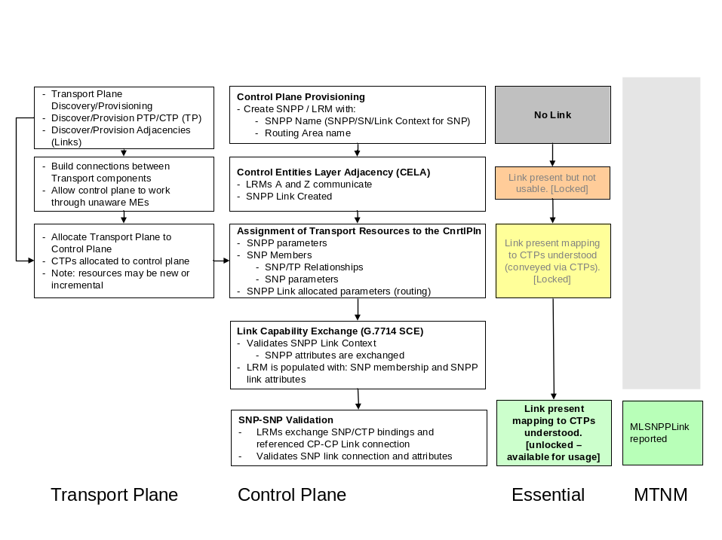
Figure 7 Discovery of SNPPLinks – network preconditions

Addition of first capacity to the SNPPLink or set of Links at different layers will cause:
- MLSNPPLink object creation notification
  - Including all SNPPLinks
  - Including SNP-CTP relationships
- PTP attribute change
  - “allocatedToControlPlane” additional info attribute will change to “True”
  - ”TPConnectionState_T” will change to “TPCS_NA”

Note that when the TP is allocated to the control plane (“allocatedToControlPlane” = “True”) the TP attribute ”TPConnectionState_T” should take the state “TPCS_NA” as it does not reflect the connection state of the control plane.

Increase in capacity of the MLSNPPLink
Further addition of capacity to an SNPPLink or set of SNPPLinks at different layers that are included in a single MLSNPPLink will cause:
- MLSNPPLink attribute change notification
  - Including SNPP SNP-CTP relationships which uses a specialised notification structure in the solution set to increment the list
  - Potentially SNPPLink addition
- TP attribute change
  - “allocatedToControlPlane” additional info attribute will change to “True”
  - ”TPConnectionState_T” will change to “TPCS_NA”

The "capacity increase / decrease" is described through the number of available SNPs at link end side, with their layer rate.

Decrease in capacity of the MLSNPPLink
Reduction in capacity of an SNPPLink or set of SNPPLinks at different layers that are included in a single MLSNPPLink will cause:
- MLSNPPLink attribute change notification
  - Including SNPP SNP-CTP relationships which uses a specialised notification structure in the solution set to decrement the list
  - Potentially SNPPLink removal
- TP attribute change for the relevant TPs
  - “allocatedToControlPlane” additional info attribute will be deleted from the list of additional info
  - ”TPConnectionState_T” will change to “TPCS_NOT_CONNECTED”

Deletion of the MLSNPPLink
Removal of the final capacity from the SNPPLink or set of SNPPLinks at different layers that are included in a single MLSNPPLink will cause:
- MLSNPPLink deletion
- TP attribute change for the relevant TPs
  - “allocatedToControlPlane” additional info attribute will be deleted from the list of additional info
  - ”TPConnectionState_T” will change to “TPCS_NOT_CONNECTED”

Key aspects of the MLSNPP Lifecycle
The behaviour of the MLSNPP is equivalent to that of the MLSNPPLink (see 2.9.4 MLSNPPLink Lifecycle on page 31) other than that there is no specialised notification to account for the SNP-CTP relationship increment-decrement.

  - Problem analysis – Discovering the route of a connection
During the analysis of a problem it may be necessary to determine the current route of a connection of a call.

The NMS may use the following to identify the calls that are impacted by a failed resource:
- Use Case “NMS requests EMS for the ID or Name of each Call supported by a specified TP/SNPP/TNA”
- MultiLayerRoutingArea::getAllCallsWithPoint() from TMF 608
- MultiLayerSubnetworkMgr_I::getAllCallIdsWithTP() and MultiLayerSubnetworkMgr_I::getAllCallIdsWithSNPPOrTNAName() from TMF 814

The CallID derived from this operation will be used to collect the Call and top level connection details from the NMS database populated from previous enquiries on the network (see 2.4.4.1 Retrieve a list of all calls and top level connections from all EMSs on page 17 and 2.5 Call and Connection management on page 25). It should be noted that the call ID is the only aspect of the call that is signalled throughout the network and as a consequence is the only thing that an EMS that controls a mid section of a connection supporting a call will have access to.

Once the NMS has identified the target call and top level connection the same approach to that identified in 2.4.4.2.1 Expected approach - Follow the route on page 19 (or 2.4.4.2.2 Alternative approach - Gather the route on page 22) should be used except that the RouteType in the request should be set to “ACTUAL/CURRENT” (rather than “HOME/INTENDED”). The response will indicate whether this connection is using the home route via the additional info attribute “UsingHomeRoute”.

Note that there are two operations:
- MultiLayerSubnetworkMgr_I: getAllCallsAndTopLevelConnectionsAndSNCsWithTP
- MultiLayerSubnetworkMgr_I: getAllCallsAndTopLevelConnectionsAndSNCsWithME
These are only specified for use in non-control plane case (Use Case “NMS retrieves all the Connections and SNCs for a specific list of Calls”) and should not be used for Control Plane deployments.

  - Network Operations – Planned Engineering works
During normal operation it is necessary to rearrange and grow the physical network. This often leads to the need to disrupt traffic carrying fibre and equipment. Prior to disrupting the network the operator will want to determine what the impact of such a disruption will be and will also want to move key traffic in a controlled fashion from the network components and to then take those components out of service.

The key operation from TMF 814 used during Problem Analysis (see 2.10 Problem analysis – Discovering the route of a connection on page 34) MultiLayerSubnetworkMgr_I: getAllCallIdsWithTP will be used. This will be seeded with the name of the TP at the end of the link, or the names of TPs on the ME, that is to be taken out of service will be used to provide a list of call IDs for the calls that currently are using the resources to support their “actual” route.

Once the list of call IDs has been acquired the information gathered for calls described in 2.4.4 Retrieve calls and connections on page 17 in conjunction with other information on customer service outside the scope of this document will be used to look up the call ID and determine the customer and service details. The operator may also choose to examine the resources available in the network to determine where there is sufficient to support all services during the period that the resource to be adjusted is out of service. From this the operator will make identify the course of action to take which may be one of:
- Do nothing, allow the call to recover automatically when the resource is removed
- Call the customer to indicate that there will be a temporary outage
- Reroute connections of call
- Call customer to indicate that connections of call will be rerouted and agree time
- Etc.

Rerouting of the connections may involve deletion of a connection or simple change of the routing constaints via Use Case “NMS requests EMS to set/modify diversity and co-routing parameters of a Call” (see 2.5.2 Add connection to call on page 27).

To prevent the resources supported by the TP from being used for new calls and for recovery of connections as a result of network failure the TP is locked using “AdministrativeState” set to “LOCKED” (see SD1-8_encodingX731M3100). The TP resources will continue to be allocated to the control plane although they will temorarily not be available to the control plane.

For those connections that have not been rerouted the change of state of the TP will trigger rerouting as the SNPPLink will become no longer available (equivalent to failure of the link).

Upon completion of the planned engineering works the state of the appropriate TPs’ “AdministrativeState” will be returned to “UNLOCKED” and as a consequence those connections that rerouted will return to the restored SNPPLink. Where manual action was taken to force a rerouting this will need to be reversed to return the connection to the restored SNPPLink.

  - Alternative architectures – client OS does not retain a database
This section will be completed in a later release of the document assuming that there is demand. Please see Appendix M How to comment on the document on page 62.
Appendix

- Limitations of this release
  - Introduction
This section briefly summarises the key limitations of this release and provides some of the rationale behind the limitation. The specific aspects of the control plane that are supported and the operations that may be performed on the control plane entities are covered in section 2 Guidelines for simple Control Plane interface operation on page 5.
  - Support for active build of control plane infrastructure
Infrastructure build is not supported through the interface. Infrastructure (MLSNPPLink, MLSNPP, MLRA) will be created as a result of actions performed directly on the network.
  - Management of control plane controllers
It will not be possible to monitor or control through the interface:
- The signalling controllers involved in the control and coordination of the control plane
  - Other than control of UNI signalling controller parameters
- The communications network used by the signalling controllers of the control plane
  - Other than where it incidentally travels across transport network controlled via the interface
  - Billing
Billing is a regulatory/legal/commercial issue. Billing information recording and auditing is an onerous area that requires special rigorous attention. Billing information does not pass through the EMS but instead will pass through a separate interface that is outside the scope of mTOP work. It is not intended that the MTNM interfaces be used to convey billing information. As a consequence support for billing of control plane calls is not provided.
  - Modelling of SNPPLinks
This release has the following restrictions:
- Multi-ended links are not supported
- Uni-directional MLSNPP links are not supported
- SNPP links will no resources allocated (i.e. zero capacity) will not be visible across the interface. Therefore there will be no object creation/deletion notification of zero capacity SNPP link in the interface.

  - Modelling of Calls
This release has the following restrictions:
- All calls are modelled in the top level routing area.
- All calls are assumed to have only two ends. These ends can:
  - Be abstractly named with TNA address alone (the TNA can represent several separate ports in a group – see Appendix F TNA on page 54)
  - Be unnamed leaving a very loose call definition for adequate coverage of more complex cases
  - Have specific TP names for very specific tightly constrained cases

  - Modelling of Routing Areas
    - Levels of Routing Area Hierarchy
In this release there are a maximum of 3 levels to the routing area hierarchy:
- Top level
  - The entire control plane domain
- Intermediate level
  - A collection of Routing Nodes
- Routing Node
  - The lowest level Routing Area for a particular layer.

Note: Although the release was developed for 3 levels it is considered likely that more levels could be managed however no explanation is provided of how the routing areas should be managed (this is for further study).

    - EMS to Routing Area Relationship
In this release an intermediate level routing area is expected to be wholly managed by a single EMS.

    - Routing Area demarcation
In this release the Operating Domain, Routing Domain and Re-routing/Recovery Domain (defined in G.8080), must coincide. Routing areas demarked by the scope of Routing Performer. Each Routing Area is bounded such that there is no visibility of its internals.
.
    - Routing Node
In this release a Routing Node corresponds to the entire routing capability of an ME (i.e. the ME capability in a layer will not be subdivided between several Routing Areas and the lowest level routing area will not span more than one NE).
- The release does not support no partitioning of ME functionality between Routing Nodes and does not support SNPPLinks internal to an ME.
- The release does not support Routing Nodes that are built from the connection capability of more than one ME
  - e.g. does not support a Routing Node that represents the connection capability of a BLSR subnetwork.

  - Call and Connection Segments
ASON architecture documents identify Call, Call Segment, Connection and Connection Segment. The MTNM interface provides direct support for Call, Connection and Connection Segment as described in the SD1-46_ASONControlPlaneManagement-Scenarios.

Note all network deployments exhibit the call segment. The figures below (extracted from SD1-46) show the essential relationship between the Call and Connection entities.
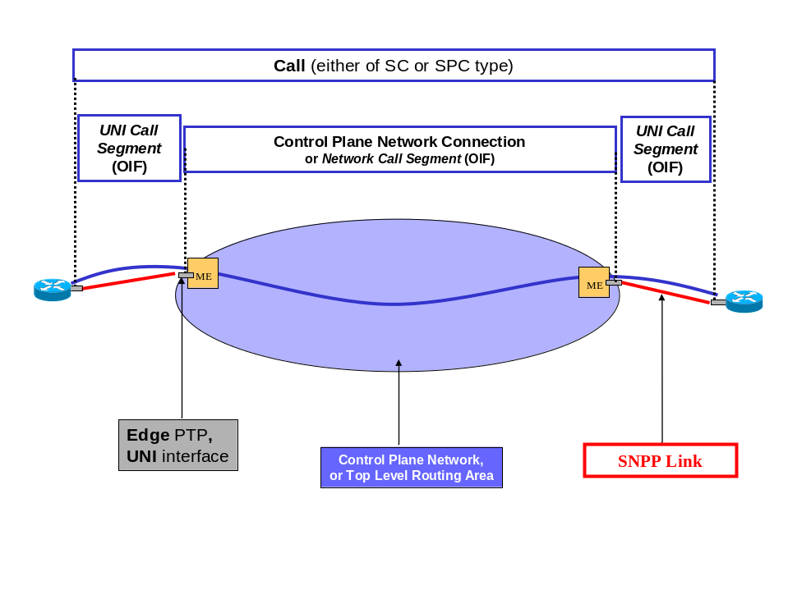
Figure 8 Call and Call Segment

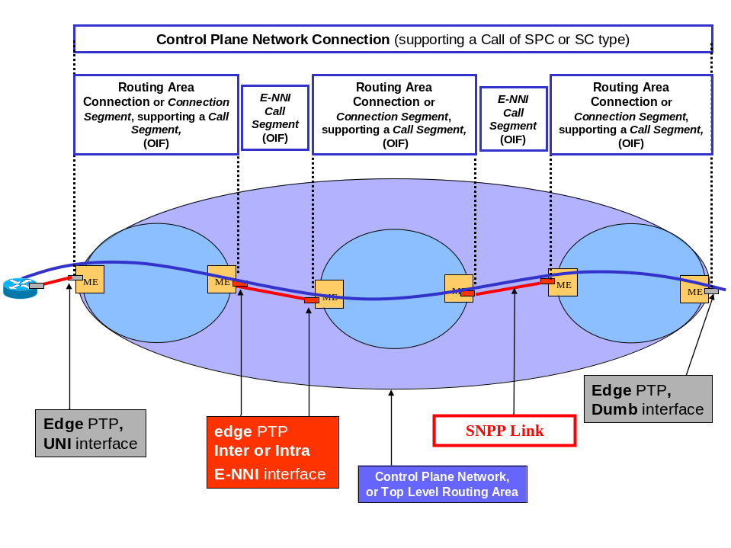
Figure 9 Connection and Connection Segments
In this release the Call object can be used to represent a Call Segment where the following are all true:
- The Call Segment is part of a Call that spans multiple operators networks
- The Call enters and exits the network being managed via E-NNIs
- The Call Segment spans the entirety of the single operators network from E-NNI entry to exit

Where the Call Segment does not provide any relevant properties to be managed it can be subsumed into a Connection (as shown for the top level connection in the figure above).

There are however cases where the Call Segment can not be subsumed into the connection as it requires information that could not be carried by the connection and it is required at an intermediate point in the network where the NMS manages several Call Segments of the same call. The interface defined in this release does not support these cases.
  - TP data setting
The interface provides an operation for the establishment of a call that allows the setting of TP attributes at both ends of the connections supporting the call (and at intermediate points). In many cases the attributes of the remote TP may not be applied as the control plane signalling does not provide the capability to propagate the TP attribute setting.

  - TP Naming and Identification
If a TP reference is used to identify the far end of a connection supporting a call, the call will be established only if the EMS is able to translate the TP name to the ID used to signal across the control plane. This will be possible if:
- The EMS manages both ends of the call and hence has access via the NML-EML interface to the translation.
- The EMS has access to a directory that provides a look up for translation of TP name to control plane ID.
- The control plane uses a proprietary signalling scheme that uses the TP name to signal.

  - Mixed networks of ASON Control Plane and traditional OSS based routing
The NML-EML interface has been developed to manage a network that comprises a mix of traditional NML controlled SNCs and Control Plane calls. The Control Plane support has also been extended to provide a 3 level hierarchy for traditional MLSNs. However there is no specific support for a Call that traverses a mix of control plane and traditional network, i.e. if a Connection Segment of the a control plane call is effectively a traditional SNC in an island of the network not controlled by the Control Plane. In such cases the end to end service would need to be broken into three components:
- Two independent Calls at either end
- A traditional SNC in the middle

What is the Control Plane?
This section:
- Introduces the key standards and key concepts such as call and connection separation and key components such as signalling controllers, call controllers etc.
- Highlights the separation between the communications aspect of the control plane from the traffic aspects.
- Provides some references to the Scenarios document.

  - Control Plane purpose and overview
The control plane automates the process for connection setup and tear down in an optical network. The architecture of the control plane is described in ITU-T Recommendation G.8080. This architecture provides a separation between the call (which represents the service offered to the user) and the connections that deliver the service. The architecture is described in terms of control plane components. The communication between these components is separated from the bearer plane that is being controlled. To optimise the performance of the control plane and maximize the reuse of existing control protocols the addressing scheme used by the control components to reference the transport resources is independent of the addressing scheme used by the management applications. The request for a call can originate from a customer directly via a UNI or from an OSS within an operator's network. For connection request from the UNI the control plane automatically computes a route and initiates signalling to establish the connections. In the case of a request from the network operator's OSS the request is directed to the ingress point for the call, the operator may provide may control the routing of the connections by providing an explicit route or routing constraints or allow the control plane freedom to compute the route. In all cases the control plane initiates signalling to establish the required connections. The control plane can also perform automatic restoration in the event of a traffic plane failure. when the failure has been repaired the control plane may force the connections to revert to the original (home) route.

  - The mechanism of service setup and recovery in a Control Plane environment
Requests for service are directed to a network call controller (NCC), this validates the request against the policy provide by the network operator and applies network policy to convert the call request into one or more connection requests. Abstract names are converted into routable address and the connection request is passed to a connection controller (CC). The connection controller passes the request to a routing controller (unless an explicit route is provided). The routing controller computes the route and returns it to the connection controller. The network may be divided into multiple hierarchical routing areas. The detailed topology of a routing area is only visible from within that routing area, externally only reachability information is provided. This allows the networks of multiple operators to be interconnected without revealing the details of the internal topology to other operators. On receipt of a detailed route (for that routing area) the connection controller initiates signalling to set up the connections. The choice of a specific time slot on a link is made by a link resource manager (LRM). The call parameters are passed along with the connection setup request. When an administrative boundary is reached (an E-NNI) a NCC examines the call request and performs the same functions as the originating NCC.

In the event of a failure in the network the NCC (on the boundary administrative domain where the failure is detected) examines the nature of the failure and based on the call parameter may initiate restoration by initiating a request for a new connection. If a restoration connection has been established then when the failure is repaired the NCC may cause the service to revert to the original route and release the restoration connection.

MTNM interface in the context of overall control plan operation
Some aspects of the setup of the control plane are outside the scope of the interface. This is section identifies the configuration that must be performed on the control plane via means other than the MTNM interface. The section highlights each point at which entities would be visible over the MTNM interface in Bold Blue.

The section identifies when each aspect of the infrastructure (Routing Areas, SNPP Links and SNPPs) will be created.

  - Overview of the MTNM interface capability to support control plane
The extensions to the MTNM interface in release 3.5 have been developed to allow the NMS to set up services in a Control Plane network. Much like earlier releases of the MTNM interface, the focus of release 3.5 has been on the key subset of all possible capabilities as a first step. It is intended that the capabilities of the interface related to Control Plane be expanded in later releases.

Release 3.5 of the MTNM interface can be used to discover the network and to set-up and configure services (these operations are examines in section 3 of this document):
- Discover the Control Plane infrastructure
- Discover existing Calls and Connections that are in place under the control of the Control Plane
- Set up and tear down Calls and Connections
- Associate signalling controllers with UNI ports and configure signalling parameters

Release 3.5 of the MTNM interface covers common network scenarios, however there are a number of limitations set out in section Appendix A Limitations of this release on page 36. Although the interface may operate outside the boundaries of the constraints described, no reviewing/analysis effort has been applied by the specification team to prove this.

Release 3.5 of the MTNM interface can NOT be used to set up the network infrastructure:
- Set up/adjust the Control Plane communications infrastructure
- Set up/adjust Routing Area hierarchies
- Set up/adjust SNPP Links

The network infrastructure needs to be constructed using EMS tools prior to it being available for service setup. This section details in a relatively high level of abstraction the essential steps that an operator would take whilst setting up the Control Plane network prior to using the MTNM interface and summarised the setup level of the Control Plane at the point that the operator would start using the MTNM interface.
  - Communication infrastructure
To use the control plane it will be necessary for the network operator to set up the control plane communication infrastructure. The majority of the specific details of the communication network are outside the scope of this document and outside the scope of the MTNM interface. The signalling at the UNI is in scope of release 3.5 of the MTNM interface and is covered elsewhere in this document. The communication infrastructure will be used by the control plane to carry out signalling of Link information, signalling of Connection set-up information etc.

The control plane communication infrastructure supports exchange of signalling between:
- Connection Controller (CC)
- Routing Controller (RC)
- Link Resource Manager (LRM)
- Network Call Controller (NCC)

  - Controllers, Control Plane Communications and Routing Areas
The control plane capacity, structure and partitioning needs to be planned and engineered. As a result the communication infrastructure will need to be designed and constructed to enable communications/signalling between the various ASON controllers. The configuration and set-up of the communications system is outside the scope of the MTNM interface and the interface does not represent or manage the communications infrastructure in any way.

The Routing Area hierarchy and Routing Area arrangement will need to be engineered. Each Routing Area is populated with an LRM, a CC and a RC. Some RAs will be populated with NCCs. Depending upon the actual control plane implementation this may be a real or conceptual allocation at this stage. This allocation of LRM/CC/RC/NCC will NOT be reflected through the MTNM interface as release 3.5 does not represent or manage these entities and does not manage the relationships between these entities.

The RA implied by the existence of the LRM/CC/RC/NCC will be available over the MTNM interface if it is operational at this stage. This RA will have no associated resources of any kind upon creation (see 2.4.1 Retrieve a list of all Multi-Layer Routing Areas from all EMSs on page 9).

  - SNPP Links and SNPPs
As a result of local configuration operations outside the scope of the MTNM interface two LRMs, each representing a routing area, communicate for the purpose of setting up an SNPP Link. During this link setup process an SNPP is created in each of the routing areas and associated with the SNPP Link.

At this stage there is no actual capacity associated with the SNPP Link. A zero capacity link is not visible through the MTNM interface.

After creation, the SNPP Link is associated with actual network capacity. This process, that may take place in several steps, associates the SNPP of the link end to the actual resources in the transport network and also associates the SNPPs with their aliases in each of the subordinate levels of the RA hierarchy.

In a simple network where there is a three level routing area hierarchy (see Appendix A.7.1 Levels of Routing Area Hierarchy on page 37 and where each physical link is represented by one and only one SNPP Link (see Figure 10 Three Level Routing Area Hierarchy on page 45).

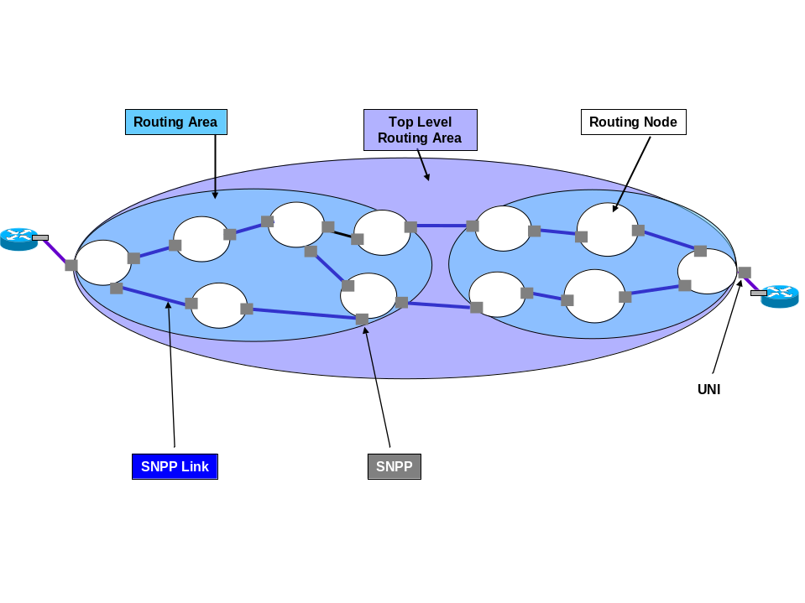
Figure 10 Three Level Routing Area Hierarchy

- the end points of the SNPP Links representing the UNI ports will have 3 SNPP names associated with the network end
- the endpoints of the SNPP Links connection the intermediate level routing areas will have two SNPP names associated with each end
- the endpoint so the SNPP Links between Routing Nodes within an intermediate level routing area will have only a single SNPP name associated with each end

The process for SNPP link creation is depicted in Figure 7 Discovery of SNPPLinks – network preconditions on page 32. It should be noted that SNPPLinks are created as empty in the network but are only reported over the MTNM interface as components of MLSNPPLinks once resources have been allocated.

The SNPPs that relate to TPs that are of G.805 TCP type are created by allocation appropriate resources from the network to the control plane. This creation relates to functions of the TAP.

Once resources are allocated to a SNPP Link or SNPP (TCP type) it is reported over as part of an MLSNPPLink or MLSNPP (respectively), see 2.4.2 Retrieve a list of all MLSNPPLinks from all EMSs on page 12, 2.4.3 Retrieve a list of all MLSNPPs from all EMSs on page 16 and 2.9 Infrastructure build – Maintaining alignment with the network on page 30 the interface identified above are reported over the MTNM interface.

  - Setup achieved by configuration outside the scope of the MTNM interface
As a result of the infrastructure build identified in the previous sections the EMSs managing the network can make available to the NMS over the MTNM interface the following information related to the control plane:
- Routing Area hierarchy
- SNPP and SNPP Links
- SNP-CTP relationships

TCP Termination – concept
The Termination Connection Point (TCP) is the point at which the network connection terminates and accesses the Trail Termination function, i.e. it is approximately coincident with the end of the Trail. A TCP terminated Connection supports a call that is providing capacity to a client layer in the same network as the call.

The figure below shows a representation of the Termination functions including the TCP. This figure has been extracted from SD1-18_layers which provides further explanation of the termination and layering concept. See also SD1-46_ASONControlPlaneManagement-Scenarios which shows many examples of TCP terminated Connections supporting Ethernet and other client layers.

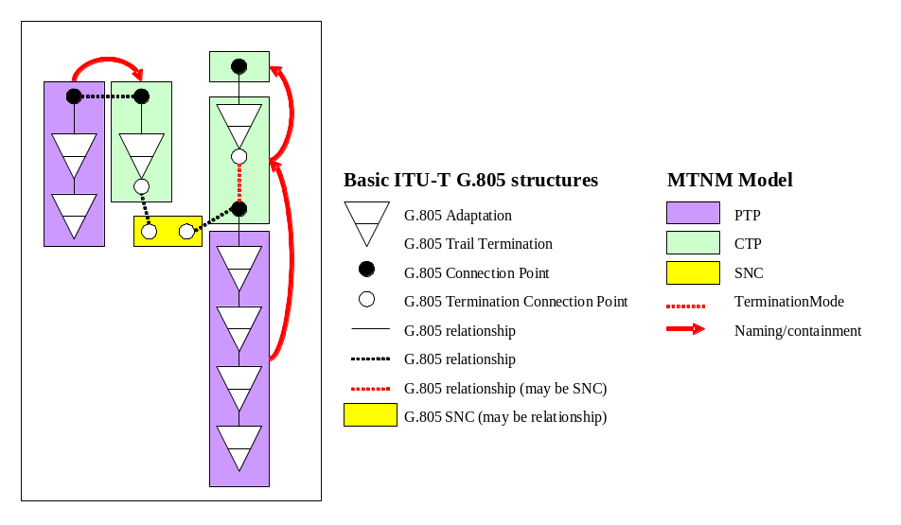
Figure 11 MTNM and G.805 Layered Model

SNPs are groups together into SNPPs. The SNPPs themselves are encapsulated into MTNM objects:
- The SNPP forms part of an MLSNPP if it represents TP functions which have a G.805 TCP/TerminationFunction
- The SNPP forms part of an MLSNPPLink if it represents TP functions which have a G.805 CP role.

To determine the grouping that may take place to form MLSNPPs the following guidelines have been constructed
- The SNPs of TCP role that are assembled into an SNPP should have the same relevance from the client perspective (e.g. VCAT).
- The SNPPs that are assembled into an MLSNPP likewise should have the same relevance from a client perspective (e.g. various CCAT and VCAT terminations providing the same essential client service)

Diversity and Co-routing
This section provides some background behind the diversity model choice and then moves on to highlight some aspects of the application the interface to some specific diversity cases.

  - Background
Many services sold by the network operator are supported by multiple independent end to end flows/connections across the network. In some cases these flows are interrelated and have requirements related to resilience.

It is often that case that two or more specific flows across the network should have a low probability of suffering a coincident failure to support the resilience specified service level agreement. To achieve this the flows/connections need to be routed across the network such that the resources that they use are not within close enough proximity to suffer failure as a result of a single cause. Clearly this depends upon the magnitude of impact of the cause considered (e.g. major explosion v bridge collapse v JCB/Backhoe disruption of a duct). This requirement is satisfied by routing the connections diversely across the network such that there is no (i.e. acceptable) shared risk (share fate) with in the scope of the type of impact considered.

In other cases it is specifically not beneficial to route two flows/connections diversely as the service will fail if either of the flows/connections fail and therefore spreading the service across more independent resources will increase the probability of failure. In these cases the flow/connection are required to be co-routed so as to specifically share risk.
In cases where a service is supported by multiple flows/connections there may be a mixed requirement where some of the flows/connections must be diverse from some other flows/connections.

This release provides support for all of the above considerations in the context of a single service where the EMS or Control Plane is choosing the route. The release does not support routing relationships between flows/connections that support different services.

The service is represented by the Call and all diversity and co-routing requirements for a particular service are stated in the context of a single Call.

The network/EMS requires information to allow appropriate routing decision to be made. Shared risk is related to being within appropriate proximity of the problem causing the failure. This information is conveyed via Shared Risk Group values provided against the Routing Node (or Subnetwork) and Link (MLSNPPLink).

  - Specific application to the call and connections/SNCs
Connections/SNCs that are required to be co-routed are identified by being in the same Route Group. Connections/SNCs not in the same Route Group may have no diversity requirement or may be required to be diverse. As noted above, in this release the diversity statements are bounded by the call and hence the diversity requirements are conveyed via the Call Object.

Depending upon the criticality of the requirement to satisfy diversity in some cases it may be acceptable to have a degree of shared risk. The acceptable level of effort applied to the diversity statement is conveyed via the Call Object.

Considering Co-Routing it is also the case that a limited degree of diverse routing may be acceptable. In this release of the interface it is assumed that the co-routing level of effort requirements for all Route Groups within a particular Call are the same. The level of effort to be applied to the co-routing requirement for all connections of the Call is stated in the Call. As a consequence the Route Group has no information to carry other than the identification of the Connections/SNCs that it groups. Therefore the model has been simplified to not have explicit Route Groups but instead to convey the Route Group label via the Connections/SNCs.
The following diagram shows the relationship between Route Group, Call and Connection/SNC.
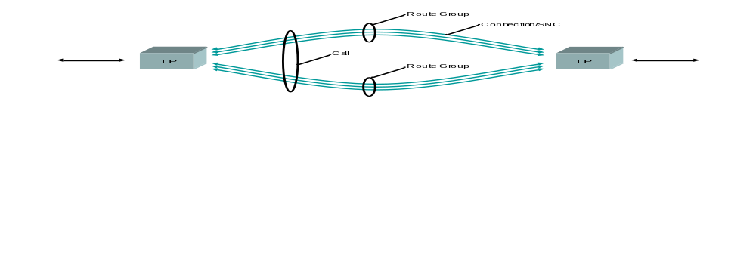
Figure 12 Call, Connections and Route Groups

  - Shared Risk in more detail
The physical route of a flow/connection can be considered as a combination of nodes and links in the physical space. The nodes can be considered at various levels and cover buildings, splice cabinets, distribution frames and actual active network devices. The links likewise can be considered to cover fibres, bundles, ducts, bridges etc. The representative of the nodes in the model are the Managed Elements and MLSNs and the representatives of the links are the Topological Links and SNPPLinks, however, these interface objects are quite remote from the physical environment. A Topological Link may span many ducts and buildings and likewise an MLSN may span many buildings and ducts.

To reconcile this, shared risk is considered against the physical environment in general. A geographic referencing scheme (numbering/labelling) is developed (in 3 dimensions) scaled to cover a specific degree of risk. Each degree of risk considered relevant has a referencing scheme (e.g. duct diversity). Each item that is considered during routing (Nodes and Links) at a particular layer is allocated one or more references from the scheme of references for each degree of risk. If two items have shared risk with respect to a particular degree of risk they will have one of more shared references from that scheme. This list of references is called the Shared Risk Group (SRG).

SRG is allocated to Routing Nodes (represented by MLSNs in the interface) and to MLSNPPLinks. Each MLSN and MLSNPPLink has a structure that allows it to be considered against a number of separate degrees of risk. The structure allows for any number of degrees and also provides a free format labelling capability.

The SRG data for the Nodes and Links is discoverable over the interface but may not be set in this release.
When a request to establish a Call is made to an EMS the NMS may specify diversity to various levels:
- No diversity constraint
- Link diversity alone
  - Simple link diversity (assuming no relevant SRG specified) which simply causes the routing engine to avoid the same MLSNPPLink
  - Link level SRG specifying the label of the SRG that relates to the degree of diversity to be considered
- Node diversity alone
  - Simple node diversity (assuming no SRG specified) which simply causes the routing engine to avoid the same Routing Node
  - Node level SRG specifying the label of the SRG that relates to the degree of diversity to be considered
- Node and Link diversity in combination
  - With any combination of the considerations above
The above scheme allows for traditional operation where no diversity consideration is applied, simple diversity where the SRG data has not been specified and sophisticated operation where full SRG is available.

The specific degrees of risk considered are fully flexible and down to the allocation of SRG data. Labelling such as “duct diversity”, “road and bridge diversity” and “bomb diversity” might be considered.

  - A specific case
The case of Ethernet over SDH VCAT with LCAS is explored as it highlights a majority of the capability of the interface.

Lets assume that the Ethernet is carried by 6 VC4s. With LCAS operating, it is possible for the Ethernet service to be preserved all be it at a lower bandwidth so long as at least one VC4 is operational. As a consequence it is quite reasonable to aim for diverse routing of the VC4 to achieve a degree of resilience against failure. However, allocating a different route to each VC4 is not particularly beneficial. So a reasonable distribution is to have the VC4s divided into two groups of 3 where the VC4s in a group are co-routed but the VC4s in one group are diverse to the VC4s in the other.

This is in essence what is shown in the earlier diagram (see Figure 12 Call, Connections and Route Groups on page 49).

Assuming that there is SRG information available the request might specify in the Call establish request both node and link diversity to a particular level, say “duct” on the Links and “building” on the nodes (where these are levels recorded on the links and nodes). The Call establish request would also identify the degree of effort, in this case we shall assume “best effort” and would provide either the specific names of the Route Group reference in the Connections identified or alternatively would provide the number of route groups (assuming an even distribution would be preferred by the EMS). If the EMS was not able to achieve full diversity on the links for example then the response to the Call establish request, the Call would still be set up as it is best effort, but the response would provide an indication of the links that failed.

  - Some specific capabilities available through the interface
The specific capabilities available over the interface are best understood by reviewing the following material:
- BA Use Case:
  - Use Case “NMS establishes a Call”
- BA Requirements:
  - Requirement II. 392
  - Requirement II. 393
  - Requirement II. 403,
  - Requirement I. 134
- IDL
  - The struct callSNC::Diversity_T used in callSNC::CallCreateData_T conveys the diversity and co-routing effort information in the establish call operation.
struct Diversity_T
{
LevelOfEffort_T coroutingLevelOfEffort;
LevelOfEffort_T nodeDiversityLevelOfEffort;
LevelOfEffort_T linkDiversityLevelOfEffort;
string nodeSRGType;
string linkSRGType;
};
  - The diversity level of the Call is persisted in the object after creation and can be retrieved with the call in callSNC:Call_T.
struct Diversity_T
{
LevelofEffort_T coroutingLevelofEffort;
LevelofEffort_T nodeDiversityLevelofEffort;
LevelofEffort_T linkDiversityLevelofEffort;
string nodeSRGType;
string linkSRGType;
};
- Additional info is provided for the SNC: “routeGroupLabel”
- SRG data is provided for MLSNPPLink and MLSN
  - “linkSRG” in mLSNPPLink:MultiLayerSNPPLink_T
  - Additional info “SRG” for the MLSN
- The struct Call_T provides support for a set of violation indications that enable various degrees of partial support of best effort requests.
struct Call_T
{
globaldefs::NamingAttributes_T callName;
……
string diversitySynthesis;
DiversityInfo_T linkDiversityViolations;
DiversityInfo_T nodeDiversityViolations;
DiversityInfoList_T linkPartialDiversityList;
DiversityInfoList_T nodePartialDiversityList;
globaldefs::NVSList_T callAdditionalInfo;
……
};
Which uses:
struct DiversityInfo_T
{
string sRGTypeValue;
SharedResourceList_T sharedResourceList;
};
And:
typedef sequence<DiversityInfo_T> DiversityInfoList_T;

  - Rules for Modification
Consider the case where there is a call supported by two connections and the call did not have any specific diversity requirements when it was originally set up, i.e. there are no diversity parameters set on the call and the connections do not belong to route groups. Assume that as a result, when the call was established the control plane chose to route the connections in such a way that they shared many resources. Now consider what happens if the operator applies a diversity specification to that existing call that includes the requirement for connections in different route groups to be diverse from each other and also sets one existing connection to belong to one route group and the other existing connection to belong to another route group. If the control plane is to obey this request it must reroute one of the connections (and in nasty cases potentially both connections).

The NMS may indicate to the EMS in the request whether rerouting is allowed or not. To enable rerouting the “connectionRouteReArrangementAllowed” parameter is set to true. This is covered in Use Case “NMS requests EMS to set/modify diversity and co-routing parameters of a Call” and MultiLayerSubnetworkMgr_I:modifyDiversityAndCorouting() from TMF 814.

TNA
Transport Network-Assigned (TNA) address is the address assigned to the flow component or group for the purpose of external reference. The TNA address is in a separate namespace (separated from the other two name spaces for flow/points which are the MTNM TP name space and the SNPP namespace). The SNPP and TP names are built to reflect the network construction and equipment construction respectively, i.e. they provide some level of view of the network. The TNA address is effectively unrelated to the network construction and from this perspective can be considered opaque. This allows the network operator to publish addresses for access to the network whilst maintaining privacy with respect to the details of the implementation of the network.

The TNA address can be considered as related to the hand over point on a link between a client and a provider entity or it can equally be considered as referencing the actual access point (used loosely here) in the provider network which is effectively equivalent to the handover point. It is the latter, i.e. application of the TNA address to the “points” in the model, that is used in the MTNM interface.

The TNA address is defined by the OIF. The ITU-T defines a name that serves the same purpose but differs in structure. The TMF structure has been defined to accommodate these two definitions and is hence a string “mLSNPP::TNAName_T“. The OIF structure is considered to have three components:
- “TNA Name” which corresponds to a group of SNPPLinks or SNPPLink ends
- “TNA Logical Port Identifier” which corresponds to a single SNPPLink or SNPPLink end
- “Index” which corresponds to a single channel within a SNPPLink or SNPPLink end

The TNA is made available through the “mLSNPPLink::MultiLayerSNPPLink_T” structure and a representation is present for each of the possible applications:
- For the multi-layered ends of the MLSNPP Link itself directly in the structure which allows naming of multi-layered structures where all layers have the same TNA address
- For the individual layered ends via “mLSNPPLink::LayeredSNPPLinkList_T” which has a “mLSNPPLink::SNPPLinkList_T” per layer each of which includes an a and z end parameters “mLSNPP::SNPP_T” that provides “tNAName” and “groupTNAName” which allows naming of each SNPP on a per layer and per level of routing area hierarchy basis in the network individually
- Via the “mLSNPP::SNPList_T” of the “mLSNPP::SNPPList_T” which provides “tNAName” per channel which again allows naming of single layer structures where the TNA address is different per layer and naming of channel is required

Any combination of the above may be applicable.

The “groupTNAName” is used when several MLSNPP Link ends (or SNPP Link ends from different MLSNPP Links) have the same TNA address. This approach was chosen to allow an explicit statement. It is expect that only the first component, i.e. the “TNA Name”, of the TNA address would be used in these cases and that the “groupTNAName” would be set to the same value for several SNPP Link ends across several MLSNPPLinks.

The TNA address may also be used within the provider’s network for naming TCP terminations that may need to be externally accessible. This may be the case where a data source (e.g. a video server) is being accessed. The approach for the MLSNPP (and corresponding SNPP) is equivalent to that for the MLSNPPLink as described above.

OIF note that the structure of the TNA address may take the form of IPv4, IPv6 or NSAP address. In addition, as noted above, the TNA address may reflect the naming used in the operator network.

Mapping from external standards to Information Agreement and Solution Set
The mapping from the external standards to the solution set is covered in part in SD1-21_MappingIASS and in SD1-46_ASONControlPlaneManagement-Scenarios. To assist the reader of this document the essential aspects of this mapping have been captured here.

The external standards that define the control plane in terms of structure and operation (see Appendix J References on page 61) identify several key concepts. The key concepts that are mapped and refactored to arrive at the interface definitions are:
- Grouping of network functionality related to representation of the domains of routing and restoration
- External Standards: The term used is Routing Area. The Routing Area applies to a single layer network. Routing Areas can be nested. In addition to the routing area there are other grouping concepts specified in the external standards, but these are subsumed into the Routing Area for this release (see Appendix 37A.7 Modelling of Routing Areas on page 37).
- TMF 608: The corresponding entity is Multi-Layer Routing Area (MLRA). An MLRA can be used to represent the Routing Areas of a number of layers where the boundaries for the Routing Areas for those layers are coincident. The move from a single layered entity to a multi-layered entity reflects the approach taken to other aspects of the interface and is driven by the need to develop an efficient interface. The MLRA is used to represent both the domains of routing and recovery/restoration.
- TMF 814: The corresponding object is the Multi-Layer SubNetwork (MLSN). The existing MLSN object has been reused for the purpose of representing the MLRA and as a consequence the operations available have been extended to account for the additional needs. The MLSN was reused recognising the solution implementation efficiency that this would enable for existing deployed solutions.
- Representing the flow of traffic across the network
- External Standards: Identify two concepts, the call and the connection. The call represents the delivered service and the connection, which can be decomposed into subordinate connection segments, represents the detail of flow of traffic across the network.
- TMF 608: The call and connection are both modelled as per the external standards.
- TMF 814: The call is modelled as per the external standards however the connection is represented by the SNC object (aligning with the choice made for the MLRA to MLSN mapping described above).

As a consequence an EMS that manages both Control Plane and traditional network will report MLSNs where some represent a traditional subnetworks and some represent a Control Plane Routing Area. An MLSN that represents a Control Plane Routing Area will have the additional info attribute “RoutingAreaLevel” where as an MLSN that represents a traditional subnetwork will not.

Migration Considerations
There are several migration scenarios that could be examined, a number are briefly considered here:
- Traditional network migrating to control plane where a network that has been using traditional OSS based direct control
  - singleton style (MLSN containing only a single NE)
  - multi-nodal style with Ring MLSNs
  - multi-nodal style including mesh MLSNs
- Control Plane network managed using release 3.0 of the MTNM interface.

It is assumed that where a traditional network is already operating and a Control Plane is being introduced the Control Plane will either be in a separate region or will be some form of overlay. The separate region is clearly relatively straight forward as there is no migration and this case should be considered as a new network using the text in the main body of this document as a guide.

The overlay is potentially more complicated, but if it involves simply the use of ports that are new in existing MEs, again there is no migration although there may be mix of Calls and traditional SNCs within a single ME. The restrictions for mixed networks should also be noted (See Appendix A.11 Mixed networks of ASON Control Plane and traditional OSS based routing on page 40).

At some stage during the evolution of the overlay case it may be necessary to migrate an existing service, supported by a traditional SNC, to be supported by a Call. In this release of the interface this will require the de-enrol of an SNC contained in a traditional MLSN and the enrol of a Call and SNC or set of SNCs in a Control Plane MLSN. Depending upon the degree of change of the network structure this may be a relatively simple change or it may be quite significant.

It should be noted that:
- The specific approach to migration, the phases and the outcome will depend greatly upon the capabilities of the ASON Control Plane deployment (which is likely to require service interruption). This is not covered here.
- The resulting network may have a single large Routing Area represented by a single MLSN at the top level or it may have a hierarchy of Routing Areas and this will determine some of the aspects of the changes
- All of the migrations highlighted below will involve the de-enrol of SNCs in a traditional MLSN and the enrol of SNCs in MLSNs representing the Control Plane

A number of cases are sketched below:
- SNCs in a network composed of Singleton MLSNs:
  - The SNCs that formed the route that were each in a “top level” MLSN will, after the migration, all simply be route details of the one or more SNCs that support the call (a single SNC if there is only one Routing Area or multiple if there is a hierarchy)
  - After the migration, if the ASON control plane was appropriately constrained in Call establishment phase (see 2.5.1 Establishing a call on page 25) the detailed route of the resulting SNCs (see 2.4.4.2 Retrieve a list of the home route of each top level on page 19) should reflect the route represented by the SNCs in the Singleton MLSN that existed prior to the migration
- SNCs in a network composed of BLSR MLSNs:
  - If the arrangement of Routing Areas reflects the BLSR MLSNs, the SNCs that were present in the BLSR MLSNs prior to the migration will be visible via the SNCs that represent the “Connection Segments” in the Control Plane network
  - If the arrangement of Routing Areas is orthogonal to the arrangement of BLSR MLSNs the route of the SNCs that were present in the BLSR MLSNs may be preserved but will be scattered across SNCs that pass through the new Routing Areas
- SNCs in a network composed of Mesh MLSNs:
  - If the entire network was represented by a single mesh MLSN and this effectively encapsulated ASON Control Plane functionality then the SNCs through that MLSN will be preserved as the SNCs in the MLSN representing the top level Routing Area
  - If there were several separate Mesh MLSNs that are being merged into a single ASON Control Plane then the characteristics of the relationship between the original network and the resulting network will be equivalent to those described for the BLSR MLSN above

Naming Considerations
This section provides some of the rational behind the choices for naming of control plane entities (see SD1-25_objectNaming).

For correct NML operation it is vital that objects reported through different instances of the EML interface are named in a consistent fashion. If an object is reported through more than one instance of EML interface the name used for that object on each instance of interface must either be the same or must be algorithmically related.

Clearly, the entities that are being considered are know to and named by the control plane using a control plane wide scheme. The basis for the NML-EML naming will be the actual control plane name.

There are however a number of challenges which the approach chosen deals with:
- Per layer treatment of the control plane v multi-layer treatment of the MTNM interface
- Multiple separate independent control planes under the control of a single EMS
- Control Plane is under the control of many EMSs

In general a name must be:
- Unique in the entire name space
- The same regardless of where viewed (or potentially related by a generally known algorithm)
- The same for the entire life of the actual entity in the network regardless of failures and/or rearrangements of any supporting infrastructure

The interface will include the EMS name as the first component of the name to allow the NMS to readily determine actual source of the information. This EMS name component may be removed by the NMS to reveal the actual name of the control plane entity. With this EMS name component removed the resulting name of the entity will satisfy the naming rules specified above.

  - Dealing with changes in the name source
During normal operation of the control plane it will be necessary from time to time to rearrange the infrastructure or re-label sets of control plane entities. In some cases the control plane may allow the change of name with no disruption to service provision etc. Where the changing name-property of the control plane entity has been used as the basis for the management plane name it will be necessary for the EMS to report the deletion of that object (and all other objects that have a naming dependency upon that object) and then to report the creation of a new object with the same properties (as appropriate) but different name.

The naming approach adopted has been chosen to minimize such disruption, however it is clear that certain control plane adjustments will cause object deletion and effective recreations to occur.

  - ASON Administration cost v algorithmic approach
To allow for sophisticated capabilities such as VPNs and to divorce the structure of the network offered to the routing and signalling engines from that of the physical network a name space that is separate from that of the physical network is used. The ASON control plane operates on entities that are abstractions of the real physical implementation entities.

The MTNM interface allows for this name space and provides information on the mapping between the physical/transport network name space and the ASON control plane name space (such as between the CTP and the SNP).

Manually mapping each of the names of the physical/transport name space to the control plane name space would appear to be a very expensive task and as a consequence it is assumed that a network operator will use an algorithmic approach to naming. For example, it is assumed that the operator will use an algorithmic approach to naming the coincident links representing the variety of client mappings of the SDH Multiplex Section (SONET Line).

The multilayer model takes advantage of this assumed algorithmic naming to reduce the number of entities that are reported over the interface by representing several SNPP Links from the ASON control plane as a single Multi-Layer SNPP Link as set out in the following section.

  - Multilayer consideration
The control plane network functions deal with the network resources on a per layer basis. So, for example, each routing area would represent only one layer of capability (e.g. VC4 routing). In networks with many layers, such as those where all higher order layers are supported (i.e. STS1, STS2, STS3 etc), as noted above it would seem an intolerable operational overhead for each of these layer networks to require administration independently. It is assumed that a mechanism to automate the generation of network entity names (or a system to achieve pattern in the names) will be utilised to take advantage of patterns of layered network entities that are coincident such that they can have some aspects of common naming.

Where no advantage is being taken of any pattern in naming by the EMS then the Multi-layer entities will exist however they will each be representing one and only one layer (and as a consequence in many cases there will be a far greater number).
  - Specific Naming
For specific naming considerations refer to SD1-25_objectNaming.

References and Related Documents
Reference | Description
OIF-UNI-01.0 | User Network Interface (UNI) 1.0 Signaling Specification.  [From October 24, 2001 OIF press release]
OIF-CDR-01.0 | Call Detail Records for OIF UNI 1.0 Billing.  [From August 12, 2002 OIF press release]
ITU-T G.7713 | Distributed Call and Connection Management (DCM)  [12/2001]
ITU-T G.8080 | Architecture for the automatically switched optical network (ASON)  [11/2001 and Amendment 01/2003]
ITU-T G.8081 | Terms and definitions for Automatically Switched Optical Networks (ASON)  [06/13/2004]
ITU-T G.7715 | Architecture and requirements for routing in the automatically switched optical networks  [06/2002]
OIF 2003.041.00 | Requirements for the Management Plane in Support of NG-OTN Control Plane Functions  [Feb 2003]
OIF 2002.353.05 | Draft OIF Intra-Carrier E-NNI Signaling Specifications (OIF E-NNI 1.0)  [7 May 2003]
ITU-T Draft Recommendation G.fame | [June 2003]

Revision History
Version | Date | Description of Change
1.0 | 2006/12/21 | First formal release

Acknowledgements
First Name | Last Name | Company
Nigel | Davis | Nortel
Malcolm | Betts | Nortel
Andrea | Mazzini | Alcatel-Lucent
Monica | Lazer | AT&T

How to comment on the document
Comments and requests for information must be in written form and addressed to the contact identified below:

Nigel | Davis | Nortel
Phone: | +44 1279 405978
Fax: | <will be provided if required>
e-mail: | nigeld@nortel.com

Please be specific, since your comments will be dealt with by the team evaluating numerous inputs and trying to
produce a single text. Thus we appreciate significant specific input. We are looking for more input than wordsmith” items, however editing and structural help are greatly appreciated where better clarity is the result.

TMF 513 contains cases and requirements, TMF 608 contains the UML and TMF 814 contains the IDL
The use cases provide a cross reference to the requirements.
Appendix A provides a summary of the limitations of the release.
See Appendix J References on page 61
The reader of this document is advised to at least read the referenced Use Cases and fragments of the UML model as these documents will expand on the comments in the IDL and greatly assist in the understanding of each step.
See Appendix J References on page 61 for reference to naming guidelines
See Appendix J References on page 61 for reference to control plane scenarios
See Appendix J References on page 61 for reference to naming guidelines.
See Appendix J References on page 61 for reference to Control Plane Scenarios documents for pictorial representations of the control plane entities such as SNPPLink and Call. It is recommended that the reader not familiar with entities discussed in this section (such as MLSNPPLink) should read the referenced documents in parallel with this document).
Includes the retrieval of Routing Nodes. A Routing Node represents the lowest level MLRA (i.e. indivisible) and in this release represents all the routing capability related to a single ME in the layer of the Routing Area.
Includes the retrieval of Routing Nodes. A Routing Node represents the lowest level MLRA (i.e. indivisible) and in this release represents all the routing capability related to a single ME in the layer of the Routing Area.
Individual operations to retrieve edge MLSNPP Links and Internal MLSNPP Links could be used here, however, it is considered most efficient for the NMS to retrieve all MLSNPP Links in one single operation.
It is possible to get all MLSNPP Links without an SNP-CTP mapping information. This would be a more efficient operation in some cases (as the mapping data is large), however it would leave the NMS only partially aligned with the network.
If the “allocatedToControlPlane” additional info attribute is “True” for a specific TP then there should be no SNCs connected to that TP directly. There may however be an SNC representing a control plane connection that connects an SNP that is references that specific TP. If the “allocatedToControlPlane” additional info attribute is not present for a specific TP then there may be an SNCs connected to that TP directly and there will be no SNP representing that TP. An SNC representing a control plane connection can not be created for that specific TP.
Strictly an MLSNPPLink could connect multiple routing areas (for release 3.5 the MLSNPPLink is limited to two ended).
Strictly an MLSNPPLink could connect multiple routing areas (for release 3.5 the MLSNPPLink is limited to two ended).
It is possible to get all MLSNPPs without an SNP-CTP mapping information. This would be a more efficient operation in some cases (as the mapping data is large), however it would leave the NMS only partially aligned with the network.
Note that for a non-control plane case where nested MLSNs are supported the NMS may use MultiLayerSubnetworkMgr_I::getCallAndTopLevelConnectionsAndSNCs to retrueve the call, the top level SNCs and all subordinate SNCs.
In some extreme cases it is strictly possible for a call to have two connections where one originates in the view of one EMS and the other in the view of another. In this case both EMSs will respond with the call and connections.
Current signalling standards do not support signalling of a call with no connections.
i.e. it is of the type shown in Figure 2 NMS with rich stored model
In a non-control plane case where hierarchical MLSNs are supported the operation getCallAndTopLevelConnectionsAndSNCs can be used to get all connection details in one go.
It would be quite reasonable for the management application to construct the relatively static infrastructure relationships between MLSNPP/MLSNPPLink and MLRA including the SNPP to RA relationship during the early alignment phase to ease the navigation required in this process.
This could be considered as a connection segment.
These are input parameters to the operation.
The single operation can derive both connection and SNPPLink with one request, however this is not efficient for this scenario
It is possible to determine the actual route using the same operation.
There may be several connections in a single MLRA supporting a single call.
This could be considered as a connection segment.
The single operation can derive both connection and SNPPLink with one request, however this is not efficient for this scenario
It is possible to determine the actual route using the same operation.
The value “False” never appears, all unallocated TPs simply do not include the attribute.
If the “allocatedToControlPlane” additional info attribute is “True” for a specific TP then there should be no SNCs connected to that TP directly. There may however be an SNC representing a control plane connection that connects an SNP that is references that specific TP. If the “allocatedToControlPlane” additional info attribute is not present for a specific TP then there may be an SNCs connected to that TP directly and there will be no SNP representing that TP. An SNC representing a control plane connection can not be created for that specific TP.
The SNPP Link creation order (created with no resource and then resource is added) leads to SNPs of G.805 CP type only having meaning in the context of the SNPP Link.
Note that this scheme is essentially flawed other than in the most trivial of networks as two different MLSNs can be collocated and two different MLSNPPLinks can use the same duct (however, it is better than nothing)
The behaviour of the EMS is not mandated by the specification of the interface.
The network operator is at liberty to construct TNA addresses in such a way that they mirror the names of components in the network. Whilst this removes the opaqueness it also simplifies the assignment process and it may be applicable under certain circumstances.
Layer is used here as it is defined in ITU G.805 and as it is used in SD1-18_layers.
In a SONET environment there may effectively be layer networks for STS1, STS2, STS3… STSn. It is clear that the subnetworks of these layer networks will be effectively coincident and that representing each individually over the interface would be grossly inefficient (see Appendix I.3 Multilayer consideration on page 59).
Note that Call Segment is not explicitly modelled and only a subset of potential network cases are covered (see Appendix A.8 Call and Connection Segments on page 38).
It is clearly possible to have a set of coincident MLSNs which each represent the connection functionality of a single layer instead of a single MLSN that represents many layers.

