PM Threshold Types

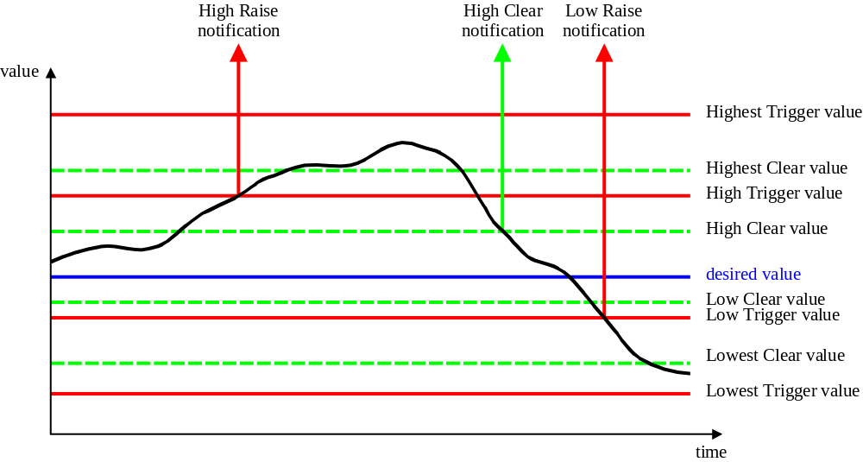
Note: Identification of Trigger/Clear for each threshold type is modelled by the attribute triggerFlag

Administrative Appendix

Document History

Version | Date | Description of Change
3.0 | June 2005 | Conversion into new template.

Acknowledgments

First Name | Last Name | Company

How to comment on this document
Comments and requests for information must be in written form and addressed to the contact identified below:

Keith | Dorking | CIENA
Phone: | +1 678 867 5007
Fax: | +1 678 867 5010
e-mail: | Kdorking@ciena.com

Please be specific, since your comments will be dealt with by the team evaluating numerous inputs and trying to produce a single text. Thus we appreciate significant specific input. We are looking for more input than wordsmith” items, however editing and structural help are greatly appreciated where better clarity is the result.

