This document compares BA, IA and IIS of the Resource Provisioning DDP

References:
BA: TMF518_NRB.doc 1231 05.12.07 besson
IA: ResourceProvisioning.emx 1594 15.04.08 zeuner
IIS: CommonResourceProvisioningMessages.xsd 1574 08.04.08 jeromem
EquipmentProvisioningMessages.xsd 1574 08.04.08 jeromem
GuiCutThroughControlMessages.xsd 1470 01.03.08 jeromem
SoftwareAndDataControlMessages.xsd 1574 08.04.08 jeromem
TerminationPointControlMessages.xsd 1574 08.04.08 jeromem
TopologicalLinkControlMessages.xsd 1574 08.04.08 jeromem
TrafficConditioningProfileControlMessages.xsd 1574 08.04.08 jeromem
TransmissionDescriptorControlMessages.xsd 1574 08.04.08 jeromem
SDs:

Conventions:
yellow marked items need discussion
turquoise marked items are obvious (from my point of view) and need to be added/changed/deleted
green marked items are postponed after MTOSI 2.0; i.e to TIP

Content:
1 High level UML diagrams 4
1.1 RP Interface Diagram 4
2 Common Resource Provisioning Service 5
2.1 setNetworkAccessDomain «profile=corba» 6
2.2 setCommonAttributes «profile=xml» 6
3 Connection Control Service 8
4 Equipment Provisioning Service 9
4.1 provisionEquipment 10
4.2 unprovisionEquipment 12
5 Flow Domain Control Service 15
6 Gui Cut Through Control Service 16
6.1 destroyGuiCutThrough 16
6.2 getGuiCutThroughProfileInfo 18
6.3 launchGuiCutThrough 19
7 Software And Data Control Service 26
7.1 abortManagedElementBackup 26
7.2 backupManagedElement 27
7.3 getBackupList 28
7.4 getManagedElementBackupStatus 29
8 Termination Point Control Service 31
8.1 createFloatingTerminationPoint 31
8.2 createGroupTerminationPoint 35
8.3 createTerminationPointPool 37
8.4 deleteFloatingTerminationPoint 39
8.5 deleteGroupTerminationPoint 42
8.6 deleteTerminationPointPool 43
8.7 modifyGroupTerminationPoint 44
8.8 modifyTerminationPointPool 46
8.9 setTerminationPointData 48
9 Topological Link Control Service 54
9.1 createTopologicalLink 55
9.2 deleteTopologicalLink 57
10 Traffic Conditioning Profile Control Service 59
10.1 createTrafficConditioningProfile 60
10.2 deleteTrafficConditioningProfile 62
10.3 modifyTrafficConditioningProfile 64
11 Transmission Descriptor Control Service 67
11.1 createTransmissionDescriptor 69
11.2 deleteTransmissionDescriptor 70
11.3 modifyTransmissionDescriptor 72
11.4 setTransmissionDescriptorAssociation 74
11.5 verifyTransmissionDescriptorAssignment 77
11.6 verifyTransmissionDescriptorAssignmentToMFD?? 80
12 Data Types 82
12.1 EquipmentCreateData Type 82
12.2 GroupTerminationPointCreateData Type 84
12.3 TerminationPointPoolCreateData Type 88
12.4 GuiCutThroughProfileInfo Type 91
12.5 GuiCutThroughData Type 92
12.6 FloatingTerminationPointCreateData Type 94
12.7 TopologicalLinkCreateData Type 98
12.8 TrafficConditioningProfileCreateData Type 101
12.9 TrafficConditioningProfileModifyData Type 104
12.10 TransmissionDescriptorCreateData Type 105
12.11 TransmissionDescriptorModifyData Type 108

Figures:
Figure 1: RP Interface Diagram 4
Figure 3: RP Common Resource Provisioning Service Interface Diagram 5
Figure 4: RP Equipment Provisioning Service Interface Diagram 9
Figure 5: RP Gui Cut Through Control Service Interface Diagram 16
Figure 6: RP Software And Data Control Service Interface Diagram 26
Figure 7: RP Termination Point Control Service Interface Diagram 31
Figure 8: RP Topological Link Control Service Interface Diagram 54
Figure 9: RP Traffic Conditioning Profile Control Service Interface Diagram 60
Figure 10: RP Transmission Descriptor Control Service Interface Diagram 68

History:
Version | Date | Description of Change
0.1 | 26.02.2008 | Initial version.
0.2 | 15.04.2008 | All service completed.  Reference to Connection Control Service comparison document added.  Reference to Flow Domain Control Service comparison document added.
0.3 | 16 04 2008 | Solved a big part of the BA blue comments (a few left)
0.4 | 25.04.2008 | Input parameter providing the containing resource in create operations added.
0.5 | 5.5.2008 | Resolved more BA blue comments (still few left).
0.6 | 29.05.2008 | Comments added during CC 29th May (stopped at page 12).
0.7 | 06.06.2008 | Comments added during CC 2nd June (stopped at page 21).  Comments added during CC 5th June (stopped at page 34).
0.8 | 19.06.2008 | Comments added during CC 12th June (stopped at page 44).  Comments added during CC 19th June (stopped at page 54).
0.9 | 10.07.2008 | Comments added during CC 10th July (stopped at page 76).
0.10 | 20.10.2008 | Exceptions notImplemented, internalError, unableToComply and commLoss have to be added to all use cases/operations.  GuiCutTrough, setTransmissionDescriptorAssociation(),verifyTransmissionDescriptorAssignment(), TerminationPointPoolCreateData Type, GuiCutThroughProfileInfo Type, GuiCutThroughData Type reviewed.
0.11 | 07.11.2008 | Previous changes accepted.  setTransmissionDescriptorAssociation() moved from CommonResourceProvisioningService to TransmissionDescriptorControlService.  Identified changes made in the IA.
General:
BA: R_TMF518_RP_II_0033 (EMS::getCapabilities) not in IIS and only for IDL in IA.
old BA | MTOSI 2.0 BA | content | IA solution | XML solution | IDL solution
TMF 513 v3.0, Requirement II.100 | R_TMF518_MRIRP_II_0033 | subnetwork connection management mode of operation | MRI:  ConnectionRetrievalService:  getSncModeOfOperation() | MRI:  ConnectionRetrievalService:  getSncModeOfOperation() | Common_I:  getCapabilities()  except alarms and notifications
TMF 513 v3.0, Requirement II.146  TMF517, Requirement II.40 | Map R_TMF518_FMW_II_0022 to TMF 513 v3.0, Requirement II.146 instead of TMF517, Requirement II.40 | operations  operations, alarms, notifications | FMW:  Common:  getCapabilities()
TMF 513 v3.0, Requirement II.290 | to be added to MRI | connectivity awareness capability | MRI:  FlowDomainRetrievalService:  getConnectivityAwareness() | MRI:  FlowDomainRetrievalService:  getConnectivityAwareness()
BA: Some Requirements are not listed in section 5 Traceability Matrices.
BA: Use Case Exceptions: "Category III: Abnormal or Exception Conditions, Dynamic Requirements" but "No requirements have been identified for this category."
BA, IA, IIS: Add exceptions notImplemented, internalError, unableToComply and commLoss have to be added to all use cases/operations.

High level UML diagrams

RP Interface Diagram
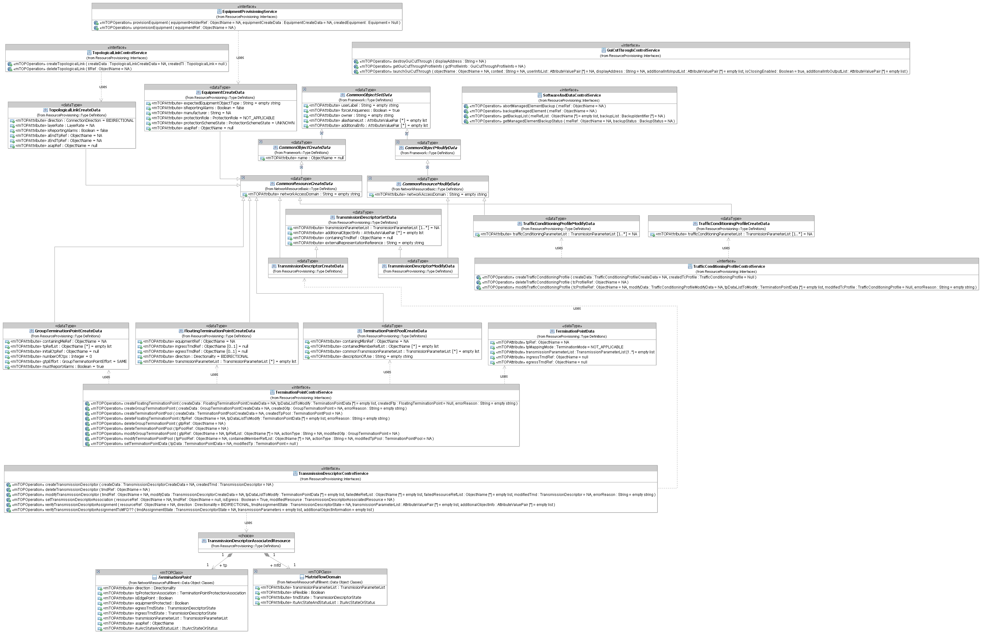
Figure 1: RP Interface Diagram

Common Resource Provisioning Service
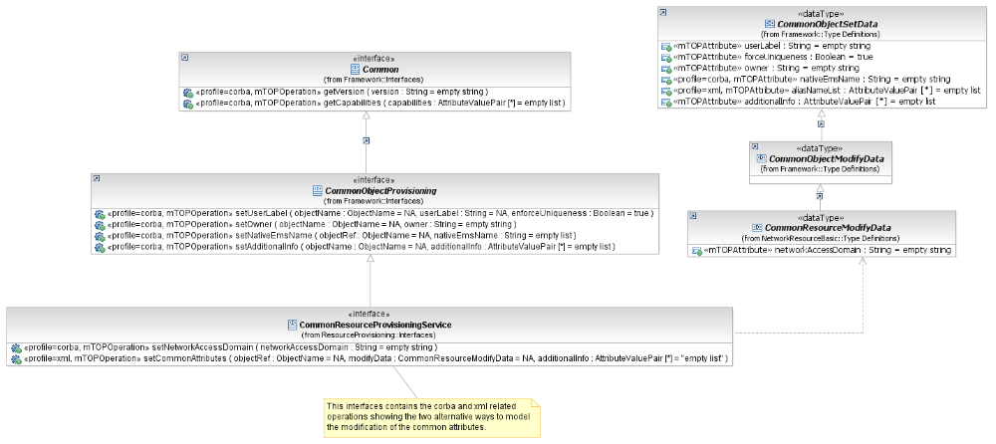
Figure 2: RP Common Resource Provisioning Service Interface Diagram

setNetworkAccessDomain «profile=corba»

BA | IA (setNetworkAccessDomain) | IDL | Comments
{Requirement II. 193} | This operation changes the association of a resource (which contains a networkAccessDomain attribute) to a Network Access Domain.  Traceability: |  | bz:  Not part of MTOSI Ba and XML.
networkAccessDomain (in) (String)
This parameter identifies the new Network Access Domain name.

 | 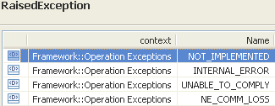

setUserLabel «profile=corba»

BA | IA (setNetworkAccessDomain) | IDL | Comments
{Requirement II. 075}

setOwner «profile=corba»

BA | IA (setNetworkAccessDomain) | IDL | Comments
{Requirement II. 076}

setAdditionalInfo «profile=corba»

BA | IA (setNetworkAccessDomain) | IDL | Comments
{Requirement II. 223}

setNativeEmsName «profile=corba»

BA | IA (setNetworkAccessDomain) | IDL | Comments
{Requirement II. 077}

setCommonAttributes «profile=xml»

BA (setCommonAttributes) | IA | XML | Comments
{Requirement II. 193}  {Requirement II. 075}  {Requirement II. 076}  {Requirement II. 223}  plus requierement for setAliasNameList  plus requierement for setVendorExtensions. | This operation sets the common attributes of the provided Resource.  Traceability: ?? | This operation allows the Client OS to set one or many of the common resource attributes of the specified object by its name.
?? | objectRef (in) (ObjectName)  This parameter provides the name of the Resource for which the common attributes have to be changed. | (in) element name="objectRefName" type="nam:NamingAttributeType"  Name of the object for which to change the owner designation.
?? | modifyData (in) (CommonResourceModifyData)  This parameter provides the data structure with all common resource attributes to be modified. | (in) element name="modifyData" type="crmd:CommonResourceModifyDataType"  The data structure with all common resource attributes to modify.
 | (inout) additional info (*) (AttributeValuePair) = empty list  This Parameter allows the communication from the requesting OS to the target OS of additional information which is not explicitly modelled. | (out) element name="modifiedVendorExtensions" type="gen:AnyListType"  This is the containment used to provide the outcome for the setting of the object vendorExtensions. Because this operation is best effort, the policy is to return all the vendorExtensions structure(s) that were successfully modified.
No use case defined. | 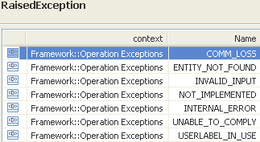 | restriction base="msg:AllExceptionsType"  element ref="msg:commLoss"  element ref="msg:entityNotFound"  element ref="msg:internalError"  element ref="msg:invalidInput"  element ref="msg:notImplemented"  element ref="msg:unableToComply"  element ref="msg:userlabelInUse"

Connection Control Service

Refer to separate comparison document Comparison-RP-ConnectionControlService.doc.

Equipment Provisioning Service

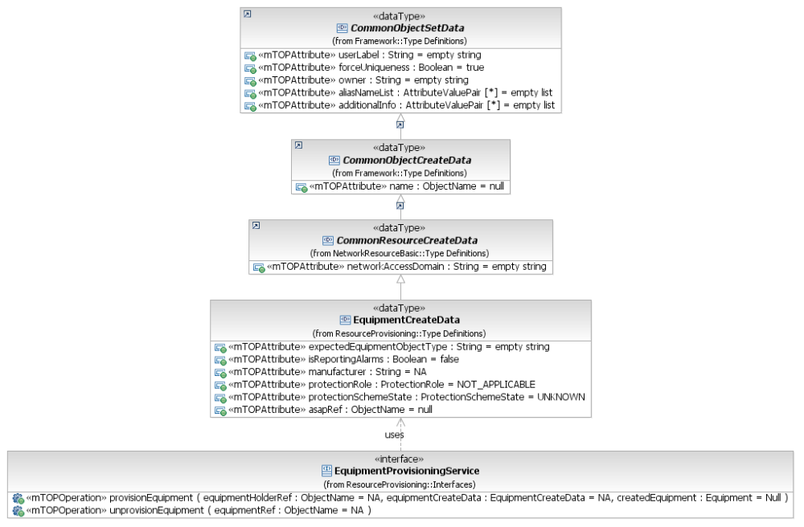
Figure 3: RP Equipment Provisioning Service Interface Diagram

provisionEquipment

BA (provision Equipment) | IA | IIS | Comments
R_TMF518_RP_II_0034  The Interface shall allow the requesting OS to provision anthe expected Equipment in anfor each Equipment Holder given the requesting OS specified data listed in R_TMF518_RP_II_0035. | This operation allows the requesting OS to provision an Equipment in an Equipment Holder in a Managed Element. The successful result of this operation is the creation or update of the Equipment object and the creation of all its related objects such as Termination Points. The Equipment object may already exist, but the Equipment Holder must not have an expected Equipment already provisioned.  See attached supporting document SD1-10_EquipmentModel.  Traceability: R_TMF518_RP_II_0034, R_TMF518_RP_II_0035, UC_TMF518_RP_0013. | This operation allows the NMS to permanently provision an equipment in an equipment holder in a Managed Element. The successful result of this operation is the creation or update of the equipment object and the creation of all its related objects such as Termination Points. The resulting object will be returned.  The equipment holder that will contain the equipment must exist. The equipment object may already exist, but the equipment holder must not have an expected equipment already provisioned. See SD1-10_EquipmentModel.pdf . | bz:  Only expected?
 | equipmentHolderRef (ObjectName)  This parameter provides the name of the Equipment Holder that will contain the Equipment. | element name="equipmentHolderRef" type="nam:NamingAttributeType"  Represents the name of equipment holder that will contain the equipment. | bz:  Should be moved from EquipmentCreateDataType to an input parameter.
R_TMF518_RP_II_0035  The Interface shall allow the requesting OS to specify the following parameters when it requests that a target OS provision an Equipment.  +++++++++++++++++  see EquipmentCreateData Type in section 12.1 | createData (EquipmentCreateData)  This parameter provides the data that describes the Equipment to create.  Traceability: R_TMF518_RP_II_0035.  +++++++++++++++++  see EquipmentCreateData Type in section 12.1 | (in) element name="equipmentCreateData" type="tns:EquipmentCreateDataType"  The data that describes the equipment to create.  +++++++++++++++++  see EquipmentCreateData Type in section 12.1
 | createdEquipment  This parameter returns the resulting created Equipment. | (out) element name="createdEquipment" type="eq:EquipmentType"  The resulting created equipment.
UC_TMF518_RP_0013  Pre-Conditions:  1. The requesting OS and target OS have successfully executed the Use Case The requesting OS and target OS have successfully executed the Use Case 0001 OS (Re) Starts as defined in the TMF518_FMW BA document.  2. The Equipment holder do not have an expected equipment. | None
UC_TMF518_RP_0013  Post-Conditions:  The new Equipment object is created and depending on the target OS, any object supported by the Equipmentall of its related objects exist. | 1. The new Equipment object is created and depending on the target OS, any object supported by the Equipment.  The Equipment object reflects the newly created card.  2. The Equipment Holder State reflects that the Equipment is now EXPECTED_AND_NOT_INSTALLEDexpected.
UC_TMF518_RP_0013  Exceptions:  1. Not implemented: The target OS does not support this service.  2. Processing failure: The requested operation could not be performed.  3. Object in use: The equipment holder already has an expected equipment.  4. Invalid input: The equipment holder does not reference an equipmentHolder object.  5. Entity not found: The equipmentHolder references object that does not exist.  6. Unable to comply: The equipment can not be created at the managedElement.  7. NE communication loss.  8. User label in use | 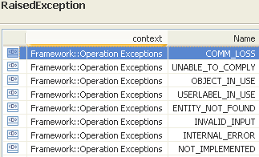 | restriction base="msg:AllExceptionsType"  element ref="msg:commLoss"  element ref="msg:entityNotFound"  element ref="msg:internalError"  element ref="msg:invalidInput"  element ref="msg:notImplemented"  element ref="msg:objectInUse"  element ref="msg:unableToComply"  element ref="msg:userlabelInUse" | bz:  The Exceptions clause is not in line with mTOP_Guidelines_BAs.doc: It shall only contain a list of all necessary exceptions. The specific exceptions have to be explicitly listed in the Description clause.

unprovisionEquipment

BA (unprovisionEquipment) | IA | IIS | Comments
R_TMF518_RP_II_0036  The Interface shall allow the requesting OS to unprovision anthe expected Equipment from anfor each Equipment Holder. | This operation allows the requesting OS to permanently unprovision an Equipment from a Managed Element. The successful result of this operation is the potential deletion of the equipment object and the deletion of all its related objects such as Termination Points.  The target OS should attempt to set the Equipment's service state to OUT_OF_SERVICE_BY_MAINTENANCE before it unprovisions it.  Traceability: R_TMF518_RP_II_0036, UC_TMF518_RP_0012. | This operation allows the NMS to permanently unprovision an equipment from the Managed Element. The successful result of this operation is the potential deletion of the equipment object and the deletion of all its related objects such as Termination Points.  The EMS should attempt to set the equipment to OUT_OF_SERVICE_BY_MAINTENANCE before it unprovisions it.
 | equipmentRef (ObjectName)  This parameter provides the name of the Equipment that is to be unprovisioned. | (in) element name="equipmentName" type="nam:NamingAttributeListType"  The name of equipment to be unprovisioned.
UC_TMF518_RP_0012  Pre-Conditions:  1. The requesting OS and target OS have successfully executed the Use Case The requesting OS and target OS have successfully executed the Use Case 0001 OS (Re) Starts as defined in the TMF518_FMW BA document.  2. Equipment to be unprovisioned is not in use. | None
UC_TMF518_RP_0012  Post-Conditions:  The Equipment is unprovisioned and all its related objects are deleted. | The specified Equipment and all its related objects are deleted.
UC_TMF518_RP_0012  Exceptions:  1. Not implemented: The target OS does not support this service.  2. Processing failure: The requested operation could not be performed.  3. Invalid input: The equipment name does not reference an equipment object.  4. Object in use: The equipment resources are in use.  5. Entity not found: The equipment name references an object which does not exist.  6. Unable to comply: The equipment can not be unprovisioned at the managedElement.  7. NE communication loss. | 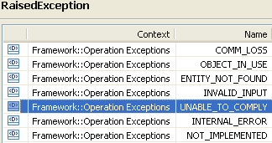 | restriction base="msg:AllExceptionsType"  element ref="msg:commLoss"  element ref="msg:entityNotFound"  element ref="msg:internalError"  element ref="msg:invalidInput"  element ref="msg:notImplemented"  element ref="msg:objectInUse"  element ref="msg:unableToComply" | bz:  The Exceptions clause is not in line with mTOP_Guidelines_BAs.doc: It shall only contain a list of all necessary exceptions. The specific exceptions have to be explicitly listed in the Description clause.

Flow Domain Control Service

Refer to separate comparison document Comparison-RP-FlowDomainControlService.doc.

Gui Cut Through Control Service
BZ: This Service has a weak consistency.
BZ: Not sure if R_TMF518_RP_II_0068, R_TMF518_RP_II_0069 apply here. → just general requirements; need not to be mapped to one of the operations

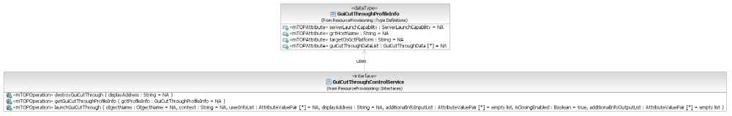
Figure 4: RP Gui Cut Through Control Service Interface Diagram

destroyGuiCutThrough

BA (destroyGuiCutThrough) | IA | IIS | Comments
R_TMF518_RP_II_0072  If possible, the EMS should be able to actively manage the GCT application windows.  9. Integrate the EMS window within NMS window hierarchy (e.g. associate it to the NMS main window on creation of the GCT window) if made possible by the window system protocol.  10. The EMS should be able to close all of the GCT windows upon request by the NMS, or notify the NMS that closing of the GCT is disabled. Optional based on EMS. | This operation closes all Gui Cut Through (GCT) windows opened by the operation launchGuiCutThrough at the given display address. The relevant GCT records maintained by the EMStarget OS are cleared.  Traceability: R_TMF518_RP_II_0072, UC_TMF518_RP_0036. | This operation closes all the GCT windows opened by launchGuiCutThrough() at the given displayAddress; it also removes all related records from the EMS/GCT window manager.
 | displayAddress (String)  This parameter provides the IP address or hostname of the display from which all GCT windows are to be closed. | (in) element name="displayAddress" type="xsd:string"  the IP address or hostname of the display from which all GCT windows are to be closed.
UC_TMF518_RP_0036  Pre-Conditions:  1. The NMS and EMS have successfully executed the Use Case 0001 OS (Re) Starts as defined in the TMF518_FMW BA document.  2. The EMS has indicated that it supports server launch.  3. The NMS has ensured that it is possible for GCT to be displayed on the GCT Display location. | 1. The target OS is able to manage GCT application windows.  2. The target OS has 1 or more GCT applications that have been launched directly by the target OS (under a "server launched" configuration) being displayed at the given GCTDisplayAddress.
UC_TMF518_RP_0036  Post-Conditions: | 1. All of the GCT windows opened by the target OS at the given display host address are closed.  2. The relevant GCT records maintained by the target OS are cleared.
UC_TMF518_RP_0036  Exceptions:  1. Not implemented: The EMS does not support this service.  2. Internal error.  3. Invalid Input.  4. Unable to comply. For example the EMS cannot support the (valid) context and scope combination requested.  5. Maximum GCT displays has been reached. | 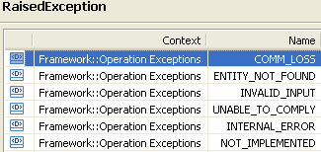 | restriction base="msg:AllExceptionsType"  element ref="msg:entityNotFound"  element ref="msg:internalError"  element ref="msg:invalidInput"  element ref="msg:notImplemented"  element ref="msg:commLoss" | bz:  The Exceptions clause is not in line with mTOP_Guidelines_BAs.doc: It shall only contain a list of all necessary exceptions. The specific exceptions have to be explicitly listed in the Description clause.  bz:  Is commLoss missing?  add commLoss (to all operations)

getGuiCutThroughProfileInfo

BA (getGuiCutThroughProfileInfo) | IA | IIS | Comments
R_TMF518_RP_II_0070  The GUI Cut-through shall allow the context to be specified. The user can make a request for a specific object in different window contexts and the user’s entry point into the EMS should be in the same context or window type as requested by the NMS. The only window context that must be supported is the Top-Level context. If the EMS does not provide data for a window type, the NMS will use the data for the top level window. The suggested optional window contexts are Fault, Configuration (software management/connection management), Accounting, Performance, Security and Systems Management. When the desired window context is unavailable for the given object scope, then a window context that contains and/or allows navigation into the requested context is provided. The interface will allow the NMS to retrieve all the GCT contexts that are supported by the EMS. | This operation returns the EMS profiling information that applies to the GUI Cut-through:  - indication of support for the "server-launch",  - the supported GCT contexts and scopes,  - the GCT command information necessary to launch the GCT on the client side.  Traceability: R_TMF518_RP_II_0070, UC_TMF518_RP_0034. | This operation allows an NMS to request the GUI Cut-Through information from the EMS.  The interface will include two different operation modes, client launch and server launch.  EMS support of the client launch is mandatory and the client launch itself is handled outside this interface. The EMS should, to the best of its abilities, provide sufficient information in the response to enable the NMS to launch a GUI Cut-Through.  EMS support for server launch is optional and the server launch is invoked through the interface.  Note that it is not required for the NMS to reobtain the GCT profile before every launchGCT request and therefore the EMS cannot change the GuiCutThroughProfileInfoType unless the session is closed.
to be added | gctProfileInfo (GuiCutThroughProfileInfo)  This parameter returns the data on all supported GCT window types.  +++++++++++++++++  see GuiCutThroughProfileInfo Type in section 12.4 | (out) element name="guiCutThroughgctProfileInfo" type="tns:GuiCutThroughProfileInfoType"  The EMS will fill this list to contain data on all supported GCT window types.  +++++++++++++++++  see GuiCutThroughProfileInfo Type in section 12.4
UC_TMF518_RP_0034  Pre-Conditions:  The NMS and EMS have successfully executed the Use Case 0001 OS (Re) Starts as defined in the TMF518_FMW BA document. | None
UC_TMF518_RP_0034  Post-Conditions:  The NMS has retrieved the GCT information from the EMS. | The NMS has retrieved the GCT information from the EMS.
UC_TMF518_RP_00  Exceptions:  Internal errorProcessing failure: The requested operation could not be performed.  Not implemented | 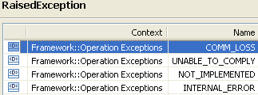 | restriction base="msg:AllExceptionsType"  element ref="msg:notImplemented"  element ref="msg:internalError" | bz:  The Exceptions clause is not in line with mTOP_Guidelines_BAs.doc: It shall only contain a list of all necessary exceptions. The specific exceptions have to be explicitly listed in the Description clause.

launchGuiCutThrough

BA (launchGuiCutThrough) | IA | IIS | Comments
R_TMF518_RP_II_0067  The NML-EML Interface shall allow the NMS to access the EMS user interface.  R_TMF518_RP_II_0071  The GCT feature may apply to different objects managed within each EMS, i.e. the GCT request must have a scope (either EMS or ME). The scope field in the GCT data record reflects the supported scope of the GCT operation.  When the GCT is not implemented for the requested object scope, the EMS will launch the GCT of the closest superior object available (this information is available through the hierarchy of the object name). For example, if a certain GCT is unavailable for the requested ME then a GCT (of the same context) should be launched for the EMS instead. The NMS should request the narrowest scope desired. Alternatively the NMS shall only request a scope that is known to be supported according to the profile/GCT capability information received.  R_TMF518_RP_II_0070 | This operation of the EMStarget OS invokes the launch of the GCT under a server-launched configuration.  Traceability: R_TMF518_RP_II_0067, R_TMF518_RP_II_0070, R_TMF518_RP_II_0071, UC_TMF518_RP_0035, UC_TMF518_RP_0036. | This operation invokes the EMS server launch of the GCT.
requieremnt for parameter list to be added | objectName (ObjectName)  This parameter provides the applicable reference object. The EMS displays the GCT to the extent supported by the EMS. The EMStarget OS should invoke the GCTwhich is available for the closest object in the object name hierarchy. (e.g., if the card internal view is not available for the equipment object indicated then the EMS will invoke the GCT of its Managed Element instead). Only the top-level of the EMS is mandatory to be supported by the EMS. | (in) element name="objectName" type="nam:NamingAttributeType"  The object which should be displayed, if possible, upon creation of the GCT window. If not possible, the EMS will select the closest superior object available.
 | context (String)  This parameter provides the window context. Context is of secondary priority with the Object Name as serving as the highest priority in determining which GCT window to open.  Suggested window contexts are:  - TOP_LEVEL,  - FAULT,  - CONFIGURATION_SOFTWARE,  - CONFIGURATION_CONNECTION,  - ACCOUNTING,  - PERFORMANCE,  - SECURITY,  - SYSTEMS_MANAGEMENT. | (in) element name="guiCutThroughCcontext" type="xsd:string"  The window context (see GuiCutThroughDataType).
 | userInfoList (*)  This parameter provides the capability / user information that applies to the operations that are made available through the GCT application, depending on the EMStarget OS ability to enforce capability / user limitations on the GCT.  Suggested information is:  - userId,  - password,  - capability.  Capability suggested values are:  - READ_ONLY,  - READ_WRITE.  Values and meaning for these attributes are left to bilateral agreement EMS andNMS. | (in) element name="userInfoList" type="gen:NameAndValueStringListType"  Identifies the GCT user. The contents of this parameter is subject to bilateral agreements.
 | displayAddress (String)  This parameter provides the IP address or hostname including any display port information. | (in) element name="displayAddress" type="xsd:string"  The IP address or hostname of the display for the window.
 | additionalInputInfoList (*)  This parameter provides additional information provided to the EMS. The content of this parameter is subject to bilateral agreements.  A suggested value is GCT Parent Window. It allows the association of the GCT to the desired parent window when the window meachanism supports this (e.g. when using a pure X-protocol). | (in) element name="additionalInputInfoList" type="gen:NameAndValueStringListType"  Additional input info provided to the EMS. The contents of this parameter is subject to bilateral agreements.
 | isClosingEnabled (Boolean)  This parameter returns a flag indicating the ability of the EMS to manage the open GCT window. Specifically whether the EMS is able to close it upon request (i.e. using a subsequent destroyGCT operation). | (out) element name="isClosingEnabled" type="xsd:boolean"  Indicates to the NMS whether or not destroyGuiCutThrough() will be supported for this window.
 | additionalOutputInfoList (*)  This parameter returns additional information provided by the EMS. The content of this parameter is subject to bilateral agreements.  A suggested value is GCT Window Handle: It allows the requesting OS to manage the GCT, within its own window manager, when possible (e.g. when using a pure X-protocol). | (out) element name="additionalOutputInfoList" type="gen:NameAndValueStringListType"  Additional output info provided by the EMS to the NMS. The contents of this parameter is subject to bilateral agreements.
Pre-Conditions:  UC_TMF518_RP_0036  1. The NMS and EMS have successfully executed the Use Case 0001 OS (Re) Starts as defined in the TMF518_FMW BA document.  2. The EMS has indicated that it supports server launch.  3. The NMS has ensured that it is possible for GCT to be displayed on the GCT Display location. | 1. The EMSsupports the server launch window system protocol (i.e., is capable of server launching in addition to client launching).  2. The NMS has retrieved the GCT profile of the EMS that contains the window/widget data the EMS supports for GCT, and has selected an object to be displayed upon GCT launch.  3. The managed object to be displayed upon GCT launch exists and is in a valid state.  4. The EMS has access to the NMS display address.
Post-Conditions:  UC_TMF518_RP_0036  1. The NMS is aware to whether the GCT has launched successfully (otherwise an exception would have been thrown).  2. If the EMS supports closing of GCT windows then it must maintain the aliases of the open GCT windows.  3. The EMS must notify the NMS system whenever the closing of the GCT being opened is not available. | The GCT application opens the display successfully at the NMS host address.
Exceptions:  UC_TMF518_RP_0036  1. Not implemented: The EMS does not support this service.  2. Internal error.  3. Invalid Input.  4. Unable to comply. For example the EMS cannot support the (valid) context and scope combination requested.  5. Capacity exceeded. Maximum GCT displays has been reached. | 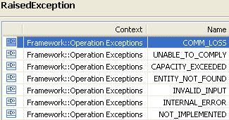 | restriction base="msg:AllExceptionsType"  element ref="msg:capacityExceeded"  element ref="msg:entityNotFound"  element ref="msg:internalError"  element ref="msg:invalidInput"  element ref="msg:notImplemented"  element ref="msg:unableToComply" | bz:  The Exceptions clause is not in line with mTOP_Guidelines_BAs.doc: It shall only contain a list of all necessary exceptions. The specific exceptions have to be explicitly listed in the Description clause.

Software And Data Control Service

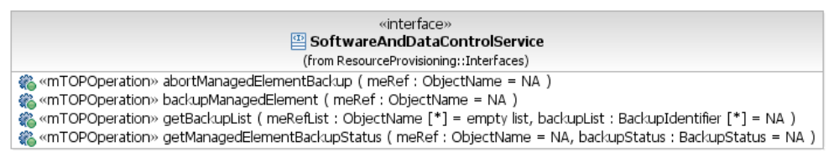
Figure 5: RP Software And Data Control Service Interface Diagram

abortManagedElementBackup

BA (abortManagedElementBackup) | IA | IIS | Comments
R_TMF518_RP_II_0075  The Interface shall allow the requesting OS to request the target OS abort the database backup for a Managed Element (ME) specified by the requesting OS. | This operation will abort a backup of ME configuration data that is pending or in progress. If there is no backup of configuration data of the ME pending or in progress exception NOT_IN_VALID_STATE will be thrown.  Traceability: R_TMF518_RP_II_0075. | This operation will abort a backup of ME configuration data that is pending or in progress. If there is no backup of configuration data of the ME pending or in progress an exception will be thrown.
 | meRef (ObjectName)  This parameter provides the name of the Managed Element for which the requesting OS wants to abort the backup request. | (in) element name="meRefName" type="nam:NamingAttributeType"  The name of the ME for which an existing backup process is to be aborted.
No use case defined. | 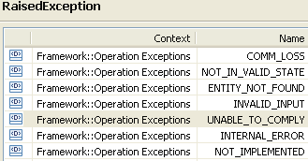 | restriction base="msg:AllExceptionsType"  element ref="msg:commLoss"  element ref="msg:entityNotFound"  element ref="msg:internalError"  element ref="msg:invalidInput"  element ref="msg:notImplemented"  element ref="msg:notInValidState"

backupManagedElement

BA (backupManagedElement) | IA | IIS | Comments
R_TMF518_RP_II_0073  The Interface shall allow the requesting OS to request the target OS to backup the data of the Managed Element (ME) specified by the requesting OS. | This operation initiates a backup request on the specified Managed Element.  The target OS sends the results of the backup operation for the Managed Element as Notifications to the Notification Service.  Traceability: R_TMF518_RP_II_0073. | This operation will initiate a backup request on the specified ME. This is an asynchronous operation. The EMS will send the results of the backup operation for the Managed Element as notifications to the provided Notification ServiceConsumer end-point. | This is a non-blocking operation.
 | meRef (ObjectName)  This parameter provides the name of the Managed Element for which the backup is to be associated to. | (in) element name="meRefName" type="nam:NamingAttributeType"  The name of the ME for which a backup of configuration data is required.
(in) element name="consumerEpr" type="not:EndPointReferenceType"
the notification consumer endpoint (callback handler) that the broker will call to send the notification event; backupStatus.

No use case defined. | 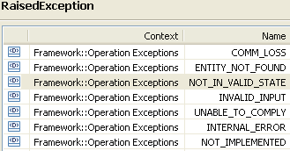 | restriction base="msg:AllExceptionsType"  element ref="msg:commLoss"  element ref="msg:entityNotFound"  element ref="msg:internalError"  element ref="msg:invalidInput"  element ref="msg:notImplemented"  element ref="msg:notInValidState"

getBackupList

BA (getBackupList) | IA | IIS | Comments
R_TMF518_RP_II_0076  The Interface shall allow the requesting OS to retrieve the names of all the database backups for a list of Managed Element (ME) names specified by the requesting OS that are available on the target OS. | This operation is used to determine what backups exist in the target OS for a specified list of Managed Elements. It returns the list of available backups for the specified Managed Elements. If the ME list is empty, all database backups will be returned (note that only the names are returned not the backups themselves).  Traceability: R_TMF518_RP_II_0076. | The NMS will invoke this method to determine what configuration data backups exist in the EMS for a specified list of MEs.  This operation will return the list of the ids of all configuration data backups for specified MEs. If the list of MEs in the request is empty, the ids of all configuration data backups will be returned for all MEs.
 | meRefList (*) (ObjectName)  This parameter provides the list of Managed Elements for which the requesting OS wants to retrieve the backups existing in the target OS. | (in) element name="meRefNameList" type="nam:NamingAttributeListType"  The name of the ME for which a backup of configuration data is required.
 | backupList (*) (BackupIdentifier)  This parameter returns the list of backups contained in the target OS for the specified Managed Elements.  +++++++++++++++++  BackupIdentifier  This data type uniquely identifies a backup from a Managed Element (ME), using the ME name and the time when the backup was taken.  The EMS may decide to ignore the seconds/sub-seconds field in the time parameter.  meRef (ObjectName)  This attribute contains the name of the Managed Element to which the backup refers to.  backupTime (ItuTTime)  This attribute contains the time when the backup was taken. | (out) element name="backupList" type="tns:BackupIdentifierListType"  First batch of configuration data backup ids.  +++++++++++++++++  BackupIdType  This data structure provides an identifier for a backup on an EMS. The ME name and the time when the backup was taken uniquely identifies the backup. The EMS may decide to ignore the seconds/sub-seconds field in the Time parameter. The EMS is expected to administer time adjustments and ME name changes in such a way as to ensure that no two backups have the same identifier.  element name="meRefName" type="nam:NamingAttributeType"  The name of the Managed Element from which the backup was taken.  element name="backupTime" type="xsd:dateTime"  The time at which the backup was taken.
No use case defined. | 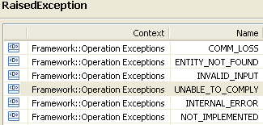 | restriction base="msg:AllExceptionsType"  element ref="msg:commLoss"  element ref="msg:entityNotFound"  element ref="msg:internalError"  element ref="msg:invalidInput"  element ref="msg:notImplemented"  element ref="msg:tooManyOpenIterators"

getManagedElementBackupStatus

BA (getManagedElementBackupStatus) | IA | IIS | Comments
R_TMF518_RP_II_0074  The Interface shall allow the requesting OS to retrieve the current status of the database backup for a Managed Element (ME) specified by the requesting OS. | This operation retrieves t the current status of the database backup of an individual Managed Element.  Traceability: R_TMF518_RP_II_0074. | This operation can be used by the NMS to get the current backup status of an individual ME.
 | meRef (ObjectName)  This parameter provides the name of the Managed Element for which the requesting OS wants to know the backup status. | (in) element name="meRefName" type="nam:NamingAttributeType"  The name of the ME for which a status of the backup of configuration data is required.
 | backupStatus (BackupStatus)  This parameter returns the actual backup status of the Managed Element. | (out) element name="backupStatus" type="tns:BackupStatusType"  The status of the backup of configuration data.
No use case defined. | 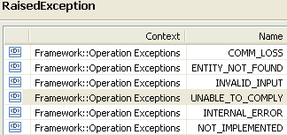 | restriction base="msg:AllExceptionsType"  element ref="msg:commLoss"  element ref="msg:entityNotFound"  element ref="msg:internalError"  element ref="msg:invalidInput"  element ref="msg:notImplemented"

Termination Point Control Service
BA: R_TMF518_RP_II_0087 (ConnectionTerminationPoint::getTPMappingMode) to be moved to MRI and be associated to the getTerminationPoint operation.

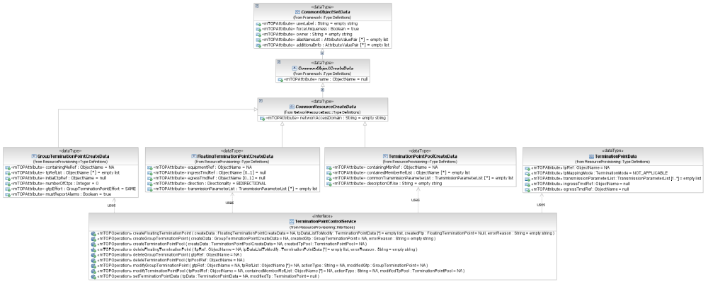
Figure 6: RP Termination Point Control Service Interface Diagram

createFloatingTerminationPoint

BA (createFloatingTerminationPoint) | IA | IIS | Comments
R_TMF518_RP_II_0090  The Interface shall allow the requesting OS to create a Floating Termination Point (FTP) given the requesting OS specified data listed in R_TMF518_RP_II_0091.  The target OS will attempt to fulfill the request including the creation of the appropriate fragment CTPs if applicable (e.g., VCAT or LAG). | This operation creates a Floating Termination Point (FTP) within an Equipment (and the CTPs contained in the FTP, if applicable).  Traceability: R_TMF518_RP_II_0090, R_TMF518_RP_II_0091, UC_TMF518_RP_0040. | This operation allows an NMS requests from the EMS the creation of an FTP given the parameters passed in the method.
R_TMF518_RP_II_0091  The Interface shall allow the requesting OS to specify the following parameters when it requests the creation of a Floating Termination Point (FTP) object.  +++++++++++++++++  see FloatingTerminationPointCreateData Type in section 12.6 | createData (FloatingTerminationPointCreateData)  This parameter provides the attributes describing the Floating Termination Point to be created.  Traceability: R_TMF518_RP_II_0091.  +++++++++++++++++  see FloatingTerminationPointCreateData Type in section 12.6 | (in) element name="createData" type="tns:FloatingTerminationPointCreateDataType"  Structure describing the floating termination point structure to be created.  +++++++++++++++++  see FloatingTerminationPointCreateData Type in section 12.6
 | tpDataListToModify (in/out) (*) (TerminationPointData)  This parameter, when used in the request,  (in) identifies a list of TPs with associated parameters to be applied; the parameter may be used by the requesting OS to determine the number of server layer CTPs to create for the specified FTP; an empty list means that the number of server layer CTPs is determined by the target OS;  (out) identifies the list of TPs with associated applied parameters.  +++++++++++++++++  see TerminationPointData Type in section 12.1 of Comparison-RP-ConnectionControlService.doc | (in) element name="tpDataListToModify" type="tpdata:TerminationPointDataListType"  The list of TPs with associated parameters to be applied. Applying transmission parameters is best-effort (where not stated otherwise) and the resulting values of the transmission parameters are provided in the updated tpDataListToModify parameter. If the parameter is "not best effort" then the whole operation will be rejected and the appropriate exception thrown (see exceptions below).  This parameter may be used by the NMS to determine the number of server layer CTPs to create for the specified FTP. An empty list means that the number of server layer CTPs is determined by the EMS.  +++++++++++++++++  see TerminationPointData Type in section 12.1 of Comparison-RP-ConnectionControlService.doc
(out) element name="tpDataListToModify" type="tpdata:TerminationPointDataListType"
The list of TPs with associated parameters to be applied.
+++++++++++++++++
see TerminationPointData Type in section 12.1 of Comparison-RP-ConnectionControlService.doc

 | createdFtp  This parameter returns the newly created Floating Termination Point object. | (out) element name="theFtp" type="ftp:FloatingTerminationPointType"  The new floating termination point. The EMS is responsible for guaranteeing uniqueness of the name of the FTP. The name may be specified by the NMS in the createData.
 | errorReason (out)  This parameter returns the error(s) if any. | (out) element name="errorReason" type="xsd:string"  Specifies the creation error(s) if any.
UC_TMF518_RP_0040  Pre-Conditions:  The requesting OS and target OS have successfully executed the Use Case 0001 OS (Re) Starts as defined in the TMF518_FMW BA document. | None
UC_TMF518_RP_0040  Post-Conditions:  In case of success:  1) The FTP has been created.  2) The contained fragment CTPs have been created (if applicable).  In case of failure:  No change occurred to the system, i.e., the FTP has not been created. | 1. The FTP object has been created.  2. The contained CTPs have been created (if applicable).
UC_TMF518_RP_0040  Exceptions:  Refer to Category III: Abnormal or Exception Conditions, Dynamic Requirements | 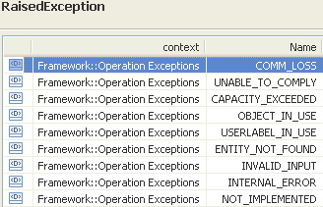 | restriction base="msg:AllExceptionsType"  element ref="msg:capacityExceeded"  element ref="msg:commLoss"  element ref="msg:entityNotFound"  element ref="msg:internalError"  element ref="msg:invalidInput"  element ref="msg:notImplemented"  element ref="msg:objectInUse"  element ref="msg:unableToComply"  element ref="msg:userlabelInUse"

createGroupTerminationPoint

BA (createGroupTerminationPoint) | IA | IIS | Comments
R_TMF518_RP_II_0077  The Interface shall allow the requesting OS to create a Group Termination Point (GTP) in the target OS given the requesting OS specified data listed in R_TMF518_RP_II_0078.  Use Case 7.5.18 to be added | This operation creates a new Group Termination Point (GTP). The requesting OS can either specify the list of CTPs comprising the GTP (the list is placed in the tpRefList parameter) or, in the case of contiguous CTPs of the same layerRate, the requesting OS may list the first CTP (in the initialCtpRef parameter) and the number of following CTPs (in the numberOfCtps parameter). The requesting OS may also provide the target OS with the flexibility to decide the list of CTPs by using the gtpEffort parameter. In this flexible mode the target OS uses the tpRefList parameter or the initialCtpRef/ numberOfCtps parameters to determine the total requested bandwidth but it may return a GTP (createdGtp parameter) with a different set of CTPs than those indicated in the original request. Note that this mode allows for the GTP components to be instantiated at a later time by the Managed Element (e.g., upon detection of user's signal). Therefore the operation may successfully return a createdGtp with an empty tpRefList attribute (to be updated at a later time once the component CTPs are created in the Managed Element).  Traceability: R_TMF518_RP_II_0077, R_TMF518_RP_II_0078, UC_TMF518_RP_00??. | The NMS uses this operation to request the creation of a GTP see SD1-3_BundledSNC.pdf for further information on GTP usage). The NMS can either specify the list of CTPs comprising the GTP (the list is placed in the listOfTPs parameter) or, in the case of contiguous CTPs of the same layerRate, the NMS may list the first CTP (in the initialCTPname parameter) and the number of following CTPs (in the numberOfCTPs parameter). The NMS may also provide the EMS with the flexibility to decide the list of CTPs by using the gtpEffort parameter. In this flexible mode the EMS uses the listOfTPs parameter or the initialCTPname/ numberOfCTPs parameters to determine the total requested bandwidth but it may return a GTP (newGTP parameter) with a different set of CTPs than those indicated in the original createGTP request. Note that this mode allows for the GTP components to be instantiated at a later time by the ME (e.g., upon detection of user's signal). Therefore the operation may successfully return a newGTP with an empty listOfTPs attribute (to be updated at a later time once the component CTPs are created in the ME). | bz:  Use Case 7.5.18: NMS creates a Group Termination Point (GTP) not contained in BA. → will be added to the BA
R_TMF518_RP_II_0078  The Interface shall allow the requesting OS to specify the following parameters when it requests that A target OS creates a Group Termination Point (GTP):  +++++++++++++++++  see GroupTerminationPointCreateData Type in section 12.2 | createData (GroupTerminationPointCreateData)  This parameter provides the attributes describing the Group Termination Point to be created.  Traceability: R_TMF518_RP_II_0078.  +++++++++++++++++  see GroupTerminationPointCreateData Type in section 12.2 | (in) element name="createData" type="tns: GroupTerminationPointCreateDataType"  Structure describing the group termination point to be created.  (in) element name="userLabel" type="xsd:string"  the userLabel for the GTP.  (in) element name="forceUniqueness" type="xsd:boolean"  Specifies whether uniqueness of the userLabel is required amongst GTPs of the EMS. The operation will fail if userLabel is already in use.  (in) element name="owner" type="xsd:string"  the owner of the GTP.  (in) element name="vendorExtensions" type="gen:AnyListType"  This is a container for all vendor extensions. | bz:  A separate GroupTerminationPointCreateDataType data type should be created in the IIS which inherits from CommonResourceCreateDataType.
 |  | (in) element name="tpRefList" type="nam:NamingAttributeListType"  the list of CTPs that comprise the GTP.  (in) element name="initialCtpName" type="nam:NamingAttributeType"  in cases where the CTPs are contiguous and of the same layerRate, this parameter is used to indicate the first CTP in the group. This parameter is used in lieu of the listOfTPs parameter.  (in) element name="numberOfCtp" type="xsd:long"  This parameter is used in conjunction with the initialCTPname parameter. It indicates the number of contiguous CTPs that follow the initial CTP. It equals 1 minus the total number of CTPs in the GTP.  (in) element name="gtpEffort" type="tns:GroupTerminationPointEffortType"  This parameter is used to indicate if the GTP bandwidth specification can be met with a different list of CTPs. | bz:  Should be moved to new GroupTerminationPointCreateDataType; see GroupTerminationPointCreateData in section 12.2.
 | createdGtp  This parameter returns the newly created Group Termination Point object. | (out) element name="newGtp" type="gtp:GroupTerminationPointType"  This output parameter contains the newly created GTP.
errorReason (out)
This parameter returns the error(s) if any.

No use case defined. | 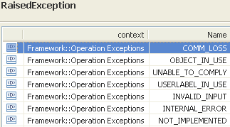 | restriction base="msg:AllExceptionsType"  element ref="msg:commLoss"  element ref="msg:internalError"  element ref="msg:invalidInput"  element ref="msg:notImplemented"  element ref="msg:objectInUse"  element ref="msg:unableToComply"  element ref="msg:userlabelInUse"

createTerminationPointPool

BA (createTerminationPointPool) | IA | IIS | Comments
R_TMF518_RP_I_0081  The Interface shall allow the requesting OS to create a OS given the requesting OS specified data listed in R_TMF518_RP_II_0082.Termination Point Pool (TP Pool) in the target  Use Case 7.5.21 to be added | This operation creates a new Termination Point Pool.  Traceability: R_TMF518_RP_II_0081, R_TMF518_RP_II_0082, UC_TMF518_RP_00??. | This operation . | bz:  Use Case 7.5.21: NMS creates a Termination Point Pool (TP Pool) not contained in BA. → to be added to BA
R_TMF518_RP_II_0082  The Interface shall allow the requesting OS to specify the following parameters when it requests that a target OS creates a Termination Point Pool (TP Pool):  +++++++++++++++++  see TerminationPointPoolCreateData Type in section 12.3 | createData (TerminationPointPoolCreateData)  This parameter provides the attributes describing the Termination Point Pool to be created.  Traceability: R_TMF518_RP_II_0082.  +++++++++++++++++  see TerminationPointPoolCreateData Type in section 12.3 | (in) element name="createData" type="tns: TerminationPointPoolCreateDataType"  Structure describing the termination point pool to be created.  (in) element name="userLabel" type="xsd:string"  the userLabel for the TpPool.  (in) element name="forceUniqueness" type="xsd:boolean"  Specifies whether uniqueness of the userLabel is required amongst TpPools of the MLSN. The operation will fail if userLabel is already in use.  (in) element name="owner" type="xsd:string"  the owner of the TpPool.  (in) element name="vendorExtensions" type="gen:AnyListType"  This is a container for all vendor extensions. | bz:  A separate TerminationPointPoolCreateDataType data type should be created in the IIS which inherits from CommonResourceCreateDataType.
 |  | (in) element name="containingMlsn" type="mlsn:MultiLayerSubnetworkType"  The subnetwork that shall contain the TPPool to be created.  (in) element name="containedMembersRefList" type="nam:NamingAttributeListType"  The list of TPs or GTPs that shall comprise the TPPool.  (in) element ref="lp:transmissionParametersList"  The common layers and transmission parameters the above-specified Contained TPs, or TPs contained in Contained GTPs, are required to have (e.g., ATM VP layer with prescribed traffic characteristics).  (in) element name="descriptionOfUse" type="xsd:string"  A description of the specific use of the TP pool, in particular how its members are collected and administered. It could include, for example, the name of a TP with the meaning that all TP pool members have to be collected from the set of potential client CTPs of this TP. | bz:  Should be moved to new TerminationPointPoolCreateDataType; see GroupTerminationPointCreateData in section 12.3.
 | createdTpPool  This parameter returns the newly created Termination Point Pool object. | (out) element name="newTpPool" type="tppool:TerminationPointPoolType"  This parameter contains the newly created TPPool.
No use case defined. | 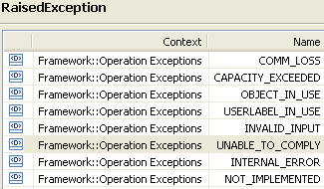  add unable to comply to ALL operations in the IA | restriction base="msg:AllExceptionsType"  element ref="msg:capacityExceeded"  element ref="msg:commLoss"  element ref="msg:internalError"  element ref="msg:invalidInput"  element ref="msg:notImplemented"  element ref="msg:objectInUse"  element ref="msg:unableToComply"  element ref="msg:userlabelInUse"

deleteFloatingTerminationPoint

BA (deleteFloatingTerminationPoint) | IA | IIS | Comments
R_TMF518_RP_II_0092  The Interface shall allow the requesting OS to delete a Floating Termination Point (FTP) given the requesting OS specified FTP name from the target OS.  The deletion request shall fail if:  • the FTP is a Call endpoint, or  • the FTP or any of its contained server CTPs (VCAT and LAG case) is an Subnetwork Connection (SNC) endpoint, or  • if the FTP cannot be explicitly deleted (e.g., was automatically created by the target OS).  • if the FTP is a call-end-point whose role is “assigned” or “fdEdge”. | This operation deletes a Floating Termination Point (FTP) from the Managed Element together with any contained CTPs.  Traceability: R_TMF518_RP_II_0092, UC_TMF518_RP_0041. | This operation allows an NMS to request the deletion of a floating termination point from the EMS. The operation may be used to delete "CPTP" FTPs.
 | ftpRef (ObjectName)  This parameter provides the name of the Floating Termination Point to be deleted. | (in) element name="ftpName" type="nam:NamingAttributeType"  The name of the termination point to be deleted.
 | tpDataListToModify (in/out) (*) (TerminationPointData)  This parameter, when used in the request,  (in) identifies a list of TPs with associated parameters to be applied;  (out) identifies the list of TPs with associated applied parameters.  +++++++++++++++++  see TerminationPointData Type in section 12.1 of Comparison-RP-ConnectionControlService.doc | (in) element name="tpDataListToModify" type="tpdata:TerminationPointDataListType"  The list of TPs with associated parameters to be applied.  +++++++++++++++++  see TerminationPointData Type in section 12.1 of Comparison-RP-ConnectionControlService.doc
(out) element name="tpDataListToModify" type="tpdata:TerminationPointDataListType"
The list of TPs with associated parameters to be applied.
+++++++++++++++++
see TerminationPointData Type in section 12.1 of Comparison-RP-ConnectionControlService.doc

 | errorReason (out)  This parameter returns the error(s) if any. | (out) element name="errorReason" type="xsd:string"  This parameter returns the error(s) if any.In case a "best effort" parameter could not be set an indication of the fault reason is provided by the EMS.
UC_TMF518_RP_0041  Pre-Conditions:  The requesting OS and target OS have executed successfully the Use Case 0001 OS (Re) Starts as defined in the TMF518_FMW BA document. | None
UC_TMF518_RP_0041  Post-Conditions:  In case of success:  The FTP and its contained CTPs have been deleted.  In case of failure:  No change occurred to the system, (i.e., the FTP or any of its contained CTPs have not been deleted or modified). | 1. The FloatingTerminationPoint object has been deleted.  2. Any contained CTPs have been deleted.
UC_TMF518_RP_0041  Exceptions:  Refer to Category III: Abnormal or Exception Conditions, Dynamic Requirements | 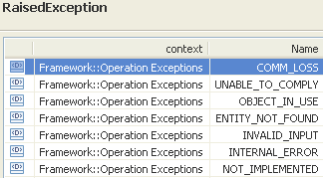 | restriction base="msg:AllExceptionsType"  element ref="msg:commLoss"  element ref="msg:entityNotFound"  element ref="msg:internalError"  element ref="msg:invalidInput"  element ref="msg:notImplemented"  element ref="msg:objectInUse"  element ref="msg:unableToComply"

deleteGroupTerminationPoint

BA (deleteGroupTerminationPoint) | IA | IIS | Comments
R_TMF518_RP_II_0079  The Interface shall allow the requesting OS to delete a Group Termination Point (GTP) given the GTP name specified by the requesting OS from the target OS.  Use Case 7.5.20 to be added | This operation deletes a Group Termination Point (GTP). An attempt to delete a GTP that is involved in a Cross-Connection or SNC should be rejected by the target OS.  The operation is idempotent; i.e., if the operation is called with the name of a non-existent GTP, it will succeed.  Traceability: R_TMF518_RP_II_0079, UC_TMF518_RP_00??. | This operation is used to delete a GTP (see SD1-3 Bundled SNC overview for further information on GTP usage). An attempt to delete a GTP that is involved in a cross connection or SNC should be rejected by the EMS. This operation is idempotent. If the service is called with the name of a non-existent GTP, it will succeed. | bz:  Use Case 7.5.20: NMS deletes a Group Termination Point (GTP) not contained in BA. → to be added to the BA
 | gtpRef (ObjectName)  This parameter provides the name of the Group Termination Point to be deleted. | (in) element name="gtpName" type="nam:NamingAttributeType"  The name of GTP to be deleted.
No use case defined. | 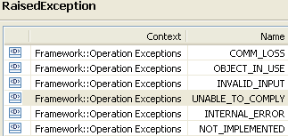  element ref="msg:entityNotFound" | restriction base="msg:AllExceptionsType"  element ref="msg:entityNotFound"  element ref="msg:internalError"  element ref="msg:invalidInput"  element ref="msg:notImplemented"  element ref="msg:objectInUse"  element ref="msg:commLoss" | bz:  Exception commLoss to be added? → yes  bz:  Exception entityNotFound to be deleted (note, operation is idempotent)?

deleteTerminationPointPool

BA (deleteTerminationPointPool) | IA | IIS | Comments
R_TMF518_RP_II_0083  The Interface shall allow the requesting OS to delete a Termination Point Pool (TP Pool) given the TP Pool name specified by the requesting OS from the target OS.  Use Case 7.5.2 to be added | This operation deletes a Termination Point Pool.  The operation is idempotent; i.e., if the operation is called with the name of a non-existent Termination Point Pool, it will succeed.  Traceability: R_TMF518_RP_II_0083, UC_TMF518_RP_00??. | The delete TPPool operation is used to delete a TPPool. This operation is idempotent. If the service is called with the name of a non-existent TPPool, it will succeed. | bz:  Use Case 7.5.23: NMS deletes a Termination Point Pool (TP Pool) not contained in BA. → to be added to the BA
 | tpPoolRef (ObjectName)  This parameter provides the name of the Termination Point Pool object to be deleted. | (in) element name="tpPoolName" type="nam:NamingAttributeType"  The name of the TPPool to be deleted.
No use case defined. | 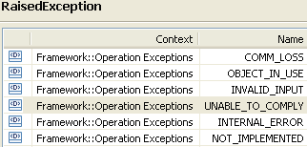 | restriction base="msg:AllExceptionsType"  element ref="msg:internalError"  element ref="msg:invalidInput"  element ref="msg:notImplemented"  element ref="msg:objectInUse"  element ref="msg:commLoss | bz:  Exception commLoss to be added?

modifyGroupTerminationPoint

BA (modifyGroupTerminationPoint) | IA | IIS | Comments
R_TMF518_RP_II_0080  The Interface shall allow the requesting OS to add or remove Connection Termination Pont (CTP)s to/from a Group Termination Point (GTP) given the CTP names and the GTP name specified by the requesting OS from the target OS.  Use Case 7.5.19 to be added | This operation is used to add or remove CTPs to/from a Group Termination Point (GTP). For a given request, the requesting OS can only add or remove CTPs, not both. It should not be possible to add a CTP that is already involved in a Cross-Connection or SNC, or that is part of another GTP. See attached supporting document SD1-3_BundledSNC for further information on GTP usage.  Attempts to modify a GTP that is involved in a Cross-Connection or SNC should be rejected by the target OS.  The operation is best-effort, i.e., the target OS will add or remove as many of the identified CTPs as possible.  If the operation is called with the name of a non-existent GTP or CTP, it will fail.  Note: If the requesting OS created a GTP with gtpEffort equal to SAME, this also implies that the target OS will not modify on its own, i.e., the target OS will only modify the GTP if requested via the modify GTP operation.  Traceability: R_TMF518_RP_II_0080, UC_TMF518_RP_00??. | This operation is used to add TPs to or removedelete TPs from a GTP (see SD1-3_BundledSNC.pdf for further information on GTP usage). For a given request, the NMS can only add or removedelete CTPs, not both. It is not possible to add a CTP that is already involved in a cross connection or SNC, or that is part of another GTP. Attempts to modify a GTP that is involved in a cross connection (or SNC) should be rejected by the EMS. The operation is best-effort, i.e., the EMS will add or removedelete as many of the identified CTPs as possible. If the service is called with the name of a non-existent GTP or CTP, it will fail.  If the NMS created a GTP with gtpEffort equal to EFFORT_SAME, this also implies that the EMS will not modify on its own, i.e., the EMS will only modify the GTP if requested by the NMS via the modifyGTP operation. | bz:  Use Case 7.5.19: NMS modifies a Group Termination Point (GTP) not contained in BA. → to be added to the BA
 | gtpRef (ObjectName)  This parameter provides the name of the Group Termination Point to be modified. | (in) element name="gtpName" type="nam:NamingAttributeType"  The name of the GTP to be modified.
 | tpRefList (*) (ObjectName)  This parameter provides the names of the CTPs to be added or removed. | (in) element name="tpRefList" type="nam:NamingAttributeListType"  The names of the CTPs to be added or removeddeleted.
 | actionType (ActionTypeString) = NA  This parameter provides an indication of whether the listed TPs are to be added or removed.  Two values are possible, i.e., "add" or "removedelete".  +++++++++++++++++  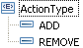 | (in) element name="actionType" type="ActionTypexsd:string"  an indication of whether the listed TPs are to be added or removeddeleted. Two values are possible "add" or "removedelete". | bz:  Should this be an enumeration? Yes
 | modifiedGtp  This parameter returns the structure of the modified GTP. | (out) element name="modifiedGtp" type="gtp:GroupTerminationPointType"  the structure for the modified GTP.
No use case defined. | 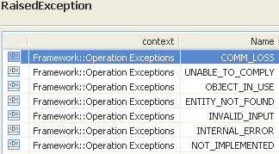 | restriction base="msg:AllExceptionsType"  element ref="msg:commLoss"  element ref="msg:entityNotFound"  element ref="msg:internalError"  element ref="msg:invalidInput"  element ref="msg:notImplemented"  element ref="msg:objectInUse"  element ref="msg:unableToComply"

modifyTerminationPointPool

BA (modifyTerminationPointPool) | IA | IIS | Comments
R_TMF518_RP_II_0084  The Interface shall allow the requesting OS to add or remove Termination Point (TP) s or Group Termination Point (GTP) s to or from a TP Pool given TP or GTP names and the TP Pool name specified by the requesting OS.  Use Case 7.5.22 to be added | This operation modifies a Termination Point Pool, i.e., adds/removes TPs or GTPs to/from a TPPool.  For a given request, the requesting OS can only add TPs/GTPs or remove TPs/GTPs, not both. When TPs/GTPs are to be added, all the specified TPs/GTPs shall be contained in Managed Elements of the TP Pool's Subnetwork. It is not possible to add a TP/GTP that is part of another TP Pool or GTP.  The operation is best-effort, i.e., the target OS will add or remove as many of the identified TPs as possible. If the service is called with the name of a non-existent TP Pool or TP or GTP, it will fail.  Traceability: R_TMF518_RP_II_0084, UC_TMF518_RP_00??. | The modify TPPool operation is used to add TPs/GTPs to or removedelete TPs/GTPs from a TPPool. For a given request, the NMS can only add TPs/GTPs or removedelete TPs/GTPs, not both. When TPs/GTPs are to be added, all the specified TPs/GTPs shall be contained in MEs of the TPPool's Subnetwork. It is not possible to add a TP/GTP that is part of another TPPool or GTP. The operation is best-effort, i.e., the EMS will add or removedelete as many of the identified TPs as possible. If the service is called with the name of a non-existent TPPool or TP or GTP, it will fail. | bz:  Use Case 7.5.22: NMS modifies a Termination Point Pool (TP Pool) not contained in BA. → to be added to the BA
 | tpPoolRef (ObjectName)  This parameter provides the name of the Termination Point Pool object to be modified. | (in) element name="tpPoolName" type="nam:NamingAttributeType"  The name of the TPPool to be modified.
 | containedMemberRefList (*) (ObjectName)  This parameter provides the list of names of TPs or GTPs to be added/removed to/from the TP Pool. | (in) element name="containedMembersRefList" type="nam:NamingAttributeListType"  The names of the TPs or GTPs to be added or removeddeleted.
 | actionType (ActionTypeString)  This parameter provides an indication of whether the listed TPs or GTPs are to be added or removed. Two values are possible: "add" or "removedelete".  +++++++++++++++++ | (in) element name="actionType" type="ActionTypexsd:string"  an indication of whether the listed TPs or GTPs are to be added or removeddeleted. Two values are possible "add" or "removedelete". | bz:  Should this be an enumeration? Yes
 | modifiedTpPool  This parameter returns the modified TP Pool object. | (out) element name="modifiedTpPool" type="tppool:TerminationPointPoolType"  the structure for the modified TPPool.
No use case defined. | 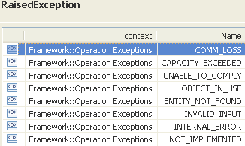 | restriction base="msg:AllExceptionsType"  element ref="msg:capacityExceeded"  element ref="msg:commLoss"  element ref="msg:entityNotFound"  element ref="msg:internalError"  element ref="msg:invalidInput"  element ref="msg:notImplemented"  element ref="msg:objectInUse"  element ref="msg:unableToComply"

setTerminationPointData

BA (setTerminationPointData) | IA | IIS | Comments
R_TMF518_RP_II_0085  The Interface shall allow the requesting OS to request that a Connection Termination Point (CTP) specified by the requesting OS be terminated and mapped.  This request, if successful, will configure the CTP specified by the requesting OS such that it will then be capable of supporting lower rate connections. If the CTP is successfully configured such that it is capable of supporting lower rate connections, then the CTP’s mapping mode should indicate as such.  Note that before carrying out the requesting OS’ request, the target OS should confirm that the CTP specified by the requesting OS is capable of being terminated and mapped and that it is not involved in an active cross-connection at the CTP’s rate. Some examples:  • Termination and mapping of an STS1 CTP such that it will support VT1.5 CTPs.  • Termination and mapping of a T3 CTP such that it will support T1 CTPs.  R_TMF518_RP_II_0086  The Interface shall allow the requesting OS to request that a Connection Termination Point (CTP) specified by the requesting OS no longer be terminated and mapped.  This request, if successful, will configure the CTP specified by the requesting OS such that it will then be capable of supporting cross-connections at the CTP’s rate. If the CTP is successfully configured such that it is capable of supporting cross-connections at the CTP’s rate, then the CTP’s mapping mode should indicate as such.  Note that before carrying out the requesting OS’ request, the target OS shall confirm that the CTP specified by the requesting OS is not supporting an active Cross Connection (CC) at a client layer rate (e.g., for A requesting OS specified STS1 CTP, target OS should confirm that no contained VT1.5 CTPs are involved in an active cross-connection).  R_TMF518_RP_II_0088  The Interface shall allow the requesting OS to provision Termination Point (TP) transmission parameters.  Refer to supporting document SD1-16_LayeredParameters for the currently defined set of supported TP parameters.  R_TMF518_RP_II_0089  Only applicable to ATM technology.  The Interface shall allow the requesting OS to configure terminated and mapped VP (or VC) Connection Termination Point (CTP) s at the end of a VP (or VC) trail.  A terminated (and available for mapping) VP or VC CTP can be turned to non terminated (nor available for mapping), (and can therefore be deleted on the NE if required), only if not used as a server by other lower level CTPs (e.g., a terminated VP CTP can be deleted only if does not carry any VC CTPs).  R_TMF518_RP_II_0059  The Interface shall allow the requesting OS to configure the mappings of specific Traffic Classes and Traffic Conditioning (TC) Profiles to specific groups of traffic units (e.g., Ethernet frames identified by VLAN-Id and Priority) at the following points:  a) a call-end-point  b) a FDFr point (Flow Point (FP)  The requesting OS shall provide a complete (except default) set of new mappings which overwrite all (except default) existing mappings in the Traffic Mapping Table. The provisioning of an empty mapping set removes all (except default) existing mappings; i.e., the traffic units are conditioned according to the default mapping.  Note:  The traffic units may still be conditioned specifically by another TP on this port.  As a result of (successful) completion of this request, the target OS shall condition the traffic units flowing through the resource as defined by the Traffic Class and the TC Profile, or as defined by the default Traffic Class and default TC Profile respectively. | This operation can be used to  - terminate and map Connection Termination Points (CTPs); refer to UC_TMF518_RP_0037,  - unterminate and unmap Connection Termination Points (CTPs); refer to UC_TMF518_RP_0038,  - provision Transmission Parameters on a Termination Point; refer to UC_TMF518_RP_0039.  The operation is best effort (except where specified otherwise for a particular parameter). The results of the operation are returned so that the requesting OS is aware of what modifications succeeded.  If the source TP of a broadcast system is used as input, then the entire multipoint system will be affected based on the new parameter values for the source TP.  The tpMappingMode may be set with this operation. When the mode is set to TERMINATED_AND_AVAILABLE_FOR_MAPPING, the target OS will terminate the specified CTP. In this case the target OS must create the specified CTP on the Managed Element if it does not actually exist. Setting the tpMappingMode of an ATM VP or VC CTP can only be done if the CTP has been created. Note that the tpMappingMode can be set only on the ingress and egress CTPs of an ATM SNC since they are the only ones which may not be cross-connected.  The provided Transmission Parameter List is a "delta" list that needs to be applied to the specified TP, i.e. only a subset of the parameters may be specified in the list, in which case only those should be applied in the Managed Element. Transmission Parameters are used to associate a TCA profile with a TP using this service. In this case there are potentially additional failure modes (see Use Case). The assignment of a Transmission Descriptor (TMD) to a Termination Point (TP) as egress or ingress TMD by using the TMD's name amounts to an overwriting of the Layered Transmission Parameters of the TP by the Layered Transmission Parameters of the TMD, and to an overwriting of the additionalInfo parameters of the TP by the additionalObjectInformation parameters of the TMD.  Traceability: R_TMF518_RP_II_0085, R_TMF518_RP_II_0086, R_TMF518_RP_II_0088, R_TMF518_RP_II_0089, R_TMF518_RP_II_0059, UC_TMF518_RP_0030, UC_TMF518_RP_0037, UC_TMF518_RP_0038, UC_TMF518_RP_0039. | This operation allows the NMS to set parameters on a specified Termination Point (CTP, PTP or FTP). See SD1-16_LayeredParameters.pdf for further information.  This operation is best effort (except where specified otherwise for a particular parameter). The results of the operation are returned so that the NMS is aware of what modifications succeeded.  If the source TP of a broadcast system is used as input, then the entire multipoint system will be affected based on the new parameter values for the source TP.  The tpMappingMode may be set with this operation. When the mode is set to TM_TERMINATED_AND_AVAILABLE_FOR_MAPPING, the EMS will terminate the specified CTP. In this case the EMS must create the specified CTP on the NE if it does not actually exist. Setting the tpMappingMode of an ATM VP or VC CTP can only be done if the CTP has been created. Note that the tpMappingMode can be set only on the ingress and egress CTPs of an ATM SNC since they are the only ones which may not be cross-connected.  No change to tpMappingMode or trafficTransmissionDescriptors will take place if there is any active cross connect (NE cross connect) using the CTP passed in parameter.  The transmissionParams is a "delta" list that needs to be applied to the specified TP, i.e. only a subset of the parameters may be specified in the list, in which case only those should be applied in the NE. Transmission parameters are used to associate a TCA profile with a TP using this service. In this case there are potentially additional failure modes (see exceptions). The assignment of a Transmission Descriptor (TMD) to a Termination Point (TP) as egress or ingress TMD by using the TMD's name amounts to an overwriting of the layered transmission parameters of the TP by the layered transmission parameters of the TMD, and to an overwriting of the additional info parameters of the TP by the "additional TP information" parameters of the TMD. | bz:  Is this description necessary?
 | tpData (TerminationPointData)  This parameter provides the details of the required modifications. | (in) element name="tpDataInfo" type="tpdata:TerminationPointDataType"  Details of modifications required..
 | modifiedTp  This parameter returns the modified TP object. | (out) element name="modifiedTp" type="tp:TerminationPointType"  Result of modification.
Pre-Conditions:  UC_TMF518_RP_0037  1. The requesting OS and target OS have executed successfully the Use Case 0001 OS (Re) Starts as defined in the TMF518_FMW BA document.  2. The requesting OS knows the CTP it wishes to terminate and map, e.g. has a handle for the CTP.  3. CTP has to be able to be terminated and mapped.  UC_TMF518_RP_0038  1. The requesting OS and target OS have successfully executed the Use Case 0001 OS (Re) Starts as defined in the TMF518_FMW BA document.  2. The requesting OS has a handle for a CTP that it wishes to modify.  3. CTP has to be able to be un-terminated and un-mapped.  UC_TMF518_RP_0039  The requesting OS and target OS have successfully executed the Use Case 0001 OS (Re) Starts as defined in the TMF518_FMW BA document. | None
Post-Conditions:  UC_TMF518_RP_0037  In case of success:  1. The server layer trail termination functions are available.  2. The CTP (including server layer trail termination functions) alarm reporting state remains unchanged from its setting prior to use of this operation. If the CTP had not previously existed on the NE, then it is assumed that the alarm reporting state of the newly created CTP will be disabled by default.  3. If in the specific implementation of NE/target OS the client layer CTPs are actually created then it is assumed that the alarm reporting state of the client layer CTPs will be disabled by default on application of the terminate and map operation.  4. AVC notifications are sent to the notification service.  In case of failure:  None.  UC_TMF518_RP_0038  In case of success:  1. The appropriate structure is set on the NE so that the Server layer CTP (e.g., an STS1 CTP) is then available to be part of an SNC at the CTP rate (e.g., STS1).  2. The Server layer CTP (and aggregated G.805 TTP) alarm reporting state remains unchanged from its setting prior to use of this operation.  3. AVC notifications are sent to the Notification Service.  In case of failure:  None. The requesting OS has received a negative response.  UC_TMF518_RP_0039  In case of success:  1. The TP’s transmission parameter(s) have been set to the specified value.  2. The target OS has forwarded attribute value change notification(s) if the TP’s transmission parameter(s) have changed in value.  In case of partial success:  If the request to set the transmission parameter(s) succeeded and the TP’s transmission parameter(s) have changed in value, then the target OS has forwarded attribute value change notification(s) to all subscribing requesting OSs.  In case of failure:  Appropriate exception is reported to the requesting OS. | Depending on the requested modification:  - terminate and map: The server layer trail termination functions are available.  - unterminate and unmap: The server layer CTP is available to be part of an SNC at the CTP rate  - provision parameters: The TP’s transmission parameter(s) have been set to the specified value.
Exceptions:  UC_TMF518_RP_0037  1. Entity not found: The specified CTP does not exist.  2. Internal error: The requested operation could not be performed.  3. Unable to comply: The CTP is involved in an existing, active cross connection at the CTP's native rate (CTP's layer rate); or the CTP is not in a valid state.  4. Target OS communications loss  UC_TMF518_RP_0038  1. Entity not found: The specified CTP does not exist.  2. Internal error: The requested operation could not be performed.  3. Unable to comply: The CTP is supporting (containing) one or more lower order (client) CTPs that are involved in existing, active cross connections at the lower order CTP rates.  4. Comm loss (Communication loss).  UC_TMF518_RP_0039  1. Internal error: The requested operation could not be performed.  2. Invalid input: The TP reference is invalid.  3. Target OS communications loss. | 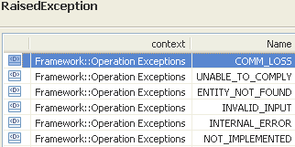 | restriction base="msg:AllExceptionsType"  element ref="msg:commLoss"  element ref="msg:entityNotFound"  element ref="msg:internalError"  element ref="msg:invalidInput"  element ref="msg:unableToComply" | bz:  The Exceptions clause is not in line with mTOP_Guidelines_BAs.doc: It shall only contain a list of all necessary exceptions. The specific exceptions have to be explicitly listed in the Description clause.  bz:  Do we have to add "not implemented"? Follow the IDL exceptions.

Topological Link Control Service

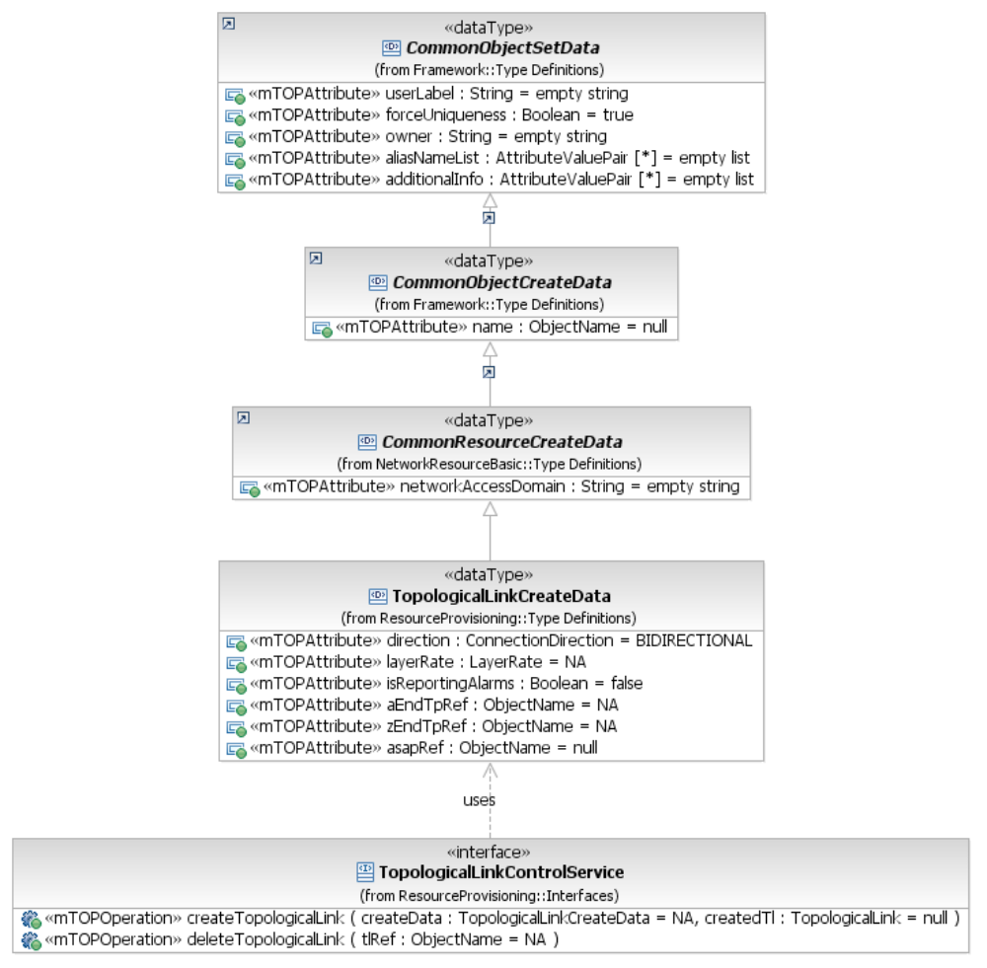
Figure 7: RP Topological Link Control Service Interface Diagram

createTopologicalLink

BA (createTopologicalLink) | IA | IIS | Comments
R_TMF518_RP_II_0100  The Interface shall allow the requesting OS to create a Topological Link (TL) in the target OS given the requesting OS specified data listed in R_TMF518_RP_II_0101. | This operation creates a Topological Link; top-level as well as intra-MLSN.  The behaviour of the operation should be the same as if a target OS user were to attempt to create a Topological Link (or equivalent operation) at the target OS user interface.  Therefore, the specific conditions under which the creation is rejected are left to the target OS implementation.  Note: It is at the discretion of the target OS to delete Topological Links created by the requesting OS, as the owner of the Topological Link is the target OS, not the requesting OS.  Traceability: R_TMF518_RP_II_0100, R_TMF518_RP_II_0101, UC_TMF518_RP_0045. | This operation can be used to create top-level topological links as well as intra-MLSN topological links.  The behaviour of this operation should be the same as if an EMS user were to attempt to create a topological link (or equivalent operation) at the EMS user interface. Therefore, the specific conditions under which the creation is rejected are left to the EMS implementation.
R_TMF518_RP_II_0101  The Interface shall allow the requesting OS to specify the following parameters when it requests that a target OS create a Topological Link (TL):  +++++++++++++++++  see TopologicalLinkCreateData Type in section 12.7 | createData (TopologicalLinkCreateData)  This parameter provides the attributes describing the Topological Link to be created.  Traceability: R_TMF518_RP_II_0101.  +++++++++++++++++  see TopologicalLinkCreateData Type in section 12.7 | (in) element name="newTlCcreateData" type="tns:TopologicalLinkCreateDataType"  Structure describing the topological link to be created.  +++++++++++++++++  see TopologicalLinkCreateData Type in section 12.7
 | createdTl  This parameter returns the newly created Topological Link object. | (out) element name="newTl" type="tl:TopologicalLinkType"  the newly created topological link reflecting the input data.
UC_TMF518_RP_0045  Pre-Conditions:  1. The requesting OS and target OS have successfully executed the Use Case 0001 OS (Re) Starts as defined in the TMF518_FMW BA document.  2. The Topological Link end TPs have to exist | None
UC_TMF518_RP_0045  Post-Conditions:  In case of success:  The TL is available.  In case of failure:  None. The requesting OS has received an indication of failure of the action or exception | The requested Topological Link exists.
UC_TMF518_RP_0045  Exceptions:  not implemented  1. Invalid input: request syntax is not valid.  2. Object in use: the request attempts to create a TL that already exists, or the request references TPs that are already associated with TLs.  3. Entity not found: the request references an entity that does not exist.  4. Unable to comply: the target OS rejects the request based on its own criteria.  5. Internal error: The requested operation could not be performed.  6. User label in use: The user label supplied by the requesting OS is already in use.  comm loss | 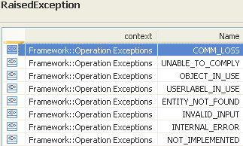 | restriction base="msg:AllExceptionsType"  element ref="msg:commLoss"  element ref="msg:entityNotFound"  element ref="msg:internalError"  element ref="msg:invalidInput"  element ref="msg:notImplemented"  element ref="msg:objectInUse"  element ref="msg:unableToComply"  element ref="msg:userlabelInUse" | bz:  The Exceptions clause is not in line with mTOP_Guidelines_BAs.doc: It shall only contain a list of all necessary exceptions. The specific exceptions have to be explicitly listed in the Description clause.

deleteTopologicalLink

BA (deleteTopologicalLink) | IA | IIS | Comments
R_TMF518_RP_II_0102  The Interface shall allow the requesting OS to delete a Topological Link (TL) given the TL name specified by the requesting OS from the target OS. | This operation deletes a Topological Link; top-level as well as intra-MLSN.  The behaviour of this operation should be the same as if a target OS user were to attempt to delete a Topological Link (or equivalent operation) at the target OS user interface.  Therefore, the specific conditions under which the deletion is rejected are left to the target OS implementation.  Traceability: R_TMF518_RP_II_0102, UC_TMF518_RP_0046. | This operation can be used to delete top-level topological links as well as intra-MLSN topological links.  The behaviour of this operation should be the same as if an EMS user were to attempt to delete a topological link (or equivalent operation) at the EMS user interface. Therefore, the specific conditions under which the deletion is rejected are left to the EMS implementation.  It is at the discretion of the EMS to delete topological links created by the NMS, as the owner of the topological link is the EMS, not the NMS.
 | tlRef (ObjectName)  This parameter provides the name of the Topological Link to be deleted. | (in) element name="tlName" type="nam:NamingAttributeType"  The name of the topological link to be deleted.
UC_TMF518_RP_0046  Pre-Conditions:  1. The requesting OS and target OS have successfully executed the Use Case 0001 OS (Re) Starts as defined in the TMF518_FMW BA document.  2. The requesting OS has identified an existing Topological Link for deletion. | None
UC_TMF518_RP_0046  Post-Conditions:  In case of success:  The TL is deleted.  In case of failure:  None. | The TopologicalLink do no longer exsist.
UC_TMF518_RP_0046  Exceptions:  1. Invalid input: request syntax is not valid.  2. Entity not Found: the request references a TL that does not exist.  3. Unable to Comply: the target OS rejects the request based on its own criteria.  4. Internal error: The requested operation could not be performed.  Not implemented  Comm loss | 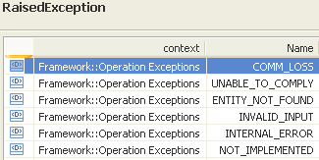 | restriction base="msg:AllExceptionsType"  element ref="msg:commLoss"  element ref="msg:entityNotFound"  element ref="msg:internalError"  element ref="msg:invalidInput"  element ref="msg:notImplemented"  element ref="msg:unableToComply" | bz:  The Exceptions clause is not in line with mTOP_Guidelines_BAs.doc: It shall only contain a list of all necessary exceptions. The specific exceptions have to be explicitly listed in the Description clause.

Traffic Conditioning Profile Control Service
BA: Traffic Conditioning (TC) Profile Management is part of Flow Domain Control Service. → should be moved to a separate section.
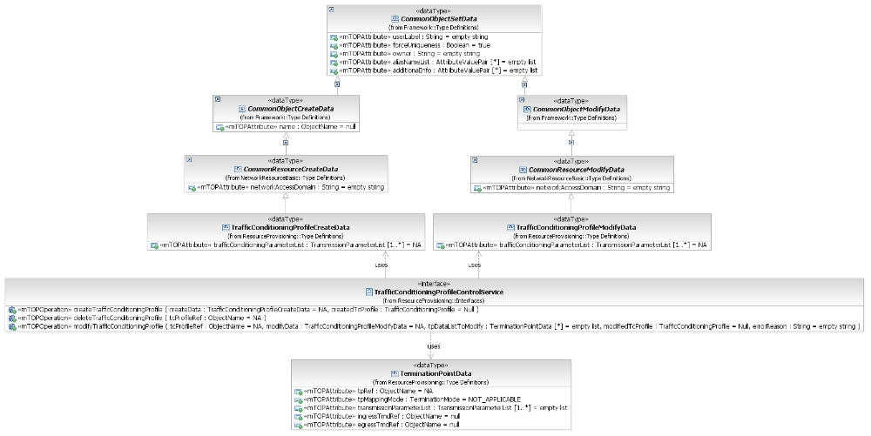
Figure 8: RP Traffic Conditioning Profile Control Service Interface Diagram

createTrafficConditioningProfile

BA (createTrafficConditioningProfile) | IA | IIS | Comments
R_TMF518_RP_II_0055  The Interface shall allow the requesting OS to create a Traffic Conditioning (TC) Profile in the target OS given the requesting OS specified data listed in R_TMF518_RP_II_0056. | This operation creates a Traffic Conditioning (TC) Profile in the target OS.  Traceability: R_TMF518_RP_II_0055, R_TMF518_RP_II_0056, UC_TMF518_RP_0027. | This operation is used to create a new Traffic Conditioning Profile on the server. A Traffic Conditioning Profile cCreate dData structure representing the new Traffic Conditioning Profile is passed as input. The resulting Traffic Conditioning Profile is returned as a result.
R_TMF518_RP_II_0056  The Interface shall allow the requesting OS to specify the following parameters when it requests that a target OS creates or modifies Traffic Conditioning (TC) Profile:  +++++++++++++++++  see TrafficConditioningProfileCreateData Type in section 12.8 | createData (TrafficConditioningProfileCreateData)  This parameter provides the attributes describing the Traffic Conditioning Profile to be established.  Traceability: R_TMF518_RP_II_0056.  +++++++++++++++++  see TrafficConditioningProfileCreateData Type in section 12.8 | (in) element name="newTcProfileCreateData" type="tns:TrafficConditioningProfileCreateDataType"  information about the TC Profile to be created.  +++++++++++++++++  see TrafficConditioningProfileCreateData Type in section 12.8 | bz:  R_TMF518_RP_II_0056 needs to be separated into a create and a modify requirement because the name attribute can not be modified.
 | createdTcProfile  This parameter returns the newly created Traffic Conditioning Profile object. | (out) element name="newTcProfile" type="tcp:TrafficConditioningProfileType"  The resulting TC Profile.
UC_TMF518_RP_0027  Pre-Conditions:  The requesting OS and target OS have successfully executed the Use Case The requesting OS and target OS have successfully executed the Use Case 0001 OS (Re) Starts as defined in the TMF518_FMW BA document. | None
UC_TMF518_RP_0027  Post-Conditions:  In case of success:  The TC Profile has been created by the target OS.  In case of failure:  Nothing has changed in the System, i.e., the TC Profile has not been created. | The TC Profile object has been created.
UC_TMF518_RP_0027  Exceptions:  Refer to Category III: Abnormal or Exception Conditions, Dynamic Requirements. | 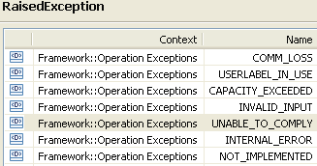 | restriction base="msg:AllExceptionsType"  element ref="msg:capacityExceeded"  element ref="msg:commLoss"  element ref="msg:internalError"  element ref="msg:invalidInput"  element ref="msg:notImplemented"  element ref="msg:userlabelInUse" | bz:  Section "Category III: Abnormal or Exception Conditions, Dynamic Requirements" is empty.

deleteTrafficConditioningProfile

BA (deleteTrafficConditioningProfile) | IA | IIS | Comments
R_TMF518_RP_II_0058  The Interface shall allow the requesting OS to delete a Traffic Conditioning (TC) Profile in the target OS given A requesting OS specified TC Profile name.  The target OS shall reject the deletion request if any Flow Domain Edge call-end-point (FD Edge call-end-point) or Flow Point (FP) is still associated with this TC Profile.  The target OS shall reject the deletion request if the requesting OS wants to delete the default TC Profile. | This operation deletes a Traffic Conditioning (TC) Profile.  Traceability: R_TMF518_RP_II_0058, UC_TMF518_RP_0028. | This operation is used to delete a Traffic Conditioning Profile on the server. This operation is idempotent. If the service is called with the name of a non-existent Traffic Conditioning Profile, it will succeed. | bz:  IIS not in line with UC_TMF518_RP_0028: "2b) If the specifed TC Profile object is not known to the target OS, an Entity Not Found exception is raised."
 | tcProfileRef (ObjectName)  This parameter provides the name of the Traffic Conditioning Profile to be deleted. | (in) element name="tcProfileName" type="nam:NamingAttributeType"  The name of the Traffic Conditioning profile to be deleted.
UC_TMF518_RP_0028  Pre-Conditions:  The requesting OS and target OS have successfully executed the Use Case The requesting OS and target OS have successfully executed the Use Case 0001 OS (Re) Starts as defined in the TMF518_FMW BA document. | None
UC_TMF518_RP_0028  Post-Conditions:  In case of success:  The TC Profile has been deleted by the target OS.  In case of failure:  Nothing has changed in the System, i.e., the TC Profile has not been deleted. | The TC Profile object has been deleted.
UC_TMF518_RP_0028  Exceptions:  Refer to Category III: Abnormal or Exception Conditions, Dynamic Requirements. | 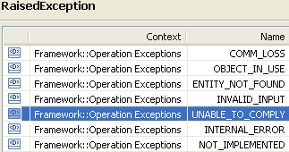 | restriction base="msg:AllExceptionsType"  element ref="msg:commLoss"  element ref="msg:entityNotFound"  element ref="msg:internalError"  element ref="msg:invalidInput"  element ref="msg:notImplemented"  element ref="msg:objectInUse" | bz:  Section "Category III: Abnormal or Exception Conditions, Dynamic Requirements" is empty.

modifyTrafficConditioningProfile

BA (modifyTrafficConditioningProfile) | IA | IIS | Comments
R_TMF518_RP_II_0057  The Interface shall allow the requesting OS to modify a Traffic Conditioning (TC) Profile in the target OS given the requesting OS specified data listed in R_TMF518_RP_II_0056xx.  Note: When traffic conditioning parameters are modified, this will automatically modify the traffic conditioning in all associated TPs. | This operation modifies a Traffic Conditioning (TC) Profile.  When Traffic Conditioning parameters are modified, this will automatically modify the Traffic Conditioning in all associated TPs.  Traceability: R_TMF518_RP_II_0057, R_TMF518_RP_II_0056xx, UC_TMF518_RP_0029. | This operation is used to request from the EMS to modify an existing Traffic Conditioning Profile as specified by the parameters passed in the method. A Traffic Conditioning Profile mModify dData structure representing the data to be changed is passed as input. The resulting Traffic Conditioning Profile is returned as a result. | BA: Copy R_TMF518_RP_II_0056 and delete the name → becomes modify data = R_TMF518_RP_II_0056xx.
?? | tcProfileRef (ObjectName)  This parameter provides the name of the Traffic Conditioning Profile to be modified. | (in) element name="tcProfileName" type="nam:NamingAttributeType"  The name of the Traffic Conditioning profile to be deleted.
R_TMF518_RP_II_0056xx  The Interface shall allow the requesting OS to specify the following parameters when it requests that a target OS modifies Traffic Conditioning (TC) Profile:  +++++++++++++++++  see TrafficConditioningProfileModifyData Type in section 12.9 | modifyData (TrafficConditioningProfileModifyData)  This parameter provides the parameters that shall be modified in the Traffic Conditioning Profile.  Traceability: R_TMF518_RP_II_0056xx.  +++++++++++++++++  see TrafficConditioningProfileModifyData Type in section 12.9 | (in) element name="tcProfileModifyData" type="tns:TrafficConditioningProfileModifyCreateDataType"  TC Profile data to be changed.  +++++++++++++++++  see TrafficConditioningProfileModifyData Type in section 12.9 | bz:  The name attribute can not be modified.
?? | tpDataListToModify (in/out) (*) (TerminationPointData)  This parameter, when used in the request,  (in) identifies a list of TPs with associated parameters to be applied;  (out) identifies the list of TPs with associated applied parameters.  +++++++++++++++++  see TerminationPointData Type in section 12.1 of Comparison-RP-ConnectionControlService.doc | (in) element name="tpDataListToModify" type="tpdata:TerminationPointDataListType"  The TPs to be modified.  +++++++++++++++++  see TerminationPointData Type in section 12.1 of Comparison-RP-ConnectionControlService.doc
(out) element name="tpDataListToModify" type="tpdata:TerminationPointDataListType"
The modified TPs are returned.
+++++++++++++++++
see TerminationPointData Type in section 12.1 of Comparison-RP-ConnectionControlService.doc

 | modifiedTcProfile  This parameter returns the modified Traffic Conditioning Profile object. | (out) element name="modifiedTCProfile" type="tcp:TrafficConditioningProfileType"  The modified TC Profile.
 | errorReason (out)  This parameter returns the error(s) if any. | (out) element name="errorReason" type="xsd:string"  This parameter returns the error(s) if any.  In case a "best effort" parameter could not be set an indication of the fault reason is provided by the EMS.
UC_TMF518_RP_0029  Pre-Conditions:  The requesting OS and target OS have successfully executed the Use Case The requesting OS and target OS have successfully executed the Use Case 0001 OS (Re) Starts as defined in the TMF518_FMW BA document. | None
UC_TMF518_RP_0029  Post-Conditions:  In case of success:  The TC Profile has been modified by the target OS.  In case of failure:  Nothing has changed in the System, i.e., the TC Profile has not been modified. | The Traffic Conditioning Profile has been modified as requested.
UC_TMF518_RP_0029  Exceptions:  Refer to Category III: Abnormal or Exception Conditions, Dynamic Requirements. | 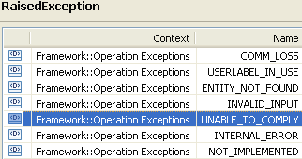 | restriction base="msg:AllExceptionsType"  element ref="msg:commLoss"  element ref="msg:entityNotFound"  element ref="msg:internalError"  element ref="msg:invalidInput"  element ref="msg:notImplemented"  element ref="msg:userlabelInUse" | bz:  Section "Category III: Abnormal or Exception Conditions, Dynamic Requirements" is empty.

Transmission Descriptor Control Service

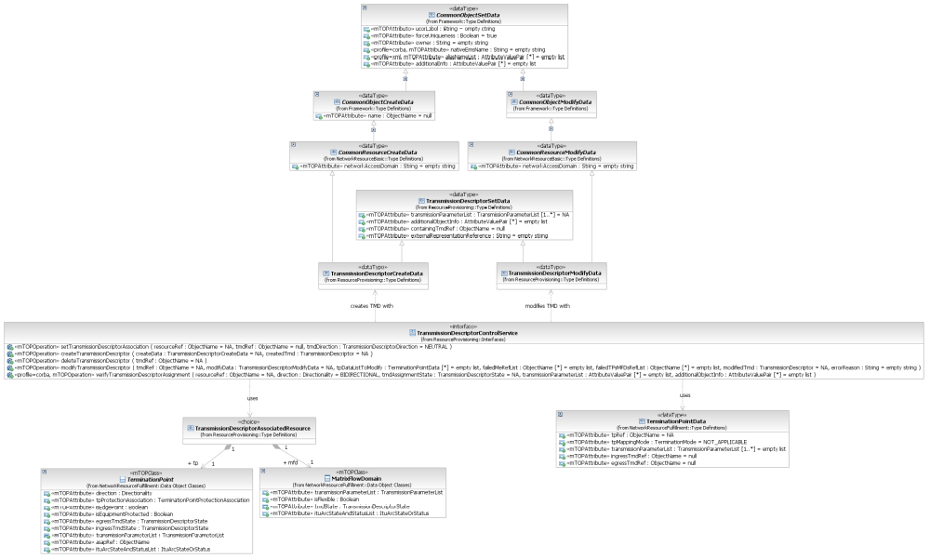
Figure 9: RP Transmission Descriptor Control Service Interface Diagram

createTransmissionDescriptor

BA (createTransmissionDescriptor) | IA | IIS | Comments
R_TMF518_RP_II_0093  The Interface shall allow the requesting OS to create a Transmission Descriptor (TMD) in the target OS given the requesting OS specified data listed in R_TMF518_RP_II_0094. | The operation creates a new Transmission Descriptor.  Traceability: R_TMF518_RP_II_0093, R_TMF518_RP_II_0094, UC_TMF518_RP_0042. | This operation is used to create a new Transmission Descriptor on the server. A Transmission Descriptor cCreate dData structure representing the new Transmission Descriptor is passed as input. The resulting Transmission Descriptor is returned as a result.
R_TMF518_RP_II_0094  The Interface shall allow the requesting OS to specify the following parameters when it requests that A target OS creates a Transmission Descriptor (TMD):  +++++++++++++++++  see TransmissionDescriptorCreateData Type in section 12.10 | createData (TransmissionDescriptorCreateData)  This parameter provides the attributes describing the Transmission Descriptor to be created.  Traceability: R_TMF518_RP_II_0094.  +++++++++++++++++  see TransmissionDescriptorCreateData Type in section 12.10 | (in) element name="newTmdCcreateData" type="tns:TransmissionDescriptorCreateDataType"  information about the TMD to be created.  +++++++++++++++++  see TransmissionDescriptorCreateData Type in section 12.10
 | createdTmd  This parameter returns the newly created Transmission Descriptor object. | (out) element name="newTmd" type="tmd:TransmissionDescriptorType"  The resulting TMD.
UC_TMF518_RP_0042  Pre-Conditions:  The requesting OS and target OS have successfully executed the Use Case 0001 OS (Re) Starts as defined in the TMF518_FMW BA document. | None
UC_TMF518_RP_0042  Post-Conditions:  The TMD has been created in the target OS | The requested Transmission Descriptor exists.
UC_TMF518_RP_0042  Exceptions:  1. Not implemented: The target OS does not support this service.  2. Invalid input: The requesting OS has supplied invalid input data.  3. User label in use: The user label supplied by the requesting OS is already in use.  4. Capacity exceeded: The Input data is valid but the target OS cannot create the TMD because the target OS has already exceeded its maximum number of TMDs.  5. Internal error: The requested operation could not be performed.  Comm loss | 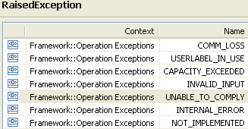 | restriction base="msg:AllExceptionsType"  element ref="msg:capacityExceeded"  element ref="msg:commLoss"  element ref="msg:internalError"  element ref="msg:invalidInput"  element ref="msg:notImplemented"  element ref="msg:userlabelInUse" | bz:  The Exceptions clause is not in line with mTOP_Guidelines_BAs.doc: It shall only contain a list of all necessary exceptions. The specific exceptions have to be explicitly listed in the Description clause.

deleteTransmissionDescriptor

BA (deleteTransmissionDescriptor) | IA | IIS | Comments
R_TMF518_RP_II_0095  The Interface shall allow the requesting OS to delete a Transmission Descriptor (TMD) given the requesting OS specified TMD name from the target OS.  The target OS shall refuse/fail this request if any Termination Point (TP)s are associated with this TMD. | This operation deletes a Transmission Descriptor (TMD).  Traceability: R_TMF518_RP_II_0095, UC_TMF518_RP_0044. | This operation is used to delete a Transmission Descriptor on the server. This operation is idempotent. If the service is called with the name of a non-existent Transmission Descriptor, it will succeed. | bz:  IIS not in line with UC_TMF518_RP_0044 exception: "4. Entity not found: The TMD does not exist in the target OS."
 | tmdRef (ObjectName)  This parameter provides the name of the Transmission Descriptor to be deleted. | (in) element name="tmdName" type="nam:NamingAttributeType"  The name of the TMD to be deleted.
UC_TMF518_RP_0044  Pre-Conditions:  1. The requesting OS and target OS have successfully executed the Use Case 0001 OS (Re) Starts as defined in the TMF518_FMW BA document.  2. The Transmission Descriptor to be deleted has to exist.  3. The Transmission Descriptor has no association to a TP. | None
UC_TMF518_RP_0044  Post-Conditions:  The TMD has been deleted in the target OS. | Identified Transmission Descriptor no longer exists.
UC_TMF518_RP_0044  Exceptions:  1. Not implemented: The target OS does not support this service.  2. Comm loss (communication loss)  3. Object in use: The TMD is being used.  4. Entity not found: The TMD does not exist in the target OS.  5. Invalid input: The requesting OS has supplied invalid input data (The TMD Name is invalid).  Comm loss | 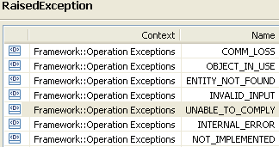 | restriction base="msg:AllExceptionsType"  element ref="msg:commLoss"  element ref="msg:entityNotFound"  element ref="msg:internalError"  element ref="msg:invalidInput"  element ref="msg:notImplemented"  element ref="msg:objectInUse" | bz:  The Exceptions clause is not in line with mTOP_Guidelines_BAs.doc: It shall only contain a list of all necessary exceptions. The specific exceptions have to be explicitly listed in the Description clause.

modifyTransmissionDescriptor

BA (modifyTransmissionDescriptor) | IA | IIS | Comments
{Requirement II. 353} from MTNM 3.5 not included in BA. | This operation modifies a Transmission Descriptor (TMD).  When transmission parameters are modified, this will automatically modify the corresponding parameters in all associated TPs/MFDs on a best effort basis. TPs/MFDs whose parameters could not be modified shall be returned by the target OS.  Note: Only the modified parameters will be updated in the TPs/MFDs; i.e., the TMD parameter/value list may be inconsistent with the corresponding parameter/value list of the associated TPs/MFDs.  Traceability: R_TMF518_RP_II_00xx, UC_TMF518_RP_00xx. | This operation is used to modify a Transmission Descriptor (TMD) in the EMS. The resulting Transmission Descriptor is returned as a result. When transmission parameters are modified, this will automatically modify the corresponding parameters in all associated TPs/MFDs on a best effort basis. TPs/MFDs whose parameters could not be modified shall be returned by the EMS. Note: Only the modified parameters will be updated in the TPs/MFDs; i.e., the TMD parameter/value list may be inconsistent with the corresponding parameter/value list of the associated TPs/MFDs. | bz:  Use Case 7.5.15: NMS modifies a Transmission Descriptor (TMD) not contained in BA. → to be added.
 | tmdRef (ObjectName)  This parameter provides the name of the TransmissionDescriptor to be modified. | (in) element name="tmdName" type="nam:NamingAttributeType"  The name of the TMD to be modified.
 | modifyData (TransmissionDescriptorModifyData)  This parameter provides the new values of the attributes/parameters that shall be modified in the Transmission Descriptor.  Traceability: R_TMF518_RP_II_0094.  +++++++++++++++++  see TransmissionDescriptorModifyData Type in section 12.11 | (in) element name="tmdModifyData" type="tns:TransmissionDescriptorModifyDataType"  information about the TMD to be modified.  +++++++++++++++++  see TransmissionDescriptorModifyData Type in section 12.11
 | tpDataListToModify (in/out) (*) (TerminationPointData)  This parameter, when used in the request,  (in) identifies a list of TPs with associated parameters to be applied;  (out) identifies the list of TPs with associated applied parameters.  +++++++++++++++++  see TerminationPointData Type in section 12.1 of Comparison-RP-ConnectionControlService.doc | (in) element name="tpDataListToModify" type="tpdata:TerminationPointDataListType"  The list of TPs with associated parameters to be applied.
(out) element name="tpDataListToModify" type="tpdata:TerminationPointDataListType"
The list of TPs with associated applied parameters.

 | modifiedTmd  This parameter returns the modified Transmission Descriptor object. | (out) element name="modifiedTmd" type="tmd:TransmissionDescriptorType"  result of the modification.
 | failedMeRefList (*) (ObjectName)  This parameter returns the names of all TMD associated Managed Eelements which could not be reached by the target OS. | (out) element name="failedMeRefList" type="nam:NamingAttributeListType"  the names of all TMD associated MEs that could not be reached by the EMS.
 | failedTPsMFDsResourceRefList (*) (ObjectName)  This parameter returns the names of all TPs and MFDs that could not be changed to the new attribute/parameter values due to some error reasons. | (out) element name="failedTPsMFDsRefList" type="nam:NamingAttributeListType"  the names of all TPs and MFDs that could not be changed to the new parameter values due to some error reasons.
 | errorReason (out)  This parameter returns the error(s) if any. | (out) element name="errorReason" type="xsd:string"  In case a "best effort" parameter could not be set an indication of the fault reason is provided by the EMS.
No use case defined. | 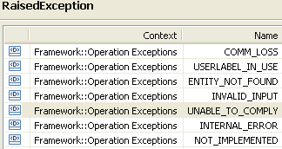 | restriction base="msg:AllExceptionsType"  element ref="msg:commLoss"  element ref="msg:entityNotFound"  element ref="msg:internalError"  element ref="msg:invalidInput"  element ref="msg:notImplemented"  element ref="msg:userlabelInUse"

setTransmissionDescriptorAssociation

BA (setTransmissionDescriptorAssociation) | IA | IIS | Comments
R_TMF518_RP_II_0044  The Interface shall allow the requesting OS to associate a Transmission Descriptor (TMD) to a given Matrix Flow Domain (MFD) identified by A requesting OS specified MFD name.  The association will overwrite specific transmission parameters of the MFD with the corresponding parameter values contained in the TMD. The Behaviour is defined in R_TMF518_RP_II_0098.  R_TMF518_RP_II_0045  The Interface shall allow the requesting OS to de-associate a Transmission Descriptor (TMD) from a given Matrix Flow Domain (MFD) identified by A requesting OS specified MFD name.  The de-association shall not influence any transmission parameter configured in the MFD. The Behaviour is defined in R_TMF518_RP_II_0098.  R_TMF518_RP_II_0097  The Interface shall allow the requesting OS to associate an ingress and/or egress Transmission Descriptor (TMD) with a given Termination Point (TP) identified by its TP name specified by the requesting OS.  R_TMF518_RP_II_0098  The assignment of a Transmission Descriptor (TMD) to a Termination Point (TP) or Matrix Flow Domain (MFD) by using the TMD's name amounts to an overwriting of the layered transmission parameters of the TP or MFD by the layered transmission parameters of the TMD and to an overwriting of the additional information parameters of the TP or MFD by the additional Object information parameters of the TMD.  Note that these parameters may also be set according to R_TMF518_RP_II_0088 and without using a TMD. Current parameters of the TP or MFD that are not present as parameters of the TMD are left unchanged by the TMD assignment.  The unassignment of a TMD from a TP or MFD (by using the empty TMD name) has no effect on the parameters of the TP or MFD, i.e. the layered transmission parameters and additional info parameters of the TP or MFD remain unchanged. | This operation associates/de-associates a TransmissionDescriptor (TMD) to/from a TP or MFD object.  Traceability: R_TMF518_RP_II_0044, R_TMF518_RP_II_0045, R_TMF518_RP_II_0097, R_TMF518_RP_II_0098, UC_TMF518_RP_0043. | This operation associates/un-associates a TransmissionDescriptor (TMD) to/from a TP or MFD object.  The association of a TMD to an an object by this operation amounts to a forced overwriting of the layered transmission parameters of the object by the layered transmission parameters of the TMD and to a forced overwriting of the additional info parameters of the object by the additional TP info parameters of the TMD. When parameters of the TMD are already present as parameters of the object,the current object parameter values are overwritten by the TMD parameter values. When current parameters of the object are not present as parameters of the TMD, the current parameters are left unchanged. An associated TMD is un-associated when no name is provided for the transmissionDescriptorName input parameter. The un-association of a TMD from an object has no effect on the other parameters of the object, i.e. the other layered transmission parameters and additional info parameters of the object remain unchanged. Consistency rules:<ol> <li> When a TMD is assigned to an object this assignment is called consistent if whenever a TMD transmission parameter is also present as an object transmission parameter or a TMD additional TP info parameter is also present as an object additional info parameter, the common parameters of the TMD and object have the same values. </li> <li> The degree of consistency of a TMD assignment to an object is determined by the TMD state of the object. </li> </ol>. | bz:  BA: Table 5 2. Requirements – Use Cases Traceability Matrix  No head line in table.  Wrong Use Case name for R_TMF518_RP_II_0097.  R_TMF518_RP_II_0044 and R_TMF518_RP_II_0045 not associated to the Use Case.  bz:  Use Case 7.5.14 from BA v3.1: "NMS sets the Transmission Descriptor (TMD) Profile Pointer" should replace UC_TMF518_RP_0043. → to be replaced
 | resourceRef (ObjectName)  This parameter provides the name of the resource (TP or MFD or FDFr) whose TMD assignment has to be modified. | (in) element name="resourceRef" type="nam:NamingAttributeType"  This parameter provides the name of the resource whose TMD assignment has to be modified.  (in) <xsd:choice>  The TP, MFD or FDFr object.  element name="tp" type="tp:TerminationPointType"  element name="mfd" type="mfd:MatrixFlowDomainType"  element name="fdfr" type="fdfr:FlowDomainFragmentType"  </xsd:choice> | bz:  Don't understand this choice; should be an object name.  Change to object name.
 | tmdRef (ObjectName)  This parameter provides the name of the TransmissionDescriptor to associate to the resource (TP or MFD).  "Null" means that an associated Transmission Descriptor has to be de-associated from the resource. | (in) element name="tmdRefName" type="nam:NamingAttributeType"  The name of the TransmissionDescriptor to associate to the object. NULL means that an associated TransmissionDescriptor has to be un-associated from the object.
 | tmdDirection (TransmissionDescriptorDirection) = NEUTRAL  isEgress (Boolean)  This parameter identifies if the "direction" (ingress, egress or neutral) of the egress Transmission Descriptor that has to be assigned/de-assigned (True) or if it is the ingress Transmission Descriptor (False).  +++++++++++++++++  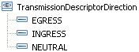 | tmdDirection (Enumeration) | bz:  What's about neutral?  to be added.
 | modifiedResource (TransmissionDescriptorAssociatedResource)  This parameter returns the modified resource (TP or MFD) object. | (out) <xsd:choice>  The TP, MFD or FDFr object.  element name="tp" type="tp:TerminationPointType"  element name="mfd" type="mfd:MatrixFlowDomainType"  element name="fdfr" type="fdfr:FlowDomainFragmentType"  </xsd:choice> | bz:  Need to add CTP and PTP instead of TP here?  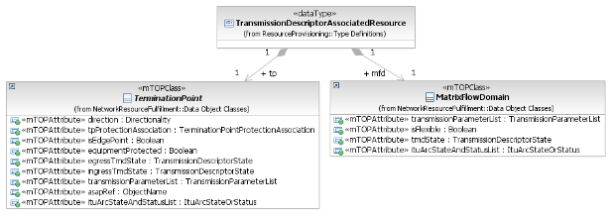
UC_TMF518_RP_0043 see comment at the previous page  Pre-Conditions: | None |  | bz:  The Execution of the Use Case is not enough, because this can fail. There has to be a communication connection between the OSes.
UC_TMF518_RP_0043 see comment at the previous page  Post-Conditions: | The Transmission Parameter values of the TP/MFD are consistent with the values of the associated Transmission Descriptor.
UC_TMF518_RP_0043 see comment at the previous page  Exceptions: | 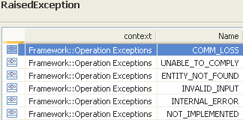 | restriction base="msg:AllExceptionsType"  element ref="msg:commLoss"  element ref="msg:entityNotFound"  element ref="msg:internalError"  element ref="msg:invalidInput"  element ref="msg:notImplemented"  element ref="msg:unableToComply"

verifyTransmissionDescriptorAssignment (restricted to CORBA only)

BA (verifyTransmissionDescriptorAssignment) | IA | IIS (verifyTransmissionDescriptorAssignment) | IIS (validateTransmissionDescriptorAssignmentToObject)
R_TMF518_RP_II_0096  The Interface shall allow the requesting OS to validate the ingress and/or egress Transmission Descriptor (TMD) assigned to a Termination Point (TP) given a TP name specified by the requesting OS.  The following is provided for clarification:  The assignment of a Transmission Descriptor (TMD) to a Termination Point (TP) is called consistent, if whenever a TMD transmission parameter is also present as a TP transmission parameter or a TMD additional TP info parameter is also present as a TP additional info parameter, the common parameters of the TMD and TP have the same values.  R_TMF518_RP_II_0099  The NML-EML Interface shall allow the NMS requesting OS to verifyvalidate the Transmission Descriptor (TMD)s assigned to a Termination Point (TP) or Matrix Flow Domain (MFD) given a TP or MFD name specified by the NMSrequesting OS.  The following is provided for clarification:  The assignment of a Transmission Descriptor (TMD) to a Termination Point (TP) or Matrix Flow Domain (MFD) is called consistent, if whenever a TMD transmission parameter is also present as a TP transmission parameter or a TMD additional Object information parameter is also present as a TP or MFD additional information parameter and the common parameters of the TMD and TP or MFD have the same values. | The operation verifies the Transmission Descriptor (TMD) state of the specified resourceTP or MFD object identified by the resource referencename.  According to the requested transmission direction it checks whether a TMD is assigned as egress and/or ingress or neutral TMD to the resource (TP/MFD). If this is true it first verifies the existence of the assigned TMD(s) and then compares the Transmission Parameters of the TMD with the Transmission Parameters of the resource. After this the additionalObjectInfo parameters of the TMD are compared with the additionalInfo parameters of the resource.  If a TMD Transmission Parameter is not present as a resource Transmission Parameter or is present but has a different value, this is called a "parameter mismatch", and the TMD state will take the value "mismatch".  The operation returns the current TMD state and all mismatched Transmission or additionalObjectInfo Parameters of the TMD.  Traceability: R_TMF518_RP_II_0099. | This operation verifies the egress and/or ingress TMD state of the specified TP identified by tpName.  According to the requested transmission direction it checks whether a TMD is assigned as egress and/or ingress TMD to the TP. If this is true it first verifies the existence of the assigned TMD(s) and then compares the transmission parameters of the TMD and TP, and the additional TP info parameters of the TMD with the additional info parameters of the TP.  If a TMD parameter is not present as a TP parameter or is present but with a different value, this is called a "parameter mismatch", and the TMD state will take the value "mismatch". The service returns the current TMD state and all mismatched transmission or additional TP info parameters of the TMD (which should mostly be none) as its output. | validateTransmissionDescriptorAssignmentToObject  This operation validates the TMD state of the specified TP, MFD or FDFr object identified by ObjectName.  It first verifies the existence of the assigned TMD and then compares the transmission parameters of the TMD and object, and the "additional TP info" parameters of the TMD with the additional info parameters of the object.  If a TMD parameter is not present as an object parameter or is present but with a different value, this is called a "parameter mismatch", and the TMD state will take the value "mismatch". The service returns the current TMD state and all mismatched transmission or "additional TP info" parameters of the TMD (which should mostly be none) as its output.
 | resourceRef (ObjectName)  This parameter provides the name of the resource (TP or MFD) whose TMD assignment shall be verified. | (in) element name="tpName" type="nam:NamingAttributeType"  the TP whose TMD assignment(s) shall be verified. | (in) element name="objectName" type="nam:NamingAttributeType"  the TP, MFD or FDFr object whose TMD assignment shall be verified.
?? | direction (Directionality)  This parameter identifies the direction for which the Transmission Descriptor assignment(s) of the resource shall be verified.  SOURCE refers to the egress TMD state.  SINK refers to the ingress TMD state.  BIDRECTIONAL refers to the egress and ingress or neutral TMD states.  UNIDIRECTIONAL is not allowed. | (in) element name="direction" type="com:DirectionalityType"  the direction for which the TMD assignment(s) of the TP shall be verified D_SOURCE refers to the egress TMD state, D_SINK refers to the ingress TMD state, D_BIDRECTIONAL refers to the egress and ingress TMD states, and D_NA is not allowed.
 | tmdAssignmentState (TransmissionDescriptorState)  This parameter returns the TMD state of the resource as determined by the verification procedure.  If both the egress and ingress TMD states are requested and their values are different, the concatenation of the egress TMD state with the ingress TMD state is returned, separated by a semicolon. | (out) element name="tmdAssignmentState" type="xsd:string"  the TMD state (s) of the TP as determined by the verification procedure; if both the egress and ingress TMD states are requested and their values are different, the concatenation of the egress TMD state with the ingress TMD state is returned, separated by a semicolon. | (out) element name="tmdAssignmentState" type="xsd:string"  the TMD state (s) of the object as determined by the verification procedure.
 | transmissionParametersList (*)  This parameter returns a "delta" list of mismatched TMD Transmission Parameters, or is empty.  See attached supporting document SD1-16_LayeredParameters for more details. | (out) element ref="lp:transmissionParametersList"  a "delta" list of mismatched TMD transmission parameters, or empty. See SD1-16_LayeredParameters.pdf for more details. | (out) element ref="lp:transmissionParametersList"  a "delta" list of mismatched TMD transmission parameters, or empty. See SD1-16_LayeredParameters.pdf for more details.
 | additionalObjectInfo (*)  This parameter returns a "delta" list of mismatched additionalObjectInfo parameters, or is empty. | (out) element name="additionalTpInfo" type="gen:NameAndValueStringListType"  a "delta" list of mismatched "additional TP info" parameters, or empty. | (out) element name="additionalTpInfo" type="gen:NameAndValueStringListType"  a "delta" list of mismatched "additional TP info" parameters, or empty.
No use case defined. | 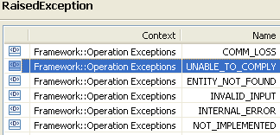 | restriction base="msg:AllExceptionsType"  element ref="msg:commLoss"  element ref="msg:entityNotFound"  element ref="msg:internalError"  element ref="msg:invalidInput"  element ref="msg:notImplemented"  element ref="msg:unableToComply" | restriction base="msg:AllExceptionsType"  element ref="msg:commLoss"  element ref="msg:entityNotFound"  element ref="msg:internalError"  element ref="msg:invalidInput"  element ref="msg:notImplemented"  element ref="msg:unableToComply"

verifyTransmissionDescriptorAssignmentToMFD??

Data Types

EquipmentCreateData Type

BA | IA | IIS (EquipmentCreateData Type) | Comments
R_TMF518_RP_II_0035  The Interface shall allow the requesting OS to specify the following parameters when it requests that a target OS provision an Equipment. | This data type represents the specific parameters that may be provided when creating an Equipment.  Traceability: R_TMF518_RP_II_0035.  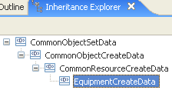 | The data structure for provisioning an equipment.  extension base="crcd:CommonResourceCreateDataType" | 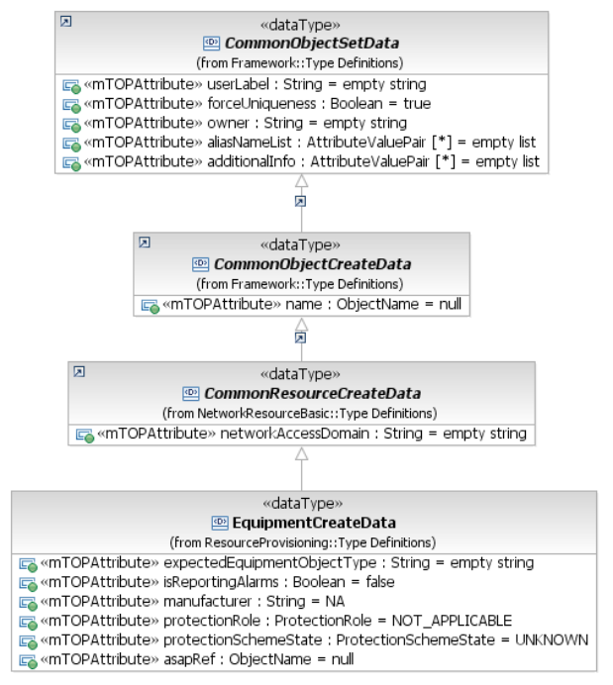
name | Inherited from CommonObjectCreateData. | Inherited from CommonObjectCreateDataType.
1) User label  Refer to R_TMF518_FMW_I_0001 in the TMF518_FMW BA.  2) User label uniqueness  This parameter shall indicate to the target OS to check whether the user label is unique amongst the equipments within the target OS.  3) Owner  Refer to R_TMF518_FMW_I_0001 in the TMF518_FMW BA.  aliasNameList  additionalInfo | Inherited from CommonObjectSetData.  This includes in addition:  - aliasNameList  - additionalInfo. | Inherited from CommonObjectSetDataType.  This includes in addition:  - aliasNameList  - vendorExtensions.
network access domain | Inherited from CommonResourceCreateData. | Inherited from CommonResourceCreateDataType.
4) Expected equipment type  This parameter shall represent the type of the expected equipment. | expectedEquipmentObjectType (String)  This attribute defines the type of the expected Equipment. Values are vendor-specific. | element name="expectedEquipmentObjectType" type="com:EquipmentObjectTypeType"  Defines the type of expected equipment.
5) Alarm reporting  This parameter shall indicate whether alarm reporting for this equipment is to be enabled or disabled. | isReportingAlarms (Boolean)  This attribute indicates whether alarm reporting for the Equipment is administratively activated or de-activated.  True = alarm reporting is activated; False = alarm reporting is de-activated. | ??
 |  | element name="equipmentHolderRefName" type="nam:NamingAttributeType"  Represents the name of equipment holder that will contain the equipment. | bz:  Should be an input parameter of the operation.
6) Alarm severity assignment profile  This parameter shall represent the name of the Alarm Severity Assignment Profile (ASAP) that is to be assigned to the Equipment. | asapRef (ObjectName)  This attribute indicates the required assignment of an Alarm Severity Assignement Profile (ASAP) to the Equipment. | element name="asapRef" type="xsd:string"  Indicates the assignment of an ASAP to the managed object.
7) Manufacturer  This parameter shall represent the name of the equipment vendor. | manufacturer (String)  This attribute identifies the required Equipment manufacturer name. It is defined as a non-empty free format string with no semantics.  In cases where the requesting OS provisions Equipment with a particular manufacturer name and this name conflicts with the manufacturer name as discovered by the target OS, the manufacturer name discovered by the target OS shall be considered the correct name, and the target OS shall issue an AVC notification to the requesting OS indicating a change to the manufacturer name. | element name="manufacturer" type="gen:ManufacturerType"
8) Protection role  This parameter shall represent the protection role (e.g. primary or secondary) that the equipment plays in case it takes part in an equipment protection scheme | protectionRole (ProtectionRole)  This attribute defines the protection role that the Equipment plays in case it takes part in an Equipment protection scheme. In case the Equipment is not protected, the value NOT_APPLICABLE shall be used. | element name="protectionRole" type="com:ProtectionRoleType"
9) Protection scheme state  This parameter shall indicate the state of the protection scheme (i.e. whether it is to be active or locked). | protectionSchemeState (ProtectionSchemeState)  This attribute identifies the individual lock of this Equipment when it is participating in an Equipment protection scheme. In case the Equipment is not protected, the value "UNKNOWN" shall be used. | element name="protectionSchemeState" type="nrb.com:ProtectionSchemeStateType"

GroupTerminationPointCreateData Type

BA | IA (GroupTerminationPointCreateData) | IIS | Comments
R_TMF518_RP_II_0078  The Interface shall allow the requesting OS to specify the following parameters when it requests that A target OS creates a Group Termination Point (GTP). | This data type represents the specific parameters that may be provided when creating a Group Termination Point.  Traceability: R_TMF518_RP_II_0078.  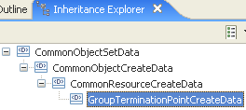 | The data structure for provisioning a Group Termination Point.  extension base="crcd:CommonResourceCreateDataType" | 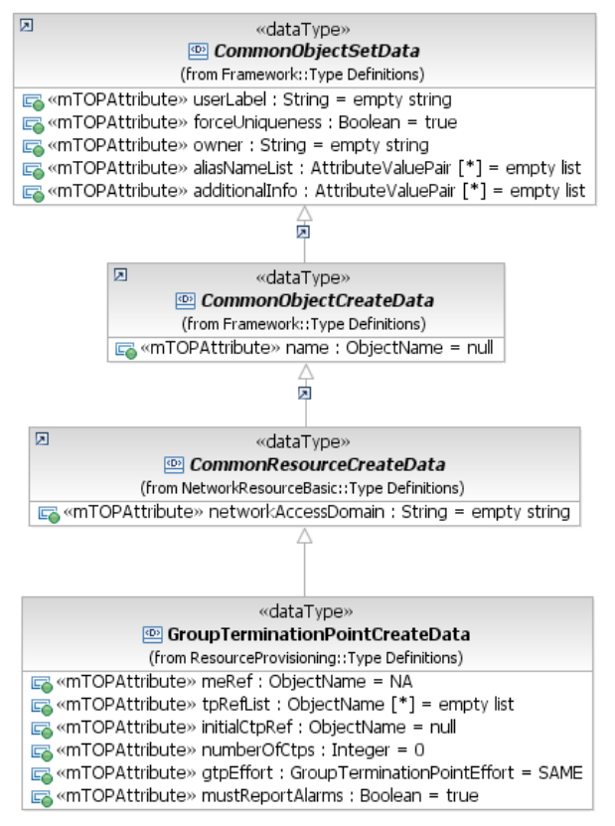
name | Inherited from CommonObjectCreateData. | Inherited from CommonObjectCreateDataType.
1) User label  Refer to R_TMF518_FMW_I_0001 in the TMF518_FMW BA .  2) User label uniqueness  This parameter shall indicate to the target OS to check whether the user label is unique amongst the GTPs within the target OS.  3) Owner  Refer to R_TMF518_FMW_I_0001 in the TMF518_FMW BA .  aliasNameList  additionalInfo | Inherited from CommonObjectSetData.  This includes in addition:  - aliasNameList  - additionalInfo. | Inherited from CommonObjectSetDataType.  This includes in addition:  - aliasNameList  - vendorExtensions.
network access domain | Inherited from CommonResourceCreateData. | Inherited from CommonResourceCreateDataType.
containingMeRef (ObjectName)
This attribute defines the identifier of the Managed Element hosting the new Group Termination Point.

4) Contained CTPs  This parameter shall represent a list of the names of the Connection Termination Point (CTP) that are to be contained by the GTP. | tpRefList (*) (ObjectName)  This attribute defines the list of CTPs that comprise the GTP. | Moved from createGroupTerminationPointRequest  element name="tpRefList" type="nam:NamingAttributeListType"  the list of CTPs that comprise the GTP.
5) Starting CTP name  In cases where the CTPs are contiguous and of the same layer rate, this parameter shall indicate the first CTP in the group. This parameter is used in lieu of the Contained CTPs parameter. | initialCtpRef (ObjectName)  In cases where the CTPs are contiguous and of the same Layer Rate, this attribute is used to indicate the first CTP in the group. This parameter is used in lieu of the tpRefList parameter. | Moved from createGroupTerminationPointRequest  element name="initialCtpName" type="nam:NamingAttributeType"  in cases where the CTPs are contiguous and of the same layerRate, this parameter is used to indicate the first CTP in the group. This parameter is used in lieu of the listOfTPs parameter.
6) Number of CTPs  This parameter is used in conjunction with the starting CTP name parameter. It shall indicate the number of contiguous CTPs that follow the first CTP in the group. It equals 1 minus the total number of CTPs in the GTP.. | numberOfCtps (Integer)  This attribute is used in conjunction with the initialCtpRef attribute. It indicates the number of contiguous CTPs that follow the initial CTP. It equals 1 less than the total number of CTPs in the GTP. | Moved from createGroupTerminationPointRequest  element name="numberOfCtp" type="xsd:long"  This parameter is used in conjunction with the initialCTPname parameter. It indicates the number of contiguous CTPs that follow the initial CTP. It equals 1 minus the total number of CTPs in the GTP.
to be added | gtpEffort (GroupTerminationPointEffort)  This attribute is used to indicate if the GTP bandwidth specification can be met with a different list of CTPs.  +++++++++++++++++  GroupTerminationPointEffort  This enumeration defines a statement of the requirement of the list of CTPs for a new GTP.  If SAME is specified then the target OS must create the GTP with the exact same list of CTPs as provided with the GTP creation request. Further, if the requesting OS uses SAME, it is assumed that the target OS will not modify the CTP list comprising the GTP at some later point (unless requested via the modifyGroupTerminetionPoint operation).  If WHATEVER is specified then the target OS may comply with the total bandwidth requirement by using a different set of CTPs. | Moved from createGroupTerminationPointRequest  element name="gtpEffort" type="tns:GroupTerminationPointEffortType"  This parameter is used to indicate if the GTP bandwidth specification can be met with a different list of CTPs.  +++++++++++++++++  GroupTerminationPointEffortType  The GTP effort is a statement of the requirement of the list of CTPs that a new GTP. If EFFORT_SAME is specified then the EMS must create the GTP with the exact same list of CTPs as provided with the GTP creation request. Further, if the NMS uses EFFORT_SAME, it is assumed that the EMS will not modify the CTP list comprising the GTP at some later point (unless requested by the NMS via the modifyGTP operation). If EFFORT_WHATEVER is specified then the EMS may comply with the total bandwidth requirement by using a different set of CTPs.  If the NMS requests a GTP with gtpEffort equal to EFFORT_SAME, this also implies that the EMS will not modify on its own, i.e., the EMS will only modify the GTP if requested by the NMS via the modifyGTP operation.
to be added | ismustReportingAlarms (Boolean)  This attribute indicates whether alarm reporting for the GTP to be created is administratively activated or de-activated.  True = alarm reporting is activated; False = alarm reporting is de-activated. | to be added

TerminationPointPoolCreateData Type

BA | IA (TerminationPointPoolCreateData) | IIS | Comments
R_TMF518_RP_II_0082  The Interface shall allow the requesting OS to specify the following parameters when it requests that a target OS creates a Termination Point Pool (TP Pool): | This data type represents the specific parameters that may be provided when creating a Termination Point Pool.  Traceability: R_TMF518_RP_II_0082.  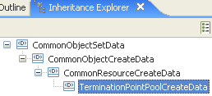 | The data structure for provisioning a Termination Point Pool.  extension base="crcd:CommonResourceCreateDataType" | 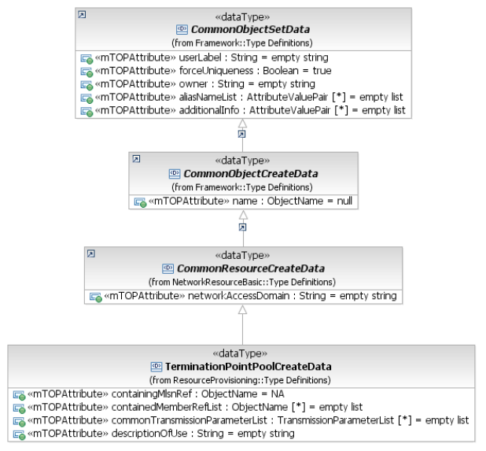
name | Inherited from CommonObjectCreateData. | Inherited from CommonObjectCreateDataType.
1) User label  Refer to R_TMF518_FMW_I_0001 in the TMF518_FMW BA .  2) User label uniqueness  This parameter shall indicate to the target OS to check whether the user label is unique amongst the TP Pools within the target OS.  3) Owner  Refer to R_TMF518_FMW_I_0001 in the TMF518_FMW BA .  aliasNameList  additionalInfo | Inherited from CommonObjectSetData.  This includes in addition:  - aliasNameList  - additionalInfo. | Inherited from CommonObjectSetDataType.  This includes in addition:  - aliasNameList  - vendorExtensions.
network access domain | Inherited from CommonResourceCreateData. | Inherited from CommonResourceCreateDataType.
4) Containing Subnetwork  This parameter shall represent the name of Subnetwork containing the TP Pool. | containingMlsnRef (ObjectName)  This attribute defines the identifier of the Multi Layer Subnetwork hosting the new Termination Point Pool. | Moved from createTerminationPointPoolRequest  element name="containingMlsnRef" type="mlsn:MultiLayerSubnetworkType"  The subnetwork that shall contain the TPPool to be created.
5) Contained members  This parameter shall represent a list of the names of the Termination Point (TP)s or Group Termination Point (GTP) s, all taken from MEs that belong to the above-specified Subnetwork, that are to be contained by the TP Pool. | containedMemberRefList (*) (ObjectName)  This attribute identifies the set of TP names or GTP names (all taken from Managed Elements that belong to the Multi Layer Subnetwork) to be contained in the TP Pool. | Moved from createTerminationPointPoolRequest  element name="containedMembersRefList" type="nam:NamingAttributeListType"  The list of TPs or GTPs that shall comprise the TPPool.
6) Layered transmission parameters  This parameter shall represent the common layers and transmission parameters the above-specified Contained TPs, or TPs contained in Contained GTPs, are required to have (e.g., ATM VP layer with prescribed traffic characteristics).  Note: This does not affect the values of the layered transmission parameters of the contained TPs. | commonTransmissionParameterList (TransmissionParameterList) (*)  This attribute represents the common layers and transmission parameters that the TPs in the containedMemberRefList attribute are required to have to be members of the TP Pool.  Note: This does not affect the values of the layered transmission parameters of the contained TPs.  contains the requested layered Transmission Parameters associated with the different layers that are encapsulated within the TP Pool.  Refer to the attached supporting document SD1-16_LayeredParameters for details of the currently defined Transmission Parameters. | Moved from createTerminationPointPoolRequest  element name="commonTransmissionParameterList" typeref="lp:transmissionParametersList"  This attribute represents the common layers and transmission parameters that the TPs in the containedMemberRefList attribute are required to have to be members of the TP Pool.  Note: This does not affect the values of the layered transmission parameters of the contained TPs.  The common layers and transmission parameters the above-specified Contained TPs, or TPs contained in Contained GTPs, are required to have (e.g., ATM VP layer with prescribed traffic characteristics).  Refer to the attached supporting document SD1-16_LayeredParameters for details of the currently defined Transmission Parameters.
7) Description of use  This attribute shall describe the specific use of the TP pool, in particular how its members are collected and administered.. | descriptionOfUse (String)  This attribute contains a description of the specific use of the TP Pool, in particular how its members are collected and administered. It could include, for example, the name of a TP such that all TP Pool members have to be collected from the set of potential client CTPs of this TP. | Moved from createTerminationPointPoolRequest  element name="descriptionOfUse" type="xsd:string"  A description of the specific use of the TP pool, in particular how its members are collected and administered. It could include, for example, the name of a TP with the meaning that all TP pool members have to be collected from the set of potential client CTPs of this TP.

GuiCutThroughProfileInfo Type

BA | IA | IIS (GuiCutThroughProfileInfoType) | Comments
to be added | This data type provides EMS profiling information that applies to the GUI Cut-through (GCT):  - indication of support for the "server-launch",  - the supported GCT contexts and scopes,  - the GCT command information necessary to launch the GCT on the client side. | Exception message structure of the launchGuiCutThrough operation.
 | serverLaunchCapability (ServerLaunchCapability)  This attribute indicates whether the EMS supports the launchGCT operation to launch the GCT on the server-side. If this value is CLIENT_LAUNCH_ONLYfalse the launch can only be carried out outside the NMS-EMS interface (i.e. a "client-launch"). | element name="serverLaunchCapability" type="tns:ServerLaunchCapabilityType"  Indicates whether the EMS supports the server launchGuiCutThrough operation.  The default is to support client launch only.
 | gctHostName (String)  This attribute contains the IP address (or host name which is mapped to the appropriate IP address) that allows the NMS to identify where to launch the EMS GUI client. This string can be empty only in case the attribute targetOsGctPplatform is "local" or "web-based". For Citrix commands, it is the TSE (Terminal Server Environment) IP address. | element name="gctguiCutThroughHostname" type="xsd:string"  IP address (or host name which is mapped to the appropriate IP address) that allows the NMS to identify where to launch the EMS GUI client (NMS display). This string can be empty only in case the attribute emsGuiCutThroughPplatform is "local" or "web-based".  For Citrix commands, this is the TSE (Terminal Server Environment) IP address. | In MTOSI 2.0 the GUICutThrough is also between NMS and EMS and not between NMSs.
 | targetOsGctPplatform (PlatformString) = WINDOWS  This attribute indicates the platform supported for the GUI Cut-Through. Valid values are: "unix", "windowsNT", "local", and "web-based". This string shall not be empty except for local or web-based GUI.  +++++++++++++++++  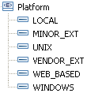 | element name="emsGuiCutThroughPplatform" type="tns:GuiCutThroughPlatformType"  Indicates the platform supported for the GUI Cut-Through. | IIS: GuiCutThroughPlatformEnumType  Defines the enumeration of all platform supported for the GUI Cut-Through.  restriction base="xsd:string"  enumeration value="MINOR_EXT"  enumeration value="VENDOR_EXT"  enumeration value="UNIX"  enumeration value="WINDOWS_NT"  enumeration value="LOCAL"  enumeration value="WEB_BASED"
 | guiCutThroughgctDataList (*) (GuiCutThroughData)  This attribute defines the list of records associated with each supported window type and how to launch them. If the EMS does not provide data for a desired window type, the NMS may use an alternative data record such as the top level window. (The EMS top level window is the only window that is mandatory for the EMS to support.)  +++++++++++++++++  see GuiCutThroughData Type in section 12.5 | element name="guiCutThroughgctDataList" type="tns:GuiCutThroughDataListType"  Indicates the supported window types and how to lauch them.  +++++++++++++++++  see GuiCutThroughData Type in section 12.5

GuiCutThroughData Type

BA | IA | IIS (GuiCutThroughDataType) | Comments
to be added | This data type contains the record associated with each supported window type and how to launch them. | This struct is used to represent the GCT window data for one window.  It provides all the information needed by the NMS to launch a specific GUI Cut-Through window outside of the EMS-NMS interface. The information in the guiCutThroughDataList attribute of a GCT profile information (see below) represents all the windows supported by the EMS. This is a readonly attribute, i.e. the NMS cannot configure GCT launch data but retrieve the GCT capabilities of the EMS.
R_TMF518_RP_II_0071 | gctScope (String)  This attribute defines the scope of the window: "EMS", "Managed Element".  Traceability: R_TMF518_RP_II_0071 | element name="guiCutThroughgctScope" type="xsd:string"  Scope of the window: EMS, ME.  Only support of the EMS scope is mandatory.
 | gctContext (String)  This attribute defines the context of the window:  - "TOP_LEVEL",  - "FAULT",  - "CONFIGURATION_SOFTWARE",  - "CONFIGURATION_CONNECTION",  - "ACCOUNTING",  - "PERFORMANCE",  - "SECURITY",  - "SYSTEMS_MANAGEMENT". | element name="guiCutThroughgctContext" type="xsd:string"  Context of the window.  Valid values are: TOP_LEVEL, FAULT, CONFIGURATION_SOFTWARE, CONFIGURATION_CONNECTION, ACCOUNTING, PERFORMANCE, SECURITY, SYSTEMS_MANAGEMENT.  Only support of the "TOP_LEVEL" context is mandatory.
 | gctCommand (String)  This attribute provides the exact command name needed by the EMS to launch its GUI so that the window for that EMS is launched. Placeholders are used to indicate where values should be replaced by the NMS when performing the client launch. | element name="guiCutThroughgctCommand" type="xsd:string"  contains the exact command needed by the EMS to launch its GUI so that the window for that EMS is launched. This string shall not be empty. Placeholders are used to indicate where values should be replaced by the NMS when performing the client launch.  For details of how this list is filled see SD1-13_guiCutThrough.pdf for conventions of the Client Launch.
 | additionalInfo (*)  This attribute allows the communication (on a pairwise agreement) between the NMS and the EMS of additional information which is not explicitly modelled. | element name="vendorExtensions" type="gen:AnyListType"  This is a container for all vendor extensions.

FloatingTerminationPointCreateData Type

BA | IA | IIS (FloatingTerminationPointCreateDataType) | Comments
R_TMF518_RP_II_0091  The Interface shall allow the requesting OS to specify the following parameters when it requests the creation of a Floating Termination Point (FTP) object. | This data type represents the parameters that may be provided when creating a Floating Termination Point.  Traceability: R_TMF518_RP_II_0091.  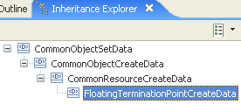 | The read/write attributes required for the creation of a floating termination point on the EMS are packed together in an FTPCreateData structure which the NMS will pass to the EMS at FTP creation time.  extension base="crcd:CommonResourceCreateDataType" | 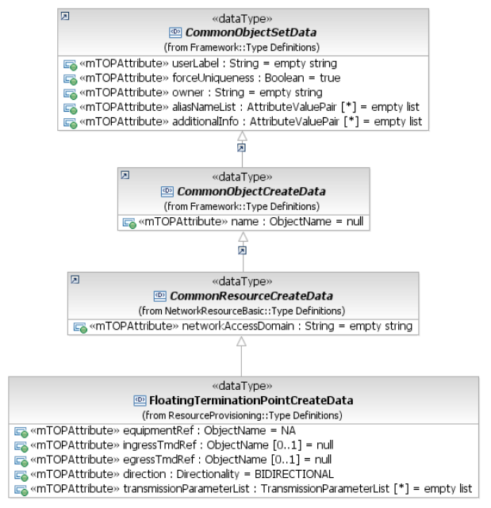
name | Inherited from CommonObjectCreateData. | Inherited from CommonObjectCreateDataType.
1) User label  Refer to R_TMF518_FMW_I_0001 in the TMF518_FMW BA .  2) User label uniqueness  This parameter shall indicate to the target OS that the value of the user label attribute must be unique amongst the FTPs within the target OS domain.  3) Owner  Refer to R_TMF518_FMW_I_0001 in the TMF518_FMW BA  aliasNameList  additionalInfo | Inherited from CommonObjectSetData.  This includes in addition:  - aliasNameList  - additionalInfo. | Inherited from CommonObjectSetDataType.  This includes in addition:  - aliasNameList  - vendorExtensions.
4) Network Access Domain  This attribute represents the Network Access Domain (NAD) to which the new FTP shall be assigned to. | Inherited from CommonResourceCreateData. | Inherited from CommonResourceCreateDataType.
5) Equipment name  Equipment hosting the new FTP in the ME. | equipmentRef (ObjectName)  This attribute defines the identifier of the Equipment hosting the new Floating Termination Point in the Network Element. | to be added
6) Ingress TMD  This attribute shall represent the name of the ingress Transmission Descriptor (TMD) associated with this FTP. | ingressTmdRef (ObjectName)  This attribute identifies the required ingress Transmission Descriptor for the new Floating Termination Point. | element name="ingressTmdRef" type="nam:NamingAttributeType"  The FTP may have an optional reference to an ingress (incoming) Transmission Descriptor.
7) Egress TMD  This attribute shall represent the name of the egress Transmission Descriptor (TMD) associated with this FTP. | egressTmdRef (ObjectName)  This attribute identifies the required egress Transmission Descriptor for the new Floating Termination Point. | element name="egressTmdRef" type="nam:NamingAttributeType"  The FTP may have an optional reference to an egress (outgoing) Transmission Descriptor.
tpMappingMode | tpMappingMode (TerminationMode) =NEITHER_TERMINATED_NOR_AVAILABLE_FOR_MAPPING  Within the façade definition, the CTP/FTP can act as an aggregate of associated G.805 TCPs, G.805 Termination Functions and G.805 CPs at one or more LayerRates. The CTP is contained within a PTP or FTP.  The tpMappingMode attribute indicates and controls the connection of the named CP at a specified LayerRate to the dedicated G.805 TCP and associated G.805 Termination Function at the same LayerRate within the CTP/FTP. | element name="tpMappingMode" type="com:TerminationModeType"  Within the facade definition, the CTP/FTP can act as an aggregate of associated G.805 TCPs, G.805 Termination Functions and G.805 CPs at one or more LayerRates. The CTP is contained within a PTP or FTP.  The TerminationMode attribute indicates and controls the connection of the named CP at a specified LayerRate to the dedicated G.805 TCP and associated G.805 Termination Function at the same LayerRate within the CTP/FTP.  The TerminationMode is used, for example, to control the Termination and mapping to VT1.5 of an STS1 Trail within an OC3 port. This capability could potentially be used to terminate an STS1 backbone Trail within a lower order mux that has the capability to alternatively cross-connect the STS1 unterminated. The same capability is used in SDH and is potentially applicable to any LayerRate.
Direction added | direction (Directionality)  This attribute identifies the required direction of the Floating Termination Point. | element name="direction" type="com:DirectionalityType"  The direction of the termination point.
8) Layered transmission parameters  This parameter represents the client layer rate (e.g., LR_Ethernet), the layer rate (e.g., LR_Encapsulation, LR_Fragment, LR_LAG_Fragment) and the server layer rate (e.g., VC12, any supported concatenated layer rate, including LR_Fragment) of the new call-end-point. A list of technology-specific transmission parameters is associated to every layer rate. Refer to the supporting documents SD1-18_layers and SD1-16_LayeredParameters for details of the currently defined layer rates and transmission parameters.  Note:  Virtual Concatenation (VCAT) is indicated by the presence of the LR_Fragment layer rate and its associated layered transmission parameters (e.g., number and rate of the server CTPs), and that Link Aggregation (LAG) is indicated by the presence of the LR_LAG_Fragment layer rate and its associated layered transmission parameters. | transmissionParameterList (*)  This attribute contains the layer rate on which connectivity is established and a related set of layered parameters.  Refer to supporting document SD1-16_LayeredParameters for details of the currently defined layered parameters. | element ref="lp:transmissionParametersList"  This attribute contains the layer rate on which connectivity is established and a related set of layered parameters.  A list of layer rates on which connectivity can be established in the flow domain together with a set of connectionless technology parameters for each layer rate. Refer to chapter "Connectionless Technology Parameters" of the supporting document LayeredParameters.pdf for details of the currently defined connectionless parameters.
9) VendorExtensions  Refer to R_TMF518_FMW_I_0001 in the TMF518_FMW BA . |  |  | bz:  Is XML specific; will be covered by additionalInfo.

TopologicalLinkCreateData Type

BA | IA | IIS (TopologicalLinkCreateDataType) | Comments
R_TMF518_RP_II_0101  The Interface shall allow the requesting OS to specify the following parameters when it requests that a target OS create a Topological Link (TL): | This data type represents the parameters that may be provided when creating a Topological Link.  Traceability: R_TMF518_RP_II_0101.  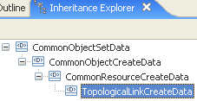 | ??  extension base="crcd:CommonResourceCreateDataType" | 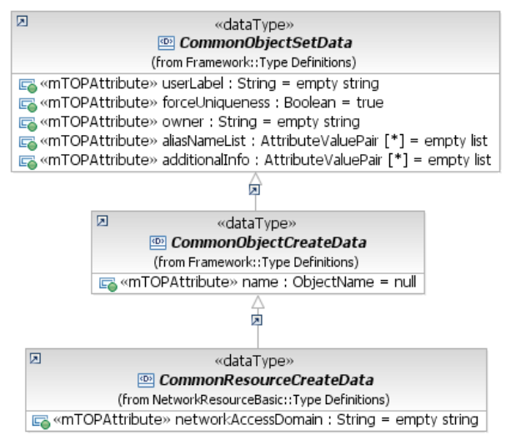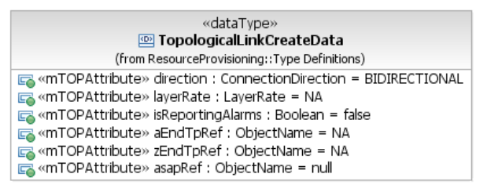
Name | Inherited from CommonObjectCreateData. | Inherited from CommonObjectCreateDataType.
1) User label  Refer to R_TMF518_FMW_I_0001 in the TMF518_FMW BA.  2) User label uniqueness  This parameter shall indicate to the target OS to check whether the user label is unique amongst the TLs within the target OS.  3) Owner  Refer to R_TMF518_FMW_I_0001 in the TMF518_FMW BA.  aliasNameList  additionalInfo | Inherited from CommonObjectSetData.  This includes in addition:  - aliasNameList  - additionalInfo. | Inherited from CommonObjectSetDataType.  This includes in addition:  - aliasNameList  - vendorExtensions.
8) Network Access Domain  This attribute represents the Network Access Domain (NAD) to which this Subnetwork TL has been assigned. | Inherited from CommonResourceCreateData. | Inherited from CommonResourceCreateDataType.
4) Directionality  This attribute shall represent the directionality of the TL (bidirectional or unidirectional). | direction (ConnectionDirection)  This attribute defines the direction of the Topological Link.  Note: A Topological Link can be unidirectional even if both of its ends are bidirectional TPs. | element name="direction" type="com:ConnectionDirectionType"  Direction of the topological link. A topological link can be unidirectional even if both its ends are bidirectional TPs.
7) Layer Rate  This parameter shall represent the layer rate of the TL. Refer to R_TMF518_NRB_I_0003 in the TMF518_NRB document. | layerRate (LayerRate)  This attribute identifies the layer at which the Topological Link is to be created. | element name="layerRate" type="lr:LayerRateType"  The layer of the topological link.
5) aEnd Termination Point (TP)  This parameter shall represent the name of the aEnd TP of the TL. | aEndTpRef (ObjectName)  This attribute contains the requested A end Termination Point of the new Topological Link.  The Termination Point name must be explicit; i.e., a generic endpoint specification may not be used in this case. | element name="aEndRefList" type="nam:NamingAttributeListType"  Name of A end TP. The termination point name must be explicit (a generic endpoint specification may not be used in this case). See SD1-25_objectNaming.pdf for further detail on FTP naming.
6) zEnd Termination Point (TP)  This parameter shall represent the name of the zEnd TP of the TL. | zEndTpRef (ObjectName)  This attribute contains the requested Z end Termination Point of the new Topological Link.  The Termination Point name must be explicit; i.e., a generic endpoint specification may not be used in this case. | element name="zEndRefList" type="nam:NamingAttributeListType"  Name of Z end TP. The termination point name must be explicit (a generic endpoint specification may not be used in this case). See SD1-25_objectNaming.pdf for further detail on FTP naming.
9) Alarm reporting  This attribute shall indicate whether alarm reporting for the TL is enabled or disabled. | isReportingAlarms (Boolean)  This attribute indicates whether alarm reporting for the Topological Link is administratively activated or de-activated.  True = alarm reporting is activated; False = alarm reporting is de-activated. | element name="isReportingAlarms" type="xsd:boolean"  ??
10) Alarm severity assignment profile  This attribute indicates the required assignment of an Alarm Severity Assignement Profile (ASAP) to the TL | asapRef (ObjectName)  This attribute indicates the required assignment of an Alarm Severity Assignement Profile (ASAP) to the Topological Link. | element name="asapRef" type="nam:NamingAttributeTypexsd:string"  Indicates the assignment of an ASAP to this TL object. Value is of the ASAP name.

TrafficConditioningProfileCreateData Type

BA | IA | IIS (TrafficConditioningProfileCreateDataTyp) | Comments
R_TMF518_RP_II_0056  The Interface shall allow the requesting OS to specify the following parameters when it requests that a target OS creates or modifies Traffic Conditioning (TC) Profile: | This data type represents the parameters that may be provided when creating a Traffic Conditioning Profile.  Traceability: R_TMF518_RP_II_0056.  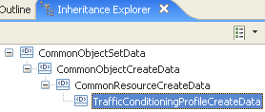 | ??  extension base="crcd:CommonResourceCreateDataType" | 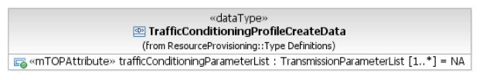  bz:  R_TMF518_RP_II_0056 and TrafficConditioningProfileCreateDataTyp needs to be separated into a create and a modify requirement/data type because the name attribute can not be modified.
Name | Inherited from CommonObjectCreateData. | Inherited from CommonObjectCreateDataType.
1) User label  Refer to R_TMF518_FMW_I_0001 in the TMF518_FMW BA .  2) User label uniqueness  This parameter shall indicate to the target OS that the value of the user label attribute must be unique amongst the Traffic Conditioning Profiles within the target OS domain.  3) Owner  Refer to R_TMF518_FMW_I_0001 in the TMF518_FMW BA .  aliasNameList  additionalInfo / VendorExtensions | Inherited from CommonObjectSetData.  This includes in addition:  - aliasNameList  - additionalInfo. | Inherited from CommonObjectSetDataType.  This includes in addition:  - aliasNameList  - vendorExtensions.
Network Access Domain | Inherited from CommonResourceCreateData. | Inherited from CommonResourceCreateDataType.
4) Layered traffic conditioning parameters  This parameter shall represent a list of traffic conditioning parameters which can be set and/or retrieved at a specified connectionless layer on a Termination Point (TP) having this TC Profile associated. Refer to chapter “Traffic Conditioning Parameters” of the supporting document SD1-16_LayeredParameters for details of the currently defined connectionless parameters. | trafficConditioningParameterList (1..*)  This attribute contains the list of Traffic Conditioning parameters associated with the different layers that are supported by the new Traffic Conditioning Profile object.  Refer to chapter "Traffic Conditioning Parameters" of the supporting document SD1-16_LayeredParameters for details of the currently defined Traffic Conditioning parameters. | element ref="lp:transmissionParametersList"  A list of traffic conditioning parameters which can be set and/or retrieved at a specified connectionless layer on a Termination Point (TP) having this TC Profile associated. Refer to chapter "Traffic Conditioning Parameters" of the supporting document SD1-16_LayeredParameters.pdf for details of the currently defined connectionless parameters.
5) VendorExtensions  Refer to R_TMF518_FMW_I_0001 in the TMF518_FMW BA. |  |  | bz:  Is XML specific; will be covered by additionalInfo.

TrafficConditioningProfileModifyData Type

BA | IA (TrafficConditioningProfileModifyData) | IIS | Comments
R_TMF518_RP_II_00  The Interface shall allow the requesting OS to specify the following parameters when it requests that a target OS modifies a Traffic Conditioning (TC) Profile: | This data type represents the parameters that may be provided when modifying a Traffic Conditioning Profile.  Traceability: R_TMF518_RP_II_00??.  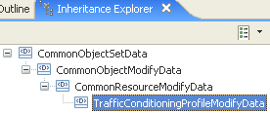 | ??  extension base="crcd:CommonResourceModifyDataType" | 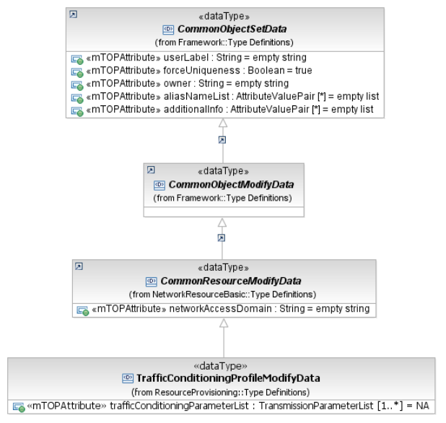
User label  User label uniqueness  Owner  Alias name list  Additional info | Inherited from CommonObjectSetData.  This includes in addition:  - aliasNameList  - additionalInfo. | Inherited from CommonObjectSetDataType.  This includes in addition:  - aliasNameList  - vendorExtensions.
Network access domain | Inherited from CommonResourceCreateData. | Inherited from CommonResourceCreateDataType.
Traffic conditioning parameters | trafficConditioningParameterList (1..*)  This attribute contains the list of Traffic Conditioning parameters associated with the different layers that are supported by the modified Traffic Conditioning Profile object.  Refer to chapter "Traffic Conditioning Parameters" of the supporting document SD1-16_LayeredParameters for details of the currently defined Traffic Conditioning parameters. | element ref="lp:trafficConditioningParameterList"

TransmissionDescriptorCreateData Type

BA | IA | IIS (TransmissionDescriptorCreateDataType) | Comments
R_TMF518_RP_II_0094  The Interface shall allow the requesting OS to specify the following parameters when it requests that a target OS creates a Transmission Descriptor (TMD): | This data type represents the parameters that may be provided when creating a Transmission Descriptor.  Traceability: R_TMF518_RP_II_0094.  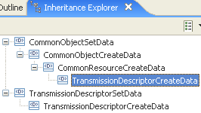 | The attributes required for the creation of a transmission descriptor on the EMS are packaged together in a TMDCreateData structure which the NMS will pass to the EMS at TMD creation time. These are the read-create attributes of the TMD.  extension base="crcd:CommonResourceCreateDataType" | 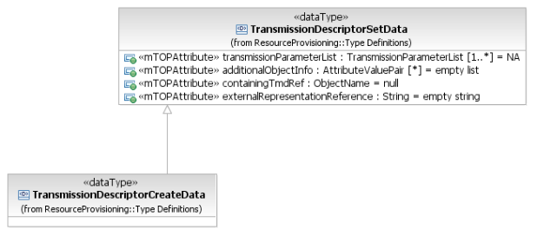
Name | Inherited from CommonObjectCreateData. | Inherited from CommonObjectCreateDataType.
1) User label  Refer to R_TMF518_FMW_I_0001 in the TMF518_FMW BA.  2) User label uniqueness  This attribute shall indicate to the target OS that the value of the user label attribute must be unique amongst the TMDs within the target OS.  3) Owner  Refer to R_TMF518_FMW_I_0001 in the TMF518_FMW BA.  aliasNameList  additionalInfo | Inherited from CommonObjectSetData.  This includes in addition:  - aliasNameList  - additionalInfo. | Inherited from CommonObjectSetDataType.  This includes in addition:  - aliasNameList  - vendorExtensions.
Network Access Domain | Inherited from CommonResourceCreateData. | Inherited from CommonResourceCreateDataType.
4) Layered transmission parameters  This attribute shall represent a list of transmission parameters which can be set and/or retrieved at a specified layer on a TP having this TMD assigned as egress or ingress TMD. Specific parameters include, for example, frame format, line code, alarm reporting control (enable/disable), TP service state (In Service, Out Of Service etc.). | Inherited from CommonObjectSetData.  transmissionParameterList (1..*)  This attribute contains the requested layered Transmission Parameters associated with the different layers that are encapsulated within the Transmission Descriptor.  Refer to the attached supporting document SD1-16_LayeredParameters for details of the currently defined Transmission Parameters. | element ref="lp:transmissionParametersList"  A list of traffic conditioning parameters which can be set and/or retrieved at a specified connectionless layer on a Termination Point (TP) having this TC Profile associated. Refer to chapter "Traffic Conditioning Parameters" of the supporting document SD1-16_LayeredParameters.pdf for details of the currently defined connectionless parameters.
5) Additional TP information  This attribute shall represent any additional information parameters which can be set on the Termination Point (TP) having this TMD assigned as an egress or ingress TMD. | Inherited from CommonObjectSetData.  additionalObjectInfo (*)  This attribute contains additional information which can be set on a Termination Point (TP) or on a Matrix Flow Domain (MFD) by associating this Transmission Descriptor (TMD). | element name="additionalObjectInfo" type="gen:NameAndValueStringListType"  Additional info parameters which can be set on a TP or MFD by associating this TMD.
?? | Inherited from CommonObjectSetData.  containingTmdRef (ObjectName)  This attribute contains the name of another Transmission Descriptor (TMD) which is considered to contain this TMD.  The semantics of the containment is that the TMD shall inherit the layered Transmission Parameters and additional Object information from the containing TMD. | element name="containingTmdName" type="nam:NamingAttributeType"  The name of another TMD which is considered to contain this TMD. The semantics of the containment is that the TMD to be created shall inherit the layered transmission parameters and additional TP information from the containing TMD.
6) External representation  This attribute shall represent a reference to the external representation of the TMD (e.g., an XML file name). The contents of this information is opaque at the Interface and not utilized.. | Inherited from CommonObjectSetData.  externalRepresentationReference (String)  This attribute provides a means to store at the target OS a reference to the external representation of the Transmission Descriptor (e.g., an XML file name). The content of this attribute is opaque at the interface and is not utilized. | element name="externalRepresentationReference" type="xsd:string"  A means to store at the EMS a reference to the external representation of the TMD (e.g., an XML file name). The contents of this attribute is opaque at the NML-EML interface and not utilized.

TransmissionDescriptorModifyData Type

BA | IA | IIS (TransmissionDescriptorModifyDataType) | Comments
R_TMF518_RP_II_00xx | This data type represents the parameters that may be provided when modifying a Transmission Descriptor.  Traceability: R_TMF518_RP_II_0094.  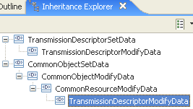 | The attributes required for the modification of a transmission descriptor on the EMS are packaged together in a TMDModifyData structure which the NMS will pass to the EMS.  extension base="crmd:CommonResourceModifyDataType" | 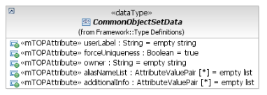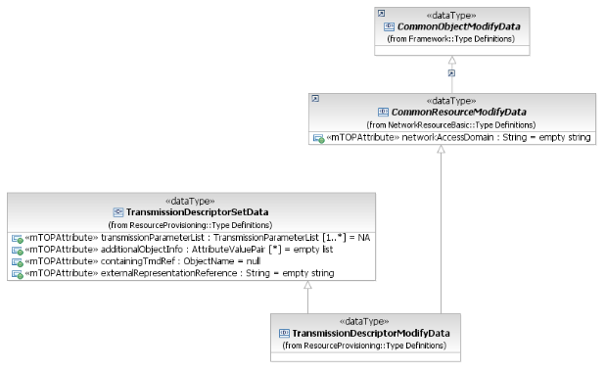
 | Inherited from CommonObjectSetData.  This includes in addition:  - aliasNameList  - additionalInfo. | Inherited from CommonObjectSetDataType.  This includes in addition:  - aliasNameList  - vendorExtensions.
 | Inherited from CommonResourceCreateData. | Inherited from CommonResourceCreateDataType.
 | Inherited from CommonObjectSetData.  transmissionParameterList (1..*)  This attribute contains the requested layered Transmission Parameters associated with the different layers that are encapsulated within the Transmission Descriptor.  Refer to the attached supporting document SD1-16_LayeredParameters for details of the currently defined Transmission Parameters. | element ref="lp:transmissionParametersList"  A list of traffic conditioning parameters which can be set and/or retrieved at a specified connectionless layer on a Termination Point (TP) having this TC Profile associated. Refer to chapter "Traffic Conditioning Parameters" of the supporting document SD1-16_LayeredParameters.pdf for details of the currently defined connectionless parameters.
 | Inherited from CommonObjectSetData.  additionalObjectInfo (*)  This attribute contains additional information which can be set on a Termination Point (TP) or on a Matrix Flow Domain (MFD) by associating this Transmission Descriptor (TMD). | element name="additionalObjectInfo" type="gen:NameAndValueStringListType"  Additional info parameters which can be set on a TP or MFD by associating this TMD.
 | Inherited from CommonObjectSetData.  containingTmdRef (ObjectName)  This attribute contains the name of another Transmission Descriptor (TMD) which is considered to contain this TMD.  The semantics of the containment is that the TMD shall inherit the layered Transmission Parameters and additional Object information from the containing TMD. | element name="containingTmdName" type="nam:NamingAttributeType"  The name of another TMD which is considered to contain this TMD. The semantics of the containment is that the TMD to be created shall inherit the layered transmission parameters and additional TP information from the containing TMD.
6) External representation  This attribute shall represent a reference to the external representation of the TMD (e.g., an XML file name). The contents of this information is opaque at the Interface and not utilized.. | Inherited from CommonObjectSetData.  externalRepresentationReference (String)  This attribute provides a means to store at the target OS a reference to the external representation of the Transmission Descriptor (e.g., an XML file name). The content of this attribute is opaque at the interface and is not utilized. | element name="externalRepresentationReference" type="xsd:string"  A means to store at the EMS a reference to the external representation of the TMD (e.g., an XML file name). The contents of this attribute is opaque at the NML-EML interface and not utilized.

