This document compares BA, IA and IIS Control Plane enhancements of the Network Resource Fulfillment DDP

References:
BA:
IA: https://collab.tmforum.org/svn/repos/mtop/Product/trunk
IIS:
MTOSI2x-newXSDfilesForCP:
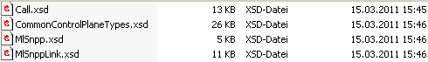
MTOSI20-ModifiedXSDfilesForCP:
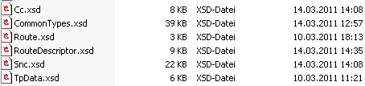

Conventions:
yellow marked items are to be corrected (often discussion necessary)
turquoise marked items are to be added/changed

Content:
1 UML diagrams 4
1.1 NRF Call and Connection Inheritance Class Diagram 4
1.2 NRF Call and Connection Class Diagram 5
1.3 NRF Control Plane Inheritance Class Diagram 6
1.4 NRF Control Plane Class Diagram 7
2 New Object Classes 8
2.1 Call 8
2.2 MultiLayerSNPP 15
2.3 MultiLayerSnppLink 17
2.4 MultiLayerRoutingArea 23
2.5 Connection 25
2.6 ConnectionParameterProfile 37
3 Modified Object Classes 37
3.1 SubNetworkConnection 37
3.2 Cross Connect 48
3.3 Route 49
3.4 Route Descriptor 50
4 New Data Types 50
4.1 CallState Type 50
4.2 EndPointType Type 52
4.3 CallParameterProfile Type 54
4.4 DiversityData Type 55
4.5 DiversityViolations Type 58
4.6 DiversityInfo Type 58
4.7 LayeredSnpp Type 59
4.8 Snpp Type 60
4.9 LayeredSnppLink Type 64
4.10 SnppLink Type 65
4.11 LayeredRoutingArea Type 65
5 Modified Data Types 66
5.1 TerminationPointData Type 66
5.2 Reroute Type 69
5.3 SubnetworkConnectionState Type 70
5.4 SubnetworkConnectionType Type 72
6 Snc.xsd comparison 73

Figures:
Figure 1: NRF Call and Connection Inheritance Class Diagram 4
Figure 2: NRF Call and Connection Class Diagram 5
Figure 3: NRF Control Plane Inheritance Class Diagram 6
Figure 4: NRF Control Plane Class Diagram 7

History:
Version | Date | Description of Change
0.1 | 20.03.2012 | Initial version.
0.2 | 22.03.2012 | ProtectionEffort enumeration deleted since it is already defined in RP.  SNPP replaced by SubNetworkPointPool in object classes.  Figures updated: Operations removed from the (data) object classes.

UML diagrams

NRF Call and Connection Inheritance Class Diagram
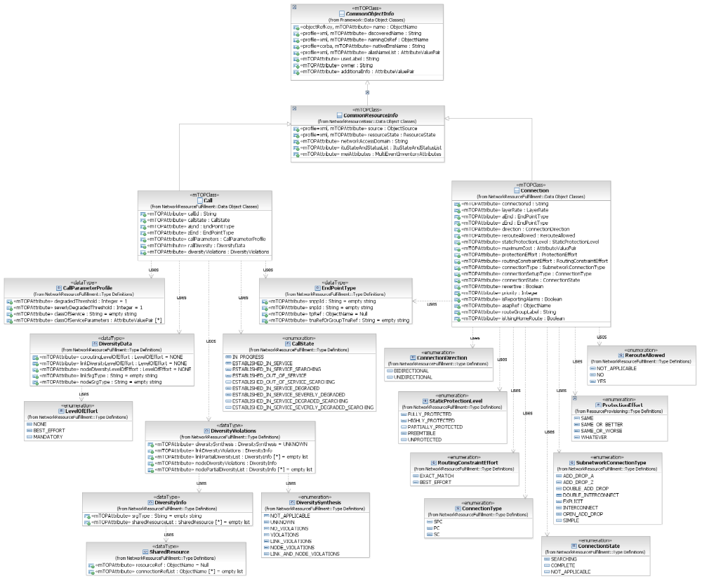
Figure 1: NRF Call and Connection Inheritance Class Diagram

NRF Call and Connection Class Diagram
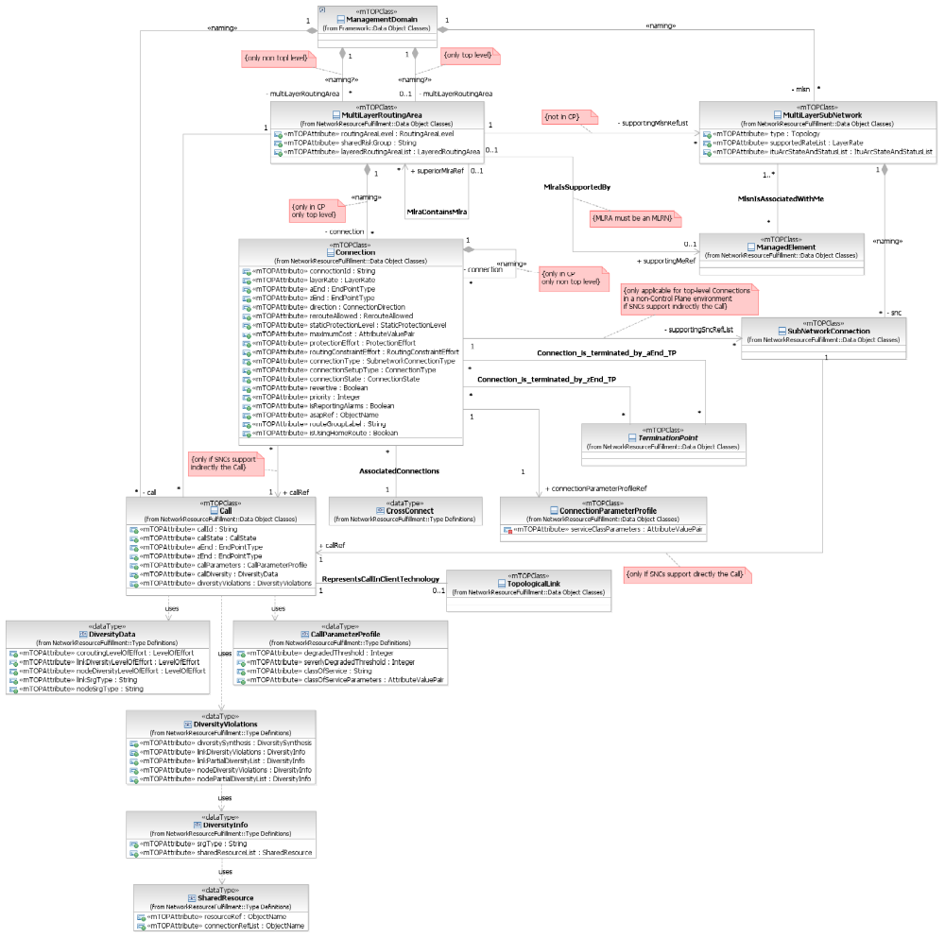
Figure 2: NRF Call and Connection Class Diagram

NRF Control Plane Inheritance Class Diagram
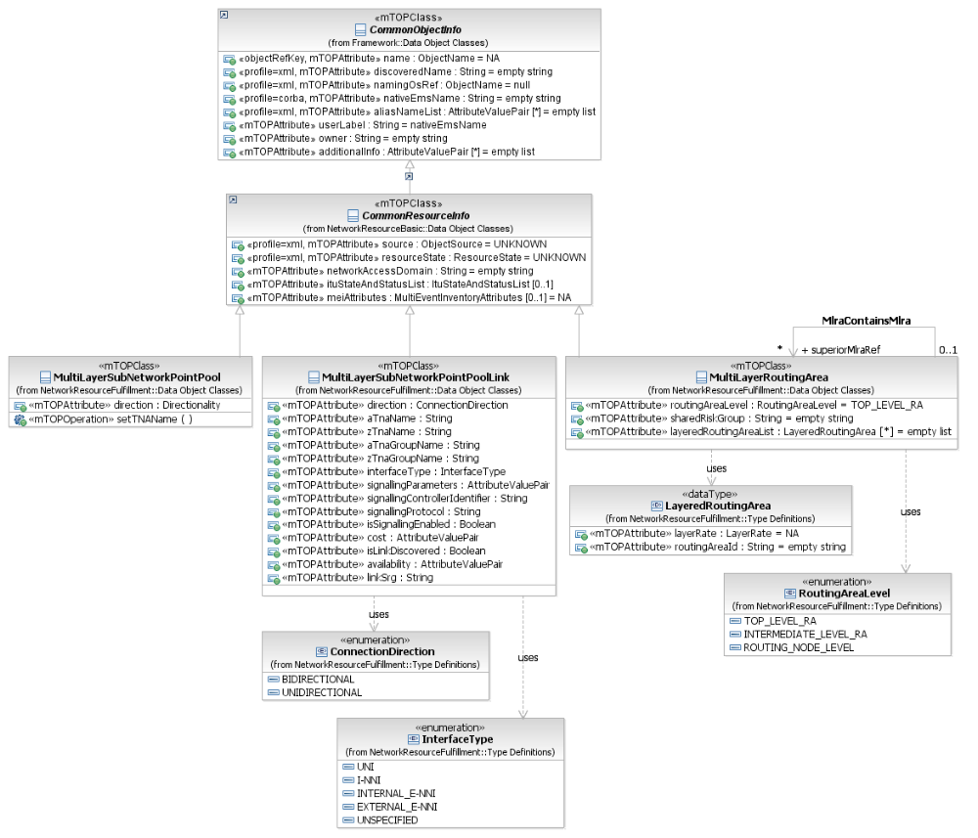
Figure 3: NRF Control Plane Inheritance Class Diagram

NRF Control Plane Class Diagram
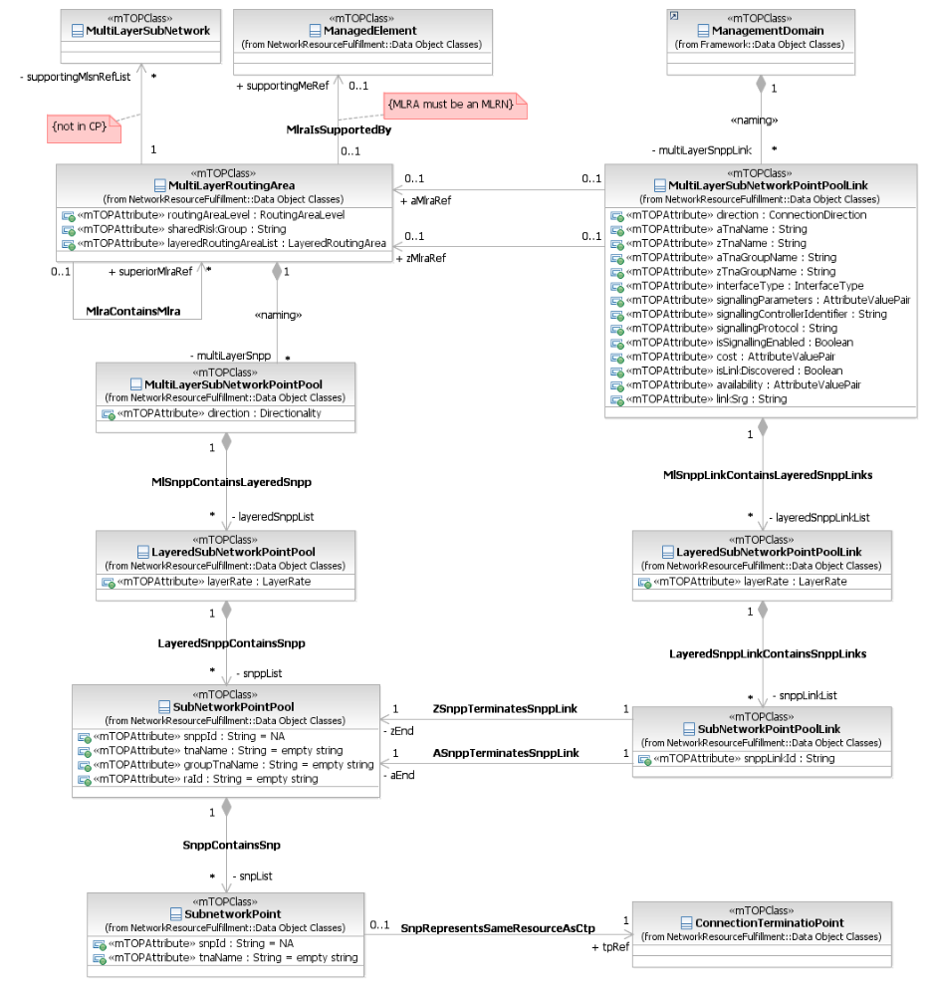
Figure 4: NRF Control Plane Class Diagram

New Object Classes

Call

BA | IA (Call) | IIS (CallType) | Comments
 | 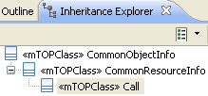  This object class represents a Call.  A Call can exist in the context of a MultiLayer Subnetwork (MLSN) if the routing domain is equivalent to the MLSN domain.  A Call can exist in the context of a Multi Layer Routing Area (MLRA) if the routing domain is spread over more than one MLSN domain.  In both cases the Call is named by the EMS. It represents the association between endpoints in support of an instance of a service or an infrastructure trail.  A Call is a grouping object that is used to facilitate and manage (establish, modify, delete) a set of Subnetwork Connections (SNCs) that provide end-to-end transport of user information.  Because the Call manages the set of Connections/SNCs as a group, it is possible to take diversity constraints between the individual Connections/SNCs into account when they are created/modified.  Calls which exist in the context of an MLSN manage the SNCs directly.  Calls which exist in the context of an MLRA:  - manage the SNCs indirectly via top-level Connections  - manage the Connections indirectly via top-level Connections  (refer to Figure \"Example of Encapsulation Layer Link segments with off-network CPTPs\" in the attached supporting document SD1-44_ConnectionlessTechnologyManagement.pdf).  There is a relationship between Calls and top-level Connections. Zero or more top-level Connections may be associated to a Call. A top-level Connection may not be part of more than one Call.  The bandwidth of a Call is provided by one or more Connections.  Note: Creating a Call between Termination Points (TPs) in the same Managed Element is possible.  Calls are expected to be identified globally. | xsd:extension base="cri:CommonResourceInfoType"  This element entails the attributes common to all mTOP network resource objects.  xsd:extension base="cri:CommonResourceInfo_T"  This aggregate defines the Call mTOP network resource object.  The call structure is the abstraction of a call. G.8080 defines a call as the association between endpoints that supports an instance of a service.  As such, an end-to-end call is considered to consist of multiple call segments, depending on whether the call traverses multiple domains (signalling, routing or recovery domains included).  For purposes of this interface call and call segments are identical.  The association between calls in a client/server layer relationship are coordinated by the layer NCC (Network Call Controller). This association can recurs to mirror a set of "stacked" adaptations.  The target OS interaction with the call is realized through the layer NCC at which the call was requested.  Call Operations can only be done by the target OS that controls the call, this is by the OS that controls the originating points of the call.
 | callId (String) = empty string  This attribute shall represent the unique identifier of the Call. The identifier is assigned by the Control Plane and is only used for Control Plane Signalling.  Note: callId corresponds to the Call Name attribute in ITU-T Recommendation G.7713. | element name="callId" type="xsd:string"  This attribute represents the identifier of the Call. This identifier is only used for control plane signaling.  This attribute is the Call Name attribute in G.7713.
 | callState (CallState) = NA  This attribute represents the state of the Call. The Call state dependents on the state of the associated Connections. | element name="callState" type="comcp:CallStateType"  This attribute represents the state of the Call. The Call state dependents on the state of the associated Connections.
 | aEnd (EndPointType) = NA  This attribute represents the source end point of the Call. The value of this attribute has the following fields:  - SNPP (Control Plane name space)  - SNP (Control Plane name space)  - CPTP/FTP/CTP/PTP (Transport Plane name space)  - TNA Name (which identifies either a TNA or a Group-TNA Name in the Control Plane name space).  All the fields may be empty.  Notes:  All TPs that are managed by different target OSes are off-network TPs which are addressed by remote addresses.  In a Control Plane environment the A-end TP and/or Z-end TP attributes may also contain a \"Null-name\".  In a Control Plane environment, the type is independent of the type of the Z-end. | element name="aEnd" type="comcp:CallEndType"  The source point of the call. During Call Creation the A-end and Z-end names shall be of the same type.  For a detailed description of the use of this attribute, see SD1-25 Naming.  This is a read only attribute.
 | zEnd (EndPointType) = NA  This attribute represents the destination end point of the Call. The value of this attribute has the following fields:  - SNPP (Control Plane name space)  - SNP (Control Plane name space)  - CPTP/FTP/CTP/PTP (Transport Plane name space)  - TNA Name (which identifies either a TNA or a Group-TNA Name in the Control Plane name space).  All the fields may be empty.  Notes:  All TPs that are managed by different target OSes are off-network TPs which are addressed by remote addresses.  In a Control Plane environment the A-end TP and/or Z-end TP attributes may also contain a \"Null-name\".  In a Control Plane environment, the type is independent of the type of the A-end. | element name="zEnd" type="comcp:CallEndType"  The destination point of the call. During Call Creation the A-end and Z-end names shall be of the same type.  For a detailed description of the use of this attribute, see SD1-25 Naming.  This is a read only attribute.
 | callParameters (CallParameterProfile) = NA  This attribute represents the following parameters:  - Severely Degraded Threshold  - Degraded Threshold  - Class Of Service  - Class Of Service specific Parameters. | element name="callParameters" type="comcp:CallParameterProfileType"  It provides the Call parameters.
 | callDiversity (DiversityData) = NA  This attribute represents the diversity status of the Call. | element name="callDiversity" type="comcp:DiversityType"  It provides the information on corouting and diversity (link and node) for the call.  A call may have No Diversity or Link Diversity and/or Node Diversity.
 | diversityViolations (DiversityViolations) = NA  This attribute represents information on the current state of diversity violations of the Call in the following parameters:  - diversitySynthesis  - linkDiversityViolationsList  - linkPartialDiversityList  - nodeDiversityViolationsList  - nodePartialDiversityList. | ?? | bz: No grouping of diversity violations in IIS.  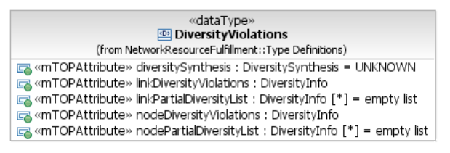
 | diversitySynthesis (DiversitySynthesis) = UNKNOWN  This attribute indicates a synthesis of the current state of diversity violations of the Call.  Possible values are:  - Not Applicable  - Unknown  - NoViolations  - Violations (in case the EMS does not distinguish between node and link violations)  - LinkViolations  - NodeViolations  - LinkAndNodeViolations.  +++++++++++++++++  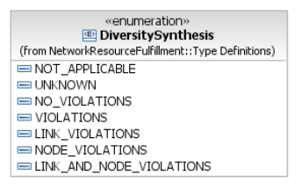 | element name="diversitySynthesis" type="xsd:string"  This string provides a synthesis of current state of diversity violations of the call (diversity different to the provisioned diversity).  The possible values are:  - "NotApplicable"  - "Unknown"  - "NoViolations"  - "Violations": This value can be used when the target OS does not distinguish between link and node violations  - "LinkViolations"  - "NodeViolations"  - "LinkAndNodeViolations"
 | linkDiversityViolations (DiversityInfo)  This attribute indicates the link(s) where the requested diversity type has been violated with three possible levels of detail:  - SRG types where the violation is, plus (opt.) the related  - list of links involved, plus (opt.) the related  - list of involved Connections. | element name="linkDiversityViolations" type="comcp:DiversityInfoType"  This attribute contains the list of link diversity violations.  The value sRGType indicates the link sRGType required for the call.  The sharedResourceList indicates the MLSNPPLink/TopologicalLink Name(s) where the violation(s) occurred and also the Name of the connection(s)/SNC(s) affected by each violation.  Note that the connection(s) affected by the violation(s) can not be currently routed in the case of a Mandatory diversity effort requirement.  Depending upon the capability of the target OS this parameter may be empty.
 | nodeDiversityViolations (DiversityInfo)  This attribute indicates the node(s) where the requested diversity type has been violated.  The value srgType indicates the node sRGType required for the call.  The sharedResourceList indicates the routingNode/ME Name(s) where the violation(s) occurred and also the Name of the connection(s)/SNC(s) affected by each violation.  Note that the connection(s) affected by the violation(s) can not be currently routed in the case of a Mandatory diversity effort requirement. Depending upon the capability of the EMS this parameter may be empty. | element name="nodeDiversityViolations" type="comcp:DiversityInfoType"  This attribute contains the list of node diversity violations.  The value sRGType indicates the node sRGType required for the call.  The sharedResourceList indicates the routingNode/ME Name(s) where the violation(s) occurred and also the Name of the connection(s)/SNC(s) affected by each violation.  Note that the connection(s) affected by the violation(s) can not be currently routed in the case of a Mandatory diversity effort requirement.  Depending upon the capability of the target OS this parameter may be empty.
 | linkPartialDiversityList (DiversityInfo) [*] = empty list  This attribute contains the link diversity that was partially achieved in the cases where the diversity requirements were not met. It provides further information on the current state of routing.  The parameter provides three possible levels of detail:  - SRG types where the violation is, plus (opt.) the related  - list of links involved, plus (opt.) the related  - list of involved Connections.  The value srgType indicates:  - For Mandatory: The SRG type that could have been achieved on the links(s) where the diversity violation occurred if the request had been for Best Effort. The sharedResourceList indicates the MLSNPPLink/TopologicalLink(s) where the \"reduced\" diversity would have been achieved and also the name of each top level Connection affected.  - For Best Effort: The SRG type that has been achieved on the links(s) where the diversity violation occurred. The sharedResourceList indicates the MLSNPPLink/TopologicalLink(s) where the \"reduced\" diversity has been achieved and also the Name of each top level connection affected.  Note that in the case of a Mandatory Diversity Effort, the connection(s) affected by the violation(s) can not be currently routed and they are in \"searching\" state.  Depending upon the capability of the EMS this parameter may be empty. For example, consider the case where a call is requested with best effort link diversity of \"bridge\" srgType, but only routes that all share a single bridge are available. In this case a violation will be indicated identifying the links that traverse the bridge, the connections that used these links and the degree of diversity achieved (e.g. \"duct\"). | element name="linkPartialDiversityList" type="comcp:DiversityInfoListType"  Where there has been a diversity violation this attribute provides further information on the current state of routing.  The value sRGType indicates:  - For Mandatory: The sRGType that could have been achieved on the links(s) where the diversity violation occurred if the request had been for Best Effort. The sharedResourceList indicates the MLSNPPLink/TopologicalLink(s) where the "reduced" diversity would have been achieved and also the Name of each top level connection affected.  - For Best Effort: The sRGType that has been achieved on the links(s) where the diversity violation occurred. The sharedResourceList indicates the MLSNPPLink/TopologicalLink(s) where the "reduced" diversity has been achieved and also the Name of each top level connection affected.  Note that in the case of a Mandatory Diversity Effort, the connection(s) affected by the violation(s) can not be currently routed and they are in "searching" state.  Depending upon the capability of the target OS this parameter may be empty.  For example, consider the case where a call is requested with best effort link diversity of "bridge" sRGType, but only routes that all share a single bridge are available. In this case a violation will be indicated identifying the links that traverse the bridge, the connections that used these links and the degree of diversity achieved (e.g. "duct").
 | nodePartialDiversityList (DiversityInfo) [*] = empty list  This attribute contains the node diversity that was partially achieved in the cases where the diversity requirements were not met. It provides further information on the current state of routing.  The parameter provides three possible levels of detail:  - SRG types where the violation is, plus (opt.) the related  - list of nodes involved, plus (opt.) the related  - list of involved Connections.  The value srgType indicates:  - For Mandatory: The SRG type that could have been achieved on the node(s) where the diversity violation occurred if the request had been for Best Effort. The sharedResourceList indicates the routingNode/ME(s) where the \"reduced\" diversity would have been achieved and also the Name of each top level connection affected.  - For Best Effort: The SRG type that has been achieved on the node(s) where the diversity violation occurred. The sharedResourceList indicates the routingNode/ME(s) where the \"reduced\" diversity has been achieved and also the Name of each top level connection affected.  Note that in the case of a Mandatory Diversity Effort, the connection(s) affected by the violation(s) can not be currently routed and they are in \"searching\" state.  Depending upon the capability of the EMS this parameter may be empty. | element name="nodePartialDiversityList" type="comcp:DiversityInfoListType"  Where there has been a diversity violation this attribute provides further information on the current state of routing.  The value sRGType indicates:  - For Mandatory: The sRGType that could have been achieved on the node(s) where the diversity violation occurred if the request had been for Best Effort. The sharedResourceList indicates the routingNode/ME(s) where the "reduced" diversity would have been achieved and also the Name of each top level connection affected.  - For Best Effort: The sRGType that has been achieved on the node(s) where the diversity violation occurred. The sharedResourceList indicates the routingNode/ME(s) where the "reduced" diversity has been achieved and also the Name of each top level connection affected.  Note that in the case of a Mandatory Diversity Effort, the connection(s) affected by the violation(s) can not be currently routed and they are in "searching" state.  Depending upon the capability of the target OS this parameter may be empty.

MultiLayerSubNetworkPointPool

BA | IA (MultiLayerSubNetworkPointPool) | IIS (MlSnppType) | Comments
 | This object class represents a collection of SNPPs that are of typeTCP (Termination Connection Point).  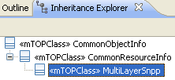 | The MultiLayer Subnetwork point pool is used to represent a list of Layered SNPP. There is one Layered SNPP per supported layer rate.  A MLSNPP is composed by SNPPs which represent TP functions which have a G.805 TCP/TerminationFunction. Otherwise SNPPs forms part of an MLSNPPLink if they represent TP functions which have a G.805 CP role.  Note that multi-layer does not imply client-server relationship, but flexible mapping at the same switching layer.  For more details see SD1-45_ASONControlPlaneManagement-Primer.  extension base="cri:CommonResourceInfoType"  This element entails the attributes common to all mTOP network resource objects.
 | direction : Directionality = BIDIRECTIONAL  This attribute represents the directionality of its SNP components. All SNPs within a MLSNPP shall have the same direction.  The direction of the SNP is inherited from the CTP that the SNP represents. | element name="direction" type="com:DirectionalityType"  This attribute represents the directionality of its SNP components. All SNPs within a MLSNPP shall have the same direction.  The direction of the SNP is inherited from the TP (CTP/PTP/FTP) that the SNP represents.
 | layeredSnppList (LayeredSnpp) [*] = empty list  This attribute contains the list of Layered SNPPs that comprise the MLSNPP. One Layered SNPP per supported layer rate. | element name="layeredSNPPList" type="comcp:LayeredSNPPListType"  The list of Layered SNPPs that comprise the MLSNPP. One Layered SNPP per supported layer rate.  +++++++++++++++++++  xsd:complexType name="LayeredSNPPListType"  The List of layered SNPPs. It is a list of the SNPPs at all layers. A given layerRate value can appear only once in this list.  xsd:sequence>  element name="layeredSNPPType" type="tns:LayeredSNPPType"

MultiLayerSubNetworkPointPoolLink

BA | IA (MultiLayerSubNetworkPointPoolLink) | IIS (MlSnppLinkType) | Comments
 | This object class represents a multi-layer SNPP (Subnetwork Point Pool) Link.  The MLSNPPLink is the abstraction of a set of control plane SNPP Links in different layered networks. Note that multi-layer does not imply client-server relationship, but flexible mapping at the same switching layer.  The MLSNPPLink represents the relationship between a pair of MLSNPPs. The MLSNPPLink represents a set (>0) of SNPP Links.  The SNPP link represents the relationship between a pair of SNPPs in different routing areas that are part of the same layer network.  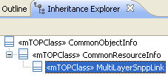 | The MLSNPPLink (Multi-Layer SNPP Link) structure is the abstraction of a set of control plane SNPP Links in different layered networks offered by the target OS to the requesting OS. Note that multi-layer does not imply client-server relationship, but flexible mapping at the same switching layer.  The MLSNPPLink represents the relationship between a pair of MLSNPPs. The MLSNPPLink represents a set (>0) of SNPP Links.  The SNPP link represents the relationship between a pair of SNPPs in different routing areas that are part of the same layer network.  For more details see SD1-45_ASONControlPlaneManagement-Primer.  xsd:extension base="cri:CommonResourceInfoType"  This element entails the attributes common to all mTOP network resource objects.
 | direction : ConnectionDirection = BIDIRECTIONAL  This attribute specifies the directionality of the MultiLayerSNPPLink.  +++++++++++++++++++++  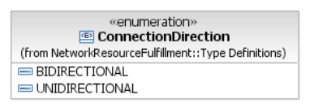 | element name="direction" type="com:ConnectionDirectionType"  This attribute specifies the directionality of the link.  +++++++++++++++++  simpleType name="ConnectionDirectionType"  Direction of a subnetwork connection, cross-connects, or topological link.  For a detailed description of the use of this attribute see SNC Types supporting document.  restriction base="xsd:string"  enumeration value="CD_UNI"  UNIdirectional, i.e. source TP to sink TP. Note: creation of unidirectional connections is supported even when CTPs/FTPs are modelled as bidirectional.  enumeration value="CD_BI"  BIidirectional, i.e. bidirectional TP to bidirectional TP, a.k.a. two-way.
 | aMlraRef (MultiLayerRoutingArea) [0..1]  This relationship identifies the MLRA name at the A end of the MultiLayerSnppLink.  If the information is not available, the field is left empty. This may occur e.g. in case of UNSPECIFIED, or External E-NNI or UNI interface types. | element name="aMLRAName" type="nam:NamingAttributeType"  Identifies the MLRA name at the A end. If the information is not available, the field is left empty.  This may occur e.g. in case of UNSPECIFIED, or External E-NNI or UNI interface types.
 | zMlraRef (MultiLayerRoutingArea) [0..1]  This relationship identifies the MLRA name at the Z end of the MultiLayerSnppLink.  If the information is not available, the field is left empty. This may occur e.g. in case of UNSPECIFIED, or External E-NNI or UNI interface types. | element name="zMLRAName" type="nam:NamingAttributeType"  Identifies the MLRA name at the Z end. If the information is not available, the field is left empty.  This may occur e.g. in case of UNSPECIFIED, or External E-NNI or UNI interface types.
 | aTnaName : String = empty string  This attribute represents the TNA name of the a-End of the MultiLayerSnppLink. | element name="aTNAName" type="xsd:string"  The TNAName of the a-end of the MLSNPPLink.
 | zTnaName : String = empty string  This attribute represents the TNA name of the z-End of the MultiLayerSnppLink. | element name="zTNAName" type="xsd:string"  The TNAName of the z-end of the MLSNPPLink.
 | aTnaGroupName : String = empty string  This attribute represents the TNAGroup name of the a-End of the MultiLayerSnppLink. | element name="aTNAGroupName" type="xsd:string"  The TNAGroupName of the a-end of the MLSNPPLink.
 | zTnaGroupName : String = empty string  This attribute represents the TNAGroup name of the z-End of the MultiLayerSnppLink. | element name="zTNAGroupName" type="xsd:string"  The TNAGroupName of the z-end of the MLSNPPLink.
 | layeredSnppLinkList (LayeredSnppLink) [*]  This relationship identifies the LayeredSnppLink objects contained by the MultiLayerSnppLink. | element name="sNPPLinkList" type="comcp:LayeredSNPPLinkListType"  The list of multilayer SNPP links.  +++++++++++++++++++  complexType name="LayeredSNPPLinkListType"  It is a list of the SNPP Links at a particular layer. A given layerRate value can appear only once in this list.  xsd:sequence  element name="layeredSNPPLinkType" type="tns:LayeredSNPPLinkType"
 | interfaceType : InterfaceType = UNSPECIFIED  This attribute defines the type of interface in which the link participates.  ++++++++++++++++++++  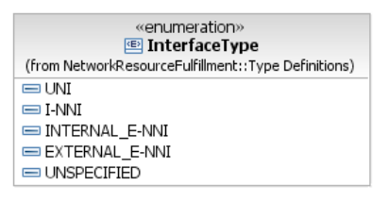  This enumeration defines the type of an interface.  External E-NNI means that the link is at the edge of the requesting OS domain. | element name="interfaceType" type="comcp:InterfaceTypeType"  Defines the type of interface in which the link participates. Four values are possible: UNI, I-NNI, internal E-NNI, external E-NNI and UNSPECIFIED where External E-NNI means that the link is at the edge of the requesting os domain.  ++++++++++++++++++++  simpleType name="InterfaceTypeType"  This attribute represents the type of interface in which the MLSNPPLink participates.  Possible values are:  - "UNI"  - "I-NNI"  - "internal E-NNI"  - "external E-NNI": the link is at the edge of the requesting OS domain.  - "UNSPECIFIED"  restriction base="xsd:string"
 | signallingParameters : AttributeValuePair [*] = empty list  This attribute is used to specify the parameters that can be used for signalling. | element name="signallingParameters" type="gen:NameAndValueStringListType"  It specifies the parameters to be used for signalling.
 | signallingControllerIdentifier : String = empty string  This attribute specifies the Identifier of the signalling controller that the MLSNPP link is assigned to. | element name="signallingControllerIdentifier" type="xsd:string"  Attribute that provides the Identifier of the signalling controller that the MLSNPP link is assigned to.
 | signallingProtocol : String = empty string  This attribute specifies the signalling protocol used across the link. Examples of the types of protocol would be RSVP, PNNI, CR-LDP etc. | element name="signallingProtocol" type="comcp:SignallingProtocolType"  Defines the type of interface in which the link participates. Four values are possible: UNI, I-NNI, internal E-NNI, external E-NNI and UNSPECIFIED where External E-NNI means that the link is at the edge of the requesting os domain.  +++++++++++++++++++  simpleType name="SignallingProtocolType"  This represents the Signalling Protocol to be used.  Potential values are:  - "CRLDP"  - "RSVP"  - "PNNI"  restriction base="xsd:string" | bz: Should we define this as an enumeration?  bz: copy&paste error  bz: Missing "<!-- ============== -->"  …  </xsd:simpleType>  "<!-- ============== -->  <xsd:simpleType name="SignallingProtocolType">  <xsd:annotation>  …
 | isSignallingEnabled : Boolean = TRUE  This attribute specifies whether signalling is enabled or disabled on the link. | element name="signallingEnabled" type="xsd:boolean"  Specifies whether signaling is enabled in the link.
 | cost : AttributeValuePair [*] = empty list  This attribute represents a vector of one or more metrics, each of which indicates the relative desirability of this link over another during path selection. | element name="cost" type="gen:NameAndValueStringListType"  It represents a vector of one or more metrics, each of which indicates the relative desirability of this link over another during path selection.
 | isLinkDiscovered : Boolean = FALSE  This attribute indicates whether the link was discovered or provisioned. | element name="discovered" type="xsd:boolean"  Optional attribute which represents if the link is discovered or provisioned.
 | availability : AttributeValuePair [*] = empty list  This attribute represents a vector of one or more availability factors for the MultiLayerSnppLink. Availability may be represented in different ways between domains and within domains.  Within domains it may be used to represent a survivability capability of the MultiLayerSnppLink. | element name="availability" type="gen:NameAndValueStringListType"  Optional attribute which represents a vector of one or more availability factors for the MLSNPPLink.  Availability may be represented in different ways between domains and within domains.  Within domains it may be used to represent a survivability capability of the MultiLayerSNPPlink.
 | linkSrg : String = empty list  This attribute represents the risks factors assigned to the MultiLayerSnppLink. The string shall represent a sequence of {risk type, and sequence of values}.  The format of the linkSRG attribute is the same as that of the \"SRG\" additional Info attribute. | element name="linkSRG" type="xsd:string"  Sequence of {risk type, and sequence of values}.  The format of the LinkSRG is the same as that of the "SRG" additional Info attribute.  See SD1-1 Additional Info Usage for further information on the format.  Note: The behavior when routing a connection that specifies a risk type that is not present in the linkSRG for one or more links is dictated by the control plane implementation. | bz: Should we define a more formal attribute type?

MultiLayerRoutingArea

BA | IA (MultiLayerRoutingArea) | IIS covered by MLSN object class? | Comments
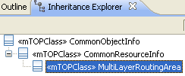
This object class represents a Multi Layer Routing Area (MLRA) that is managed by the target OS.
An MLRA consists of multiple congruent Routing Areas (RAs) at different layers. The Control Plane RA consists of a set of subordinate RAs, the SNPP Links that interconnect them, and the SNPPs representing the ends of the SNPP Links exiting that RA. The way that RAs and SNPP Links are grouped in RAs is entirely determined by the target OS.
MLRAs are organized in a hierarchical structure based upon \"containment\" (in which the lower level MLRAs are completely contained within a single higher level MLRA). The MLRA can contain other MLRAs and this recursion can continue as many times as necessary. A Top Level RA coincides with the whole Control Plane Network. The information on MLRA (subordinated MLRAs) can be accessed through operation on the containing MLRA.

routingAreaLevel : RoutingAreaLevel = TOP_LEVEL_RA
This attribute specifies whether the prescribed Multi-Layer Routing Area (MLRA) is
- a top level MLRA
- an intermediate level MLRA or
- a Multi-Layer Routing Node.
++++++++++++++++++
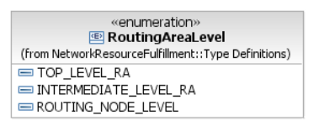
sharedRiskGroup : String = empty string
This attribute is applicable when the MLRA is a routing node. It is a sequence of {risk type, and sequence of strings}.

layeredRoutingAreaList : LayeredRoutingArea [*] = empty list
This attribute defines the list of associated Routing Areas.

supportingMlsnRefList (MultiLayerSubNetwork) [*] {not in CP}
This relationship contains the names of the MLSNs supporting the MLRA.

supportingMeRef (ManagedElement) [0..1] {MLRA must be an MLRN}
This relationship contains the names of the Managed Elements for the MLRA which are routing nodes.

superiorMlraRefList (MultiLayerRoutingArea) [*]
This relationship contains the names of the superior MLRAs.

Relationship MLRA – Call (abstract?)
The value of the name for the CallSegment is the MultiLayerRoutingArea.

Connection

BA | IA (Connection) | IIS covered by SNC object class | Comments
 | 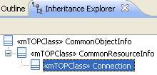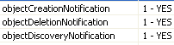  The Connection object represents the relationship between two Subnetwork Points (SNP) or Termination Points.  A Connection may encompass a sequence of Connections (which are referred to as Connection Segments, but not represented in this model) and thus create a recursive relationship between Connections (i.e., Connections supporting Connections).  The Connection(s) at the highest level of recursion are referred to as top-level Connection(s).  Note that a Call may have one or more parallel top-level Connection(s). | This aggregate defines the Subnetwork Connection mTOP network resource object.  A subnetwork connection represents a connection between TPs (in any combination). It may also represent Network Connections between the G.805 TCP of any TP</p>.  This structure is also used to represent a Connection supporting a call in the Control Plane at any level of the routing area hierarchy. The Connection object represents the relationship between subnetwork points (SNP).  A connection may encompass a sequence of connections (referred to as connection segments although but not represented in this model) and thus create a recursive relationship across the routing hierarchy.  This object can represent a connection at the highest level of recursion (a top-level connection).  Note that a Call may have one or more parallel top-level connection(s).
 | connectionId : String = empty string  This attribute represents the unique identifier of the Connection. The identifier is assigned by the Control Plane and is used for Control Plane signalling.  Note: connectionId corresponds to the Connection Name attribute in ITU-T Recommendation G.7713. | element name="connectionId" type="xsd:string"  This is the control plane identifier. This attribute is the Connection Name attribute in G.7713.  Note that also the Cross Connection points to its superior Connection.
 | layerRate : LayerRate = NA  This attribute identifies the layer rate of the Connection. | element name="layerRate" type="lay:LayerRateType"  The rate of the SubnetworkConnection is obtained by reading this attribute. The target OS sets this attribute at creation of the SNC.  The target OS is allowed to choose a Layer Rate equivalent to that of one of the TPs/SNPs. The target OS is expected to reflect any equivalent layer rate in any connection retrievals (i.e. the connection rate of the SNC retrieved from the target OS does not have to be the same as that requested by the requesting OS so long as it is an equivalent rate).  For a detailed description of the use of this attribute see SD1-36 SNC Types.  This is a readonly attribute.
 | aEnd : EndPointType = NA  This attribute represents the source end point of the Connection. The value of this attribute is in one of the following name types:  - SNPP (Control Plane name space)  - SNP (Control Plane name space)  - TP (Transport Plane name space)  - TNA Name (which identifies either a TNA or a Group-TNA Name in the Control Plane name space). | element name="aEndTnaNameOrGroupTnaName" type="xsd:string"  Represent the TNA or Group-TNA of the Connection. A TNA Name List may have 3 value pairs.  Format: \name=TNAName\value=TNANameValue\name=LogicalPortId\value=LogicalPortIdValue\name= Index\value=IndexValue. | bz: Is this the right mapping?
Connection_is_terminated_by_aEnd_TP
non navigable association between Connection and TerminationPoint

 | zEnd : EndPointType = NA  This attribute represents the sink end point of the Connection. The value of this attribute is in one of the following name types:  - SNPP (Control Plane name space)  - SNP (Control Plane name space)  - TP (Transport Plane name space)  - TNA Name (which identifies either a TNA or a Group-TNA Name in the Control Plane name space). | element name="zEndTnaNameOrGroupTnaName" type="xsd:string"  Ssee aEndTNANameOrGroupTNAName. | bz: Is this the right mapping?
Connection_is_terminated_by_zEnd_TP
non navigable association between Connection and TerminationPoint

 | direction : ConnectionDirection = NA  This attribute identifies the directionality of the Connection. | element name="direction" type="com:ConnectionDirectionType"  This attribute identifies the directionality of the Connection.
 | rerouteAllowed : RerouteAllowed = NOT_APPLICABLE  This attribute specifies if the target OS/Control Plane is allowed and/or required to reroute the Connection if there is a failure on the Connection, periodically to optimize the routes, or for any other reason. It is an target OS/Control Plane implementation whether this is done using network routing protocols or if the target OS/Control Plane detects the failure and takes appropriate action to attempt to fix the Connection.  The NO value means that the target OS/Control Plane is not allowed to reroute the Connection.  The YES value means that the target OS/Control Plane is allowed to reroute the Connection and is required to attempt to reroute it upon failure.  The NOT_APPLICABLE value is used when the requesting OS does not want to specify the exact target OS/Control Plane behaviour. In this case it is left up to the target OS/Control Plane to decide whether rerouting will be provided. It is also used if the target OS/Control Plane is allowed to reroute the Connection but not required to attempt to reroute it upon failure. | element name="rerouteAllowed" type="com:RerouteType"  This attribute indicates if the target OS/MEs/CP are allowed and/or required to reroute this SNC if there is a failure on this SNC, periodically to optimize the routes, of for any other reason. It is a target OS/ME/CP implementation whether this is done using network routing protocols or if the OS/MEs/CP detect the failure and take appropriate action to attempt to fix the SNC.
 | staticProtectionLevel : StaticProtectionLevel = NA  This attribute indicates the degree of internal resilience/protection of the Connection. | element name="staticProtectionLevel" type="com:StaticProtectionLevelType"  This attribute indicates the degree of internal resilience/protection of the Connection.
 | maximumCost : AttributeValuePair [*] = empty list  This attribute defines a number that indicates the maximum cost allowed for a Connection. The cost of a Connection is calculated based on the cost of the supporting MLSNPP links. This link cost represents a vector of one or more metrics, each of which indicates the relative desirability of a particular link over another during path selection. | element name="maximumCost" type="xsd:string"  The maximum link/node cost allowed for routing.
 | protectionEffort : ProtectionEffort = WHATEVER  This attribute indicates the protection effort of the Connection.  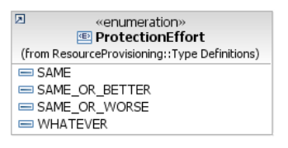 | element name="protectionEffort" type="com:ProtectionEffortType"  This attribute indicates the protection effort of the Connection. | bz: ProtectionEffort enumeration already defined in RP. This violates the rule that OM DDPs reference only Data DDPs.  Note: ProtectionRole has been defined in NRF and RP in MTOSI 2.1 already.
 | routingConstraintEffort : RoutingConstraintEffort = BEST_EFFORT  This attribute indicates the requested level of effort to meet the routing constraint when creating the Connection.  ++++++++++++++++++++  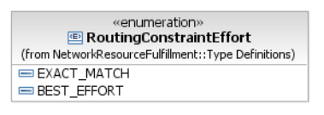This enumeration defines the degree to which the target OS must apply the routing constraints to the route of a Connection.  EXACT_MATCH  This value indicates that the route of the Connection must meet the routing constraints exactly.  BEST_EFFORT  This value indicates that the route of the Connection should try to match the routing constraints however it does not have to match exactly. | element name="routingConstraintEffort" type="xsd:string"  The effort required for routing constraint application.  Legal Values are:  - BEST_EFFORT  - EXACT_MATCH
 | connectionType : SubnetworkConnectionType = NA  This attribute identifies the external traffic flow through the connection. The Connection types are specified in the attached supporting document SNCTypes.  Notes:  For the top level Connection only SIMPLE will be used in this version.  ADD_DROP_A and ADD_DROP_Z are only for subordinate Connections in this version. | element name="sncType" type="com:SubnetworkConnectionTypeType"  Description tba
 | connectionSetupType : ConnectionType = PC  This attribute identifies the setup type of the Connection. It indicates whether the Connection has been established by UNI signalling (SC) or NMS operation (SPC, PC).  ++++++++++++++++++  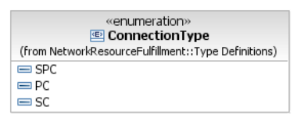  This enumeration defines the type of the Connection; i.e., how the Connection object was created.  SPC  This value indicates that the Connection is a Soft Permanent Connection (SPC); a Connection object that has been created either:  - as a side effect of establishCall(), or  - by the network, at E-NNI, as a side effect of establishCall() performed at another interface.  PC  This value indicates that the Connection is a Permanent Connection (PC); a Connection that has been created via establishCall() where there is no Control Plane.  SC  This value indicates that the Connection is a Switched Connection (SC); a Connection that has been created by the network, at UNI. | element name="connectionSetUpType" type="xsd:string"  This attribute indicates whether the connection has been established by UNI signalling (SC) or NMS (SPC, PC).  Legal values are:  - PC  - SC  - SPC>
element name="sncState" type="com:SubnetworkConnectionStateType"
This is the state of a SubnetworkConnection.
If this SNC represents a Control Plane connection, then this attribute is fixed to "SNCS_ACTIVE".
The target OS may operate in one of four modes, summarized below. See SD1-23 SNC Management Modes Of Operation.
  - No pending no sharing: The pending state is not supported. Conflicting SNCs are rejected on creation. Sharing of CCs amongst SNCs is not allowed, except for broadcast SNCs.
  - No pending with sharing: The pending state is not supported. Conflicting SNCs are rejected on creation. However, sharing of CCs amongst SNCs is allowed.
  - Pending no sharing: The pending state is supported. Conflicting SNCs and SNCs that share CCs are accepted on creation, however their activation is rejected. Sharing of CCs amongst SNCs is not allowed for partial and active SNCs, except for broadcast SNCs.
  - Pending with sharing: The pending state is supported. Conflicting SNCs are accepted on creation, however their activation is rejected. Sharing of CCs amongst SNCs is allowed.
The sncState is an attribute managed by the target OS. The target OS manages the state transition of this attribute. The target OS will assess the cross-connections in the network that support the SNC and will appropriately adjust the value of SNCState to reflect the actual state of the SNC in the network.

 | connectionState : ConnectionState = NA  This attribute represents the state of the Connection by indicating that either all (\"Complete\") or not all (\"Searching\") of the resources necessary to support the Connection have been successfully allocated yet.  +++++++++++++++++++  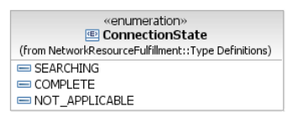  This enumeration defines the state values for a Connection object.  SEARCHING  This value indicates that NOT all the resources necessary to support the Connection have been successfully allocated.  This state may not be applicable in a non Control Plane environment.  COMPLETE  This value indicates that ALL resources necessary to support the Connection have been successfully allocated.  NOT_APPLICABLE  This value indicates that the Connection is used in a non Control Plane environment. | element name="connectionState" type="xsd:string"  Indicates that all (â€œCompleteâ€) or not all (â€œSearchingâ€) the resources necessary to support the connection have been successfully allocated yet.  Legal values are:  - Complete  - Searching  - N/A
 | revertive : Boolean = True  This attribute indicates whether the Connection shall always attempt to return to its home (intended) Route. | element name="revertive" type="xsd:boolean"  Takes value â€œTrueâ€, i.e. the SNC or Connection is revertive, when the SNC or connection can be switched back to its original route. In case of an SNC with multiple routes when the SNC is revertive, then the restoration or rerouting process will always switch to the intended route if possible, i.e. if there are no failures or if the intended route is not locked.
 | priority : Integer = 0  This attribute defines the priority of the Connection.  Allowed values are = "0" , "1" , "2" , ... where zero (0) is the highest priority. | element name="priority" type="xsd:unsignedInt"  The priority allows to prevent activating routes because of XC or CTP conflicts with equal or higher prior SNCs.  An SNC or a Connection in the Control Plane can pre-empt resources of another SNC of lower priority for restoration purposes.  Values: “0”, “1”, “2”, ... where “0” is the highest priority.
 | isReportingAlarms : Boolean = false  This attribute identifies whether alarm reporting for this Connection is administratively activated or de-activated.  True = alarm reporting is activated; False = alarm reporting is de-activated. | element name="isReportingAlarms" type="xsd:boolean"  This attribute identifies whether alarm reporting for this Connection is administratively activated or de-activated.  True = alarm reporting is activated; False = alarm reporting is de-activated.
 | asapRef : ObjectName = null  This attribute indicates the assignment of an Alarm Severity Assignment Profile (ASAP) to the Connection.  Writeable by the requesting OS only via assignASAP/deassignASAP operations. | element name="asapRef" type="xsd:string"  Indicates the assignment of an ASAP to this SNC object. Value is of the ASAP name.
 | routeGroupLabel : String = empty string  This attribute represents the Route Group the Connection is associated to. When a target OS creates a Call with diverse Route Groups, it assigns a Route Group label (which may be a number) to each Connection. Connections in the same Route Group will be assigned the same value for routeGroupLabel. Connections in different Route Groups will be assigned different values for routeGroupLabel. | element name="routeGroupLabel" type="xsd:string"  This attribute shall represent the route group of the connection.
 | isUsingHomeRoute : Boolean = NA  This attribute describes whether the Connection is currently using the home route. | element name="usingHomeRoute" type="xsd:boolean"  Indicates whether the connection is using the home route or not.
 | supportingSncRefList (SubnetworkConncetion) [*]  This relationship provides the names of the supporting Subnetwork Conncetions, if any. | element name="supportingSncList" type="xsd:string"  This attribute shall contain the names of the supporting Subnetwork Connections if any.  Note: This attribute is only applicable for top level connections in a non-Control Plane environment if SNCs support indirectly the Call.  Format:  \name=OS\value=CompanyName/EMSname\name=MLSN\value= SubnetworkName\name= SNC\value=SubnetworkName
 | callRef (Call)  This relationship provides the name of the associated Call, if any. | element name="callName" type="xsd:string"  This attribute indicates the Call Name which the connection is supporting in a non control plane case.  String containing the RDN of the Call Name.The value in the last name-value pair of name structure.
 | connectionParameterProfileRef (ConnectionParameterProfile)  This relationship provides the set of class of service related parameters that are associated with the Connection. | ?? | bz: Since this class does not have an identifier we may consider to model it as a data type.
AssociatedConnections
non navigable association between Connection and CrossConnect data type

ConnectionParameterProfile

BA | IA (ConnectionParameterProfile) | IIS covered by ?? | Comments
 | 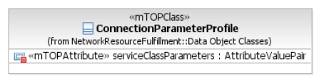  This object class defines a set of class of service related parameters that can be associated with a Connection. |  | bz: Since this class does not have an identifier we may consider to model it as a data type.
serviceClassParameters : Framework::Type Definitions::AttributeValuePair [*]
This attribute defines a sequence of name value pairs that can be used to define the class of service parameters and their values to be associated to a Connection.
Readable by NMS? No
Writeable by NMS? Yes
Invariant? Yes

Modified Object Classes

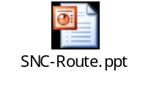

SubNetworkConnection

BA | IA (SubNetworkConnection) | IIS (SubnetworkConnectionType) | Comments
 | This object class represents the relationship between Termination Points.  All end point TPs related by an Subnetwork Connection (SNC) must support the same or an equivalent layer rate which is also the SNC's layer rate.  In pending state, generic Connection Termination Point(s) of the SNC could be replied.  Refer to the associated supporting document SD1-36_SNCTypes for explanation of SNC Properties, SNC Parameters, unidirectional SNCs, Point-to-Multipoint SNC, Routing Constraints and Route Discovery.  Traceability: R_TMF518_NRF_I_0024 and R_TMF518_NRF_I_0025.  For bundled SNCs Traceability: R_TMF518_NRF_I_0032. | This aggregate defines the Subnetwork Connection mTOP network resource object.  A subnetwork connection represents a connection between TPs (in any combination). It may also represent Network Connections between the G.805 TCP of any TP</p>.  This structure is also used to represent a Connection supporting a call in the Control Plane at any level of the routing area hierarchy. The Connection object represents the relationship between subnetwork points (SNP).  A connection may encompass a sequence of connections (referred to as connection segments although but not represented in this model) and thus create a recursive relationship across the routing hierarchy.  This object can represent a connection at the highest level of recursion (a top-level connection).  Note that a Call may have one or more parallel top-level connection(s).
 | state : SubnetworkConnectionState = NA  This attribute identifies the SNC connection state.  Traceability: R_TMF518_NRF_I_0028. | element name="sncState" type="com:SubnetworkConnectionStateType"  This is the state of a SubnetworkConnection.  If this SNC represents a Control Plane connection, then this attribute is fixed to "SNCS_ACTIVE".  The target OS may operate in one of four modes, summarized below. See SD1-23 SNC Management Modes Of Operation.  - No pending no sharing: The pending state is not supported. Conflicting SNCs are rejected on creation. Sharing of CCs amongst SNCs is not allowed, except for broadcast SNCs.  - No pending with sharing: The pending state is not supported. Conflicting SNCs are rejected on creation. However, sharing of CCs amongst SNCs is allowed.  - Pending no sharing: The pending state is supported. Conflicting SNCs and SNCs that share CCs are accepted on creation, however their activation is rejected. Sharing of CCs amongst SNCs is not allowed for partial and active SNCs, except for broadcast SNCs.  - Pending with sharing: The pending state is supported. Conflicting SNCs are accepted on creation, however their activation is rejected. Sharing of CCs amongst SNCs is allowed.  The sncState is an attribute managed by the target OS. The target OS manages the state transition of this attribute. The target OS will assess the cross-connections in the network that support the SNC and will appropriately adjust the value of SNCState to reflect the actual state of the SNC in the network.
 | direction : ConnectionDirection = NA  This attribute identifies the directionality of the SNC.  +++++++++++++++++++++ | element name="direction" type="com:ConnectionDirectionType"  This attribute specifies the directionality of the SNC/Connection.  +++++++++++++++++  simpleType name="ConnectionDirectionType"  Direction of a subnetwork connection, cross-connects, or topological link.  For a detailed description of the use of this attribute see SNC Types supporting document.  restriction base="xsd:string"  enumeration value="CD_UNI"  UNIdirectional, i.e. source TP to sink TP. Note: creation of unidirectional connections is supported even when CTPs/FTPs are modelled as bidirectional.  enumeration value="CD_BI"  BIidirectional, i.e. bidirectional TP to bidirectional TP, a.k.a. two-way.
 | layerRate : LayerRate = NA  This attribute identifies the layer rate of the SNC. It is specified by the requesting OS upon object creation.  Note: In case of a bundled SNC the value LR_Not_Applicable is used. The requesting OS can determine the layer rate by looking at the CTPs contained in the aEnd and zEnd GTPs. | element name="layerRate" type="lay:LayerRateType"  The rate of the SubnetworkConnection is obtained by reading this attribute. The target OS sets this attribute at creation of the SNC.  The target OS is allowed to choose a Layer Rate equivalent to that of one of the TPs/SNPs. The target OS is expected to reflect any equivalent layer rate in any connection retrievals (i.e. the connection rate of the SNC retrieved from the target OS does not have to be the same as that requested by the requesting OS so long as it is an equivalent rate).  For a detailed description of the use of this attribute see SD1-36 SNC Types.  This is a readonly attribute.
 | staticProtectionLevel : StaticProtectionLevel = NA  This attribute indicates the degree of internal resilience/protection of the SNC. | element name="staticProtectionLevel" type="com:StaticProtectionLevelType"  This attribute indicates the degree of internal resilience/protection of the SNC.
 | type : SubnetworkConnectionType = NA  This attribute indicates the external traffic flow through the SNC.  Traceability: R_TMF518_NRF_I_0029. | element name="sncType" type="com:SubnetworkConnectionTypeType"  This attribute indicates the external traffic flow through the SNC.
 | aEndTpDataList : TerminationPointData [*] = NA  This attribute lists all A End TP names together with their TP data (TP Mapping Mode, Transmission Parameters). | element name="aEndTpDataList" type="tpdata:TerminationPointDataListType"  The list of Aend termination points TP where this SNC terminates.  The TPname provides the name of the CTP/FTP/GTP in a non-control plane SNC.  In a control plane connection, this attribute shall represent the A-end of the Connection in the control plane name space, i.e., the value of this attribute shall identify an SNP or an SNPP. The optional TNA/FTP/CTP values are provided by aEndTpList and aEndTnaNameOrGroupTnaName attributes.  For a detailed description of the use of this attribute, see SD1-36 SNC Types supporting document.  This is a readonly attribute.
 | zEndTpDataList : TerminationPointData [*] = NA  This attribute lists all Z End TP names together with their TP data (TP Mapping Mode, Transmission Parameters). | element name="zEndTpDataList" type="tpdata:TerminationPointDataListType"  The list of Zend termination points TP where this SNC terminates. See aEndTpDataList.
 | rerouteAllowed : RerouteAllowed = NOT_APPLICABLE  This attribute specifies if the target OS/MEs are allowed and/or required to reroute this SNC if there is a failure on this SNC, periodically to optimize the routes, of for any other reason. It is a target OS/ME implementation whether this is done using network routing protocols or if the target OS/MEs detect the failure and take appropriate action to attempt to fix the SNC.  The NO value means that the target OS/MEs are not allowed to reroute the SNC.  The YES value means that the target OS/MEs are allowed to reroute the SNC and are required to attempt to reroute it upon failure.  The NA value is used when the requesting OS does not want to specify the exact target OS behaviour. In this case it is left up to the target OS to decide whether rerouting will be provided. It is also used if the target OS/MEs are allowed to reroute the SNC but not required to attempt to reroute it upon failure. | element name="rerouteAllowed" type="com:RerouteType"  This attribute indicates if the target OS/MEs/CP are allowed and/or required to reroute this SNC if there is a failure on this SNC, periodically to optimize the routes, of for any other reason. It is a target OS/ME/CP implementation whether this is done using network routing protocols or if the OS/MEs/CP detect the failure and take appropriate action to attempt to fix the SNC.
 | networkRouted : NetworkRouted = NOT_APPLICABLE  This attribute specifies if the route for this SNC is computed by the network.  If rerouting is allowed, this attribute tells who last rerouted the SNC, the network (YES) or the EMS (NO). | element name="networkRouted" type="com:NetworkRoutedType"  This attribute specifies if the route for this SNC is computed by the network.
 | networkReroute : Reroute = NOT_SET  This attribute indicates if the reroute (if allowed) should be computed by the network (YES), by the EMS (NO), or if it does not matter (NOT_SET). | element name="networkReroute" type="com:RerouteType"  Indicates if the reroute of an SNC (if allowed) should be computed by the network, by the target OS, or if it does not matter.
 | revertive : Boolean = false  This attribute defines if the SNC can be switched back to its original (intended) route.  In case the SNC is "revertive" (True), the restoration process will always switch to the intended route if possible, i.e. if there are no failures or if the intended route is not locked. | element name="revertive" type="xsd:boolean"  Takes value â€œTrueâ€, i.e. the SNC or Connection is revertive, when the SNC or connection can be switched back to its original route. In case of an SNC with multiple routes when the SNC is revertive, then the restoration or rerouting process will always switch to the intended route if possible, i.e. if there are no failures or if the intended route is not locked.
 | isReportingAlarms : Boolean = false  This attribute identifies whether alarm reporting for this subnetwork connection is administratively activated or de-activated.  True = alarm reporting is activated; False = alarm reporting is de-activated. | element name="isReportingAlarms" type="xsd:boolean"  This attribute identifies whether alarm reporting is administratively activated or de-activated.  True = alarm reporting is activated; False = alarm reporting is de-activated.
 | correlationIdentifier : String = empty string  This attribute contains information about relationships that this subnetwork connection may have to other objects. | element name="correlationIdentifier" type="xsd:string"  Used to contain information about relationships that this SNC may have to other managed objects.
 | isBundledSnc : Boolean = false  This attribute indicates if the SNC is a bundled SNC. | element name="isBundledSnc" type="xsd:boolean"  Indicates whether the SNC constitutes a Bundled SNC service (value â€œTrueâ€) or not..
 | priority : Integer = 0  This attribute identifies the priority of the SNC.  Allowed values are = "0" , "1" , "2" , ... where zero (0) is the highest priority. | element name="priority" type="xsd:unsignedInt"  The priority allows to prevent activating routes because of XC or CTP conflicts with equal or higher prior SNCs.  An SNC or a Connection in the Control Plane can pre-empt resources of another SNC of lower priority for restoration purposes.  Values: “0”, “1”, “2”, ... where “0” is the highest priority.
 | mustRemoveGtps : Boolean = true  This attribute defines that the target OS has to delete all the interior GTPs supporting the bundled SNC when the SNC is deleted. It is only used for bundled SNCs.  It can take on two possible values:  - TRUE (the target OS must make a best-effort attempt to remove the interior GTPs that once belonged to the SNC) and  - FALSE (the requesting OS doesn't care if the target OS removes the interior GTPs or not).  In the case that mustRemoveGTPs is set to "TRUE" and the target OS cannot remove all the interior GTPs, the target OS should return a list of the GTPs that could not be removed in the errorReason field of the deactivateAndDeleteSNC and deleteSNC operations. The errorReason will be "not all interior GTPs could be deleted" - this will be followed by the names of the GTPs that could not be deleted. | element name="isMustRemoveGtpList" type="xsd:boolean" nillable="true" minOccurs="0"  The parameter is only used for bundled SNCs.  If set to â€œTrueâ€ the EMS when removing the SNC must make a best-effort attempt to remove the interior GTPs that once belonged to the SNC, and if set to â€œFalseâ€ the NMS does not care whether the EMS removes the interior GTPs or not.  Any behavior other than best-effort is likely to involve a complicated rollback procedure for the EMS and NEs. In the case that the parameter is set to â€œTrueâ€ and the EMS cannot remove all the interior GTPs, the EMS should return a list of the GTPs that could not be removed in the errorReason field of the deactivateAndDeleteSNC() and deleteSNC() operations. The errorReason would  be â€œnot all interior GTPs could be deletedâ€; this would be followed by the names of the GTPs that could not be deleted.
 | isFixed : Boolean = NA  This attribute identifies if the SubnetworkConnection is fixed (i.e. cannot be deleted by the requestig OS).  A fixed SNC is defined a SNC whose all cross connects are fixed. | element name="isFixed" type="xsd:boolean"  Takes value True when all cross-connects of the SNC are fixed.
 | mustRetainOldSnc : Boolean = true  This attribute identifies if an original route of the SNC is maintained and that it is possible to swap back this route. | <xsd:element name="mustRetainOldSnc" type="xsd:boolean" default="true" minOccurs="0"/>  This attribute identifies if an original route of the SNC is maintained and that it is possible to swap back this route. | bz: Contained in MTOSI 2.1 but not in CP version of MTOSI 3.0.
 | aEndPointsRole : EndPointRole [*] = NA  This attribute indicates the end point role of the aEndTPs of the SNC.  At a connection matrix (CM) end point the span of the SNC starts at a G.805 CP with a fixed or flexible connection through the ME at the SNC layer, i.e. the connectable layer of the end point. At a link connection (LC) end point connectivity is adapted from a server layer and the span of the SNC starts with a G.805 TCP.  Traceability: R_TMF518_NRF_I_0026.  +++++++++++++++++++++++  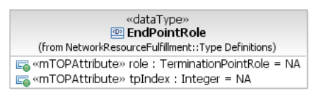  This data type indicates the end point role of an end TP.  Traceability: R_TMF518_NRF_I_0026.  role : TerminationPointRole = NA  This attribute indicates the role of the end TP specified by the tpIndex.  tpIndex : Integer = NA  This attribute indicates the index of the end TP within the end list. | element name="aEndPointsRole"  Defines the element that defines the end point role of all aEnd TPs of an SNC. This is an ordered list indexed with the aEnd TP list of the SNC.  <xsd:sequence>  element name="role" type="com:EndPointRoleType"  ++++++++++++++++++++++  complexType name="EndPointRoleType"  This data type indicates the end point role of an end TP.</p>  <p>See R_TMF518_NRF_I_0026.  element name="role" type="tns:TerminationPointRole"  This attribute indicates the role of the end TP specified by the tpIndex.  element name="tpIndex" type="xsd:unsignedInt"  This attribute indicates the index of the end TP within the end list.
 | zEndPointsRole : EndPointRole [*] = NA  This attribute indicates the end point role of the zEndTPs of the SNC.  At a connection matrix (CM) end point the span of the SNC starts at a G.805 CP with a fixed or flexible connection through the ME at the SNC layer, i.e. the connectable layer of the end point. At a link connection (LC) end point connectivity is adapted from a server layer and the span of the SNC starts with a G.805 TCP.  Traceability: R_TMF518_NRF_I_0026.  +++++++++++++++++++++++  This data type indicates the end point role of an end TP.  Traceability: R_TMF518_NRF_I_0026.  role : TerminationPointRole = NA  This attribute indicates the role of the end TP specified by the tpIndex.  tpIndex : Integer = NA  This attribute indicates the index of the end TP within the end list. | element name="zEndPointsRole"  Defines the element that defines the end point role of all zEnd TPs of an SNC. This is an ordered list indexed with the zEnd TP list of the SNC.  <xsd:sequence>  element name="role" type="com:EndPointRoleType"  ++++++++++++++++++++++  complexType name="EndPointRoleType"  This data type indicates the end point role of an end TP.</p>  <p>See R_TMF518_NRF_I_0026.  element name="role" type="tns:TerminationPointRole"  This attribute indicates the role of the end TP specified by the tpIndex.  element name="tpIndex" type="xsd:unsignedInt"  This attribute indicates the index of the end TP within the end list.
 | routeGroupLabel : String = empty string  This attribute represents the Route Group the Subnetwork Connection is associated to. When a target OS creates a Call with diverse Route Groups, it assigns a Route Group label (which may be a number) to each SNC. SNCs in the same Route Group will be assigned the same value for routeGroupLabel. SNCs in different Route Groups will be assigned different values for routeGroupLabel. | element name="routeGroupLabel" type="xsd:string"  This attribute shall represent the route group of the connection.
 | asapRef : ObjectName = null  This attribute indicates the assignment of an Alarm Severity Assignment Profile (ASAP) to the Subnetwork Connection. | element name="asapRef" type="xsd:string"  Indicates the assignment of an ASAP to this SNC object. Value is of the ASAP name.
 | ituArcStateAndStatusList : ItuArcStateAndStatusList [0..1]  Traceability: R_TMF518_NRB_I_0001 and R_TMF518_NRB_I_0004.  See supporting document SD1-8_encodingX731M3100. | <xsd:element name="ituArcStateAndStatusList" type="ituArc:ItuArcStateAndStatusList"/> | bz: Contained in MTOSI 2.1 but not in CP version of MTOSI 3.0.
 |  | element name="aEndTpList" type="xsd:string"  </xsd:string" nillable="true" minOccurs="0">  String representing a sequence of name-value pairs. The backslash (â€œ\â€) character is used as separator.  Format: \name=OS\value=CompanyName/OSname\name=ME\value=ManagedElementName\name=PTP\value=PTPName\name=CTP\value=CTPName E.g.: \name=OS\value=BigCompany/SmallEMS\name=ME\value=YellowManagedElement\name=PTP\value=BluePTP\name=CTP\value=RedCTP | bz: May have been deleted in MTOSI 2.1.
 |  | element name="aEndTnaNameOrGroupTnaName" type="xsd:string"  Represent the TNA or Group-TNA of the Connection. A TNA Name List may have 3 value pairs.  Format: \name=TNAName\value=TNANameValue\name=LogicalPortId\value=LogicalPortIdValue\name= Index\value=IndexValue. | bz: For Connection only?
 |  | element name="zEndTpList" type="xsd:string"  Ssee aEndTpList. | bz: May have been deleted in MTOSI 2.1.
 |  | element name="zEndTnaNameOrGroupTnaName" type="xsd:string"  Ssee aEndTNANameOrGroupTNAName. | bz: For Connection only?
 |  | element name="srg" type="xsd:string"  E.g.:/bridge=123,456/duct=12,34 or /block=123/room=56,78,99.  Complex string, slash is used as separator. | bz: ??
 |  | element name="usingHomeRoute" type="xsd:boolean"  Indicates whether the connection is using the home route or not. | bz: For Connection only.

Cross Connect

BA | IA (CrossConnect) data type | IIS (CrossConnectType) | Comments
 | aEndTpRefList (ConnectionTerminationPoint) [*]  This relationship contains the the Z end TP names.  If the cross connection represents a Control Plane (Routing Node) connection, the end points are the SNPs. | element name="aEndRefList"  complexType  sequence  element name="aEndName" type="nrb.nam:NamingAttributeType"  Names of PTPs/CTPs/FTPs at the aEnd of the cross connection.  If the cross connection represents a Control Plane (Routing Node) connection, the end points are the SNPs. | bz: Do we also have to enhance the description of the aEndGtpRefList?
 | zEndTpRefList (ConnectionTerminationPoint) [*]  If the cross connection represents a Control Plane (Routing Node) connection, the end points are the SNPs. | element name="zEndRefList"  complexType  sequence  element name="zEndName" type="nrb.nam:NamingAttributeType"  Names of PTPs/CTPs/FTPs at the zEnd of the cross connection.  If the cross connection represents an Routing Node connection, then end points are the SNPs. | bz: Do we also have to enhance the description of the zEndGtpRefList?

Route

BA | IA (Route) | IIS (RouteType) | Comments
 | This object class represents a partially ordered list of Cross-Connects defining the route for a Subnetwork Connection.  Traceability: R_TMF518_NRF_I_0035 and R_TMF518_NRF_I_0036. | A route for an SNC is defined as a partially ordered list of cross-connects.  This structure can deal with any arbitrarily complex protection paths made up from connection types described in SD1-36 SNC Types.  The cross-connects are listed from the NE on which the SNC starts (first entry) to the NE on which the SNC ends (last entry). There is no mandatory order in the cross-connects listed in between the first one and the last one.

Route Descriptor

BA | IA (Route) | IIS (RouteDescriptorType) | Comments
 |  |  | bz: IA Route is described wrt SNC; should it be enhanced for Connection?
 | crossConnectList (CrossConnect) [*]  This attribute represents a route for a Subnetwork Connection. The Cross-Connects are listed from the NE on which the SNC starts (first entry) to the NE on which the SNC ends (last entry) and the aEnd(G)TpList and zEnd(G)TpList will name CTPs of the same or equivalent layer rate only. | element name="routeCcList" type="route:RouteType"  The partially ordered list of cross-connects that forms the route.

New Data Types

CallState Type

BA | IA (CallState) | IIS (CallStateType) | Comments
 | 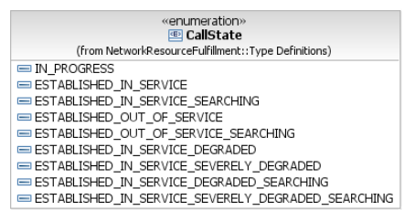 This enumeration defines the state values for a Call object.  Note: Values 0, 2, 4, 7, and 8 may not be applicable in a non Control Plane environment.  - "IN_PROGRESS": This value indicates that the supporting Connection objects of the Call object are currently being created.  - "ESTABLISHED_IN_SERVICE": This value indicates that all the supporting Connection objects of the Call object have been successfully created.  - "ESTABLISHED_IN_SERVICE_SEARCHING": This value indicates that the Call object has been modified through the addition of Connection objects and that not all the new Connection objects have been successfully created.  - "ESTABLISHED_OUT_OF_SERVICE": This value indicates that all the Connection objects in the Call object have failed and they are NOT being restored.  - "ESTABLISHED_OUT_OF_SERVICE_SEARCHING": This value indicates that all the Connection objects in the Call object have failed and they are being restored.  - "ESTABLISHED_IN_SERVICE_DEGRADED": This value indicates that the number of failed Connection objects has reached or exceeded the degraded threshold AND the severely degraded threshold has not been reached or exceeded for the Call object.  - "ESTABLISHED_IN_SERVICE_SEVERELY_DEGRADED": The value of failed supporting Connections has reached or exceeded the severely degraded threshold (in case of LCAS support).  - "ESTABLISHED_IN_SERVICE_DEGRADED_SEARCHING": This value indicates that at least one supporting Connection object has failed (in the case of LCAS support) AND the severely degraded threshold has not been reached or exceeded for the Call object.  The failed Connections are being restored.  - "ESTABLISHED_IN_SERVICE_SEVERELY_DEGRADED_SEARCHING": This value indicates that the number of failed supporting Connection objects has reached or exceeded the severely degraded threshold (in case of LCAS support) for the Call object.  The failed Connections are being restored. | The call state has dependency upon the state of the associated connections. This dependency is related to call type and policy.  See SD1-35_StateDiagrams for details on valid transitions.  The state values are:  - "IN_PROGRESS": The supporting Connections are currently being created. May not be valid for non Control Plane calls.  - "ESTABLISHED_IN_SERVICE": All the supporting Connections have been created successfully.  - "ESTABLISHED_IN_SERVICE_SEARCHING": A Call has been modified through the addition of Connections and not all new Connections have been successfully created. May not be valid for non Control Plane calls.  - "ESTABLISHED_OUT_OF_SERVICE": All Connections have failed and they are not being restored.  - "ESTABLISHED_OUT_OF_SERVICE_SEARCHING": All Connections have failed and they are currently being restored. May not be valid for non Control Plane calls.  - "ESTABLISHED_IN_SERVICE_DEGRADED": The number of failed connections has reached or exceeded the degraded threshold AND the severely degraded threshold has not been reached or exceeded.  - "ESTABLISHED_IN_SERVICE_SEVERELY_DEGRADED": The number of failed supporting Connections has reached or exceeded the severely degraded threshold (in case of LCAS support).  - "ESTABLISHED_IN_SERVICE_DEGRADED_SEARCHING": At least one supporting Connection has failed (in the case of LCAS support) AND the severely degraded threshold has not been reached or exceeded. The failed Connections are being restored. May not be valid for non Control Plane calls.  - "ESTABLISHED_IN_SERVICE_SEVERELY_DEGRADED_SEARCHING": The number of failed supporting Connections has reached or exceeded the severely degraded threshold (in case of LCAS support). The failed Connections are being restored. May not be valid for non Control Plane calls. | bz: Enumeration in IA and String in IIS.

EndPointType Type

BA | IA (EndPointType) | IIS (CallEndType) | Comments
 | 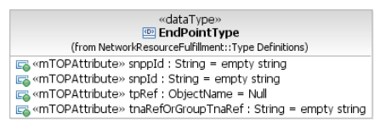  This data type defines the various ends of a Call or Connection. It has the following fields:  - SNPP  - SNP  - CPTP/FTP/CTP/PTP  - TNA Name (which identifies either a TNA or a Group-TNA Name). | This structure provides the names of one call end. The value of this attribute is in one or more of the included fieds.
 | tnaRefOrGroupTnaRef (String) = empty string  This attribute contains either a TNA or a Group-TNA Name for a Call/Connection end.  It is possible to specify here any depth of substructure (e.g. logical port identifier index). | element name="tNANameOrGroupTNAName" type="tns:TNANameType"  This attribute provides either a TNA or a Group-TNA Name for the call end.  It is possible to specify to any depth of substructure (e.g. logical port identifier, index).  ++++++++++++++++++++++++++++  TNANameType  This represents the TNA Name.  It is an opaque logical name that does not reflect the network structure that may be published externally to the network.  The value maybe substructured, it may include a sequence of TNA Name, TNA Logical Port Identifier and Index, however there is no constraints placed on the structure by the interface definition.  restriction base="xsd:string"
 | snppId (String) = empty string  This attribute contains the identifier of the SNPP ending a Call/Connection. | element name="sNPPid" type="xsd:string"  The control plane identifier of the SNPP at the end of the call.
 | snpId (String) = empty string  This attribute contains the identifier of the SNP ending a Call/Connection. | element name="sNPid" type="xsd:string"  The control plane identifier of the SNP at the end of the call.
 | tpRef (ObjectName) = Null  This attribute contains the name of the TP ending a Call/Connection. One of the end TPs of the Call can be an \"off-network\" TP (i.e., outside the target OS domain and therefore addressed by a remote address). If this happens in a Control Plane environment, an abstract name may be used that could be equated to the TNA. | element name="tpName" type="nam:NamingAttributeType"  This attribute represents the name of the TP at the end of the call.  One of the end TPs of the Call can be an "off-network" TP (i.e., outside the target OS domain and therefore addressed by a remote address.  See SD1-25 Object Naming for further detail.

CallParameterProfile Type

BA | IA (CallParameterProfile) | IIS (CallParameterProfileType) | Comments
 | 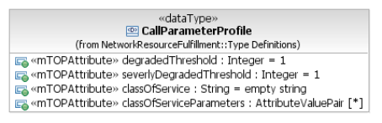  This data type includes the parameters of the Call. It includes conditions and qualifiers to support a class of service for the Call (e.g., qualifiers that describe LCAS based services). | This structure includes parameters of the Call. It includes conditions and qualifiers to support a class of service for the call.  (E.g. qualifiers that describe LCAS based services).
 | degradedThreshold : Integer = 1  Indicates the threshold (number of working VCAT legs) that qualifies the Call as degraded. | element name="degradedTreshold" type="xsd:string"  Indicates the threshold that qualifies the call as degraded in a VCAT environment.  Default Value is "1".
 | severlyDegradedThreshold : Integer = 1  Indicates the threshold (number of working VCAT legs) that qualifies the Call as severely degraded. | element name="severelyDegradedThreshold" type="xsd:string"  Indicates the threshold that qualifies the call as severely degraded in a VCAT environment.  Default Value is "1".
 | classOfService : String = empty string  Indicates the \"Class of Service\" of the Call.  This parameter applies only to an established Call and shall be ignored during Call creation in a VCAT environment. | element name="classOfService" type="xsd:string"  The class of service of the Call.
 | classOfServiceParameters : Framework::Type Definitions::AttributeValuePair [*]  Contains the \"Class of Service\" specific parameters.  They are only relevant to an established Call and shall be ignored during Call creation in a VCAT environment. | element name="classOfServiceParameters" type="gen:NameAndValueStringListType"  Includes parameters specific to Class of Service.

DiversityData Type

BA | IA (DiversityData) | IIS (DiversityType) | Comments
 | 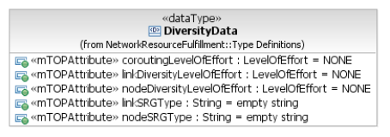  This data type provides the diversity information for one Call and its supporting connections using the following diversity related parameters:  - coroutingLevelOfEffort  - nodeDiversityLevelOfEffort  - linkDiversityLevelOfEffort  - nodeSRGType  - linkSRGType. | This structure provides the diversity information for one call and its supporting connections.  The diversity and co-routing parameter set includes a route group label for each Connection supporting a Call).  Please see SD1-45_ASONControlPlaneManagement-Primer for further detail on diversity use.
 | coroutingLevelOfEffort : LevelOfEffort = NONE  This attribute represents (or defines) whether the top-level Connections / Subnetwork Connections in a Route Group are (or shall be) co-routed or not.  This applies within all Route Groups of the Call.  If the value is \"None\" then there is no co-routing requirement in any of the Route Group.  ++++++++++++++++++++  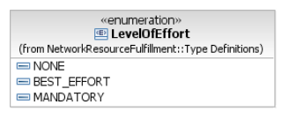  NONE  This attribute indicates that there is no level of effort.  BEST_EFFORT  This attribute indicates that the level of effort is best-effort.  MANDATORY  This attribute indicates that the level of effort is mandatory. | element name="coroutingLevelOfEffort" type="tns:LevelOfEffortType"  This parameter shall represent whether the connections in a route group are co-routed or not.  This applies within all route groups of the call.  If the value is "None" then there is no co-routing requirement in any of the route group.  ++++++++++++++++++++  <xsd:simpleType name="LevelOfEffortType">  The following degrees of effort are defined:  - "NONE"  - "BEST_EFFORT"  - "MANDATORY"  <xsd:restriction base="xsd:string"> | ++++++++++++++++++++  bz: Enumeration in IA and String in IIS.
 | linkDiversityLevelOfEffort : LevelOfEffort = NONE  This attribute represents (or defines) whether the Route Groups in a Call are (or shall be) link diversely routed or not.  If the value is \"None\" there is no link diversity requirement for the Call. | element name="linkDiversityLevelOfEffort" type="tns:LevelOfEffortType"  This parameter indicates the degree to which the connections in any route group are required to be link diverse from the connections in all other route groups of the call.  If the value is "None" there is no link diversity requirement for the call.
 | nodeDiversityLevelOfEffort : LevelOfEffort = NONE  This attribute represents (or defines) whether the Route Groups in a Call are (or shall be) node diversely routed or not.  If the value is \"None\" there is no node diversity requirement for the Call. | element name="nodeDiversityLevelOfEffort" type="tns:LevelOfEffortType"  This parameter indicates the degree to which the connections in any route group are required to be node diverse from the connections in all other route groups of the call.  If the value is "None" there is no node diversity requirement for the call.
 | linkSrgType : String = empty string  This attribute represents (or defines) the Shared Risk Group Type used (or to be used) for link diversity.  Note: If the \"Link Diversity Level of Effort\" attribute specifies link diversity (i.e., Best Effort or Mandatory), but no value is specified for this attribute, then basic link diversity is followed, i.e., the Call is routed by using separate Links, and no other link-related risk types, (e.g., duct, bridge, etc.) will be used.  See attached supporting document SD1-45_ASONControlPlaneManagement-Primer.pdf for further detail on diversity use. | element name="linkSRGType" type="xsd:string"  This attribute represents the risk type to be used for Link diversity.  Note that risk type is defined for the Additional info attribute "SRG".  See SD1-1 Additional Info Usage for further information on the format and usage.  If linkDiversityLevelOfEffort is not set to "None" but no value is specified for the linkSRGType, then the requirement is to route the call simply using separate SNPPLinks/TopologicalLinks.
 | nodeSrgType : String = empty string  This attribute represents (or defines) the Shared Risk Group Type used (or to be used) for node diversity.  Note: If the \"Node Diversity Level of Effort\" attribute specifies node diversity (i.e., Best effort or Mandatory), but no value is specified for this attribute, then basic node diversity is followed, i.e., the call is routed by using separate nodes, and no other node-related risk types (e.g., building, floor, etc.) will be used. | element name="nodeSRGType" type="xsd:string"  This attribute represents the risk type to be used for Node diversity.  Note that risk type is defined for the Additional info attribute "SRG".  See SD1-1 Additional Info Usage for further information on the format and usage.  If nodeDiversityLevelOfEffort is not set to "None" but no value is specified for the nodeSRGType, then the requirement is to route the call simply using separate routingNodes/MEs.

DiversityViolations Type

BA | IA (DiversityViolations) | IIS | Comments
 | This data type defines the diversity violation related parameters.

DiversityInfo Type

BA | IA (DiversityInfo) | IIS (DiversityInfoType) | Comments
 | 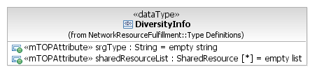  This data type provides the information on the diversity that was partially achieved or the diversity violations produced during Call restoration in failure events. | This structure provides the information on the diversity that was partially achieved or the diversity violations produced during call restoration in failure events
 | srgType : String = empty string  This attribute contains the type of Shared Risk Group (SRG) causing a diversity violation or where diversity is only partially achieved. | element name="sRGType" type="xsd:string"  The SRG Type where a violation is or the sRGType value of the diversity partially achieved. Default Value is Empty String.
 | sharedResourceList : SharedResource [*] = empty list  This attribute contains the optional list of resources causing a diversity violation or where diversity is only partially achieved.  +++++++++++++++++++  +++++++++++++++++++  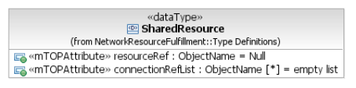  This data type provides the list of Connection names that share a resource (link or node).  resourceRef : ObjectName = Null  This attribute contains the name of the node or the link being shared.  connectionRefList : ObjectName [*] = empty list  This attribute contains the list of Connection/SubnetworkConnection objects sharing a link or a node. | element name="sharedResourceList" type="tns:SharedResourceListType"  May be an empty sequence according to target OS capability. Default value is an empty list.  +++++++++++++++++++  complexType name="SharedResourceListType"  A list of the resources being shared by a list of connections.  >xsd:sequence>  element name="sharedResourceType" type="tns:SharedResourceType"  +++++++++++++++++++  complexType name="SharedResourceType">  This structure provides the list of connection/SNC names that share a resource (link or node).</p>  element name="name" type="nam:NamingAttributeType"  The name of the node or the link being shared.  element name="connectionNameList" type="nam:NamingAttributeListType"  The list of connections sharing a link or a node. This list may be empty according to target OS capability.  Default value is an empty list.

LayeredSnpp Type

BA | IA (LayeredSnpp) | IIS (LayeredSNPPType) | Comments
 | 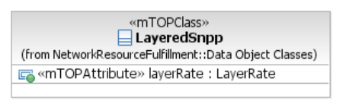This object class represents a layered Subnetwork Point Pool (SNPP). A LayeredSnpp consists of a layer rate and the SNPP objects at that layer. | This structure provides a layerRate and the list of SNPPs at the particular layer rate.
 | layerRate : LayerRate = NA  This attribute represents the layer rate of the SNPP. | element name="layerRate" type="lay:LayerRateType"
 | snppList (Snpp) [*]  This relationship represents the SNPP objects that are part of the LayeredSnpp object. | element name="sNPPListType" type="tns:SNPPListType"  +++++++++++++++  xsd:complexType name="SNPPListType"  It is a list of the SNPPs across the levels of routing hierarchy. This shall always include the details for the SNPPs in the relevant layer directly represented by the MLSNPP and may also include details for the subordinate SNPPs if the information is available to the target OS. The routing level is identified via the Routing Area IDs.  +++++++++++++++++  xsd:sequence  element name="sNPPType" type="tns:SNPPType"

Snpp Type

BA | IA (Snpp) | IIS (SNPPType) | Comments
 | 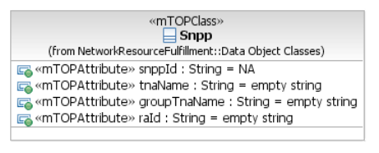  This object class represents the Subnetwork Point Pool (SNPP) object. An SNPP object consists of an identifier, a set of alternative identifiers (i.e. TNA, Group TNA), an identifier for the Routing Area (in which the SNPP is defined) and a set of SNP objects. | This structure provides a SNPP control plane identifier and the list of the SNPs contained.  The Subnetwork Point Pool (SNPP) is a set of subnetwork points (SNPs) with common attributes which are grouped together for the purposes of routing.
 | snppId : String = NA  This attribute shall represent the unique identifier for the SNPP. | element name="sNPPId" type="xsd:string"  It represents the control plane identifier of the SNPP.  Each SNPP at each routing level may be identified by the control plane following a hierarchical partition.  In addition, an SNPP at a higher level may represent more than one SNPP at a lower hierarchical level.
 | snpList (Snp) [*]  This relationship represents the set of SNP objects that are contained in the SNPP object.  +++++++++++++++++  +++++++++++++++++  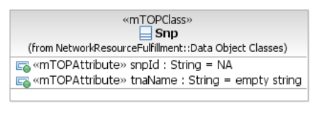  This object class represents the Subnetwork Point (SNP) object. An SNP object is a Control Plane representation of a Management Plane resource (the CTP). It consists of an identifier, an alternative identifier (i.e. TNA) and the name of CTP that it represents.  snpId : String = NA  This attribute represents the unique identifier for the SNP.  tpRef (ConnectionTerminatioPoint)  This relationship represents the name of the CTP.  tnaName : String = empty string  This attribute defines the TNA identifier for the SNP object. | element name="sNPList" type="tns:SNPListType"  It provides the list of SNPs contained in the SNPP, if the detailed knowledge of Control Plane resources is available (and requested).  +++++++++++++++++  xsd:complexType name="SNPListType"  It is a list of the SNPs.  xsd:sequence  element name="sNPType" type="tns:SNPType"  +++++++++++++++++  xsd:complexType name="SNPType"  An SNP is an abstraction that represents an actual or potential underlying TP (CTP/PTP/FTP representing a CP or TCP).  Several SNPs (in different sub-network partitions or Routing Areas) may represent the same TP.  See SD1-18 layers (Functional Modelling Concepts) for further detail on TP modelling and SD1-45_ASONControlPlaneManagement-Primer for further details on SNP to TP relationships.  A SNP is modeled as a data structure which is used to encapsulate details of the SNP and TP to reduce the number of objects across the interface.  The SNP structure provides the names that identifies the SNP. The names may contain information on attributes, e.g. directionality is implicit in the TP name.  element name="sNPId" type="xsd:string"  The control plane identifier of the SNP. It is a readonly attribute.  element name="tPName" type="nam:NamingAttributeType"  It represents the name of the TP associated with SNP.  element name="tNAName" type="tns:TNANameType"  The TNA name assigned to the SNP. This string may include the TNA Name, TNA Logical Port Identifier and TNA Index.
 | tnaName : String = empty string  This attribute defines the TNA identifier for the SNPP object. | element name="tNAName" type="tns:TNANameType"  The TNA name assigned to the SNPP.  ++++++++++++++++++  xsd:simpleType name="TNANameType"  This represents the TNA Name.  It is an opaque logical name that does not reflect the network structure that may be published externally to the network.  The value maybe substructured, it may include a sequence of TNA Name, TNA Logical Port Identifier and Index, however there is no constraints placed on the structure by the interface definition.  xsd:restriction base="xsd:string"
 | groupTnaName : String = empty string  This attribute defines the group TNA identifier for the SNPP object. | element name="groupTNAName" type="tns:TNANameType"  The TNA group name associated to the SNPP.  ++++++++++++++++++  xsd:simpleType name="TNANameType"  see above
 | raId : String = empty string  This attribute defines the Routing Area (RA) identifier for the RA in which the SNPP object exists. | element name="rAId" type="xsd:string"  It identifies the Routing Area with which the SNPP is associated.  ++++++++++++++++++  xsd:simpleType name="TNANameType"  see above

LayeredSnppLink Type

BA | IA (LayeredSnppLink) | IIS (LayeredSNPPLinkType) | Comments
 | 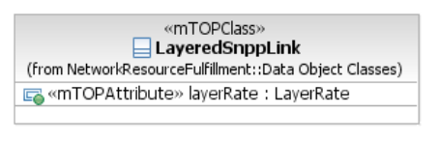This object class represents a layered Subnetwork Point Pool (SNPP) link. A LayeredSnppLink consists of a layer rate and the SnppLink objects at that layer. | This structure provides a layerRate and the list of SNPPLinks at the particular layer rate.
 | layerRate : LayerRate = NA  This attribute represents the layer rate of the LayeredSnppLink. | element name="layerRate" type="lay:LayerRateType"
 | snppLinkList (SnppLink) [*]  This relationship identifies the SnppLink objects that are part of the LayeredSnppLink object. | element name="sNPPLinkList" type="tns:SNPPLinkListType"  +++++++++++++++++  complexType name="SNPPLinkListType"  It is a list of the SNPP Links across the levels of routing hierarchy.  This shall always include the details for the SNPP Links in the relevant layer directly represented by the MLSNPPLink and may also include details for the subordinate SNPP Links if the information is available to the target OS.  The routing level is identified via the Routing Area IDs of end SNPPs.  xsd:sequence  element name="sNPPLinkType" type="tns:SNPPLinkType"

SnppLink Type

BA | IA (SnppLink) | IIS (SNPPLinkType) | Comments
 | 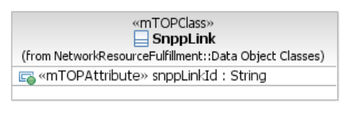  The object class interconnects a pair of SNPPs in different Routing Areas that are part of the same layer network. | The SNPP Link interconnects a pair of SNPPs in different subnetworks that are part of the same layer network.
 | snppLinkId : String = empty string  This attribute represents the unique identifier for the SnppLink. | element name="sNPPLinkId" type="xsd:string"  This is the Control Plane identifier for the SNPPLink.
 | aEnd (Snpp)  This relationship identifies the Snpp object which originates the SnppLink object. | element name="aEnd" type="tns:SNPPType"  It identifies the SNPP of type CP which originates the link.
 | zEnd (Snpp)  This relationship identifies the Snpp object which terminates the SnppLink object. | element name="zEnd" type="tns:SNPPType"  It identifies the SNPP of type CP which terminates the link.

LayeredRoutingArea Type

BA | IA (LayeredRoutingArea) | IIS | Comments
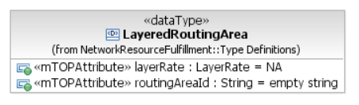
This data type defines a Routing Area and its corresponding layer rate.

layerRate : LayerRate = NA
This attribute defines the layer rate.

routingAreaId : String = empty string
This attribute contains the identifier for the Routing Area (RA).

Modified Data Types

TerminationPointData Type

BA () | IA (TerminationPointData) | IDL (TerminationPointDataType) | Comments
 | 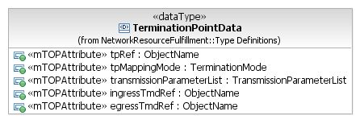  This data type identifies a Termination Point with associated parameters and their values.  Traceability: R_TMF518_RP_II_0008. | This aggregate defines a set of attributes associated with a TP.  In a control plane connection the TP Data Structure provides the information of the the SNP.
 | tpRef : ObjectName = NA  This attribute contains the Termination Point name to which the transmission parameters apply to. | element name="tpRef" type="nam:NamingAttributeType"  The name of the termination point to which this data applies. The termination point name must be explicit (a generic endpoint specification may not be used in this case).
 | tpMappingMode : TerminationMode = NOT_APPLICABLE  This attribute indicates if the Termination Point is to be configured such that it is capable of supporting lower rate connections or is capable of supporting connections at the CTP's layer rate. | element name="tpMappingMode" type="com:TerminationModeType"  The mapping mode to put the TP in. In the context of a control plane connection, the value of this attribute shall be ignored.
 | transmissionParameterList : TransmissionParameterList [1..*] = empty list  This attribute contains the layered Transmission Parameters associated with the Termination Point.  Refer to the attached supporting document SD1-16_LayeredParameters for details of the currently defined Transmission Parameters. | element ref="lp:transmissionParametersList"  This attribute contains the layered Transmission Parameters associated with the Termination Point.</p>  <p>Refer to the attached supporting document SD1-16_LayeredParameters for details of the currently defined Transmission Parameters.  When used as input to the target OS, this is a "delta" list that needs to be applied to the specified TP. Only a subset of the parameters may be specified in the list, and only those should be applied, typically in the NE..  Note that this could be used to convey the pointer to the alarm severity assignment profile during SNC creation/activation.  If the list is empty then this means do nothing. To remove a parameter from the list, "-" should be specified in the value part of the structure.  When a BLSR connection is created, the SPRING_NodeId parameter should be provided for the aEnd and zEnd CTPs/FTPs.
 | ingressTmdRef : ObjectName = null  This attribute indicates the name of the ingress Traffic Descriptor or Transmission Descriptor that supports this CTP.  May be empty if the CTP is involved in a uni-directional connection. | element name="ingressTmdRef" type="nam:NamingAttributeType"  A connection termination point may have an optional reference to an ingress (incoming)Transmission Descriptor. The Descriptor name will be empty if there is no associated Descriptor.  It is expected that Traffic Descriptors and Transmission Descriptors are not mixed on a single TP. Therefore if the Ingress Descriptor name is that of a Traffic Descriptor then the Egress Descriptor name should either be that of a Traffic Descriptor or a null value.  Likewise the other case for Transmission Descriptor.
 | egressTmdRef : ObjectName = null  This attribute indicates the name of the egress Traffic Descriptor or Transmission Descriptor that supports this CTP.  May be empty if the CTP is involved in a uni-directional connection. | element name="egressTmdRef" type="nam:NamingAttributeType"  A connection termination point may have an optional reference to an egress (outgoing)Transmission Descriptor. The Transmission Descriptor name will be empty if there is no associated Descriptor.

Reroute Type

BA () | IA (Reroute) | IDL (RerouteType) | Comments
 | 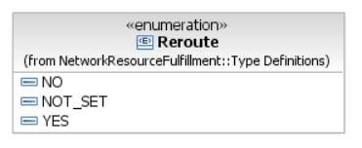 | The RerouteType type indicates if the target OS/MEs/Control Plane are allowed and/or required to reroute this SNC if there is a failure on this SNC, periodically to optimize the routes, of for any other reason.  This can be done either using network routing protocols or through centralized management.  The RR_NO value means that the target OS/MEs/Control Plane are not allowed to reroute the SNC.  The RR_YES value means that the target OS/MEs/Control Plane are allowed to reroute the SNC and required to attempt to reroute it upon failure.  The RR_NA value is used when the requesting OS does not want to specify the exact behaviour. In this case it is left up to the target OS/(MEs/Control Plane to decide whether rerouting will be provided. It is also used if the target OS/MEs/Control Plane are allowed to reroute the SNC but not required to attempt to reroute it upon failure.
<xsd:restriction base="xsd:string">
<xsd:enumeration value="RR_NA"/>
<xsd:enumeration value="RR_NO"/>
<xsd:enumeration value="RR_YES"/>
</xsd:restriction>

SubnetworkConnectionState Type

BA () | IA | IDL (SubnetworkConnectionStateType) | Comments
 | 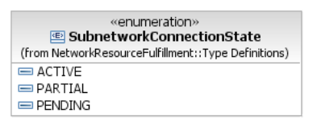  Traceability: R_TMF518_NRF_I_0028.  PENDING  The SNC has been created by an NMS and has not been activated by any NMS; or the SNC has been successfully deactivated by an NMS. That state has no relationship with the network state of the cross-connects of the SNC.  ACTIVE  The SNC is not in pending state, a route has been assigned to the SNC and all cross-connects for the SNC are active in the network.  PARTIAL  The SNC is not in pending state, and either a route has not been assigned to the SNC, or not all of the cross-connects of the SNC are active in the network. This may or may not include activated SNCs for which there are currently no active cross-connects in the network, depending on the SNC management mode of operation.  ?? | The SNCState enum is used to represent the various states that an SNC may take.  The following states may be supported by the target OS, depending on the SNC management mode of operation used by the target OS. See SD1-23 SNC Management Modes Of Operation for details.  If the Connection is used in a Control Plane environment, the SNC State is fixed to active.  SNCS_PENDING: the SNC has been created by a requesting OS and has not been activated by any requesting OS; or the SNC has been successfully deactivated by a requesting OS. That state has no relationship with the network state of the cross- connects of the SNC. It is allowable for a target OS to not support the SNCS_PENDING state and to reject any operation that attempts to put an SNC into SNCS_PENDING state.  SNCS_ACTIVE: the SNC is not in pending state, a route has been assigned to the SNC and all cross-connects for the SNC are active in the network. This is the only SNC State valid for an Connection in the Control Plane environment.  SNCS_PARTIAL: the SNC is not in pending state, and either a route has not been assigned to the SNC, or not all of the cross-connects of the SNC are active in the network. This may or may not include activated SNCs for which there are currently no active cross- connects in the network, depending on the SNC management mode of operation.It is possible that, in some target OSs, this state be unreachable.  SNCS_NONEXISTENT: this is not an SNC state per se, as it applies to "non-existent SNCs". It is used in the interface to report SNCs that have been deleted.  See SNCState state diagram for details on valid transitions.
<xsd:restriction base="xsd:string">
<xsd:enumeration value="SNCS_NONEXISTENT"/>
<xsd:enumeration value="SNCS_PENDING"/>
<xsd:enumeration value="SNCS_ACTIVE"/>
<xsd:enumeration value="SNCS_PARTIAL"/>
</xsd:restriction>

SubnetworkConnectionType Type

BA () | IA (SubnetworkConnectionType) | IDL (SubnetworkConnectionTypeType) | Comments
 | Traceability: R_TMF518_NRF_I_0029. | The SNC Type describes the connection based on the signal flows.  The only types applicable to a Control Plane Connection are ST_SIMPLE, ST_ADD_DROP_A and ST_ADD_DROP_Z.  For a detailed description of the use of this attribute see SD1-36 SNC Types.  In case of an ATM SNC (VP or VC), ST_SIMPLE is used to specify a 'plain' (hard or regular) PVC.
 | 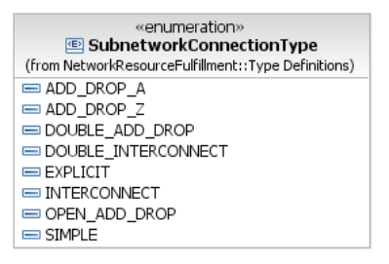 | <xsd:restriction base="xsd:string">  <xsd:enumeration value="ST_SIMPLE"/>  <xsd:enumeration value="ST_ADD_DROP_A"/>  <xsd:enumeration value="ST_ADD_DROP_Z"/>  <xsd:enumeration value="ST_INTERCONNECT"/>  <xsd:enumeration value="ST_DOUBLE_INTERCONNECT"/>  <xsd:enumeration value="ST_DOUBLE_ADD_DROP"/>  <xsd:enumeration value="ST_OPEN_ADD_DROP"/>  <xsd:enumeration value="ST_EXPLICIT"/>  </xsd:restriction>

Snc.xsd comparison

MTOSI 2.1 Snc.xsd | MTOSI 3.0 Control Plane enhanced Snc.xsd
<?xml version="1.0" encoding="UTF-8"?>  <!-- mTOP DDP - Network Resource Fulfillment - Copyright TeleManagement Forum 2008 -->  <xsd:schema xmlns:xsd="http://www.w3.org/2001/XMLSchema"  xmlns:tns="http://www.tmforum.org/mtop/nrf/xsd/snc/v1" xmlns:gen="http://www.tmforum.org/mtop/fmw/xsd/gen/v1" xmlns:lay="http://www.tmforum.org/mtop/nrb/xsd/lay/v1" xmlns:cri="http://www.tmforum.org/mtop/nrb/xsd/cri/v1" xmlns:com="http://www.tmforum.org/mtop/nrf/xsd/com/v1" xmlns:tpdata="http://www.tmforum.org/mtop/nrf/xsd/tpdata/v1" xmlns:ituArc="http://www.tmforum.org/mtop/nra/xsd/ituArc/v1" targetNamespace="http://www.tmforum.org/mtop/nrf/xsd/snc/v1" elementFormDefault="qualified" attributeFormDefault="unqualified" version="1.0">  <xsd:annotation>  <xsd:documentation>  <p>DDP: Data Model Network Resource FulFillment</p>  <p>Module: Aggregate XSD Module</p>  <p>Description: This module contains the XML Schema type definition of the mTOP SNC XML structures.</p>  </xsd:documentation>  </xsd:annotation> | <?xml version="1.0" encoding="UTF-8"?>  <!-- mTOP DDP - Network Resource Fulfillment - Copyright TeleManagement Forum 2008 -->  <xsd:schema xmlns:xsd="http://www.w3.org/2001/XMLSchema" targetNamespace="http://www.tmforum.org/mtop/nrf/xsd/snc/v1" xmlns:tns="http://www.tmforum.org/mtop/nrf/xsd/snc/v1" xmlns:gen="http://www.tmforum.org/mtop/fmw/xsd/gen/v1" xmlns:lay="http://www.tmforum.org/mtop/nrb/xsd/lay/v1" xmlns:cri="http://www.tmforum.org/mtop/nrb/xsd/cri/v1" xmlns:com="http://www.tmforum.org/mtop/nrf/xsd/com/v1" xmlns:tpdata="http://www.tmforum.org/mtop/nrf/xsd/tpdata/v1" xmlns:ituArc="http://www.tmforum.org/mtop/nra/xsd/ituArc/v1" targetNamespace="http://www.tmforum.org/mtop/nrf/xsd/snc/v1" elementFormDefault="qualified" attributeFormDefault="unqualified" elementFormDefault="qualified" version="1.0">  <xsd:annotation>  <xsd:documentation>  <p>DDP: Data Model Network Resource FulFillment</p>  <p>Module: Aggregate XSD Module</p>  <p>Description: This module contains the XML Schema type definition of the mTOP SNC XML structures.</p>  </xsd:documentation>  </xsd:annotation>
<xsd:import namespace="http://www.tmforum.org/mtop/fmw/xsd/gen/v1" schemaLocation="../../../Framework/IIS/xsd/GeneralDefinitions.xsd"/>  <xsd:import namespace="http://www.tmforum.org/mtop/nrb/xsd/lay/v1" schemaLocation="../../../NetworkResourceBasic/IIS/xsd/LayerRates.xsd"/>  <xsd:import namespace="http://www.tmforum.org/mtop/nrb/xsd/cri/v1" schemaLocation="../../../NetworkResourceBasic/IIS/xsd/CommonResourceInfo.xsd"/>  <xsd:import namespace="http://www.tmforum.org/mtop/nrf/xsd/com/v1" schemaLocation="CommonTypes.xsd"/>  <xsd:import namespace="http://www.tmforum.org/mtop/nrf/xsd/tpdata/v1" schemaLocation="TpData.xsd"/>  <xsd:import namespace="http://www.tmforum.org/mtop/nra/xsd/ituArc/v1" schemaLocation="../../../NetworkResourceAssurance/IIS/xsd/ITU-T-ArcDefinitions.xsd"/> | <xsd:import schemaLocation="../../../Framework/IIS/xsd/GeneralDefinitions.xsd" namespace="http://www.tmforum.org/mtop/fmw/xsd/gen/v1"/>  <xsd:import schemaLocation="../../../NetworkResourceBasic/IIS/xsd/LayerRates.xsd" namespace="http://www.tmforum.org/mtop/nrb/xsd/lay/v1"/>  <xsd:import schemaLocation="../../../NetworkResourceBasic/IIS/xsd/CommonResourceInfo.xsd" namespace="http://www.tmforum.org/mtop/nrb/xsd/cri/v1"/>  <xsd:import schemaLocation="CommonTypes.xsd" namespace="http://www.tmforum.org/mtop/nrf/xsd/com/v1"/>  <xsd:import schemaLocation="TpData.xsd" namespace="http://www.tmforum.org/mtop/nrf/xsd/tpdata/v1"/>  <xsd:import namespace="http://www.tmforum.org/mtop/nra/xsd/ituArc/v1" schemaLocation="../../../NetworkResourceAssurance/IIS/xsd/ITU-T-ArcDefinitions.xsd"/>
<xsd:element name="snc" type="tns:SubnetworkConnectionType"/> | <xsd:element name="snc" type="tns:SubnetworkConnectionType"/>
<xsd:complexType name="SubnetworkConnectionType">  <xsd:annotation>  <xsd:documentation>  <p>This aggregate defines the Subnetwork Connection mTOP network resource object.</p>  </xsd:documentation>  </xsd:annotation>  <xsd:complexContent>  <xsd:extension base="cri:CommonResourceInfoType">  <xsd:annotation>  <xsd:documentation>  <p>This element entails the attributes common to all mTOP network resource objects.</p>  </xsd:documentation>  </xsd:annotation>  <xsd:sequence> | <xsd:complexType name="SubnetworkConnectionType">  <xsd:annotation>  <xsd:documentation>  <p>This aggregate defines the Subnetwork Connection mTOP network resource object.</p>  <p> A subnetwork connection represents a connection between TPs (in any combination). It may also represent Network Connections between the G.805 TCP of any TP</p>.  <p> This structure is also used to represent a Connection supporting a call in the Control Plane at any level of the routing area hierarchy. The Connection object represents the relationship between subnetwork points (SNP).</p>  <p> A connection may encompass a sequence of connections (referred to as connection segments although but not represented in this model) and thus create a recursive relationship across the routing hierarchy.</p>  <p> This object can represent a connection at the highest level of recursion (a top-level connection).</p>  <p> Note that a Call may have one or more parallel top-level connection(s).</p>  </xsd:documentation>  </xsd:annotation>  <xsd:complexContent>  <xsd:extension base="cri:CommonResourceInfoType">  <xsd:annotation>  <xsd:documentation>  <p>This element entails the attributes common to all mTOP network resource objects.</p>  </xsd:documentation>  </xsd:annotation>  <xsd:sequence>
<xsd:element name="sncState" type="com:SubnetworkConnectionStateType" nillable="true" minOccurs="0">  <xsd:annotation>  <xsd:documentation>  <p>The sncState is an attribute managed by the EMS. The EMS manages the state transition of this attribute. The EMS will assess the cross-connections in the network that support the SNC and will appropriately adjust the value of SNCState to reflect the actual state of the SNC in the network.</p>  </xsd:documentation>  </xsd:annotation>  </xsd:element> | <xsd:element name="sncState" type="com:SubnetworkConnectionStateType" nillable="true" minOccurs="0">  <xsd:annotation>  <xsd:documentation>  <p> This is the state of a SubnetworkConnection.</p>  <p> If this SNC represents a Control Plane connection, then this attribute is fixed to "SNCS_ACTIVE".</p>  <p> The target OS may operate in one of four modes, summarized below. See SD1-23 SNC Management Modes Of Operation.  <ol>  <li>No pending no sharing: The pending state is not supported. Conflicting SNCs are rejected on creation. Sharing of CCs amongst SNCs is not allowed, except for broadcast SNCs.</li>  <li>No pending with sharing: The pending state is not supported. Conflicting SNCs are rejected on creation. However, sharing of CCs amongst SNCs is allowed.</li>  <li>Pending no sharing: The pending state is supported. Conflicting SNCs and SNCs that share CCs are accepted on creation, however their activation is rejected. Sharing of CCs amongst SNCs is not allowed for partial and active SNCs, except for broadcast SNCs.</li>  <li>Pending with sharing: The pending state is supported. Conflicting SNCs are accepted on creation, however their activation is rejected. Sharing of CCs amongst SNCs is allowed.</li>  </ol></p>  <p>The sncState is an attribute managed by the target OS. The target OS manages the state transition of this attribute. The target OS will assess the cross-connections in the network that support the SNC and will appropriately adjust the value of SNCState to reflect the actual state of the SNC in the network.</p>  </xsd:documentation>  </xsd:annotation>  </xsd:element>
<xsd:element name="direction" type="com:ConnectionDirectionType" nillable="true" minOccurs="0"/> | <xsd:element name="direction" type="com:ConnectionDirectionType" nillable="true" minOccurs="0">  </xsd:element>
<xsd:element name="layerRate" type="lay:LayerRateType" nillable="true" minOccurs="0">  <xsd:annotation>  <xsd:documentation>  <p>The rate of the SubnetworkConnection is obtained by reading this attribute.</p>  </xsd:documentation>  </xsd:annotation>  </xsd:element> | <xsd:element name="layerRate" type="lay:LayerRateType" nillable="true" minOccurs="0">  <xsd:annotation>  <xsd:documentation>  <p>The rate of the SubnetworkConnection is obtained by reading this attribute. The target OS sets this attribute at creation of the SNC.</p>  <p> The target OS is allowed to choose a Layer Rate equivalent to that of one of the TPs/SNPs. The target OS is expected to reflect any equivalent layer rate in any connection retrievals (i.e. the connection rate of the SNC retrieved from the target OS does not have to be the same as that requested by the requesting OS so long as it is an equivalent rate).</p>  <p> For a detailed description of the use of this attribute see SD1-36 SNC Types.</p>  <p> This is a readonly attribute.</p>  </xsd:documentation>  </xsd:annotation>  </xsd:element>
<xsd:element name="staticProtectionLevel" type="com:StaticProtectionLevelType" nillable="true" minOccurs="0"/> | <xsd:element name="staticProtectionLevel" type="com:StaticProtectionLevelType" nillable="true" minOccurs="0">  </xsd:element>
<xsd:element name="sncType" type="com:SubnetworkConnectionTypeType" nillable="true" minOccurs="0"/> | <xsd:element name="sncType" type="com:SubnetworkConnectionTypeType" nillable="true" minOccurs="0">  </xsd:element>
<xsd:element name="aEndTpDataList" type="tpdata:TerminationPointDataListType" nillable="true" minOccurs="0">  <xsd:annotation>  <xsd:documentation>  <p>The list of Aend termination points TP where this SNC terminates.  For a detailed description of the use of this attribute, see MTNM SNC Types supporting document.</p>  </xsd:documentation>  </xsd:annotation>  </xsd:element> | <xsd:element name="aEndTpDataList" type="tpdata:TerminationPointDataListType" nillable="true" minOccurs="0">  <xsd:annotation>  <xsd:documentation>  <p> The list of Aend termination points TP where this SNC terminates.</p>  <p> The TPname provides the name of the CTP/FTP/GTP in a non-control plane SNC.</p>  <p> In a control plane connection, this attribute shall represent the A-end of the Connection in the control plane name space, i.e., the value of this attribute shall identify an SNP or an SNPP. The optional TNA/FTP/CTP values are provided by aEndTpList and aEndTnaNameOrGroupTnaName attributes.</p>  <p> For a detailed description of the use of this attribute, see SD1-36 SNC Types supporting document.</p>  <p> This is a readonly attribute.</p>  </xsd:documentation>  </xsd:annotation>  </xsd:element>
<xsd:element name="zEndTpDataList" type="tpdata:TerminationPointDataListType" nillable="true" minOccurs="0">  <xsd:annotation>  <xsd:documentation>  <p>The list of Zend termination points TP where this SNC terminates. For a detailed description of the use of this attribute, see MTNM SNC Types supporting document.</p>  </xsd:documentation>  </xsd:annotation>  </xsd:element> | <xsd:element name="zEndTpDataList" type="tpdata:TerminationPointDataListType" nillable="true" minOccurs="0">  <xsd:annotation>  <xsd:documentation>  <p>The list of Zend termination points TP where this SNC terminates. See aEndTpDataList.</p>  </xsd:documentation>  </xsd:annotation>  </xsd:element>
<xsd:element name="rerouteAllowed" type="com:RerouteType" nillable="true" minOccurs="0"/> | <xsd:element name="rerouteAllowed" type="com:RerouteType" nillable="true" minOccurs="0">  <xsd:annotation>  <xsd:documentation>  <p>This attribute indicates if the target OS/MEs/CP are allowed and/or required to reroute this SNC if there is a failure on this SNC, periodically to optimize the routes, of for any other reason. It is a target OS/ME/CP implementation whether this is done using network routing protocols or if the OS/MEs/CP detect the failure and take appropriate action to attempt to fix the SNC.</p>  </xsd:documentation>  </xsd:annotation>  </xsd:element>
<xsd:element name="networkRouted" type="com:NetworkRoutedType" nillable="true" minOccurs="0"/> | <xsd:element name="networkRouted" type="com:NetworkRoutedType" nillable="true" minOccurs="0">  <xsd:annotation>  <xsd:documentation>  <p>This attribute specifies if the route for this SNC is computed by the network.</p>  </xsd:documentation>  </xsd:annotation>  </xsd:element>
<xsd:element name="isReportingAlarms" type="xsd:boolean" nillable="true" minOccurs="0"/> | <xsd:element name="isReportingAlarms" type="xsd:boolean" nillable="true" minOccurs="0">  </xsd:element>
<xsd:element name="isFixed" type="xsd:boolean" nillable="true" minOccurs="0">  <xsd:annotation>  <xsd:documentation>  <p>Takes value True when all cross-connects of the SNC are fixed.</p>  </xsd:documentation>  </xsd:annotation>  </xsd:element> | <xsd:element name="isFixed" type="xsd:boolean" nillable="true" minOccurs="0">  <xsd:annotation>  <xsd:documentation>  <p>Takes value True when all cross-connects of the SNC are fixed.</p>  </xsd:documentation>  </xsd:annotation>  </xsd:element>
<xsd:element name="asapRef" type="xsd:string" nillable="true" minOccurs="0">  <xsd:annotation>  <xsd:documentation>  <p>Indicates the assignment of an ASAP to this SNC object. Value is of the ASAP name.</p>  </xsd:documentation>  </xsd:annotation>  </xsd:element> | <xsd:element name="asapRef" type="xsd:string" nillable="true" minOccurs="0">  <xsd:annotation>  <xsd:documentation>  <p>Indicates the assignment of an ASAP to this SNC object. Value is of the ASAP name.</p>  </xsd:documentation>  </xsd:annotation>  </xsd:element>
<xsd:element name="correlationIdentifier" type="xsd:string" nillable="true" minOccurs="0">  <xsd:annotation>  <xsd:documentation>  <p>Used to contain information about relationships that this SNC may have to other managed objects.</p>  </xsd:documentation>  </xsd:annotation>  </xsd:element> | <xsd:element name="correlationIdentifier" type="xsd:string" nillable="true" minOccurs="0">  <xsd:annotation>  <xsd:documentation>  <p>Used to contain information about relationships that this SNC may have to other managed objects.</p>  </xsd:documentation>  </xsd:annotation>  </xsd:element>
<xsd:element name="networkReroute" type="com:RerouteType" nillable="true" minOccurs="0">  <xsd:annotation>  <xsd:documentation>  <p>Indicates if the reroute of an SNC (if allowed) should be computed by the network, by the EMS, or if it does not matter.</p>  </xsd:documentation>  </xsd:annotation>  </xsd:element> | <xsd:element name="networkReroute" type="com:RerouteType" nillable="true" minOccurs="0">  <xsd:annotation>  <xsd:documentation>  <p>Indicates if the reroute of an SNC (if allowed) should be computed by the network, by the target OS, or if it does not matter.</p>  </xsd:documentation>  </xsd:annotation>  </xsd:element>
<xsd:element name="priority" type="xsd:unsignedInt" nillable="true" minOccurs="0">  <xsd:annotation>  <xsd:documentation>  <p>The SNC creation priority</p>  </xsd:documentation>  </xsd:annotation>  </xsd:element> | <xsd:element name="priority" type="xsd:unsignedInt" nillable="true" minOccurs="0">  <xsd:annotation>  <xsd:documentation>  <p>The priority allows to prevent activating routes because of XC or CTP conflicts with equal or higher prior SNCs.</p>  <p>An SNC or a Connection in the Control Plane can pre-empt resources of another SNC of lower priority for restoration purposes.</p>  <p>Values: “0”, “1”, “2”, ... where “0” is the highest priority.</p>  </xsd:documentation>  </xsd:annotation>  </xsd:element>
<xsd:element name="revertive" type="xsd:boolean" nillable="true" minOccurs="0">  <xsd:annotation>  <xsd:documentation>  <p>Takes value â€œTrueâ€, i.e. the SNC or Connection is revertive, when the SNC or connection can be switched back to its original route. In case of an SNC with multiple routes when the SNC is revertive, then the restoration or rerouting process will always switch to the intended route if possible, i.e. if there are no failures or if the intended route is not locked.</p>  </xsd:documentation>  </xsd:annotation>  </xsd:element> | <xsd:element name="revertive" type="xsd:boolean" nillable="true" minOccurs="0">  <xsd:annotation>  <xsd:documentation>  <p>Takes value â€œTrueâ€, i.e. the SNC or Connection is revertive, when the SNC or connection can be switched back to its original route. In case of an SNC with multiple routes when the SNC is revertive, then the restoration or rerouting process will always switch to the intended route if possible, i.e. if there are no failures or if the intended route is not locked.</p>  </xsd:documentation>  </xsd:annotation>  </xsd:element>
<xsd:element name="aEndPointsRole" nillable="true" minOccurs="0">  <xsd:annotation>  <xsd:documentation>  <p>Defines the element that defines the end point role of all aEnd TPs of an SNC. This is an ordered list indexed with the aEnd TP list of the SNC.<p>  </xsd:documentation>  </xsd:annotation>  <xsd:complexType>  <xsd:sequence>  <xsd:element name="role" type="com:EndPointRoleType" minOccurs="0" maxOccurs="unbounded"/>  </xsd:sequence>  </xsd:complexType>  </xsd:element> | <xsd:element name="aEndPointsRole" minOccurs="0" nillable="true">  <xsd:annotation>  <xsd:documentation>  <p>Defines the element that defines the end point role of all aEnd TPs of an SNC. This is an ordered list indexed with the aEnd TP list of the SNC.</p>  </xsd:documentation>  </xsd:annotation>  <xsd:complexType>  <xsd:sequence>  <xsd:element name="role" type="com:EndPointRoleType" minOccurs="0" maxOccurs="unbounded"/>  </xsd:sequence>  </xsd:complexType>  </xsd:element>
<xsd:element name="isBundledSnc" type="xsd:boolean" nillable="true" minOccurs="0">  <xsd:annotation>  <xsd:documentation>  <p>Indicates whether the SNC constitutes a Bundled SNC service (value â€œTrueâ€) or not..</p>  </xsd:documentation>  </xsd:annotation>  </xsd:element> | <xsd:element name="isBundledSnc" type="xsd:boolean" nillable="true" minOccurs="0">  <xsd:annotation>  <xsd:documentation>  <p>Indicates whether the SNC constitutes a Bundled SNC service (value â€œTrueâ€) or not..</p>  </xsd:documentation>  </xsd:annotation>  </xsd:element>
<xsd:element name="callId" type="xsd:string" nillable="true" minOccurs="0">  <xsd:annotation>  <xsd:documentation>  <p>This is the control plane identifier. This attribute is the Call Name attribute in G.7713.</p>  </xsd:documentation>  </xsd:annotation>  </xsd:element> | <xsd:element name="callId" type="xsd:string" nillable="true" minOccurs="0">  <xsd:annotation>  <xsd:documentation>  <p>This is the control plane identifier. This attribute is the Call Name attribute in G.7713.</p>  </xsd:documentation>  </xsd:annotation>  </xsd:element>
<xsd:element name="callName" type="xsd:string" nillable="true" minOccurs="0">  <xsd:annotation>  <xsd:documentation>  <p>This attribute indicates the Call Name which the connection is supporting in a non control plane case.</p>  <p>String containing the RDN of the Call Name.The value in the last name-value pair of name structure</p>  </xsd:documentation>  </xsd:annotation>  </xsd:element> | <xsd:element name="callName" type="xsd:string" nillable="true" minOccurs="0">  <xsd:annotation>  <xsd:documentation>  <p>This attribute indicates the Call Name which the connection is supporting in a non control plane case.</p>  <p>String containing the RDN of the Call Name.The value in the last name-value pair of name structure</p>  </xsd:documentation>  </xsd:annotation>  </xsd:element>
<xsd:element name="connectionId" type="xsd:string" nillable="true" minOccurs="0">  <xsd:annotation>  <xsd:documentation>  <p>This is the control plane identifier. This attribute is the Connection Name attribute in G.7713.  Note that also the Cross Connection points to its superior Connection.</p>  </xsd:documentation>  </xsd:annotation>  </xsd:element> | <xsd:element name="connectionId" type="xsd:string" nillable="true" minOccurs="0">  <xsd:annotation>  <xsd:documentation>  <p>This is the control plane identifier. This attribute is the Connection Name attribute in G.7713.  Note that also the Cross Connection points to its superior Connection.</p>  </xsd:documentation>  </xsd:annotation>  </xsd:element>
<xsd:element name="connectionSetUpType" type="xsd:string" nillable="true" minOccurs="0">  <xsd:annotation>  <xsd:documentation>  <p>This attribute indicates whether the connection has been established by UNI signalling (SC) or NMS (SPC, PC).</p>  <p>Legal values are:<ul>  <li>PC</li>  <li>SC</li>  <li>SPC</li>  </ul>  </p>  </xsd:documentation>  </xsd:annotation>  </xsd:element> | <xsd:element name="connectionSetUpType" type="xsd:string" nillable="true" minOccurs="0">  <xsd:annotation>  <xsd:documentation>  <p>This attribute indicates whether the connection has been established by UNI signalling (SC) or NMS (SPC, PC).</p>  <p>Legal values are:<ul>  <li>PC</li>  <li>SC</li>  <li>SPC</li>  </ul>  </p>  </xsd:documentation>  </xsd:annotation>  </xsd:element>
<xsd:element name="connectionState" type="xsd:string" nillable="true" minOccurs="0">  <xsd:annotation>  <xsd:documentation>  <p>Indicates that all (â€œCompleteâ€) or not all (â€œSearchingâ€) the resources necessary to support the connection have been successfully allocated yet.</p>  <p>Legal values are:<ul>  <li>Complete</li>  <li>Searching</li>  <li>N/A</li>  </ul>  </p>  </xsd:documentation>  </xsd:annotation>  </xsd:element> | <xsd:element name="connectionState" type="xsd:string" nillable="true" minOccurs="0">  <xsd:annotation>  <xsd:documentation>  <p>Indicates that all (â€œCompleteâ€) or not all (â€œSearchingâ€) the resources necessary to support the connection have been successfully allocated yet.</p>  <p>Legal values are:<ul>  <li>Complete</li>  <li>Searching</li>  <li>N/A</li>  </ul>  </p>  </xsd:documentation>  </xsd:annotation>  </xsd:element>
<xsd:element name="maximumCost" type="xsd:string" nillable="true" minOccurs="0">  <xsd:annotation>  <xsd:documentation>  <p>The maximum link/node cost allowed for routing.</p>  </xsd:documentation>  </xsd:annotation>  </xsd:element> | <xsd:element name="maximumCost" type="xsd:string" nillable="true" minOccurs="0">  <xsd:annotation>  <xsd:documentation>  <p>The maximum link/node cost allowed for routing.</p>  </xsd:documentation>  </xsd:annotation>  </xsd:element>
<xsd:element name="mustRemoveGtpList" type="xsd:boolean" default="true" minOccurs="0">  <xsd:annotation>  <xsd:documentation>  <p>The parameter is only used for bundled SNCs.</p>  <p>If set to â€œTrueâ€ the EMS when removing the SNC must make a best-effort attempt to remove the interior GTPs that once belonged to the SNC, and if set to â€œFalseâ€ the NMS does not care whether the EMS removes the interior GTPs or not.</p>  <p>Any behavior other than best-effort is likely to involve a complicated rollback procedure for the EMS and NEs. In the case that the parameter is set to â€œTrueâ€ and the EMS cannot remove all the interior GTPs, the EMS should return a list of the GTPs that could not be removed in the errorReason field of the deactivateAndDeleteSNC() and deleteSNC() operations. The errorReason would  be â€œnot all interior GTPs could be deletedâ€; this would be followed by the names of the GTPs that could not be deleted.</p>  </xsd:documentation>  </xsd:annotation>  </xsd:element> | <xsd:element name="isMustRemoveGtpList" type="xsd:boolean" nillable="true" minOccurs="0">  <xsd:annotation>  <xsd:documentation>  <p>The parameter is only used for bundled SNCs. </p>  <p>If set to â€œTrueâ€ the EMS when removing the SNC must make a best-effort attempt to remove the interior GTPs that once belonged to the SNC, and if set to â€œFalseâ€ the NMS does not care whether the EMS removes the interior GTPs or not. </p>  <p>Any behavior other than best-effort is likely to involve a complicated rollback procedure for the EMS and NEs. In the case that the parameter is set to â€œTrueâ€ and the EMS cannot remove all the interior GTPs, the EMS should return a list of the GTPs that could not be removed in the errorReason field of the deactivateAndDeleteSNC() and deleteSNC() operations. The errorReason would  be â€œnot all interior GTPs could be deletedâ€; this would be followed by the names of the GTPs that could not be deleted.</p>  </xsd:documentation>  </xsd:annotation>  </xsd:element>
<xsd:element name="mustRetainOldSnc" type="xsd:boolean" default="true" minOccurs="0"/> | ??
<xsd:element name="protectionEffort" type="com:ProtectionEffortType" nillable="true" minOccurs="0"/> | <xsd:element name="protectionEffort" type="com:ProtectionEffortType" nillable="true" minOccurs="0">  </xsd:element>
<xsd:element name="routeGroupLabel" type="xsd:string" nillable="true" minOccurs="0">  <xsd:annotation>  <xsd:documentation>  <p>This attribute shall represent the route group of the connection.</p>  </xsd:documentation>  </xsd:annotation>  </xsd:element> | <xsd:element name="routeGroupLabel" type="xsd:string" nillable="true" minOccurs="0">  <xsd:annotation>  <xsd:documentation>  <p>This attribute shall represent the route group of the connection.</p>  </xsd:documentation>  </xsd:annotation>  </xsd:element>
<xsd:element name="routingConstraintEffort" type="xsd:string" nillable="true" minOccurs="0">  <xsd:annotation>  <xsd:documentation>  <p>The effort required for routing constraint application.</p>  <p>Legal Values are:<ul>  <li>BEST_EFFORT</li>  <li>EXACT_MATCH</li>  </ul>  </p>  </xsd:documentation>  </xsd:annotation>  </xsd:element> | <xsd:element name="routingConstraintEffort" type="xsd:string" nillable="true" minOccurs="0">  <xsd:annotation>  <xsd:documentation>  <p>The effort required for routing constraint application.</p>  <p>Legal Values are:<ul>  <li>BEST_EFFORT</li>  <li>EXACT_MATCH</li>  </ul>  </p>  </xsd:documentation>  </xsd:annotation>  </xsd:element>
<xsd:element name="supportedConnectionName" type="xsd:string" nillable="true" minOccurs="0">  <xsd:annotation>  <xsd:documentation>  <p>This attribute indicates the Connection Name (i.e. its superior connection) which the connection is supporting in a non control plane case. Note that this superior connection must be defined in a top level MLSN â€“ which allows identifying it with a simple string â€“ RDN value.</p>  <p>RDN of Connection Name, i.e., the value in the last name-value pair of name structure</p>  </xsd:documentation>  </xsd:annotation>  </xsd:element> | <xsd:element name="supportedConnectionName" type="xsd:string" nillable="true" minOccurs="0">  <xsd:annotation>  <xsd:documentation>  <p>This attribute indicates the Connection Name (i.e. its superior connection) which the connection is supporting in a non control plane case. Note that this superior connection must be defined in a top level MLSN â€“ which allows identifying it with a simple string â€“ RDN value.</p>  <p>RDN of Connection Name, i.e., the value in the last name-value pair of name structure</p>  </xsd:documentation>  </xsd:annotation>  </xsd:element>
<xsd:element name="supportingSncList" type="xsd:string" nillable="true" minOccurs="0">  <xsd:annotation>  <xsd:documentation>  <p>This attribute shall contain the names of the supporting Subnetwork Connections if any.  Note: This attribute is only applicable for top level connections in a non-Control Plane environment if SNCs support indirectly the Call.  Format:  \name=OS\value=CompanyName/EMSname\name=MLSN\value= SubnetworkName\name= SNC\value=SubnetworkName</p>  </xsd:documentation>  </xsd:annotation>  </xsd:element> | <xsd:element name="supportingSncList" type="xsd:string" nillable="true" minOccurs="0">  <xsd:annotation>  <xsd:documentation>  <p>This attribute shall contain the names of the supporting Subnetwork Connections if any.  Note: This attribute is only applicable for top level connections in a non-Control Plane environment if SNCs support indirectly the Call.  Format:  \name=OS\value=CompanyName/EMSname\name=MLSN\value= SubnetworkName\name= SNC\value=SubnetworkName</p>  </xsd:documentation>  </xsd:annotation>  </xsd:element>
<xsd:element name="zEndPointsRole" nillable="true" minOccurs="0">  <xsd:annotation>  <xsd:documentation>  <p>Defines the element that defines the end point role of all zEnd TPs of an SNC. This is an ordered list indexed with the zEnd TP list of the SNC</p>  </xsd:documentation>  </xsd:annotation>  <xsd:complexType>  <xsd:sequence>  <xsd:element name="role" type="com:EndPointRoleType" minOccurs="0" maxOccurs="unbounded"/>  </xsd:sequence>  </xsd:complexType>  </xsd:element> | <xsd:element name="zEndPointsRole" minOccurs="0" nillable="true">  <xsd:annotation>  <xsd:documentation>  <p>Defines the element that defines the end point role of all zEnd TPs of an SNC. This is an ordered list indexed with the zEnd TP list of the SNC</p>  </xsd:documentation>  </xsd:annotation>  <xsd:complexType>  <xsd:sequence>  <xsd:element name="role" type="com:EndPointRoleType" minOccurs="0" maxOccurs="unbounded"/>  </xsd:sequence>  </xsd:complexType>  </xsd:element>
<xsd:element name="ituArcStateAndStatusList" type="ituArc:ItuArcStateAndStatusList"/> | ??
<xsd:element name="aEndTpList" type="xsd:string" nillable="true" minOccurs="0">
<xsd:annotation>
<xsd:documentation>
<p>String representing a sequence of name-value pairs. The backslash (â€œ\â€) character is used as separator.</p>
<p>Format: \name=OS\value=CompanyName/OSname\name=ME\value=ManagedElementName\name=PTP\value=PTPName\name=CTP\value=CTPName E.g.: \name=OS\value=BigCompany/SmallEMS\name=ME\value=YellowManagedElement\name=PTP\value=BluePTP\name=CTP\value=RedCTP</p>
</xsd:documentation>
</xsd:annotation>
</xsd:element>

<xsd:element name="aEndTnaNameOrGroupTnaName" type="xsd:string" nillable="true" minOccurs="0">
<xsd:annotation>
<xsd:documentation>
<p>Represent the TNA or Group-TNA of the Connection. A TNA Name List may have 3 value pairs.</p>
<p>Format: \name=TNAName\value=TNANameValue\name=LogicalPortId\value=LogicalPortIdValue\name= Index\value=IndexValue.</p>
</xsd:documentation>
</xsd:annotation>
</xsd:element>

<xsd:element name="zEndTpList" type="xsd:string" nillable="true" minOccurs="0">
<xsd:annotation>
<xsd:documentation>
<p>see aEndTpList.</p>
</xsd:documentation>
</xsd:annotation>
</xsd:element>

<xsd:element name="zEndTnaNameOrGroupTnaName" type="xsd:string" nillable="true" minOccurs="0">
<xsd:annotation>
<xsd:documentation>
<p>see aEndTNANameOrGroupTNAName.</p>
</xsd:documentation>
</xsd:annotation>
</xsd:element>

<xsd:element name="srg" type="xsd:string" nillable="true" minOccurs="0">
<xsd:annotation>
<xsd:documentation>
<p>E.g.:/bridge=123,456/duct=12,34 or /block=123/room=56,78,99.</p>
<p>Complex string, slash is used as separator.</p>
</xsd:documentation>
</xsd:annotation>
</xsd:element>

<xsd:element name="usingHomeRoute" type="xsd:boolean" nillable="true" minOccurs="0">
<xsd:annotation>
<xsd:documentation>
<p>Indicates whether the connection is using the home route or not.</p>
</xsd:documentation>
</xsd:annotation>
</xsd:element>

</xsd:sequence>  </xsd:extension>  </xsd:complexContent>  </xsd:complexType> | </xsd:sequence>  </xsd:extension>  </xsd:complexContent>  </xsd:complexType>
<!-- ================= --> | <!-- ================= -->
<xsd:complexType name="SubnetworkConnectionListType">  <xsd:annotation>  <xsd:documentation>  <p>A list of SubnetworkConnections</p>  </xsd:documentation>  </xsd:annotation>  <xsd:sequence>  <xsd:element ref="tns:snc" minOccurs="0" maxOccurs="unbounded"/>  </xsd:sequence>  </xsd:complexType> | <xsd:complexType name="SubnetworkConnectionListType">  <xsd:annotation>  <xsd:documentation>  <p>A list of SubnetworkConnections</p>  </xsd:documentation>  </xsd:annotation>  <xsd:sequence>  <xsd:element ref="tns:snc" minOccurs="0" maxOccurs="unbounded"/>  </xsd:sequence>  </xsd:complexType>
<xsd:simpleType name="SubnetworkConnectionModeOfOperationType">  <xsd:annotation>  <xsd:documentation>  <p>The supported subnetwork connection management mode of operation.</p>  </xsd:documentation>  </xsd:annotation>  <xsd:restriction base="xsd:string">  <xsd:enumeration value="NO_PENDING_NO_SHARING"/>  <xsd:enumeration value="NO_PENDING_WITH_SHARING"/>  <xsd:enumeration value="PENDING_NO_SHARING"/>  <xsd:enumeration value="PENDING_WITH_SHARING"/>  </xsd:restriction>  </xsd:simpleType> | ??
</xsd:schema> | </xsd:schema>

