Introduction
This document was prepared by Irena Bartkowska and Nigel Davis based upon an initial trial by Chris Hartley. It provides a guide of the steps taken to add the MTNM/MTOSI LR model to the SID.

This document is not a formal deliverable. It provides some notes that illustrates a stage of work in progress. The document should in no way be taken as an indication that the SID will be modified in the way proposed.

The work is being tracked formally via the wiki structure in the TM Forum Community entered via http://www.tmforum.org/Community/groups/resource_management/wiki/rm-sid-mtnm-mtosi-resource-alignment-phase-1.aspx.

The document is stored in the TIP SVN repository with the model work in the RM-LR_documentation folder in the sandbox <<add link>>.

IPR declaration

No IPR was declared by any party involved in the meetings, email exchanges or any other exchange that led to the development and generation of this document, during the production of this document itself or during any other activity related to this work that led to production of this document or during the subsequent reviews of this document.

The transplant method
The approach adopted involves taking a number of fragments of the MTOSI model and adding them to the SID.

The transplant method can be broken down into the following major steps:
- Prepare for Transplant
  - Load the SID and MTOSI models into RSM
- Identify relevant MTOSI DDPs to copy
  - DDPs providing classes and attributes
  - DDPs providing related classes to preserve relationships
- Identify position in the SID for each relevant element
  - RootEntity: For general common attributes
  - Resource: For common resource attributes
  - Logical Resource: for LR specific elements
- Prepare SID for MTOSI model
  - Create two profiles, TIP Profile and Lifecycle Profile
  - Add to SID the TIP Profile and Lifecycle Profile
  - Create packages/ABEs in Resource and Logical Resource
  - Create temporary “MTOSI” package in SID to take copy of MTOSI
- Create new “CombinedDDP” model in MTOSI
  - Apply mTOP and TIP Profiles to the model
  - Create packages for each DDP
- Move MTOSI DDP IAs to “CombinedDDP” model in the MTOSI
  - Mark collection of all DDPs and then Drag
- Prune elements in “CombinedDDP” model packages
  - Remove unwanted elements
  - Empty contents from classes that will be relationship termination only (including MD and ME)
  - Remove all other DDPs that are not necessary
- Apply appropriate stereotypes to elements in MTOSI package
  - Identify all appropriate classes, attributes and relationships as TIP
  - Replace mTOP annotations with corresponding TIP stereotypes
    - Ensure that relationships that reflect naming are documented correctly
  - Remove mTOP stereotypes (so that mTOP Profile can be detached in the next step)
  - Highlight empty classes as temporary
  - Validate the model
- Move “CombinedDDP” model content to “MTOSI” package in the SID
- Move/Split DDPs as necessary
  - Drag the elements from temporary “MTOSI” package of the SID model to the appropriate ABE/packages
- Apply new inheritance relationships to MTOSI classes (i.e. reparent)
  - MTOSI classes will now gain a load of additional attributes and relationships via inheritance
  - Mark attributes and relationships with stereotypes to indicate that they should not be used for TIP
- Change existing SID class names where there may be confusion
  - Some SID classes may have
- Apply Lifecycle Profile stereotypes
  - Mark with <<deprecated>> or <<likelyToChange>> as necessary
- Add relationships from new TIP model to other SID classes
  - ONLY relationship to the Equipment model
  - Note that this step may be deferred to the Physical Resource activity
- Create model fragments for all new TIP ABE packages. These are as follows:
  - Tip Common ABE
  - Framework ABE
  - Tip Resource ABE
  - Network Resource Assurance ABE
  - Network Resource Basic ABE
  - Tip Logical Resource ABE
  - Network Resource Fulfillment ABE
- Adjust existing SID diagrams to account for MTOSI model addition
  - As per wiki
- Construct new diagrams for 5LR
  - Showing new MTOSI classes
- Validate the model
- Add text to MTOSI IA sections to relate SID model
  - Tables of mappings and generalized text
- Add text to 5LR to explain diagrams
  - Text for both new MTOSI diagrams and existing diagrams
- Construct Primer
  - Explaining how to navigate from MTOSI to the SID and vice-versa

Transplanting MTOSI2.0 DDPs to SID Phase IX LR

Step 1 Prepare for Transplant – Importing into RSM or RSA SID and MTOSI
The following are the steps to import all required models from appropriate formal location (using SVN from either Resource Management sandbox or http://collab.tmforum.org/sf/scm/do/listRepositories/projects.sid/scm):
- SID Phase 9
  - Obtain SID model (http://collab.tmforum.org/svn/repos/sidphase9)
    - Note: there are two separate projects, i.e. SID Phase IX Models and SID Models Profiles
  - name the project for example as SID Phase IX Models with MTOSI LR as all transplanted DDPs will be placed in this project
    - Note: do not rename the project, may loose some model fragments it seems to be a bug in RSM/RSA
    - Note that the model should have already been refactored to move all contents under Logical View to the top package ‘SID Phase IX Models’; delete Component, Logical etc view folders (this needs SID team approval}
  - Run Validate
- MTOSI 3.0
  - May delete all with exception of IAs for faster import but also all contents can be left untouched.
  - Do not validate at this stage. Validation will be left to later when the model has been pruned.

Step 2 Identify relevant MTOSI DDPs to copy
- DDPs providing classes and attributes
  - Framework:
  - NRB:
  - NRF:
- DDPs providing related classes to preserve relationships
  - NRA:.

Step 3 Identify positions in the SID for each relevant entity
- RootEntity: For general common attributes
- Resource: For common resource attributes
- Logical Resource: for LR specific elements

Step 4 Prepare SID for MTOSI model by constructing profiles and packages
Note that the profiles should NOT be “Released”.

- Take SID phase 9 TIP Profile (from “SID Models_Profiles” project”) and adjust as below
  - All stereotypes of the TIP profile should be optional not mandatory
    - The TIP profile stereotype should not be applied to any of the classes in the SID at this stage
    - Note that the TIP profile will need to have been corrected before it is applied so that no stereotypes are applied by default
    - Note: This profile will continue to be called “TIPProfile” although this may be changed at a later stage
  - The relevant sterotypes in the TIPProfile are:
    - <<tipClass>>
    - <<tipAttribute>>
    - <<tipRelationship>>
      - This is a new proposed stereotype and should be added with attributes base_association, base_associationClass, base_dependency, base_generalisation, base_realisation
    - <<productSupport>>
      - With a single attribute with value “mtnmOnly” or “mtosiOnly”
    - <<doNotImplement>>
      - It is expected that the relationships marked <<doNotImplement>> at this point will also have the “isAbstract: property marked as “true”. A list should be kept of all that do not have.
  - Remove the stereotype <<tipProfile>>
  - All stereotypes are “not required” (not mandatory). To achieve this for each of the relevant stereotypes as listed above
    - Select the stereotype
    - Select extensions
    - For each extension that is set to Required = True, remove the extension and then add the same extension set to Required = False (i.e. required not checked in the selection dialogue)
- Create Lifecycle Profile in “SID Models_Profiles” project including the following stereotypes (all not required) such that they can be applied to any relevant element (class, relationship, attribute, package etc) in the SID etc using the sterotype extensions operations noted in the previous bullet
  - <<likelyToChange>>
  - <<deprecated>>
  - <<preliminary>>
  - <<likelyToBeDeprecated>>
- Extend applicability of <<doNotImplement>> stereotype to other relevant elements such as “package” to line up with the applicability of the LifeCycle profile stereotypes
  - So <<doNotImplement>> should have the same applicability as <<likelyToChange>> for example.
- Localize, Compress and save TIP Profile and Lifecycle Profile
- Ensure that the SID model is related to the new TIP Profile. To do this the profile needs to be removed and re-added as everything has acquired tipClass etc from the old version. Do not apply any stereotypes of the profile to any entities yet (all stereotypes should be optional not mandatory (as a result of the adjustment to the profiles above)). To re-add the profile:
  - Select the SID Phase 9 models file in the SID Phase 9 project
  - Select the profiles tab
  - Remove the TIP Profile (this will remove all current stereotypes)
  - Add the TIP Profile (this will add the new version of the TIP Profile with the stereotypes set to not required and hence no stereotypes will be applied)
  - Validate that (taking a sample of each) that no classes are marked tipClass, no attributes are marked tipAttribute etc)
- Add the Lifecycle Profile to the SID model, but do not apply any stereotypes of the profile to any entities yet (all stereotypes are optional)
- Create packages in RootBusinessEntities ABE in the SID
  - Tip Common ABE containing Framework ABE package
- Create packages in the Resource ABE in the SID
  - “MTOSI” – temporary package to handle the transfer of MTOSI
  - Tip Resource ABE containing
    - Network Resource Assurance ABE
    - Network Resource Basic ABE
- Create packages in the Logical Resource ABE in the SID
  - Tip Logical Resource ABE contains Network Resource Fulfillment ABE

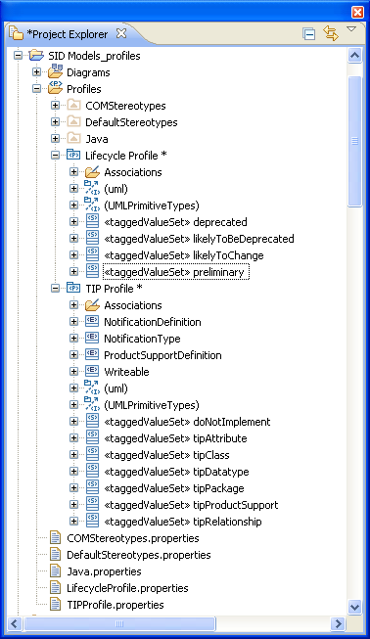

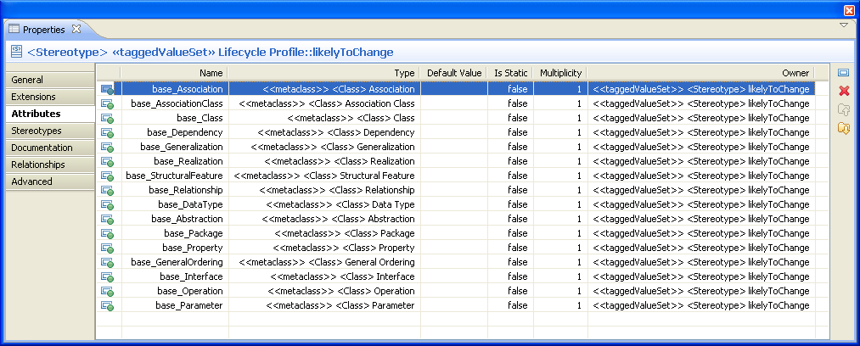

Step 5 <removed>

Step 6 Create new “CombinedDDP” model in MTOSI
Create a new model in MTOSI called “CombinedDDP”.
- Need to combine relevant DDPs of MTOSI (Framework, NRB etc) into a single EMX (called “CombinedDDP”.emx) so that inter relationships are not corrupted

In MTOSI model, right click, create new model.

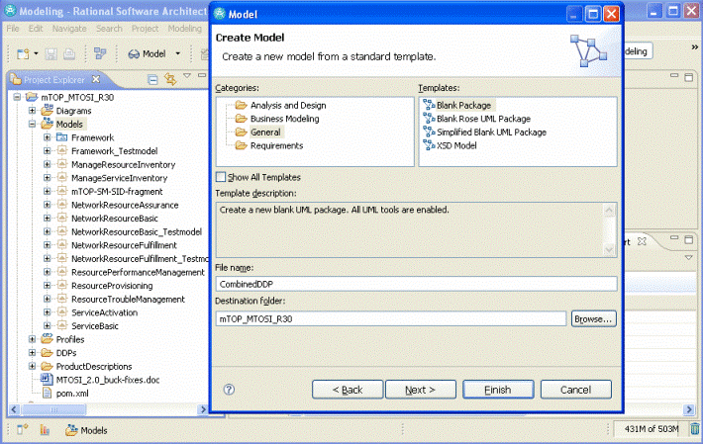

Add Profile to new model (Profiles selection of properties tab)
- mTOPProfile (as per existing mTOP model)
- TIP Profile
- Lifecycle Profile
Create package for:
- Framework ABE
- Network Resource Basic ABE
- Network Resource Assurance ABE
- Network Resource Fulfillment ABE

Step 7 Move MTOSI DDPs (only IAs required) to “CombinedDDP” model in MTOSI

Mark contents of each DDP in turn and drag to appropriate package in “CombinedDDP”.
Drag all following in one go from each DDP in turn
- Class Diagrams
- Data Object Classes
- Type Definitions
- Notification
- Association

Save as necessary

Do not drag primitive types (various additional elements).

Ensure all documentation for each relevant diagram, class, attribute, type and association is preserved.

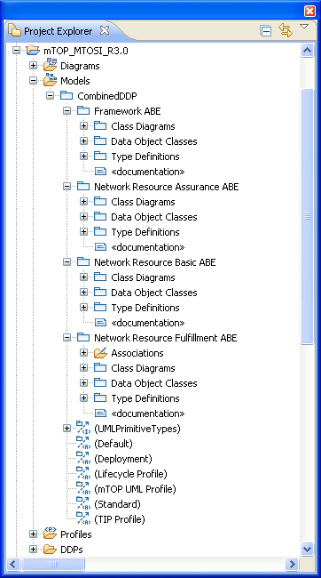

Step 8 Prune elements in “CombinedDDP” Package
Remove all unwanted elements(diagrams, objects, attributes, types, relationships) and empty contents of classes that will be relationship terminations only as described below:

- Network Resource Fulfillment ABE
  - Note that there are associations at the top level and within several other packages, these are listed in separate sections below reflecting the structure of the model. The logic for this separation is not clear and there may be reason to merge them at the end of this piece of work.
  - Associations – leave all as they are
    - Note: The Naming relationships stereotype will have to be adjusted before the move to the SID (see later)
  - Class Diagrams (do not delete any of the actual entities at this point, just modify the diagram)
    - Connectionless Class Diagram
      - Keep this diagram as is
    - Connectionless Inheritance Diagram
      - Keep this diagram as is
    - Connection Oriented Class Diagram
      - Keep this diagram as is
    - Connection Oriented Inheritance Diagram
      - Remove Equipment holder from diagram
    - DDP Relationship Diagram
      - Delete this diagram
    - Equipment Model Class Diagram
      - Delete this diagram (it will be replaced by a new diagram in the SID)
    - Naming Tree
      - Delete EquipmentHolder and Equipment from diagram
    - Notification Diagram
      - Delete this diagram
  - Data Object Classes – keep all as they are other than following
    - Associations – Keep all as they are other than those highlighted to be removed or modified below
      - Note: The Naming relationships stereotype will have to be adjusted before the move to the SID (see later)
      - Note: Do NOT change SupportedSupporting, it will be changed later in the process (once the model is moved to the SID)
    - Equipment
      - To preserve the attributes and relationships for the Physical Resource activity the Equipment class will not have its attributes/relationships adjusted.
        - The relationship to this class from Logical Resource classes will be moved to the SID class in Physical Resource and this class deleted later in the process (once the Physical Resource model is corrected in the SID)
      - Delete asapRef attribute and relate to ASAP
        - Add an association (multiplicity 0..1) to the AlarmSeverityAssignmentProfile class in NRA
        - Note that the Physical Resource activity will need to adopt this approach
    - EquipmentHolder
      - To preserve the attributes and relationships for the Physical Resource activity the Equipment Holder class will not have its attributes/relationships adjusted
        - This class will be deleted later in the process (once the Physical Resource model is corrected in the SID)
      - Delete asapRef attribute and relate to ASAP
        - Add an association (multiplicity 0..1) to the AlarmSeverityAssignmentProfile class in NRA
        - Note that the Physical Resource activity will need to adopt this approach
    - GroupTerminationPoint
      - Delete asapRef attribute
      - Add an association (multiplicity 0..1) to the AlarmSeverityAssignmentProfile class in NRA
    - ManagedElememt
      - Delete all attributes and relationship reference from within the class but keep class. This class will be kept in the SID as a reference end.
    - OperationsSystem
      - Delete all attributes and relationship reference from within the class but keep class. This class will be kept in the SID as a reference end.
    - PhysicalTerminationPoint
      - Delete state machine PortTpRoleState
    - SubnetworkConnection
      - Delete all state machines
        - Modification of an SNC with multiple Routes and SNC name preserved
        - Modification of an SNC with SNC name not preserved
        - Modification of an SNC with SNC name preserved
        - SubNetworkConnection.state [Pending Not Supported]
        - SubNetworkConnection.state [Pending Supported]
      - Delete asapRef attribute
      - Add an association (multiplicity 0..1) to the AlarmSeverityAssignmentProfile class in NRA
    - TerminationPoint
      - Delete asapRef attribute
      - Add an association (multiplicity 0..1) to the AlarmSeverityAssignmentProfile class in NRA
    - TopologicalLink
      - Delete asapRef attribute
      - Add an association (multiplicity 0..1) to the AlarmSeverityAssignmentProfile class in NRA
  - Notifications
    - Delete this package and its contents
  - Type Definitions
    - Associations: Leave unchanged
    - ActualState: Need to confirm no longer used, if so then delete
    - CommunicationState: Need to confirm no longer used if so then delete
    - HolderState : This is maintained to support the Equipment model. The type definition should be moved to the Physical Resource once the work has been done to correct that model. This type definition should then NOT appear in the Logical Resource package.
- Network Resource Basic ABE
  - Class Diagrams
    - Delete all diagrams and the package
  - Data Object Classes – keep as is
    - Note that the attributes of CommonResourceInfo will be moved to other classes in the SID later
  - Type Definitions
    - Delete the following types
      - CommonResourceModifyData
      - CommonResourceCreateData
      - Note: I am not sure about ObjectSource – need to validate that this is related to operations, if so then it should be deleted
    - Do not delete HolderStatus.This is maintained to support the Equipment model. The type definition should be moved to the Physical Resource once the work has been done to correct that model. This type definition should then NOT appear in the Logical Resource package.
- Framework ABE
  - Diagrams
    - Delete all diagrams other than MTOSI naming tree Class Diagram (keep this as a basis for later work)
  - Data Object Class
    - ManagementDomain
      - Delete all attributes and relationship reference from within the class but keep class. This class will be kept in the SID as a reference end.
    - Keep CommonObjectInfo as is (this will be dismantled later in the process)
  - Interfaces
    - Delete whole package from model
  - Notifications
    - Delete whole package from model
  - Operation Exceptions
    - Delete whole package from model
  - Type Definitions – delete all other than the following types
    - ResourceFulfillmentState
    - ObjectType
    - Any
    - Real
    - UnsignedInteger
    - AttributeValuePair
    - ITU-TTime (Not sure – need to check)
    - ObjectName
- Network Resource Assurance ABE
  - Diagrams
    - Delete this package and all contents
  - Data Object Classes
    - Delete all associations other than TPContainsPmps and newly added to the AlarmSeverityAssignmentProfile in previous steps
    - Keep AlarmSeverityAssignmentProfile but
      - Delete all attributes and relationship reference from within the class but keep class. This class will be kept in the SID as a reference end.
    - Delete EquipmentProtectionGroup
    - Keep PerformanceMonitoringPoint but
      - Delete all attributes and relationship reference from within the class but keep class. This class will be kept in the SID as a reference end.
    - Keep ProtectionGroup but
      - Delete all attributes and relationships from within the class but keep class. This class will be kept in the SID as a reference end by preserving the essence of the protectionRelatedTpRefList attribute using a new class related to ProtectionGroup via composition as follows:
        - Create a new class called ProtectionRelatedTpRef
          - Mark this as tipClass
        - Associate the ProtectionRelatedTpRef with the ProtectionGroup via a composition relationship to the ProtectionGroup (multiplicity 0..*)
          - Mark this as a tipRelationship
        - Add a single relationship from this class to the TerminationPoint class in NRF
    - Keep TcaParameterProfile but
      - Delete all attributes and relationships from within the class but keep class. This class will be kept in the SID as a reference end by preserving the essence of the associatedTpRefList attribute using a new class related to TCAParameterProfile via composition as follows:
        - Create a new class called AssociatedTpRef
          - Mark this as tipClass
        - Associate the AssociatedTpRef with the TcaParameterProfile via a composition relationship to the TcaParameterProfile (multiplicity 0..*)
          - Mark this as a tipAssociation
      - Add a single relationship from this class to the TerminationPoint class in NRF
  - Notifications
    - Delete whole package from model
  - Types – delete all other than the following (which I am not sure of at this point)
    - ProtectionSchemeState
    - ProtectionType
    - ReversionMode
    - ServiceAffecting
    - SwitchReason
    - Trigger
- Remove all other DDPs leaving only the CombinedDDP

Step 9 Apply appropriate stereotypes to elements in “CombinedDDP”
To carry out this step temporarily make the TIP Profile stereotypes <<tipClass>>, <<tipAttribute>> and <<tipRelationship>> mandatory, apply the profile to the combinedDDP and then change it back to not mandatory (prior to porting from MTOSI to SID (i.e. TIP Profile in SID should be set to not mandatory for the sterotypes)).
- Mark all classes in CombinedDDP as <<tipClass>> other than
  - ManagementDomain (in Framework)
  - ManagedElement (in Network Resource Fulfillment)

  - ProtectionGroup (in Network Resource Assurance)
  - AlarmSeverityAssignmentProfile (in Network Resource Assurance)
  - TcaParameterProfile (in Network Resource Assurance)
  - PerformanceMonitoringPoint (in Network Resource Assurance)
- Mark all attributes in CombinedDDP as <<tipAttribute>>
- Mark attributes that are MTNM or MTOSI only with the <<mtnmOnly>> or <<mtosiOnly>> stereotypes from the TIP Package respectively reflecting values in mTOP annotations then remove the mTOP annotations
- Mark all relationships as <<tipRelationship>>
- Mark classes that are to be used only as relationship end with <<likelyToChange>>, <<preliminary>> and <<doNotImplement>>
  - ManagementDomain (in Framework)
  - ManagedElement (in Network Resource Fulfillment)
  - ProtectionGroup (in Network Resource Assurance)
    - Also mark the new composition classes in the same way
  - AlarmSeverityAssignmentProfile (in Network Resource Assurance)
    - Also mark the new composition classes in the same way
  - TcaParameterProfile (in Network Resource Assurance)
  - PerformanceMonitoringPoint (in Network Resource Assurance)
  - Note that Equipment will be removed later
- Find all relationships that are marked with the <<naming>> annotation and correct these
  - Mark relationships with <<doNotImplement>>
  - Ensure that comments of the relationship indicate that it highlights a naming relationship.
  - Remove the annotation <<naming>>
- Remove mTOP Profile
  - Removal at this stage should have no impact
- Remove remaining DDPs leaving only the CombinedDDP
- Save results in work space.
- Validate model
  - It will be necessary to refresh DDP package level documentation to point to CombinedModel

Step 10 Move “CombinedDDP” model content to “MTOSI” package in the SID
Drag all contents of “CombinedDDP” from MTOSI to the “MTOSI” package in the ResourceABE in one go.

An alternative is to select all packages from CombinedDDP and use refactor function to move them to MTOSI in SID.

Validate model.

Step 11 Move/Split DDPs as necessary
Drag the elements from the temporary “MTOSI” package of the SID model to the appropriate ABEs

Note: Dragging elements appears to preserve both directions of relationship where as cut/paste does not (only preserving the relationship from the cut entities to those not cut).

Move elements as follows:
- All contents from Network Resource Fulfillment ABE in “MTOSI” to
  - The Network Resource Fulfillment ABE in TipLogicalResource of the Logical Resource ABE
  - Note that ManagedElement will be left in Logical Resource as it is a temporary class to terminate relationships. In a following phase the relationships will be enhanced and the empty ME class removed
- All contents from Network Resource Basis ABE in “MTOSI” to
  - The Network Resource Basis ABE in Tip Resource ABE of the Resource ABE
  - Note that the CommonResourceInfo will be dismantled and the attributes moved to Resource Class below in the flow so only the types definitions will remain
- All contents of Network Resource Assurance ABE in “MTOSI”
  - To Network Resource Assurance ABE in Tip Resource ABE of the Resource ABE
- All contents from Framework ABE in “MTOSI”
  - To Framework ABE in Tip Common ABE of the RootBusinessEntities ABE
  - Note that ManagementDomain will be left in RootBusinessEntities ABE as it is a temporary class to terminate relationships. In a following phase the relationships will be enhanced and the empty ManagementDomain class removed
  - Note that the CommonObjectInfo will be dismantled and the attributes moved to RootEntity Class below in the flow so only the types definitions will remain
- Delete empty temporary MTOSI package.
  - All tip stereotypes should remain applied to all transplanted artifacts

Step 12 Apply new inheritance relationships to MTOSI classes (i.e. reparent)

Resource and LogicalResource need to be prepared
Resource has the following relationships that should be marked with the <<doNotImplement>> stereotype. Each item has detailed notes on the future plans. These do not need to be applied to the model and are only provided here for background.
- _businessInteractionItem:
  - Needs to be explored in future release.
- _compoundResource:
  - Needs to be worked in phase 2/3
- _managementDomain:
  - Handled by common work in this release
  - Interrelationship between this and MTNM/MTOSI model needs to be explained in supporting text in SID 9
- _partyRole:
  - Relates to owner and needs to be worked in phase 2/3
- _performance:
  - Interrelationship between this and MTNM/MTOSI model needs to be explained in supporting text in SID 9
- _place:
  - Relates to location, being more relevant to PR, and needs to be worked in a later phase of PR work
  - Action: Does current PR phase deal with _place and add this concept to MTNM/MTOSI? Suspect not.
- _product:
  - Need to handle the interrelationship between Product and Service in MTOSI via text in this SID 9
  - Need to be further worked in a later phase with the Service Management team
- _resourceCharacteristicValue
  - Relates to resourceSpecification. Requires a general analysis on specification. This work will require a study.
- _resourceFacingService
  - As per _product
- _resourceRole
  - Relates to role and also to resourceSpecification. Requires a general analysis on role and specification. This work will require a study.
- _resourceSpecification
  - Requires a general analysis on specification. This work will require a study.
- _resourceUsage
  - Requires a general analysis. This work requires a study
Resource has the following attributes:
- UsageState
LogicalResource has the following relationships that should be marked with the <<doNotImplement>> stereotype
- _logicalResourceRole:
  - Note: As per _ResourceRole in Resource. Relates to role and also to resourceSpecification. Requires a general analysis on role and specification. This work will require a study.
- _network
  - Needs to be worked in phase 2/3
- _physicalResource
  - Need to offer explanation of how specific MTOSI/MTNM relationships are used for implementation.
- _resourceFacingService
  - As per _resourceFacingService in Resource (not clear why here too!).
  - Need to handle the interrelationship between Product and Service in MTOSI via text in this SID 9
  - Need to be further worked in a later phase with the Service Management team
LogicalResource class has attributes that should be marked with the <<doNotImplement>> stereotype (an alternative is to use the mechanism used for the rooting solution)
- network
- lrStatus
- serviceState
- isOperational

Change rooting of Logical Resource classes in Network Resource Fulfillment ABE that are to CommonResourceInfo to LogicalResource. Move generalization relationship for the following classes:
- FlowDomain
- FlowDomainFragment
- GroupTerminationPoint
- MatrixFlowDomain
- MultiLayerSubnetwork
- SubnetworkConnection
- TerminationPoint
- TerminationPointPool
- TopologicalLink
- TransmissionDescriptor

Change rooting of Physical Resource classes in Network Resource Fulfillment ABE that are to CommonResourceInfo to PhysicalResource. Move generalization relationship for the following classes:
- Equipment
- EquipmentHolder

Dismantle CommonResourceInfo by moving all attributes to Resource class .
- Mark all existing relationships from Resource with stereotype <<doNotImplement>>
- Mark all existing attributes from Resource with stereotype <<doNotImplement>>
- Drag all attributes to Resource
- Delete relationship to CommonObjectInfo
- Delete CommonResourceInfo and folder Data Object Classes it is empty now
Dismantle CommonObjectInfo by moving all attributes to RootEntity
- Mark all existing relationships from RootEntity with stereotype <<doNotImplement>>
- Mark all existing attributes from RootEntity with stereotype <<doNotImplement>>
- Drag all attributes to RootEntity
- Delete CommonObjectInfo

Validate the model.

Step 13 Change existing SID class names where there may be confusion

Note that in earlier versions there was a proposal to change names of TerminationPoint and ConnectionTerminationPoint. This proposal was subsequently rejected during final review and a new lifecycle stereotype was developed. See next section.

Any potential name collision issues will be dealt with via the documentation.

Step 14 Apply Lifecycle Profile stereotypes
Apply the <<deprecated>> stereotype to:
- At this point no classes will be marked as <<deprecated>>

Apply the <<likelyToBeDeprecated>> stereotype to:
- Termination Point ABE in Managed Transmission ABE
  - TerminationPoint
  - ConnectionTerminationPoint

Apply the <<likelyToChange>> stereotype to
- All classes in Managed Transmission ABE other than TerminationPoint and ConnectionTerminationPoint (which are already marked as <<likelyToBeDeprecated>>
  - Connection
  - ManagedTransmissionEntity
  - Pipe
  - Trail
  - TrailTerminationPoint in Managed Transmission ABE
- All classes in NetworkABE
- All classes in DeviceInterfaceABE
- All classes in LogicalDeviceABE

Validate the model.

Step 15 Defining model fragments for new TIP ABEs
The SID model is divided into a number of separate fragments where each fragment corresponds to ABE model package. Each fragment is saved as an EFX file.
Create a model fragment for the following TIP ABEs:
- Tip Common ABE
- Framework ABE
- Tip Resource ABE
- Network Resource Assurance ABE
- Network Resource Basic ABE
- Tip Logical Resource ABE
- Network Resource Fulfillment ABE

The model fragment can be created from the Project Explorer view by right-click ABE package and then click Refactor > Create Fragment. Use package name as the name of the fragment EFX file.

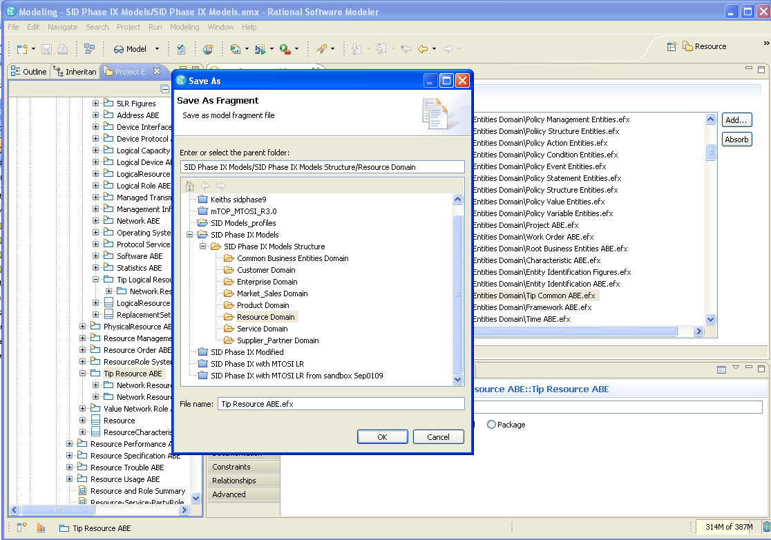

Update all references

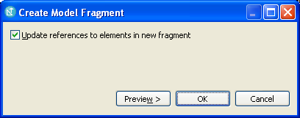

Check if EFX files are present in the project folder as follows where all fragments files are stored:
SID Phase IX Models\SID Phase IX Models Structure
Validate the model.
It can also be created the “Add…” button in the Fragments tab.

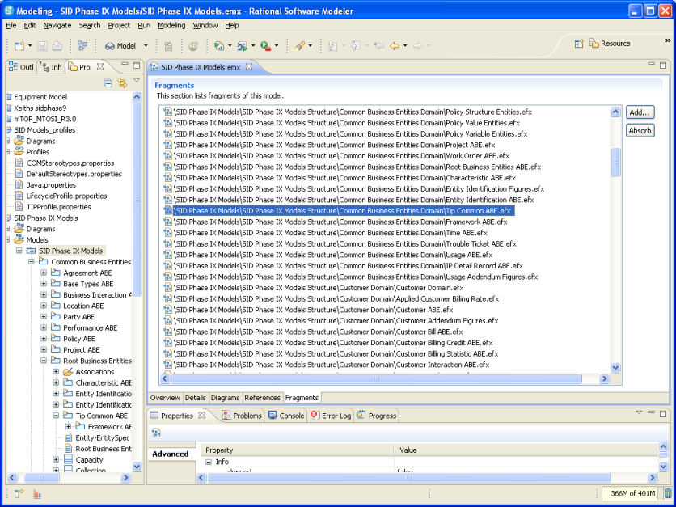

MODEL TRANSPLANT WORK STOPS HERE AND MODEL DOCUMENTATION WORK BEGINS.

Step 16 Add relationships from new TIP model to other SID classes
Only relationships that are present in the MTOSI/MTNM model between Logical Resources and Physical Resources should be added. These relationships will be from classes in the NEW Logical Resource model added in the previous steps to classes in the NEW/ADJUSTED Equipment model constructed by the Physical Resource activity.

Validate the model.

Step 17 Construct new diagrams to be used for 5LR
To be detailed as the model is constructed and added on completion of previous steps.

- Showing MTOSI classes in inheritance tree
- Showing <<doNotImplement>> relationships
- Showing relationships to implement
- Showing several simplified forms of model
- Showing metaclass inheritance (adjust diagram from MTOSI)
Note that there will be several other diagrams constructed as the model is completed and as the Primer is generated.

Step 18 Adjust the SID diagrams to account for the MTOSI model addition
All 5LR figures are to be reviewed. The following figures need to be adjusted (note that some highlighted are for future adjustment, this is made clear in the comments and where the figure only requires future mods the comment is surrounded by "[... ...]". This section requires some updates.
- Figure 5 (Resource split)
  - The relationship between Physical and Logical Resource should be marked with the <<doNotImplement>> stereotype (Note: Resource and should mark the bonus relationships caused by this with <<doNotImplement>> stereotype)
    - The specific relationship between PTP and Equipment will be added separately.
- Figure 7(Resource - Product)
  - As per figure 5
- Figure 9 (Product - Resource - Service)
  - As per figure 5 but also should show <<doNotImplement>> relationship from LogicalResource to RFS
- Figure 11 (LR Subclasses)
  - Need to show MTNM/MTOSI classes on the diagram - diagram usage needs to be clarified.
- Figure 13 ( Resource and ResourceSpec Overview)
  - As per figure 5
  - This highlights the ResourceSpecification SpecifiesResource relationship. This relationship should be marked the <<doNotImplement>> stereotype
- [...Figure 14 (ResourceSpecs)
  - Does not require change at this stage but does highlight areas of specification that need to be adjusted in later phase...]
- [...Figure 18 (Concept of DeviceRoles)
  - Does not require change at this stage but does highlight a poor area of the model (over specialisation, not clear if simply for example or intended to be solution form etc...]
- Figure 19 (LogicalResourceRole)
  - Introduces Role. Relationship between LR and Role be marked with the <<doNotImplement>> stereotype
- Figure 20 (PartyRole-ResourceRole)
  - As Figure 19 for LogicalResource and ResourceRole
  - Also need to mark "OwnsResource" relationshio with the <<doNotImplement>> stereotype
- [...Figure 21(ResourceSpec and ResourceSpecChar)
  - Does not require change at this stage but does need to be worked in the next phase to grow a pattern for resource specification related to the G.800 work...]
- Figure 22 (Resource and ResourceCharValue)
  - Relationships from Resource need to be marked <<doNotImplement>> (to spec and spec characteristic value)
- [...Figure 27 (DeviceInterface Subclasses)
  - Not in this phase but an area for major work in phase 2/3...]
- [.. Figure 30 (Protocol Hierarchy)
  - Not in this phase but this is in essentially LayerRate!...]
- Figure 32 (CompoundResource Model)
  - As per figure 5
  - Also need mark the the aggregation relationship from CompoundResource to Resource as <<doNotImplement>>
- Figure 33: (CompoundResource Instance Example)
  - As per figure 32
  - Note that we may wish to have an instance diagram for MTNM/MTOSI or alternatively point from the SID documentation at the information in the SDs for MTNM/MTOSI especially SD1-18.
- Figure 34 (SID-MTNM Integration)
  - Needs to be replaced with a correct representation of the new model and the name of the figure needs to be changed to MTNM/MTOSI... There is probably text with this figure in the SID that needs to be adjusted.
- [... Figure 35 (ResourcePort Programming - First Attempt)
  - Not in this phase but will want to show relationship between PTP and ports etc...]
- [... Figure 36 (ResourcePort Programming - Final Design)
  - Not in this phase but will want to show relationship between MTNM/MTOSI model of this sort ...]
- Figure 37 (MTE Top-Level Hierarchy)
  - Indicate that Figure outlines objects that are marked <<likelyToChange>>..
- [...Figure 41 (Mapping networkAccessDomain to the SID)
  - Not in this release but shows ManagementDomain and ManagedEntity and requires rework in phase 2/3 ...]
- Figure 42 (Termination Point Final Diagram)
  - Indicate that Figure outlines objects that are marked <<likelyToChange>>
  - Requires equivalent for MTNM/MTOSI, could Update with TerminationPoint final Diagram
- [... Figure 43 (First Attempt at Defining a Network)
  - Not in this release but need to understand context and probably needs refinement (First attempt at defining Network is an odd title)... ]
- Figure 45 (ResourcePort Details), 46 (Network Composite Classes), 47 (Network Class Subclasses), 48 (Policy Management of Network Entities):
  - Need to mark the resource role relationship from CompoundResource to Resource as <<doNotImplement>>
  - No other mods in this release but will need rework in later release to relate PTP to compound resource, resource port and physical port
- Figure 51 ( Resource-ResourceRole)
  - Need to mark the the "role describes logical resource details" relationship from LogicalResourceRole to LogicalResource as <<doNotImplement>> (and assume the same for PhysicalResource case)
- Figure 52 (LogicalResourceRole Overview)
  - Need to mark the the relationship from LogicalResourceRole to LogicalResource as <<doNotImplement>>
  - No other mods in this release but will need to rework in later release to related PTP to the role
- [... Figure 55 (MgmtMethodEntity-MgmtInfo)
  - Not in this release but will require significant rework with respect to ManagementMethod and ManagementInfo in an as yet unplanned release ...]
- Figure 56 (PartyRole-LogicalResource)
  - Need to mark the OwnsResource relationship from PartyRole to Resource as <<doNotImplement>>
  - Not in this release but will need to determine the relationship between PartyRole and owner etc.
- Figure 60 (Protocol Biz Model)
  - No change to figure but must have supporting text that emphasises that the MTNM/MTOSI model uses a simple single attribute for this information (i.e. LayerRate).
- Figure 61 (CompoundResource Biz Model)
  - The relationship between Physical and Logical Resource should be marked with the <<doNotImplement>> stereotype (Note: Resource and should mark the bonus relationships caused by this with <<doNotImplement>> stereotype)
    - The specific relationship between PTP and Equipment will be added separately.
  - This highlights the CompoundResource aggregates Resource relationship. This relationship should be marked the <<doNotImplement>> stereotype.
- Figure 62 (Resource Role Biz Model)
  - Need to mark the ResourceTakesOnRoles relationship from Resource to ResourceRole as <<doNotImplement>>
- Figure 65 (Pipe Subclasses), 66 (TP Biz Model)
  - Many of these classes are marked <<likelyToChange>>. It will be necessary to make comments on this against this diagram
- Figure 71 ( LayerNetwork Diagram)
  - The layered model is migrating over time to one more consistent with G.800 and MTNM/MTOSI. It will be necessary to make comments on this against this diagram
- Figure 74 (LogicalResource-LogicalResourceSpec Biz Model)
  - This highlights the ResourceSpecification SpecifiesResource relationship. This relationship should be marked the <<doNotImplement>> stereotype
- Figure 75 (ResourceSpexXXX Biz Model)
  - This highlights the CompoundResource aggregates Resource relationship. This relationship should be marked the <<doNotImplement>> stereotype.
  - This highlights the ResourceSpecification SpecifiesResource relationship. This relationship should be marked the <<doNotImplement>> stereotype
  - The relationship between Physical and Logical Resource should be marked with the <<doNotImplement>> stereotype (Note: Resource and should mark the bonus relationships caused by this with <<doNotImplement>> stereotype)
    - The specific relationship between PTP and Equipment will be added separately.
- Figure 77 (LRSpec Subclasses Biz Model)
  - This highlights the CompoundResource aggregates Rsource relationship. This relationship should be marked the <<doNotImplement>> stereotype.
  - This highlights the ResourceSpecification SpecifiesResource relationship. This relationship should be marked the <<doNotImplement>> stereotype
  - The relationship between Physical and Logical Resource should be marked with the <<doNotImplement>> stereotype (Note: Resource and should mark the bonus relationships caused by this with <<doNotImplement>> stereotype)
    - The specific relationship between PTP and Equipment will be added separately.
- Figure 80 (MTE Biz Model)
  - Many of these classes are marked <<likelyToChange>>. It will be necessary to make comments on this against this diagram
- Figure 82 (Network Biz Model)
  - The layered model is migrating over time to one more consistent with G.800 and MTNM/MTOSI. It will be necessary to make comments on this against this diagram
- Figure 87 (LogicalResourceSpec Detailed Biz Model)
  - This highlights the CompoundResource aggregates Rsource relationship. This relationship should be marked the <<doNotImplement>> stereotype.
  - This highlights the ResourceSpecification SpecifiesResource relationship. This relationship should be marked the <<doNotImplement>> stereotype
  - The relationship between Physical and Logical Resource should be marked with the <<doNotImplement>> stereotype (Note: Resource and should mark the bonus relationships caused by this with <<doNotImplement>> stereotype)
    - The specific relationship between PTP and Equipment will be added separately.
- Figure 88 (Resource Characteristic Biz Model)
  - This highlights the CompoundResource aggregates Rsource relationship. This relationship should be marked the <<doNotImplement>> stereotype.
  - This highlights the ResourceSpecification SpecifiesResource relationship. This relationship should be marked the <<doNotImplement>> stereotype
  - This highlights the ResourceDescribedBy CharacteristicValue relationship. This relationship should be marked the <<doNotImplement>> stereotype
  - The relationship between Physical and Logical Resource should be marked with the <<doNotImplement>> stereotype (Note: Resource and should mark the bonus relationships caused by this with <<doNotImplement>> stereotype)
    - The specific relationship between PTP and Equipment will be added separately.
Following figures have been checked (note some figures are not included in the 5LR figures package): 5, 7, 8, 9, 11, 12, 13, 14, 15, 16, 18, 19, 20, 21, 22, 23, 24, 25, 26, 27, 28, 30, 31, 32, 33, 34, 35, 37, 41, 42, 43, 45, 46, 47, 48, 51, 52, 53, 54, 55, 56, 57, 59, 60, 61, 62, 63, 64, 65, 66, 67, 68, 69, 70, 71, 72, 73, 74, 75, 76, 77, 79, 80, 81, 82, 83, 84, 85, 86, 87, 88, 89 <end>
Following figures were not in 5LR Diagrams module in RSM: 1, 2, 3, 4, 6, 10, 17, 29, 36, 28, 39, 40, 44, 49, 50, 58, 78

Step 19 Update accordingly transplanted documentation in packages, classes to be reviewed
The following are relevant artifacts with MTOSI documentation have been transplanted along, and/or adjusted during the transplant process. These need to be reviewed:
- Framework:
  - Framework: Data Object Classes CommonObjectInfo
  - Framework: Data Object Classes ManagementDomain
  - Framework: Type Definitions

- NetworkResourceAssurance:
  - NetworkResourceAssurance:DataObjectClasses:AlarmSeverityAssignmentProfile
  - NetworkResourceAssurance: PerformanceMonitoringPoint
  - NetworkResourceAssurance: DataObjectClasses: ProtectionGroup
  - NetworkResourceAssurance: DataObjectClasses: TcaParameterProfile
  - NetworkResourceAssurance: Type Definitions and under all types preserved in the Transplanted model (ProtectionType, SwitchReason)

- NetworkResourceBasic
  - NetworkResourceBasic: Data Object Classes: CommonResourceInfo
    - NetworkResourceBasic: Data Object Classes: CommonResourceInfo: ituStateAndStatusList
    - NetworkResourceBasic: Data Object Classes: CommonResourceInfo: networkAccessDomain
    - NetworkResourceBasic: Data Object Classes: CommonResourceInfo: resourceState
    - NetworkResourceBasic: Data Object Classes: CommonResourceInfo: source )when confirmed)
  - NetworkResourceBasic: Type Definitions
    - NetworkResourceBasic: Type Definitions: ItuStateOrStatus
    - NetworkResourceBasic: Type Definitions: ObjectSource
    - NetworkResourceBasic: Type Definitions: ItuStateOrStatusNameValuePair
    - NetworkResourceBasic: Type Definitions: LayerRate
    - NetworkResourceBasic: Type Definitions: TransmissionParameterList

- NetworkResourceFulfillment
  - NetworkResourceFulfillment: Data Object Classes: all classes transplanted
  - NetworkResourceFulfillment: Type Definitions
    - NetworkResourceFulfillment: Type Definitions: there is no documentation here

Step 20 Validate the model
Run a final validation to ensure that documentation phase has not damaged the model.

Step 21 Add text to MTOSI IA sections to relate SID model
To be detailed

Step 22 Add text to 5LR to Transplant MTOSI DDPs to SID Resource ABE
To be detailed

Step 23 Construct Primer
To be provided

Appendix – Stereotypes and tooling application
The attached slide pack highlights the rules that were used to apply the stereotypes to the model. It should also be noted that the assumption is that the tooling will perform the following transformations;

- All associations other than composition and specialisation to classes will be encoded as attributes of type objectName (shown in the slides)
- All Composition relationships will collapse to simple list elements in the parent of the composed elements (shown in the slides)
- All specialization relationships will cause the child to adopt all attributes of its parent (shown in the slides)

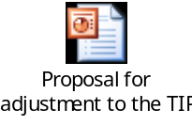

Appendix - Diagram Cleanup

Remove the “From …” in diagrams by selecting classes and setting the parent style to none.

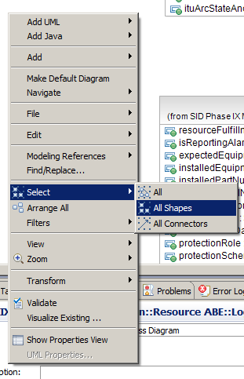

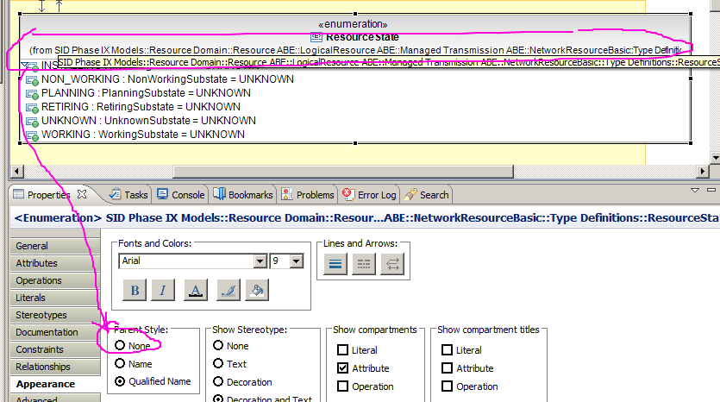

or from the menu
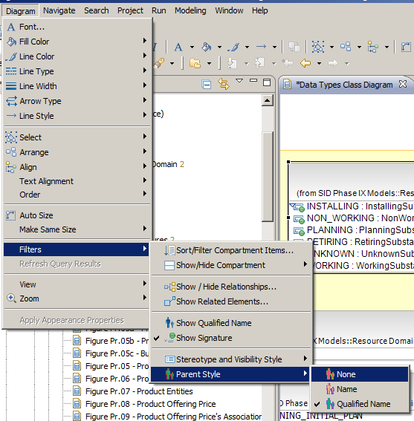

Where possible, for any new entities, attributes and relationships the SID (GB921U) guidelines should be followed especially with respect to naming of these items. However, where items are being added from MTOSI the current names can be maintained at this point. In a future phase there will be a general name migration..
The intention is that this profile be applied broadly across the SID independent of the TIP work. So the stereotype may be applied in ABEs that are not (or are not yet) being used for interface generation.
When manipulating, changing, etc MTOSI I found it is desirable to close SID model
Service management and Test DDPs cause validation errors. It is assumed these will be fixed in MTOSI but as they are not necessary the easisets approach is to remove them
When cleaning MTOSI30 it is better to close SID model to avoid any interference
There is a risk that this stereotype may need to change in future but addition at this stage will ease any changes.
We should call this tipProductSupport really but we will keep productSupport until we find out how to change the stereotypes without destroying the model.
This change to the TIP Profile has been validate with Bernd Zeuner and Marc Flauw. The basis for the removal is that the SID should not carry implementation technology specific information
The current form of the TIP Profile applies the stereotypes to every class in the SID where as a vast majority of the classes are not used by TIP.
The explicit list is base_Abstraction, base_Association, base_AssociationClass, base_Class, base_DataType, base_Dependency, base_Generalisation, base_GeneralOrdering, base_Interface, base_Operation, base_Package, base_Parameter, base_Property, base_Reaslisation, base_Relationship and base_StructuralFeature
The aim is to further harmonise and rationalise this and other ABEs in the following phases of work.
Although Equipment is retained temporarily it is not relevant in the LR diagrams
Although EquipmentHolder is retained temporarily it is not relevant in the LR diagrams
In previous versions the instruction was to “Delete all attributes and relationship reference from within the class but keep class”.
In previous versions the instruction was to “Delete this class”.
aEndTpList appears to relate to GTP only in the model. This should be explored and corrected during a later phase of work.
Note that the attribute namingOsRef currently is encoded as a naming attribute. It is debatable whether this is actually valid as the OS is not a entity named in the MTOSI interface and hence although an NVS list structure may be appropriate it is not actually an MTOSI name. The attribute has been left unchanged in the SID model for this release.
The naming relationships are deleted as these classes are empty.
Note that this class may be deleted eventually as it appears to not have a relationship from TP although it has a relevant relationship to TP that provides key resource model details.
Note that this class may be deleted eventually as it appears to not have a relationship from TP although it has a relevant relationship to TP that provides key resource model details.
While marking relationships the one to commonObjectInfo and CommonResourceInfo could be excluded but these will be deleted later anyway.
The naming relationships will be kept but marked appropriately to ensure that they are recognised as not to be implemented by simple relationship attributes.
This stereotype indicates that they should not be implemented for TIP but has no bearing on any other implementation that the user may choose to do.
Note that this move is only for temporary classes that will be migrated to the Physical Resource model fully by the Physical Resource activity
Do not copy any relationships
Note that the SID may give errors from areas not being adjusted and these should be ignored at this point.

