Our game is a dungeon crawler with elements of horror, collection, and puzzles. The player will be able to collect treasure in order to increase their score. Each dungeons will have enemies, traps, and puzzles. Enemies will become progressively harder and change in appearance. For example, our first level will have magical wisps which will later be replaced by scary ghasts. Traps will come in form of spike traps and frightening jump scares activated by pressure plates and will increase the player’s fear meter. Puzzles will come in the form of the dungeons’ layout and tricks. Lastly, the player will be surrounded in a constant fog of war limiting their knowledge of their environment.

The object of our game is to clear all of the dungeons’ floors and collect treasure. We will be using the WASD keys for movement, the mouse buttons for attacking and blockings, and the J key for easy mode. To win the player must clear all dungeon floors in the game. Their score will be based on how much treasure they collected along the way. The player loses if they run out of health.

Layouts

Title Concept

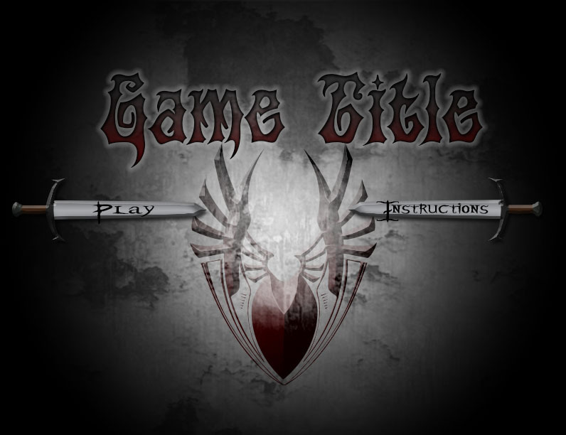

Game over Concept

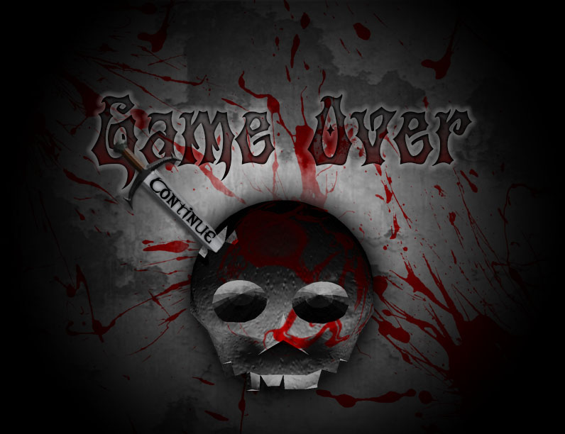

Game Board Example

