COMP4002 Games Coursework: Documentation
Student Name: Tom Golden
Student ID Number: 20796209

PART A
Design outline
Players: 1
(Primary) Objective(s): Mine as many rocks as possible from a volcano, then escape when it erupts
(Primary) Procedure: The player’s character can mine in all 8 directions, and single jump high enough to jump two tiles high at a time. The time until eruption
(Primary) Rules:
Resources: The player’s score reflects how many ores they have mined (and if they escape, how deep they have dug). The player’s time left is a resource – they must manage it during the playthrough.
Conflict: The player wants to dig straight down to get to the more valuable ores, but doing so makes the escape harder. Time forces fast progress, preventing the player from optimal planning. Some rocks are harder to mine than others, choosing the dig path represents tradeoffs. Some valuable ores have environmental effects that cause logistical challenges for the player.
Boundaries: The player cannot dig through certain rocks, which enforce the game’s spatial boundary. The player can dig down forever, though ores act as the limiting factor on time, which eventually runs out and the eruption acts as the time boundary, and the bottom spatial boundary. The player can escape via the rope at the top of the mountain, which acts as the upper most boundary.
(Primary) Outcome: No explicit win condition - the game incentivises getting as high a score as possible - in an arcade style.

Core mechanic or game loop: Dig and explore, looking for ore. Ensure timer does not reach 0. Avoid environmental hazards. Upon timer running out, escape, creating a path as necessary.

Sketch overleaf

Sketch, diagram or screenshot
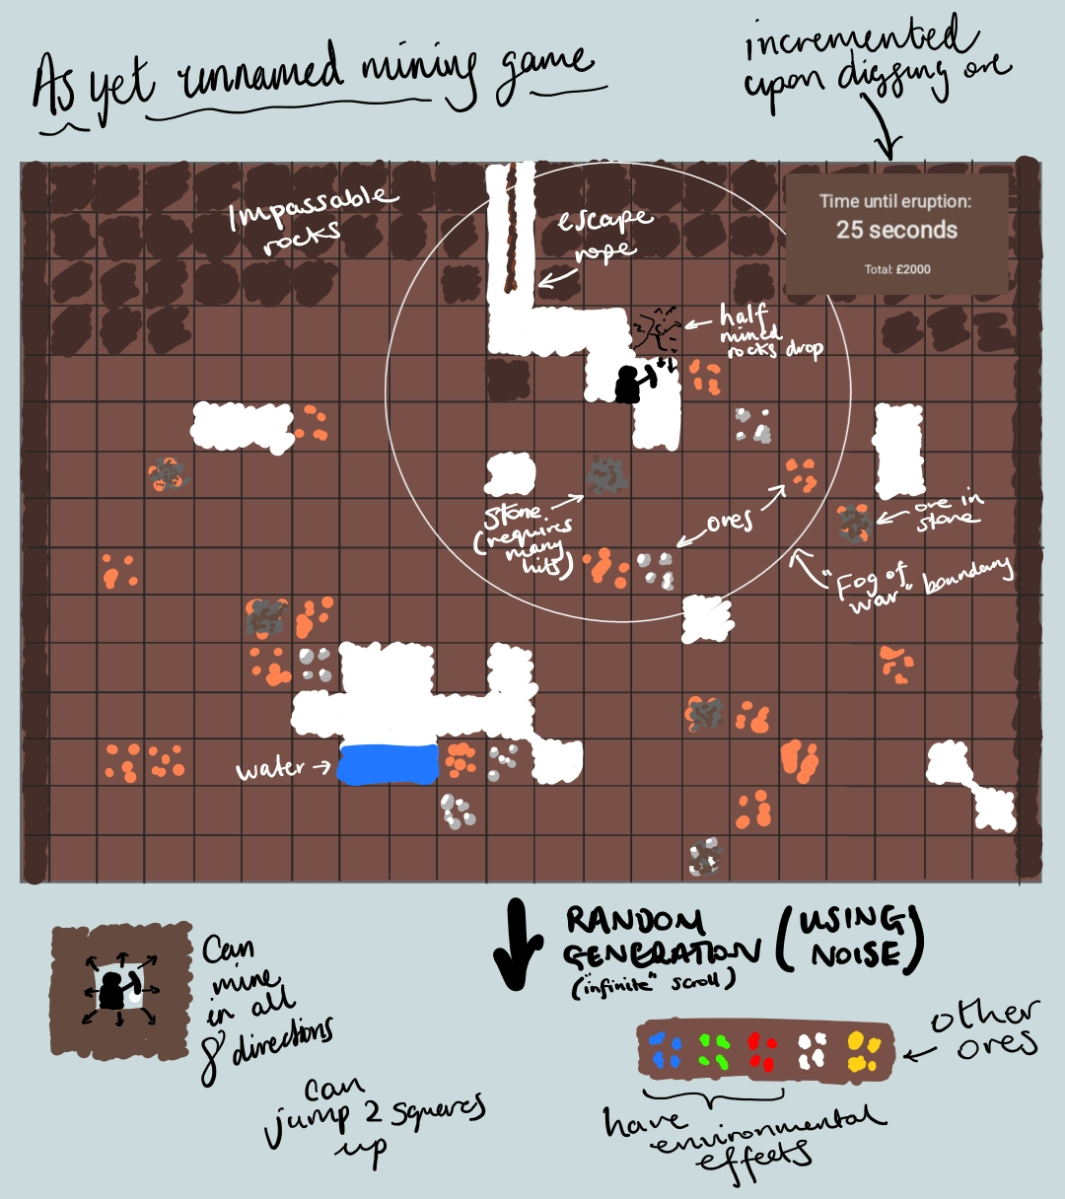

PART B
Prototype Trailer
https://youtube.com/shorts/JXObimSHIYQ?feature=share

Premise
You are a teddy bear. You like mining ore. We’ve all been there...

What starts as a search for diamonds quickly becomes a dangerous puzzle of urgency - a puzzle of escape.

(The game is a puzzle platformer with mining mechanics. The main differentiator is that you must escape using the path you used to dig down.)
Prototype Instructions
To move, use arrow keys.

To mine, use the keys (Q for mine up and left, X for mine down, etc):
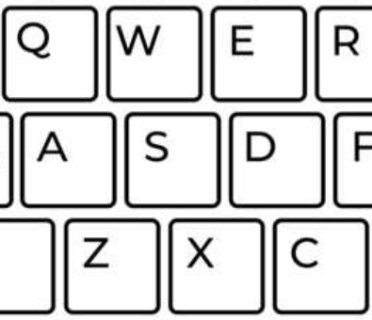
These keys are directional, with the S at its centre.

Complete the tutorial levels between each chamber; dig down to find the diamond, surviving hazards (each gem besides the diamond has an area effect) and escape the same way you came up - escaping through the diamond door before the lava catches you.

There are two main logistical issues in the prototype to be aware of:
- When the game respawns the player, the level/game is not reset to where it would have been when they were there. You may find it easier to open the game in Godot, and manually move the player between chambers if it becomes too challenging to complete each level without respawning.
- Ore would allow you to buy powerups to aid survival via vending machines, but this was not implemented for the sake of the prototype.

Unlike the original version pitched, this changes the gameplay loop by having area effects from things like water and gas flowing - as well as the lava - to apply the pressure on the player to dig down and escape with urgency. The mining area of each chamber has also been made narrower to further emphasise this pressure of digging down.

Asset Manifest
All music (in music subdir) was taken from this source: https://loyaltyfreakmusic.com/music/a-tale-is-never-forgotten/
("A Tale is never forgotten" by "Komiku")

The pixel art font was taken from here:
https://fonts.google.com/specimen/Tiny5

The rest - including sprites and code - is entirely my own work.

No Generative AI was used at any point.

File checklist
Project download location: https://github.com/tmgldn/miner-game

[x] Godot standalone build (/Made of Stronger Fluff.exe)
[x] Godot project folder (/)
[x] Trailer .mp4 or .mov (/made-of-stronger-fluff.mp4)

