PROJECT DOCUMENTATION REPORT
Smart Multi-Pot Irrigation System
ESP32-Controlled, Rotary-Valve Watering System (No Soil Sensors)
A plain-language explanation of how the system works, how it is
built, and what it costs — for readers with no technical background
Document Version 1.0
Prepared: July 2026
Project: HydroHub — Smart Irrigation Initiative

Table of Contents
1. Executive Summary3
2. The Problem This System Solves3
3. How the System Works (Overview)3
4. What Happens During a Single Watering Event6
5. What the App Lets the User Control6
6. Hardware Used, Explained Simply7
7. Software and Control Logic, Explained Simply7
8. Maintenance and Possible Future Additions8
9. Glossary — Plain-Language Definitions8
10. Summary8

1. Executive Summary
Most home watering systems treat every plant the same way — one schedule, one zone, no exceptions. But a basil plant, a fern, and a succulent don't want the same amount of water at the same times. This project solves that problem without needing a separate pump or valve for every single pot, which would be expensive and complicated.
Instead, the system uses one water pump and one clever rotating valve. The valve works like a spinning selector: it turns to point at whichever pot needs water, water flows through it briefly, and then it moves on. All of the scheduling — which pot, how often, for how long — is set by the user from a simple phone app.
Unlike many "smart garden" products, this system does not use soil moisture sensors. That is a deliberate choice: soil sensors are prone to corroding, giving false readings, and needing regular cleaning. This system instead relies on a reliable internet-synchronized clock and user-defined timers, which is simpler to build, cheaper, and easier to maintain.
In one sentence:
A phone app lets the user name each pot and set a watering schedule; an ESP32 controller follows that schedule, turns a rotating valve to the right pot, and briefly runs a shared pump — with no soil sensors involved.

2. The Problem This System Solves
Different plants have very different watering needs. A succulent might only need water every two days, while a leafy fern may want it daily. Standard irrigation timers water an entire zone on one single schedule, which means some plants get overwatered and others get underwatered.
Building a fully separate pump and pipe for every pot would fix this, but it would be expensive, bulky, and wasteful — most of the time, most pumps would simply be sitting idle. This project's goal was to get the benefit of per-plant scheduling using the smallest, cheapest possible amount of hardware.

3. How the System Works (Overview)
The diagram below shows every part of the system and how they connect: the water tank and pump, the ESP32 controller, the rotating valve, the multi-channel outlet base, all eight pots, and the phone app used to control everything.
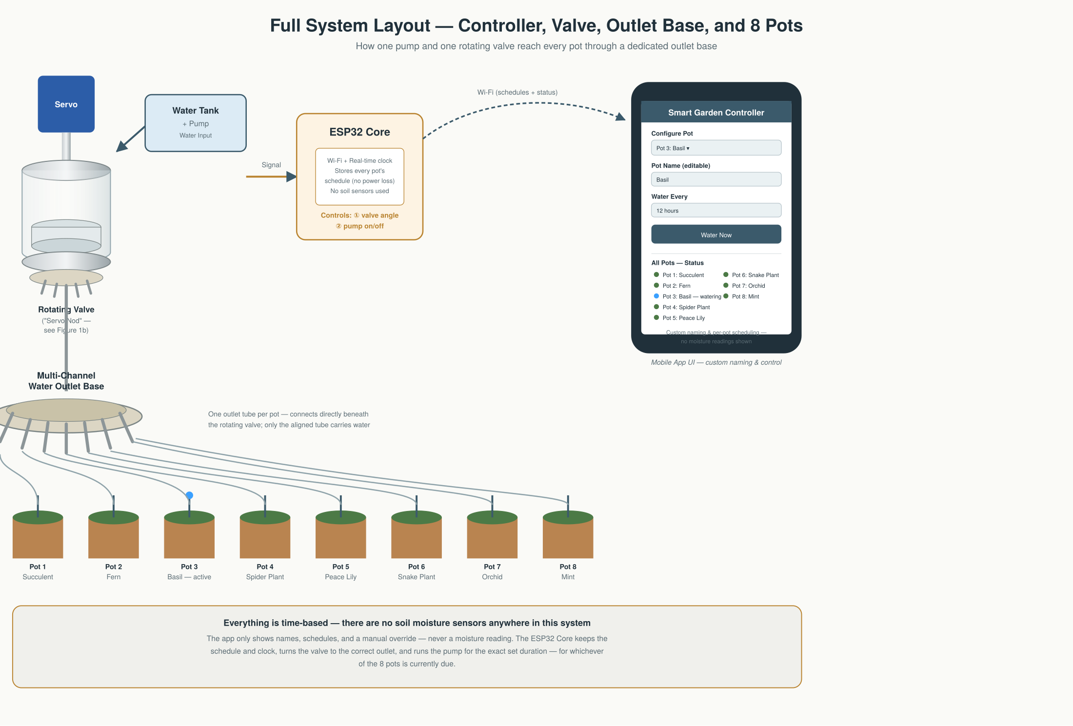
Figure 1 — Full system layout: controller, valve, outlet base, all 8 pots, and the app

A Closer Look at the Rotating Valve
Because this rotating valve is the one genuinely novel part of the design, it's worth seeing in more mechanical detail. The diagram below breaks the assembly into its physical layers: the servo motor on top, the sealed housing, the internal chamber that actually rotates, and the ring of outlet pins at the bottom — one pin per pot.
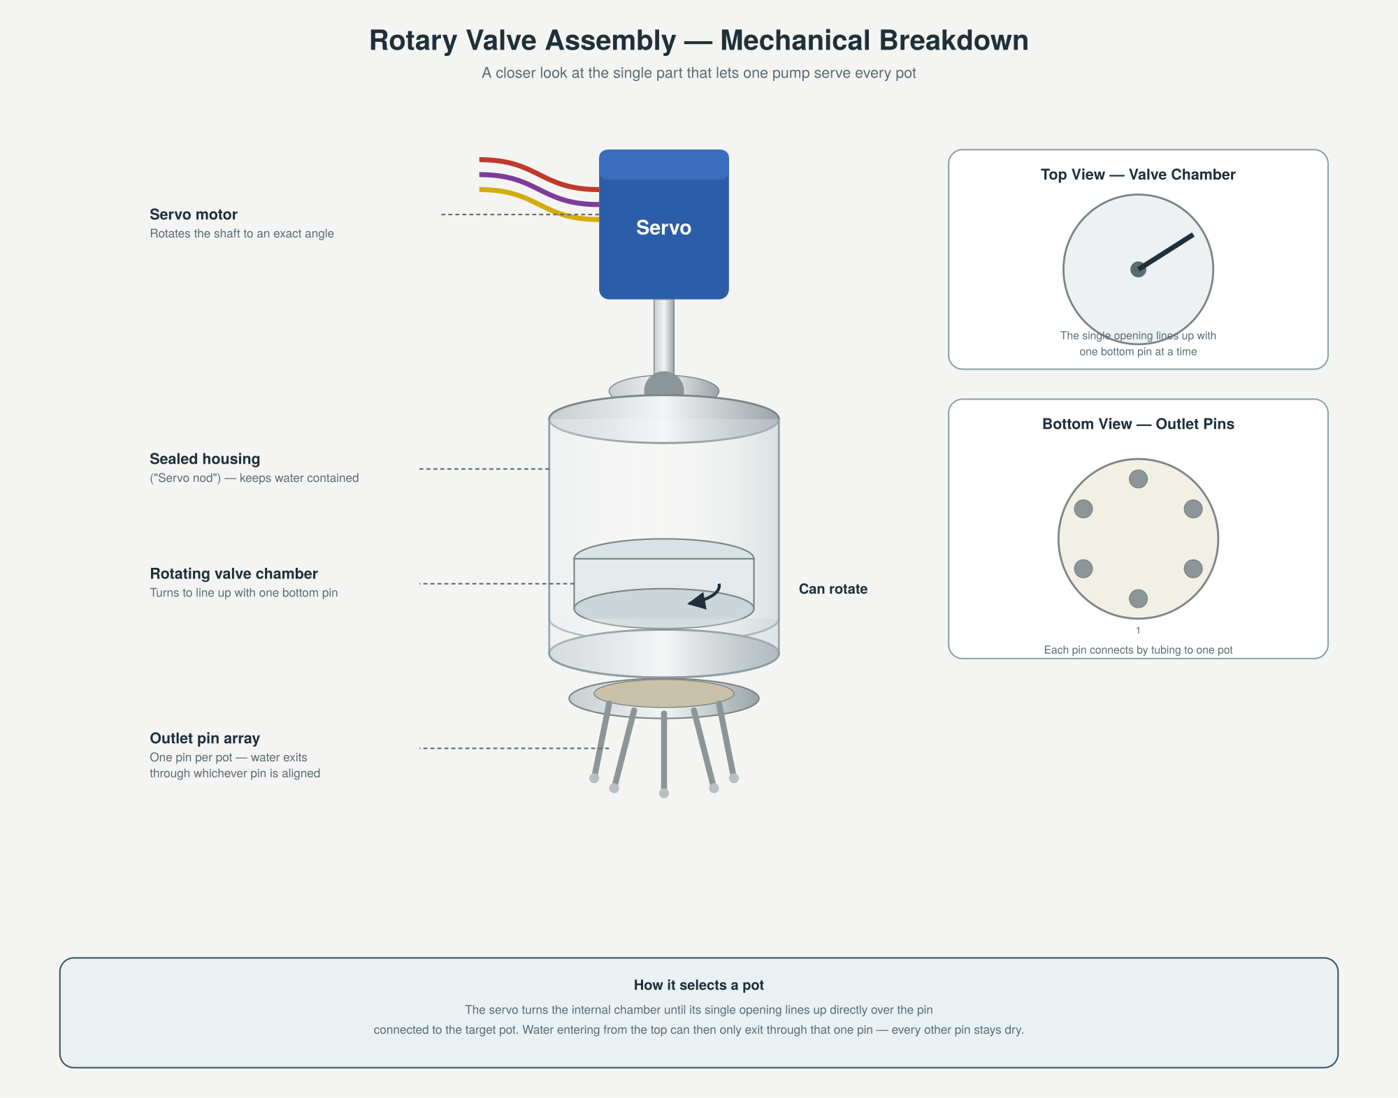
Figure 1b — Mechanical breakdown of the rotary valve ("servo nod") assembly

3.1 The Phone App
This is the only part of the system the user directly interacts with. From the app, the user can:
- Give each pot a custom name (e.g. "Kitchen Basil", "Desk Bonsai")
- Set how often that pot should be watered (every 6, 12, 24, 48 hours, or 7 days)
- Set exactly how long the water should run for, in seconds
- Trigger a "Water Now" for any pot instantly, without disturbing its normal schedule
All of these settings are sent from the phone to the ESP32 over the home Wi-Fi network — the same way a smart plug or smart bulb is controlled from an app.

3.2 The ESP32 Controller
The ESP32 is a small, inexpensive computer chip that acts as the brain of the whole system. It keeps an accurate clock (synced over the internet), remembers every pot's schedule even if the power goes out, and decides exactly when to act.

3.3 The Rotating Valve
This is the mechanical heart of the design. A motor called a servo sits on top and turns an internal chamber like a dial. Water enters from the pump at the top, and depending on where the dial is currently pointing, it exits through one specific pipe at the bottom — the one connected to the pot that's due for watering.

3.4 The Multi-Channel Outlet Base and the Pots
Just beneath the rotating valve sits the multi-channel outlet base — a fixed connector with one tube per pot (eight in this design). Each pot has its own dedicated pipe running from this base. Because only one pipe is ever "open" at a time (wherever the valve is currently pointing), only one plant receives water at any given moment — but the system cycles through all eight pots automatically, each on its own independent schedule.

4. What Happens During a Single Watering Event
To make this concrete, here is exactly what happens, step by step, when it's time to water one particular pot.
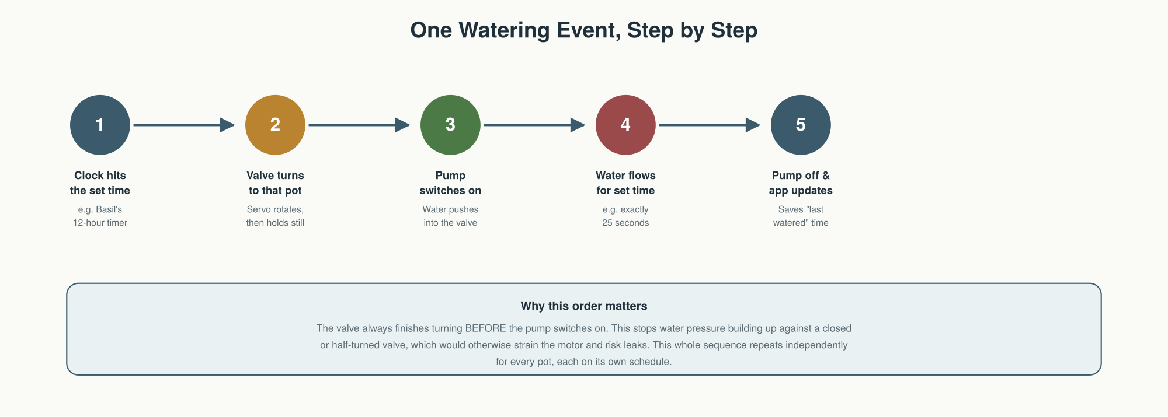
Figure 2 — The five steps of a single automatic watering event
This same five-step sequence repeats independently for every pot, each time its own individual schedule comes due. Two or more pots are never watered at the exact same instant, since there is only one shared pump and one shared valve — but because each watering only takes a matter of seconds, this is not a practical limitation.

5. What the App Lets the User Control
- Custom pot naming — rename any channel to match the actual plant
- Per-pot watering interval — e.g. every 6h / 12h / 24h / 48h / 7 days
- Per-pot watering duration — precise, down to the second
- Manual override — an instant "Water Now" button per pot
- Status view — shows when each pot was last watered and when it's next due
Because there are no soil sensors, the app does not show moisture readings — it is purely a scheduling and control tool, which keeps it simple and easy to use for someone with no technical background.

6. Hardware Used, Explained Simply
The table below lists every physical part in the system, its approximate cost, and — most importantly — what it actually does in plain terms.
# | Component | Qty | Role in plain terms | Est. Cost (USD)
1 | ESP32 Development Board | 1 | The brain of the system | $4.50
2 | High-Torque Servo Motor (MG996R) | 1 | Turns the rotating valve | $6.80
3 | Rotary Valve Assembly (custom) | 1 | Directs water to one pot at a time | $12.00
4 | 12V DC Diaphragm Water Pump | 1 | Pushes water through the valve | $8.50
5 | 12V 3A Power Adapter | 1 | Powers the pump | $6.00
6 | Buck Converter (12V to 5V) | 1 | Safely powers the servo motor | $1.80
7 | MOSFET Switch Module | 1 | Lets the ESP32 turn the pump on/off | $2.20
8 | Silicone Drip Tubing (4 mm, 10 m) | 1 | Carries water from valve to each pot | $5.00
9 | Fittings & Connectors | 1 | Holds tubing and wiring together | $7.00
 | Estimated Total |  |  | $53.80
Estimated total build cost: approximately $53.80 USD per unit (excluding the plant pots and water tank).

7. Software and Control Logic, Explained Simply
The ESP32's program does three main jobs, repeated continuously:
- Keep an accurate clock, corrected periodically over the internet, so schedules stay precise even over weeks or months
- Store every pot's settings safely, so a power cut does not erase anyone's schedule
- Watch the clock and, the moment any pot's time is due, carry out the five-step watering sequence described in Section 4
The phone app and the ESP32 exchange small pieces of information over Wi-Fi — mainly "here is the new schedule" (app to ESP32) and "here is the current status of each pot" (ESP32 to app).

8. Maintenance and Possible Future Additions

8.1 Routine Maintenance
- Periodically flush the tubing to prevent mineral buildup
- Check the rotating valve's seal for wear every few months
- Refill the water tank as needed

8.2 Possible Future Additions
- Remote firmware updates, so the controller's software can be improved without physically accessing it
- A simple water-level sensor for the tank, to warn the user before it runs dry
- Optional soil moisture sensors, if the user later decides they want automatic feedback in addition to fixed schedules

9. Glossary — Plain-Language Definitions
A quick reference for any technical terms used in this report.
Term | What it means
ESP32 | A small, low-cost computer chip with built-in Wi-Fi. It is the "brain" of this project — it keeps the schedule, tells time, and controls the motor and pump.
Servo motor | A motor that turns to an exact angle and holds that position. Here it rotates the valve to line up with the correct pot.
Rotary valve | A round mechanical part with one opening on top and several outlets underneath. As it turns, it lines up with a different outlet — like a spinning door that opens onto a different room each time.
NTP (Network Time Protocol) | A way for a device to get the exact correct time over the internet, similar to how a phone's clock updates itself automatically.
NVS (flash memory) | A small storage area inside the ESP32 that keeps saved settings even when the power goes out — so schedules aren't lost.
MOSFET / Relay | An electronic switch. The ESP32 uses it to turn the water pump fully on or off, since the pump needs more power than the ESP32 can supply directly.
Wi-Fi / App communication | The phone app and the ESP32 talk to each other over the home Wi-Fi network, the same way a smart bulb or smart plug is controlled from a phone.

10. Summary
This system provides one clear benefit over a standard irrigation timer: every single plant can be watered on its own schedule, using shared, low-cost hardware. By deliberately leaving out soil moisture sensors, the design stays simple, affordable, and easy to maintain, while still giving the plant owner full, precise control through an easy-to-use phone app.

