Trevor Greenside

Tom Hughes

Matthew Lee

Assignment #11

Contributions:

* Thomas helped with figuring out how to get the commands working and troubleshooting running MapReduce on the Gonzaga cluster.
* Trevor wrote the test and cleanup scripts, managed the Git repository, and conducted DevOps to streamline development.
* Matthew translated the provided pseudocode to Java and lead debugging. He was lead developer on this project.

Output from compiling and running the TermPairCount program. Note that compiling, testing, and output are managed by the test.sh file.

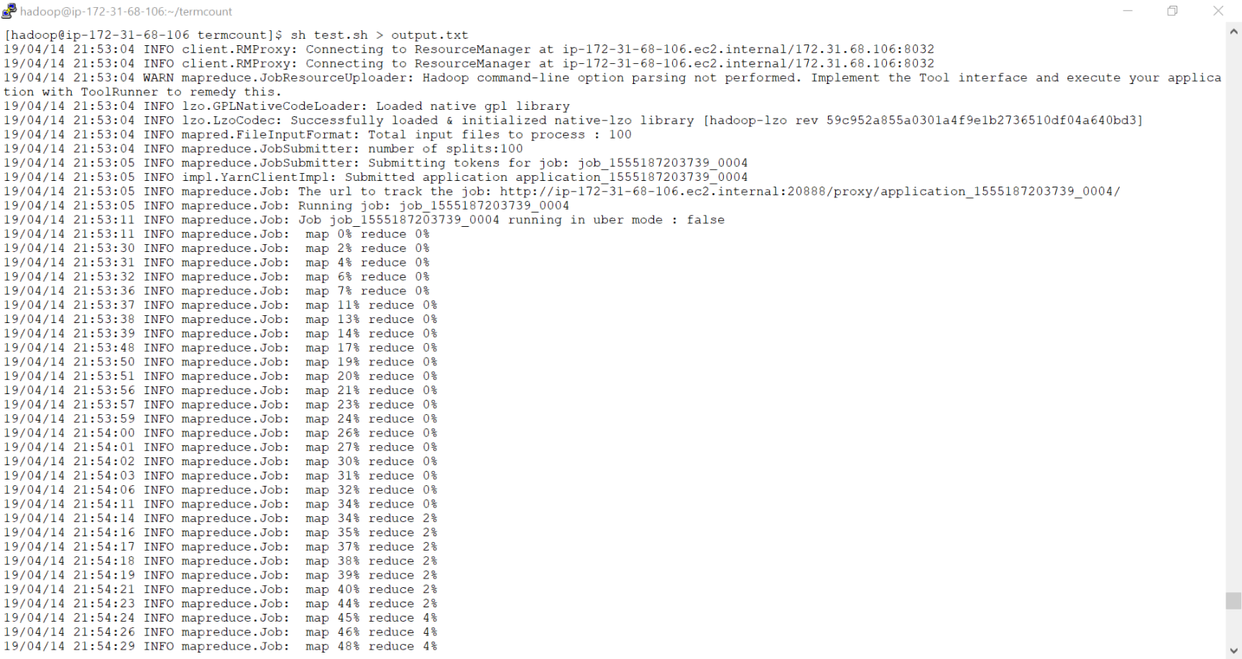

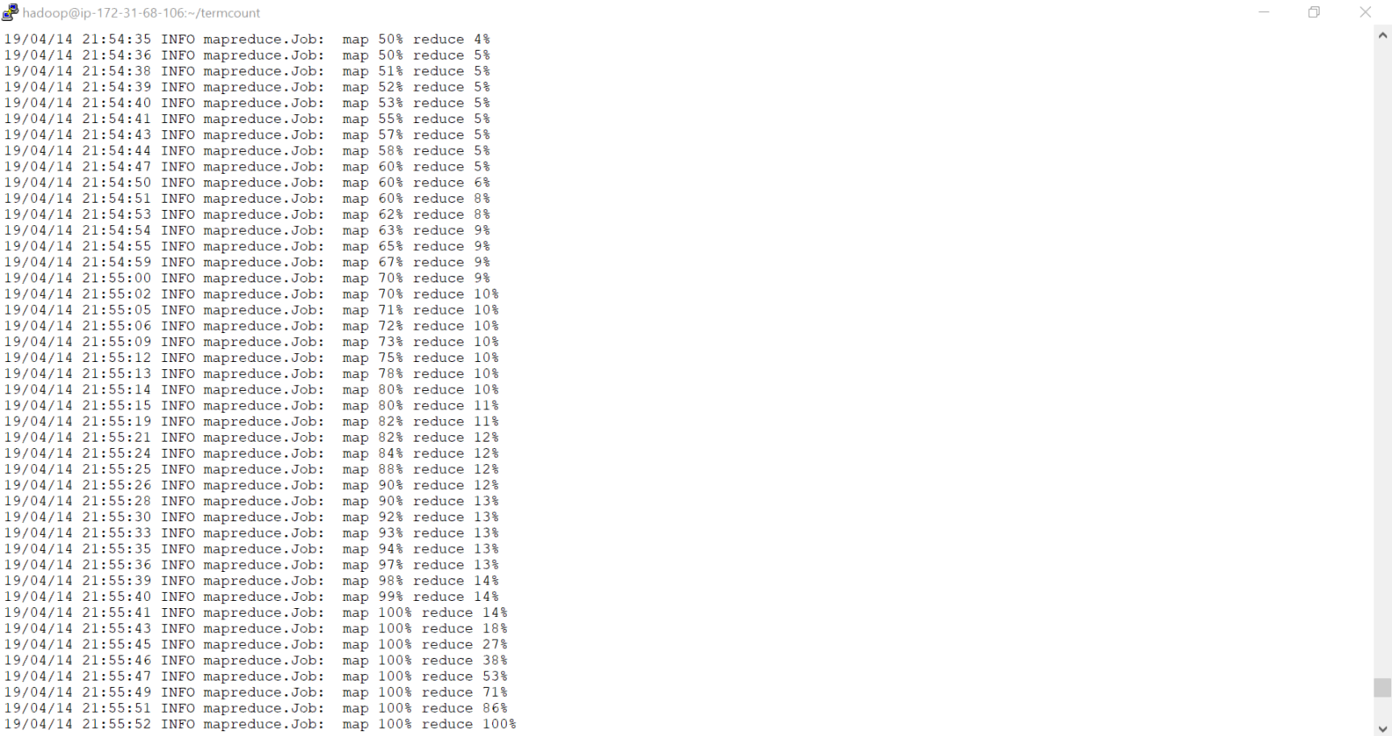

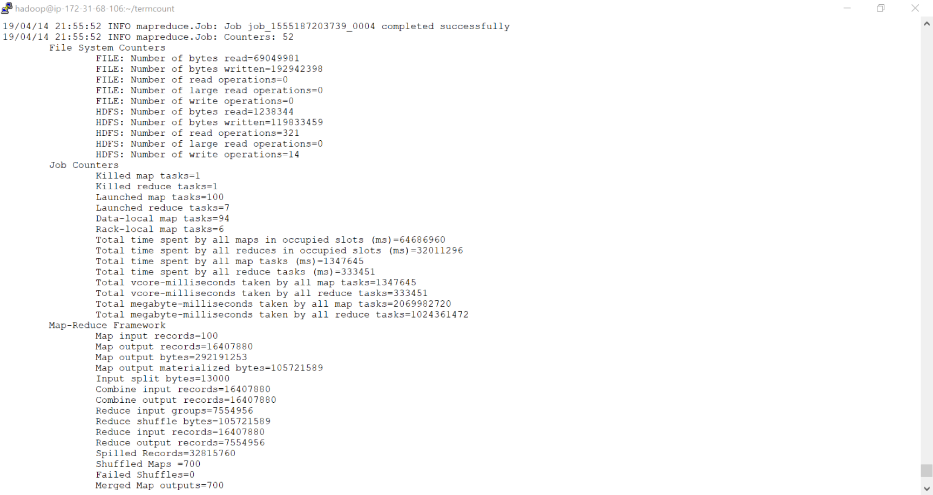

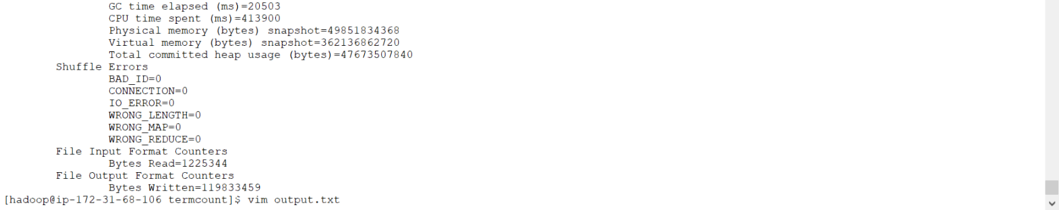

Sample output:

1000247 2

1000247,1145667 1

1000247,1156237 1

1000247,1159527 1

1000247,1000247 2

1000247,1150572 1

1000247,1171362 1

1000247,1280464 1

1000247,1301751 2

1000247,1305923 1

1000247,1312062 2

1000247,1327413 1

1000247,1327616 1

1000247,1335876 1

1000247,1417055 2

1000247,1427198 1

1000247,1444656 1

1000247,1510827 1

1000247,1511625 2

1000247,1511695 1

1000247,1512080 1

1000247,1514873 2

1000247,1517631 1

1000247,1517806 1

1000247,1518422 2

1000247,1518681 1

1000247,1520214 1

1000247,1521761 2

1000247,1627358 1

1000247,1701810 1

1000247,1704729 1

1000247,1710378 1

1000247,1710574 1

1000247,1711239 1

1000247,1711351 2

1000247,1879547 2

1000247,1880177 1

1000247,1882074 2

1000247,1882508 1

1000247,1883712 2

1000247,1960278 1

1000247,2346972 1

1000247,2347469 2

1000247,2348792 1

1000247,2349975 2

1000247,2587184 1

1000247,2610690 1

1000247,2681537 2

1000247,2699156 2

1000247,2825142 1

1000247,2949735 1

1000247,2951520 1

1000247,2984756 1

1000247,3152252 1

1000247,3244092 1

1000247,3272372 2

1000247,3538743 2

1000247,3538806 1

1000402,1257751 1

1000402,1273305 1

1000402,1274040 1

1000402,1301725 1

1000402,1316572 1

1000402,1415895 1

1000402,1427487 1

1000402,1510941 1

1000402,1514721 1

1000402,1515981 1

1000402,1516695 1

1000402,1547061 1

1000402,1551786 1

1000402,1552738 1

1000402,1555265 1

1000402,1660153 1

1000402,1708726 1

1000402,1710378 1

1000402,1883712 1

1000402,2349165 1

1000402,2827734 1

1000402,2986676 1

1000402,3539879 1

1000402,3541314 1

1002 4

1002,1080898 1

1002,1096774 1

1002,1115660 1

1002,1135183 1

1002,1155000 1

1002,1155266 1

1002,1184743 2

1002,1185625 1

1002,12238 3

1002,1272684 4

1002,1273517 4

1002,1278655 1

1002,12854 2

1002,1292732 2

1002,1300565 2

1002,13064 1

1002,13113 1

1002,1315013 4

1002,13218 1

1002,1328929 1

1002,1334046 1

1002,13715 1

1002,1412999 2

1002,1415351 1

1002,1416933 1

1002,1442448 1

1002,1442455 2

1002,1442462 1

1002,14597 1

1002,14772 2

1002,150103 1

1002,150369 1

1002,1510747 1

1002,1511790 2

1002,1514534 1

1002,1515101 1

1002,1517495 2

1002,1519042 1

1002,1519168 1

1002,1519595 1

1002,1519623 1

1002,1522472 1

1002,15283 1

1002,15388 1

1002,1550101 2

1002,1554077 1

1002,162388 1

1002,1624 1

1002,1624602 1

1002,16263 2

1002,1704241 1

1002,1704675 1

1002,1704689 1

1002,1705242 1

1002,1705417 1

1002,1706852 4

1002,1707391 2

1002,1708595 2

1002,1708728 1

1002,17243 1

1002,17446 2

1002,17558 1

1002,175723 2

1002,175730 1

1002,175996 1

1002,1819461 1

1002,185117 4

1002,1880165 1

1002,1880389 2

1002,1883357 2

1002,1883525 1

1002,1947946 2

1002,1955394 1

1002,1978802 1

1002,205088 2

1002,205172 3

1002,205214 3

1002,205263 3

1002,205396 2

1002,205410 1

1002,205431 1

1002,205543 2

1002,205557 1

1002,206243 2

1002,20792 2

1002,20960 2

1002,21044 1

1002,21135 2

1002,21149 1

1002,21485 1

1002,22675 1

1002,22885 1

1002,229665 1

1002,229686 1

1002,230715 1

1002,2345 1

1002,234621 1

1002,23473 1

1002,2348019 1

1002,2348236 4

1002,23487 1

1002,2348887 1

1002,23508 2

1002,237820 2

1002,242349 2

1002,24264 2

1002,24299 1

1002,243091 1

1002,243161 1

1002,24348 2

1002,24530 1

1002,24537 1

1002,2520 1

1002,25664 2

1002,2607943 3

1002,26259 1

1002,26777 1

1002,268060 1

1002,26882 1

1002,27778 1

1002,280100 1

1002,2826182 2

1002,2828366 1

1002,28303 1

1002,2987476 1

1002,30956 1

1002,312860 2

1002,3178849 1

1002,31789 1

1002,3179017 1

1002,31831 1

1002,32181 1

1002,3241 3

1002,32594 1

1002,3272453 1

1002,332152 1

1002,332173 1

1002,332257 4

1002,332453 1

1002,333321 1

1002,3339 2

1002,34036 4

1002,34848 1

1002,35191 2

1002,35268 1

1002,3538705 1

1002,3538992 1

1002,36563 1

1002,369637 4

1002,37088 1

1002,37179 1

1002,37494 1

1002,38250 2

1002,38894 1

1002,3962 1

1002,42219 1

1002,42520 1

1002,427184 1

1002,427716 2

1002,428304 1

1002,428479 1

1002,43038 2

1002,4340 1

1002,439070 2

1002,439084 4

1002,439175 2

1002,439742 1

1002,439861 1

1002,441436 3

1002,441471 1

1002,441835 1

1002,442598 1

1002,443193 1

1002,443228 2

1002,445034 1

1002,449381 1

1002,449822 1

1002,449864 1

1002,449878 2

1002,449913 4

1002,450333 1

1002,450354 1

1002,450375 2

1002,450382 1

1002,450389 1

1002,457242 1

1002,475211 1

1002,542341 1

1002,54322 1

1002,54868 1

1002,5516 3

1002,5775 1

1002,589507 1

1002,596227 1

1002,596654 1

1002,597277 4

1002,597298 1

1002,597361 1

1002,597704 1

1002,600210 1

1002,600322 1

1002,60916 1

1002,6104 1

1002,6797 1

1002,680220 1

1002,682523 1

1002,684224 3

1002,700198 1

1002,7413 1

1002,7448 1

1002,750563 1

1002,750591 2

1002,7595 1

1002,7616 1

1002,79459 1

1002,79613 1

1002,79816 1

1002,80103 2

1002,813724 1

1002,85437 1

1002,855227 1

1002,870312 1

1002,871208 2

1002,8736 1

1002,882828 1

1002,882849 2

1002,886384 2

1002,934502 1

1002,935440 1

1002,939276 1

1002,9450 1

1002,949307 1

1002,991566 2

1003001,1167624 1

1003001,1314939 1

1003001,1327413 1

1003001,1332320 1

1003001,1412820 1

1003001,1417055 1

1003001,1419337 1

1003001,1441506 1

1003001,1444656 1

1003001,1512045 1

1003001,1514873 1

1003001,1517001 1

1003001,1518422 1

1003001,1521761 1

1003001,1555599 1

1003001,1705175 1

1003001,1707478 1

1003001,1709305 1

1003001,1720092 1

1003001,2610891 1

1003001,2945617 1

1003001,3244092 1

1003001,3272372 1

1003001,3538743 1

1003001,3538806 1

10046,10454 3

10046,108282 1

10046,1136143 1

10046,1139930 4

10046,1148554 1

10046,1148673 1

10046,1149289 1

10046,11546 2

10046,1155008 1

10046,1155064 1

10046,1159950 1

10046,1173313 1

10046,1185738 2

10046,11945 1

10046,120742 2

10046,1235746 1

10046,123759 1

10046,12568 1

10046,1292425 2

10046,1293097 3