Recommender Systems - Course Project Report
Cumulative report template - Parts 1, 2, and 3
Team | Group 6
Members | Tatu Anttila, Arttu Kiviranta, Patrik Salmensaari
For Part 3 track: select one | A / B / C
GitHub repository link | https://github.com/tmhantti/RecSystems_project

How to use this template
- This is one cumulative report. Extend and revise the same document at each project stage.
- Maximum length: 4 pages at Part 1, 8 pages at Part 2, and 12 pages for the final report, excluding references.
- Keep the section headings below. You may add subsections where useful.
- All explanations and justifications requested in the project specification belong in this report.
- The Results Sheet contains the complete standardized numerical record. In the report, include only the tables and figures needed to support your analysis.
- Delete all italic instructional text before the final submission.

1. Part 1 - Data, Protocol and Baselines

1.1 Data characterization
In total, the retrieved database includes 6040 users, 3706 movies and around one million interactions (ratings given). The density was calculated to be around 4.47%, indicating that vast majority of user/movie rating matrix consist of missing values. To further look into the statistical features , distribution of ratings was calculated (Figure 1) along with distributions of ratings given per user and per movie (Figure 2).
Figure 1 shows that ratings are biased towards favorable ratings, the mean and median ratings being around 4.0 and 3.58, respectively. From Figure 1 (top) one can see that ratings per user distribution exhibit long tail towards larger counts: in semi-logarithmic scale, counts decrease almost linearly up to around 1000 ratings / user. The 50% and 90% quantiles were 96 and 400, implying that average user submitted 96 ratings and that 10% of the users rated more than 400 movies. Similarly, ratings / movie count distribution displays long tail, and the counts decrease almost linearly in the semi-logarithmic scale up to around 1500 ratings / movies (Figure 2, bottom). The 50% and 90% quantiles were around 124 and 730 in this case. Taken together, these results show that there is a relatively small group of highly active users (in terms of rating movies) and a small set of movies that have received disproportionately large share of ratings.
We also took a look at the activity (as measured by the number ratings given) across the time span of the data set which cover time period of April 2000 to February 2003 (Figure 3). Initially, the number of ratings rises rapidly so that half of them were already subscribed by around November 2000 and after a burst of activity, around 90% of the total was reached by January 2001. Afterwards, the activity flattens out. As a consequence, the ratings are not distributed evenly in time but are concentrated on relatively small period between March 2000 and January 2001. It should also be noted that the rated movies are published between 1919 and 2000, so no movie published during the survey is included in the data set.
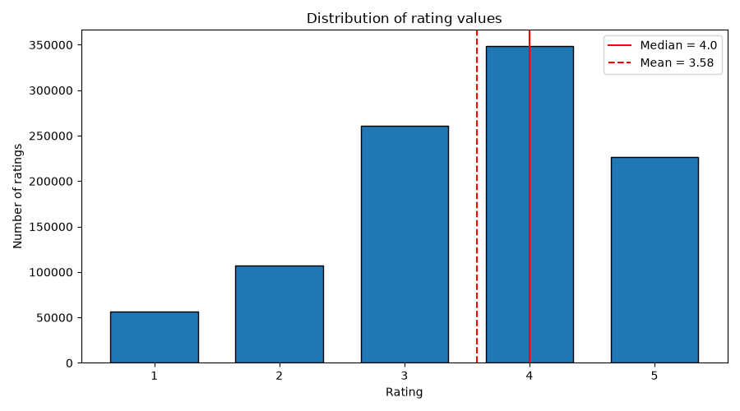
Figure 1. Rating distribution.
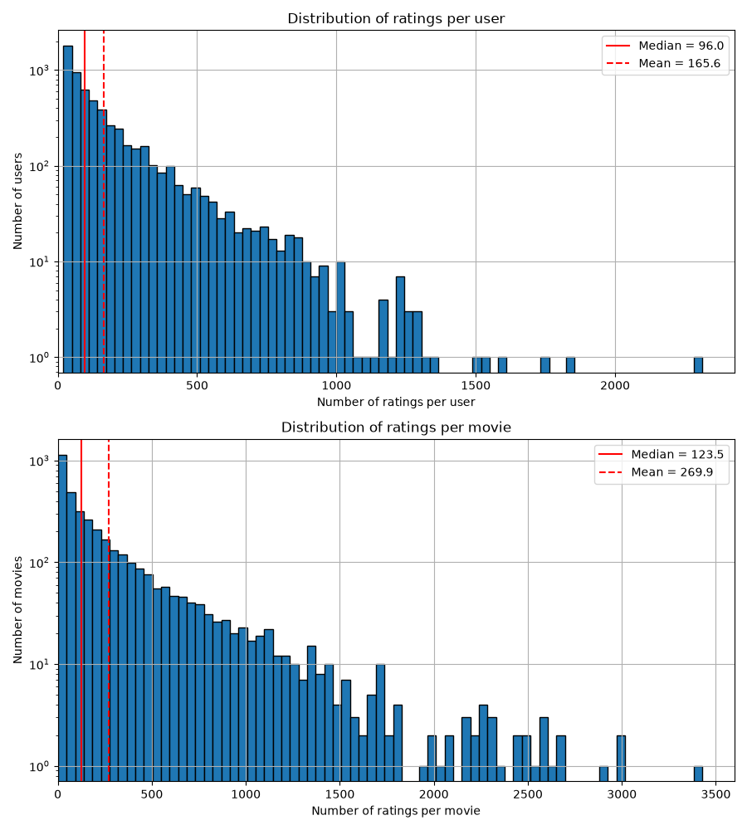
Figure 2. Histograms of ratings per user (top) and per movie (bottom). Note that y-axis are in logarithmic scale.

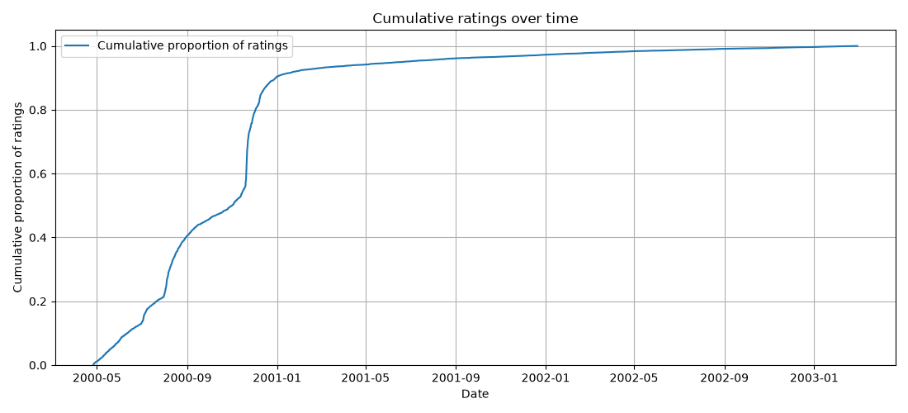
Figure 3. Cumulative sum of rating count relative to the total rating count.

1.2 Preprocessing and feedback treatment
We iteratively filtered the complete dataset before splitting: users needed at least 25 ratings and movies at least 5 ratings. This removed 416 users, 293 movies, and 9,725 rating rows, leaving 5,624 users, 3,413 movies, and 990,484 ratings. Ratings of 4 or 5 were treated as positive feedback for kNN training and evaluation; lower ratings were retained for descriptive statistics but were not positive targets.

1.3 Train/validation/test split
For each retained user, ratings were ordered by timestamp. The two most recent ratings were assigned to test, the preceding two to validation, and all earlier ratings to training. This produced 967,988 training, 11,248 validation, and 11,248 test ratings. The chronological split prevents future interactions from being used to predict earlier ones.

1.4 Evaluation protocol
Recommendations were ranked against the full filtered catalogue of 3,413 movies, excluding movies already present in each user's training history. We report Precision@10, Recall@10, NDCG@10, and catalogue coverage. Relevance was defined as a held-out rating of at least 4. NDCG@10 was used as the primary validation selection metric because it accounts for the rank of relevant items.

1.5 Baseline methods and settings
The item-based kNN model represents each movie by a sparse vector of user ratings and uses scikit-learn NearestNeighbors. We evaluated cosine and Euclidean distances with k in {1, 2, 5, 10, 15, 20, 30, 40, 60, 80}. Models were fitted on training data only. Cosine distance performed substantially better; the best validation configuration was cosine with k=10 (NDCG@10 = 0.0478).

1.6 Results and analysis
After selecting cosine k=10 on validation, the model was refitted on the combined training and validation data and evaluated once on test. The resulting Precision@10 was 0.0120, Recall@10 was 0.0769, NDCG@10 was 0.0431, and catalogue coverage was 0.1386. The validation plot shows that larger cosine neighborhoods generally reduced ranking quality and coverage; Euclidean produced much lower ranking metrics despite higher coverage at small k.

2. Part 2 - Models and Honest Comparison

2.1 Models
Describe the additional models and paradigms. Clearly identify the self-implemented algorithm and explain its implementation.

2.2 Hyperparameter tuning and variability
Describe the validation-only tuning procedure, search spaces/budgets, random seeds, and confidence intervals or statistical testing.

2.3 Overall results
Present and discuss the main comparison. Explain important differences and avoid unsupported claims.

2.4 Disaggregated analysis
Report and interpret results broken down by at least two of the required dimensions: items with few vs. many training interactions, low- vs. high-activity users, popular vs. long-tail items, and early vs. late test period. Define any thresholds used and focus on findings that change or qualify the overall conclusions.

2.5 Sparsity ablation
Report and discuss the 100%, 50%, and 20% training-interaction experiments, including changes in the ranking between models.

3. Part 3 - Beyond Accuracy

3.1 Selected track and motivation
State Track A, B, or C and briefly motivate the selected intervention/extension.

3.2 Method
Describe only your selected track. The Track A/B/C guidance below is provided as instructions; delete the guidance for the two tracks you did not select before submission.

If Track A - Diversity and popularity bias
State the base recommender, selected re-ranking method, genre-vector item representation, trade-off parameter, and exact item-distance measure. Describe how the parameter was swept.

If Track B - Fairness
Define the release-decade provider proxy, report and justify the final decade boundaries and group sizes, state and justify the adopted fairness notion, describe the consumer groups based on MovieLens user attributes, and identify the stage and form of the mitigation.

If Track C - Group recommendations
State the selected synthetic group type and justify the chosen group size (3-5). Describe the three aggregation strategies. Identify which strategy was extended to the sequential scenario and explain how satisfaction is carried forward between recommendation rounds.

3.3 Results and trade-offs
Present the required track-specific results. Track A: report intra-list diversity, catalogue coverage, Gini and calibration error across the parameter sweep, and discuss the accuracy-diversity frontier. Track B: report position-weighted exposure against catalogue share, per-group consumer-side accuracy, and the fairness-performance frontier. Track C: compare group satisfaction, disagreement and minimum member satisfaction across the three aggregation strategies, then analyse how member and group satisfaction develop in the sequential scenario.

3.4 Cost and interpretation
State what is gained, what is lost, and who bears the cost where applicable. Explain what operating choice or strategy you would select and why.

3.5 "One number we cannot explain"
Identify one result you do not fully understand and describe how you would investigate it.

4. Discussion and Conclusions
Summarize the main findings across the project. Discuss limitations, failed approaches where relevant, and what the experiments support.

5. Contribution Statement
For each team member, provide two or three sentences describing their contribution.

6. Use of AI Assistants
State which AI tools were used and for what. If none were used, state that explicitly.

References
List references used in the report. References do not count toward the page limit.

