Tiffany Hernandez - tmhernan

SER 316

Assignment 3

**Task 3 Important Notes:**

Changes to method calculateAverageWithoutMinWithoutMax before testing include fixing counter variable so it’s calculating the average correctly and subtracting min and max from counter to calculate the correct average. Data control flow graph is based on these changes only (screen shot below).

Node Coverage Test Cases (some are also edge)

TS 1: {<53, 54, 56, 57, 58, 59, 60, 82>} one student

TS 2: {<53, 54, 56, 57, 58, 62, 63, 64, 82>} two students

TS 3: {<53, 54, 56, 57, 58, 65, 66, **67, 68, 69, 70, 71, 72, 76, 77, 78, 67, 68, 69, 70, 71, 72, 76, 77, 78, 67, 68, 69, 70, 71, 72, 76, 77, 78,** 79, 80, 81, 82>} three students, point positive, less than min and less than max. Min: 20 Point: 10 Max: 30

TS 4: {<53, 54, 56, 57, 58, 65, 66, **67, 68, 69, 73, 74, 75, 76, 77, 78, 67, 68, 69, 73, 74, 75, 76, 77, 78, 67, 68, 69, 73, 74, 75, 76, 77, 78**, 79, 80, 81, 82>} three students, point positive, greater than min, greater than max. Min: 10 Point: 30 Max: 20

Edge Coverage Test Cases

TS 5: {<53, 54, 56, 57, 58, 65, 66, **67, 78, 67, 78, 67,** 78 79, 80, 81, 82>} three negative numbers

-All negative numbers were not calculating correctly, therefore, a fix is put in with the notation SER316-start and SER316-end. This test case cannot be properly reached until this is fixed.

-I would have written cleaner code to filter out negatives, but this would have affected my already calculated tests, control flow graph and code coverage so I tried to keep it as close to the original as possible.

TS 6: {<53, 54, 56, 57, 58, 65, 66, **67, 68, 69, 76, 77, 78,** , **67, 68, 69, 76, 77, 78,** , **67, 68, 69, 76, 77, 78,** 78 79, 80, 81, 82>} min, max and point are all the same numbers

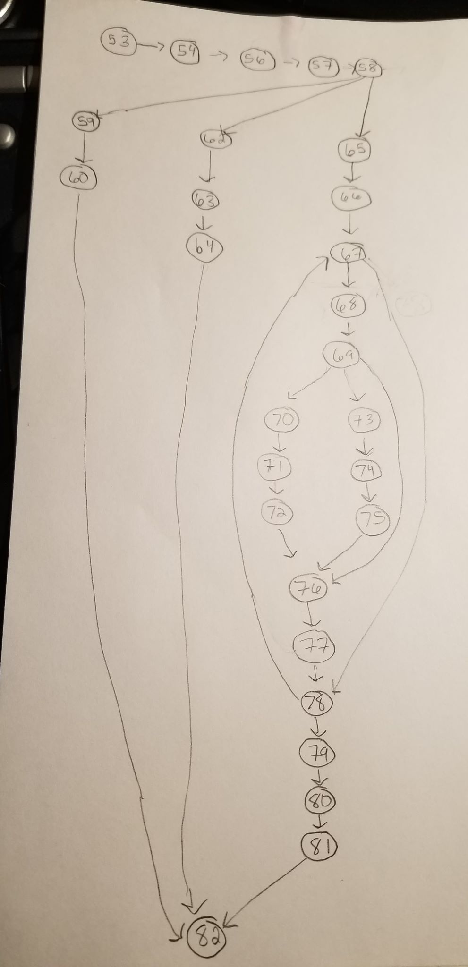

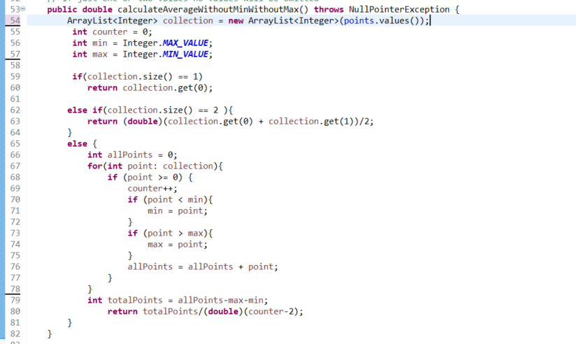

c) In your document:

i. Cut and paste your code coverage pane and include it in your document (or report when done through Gradle).

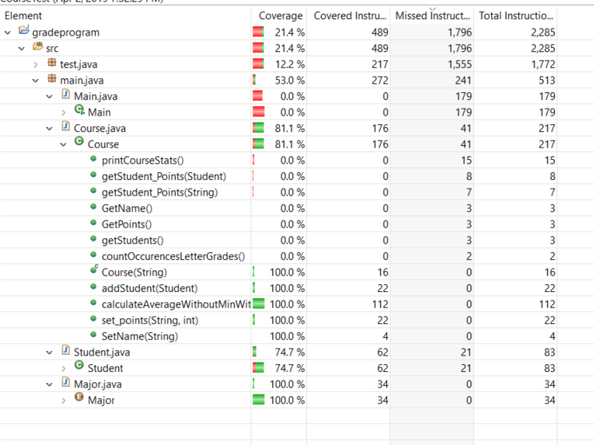

ii. Answer: What is the overall code coverage for the program?

Overall for main package it’s 53%.

iii. Answer: What is the code coverage for Course.java with your tests from CourseTest.java?

Course.java is 81.1%.

iv. If it is not already, include more Unit Tests into your test class (CourseTest.java) until you reach code coverage of at least 95% for the 3 methods you tested. (again make sure a test only counts as test, if it tests something, fix errors if you find any)

The three methods are all covered at 100% coverage.

v. Answer: What is the Code Coverage you were able to reach for each of them?

The three methods are all covered at 100% coverage.

vi. Take a screenshot of your code coverage and paste it into your document (or report when done through Gradle).

I hope I’m not missing anything here. It’s the same screenshot I posted above but here’s another, expanded:

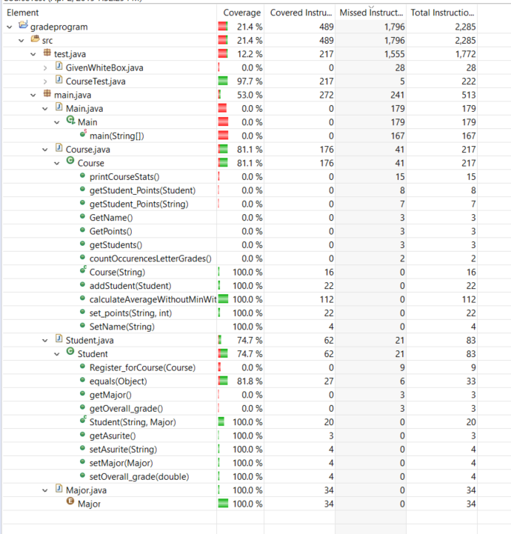

**Task 4**

