Midterm Project Overview and Final Submission

Project Goals
Our goals are to
- Replicated the visualizations from the following article: https://www.nbcnews.com/data-graphics/men-do-housework-women-still-do-more-rcna216748
- This article doesn't provide specifics about who exactly is in the sample, so we will use the definition from the linked paper, namely https://journals.sagepub.com/doi/full/10.1177/23780231251314667
  - Married men and women ages 25 to 64.
- The main tasks in this project are
  - Automate the downloading and unzipping of all the relevant files (data tables and dictionaries).
  - Explore any column mismatches (UNION) and key mismatches (JOIN).
  - Combine the relevant data.
  - Attempt the remake the visualizations two ways
    - Using a regular average and
    - Using a weighted average using the provided weight columns. Details on the weighting can be found here: https://www.bls.gov/tus/other-documentation/pooling.htm (Also see Figure 1 below)
- Special care needs to be given to make sure that all such individuals are included in the average, even if their time was 0 for any/all categories.
- We will be using sample weights to compute representative estimates for the population and comparing these estimates to regular averages (see Figure 1.).
- To practice all the related content from Module 4, you should
  - Potential A-level work. Combine the data from all the individual types of yearly files (activity, roster, respondent, and who). In other words, the 2003, 2004, ..., 2024 files are download separately and then combined. Ignore the precompiled files on the ATUS site (either combined years or summary files).
  - Maximum of B-level work. If you are struggling, you can use the combined files (combined years and/or summary files) to complete the project, but your score will reflect each compromise (e.g., using the summary files will drop the final grade one level and using both the summary files and combined yearly data files two levels).
- BONUS. As of writing these instructions, I am not getting the same numbers as found in either the article or paper. I will provide a bonus for any student that (A) can replicated the "correct" numbers (small bonus) or (B) can explain and demonstrate the cause of the differences (major bonus).

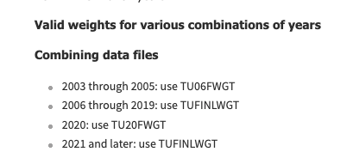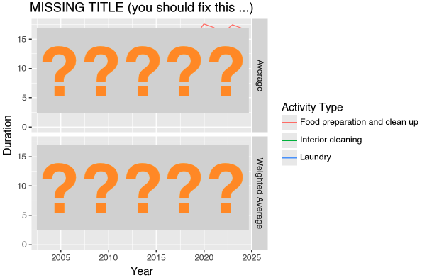
Figure 1. When combining the data across years, the weights need to be selected from the appropriate column based on the year that data was collected (RHS). The final visualizations should include plots based off both the regular and weight averages in separate facets.

Final Submission Requirements
The final submission should adhere to each of the following.
  - All relevant files, other than large data tables, should be committed to the GitHub Classroom repository for Labs 4.2-4.4.
  - The repository should have all code separated into notebooks based on the concern (see goals above and figure below).
.
├── columns.py
├── data
├── img
├── project_1_1_download_and_unzip.ipynb
├── project_1_2_column_and_key_exploration.ipynb
├── project_1_3_combine_data.ipynb
├── project_1_4_create_visualizations.ipynb
└── tree.md

Figure 2. An example structure for the final submission, where code is separated into separate notebooks by concern and Python data is share by a script file (columns.py) or CSV data tables in the data folder.
  - Python data should be shared across notebooks by either (A) using a Python script file like columns.py or (B) by importing/exporting combined data tables out to a CSV file in the data folder.
  - Code within notebooks should be navigable via the outline by using appropriate levels of headings embedded in markdown cells.

Coding Style
- Code should be as simple and readable as possible, using variable and function names that describe the data/operations in context.
- Restrict yourself to the following platforms.
  - Use polars for all data management,
  - Use plotnine for all visualizations,
  - Use glob to find all relevant paths,
  - Use list and/or dict comprehensions—as well as reduce—for any iterative tasks (no for loops!), and
  - Use the re module or built-in str methods for extraction information from a path.
  - Optionally, you can use pipe from the toolz library for any piping (i.e., piping between comprehensions).
- Other than when downloading and unzipping the data from the BLS website, Python statements should be avoided. Instead, coding should be accomplished using multiline expressions using a dot- (polars) or +-chains (plotnine).
- All conditional logic should be captured using (A) the polars when/then expression or (B) the Python if/else expression (… if … else …). No if/else statements!
- All important output should be displayed by placing your multiline expressions at the bottom of a separate code cell. No printing allowed!

