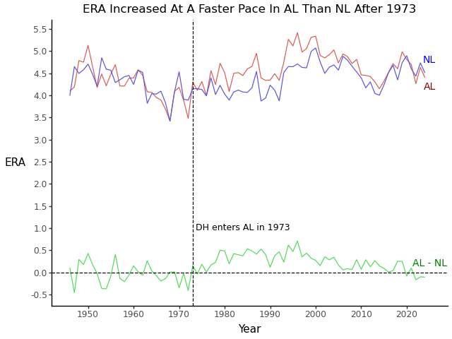

Based on the image, this chart is comparing the ERA (Earned Run Average) trends in the American League (AL) and National League (NL) over time, with a focus on the change that occurred after 1973. The chart shows that the ERA in the AL increased at a faster pace than in the NL starting after 1973, which corresponds with the introduction of the Designated Hitter (DH) rule in the AL. The green line represents the difference between the two leagues' ERA (AL - NL), which shows that the AL's ERA was consistently higher than the NL's after the rule change. The dotted vertical line at 1973 highlights the point where the DH was introduced, and the note below the graph indicates this significant change in the AL. which is interesting when you look at a chart of ERA trends between the two leagues.

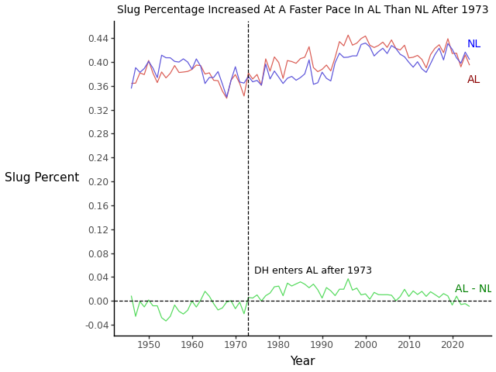

This chart is showing the trends in Slug Percentage (a baseball statistic that measures a player's ability to hit for power) for both the American League (AL) and the National League (NL) over time. The chart indicates that after 1973, when the Designated Hitter (DH) rule was introduced in the AL, the AL saw a faster increase in slug percentage compared to the NL. The green line represents the difference in slug percentage between the AL and NL (AL - NL), and it shows that the AL's slug percentage consistently surpassed the NL’s after the DH rule was implemented. The vertical dashed line at 1973 highlights the point when the DH rule was introduced in the AL, which is interesting when you look at a chart of slug percentage trends between the two leagues.