Report on DIFM Field Trial

# Header 1

## Header 2

### Header 3

A soybean seed rate trial was conducted on the Bohnhoff_Tims field in crop year 2020. The trial was implemented with a high level of accuracy. The best estimate provided by the data and model is that, under growing conditions identical to those of the field in 2020, implementing the recommended site-specific seeding rate strategy would have increased profits by approximately $46 per acre. The data and model placed a 95% level of statistical confidence that this profit gain would have been between approximately $29 and $63 per acre.

Figure 1 shows the analysis’s recommended site-specific seed rate map. The figure was calculated using data from each management zone separately. (Details about how management zones were determined are provided later in this report.) A generalized additive model (GAM) regression was used to model yield as a function of seed rate in each zone, and then given that model estimation, the profit-maximizing seed rate was found for each zone. Table 1 lists for each zone the estimated per-acre yields that would have resulted, given the year’s growing conditions, from applying the grower-chosen seeding strategy and the estimated optimal seed rate derived from the data and model.

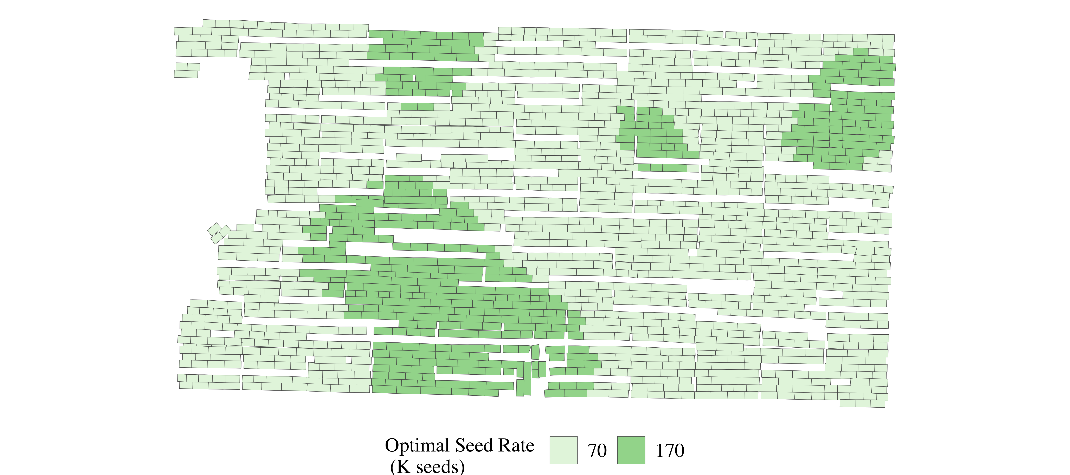

Figure 1: Estimated Optimal site-specific seed rate Rx

Table 1: Summary yield and seed rate data by zone

| Zone | Strategy | Yield (bu/acre) | Seed Rate |
| --- | --- | --- | --- |
| Zone 1 | Grower-chosen | 38 | 110 |
| Optimal site-specific | 46 | 70 |
| Zone 2 | Grower-chosen | 54 | 110 |
| Optimal site-specific | 48 | 70 |
| Zone 3 | Grower-chosen | 61 | 110 |
| Optimal site-specific | 48 | 70 |
| Zone 4 | Grower-chosen | 38 | 110 |
| Optimal site-specific | 48 | 170 |