Untitled

2022-09-27

## R Markdown

This is an R Markdown document. Markdown is a simple formatting syntax for authoring HTML, PDF, and MS Word documents. For more details on using R Markdown see <http://rmarkdown.rstudio.com>.

When you click the **Knit** button a document will be generated that includes both content as well as the output of any embedded R code chunks within the document. You can embed an R code chunk like this:

library(gt)  
library(tidyverse)

## ── Attaching packages ─────────────────────────────────────── tidyverse 1.3.1 ──

## ✔ ggplot2 3.3.6 ✔ purrr 0.3.4  
## ✔ tibble 3.1.7 ✔ dplyr 1.0.9  
## ✔ tidyr 1.2.0 ✔ stringr 1.4.0  
## ✔ readr 2.1.2 ✔ forcats 0.5.1

## ── Conflicts ────────────────────────────────────────── tidyverse_conflicts() ──  
## ✖ dplyr::filter() masks stats::filter()  
## ✖ dplyr::lag() masks stats::lag()

library(flextable)

##   
## Attaching package: 'flextable'

## The following object is masked from 'package:purrr':  
##   
## compose

gtcars %>%  
 dplyr::select(mfr, model) %>%  
 dplyr::slice(1:2) %>%  
 flextable()

| mfr | model |
| --- | --- |
| Ford | GT |
| Ferrari | 458 Speciale |

## Including Plots

You can also embed plots, for example:

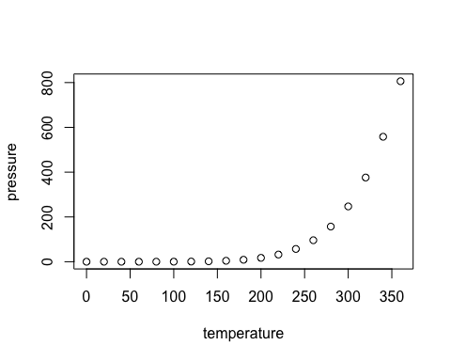

Note that the echo = FALSE parameter was added to the code chunk to prevent printing of the R code that generated the plot.