Sensor-guided Side-dressing Decision Making

Taro Mieno[1] and John Doe[2]

2020-11-09

Abstract: this research is so awesome that you cannot reject this paper.

# Introduction

bluh bluh

Adrian, Norwood, and Mask (2005) examined bluh bluh.

bluh bluh (Shrader, Fuller, and Cady 1966)

bluh bluh (Shrader, Fuller, and Cady 1966; Adrian, Norwood, and Mask 2005)

bluh bluh (1966)

##### page break (you cannot see this text on the output WORD file)

# Materials and Methods

This line break does not work: See?

This line break does work:

See?

## Data

The number of observations are 598 and 1376 for Zones 2 and 3, respectively.

Table 1 presents summary statistics by zone.

## Statistical Model

Here is the statistical model to estimate:

$Y_{z}=f_{z}(S)+g_{z}(N)+h_{z}(X,Y)+ε_{z}$

$=f_{z}(S)+g_{z}(N)+h_{z}(X,Y)+ε_{z}$

$=f_{z}(S)+g_{z}(N)+h_{z}(X,Y)+ε_{z}$

# Results and Discussions

Table 1 presents the regression results.

Figure ?? presents the distribution of yields by zone.

# Conclusions

bluh bluh[3]

# Figures

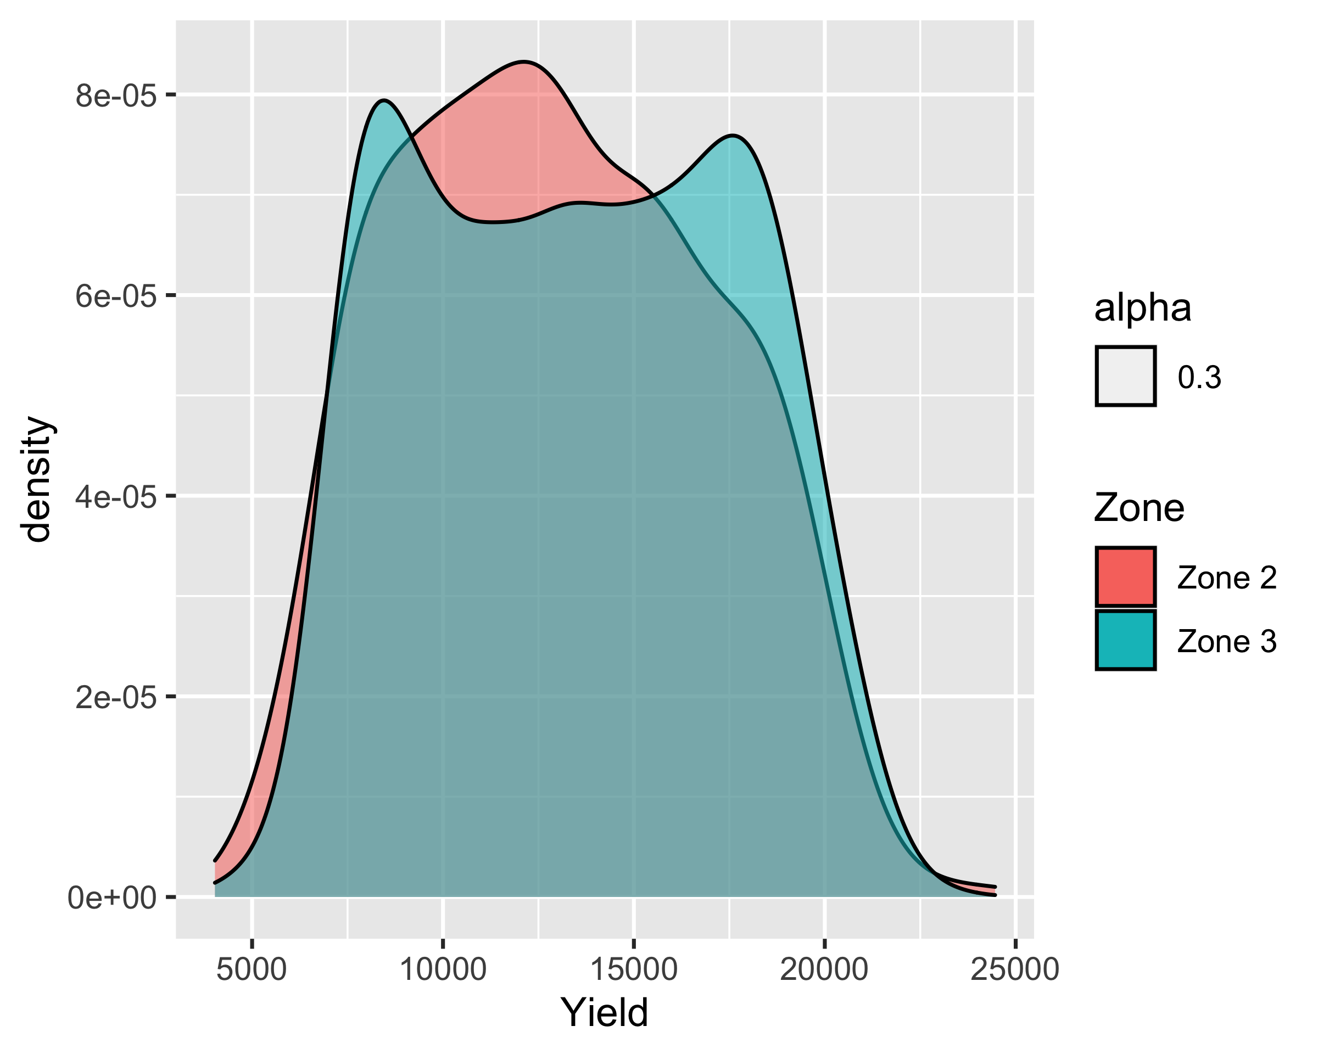

Figure 1: The Distribution of Yield by Zone

# Tables

Table 1: Summary Statistics by Zone

| Zone |  | get_N | Mean | SD | Min | Max |
| --- | --- | --- | --- | --- | --- | --- |
| Zone 2 | Yield (kg/ha) | 598 | 12932.11 | 3994.57 | 4344.71 | 24459.46 |
|  | Nitrogen Rate (kg/ha) | 598 | 117.82 | 14.73 | 88.94 | 145.57 |
|  | Seed Rate (1000/ha) | 598 | 84.01 | 6.86 | 69.17 | 98.61 |
| Zone 3 | Yield (kg/ha) | 1376 | 13430.38 | 4132.89 | 4026.51 | 23319.59 |
|  | Nitrogen Rate (kg/ha) | 1376 | 118.20 | 14.61 | 88.84 | 143.75 |
|  | Seed Rate (1000/ha) | 1376 | 87.20 | 7.03 | 69.58 | 98.82 |

# References

Adrian, Anne Mims, Shannon H Norwood, and Paul L Mask. 2005. “Producers’ Perceptions and Attitudes Toward Precision Agriculture Technologies.” *Computers and Electronics in Agriculture* 48 (3): 256–71.

Shrader, WD, WA Fuller, and FB Cady. 1966. “Estimation of a Common Nitrogen Response Function for Corn (Zea Mays) in Different Crop Rotations 1.” *Agronomy Journal* 58 (4): 397–401.

1. University of Nebraska Lincoln, [tmieno2@unl.edu](mailto:tmieno2@unl.edu)
2. Random University, [johndoe@email.com](mailto:johndoe@email.com)
3. this is a footnote