The Impact of Weather on Flight Delay

Forgot MyName, Random University

No Name, Highest-ranked University

2023-10-04

Abstract: this research is so awesome that you cannot reject this paper.

# Introduction

Nothing is more frustrating than flight delays. The goal of this article is to understand what weather variables affect flights delays so that we can control weather when such time comes in the future[1].

# Method

Regression analysis was used in this article. The econometric model writes as follows (equation (1)):

## Code availability

All computations (including creating tables and plots) were conducted using R software (R Core Team 2022), The Bergé (2018) package was used to run regressions.

# Data

We use publicly available datasets from the R nycflights13 package (Wickham 2021). Table presents the summary statistics.

|  | Mean | SD | Max |
| --- | --- | --- | --- |
| dep_delay | 12.64 | 40.21 | 1301.00 |
| temp | 55.57 | 17.10 | 92.14 |
| precip | 0.00 | 0.01 | 0.15 |
| wind_speed | 10.45 | 4.19 | 56.39 |

**Table** **:** Summary Statistics

Figure shows the histogram of departure delay by carrier for each of the airports.

**Figure** **:** Distribution of delay by carrier

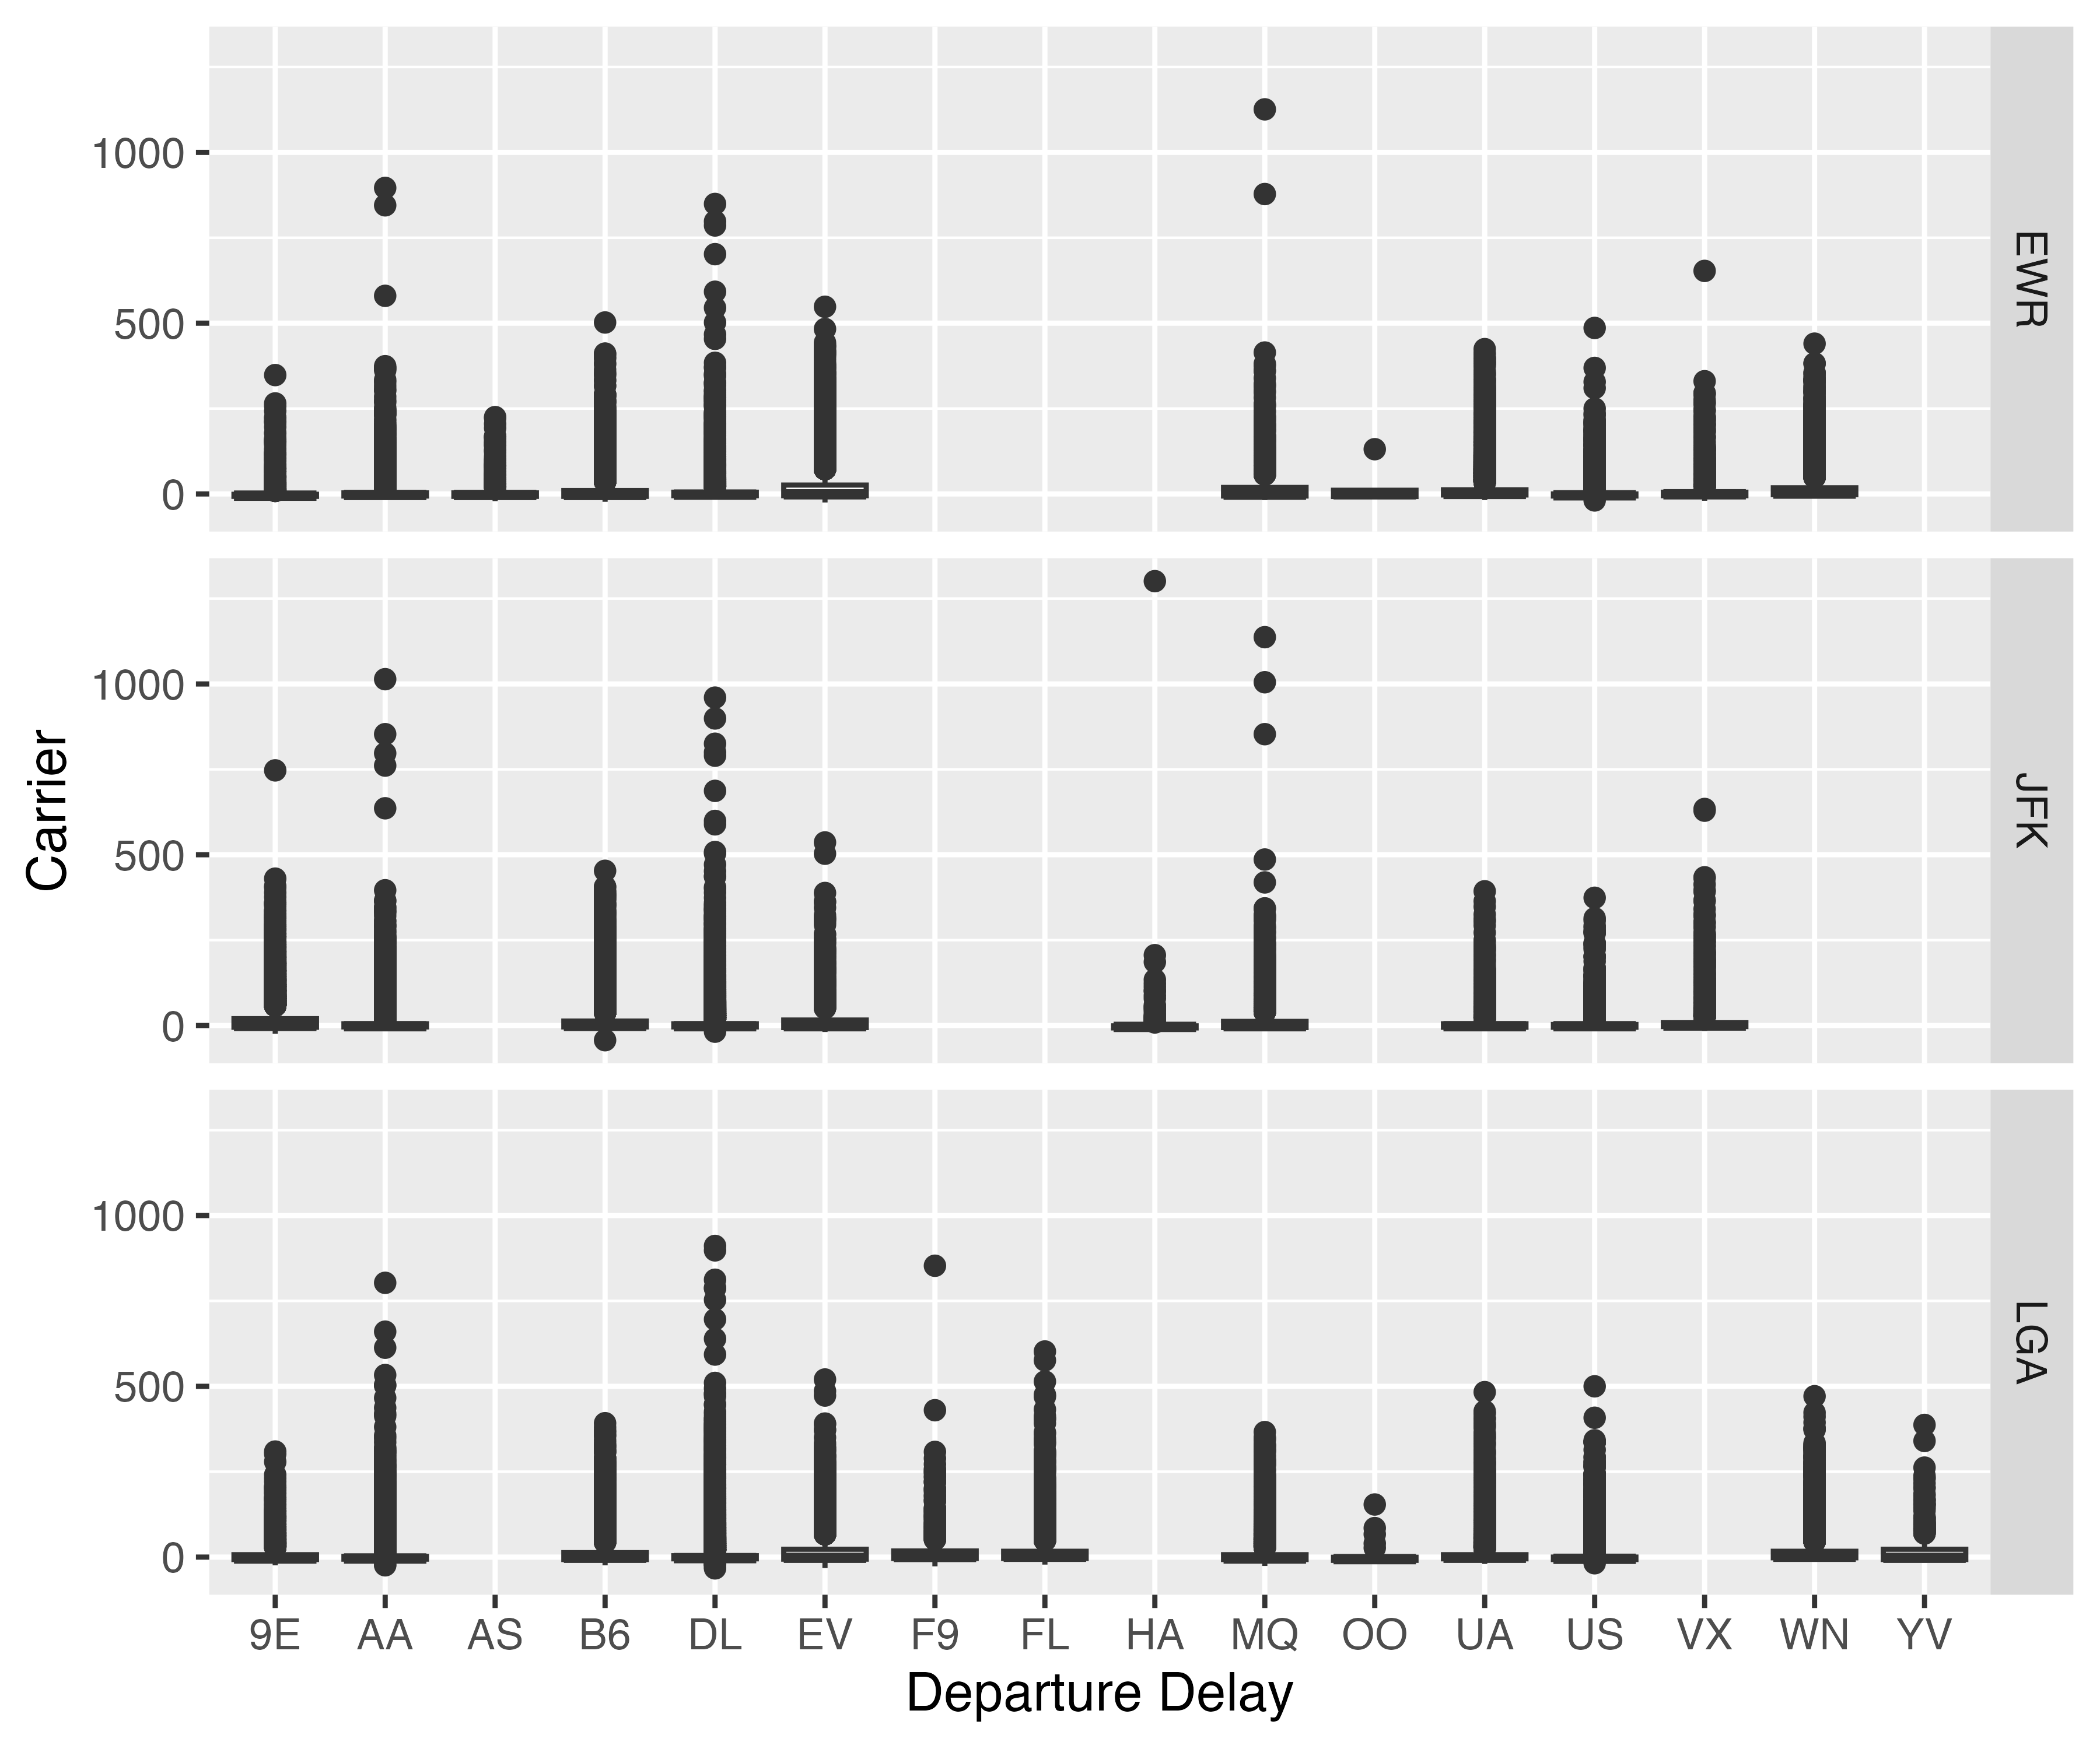

# Results and Discussions

Table presents the regression results.

|  | (1) | (2) | (3) |
| --- | --- | --- | --- |
| (Intercept) | 0.068 |  |  |
|  | (0.348) |  |  |
| temp | 0.145*** | 0.251+ | 0.251** |
|  | (0.004) | (0.125) | (0.023) |
| precip | 379.641*** | 348.979** | 348.979** |
|  | (5.363) | (105.112) | (28.751) |
| wind_speed | 0.274*** | 0.326+ | 0.326* |
|  | (0.018) | (0.155) | (0.059) |
| Num.Obs. | 326164 | 326164 | 326164 |
| R2 | 0.020 | 0.034 | 0.034 |
| Std.Errors | IID | by: month | by: origin |
| + p < 0.1, * p < 0.05, ** p < 0.01, *** p < 0.001 | | | |

**Table** **:** Regression Results

# Conclusion

Weather matters.

# References

Bergé, Laurent, “Efficient estimation of maximum likelihood models with multiple fixed-effects: The R package FENmlm,” *CREA Discussion Papers*, (2018).

R Core Team, “[R: A language and environment for statistical computing](https://www.R-project.org/),” (Vienna, Austria, R Foundation for Statistical Computing, 2022).

Wickham, Hadley, “[nycflights13: Flights that departed NYC in 2013](https://CRAN.R-project.org/package=nycflights13),” (2021).

1. This is just for illustrating how to create a footnote