Guide to Page-Debugging Tool
Summary
Current site pages are always divided into many nested page fragments. These page fragments improved code re-usability, but meantime made it more difficult for a web developer to find the right fragment file to modify. This tool can make the finding easy.

Features
This tool’s functions can be simply described as follows:
a) Before using the tool,
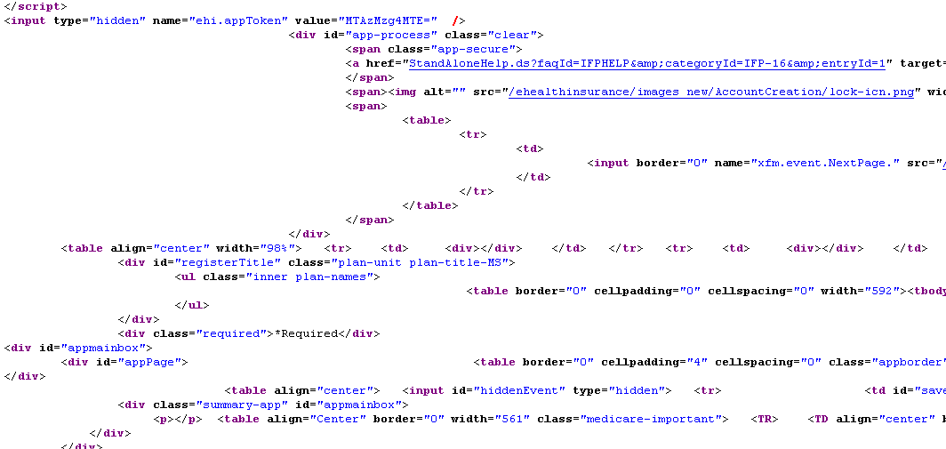
b) After using the tool (i.e. append ‘pageDebugging=on’ to current url),
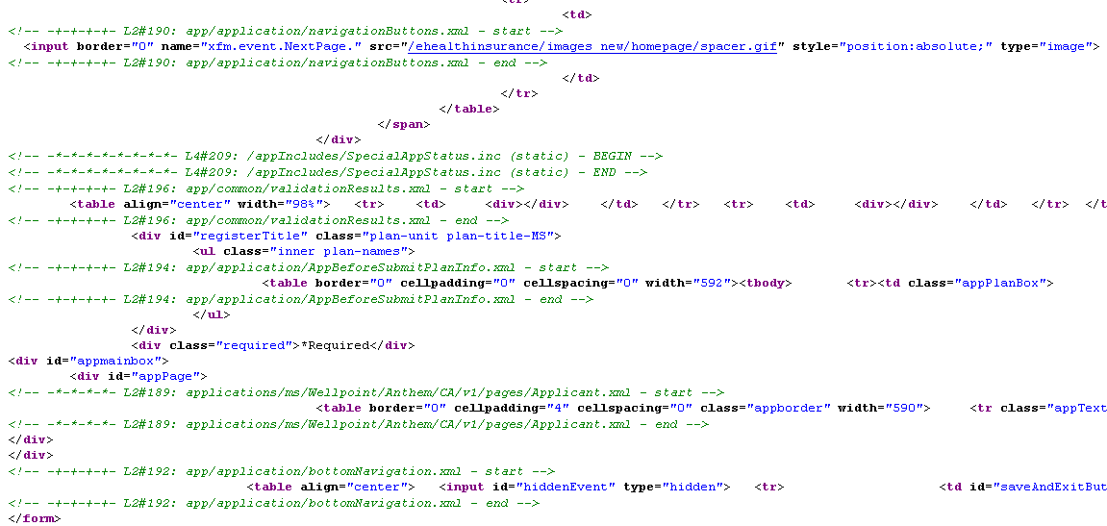
As you seen, the included files are traced with “<!—[debugging code] - start -->” and “<!-- [debugging code] - end -->”, so you can easily find the right fragment files.

Tips: You can get such info from it:
a) The path name of an included file
b) Begin and end points of an included file
c) Level of an included file in current page structure

p.s. debugging code format := ‘L’ + [level number] + ‘#’ + [sequence number] + ‘:’ + [file name]

Technical Principles
Use the aspect technology to insert a HTML comment (tracking code) at begin and end of the output content when the web container or template engine includes a page fragment.

* Supports Tomcat 6.0+, JBoss-Web 2, Freemarker 2+ and Velocity 1.5/1.7.

Installation & Configuration
For different scenarios, they can exist different ways to install/configure the tool:

A: JSP is the only template technology in your project
- Place page-debugging.jar, and aspectjweaver.jar/aspectjrt.jar under ‘[tomcat home]\lib’
- Let AspectJ take over class loading job, so it can weave them if necessary, which can be simply done by appending JVM argument:
-javaagent:[pathto]\aspectjweaver.jar
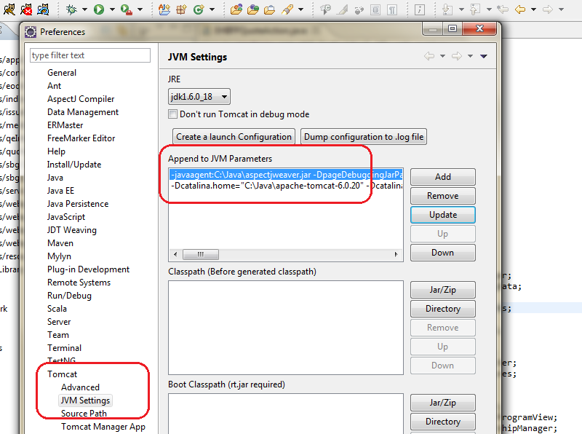

- Add a listener class (a tomcat valve) to runtime environment, so you can turn on/off this tool as you expected:
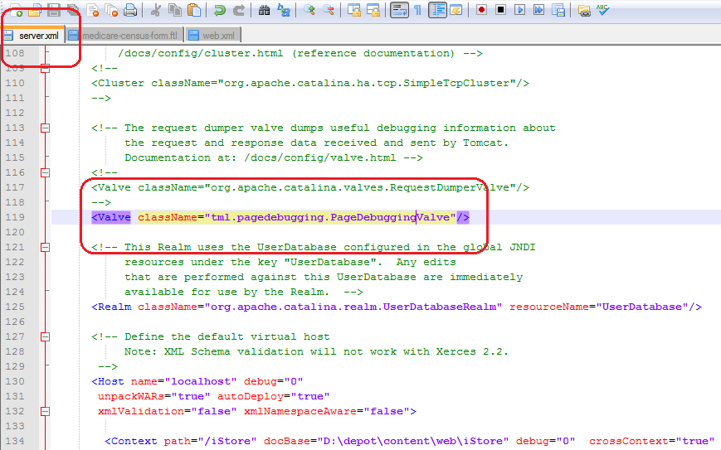

4. Then you can turn on/off this tool by appending “pageDebugging=true/on” or “pageDebugging=false/off” to current page URL.
Ps: this configuration info will be kept during your current session.

* Tips: cleanup tomcat working cache before firstly using it.

B: Freemarker and/or Velocity is/are the template technologies in your project
- Place page-debugging.jar, and aspectjweaver.jar/aspectjrt.jar under ‘[your project]\web-inf\lib’
- Let AspectJ take over class loading job, so it can weave them if necessary, which can be simply done by appending JVM argument:
-javaagent:[pathto]\aspectjweaver.jar

- Add a filter to the web.xml, so you can turn on/off this tool as you expected:
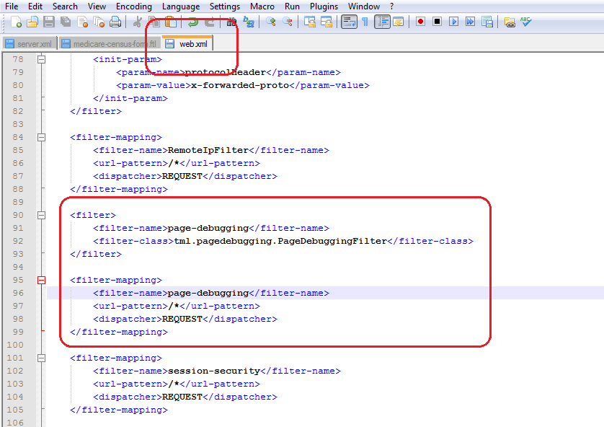

4. Then you can turn on/off this tool by appending “pageDebugging=true/on” or “pageDebugging=false/off” to current page URL.
Ps: this configuration info will be kept during your current session.

C: all the three (JSP/Template/Velocity) are used in your project
1. Deploy related files to their specific dirs, and that means:
a) Ensure aspectjweaver.jar is on your machine;
b) Place page-debugging.jar and aspectjrt.jar under dir ‘[tomcat home]\lib’

2. Let AspectJ take over class loading job, so it can weave them if necessary, which can be done by simply adding JVM arguments when launching tomcat like belows:
-javaagent:[pathto]\aspectjweaver.jar

3. Add listener class (a tomcat valve) to runtime environment, so you can turn on/off this tool as you expected; and add customized class loader to your app’s <Context> element, so it can load the tool related classes on command under app runtime environment. You can do it just as below picture described:
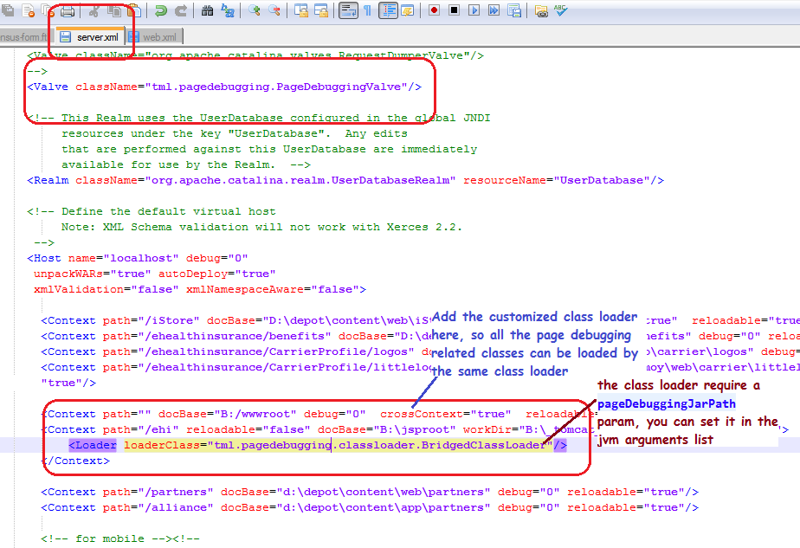

*note: above ‘BridgedClassLoader’ need a working parameter ‘pageDebuggingJarPath’, which was used to tell ‘BridgedClassLoader’ the path to page-tracking.jar and then the class loader can find other required java classes in it. You can set it by adding a jvm parameter like below:
-DpageDebuggingJarPath=[path_to_page-debugging.jar]

** So all the extra jvm arguments that you’ll add for the page debugging tool will like as below:
-javaagent:[pathto]\aspectjweaver.jar -DpageDebuggingJarPath=[path_to_page-debugging.jar]

4. Then you can turn on/off this tool by appending “pageDebugging=true/on” or “pageDebugging=false/off” to current page URL. And this configuration info will be kept during your current session.

* Tips: cleanup tomcat working cache before firstly using it.

FAQ
Q: How to resolve if name conflict occurred with the default debugging switch key name “pageDebugging”?
A: You can specify a new debugging switch key name by appending JVM argument:
-DpageDebugging.switchKey=[new debugging switch key name]

Q: If I want to specify some files or dirs not to be tracked, can I? How?
A: Yes, you can. By default all files under /WEB-INF/tags/ (include its sub dirs) and file StandardFunctions.jsp are not be tracked. If your requirement is different, you can change it by appending one more JVM argument like below:
-DpageDebugging.excluded=”foo/bar/, tttt.txt”
Or
-DpageDebugging.excluded_append:“foo/bar/, tttt.txt”

* Please use ‘,’ or ‘;’ to split these files or dirs.
** ‘append:’ means append to current item list.
*** Don’t worry about the redundant whitespaces between them.

Q: As we know, the configuration info was kept into the user current session. But if we need to change it only in a request life scope, can we? How?
A: Yes, we can. Append ‘req_pageDebugging=on/off’ to the url, then you can change the configuration temporarily, and the configuration in the session will be kept unchanged.

