**Hanoi University of Science and Technology**

**School of Mechanical Engineering**

**\*\*\***



**AUTOMOTIVE ENGINEERING PROJECT**

**Project topic: Design a drive system of motorcycle brake tester**

Instructor: MSc. Nguyễn Đức Khánh

Student name: Nguyễn Công Tuấn

Student ID: 20196939

**Hanoi, 02 / 2023**

Table of Contents

Introduction 4

I. Overview of motorcycle brake tester 5

1. What is motorcycle brake tester 5

2. Eddy current dynamometer 6

2.1. Definition and construction of eddy current dynamometer 6

2.2. Working principle 7

2.3. Feature of eddy current dynamometer 8

2.4. The advantages and applications of eddy current dynamometer 8

II. Calculation and design the drive system of motorcycle brake tester 10

1. Input parameters 10

2. Calculation the parameters of roller 10

3. Choose electric brake 11

4. Calculation and design shaft 11

4.1. Choose the material to produce shaft 11

4.2. Determine preliminary shaft diameter 11

4.3. Determine the length of the shaft 12

4.4. Determine the diameter of the shaft 12

4.5. Determine and test the fatigue strength 21

4.6. Determine and test shaft for static strength 23

5. Design the hub of roller 24

6. Calculate and design the flange 24

7. Calculate and design key 25

8. Calculation and design bearing 27

8.1. Select the type of bearing 27

8.2. Select bearing’s degree of accuracy 27

8.3. Select the dimension of bearing 27

8.4. Static load test 29

8.5. Quick spin test 30

9. Tolerance assembly 30

9.1. Bearing tolerance assembly 30

9.2. Key tolerance assembly 31

III. Reference 34

# Introduction

Automotive engineering project is an important subject for students of automobile industry. The course helps students synthesize, sequence and apply the knowledge they have learned in previous subjects to complete the project. Moreover, the subject helps students have a realistic view of the process of calculating and designing a product. In the process of completing the project, the course also helps students practice skills in using mechanical design software such as AutoCad, SolidWorks, NX, ... The strong development of information technology, parts increasingly modern software, making the design calculation process faster and more accurate.

I would like to express my sincere thanks to MSc. Nguyễn Đức Khánh and other teachers who have guided me wholeheartedly during the implementation of the project. Because this is the first technical design, with limited understanding, even though I have tried to refer to the documents and lectures, the mistakes cannot be avoided. I look forward to the guidance and dedicated guidance of teachers to help students improve more and more.

# I. Overview of motorcycle brake tester

## 1. What is motorcycle brake tester

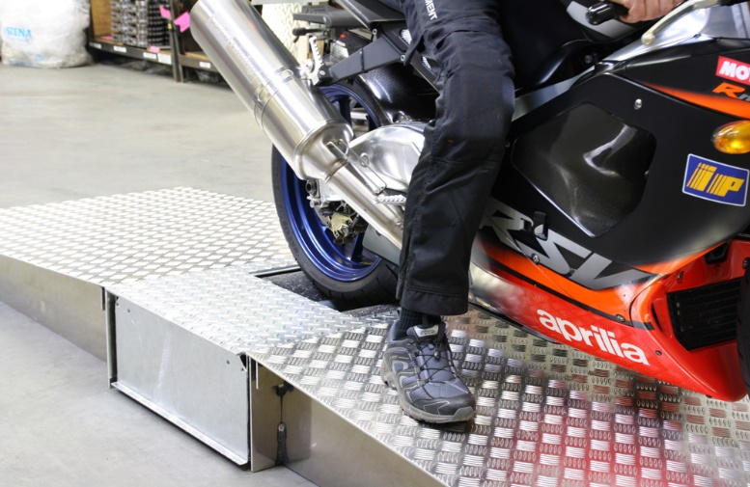Motorcycle can be subdivided into two-wheeled motorcycle and three-wheeled motorcycle, while three-wheeled motorcycle can be further subdivided into right three-wheeled motorcycle and three-wheeled motorcycle with sidecar. As the name suggests, a right three-wheeled motorcycle is equipped with a front wheel and two symmetrically distributed rear wheels. The three-wheeled motorcycle with sidecar, on the other hand, has a side car on one side of a two-wheeled motorcycle. Therefore, the Motorcycle Brake Tester can be also subdivided into Two-wheeled Motorcycle Brake Tester and Combined Motorcycle Brake Tester, which can be used to test all kinds of motorcycles.

The Two-wheeled Motorcycle Brake Tester consists of one set of short rollers. The Combined Motorcycle Brake Tester is similar to normal Car Brake Tester, it consists of two sets of rollers, from which the braking force of two rear wheels can be tested respectively. Generally, the set of short rollers are at the right side of the bench, which is the same as the Two-wheeled Motorcycle Brake Tester. While the set of long rollers are on the left side. During the inspection, the front wheel of the right three-wheeled motorcycle is tested at the left long roller, and then the rear two wheels can be tested at the left and right sides respectively. That means, Two-wheeled Motorcycle Brake Tester can only be used to test two-wheeled motorcycles, while the Combined Motorcycle Brake Tester can test all types of motorcycles.

In this project, we consider only the Two-wheeled Motorcycle Brake Tester consists of one roller connecting with an eddy current dynamometer as an electric brake.

## 2. Eddy current dynamometer

### 2.1. Definition and construction of eddy current dynamometer

An eddy current dynamometer is an electromechanical energy conversion device, which converts mechanical energy to electrical energy. It fundamentally uses Faraday’s Law of electromagnetic induction as its working principle. A schematic of the dynamometer is shown below.

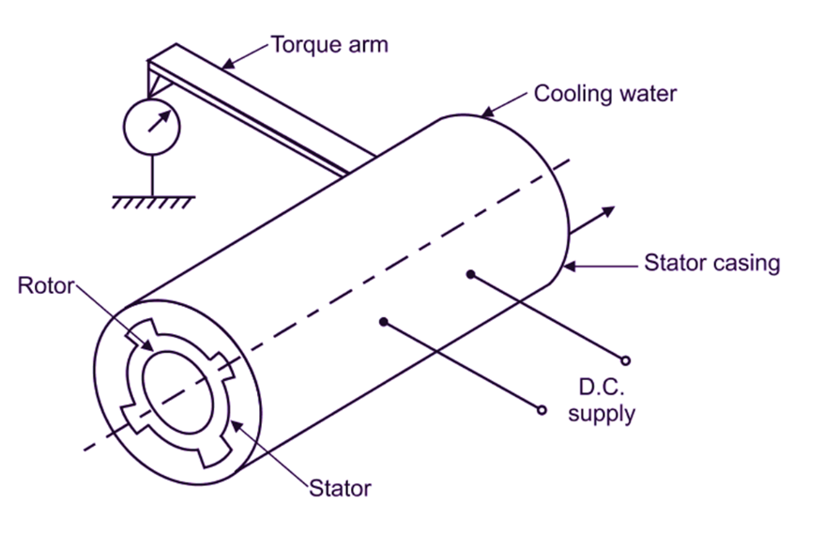

The constructional aspects of the eddy current dynamometer are shown in the above figure. It consists of the outer frame as the stator, which is also called a stationary member of the machine. The stator consists of windings, which are placed in stator slots. When the stator windings are excited, a stator magnetic field is produced in the stator coils. In the case of high rated machines, 3 phase windings are placed in the stator slots.

The stator windings are made of copper. The outer frame, i.e. the stator is made of a magnetic material like cast iron or silicon steel in case of delicate applications. The rotating member is called a rotor, which is kept below the stator coils. The rotor is placed on a shaft so that it can rotate. Rotor windings are placed on the rotor slots. In the case of heavy machines, three-phase rotor windings are used to be kept on rotor slots.

The rotor must be connected to the prime mover, such that when the prime mover rotates, it provides the mechanical input to the device. A D.C supply is used to excite the stator windings. In the case of large machines, rectifier units are used to achieve this DC supply. For large machines, oil is used for cooling and insulation of the stator windings. This is important to dissipate the heat generated.

Once current meter as shown in the diagram is used to measure the current produced and torque induced. A pointer is connected by an arm to the stator, which can measure the torque generated in the rotor. And with the knowledge of speed, by using this torque value, we can calculate the power generated in the machine.

The fig show below is the real DW series eddy current dynamometer

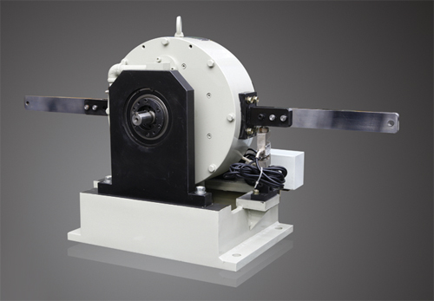

### 2.2. Working principle

An eddy current dynamometer works on the principle of Faradays’ Law of electromagnetic induction. As per the law, whenever there is a relative displacement between a set of conductors and a magnetic field, an emf is induced on the set of the conductor. This emf is called is dynamically induced emf. In the case of the dynamometer, when the stator poles are excited with a DC supply which is connected to the stator.

When the DC supply is connected, the stator coils are excited and a magnetic field is produced in the stator coils. In the case of a three-phase machine, we obtain a 3 phase rotating magnetic field, in the stator coils when the coils are excited with the three-phase supply. When the prime mover rotates, the rotor, the rotor coils rotate and interact with the stator magnetic field.

It must be noted that in this the stator magnetic field is static in nature. Since the excitation is DC, we get a static magnetic field. When the rotor coils cut the stator magnetic field, an emf is induced since in this case the magnetic field is static and the conductors are rotating. So there is a relative displacement between the magnetic field and the conductors.

### 2.3. Feature of eddy current dynamometer

It must be observed that the eddy current dynamometer is different from than conventional mechanical dynamometer. In this case, when the rotor of the dynamometer cuts the stator magnetic field, an emf is induced on the rotor conductors. It causes eddy currents to flow in the rotor conductors. The direction of the eddy currents is opposite to the change in the magnetic flux and is generated in the rotor.

The rotor opposes the force exerted due to the magnetic flux, but due to the prime mover input, it keeps rotating. And since there is no physical contact between the magnetic field and the conductors, the losses produced are very less as compare to a conventional generator.

Unlike in a conventional mechanical dynamometer, in an eddy current dynamometer, an arm is connected to the body of the stator. At the end of the arm, a pointer is connected, which can measure the torque produced in the rotor winding. By knowing the speed of the rotor, the amount of power can be known, as the power is equal to the product of torque and speed.

### 2.4. The advantages and applications of eddy current dynamometer

*The advantages of eddy current dynamometer are*

* It is more efficient as compared to conventional mechanical dynamometer due to low frictional losses.
* Its structure is simple
* It can be operated more conveniently as compared to conventional dynamometers
* It has a fast dynamic response because of low rotational inertia.
* Due to the absence of huge windings, the number of copper losses is less.
* It can be connected to an external control unit easily to monitor the flow of currents and even control it.
* The braking torque is very high
* It is highly precise and stable

*The major applications are*

* Performance testing of the internal combustion engine
* Used in small power motor
* Automobile transmission parts
* Gas turbines
* Water turbines

# II. Calculation and design the drive system of motorcycle brake tester

## 1. Input parameters

Engine power:

Engine speed: = 9500 rpm = 994.838 rad/s

Using belt transmission connect engine and wheel with ratio: k = 3.5

Wheel’s radius: = 250 mm = 0.25 m

Roller’ s diameter: = 470 mm = 0.47 m

Roller’s length:

Working hours: 10000 h

## 2. Calculation the parameters of roller

Engine torque:

Choose the belt transmission efficiency

Torque at the wheel:

The wheel speed:

Torque at the roller (suppose that the wheel and the roller roll without sliding):

The roller speed:

The power at the roller:

## 3. Choose electric brake

Choose the propeller shaft to connect the roller and the electric brake. Therefore the needed power for electric brake is

* Choose brake DWZ/DW-10

## 4. Calculation and design shaft

### 4.1. Choose the material to produce shaft

Material: steel C45

Hardness: HB =

Limited durability:

Yield strength:

Allowable torsion stress:

=> Choose

### 4.2. Determine preliminary shaft diameter

* The diameter of shaft will be determined by this equation:

*Where:*

d – diameter (mm)

T – Torque (N.mm)

– allowable torsion stress (MPa)

We have the torque T here is the torque at roller

The diameter of shaft:

Choose the diameter of shaft d = 20 (mm)

### 4.3. Determine the length of the shaft

With d = 20 (mm), we choose the bearing width (according to the table 10.2 – page 189 – textbook 1)

Choose the distance between the bearing and the roller’s hub is k = 30 mm

Choose the hub of roller is

We have the minimum length of shaft is:

Base on the details place on the shaft and the connection of it with the electric brake choose L = 400 mm

### 4.4. Determine the diameter of the shaft

The material to produce the roller is also steel C45, which have the mass density

, so the mass of roller is:

The mass of the rear of popular vehicle applying on the roller will be

Tangential force at roller:

Vertical force at roller:

**In xoz surface:**

From (1) and (2) we have:

In segment AB:

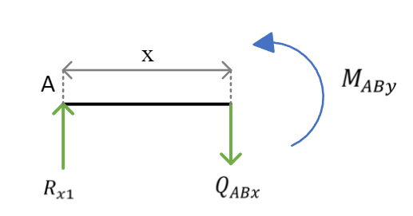

At x = 0 mm =>

At x = 147.5 mm =>

In segment BC:

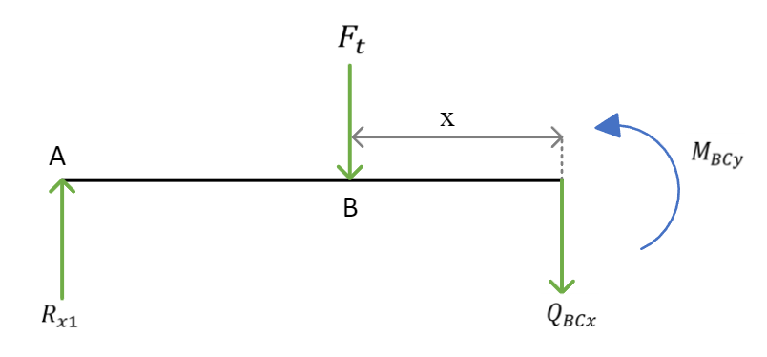

At x = 0 mm =>

At x = 147.5 mm =>

In segment CD:

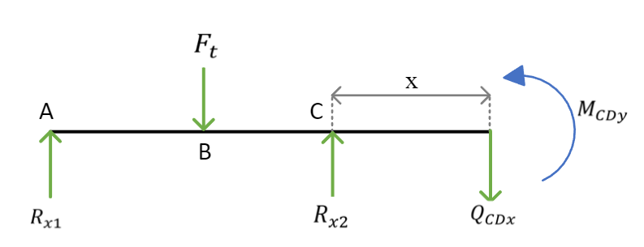

At x = 0 mm =>

At x = 145.5 mm =>

**In yoz surface:**

From (3) and (4) we have:

In segment AB:

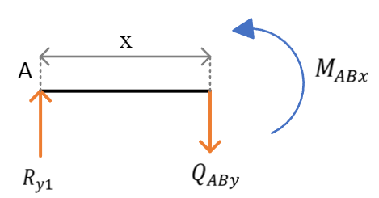

At x = 0 mm =>

At x = 147.5 mm =>

In segment BC:

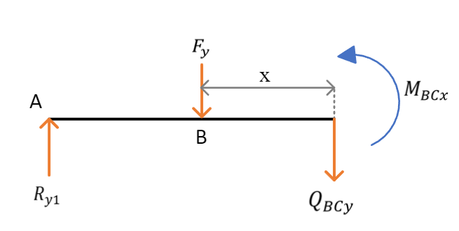

At x = 0 mm =>

At x = 147.5 mm =>

In segment CD:

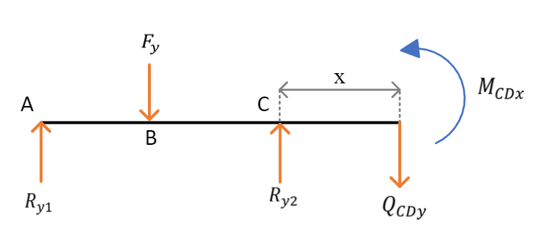

At x = 0 mm =>

At x = 145.5 mm =>

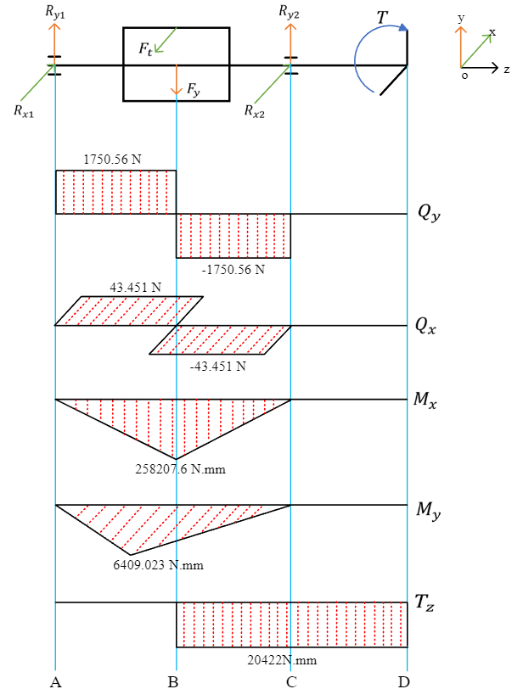

Forces and moments diagram

*Consider the dangerous sections on the shaft we have:*

**Cross-section B:**

The diameter at cross-section B:

Where:

– the equivalent moment at cross-section B

– allowable stress of shaft fabricated steel

Base on table 10.5 – page 195 – textbook 1 we have:

Therefore:

**Cross-section C:**

The diameter at cross-section C:

Where:

– the equivalent moment at cross-section C

– allowable stress of shaft fabricated steel

Base on table 10.5 – page 195 – textbook 1 we have:

Therefore:

**Cross-section D:**

The diameter at cross-section D:

Where:

– the equivalent moment at cross-section D

– allowable stress of shaft fabricated steel

Base on table 10.5 – page 195 – textbook 1 we have:

Therefore:

* Base on the requirements of durability, assembly and technology, we choose the shaft diameter at the following sections:

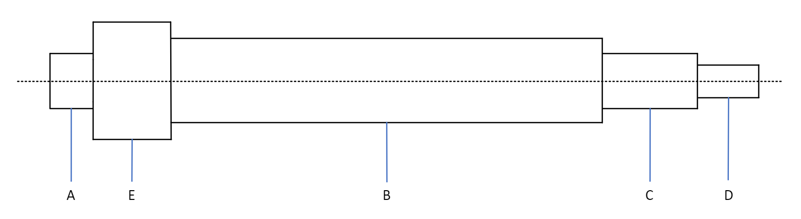

### 4.5. Determine and test the fatigue strength

The newly shaft structure must ensure the fatigue strength at dangerous cross-section (here is cross-section B) satisfying the following condition:

Where:

* – allowable safety factor; choose so that it is not necessary to test hardness of the shaft
* – the safety factors when only consider the normal stress and when only consider the shear stress at cross-section B:
* – flexural and torsional fatigue limits for the symmetry period. For carbon steel can be approximated
* – amplitude and average value of normal and shear stresses at cross-section at point B:

For the shaft of rotation, the bending stress varies with the symmetry period, so:

When the shaft rotates in 1 direction, the stress changes with the dynamic circuit period, so:

* – factor taking into account the influence of the average stress value on the fatigue strength, base on the table 10.7 – page 197 – textbook 1 we have:
* – the factors will be determined according to these fomula:

Where:

– stress concentration factor due to surface state, dependent on machining method and surface smoothness. Choose the machining by turning method Ra 2.5 … 0.63 =>

– shaft surface strength factor, depend on the method of increasing surface strength, material mechanical properties. Low stress concentrated shaft, strength increase method: high frequency quenching =>

– dimension factor account on the influence of shaft cross-sectional dimension on the fatigue limit

– actual stress concentration factor in bending and in torsion

For mounting shaft with redundancy, with 700 MPa endurance and install k6 endurance we have:

Therefore:

We have:

The safety factor:

Thus, the shaft ensures fatigue strength

### 4.6. Determine and test shaft for static strength

The test formula has the form:

Where:

Thus, ensuring static strength

## 5. Design the hub of roller

We have the length of the hub

The hub’s diameter:

## 6. Calculate and design the flange

With the shaft’s diameter d = 20 mm, choose the FCL flange with the characteristics as below

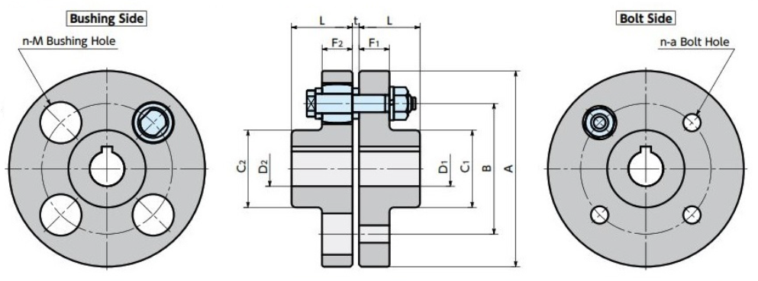

|  |  |  |  |  |  |  |  |  |  |  |
| --- | --- | --- | --- | --- | --- | --- | --- | --- | --- | --- |
| A | Max. Bore Diameter | | L | C | | B | F | | n (pc) | Coupling bolt Part Number |
|  |  |  |  |  |  |
| 90 | 20 | 20 | 28 | 35.5 | 35.5 | 60 | 14 | 14 | 4 | F1 |

unit: mm

Bolt dimension:

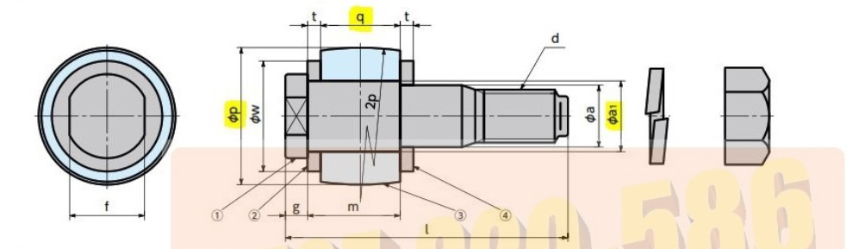

|  |  |  |  |  |  |  |  |  |  |  |  |  |  |
| --- | --- | --- | --- | --- | --- | --- | --- | --- | --- | --- | --- | --- | --- |
| Part number | Nominal | 1) Bolt | | | | | | | 2), 4) Wash | | 3) Bush | | Tightening torque T (N.m) |
| d | a1 | a | f | g | m | l | w | t | p | q |
| F1 | 8 x 50 | M8 | 9 | 8 | 10 | 4 | 17 | 50 | 14 | 3 | 18 | 14 | 11 |

unit: mm

## 7. Calculate and design key

The stamping strength and shear strength conditions have the following form:

Where:

– calculated stamping stress and calculated shear stress

d – shaft’s diameter

T – torque

b, h – the width and height of key’s cross-section

– keyseat depth on shaft

**Cross-section B** (connecting the roller with the shaft):

= 40 mm

= 20422 N.mm

With = 40 mm base on the table 9.1a – page 173 – textbook 1 we have:

– length of key, determine through the length of roller’s hub:

– allowable stamping stress, base on the table 9.5 – page 178 – textbook 1:

Fix joint, light impact load

– allowable shear stress, with key made by steel C45 when apply light impact load decrease 1/3 of static load:

Therefore:

Thus, the stability condition is satisfied

**Cross-section D** (connecting the flange with the shaft):

= 20 mm

= 20422 N.mm

With = 20 mm base on the table 9.1a – page 173 – textbook 1 we have:

– length of key, determine through the length of flange:

– allowable stamping stress, base on the table 9.5 – page 178 – textbook 1:

Fix joint, light impact load

– allowable shear stress, with key made by steel C45 when apply light impact load decrease 1/3 of static load:

Therefore:

Thus, the stability condition is satisfied

## 8. Calculation and design bearing

### 8.1. Select the type of bearing

Choose deep groove ball bearings (because of the small axial force, ):

* Bearing can withstand radial force while also withstand small axial force
* Works at high revs
* Lowest price

### 8.2. Select bearing’s degree of accuracy

* Degree of accuracy: 0
* Radial runout: 20

### 8.3. Select the dimension of bearing

Choose the dimension of bearing according to the dynamic load capacity:

Where:

* – dynamic load capacity
* m – degree of fatigue curve in bearing test, m = 3 with ball bearing
* L – longevity (millions of revs):

Where:

- longevity in hours

n – revs of bearing, this equal to the roller speed

* Q – conditional dynamic load

With deep groove ball bearing we have a formula:

Where:

Radial load:

Axial load:

Factor refers to which ring rotates V, with the inner ring rotates V = 1

Factor refers to the effect of temperature , when it is

Factors refers to load characteristics, search in table 11.3 – page 215 – textbook 1 with small or medium electric engine , choose

Load factor base on table 11.4 – page 215 – textbook 1:

Therefore:

Select the bearing follow table P2.7 – page 255 – textbook 1: Heavy size

|  |  |  |  |  |  |  |  |
| --- | --- | --- | --- | --- | --- | --- | --- |
| Bearing number | d, mm | D, mm | B, mm | r, mm | Ball’s diameter, mm | C, kN | , kN |
| 406 | 30 | 90 | 23 | 2.5 | 19.05 | 37.2 | 27.2 |

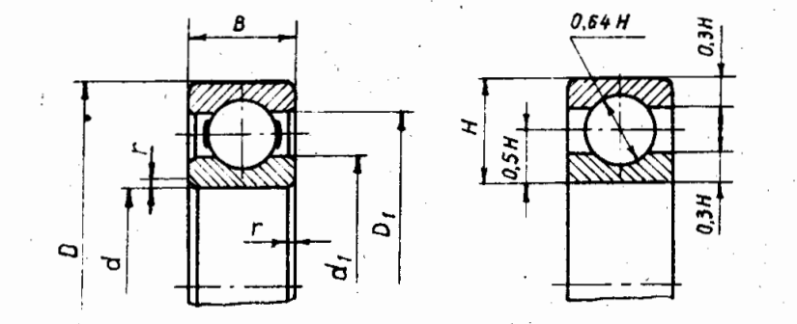

### 8.4. Static load test

Where:

– static load capacity (kN)

– conventional static load (kN) will be determined follow these formula:

For the deep groove ball bearings, is the higher value in two calculated by formula below:

Where:

– radial load factor and axial load factor are given in table 11.6 – page 221 – text book 1

For deep groove ball bearing:

Therefore:

Choose

Satisfy the static load capacity

### 8.5. Quick spin test

Bearing’s critical revolution will be determine follow this formula:

Where:

– conventional velocity parameter, search in table 11.7 – page 222 – textbook 1 with deep groove ball bearing use oil as lubricant

– diameter of circle goes through the center of balls

– size coefficient

– bearing’s size coefficient base on table 11.8 – page 222 – textbook 1

– longevity coefficient when

Therefore:

We have the revs of the bearing: n = 2888 rpm

* Satisfy the condition , the bearing ensure the ability to rotate fast.

## 9. Tolerance assembly

### 9.1. Bearing tolerance assembly

Use intermediate installation with axis according to the scope of reference from table 20-4 –page 121 and table 20-12 –page 132 – textbook 2

Select degree of accuracy: 0

According to table P4.2 and P4.3 – page 219, 220 – textbook 2

* At the axis diameter 18…30 the shaft has a dimension
* At the bearing diameter 18…30 the bearing has a limit deviation is

So the inner diameter of bearing has dimension

### 9.2. Key tolerance assembly

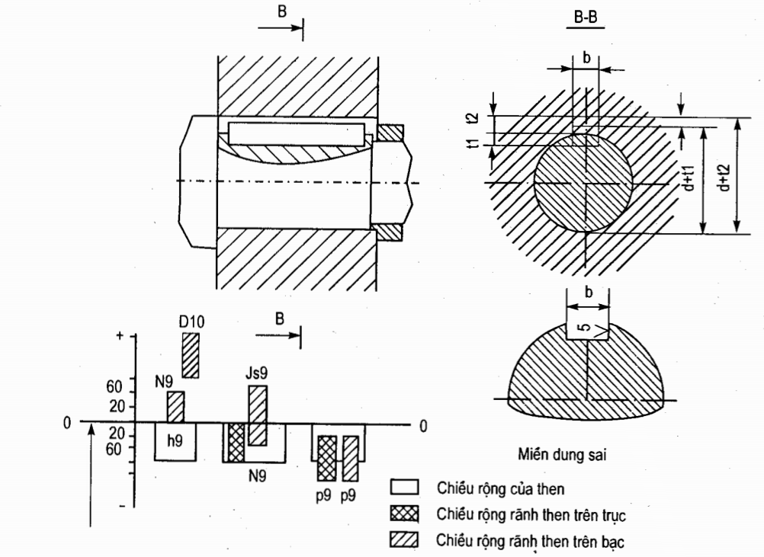

The limit deviation of width b, height h and length L of key as well as the limit deviation of the key groove width on the axis and on the silver is collected according to the data stated in table 20-5 – page 124

**Cross-section B (connecting the roller with the shaft):**

Search in table 20-5 – page 124 – textbook 2:

Limit deviation of key size on shaft:

* Width b-h9 =>
* Height h-h11 =>
* Length l-h14 =>

Limit deviation of keyseat on shaft: N9

Limit deviation of keyseat on flange: Js9

Recommended value of tolerance: keyseat diagonal on hole and shaft and keyseat asymmetry tolerance when using 1 key, where is keyseat width tolerance, which is the difference of keyseat width limit deviations on hole and shaft in table 20-6

Search in table 20-6 – page 125 – textbook 2:

Limit deviation of keyseat width on shaft:

=> Keyseat width tolerance on shaft:

=> Keyseat diagonal tolerance on shaft:

=> Keyseat asymmetry tolerance on shaft:

Limit deviation of keyseat width on roller’s hub:

=> Keyseat width tolerance on roller’s hub:

=> Keyseat diagonal tolerance on roller’s hub:

=> Keyseat asymmetry tolerance on roller’s hub:

Limit deviation of keyseat depth:

* On the shaft t1:
* On the roller’s hub t2:

**Cross-section D (connecting the flange with the shaft):**

Search in table 20-5 – page 124 – textbook 2:

Limit deviation of key size on shaft:

* Width b-h9 =>
* Height h-h11 =>
* Length l-h14 =>

Limit deviation of keyseat on shaft: N9

Limit deviation of keyseat on flange: Js9

Recommended value of tolerance: keyseat diagonal on hole and shaft and keyseat asymmetry tolerance when using 1 key, where is keyseat width tolerance, which is the difference of keyseat width limit deviations on hole and shaft in table 20-6

Search in table 20-6 – page 125 – textbook 2:

Limit deviation of keyseat width on shaft:

=> Keyseat width tolerance on shaft:

=> Keyseat diagonal tolerance on shaft:

=> Keyseat asymmetry tolerance on shaft:

Limit deviation of keyseat width on flange:

=> Keyseat width tolerance on flange:

=> Keyseat diagonal tolerance on flange:

=> Keyseat asymmetry tolerance on flange:

Limit deviation of keyseat depth:

* On the shaft t1:
* On the flange t2:

# III. Reference

*Eddy current dynamometer:*

<https://www.lanmec.com/enPhoto_Show.asp?InfoId=230&ClassId=41&Topid=0>

<https://www.elprocus.com/what-is-eddy-current-dynamometer-construction-its-working/#:~:text=An%20eddy%20current%20dynamometer%20is%20an%20electromechanical%20energy%20conversion%20device,the%20dynamometer%20is%20shown%20below>.

<https://electricalworkbook.com/eddy-current-dynamometer/>

*Design:*

Textbook 1 – Thiết kế dẫn động cơ khí tập 1

Textbook 2 – Thiết kế dẫn động cơ khí tập 2