**Find**: What angles must each motor be moved by so the tip of the hand ends up at a point P, given by coordinates (a,b,c), with respect to the original location as the origin?

**Requirements**: The arm must take a given Cartesian coordinate, (a,b,c), and move by a in the X direction, b in the Y direction, and c in the Z direction. The tip of the hand represents the coordinate relative to the destination.

**Given**: Prior to the arm mechanism moving to its destination, the tip of the hand is located at (0,0,0).

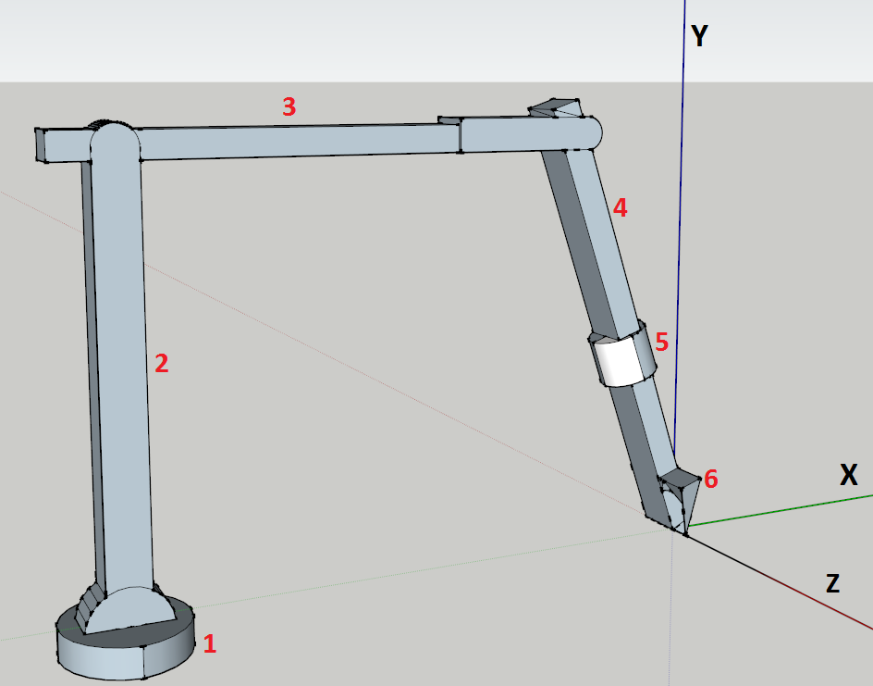

**The Arm at its Default Position**

To develop the methodology through which we will move the mechanism, we first studied the geometry of the arm and the direction of movement of each joint and came across some important conclusions:

1. The mechanism consists of 2 main portions:
   1. The base (section 1 of the image above)
   2. The rest of the arm (all other numbers denoting the arm)
2. The base remains at a stationary coordinate since it rotates about its center.
3. The positions of 2 to 6 relative to the origin are dependent upon the rotation of the base.
4. The positions of 2 to 6 relative to each other are independent of the movement of the base.

Using this information, we came up with the following information:

1. The rotation of the base changes the angle at which our arm section is oriented towards.
2. There are certain angles of the base that align the location of our arm section with respect to some axis and eliminate the calculations that would normally require 3 variables to one that would require just 2.
3. The arm section itself is fixed to a plane rotating about the base.

Therefore, we assume that it would be best to align the arm and tip direction towards the +X-axis. This eliminates a lot of complexity as it gives us a reference point where one coordinate is not changing, the Z-coordinate, helping to simplify the calculations.

We will now define the points that we are using and further elaborate on our methodology.

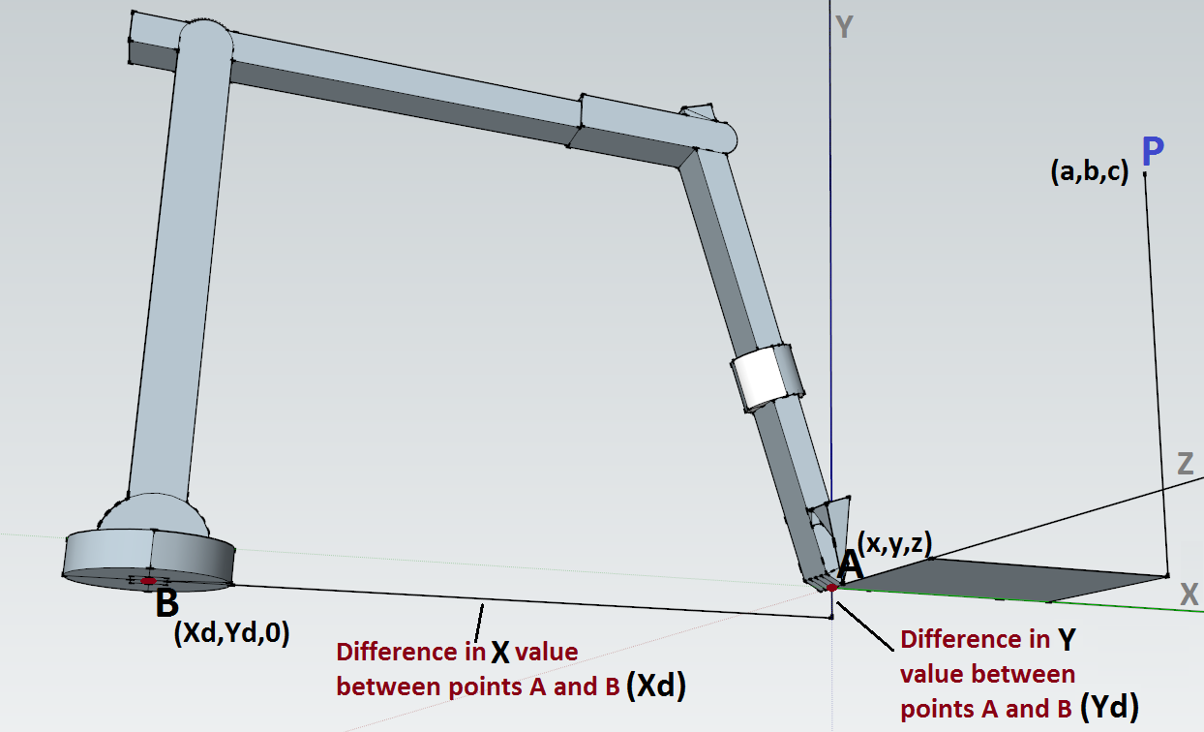

Points A and B represent the location of the tip and the location of the center of the base respectively. As evident in the image above, the base is at a lower Y value than the tip is. This isn’t always the case since all the angles of the moving portions other than the base control the relative difference in the X and Y values between points A and B. Therefore, we will define the coordinates as variables that we will use in deriving equations relating the angles with the relative locations of point A and B.

Point A is by default at the origin so if we define Point A as (x,y,z), then x=y=z=0. We will define Point B as (Xd,Yd,0). Xd is the difference in the X value between points A and B and Yd is the difference in the Y value between A and B. Intuitively, $\sqrt{{Xd}^{2}+{Yd}^{2}}$ gives us the value of the distance between point A and B when in the default position.

If we assume that Point B is a pivot point that, by default, faces in the +X-axis, we can assume that any deviation of the pivot point will trace out an angle relative to the X-axis. However, to create this angle, we need to make sure that our two locations are on the same plane that the base is on. Therefore, we introduce a new point, Point C, which represents Point P projected onto the Y=Yd plane (for the base) and has coordinates (a,Yd,c). Comparing the angle created between $\overline{BC}$ and $\overline{BA}$ (which lies on the Y-axis) gives us the angle, $θ_{B}$, that we must rotate by to orient ourselves in the direction of Point P.

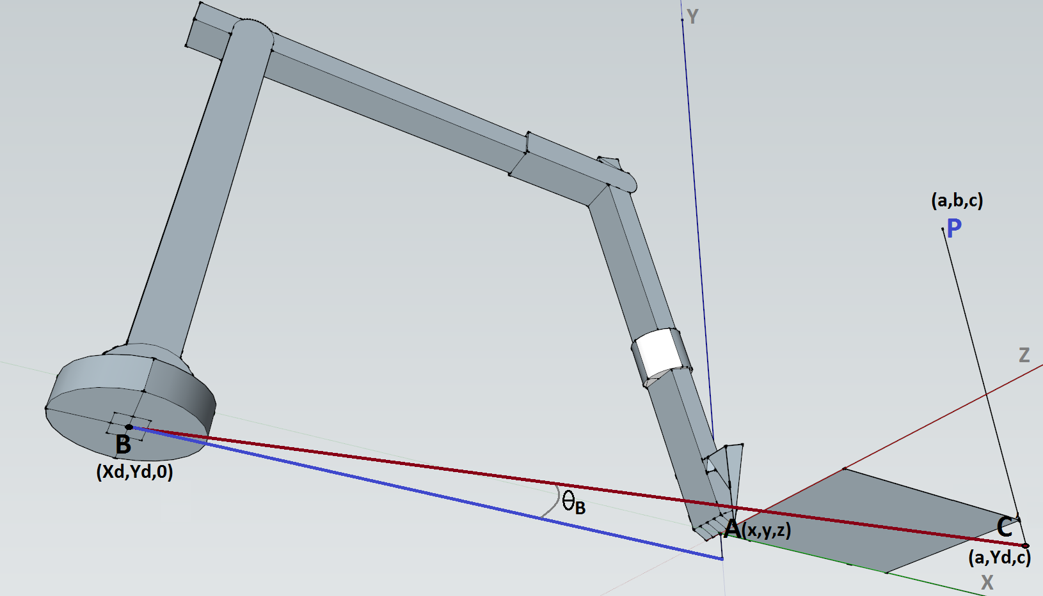

To calculate $θ_{B}$, we use the following calculations:

**Given: B**= $(Xd,Yd,0)$ and **C**= $(a,Yd,c)$

Since our point of reference is the XZ-axis, we can simply decompose the difference of the X coordinates between B and C and the difference in the Z coordinates between B and C and can use trigonometry to figure out the angle, $θ_{B}$. We don’t need to worry about the Y-axis as the two points lie on the same value of Y.

The difference between Point C and B is: $\left(a-Xd,Yd-Yd,c-0\right)=(a-Xd,0,c)$

We can now to calculate the angle $θ_{B}.$

$${Tan}^{-1}{(\frac{c}{a-Xd})}=θ_{B}$$

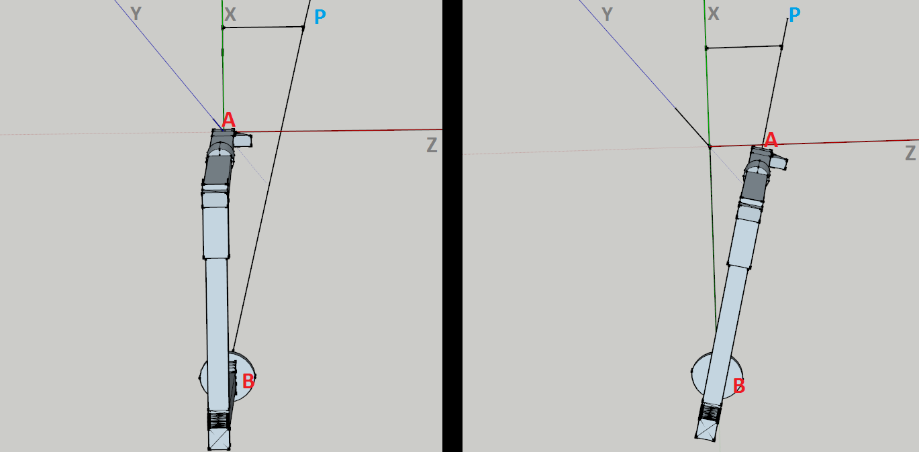

Now that we have calculated the angle for the movement of the base, $θ_{B}$, we can move on to calculating the angles for the actual arms.

The important thing to notice is that changes in the base angle don’t correspond to changes in the locations of each section of the arm relative to each other section of the arm. This means that regardless of the angle, the relative angles of the motors in the arm are going to remain the same.

If our arm remains stationary but the base rotates around, we would create a circular shape of radius Xd. This means that the distance from Point B to Point C represents the radius of this circle and we can project this radius onto the +X-axis to find the equivalent point of that circle on the X-axis. Since we’ve put our new point onto the X-axis, we’ve made Z=0 for all values.

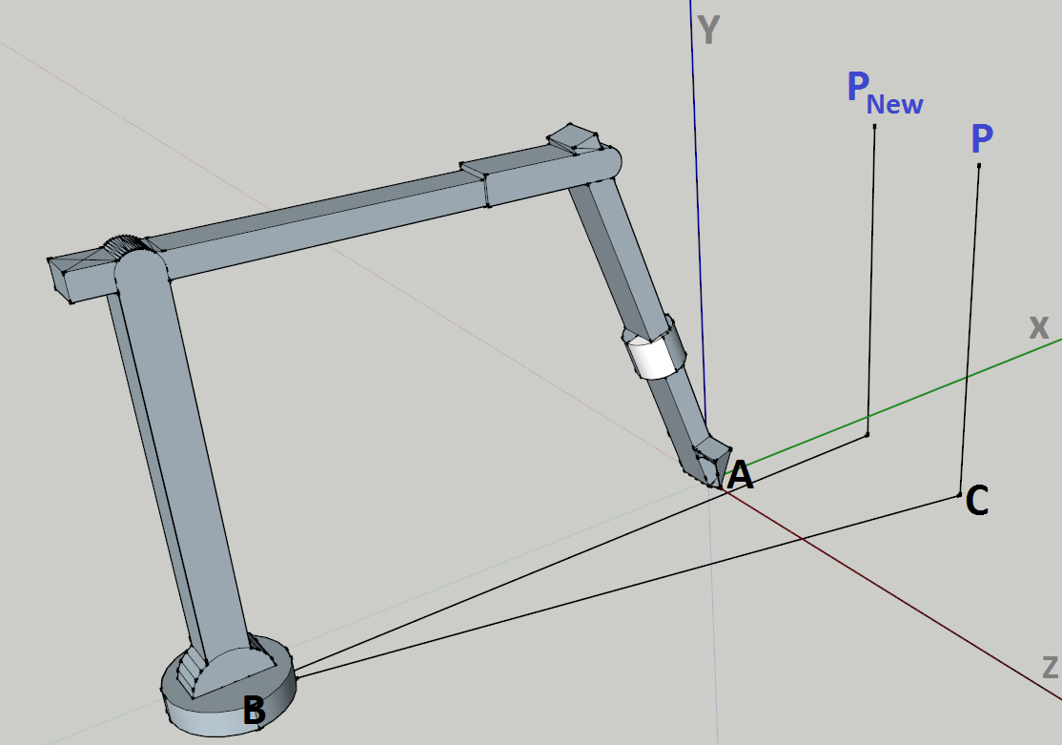

The value of $\overline{BC}$ is the distance between the pivot, Point B, and the projection of Point P on the Y=Yd plane. Finding the distance between the two points gives us:

$$\sqrt{{(a-Xd)}^{2}+{(Yd-Yd)}^{2}+{(c-0)}^{2}}= \sqrt{{(a-Xd)}^{2}+c^{2}}$$

We now project this value along the +X-axis starting from point B. Since we are projecting on the X-axis itself, the value of Z is now 0.

The X value of the new point is $Xd+\sqrt{{(a-Xd)}^{2}+c^{2}}$. This makes sense because we are adding the radius starting from an offset of Xd.

The Y value of the new point is simply $b$. This is because if the tip extended out and fell on Point P, rotating the base so the direction overlapped with the X-axis would not change the Y coordinate of the location of the tip.

The Z value is 0 since we are operating on the XY plane.

All together, the coordinate for Point $P_{New}$ is $(Xd+\sqrt{{\left(b-Xd\right)}^{2}+c^{2}},b,0)$

Now, what we need to do is calculate the movement of the arms so the tip reaches ${ P}_{New}$. Then, we simply rotate the arm by $θ_{B}$ degrees to the right and see where the tip ends up. That will end up being our actual destination coordinate.

To keep things clean in the calculation of the arm angles, we will refer to the coordinate of $P_{New}$ as $(a_{N},b_{N},c_{N})$ instead of $(Xd+\sqrt{{\left(b-Xd\right)}^{2}+c^{2}},b,0)$. Since $c_{N}=0$, $P_{New}$ is simply $(a_{N},b_{N})$.

The process of determining the movement can be done either through brute force or can be done via an intelligent algorithm. As efficiency is key and we need to develop an algorithm that minimizes movement of the motors, we haven’t finalized the process of coming up with an efficient algorithm as of yet and are still working on developing it.