Freeway Lane Optimization
(FLO)

CS 337 Software Design

Functional Requirements and Design Document

Prepared by

Scott Rice
Timothy Myung
Gia Pham
Thanh Nguyen

May 15, 2012

Freeway Lane Optimization
(FLO)

Prepared By:

Scott Rice
Timothy Myung
Gia Pham
Thanh Nguyen

Approved By:

__________________ ___5/15/2012______
Jose Macias Date

Document Change Log

Update | Date Released | Changes
Draft #1 | 5/15/2012 | First Draft
Final | 5/30/2012 | Delivery version

List of TBD Items

Page | Item | Description | Status
Section 5 | Implementation | Coding | TBI in cs437
Section 6 | Test Plan | Testing Plan | TBI in cs437

Table of Contents

Page
1.0 INTRODUCTION ....................................... 7

1.1 Purpose …………………………………………………………..… 7

1.2 Scope ………………………………………………………......... 7
1.2.1 Document Organization ………………………………. 8

1.2.2 Relationship to Other Documents …………...... 8

1.3 FLO Architecture ……………………………………………..... 8

1.3.1 Context Diagram (Level 0 Data Flow Diagram) 8

1.3.2 Description and Major Functions …………………... 9

1.3.3 Hardware and Software Considerations......... 9

1.4 Documentation of the Development Process …….. 10

1.5 References ................................................... 10

1.5.1 Controlling Documents.................................... 10

1.5.2 Applicable Documents ..................................... 10

1.5.3 Standards ………………………................................. 10

2.0 FLO DETAILED FUNCTIONAL DESCRIPTION... 11

2.1 Detailed FLO Functional Description ……………………… 11

2.1.1 Level 1 Data Flow Diagram (DFD) …..………………….. 11
.
2.1.2 Detailed Functional Description of FLO Major Sub-Units 12

3.0 FLO REQUIREMENTS....….………........................ 14

3.1 FLO Functional Requirements ……………………………….. 14

3.2 FLO Non-Functional Requirements …………………………. 20

3.3 FLO Hardware Requirements ……………………………...... 20

4.0 FLO DETAILED DESIGN…................................. 20

4.1 Level 2 DFDs …………………………………………….....……..... 21

5.0 FLO IMPLEMENTATION……………………...………………. 21

6.0 FLO TEST PLAN …..……………………………….....…………. 21

6.1 Introduction………………………………………………....…………. 21

6.2 Functional Requirements Validation Matrix .......... 22

A. ACRONYMS .................................................... 29

B. DATA DICTIONARY ........................................ 29

List of Figures

Figure 1-1 Context Diagram (Level 0 Data Flow Diagram)
Figure 2-1 Level 1 Data Flow Diagram

List of Tables

None.
1.0 INTRODUCTION

1.1 Purpose

The purpose of this document is four-fold:

a) Define a full set of requirements for FLO.
(These sections correspond to a Software Requirements Document, SRD).

b) Define the design for FLO. These sections correspond to a
Software Design Document (SDD).

c) Define the implementation of FLO. These sections correspond to a Software Implementation Document (SID) and will be partially completed during a subsequent Software Engineering class.

d) Define the Test Plan for FLO. These sections correspond to a Software Test Plan (STP) and will be partially completed during a subsequent Software Engineering class.

The complete definition of all FLO requirements provides the requirements to be used in the subsequent software subsystem documents.

1.2 Scope

This documentation was developed as part of a Software Design class, CS337. Implementation will be continued in a subsequent Software Engineering class.

The scope of this document includes the following:

- All functional and non-functional requirements. These requirements are organized by key FLO functional units shown on the Level 1 DFD given in section 2.0.
- A trace matrix, relating all FLO functional requirements to functional subunits as expanded in lower level DFDs. Higher level DFDs will be provided next quarter as part of the design in section 4.0.
- General descriptions of hardware necessary for implementation of FLO.
- A matrix of testing methods for each functional requirement.

1.2.1 Document Organization

The organization of this document provides a natural 'flow' or allocation of requirements to each succeeding section. Details regarding the overall document structure are discussed in sub-section 1.4.

1.2.2 Relationship to Other Documents

The FLO SRD/SDD/STP/SID is a complete self-contained document. Some relationships to other documents in the literature are indicated below in sub-section 1.5.

1.3 Project Name Architecture

1.3.1 Context Diagram (DFD Level 0)

FLO’s architecture is summarized in the Context Diagram (DFD Level 0) given below. A more detailed Functional Description is given in Section 2 of this document.

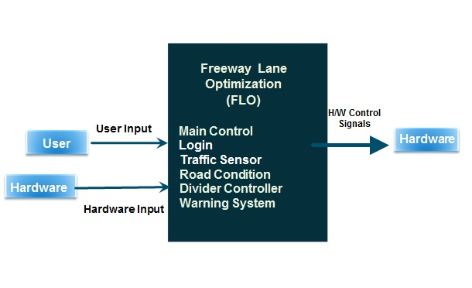Figure 1-1: Level 0 DFD

1.3.2 Description and Major Functions of FLO

Flo will automate sets of moving dividers to even out congested traffic between both incoming and outgoing sides of the road. The system will offer programmed controls of the dividers, the signals, the warnings and alerts, and other mechanical hardware. FLO will also detect the condition of the road as to warn, avoid, and block hazards that may endanger drivers. FLO will be controlled by a GUI with one standard mode with a manual override should dividers need to be moved or signals need to be changed.

1.3.3 Hardware and Software Considerations

FLO requires standard computer hardware. Other hardware requirements include mobile dividers/walls that can move in all 360 degrees, a system to receive information from current traffic sensors that detect the flow of traffic signals to address drivers change lanes and additional sensors in the road to detect any hazards that may endanger drivers. It will also incorporate a warning system that will require radio broadcasting hardware that will override any targeted vehicle that may be in danger as well as LED built into the road and the dividers as an additional precaution. Manual controls are applications that can be used in computers, phones, tablets that are not available for public use and can only be accessed with the right credentials.

1.4 Documentation of the Development Process

FLO’s detailed functional description is documented in section 2.0. Section 2 is a succinct software description document. The overall detailed functional description is based on higher level DFDs (above level 1). All major functional units are described in detail in this part of the document.

Requirements for FLO are captured in Section 3.0 of this document. This section includes both functional and non-functional software requirements, supplemented with more detailed information when necessary.

Section 4, FLO’s detailed Design Description Document (SDD), will be completed in a subsequent Software Engineering class.

Section 5, FLO’s Software Implementation Document (SID), will be completed in a subsequent Software engineering class.

Section 6, FLO’s Software Test Plan (STP), will be completed in a subsequent Software engineering class.

1.5 References

All references used in the creation of this document are listed below.

1.5.1 Controlling Documents

There is no other document controlling this document.

1.5.2 Applicable Documents

No additional applicable document has been used in the production of this document.

1.5.3 Standards

No standard has been used in the creation of this document. However, some Standards described in textbooks have been examined as a reference. In particular, the IEEE standard has been briefly discussed in class.

2.0 DETAILED FUNCTIONAL DESCRIPTION OF FLO

2.1 Detailed FLO Functional Description.

The major tool used to design FLO is the Data Flow Diagram, DFD. The rationale for the selection of DFDs as the preferred design tool is its simplicity and versatility. In the future additional tools may be used if a stronger correlation from Design to Requirement to Implementation and Testing is required.

2.1.1 Level 1 DFD

FLO’s major functional subunits are shown in the DFD Level 1 shown below:

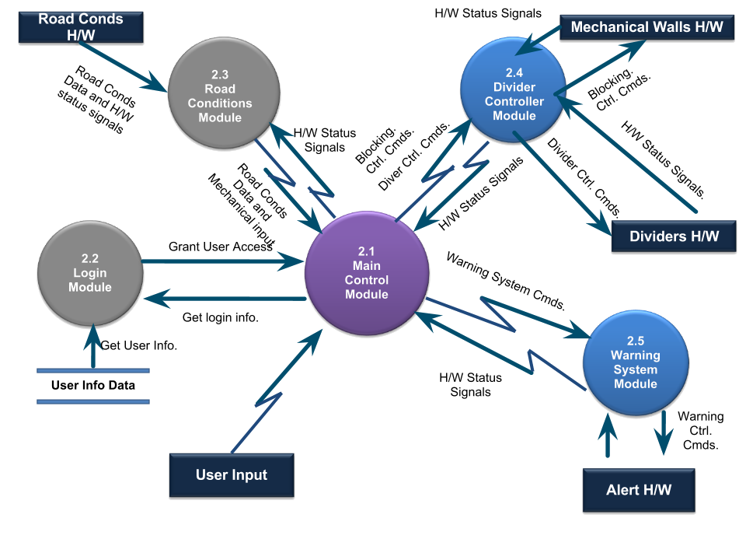

Figure 2.1: Level 1 DFD

2.1.2 Detailed Functional Description of FLO’s Major Units.

The description of FLO’s major functional units shown in Figure 2.1 follows.

Main Control - Module 2.1

The Main Control Module (MCM) will provide the GUI and functionality for programming performance cues in FLO. The MCM will contain submodules for traffic tracking, gui and safety checking.

The MCM sends messages to the Warning System Module(WSM) that tells how the road is going to be changed.

A GUI shows all actions that occur in FLO. The GUI will allow for the user to override system settings according to what is needed in real time. The GUI will be based on a multi-touchscreen interface and will be arranged in a series of tabs that allow the user to switch between screens that control different functions. Since the GUI will include multi-touch options, the user can control multiple objects simultaneously. The GUI will display the map of the FLO way displaying statuses of walls and traffic.

The Traffic Tendencies Submodule (TTS) stores data from the Road Conditions Module (RCM) information from the storage database and sends the required signals to the other modules to execute the planned actions.

The Safety Submodule (SS) is responsible for monitoring all FLO modules. It handles errors, ensures atomic transactions, detects and avoids deadlocks, and is responsible for safety. All executed actions and errors are logged, and this allows FLO to examine history and recover from errors. These errors are displayed back to the user with suggested actions. Safety Submodule also autonomously provides appropriate recovery actions to each module in FLO

Log-in / Security function - Module 2.2

The Login module will provide standard security features to protect the system from unauthorized access.

Road Conditions - Module 2.3

The Road Conditions Module (RCM) Has two main purposes it gets Traffic data from sensors that are on the FLO way and its second purpose is accident prevention. It also acts as a secondary input for the system when there isnt a user to give input. It prevents accident by detecting ice and anything else that can cause automobiles to slip on the road. Another way of Accident prevention is that it looks for anything on the road like boulders or other large objects. In the case an accident does happen The RCM will reduce the damage by detecting other stopped, or over turned automobiles. The RCM sends all this data in real time to the MCM where it will decide what to do.

Divider Controller - Module 2.4

Divider Controller Module (DCM) handles physical movement of freeway divider. It has an ability to move the divider to the left and to the right. It’s also able to block lanes in case we have accident or road construction. Based on the intensity of traffic and situation on freeway, MCM will give DCM optimal commands to move the divider.

DCM also has several sub-modules to support its functionality. They include divider physical control, signal, power supply, blocking, and safety control.

Warning System - Module 2.5

FLO features a warning system to alert drivers of any modifications that they are approaching. The warning system module contains two submodules: LED and Radio.

The Warning System Module also contains a main control submodule that is responsible for routing control signals to each submodule, which then routes them to the control hardware.

3.0 FLO REQUIREMENTS

3.1 FLO Functional Requirements

This Section lists FLO’s functional requirements. This section includes the complete set of functional requirements, along with explanations for cases in which the statement of the requirement was deemed insufficient or requires additional clarification. All requirements relate to the design modules described in Section 2. An effort has been made to standardize the correlation between the design modules and the requirements to make access and organization more consistent. For example, requirement number “n” affecting module 2.1 will be labeled 3.1.n.

Requirements Related to Design Module 2.1: Main Control
Requirement No. | Requirement Description
3.1.1 | MCM shall accept user input to manually override system settings.
3.1.2 | MCM shall receive traffic data from the Road Conditions Module.
3.1.3 | MCM shall analyze conditions data from the Road Conditions Module.
3.1.4 | MCM shall receive hardware status information from the hardware controller.
3.1.5 | MCM shall send instructions to the Warning System Module.
3.1.6 | MCM shall receive status information from the Warning System Module.
3.1.7 | MCM shall send road status information to authorized mobile devices.
 | Main Module Graphical User Interface (MMG)
3.1.8 | MMG shall be a multi-touch screen interface.
3.1.9 | MMG shall provide a GUI for each element.
3.1.10 | MMG shall provide the necessary controls for all aspects of the hardware.
3.1.11 | MMG shall display any necessary error, or other messages to the user.
3.1.12 | MMG shall display the current status of the traffic on the freeway to the user
 | Traffic Tendencies Submodule (TTS)
3.1.13 | TTS shall store information regarding traffic data in the database.
3.1.14 | TTS shall calculate traffic tendencies.
3.1.15 | TTS shall send optimized lane configurations to the Divider Control Module.
 | Safety Submodule (SS)
3.1.16 | SS shall detect errors in the system.
3.1.17 | SS shall store all performed actions.
3.1.18 | SS shall avoid deadlocks in the system.
3.1.19 | SS shall send error reports to the MMG.

Requirements Related to Design Module 2.2: Login
Requirement No. | Requirement Description
3.2.1 | Login module shall provide standard access security services

Requirements Related to Design Module 2.3: Road Conditions Module (RCM)
Requirement No. | Requirement Description
3.3.1 | RCM shall monitor traffic.
3.3.2 | RCM shall send traffic data to MCM
3.3.3 | RCM shall detect large objects on the freeway
3.3.4 | RCM shall detect the location of ill positioned automobiles on the freeway
3.3.5 | RCM shall detect the location automobiles stopped on the freeway
3.3.6 | RCM shall send the foreign object data to the MCM
3.3.7 | RCM shall send the location of any stopped automobiles to the MCM.
3.3.8 | RCM shall send the location of any ill positioned automobile to the MCM.
3.3.9 | RCM shall detect any damage on the FLOway.
3.3.10 | RCM shall send damage reports to the MCM
3.3.11 | RCM shall detect the slickness of the road.
3.3.12 | RCM shall provide input for the MCM when there is an absence of user input.
3.3.13 | RCM shall get all status information from the MCM
3.3.14 | RCM shall make decisions based on all data FLO has gathered.
3.3.15 | RCM shall get weather data from several databases.
3.3.16 | RCM shall get climate data from several databases.

Requirements Related to Design Module 2.4: Divider Controller
Requirement No. | Requirement Description
 | Divider Physical Control Module (DPCM)
3.4.1 | DPCM shall adjust divider positioning
3.4.1.1 | DPCM shall be able to move divider to the left
3.4.1.2 | DPCM shall be able to move divider to the right
3.4.2 | DPCM shall move each segment of divider individually
3.4.3 | DPCM shall keep divider stable
 | Signal Module (SM)
3.4.4 | SM shall alert drivers of the divider’s movement via color of lights
3.4.4.1 | SM shall allow the user to adjust the G, Y, R values of the lights individually.
3.4.4.2 | SM shall allow the user to adjust the blinking displays of the lights
3.4.5 | SM shall alert drivers of the divider’s movement via sound
3.4.5.1 | SM shall allow the user to adjust different levels of the alarm system
3.4.5.2 | SM shall allow the user to play different sounds
 | Power Supply Module (PSM)
3.4.6 | PSM shall generate electrical use via wind turbines
3.4.6.1 | PSM shall capture wind from passing vehicles
3.4.6.2 | PSM shall produce electricity for freeway using
 | Blocking Module (BM)
3.4.7 | BM shall adjust mechanical walls positioning
3.4.7.1 | BM shall be able to move mechanical walls up
3.4.7.2 | BM shall be able to move mechanical walls down
3.4.8 | BM shall move each mechanical walls individually
 | Safety Control Module (SCM)
3.4.9 | SCM shall detect vehicles nearby
3.4.10 | SCM shall stop divider/mechanical walls movement

Requirements Related to Design Module 2.5: Warning System Module (WSM)

Requirement No. | Requirement Description
3.5.1 | Warning System Control Module (WSCM)
3.5.1.1 | WSCM shall alert the drivers of the Freeway narrowing.
3.5.1.2 | WSCM shall alert the drivers of the Freeway widening.
3.5.1.3 | WSCM shall send requests to the LEDM to make the according signals.
3.5.1.4 | WSCM shall track drivers that must merge.
3.5.1.5 | WSCM shall track drivers that are approaching dividers.
3.5.1.6 | WSCM shall send requests to the LEDM to warn drivers approaching dividers.
3.5.1.7 | WSCM shall receive all requests for Alert control h/w status information from MCM.
3.5.1.8 | WSCM shall supply error signals from Alert control h/w to MCM when available.
3.5.2 | Light Emitting Diode Module(LEDM)
3.5.2.1 | LEDM shall process all communication between WSCM and the LED control hardware.
3.5.2.2 | LEDM shall communicate with Radio control hardware to perform requested signals simultaneously.
3.5.2.3 | LEDM shall signal drivers to merge/change lanes from any lane, towards either direction.
3.5.2.4 | LEDM shall signal drivers to stop a safe distance away from the barriers should they be unable to merge/change lanes.
3.5.3 | Radio Module (RM)
3.5.3.1 | RM shall process all communication between WSCM and the radio control hardware.
3.5.3.2 | RM shall intercept radio broadcasts only for cars that are required to merge
3.5.3.3 | RM shall broadcast drivers to merge/change lanes.
3.5.3.4 | RM shall communicate with LED module to perform requested signals simultaneously.

3.2 FLO Non-Functional Requirements

This Section collects all the FLO Non-Functional Requirements. All non-functional requirements are numbered “NF – n” where “n” indicates the n^{th} requirement.

NF - 1 FLO requires sufficient data storage to process live traffic data in real time
NF - 2 FLO must execute signals quickly and clearly in real time.
NF - 3 FLO must prioritize the safety of the drivers above all else.

3.3 FLO Hardware Requirements

This Section collects all FLO’s electronic hardware requirements. All hardware requirements are numbered “H – n” where “n” indicates the n^{th} requirement.

H - 1 FLO will run on standard microcomputer hardware

H - 2 FLO will require mobile dividers/walls with complete 360 degree motion.

H - 3 FLO will require LEDs to be built into the roads and the mobile dividers
and walls to be able to signal drivers.

H - 4 FLO will require radio broadcasting equipment to intercept and warn
drivers.

4.0 FLO DETAILED DESIGN

In this section, FLO will be designed in detail including several higher level DFDs. Each major module detailed design is included in correspondence with the design sections defined in Section 2 and responding to the requirements listed in its correlated sub-section in chapter 3.

The detailed design of each of the modules discussed in section 2 with requirements presented in section 3 is presented in the Figures below.

4.1 Level 2 DFDs

5.0 FLO ELEMENTS OF IMPLEMENTATION

In this section (some of) the modules designed in Section 4 with requirements listed in Section 3 will be implemented initially at the level of pseudo code. Actual code will be provided as time permits. Each module is implemented in correspondence with the design sections defined in section 2 and responding to the requirements listed in its correlated sub-section in chapter 3.

THIS SECTION WILL BE COMPLETED IN cs437

6.0 FLO TEST PLAN

6.1 INTRODUCTION
In this section the testing methodology to be used to V&V each of the requirements listed in section 3.0 has been identified. At points some additional testing may be required and they shall be documented as an attachment to this document.

The methodologies and testing strategies identified at this point include three major approaches with various variations to adapt to the FLO project:
- Testing using additional ad-hoc created software including a correlation testing unit.
- Demonstration of the specified capability
- Inspection of the software code possibly using additional inspection techniques
6.2 FUNCTIONAL REQUIREMENTS VALIDATION MATRIX

The FLO Functional and Performance Requirements Validation Matrix is given below.

Requirements Related to Design Module 2.1: Main Control
Requirement No. | Requirement Description | Testing Methodology
3.1.1 | MCM shall accept user input to manually override system settings. | Demonstration
3.1.2 | MCM shall receive traffic data from the Road Conditions Module. | Demonstration
3.1.3 | MCM shall analyze conditions data from the Road Conditions Module. | Demonstration
3.1.4 | MCM shall receive hardware status information from the hardware controller. | Demonstration
3.1.5 | MCM shall send instructions to the Warning System Module. | Demonstration
3.1.6 | MCM shall receive status information from the Warning System Module. | Demonstration
3.1.7 | MCM shall send road status information to authorized mobile devices. | Demonstration
 | Main Module Graphical User Interface (MMG)
3.1.8 | MMG shall be a multi-touch screen interface. | Demonstration
3.1.9 | MMG shall provide a GUI for each element. | Demonstration
3.1.10 | MMG shall provide the necessary controls for all aspects of the hardware. | Demonstration
3.1.11 | MMG shall display any necessary error, or other messages to the user. | Demonstration
3.1.12 | MMG shall display the current status of the traffic on the freeway to the user | Demonstration
 | Traffic Tendencies Submodule (TTS)
3.1.13 | TTS shall store information regarding traffic data in the database. | Demonstration
3.1.14 | TTS shall calculate traffic tendencies. | Demonstration
3.1.15 | TTS shall send optimized lane configurations to the Divider Control Module. | Demonstration
 | Safety Submodule (SS)
3.1.16 | SS shall detect errors in the system. | Demonstration
3.1.17 | SS shall store all performed actions. | Demonstration
3.1.18 | SS shall avoid deadlocks in the system. | Demonstration
3.1.19 | SS shall send error reports to the MMG. | Demonstration

(Testing Methodology Omitted for Module 3.2, Login)

Requirements Related to Design Module 2.3: Road Conditions Module (RCM)
Requirement No. | Requirement Description | Testing Methodology
3.3.1 | RCM shall monitor traffic. | Demonstration
3.3.2 | RCM shall send traffic data to MCM | Demonstration
3.3.3 | RCM shall detect foreign objects on the freeway | Demonstration
3.3.4 | RCM shall detect ill positioned automobiles on the freeway | Demonstration
3.3.5 | RCM shall detect automobiles stopped on the freeway | Demonstration
3.3.6 | RCM shall send the foreign object data to the MCM | Demonstration
3.3.7 | RCM shall send the location of any stopped automobiles to the MCM. | Demonstration
3.3.8 | RCM shall send the location of any ill positioned automobile to the MCM. | Demonstration
3.3.9 | RCM shall detect any damage on the FLOway. | Demonstration
3.3.10 | RCM shall send damage reports to the MCM | Demonstration
3.3.11 | RCM shall detect the slickness of the road. | Demonstration

Requirements Related to Design Module 2.4: Divider Controller
Requirement No. | Requirement Description | Testing Methodology
 | Divider Physical Control Module (DPCM)
3.4.1 | DPCM shall adjust divider positioning | Demonstration
3.4.1.1 | DPCM shall be able to move divider to the left | Demonstration
3.4.1.2 | DPCM shall be able to move divider to the right | Demonstration
3.4.2 | DPCM shall move each segment of divider individually | Demonstration
3.4.3 | DPCM shall keep divider stable | Demonstration
 | Signal Module (SM)
3.4.4 | SM shall alert drivers of the divider’s movement via color of lights | Demonstration
3.4.4.1 | SM shall allow the user to adjust the G, Y, R values of the lights individually. | Demonstration
3.4.4.2 | SM shall allow the user to adjust the blinking displays of the lights | Demonstration
3.4.5 | SM shall alert drivers of the divider’s movement via sound | Demonstration
3.4.5.1 | SM shall allow the user to adjust different levels of the alarm system | Demonstration
3.4.5.2 | SM shall allow the user to play different sounds | Demonstration
 | Power Supply Module (PSM)
3.4.6 | PSM shall generate electrical use via wind turbines | Demonstration
3.4.6.1 | PSM shall capture wind from passing vehicles | Demonstration
3.4.6.2 | PSM shall produce electric for freeway using | Demonstration
 | Blocking Module (BM)
3.4.7 | BM shall adjust mechanical walls positioning | Demonstration
3.4.7.1 | BM shall be able to move mechanical walls up | Demonstration
3.4.7.2 | BM shall be able to move mechanical walls down | Demonstration
3.4.8 | BM shall move each mechanical walls individually | Demonstration
 | Safety Control Module (SCM)
3.4.9 | SCM shall detect vehicles nearby | Demonstration
3.4.10 | SCM shall stop divider/mechanical walls movement | Demonstration

Requirements Related to Design Module 2.5: Warning System Module (WSM)

Requirement No. | Requirement Description | Testing Methodology
3.5.1 | Warning System Control Module (WSCM)
3.5.1.1 | WSCM shall alert the drivers of the Freeway narrowing. | Demonstration
3.5.1.2 | WSCM shall alert the drivers of the Freeway widening. | Demonstration
3.5.1.3 | WSCM shall send requests to the LEDM to make the according signals. | Demonstration
3.5.1.4 | WSCM shall track drivers that must merge. | Demonstration
3.5.1.5 | WSCM shall track drivers that are approaching dividers. | Demonstration
3.5.1.6 | WSCM shall send requests to the LEDM to warn drivers approaching dividers. | Demonstration
3.5.1.7 | WSCM shall receive all requests for Alert control h/w status information from MCM. | Demonstration
3.5.1.8 | WSCM shall supply error signals from Alert control h/w to MCM when available. | Demonstration
3.5.2 | Light Emitting Diode Module(LEDM)
3.5.2.1 | LEDM shall process all communication between WSCM and the LED control hardware. | Demonstration
3.5.2.2 | LEDM shall communicate with Radio control hardware to perform requested signals simultaneously. | Demonstration
3.5.2.3 | LEDM shall signal drivers to merge/change lanes from any lane, towards either direction. | Demonstration
3.5.2.4 | LEDM shall signal drivers to stop a safe distance away from the barriers should they be unable to merge/change lanes. | Demonstration
3.5.3 | Radio Module (RM)
3.5.3.1 | RM shall process all communication between WSCM and the radio control hardware. | Demonstration
3.5.3.2 | RM shall intercept radio broadcasts only for cars that are required to merge | Demonstration
3.5.3.3 | RM shall broadcast drivers to merge/change lanes. | Demonstration
3.5.3.4 | RM shall communicate with LED module to perform requested signals simultaneously. | Demonstration

A. ACRONYMS
BM Blocking Module
DCM Divider Controller Module
DPCM Divider Physical Control Module
FLO Freeway Lane Optimization
GUI Graphical User Interface
MCM Main Control Module
MMG Main Module Graphical User Interface (component of MCM)
PSM Power Supply Module
RCM Road Conditions Module
SCM Safety Control Module
SM Signal Module
SS Safety Submodule (component of MCM)
TTS Traffic Tendencies Submodule (component of MCM)
WSCM Warning System Control Module (component of WSM)
WSM Warning System Module

B. DATA DICTIONARY
FLOWAY - a free way that uses FLO.
Slickness - Ice, oil water and any other liquid that is slippery.

