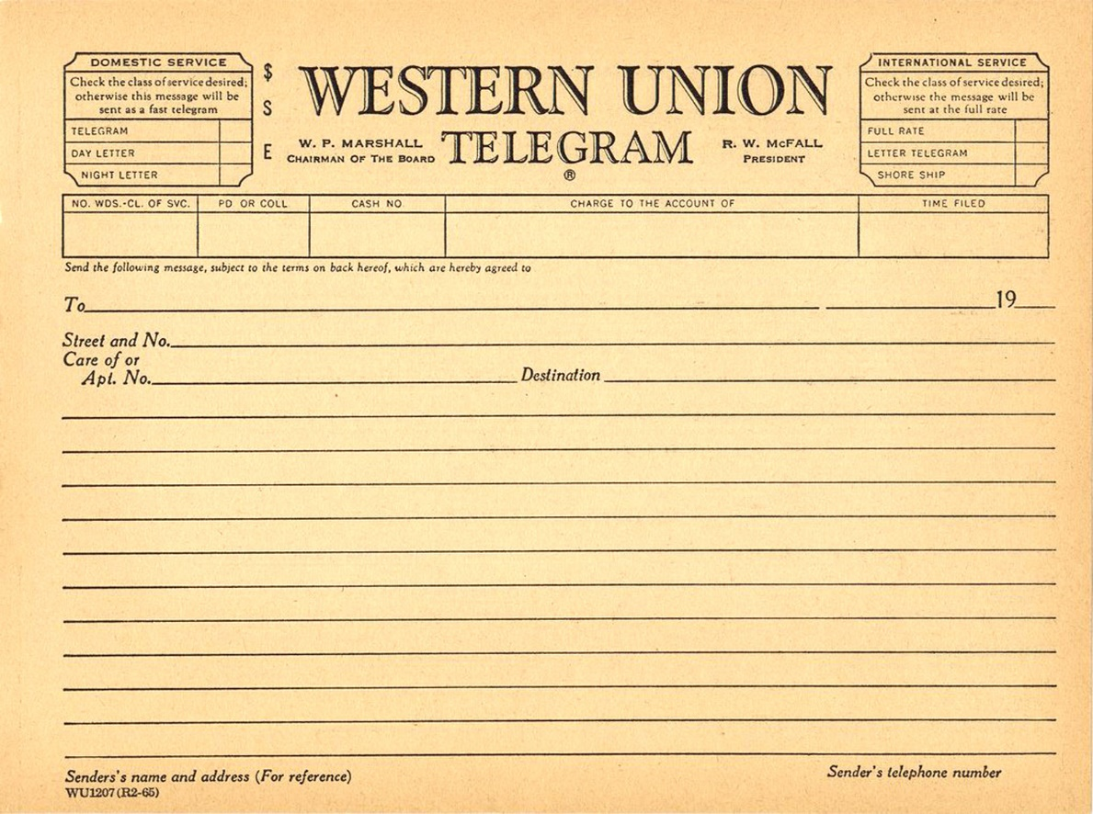

High Street, Manchester, England

22

Mrs H McDonald

=Just docked in Halifax Lovely trip Will write soon=

Love Pearle