1) Download LM Studio: https://lmstudio.ai/
2) Download any model (testing was conducted on Llama 3 8B Instruct 64k).
3) In the left menu, navigate to the "Developer" tab.
4) Click "Load model" and select the downloaded model. Wait for the process to finish and start the server (also, check the address – it should be 1234 by default).
In its working state, it will look like this:
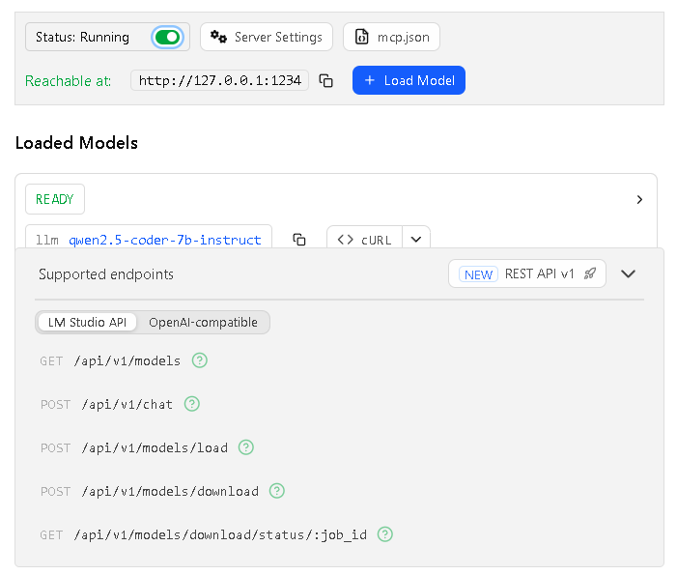
5) Place all .py files into a single folder.
6) Open VS Code, run chembl_db.py, and wait for the molecule database to be created.
7) Run the bot.py file.

