**HARSH PARAMMAL**

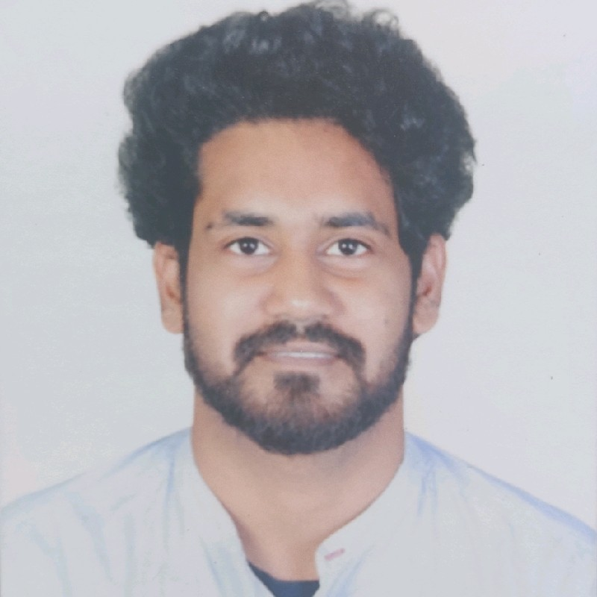

**✆ :** +91-7208463103| **🖂 :** harsh.harish1@gmail.com

**Technical Analyst**

A dedicated analyst, proficient in running successful method-oriented operations targeting **Software Development** assignments with an organization of high repute across the IT industry.

**PROFILE SUMMARY**

* Result oriented full-stack technocrat with **hands on** experience in **Software/ Web Application Development** & **Project Execution** for 5.9 years.
* Managing **end-to-end Software Development Lifecycle (SDLC)** right from requirement analysis, documentation (functional specifications, technical design), coding and testing (preparation of test cases along with implementation) to maintenance of proposed applications.
* Extensive experience in **Front-end development**, **User-interface**, **Framework Development**, **Maintenance** and **Demo** **presentations**.
* Liaised with stakeholders during the **root cause analysis**, requirements gathering, detailed level design, development, system test and production implementation to ensure that optimal resolutions were achieved.
* An avid learner with strong communication, analytical and relationship skills

**CORE COMPETENCY**

- Project Management - Software Design / Development - Requirement Gathering

- Incident Resolution - Change Request Management - Process Enhancement

- User-interface/Framework Development - Unit & Integration Testing   
- Reporting & Documentation

**TECHNICAL SKILLS**

**Languages:** Javascript, Typescript, HTML, CSS, LESS/SCSS, Tailwind, ReactJS/TS, ExtJS, Jest, React-testing-library, Redux, Java, Spring-boot.

Postman, API integrations (Authentication, Payments), Bootstrap

**Database:** MySQL, Oracle, Postgres

**IDE/GUI:** VisualStudio Code, Notepad++, Eclipse

**Repository:** GitHub,Azure

**Version control:** GIT, SVN

**File Transfer Tools:** WinSCP, FileZilla

**ORGANIZATIONAL EXPERIENCE**

**Doyen Infosolutions Pvt. ltd. May 2020 - On going**

**Technical Analyst**

**Client:** ‘Brain2’

* Development of applications using reactJS/TS with modern trending UI look and feel.
* Web application migrations.
* Managing the project development timeline, team and resources.
* Periodic training sessions to keep in touch with the latest UI trends, best practices and root cause analysis.
* Production deployment.
* Managing multiple clients, project requirements and Issue tracking.

**Ixia Solutions L.L.P. July 2018 – March 2020**

**Software Engineer**

**Client:** ‘Campus Management’

* Development and maintenance of a client application named ‘Radius’ which is an educational domain.
* The domain is built in various different technologies as follows:
* Frontend (Javascript, HTML, CSS, Theming, ExtJS, ReactJS, NPM, Testing: Jest, React Testing Library)
* Java (Spring framework 3,Testing: JUnit, Powermockito)
* Database MySql
* Versioning control system GIT
* Pull requests, Merging, Branching, Repo management, Agile Scrum Board, Issue Tracking were all taken care of via Microsoft Dev Azure via GIT..
* Deployments are done via Jenkins and build scripts written via ANT.
* **Role:** 
  + Worked as Software Engineer and led the front end development.
* Skill set were as follows:
  + Requirement gathering from stakeholders.
  + Enhancements, Bug fixes, RND and Maintenance.
  + 3rd party API for authentication (Google sign-in, Online Payments)
  + Backward compatibility for IE using polyfills.
  + Migration
    - Javascript, html, css -> ReactJS
    - JSP -> ExtJS 6
    - ExtJS 4 -> ExtJS 6
    - Struts -> Spring MVC
    - Non responsive to Responsive UI
  + Documentation, Presentation, Training, Scrum Management Lead.

**Vistaar Systems Pvt. Ltd., Mumbai Jan 2016 – July 2018**

**Software Engineer**

**Role:**

* Developing software/ application solutions by studying information needs, conferring with users, studying systems flow, data usage and work processes
* Understanding process requirements and providing use cases for business, functional & technical requirements
* Interacting with users for requirement gathering; preparing functional specifications and low-level design documents
* Creating and sharing the Daily Status Report (DSR) including key highlights, open defects, number of test cases executed/pending and so on with the Project Manager
* Aiding in determining operational feasibility through analysis, problem definition, requirement analysis and proposing appropriate solutions
* Coding, implementing and integrating complex software programs using technologies such as **ExtJS, Tableau, ElasticSearch** troubleshooting and debugging new or existing software programs.

**Highlights:**

* Mapped client’s requirements, implemented processes aligned to their requirements and delivered satisfactory solutions
* Translated business requirements into functional requirements; prepared functional specifications and documents for enhancements & customization
* Participated in the team’s **agile** software development process; developed unit tests and functional/integration tests; supported production deployments of developed solutions
* Participated in testing of **Reports Module**, monitored Functional Testing (FT) and User Acceptance Testing (UAT) Test Scripts, provided User Acceptance Testing (UAT) Testing Support, and reviewed Functional Test Scripts
* As Scrum member, participated in the complete development process from requirements gathering, analysis, design, development and testing of **Vistaar WebUI Framework, Vistaar Tableau Framework and Vistaar ElasticSearch Framework**.
* Performed detailed design of modules such as **Vistaar Tableau Framework and Vistaar ElasticSearch Framework** along with their implementation, and documentation; integrated software modules developed by other team members, and performed integration testing; successfully implemented the **Tableau Authentication** and **Vistaar Authentication** functionalities.
* Identified and fixed **200+** bugs over span of 2+years; integrated unit tests of **Tableau** into **Vistaar WebUI Framework**.
* Attended daily defect meetings with the **Project Manager** and **Development Team**; identified gaps and suggested relevant solutions.
* Fabricated Dashboards and visualizations using Tableau and integrated them with web applications

**MAJOR PROJECTS EXECUTED**

**Project Title:** Application Framework Group. (Vistaar Product Team)

**Period:** 01/16 – 03/17

**Client:** Vistaar Product

**Description:** Developed, enhanced, ensured backward compatibility & maintenance of custom components that integrates with VistaarFramework; these components were shipped to SDG as new release updates and were directly integrated into client’s application. Maintained changes to WebUI access layer which is the middle layer - between the ExtJS and Vistaar product. Provided support for the same and created prototypes for feasibility study.

**Project Title:** Solution Development Group, Vistaar Solution Team

**Period:** 03/17 – 07/17

**Client:** Speedway LLC

**Description:** Developed a module from scratch which Integrated latest Vistaar Framework custom components. This module provides reports based on different complex filters in scope selection pattern and is represented back on grid with huge margin of data. Fixed High Priority bug within stipulated time.

**Project Title:** Vistaar- Proof of Concept

**Period:** 07/17 – Present

**Description:**

* **Tableau POC**, **Elasticsearch POC**
* Defined project roles and responsibility
* Utilized:

1. **Tableau** (3rd party application) for Web UI Visual enhancement
2. **Elasticsearch** (3rd party application) to reduce the time spent on data analysis

* Developed **Vistaar Tableau Framework** (consisting of custom API’s, events and other functionalities)& **Vistaar Elasticsearch Framework** from scratch and integrated it with **VistaarWebUI**

**ACADEMIC PROJECTS**

**Project Title:** Railway Ticket Booking (C++ and Php)

**Period:** 09/13 – 12/13

**Project Title:** Interactive Job Portal (ASP.net-C#)

**Period:** 05/14 – 07/14

**Project Title:** VESIT Leave Application Management (ASP.net-C#)

**Period:** 09/15 – 12/15

**ACADEMIC DETAILS**

2016: **MCA Major** from Vivekanand Education Institute of Science and Information Technology, Mumbai with **7.36 CGPI**

2013: **B.Sc. (Computer Science)** from Model Junior College, Dombivli, Mumbai University with **61.00%**

2010: **12th** from Royal Junior College, Dombivli, Maharashtra State Board with **60.00%**

2008: **10th** from Don Bosco School, Dombivli, Maharashtra State Board with **59.38%**

**PERSONAL DETAILS**

**Date of Birth:** 25/03/1993

**Languages Known:** English, Hindi, Marathi, Telugu & Malayalam

**Address:**  A/10 Shree Sai Vaibhav C.H.S., Sakharam Complex, Dombivli-421202, Maharashtra