Entrant’s school: Quezon City Science High School | Adviser’s Name: Skjoukje U. Jemoya
Name of Team Members:  1. Aaron Jed E. Campo  2. Raya Kalayaan R. Amparo  3. Ayeza Leigh F. Delos Santos  4. Sophia Laureen A. Tado | Grade Level per member:  1. Grade 10  2. Grade 10  3. Grade 10  4. Grade 10
Theme (choose 1):
- Environmental Sustainability through Technology
Entry Title: SAGIP: Solar-Powered Estero Guardian with On-Chip AI
Project description: ONLY THREE (3) SENTENCES which may be used as the entry’s official description for write-ups
SAGIP is a low-cost, solar-powered unit that filters floating plastic out of a creek, lifts it into a sorted bin and names each item with a small on-chip image model. Barangay officials get a weekly offline report of what the creek carried, plus a secondary water-level alert for blockages. Built for about PHP 6,000 from local parts, it adds anonymized records to an open dataset that other barangays can copy.

- What problem are you trying to solve?

Plastic reaches the sea through rivers, and the Philippines ranks near the top in every estimate. Global models placed it among the leading sources of mismanaged plastic waste (Jambeck et al., 2015) and of river emissions (Lebreton et al., 2017), and a later model built on measurements from more than 1,000 rivers kept Philippine rivers at the top (Meijer et al., 2021). Monitoring at the river outlets of Greater Jakarta found higher debris release in the rainy season (Cordova & Nurhati, 2019), and in the Saigon River water hyacinth mats carried most of the floating plastic that observers counted (Schreyers et al., 2021).
Two gaps keep the problem going. Removal is manual and unrecorded, so cleanups weigh bulk waste and learn nothing about its contents. Product-level evidence is also scarce. River plastic research still lacks long-term monitoring data (van Emmerik & Schwarz, 2020), and brand audits, though valuable, are periodic, labor-intensive and mostly land-based (Break Free From Plastic, 2019). The Extended Producer Responsibility Act of 2022 (RA 11898) obliges large companies to recover a rising share of their plastic packaging, and the DENR has begun auditing reported recovery rates (Food Packaging Forum, 2026). Enforcement still needs proof of which packaging reaches waterways.
What is missing is a continuous, inexpensive record taken at the creek itself that one barangay can run. Large systems are arriving, such as solar-powered Interceptor barriers planned for the Pasig and Meycauayan rivers (Manila Bulletin, June 2026), but a narrow estero needs a unit a barangay can afford. A secondary hazard shares the channel. Clogged waterways worsen flooding in low-lying neighborhoods, and residents learn of a blockage only after the water rises.

- What do you want to achieve?

- Goal: We want barangays to treat the plastic in their creeks as measurable evidence instead of invisible waste. In the long run, this means cleaner waterways and community-owned data that shifts the burden of proof toward the companies that produce the packaging.
- Objectives (SMART):
- 1. Remove and measure plastic. In an 8-week pilot at [ESTERO SITE] starting in December 2026, capture at least 50% of the floating debris that reaches the boom, measured against a baseline week recorded before installation, lift at least 20 kg of plastic and log at least 1,000 classified items.
- 2. Prove what the plastic is. By November 20, 2026, train an on-device 2D convolutional neural network that reaches at least 85% precision and recall on photographs from places it has not seen. Across the pilot, weekly device counts should stay within 15% of a trained hand audit.
- 3. Make it copyable. By March 2027, publish a free English and Filipino build guide and an open dataset, and help at least 2 other barangays or schools build a unit for about PHP 6,000 each.

- Who will benefit from this project?

Primary beneficiaries are the [N] households of [BARANGAY AND PUROK] along [ESTERO SITE] in Quezon City, who bear the creek's pollution and flooding, and the barangay sanitation officers, who will empty the bins weekly and use the report. Secondary beneficiaries are the city solid-waste office and the DENR, who need item-level evidence for EPR enforcement, at least 2 neighboring barangays or schools that copy the design by March 2027, and downstream fisherfolk as less plastic reaches Manila Bay. We chose a barangay estero because Quezon City already runs river programs with partners (Philstar, 2025), and community-based monitoring builds local ownership of data (Conrad & Hilchey, 2011). [Add the barangay's household count and its current cleanup program.]

- How did you come up with your proposal?

Select. We listed five community problems and scored each on significance, feasibility, STEM depth, replicability and originality. Creek plastic won. We can reach a creek, we can measure it weekly, and RA 11898 has just made item-level data useful. We then fitted the design to PHP 6,000 with a bank-mounted unit, an image classifier and a sorting gate. [Edit this to match your team's actual brainstorming steps.]
What exists. Five kinds of work address parts of the problem.
Existing work | What it does | What it leaves open
Cameras with deep learning (van Lieshout et al., 2020) | Count floating plastic from bridge-mounted cameras, tested in Jakarta | Monitor only and remove nothing
Solar river barriers (The Ocean Cleanup, 2026) | Intercept and lift river plastic with a solar-powered conveyor | Built for large rivers, announced for the Pasig and Meycauayan
AI cleanup boats (Manila Bulletin, 2025) | Collect plastic with a solar-powered, AI-enabled vessel in a Pasig pilot | Mobile boats on a large river, not fixed estero units
Trash traps (Philstar, 2022) | Remove plastic in bulk at river tributaries | Record bulk weight only
Brand audits (Break Free From Plastic, 2019) | Name the brands behind plastic waste | Periodic, manual, mostly land-based

Gap we test. None of these lifts plastic, counts it item by item and shares open data in a unit a barangay can afford. Our search was limited and found no such system. We therefore ask one research question: can a PHP 6,000 on-chip counter match a trained hand audit within 15%, and does continuous counting reveal rain-driven pulses of plastic that weekly audits miss?

- How will your tech solution work?

STEM is the core of the design. Physics sets the boom angle, the lever and torque of the arm and the solar energy budget. Mathematics and statistics define precision, recall and count error. Computer science supplies a small 2D convolutional neural network (CNN) with INT8 quantization, which shrinks a model about fourfold with little loss of accuracy (Jacob et al., 2018), running on TensorFlow Lite for Microcontrollers (David et al., 2021). Engineering joins them in a weatherproof structure. Our key message is that proof of what plastic reaches a creek can be continuous, cheap and community-owned. Pairing a collector with a counter delivers it best.
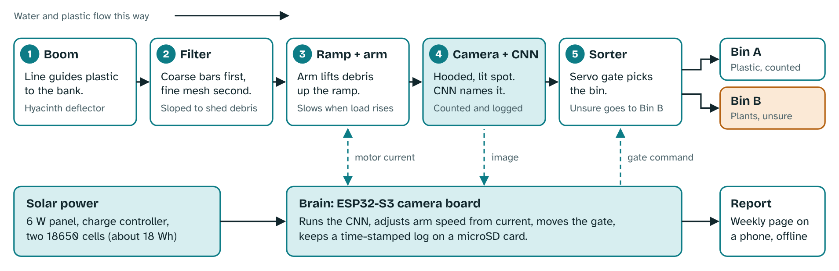
Figure 1. How plastic and signals move through the unit.
Catch. A floating boom of reused PET bottles with a net skirt guides surface debris toward the bank. A wide-gapped deflector upstream turns water hyacinth mats aside. The current does the herding, so the boom needs no energy.
Filter. Coarse bars stop large debris, then a fine mesh basket catches small plastic. Both slope so leaves and mud shed. The foot of the ramp is hinged and rides on bottle floats, so it follows the water level as rain raises and lowers the creek.
Lift. A worm-gear DC motor, mounted above the flood mark, turns a short rake arm that sweeps debris up the ramp in bursts. A sacrificial shear pin protects the gearbox. A guard, stop switch and lockout protect people.
Protect. The chip reads motor current and adjusts speed. Under heavy load it slows and keeps torque, and under light load it speeds up, within a limit set by the solar budget. A Hall sensor confirms the arm is moving. If current rises sharply, the arm reverses briefly, retries at most three times, then locks out and alerts the barangay. The driver defaults to off, so a crashed chip cannot leave the motor running.
Count and sort. An ESP32-S3 camera looks down at a fixed landing plate under a hood with LED lighting, so every item appears in the same light. The CNN classifies it as PET bottle, sachet or film, bag, foam, cup, plant or other. A servo gate then drops plastic into Bin A and plants or low-confidence items into Bin B for a person to check. If the servo fails, items still land in one bin and are still counted. Training photographs come from our own collection along the creek bank, labelled by students and checked by the adviser. Items that land together may count as one, so each week students hand-count both bins as the accuracy test.
Software. We train in Keras on a laptop, start from a small pretrained MobileNet-style network at 96 by 96 pixels, quantize to INT8 and deploy with TensorFlow Lite for Microcontrollers on the ESP32-S3.
Report. A phone reads an offline Wi-Fi page hosted by the chip. Each record stores class, time, water level and an image hash in an append-only log on a microSD card, with time from a clock module. A script builds the weekly report and an anonymized open dataset, and plotting counts against rainfall shows whether plastic arrives in pulses.
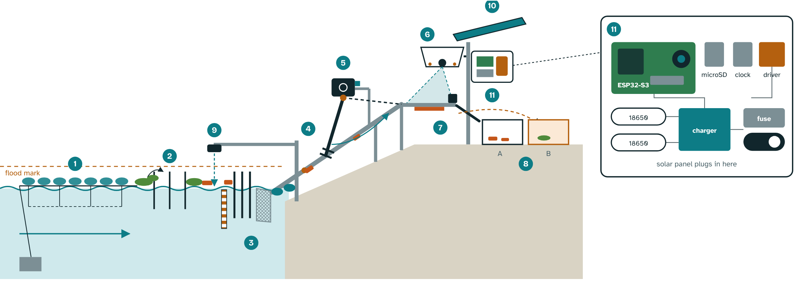
Figure 2. Cutaway of the SAGIP unit at the creek bank (schematic).
Warn (secondary). A waterproof ultrasonic sensor measures the distance to the water against a painted staff gauge. It raises an alert when the level rises quickly or a bin nears capacity, and the arm stops above a set level.
Power. Planning figures until bench measurements replace them. The camera runs only when an item is present. Electronics draw about 6 Wh per day and the arm about 0.3 Wh. A 6 W panel yields about 11 Wh per day at 3 effective sun-hours and 60% efficiency, and two 18650 cells store about 18 Wh. When the battery is low the chip lengthens its capture interval.
Scope. SAGIP lifts light floating debris such as bottles, sachets, bags, foam and cups. Heavy or tangled items, hyacinth mats, sunken waste and dissolved pollutants fall outside its reach, so we report a measured capture rate instead of claiming a clean creek.
In plain words. The model is the skill of a sanitation worker who can tell a PET bottle from a sachet at a glance, saved as a file of numbers. Quantization rounds them like a gradebook recording 87, not 87.3416, so the file fits the chip. No internet is needed.

- How will you implement this?

The pilot unit costs about PHP 6,000 and is built in three stages, each bought only after the previous test passes.
- Resources:
Item | PHP
ESP32-S3 camera board with PSRAM, microSD card, clock module, sealed enclosure with light hood | 1,850
6 W solar panel, charge controller, two 18650 cells, converter | 1,200
Boom rope and net, anchor and post, two bins and staff gauge, wiring, fuse and switch | 1,100
Waterproof ultrasonic level sensor | 350
Geared motor, driver, current and motion sensing, servo gate | 1,000
Ramp with hinged float foot, rake arm, coarse bars, fine mesh, spare shear pins | 350
Subtotal | 5,850
Contingency | 150
Total | 6,000

Tools. Python, Keras, TensorFlow Lite for Microcontrollers, Arduino IDE, a borrowed soldering iron and multimeter, a kitchen scale and our phones. Prices are estimates to confirm locally, and we will ask the barangay for posts, rope and bins in kind.
Stage 1, bench (about PHP 1,850). Train and test the model and measure power draw. Gate: precision and recall on held-out photographs reach 85%.
Stage 2, passive trap (about PHP 2,650). Install the boom, deflector, filter, hinged ramp foot, bins, post, solar supply and level sensor. Gate: the boom survives at least 3 rain events and weekly counts fall within 15% of hand counts.
Stage 3, arm and sorter (about PHP 1,350). Fit the motor, jam protection, current sensing and servo gate. Gate: a wet bench test with real hyacinth, estero silt and a little cooking oil, then solar-only lifts at the target jam rate.
Timeline. Site visit, barangay letter and starter dataset by November 2. Model and a baseline week by November 20. Early results on December 7 if shortlisted. Pilot from December to February. Build guide and further sites by March 2027.
- Stakeholders:
Barangay captain and sanitation officers: site approval, weekly emptying, and use of the reports under a one-page maintenance agreement.
City solid-waste office and DENR: use of the data and fit with Quezon City's river programs (Philstar, 2025).
Adviser and school head: supervision and safety sign-off.
Students and residents: students build, label, count and report. Residents give consent.
- Risks & Mitigation:
Manual labor: people must still empty both bins weekly, clear the screen after storms, wipe the lens and check the battery. We will log those hours.
Hyacinth mats: a deflector, sloped filters and a plant class that sends mats to Bin B.
Jams and burnout: shear pin, current and Hall sensing, three retries, driver off by default.
Changing water level: a hinged ramp foot on floats and a level sensor that stops the arm above a set height.
Oil and silt: motor mounted high, sealed bearings with marine grease, hooded lens.
Model errors in new light or water: test on unseen places, send unsure items to Bin B and keep the weekly hand count.
Arm failure: the boom, bin and camera still work, so the data pilot survives.
Safety, privacy, storms and theft: no student enters the water, the arm is guarded, the camera sees the water only, and electronics are retrieved before a typhoon.

- What kind of impact do you hope to achieve and what is the long term vision for this proposal?

Success means floating plastic lifted from a real creek and a trustworthy weekly record of what it was. One unit lifts little mass, so its value lies in a design cheap to copy and data open to combine.

- Measurable Outcomes:
1. Less plastic in the creek: a capture rate of at least 50% against the baseline week and at least 20 kg lifted in 8 weeks.
2. Trustworthy counts: at least 1,000 classified items, weekly device error of 15% or less against the hand audit, and at least 85% precision and recall on unseen places.
3. Replication: at least 2 more sites by March 2027 at about PHP 6,000 each, sharing one open data format, with weekly labor hours reported so other barangays know the real workload.
- Long-Term Vision: We see a student-built, barangay-owned network of units along connected creeks that feeds one open dataset showing where plastic enters, which products dominate, and whether EPR commitments change what the water carries. Planned upgrades are a belt conveyor for higher volumes and a second camera angle.
- Key Takeaway: The Philippines already knows who makes much of its plastic. SAGIP makes the proof continuous, cheap and community-owned, and it lifts some of the plastic out along the way.
References
Break Free From Plastic and GAIA (2019). Plastics Exposed.
Conrad, C. C., & Hilchey, K. G. (2011). A review of citizen science and community-based environmental monitoring. Environmental Monitoring and Assessment, 176, 273-291.
Cordova, M. R., & Nurhati, I. S. (2019). Release of land-derived marine debris from the Greater Jakarta area. Scientific Reports, 9, 18730.
David, R., et al. (2021). TensorFlow Lite Micro: Embedded machine learning for TinyML systems. Proceedings of Machine Learning and Systems, 3.
Food Packaging Forum (2026). Philippines steps up enforcement of plastic packaging recovery requirements. foodpackagingforum.org
Jacob, B., et al. (2018). Quantization and training of neural networks for integer-arithmetic-only inference. CVPR.
Jambeck, J. R., et al. (2015). Plastic waste inputs from land into the ocean. Science, 347, 768-771.
Lebreton, L. C. M., et al. (2017). River plastic emissions to the world's oceans. Nature Communications, 8, 15611.
Manila Bulletin (June 6, 2026). DENR, The Ocean Cleanup forge alliance for Pasig River.
Manila Bulletin (October 12, 2025). AI-powered robot waterway cleaning vehicle launched in Pasig.
Meijer, L. J. J., et al. (2021). More than 1,000 rivers account for 80% of global riverine plastic emissions. Science Advances, 7, eaaz5803.
Philstar (August 28, 2025). Quezon City government, SMC team up for river cleanup.
Philstar (July 14, 2022). DENR-EMB to install trash traps in polluted rivers.
Republic Act No. 11898 (2022). Extended Producer Responsibility Act of 2022.
Schreyers, L., et al. (2021). Plastic plants: The role of water hyacinths in plastic transport in tropical rivers. Frontiers in Environmental Science, 9, 686334.
The Ocean Cleanup (2026). Meycauayan plastic Interceptor rollout. Press release.
van Emmerik, T., & Schwarz, A. (2020). Plastic debris in rivers. WIREs Water, 7, e1398.
van Lieshout, C., et al. (2020). Automated river plastic monitoring with deep learning and cameras. Earth and Space Science, 7, e2019EA000960.

