CALM-AI: Prototype Design (v4, short)
Quick visual of what we will build and buy. Quezon City Science High School, Grade 10 team. Adviser: Skjoukje U. Jemoya.
1. What it is
One controller box on the teacher's wall plus a few cooling parts in the classroom. It reads the room, forecasts heat 30 minutes ahead, and tells the teacher what to do on a small screen, so the same unit helps in every season.
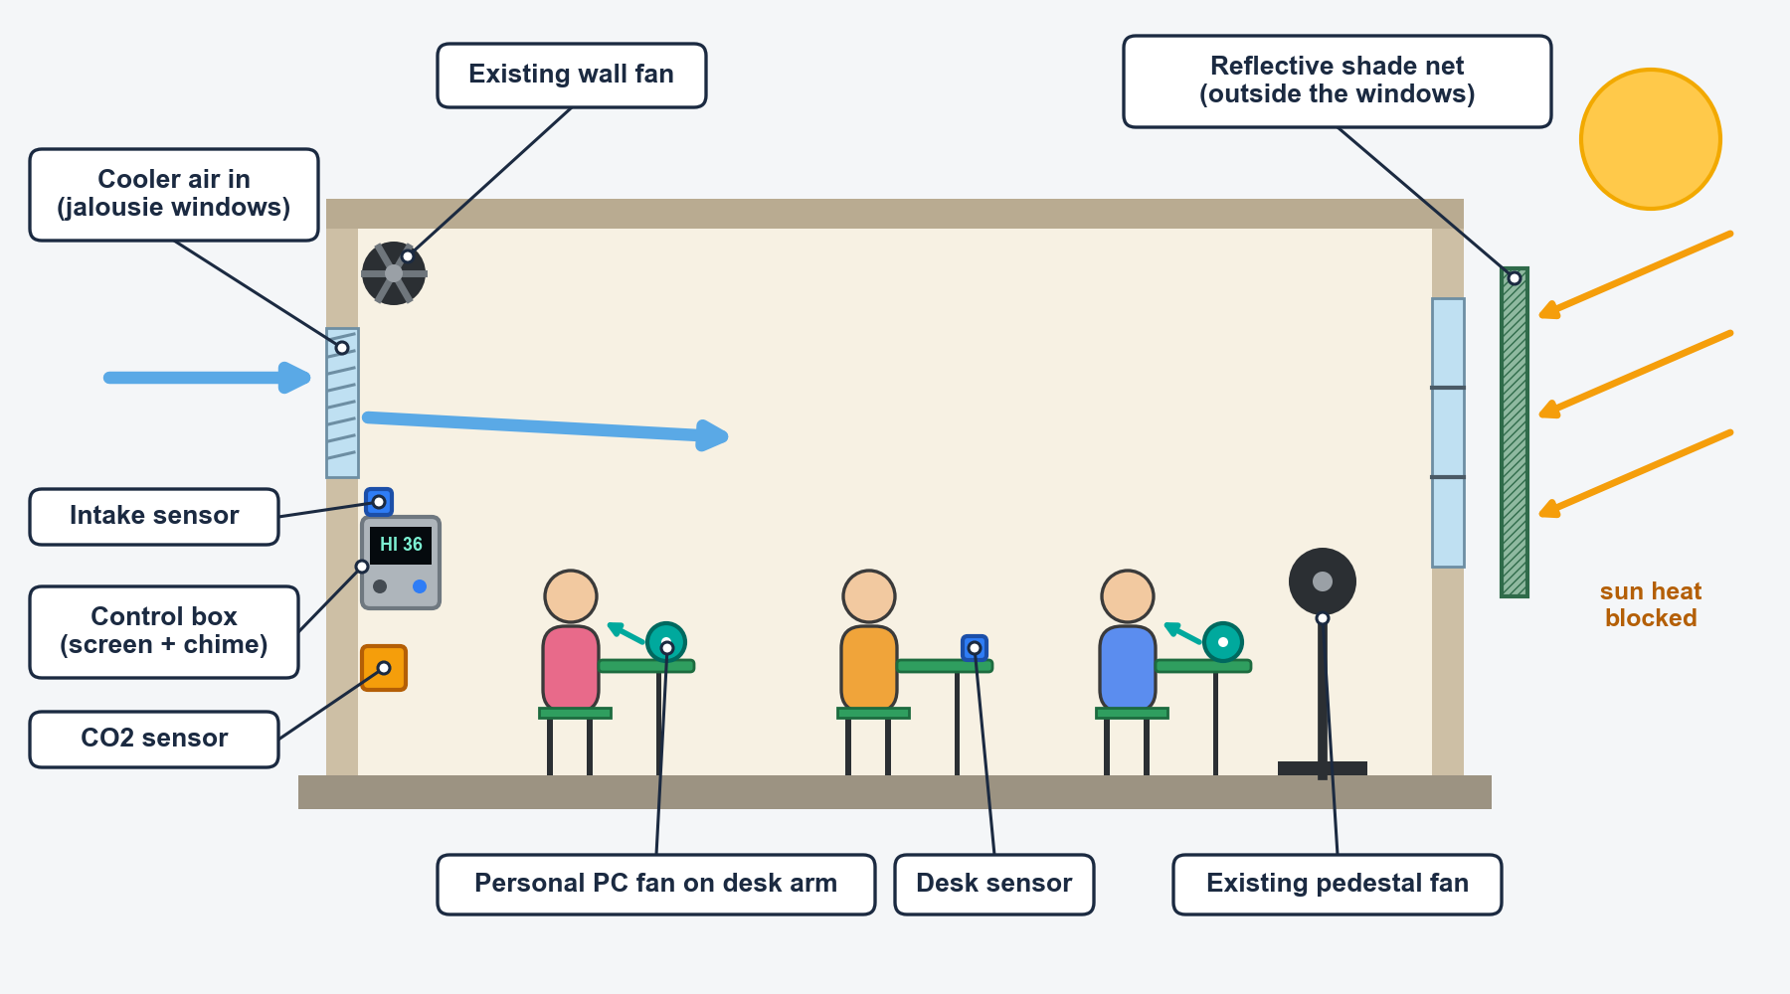
Classroom installation (2nd floor, schematic).
2. How it works
- Sense: 2 temperature-humidity sensors (a desk sensor, a small chip at desk height where students sit, and an outdoor or intake sensor by the jalousies) and one CO2 sensor for stuffy air, every minute.
- Predict: a tiny AI on the ESP32 forecasts the heat index 30 minutes ahead; it stays off until it beats a simple straight-line guess.
- Act: reflective exterior shade net (block), plus prompts for the existing wall and pedestal fans and 6 to 8 recycled PC fans clipped to chair arms on weak rows (feel). Optional add-ons, only if measurements call for them: an exhaust fan in a window panel and a water-limited wick in dry air.
- Inform: 2.42 in screen with live readings, level (OK, Watch, Act now), one action tip and a ventilate prompt when CO2 is high; chime once and a snooze button.
- Year-round: March to May, heat warnings with shade and fans. June to November, humid-heat warnings and a ventilate prompt when the outside air is drier or CO2 is high. Cooler months, it quietly logs.
3. The control box
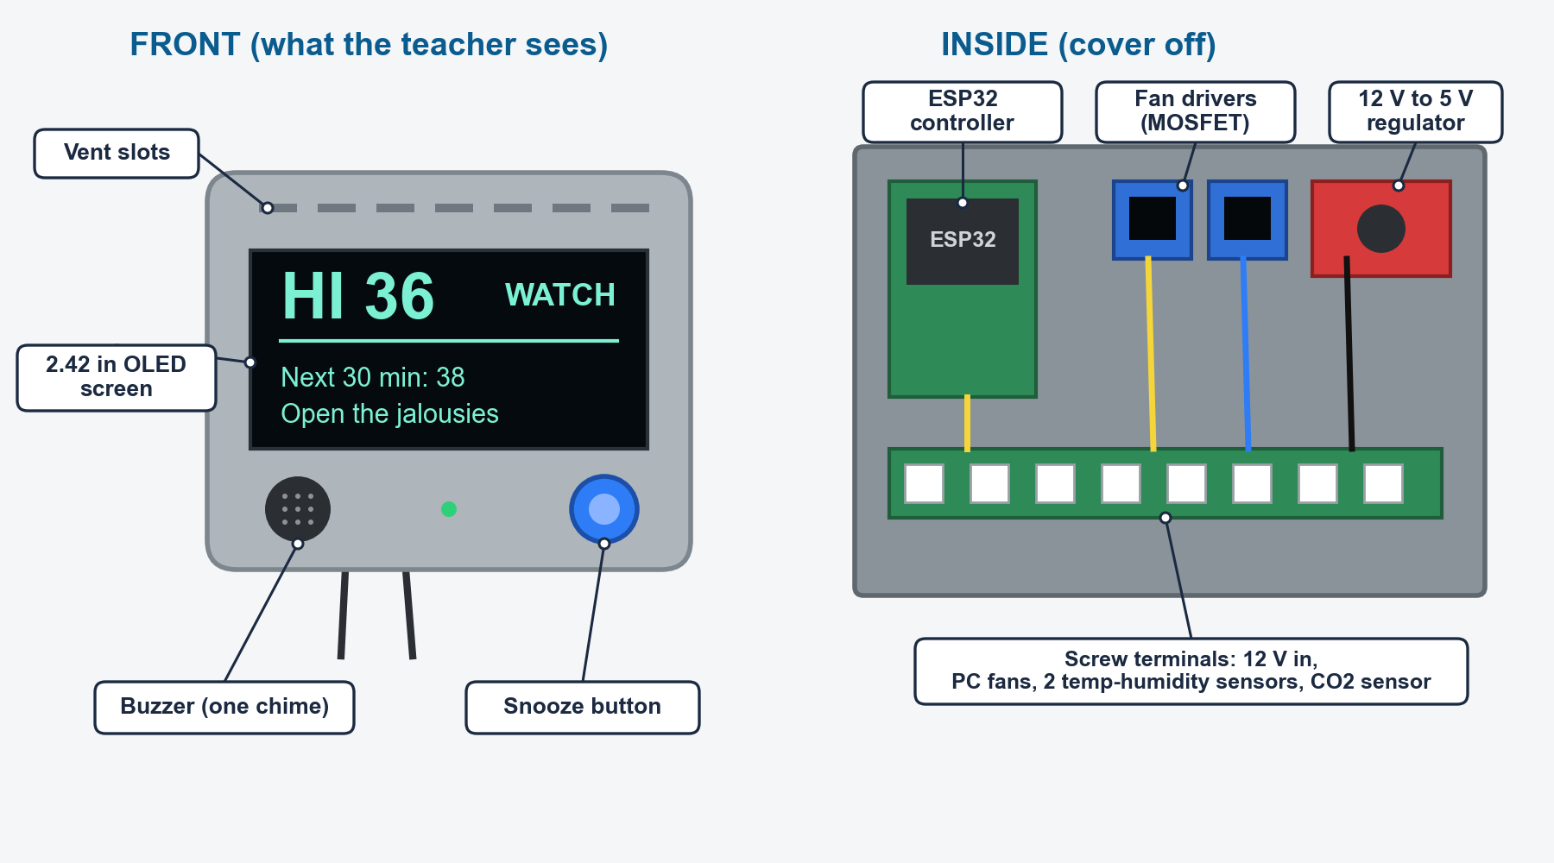
Control box, front and inside (schematic).
- Brain: ESP32 DevKit V1 (WROOM).
- Power: reused 12 V adapter, 5 A fuse, buck to 5 V. Base load up to about 29 W. Solar is an option.
- Safety: finger grills on every fan, logic-level MOSFETs with flyback diodes, cables off the aisles.
4. Materials and cost (estimated local prices, to be confirmed)
Item | Qty | PHP
ESP32 DevKit V1 (WROOM-32) | 1 | 450
SHT31 temperature-humidity sensor (desk and outdoor/intake) | 2 | 500
CO2 sensor (SCD40 type; price unconfirmed) | 1 | 2,000
DS3231 clock module | 1 | 150
2.42 in OLED screen | 1 | 700
MOSFET driver modules | 2 | 160
Reused 12 V 3 to 5 A adapter | 1 | 200
Buck regulator, 5 A fuse, diodes, capacitor | 1 set | 150
Buzzer, button, enclosure, wires | 1 set | 250
Reflective exterior shade net + frame | 1 | 900
Personal fans: 8 PC fans, grills, 12 V strip (about 500 if recycled) | 1 set | 1,200
Pilot unit (about 6,000 with recycled fans) |  | about 6,700
Logging-only unit for the control classroom | 1 | 1,200
Contingency (10%) |  | about 800
Pilot total (about 7,900 with recycled fans) |  | about 8,600
Core unit for other schools (without the CO2 sensor) |  | about 4,000

Add-ons, only when a measured trigger fires:
Add-on | PHP
Extra wall fans (rooms often have some already) | +3,000
Wet wick (dry season only) | +700
Exhaust fan in a window panel (fan 350, panel 150) | +500
Solar (60 W panel, controller, 12 V battery) | +4,000 to 6,000
Reflective foil under ceiling or roof (unconfirmed price; test a small patch first, needs school approval) | +3,000 to 6,000

Tools to borrow: soldering iron, multimeter, reference thermometer, handheld anemometer (about 1,000 to 1,500 to buy).
5. What we expect (to be tested, not promised)
Base build (shade net and fans): about 0.5 to 1.5 C lower air temperature. Felt temperature: about 2 to 4 C lower for students at the fan clusters and 1 to 3 C elsewhere. 5 C is a best case on a dry, sunny day.
Measurement details (moved from the proposal): Felt temperature is air temperature and humidity adjusted for the air speed we measure at the desks, taken from 1 to 3 p.m. The stretch target is 5 C lower on dry, sunny days. Secondary targets are 30% fewer minutes above a 38 C heat index and comfort up at least 1 point on a short student survey. Early warnings should reach teachers at least 15 minutes ahead. The ventilate prompt starts near 1,000 ppm CO2, to be set after the baseline week. If a wick is added, it stays within 5 liters of water a day, and the effect of any added layer is reported on its own.
6. Build steps
Oct 12 to 18 bench build. Oct 19 to 25 enclosure, calibration, 48-hour test. Oct 26 to Nov 2 install and baseline week. From Nov 3 the ON/OFF pilot: the unit in one classroom (about 35 students) and a logging-only control unit in a second classroom on the same floor (about 35 students).

