Entrant’s school: Quezon City Science High School | Adviser’s Name: Skjoukje U. Jemoya
Name of Team Members:  1. Aaron Jed E. Campo  2. Raya Kalayaan R. Amparo  3. Ayeza Leigh F. Delos Santos  4. Sophia Laureen A. Tado | Grade Level per member:  1. Grade 10  2. Grade 10  3. Grade 10  4. Grade 10
Theme (choose 1):
- Environmental Sustainability through Technology
Entry Title: SAGIP: Autonomous Solar Skimmer Boat with On-Chip AI
Project description: ONLY THREE (3) SENTENCES which may be used as the entry’s official description for write-ups
SAGIP is a low-cost, solar-powered robot boat that patrols a creek, goes to floating debris, lifts it onto a conveyor and names each item using a small on-chip neural network running on an ESP32 chip. Barangay officials get a weekly report of the plastic collected by type and weight through an offline phone page, plus a float-switch flood alarm at the bank. Built for about PHP 16,000 from local parts, it adds anonymized records to an open dataset that other barangays can copy.

- What problem are you trying to solve?

Plastic reaches the sea through rivers, and the Philippines is the largest source. A global model of more than 1,000 rivers estimated that Philippine rivers carry about 356,000 tonnes of plastic to the sea each year, the most of any country, and ranked the Pasig River first (Meijer et al., 2021). These are model estimates and not measurements. Floating plastic transport rises with river discharge, reaching up to six times its normal rate at peak flow (van Emmerik et al., 2022), and in the Saigon River water hyacinth mats carried most of the floating plastic that observers counted (Schreyers et al., 2021).
Two gaps keep the problem going. Removal is manual and unrecorded, so cleanups weigh bulk waste and learn nothing about its contents. Product-level evidence is scarce too, because community-run monitoring of freshwater plastic is rare (Cook et al., 2021) and brand audits are periodic and mostly land-based (Break Free From Plastic, 2021). The Extended Producer Responsibility Act of 2022 (RA 11898) obliges large companies to recover a rising share of their plastic packaging, and the DENR has begun auditing reported recovery rates (Food Packaging Forum, 2026), so enforcement needs proof of which packaging reaches waterways.
What is missing is a sustainable, inexpensive record taken at the creek itself that one barangay can run. Large systems are arriving, such as solar Interceptor barriers planned for the Pasig and Meycauayan rivers (Manila Bulletin, June 2026), but a narrow estero needs a unit a barangay can afford. Clogged waterways also worsen flooding, and residents learn of a blockage only after the water rises.

- What do you want to achieve?

- Goal: We want barangays to treat creek plastic as measurable evidence instead of invisible waste. In the long run, this means cleaner waterways and community-owned data that shifts the burden of proof toward packaging producers.
- Objectives (SMART):
- 1. Remove and measure plastic. In an 8-week pilot at Dario River starting in January 2027, remove at least 50% of floating debris entering a 30 m patrol stretch, measured by hand-net sampling below the downstream barrier against a baseline week, lift at least 20 kg of plastic and log at least 1,000 classified items.
- 2. Prove what the plastic is. By December 5, 2026, train an on-device 2D convolutional neural network that reaches at least 85% precision and recall on photographs from places it has not seen, with weekly counts within 15% of a trained hand audit.
- 3. Make it copyable. By March 2027, publish a free English and Filipino build guide (parts list, wiring, code) and an open dataset of anonymized counts and photographs, and help at least 2 other barangays or schools build a unit for about PHP 16,000 each.

- Who will benefit from this project?

Primary beneficiaries are the [N] households of [BARANGAY AND PUROK] along Dario River in Quezon City, who bear the creek's pollution and flooding, gain a flood alarm and see monthly results on a Plastic Trend Scoreboard at the Barangay Hall, and the sanitation officers, who empty the bins and use the report. Secondary beneficiaries are the city solid-waste office and the DENR, who need item-level evidence, and the barangays or schools that copy the design. We chose a barangay estero because Quezon City already runs river programs with partners (Philstar, 2025) and a barangay-run record adds new data where citizen science is rare (Cook et al., 2021). [Confirm Dario River is the estero nearest to our school and most in need, and add the household count and cleanup program.]

- How did you come up with your proposal?

Select. We listed five community problems and scored each on significance, feasibility, STEM depth, replicability and originality. Creek plastic won because we can reach a creek and measure it weekly, and RA 11898 has just made item-level data useful. [Edit this to match your team's actual brainstorming steps.]
What exists. Six kinds of work address parts of the problem.
Existing work | What it does | What it leaves open
Cameras with deep learning (Kataoka et al., 2024) | Detect floating plastic in fixed river camera images | Monitor only, remove nothing
Solar river barriers (The Ocean Cleanup, 2026) | Intercept and lift river plastic with a solar conveyor | Built for large rivers such as the Pasig
AI cleanup boats (Manila Bulletin, 2025) | Collect plastic with a solar AI vessel in a Pasig pilot | Built for a large river, not a barangay estero
Tiny on-chip classifiers (Mendez-Cruz et al., 2024) | Classify microplastics and waste on an ESP32 camera, 91.7% accuracy on 229 images | Controlled tests only, no collection or field data
Trash traps (Philstar, 2022) | Remove plastic in bulk at river tributaries | Record bulk weight only
Brand audits (Break Free From Plastic, 2021) | Name the brands behind plastic waste | Periodic, manual, mostly land-based

Gap we test. None of these patrols a creek, collects plastic, counts it item by item and shares open data at a price a barangay can pay. Our search found no system that does all four. We therefore ask one question: can a PHP 16,000 robot boat match a trained hand audit within 15%, and does continuous counting reveal rain-driven pulses that weekly audits miss?

- How will your tech solution work?

STEM is the core of the design. Physics sets the hull's buoyancy, the thrust, the belt torque and the solar energy budget, and mathematics defines precision, recall and count error. Computer science supplies a small 2D convolutional neural network (CNN) with INT8 quantization, which shrinks a model about fourfold with little loss of accuracy (Gholami et al., 2021), running on TensorFlow Lite for Microcontrollers (David et al., 2021).
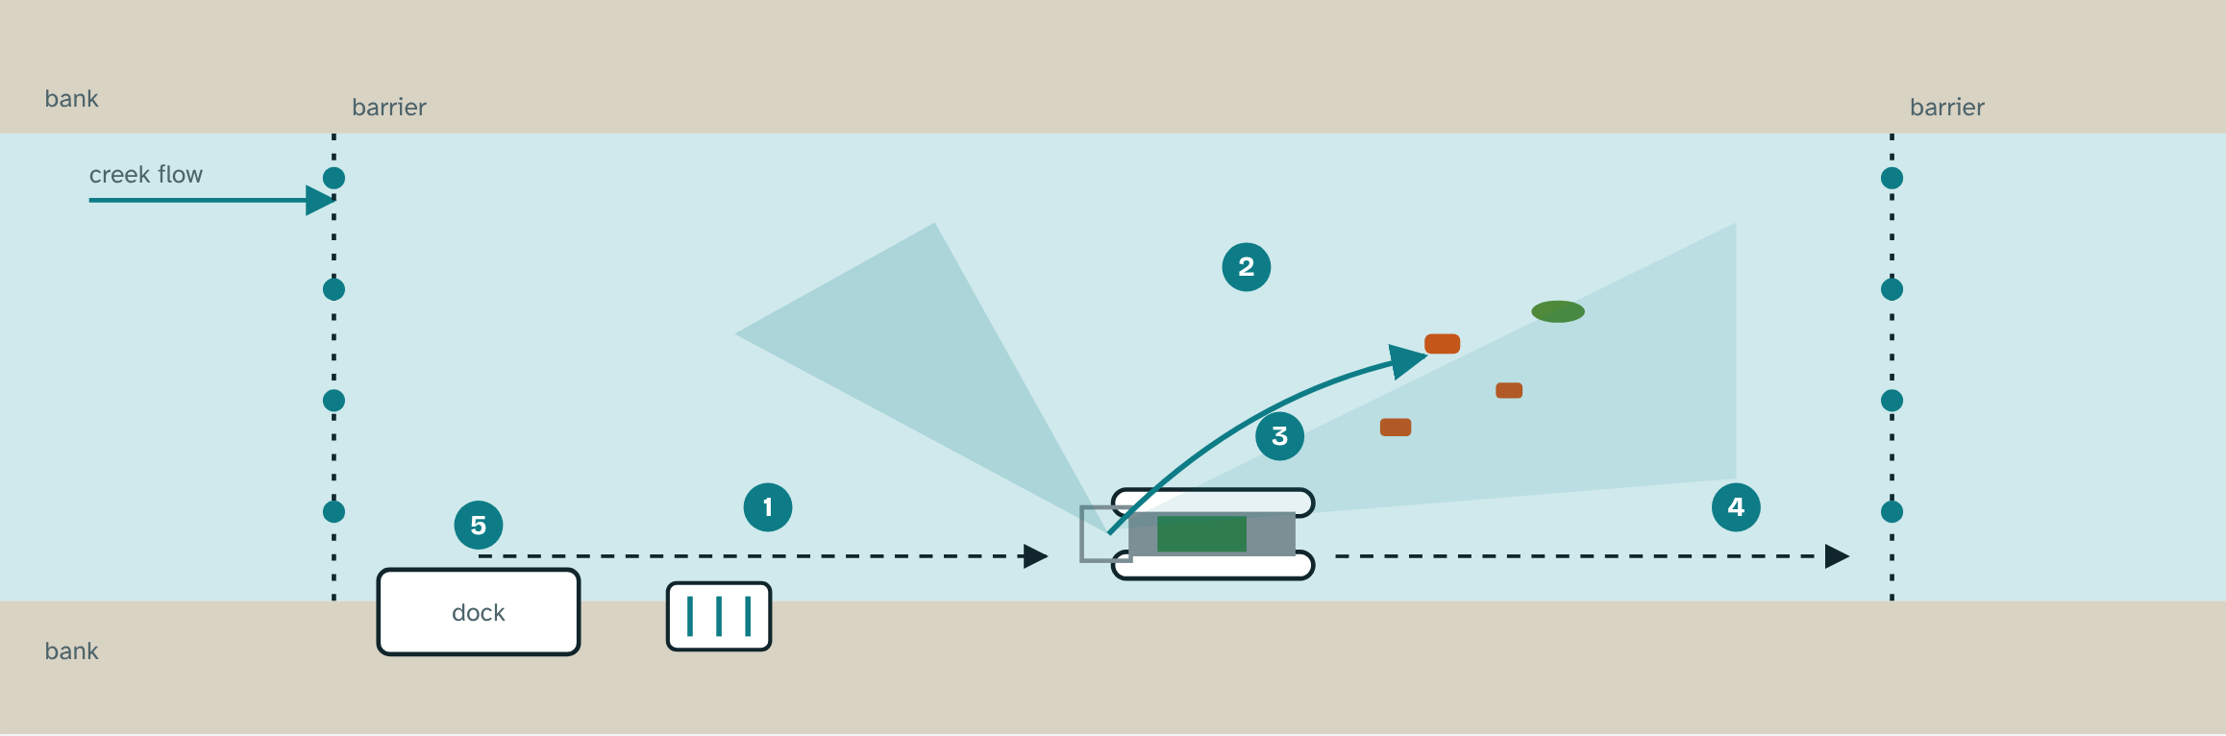
Figure 1. Patrol, detect, scoop and dock (top view, schematic).
Float. Two sealed 6-inch PVC floats filled with foam carry a deck. A wide beam and a low battery keep the boat stable at about 25 kg, and a tilt sensor stops the motors past 20 degrees.
Patrol. Two thrusters steer by differential thrust. Side ultrasonic sensors and a compass keep the boat along the bank between two floating barriers about 30 m apart, and it docks when its bins are full or its battery is low. A phone remote lets staff take over.
Barriers. The upstream barrier is a 10 mm rope with a plastic float every 30 cm, strung at about 30 degrees to the flow between bank posts, so hyacinth mats and large debris slide to the bank. The downstream barrier is the same rope strung straight across. A pond test checks sag and hold.
Detect and scoop. The bow ESP32-CAM runs a small INT8 object detector that boxes each floating item and separates plastic from plants. The boat steers to the nearest plastic box, and a scoop lifts it onto a cleated conveyor belt.
Count and sort. The cleats hold one item per pocket, so the belt delivers items singly to an ESP32-S3 camera. A skirted black hood blocks sunlight and a fixed LED strip lights each photograph the same way. A hydrophobic film, an angled window and a desiccant pack keep each sealed camera housing clear of droplets and fog. The CNN labels each item as PET bottle, sachet or film, bag, foam, cup, plant or other. A blob count against an empty-belt photograph flags two items in one frame as mixed. A servo gate drops plastic into Bin A and plants, mixed or unsure items into Bin B for a hand count.
Software. We train in Keras, start from small pretrained MobileNet-style networks, quantize to INT8 and deploy on the ESP32 boards. Creek-bank photographs are augmented with brightness, contrast and color shifts, blur, rotation, crops, random erasing and synthetic mud and droplet overlays to hold accuracy in muddy water.
Protect. The chip reads belt and thruster current. After a jam it reverses, retries up to three times, then stops and docks. Drivers default to off, so a crash cannot leave a motor running.
Report. Each record stores class, time and an image hash on a microSD card. A docked phone reads an offline Wi-Fi page with the weekly report and an anonymized open dataset, and counts are plotted against rainfall. Each month the barangay posts a Plastic Trend Scoreboard at the Barangay Hall showing the top plastic types, estimated kilograms and flood alarms.
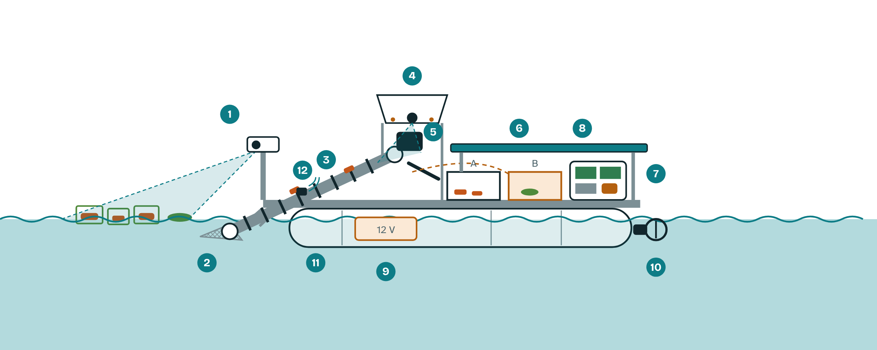
Figure 2. Side view of the SAGIP boat (schematic).
Plastic accounting. Counts become estimated kilograms from typical item weights, corrected by a weekly weigh-in. A weekly sheet lists items by type with estimated junk-shop value as item-level evidence for RA 11898.
Flood warning. A separate solar node on the bank carries three float switches at watch, alert and danger levels on a painted staff gauge. A buzzer and a small LED alert residents, and the boat stays docked from the alert level.
Power. Planning figures: a 30 W panel on the deck yields about 54 Wh per day at 3 effective sun-hours and 60% efficiency and charges a sealed 12 V 12 Ah lead-acid battery of about 144 Wh. A 20-minute patrol uses about 25 Wh, and a low battery skips it.
Deep sleep. At 5 V a camera board draws about 180 mA awake and 6 mA asleep (datasheet values), about 22 Wh a day against 0.7 Wh, so sleep protects the 54 Wh solar budget. Docked boards sleep and wake on a timer for each patrol, then check the flood node's last status. On patrol the bow camera idles at a low frame rate until it sees plastic, and the belt camera and LED power up only when an item arrives. The flood node sleeps until a float switch trips and wakes every ten minutes to report.
End of life and safety. The floats are PVC pipe, the bins are plastic and the hardware is stainless steel, all materials that local junk shops take. Foam, the one hard-to-recycle part, is used only to keep a holed float afloat. The lead-acid battery returns to a dealer for recycling. The flood node's protected 18650 cell sits in an IP67 box with overcharge and over-discharge protection, so a tipped node cannot leak into the creek.
Scope. SAGIP lifts light floating debris such as bottles, sachets, bags, foam and cups. It cannot lift heavy or tangled items or sunken waste, and it covers one creek stretch, so we report a measured capture rate.
In plain words. The model is a sanitation worker's eye for bottles and sachets, saved as a file of numbers.

- How will you implement this?

The pilot unit costs about PHP 16,000 and is built in three stages, each bought only after the previous test passes.
- Resources:
Item | PHP
Two 6-inch PVC floats, foam, frame and deck | 2,300
Two 12 V thrusters and dual driver | 1,800
Cleated conveyor, gear motor and driver | 2,000
ESP32-S3 camera board, hood, LED, enclosure | 1,850
ESP32-CAM bow detector | 600
Compass, tilt and ultrasonic sensors, bump switches | 900
Gate servo and reused bins | 300
12 V 12 Ah battery, converters, fuses, wiring | 2,400
30 W solar panel and 20 A charge controller | 1,100
Waterproofing and hardware | 500
Flood node: ESP32, float switches, buzzer, mini panel, cell, gauge | 1,000
Bank dock and two barriers (rope, floats, post) | 600
Subtotal | 15,350
Contingency | 650
Total | 16,000

Tools. Python, Keras, TensorFlow Lite for Microcontrollers, a borrowed multimeter, a kitchen scale and our phones. Prices are online-shop estimates, and the barangay may give rope, floats, a post and bins in kind.
Stage 1, bench (about PHP 7,650). Build the conveyor, camera, CNN, gate, battery and panel on a bench. Gate: 85% precision and recall on held-out photographs and a simulated patrol on battery.
Stage 2, boat (about PHP 6,100). Build the floats, deck, thrusters, bow detector and sensors. Gate: float and tilt tests, then a pond test where the boat scoops at least 70% of 20 items placed 2 to 5 m ahead.
Stage 3, dock, barriers and flood node (about PHP 1,600). Gate: the boat patrols between barriers without help, and the flood alarm sounds at all three marks in a bucket test.
Timeline. Site visit, barangay letter and starter dataset by November 2. If shortlisted, mentorship from November 16 to December 5 finishes Stage 1 and builds a scaled mock-up and flood node for the December 7 pitch. The pilot runs January to February 2027 if supported.
- Stakeholders:
Barangay captain and sanitation officers: site approval, bin emptying, the flood alarm and reports under a one-page agreement.
City solid-waste office and DENR: data use and fit with Quezon City's river programs.
Adviser and school head: supervision and safety sign-off.
Students and residents: students build, label and count, and residents give consent.
- Risks & Mitigation:
Manual labor: people still empty the bins, clear snags and wipe the lenses, and we log those hours.
Stability and navigation: foam-filled floats, a tilt cut-off, pond tests, barriers that set the stretch and a phone remote for takeover.
Fast water and permission: the boat stays docked from the alert level, and the stretch needs barangay, city and DENR approval.
Hyacinth and snags: the upstream barrier turns mats aside, the detector sends plants to Bin B and current sensing reverses a jam.
Model errors: test on unseen places, send unsure and mixed items to Bin B and keep the weekly hand count.
Safety, privacy, theft: no student rides the boat or enters the water, the cameras see only the water, and the boat is docked when unattended.

- What kind of impact do you hope to achieve and what is the long term vision for this proposal?

Success means plastic lifted from a real creek, a trustworthy weekly record of what it was and a flood alarm that works.

- Measurable Outcomes:
1. Less plastic in the creek: at least 50% of floating debris removed against the baseline week and 20 kg lifted in 8 weeks.
2. Trustworthy counts and warnings: at least 1,000 classified items, weekly error of 15% or less, 85% precision and recall on unseen places and a flood alarm at all three marks.
3. Replication: at least 2 more sites by March 2027 at about PHP 16,000 each, one open data format and weekly labor hours reported.
- Long-Term Vision: We see a student-built, barangay-owned network of units along connected creeks that feeds one open dataset showing where plastic enters, which products dominate, and whether EPR commitments change what the water carries.
- Key Takeaway: The Philippines already knows who makes much of its plastic. SAGIP makes the proof continuous, cheap and community-owned.
References
Break Free From Plastic (2021). BRANDED Volume IV: Holding corporations accountable for the plastic and climate crisis.
Cook, S., Abolfathi, S., & Gilbert, N. I. (2021). Goals and approaches in the use of citizen science for exploring plastic pollution in freshwater ecosystems: A review. Freshwater Science, 40.
David, R., et al. (2021). TensorFlow Lite Micro: Embedded machine learning for TinyML systems. Proceedings of Machine Learning and Systems, 3.
Food Packaging Forum (2026). Philippines steps up enforcement of plastic packaging recovery requirements. foodpackagingforum.org
Gholami, A., et al. (2021). A survey of quantization methods for efficient neural network inference. arXiv:2103.13630.
Kataoka, T., Yoshida, T., & Yamamoto, N. (2024). Instance segmentation models for detecting floating macroplastic debris from river surface images. Frontiers in Earth Science, 12, 1427132.
Manila Bulletin (June 6, 2026). DENR, The Ocean Cleanup forge alliance for Pasig River.
Manila Bulletin (October 12, 2025). AI-powered robot waterway cleaning vehicle launched in Pasig.
Mendez-Cruz, Silva-Cuzqui, et al. (2024). Proof of concept: A TinyML-based image classifier for detecting microplastics and waste in simulated marine environments. IEEE.
Meijer, L. J. J., et al. (2021). More than 1,000 rivers account for 80% of global riverine plastic emissions. Science Advances, 7, eaaz5803.
Philstar (August 28, 2025). Quezon City government, SMC team up for river cleanup.
Philstar (July 14, 2022). DENR-EMB to install trash traps in polluted rivers.
Republic Act No. 11898 (2022). Extended Producer Responsibility Act of 2022.
Schreyers, L., et al. (2021). Plastic plants: The role of water hyacinths in plastic transport in tropical rivers. Frontiers in Environmental Science, 9, 686334.
The Ocean Cleanup (2026). Meycauayan plastic Interceptor rollout. Press release.
van Emmerik, T. H. M., et al. (2022). Hydrology as a driver of floating river plastic transport. Earth's Future, 10, e2022EF002811.

