**Project Report**

**-Taufiq Monghal**

**Purva Jhaveri**

**Title : Farm Fresh**

**Subject : Database Management Systems**

**Semester : III**

**Branch : Information Technology**

**Mentor : Prof. Rupali Sawant**

**Explanation of flow:**

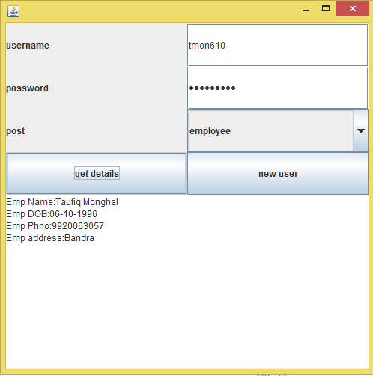The window below is the first window. If we put the correct username and password and select employee as the option in the combo box and press "get details" we get the details as below.

. If we put the correct username and password and select supplier as the option in the combo box and press "get details" we get the details as below.

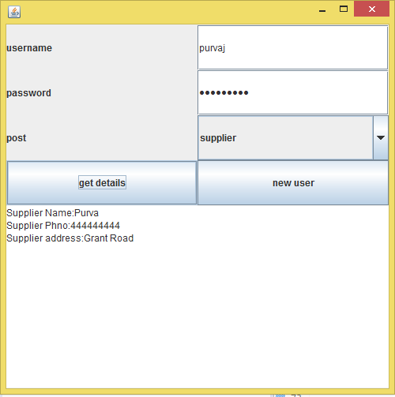

. If we put the incorrect username and password and select employee as the option in the combo box and press "get details" we get a message dialogue box as below.

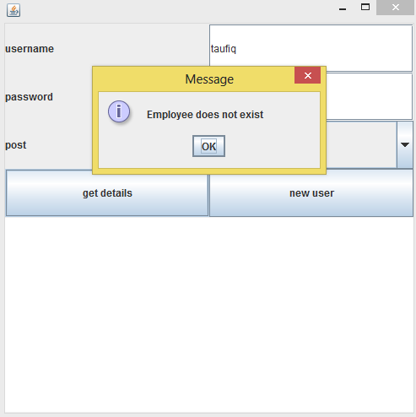

. If we put the incorrect username and password and select supplier as the option in the combo box and press "get details" we get a message dialogue box as below.

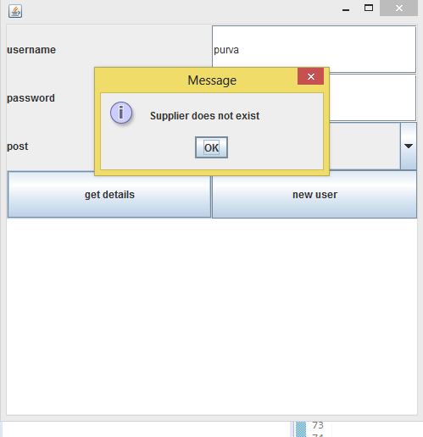

When we press the button new user we are directed to the screen below.

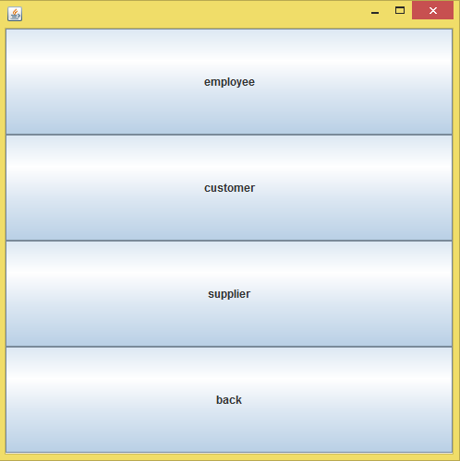

If we select employee from the current window we get as below when we put all the details and click submit.

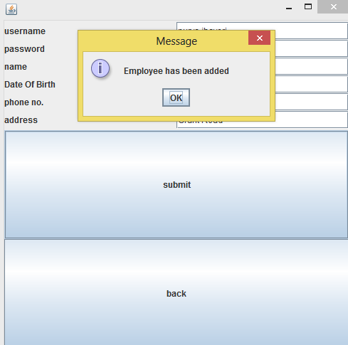

When we don't put all the details ie if we leave few fields vacant we get as below.

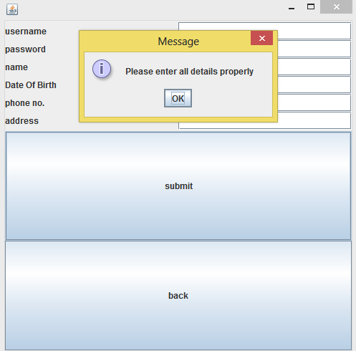.

Now we go back to the screen below by clicking back.



If we select supplier from the current window we get as below when we put all the details and click submit.

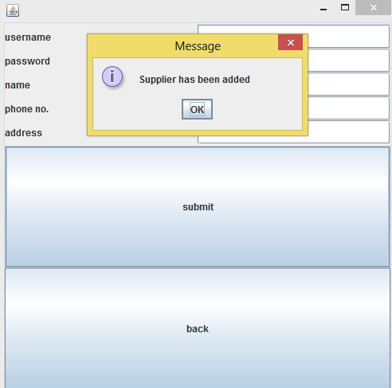

When we don't put all the details ie if we leave few fields vacant we get as below.

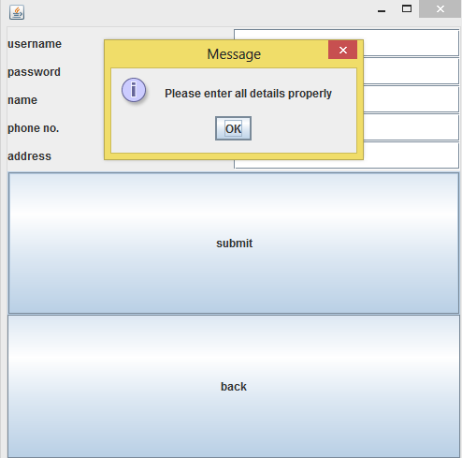

Now we press back button to get screen below.



We select customer and select product say milk, put the quantity say 2 and click add to list.

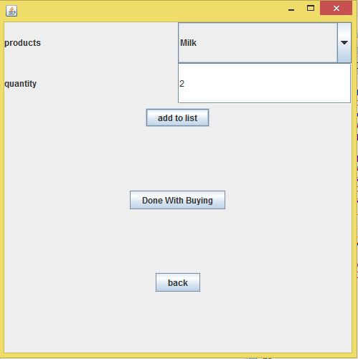

Then we select say oil from combo box and keep the quantity as 1.

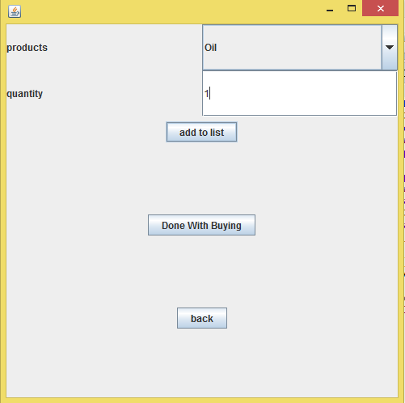

Now assume we are done with buying so click "Done With Buying". We are directed to a new screen where we click "bill" button to get the bill.

