ShopWorld E-Commerce Platform
Software Development Documentation
System requirements · Use cases · Architecture & system design · Screen design · Test design

Item | Value
Document ID | SW-DEV-DOC-001
Version | 1.0 (baseline for review)
Date | 25 September 2026
Status | Draft – for technical review
System | ShopWorld E-Commerce Platform (repository eshop-web, internal code name “auramart”)
Baseline | Git branch main, commit b2e8dbe
Standards applied | ISO/IEC/IEEE 15289:2019, 29148:2018, 42010:2022, 12207:2017, ISO/IEC 25010:2023, ISO 9241-110:2020, ISO/IEC/IEEE 29119-3:2021
Classification | Internal

Document control
Revision history
Version | Date | Author | Description of change
0.1 | 2026-09-24 | Development team | Initial structure; information gathered from source code
1.0 | 2026-09-25 | Development team | Complete baseline covering requirements, use cases, design, screens and tests

Review and approval
Role | Name | Signature | Date
Product owner
Technical lead / architect
Quality assurance lead
Security officer

Distribution
Development team (backend, web, Android), QA, operations, product management. The controlled copy is the file kept in the project repository; printed copies are uncontrolled.

Table of contents
Document control 2
1 Introduction 6
1.1 Purpose 6
1.2 Scope 6
1.3 Intended audience and how to read this document 6
1.4 Conformance to standards 6
1.5 Definitions, acronyms and abbreviations 7
1.6 References 7
2 Overall description 9
2.1 Product perspective 9
2.2 Stakeholders and their needs 9
2.3 Product functions (summary) 9
2.4 User classes and characteristics 10
2.5 Operating environment 10
2.6 Design and implementation constraints 10
2.7 Assumptions and dependencies 11
3 Software requirements specification 12
3.1 Requirement attributes 12
3.2 Functional requirements 12
3.3 Non-functional requirements (ISO/IEC 25010) 15
4 Use-case model 16
4.1 Actors 16
4.2 Use-case diagram 16
4.3 Use-case catalogue 17
4.4 Customer use-case specifications 17
4.5 Back-office use-case specifications 21
5 Architecture description 24
5.1 Stakeholders and concerns 24
5.2 Viewpoints 24
5.3 Container view 24
5.4 Backend layered view 26
5.5 Behaviour view 26
5.6 Deployment view 26
5.7 Architecture decisions 27
6 Detailed software design 28
6.1 Backend module decomposition 28
6.2 Authentication and session design 29
6.3 Pricing algorithm 29
6.4 Cart revalidation 30
6.5 Checkout and transaction design 30
6.6 Order life-cycle state machine 31
6.7 Image-search design 31
6.8 Security design 32
6.9 Internationalisation design 33
6.10 Error handling and logging 33
6.11 Web client design 33
6.12 Android client design 34
7 Data design 35
7.1 Logical data model 35
7.2 Collection specifications 35
7.3 Indexes and integrity rules 37
7.4 Data retention and seed data 37
8 Interface design 38
8.1 API conventions 38
8.2 Endpoint catalogue 38
8.3 Example exchange 39
8.4 Client–OS interfaces (Android) 39
9 Screen design 41
9.1 Design principles 41
9.2 Visual design system 41
9.3 Screen inventory 42
9.4 Screen transition diagrams 43
9.5 Storefront screen specifications 44
9.6 Admin panel screen specifications 47
9.7 Android screen specifications 49
10 Review findings and deviations 52
11 Test design 53
11.1 Test strategy 53
11.2 Test environment 53
11.3 Entry and exit criteria 53
11.4 Test cases 53
Appendix A – Configuration reference 56
Appendix B – Requirements traceability matrix 56
Appendix C – Build, run and release procedure 57

1 Introduction

1.1 Purpose
This document is the development baseline for the ShopWorld e-commerce platform. It collects in one place the information items that ISO/IEC/IEEE 15289 lists for the software life cycle: the software requirements specification, the use-case model, the architecture description, the software design description, the user-interface (screen) design and the test design. It is written for engineers who build, test, operate or extend the system, and for reviewers who approve changes to it.
The document describes the system as built. Every statement was derived from the source code at the baseline commit, not from an earlier specification. Where the implementation departs from good practice or from its own documentation, the difference is recorded as a finding in section 10 rather than silently corrected, so that the document can be used as the starting point for remediation.

1.2 Scope
ShopWorld is a multi-channel retail system consisting of four software items that share one REST API:
Table 1 – Software items in scope
Software item | Technology | Users | Repository folder
REST API (backend) | Node.js 18.19, Express 4, MongoDB 6.0, Mongoose 8, JWT, ONNX Runtime | All clients | backend/
Customer storefront | React 18, Vite 5, React Router 6, Zustand 4, Axios | Guests, customers | frontend/
Admin panel | React 18, Vite 5, Recharts 2, Zustand 4, Axios | Managers, admins, super admins | admin-panel/
Android app | Java 17, Android SDK 24–35, Retrofit 2, Glide 4, ONNX Runtime Android | Guests, customers | android/

In scope: catalogue browsing, text and image search, cart, checkout with a mock payment gateway, order tracking and cancellation, reviews, wishlist, customer accounts, back-office administration (catalogue, inventory, orders, customers, promotions, content, reports, staff) and three user languages (English, Simplified Chinese, Japanese). Out of scope: real payment processing, shipping-carrier integration, e-mail/SMS notifications, tax calculation by jurisdiction, multi-currency conversion and an iOS client.

1.3 Intended audience and how to read this document
Reader | Most relevant sections
Product owner, business analyst | 2 Overall description · 3 Requirements · 4 Use cases
Architect, backend developer | 5 Architecture · 6 Detailed design · 7 Data design · 8 Interface design
Web and Android developers | 4 Use cases · 8 Interface design · 9 Screen design
QA engineer | 3 Requirements · 4 Use cases · 11 Test design · Appendix B traceability
Operations / security | 5.6 Deployment view · 6.8 Security design · 10 Findings · Appendix A

1.4 Conformance to standards
The structure follows the standards below. The table shows which part of this document realises which information item. Conformance is tailored (tailoring according to ISO/IEC/IEEE 12207 Annex A): items that a small product team does not need as separate documents are combined here.
Table 2 – Standards and where they are applied
Standard | Information item / concept | Realised in
ISO/IEC/IEEE 12207:2017 | Software life cycle processes; tailoring | 1.4, 11
ISO/IEC/IEEE 15289:2019 | Content of life-cycle information items (description, specification, plan) | Whole document; document control
ISO/IEC/IEEE 29148:2018 | Software requirements specification (SRS), requirement attributes, stakeholder needs | 2, 3, Appendix B
ISO/IEC 25010:2023 | Product quality model (non-functional characteristics) | 3.3
ISO/IEC/IEEE 42010:2022 | Architecture description: stakeholders, concerns, viewpoints, views, correspondences | 5
ISO/IEC/IEEE 15289 (SDD) | Software design description: decomposition, interfaces, data, algorithms | 6, 7, 8
ISO 9241-110:2020, ISO 9241-112:2017 | Interaction principles; presentation of information | 9.1
ISO/IEC 40500:2012 (WCAG 2.0) | Accessibility of web content | 9.1, 3.3
ISO/IEC/IEEE 29119-3:2021 | Test documentation: test plan, test design, test cases | 11
ISO/IEC 27002:2022 | Information-security controls (reference for security design) | 6.8, 10

1.5 Definitions, acronyms and abbreviations
Table 3 – Glossary
Term | Definition
Access token | Short-lived JSON Web Token (15 minutes) sent as Authorization: Bearer on every API call.
Refresh token | Long-lived JWT (30 days) used once to obtain a new token pair; rotated on every use.
Customer | Registered shopper (role customer).
Guest | Visitor who is not signed in. Can browse, search and keep a local cart (web) but cannot check out.
Staff | Any back-office role: manager, admin or superadmin.
Super admin | Staff role that can additionally manage other staff accounts; cannot be created through the API.
DINOv3 | Self-supervised vision transformer (Meta AI). ViT-S/16 variant used to turn a photo into a 384-number feature vector.
Embedding / vector | L2-normalised 384-dimensional float vector describing an image; compared by cosine similarity.
ONNX | Open Neural Network Exchange model format; executed with ONNX Runtime on server and phone.
REM | Second listing currency in the catalogue. No exchange rate exists; a cart cannot mix USD and REM.
COD | Cash on delivery payment method. The order stays unpaid until it is delivered.
Envelope | Standard JSON response shape {success, message, data, pagination?, errors?}.
SF / AD / AN | Screen-ID prefixes: storefront, admin panel, Android.
UC / FR / NFR / TC | Identifiers for use cases, functional requirements, non-functional requirements, test cases.

1.6 References
ID | Reference
[R1] | Repository README.md, backend/README.md, backend/ml/README.md, android/README.md (baseline b2e8dbe)
[R2] | backend/src — routes, controllers, services, models (authoritative for business rules)
[R3] | backend/.env.example and backend/src/config/env.js — configuration
[R4] | docker-compose.yml, backend/Dockerfile — deployment
[R5] | Oquab et al. / Siméoni et al., DINOv3 model card, onnx-community/dinov3-vits16-pretrain-lvd1689m-ONNX
[R6] | The standards listed in Table 2

2 Overall description

2.1 Product perspective
ShopWorld is a self-contained system. Three client applications talk to one stateless REST API over HTTP(S) with JSON. The API owns all business rules (prices, stock, coupons, order status) so that the clients cannot disagree about totals. Persistent data lives in MongoDB; product images live on the API server's file system; the image-search model is a local ONNX file, so the running system needs no external network service. Figure 1 shows the system context.
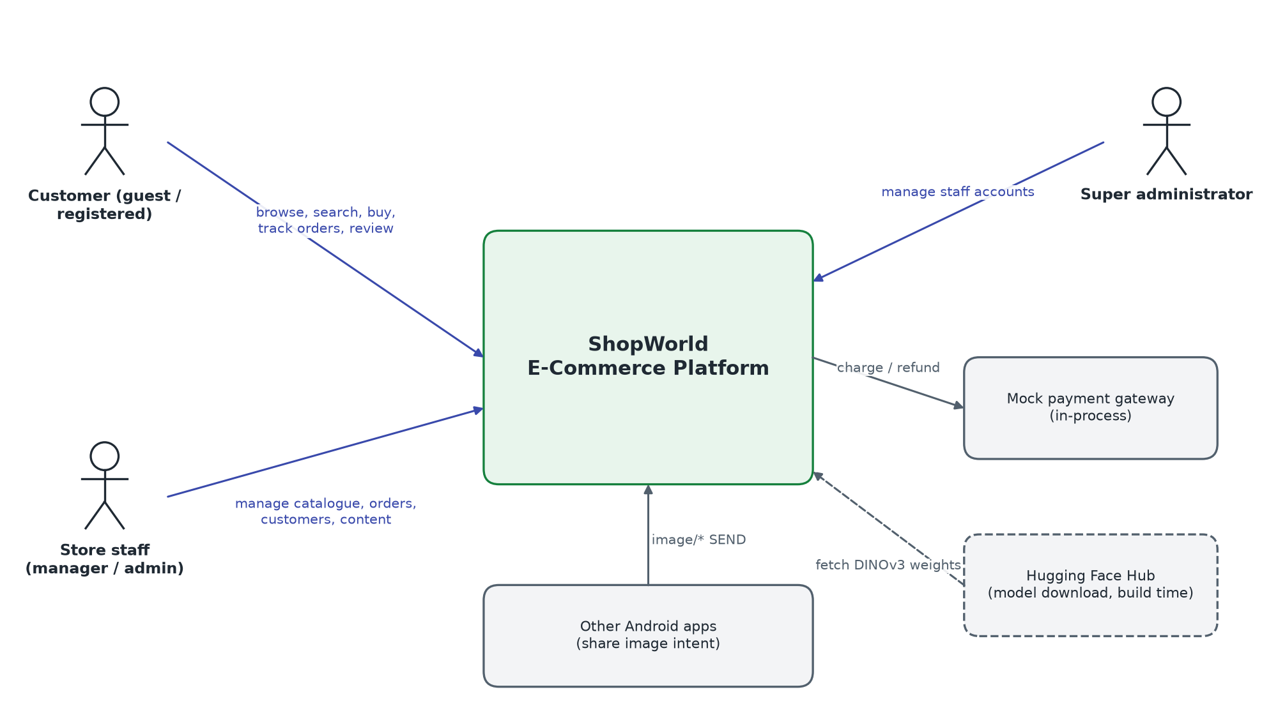
Figure 1 – System context

2.2 Stakeholders and their needs
Table 4 – Stakeholders
Stakeholder | Key needs (ISO/IEC/IEEE 29148 stakeholder requirements)
Guest shopper | Find products quickly (browse, filter, text search, photo search); see prices, stock, reviews.
Registered customer | Buy safely and quickly; see correct totals; track and cancel orders; keep addresses and wishlist; use own language.
Store manager / admin | Keep the catalogue and stock correct; process orders through a controlled workflow; moderate reviews; run promotions; see sales figures.
Super administrator | Control who can sign in to the back office and with which role.
Development team | One place for business rules; clear API contract; runnable locally with seed data.
Operations | Simple deployment (Docker), health endpoint, configurable secrets, rate limiting in production.
Business owner | Conversion and revenue reporting; brand consistency across web and mobile; no licence cost for image search.

2.3 Product functions (summary)
Table 5 – Product functions
Area | Functions
Identity | Register, sign in, sign out, token refresh with rotation, change password, profile, language preference
Catalogue | Category tree, product list with faceted filters and 8 sort orders, product detail with variants, related products, featured / best sellers, banners, promotions
Search | Type-ahead text search; image search with DINOv3 (upload on web, on-device vector on Android, share-to-app)
Shopping | Server cart with revalidation, guest cart (web), coupon codes, free-shipping meter, wishlist
Ordering | Three-step checkout, atomic stock reservation, mock payment, order history, tracking timeline, customer cancellation
Engagement | Reviews with verified-purchase badge, rating summary, helpful votes
Back office | Dashboard KPIs and charts, products, categories, inventory alerts, orders workflow, customers + CSV export, reviews moderation, coupons, banners, reports, settings, staff accounts, image-index maintenance

2.4 User classes and characteristics
Table 6 – User classes
User class | Channel | Frequency | Technical skill | Access
Guest | Web, Android | Occasional | Low | Public catalogue, search, guest cart (web)
Customer | Web, Android | Weekly | Low | Own cart, orders, reviews, wishlist, profile
Manager | Admin panel | Daily | Medium | All back-office sections except staff management
Admin | Admin panel | Daily | Medium | Same as manager (permissions stored but not enforced – see F-01)
Super admin | Admin panel | Rare | High | Everything, including staff accounts

2.5 Operating environment
- Server: Node.js ≥ 18.19 < 19 on Linux (Debian bookworm image) or Windows/macOS for development; glibc required by onnxruntime-node.
- Database: MongoDB 6.0; a single-node replica set (rs0) is recommended so checkout runs in a multi-document transaction.
- Web clients: Current evergreen browsers (Chrome, Edge, Firefox, Safari); responsive from 360 px to desktop.
- Android: Android 7.0 (API 24) to Android 15 (API 35); ≈ 90 MB free storage for the bundled image-search model.
- Network: Emulator reaches the host at 10.0.2.2:5000; release build uses https://api.auramart.com/api/v1/.

2.6 Design and implementation constraints
- All order arithmetic is implemented once, in backend/src/services/pricing.service.js; clients only display server totals (the web guest cart mirrors the same formula for display).
- The API response envelope and the /api/v1 prefix are a contract shared by three clients; breaking changes require a new prefix.
- The image-search model id (dinov3-vits16/model.onnx) must be identical on server and Android, otherwise vectors are rejected (HTTP 409).
- Every user-visible text must exist in en, zh and ja; catalogue content is stored per locale in a translations sub-document.
- Prices are stored and charged in the listing currency without conversion; USD and REM cannot be mixed in one cart.
- No third-party UI kit is used on the web; the design system is plain CSS custom properties shared by storefront and admin.

2.7 Assumptions and dependencies
- The mock payment gateway will be replaced by a PCI-DSS compliant provider before live trading; card data must then never reach the API (see F-06).
- Tax is a flat rate (default 10 %) applied to the discounted subtotal; real tax rules are out of scope.
- Product images are stored on the API host; a CDN or object store is an operational decision outside this baseline.
- The DINOv3 weights are licensed under the DINOv3 licence shipped as ml/dinov3-vits16/LICENSE.md; redistribution in the APK is assumed to be permitted.

3 Software requirements specification
Requirements follow ISO/IEC/IEEE 29148: each has a unique identifier, is singular, verifiable and traceable to a use case (section 4) and a test (section 11). Priority uses MoSCoW (M = must, S = should, C = could). Status: I = implemented and verified in code, P = partially implemented, N = not implemented (see findings in section 10).

3.1 Requirement attributes
Attribute | Meaning
ID | FR-<area>-<nn> for functional, NFR-<characteristic>-<nn> for non-functional requirements
Statement | “The system shall …” — one testable behaviour
Priority | M / S / C
Source | Stakeholder or use case the requirement derives from
Status | I / P / N at the baseline commit

3.2 Functional requirements

3.2.1 Identity and access (AUTH)
ID | Requirement | Pri. | Source | St.
FR-AUTH-01 | The system shall let a visitor register with name (2–80 chars), unique e-mail, password (≥ 6 chars) and optional phone, and sign them in immediately. | M | UC-01 | I
FR-AUTH-02 | The system shall authenticate with e-mail and password and return an access token (15 min) and a refresh token (30 days). | M | UC-02 | I
FR-AUTH-03 | The system shall reject sign-in of a deactivated account with HTTP 403. | M | UC-02 | I
FR-AUTH-04 | The system shall rotate refresh tokens: each refresh invalidates the used token and keeps at most the 5 newest sessions per user. | M | UC-02 | I
FR-AUTH-05 | Clients shall refresh an expired access token transparently once and replay the failed request; on refresh failure they shall return to sign-in. | M | UC-02 | I
FR-AUTH-06 | The system shall let a signed-in user change the password after confirming the current one, and shall then revoke all sessions. | M | UC-12 | I
FR-AUTH-07 | The admin panel shall refuse sign-in for accounts with role customer. | M | UC-14 | I
FR-AUTH-08 | Back-office operations shall be available only to staff roles; staff management only to super admins. | M | UC-24 | I
FR-AUTH-09 | The system shall restrict each back-office section to staff holding the matching permission (products, orders, customers, reviews, content, reports, settings). | S | UC-24 | N

3.2.2 Catalogue and search (CAT)
ID | Requirement | Pri. | Source | St.
FR-CAT-01 | The system shall list active products with pagination (default 12, max 100 per page). | M | UC-03 | I
FR-CAT-02 | The system shall filter by category (including sub-categories), brand, colour, tag, price range, minimum rating, in-stock, featured and on-sale. | M | UC-03 | I
FR-CAT-03 | The system shall sort by best selling (default), newest, oldest, price ascending/descending, rating, name and popularity. | M | UC-03 | I
FR-CAT-04 | The system shall return filter facets (brands, colours, price bounds, rating buckets) for the current category. | S | UC-03 | I
FR-CAT-05 | The system shall search product name, brand, SKU, tags and translated names, case-insensitively, with user input escaped. | M | UC-04 | I
FR-CAT-06 | The storefront shall show up to 5 type-ahead suggestions after 2 characters with a 280 ms debounce. | S | UC-04 | I
FR-CAT-07 | The system shall show product detail with gallery, variants (colour/size with price delta and stock), stock status, warranty, return days and related products (≤ 8). | M | UC-06 | I
FR-CAT-08 | Inactive products shall be hidden from customers and visible to staff. | M | UC-15 | I
FR-CAT-09 | The system shall serve catalogue text in the requested language, falling back to English. | M | UC-13 | I

3.2.3 Image search (VIS)
ID | Requirement | Pri. | Source | St.
FR-VIS-01 | The system shall rank active products by visual similarity to an uploaded photo (JPEG, PNG, WEBP, GIF, AVIF) and return up to 24 results with a similarity score. | M | UC-05 | I
FR-VIS-02 | The system shall accept a pre-computed 384-d vector from a client whose model id matches the server's and reject a mismatch with HTTP 409. | M | UC-05 | I
FR-VIS-03 | Results below the minimum score (default 0.25) shall be excluded. | M | UC-05 | I
FR-VIS-04 | The system shall report {enabled, available, model} so clients can show or hide the camera entry point. | M | UC-05 | I
FR-VIS-05 | The Android app shall compute the vector on the device and fall back to uploading a ≤ 640 px JPEG if on-device inference is unavailable or rejected. | M | UC-05 | I
FR-VIS-06 | The Android app shall accept images shared from other apps (ACTION_SEND, image/*). | S | UC-05 | I
FR-VIS-07 | The system shall index product images when a product is created or its images change, and on demand (per product or full rebuild). | M | UC-23 | I
FR-VIS-08 | The system shall run without network access to any model hub at run time. | M | UC-05 | I

3.2.4 Cart, coupons and wishlist (CART)
ID | Requirement | Pri. | Source | St.
FR-CART-01 | The system shall keep one server cart per customer and revalidate it on every read: remove missing/inactive/out-of-stock products, clamp quantities to stock, refresh prices. | M | UC-07 | I
FR-CART-02 | The system shall reject adding a quantity that exceeds stock or a product in a different currency from the cart. | M | UC-07 | I
FR-CART-03 | The storefront shall keep a guest cart in local storage and merge it into the server cart after sign-in (quantities clamped to stock). | S | UC-07 | I
FR-CART-04 | The system shall apply a coupon if it is active, started, not expired, below its usage limit and the subtotal ≥ minimum purchase; otherwise return the reason. | M | UC-07 | I
FR-CART-05 | A percentage coupon shall be capped by its maximum discount (0 = no cap) and no discount shall exceed the subtotal. | M | UC-07 | I
FR-CART-06 | The system shall compute shipping as free when the discounted subtotal ≥ 50, every item has free shipping, or the cart is empty; otherwise 9.99. | M | UC-07 | I
FR-CART-07 | The system shall compute tax as 10 % of the discounted subtotal, excluding shipping, rounded to cents. | M | UC-07 | I
FR-CART-08 | The system shall let a customer add or remove a product from the wishlist with one action. | S | UC-11 | I

3.2.5 Checkout and orders (ORD)
ID | Requirement | Pri. | Source | St.
FR-ORD-01 | The system shall place an order only from a non-empty, revalidated cart with a shipping address (new, saved, or default). | M | UC-08 | I
FR-ORD-02 | The system shall reserve stock atomically: each line decrements stock only if stock ≥ quantity; otherwise the whole order fails with HTTP 409. | M | UC-08 | I
FR-ORD-03 | The system shall support payment methods card, PayPal, Apple Pay and cash on delivery. | M | UC-08 | I
FR-ORD-04 | The system shall snapshot item name, price, SKU, image and variant into the order. | M | UC-08 | I
FR-ORD-05 | The system shall assign an order number ORD + 6 digits, a tracking number AM- + 10 characters and an estimated delivery of 5 days. | M | UC-08 | I
FR-ORD-06 | Order status shall follow pending → processing → shipped → delivered, with cancellation allowed from pending or processing only. | M | UC-18 | I
FR-ORD-07 | On cancellation the system shall restore stock, reverse sold counts and refund a paid payment. | M | UC-09 | I
FR-ORD-08 | The system shall record every status change with note and timestamp in the order timeline. | M | UC-18 | I
FR-ORD-09 | A customer shall see only their own orders; staff may see all. | M | UC-09 | I
FR-ORD-10 | Staff shall be able to set carrier, tracking number and estimated delivery. | S | UC-18 | I

3.2.6 Reviews (REV)
ID | Requirement | Pri. | Source | St.
FR-REV-01 | A customer shall be able to post one review (rating 1–5, title ≤ 120, comment ≤ 2000) per product. | M | UC-10 | I
FR-REV-02 | A review shall be marked “verified purchase” when the author has a delivered order containing the product. | S | UC-10 | I
FR-REV-03 | The product rating and review count shall be recalculated from approved reviews after every create, update, delete or moderation. | M | UC-20 | I
FR-REV-04 | Staff shall be able to hide, publish and delete reviews. | M | UC-20 | I

3.2.7 Back office (ADM)
ID | Requirement | Pri. | Source | St.
FR-ADM-01 | The dashboard shall show revenue, orders, customers and conversion rate with change versus the previous period for 7 d, 30 d, 90 d and 12 m. | M | UC-14 | I
FR-ADM-02 | Staff shall be able to create, edit, activate/deactivate and delete products, including images (≤ 8 per upload, ≤ 5 MB each) and zh/ja translations. | M | UC-15 | I
FR-ADM-03 | The system shall prevent deleting a category that still has products or sub-categories (HTTP 409). | M | UC-16 | I
FR-ADM-04 | The system shall list active products with stock ≤ 10 and allow setting a new stock level. | M | UC-17 | I
FR-ADM-05 | Staff shall be able to list customers with order count and total spent, view detail, deactivate/activate, and export all customers as UTF-8 CSV. | M | UC-19 | I
FR-ADM-06 | Staff shall be able to manage coupons and banners (hero, promo, mobile placements). | M | UC-21, UC-22 | I
FR-ADM-07 | A super admin shall be able to create, edit, deactivate and delete manager/admin accounts; super-admin accounts cannot be changed through the API. | M | UC-24 | I
FR-ADM-08 | Changing a staff member's role or permissions, or deactivating them, shall sign them out of every session. | M | UC-24 | I

3.2.8 Localisation (I18N)
ID | Requirement | Pri. | Source | St.
FR-I18N-01 | All three clients shall offer English, Simplified Chinese and Japanese and remember the choice. | M | UC-13 | P
FR-I18N-02 | The API shall resolve the language from ?lang, X-Language, the user's saved language, then Accept-Language, and return messages in that language. | M | UC-13 | I

3.3 Non-functional requirements (ISO/IEC 25010)
Non-functional requirements are grouped by the product-quality characteristics of ISO/IEC 25010:2023.
Table 7 – Non-functional requirements
ID | Characteristic | Requirement | Measure / verification | St.
NFR-FS-01 | Functional suitability – correctness | Cart, checkout preview and saved order totals shall be identical for the same input. | Single pricing service; unit test of computeTotals | I
NFR-PE-01 | Performance efficiency – time | Catalogue list and detail calls shall answer in ≤ 300 ms (p95) with 10 k products on reference hardware. | Load test; indexes on category, price, rating, soldCount, createdAt | P
NFR-PE-02 | Performance efficiency – time | Image search shall answer in ≤ 1.5 s for an upload and ≤ 300 ms for a vector query with 10 k images. | In-memory Float32 matrix, brute-force dot product | P
NFR-PE-03 | Performance efficiency – capacity | The API shall hold the image index in memory at 1.5 KB per image vector. | 384 × 4 bytes per vector | I
NFR-CO-01 | Compatibility – interoperability | All clients shall use the same JSON envelope and /api/v1 contract. | Contract tests per client | I
NFR-IU-01 | Interaction capability – learnability | A first-time shopper shall complete checkout without help in ≤ 3 steps. | Usability test; step indicator | I
NFR-IU-02 | Interaction capability – inclusivity | Web UI shall meet WCAG 2.0 AA contrast (text-muted 5.0:1), keyboard use, reduced motion and forced colours. | Accessibility audit | P
NFR-IU-03 | Interaction capability – user error protection | Destructive actions shall require confirmation. | Review of UI flows (see F-09) | P
NFR-RE-01 | Reliability – fault tolerance | A failure after stock reservation shall leave stock unchanged (transaction or manual rollback). | Fault-injection test on checkout | I
NFR-RE-02 | Reliability – availability | The API shall shut down gracefully on SIGINT/SIGTERM and expose /api/v1/health. | Operational test | I
NFR-SE-01 | Security – confidentiality | Passwords shall be stored as bcrypt hashes (10 rounds) and never returned by the API. | Code review; toJSON transform | I
NFR-SE-02 | Security – integrity | Request bodies shall be validated and stripped of MongoDB operators ($, .). | express-validator, express-mongo-sanitize | P
NFR-SE-03 | Security – resistance | In production the API shall rate-limit: 1000 req/15 min general, 30/15 min auth, 60/min writes, 20/min image search. | express-rate-limit configuration | I
NFR-SE-04 | Security – accountability | Order status changes shall be traceable (timeline with note and time). | Order.timeline | P
NFR-SE-05 | Security – authenticity | Mobile tokens shall be stored in encrypted storage and excluded from backups. | EncryptedSharedPreferences (not yet) | N
NFR-MA-01 | Maintainability – modularity | The backend shall keep the layering routes → middleware → controllers → services → models. | Architecture review | I
NFR-MA-02 | Maintainability – testability | Automated unit and API tests shall cover pricing, coupons, order state machine and auth. | Test suite (not present at baseline) | N
NFR-FL-01 | Flexibility – installability | A developer shall start the full stack with npm install, npm run seed, npm run dev or docker compose up. | README procedure | I
NFR-FL-02 | Flexibility – adaptability | Tax rate, free-shipping threshold, flat rate, upload limit and image-search settings shall be configurable by environment variables. | env.js | I
NFR-SF-01 | Safety – fail safe | If the image-search model is missing, the rest of the system shall work and the API shall answer 503 for image search only. | ModelUnavailableError handling | I

4 Use-case model
The use-case model refines the stakeholder needs of section 2 into user-goal interactions (operational scenarios in the sense of ISO/IEC/IEEE 29148). Each specification lists actor, trigger, pre- and post-conditions, main success scenario, alternative and exception flows, and the requirements and screens it traces to.

4.1 Actors
Table 8 – Actors
Actor | Type | Description | Generalisation
Guest | Primary, human | Unauthenticated visitor on web or Android | —
Customer | Primary, human | Registered shopper with role customer | Specialises Guest
Staff | Primary, human | Back-office user with role manager or admin | —
Super admin | Primary, human | Back-office user with role superadmin | Specialises Staff
Payment gateway | Secondary, system | Mock in-process service that charges and refunds | —
Android OS / other app | Secondary, system | Supplies camera photos, gallery images and shared images | —
Scheduler (boot job) | Secondary, system | Server start-up job that indexes pending product images | —

4.2 Use-case diagram
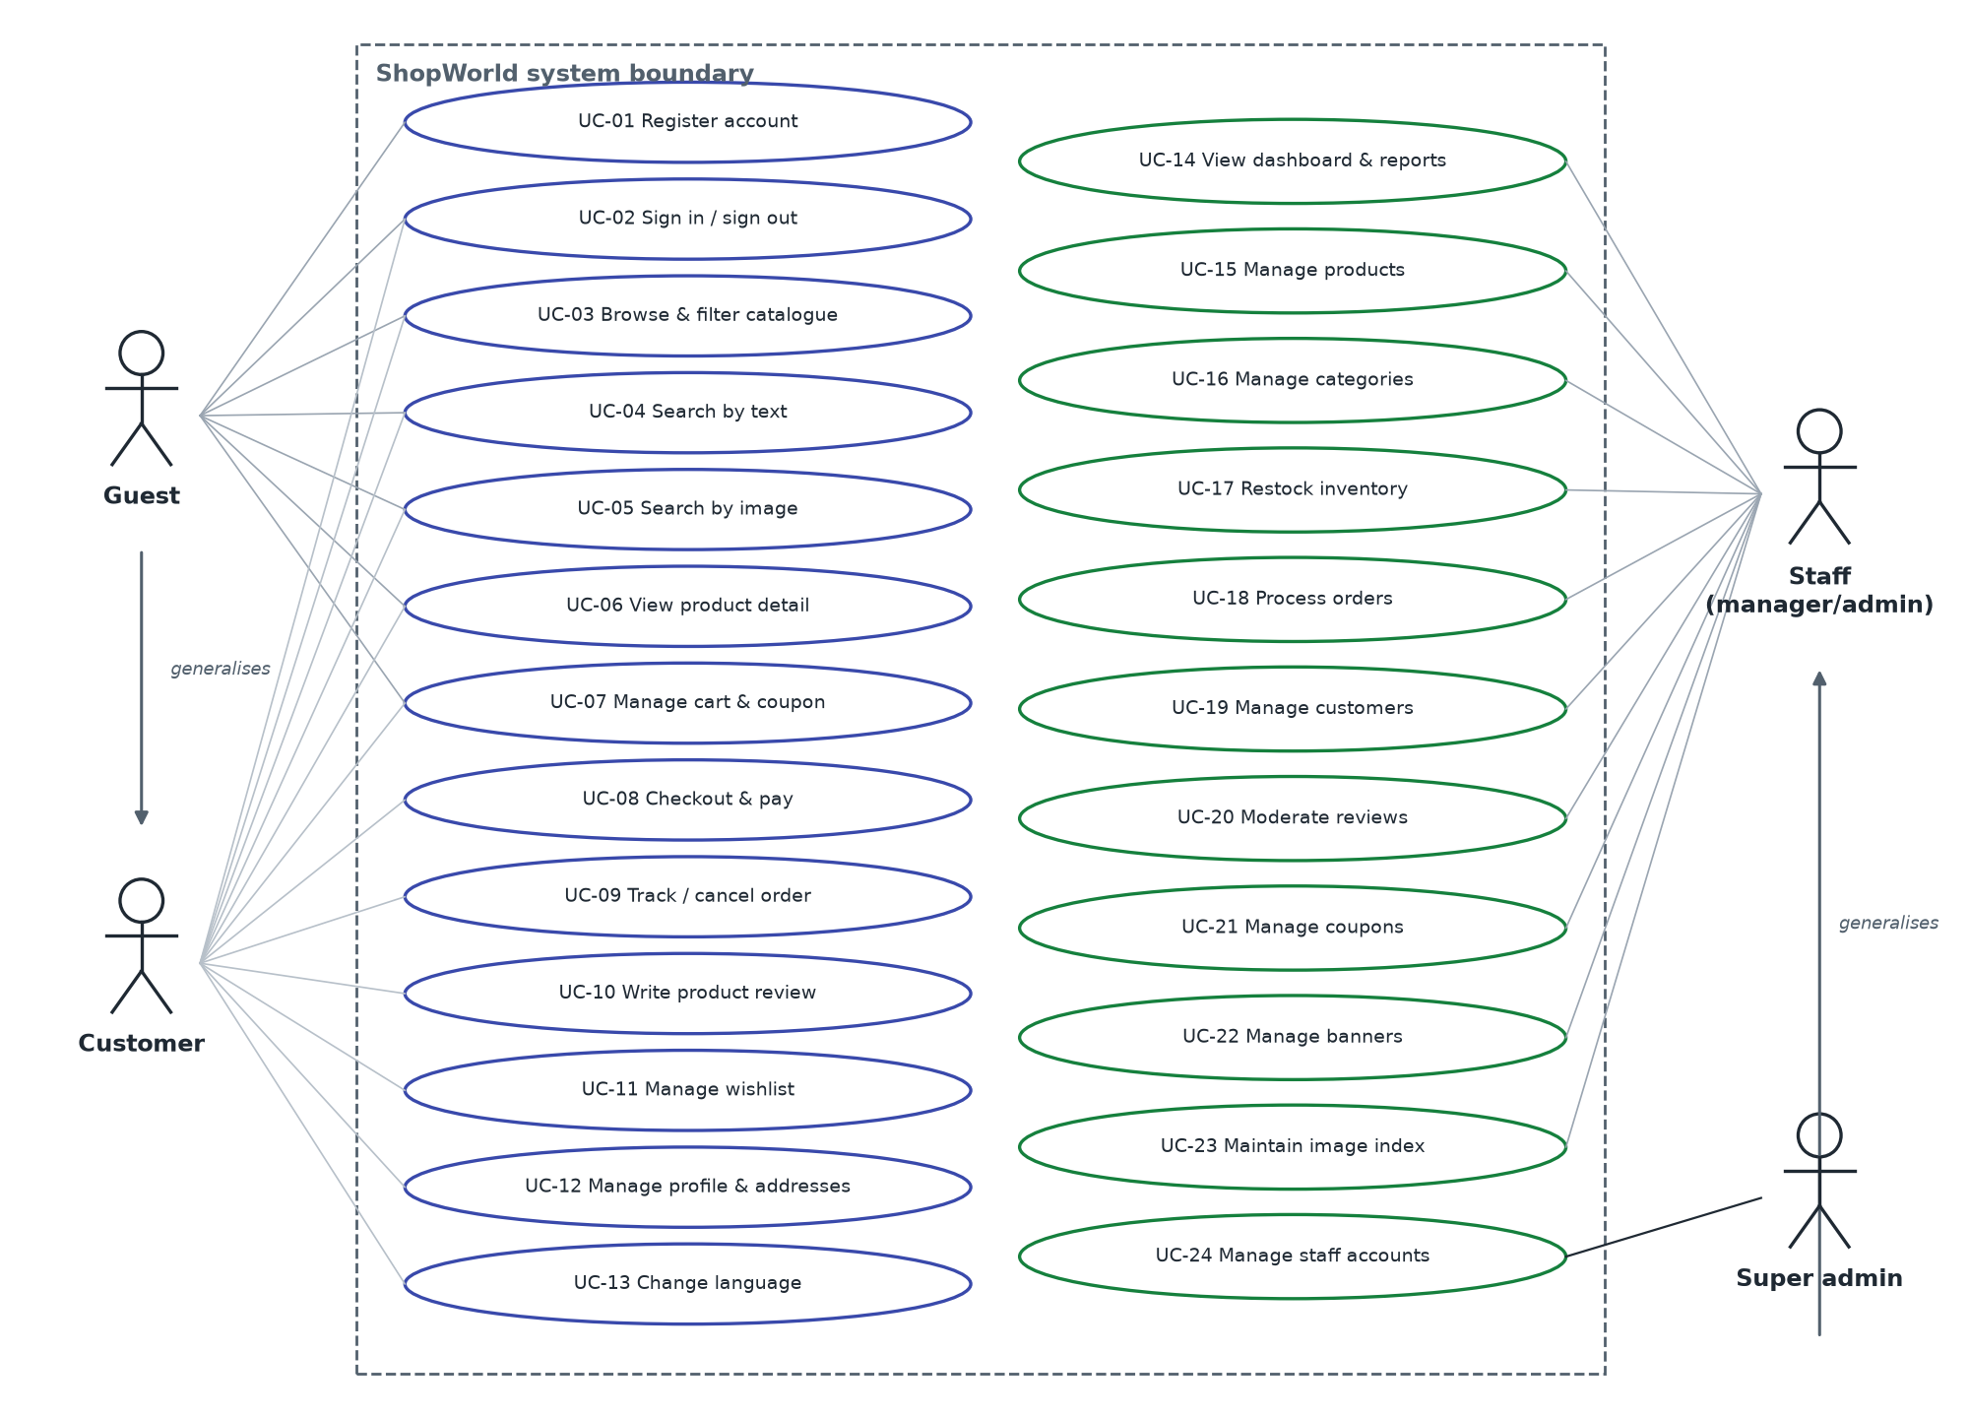
Figure 2 – Use-case diagram

4.3 Use-case catalogue
Table 9 – Use-case catalogue
ID | Use case | Primary actor | Channels | Priority
UC-01 | Register account | Guest | Web, Android | M
UC-02 | Sign in / sign out / keep session | Customer, Staff | All | M
UC-03 | Browse and filter catalogue | Guest | Web, Android | M
UC-04 | Search by text | Guest | Web, Android | M
UC-05 | Search by image | Guest | Web, Android | S
UC-06 | View product detail | Guest | Web, Android | M
UC-07 | Manage cart and coupon | Guest / Customer | Web, Android | M
UC-08 | Checkout and pay | Customer | Web, Android | M
UC-09 | Track and cancel order | Customer | Web, Android | M
UC-10 | Write product review | Customer | Web, Android | S
UC-11 | Manage wishlist | Customer | Web, Android | C
UC-12 | Manage profile, addresses and password | Customer | Web, Android | M
UC-13 | Change language | Any user | All | M
UC-14 | View dashboard and reports | Staff | Admin | M
UC-15 | Manage products | Staff | Admin | M
UC-16 | Manage categories | Staff | Admin | M
UC-17 | Restock inventory | Staff | Admin | M
UC-18 | Process orders | Staff | Admin | M
UC-19 | Manage customers | Staff | Admin | M
UC-20 | Moderate reviews | Staff | Admin | S
UC-21 | Manage coupons | Staff | Admin | S
UC-22 | Manage banners | Staff | Admin | S
UC-23 | Maintain image-search index | Staff, Scheduler | Admin | S
UC-24 | Manage staff accounts | Super admin | Admin | M

4.4 Customer use-case specifications

4.4.1 UC-01 Register account
Field | Description
Actor | Guest
Goal | Obtain a customer account and be signed in
Trigger | Guest selects “Create account” (SF-13 / AN-03)
Preconditions | Guest is not signed in
Main scenario | • Guest enters name, e-mail, optional phone, password and confirmation.  • Client checks password = confirmation (and on Android: name ≥ 2, e-mail format, password ≥ 6).  • Client sends POST /auth/register.  • System validates, creates the user (bcrypt hash) and an empty cart, returns user + token pair (201).  • Web client merges the guest cart (POST /cart/merge); client shows a welcome message and opens Home.
Alternatives | • A1 E-mail already registered → HTTP 409, message shown in the form.  • A2 Field invalid → HTTP 422 with errors[]; web maps each error under its field.
Postconditions | User with role customer exists; tokens stored on the client
Traceability | FR-AUTH-01, FR-CART-03 · SF-13, AN-03 · TC-AUTH-01..03

4.4.2 UC-02 Sign in, sign out and keep session
Field | Description
Actor | Customer or Staff
Goal | Access protected functions without re-entering credentials for up to 30 days
Preconditions | Account exists and is active
Main scenario | • User enters e-mail and password (demo buttons may fill them).  • System verifies the password, stores a new refresh token (keeps 5), records lastLoginAt, returns tokens.  • Client stores tokens (web: localStorage; Android: SharedPreferences) and returns to the page that required sign-in.  • When an access token expires, the client interceptor calls POST /auth/refresh once, stores the new pair and replays the request.  • User selects Sign out → POST /auth/logout revokes the refresh token; the client clears local state.
Alternatives | • A1 Wrong credentials → 401 “Invalid email or password”.  • A2 Account deactivated → 403.  • A3 Admin panel and role = customer → rejected with “This account does not have admin access”.  • A4 Refresh token revoked/expired → tokens cleared, toast “Your session expired”, sign-in screen shown.
Postconditions | Session established or ended
Traceability | FR-AUTH-02..05, FR-AUTH-07 · SF-12, AD-01, AN-01, AN-02 · TC-AUTH-04..08

4.4.3 UC-03 Browse and filter catalogue
Field | Description
Actor | Guest
Goal | Find products matching criteria
Trigger | Category chip, “See all” link, or Products navigation
Main scenario | • System shows root categories and product grid (GET /products, 12 per page).  • Guest selects filters: category, price range, brands, colours, minimum rating, in stock, featured, on sale.  • Client writes filters to the URL query (web) and requests the list again from page 1.  • Guest changes sort order or page; results update. Active filters appear as removable chips.
Alternatives | • A1 No result → empty state with “Clear all filters”.  • A2 Android: sort via dialog, endless scrolling instead of pages.
Postconditions | None (read-only)
Traceability | FR-CAT-01..04 · SF-01, SF-02, AN-05, AN-06, AN-08 · TC-CAT-01..04

4.4.4 UC-04 Search by text
Field | Description
Actor | Guest
Main scenario | • Guest types in the header search box.  • After 2 characters and 280 ms idle, the storefront shows up to 5 suggestions (image, name, price).  • Guest picks a suggestion (→ product detail) or submits (→ /products?search=term).  • System matches name, brand, SKU, tags and translated names case-insensitively.
Alternatives | A1 Android: product list search field with 320 ms debounce.
Traceability | FR-CAT-05, FR-CAT-06 · SF-02, AN-08 · TC-CAT-05

4.4.5 UC-05 Search by image
Field | Description
Actor | Guest; secondary: Android OS / other app
Goal | Find products that look like a photo
Preconditions | GET /products/visual-search/status reports the feature available (camera button visible)
Main scenario (Android) | • Guest taps the camera icon and takes a photo, picks one from the gallery, or shares an image into the app.  • App scales the photo to ≤ 640 px, rotates it upright from EXIF and flattens transparency onto white.  • App runs the bundled DINOv3 model and obtains a 384-d normalised vector.  • App sends POST /products/visual-search/vector {model, vector, limit 24}.  • System ranks products by cosine similarity and returns them with similarity; app shows “N % match”.
Main scenario (web) | • Guest clicks the camera button or drops a file on the Visual Search page.  • Storefront uploads the file (multipart image) to POST /products/visual-search?limit=24.  • System embeds the photo on the server and returns ranked products.
Alternatives | • A1 Model id mismatch (409) or on-device failure → app uploads the JPEG instead.  • A2 Model missing on the server → 503; client shows “Image search is not available right now”.  • A3 Image cannot be decoded → 400; client shows “unreadable photo”.  • A4 No product ≥ 0.25 similarity → empty state.
Traceability | FR-VIS-01..06, FR-VIS-08 · SF-04, AN-09 · TC-VIS-01..06

4.4.6 UC-06 View product detail
Field | Description
Actor | Guest
Main scenario | • Guest opens a product card.  • System returns product (by slug or id), increments viewCount, and the client loads related products, reviews and rating summary.  • Guest views images (zoom on hover/tap), selects colour and size variants and quantity (1..stock).  • Guest chooses Add to cart or Buy now (continues in UC-07).
Alternatives | • A1 Product inactive or not found → “not found” state.  • A2 Out of stock → purchase buttons disabled; out-of-stock sizes disabled.
Traceability | FR-CAT-07, FR-CAT-08 · SF-03, AN-10 · TC-CAT-06

4.4.7 UC-07 Manage cart and coupon
Field | Description
Actor | Customer (guest on web with local cart)
Main scenario | • User adds a product (POST /cart/items {productId, quantity, variant}).  • System checks stock and currency, adds or increases the line, revalidates the cart and returns items, totals, rules and notices.  • User changes quantity (PATCH) or removes lines (DELETE); the free-shipping meter shows the amount still needed.  • User enters a coupon code (upper-cased); system checks redeemability and returns the new totals.  • User proceeds to checkout.
Alternatives | • A1 Quantity exceeds stock → 400 with message; line unchanged.  • A2 Mixed currency → 400.  • A3 Coupon not redeemable → message with reason (e.g. minimum purchase).  • A4 A product became unavailable since last visit → line removed and a notice shown.  • A5 Guest on web: cart kept locally; coupon requires sign-in; checkout redirects to sign-in.
Postconditions | Cart persisted server-side (customer) or in localStorage (guest)
Traceability | FR-CART-01..07 · SF-05, AN-07 · TC-CART-01..08

4.4.8 UC-08 Checkout and pay
Field | Description
Actor | Customer; secondary: Payment gateway
Preconditions | Customer signed in; cart not empty
Main scenario | • System shows checkout preview (GET /checkout/preview) and saved addresses.  • Step 1: customer selects a saved address or enters and optionally saves a new one.  • Step 2: customer selects card, PayPal, Apple Pay or cash on delivery; for card enters number, name, expiry, CVC.  • Step 3: customer reviews items and totals and selects “Place order – $total”.  • System revalidates cart, reserves stock per line atomically, charges the payment, creates the order (pending), increments coupon usage and clears the cart in one transaction.  • Client opens Order success with order number, tracking number and estimated delivery.
Alternatives | • A1 A line went out of stock → 409; nothing is reserved; client returns to payment step with message.  • A2 Card declined (ends in 0000) or < 12 digits → 400; order not created, stock released.  • A3 No address → 400 “address required”.  • A4 COD → order created with payment status unpaid.
Postconditions | Order exists; stock and soldCount updated; cart empty
Traceability | FR-ORD-01..05, NFR-RE-01 · SF-06, SF-07, AN-11, AN-12 · TC-ORD-01..07

4.4.9 UC-09 Track and cancel order
Field | Description
Actor | Customer
Main scenario | • Customer opens order history, optionally filters by status.  • Customer opens an order: items, totals, payment, address, carrier, tracking number and a timeline of pending → processing → shipped → delivered.  • If status is pending or processing, customer selects Cancel order and confirms.  • System sets status cancelled, restores stock, refunds a paid payment and records the reason.
Alternatives | • A1 Order of another customer → 404/403.  • A2 Status shipped or later → cancel not offered; API returns 400.
Traceability | FR-ORD-06, FR-ORD-07, FR-ORD-09 · SF-08, SF-09, AN-13, AN-14 · TC-ORD-08..10

4.4.10 UC-10 Write product review
Field | Description
Actor | Customer
Main scenario | • On product detail the customer selects 1–5 stars, a title and a comment and submits.  • System creates the review (approved), links a delivered order if one contains the product (verified purchase), and recalculates the product rating.  • Client shows the review at the top of the list and refreshes the summary.
Alternatives | • A1 Second review for the same product → 409.  • A2 Guest → form disabled with a sign-in link.
Traceability | FR-REV-01..03 · SF-03, AN-10 (review dialog) · TC-REV-01..03

4.4.11 UC-11 Manage wishlist
Field | Description
Actor | Customer
Main scenario | • Customer taps the heart on a product card or detail page.  • System toggles the product in the user's wishlist and returns inWishlist.  • Customer opens the Wishlist page to see saved products and can remove them or add them to the cart.
Alternatives | A1 Guest → message “please sign in first” (Android opens sign-in).
Traceability | FR-CART-08 · SF-11, AN-18 · TC-CART-09

4.4.12 UC-12 Manage profile, addresses and password
Field | Description
Actor | Customer
Main scenario | • Customer edits name and phone (e-mail is read-only).  • Customer adds, edits, deletes addresses and marks one as default; the first address becomes default automatically.  • Customer changes password by entering current and new password (≥ 6) twice; all sessions are revoked and the customer signs in again.
Alternatives | • A1 Wrong current password → 401/400 with message.  • A2 Deleting the default address → first remaining address becomes default.
Traceability | FR-AUTH-06 · SF-10a–c, AN-15, AN-16 · TC-ACC-01..04

4.4.13 UC-13 Change language
Field | Description
Actor | Any user
Main scenario | • User opens the language switcher and chooses English, 中文 or 日本語.  • Client applies the language immediately and stores it locally; signed-in clients also save it (PATCH /users/language).  • Subsequent API calls carry X-Language; catalogue text and messages come back translated.
Traceability | FR-I18N-01, FR-I18N-02, FR-CAT-09 · all screens · TC-I18N-01..03

4.5 Back-office use-case specifications

4.5.1 UC-14 View dashboard and reports
Field | Description
Actor | Staff
Main scenario | • Staff opens Dashboard; default range 30 days.  • System returns KPIs (revenue, orders, customers, conversion) with change versus the previous period, daily sales, sales by category, recent orders, top products and 6-month customer growth.  • Staff switches range (7 d, 30 d, 3 m, 1 y); Reports shows the same data in more depth (orders per day, revenue by category, 12-month new customers, best sellers).
Traceability | FR-ADM-01 · AD-02, AD-11 · TC-ADM-01

4.5.2 UC-15 Manage products
Field | Description
Actor | Staff
Main scenario | • Staff filters the product table by text, category, status and stock level.  • Staff opens Add/Edit, fills name, brand, category, currency, price, compare price, cost, stock, colours, descriptions, tags, switches and zh/ja translations; uploads images.  • System validates, saves and indexes the images for image search; a warning toast appears if indexing failed.  • Staff toggles Active in the table (optimistic update) or deletes a product after confirmation (reviews and vectors are deleted too).
Alternatives | • A1 Validation error → field messages under the inputs.  • A2 Upload type/size not allowed → 400.
Traceability | FR-ADM-02, FR-CAT-08, FR-VIS-07 · AD-03 · TC-ADM-02..04

4.5.3 UC-16 Manage categories
Field | Description
Actor | Staff
Main scenario | • Staff creates or edits a category (name, description, parent, sort order, visibility, translations); slug is generated.  • Staff deletes a category after confirmation.
Alternatives | • A1 Category has products or children → 409.  • A2 Category set as its own parent → 400.
Traceability | FR-ADM-03 · AD-04 · TC-ADM-05

4.5.4 UC-17 Restock inventory
Field | Description
Actor | Staff
Main scenario | • Staff opens Inventory: summary cards (out of stock, low stock, total) and the list of active products with stock ≤ 10.  • Staff types a new stock level and presses Save (PATCH /admin/products/:id/stock).  • System stores the value; the list reloads and the product leaves the list if stock > 10.
Alternatives | A1 Value not a number ≥ 0 → error toast, nothing sent.
Traceability | FR-ADM-04 · AD-05 · TC-ADM-06

4.5.5 UC-18 Process orders
Field | Description
Actor | Staff
Main scenario | • Staff filters orders by status tab (with counts) and search (order number, customer, e-mail).  • Staff opens an order: customer, address, items, totals, timeline.  • Staff enters carrier and tracking number and saves.  • Staff optionally writes a note and selects the next status (Mark as processing / shipped / delivered / cancelled).  • System validates the transition, appends to the timeline, and on delivered sets deliveredAt (COD → paid) or on cancelled restores stock and refunds.
Alternatives | • A1 Transition not allowed → 400 and toast.  • A2 Same status → “unchanged”.
Traceability | FR-ORD-06..08, FR-ORD-10 · AD-06 · TC-ORD-11..14

4.5.6 UC-19 Manage customers
Field | Description
Actor | Staff
Main scenario | • Staff searches and filters customers (active/inactive); table shows orders and total spent.  • Staff opens detail: statistics, contact, addresses, last 10 orders.  • Staff toggles Active; deactivation signs the customer out everywhere.  • Staff exports all customers as CSV (UTF-8 with BOM, localised headers).
Alternatives | A1 Target is a staff account → 403.
Traceability | FR-ADM-05 · AD-07 · TC-ADM-07, TC-ADM-08

4.5.7 UC-20 Moderate reviews
Field | Description
Actor | Staff
Main scenario | • Staff filters reviews by published/hidden and rating.  • Staff hides or publishes a review; the product rating is recalculated from approved reviews.  • Staff deletes an abusive review after confirmation.
Traceability | FR-REV-03, FR-REV-04 · AD-09 · TC-REV-04

4.5.8 UC-21 Manage coupons
Field | Description
Actor | Staff
Main scenario | • Staff creates a coupon: code (≥ 3, upper case), type percent/fixed, value, description, minimum purchase, maximum discount, usage limit, expiry, active.  • Table shows usage (used / limit) and status Active, Paused or Expired.  • Staff edits or deletes a coupon after confirmation.
Traceability | FR-ADM-06, FR-CART-04, FR-CART-05 · AD-08 · TC-CART-05..07

4.5.9 UC-22 Manage banners
Field | Description
Actor | Staff
Main scenario | • Staff creates a banner with title, subtitle, button text/link, placement (hero, promo, mobile), sort order, image, live flag and translations.  • Active hero banners appear in the storefront carousel and the Android home pager.
Traceability | FR-ADM-06 · AD-10 · TC-ADM-09

4.5.10 UC-23 Maintain image-search index
Field | Description
Actor | Staff; Scheduler
Main scenario | • At server start, the scheduler loads the model and indexes products whose status is pending/unavailable or built by another model.  • Staff sees coverage on the Products page (“N of M products indexed · V vectors”).  • Staff selects Rebuild index (missing only) or Re-extract all (force); the page polls progress every 2 s.  • Staff can re-extract a single product from its row.
Alternatives | • A1 Model not available → buttons disabled, 503 from API.  • A2 Job already running → 200 with current job.
Traceability | FR-VIS-07 · AD-03 (VisualIndexBar) · TC-VIS-07

4.5.11 UC-24 Manage staff accounts
Field | Description
Actor | Super admin
Main scenario | • Super admin opens Administrators (menu shown only to super admins).  • Super admin creates an account: name, e-mail, password (≥ 6), role manager/admin, section permissions, active.  • Super admin edits role, permissions, status or password; the affected user is signed out.  • Super admin deletes an account after confirmation.
Alternatives | • A1 Target is a super admin or oneself → 403.  • A2 Non-super-admin calls the API → 403.
Traceability | FR-AUTH-08, FR-AUTH-09, FR-ADM-07, FR-ADM-08 · AD-13 · TC-ADM-10, TC-ADM-11

5 Architecture description
This section is an architecture description in the sense of ISO/IEC/IEEE 42010:2022. It identifies the stakeholders' architecture concerns, the viewpoints chosen to address them, the resulting views and the decisions with their rationale.

5.1 Stakeholders and concerns
Table 10 – Architecture concerns
Concern | Stakeholders | Addressed by view
What does the system interact with? | All | Context view (Figure 1)
Which deployable parts exist and how do they communicate? | Architect, developers, operations | Container view
Where does each business rule live? | Developers, QA | Layered view, section 6
How is it deployed and configured? | Operations | Deployment view, Appendix A
How is data structured and kept consistent? | Developers, DBA | Data view (section 7)
How are users authenticated and data protected? | Security officer | Security design (6.8)
How does image search work offline and on the phone? | Product owner, developers | Visual-search design (6.7)

5.2 Viewpoints
Table 11 – Viewpoints used
Viewpoint | Model kinds | Concerns framed
Context | Context diagram | Scope, external actors and systems
Functional / container | Box-and-line container diagram, layer diagram | Decomposition, responsibilities, technology
Information | Entity-relationship diagram, collection tables | Data ownership, integrity, indexing
Behaviour | Sequence diagrams, state machine | Critical flows: authentication, checkout, image search, order life cycle
Deployment | Deployment diagram, configuration table | Runtime nodes, ports, volumes, environment
Security (perspective) | Control table | Authentication, authorisation, input handling, transport, secrets

5.3 Container view
The system is a classic three-tier, API-centric architecture. The API is stateless (JWT), so it can be scaled horizontally, with one caveat: the image-search index is held in process memory and rebuilt lazily per process (see 6.7).
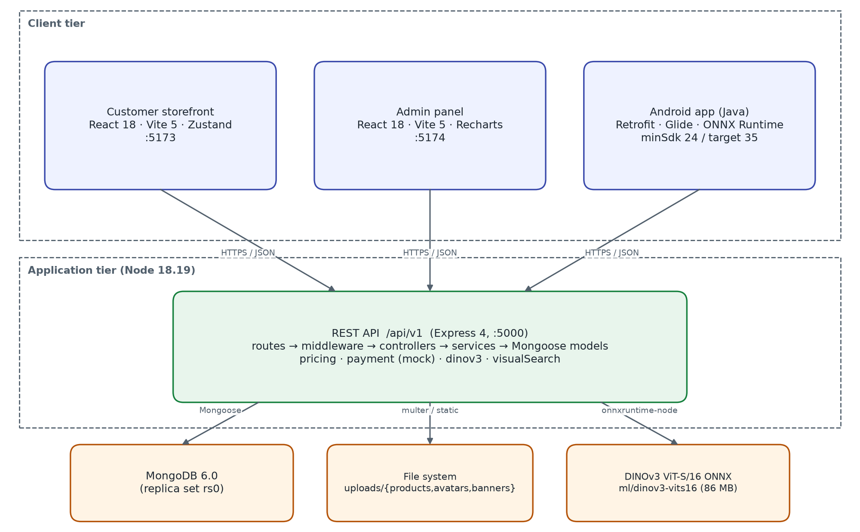
Figure 3 – Container view
Table 12 – Containers
Container | Responsibility | Key technology
Customer storefront | Shopping UI for browsers; guest cart; client-side routing; i18n | React 18, React Router 6, Zustand, Axios, Vite 5
Admin panel | Back-office UI; charts; CRUD forms; CSV download | React 18, Recharts 2, Zustand, Axios, Vite 5
Android app | Native shopping UI; on-device image embedding; share target | Java 17, AppCompat, Material 3, Retrofit 2.11, OkHttp 4.12, Glide 4.16, onnxruntime-android 1.22
REST API | All business rules, persistence, authentication, uploads, image search | Express 4.19, Mongoose 8, jsonwebtoken 9, bcryptjs, multer, sharp 0.34, onnxruntime-node 1.22
MongoDB | Documents for users, catalogue, carts, orders, reviews, coupons, banners, embeddings | MongoDB 6.0, replica set rs0
File store | Product, avatar and banner images served under /uploads (7-day cache) | Local disk / Docker bind mount
Model files | DINOv3 ViT-S/16 ONNX weights and preprocessing config | 86 MB fp32; also bundled in the APK

5.4 Backend layered view
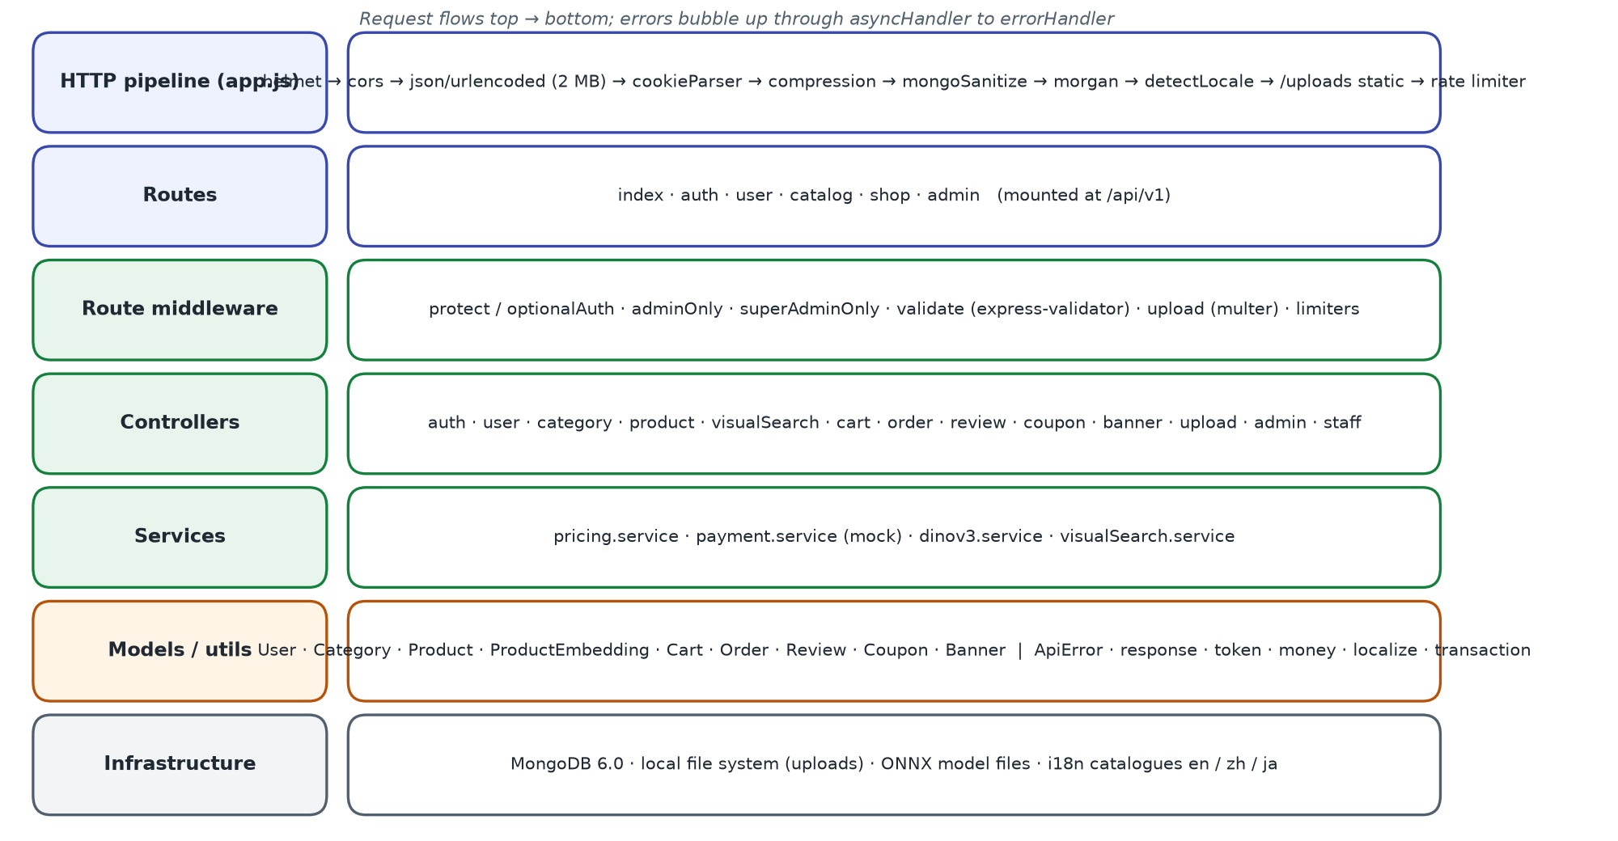
Figure 4 – Backend layers and HTTP pipeline
Each route file binds URL patterns to middleware and a controller. Controllers are thin: they parse the request, call models and services, and answer through utils/response.ok(). Errors are thrown as ApiError(status, i18nKey) and translated by the central error handler. Business rules that are used by more than one controller live in services (pricing, payment, dinov3, visualSearch).

5.5 Behaviour view
The critical flows are specified as sequence diagrams in section 6: authentication and token refresh (Figure 6), checkout (Figure 7) and image search (Figure 10). The order life cycle is a state machine (Figure 8).

5.6 Deployment view
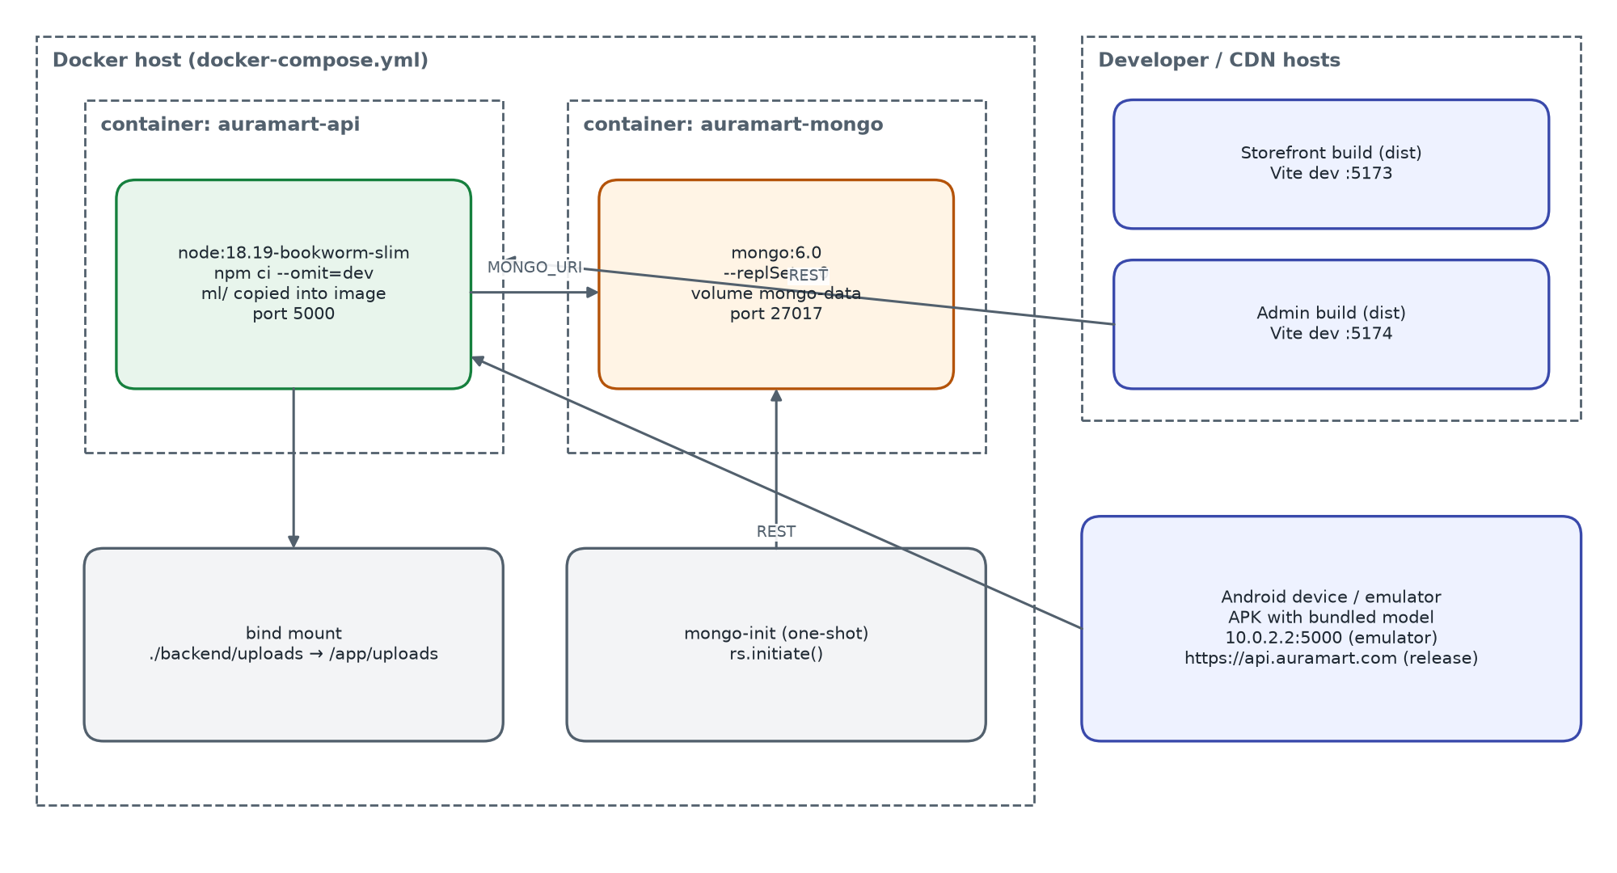
Figure 5 – Deployment view (development / single-host)
docker-compose.yml starts MongoDB 6.0 as a single-node replica set (so checkout runs in a real transaction), a one-shot mongo-init container that initiates the replica set, and the API container built from backend/Dockerfile (node:18.19-bookworm-slim, production dependencies only, model files copied into the image). The two React apps are built to static files (npm run build) and can be served by any web server or CDN; during development Vite serves them on ports 5173 and 5174. Configuration is by environment variables (Appendix A).

5.7 Architecture decisions
Table 13 – Architecture decisions
ID | Decision | Rationale | Consequences
AD-01 | One REST API for all clients | Single place for rules; web and Android behave the same | API versioning needed for breaking changes
AD-02 | MongoDB document model with embedded addresses, order snapshots | Orders must not change when products change; fewer joins | Denormalised data; aggregation for reports
AD-03 | Stateless JWT access token + rotated refresh token stored per user | Horizontal scaling; revocation on password change and deactivation | Access token valid up to 15 min after revocation
AD-04 | Pricing centralised in pricing.service | Cart, preview and order can never disagree | Guest-cart display on web duplicates the formula
AD-05 | Conditional atomic stock decrement inside a transaction | No overselling under concurrency | Replica set recommended; manual rollback path on standalone
AD-06 | Self-hosted DINOv3 with ONNX Runtime | No per-call cost, works offline, same model on phone | 86 MB model in image and APK; CPU inference
AD-07 | Brute-force in-memory cosine search | Simple and exact for catalogues up to ~100 k images | Memory per process; rebuild on change; ANN index needed beyond that scale
AD-08 | On-device embedding on Android, upload fallback | Less data sent, privacy (photo stays on phone) | Model id must match server; larger APK
AD-09 | i18n by key catalogues + per-document translations | Three languages with English fallback | Every new text needs three entries
AD-10 | No UI framework; CSS custom properties | Small bundles, consistent brand on web | Components maintained in-house

6 Detailed software design

6.1 Backend module decomposition
Table 14 – Backend modules
Module | Files | Responsibilities
Configuration | config/env.js, db.js, constants.js | Environment parsing with defaults; MongoDB connection (pool 20, 10 s selection timeout); roles, permissions, order flow, stock thresholds
Auth | routes/auth, controllers/auth, middleware/auth, utils/token | Register, login, refresh rotation, logout, me, password; protect, optionalAuth, adminOnly, superAdminOnly
Users | controllers/user | Profile, avatar, language, address book (single default), wishlist toggle
Catalogue | controllers/category, product, banner, coupon (public part) | Category tree and counts, product query builder with facets, related products, reviews listing, banners, promotions, coupon validation
Cart | controllers/cart | Server cart CRUD, merge, coupon attach/detach, buildCartPayload revalidation
Orders | controllers/order, services/payment, utils/transaction, utils/ids | Checkout, listing, tracking, customer cancel; order and tracking numbers
Reviews | controllers/review, models/Review | Create/update/delete, verified purchase, helpful counter, rating sync
Admin | controllers/admin, staff, upload, visualSearch | Dashboard aggregations, back-office CRUD, order workflow, CSV export, staff, uploads, image index
Pricing | services/pricing | computeTotals – the only implementation of order arithmetic
Image search | services/dinov3, services/visualSearch, models/ProductEmbedding | Model loading, preprocessing, inference queue, indexing, in-memory matrix search
i18n | middleware/locale, i18n/, utils/localize | Language detection, message catalogues, folding of translated catalogue fields
Cross-cutting | middleware/error, validate, rateLimit, upload; utils/ApiError, response, asyncHandler | Error mapping, validation to 422, rate limits, multer configuration, response envelope

6.2 Authentication and session design
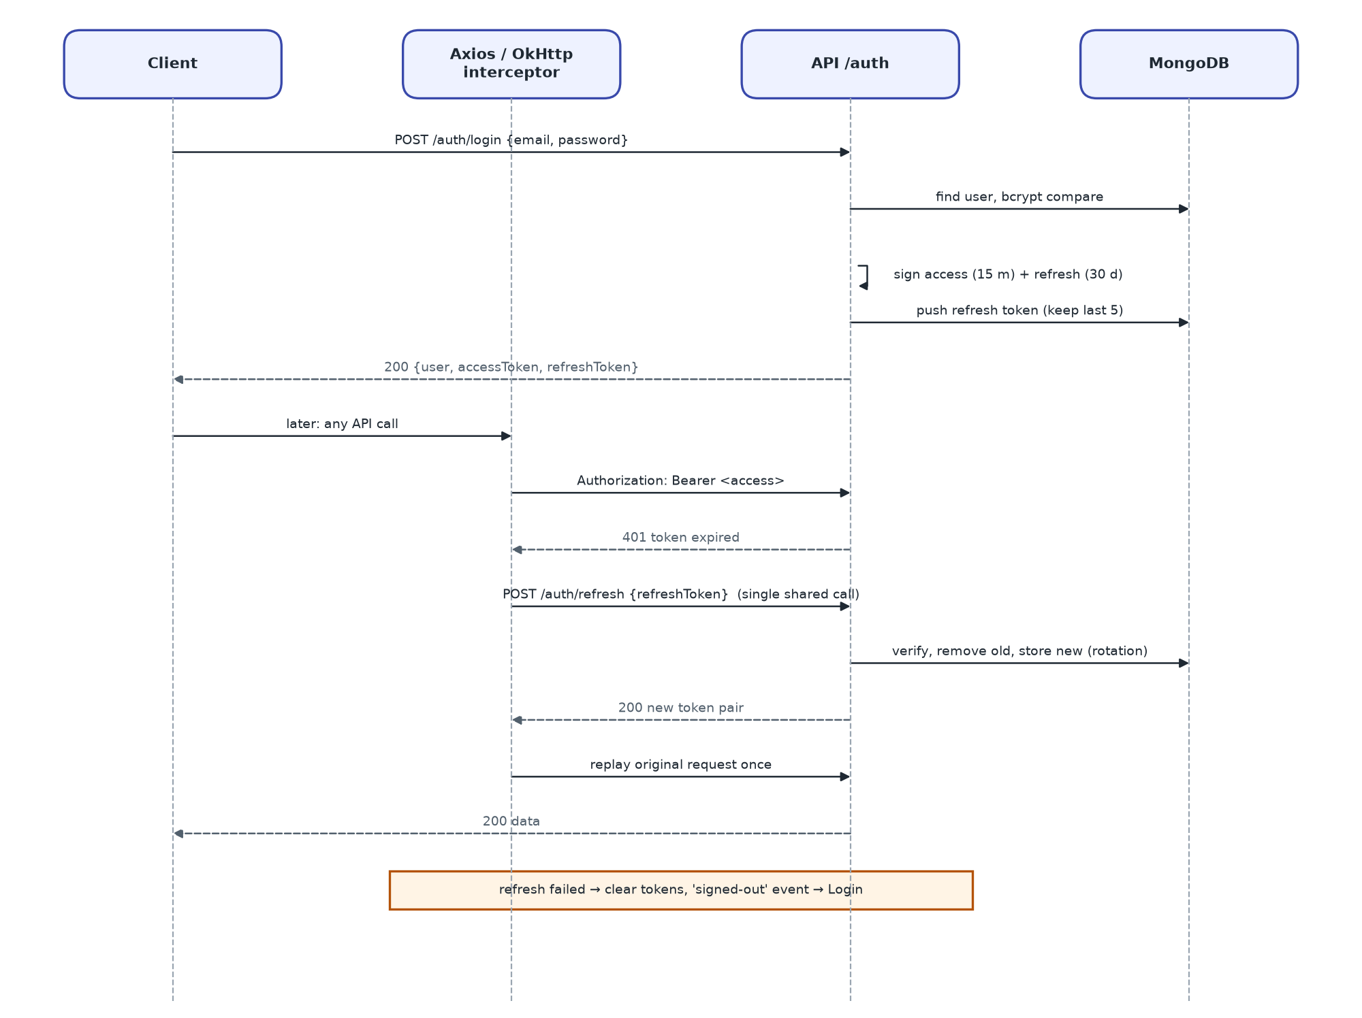
Figure 6 – Sign-in and transparent token refresh
- Tokens: access JWT {sub, role, email} signed with JWT_ACCESS_SECRET, 15 min; refresh JWT {sub, type:'refresh'} signed with JWT_REFRESH_SECRET, 30 days.
- Storage on the server: User.refreshTokens (hidden from queries) keeps the last 5 refresh tokens; reuse of a rotated token is rejected as revoked.
- Transport: Authorization: Bearer header or accessToken cookie; refresh token in the body or refreshToken cookie.
- Revocation: password change, staff role/permission change and deactivation clear all refresh tokens; protect also rejects inactive users on every request (403).
- Clients: web and admin use one shared in-flight refresh promise so concurrent 401s trigger a single refresh; Android serialises refresh with a lock inside an OkHttp interceptor.

6.3 Pricing algorithm
pricing.service.computeTotals(lines, {discount, freeShipping}) is called by the cart, the checkout preview, order placement and the seed script:
1. unit price = product.price + variant.priceDelta; subtotal = round2(Σ unit × quantity)
2. discount = min(coupon discount, subtotal); taxable = subtotal − discount
3. shipping = 0 if freeShipping option, or every item has freeShipping, or taxable ≥ FREE_SHIPPING_THRESHOLD (50), or taxable = 0; otherwise SHIPPING_FLAT_RATE (9.99)
4. tax = round2(taxable × TAX_RATE (0.10)) — shipping is not taxed
5. total = round2(taxable + shipping + tax)
Coupon discount: percent → subtotal × value / 100, fixed → value; capped by maxDiscount when > 0; rounded to cents; capped at the subtotal. Example: subtotal 120.00 with WELCOME10 → discount 12.00, taxable 108.00, shipping 0, tax 10.80, total 118.80.

6.4 Cart revalidation
Every cart read or write passes through buildCartPayload, which (1) removes lines whose product is missing, inactive or out of stock, (2) clamps quantities to available stock, (3) refreshes priceAtAdd from the current price, (4) re-checks the attached coupon and detaches it if no longer redeemable, and (5) returns {items, itemCount, coupon, totals, rules, notices}. notices are human-readable messages the clients show as toasts/snackbars, so the customer learns why the cart changed.

6.5 Checkout and transaction design
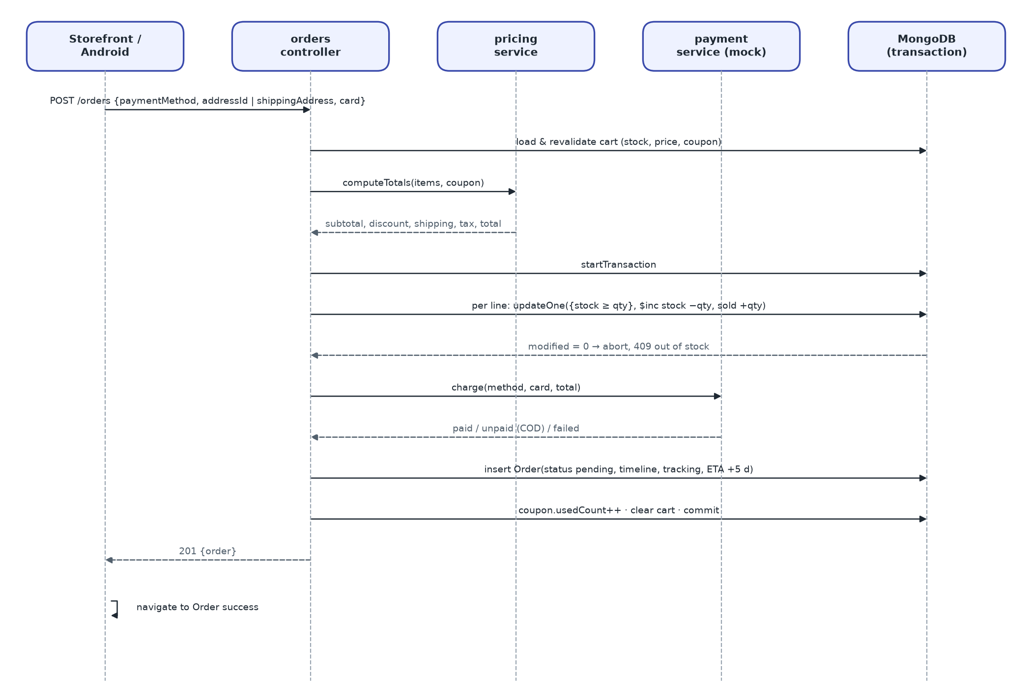
Figure 7 – Checkout sequence
runInTransaction opens a MongoDB session. On a standalone server (error code 20 / IllegalOperation) it logs one warning and re-runs the work without a session; stock that was already reserved is then rolled back by hand if a later step fails. The conditional update updateOne({_id, stock: {$gte: qty}}, {$inc: {stock: -qty, soldCount: qty}}) is the concurrency guard: two customers buying the last unit cannot both succeed.

6.6 Order life-cycle state machine
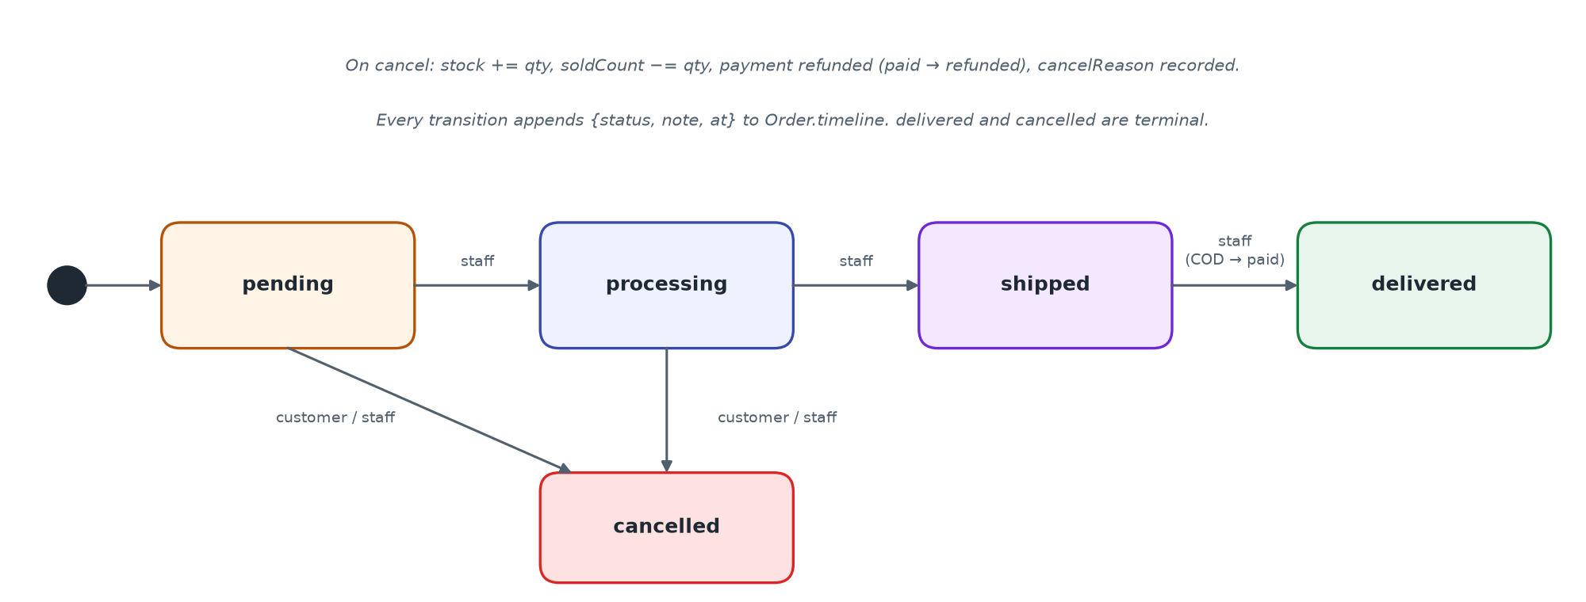
Figure 8 – Order status state machine
Table 15 – Order transitions
From | To | Who | Side effects
(new) | pending | System at checkout | Timeline “Order placed”; payment paid/unpaid; tracking no.; ETA +5 days
pending | processing | Staff | Timeline entry
pending / processing | cancelled | Customer or staff | Stock restored; soldCount reduced; refund if paid; cancelledAt, cancelReason
processing | shipped | Staff | Timeline entry (carrier/tracking can be edited separately)
shipped | delivered | Staff | deliveredAt; COD payment → paid
delivered / cancelled | — | — | Terminal; any further change → 400

6.7 Image-search design
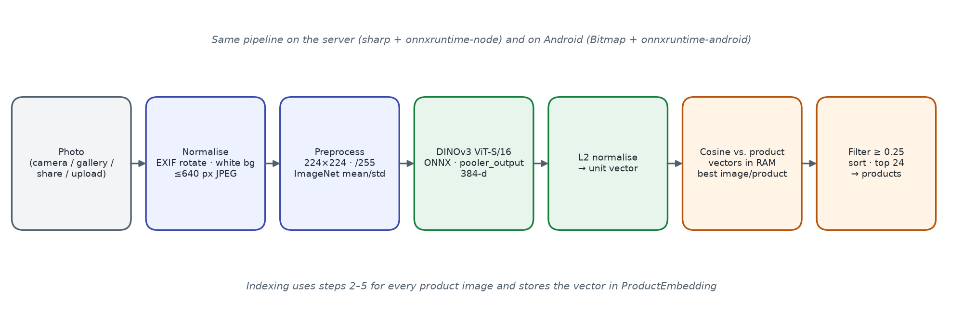
Figure 9 – Image embedding and ranking pipeline
- Model: DINOv3 ViT-S/16 (onnx-community/dinov3-vits16-pretrain-lvd1689m-ONNX), fp32, 384 dimensions, 12 layers, 4 register tokens; model id dinov3-vits16/model.onnx.
- Server runtime: onnxruntime-node on CPU, graph optimisation “all”, thread count VISUAL_SEARCH_THREADS (0 = auto); loaded lazily once; inferences serialised by a promise queue.
- Preprocessing: sharp: EXIF rotate → flatten on white → resize 224 × 224 (fill, linear) → sRGB → remove alpha → CHW float, /255, ImageNet mean/std from preprocessor_config.json.
- Descriptor: pooler_output (normalised CLS token), falling back to row 0 of last_hidden_state; then L2-normalised.
- Index: one ProductEmbedding document per product image and model (Float32 little-endian buffer, 1.5 KB). Product.visualIndex keeps status pending / indexed / partial / failed / no_images / unavailable.
- Search: vectors of active products are loaded into one Float32 matrix, rebuilt when a generation counter changes (index writes, deletes, activation toggles). Score = dot product; a product scores as its best image; keep ≥ minScore (0.25), sort, limit (default 24, 1–60).
- Guide values: same product in another photo ≥ 0.85; same kind of object ≈ 0.3; unrelated < 0.1.
- Android: same weights bundled in assets/model (stored uncompressed, copied to no-backup storage on first use), Bitmap preprocessing that matches the server to cosine ≈ 0.9998, vector sent to /visual-search/vector; upload fallback.
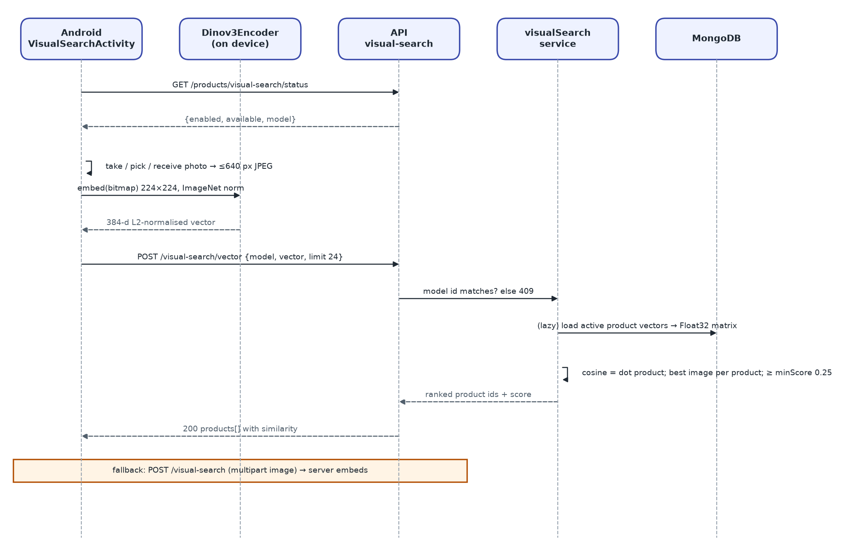
Figure 10 – Image search from Android with upload fallback

6.8 Security design
Table 16 – Security controls
Control area (ISO/IEC 27002) | Implementation
Authentication (8.5) | bcrypt(10) password hashes; JWT access/refresh with separate secrets; refresh rotation; session cap 5
Access control (8.3) | protect on customer routes; adminOnly (manager/admin/superadmin) on /admin; superAdminOnly on /admin/staff; ownership checks on orders and reviews
Input validation (8.28) | express-validator chains → 422 {field, message}; express-mongo-sanitize strips $ and . keys; regex search input escaped; 2 MB body limit
File upload (8.28) | multer: MIME whitelist jpeg/png/webp/gif/avif, ≤ UPLOAD_MAX_MB (5) each, ≤ 8 files; generated file names; delete endpoint blocks path traversal
Transport and headers (8.20) | helmet defaults (cross-origin resource policy relaxed for images); CORS whitelist from CORS_ORIGINS, localhost allowed outside production; HTTPS in release Android build
Capacity / abuse protection (8.6) | express-rate-limit in production: api 1000/15 min, auth 30/15 min, write 60/min, image search 20/min
Secrets (8.24) | JWT secrets and DB URI from environment; defaults are for development only and must be overridden
Logging (8.15) | morgan access log; [error] for 5xx; stack traces only outside production
Mobile (8.1) | Only INTERNET and ACCESS_NETWORK_STATE permissions; camera via system app (no CAMERA permission); FileProvider not exported; cleartext only for emulator hosts

Weaknesses found during the review are listed in section 10 (findings F-01, F-05 to F-08).

6.9 Internationalisation design
- Supported locales: en (default), zh, ja; aliases such as zh-CN, zh-Hant, ja-JP and en-GB map to them.
- API resolution order: ?lang → X-Language → saved user language → Accept-Language (q-ranked) → en. The API sets Content-Language and Vary: Accept-Language.
- Messages are dotted keys (e.g. error.productNotFound) with {{param}} interpolation; missing keys fall back to English, then to the key.
- Catalogue documents carry translations.{en,zh,ja} for name, descriptions, titles and CTA texts. Storefront responses are folded to flat fields; admin routes receive the raw object for editing.
- Web clients detect ?lang, then localStorage, then the browser language; Android uses per-app locales (AppCompatDelegate, locales_config.xml).
- Prices are formatted with Intl for the active locale but never converted.

6.10 Error handling and logging
Table 17 – Error mapping
Condition | HTTP | Body
Validation failure (express-validator) | 422 | {success:false, message, errors:[{field, message}]}
Mongoose ValidationError | 422 | field details
Invalid ObjectId (CastError) | 400 | message
Duplicate key (11000) | 409 | message naming the field
Missing / invalid / expired JWT | 401 | message
Inactive account, wrong role, not owner | 403 | message
Business rule (stock, coupon, transition) | 400 / 409 | translated message
Image-search model unavailable | 503 | error.visualSearchUnavailable
Rate limit exceeded (production) | 429 | “Too many requests, please try again later”
Unhandled error | 500 | generic message; stack outside production

6.11 Web client design
- Structure: main.jsx → I18nProvider → BrowserRouter → App; api/ (Axios client and endpoint groups), store/ (Zustand: auth, cart, toast), components/, pages/, i18n/, utils/, styles/global.css.
- API client: base URL from VITE_API_URL; 20 s timeout (60 s for image upload); adds Bearer token and X-Language; unwraps the envelope; single shared refresh on 401; dispatches auramart:signed-out on failure.
- Routing guard: ProtectedRoute waits for auth bootstrap, then redirects to /login with state.from so the user returns after sign-in. Admin panel uses the equivalent RequireStaff guard.
- State: authStore (user, status), cartStore (server or guest cart, totals, notices), toastStore (3.2 s toasts).
- Motion and accessibility: scroll-reveal and page-enter animations disabled under prefers-reduced-motion; forced-colors supported; toasts use aria-live=polite.

6.12 Android client design
- Packages: data.local (SessionManager, Dinov3Encoder), data.model (DTOs), data.remote (ApiClient, ApiService), data.repository (Repo), ui.* (one package per feature), util (Formats, Images, LocaleManager, SearchPhotos, Dinov3Preprocessor, Ui, Validators).
- Pattern: Activities/Fragments call Repo.call() which enqueues Retrofit calls and unwraps the envelope into onSuccess(data, message) / onError(message). View Binding is used for layouts; no ViewModel layer.
- Networking: BuildConfig.API_BASE_URL (10.0.2.2 in debug, api.auramart.com in release); timeouts 20/30/30 s; X-Language header; AuthInterceptor with synchronized refresh; image URLs pointing at localhost are rewritten to the API origin.
- Session: SharedPreferences auramart.session stores tokens, user JSON, wishlist ids and cart count; SessionExpiredListener opens Login with a cleared task.
- Build: compile/target SDK 35, min SDK 24, Java 17, AGP 8.13, R8 minification in release; checkDinov3Model fails the build if model files are missing.

7 Data design

7.1 Logical data model
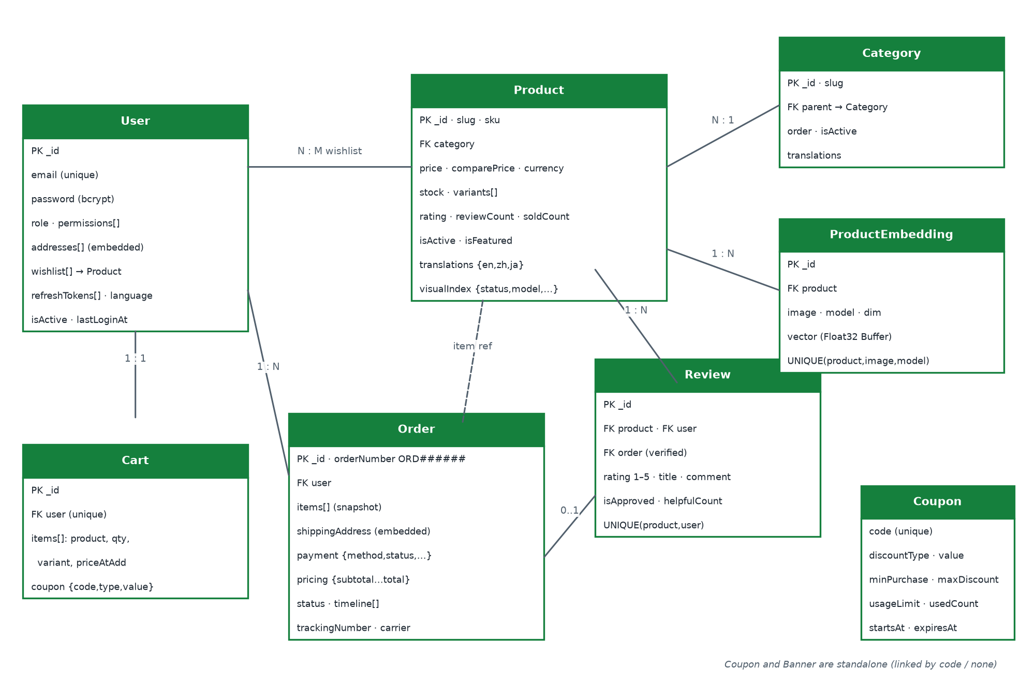
Figure 11 – Entity-relationship diagram (MongoDB collections)
All collections carry createdAt and updatedAt (Mongoose timestamps). Embedded documents (addresses, cart items, order items, timeline) are used where the child has no life of its own.

7.2 Collection specifications

7.2.1 users
Field | Type | Constraints / notes
name | String | required, ≤ 80
email | String | required, unique, lower-case
password | String | bcrypt, ≥ 6, not selected by default
role | Enum | customer | manager | admin | superadmin (default customer)
permissions | [Enum] | products, orders, customers, reviews, content, reports, settings
isActive | Boolean | default true
addresses[] | Embedded | label, fullName*, phone, street*, city*, state, zipCode*, country* (Finland), isDefault — exactly one default
wishlist[] | ObjectId[] → products
refreshTokens[] | String[] | last 5; not selected
language | Enum | en | zh | ja
lastLoginAt, avatar, phone | Date / String

7.2.2 products
Field | Type | Constraints / notes
name, slug, sku | String | name ≤ 160; slug = slugify(name)+id suffix, unique; sku unique (default SKU-xxxxxxxx)
category | ObjectId → categories | required, indexed
price, comparePrice, cost | Number | ≥ 0; price indexed
currency | Enum | USD | REM
stock | Number | ≥ 0; stockStatus virtual: ≤ 0 out, ≤ 10 low
variants[] | Embedded | name*, value*, hex, priceDelta, stock
images[], tags[], colors[] | String[] | tags indexed
rating, reviewCount, soldCount, viewCount | Number | rating 0–5 (indexed), soldCount indexed
isActive, isFeatured, freeShipping | Boolean | indexed flags
warrantyMonths, returnDays | Number | defaults 12 and 30
translations | Object | {en, zh, ja} × name, description, shortDescription
visualIndex | Object | status, model, vectors, error, indexedAt

7.2.3 orders
Field | Type | Constraints / notes
orderNumber | String | ORD + 6 digits, unique
user | ObjectId → users | indexed
customerName, customerEmail | String | snapshot
items[] | Embedded | product, name, image, sku, price, quantity ≥ 1, variant, subtotal
shippingAddress | Embedded | fullName, phone, street, city, state, zipCode, country
payment | Embedded | method card|paypal|applepay|cod; status unpaid|paid|failed|refunded; transactionId; cardLast4; paidAt
pricing | Embedded | subtotal, shipping, tax, discount, total (≥ 0)
status, timeline[] | Enum, Embedded | pending…cancelled; {status, note, at}
trackingNumber, carrier, estimatedDelivery | String, Date | AM-XXXXXXXXXX, default UPS
deliveredAt, cancelledAt, cancelReason, couponCode, notes | Mixed

7.2.4 other collections
Collection | Fields and constraints
categories | name ≤ 60, slug (unique), parent → categories, order, isActive, icon, image, translations
carts | user (unique), items[{product, quantity, variant, priceAtAdd}], coupon {code, discountType, discountValue}
reviews | product, user, order?, rating 1–5, title ≤ 120, comment ≤ 2000, isApproved, isVerifiedPurchase, helpfulCount; unique (product, user)
coupons | code (unique, upper case), discountType percent|fixed, discountValue, minPurchase, maxDiscount, usageLimit, usedCount, startsAt, expiresAt, isActive
banners | title, subtitle, image, ctaText, ctaLink, placement hero|promo|mobile, order, isActive, translations
productembeddings | product, image, model, dim, vector (Buffer); unique (product, image, model)

7.3 Indexes and integrity rules
- Unique: users.email, products.slug, products.sku, categories.slug, orders.orderNumber, carts.user, coupons.code, reviews(product,user), productembeddings(product,image,model).
- Query indexes: products text(name, description, brand, tags), products(category, price), products(createdAt −1), orders(createdAt −1), orders(user, createdAt −1), plus single-field indexes on flags and counters.
- Referential integrity is enforced by the application: deleting a product deletes its reviews and embeddings; deleting a category is refused while products or children exist.
- Order items and addresses are snapshots; later product edits never change historical orders.

7.4 Data retention and seed data
No automatic retention or purge exists at the baseline. npm run seed wipes all collections and creates 9 categories, 16 products (every 4th in REM), 8 users (1 super admin, 1 manager, 6 customers), 90 orders spread over 6 months, reviews and the coupons WELCOME10, SAVE20 and MEGA50, then indexes all product images.

8 Interface design

8.1 API conventions
- Base URL {host}/api/v1; JSON UTF-8; multipart only for uploads and image search.
- Success envelope {success:true, message, data, pagination?} with pagination {page, limit, total, totalPages, hasNext, hasPrev}.
- Error envelope {success:false, message, errors?} (see section 6.10).
- Authentication: Authorization: Bearer <accessToken>. Language: X-Language: en|zh|ja or ?lang=.
- Identifiers: MongoDB ObjectIds; products also by slug; orders also by orderNumber.

8.2 Endpoint catalogue

8.2.1 Public and identity endpoints
Method | Path | Access | Purpose
GET | /health | Public | Status, DB state, uptime
GET | /languages | Public | Supported locales
POST | /auth/register | Public · auth limiter | Create customer, return tokens
POST | /auth/login | Public · auth limiter | Sign in
POST | /auth/refresh | Public | Rotate token pair
POST | /auth/logout | User | Revoke one or all refresh tokens
GET | /auth/me | User | Current profile
PATCH | /auth/password | User | Change password, revoke sessions
PATCH | /users/profile · /users/language | User | Update name, phone, language
POST | /users/avatar | User | Upload avatar
GET/POST | /users/addresses | User | List / add address
PATCH/DELETE | /users/addresses/:id[/default] | User | Edit, delete, set default
GET · POST | /users/wishlist · /users/wishlist/:productId | User | List · toggle

8.2.2 Catalogue endpoints (public)
Method | Path | Access | Purpose
GET | /categories · /categories/tree · /categories/:slug | Public | Categories, tree, one category
GET | /products | Public | List with filters, sort, pagination
GET | /products/filters | Public | Facets
GET | /products/featured · /products/best-sellers | Public | Home page lists
GET | /products/:slug | Public (optional auth) | Detail; staff see inactive
GET | /products/:slug/related · /reviews · /reviews/summary | Public | Related, reviews, rating summary
GET | /products/visual-search/status | Public | {enabled, available, model}
POST | /products/visual-search | Public · image limiter | Multipart image → ranked products
POST | /products/visual-search/vector | Public · image limiter | {model, vector} → ranked products
GET | /banners · /promotions · /coupons/validate | Public | Banners, active coupons, coupon check

8.2.3 Shopping endpoints (customer)
Method | Path | Access | Purpose
GET/DELETE | /cart | User | Get revalidated cart / clear
POST | /cart/items | User | Add item
PATCH/DELETE | /cart/items/:itemId | User | Change quantity (0 removes) / remove
POST/DELETE | /cart/coupon | User | Apply / remove coupon
POST | /cart/merge | User | Merge guest cart
GET | /checkout/preview | User | Totals before order
POST | /orders | User · write limiter | Place order
GET | /orders · /orders/:id · /orders/:id/track | User (owner) / staff | List, detail, tracking
POST | /orders/:id/cancel | User (owner) | Cancel pending/processing order
POST | /reviews | User · write limiter | Create review
PATCH/DELETE | /reviews/:id | Owner (delete also staff) | Edit / delete review
POST | /reviews/:id/helpful | User | Increment helpful count

8.2.4 Back-office endpoints (prefix /admin, staff)
Method | Path | Access | Purpose
GET | /dashboard/stats · sales-overview · sales-by-category · customer-growth · recent-orders · top-products | Staff | Dashboard data (range 7d/30d/90d/12m or from/to)
GET/POST | /products | Staff | List / create
PATCH/DELETE | /products/:id[/status|/stock] | Staff | Edit, toggle, restock, delete
POST | /products/:id/visual-index | Staff | Re-index one product
GET · POST | /visual-search/status · /visual-search/reindex | Staff | Index status · start job {force}
POST/PATCH/DELETE | /categories[/:id] | Staff | Category CRUD
GET · PATCH | /orders[/:id] · /orders/:id/status · /orders/:id/tracking | Staff | List with statusCounts, detail, transition, tracking
GET · PATCH | /customers · /customers/export · /customers/:id[/status] | Staff | List, CSV, detail, activation
GET | /inventory/alerts | Staff | Stock ≤ 10 with summary
GET/PATCH/DELETE | /reviews · /reviews/:id/moderate · /reviews/:id | Staff | Moderation
CRUD | /coupons · /banners | Staff | Promotions and content
POST/DELETE | /uploads/products · /uploads/banners · /uploads/:folder/:file | Staff | Image upload and removal
CRUD | /staff · /staff/options | Super admin | Staff accounts

8.3 Example exchange
POST /api/v1/cart/coupon with body {"code":"WELCOME10"} returns 200 with data.totals = {subtotal: 120, discount: 12, shipping: 0, tax: 10.8, total: 118.8}, data.coupon = {code:"WELCOME10", discountType:"percent", discountValue:10} and data.rules = {freeShippingThreshold: 50, flatRate: 9.99, taxRate: 0.1}.

8.4 Client–OS interfaces (Android)
Interface | Specification
Launcher | SplashActivity: MAIN / LAUNCHER
Share target | VisualSearchActivity exported with intent filter ACTION_SEND, category DEFAULT, mimeType image/*; label “Search on ShopWorld” (localised)
Camera | ActivityResultContracts.TakePicture into cache/visual-search/camera.jpg via FileProvider ${applicationId}.fileprovider (not exported, grants URI permission)
Gallery | PickVisualMedia (ImageOnly) — system photo picker, no storage permission
Per-app language | locales_config.xml (en, zh, ja), AppCompatDelegate.setApplicationLocales

9 Screen design

9.1 Design principles
Screens are designed against the seven interaction principles of ISO 9241-110:2020 and the presentation guidance of ISO 9241-112:2017. The table shows how each principle is realised.
Table 18 – Interaction principles
ISO 9241-110 principle | Realisation in ShopWorld
Suitability for the user's tasks | Checkout limited to 3 steps; buy-now shortcut; inventory list shows only products that need action
Self-descriptiveness | Step indicator; stock badges (“Only N left”); free-shipping meter; “N % match” on image results
Conformity with user expectations | Standard e-commerce layout (header search, cart icon with badge, bottom tab bar on phones); status colours consistent across web, admin and app
Learnability | Demo-account buttons on sign-in; placeholders show formats (4242 4242 4242 4242, WELCOME10)
Controllability | Filters as removable chips; back navigation between checkout steps with Edit links; manual (not auto-playing) web hero carousel
Use-error robustness | Field-level messages from server errors[]; confirmation for deletes and order cancel; disabled buttons while a request runs
User engagement | Micro-animations (badge pop, reveal) that respect prefers-reduced-motion; personal greeting after sign-in

9.2 Visual design system
Table 19 – Design tokens
Token | Value | Use
--primary / green-600 | #16A34A | Primary buttons, links, active navigation, Android colorPrimary, theme-color
--primary-dark | #15803D | Hover, headings, admin accents
--success | #0D9488 | Delivered, in-stock
Red 500 / 600 | #EF4444 / #DC2626 | Discounts, destructive actions, errors, cancelled
Amber | #F59E0B / #B45309 | Pending, low stock, warnings
Blue | #3B82F6 / #2563EB | Processing, info
Purple | #8B5CF6 / #6D28D9 | Shipped
Ink 900 / text-muted | #0B1F14 / #5A7566 | Body text / secondary text (contrast 5.0 : 1)
Radii | 8, 12, 18, 999 px | Inputs, cards, panels, pills
Typography | Inter 400–800; Noto Sans SC / JP | Latin and CJK text
Layout | Container 1280 px; header 128 px (62 px mobile) | Page grid

Table 20 – Responsive breakpoints (storefront)
Breakpoint (max-width) | Behaviour
1280 px | Home top grid narrows (200 / 1fr / 248 px)
1100 px | Department rail hidden
1024 px | Single-column shop, cart, checkout and account layouts; filter panel behind a “Filters” toggle
860 px | Auth side panel hidden; visual-search layout stacked
768 px | Compact header without top bar and category nav; 2-column product grid; bottom tab bar (Home, Categories, Cart, Wishlist, Account)
480 px | Checkout step labels hidden (numbers only)

9.2.1 Common UI patterns
- Feedback: toasts (success, error, info; 3.2 s; aria-live polite) on web and admin; snackbars and toasts on Android.
- Loading: skeleton grids for product lists, spinners for detail pages, disabled buttons with “…ing” labels during submission.
- Empty state: icon, title, message and one recovery action (e.g. “Clear all filters”, “Start shopping”).
- Status badges: pending amber, processing blue, shipped purple, delivered green/teal, cancelled red — identical on all three clients.
- Prices: Intl currency format for USD in the active locale; REM shown as “n REM”; compare price struck through with “−X %” pill.

9.3 Screen inventory
Table 21 – Screen inventory
ID | Screen | Route / class | Access | Use cases
SF-01 | Home | / | Public | UC-03
SF-02 | Product listing | /products | Public | UC-03, UC-04
SF-03 | Product detail | /product/:slug | Public | UC-06, UC-10
SF-04 | Visual search | /visual-search | Public | UC-05
SF-05 | Cart | /cart | Public | UC-07
SF-06 | Checkout | /checkout | Customer | UC-08
SF-07 | Order success | /order-success/:no | Customer | UC-08
SF-08 | Order history | /orders | Customer | UC-09
SF-09 | Order detail | /orders/:no | Customer | UC-09
SF-10 | Account (profile, addresses, security) | /account/* | Customer | UC-12, UC-13
SF-11 | Wishlist | /wishlist | Customer | UC-11
SF-12 | Sign in | /login | Public | UC-02
SF-13 | Register | /register | Public | UC-01
SF-14 | Not found | * | Public | —
AD-01 | Staff sign in | /login | Public | UC-02
AD-02 | Dashboard | / | Staff | UC-14
AD-03 | Products | /products | Staff | UC-15, UC-23
AD-04 | Categories | /categories | Staff | UC-16
AD-05 | Inventory | /inventory | Staff | UC-17
AD-06 | Orders | /orders | Staff | UC-18
AD-07 | Customers | /customers | Staff | UC-19
AD-08 | Promotions | /promotions | Staff | UC-21
AD-09 | Reviews | /reviews | Staff | UC-20
AD-10 | Content (banners) | /content | Staff | UC-22
AD-11 | Reports | /reports | Staff | UC-14
AD-12 | Settings | /settings | Staff | UC-12, UC-13
AD-13 | Administrators | /administrators | Super admin | UC-24
AN-01 | Splash | SplashActivity | Public | UC-02
AN-02 | Sign in | LoginActivity | Public | UC-02
AN-03 | Register | RegisterActivity | Public | UC-01
AN-04 | Main shell (bottom navigation) | MainActivity | Public | —
AN-05 | Home tab | HomeFragment | Public | UC-03
AN-06 | Categories tab | CategoriesFragment | Public | UC-03
AN-07 | Cart tab | CartFragment | Customer | UC-07
AN-08 | Product list | ProductListActivity | Public | UC-03, UC-04
AN-09 | Search by image | VisualSearchActivity | Public | UC-05
AN-10 | Product detail | ProductDetailActivity | Public | UC-06, UC-10
AN-11 | Checkout | CheckoutActivity | Customer | UC-08
AN-12 | Order success | OrderSuccessActivity | Customer | UC-08
AN-13 | Orders | OrdersActivity | Customer | UC-09
AN-14 | Order detail | OrderDetailActivity | Customer | UC-09
AN-15 | Account tab | AccountFragment | Public | UC-12, UC-13
AN-16 | Addresses | AddressListActivity | Customer | UC-12
AN-18 | Wishlist | WishlistActivity | Customer | UC-11

9.4 Screen transition diagrams
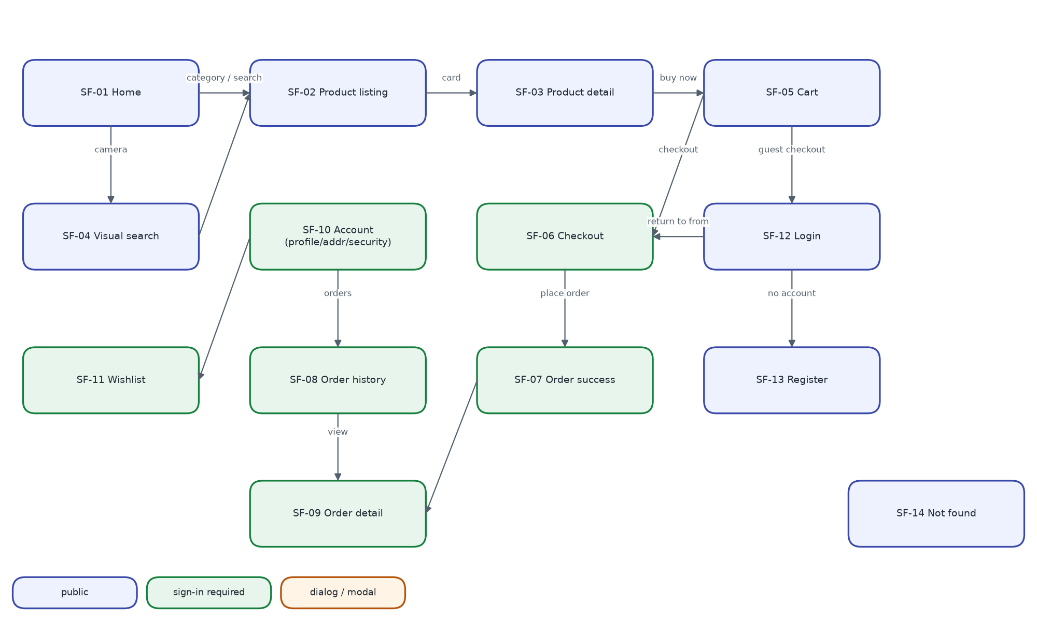
Figure 12 – Storefront screen transitions
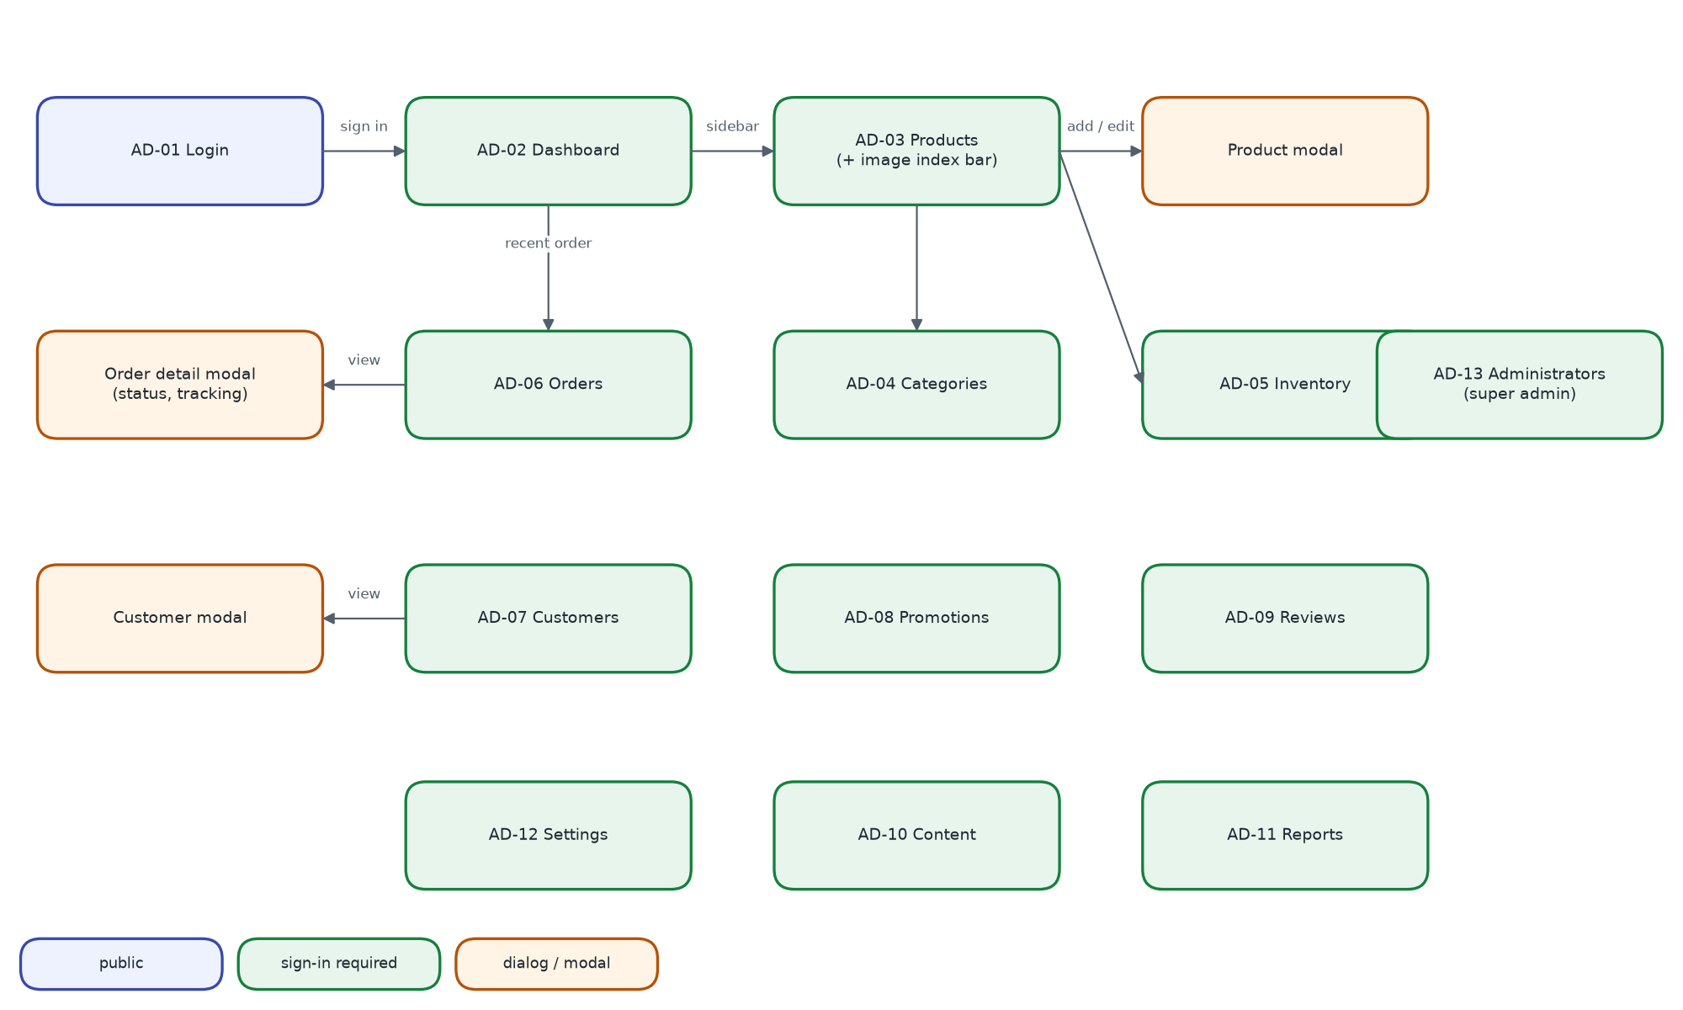
Figure 13 – Admin panel screen transitions (every page is also reachable from the sidebar)
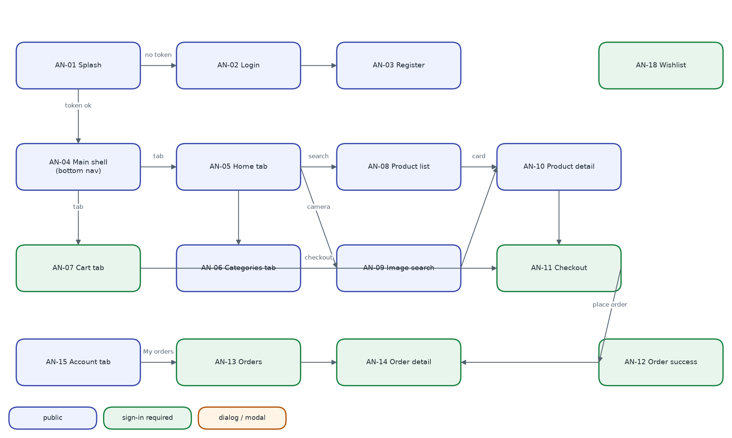
Figure 14 – Android screen transitions

9.5 Storefront screen specifications

9.5.1 Global header, footer and mobile navigation
- Top bar: shipping, money-back and support promises; compact language switcher; USD label.
- Main bar: brand (links to /), search with type-ahead (≥ 2 chars, 280 ms, 5 suggestions + “See all results”), camera button (only when image search is available), sign-in/register or user menu (account, orders, addresses, settings, sign out), wishlist and cart icons with count badges.
- Category nav: “All categories” plus up to 9 root categories; active category highlighted.
- Footer: brand, contact, shop links, help links, accepted payments, copyright.
- Mobile (≤ 768 px): compact header and bottom tab bar Home · Categories · Cart · Wishlist · Account.

9.5.2 SF-01 Home
Field | Description
Purpose | Entry point that exposes categories, promotions and product selections
Layout | Department rail · hero carousel · 4 promise cards / category ring chips / deal band (Hot deals, Best-seller top 5, promo tile) / trust strip / New arrivals / Active promotions / Featured products
Data | GET /banners?placement=hero, /categories?parent=root&withCounts=true, /products/featured, /products/best-sellers, /products?sort=newest&limit=6, /promotions — in parallel; refetched on language change
Actions | Carousel prev/next/dots (manual); category chip → SF-02 filtered; “See all” → SF-02 with sort/flag; product card → SF-03; Add to cart; wishlist heart
States | Skeleton grids while loading; a failed section renders empty

9.5.3 SF-02 Product listing
Field | Description
Purpose | Filter, sort and page through products
Layout | Breadcrumb · left filter panel (Category radio, Price min/max, Brand checkboxes, Colour swatches, Rating “& up”, Availability) · toolbar (title, count, Filters toggle ≤ 1024 px, Sort) · active-filter chips · product grid · pagination
Data | GET /categories?withCounts=true, /products/filters?category=…, /products?{query}
Behaviour | All state in the URL query; any filter change resets page to 1; pagination window of 5 with first/last and ellipses
Sort options | Best selling (default), Newest, Price low–high, Price high–low, Rating, Name A–Z
States | 8-card skeleton; empty state with “Clear all filters”

9.5.4 SF-03 Product detail
Field | Description
Purpose | Evaluate and buy one product
Layout | Breadcrumb · gallery (thumbnails + zoomable main image) · info column (brand, SKU, featured badge, name, rating/reviews/sold, price + compare + % off, short description, colour swatches, size chips, quantity stepper, stock badge, Add to cart, Buy now, wishlist) · trust row · tabs Description / Specs / Reviews · related products
Data | GET /products/:slug, /related, /reviews?limit=10, /reviews/summary
Validation | Quantity 1..stock; out-of-stock sizes disabled; buttons disabled when out of stock or busy
Review form | Star picker 1–5 (default 5), title, comment; disabled for guests with sign-in link; POST /reviews then summary refresh
States | Spinner; not found → empty state “Browse products”

9.5.5 SF-04 Visual search
Field | Description
Purpose | Find products similar to a photo
Layout | Before search: drop zone (drag-and-drop or picker, “JPEG, PNG, WEBP, GIF or AVIF”). After: left photo preview + “Change photo”; right result count and grid with “N % match” labels
Data | POST /products/visual-search?limit=24 (multipart image, 60 s timeout); rerun on language change
States | Skeleton; 503 → “Image search is not available right now”; other error → API message; empty state

9.5.6 SF-05 Cart
Field | Description
Purpose | Review items and totals, apply a promo code
Layout | Title “Cart (n)” with Continue shopping and Clear cart · free-shipping progress bar · line list (image, name, variant, unit price, quantity stepper, remove, line total) · summary (subtotal, discount, shipping, tax, total) · promo code field · Proceed to checkout
Data | GET /cart; PATCH/DELETE /cart/items/:id; DELETE /cart; POST/DELETE /cart/coupon
Validation | Quantity 1..min(stock, 99); promo code upper-cased, Apply disabled when empty; guests must sign in to use a code
States | Empty → “Start shopping”; the line being updated is disabled; server notices shown as info toasts

9.5.7 SF-06 Checkout
Field | Description
Purpose | Collect address and payment and place the order
Layout | Step indicator 1 Shipping · 2 Payment · 3 Complete; right-hand summary always visible
Step 1 fields | Saved-address radio cards or new address: full name*, phone, street*, city*, state, ZIP*, country* (default Finland); “Save to my addresses”
Step 2 fields | Card / PayPal / Apple Pay / Cash on delivery. Card: number (≥ 12 digits), name*, expiry NN/NN or NN/NNNN, CVC 3–4 digits; demo-gateway notice
Step 3 | Shipping and payment cards with Edit links; items; “Place order – $total” → POST /orders
States | Spinner “Preparing…”; empty cart → “Browse products”; failure → toast and back to step 2; success → SF-07 (replace)

9.5.8 SF-07 Order success
Field | Description
Content | Check icon, order number, status badge, items, total paid, carrier, tracking number, estimated delivery
Actions | View order → SF-09; Continue shopping → SF-02

9.5.9 SF-08 Order history
Field | Description
Layout | Status chips (all, pending, processing, shipped, delivered, cancelled) · order cards (number, date, total, status badge, up to 3 items, “+N more”) · pagination (8 per page)
Data | GET /orders?status=&page=&limit=8
States | Spinner; empty message per filter with “Start shopping”

9.5.10 SF-09 Order detail
Field | Description
Layout | Header (order no., date, status, Cancel order) · tracking card (carrier, tracking no., ETA, timeline) · items · payment summary · shipping address
Data | GET /orders/:no, /orders/:no/track; POST /orders/:no/cancel
Rules | Cancel shown only for pending/processing; confirmation dialog; cancelled orders show the reason

9.5.11 SF-10 Account
Field | Description
Layout | Side navigation: Profile, Addresses, Orders, Wishlist, Security, Sign out
SF-10a Profile | Name, e-mail (read-only), phone, preferred language, member since → PATCH /users/profile
SF-10b Addresses | Address cards with Make default, Edit, Delete; inline form (label, full name*, street*, city*, state, ZIP*, country*, phone)
SF-10c Security | Current password*, new password* (≥ 6), confirm*; mismatch → error; success → sign out and SF-12

9.5.12 SF-11 Wishlist
Field | Description
Content | Product grid of saved items; heart removes an item; empty state “Browse products”
Data | GET /users/wishlist; POST /users/wishlist/:id

9.5.13 SF-12 Sign in
Field | Description
Layout | Card (brand, “Welcome back”, language switcher, demo-account buttons, e-mail, password, Sign in, link to Register) + decorative brand panel (hidden ≤ 860 px); no header/footer
Behaviour | POST /auth/login → merge guest cart → welcome toast → return to from page or Home
Errors | Alert box with server message

9.5.14 SF-13 Register
Field | Description
Fields | Name* (≥ 2), e-mail*, phone, password* (≥ 6, hint), confirm password*
Behaviour | Mismatch → field error; server errors[] mapped to fields; success → merge cart, toast, Home

9.5.15 SF-14 Not found
Field | Description
Content | Search icon, title, message, “Back home”

9.6 Admin panel screen specifications
Layout for all pages: left sidebar grouped Overview / Catalog / Sales / Engagement / Insights with Storefront link and Sign out; top bar with menu toggle, page title, language switcher and user chip. Tables page at 20 rows; search boxes debounce 260 ms; deletes use a confirmation modal.

9.6.1 AD-01 Staff sign in
Field | Description
Fields | E-mail*, password*; demo buttons Admin / Manager
Behaviour | Customer accounts rejected; success → toast “Signed in as {name}” → previous page or Dashboard

9.6.2 AD-02 Dashboard
Field | Description
Controls | Range chips 7 Days · 30 Days (default) · 3 Months · 1 Year
KPI cards | Total revenue, Total orders, Total customers, Conversion rate — each with % change versus previous period
Charts | Sales overview (area, revenue per day); Sales by category (donut, top 5 + Other); Customer growth (area, 6 months)
Lists | Recent orders (ID → Orders search, customer, date, status, total); Top products (image, name, sold, stock, price)
States | Spinner “Loading dashboard…”; error → empty state “Could not load the dashboard”

9.6.3 AD-03 Products
Field | Description
Header | Product count, Add Product; image-search bar (model status, “N of M products indexed · V vectors”, Rebuild index, Re-extract all, progress polled every 2 s)
Filters | Search, category, status (active/inactive), stock (low/out)
Table | Image, name (brand · SKU), category, price (currency, compare), stock, stock badge, Active switch (optimistic), image-search badge, actions (re-extract, edit, delete)
Modal fields | Name*, brand, category*, currency USD/REM, price* ≥ 0, compare at, cost, stock* ≥ 0, colours, short description (≤ 300), description, tags, images (upload ≤ 8, remove), Active, Featured, Free shipping, zh/ja translations
Rules | Server errors mapped under fields; warning toast if image indexing failed; delete confirmation mentions reviews are deleted too

9.6.4 AD-04 Categories
Field | Description
Table | Name (image), slug, parent, product count, order, status (Active/Hidden), actions
Modal fields | Name* (≥ 2), description, parent (top level or a root category, not itself), sort order, Visible switch, translations
Rules | Delete refused (409) while products or children exist

9.6.5 AD-05 Inventory
Field | Description
KPI cards | Out of stock, Low stock, Needs attention
Table | Product (image, name, SKU), category, price, current stock, status badge, New stock input + Save
Validation | New stock must be a number ≥ 0; success toast “{name} restocked to {n}” and reload

9.6.6 AD-06 Orders
Field | Description
Filters | Search (order no., customer, e-mail; can be pre-filled from Dashboard); status tabs with counts
Table | Order ID, date, customer (name, e-mail), items, total, payment badge, status badge, View
Detail modal | Status and payment badges; carrier + tracking inputs with Save; customer and shipping cards; items; totals; timeline; optional status note; “Mark as {next status}” buttons (Cancel in red) or “No further changes”
Rules | Only allowed transitions are offered (see section 6.6); no confirmation before a status change (finding F-09)

9.6.7 AD-07 Customers
Field | Description
Controls | Search, status filter, Export CSV
Table | Name, e-mail, phone, orders, total spent, joined, Active switch, View
Detail modal | Orders, total spent, average order, reviews; contact; addresses; recent orders
Export | Downloads customers.csv (all customers, localised headers, UTF-8 BOM)

9.6.8 AD-08 Promotions
Field | Description
Table | Code + description, discount (x % or amount, max cap), min purchase, used/limit, expires, status Active/Paused/Expired, actions
Modal fields | Code* (≥ 3, upper case), type* percent/fixed, description, value* ≥ 0, min purchase, max discount (0 = uncapped), usage limit (0 = unlimited), expiry date, Active

9.6.9 AD-09 Reviews
Field | Description
Filters | Tabs All / Published / Hidden; rating 1–5
Table | Product, customer (Verified badge), stars, title + comment, date, status, Publish/Hide toggle, Delete

9.6.10 AD-10 Content (banners)
Field | Description
Layout | Card grid: image, placement badge (Homepage hero / Promo strip / Mobile app), Live/Hidden, title, subtitle, CTA, Edit, Delete
Modal fields | Title*, subtitle, button text (Shop Now), button link (/products), placement, sort order, image, Live, translations

9.6.11 AD-11 Reports
Field | Description
Content | Range chips (default 3 months); KPI cards Revenue, Orders, Average order value, Active products; line chart orders per day; bar chart revenue by category; bar chart new customers per month (12); best-selling products table (units, revenue, stock)

9.6.12 AD-12 Settings
Field | Description
Content | Account card (name, e-mail, role, last sign-in, panel language); environment card (API and asset URLs, storefront link); change password form (current*, new* ≥ 6, confirm*)
Behaviour | Password change → forced sign-out → AD-01

9.6.13 AD-13 Administrators
Field | Description
Access | Menu shown to super admins only; API returns 403 to others
Table | Name + e-mail, role badge, permission badges (or “All sections”), status, last sign-in, Edit/Delete (disabled for super admins)
Modal fields | Full name*, e-mail* (not editable later), password (required on create, ≥ 6; blank keeps), role manager/admin, section checkboxes (7), Account active

9.7 Android screen specifications
Material 3 light theme (primary #16A34A). Activities slide horizontally; tabs and splash cross-fade. Pull-to-refresh on lists; snackbars for errors; guests who try a member action are sent to AN-02.

9.7.1 AN-01 Splash
Field | Description
Behaviour | No token → AN-02; token → GET /auth/me → AN-04, or clear session → AN-02

9.7.2 AN-02 Sign in
Field | Description
Elements | Logo, tagline, demo hint (tap to fill), error text, e-mail, password, Sign in, “No account?”, Continue as guest
Validation | E-mail format; password ≥ 6; inline errors; buttons disabled while loading

9.7.3 AN-03 Register
Field | Description
Elements | Full name (≥ 2), e-mail, phone (optional), password (≥ 6), confirm (must match), Sign up

9.7.4 AN-04 Main shell
Field | Description
Elements | Fragment container + bottom navigation: Home, Categories, Cart (badge), Account; EXTRA_TAB selects start tab

9.7.5 AN-05 Home tab
Field | Description
Elements | Search bar with camera icon (visible when image search available) and wishlist icon; hero ViewPager2 (auto-advance 5 s); category chips; Featured row; Best-seller 2-column grid; “See all” links
Data | banners, root categories, featured, best sellers, visual-search status

9.7.6 AN-06 Categories tab
Field | Description
Elements | Title, search bar, category rows with counts; empty state “No categories yet”

9.7.7 AN-07 Cart tab
Field | Description
Elements | “Your cart (n)”, Clear, free-shipping hint, item list with steppers and remove, promo field + Apply, applied-coupon row, summary card, Checkout
States | Signed out → sign-in prompt; empty → Start shopping; notices as snackbars

9.7.8 AN-08 Product list
Field | Description
Elements | Toolbar title, search (320 ms debounce), camera button, sort dialog, result count, 2-column grid with endless scroll (page 12)

9.7.9 AN-09 Search by image
Field | Description
Elements | Query image preview, hint, Camera and Gallery buttons, result count, 2-column grid with “% match”, progress “Searching…”
States | Intro, loading, results, empty, unreadable photo, failed; survives rotation using cached query.jpg

9.7.10 AN-10 Product detail
Field | Description
Elements | Image pager with dots, discount badge, wishlist, brand · SKU, name, rating, sold, price/compare, stock badge, variant chips, stepper, shipping/warranty/returns badges, description, 5 reviews + Write review dialog, related row, bottom bar Add to cart / Buy now

9.7.11 AN-11 Checkout
Field | Description
Elements | Address radio group + Add address dialog; payment radio group; card box (number, name); order summary; “Place order · $total”
Validation | Required address fields; card number ≥ 12 digits

9.7.12 AN-12 Order success
Field | Description
Elements | Success icon, order number, items, total, carrier · tracking, ETA, View order, Continue shopping

9.7.13 AN-13 Orders
Field | Description
Elements | Status chips, order list with endless scroll (10), pull to refresh

9.7.14 AN-14 Order detail
Field | Description
Elements | Number, date, status, tracking, timeline, items, totals, payment, address, Cancel order (pending/processing, confirmation)

9.7.15 AN-15 Account tab
Field | Description
Elements | Avatar initial, name, e-mail, Edit profile dialog; rows My orders, Addresses, Wishlist, Language (System/English/中文/日本語), Settings; Sign out; version

9.7.16 AN-16 Addresses
Field | Description
Elements | Address cards with Make default and Delete (confirmation); Add (+) opens address dialog; empty state

9.7.17 AN-18 Wishlist
Field | Description
Elements | 2-column grid; open, add to cart, remove; guests redirected to sign-in

10 Review findings and deviations
While deriving this document from the code, the following deviations from the requirements, from good practice or from the project's own README files were found. They are recorded here so they can be planned as change requests; none has been fixed in the baseline. Severity: H = high, M = medium, L = low.
Table 22 – Findings
ID | Sev. | Area | Finding | Recommendation
F-01 | H | Authorisation | Staff section permissions are stored and editable, but requirePermission() is never applied to a route; any manager or admin can use every back-office section except staff management. | Apply requirePermission per /admin route group and hide menu items the user lacks (FR-AUTH-09).
F-02 | M | Admin UI | Reviews filter tabs render empty labels and always filter “All” (uses the translator t instead of the tab object). | Rename the map variable and reference tab.value / tab.label.
F-03 | L | Admin UI | Banner placement drop-down shows blank labels (renders p.label, list defines labelKey). | Render t(p.labelKey).
F-04 | L | i18n | Hard-coded English strings remain in the admin panel (e.g. “Add Banner”, “Order #”, “Verified”) and in the Android app (e.g. “% OFF”, “n sold”, “Free over $50”, settings dialog). | Move to the en/zh/ja catalogues (FR-I18N-01).
F-05 | H | Android security | Tokens are stored in plain SharedPreferences and the manifest sets allowBackup="true"; debug builds log full HTTP bodies (passwords, tokens, card numbers). | Use EncryptedSharedPreferences, exclude session prefs from backup, log headers only (NFR-SE-05).
F-06 | H | Payment | The full card number is sent to the API (mock gateway). A real integration must tokenise on the client so card data never reaches the API (PCI-DSS). | Integrate a PSP SDK / hosted fields before go-live.
F-07 | M | API security | Create/update of coupons, categories, banners and products pass req.body to the model (mass assignment; only visualIndex is stripped from products). | Whitelist fields per endpoint.
F-08 | M | Android network | network_security_config lists “192.168.0.0” as a domain, which does not match LAN IPs; a physical device on a LAN address is blocked from cleartext, contrary to the README. | Document an HTTPS dev proxy or add the concrete host; keep cleartext out of release.
F-09 | M | Usability | No confirmation before order status changes (including cancel) in the admin panel, before clearing the cart, or before deleting an address on the web. | Add confirmation dialogs (NFR-IU-03).
F-10 | L | Coupons | usedCount is not decremented when an order is cancelled; there is no per-customer usage limit. | Decrement on cancel; add optional per-user limit.
F-11 | L | Reviews | Helpful votes are not de-duplicated per user. | Store voter ids or a separate votes collection.
F-12 | L | Documentation | README says the seeded admin is role admin (it is superadmin), Android AGP 8.9.1 (it is 8.13.0) and ShopWorldApp.java (class is AuraMartApp). | Correct the README files.
F-13 | M | Visual search UX | On Android, if the status call fails once, the camera icons stay hidden for that screen with no retry or log. | Retry with back-off or show the icon when the model is bundled.
F-14 | M | Testing | No automated tests exist in any of the four projects. | Implement the test design of section 11 (NFR-MA-02).
F-15 | L | Checkout | Card expiry and CVC are validated on the web client but not sent or checked by the API. | Irrelevant once a PSP is integrated (F-06); otherwise validate server-side.

11 Test design
The test design follows ISO/IEC/IEEE 29119-3:2021. It defines the test levels and techniques, the test environment and the test cases that verify the requirements of section 3. At the baseline no automated tests exist (F-14); this section is the plan for creating them.

11.1 Test strategy
Table 23 – Test levels
Level | Scope | Technique | Tooling (proposed)
Unit | pricing.service, coupon methods, token utils, i18n resolver, Dinov3Preprocessor | Equivalence partitioning, boundary values | Jest / node:test; JUnit 4 for Android utils
API integration | Every endpoint with MongoDB (replica set) and seed data | Decision tables (state machine, coupons), error guessing | Supertest + mongodb-memory-server (replset)
UI component | Stores, API client refresh logic, forms | State transition | Vitest + React Testing Library
System / end-to-end | Use cases UC-01..UC-24 on web and admin | Use-case (scenario) testing | Playwright
Android UI | AN screens, image search, share intent | Scenario testing | Espresso 3.6
Non-functional | Performance, security, accessibility | Load profiles, OWASP ASVS L1 checks, WCAG 2.0 AA audit | k6, OWASP ZAP, axe-core

11.2 Test environment
- Docker compose stack (MongoDB 6.0 replica set + API), npm run seed before each suite; NODE_ENV=test with rate limits off.
- Browsers: Chromium, Firefox, WebKit via Playwright at 1440 × 900 and 390 × 844.
- Android emulator API 24 and API 35 (x86_64), host reached at 10.0.2.2:5000.
- Test accounts: seed customers, manager and super admin (README demo accounts).

11.3 Entry and exit criteria
- Entry: build succeeds on all four projects; seed completes; health endpoint returns connected.
- Exit: 100 % of M-priority test cases executed; no open H-severity defect; ≥ 80 % statement coverage of pricing, cart, order and auth modules.

11.4 Test cases
Table 24 – Test cases
TC ID | Requirement | Pre-condition / input | Expected result
TC-AUTH-01 | FR-AUTH-01 | Register new e-mail, valid data | 201; user role customer; tokens returned; cart exists
TC-AUTH-02 | FR-AUTH-01 | Register existing e-mail | 409 duplicate
TC-AUTH-03 | FR-AUTH-01 | Password of 5 characters | 422 with field password
TC-AUTH-04 | FR-AUTH-02 | Login john@example.com / Password@123 | 200; access expires in 15 min
TC-AUTH-05 | FR-AUTH-03 | Login deactivated customer | 403
TC-AUTH-06 | FR-AUTH-04 | Refresh twice with the same refresh token | First 200; second 401 revoked
TC-AUTH-07 | FR-AUTH-04 | Log in 6 times, refresh with the first token | 401 (only last 5 kept)
TC-AUTH-08 | FR-AUTH-05 | Expire access token; call GET /cart from web client | One refresh call; original request replayed; user unaware
TC-AUTH-09 | FR-AUTH-06 | Change password, then refresh with old token | 401
TC-AUTH-10 | FR-AUTH-09 | Manager without products permission calls POST /admin/products | Expected 403 — currently 201 (F-01)
TC-CAT-01 | FR-CAT-01 | GET /products?limit=500 | limit capped at 100
TC-CAT-02 | FR-CAT-02 | Filter parent category slug | Products of parent and child categories
TC-CAT-03 | FR-CAT-03 | sort=price_asc | Non-decreasing prices
TC-CAT-04 | FR-CAT-04 | GET /products/filters?category=x | Brands, colours, min/max price for x
TC-CAT-05 | FR-CAT-05 | search=(.* (regex characters) | 200, no error, literal match
TC-CAT-06 | FR-CAT-08 | Inactive product by slug as guest / as staff | 404 / 200
TC-VIS-01 | FR-VIS-01 | Upload a product's own image | That product ranked first, similarity ≥ 0.85
TC-VIS-02 | FR-VIS-02 | Vector with model other/model.onnx | 409 visualModelMismatch
TC-VIS-03 | FR-VIS-02 | Vector of length 100 | 400 dimension mismatch
TC-VIS-04 | FR-VIS-03 | Unrelated photo (noise) | Empty list
TC-VIS-05 | NFR-SF-01 | Remove model files, restart, search | 503; rest of API works
TC-VIS-06 | FR-VIS-05, 06 | Android: share a JPEG from Photos app | AN-09 opens and shows results; vector endpoint used
TC-VIS-07 | FR-VIS-07 | Admin: Re-extract all | 202; progress reaches total; status indexed
TC-CART-01 | FR-CART-01 | Deactivate a product that is in a cart; GET /cart | Line removed; notice present
TC-CART-02 | FR-CART-02 | Add quantity stock + 1 | 400
TC-CART-03 | FR-CART-02 | Add a REM product to a USD cart | 400 mixed currency
TC-CART-04 | FR-CART-03 | Guest cart of 2 lines, then sign in | Server cart contains both lines, clamped to stock
TC-CART-05 | FR-CART-04 | SAVE20 with subtotal 149.99 / 150.00 | Rejected (min purchase) / discount 20
TC-CART-06 | FR-CART-05 | MEGA50 with subtotal 400 | Discount 150 (cap), not 200
TC-CART-07 | FR-CART-04 | Expired coupon | Rejected with reason
TC-CART-08 | FR-CART-06, 07 | Subtotal 49.99 / 50.00 without coupon | Shipping 9.99, tax 5.00 / shipping 0, tax 5.00
TC-CART-09 | FR-CART-08 | Toggle wishlist twice | inWishlist true then false
TC-ORD-01 | FR-ORD-01 | POST /orders with empty cart | 400
TC-ORD-02 | FR-ORD-02 | Two parallel orders for the last unit | Exactly one 201, one 409; stock 0
TC-ORD-03 | FR-ORD-03 | Card ending 0000 | 400 declined; stock unchanged
TC-ORD-04 | FR-ORD-03 | Cash on delivery | 201; payment unpaid
TC-ORD-05 | FR-ORD-04 | Change product price after order | Order item price unchanged
TC-ORD-06 | FR-ORD-05 | Place order | orderNumber ORD\d{6}; tracking AM-[A-HJ-NP-Z2-9]{10}; ETA +5 days
TC-ORD-07 | NFR-RE-01 | Force failure after stock reservation (standalone Mongo) | Stock restored
TC-ORD-08 | FR-ORD-07 | Customer cancels pending paid order | cancelled; stock restored; payment refunded
TC-ORD-09 | FR-ORD-06 | Customer cancels shipped order | 400
TC-ORD-10 | FR-ORD-09 | Customer B requests customer A's order | 404/403
TC-ORD-11 | FR-ORD-06 | Staff: pending → shipped | 400 invalid transition
TC-ORD-12 | FR-ORD-06 | Staff: shipped → delivered on COD order | delivered; payment paid; deliveredAt set
TC-ORD-13 | FR-ORD-08 | Any transition with note | Timeline entry with note and time
TC-ORD-14 | FR-ORD-10 | Set carrier and tracking number | Visible in customer order detail
TC-REV-01 | FR-REV-01 | Second review same product | 409
TC-REV-02 | FR-REV-02 | Review after a delivered order | isVerifiedPurchase true; order linked
TC-REV-03 | FR-REV-03 | Ratings 5 and 2 | Product rating 3.5, reviewCount 2
TC-REV-04 | FR-REV-04 | Hide the 2-star review | Product rating 5.0, reviewCount 1
TC-ADM-01 | FR-ADM-01 | Dashboard range 30d vs seed data | KPIs equal DB aggregation; deltas vs previous 30 days
TC-ADM-02 | FR-ADM-02 | Create product with 2 images | 201; visualIndex indexed; vectors 2
TC-ADM-03 | FR-ADM-02 | Upload 6 MB image / PDF | 400 / 400
TC-ADM-04 | FR-ADM-02 | Delete product with reviews | Reviews and embeddings removed
TC-ADM-05 | FR-ADM-03 | Delete category with products | 409
TC-ADM-06 | FR-ADM-04 | Restock a low-stock product to 50 | Disappears from inventory alerts
TC-ADM-07 | FR-ADM-05 | Export CSV with zh locale | UTF-8 BOM; Chinese headers; opens correctly in Excel
TC-ADM-08 | FR-ADM-05 | Deactivate customer then customer calls API | 403 on next request; refresh 401
TC-ADM-09 | FR-ADM-06 | Create hero banner (live) | Appears in storefront carousel and Android pager
TC-ADM-10 | FR-ADM-07 | Manager calls GET /admin/staff | 403
TC-ADM-11 | FR-ADM-08 | Super admin changes manager permissions | Manager's refresh fails; must sign in again
TC-ACC-01 | UC-12 | Add first address | Becomes default
TC-ACC-02 | UC-12 | Delete default of 2 addresses | Remaining address becomes default
TC-ACC-03 | UC-12 | Profile update with e-mail field | E-mail unchanged
TC-ACC-04 | FR-AUTH-06 | Change password wrong current | Error; password unchanged
TC-I18N-01 | FR-I18N-02 | GET /products with X-Language: ja | Japanese names where translated; Content-Language ja
TC-I18N-02 | FR-I18N-02 | Accept-Language zh-TW | Resolved to zh
TC-I18N-03 | FR-I18N-01 | Switch to 日本語 on each client | All visible texts Japanese (currently fails for F-04 strings)
TC-NFR-01 | NFR-SE-03 | 31 logins in 15 min (production mode) | 31st → 429
TC-NFR-02 | NFR-SE-02 | Login body {"email":{"$gt":""}} | Operator stripped; 422/401, never 200
TC-NFR-03 | NFR-PE-01 | k6: 50 VU on /products for 5 min, 10 k products | p95 ≤ 300 ms

Appendix A – Configuration reference
Table 25 – Environment variables
Variable | Default | Purpose
NODE_ENV | development | production enables rate limits and hides stack traces
PORT / API_PREFIX | 5000 / /api/v1 | Listening port and route prefix
MONGO_URI | mongodb://127.0.0.1:27017/auramart | Database connection (use ?replicaSet=rs0 for transactions)
JWT_ACCESS_SECRET / JWT_REFRESH_SECRET | dev_access_secret / dev_refresh_secret | Token signing secrets — must be changed in production
JWT_ACCESS_EXPIRES / JWT_REFRESH_EXPIRES | 15m / 30d | Token lifetimes
CORS_ORIGINS | (empty = all) | Comma-separated allowed origins; .env.example lists 5173, 5174, 10.0.2.2:5000
PUBLIC_URL | http://localhost:5000 | Base for stored image URLs
UPLOAD_MAX_MB | 5 | Maximum upload size per file
FREE_SHIPPING_THRESHOLD / SHIPPING_FLAT_RATE / TAX_RATE | 50 / 9.99 / 0.1 | Pricing parameters
VISUAL_SEARCH_ENABLED | true | Master switch for image search
VISUAL_SEARCH_MODEL_DIR / _MODEL_FILE | ml/dinov3-vits16 / model.onnx | Model location; together form the model id
VISUAL_SEARCH_THREADS | 0 (auto) | ONNX Runtime intra-op threads
VISUAL_SEARCH_MIN_SCORE | 0.25 | Minimum cosine similarity returned
VISUAL_SEARCH_INDEX_ON_BOOT | true | Index pending products at start-up
VISUAL_SEARCH_FETCH_REMOTE | false | Allow indexing of http(s) image URLs
SEED_ADMIN_EMAIL / SEED_ADMIN_PASSWORD | admin@auramart.com / Admin@123 | Seeded super admin
VITE_API_URL / VITE_ASSET_URL (web, admin) | http://localhost:5000/api/v1 / http://localhost:5000 | Client API and asset bases
BuildConfig.API_BASE_URL (Android) | http://10.0.2.2:5000/api/v1/ (debug) | Release: https://api.auramart.com/api/v1/

Appendix B – Requirements traceability matrix
Forward traceability from requirement groups to use cases, screens, code and tests (bidirectional traceability as required by ISO/IEC/IEEE 29148).
Table 26 – Traceability matrix
Requirements | Use cases | Screens | Main code units | Tests
FR-AUTH-01..06 | UC-01, UC-02, UC-12 | SF-10, SF-12, SF-13, AN-01..03, AN-15 | auth.controller, middleware/auth, utils/token, api/client.js, ApiClient.java | TC-AUTH-01..09
FR-AUTH-07..09 | UC-02, UC-24 | AD-01, AD-13 | adminOnly, superAdminOnly, staff.controller | TC-AUTH-10, TC-ADM-10, 11
FR-CAT-01..09 | UC-03, UC-04, UC-06, UC-13 | SF-01..03, AN-05, AN-06, AN-08, AN-10 | product.controller, category.controller, utils/localize | TC-CAT-01..06, TC-I18N-01
FR-VIS-01..08 | UC-05, UC-23 | SF-04, AN-09, AD-03 | dinov3.service, visualSearch.service, Dinov3Encoder, SearchPhotos | TC-VIS-01..07
FR-CART-01..08 | UC-07, UC-11 | SF-05, SF-11, AN-07, AN-18 | cart.controller, pricing.service, Coupon model, cartStore | TC-CART-01..09
FR-ORD-01..10 | UC-08, UC-09, UC-18 | SF-06..09, AN-11..14, AD-06 | order.controller, admin.controller (orders), payment.service, utils/transaction | TC-ORD-01..14
FR-REV-01..04 | UC-10, UC-20 | SF-03, AN-10, AD-09 | review.controller, Review.syncProductRating | TC-REV-01..04
FR-ADM-01..08 | UC-14..UC-22, UC-24 | AD-02..AD-13 | admin.controller, staff.controller, upload.controller | TC-ADM-01..11
FR-I18N-01..02 | UC-13 | All | middleware/locale, i18n/*, LocaleManager | TC-I18N-01..03
NFR-SE-01..05 | — | — | User model, app.js, rateLimit, SessionManager | TC-NFR-01, 02
NFR-PE-01..03 | — | — | indexes, visualSearch matrix | TC-NFR-03

Appendix C – Build, run and release procedure
Table 27 – Procedure
Step | Command / action | Result
1 | npm install at repository root | Dependencies for backend, storefront and admin (npm workspaces)
2 | cp backend/.env.example backend/.env and set secrets | Configuration
3 | npm run model:fetch (and npm run model:android for the APK) | DINOv3 weights in backend/ml and android assets, SHA-256 verified
4 | docker compose up -d or local MongoDB 6.0 replica set | Database (and API) running
5 | npm run seed | Demo data and image index
6 | npm run dev | API :5000, storefront :5173, admin :5174
7 | npm run build | Static builds in frontend/dist and admin-panel/dist
8 | cd android && ./gradlew assembleRelease | Minified APK with bundled model (build fails if model files are missing)
9 | Smoke test: GET /api/v1/health, sign in on each client, one test order | Release candidate accepted

